Strengthening Teacher Creativity through The Blended Product Training Model in The Development of Digital Libraries

.
ABSTRACT

Aim: This research aims to measure the effectiveness of the Blended Product Training model in enhancing teachers' creativity in developing digital libraries. The steps of the Blended Product Training model are divided into three stages: (1) conducted synchronously to deliver the material while simultaneously designing the digital library product to be developed, (2) the second stage is conducted asynchronously, where the process of independently producing the digital library takes place, and (3) the final stage is conducted synchronously again, involving the evaluation of the product results through presentations, discussions, and reflections on the training process and achievements.
Study design: The research used a quasi-experimental method with a one group pre-test post-test design. The research subjects were 25 teachers who worked as librarians.
Methodology: Data collection was conducted through a creativity questionnaire with assessment aspects (1) the ability to create innovative ideas, (2) skills in developing digital products, (3) creative use of technology, (4) problem-solving through innovative approaches, and (5) originality of work.
Results: The data obtained were analyzed using the n-gain test to compare the difference between pretest and posttest scores after the training. The analysis results yielded an N gain score of 0.5979 with a standard deviation of 0.05966 and an N gain percentage of 59.7874, while the standard deviation value was 5.96634.
Conclusion: The results of training research using the Blended Product Training model are quite effective in improving the competence of digital library development teachers. This training not only results in an increase in knowledge but also encourages teachers to create original digital libraries that meet the needs of the school. It is recommended that training with this approach be more widely adopted with ongoing technical support to ensure successful implementation in the educational environment

Keywords: Blended learning, blended product training, creativity, teacher training

1. INTRODUCTION

The demand for self-development in the modern era requires every individual to continuously enhance their competencies in order to adapt to the changing times. Self-development for a teacher becomes a crucial point in facing the ever-evolving dynamics of the education world. Teachers are not only required to master the teaching material, but they must also be able to adapt to changes, especially in utilizing technology to support an effective and innovative learning process.

The rapid development of information and communication technology has brought significant changes in the field of education. One of the tangible impacts of ICT advancement is the demand for educational institutions to adapt to digital-based learning and information management systems. In actual practice on the ground, it shows that many schools still manage libraries conventionally with manual borrowing systems and non-digitized teaching materials collections. This hinders quick and flexible access to learning resources for teachers and students, thereby obstructing the learning process (Tella et al., 2023). because of that, the learning is not optimal and the learning objectives have not been achieved.

Based on the results of observations and interviews, a significant gap was found between the demands of technology and the competencies possessed by teachers. Many schools still manage their libraries conventionally with a manual borrowing system and a collection of teaching materials that have not yet been digitized. This condition indicates that teachers' mastery of competencies in utilizing information technology is still suboptimal. These limitations hinder quick and flexible access to learning resources for teachers and students, resulting in an suboptimal learning process and the learning objectives not being fully achieved. To address these challenges, a training strategy is needed that not only introduces technology but also encourages teachers' competencies as developers of innovative learning systems. One of the relevant approaches to conducting training is the Blended Learning model, which is a combination of face-to-face and online learning that allows for flexible and sustainable training. (Müller & Mildenberger, 2021). On the other hand, the product-oriented approach (Product Based Learning) requires teachers to develop products as final outcomes that have practical value in addressing existing problems (Andrianto et al., 2024).

Through this combination, an innovative training model called Blended Product Training was developed. This model combines the flexibility of Blended Learning with the product-oriented approach of Product-Based Learning, so that participants not only gain knowledge but also practical skills in designing, building, and managing digital libraries (Asitah & Ismafitri, 2021). Blended Product Training is a training model that combines synchronous and asynchronous learning to achieve training goals by producing tangible products (Keppenne et al., 2021).

The implementation of this model in training aims to enhance teachers' creativity in producing digital library products. The training stages using the Blended Product Training model are divided into three phases: (1) the first phase of training is conducted online using the Zoom application with activities such as material explanation and planning for digital library development, (2) in the second phase, participants engage in self-directed (asynchronous) learning to develop digital library products. During this phase, participants are given time to explore, experiment, and implement their ideas into tangible products, (3) in the final phase, a synchronous session is held for the presentation of the digital library products developed by the participants.

The urgency of conducting training using the Blended Product Training model lies in the process and the final outcome in the form of a product (Rini & Cholifah, 2020). Not only focusing on the theory being studied, but also guiding the trainees to produce digital products that are applicable and have a direct impact on the school environment (Brasoveanu & Dotlačil, 2021). The Blended Product Training model is suitable for implementation as a solution for using a flexible training model while still focusing on the product as the final outcome that has benefits and market value in the surrounding environment. The implementation of this model simultaneously serves as an effort to enhance teachers' creativity and competence in utilizing information technology by producing works in the form of digital libraries.
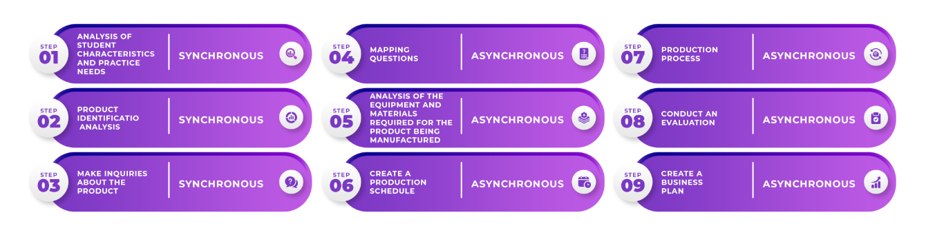
Figure 1. Blended Product Training Model Syntax

2. methodology

The research uses a quasi-experimental method with a one group pre-test post-test design. The subjects of this study are 25 teachers who will undergo an experiment using the Blended Product Training model. Data collection techniques include field observations for needs analysis and a teacher creativity questionnaire developed based on five indicators, namely: (1) the ability to create innovative ideas, (2) skills in developing digital products, (3) creative use of technology, (4) problem-solving through innovative approaches, and (5) originality of work (Green et al., 2024).

The analysis technique used in this study is n-gain, which involves calculating the score difference between the pre-test and post-test results. The criteria for interpreting n-gain refer to the classification by Hake (1999), which divides the improvement results into three categories: (1) high category if the n-gain value > 0.7; (2) medium category if the n-gain value is between 0.3 < n-gain ≤ 0.7; and (3) low category if the n-gain value < 0.3.

3. results and discussion

The purpose of this research is to measure the effectiveness of using the Blended Product Training model in enhancing teachers' creativity in developing digital libraries. The research was conducted in a hybrid manner, combining online and offline learning to optimize the effectiveness of the training. The first four meetings were conducted online via the Zoom platform, focusing on interactive material delivery. Followed by two face-to-face meetings where the participants presented and evaluated the results of the digital library development they had created. This training was attended by 25 vocational high school teachers who needed training in digital library development.

Table 1. N-gain Score
Descriptive Statistics
 | N | Minimum | Maximum | Mean | Std. Deviation
N-gain Score | 25 | 44 | .75 | .5979 | .05966
N-gain % | 25 | 44.32 | 74.67 | 59.7874 | 5.96634
Valid N (listwise) | 25

Table 2. Frequency N-gain Score
Frequency
 | Valid
 | < 0.3 | 0.3 – 0.7 | > 0.7 | Total
Frequency | 1 | 15 | 4 | 20
Percent | 5.0 | 75.0 | 20.0 | 100.0
Valid Percent | 5.0 | 75.0 | 20.0 | 100.0
Cumulative Percent | 5.0 | 80.0 | 100.0

The analysis results obtained an N gain score of 0.5979 with a standard deviation of 0.05966 and an N gain percentage of 59.7874, while the standard deviation value received a score of 5.96634. Based on the analysis results in Table 1, it can be concluded that training using the Blended Product Training model is quite effective in improving teachers' competencies to develop digital libraries. As seen in Table 2, the frequency of N gain among the research subjects is one person with low gain (< 0.3), followed by 15 people with moderate gain, and 4 people with high gain (> 0.7). These results are in line with the research (Kampf et al., 2024) which shows that the use of a blended model is more effective and efficient in enhancing the understanding and application of skills among participants. Learning with product-based outputs also helps improve teachers' skills in applying the material and their experiences into a product in the form of a digital library (Estoquia et al., 2025).

The product resulting from this research is an interactive digital library designed to facilitate teachers and students in accessing learning materials flexibly, so they can be accessed anywhere and anytime. This innovation presents itself as an intelligent solution to support more modern, efficient, and digitally integrated learning needs of schools. Training using the Blended Product Training model encourages teachers to think critically in designing a digital library system that is relevant to their school's needs (Andrianto et al., 2024). Teachers do not just imitate existing systems, but also modify the concept of libraries to be more interactive and support learning activities (Usmeldi & Amini, 2022). There is a teacher who added the "Student Book Recommendation" feature with the aim of aligning reading materials with students' preferences, although its implementation still relies on manual input. Creative ideas emerged in the learning process, namely from discussions, case studies, and exploration during the training sessions (Pan et al., 2023).

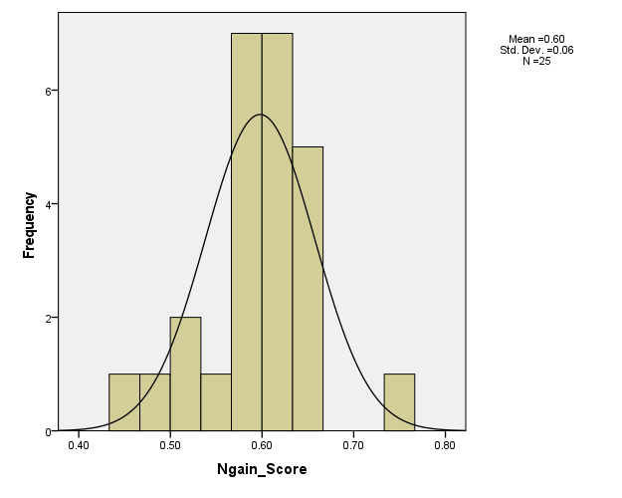
Figure 2. Histogram N-gain Score
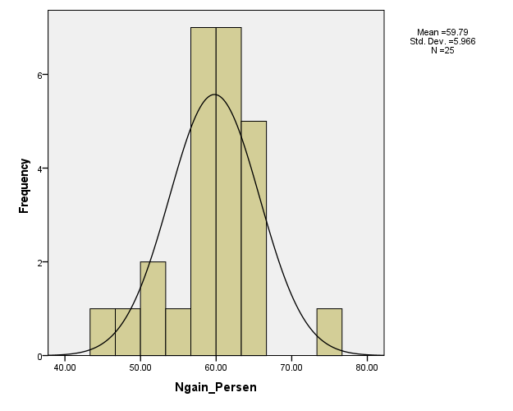
Figure 3. N-gain Score Percentage

Assistance during the online training process demonstrates skills in developing a digital library. Teachers are able to independently install, configure, and modify the appearance of the digital library. The products produced vary in terms of interface design, book categories, and borrowing systems. The creativity of the teachers is evident when they add visual elements such as the school logo and digital banners to create an appealing impression for users. Some teachers link their digital libraries to the school website and utilize QR Codes for catalog access. Teachers also plan to create tutorial videos and link them to the main page of the library so that students can more easily understand how to use the digital library.

During the process of developing the digital library, the teacher faced various obstacles such as limited internet connectivity (location), lack of hardware (using laptops with various low specifications), and challenges in configuring the digital library system. To address some of these issues, teachers sought solutions through group discussions, utilizing online forums with trainers, and conducting group practices to facilitate the development of the digital library. As a result of these challenges, collaboration among teachers emerged, where some teachers helped each other, shared template files, and evaluated each other's library products. Each teacher produces a different product according to their characteristics and favorite style. The originality of the work is evident in the menu structure, book category selections, and the design of the library's appearance. From the explanation above, it shows that the training does not produce uniform products, but instead encourages differentiation and the uniqueness of each work, so that the developed digital library products have originality and creativity, making them attractive to users (Sutrisno & Nasucha, 2022).

4. Conclusion

The Blended Product Training model has proven effective in enhancing teachers' creativity in developing digital libraries. This training requires teachers to not only be users of technology but also developers capable of designing digital library systems according to the characteristics and conditions of their schools.

Disclaimer (Artificial intelligence)

Author(s) hereby declare that NO generative AI technologies such as Large Language Models (ChatGPT, COPILOT, etc.) and text-to-image generators have been used during the writing or editing of this manuscript.

REFERENCES
Andrianto, R. E., Arianto, F., & Setyaedhi, H. S. (2024). Pengaruh Product Based Learning terhadap Kreativitas Peserta Didik pada Materi Profil Technopreneur, Peluang Usaha dan Profesi Bidang DKV. JIIP - Jurnal Ilmiah Ilmu Pendidikan, 7(2). https://doi.org/10.54371/jiip.v7i2.3293
Asitah, N., & Ismafitri, R. (2021). Product Based Learning. https://www.researchgate.net/publication/357393367
Brasoveanu, A., & Dotlačil, J. (2021). Reinforcement Learning for Production-Based Cognitive Models. Topics in Cognitive Science, 13(3). https://doi.org/10.1111/tops.12546
Estoquia, L. Q., & Vicente, L. C. (2025). Utilization of Research-based Product through Skills Training and Technology Transfer Towards Community. TWIST, 20(2), 282-285.
Hake, RR (1999). Menganalisis Skor Perubahan/ Keuntungan. Indiana: Jurusan Fisika, Universitas Indiana.
Green, A. E., Beaty, R. E., Kenett, Y. N., & Kaufman, J. C. (2024). The process definition of creativity. Creativity Research Journal, 36(3), 544-572.
Kämpf, L., & Stallmach, F. (2024). Spiral-curricular blended learning for the mathematics education in physics teacher training courses. In Frontiers in Education (Vol. 9, p. 1450607). Frontiers Media SA.
Keppenne, V., Hopman, E. W. M., & Jackson, C. N. (2021). Production-based training benefits the comprehension and production of grammatical gender in L2 German. Applied Psycholinguistics, 42(4). https://doi.org/10.1017/S014271642100014X
Müller, C., & Mildenberger, T. (2021). Facilitating flexible learning by replacing classroom time with an online learning environment: A systematic review of blended learning in higher education. In Educational Research Review (Vol. 34). https://doi.org/10.1016/j.edurev.2021.100394
Pan, A. J., Lai, C. F., & Kuo, H. C. (2023). Investigating the impact of a possibility-thinking integrated project-based learning history course on high school students’ creativity, learning motivation, and history knowledge. Thinking Skills and Creativity, 47. https://doi.org/10.1016/j.tsc.2022.101214
Rini, T., & Cholifah, P. (2020). Electronic Module With Project Based Learning (PjBL): Innovation Of Digital Learning Product On 4.0 Era. Edcomtech Jurnal Kajian Teknologi Pendidikan, 5(2). https://doi.org/10.17977/um039v5i22020p155
Sutrisno, S., & Nasucha, J. A. (2022). Islamic Religious Education Project-Based Learning Model to Improve Student Creativity. At-Tadzkir: Islamic Education Journal, 1(1). https://doi.org/10.59373/attadzkir.v1i1.3
Tella, A., Ajani, Y. A., & Ailaku, U. V. (2023). Libraries in the metaverse: the need for metaliteracy for digital librarians and digital age library users. Library Hi Tech News, 40(8). https://doi.org/10.1108/LHTN-06-2023-0094
Usmeldi, U., & Amini, R. (2022). Creative project-based learning model to increase creativity of vocational high school students. International Journal of Evaluation and Research in Education, 11(4). https://doi.org/10.11591/ijere.v11i4.21214

