Application of Iterative Learning Control in Cement Weighing Error Compensation for Concrete Mixing Stations

.
ABSTRACT

Cement powder weighing accuracy in concrete mixing stations directly impacts concrete performance and quality, with airborne residual material-induced errors being the key constraint on accuracy improvement. This paper proposes an iterative learning control-based cement weighing optimization strategy to compensate for airborne residual errors by dynamically adjusting feed closing advance. Firstly, it analyzes the dynamic characteristics of the batching weighing system, clarifying the formation mechanism of airborne residual material and its impact on weighing accuracy. Then, it designs the core optimization law of iterative learning control: through real-time error feedback and historical data learning, the strategy autonomously optimizes high-speed switching and stop advance parameters, with learning and forgetting factors selected to balance convergence and stability. Taking fixed threshold control and feedforward PID as comparison schemes, theoretical analysis is carried out from parameter adaptation, model dependence and computational complexity. MATLAB simulation results show that the strategy can converge stably with fewer iterations under multi-objective weight conditions, the error meets the industrial high-precision requirements, and the efficiency is equivalent to the traditional method. Its core innovation is to get rid of the dependence on accurate modeling, and to achieve robust adaptive control under multi-objective conditions through iterative self-learning, which provides an efficient solution for improving the batching accuracy of the mixing station, and has reference value for similar batch weighing systems.

Keywords: Weighing accuracy; Iterative learning control; Air residual material; Error compensation

1. INTRODUCTION

Concrete mixing stations are the core production equipment for modern concrete engineering. Their ingredient weighing accuracy directly impacts key concrete properties like strength and durability, determining engineering structure safety and service life while being critical to raw material cost control and production efficiency improvement [1-4]. In recent years, the performance optimization and intelligent upgrading of concrete mixing stations have become a research hotspot. Relevant research covers multiple dimensions such as environmental impact assessment, mixing process optimization and concrete workability prediction [5,6], which provides multi-scenario technical support for batching accuracy control.

In actual production, the batching weighing system encounters multiple complex disturbances [7]. At the equipment level, feeding mechanism mechanical wear and sensor dynamic response lag introduce inherent errors [8-10]; under dynamic conditions, silo pressure fluctuations and inter-equipment coordination delays continuously disturb the weighing process [11]; at the material level, cement powder fluidity and humidity changes further increase weighing uncertainty [12]. At the same time, the real-time dynamic change of measurement data, the high speed of production process switching and the diversity of working conditions make accurate measurement become the core problem of concrete mixing equipment technology upgrading. At present, a variety of intelligent control schemes have emerged in the field of industrial batching weighing, such as adaptive control based on deep reinforcement learning [13], machine learning-driven batching accuracy optimization [14] and hybrid intelligent control technology [15], which provide multiple technical ideas for solving dynamic weighing problems. In addition, the latest research progress of reinforcement learning and adaptive dynamic programming [16], as well as the innovation of automatic batching weighing process under the background of informatization [10], further consolidate the technical basis of this study. The deviation of the proportion of ingredients will not only lead to the failure of single batch production, resulting in direct economic losses, but also cause the performance of finished concrete to be substandard, which will bring potential safety risks to the engineering structure and damage the reputation of the production enterprise [17-19]. Therefore, all kinds of materials must be accurately and quantitatively mixed in strict accordance with the preset ratio. The efficient and reliable weighing system is the core support to ensure the quality of the project and control the cost of raw materials. Research on human-computer interaction technology in industrial environments shows that intelligent control strategy adaptability directly affects industrial system operation accuracy and stability, providing a reference for this study’s control scheme design [20].

As a key material of concrete, the control of weighing accuracy of cement powder is particularly important. There is inertia effect in the falling of materials. After stopping feeding, some air residual material still falls into the weighing bucket, which has become the main error source restricting the weighing accuracy of cement. In view of this core problem, this paper proposes to use an iterative self-learning algorithm to dynamically optimize and correct the feed closing advance [21]. Through real-time error feedback and historical data learning, it achieves effective compensation of airborne residual errors. MATLAB simulation verifies the algorithm’s control effect, providing theoretical and technical support for improving concrete mixing station batching accuracy.

2. Modeling and problem description of cement weighing system

2.1 Modeling and Problem Description of Cement Weighing System

The cement weighing system mainly consists of a screw conveyor, cement silo, weighing hopper, and weighing sensor. As shown in Figure 1, the silo sits above the screw conveyor, with the weighing hopper directly below the conveyor’s blanking port, forming a complete material conveying and metering chain. The weighing hopper is the core material measurement carrier, with its geometric shape directly determining the mapping relationship between material accumulation height and mass. It is a composite structure combining a conical section and a cylindrical section. The lower half of the weighing hopper is divided into a conical cylinder, with a bottom diameter of 0.5m, a top diameter of 1 m, and a height of 0.5 m, so as to realize the smooth transition of the material from a small area at the bottom to a large area at the upper part. The upper half of the weighing hopper is divided into a cylindrical cylinder, with a diameter of 1 m consistent with the top of the conical cylinder and a height of 1 m, providing a stable large-capacity accommodation space. The overall height of the weighing hopper is 1.5 m. The discharge port of the screw conveyor is directly above the weighing hopper, 2 m from the bottom plane of the hopper and 0.5 m from the top plane of the hopper, so as to ensure that the material falls vertically into the center of the hopper and avoid the influence of partial load on the weighing accuracy.

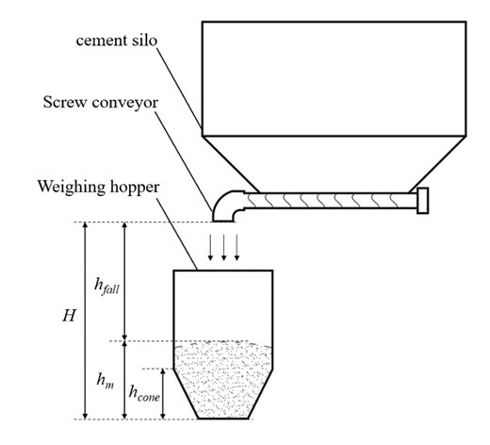

Fig. 1. Cement Weighing System Diagram

The density of cement material is ρ=1500kg/m³, and its accumulation characteristics conform to the basic law of granular materials, that is, there is a linear relationship between mass and volume. Due to the different volume calculation methods of conical cylinder and cylindrical cylinder, the relationship between material mass and height needs to be modeled in stages.

2.2 Quality-Height Mapping Model

Material stacking height in the weighing hopper increases with mass, but this relationship is nonlinear due to the structure’s segmented geometric characteristics. The following will establish the mass-height mapping model in the conical cylinder and the cylindrical cylinder respectively.

When the material is only filled with a conical cylinder, the cross-sectional radius at any height h changes linearly with height, that is, . At this time, the material volume corresponding to the height h is the cone volume:
Where r₁=0.25(m) is the radius of the bottom of the cone. Substituted into the r(h) expression and sorted out, combined with the mass , the relationship between the mass and height in the conical cylinder can be obtained:
When the material height is filled to the cylinder, the total mass consists of two parts: the full mass of the cone and the partial mass of the cylinder. When the cone is full, the volume is calculated to be about 0.1839m³, and the corresponding mass m0 ≈ 275.8kg. At this time, the height of the material in the cylindrical cylinder is , the volume is , and the corresponding mass is .

Through the above model, the accumulation height in the weighing hopper can be reversely calculated from any material mass, which provides a basis for the subsequent calculation of the blanking height.

2.3 Dynamic Change Characteristics of Blanking Height

The blanking height refers to the vertical distance from the discharge port of the screw conveyor to the surface of the material in the weighing hopper, and its value changes in real time with the accumulation of the material, which directly affects the size of the air residual material. Define the fixed height of the discharge port from the bottom of the weighing hopper is H = 2m, then the blanking height h_{fall} at any time is:
Where h_{m} is the current material accumulation height. In the initial state, h_{m}=0, h_{fall}=2m; as the material increases, h_{m} increases and h_{fall} gradually decreases. When the material reaches the top of the weighing hopper, h_{fall}=0.5m, consistent with the equipment parameters.

The dynamic change of blanking height shows nonlinear characteristics: in the cone stage, because the cross-sectional area of the cone increases with height, the increase rate of h_{m} with m gradually increases, so the decrease rate of h_{fall} gradually increases; after entering the cylindrical cylinder stage, because the cross-sectional area of the cylinder is constant, the increase rate of h_{m} with m is constant, so h_{fall} decreases at a constant rate. This dynamic characteristic leads to the time delay effect of the air residual material also changes nonlinearly with the weighing process, which increases the difficulty of control.

2.4 Time Lag Effect and Error Quantification of Air Residual Material

Air residual material refers to suspended material that has separated from the screw conveyor’s discharge port but not yet fallen into the weighing hopper. This part of the material is not detected by the weighing sensor, but it will eventually fall into the weighing bucket, resulting in overweight after stopping feeding, which is the main limiting factor of weighing accuracy. The time-lag effect of the air residual material can be quantified by the following process:

- The falling time: the falling process of the material from the discharge port to the surface is approximately free falling, which is determined by the height of the blanking h_{fall}, and the calculation formula of the falling time is:
- Calculation of the amount of remaining material: During the falling time, the screw conveyor is still transporting the material, so the amount of air residual material W_{air} is equal to the product of the feed flow and the falling time. Since the system uses high and low speed two-stage feeding (high speed Q1 = 50kg/s, low speed Q2 = 20kg/s), the amount of remaining material needs to be calculated in stages:
Among them: W_{air1} is the amount of air residual material produced in the high-speed feeding stage, and W_{air2} is the amount of air residual material produced in the low-speed feeding stage.

The time-delay effect of air residual material has two significant characteristics: one is non-linear, and the other is strongly related to the feeding speed. Traditional fixed-threshold compensation methods struggle to adapt to this dynamic characteristic, requiring a self-learning control strategy to optimize compensation in real time.

3. Iterative learning control strategy design

Aiming at the nonlinear time-delay characteristics of the air residual material in the cement weighing system and the difficulty of traditional control methods to achieve high-precision compensation, this paper designs a strategy based on iterative learning control (ILC). The strategy uses the repeatability of the weighing process to optimize the advance parameter through multiple rounds of iteration to realize the adaptive compensation of the air residual material. The core idea is that after each weighing, the control parameters are corrected according to the actual error, so that the accuracy of the subsequent weighing is gradually improved, and finally converges to the target accuracy.

3.1 Control Objectives and Overall Framework

The control objective of ILC is to make the final weighing error meet |e|<0.1kg and ensure that the weighing time does not exceed 30s by optimizing the switching advance (α₁) and the stopping advance (α₂) from high speed to low speed. The error e is defined as the difference between the total weight of the weighing hopper (including the air residual material) and the target weight after stopping feeding：
Where m_{stop} is the weight of the weighing hopper at the time of stopping feeding and W_{air -stop} is the air residual material at that time. The ILC’s overall framework (Figure 2) features closed-loop iteration and includes three core modules:
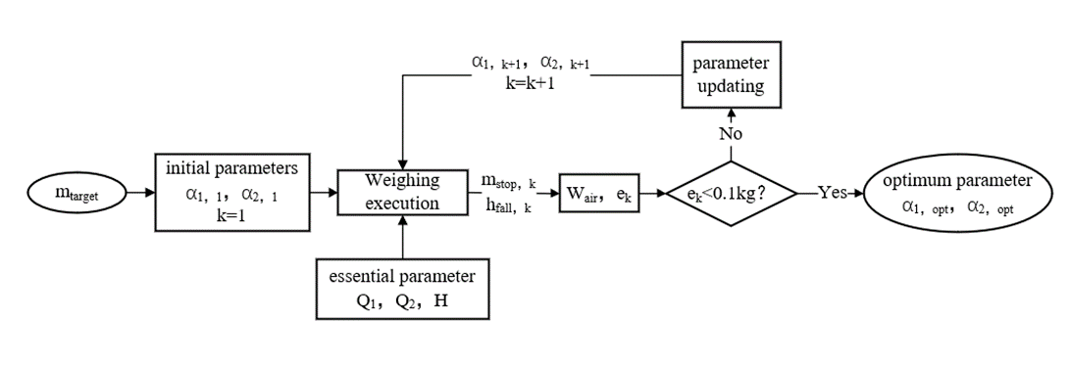

Fig. 2. ILC Control Block Diagram

The execution module performs the kth weighing experiment based on the current advance (α₁, k, α₂, k), and outputs the actual weight and error e_{k}. Learning module: according to the error e_{k} and historical parameters (α₁, k, α₂, k; α₁, k-1, α₂, k-1), and update the next advance (α₁, k+1, α₂, k+1) by the optimization law. Convergence judgment module: if |e_{k}| < 0.1kg, stop the iteration and output the optimal parameters; otherwise, repeat the iteration until the maximum number of iterations is reached.
The core of the framework is error-driven learning, that is, using the error information of each experiment to correct the control parameters, so that the parameters gradually approach the optimal value of the compensation air residual material [22]. Since the cement weighing is a repetitive operation, the iterative optimization of ILC can effectively accumulate experience and overcome the challenges caused by time-delay nonlinearity.

3.2 Iterative Optimization Law Design

The advance parameter optimization law is the core of ILC, directly determining convergence speed and stability. To address the time-delay characteristics of airborne residual material, this study designs an optimization law with a forgetting factor that balances fast convergence and anti-interference capability [23].

For the k+1th iteration of α₁ from high speed to low speed, the update formula is:
Similarly, the update formula for stopping the feeding advance α₂ is:
The physical meaning and design basis of each parameter in the formula are as follows: r₁ and r₂ are learning factors, which determine the correction strength of the error to the parameters. The larger the learning factor is, the more sensitive the response of the parameter to the error is, and the faster the convergence speed is, but too large may lead to parameter oscillation. β is a forgetting factor, and the previous parameter variation (α_{i}, k-α_{i}, k-1) is introduced to smooth the parameter update process. Its function is to suppress the interference of error fluctuation caused by high frequency noise on parameters and enhance the robustness of the system. e_{k} is the error of the kth iteration, which is the core driving information of parameter update. When e_{k} is positive, the discharge material is overweight, indicating that the amount of advance is insufficient, and it is necessary to increase α₁ or α₂ to stop feeding in advance. When e_{k} is negative, the material is not heavy, and the advance amount needs to be reduced.
The design of the optimization law takes into account the dynamic characteristics of the residual material in the air. The amount of residual material in the high-speed stage is larger, which has a more significant impact on the final error. Therefore, the learning factor r₁ of α₁ is slightly smaller than r₂ of α₂, so as to avoid excessive adjustment of α₁ caused by error fluctuation in the high-speed stage. In the low-speed stage, the amount of remaining material is small, and the convergence of α₂ needs to be accelerated by slightly larger r₂ to ensure the final accuracy.

3.3 Selection of Learning Parameters and Convergence Analysis

The values of learning factor (r₁, r₂) and forgetting factor (β) must comprehensively consider system convergence performance across multi-target weights. The selection principle is that stable convergence can be achieved in the range of 500~1000kg, and the convergence speed and accuracy meet the requirements of industrial application. Through systematic testing of multiple parameter combinations (including r₁=0.1, r₂=0.2; r₁=0.2, r₂=0.3, r₁=0.5, r₂=0.6, etc.). Finally, r₁=0.2, r₂=0.3, β=0.15 were determined as the optimal parameter combination. The rationality of this selection can be verified through the comprehensive analysis of convergence performance.

The primary advantage of this parameter combination is its balance of convergence speed and stability. In the range of 50 ~1000kg target weight, the number of convergence iterations is stable at 11~16 times (as shown in Figure 3). Compared with the combination of low learning factors, the convergence speed is significantly improved, which is more suitable for the rhythm of industrial production. At the same time, the parameter oscillation phenomenon of high learning factor combination under the influence of sensor noise is avoided, and the unity of fast convergence and stability is realized.
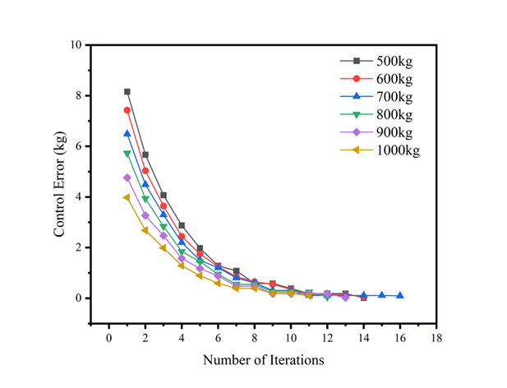

Fig. 3. Convergence Curves of ILC for Multi-Target Weights (500~1000kg)

In addition, the parameter combination has good universality for multi-target weight. Whether it is 500 kg, 700 kg or 1000 kg, the error can be gradually reduced from the initial 3 ~ 8 kg to 0.09 kg, and the convergence law is highly consistent, indicating that it can adapt to the non-linear change of air remainder with target weight, and does not need to be adjusted separately for specific weight. The setting of the forgetting factor β = 0.15 further enhances the stability, and the fluctuation range of the advance amount in a single iteration is controlled within 0.5kg, which not only ensures the response sensitivity to the error change, but also effectively suppresses the parameter mutation caused by the instantaneous measurement fluctuation, especially in the low-speed feeding stage close to the target weight.

The stable convergence of the error is essentially the result of the advance parameter α₁, α₂ approaching the optimal value through iterative optimization. Fig.4 shows the dynamic evolution process of α₁ and α₂ under the target weight of 500~1000 kg. It can be seen that, no matter how the target weight changes, α₁ and α₂ both show the law of initial rapid adjustment and slow convergence in the later stage : in the initial iteration stage (1~5 times ), the parameters are significantly adjusted due to the large gap between the initial value and the optimal value (for example, the α₁ of the 500 kg target rises rapidly from 5 kg to about 8 kg) ; with the increase of the number of iterations (6~15 times ), the adjustment range of parameters gradually decreases, and finally stabilizes in the optimal range (α₁≈8~12 kg, α₂≈ ~6 kg ). There is a significant correlation between the optimal parameters of different target weights, which is consistent with the law that the amount of air residual material with the increase of target weight.
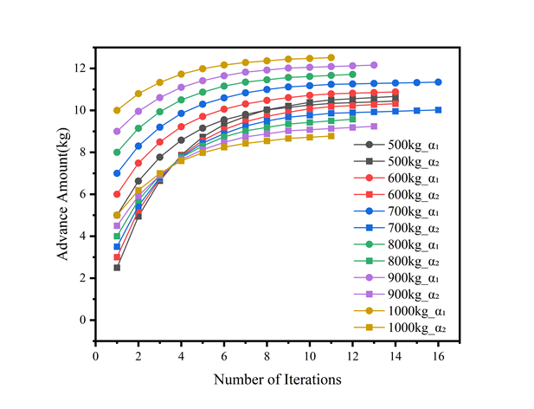

Fig. 4. Advance Evolution Diagram under Different Target Weights

The convergence characteristics of the advance further verify the rationality of the ILC optimization law: the values of the learning factors r₁ = 0.2 and r₂ = 0.3 not only ensure the response sensitivity of the parameters to the error, but also suppress the parameter jitter through the forgetting factor β = 0.15, so that the parameters under different targets can converge to the optimal value stably, which provides a core guarantee for high-precision weighing under multi-target weight.

4. Design of comparative control strategy

In order to verify the superiority of iterative learning control (ILC) in cement weighing system, this chapter designs two comparative control strategies-feedforward PID control and fixed threshold control, and expounds its control principle, mathematical model and implementation logic from the theoretical level. The three strategies all take the target weight of 500 ~ 1000kg as the control object. The core goal is to minimize the weighing error (≤ 0.1kg) and ensure the weighing efficiency (single time ≤ 30s), but the control mechanism adopted is essentially different, which provides a clear theoretical basis for subsequent simulation comparison.

4.1 Fixed Threshold Control Strategy

Fixed threshold control is the most commonly used traditional method in industrial weighing system. Its core idea is to avoid overweight caused by air residual material by preset fixed advance quantity. The method is simple in structure, does not require parameter adaptation, and is suitable for scenarios with stable working conditions.

The weighing process of fixed threshold control is divided into two stages : in the early stage of weighing, when the weight of the material in the weighing hopper has not reached the preset high-speed switching condition, the system adopts high-speed flow feeding to quickly approach the target weight and ensure the weighing efficiency ; when the weight reaches the high-speed switching condition, the system automatically switches to the low-speed flow to continue feeding until the weight reaches the preset stop feeding condition. This process compensates for the air residue by setting a fixed threshold. Among them, the setting of the fixed threshold α_{fixed} is the core, which needs to be determined based on the statistical average value of the air residue. According to the geometric parameters of the system and the blanking characteristics, the estimation formula of the air residual W_{air} is:
In the formula, h_{fall} is the blanking height when stopping feeding, which depends on the height of the material in the weighing hopper, and g is the acceleration of gravity. According to the statistics of many experiments, when the target weight is in the range of 500~1000kg, the average value of the remaining material in the air is about 9.8kg, so the fixed threshold α_{fixed}=9.8kg is set.

Fixed-threshold control offers simple implementation and low computational load but has significant limitations: it cannot adapt to dynamic changes in air residual material. When the actual remaining material deviates greatly from the threshold, it is prone to overweight or underweight. The threshold needs to be preset manually. For multi-target weight scenarios, a single threshold is difficult to take into account all working conditions.

4.2 Feedforward PID Control Strategy

Feedforward PID control combines the advantages of model feedforward compensation and feedback regulation. It compensates the predictable air residual material through the feedforward link, and then corrects the model error through PID feedback, which is suitable for the system with modeling interference [24]. The control structure of feedforward PID includes three core parts:

- Air residual material feed-forward compensation: the current air residual material W_{air} is calculated based on the real-time blanking height, and the stop condition is corrected by dynamic gain to compensate the predictable error in advance.

- PID feedback adjustment: for the residual error after feedforward compensation, the advance quantity is adjusted in real time by proportional-integral-differential (PID) control to suppress unpredictable interference;

- high-speed/low-speed switching logic: similar to the fixed threshold method, but the switching threshold is dynamically adjusted by the PID output, rather than a fixed value. Its core control law is
In the formula, u(k) is the PID output (i.e., the advance correction value of dynamic adjustment), and e_{comp}(k) is the residual error after compensation, which is defined as
Among them, m(k) is the weight of the current weighing bucket, and ff_{gain} is the feedforward gain, which is used to balance the compensation sensitivity and stability.
The selection of PID parameters is based on the principle of both response speed and overshoot: the proportional coefficient K_{p}=12.0 is used to enhance the sensitivity of the system to the error to speed up the response, the integral coefficient K_{i}=0.8 ensures long-term accuracy by eliminating the steady-state error, and the differential coefficient K_{d}=1.2 improves stability by suppressing overshoot. In order to avoid the output saturation caused by long-term deviation in the integral link, the system introduces an anti-integral saturation mechanism: when the PID output u(k) exceeds the range of [1kg,25kg] (|u(k)|>anti-integral saturation threshold=15.0), the accumulation of the integral term is suspended, otherwise it accumulates normally. This mechanism can ensure that the control output is always within the physically feasible range [25].

4.3 Theoretical Comparison of Three Control Strategies

ILC, feedforward PID, and fixed-threshold control differ significantly in design logic and performance characteristics. The theoretical structure comparison shown in Fig. 5 provides a reference for intuitive understanding. These differences can be objectively distinguished from multiple dimensions.
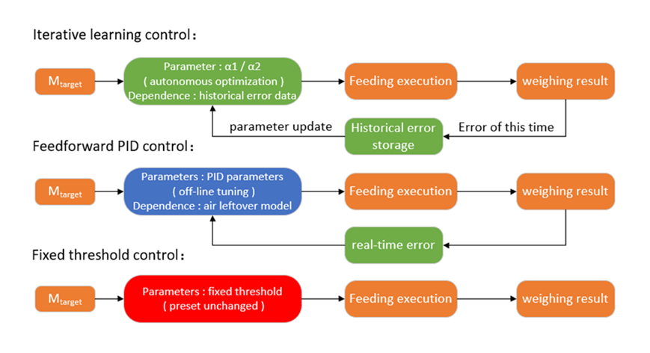

Fig. 5. The Theoretical Structure Comparison of Three Control Strategies

In terms of parameter adaptive ability, the three show obvious differences. The core parameters of the fixed threshold control (switching and stopping thresholds) are artificially preset fixed values, and there is no adjustment mechanism in the whole process, which cannot respond to the error changes or working condition fluctuations in the weighing process. Feedforward PID control realizes limited self-adaptation through PID feedback link, and can fine-tune the advance based on real-time error. However, the core parameters of PID need to be set off-line, and the correction range is limited by parameter design. The parameters of ILC are autonomously optimized by iterative learning, without manual intervention, and can adapt to the dynamic changes under multi-objective weight only by relying on historical errors. Dependence on the model is another key difference. The performance of feedforward PID control directly depends on the accuracy of the air residual model, and the deviation between the model and the actual will directly lead to the control error. Although the fixed threshold control does not rely on the accurate model, it is essentially an empirical solidification of the statistical mean of the air remainder, and it is difficult to cope with the dynamic fluctuation of the remainder; ILC does not rely on the model, and only uses the repeatability of the weighing process to correct the parameters through multiple iterations to offset the residual error. The difference between computational complexity and real-time determines the adaptation scenario of engineering implementation. The fixed threshold control logic is the simplest, and the real-time performance is the best by comparing the weight with the threshold. The feed-forward PID control needs to calculate the residual material model and PID output in real time, and the calculation amount is medium; the calculation amount of single weighing of ILC is equivalent to that of feedforward PID, but it needs to store historical error and parameter data, and the overall complexity is slightly higher, which is more suitable for batch repeated operation scenarios. These core differences define the applicable scenarios for the three strategies, with their specific performance to be further demonstrated via quantitative data in subsequent simulation experiments.

5. Simulation Experiment Results and Analysis

To verify performance differences between ILC, feedforward PID, and fixed-threshold control in cement weighing systems, this chapter conducts simulations for the 500~1000kg target weight range commonly used in practical operations. The final control error and weighing time are compared and analyzed. The experiment was carried out under the same feeding flow, blanking height and switching fluctuation to ensure the objectivity and comparability of the results. Through quantitative data and visual charts, the accuracy, stability and efficiency characteristics of the three strategies in multi-objective weight scenarios are revealed, and the root causes of performance differences are explained in combination with the control mechanism.

5.1 Experimental Setting and Evaluation Index

The experiment is based on the industrial demand of the cement weighing system, and the core parameters are set as follows: the target weight range is 500~1000kg, the high-speed feed flow Q1=50kg/s, the low-speed feed flow Q2=20kg/s, the maximum allowable weighing time is 30s, and the accuracy requirement is the absolute value of the final error ≤ 0.1kg. This standard is an industrial-grade high-precision standard. Two key evaluation indicators are selected: Final control error: the difference between the total weighing hopper weight (including landed air residual material) and the target weight after feed stop, defined as. . The error is positive to indicate overweight, negative to indicate underweight, and its absolute value directly reflects the control accuracy; weighing time: The total time from the beginning of feeding to the end of feeding reflects the weighing efficiency of the system, which needs to be controlled within 30s to meet the rhythm of industrial production. The experimental conditions of the three control strategies are exactly the same, only the control logic is different.

5.2 Comparative Analysis of Final Control Error

The final control error is the core index to measure the weighing accuracy. The error performance of the three strategies under the target weight of 500~1000kg is shown in Figure 6.
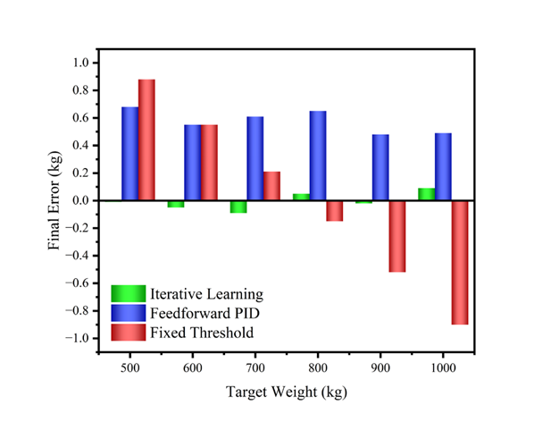

Fig. 6. Final Control Error Comparison

The absolute value of the final error of the ILC strategy is less than 0.1kg, which fully meets the requirements of high precision. The error distribution shows two characteristics: first, the fluctuation range is-0.09 ~ 0.09kg, the overall fluctuation is very small, and the stability is excellent; second, the positive and negative errors appear alternately but the absolute values are close, and there is no systematic deviation, indicating that the iterative optimization law of ILC can effectively balance the overweight and underweight trends. Feedforward PID errors are significantly larger than ILC’s, all positive (overweight), ranging from 0.48 to 0.68 kg. While smaller than fixed-threshold control errors, they fail to meet the 0.1kg high-precision requirement. This phenomenon stems from the approximation of the feedforward model: the calculation of the air residual is based on the ideal free-fall formula, and the actual blanking process is affected by the friction between the materials and the speed fluctuation, resulting in a positive residual error in the feedforward compensation, and the adjustment ability of the PID feedback is limited. The error performance of the fixed threshold strategy is the worst, and it shows a significant negative trend with the increase of the target weight. The error range is − 0.90~0.88kg, which completely exceeds the high precision requirement. The root cause is that the fixed threshold cannot adapt to the dynamic change of the remaining material in the air with the target weight: the actual remaining material of the small target is less than the threshold, resulting in overweight; the actual surplus of the large target is greater than the threshold, resulting in underweight, and the larger the target weight, the more significant the deviation.

In summary, the ILC has significant advantages in accuracy and stability, the feedforward PID is second but the accuracy is insufficient, and the fixed threshold strategy is only suitable for scenes with slightly lower accuracy requirements.

5.3 Comparative Analysis of Weighing Time

The weighing time directly affects the industrial production efficiency. The time performance of the three strategies (Figure 7) shows a linear growth trend with increasing target weight, remaining far below the 30s-time limit. The efficiency meets the industrial demand, but the specific values are different.
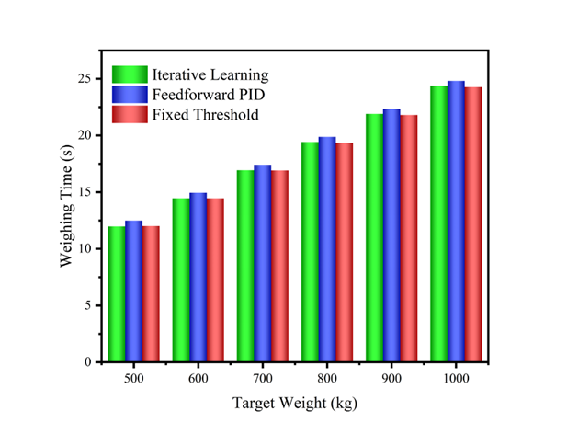

Fig. 7. Weighing Time Comparison

The difference in weighing time among the three strategies stems from the different nature of control logic. The time of ILC is derived from the continuous optimization of the advance quantity in the iterative process, and gradually converges to a stable value through parameter fine-tuning. The time difference of feedforward PID regulation is derived from its dynamic regulation mechanism: in order to avoid overshoot, PID will reduce the switching sensitivity of feeding speed when approaching the target, resulting in an increase in the time of low-speed feeding stage; the fixed threshold strategy adopts rigid switching logic without complex calculation, and the high-speed feeding stage accounts for a higher proportion, so the time is the shortest. These differences are determined by the characteristics of the control mechanism and are generally within the industrial acceptable range.

The time comparison of the three strategies shows that ILC does not significantly sacrifice efficiency while ensuring high precision; the feedforward PID efficiency is close to the ILC but the accuracy is insufficient; the fixed threshold is fast but the accuracy cannot be guaranteed. In the production of concrete industry, precision priority is the core requirement of cement weighing, so the time performance of ILC is completely acceptable.

5.4 Mechanism Analysis of Performance Difference

The three strategies’ performance differences stem from inherent differences in their control mechanisms, which can be explained in detail with experimental data:

The high accuracy and stability of ILC are due to the iterative self-learning mechanism. Through error feedback, the advance quantities α₁, α₂, ILC are continuously optimized, and the ILC does not need to rely on the accurate air residual material model, but independently adapts to the dynamic change of the surplus material through the ' trial and error-correction ' process. The error of feedforward PID is due to the limitation of model dependence and feedback regulation. The feedforward compensation is based on the ideal blanking model, but the actual residual material is affected by the fluctuation of material density and blanking speed, and the model error is inevitable. The adjustment ability of PID feedback is limited by PID parameter tuning, and the residual error cannot be completely eliminated, resulting in the final error stabilized at about 0.5kg. The failure of the fixed threshold strategy lies in the mismatch between static compensation and dynamic surplus. The air residual material increases with the increase of target weight, but the fixed threshold cannot be dynamically adjusted, which leads to the systematic deviation of small target overweight and large target underweight, and the deviation accumulates with the increase of target weight.

In this chapter, the superiority of ILC in multi-objective cement weighing system is fully verified by experimental data and mechanism analysis. Its core advantage is that the iterative optimization mechanism adaptively compensates the dynamic characteristics of the air remainder, which not only ensures high precision, but also maintains high weighing efficiency.

6. conclusion and foresight

This paper designs an iterative learning control strategy for the multi-target weight control requirements of cement weighing systems, comparing it theoretically and via simulation with traditional fixed-threshold and feedforward PID control. The main conclusions are as follows:
- The effectiveness of the ILC strategy is verified: By designing an error history-based iterative optimization law, the ILC autonomously optimizes the high-speed switching advance (α1) and feed stop advance (α2). In the target weight range of 500~1000 kg, the system can converge in 11~16 iterations, and the final weighing error is stable within 0.09 kg, which meets the requirements of industrial high precision. Its core advantage is that it does not need to rely on accurate air residual material model, only through process repeatability can offset dynamic interference, and has good adaptive ability to multi-target weight.

- The characteristics of the three control strategies are significantly different: While fixed-threshold control has the shortest weighing time, its fixed parameters result in errors of up to −0.90kg, leading to insufficient accuracy and limiting its use to simple working conditions. The feedforward PID control makes the error reach 0.3~ 0.5kg through the model feedforward and feedback adjustment, and achieves medium precision, but the performance depends on the accuracy of the air residual material model, and the PID parameters need to be adjusted off-line, and the robustness is limited. The ILC ensures the high precision of the error ≤ 0.1kg, and the weighing time meets the operation requirements, taking into account the efficiency and adaptability, which is more suitable for multi-objective and time-varying conditions.

While this paper verifies ILC’s advantages in cement weighing systems through theory and simulation, room for further expansion and improvement remains. Subsequent research will build an experimental platform for physical verification, focus on testing the performance of ILC in real industrial environment, optimize hardware interface and real-time performance, and promote the algorithm from simulation to practical application.
In summary, ILC provides an efficient and feasible solution for the multi-objective control of cement weighing system. With further theoretical refinement and engineering verification, the strategy is expected to be promoted and applied in similar batch weighing scenarios.

DISCLAIMER (ARTIFICIAL INTELLIGENCE)

Author(s) hereby declare that NO generative AI technologies such as Large Language Models (ChatGPT, COPILOT, etc) and text-to-image generators have been used during writing or editing of manuscripts.

Competing interests

Author has declared that no competing interests exist.

References

[1] Wu, C., Lu, Y., Wang, G., Wang, Y., An, H., & Zhu, X. (2025). Research and design of weighing system of concrete mixing plant. Proceedings of the 2025 International Conference on Artificial Intelligence and Smart Manufacturing, 255-260.
[2] Wu, C., Sun, Q., Tao, L., & Zhao, Y. (2022). Present situation, problems, and prospect of weighing control system in concrete mixing plant. 5th International Conference on Computer Information Science and Application Technology (CISAT 2022), SPIE, 231-235.
[3] Wang, C., Luo, W., & Xu, B. (2020). The control system design of concrete mixing station based on PLC. 2020 IEEE International Conference on Information Technology, Big Data and Artificial Intelligence (ICIBA), IEEE, 1498-1501.
[4] Lin, S. S., Shen, S. L., Zhang, N., & Zhou, A. (2021). Comprehensive environmental impact evaluation for concrete mixing station (CMS) based on improved TOPSIS method. Sustainable Cities and Society, 69, 102838.
[5] Rahman, M. L., Malakooti, A., Ceylan, H., Kim, S., & Taylor, P. C. (2023). Identifying the best mixing procedure practice for ready-mix concrete plant production of carbon fibre reinforced electrically conductive concrete. International Journal of Pavement Engineering, 24(1), 2225119.
[6] Yang, L., An, X., & Du, S. (2021). Estimating workability of concrete with different strength grades based on deep learning. Measurement, 186, 110073.
[7] Amran, M., Huang, S.-S., Onaizi, A. M., Makul, N., Abdelgader, H. S., & Ozbakkaloglu, T. (2022). Recent trends in ultra-high performance concrete (UHPC): Current status, challenges, and future prospects. Construction and Building Materials, 352.
[8] Ekpu, M., & Ayomide, I. (2023). Design, construction and testing of a weighing equipment for powdered food products. Arid Zone Journal of Engineering, Technology and Environment, 19, 381-390.
[9] Ghosh, A., & Abawajy, J. (2025). Optimising concreting equipment operations in India: An artificial intelligence and reliability-based approach. Expert Systems with Applications, 271.
[10] Zhong, W., Qi, M., & Tang, Y. (2021, October). Study on the Process and Method of Automatic Material Batching and Weighing in the Background of Informatization. In 2021 3rd International Conference on Artificial Intelligence and Advanced Manufacture (pp. 1166-1169).
[11] Zhang, X., Akber, M. Z., Poon, C., & Zheng, W. (2023). Predicting the 28-day compressive strength by mix proportions: Insights from a large number of observations of industrially produced concrete. Construction and Building Materials, 400, 132754.
[12] Shahrokhishahraki, M., Malekpour, M., Mirvalad, S., & Faraone, G. (2024). Machine learning predictions for optimal cement content in sustainable concrete constructions. Journal of Building Engineering, 82, 108160.
[13] Zhang, Y., Li, Z., & Wang, H. (2024). Adaptive Control Strategies for Industrial Batch Weighing Systems Using Deep Reinforcement Learning. IEEE Transactions on Industrial Informatics, 20(3), 4512–4523.
[14] Chen, L., & Zhou, Q. (2023). Data-Driven Optimization of Concrete Mixing and Batching Accuracy Using Machine Learning. Automation in Construction, 155, 105030.
[15] Sun, J., & Li, K. (2022). Hybrid Intelligent Control for Dynamic Weighing Systems in Process Industries. Journal of Process Control, 116, 50–61.
[16] D. Wang., N. Gao., D. Liu., J. Li., & F.L. Lewis. (2023). Recent progress in reinforcement learning and adaptive dynamic programming for advanced control applications, IEEE/CAA Journal of Automatica Sinica, 18-36.
[17] Nguyen, T.-T., Thai, H.-T., & Ngo, T. (2021). Optimised mix design and elastic modulus prediction of ultra-high strength concrete. Construction and Building Materials, 302, 124150.
[18] Olugboyega, O., Ejohwomu, O., Omopariola, E. D., & Omoregie, A. (2023). Sustainable ready-mixed concrete (RMC) production: a case study of five RMC plants in Nigeria. Sustainability, 15, 8169.
[19] Kadokawa, Y., Hamaya, M., & Tanaka, K. (2023). Learning robotic powder weighing from simulation for laboratory automation. *2023 IEEE/RSJ International Conference on Intelligent Robots and Systems (IROS), IEEE*, 2932-2939.
[20] D. Rodriguez-Guerra., G. Sorrosal., I. Cabanes., & C. Calleja. (2021). Human-Robot Interaction Review: Challenges and Solutions for Modern Industrial Environments, IEEE Access, 108557-108578.
[21] Lee, Y.-H., Rai, S., & Tsao, T.-C. (2022). Data-driven iterative learning control of nonlinear systems by adaptive model matching. IEEE/ASME Transactions on Mechatronics, 27, 5626-5636.
[22] Saab, S. S., Shen, D., Orabi, M., Kors, D., & Jaafar, R. H. (2022). Iterative learning control: Practical implementation and automation. IEEE Transactions on Industrial Electronics, 69, 1858-1866.
[23] Armstrong, A. A., Johnson, A. J. W., & Alleyne, A. G. (2021). An improved approach to iterative learning control for uncertain systems. IEEE Transactions on Control Systems Technology, 29, 546-555.
[24] Guzmán, J. L., & Hägglund, T. (2024). Tuning rules for feedforward control from measurable disturbances combined with PID control: a review. International Journal of Control, 97, 2-15.
[25] Jiang, Z., Lu, Y., Xie, X., Shi, L., Chen, C., & Zhang, J. (2024). Design of an actuator controller based on frequency feedforward parameter compensation. IEEE Access, 12, 110028-110034.

