Minireview Article

The Speed vs Quality Spectrum in MAPF: A Unified Review of Suboptimal and Bounded-Suboptimal Pathfinding Solvers

ABSTRACT

The Multi-Agent Pathfinding (MAPF) problem, a core challenge in robotics and logistics, seeks collision-free paths for multiple agents while minimizing aggregated cost. Given the NP-hard nature of MAPF, optimal solvers often fail to scale to large or highly dense environments. This review focuses exclusively on the efficient alternatives: bounded-suboptimal and suboptimal algorithms. We trace the origin of these approaches to the computational intractability of the joint state space. We classify algorithms by their solution quality guarantees, detailing bounded methods like Enhanced CBS (ECBS) and Anytime Repairing A∗ (ARA∗), which offer guaranteed performance bounds. We also review purely suboptimal and heuristic methods, such as Priority-Based Search (PBS) and Optimal Reciprocal Collision Avoidance (ORCA), which prioritize speed and scalability over global guarantees. This analysis provides a structured overview of the current state-of-the-art in scalable MAPF solving.

Keywords: Multi-Agent PathFinding, Bounded-Suboptimal, Suboptimal, Heuristics, Conflict-Based Search.

- INTRODUCTION

  - The Necessity of Suboptimal Solvers
Multi-Agent Pathfinding (MAPF) is a fundamental problem in robotics, logistics, and traffic systems, requiring multiple autonomous agents to navigate a shared space to reach their distinct goals without colliding. The necessity of efficient MAPF solutions has grown in tandem with the rise of automated warehouses, air traffic control, and swarm robotics.
  - Formal Problem Definition and Objectives
The core of the MAPF problem is formally defined by a graph $G = (V,E)$ and a set of $k$ agents $A = \{a_{1},...,a_{k}\}$, where each agent ai must find a path from a start location $s_{i}∈ V$ to a goal location $g_{i}∈ V$ [1]. The paths must satisfy two critical collision constraints:
- Vertex Conflicts: Two agents cannot occupy the same vertex at the same time step.
- Edge Conflicts: Two agents cannot swap positions by traversing the same edge in opposite directions simultaneously.
The quality of a solution is typically evaluated using one of two primary optimization objectives:
- Sum-of-Costs ($SOC$): Minimizing the total sum of travel times for all agents. This is the most common metric and the one used by foundational optimal algorithms like Conflict-Based Search (CBS) [10].
- Makespan: Minimizing the time at which the last agent reaches its goal. This objective is crucial for systems that require synchronized task completion or efficient throughput.
  - Computational Complexity and the Spectrum of Solvers
The challenge in achieving optimal solutions, particularly for $SOC$, stems from the immense search space. Since MAPF is proven to be NP-hard [17], optimal solvers, such as those based on the exhaustive joint-state search of A* [5], suffer from an exponentially growing search space, ${|V |}^{k}$, which makes them computationally prohibitive for large instances.
The predominant strategy for mitigating this complexity in optimal and bounded-suboptimal approaches is through a centralized, hierarchical two-level search architecture. This architecture is explicitly designed to decouple the centralized search for conflict resolution from the distributed search for collision-free paths. The top level manages the overall multi-agent solution, typically by resolving conflicts in a search structure (like a Constraint Tree), while the low-level handles single-agent pathfinding. This hierarchy, exemplified by Conflict-Based Search (CBS), forms the backbone for many scalable solvers (see Figure 1).
The low-level search in many MAPF algorithms relies on A*, which estimates the total cost $f (n)$ using the path cost from the start $g(n)$ and the heuristic cost to the goal h(n) [3]:
$$f (n) = g(n) + h(n)$$
Consequently, MAPF algorithms are functionally classified into three main categories based on the solution guarantee they provide:
- Optimal Solvers: Guarantee the minimum cost solution (e.g., CBS [8, 10, 11, 13, 16]). These provide a quality benchmark but are limited in scalability.
- Bounded-Suboptimal Solvers: Guarantee a solution quality ${Cost}_{solution} ≤ w ∙{Cost}_{optimal}$, where $w$ is a constant. These trade a quality bound for significantly faster run-time.
- Suboptimal/Heuristic Solvers: Provide no formal guarantee on solution quality or completeness, but offer the fastest run-times for the largest problem instances, prioritizing quick feasibility over global cost.
This review focuses on the latter two categories, which are essential for practical, real-time applications in complex, high-density environments. We analyze how these algorithms strategically compromise global optimality to achieve superior computational scalability and speed.

- Bounded-Suboptimal Algorithms
Bounded-suboptimal algorithms represent a crucial middle ground. These algorithms are designed to return a solution whose cost is guaranteed to be within a known, user-defined factor $(w)$ of the optimal cost $(OPT)$.
The solution quality constraint is formally defined by the inequality:
${Cost}_{solution} ≤ w ∙{Cost}_{optimal}$ (1)
where $w ≥ 1$ is the user-specified suboptimality bound.
  - Enhanced Conflict-Based Search (ECBS)
Enhanced CBS (ECBS) [2] is one of the most prominent bounded-suboptimal search methods. It adapts the two-level structure of CBS to allow for faster search at the high level by relaxing the cost-optimality constraint.
The traditional Conflict-Based Search (CBS) framework operates with two searches:
- High-Level (CT Search): An A* search over a Constraint Tree (CT), where nodes represent sets of constraints and paths. The cost of a CT node is the $SOC$ of the current solution set.
- Low-Level (Path Search): A constrained A* search for each agent to find the minimum-cost path that satisfies all assigned constraints.
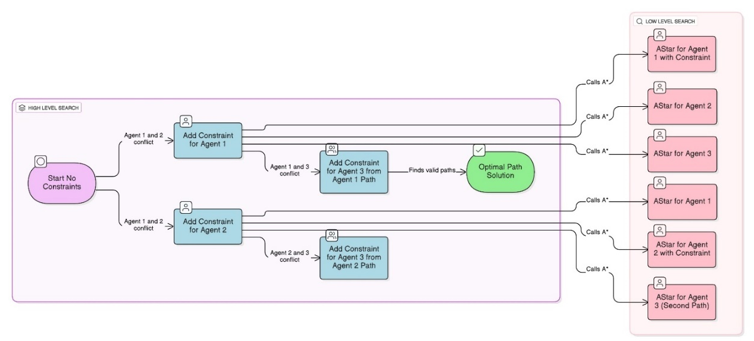
Fig 1. The Two-Level Hierarchical Architecture of Conflict-Based Search (CBS). The High-Level Search manages the Constraint Tree (CT), using a best-first search strategy (e.g., A* or Focal Search) to process nodes. Upon finding conflicts, the high-level splits the node and passes new constraints to the Low-Level Search. The Low-Level uses individual A* planners for path generation and replanning based on the constraints received.
ECBS maintains this structure but uses a technique called Focal Search at the high level. This limits the high-level node expansion to a focal list of promising nodes, which are those whose cost is within the bound w of the best node found so far.
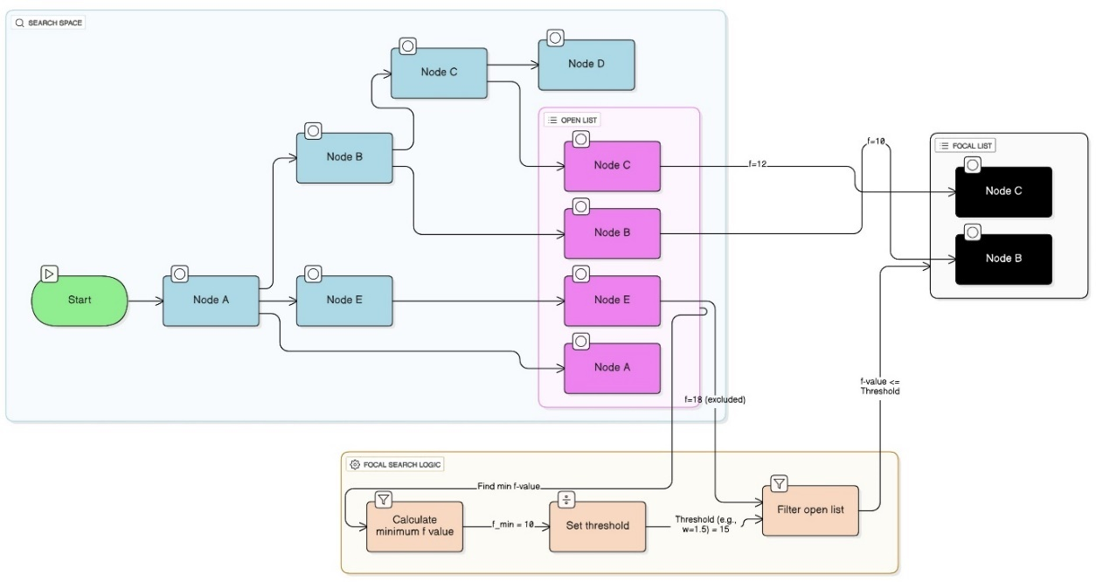
Fig 2. Conceptual Mechanism of Focal Search (used in ECBS). The search space (Focal List) is restricted to nodes whose cost $f (n)$ is within a factor w of the best current cost $f_{min}$. This bounding dramatically reduces the number of nodes expanded at the high level.
The core of ECBS’s suboptimality guarantee lies in modifying the low-level A* search using an inflated heuristic $h'(n)$:
$f_{w} (n) = g(n) + w · h(n)$ (2)
This weighted A* search finds a path whose cost $C_{i}$is guaranteed to be w-suboptimal for the single agent $a_{i}$ given its constraints. The high-level search then ensures the final solution remains within the overall bounded factor $w$.
This is the state-of-the-art advancement of the Conflict-Based Search family, proposing adaptive strategies like Conflict-Based Flex Distribution to enhance solution quality and speed [18].
  - Anytime Repairing A* (ARA*)
Anytime algorithms, such as ARA* [14], are designed to initially find a suboptimal solution quickly and then progressively refine that solution toward optimality as more time is allowed.
The ARA* algorithm begins with a high inflation factor $ϵ > 1$ (similar to $w$):
$fϵ(n) = g(n) + ϵ · h(n)$ (3)
It guarantees a solution whose cost is at most $ϵ$ times the optimal cost. In subsequent iterations, ARA* systematically reduces the $ϵ$ factor and reuses information from previous searches (recorded in $OPEN$ and $CLOSED$ lists) to efficiently find a better solution with a tighter bound. The process stops when $ϵ$ reaches $1$ (optimal) or when the time limit expires.
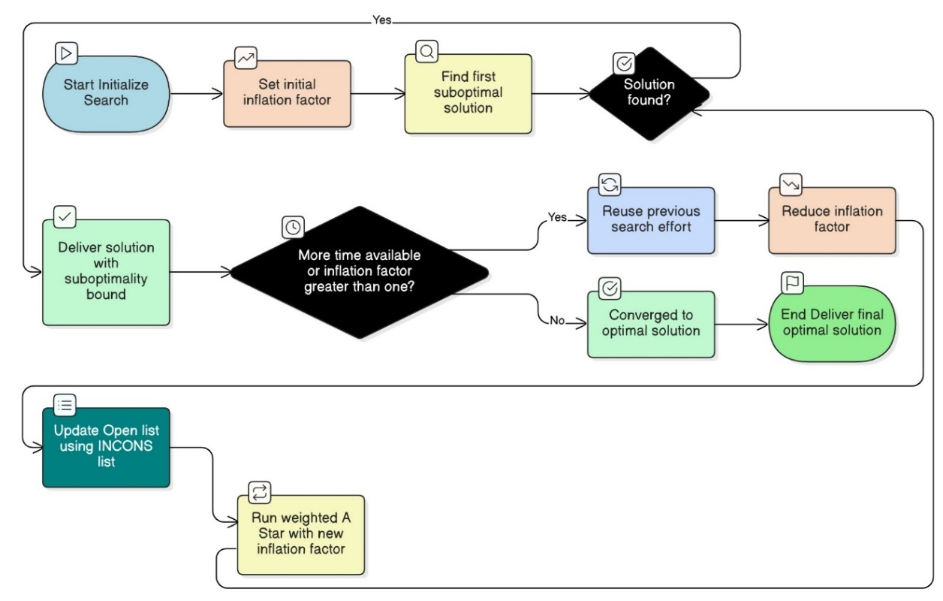
Fig 3. Conceptual process flow for Anytime Repairing A* (ARA*). The search starts with a high inflation factor $ϵ_{1}$ (yielding a fast, $w_{1}$-suboptimal solution) and iteratively reduces the factor ($ϵ_{2},ϵ_{3},...$) in subsequent search phases. This strategy provides a continuous time-for-quality trade-off, converging toward the optimal solution as $ϵ → 1$.
  - Parallel MAPF Solvers:
This work addresses the need for faster wall-clock time by introducing a parallel framework for the LNS algorithm [19], which is crucial for real-time applications like warehouse logistics [20].

Table 1. Overview of Bounded-Suboptimal MAPF Algorithms
Algorithm | Base Approach | Suboptimal Mechanism | Complexity Focus
Enhanced CBS (ECBS) [2] | Conflict-Based Search (CBS) [10] | Uses focal search (Figure 2) at the high level, restricting node expansion to costs within factor $w$ of the current best path. Low-level $A^{*}$ uses an inflated heuristic: $f = g + w · h.$ | Reduced high-level search time.
Explicit Estimation CBS (EECBS) [6] | Conflict-Based Search (CBS) | Incorporates an explicit conflict heuristic $(h_{conflict})$ into the highl Pevel evaluation function: $f(n) =\sum_{i=1}^{k}{{cost}_{(a_{i})}+ h_{conflict}(n)}$. | Improved search guidance.
Anytime Weighed $A^{*}$ (${AWA}^{*}$) [14] | Anytime Heuristic Search | Inflates the $A^{*}$ heuristic with a fixed weight $w$: $f_{w}(n) = g(n) + w · h(n)$. Finds a $w$-suboptimal solution quickly and continues to refine it. (The guaranteed bound is noted in the next column). | Fast initial solution with guaranteed bound.
Anytime Repairing $A^{*}$ (${ARA}^{*}$) [14] | Anytime Heuristic Search | Starts with a high inflation factor $ϵ > 1$, then incrementally reduces it$/ϵ$, reusing prior search data to refine the path toward optimality. | Time-for-quality trade

- Suboptimal and Incomplete Algorithms

Suboptimal (or incomplete) algorithms prioritize maximum speed and scalability. These methods often discard guarantees on global solution quality or completeness in favor of fast, decoupled, or localized decision-making, which allows them to handle extremely large problem instances.

  - Key Suboptimal Methods
Table 2. Overview of Suboptimal and Heuristic MAPF Algorithms
Algorithm | Core Principle | Advantages (Speed/Scalability) | Trade-offs (Solution Quality)
Priority-Based Search (PBS) [12] | Decoupled Search: Agents are assigned a fixed priority. Paths are planned sequentially, treating higher-priority paths as constraints. | High scalability with near-linear complexity in low-conflict settings. | Quality depends heavily on priority order; susceptible to deadlocks and high path costs.
Windowed Hierarchical Cooperative $A^{*}$ (WHCA∗) [12] | Local Coordination: Uses a fixed planning window in space or time. Agents only coordinate and plan their paths within this short horizon using a reservation table. | Dramatically reduced computational effort by constraining the planning horizon. | Sacrifices global coordination, leading to high suboptimality or local minima.
Push and Swap [7,4] | Local Manipulation: Simple, rule-based conflict resolution (pushing or swapping positions) to move agents towards goals. | Completeness guaranteed in feasible graphs [9]; polynomial time complexity. | Generates highly suboptimal paths due to the complete lack of cost-aware global coordination.
Optimal Reciprocal Collision Avoidance (ORCA) [15] | Decentralized Velocity based: Each agent independently computes collision-free velocities based on reciprocal avoidance cones with neighbors. | Extremely efficient for dynamic environments; constant time complexity per agent per frame $(O(1))$. | A purely reactive method prone to deadlocks and poor path quality in high-density or cluttered settings.

- Discussion and Future Directions

The complexity of MAPF as an NP-hard problem [17] necessitates the use of non-optimal solvers for practical, large-scale applications. The field is defined by the necessary trade-off between solution quality and computational feasibility.

Bounded-suboptimal algorithms (ECBS [2], EECBS [6]) provide a critical foundation by offering predictable performance guarantees $({Cost}_{solution} ≤ w · OPT)$ while achieving substantial speed-ups over optimal methods. However, even these advanced methods, which are rooted in the centralized hierarchical architecture of CBS, still struggle with scalability in extremely high-density and highly-cluttered environments due to the reliance on reactive, exhaustive conflict branching in the high-level Constraint Tree (CT). The exponential growth of the CT remains the primary computational bottleneck.

- Extensions and MAPF Variants

The review currently focuses on discrete-space grid maps. This paper is highly relevant for robotics, introducing the first optimal and bounded-suboptimal algorithms for Any-Angle (continuous-space) MAPF [21].

A key to achieving better, more scalable solvers for bounded-suboptimal MAPF problems lies in reducing this reliance on exhaustive reactive search. This requires developing frameworks that introduce proactive planning elements. By investigating novel approaches such as dynamic decomposition of long-term objectives into incremental sub-goals and implementing adaptive constraint management tailored to immediate local needs, we can potentially prevent the rapid proliferation of the Constraint Tree. Doing so would enable localized path refinement and progressively guide the multi-agent system toward bounded-suboptimal solutions with significantly improved runtime performance, opening the door for the next generation of scalable classical AI-based MAPF solvers.

- CONCLUSION

This review demonstrates that suboptimal MAPF algorithms serve essential roles rather than acting as inferior substitutes for optimal methods, with bounded-suboptimal approaches like ECBS providing speed improvements while maintaining solution quality guarantees, and purely suboptimal methods like PBS achieving maximum scalability by abandoning formal guarantees entirely. The field's advancement now depends on addressing the exponential growth of constraint trees through proactive planning strategies, adaptive constraint management, and goal decomposition to enable practical pathfinding in complex real-time robotics applications.

Disclaimer (Artificial intelligence)

Author(s) hereby declare that NO generative AI technologies such as Large Language Models (ChatGPT, COPILOT, etc.) and text-to-image generators have been used during the writing or editing of this manuscript.

References

- Ai, B., Jiang, J., Yu, S., & Jiang, Y. (2021). Multi-agent path finding with heterogeneous edges and roundtrips. Knowledge-Based Systems, 234, 107554. https://doi.org/10.1016/j.knosys.2021.107554
- Barer, M., Sharon, G., Stern, R., & Felner, A. (2014). Suboptimal variants of the conflict-based search algorithm for the multi-agent pathfinding problem. In Proceedings of the Seventh Annual Symposium on Combinatorial Search (SoCS), 5(1), 19–27. https://doi.org/10.1609/socs.v5i1.18315
https://ojs.aaai.org/index.php/SOCS/article/view/18315
- Rina Dechter and Judea Pearl. 1985. Generalized best-first search strategies and the optimality of A*. J. ACM 32, 3 (July 1985), 505–536. https://doi.org/10.1145/3828.3830
- De Wilde, B., Ter Mors, A. W., & Witteveen, C. (2014). Push and Swap: A complete multi-agent pathfinding algorithm. In Proceedings of the 24th International Conference on Automated Planning and Scheduling (ICAPS) (pp. 69–77). https://ojs.aaai.org/index.php/ICAPS/article/view/13658
- Hart, P. E., Nilsson, N. J., & Raphael, B. (1968). A formal basis for the heuristic determination of minimum cost paths. IEEE Transactions on Systems Science and Cybernetics, 4(2), 100–107. https://doi.org/10.1109/TSSC.1968.300136
- Li J, Ruml W, & Koenig S: EECBS. (2021). A bounded-suboptimal search for multi-agent path finding. In Proceedings of the AAAI Conference on Artificial Intelligence. 35:12353-12362. https://doi.org/10.1609/aaai.v35i15.17838. https://ojs.aaai.org/index.php/AAAI/article/view/17838
- Luna, R., & Bekris, K. E. (2011). Push and Swap: Fast cooperative path-finding with completeness guarantees. In Proceedings of the 2011 IEEE International Conference on Robotics and Automation (ICRA) (pp. 5130–5137). IEEE. https://doi.org/10.1109/ICRA.2011.5980408
- Ryan, M. R. K. (2008). Exploiting subgraph structure in multi-robot path planning. Journal of Artificial Intelligence Research, 31, 497–542. https://doi.org/10.1613/jair.2429
- Sajid, Q., Luna, R., & Bekris, K. E. (2012). Multi-agent pathfinding with simultaneous execution of single-agent primitives. In Proceedings of the 5th Annual Symposium on Combinatorial Search, SoCS 2012 (pp. 88-96). (Proceedings of the 5th Annual Symposium on Combinatorial Search, SoCS 2012). https://www.researchwithrutgers.com/en/publications/multi-agent-pathfinding-with-simultaneous-execution-of-single-age/
- Sharon, G., Stern, R., Felner, A., & Sturtevant, N. R. (2015). Conflict-based search for optimal multi-agent pathfinding. Artificial Intelligence, 219, 40–66. https://doi.org/10.1016/j.artint.2014.11.006
- Guni Sharon, Roni Stern, Meir Goldenberg, Ariel Felner. (2013). The increasing cost tree search for optimal multi-agent pathfinding, Artificial Intelligence, 195, 470-495, https://doi.org/10.1016/j.artint.2012.11.006.
- Silver, D. (2005). Cooperative pathfinding. In Rabin, S. (Ed.), AI Game Programming Wisdom 3 (pp. 99–111). Charles River Media. ("AI Game Programming Wisdom 4" was published later; the original cooperative pathfinding chapter is in Volume 3.)
- Standley, T. S. (2010). Finding optimal solutions to cooperative pathfinding problems. In Proceedings of the 4th International Symposium on Combinatorial Search (SoCS) (pp. 173–179). https://ojs.aaai.org/index.php/SOCS/article/view/18208
- Stern, R., Lelis, L., Likhachev, M., & Koenig, S. (2014). ARA and AWA: Anytime search with provable bounds. Journal of Artificial Intelligence Research (JAIR), 50, 545–571. https://doi.org/10.1613/jair.4385
- Van den Berg, J., Guy, S. J., Lin, M., & Manocha, D. (2011). Reciprocal n-body collision avoidance. In Pradalier, C., Siegwart, R., & Hirzinger, G. (Eds.), Springer Tracts in Advanced Robotics (Vol. 70, pp. 3–19). Springer. https://doi.org/10.1007/978-3-642-19457-3_1
- Wagner, G., & Choset, H. (2011). M: A complete multirobot path planning algorithm with performance bounds. In Proceedings of the 2011 IEEE/RSJ International Conference on Intelligent Robots and Systems (IROS) (pp. 3260–3267). IEEE. https://doi.org/10.1109/IROS.2011.6095111
- Yu, J., & LaValle, S. (2013). Structure and Intractability of Optimal Multi-Robot Path Planning on Graphs. Proceedings of the AAAI Conference on Artificial Intelligence, 27(1), 1443-1449. https://doi.org/10.1609/aaai.v27i1.8541
- Chan, S.-H., Phan, T., Li, J., & Koenig, S. (2025). New mechanisms in flex distribution for bounded suboptimal multi-agent path finding. arXiv preprint arXiv:2507.17054. https://arxiv.org/abs/2507.17054
- Phan, T., Zhang, B., Chan, S.-H., & Koenig, S. (2025). Anytime Multi-Agent Path Finding with an Adaptive Delay-Based Heuristic (ADDRESS). In Proceedings of the AAAI Conference on Artificial Intelligence (2025). https://idm-lab.org/bib/abstracts/papers/aaai25b.pdf
- Chan, S.-H., Chen, Z., Lin, D.-L., Zhang, Y., Harabor, D., Koenig, S., Huang, T.-W., & Phan, T. (2024). Anytime Multi-Agent Path Finding using Operation Parallelism in Large Neighborhood Search (DROP-LNS). In Proceedings of the International Conference on Autonomous Agents and Multiagent Systems (AAMAS) (2024). https://openreview.net/forum?id=ovdB0s4wnG
- K. Yakovlev, A. Andreychuk and R. Stern, "Optimal and Bounded Suboptimal Any-Angle Multi-agent Pathfinding," 2024 IEEE/RSJ International Conference on Intelligent Robots and Systems (IROS), Abu Dhabi, United Arab Emirates, 2024, pp. 7996-8001, doi: https://doi.org/10.1109/IROS58592.2024.10801691.

