Multi-Hand Gesture Recognition Using a Multilayer Perceptron (MLP) Model with mmWave Radar Sensing Data

ABSTRACT- This study presents a research on radar-based hand gesture recognition technology toward the next level of Human Computer Interaction (HCI) in the areas where minimal physical contact is preferable (healthcare and sterile environments). While visual-based systems have been properly analysed, their robustness to illumination variations, occlusion, and privacy is questionable and questions their practicality in deployment. Radar sensing is a promising alternative since it is robust to environmental changes and has better privacy protection, but radar data are complex and high-dimensional, leading to decreased recognition rate, lower generalization ability, and raised computational cost. In order to solve these problems, a multilayer perceptron (MLP) model was created and trained on a publicly available dataset taken with the Texas Instruments AWR1642BOOST millimetre-wave radar evaluation board. Experiments were conducted in Python 3.10 in Google Colab, and the model's performance was measured on training and validation splits in terms of accuracy and cross entropy loss. The accuracy of the MLP model on the training set was 94.86%, the loss on the training set was 0.16, the accuracy on the validation set was 87.66%, and the loss on the validation set was 0.41, which shows that the model converged well, the feature extraction effect was good, and the generalization ability was strong. These results show the appropriateness of compact MLP architectures for radar gesture recognition, and they offer a repeatable benchmark for efficient, data-driven, and privacy-preserving HCI systems in real time.
INDEX TERMS— human-computer interaction, hand gesture, MLP, AWR1642BOOST, radar-based gesture, radar sensing
- INTRODUCTION
In recent years, gesture recognition has become one of the most natural human-computer interaction (HCI) modes, allowing natural communication between humans and machines. Hand Gesture Recognition (HGR) within HCI has gained much research attention and has witnessed more and more use of radar and other radio frequency sensors as a viable alternative to vision-based approaches. Gestures dominate human interaction, with roles including reaching out towards objects, defining spatial relationships, and expressing shape, and HGR systems have been useful in particular situations where physical contact with machinery needs to be reduced (e.g., in hospitals with operating rooms, to minimize transmission of infections) [1]. The advancement of gesture recognition also presents an alternative means of interaction to traditional interaction techniques such as touch and click inputs to offer a more natural modality to control the device [2]. While optical sensor-based approaches using cameras (either vision or depth) have shown the possibility of high-resolution tracking for wigmoid movements, they suffer from dependence on illumination and easy-to-occultation effects. By contrast, radar-based sensing is illumination insensitive and has demonstrated promising performance for robust operation in a variety of environments. Among radar sensors, the millimetre wave (mmWave) sensors have become more and more popular due to the progress of the integrated chips technology and a tremendous cost reduction leading to a broader application of mmWave over the different fields [3]. Due to these benefits, radar-based gesture recognition is still technically challenging. Further, radar signals are commonly distorted by multipath propagation and by environmental noise, which calls for advanced preprocessing and feature extraction strategies [4], [5]. Moreover, the individual differences in hand morphology, hand execution style, and motion dynamics result in high intra-class variance, thus restraining the recognition models' ability to be generalized across users and contexts [6]. In addition, algorithms for real-time deployment must perform real-time analysis of images that are low in latency and computationally efficient, and they must ensure that accuracy of recognition is high but without being too 'hungry' on the computing resource if they're deployed on a wearable or embedded device [7]. These constraints emphasize the need for lightweight models that are computationally effective and yet can still remain robust under practical resource-constrained conditions.
Improvements in deep learning have led to some major advancements in the area of gesture recognition. Today, Convolutional Neural Networks (CNNs), Long Short Term Memory (LSTM) networks, and Transformer-based architectures have delivered superior results on benchmark sets for static and dynamic gesture task datasets [8], [9]. However, these methods are often restricted by their computational complexity and memory requirements that are also prohibitive for services on edge devices. With this objective in mind, the current trend in the field is to adopt lightweight neural nets that compute features from the collected radar information without imposing an oppressive amount of resources [10], [11]. In this paper, for multi-class hand gesture recognition with a publicly available dataset, a lightweight Multilayer Perceptron (MLP) architecture was designed and evaluated on a large dataset. The proposed model was evaluated extensively with standard classification metrics (accuracy, precision, recall, F1 score, and ROC analysis) to show the utility of the model as an explainable and repeatable baseline for a radar-enabled gesture recognition solution.
The rest of this paper is structured as follows: In Section 2, the related literature review is presented; in Section 3, the methodology has been presented; in Section 4, the results and discussion will be presented, while key findings and future research will be discussed in Section 5.

LITERATURE REVIEW
Modern Hand Gesture Recognition (HGR) works have been established on the basis of machine learning. Early techniques were based on traditional models such as Hidden Markov Model (HMM) and statistical sequence learning, which laid the groundwork for temporal pattern recognition but did not do well with robustness in unconstrained environments. With the emergence of deep learning, CNNs have been adopted widely for static gesture classification with high accuracy under controlled environments by using spatial representations of hand postures [5], [8]. In addition, Long Short-Term Memory (LSTM) architectures have further enhanced dynamic gesture recognition in which recurrent neural networks are able to model temporal dependencies and motion continuity [9].
Recently, many hybrid models have been explored to combine CNNs to extract spatial features and LSTMs for modelling the sequence. For example, Choi et al. [9] was able to apply an LSTM encoder with radar-derived features by recognizing gestures in a real-time operation, showing significant improvement in the temporal accuracy. Likewise, Wang et al. [8] integrated the 3D convolutional learning with sequence modelling (short-term intelligence (STI)-3D (TS-I3D)) for radar-based recognition, indicating the usefulness of learning long- and short-range dependencies. Apart from the existing CNN-LSTM hybrid, new paradigms of recognition such as neural event-driven models and spiking neural networks have been explored for low-latency edge-safe recognition [12].
In the meantime, vision transformer-based models have become the leading architecture for hand gesture recognition thanks to their ability to capture long-range temporal dependencies and high-order contextual relationships in time-series data. Unlike recurrent architectures like LSTMs that process information step-by-step, Transformers use self-attention to parallelize processing the entire constant and large gesture sequences—an increase in efficiency and scalability. Zhang et al. [13] put forward a Transformer model based on the dynamic gesture recognition, which achieved better performance than the CNN-LSTM baseline to model the spatiotemporal feature efficiently, and Zolfaghari et al. [14] introduced cross-modal Transformers, which fuse video and depth data to explore the advantages of multimodal integration for robust recognition. Occurring in a variety of applications, including continuous gesture monitoring and intercultural sign language interpreting [15], these articles highlight the transformative role of attention-based models. In addition, their multifunctional properties with multimodal data such as radar, vision, and electromagnetic signal (EMG) strengthen the proactiveness of their usage in practical HGR, whereas their computational cost, data demand, and deployment at the edge are still the major problems.
With all these advances, there are still major challenges to overcome. Although capable of achieving high levels of accuracy, convolutional neural networks (CNN) and long short-term memory (LSTM), principally, are computationally prohibitive and therefore not suitable for implementation on low-power solutions for embedded and wearable applications [7]. Fault transformers, although very powerful, need huge amounts of training data and computation resources [3], [14]. In addition, there is currently still no agreement on any standardized evaluation measures for ongoing gesture recognition, which further complicates the comparison between studies. Work on filling these gaps has recently looked at lightweight architectures and model optimization. Lightweight deep learning models for real-time recognition on embedded devices were proposed by Lee et al. [16]. Rahman et al. [11], and Rastogi et al. [10] reviewed pruned, quantized, and self-supervised learning for reducing resource requirements and enhancing flexibility in the involved systems. Recently, a more general overview of lightweight and self-supervised solutions has only helped to strengthen their promise of letting these techniques be used widely in real-world contexts for gesture recognition [17].
Collectively, these papers show that while HGR has benefitted considerably from deep learning, many open challenges of efficiency, generalization, and real-time applicability remain. These discrepancies have driven the interest in compact neural models such as the MLP model used in this paper.

3.0 METHODOLOGY
A. System Overview
The hand gesture recognition framework can be divided into four steps: sensing, acquisition, processing, and classification. We recorded radar signal waveforms with the Texas Instruments mmWave evaluation board AWR1642BOOST, which delivers IF signals. These signals were digitized by an analogue-to-digital converter and transformed into Range-Doppler maps (RDM) by means of a Fast Fourier Transform (FFT) [18]. The generated information was saved in the form of data sets for a later training of a Multilayer Perceptron (MLP) for gesture classification. Figure 1 shows the complete flow from sensing to classification.
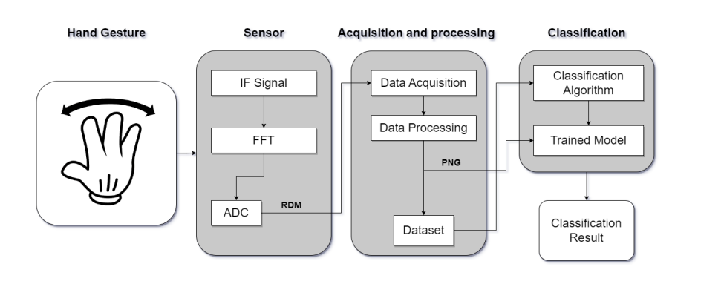
Figure 1: System architecture of a machine learning-based HGR system [19]
B. Dataset Description and data preparation
In this study we explored a publicly available radar-based hand gesture dataset [18] that was captured using the Texas Instruments AWR1642BOOST mmWave radar evaluation board. The dataset includes 4,700 labelled examples, each of which consists of 100 time-series frames that capture gesture motion. Each one measures three parameters: the x-coordinate, the y-coordinate, and the hand velocity. The structured samples consequently encode temporal information on gesture dynamics and form the basis for effective model training.
A preprocessing pipeline of the input dataset paved the way for strong and fair evaluation. The values of input to the constructing model were normalized using a common scaling in order to provide uniformity across all samples. There was stratification of the dataset to maintain a balance between the classes. Seventy percent of the data was used for training, and the other thirty percent was divided equally between the validation and test sets. Three PyTorch DataLoaders were generated, which handled these splits, with a chosen size of 64 to make a reasonable tradeoff of computational efficiency and gradient stability. The training loader shuffled samples before each epoch, but the validation and test loaders have a fixed order.
To give the temporal aspect of the dataset a visual representation, a random sample of the dataset was compiled into a visual representation of the changes between the three top-level features over the course of 100 frames. Figure 2 has been included in order to show the correlation between the numerical radar signals and the physical gesture motions, which aid in qualitative understanding as well as feature engineering purposes.
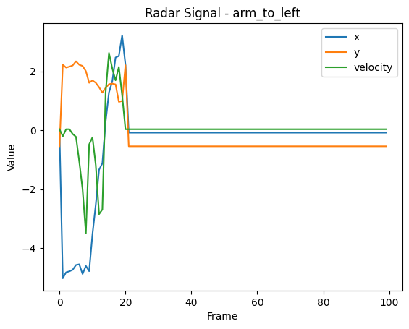
Figure 2: Visualization of a hand gesture data
C. Experimental Set up
The experiments were run in Python 3.10 using Google Colab as the main programming and experimenting environment. Computations were carried out on a CPU (Intel(R)-CoreTM i5-4210U@1.70-2.40GHz) with AWS 8GB RAM. This work started with the import of the necessary Python libraries: os for directory and file control, NumPy for numerical computation, pandas for data transformation, and tqdm for the progress bar. This framework was stable and efficient for model development, training, and evaluation.
D. Model Architecture
This paper investigated a Multilayer Perceptron (MLP) model [20] that was used for classification of radar-based HGH data. The reason for choosing MLP was the simplicity of its conception and its suitability for processing structured, tabular, or sequential data for which spatial locality is not a major issue. The data was prepared in the spreadsheet for training as a 2D array of shape 100 x 3 (each gesture can have 100 time steps and three features per time step [x-coordinate, y-coordinate, velocity]). Thus, these inputs were reduced to a one-dimensional vector prior to affecting the fully connected layer of MLP. Table 1 gives a summary of the model architecture.
Table 1: Model Architecture
Component | Details
Model Type | Multilayer Perceptron
Input Processing | Flatten input of shape (100 × 3) → vector of size 300
Layer 1 | Linear (300 → 256) + ReLU + Dropout (rate = 0.3)
Layer 2 | Linear (256 → 13)
Output Classes | 13 Gesture Classes
Loss Function | Cross Entropy Loss
Optimizer | Adam
Epochs | 30
Batch Size | 64

D. Performance Evaluation
Multilayer Perceptron architecture was tested with standard supervised learning evaluation methods. Loss and accuracy were measured over not only training but also validation sets so as to measure convergence, learning stability, and generalization capability. Cross-entropy was used to quantify the prediction error (i.e., the loss), while accuracy directly assessed whether a classification was correct. Stratified splitting was utilized to enable even evaluation amongst gesture classes, whereas dropout regularization was pulled in to cut back overfitting. Together these procedures ensured that the analysis obtained the learning capability of the MLP and its fidelity to unseen data.
E. Performance Metrics
The proposed model has been extensively evaluated using several performance measures, such as overall accuracy, precision, recall, and false positive/false negative tradeoff, in order to ensure robust evaluation of the model across the gesture classes [21].
(i) Precision:
Precision is the proportion of the right positive prediction against the total predicted positives. Low false positive rates are present when precision is high (Equation 1).
$$Precision \left(\%\right)= \frac{TP}{TP + FP } ×100 (1)$$
(ii) Recall (Sensitivity):
Recall (sensitivity) represents the ratio of correct results of collected actual positives. When recall is high, it implies that the model identifies the Fall events accurately (Equation 2).
$$Sensitivity \left(\%\right)=\frac{TP}{TP + FN }×100 (2)$$
(iii) F1-Score:
The F1 score is the harmonic mean of recall and precision and combines both concerns with one measure (Equation 3).
$$F1= \frac{2x \left(Precision x Recall\right)}{Precision + Recall} (3)$$

(iv) Accuracy:
The accuracy refers to the general correctness of the model of all classes (Equation 4).
$$Accuracy \left(\%\right)=\frac{TP+TN}{ TP + FP + TN +FN} ×100 (4)$$
where TP is True Positives, TN is True Negatives, FP is False Positives, and FN is False Negatives.

4. RESULTS AND DISCUSSION
This section shows the results of the developed hand-recognition models. Performance is evaluated by precision, recall, F1 score, and receiver operating characteristic (ROC) curve analysis.

4.1 Visualization of Training and Validation Performance
Training and validation performance was visualized using two side-by-side subplots in Figure 3 for clarity and ease of interpretation. The first subplot was the accuracy metric, in which we created a legend to identify the training curve and the validation curve together as the Accuracy Curve. The second subplot displayed the loss metric, where both training and validation loss are shown on the same scale and labelled "Loss Curve." While the accuracy curves gave a high-level view of the predictive performance, the loss curves offered the complementary view of the prediction loss over time, providing deeper insight into model convergence.

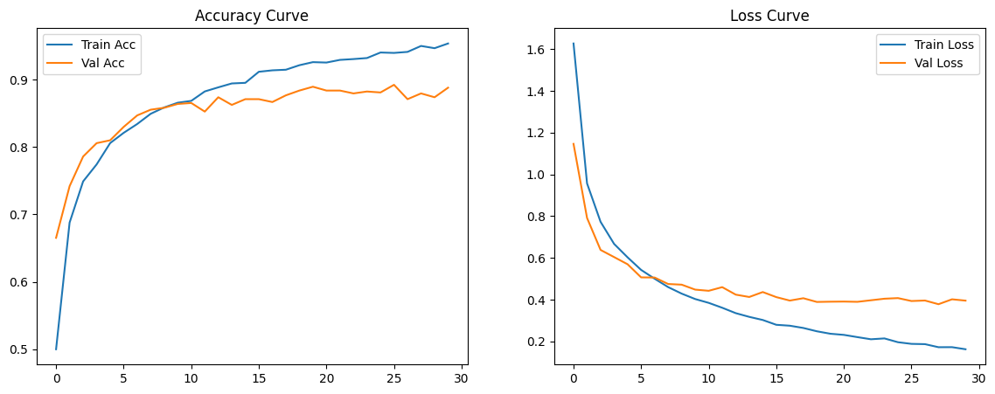
Figure 3: Visualization of Training and Validation Performance graph
4.2 Classification report and Confusion metrics
A classification report was produced to quantitatively summarize the predictive performance as precision, recall, and F1-score for each gesture class, as illustrated in Table 2.
Table 2: Classification report
Classification Report: | precision | recall | f1-score | support
arm_to_left | 0.95 | 1.00 | 0.98 | 60
arm_to_right | 0.94 | 0.98 | 0.96 | 60
close_fist_horizontally | 0.69 | 0.72 | 0.70 | 60
close_fist_perpendicularly | 0.76 | 0.87 | 0.81 | 60
hand_away | 0.98 | 0.93 | 0.96 | 60
hand_closer | 0.94 | 1.00 | 0.97 | 60
hand_down | 0.76 | 0.93 | 0.84 | 60
hand_rotation_palm_down | 0.81 | 0.77 | 0.79 | 60
hand_rotation_palm_up | 0.79 | 0.80 | 0.79 | 60
hand_to_left | 0.97 | 0.71 | 0.82 | 45
hand_to_right | 0.89 | 0.87 | 0.88 | 45
hand_up | 0.89 | 0.70 | 0.79 | 60
stop_gesture | 1.00 | 0.80 | 0.89 | 15
accuracy |  |  | 0.86 | 705
macro avg | 0.87 | 0.85 | 0.86 | 705
weighted avg | 0.86 | 0.86 | 0.86 | 705

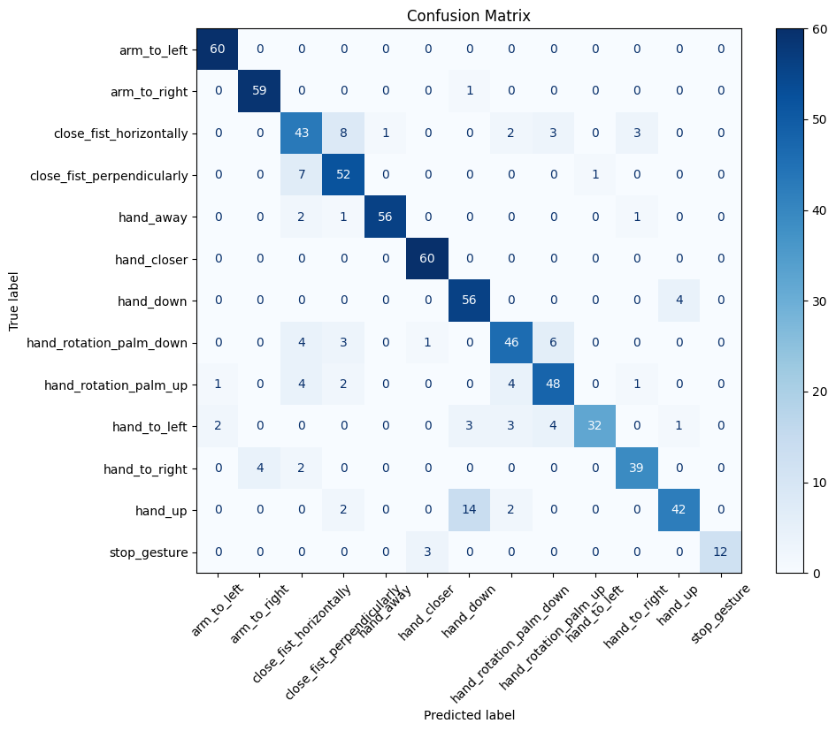
A confusion matrix was computed to complement the classification report and is presented in Figure 4.
Figure 4: Confusion matrix of MLP Model

4.3 Multi-Class ROC Curve Analysis
In order to compare the performance of each class, Receiver Operating Characteristic (ROC) curves for all 13 gesture classes were plotted in the same figure with different colours for each class. A diagonal reference line was added to represent random chance, allowing evaluation of model performance when the curves significantly increased above this reference. The figure was annotated with axis labels, a descriptive title, and a legend showing each class and associated Area Under the Curve (AUC) value. This multi-class ROC analysis offered a deeper insight into the model's strengths and weaknesses, identifying classes that were well discriminated as well as those that needed refinement.

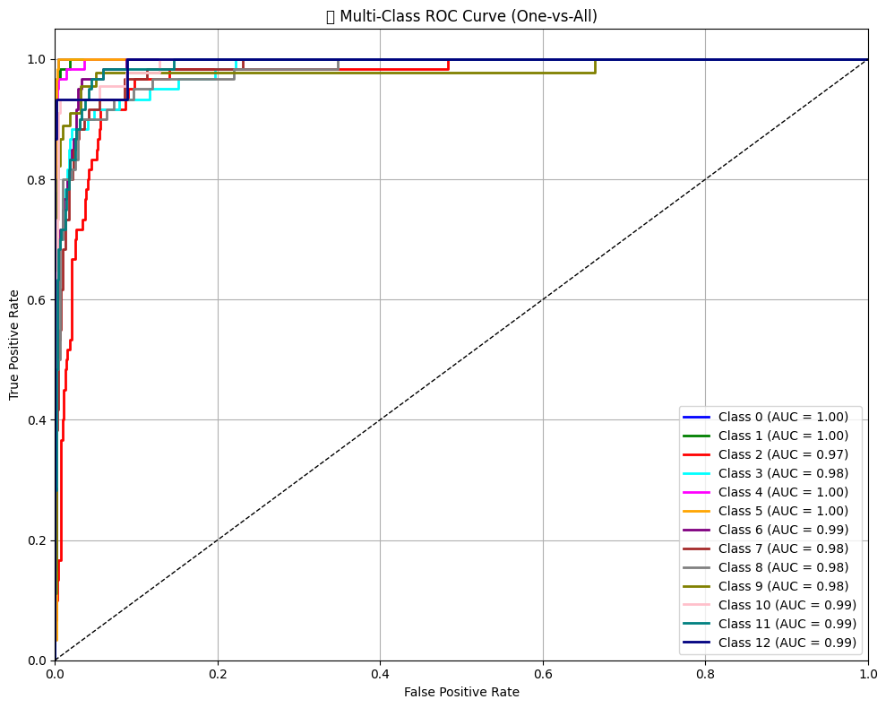

Figure 5: Multi-class ROC curves for 13 gesture categories with AUC values.
4.4 Discussion
The MLP model demonstrated a powerful learning and generalization ability with respect to radar-based hand signal recognition. Training and validation accuracy and loss converged as shown in Figure 3 with training and validation accuracy of 94.86% and 87.66%, respectively, and a loss of 0.16 and 0.41. These results imply convergent stability with a minimal difference in performance, which implies minimal overfitting and validates the model in that it managed to elicit discriminatory attributes in the radar data. Equivalent stability has been attested by related experiments on radar-based gesture recognition based on deep learning models [5], where convergence was reached with limited validation gaps, which supports the consistency of our findings with the previous literature.
Per-class analysis offered in detail also shed more light on recognition performance. As indicated in the classification report in Table 2, the gestures arm to left (F1-score = 0.98) and hand closer (F1-score = 0.97) were classified with excellent reliability, whereas relatively low performance was recorded in close fist horizontally (F1-score = 0.70) and hand up (F1-score = 0.79). These differences are predictable by the report of Gurbuz and Amin [6], who indicated that gestures with overlapping kinematic properties were more likely to generate lower recognition accuracy owing to intra-class variability. This challenge is also indicated by the confusion matrix in Figure 4, which indicates misclassifications between the gestures with a similar motion trajectory.
These observations were supported by the multi-class ROC analysis (Figure 5), which indicated class-level discriminability. The majority of the ROC curves increased significantly above the random baseline, and the respective high AUC values showed that the classes were well separated. Nevertheless, curves that were more aligned toward the diagonal denoted less confidence in the model, which agrees with the lower F1-scores in Table 2. Similar results were observed by Sarowar et al. [22], who observed that although lightweight neural networks can offer effective baselines to gesture recognition, there is a constraint on reliably differentiating gestures with low-key dynamics. Taken together, all these findings indicate that the MLP provides a reliable and reproducible baseline of radar-based gesture recognition that is more or less consistent with the trends in the recent literature but also suggests that improvements in addressing the ambiguous gesture categories are necessary.
5. CONCLUSION

This study investigated a radar-based hand gesture recognition system based on a publicly available dataset and an MLP model, showing that compact feedforward networks could be used to perform temporal radar feature-based human-computer interaction classification. Effective learning and generalization were experimentally validated, and the model was found to have a training accuracy of 94.86% and a loss of 0.16, and the model validation accuracy converged to 87.66% and a loss of 0.41. The classification report and confusion matrix showed consistent recognition of the majority of gesture categories, but lower scores of some classes indicate the difficulty of differentiating gestures with similar dynamics of motion. The ROC analysis also validated high-class separation in most classes and a small group of categories with less discrimination. These results are consistent with the literature on lightweight neural architecture and expand their use to privacy-aware, non-visual interaction systems. This paper makes MLP a reliable benchmark of gesture recognition using radar, which opens the way to low-complexity and real-time, as well as privacy-conscious, healthcare, smart environments, and human-machine interface applications. The additional topics of interest in future research are the incorporation of superior temporal models, greater feature representation, and the use of data augmentation techniques to overcome robustness and classification challenges in ambiguous gesture categories.

COMPETING INTERESTS DISCLAIMER:
Authors have declared that they have no known competing financial interests OR non-financial interests OR personal relationships that could have appeared to influence the work reported in this paper.
Disclaimer (Artificial intelligence)
Author(s) hereby declare that NO generative AI technologies such as Large Language Models (ChatGPT, COPILOT, etc.) and text-to-image generators have been used during the writing or editing of this manuscript.

References

[1] S. Ahmed, K. D. Kallu, S. Ahmed, and S. H. Cho, “Hand gestures recognition using radar sensors for human-computer-interaction: A review,” Remote Sensing, vol. 13, no. 3, p. 527, 2021.

[2] L. Guo, Z. Lu, and L. Yao, “Human–machine interaction sensing technology based on hand gesture recognition: A review,” IEEE Transactions on Human-Machine Systems, vol. 51, no. 4, pp. 300–309, 2021.

[3] A. Soumya, C. Krishna Mohan, and L. R. Cenkeramaddi, “Recent advances in mmWave-radar-based sensing, its applications, and machine learning techniques: A review,” Sensors, vol. 23, no. 21, p. 8901, 2023.

[4] P. Molchanov, S. Gupta, K. Kim, and J. Kautz, “Hand gesture recognition with 3D convolutional neural networks,” in Proc. IEEE Conf. Computer Vision and Pattern Recognition Workshops (CVPRW), Boston, MA, USA, Jun. 2015, pp. 1–7.

[5] Y. Kim and B. Toomajian, “Hand gesture recognition using micro-Doppler signatures with convolutional neural network,” IEEE Access, vol. 4, pp. 7125–7130, 2016.

[6] S. Gurbuz and M. Amin, “Radar-based human-motion recognition with deep learning: Promising applications for indoor monitoring,” IEEE Signal Processing Magazine, vol. 36, no. 5, pp. 16–28, Sep. 2019.

[7] E. Fertl, E. Castillo, G. Stettinger, M. P. Cuéllar, and D. P. Morales, “Hand gesture recognition on edge devices: Sensor technologies, algorithms, and processing hardware,” Sensors, vol. 25, no. 6, p. 1687, 2025.

[8] Y. Wang, S. Wang, M. Zhou, Q. Jiang, and Z. Tian, “TS-I3D based hand gesture recognition method with radar sensor,” IEEE Access, vol. 7, pp. 22902–22913, 2019.

[9] J. W. Choi, S. J. Ryu, and J. H. Kim, “Short-range radar based real-time hand gesture recognition using LSTM encoder,” IEEE Access, vol. 7, pp. 33610–33618, 2019.

[10] U. Rastogi, R. P. Mahapatra, and S. Kumar, “Advancements in machine learning techniques for hand gesture-based sign language recognition: A comprehensive review,” Archives of Computational Methods in Engineering, pp. 1–38, 2025.

[11] M. M. Rahman, A. Uzzaman, F. Khatun, M. Aktaruzzaman, and N. Siddique, “A comparative study of advanced technologies and methods in hand gesture analysis and recognition systems,” Expert Systems with Applications, vol. 266, p. 125929, 2025.
[12] A. Alzubaidi, A. Fadhel, O. Al-Shamma, et al., “Review of deep learning: Concepts, CNN architectures, challenges, applications, future directions,” Journal of Big Data, vol. 8, no. 53, pp. 1–74, 2021.
[13] Z. Zhang, C. Cao, Y. Xu, and H. Lu, “A transformer-based framework for dynamic hand gesture recognition,” Pattern Recognition, vol. 127, p. 108600, 2022.
[14] M. B. Shaikh, D. Chai, S. M. S. Islam, and N. Akhtar, “From CNNs to transformers in multimodal human action recognition: A survey,” ACM Transactions on Multimedia Computing, Communications and Applications, vol. 20, no. 8, pp. 1–24, 2024.
[15] Y. Zhang and X. Jiang, “Recent advances on deep learning for sign language recognition,” Computer Modeling in Engineering & Sciences (CMES), vol. 139, no. 3, 2024.
[16] Z. Chen, J. Chen, G. Ding, and H. Huang, “A lightweight CNN-based algorithm and implementation on embedded system for real-time face recognition,” Multimedia Systems, vol. 29, no. 1, pp. 129–138, 2023.
[17] J. Gui, T. Chen, J. Zhang, Q. Cao, Z. Sun, H. Luo, and D. Tao, “A survey on self-supervised learning: Algorithms, applications, and future trends,” IEEE Transactions on Pattern Analysis and Machine Intelligence, vol. 46, no. 12, pp. 9052–9071, Dec. 2024.
[18] P. Grobelny and A. Narbudowicz, “MM-Wave radar-based recognition of multiple hand gestures using long short-term memory (LSTM) neural network,” Electronics, vol. 11, no. 5, p. 787, 2022.
[19] I. Haidari and J. Shen, “Implementation of machine learning algorithm for radar-based hand gesture recognition,” 2024.
[20] A. H. Abd-elaziem and T. H. Soliman, “A multi-layer perceptron (MLP) neural networks for stellar classification: A review of methods and results,” International Journal of Advances in Applied Computational Intelligence, vol. 3, p. 10.54216, 2023.
[21] D. Chicco and G. Jurman, “The advantages of the Matthews correlation coefficient (MCC) over F1 score and accuracy in binary classification evaluation,” BMC Genomics, vol. 21, no. 6, p. 6, 2020.
[22] M. S. Sarowar, N. E. J. Farjana, M. A. I. Khan, M. A. Mutalib, S. Islam, and M. Islam, “Hand gesture recognition systems: A review of methods, datasets, and emerging trends,” International Journal of Computer Applications, vol. 975, no. 8887, 2025.

