Original Research Article
ANALYSIS OF RAIN ATTENUATION OVER THE GEO-CLIMATIC REGIONS OF NIGERIA USING ATTENUATION PREDICTION MODELS

Abstract
At frequencies above 10GHz, rain drops absorb part of the energy (signal) and part are scattered in different directions, causing unavailability of signals and making the system link unreliable. This study presents analysis of rain-induced attenuation on satellite communications at Ku band and the effects on telecommunications, broadcasting and navigations over the geo-climatic regions in Nigerian. Rainfall parameters were recorded using the ISS automatic weather station, which consists of various weather instruments integrated into one. Rain-induced attenuation data were measured using a satellite beacon setup and the measured values were compared with existing prediction models. Results shows significant attenuation levels ranging from 8.4 to 11.5 dB, demonstrating substantial impact of intense rainfall on radio wave propagation above 10 GHz. The ITU-R model showed mixed performance across locations. Its annual cumulative rain rate at 0.1% (35.6mm/hr.) and 0.01% (95.2mm/hr.) of time exceedance means that satellite link is expected to be available for 99.9% and 99.99% of time with rain attenuation exceeding the threshold of approximately 526min and 52.6min equivalent number of minutes annually. However, in Akure, the ITU-R model underestimated the measured values at 0.1% (38.83mm/hr.) and 0.01% (106.8mm/hr.) respectively with about 11% deviation and it overestimated ENUGU site values within the same range of values. This implies that any rain prediction done with ITU-R values in Akure location, the satellite link availability will experience a down time for more than 526min and 52.6min annually. While the overestimated will experience shorter equivalent number of times like in the case of Enugu within the same range of values. At GUSAU and ABUJA sites, the ITU model consistently overestimated measured rain attenuation. Among the attenuation prediction models, Moupfouma model demonstrated superior accuracy, closely following measured rain attenuation values across all locations.
Keywords: Integrated Sensor Suite, rain attenuation, satellite communication, Ku band, weather station
1. Introduction
Signal attenuation is the reduction in the strength of the signal in the process of information exchange during wireless communication. Components at different layers of the atmosphere like water droplets, carbon dioxide, ozone etc. can either absorb or reflect electromagnetic radiations, while some radiations like visible light and microwave can be transmitted through the earth’s atmosphere (Ayantunji, 2013; Ippolito, 2008; Darley, 2021; Maekawa & Yamashita, 2025). The decrease in signal strength is worse when there is interference in the radio frequency. Attenuation can be as a result of multipath reception, Fresnel zone interference, LOS interference, radio frequency interference or other weather conditions (Kodheli et al., 2020; Yusuf et al., 2022; Orji et al., 2024). When the signal strength is relatively low due to the atmospheric and other factors, it introduces an error which the receiver will decode, when rainfall is the cause of the decrease in signal strength, it is referred to as rain attenuation (Stigsson, 2024; Maekawa, 2025). Rain attenuation and rain rate predictions are the key to designing a better satellite communication link at frequencies above 10GHz (Ippolito, 2012; De & Maitra, 2024). Satellite communication is a means by which information is sent, received or exchanged from one device in a location to another through the use of satellites orbiting the Earth. This communication can be from a Geostationary (about 36,000km), Medium Earth Orbit (around 2,000 – 35,000km) or Low Earth Orbit (160 – 2,000km) satellites respectively. The application can be in Telecommunication, Navigation, Remote sensing and broadcasting (Acharya, 2017; Akinyemi et al., 2018). Satellite communication is flexible, reliable and has global coverage. The challenges faced by satellite communication system include life span limitations, cost of design and lunch, atmospheric factors (e.g. noise, attenuation), signal delays and interference (Pelton, 2012). Frequencies at Ku band and above suffers reduction in transmitted signal amplitude due to scattering and absorption caused by rain and other factors (Shriram et al., 2015). The reliability of systems operating at these frequencies can be severely affected as a result of rain induced attenuation. Rain drop size, drop velocity, rain rate and drop orientation among other factors affect the magnitude of rain attenuation (Adetan & Obiyemi, 2016). Rain attenuation prediction models are used to estimate rain attenuation. Some of the models include ITU-Model (ITU-R, 2023), DAH Model, Crane Model (Crane, 1984), Lognormal Model, Moupfouma Model etc. (Crane, 2002; Adetan & Obiyemi, 2016).
Rainfall accumulation is the quantity of precipitation over a certain period of time in a certain location. It is a crucial parameter to understand rainfall rate and rainfall attenuation for a better rain attenuation prediction which directly impact satellite communication. It can be understudied through time series of cumulative rain rate (Ojo et al., 2022; Arijaje et al., 2024; Aliyu et al., 2024). Rain rate cumulative distribution refers to a probability plot that shows the percentage of time a certain rain rate is exceeded, measured over a given time period. It's a way to represent how frequently different rain rates occur, helping in understanding the typical rain patterns in a specific location (Monjo & Martin-Vide, 2016; Mandeep, 2011; Maekawa, 2025). The percentage probability of occurrence of different rain rate as measured by rain gauge averaged over a period of one year or more, is crucial for predicting the impact of rain on radio wave propagation for designing reliable communication system (Stigsson, 2024; Lawai et al., 2025). Rain attenuation cumulative distribution represents the probability of experiencing a certain level of radio signal attenuation due to rain over a period of time (Maekawa, 2025). Rain attenuation mitigation system is designed to maintain a quality service that is desirable by adjusting the system to compensate for rain effects on the channel of communication (Strutzman & Dishman, 1982; Roger, 2019). Some mitigation techniques include; frequency diversity (FD), adaptive (hierarchical) coding and modulation (ACM), site diversity (SD), power control (PC), time diversity (TD), reconfigurable antenna pattern (RAP), orbit diversity (OD) and spot beam shaping (SBS) etc. (Shih, 2008; Ippolito, 2008). However, these mitigation techniques suffers one or more disadvantages including cost, simultaneous fading, earth station power control range, satellite power range, none-suitable for real time application, complexity, switching between satellites, immature research and reduction intolerant application (Panagopoulos et al., 2004). In view of the above, this study will be considering the rain attenuation against some rainfall prediction models and ITU-R model from some selected locations in the geo-climatic regions of Nigeria. This study will contribute to the ongoing discourse on improving prediction models for precipitation, thereby enhancing their applicability in satellite and telecommunication.
2. Some Rain Attenuation Prediction Models

ITU-R Model: This model was developed on the basis of the data obtained from ITU data bank using a satellite beacon with elevation angles from 6° to 82.5° ITU-R (2023). The model only uses rainfall rate information at one probability level (R0.01) to calculate the attenuation. ITU-R provided a step-by step procedure for estimating long-term statistics of rain attenuation along the slant-path at a given location for frequencies up to 55 GHz as follows:
Step 1: Height of Rainfall for a given location ($h_{R}$)
$\left(h_{R}\right)=3.0+0.028θ: if 0^{0}˂ θ ˂{36}^{0}$ (1a)
$\left(h_{R}\right) =4.0-0.075\left(θ - 36\right): if θ≥{36}^{0}$ (1b)
Equations (1a) and (1b) are important where there are no local measurements. But where there are local measurements we have;
$h_{R}\left(km\right)= h_{o }+0.36$ (1c)
According to Ojo (2012) and Tomiwa (2015), the value of freezing height in Nigeria lies between 3km and 4.76km.
Step 2: Effective Slant Length from rain height ($L_{s}$)
$L_{s}\left(km\right)= \frac{\left(h_{R}-h_{s}\right)}{sinθ} if θ ≥5°$ (2)
$L_{s}\left(km\right) = \frac{2(h_{R}-h_{s})}{\sqrt{\left[\sin^{2}θ+\frac{2\left(h_{R}-h_{s}\right)}{R_{e}}\right]}+sinθ} if θ<5°$ (3)
Where $h_{s}$ is the height above the mean sea level of the earth station (km), $θ$ is the elevation angle, $R_{e}$ is the effective radius of the earth (8500km).
If $\left(h_{R}-h_{s}\right)≤0$ the predicted rain attenuation for any time percentage is zero, hence the other steps i.e. step 3, step 4 etc. are not required. Otherwise
Step 3: Horizontal Projection $L_{G}$ of the slant path length
$L_{G}=L_{s}cosθ$ (4)
If $L_{G}$is –ve, it implies that $L_{s}$ is zero.
Step 4: Rain Rate, $R_{0.01}$ for 0.01% of an average year with 1min.
$R_{0.01}=\frac{1}{1+0.78\sqrt{\frac{Lgɣ_{R}}{f}}-0.38(1-e^{-2Lg})}$ (5)
The Simple Atmospheric Model (SAM): This is one of the extensively used slant path attenuation models predicted by Stutzman and Dishman (1982). The model utilizes elevation angle, specific attenuation, an empirical constant, ƞ, for the estimation of attenuation. Like most other models, it first estimates the specific attenuation. Though the values of ƙ and α can now be obtained from the ITU-R P.838 (ITU, 2005), the original SAM model utilized the regression parameters proposed by Olsen et al. (1978) as follows:
$A_{R}=ɣL_{s} if R≤\frac{10mm}{hr}$ (6a)
$A_{R}=ɣ\left\{\frac{1-exp⁡[-ɣƞ\ln\left(\frac{R}{10}\right)L_{s}cosθ]}{ƞ^{2}ln⁡(\frac{R}{10})cosθθ}\right\} if R>10mm/hr$ (6b)
Where is the angle of elevation, $ƞ=0.25$, and $L_{s}$is the slant path.
The Moupfouma I Model: This is a 3-parameter model developed by Moupfouma (1995) that resembles exponential distribution at higher rates and lognormal distribution at lower rates. It uses rain rate as an input to generate probabilities corresponding to those rainfall rates expressed as follows:
$P \left(r≥R\right)={10}^{-4}{(\frac{R_{0.01}}{r})}^{b}\exp\left(ʎr^{1-s}\left[-1\right]\right)$ (7)
Where r and R are rain rates in km/hr, $b=8.22{{(R}_{0.01})}^{-0.584}$, S and $ʎ$ are given in ITU-R according to climatic locations.
The Moupfouma and Martins Model: This was developed by Moupfouma and Martins (1984) to overcome the challenges of Moupfouma I Model. It works better in temperate and tropical zones. It is expressed as follows:
$P \left(r≥R\right)={10}^{-4}{(\frac{R_{0.01}}{r+1})}^{b}exp\left[μ(-r)\right]$ (8)
R (mm/hr.) is the rate of rainfall exceeded for a fraction of time, $R_{0.01}$ for 0.01% of time, b is given as
$b=\left(\frac{{r-R}_{0.01}}{R_{0.01}}\right)In\left(1+\frac{r}{R_{0.01}}\right)$ (9)
$μ=\left(\frac{4In10}{R_{0.01}}\right)exp-ʎ\left(\frac{r}{R_{0.01}}\right)$ (10)
where $ʎ=1.066$

Garcia-Lopez Model: Garcia - López et al. (1988) proposed an attenuation model for satellite link based on the extension of the initially proposed model for the terrestrial link. Although the model was based on measurements over satellite links in Europe, United States, Japan and Australia. The model is adjudged suitable for predictions with elevation angles ranging from 10° to 40° for global application. The rain attenuation on a satellite link is expressed as:
$A_{p}={ γ_{p} L_{s}}/{\left\{a+ \left[L_{s}{\left(bR+cL_{s}+d\right)}/e\right]\right\}}$ (11)
Where, the coefficients a, b, c and d, are empirically determined regression constants which are dependent on the geographical location. Coefficient e is a scaling factor. If e = 10⁴, the “worldwide” coefficients are: a = 0.7, b = 18.35, c = −16.51, d = 500.
$γ_{p}=k{R_{p}}^{α}$ (12)
3. Materials and Methods
3.1 Materials
The materials used include Wideband Code Division Multiple Access scanner, Thrilitic Spectrum Analyser (VNA), 6250 Vantage weather station, Mobile Work stations.
3.2 Study Location
This study covers the four geo-climatic zones of Nigeria which are Sahel Region, Guinea Savannah, Rain Forest, and Coastal Region. Sahel Region is characterized by low precipitation having annual mean rainfall below 700mm, short rainy season, and long dry season with average daytime temperatures of 35°C (95°F) and 21°C (70°F) at nighttime. Guinea Savannah (Savanah) Region is characterized with distinct wet and dry seasons with average yearly high temperatures ranging from 30 to 33°C and the lows range from 14 to 21°C. The annual rainfall typically falls between 1,600 and 2,000 mm, although there are areas in the Dahomey Gap that receive 1,000 mm or less annually. Derived Savannah (Rain Forest) Region is characterized by tropical savanna climate with moderate rainfall which has two distinct seasons: the rainy and dry seasons. The rainy season lasts for about seven months (April to October) while dry season have four months (November to March). Annual rainfall is over 1500 mm with a short August break (Balogun & Daramola, 2019). The temperatures are highest on average in March, at around 28.5°C. In August, the average temperature is 24°C. It is the lowest average temperature of the year. Coastal Region is characterized with high humidity and heavy rainfall (Ojo, 2021). The climate is humid and this humidity is at its highest between March and November with mean daily temperature of 26.7°C. The purposeful sampling technique was adapted to select one city from each zone which include Gusau (FUGUS), Abuja (PJAA), Akure (FUTA), and Enugu (ESUT). The map of Nigeria showing the selected locations is presented in Figure 1, while the site codes and their GPS location are presented in Table 1.
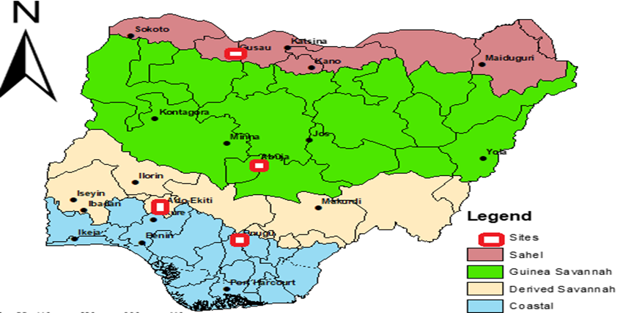
Figure 1. Map of Nigeria showing the geo-climatic zones and the sites where the weather stations are located (Lawal et al., 2021)
Table 1: Location codes with their corresponding GPS locations
S/N | GEO-CLIMATIC LOCATION | NAME | STATE CODE | GPS L0CATION
 |  |  |  | LONGITUDE | LATITUDE
1 | SAHEL | GUSAU | FUGUS | 12.10⁰N | 06.15⁰ E
2 | GUINEA SAVANNAH | ABUJA | PJAA | 08.97⁰N | 07.37⁰E
3 | DERIVED SAVANNAH | AKURE | FUTA | 07.31⁰N | 05.14⁰E
4 | COASTAL | ENUGU | ESUT | 07.27⁰N | 06.25⁰E

3.3 Method of Data Collection
Rainfall parameters were recorded using the Integrated Sensor Suite (ISS) automatic weather station, which consists of various weather instruments integrated into one, namely the rain gauge, temperature sensor, solar panel, anemometer, wind vane, and timer. The ISS instrument measures climatological parameters like temperature, relative humidity, dew point, wind speed, heat index, pressure, solar radiation, ultraviolet index, and evapo-transpiration (ET) index. The ISS is powered by a 0.5-watt solar panel backed up by a 3V lithium cell that may last longer than 2 years, depending on solar charging. This keeps the ON time of the weather at least 99%.
Rain-induced attenuation data was measured using a satellite beacon setup. This is a fixed-frequency un-modulated carrier transmitted by the satellite for reception on the ground, which is employed for purpose of uplink control, telemetry and research. Attenuation is monitored by estimating the difference between the received signal strength during clear sky and during rainfall event. Data was collected from January, 2019 to December 2021 in all the locations. During the 36 months of experiment, attenuation data were collected for a period of 80% of the time, while rainfall data were collected for about 85% of the time from all study sites except at Gusau, where attenuation data were for a period of 70% and rainfall data collected for about 75% of the time. The key measurement systems of equipment here are the weather station with its data-logger, the digital satellite meter and the spectrum analyser. They were subjected to pre-data calibration to ensure that readings were taken to correct accuracy.

Signal Attenuation: The attenuation can be calculated following the work of Ippolito (2008) as follows:
$A_{o}=10log\frac{P_{i}}{P_{o}}$ (13)
Where, $A_{o}$ is attenuation, $P_{o}$ is the output power and $P_{i}$ is the input power.
4. Results and Discussion
The average annual rainfall statistics for the period under investigation is presented in Table 2, while the analysis on attenuation for measured and predicted values are presented in Figures 2 to 6.
Table 2: Average Rainfall Accumulation for the Period under Study
MONTH | FUTA (mm) | ESUT (mm) | FUGUS (mm) | PJAA (mm)
JAN. | 0 | 0 | 0 | 0
FEB. | 25 | 50 | 0 | 0
MARCH | 75 | 100 | 0 | 0
APRIL | 150 | 175 | 0 | 0
MAY | 175 | 200 | 75 | 150
JUNE | 200 | 225 | 125 | 165
JULY | 285 | 350 | 200 | 185
AUG. | 385 | 425 | 225 | 250
SEPT. | 225 | 450 | 125 | 225
OCT. | 175 | 300 | 100 | 125
NOV. | 50 | 75 | 25 | 25
DEC. | 20 | 25 | 0 | 0

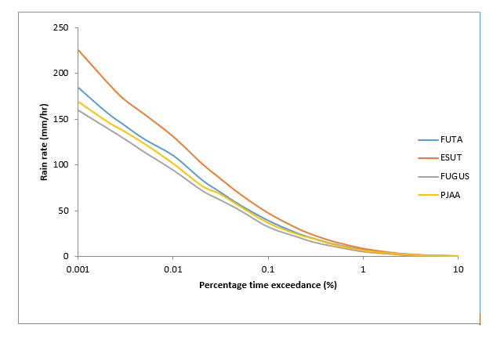

Figure 2: Rain Rate Cumulative Distribution over the Studied Location

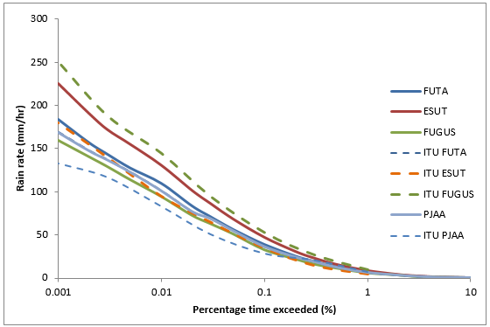

Figure 3: Comparison of Measured Rain Rate with ITU model over the Study Locations.

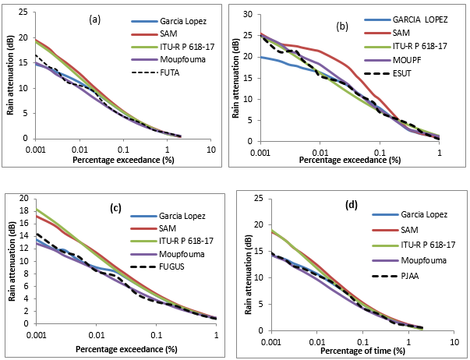
Figure 4: Comparison of measured and predicted attenuation distributions (a) FUTA, (b) ESUT (c) FUGUS and (d) PJAA.
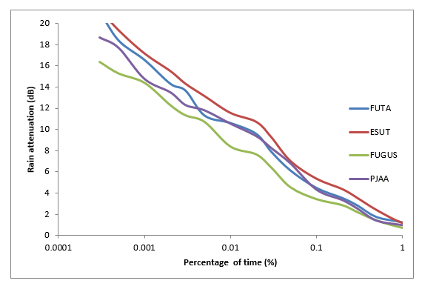
Figure 5: Cumulative distribution of rain attenuation derived from Ku-band beacon measurements
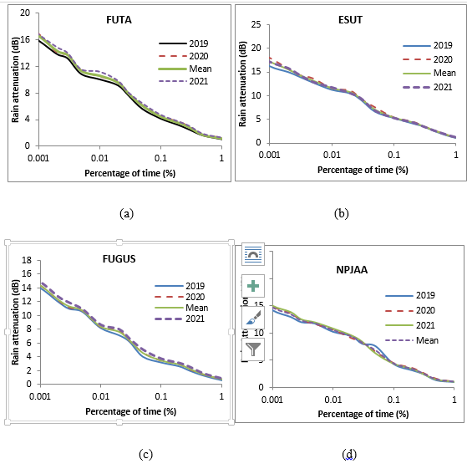
Figure 6: Annual cumulative distribution of rain attenuation derived from Ku-band beacon measurements over (a) FUTA, (b) ESUT, (c) FUGUS and (d) PJAA
The average annual rainfall statistics for the period from Table 2 revealed that ENUGU is characterized with heavy rainfall except for the relatively dry period between December and February. For the period of observation, the mean annual rainfall is about 1800 mm with the peak amount of rainfall of about 440 mm occurring in September. AKURE followed ENUGU closely with an annual mean precipitation of about 1750 mm and peak amount of about 382 mm occurring in August while ABUJA has an annual mean rainfall of about 1400 mm. Gusau continued to receive minimum rainfall all through the period of study with no rainfall throughout the dry season. However, there is the need to subject the period of intense rainy months including June through October to further analysis in order to select the worst months in the studied locations.
Several studies have proved that rainfall rate exceeded at the critical availability level of 0.01% of an average year (Ojo et al., 2008, Obiseye et al., 2015, Ojo et al., 2016), this translates to an outage of about 52 minutes in the year. It is the most important input for system designers to deduce the level of signal degradation along the propagation paths. The results presented in Figure 2 shows that at 0.01% of an average year, ESUT, FUTA, PJAA and FUGUS recorded rain rates of about 130 mm/hr., 109 mm/hr., 101 mm/hr. and 94 mm/hr. respectively. This implies that for every 52 minutes of the year, rainfall intensities were above 130 mm/hr., 109 mm/hr., 101 mm/hr. and 94 mm/hr. for the respective locations – signifying the fact that the four locations and by extension the entire country experience intense rainfall which have a huge adverse impact on the propagation of radio waves above 10 GHz.
Beacon signals were recorded continuously for 36 months in each of the location. During the period, the beacon receiver experienced some system downtime as a result of a power outage. Hence for the measurement years in FUTA, 95 events that summed up to 9983 minutes of rain beacon signal data were recorded and retrieved; while for ESUT, 89 events summed up to 5882 minutes of rain beacon signal data were retrieved and 68 events summed up to 621 minutes were retrieved and used for analysis for FUGUS, while 78 events summed up to 4887 minutes were observed in PJAA. Figure 3 shows the measured rain-induced attenuation over the study locations. Further analysis shows that ITU-R model underestimated the measured values from Akure from 0.1% - 0.01%. It overestimated Enugu, Gusau and Abuja. The result of measured data when compared with other models like Garcia Lopez, SAM, Moupfouma etc. shows noticeable deviation of above 15%. Moupfouma model follows the measured rain attenuation values closely for all the locations while other models either overestimate or underestimate Figure 4.
The rain rate deviates from 0.1% to 0.001% percentage of time in ESUT when compared with the other three locations (FUTA, FUGUS and PJAA). This is due to the heavy rainfall events at ESUT follows immediately by FUTA and PJAA. The measurements of rain rate are mostly convective in all the measurement sites except at FUGUS. Therefore, there is not much diﬀerence in the rain rate values for a higher percentage of time (10 and 1%) at all the sites. Generally, the exceedance trends in Figure 4 shows that as the rain rate increases, the trend of the slope curve gradually decreases from a large negative value. “When the rain structure is stratiform especially at higher time percentages, rainfall type is widespread, with low rain rates. The convective nature at lower time percentages is typical of the tropics nature of rain, where the water droplets inside the cloud are vertically transported to enhance the coalescence of water particles and thereby transforming into convective heavy rainfall” (Semire et al, 2020). Consequently, a transformation often occurs from stratiform rain, characterized by low rain rates, to convective rain, which is associated with relatively high rain rates. Numerically, at 0.01% of an average year, which translates to an outage of about 52 minutes in the year, Figure 4 further shows that rain attenuation of 10.6 dB, 11.5 dB, 8.4 dB, and 10.5 dB are exceeded for FUTA, ESUT, FUGUS and PJAA respectively. The implication is that for every 52 minutes of the year, rain attenuation was above 10.6 dB, 11.5 dB, 8.4 dB and 10.5 dB, for the respective locations – signifying the fact that the three locations and by extension the entire country experience intense rainfall which has a huge adverse impact on the propagation of radio waves above 10 GHz Figure 5. The same trend could be observed at other time percentages of signal unavailability in the year of study, although with different threshold of signal attenuation values across the studied locations.
In FUTA, the rain-induced attenuations in 2021 throughout the exceedance spectrum are about 2.51 dB higher than those of 2019 and 2020, while the three-year distribution seems to follow the pattern of the distribution in 2019, 2020 and 2021. The mean annual value of the rain attenuation at 0.01% is about 10.6 dB. The results are further confirmed by the comparison of link analysis as presented in Figures 6 (a-d) over each of the selected locations. Generally, rain-induced attenuation is more prevalent at ESUT than any other selected locations. This is expected as the dependence of attenuation on rainfall intensities is evidence in the plots.
Figure 6b at 0.01% of the time shows that, the rain attenuation exceeded for ESUT is about 11.2 dB in 2019; however, it was 11.6 dB in 2020 and 11.8 dB in 2021, indicating a mean value of about 11.54 dB over the three years and average difference of about 0.4 dB. In average, the rain attenuation value for the 3-year value at 0.01% of the time for FUGUS (Fig 6c) was 8.4 dB; while 10.54 dB was exceeded in average year at 0.01% of the time at PJAA. Other percentage exceeded varies over each of the location. This implies that the mitigation measure needed for each of the location will vary to achieve a good quality of signal in an average year.

5. Conclusion
A thorough examination of the rain rate measurements across selected locations in Nigeria revealed significant deviations from the ITU-R model, underscoring the necessity for region-specific assessments. The analysis of data demonstrated that measured rain rates often diverge from ITU-R predictions, with variances as high as 28.33% for specific intervals, indicating potential inadequacies in the current modelling approach. Particularly, these discrepancies suggest that the ITU-R model, while providing a useful baseline, may not capture the unique geo-climatic conditions prevalent in Nigeria, thus necessitating the development of tailored models. This is evident that localized data is crucial for accurate predictions. Ultimately, this research advocates for enhanced modelling that integrates local data to improve the reliability of rain rate predictions for effective communication infrastructure planning. The comparative analysis of the measured rainfall rates against the ITU-R model and other rain attenuation prediction models demonstrates significant deviations that highlight the nuances of Nigerian geo-climatic diversity. For instance, at the 0.1 mm/hr. rain rate, the disparities at FUTA, ESUT, and FUGUS locations reveal deviations of 9.86%, -10.29%, and -0.54%, respectively, illustrating how local conditions can impact the accuracy of universal models. Moreover, at higher rain rates, such as 1 mm/hr., notable discrepancies of 28.33% for FUTA and 22.94% for FUGUS underscore the inadequacy of the ITU-R predictions in certain environments. These findings are pivotal as they call into question the efficacy of standardized models in accurately forecasting rainfall impacts on communication systems in varied climatic zones. Understanding these deviations is crucial for enhancing the design and reliability of wireless networks, especially given the implications of rainfall attenuation on service provision. Therefore, the study recommends Location-Specific prediction models Since the ITU-R model showed varying performance. The study strongly suggests using the Moupfouma model for tropical regions instead of the ITU-R model, as it follows measured rain attenuation values closely across all locations. Also, to conduct Long-term Measurements using multi-year datasets to develop more accurate local prediction models for tropical environments.

COMPETING INTERESTS DISCLAIMER:
Authors have declared that they have no known competing financial interests OR non-financial interests OR personal relationships that could have appeared to influence the work reported in this paper.

Disclaimer (Artificial intelligence)
Author(s) hereby declare that NO generative AI technologies such as Large Language Models (ChatGPT, COPILOT, etc.) and text-to-image generators have been used during the writing or editing of this manuscript.

References
Acharya, R. (2017). Satellite Signal Propagation, Impairments and Mitigation. Elsevier Ltd. https://doi.org/10.1016/B978-0-12-809732-8.00001-6.
Adetan, O. & Obiyemi, O. O. (2016). Analysis of Raindrop Diameters for Rainfall Attenuation in Southern Africa. International Journal of Electrical & Computer Engineering (2088-8708), 6(1).
Akinyemi, G.A., Falade A. & Kolawole L. B. (2018). Estimation of Rain Attenuation at Microwave Bands in Nigeria. Journal of Radio Electronics, 8, 2018. DOI 10.30898/1684-1719.2018.8.18.
Aliyu, H., Mamman, B. H., Yarima, S. M., Balami, I. T. & Miya, H. S. (2024). Evaluation of C and Ku Bands Signal Degradation due to Rain Water Accumulation on Prime Focus Parabolic Antenna in the Tropical Region of Nigeria. ATBU Journal of Science, Technology and Education, 12(1), 770-777.
Arijaje, T. E., Omotosho, T. V. & Aizebeokhai, A. P. (2024, July). Analysis of Monthly Attenuation. In Proceedings of Ninth International Congress on Information and Communication Technology: ICICT 2024, London, Volume 4 (Vol. 1014, p. 317). Springer Nature.
Ayantunji, B. G., Mai-Unguwa, H., Adamu, A. & Orisekeh, K. (2013). Tropospheric influences on satellite communications in tropical environment: a case study of Nigeria. International Journal of Engineering and Innovative Technology, 2(2), 111-116.
Crane, R. K. (1984). A comparative evaluation for several rain attenuation prediction models. Final Rep., NASW-3645N, ASA,
Crane, R. K. (2002). Analysis of the effects of water on the ACTS propagation terminal antenna, Antennas and Propagation. IEEE Trans., 50, 954–965.
Darley, O., Yussuff, A. I. & Adenowo, A. A. (2021). Investigation into rain attenuation prediction models at locations in Lagos using remote sensing. FUOYE Journal of Engineering and Technology, 6(2), 19-24.
De, A. & Maitra, A. (2024). Dependence of rain attenuation on rain rate and drop size distribution for Ka-band satellite communication over India. Advances in Space Research, 74(5), 2424-2429.
Garcia–López J. A., Hernando J. M. & Selga, J. (1988). Simple Rain Attenuation Method for Satellite Radio Links. IEEE Transactions on Antennas and Propagation, 36(3), 444–448.
Ippolito, L. J. (2008). Propagation Effects Handbook for Satellite Systems Design. Online Journal of Space Communication, 1(2), 15.
Ippolito, L. J. (2012). Radio wave propagation in satellite communications. Springer Science & Business Media.
ITU-R P.838-3 (2005). Specific attenuation model for rain for use in prediction methods. P Series Radiowave propagation. ITU Radio-communication Bureau, Geneva.
ITU-R P. 618-15 (2023). Propagation Data and Prediction Methods Required for the Design of Earth-Space Telecommunication Systems.
Kodheli, O., Lagunas, E., Maturo, N., Sharma, S. K., Shankar, B., Montoya, J. F. M. & Goussetis, G. (2020). Satellite communications in the new space era: A survey and future challenges. IEEE Communications Surveys & Tutorials, 23(1), 70-109.
Lawal, Y. B., Ojo, J. S., Falodun, S. E. & Olurotimi, E. O. (2021). Geoclimatic characterization and latitudinal dependence of rain heights over Nigeria. Journal of Physics: Conference Series, 2034(1), 012010.
Lawal, Y. B., Tu, C., van Wyk, E. A., Owolawi, P. A. & Ojo, J. S. (2025, January). Impact of Rain Heights on Rain-Induced Attenuation for Communication Systems Operating at Ka and V Bands in Pretoria, South Africa. In 2025 IEEE 15th Annual Computing and Communication Workshop and Conference (CCWC) (pp. 01111-01117). IEEE.
Maekawa, Y. (2025). Long-term statistics of the worst month rain attenuation cumulative distribution in Ka and Ku band satellite communications links. IEICE Transactions on Communications, Early Access, 1 – 15. DOI: 10.23919/transcom.2025EBP3045.
Maekawa, Y. & Yamashita, F. (2025). A study on frequency scaling of rain attenuation using simultaneous measurements of Ka-band and Ku-band satellite beacon signals. IEICE Transactions on Communications, E108-B(10), 1254 – 1262. DOI: 10.23919/transcom.2024EBP3177.
Mandeep, J. S. (2011). Comparison of rain rate models for equatorial climate in South East Asia. Geofizika, 28(2), 265-274.
Moupfouma, F. & Martins, S. (1995). Modeling of the rainfall rate cumulative distribution for design of satellite and terrestrial communication systems, International Journal of Satellite Communication, 13(2), 105-115.
Moupfouma, F. (1984). Improvement of rain attenuation prediction method for terrestrial microwave links. Trans. Antennas and Propagation. IEEE, 32(12), 1368–1372
Monjo, R. & Martin‐Vide, J. (2016). Daily precipitation concentration around the world according to several indices. International Journal of Climatology, 36(11), 3828-3838.
Obiseye, O. O., Adetan, O. & Ibiyemi, T. S. (2015). Recent Update on One-Minute Rainfall Rate Measurements for Microwave Applications in Nigeria. International Journal of Wireless Communications and Mobile Computing, 3(3), 33-39.
Ojo, J. S., Ijomah, C. K. & Akinpelu, S. B. (2022). Artificial neural networks for earth-space link applications: a prediction approach and inter-comparison of rain-influenced attenuation models. Int. J. Intell. Syst. Appl. (IJISA), 14(5), 47-58.
Ojo, J.S. (2012). Estimation of cross-polarization due to rain over some stations in Nigeria. Annals of Telecommunications, Springer, 67, 241–245.
Ojo, J. S., Ajewole, M. O. & Sarkar, S. K. (2008). Rain rate and rain attenuation prediction for satellite communication in Ku and Ka bands over Nigeria. Progress in Electromagnetic Research B, 5(1), 207–223.
Ojo, J.S., Adenugba, A. K. & Adediji, A. T. (2016). Dynamical modeling for deriving 1-min rain rate from various integration times in a tropical region. Journal of Telecommunication Management, 5(127), 2167-2174.
Ojo, O. S. (2021, December). Effect of Climate Change on Solar Radiation over a Tropical Region. In 2021 International Conference on Decision Aid Sciences and Application (DASA) (pp. 332-337). IEEE.
Olsen, R., Rogers, D. & Hodge, D. (1978). The aR b relation in the calculation of rain attenuation. IEEE Transactions on Antennas and Propagation, 26(2), 318-329.
Orji, O. P., Chukwuebuka, O. D., Chidinma, O. E., Josephine, U. O., Chinedu, O. P., Uzochukwu, I. E., ... & Chiemeka, I. U. (2024). Rain attenuation prediction at different time percentages for ku, k, and ka bands satellite communication systems over Nigeria. Journal of Astronomy and Space Sciences, 41(1), 25-33.
Panagopoulos, A. D., Arapoglou, P. D. M. & Cottis, P. G. (2004). Satellite communications at Ku, Ka, and V bands: Propagation impairments and mitigation techniques. IEEE communications surveys & tutorials, 6(3), 2-14.
Pelton, J.N. (2012). Introduction to Satellite Communications (pp. 1–3). https://doi.org/10.1007/978-1-4614-1994-5_1
Roger, L. F. (2019). Radio System Design for Telecommunication (3rd Ed.). New York: IEEE Inc., John Wiley & Sons Inc., Pp.
Semire, F.A., Adekunle, A. J. & Abolade, R.A. (2020). Rainfall variability and its effect on communication link in Southwestern Nigeria. International Journal of Big Data Mining for Global Warming, 2(01), 2050004.
Shih, S. P. (2008). A study of precipitation effect on tropospheric electromagnetic wave propagation at frequency 19.5 GHz. Terrestrial, Atmospheric and Oceanic Sciences, 19(3), 309–319. https://doi.org/10.3319/TAO.2008.19.3.309(AA)
Shriram, R., Imthiyaz, A. S. & Kumar, L. S. K. (2015). Calculation of cloud attenuation at Ku and Ka band frequencies over Indian region. Conference: 2015 IEEE Applied Electromagnetics Conference (AEMC), DOI: 10.1109/AEMC.2015.7509233
Stigsson, A. (2024). Satellite signal attenuation due to atmospheric influences in northern Sweden.
Strutzman, W. L. & Dishman, W. K. (1982). A Simple attenuation model for the estimation of rain-induced attenuation along Earth-space paths for the estimation of millimetre wavelengths. Radio Science, 17(6), 1465-1476.
Tomiwa, A. C. (2015). Characterization and Effects of Radar Measured Rainfall Parameters on Millimetre Radiowave Propagation in Akure, Southwestern Nigeria. Doctoral dissertation, Federal University of Technology, Akure, Nigeria,
Yusuf, S. D., Gbalaja, M. & Loko, A. Z (2022). Assessment of Radio Waves Propagation Pattern from Three Radio Stations in Lokoja, Kogi State, Nigeria. International Journal of Electronics and Communication Engineering. https://doi.org/10.14445/23488549/IJECE-V9I9P101

