Short Research Article
Benchmarking EfficientNet, MobileNet and ResNet Architectures for Cassava Disease Detection in Agricultural Robotics

.
ABSTRACT

Aim: To demonstrate the feasibility of lightweight deep learning models for cassava disease detection, emphasizing their suitability for deployment on agricultural robots and other edge devices where computational efficiency is critical.
Study design: Experimental benchmarking of lightweight versus heavier convolutional neural networks on a standardized cassava disease dataset.
Place and Duration of Study: Conducted as independent research by Michael Aboh at Santa Clara University, during spring 2022.
Methodology: The 2020 Cassava Leaf Disease dataset, comprising approximately 26,000 labeled images across five categories: Cassava Mosaic Disease, Cassava Brown Streak Disease, Cassava Green Mottle, Bacterial Blight, and Healthy, was utilized. The dataset was divided into training (70%), validation (15%), and test (15%) subsets. Three convolutional neural networks were trained and evaluated: EfficientNet-Lite0 (lightweight), MobileNetV3-Large (mid-range), and ResNet18 (heavier baseline). Evaluation metrics included classification accuracy, macro-averaged F1 score, model size (parameters, M), and inference speed (frames per second, FPS). Model interpretability was examined using Grad-CAM to visualize disease-relevant activation regions.

Results: ResNet18 achieved the highest test accuracy (85.3%) and macro-F1 score (0.757). EfficientNet-Lite0 achieved comparable performance (84.3% accuracy, 0.744 macro-F1) with one-third the parameters and faster inference (123 FPS).

Conclusion: The findings show that lightweight convolutional neural networks can deliver competitive accuracy while offering significant efficiency advantages for real-time, low-power inference on agricultural robots and edge devices. These results highlight critical trade-offs between model complexity, accuracy, and speed for scalable, field-deployable AI systems.

Keywords: Agricultural robotics, Cassava leaf disease, ResNet18, Lightweight neural networks

1. INTRODUCTION

  - Importance of Cassava and Disease Threats
Cassava (Manihot esculenta) is a vital staple crop supporting the food security of more than 800 million people globally, particularly across sub-Saharan Africa and Southeast Asia [1, 10]. Its tolerance to drought, degraded soils, and erratic rainfall patterns makes it indispensable in marginal agricultural regions where other crops fail to thrive. Beyond its role as a subsistence crop, cassava underpins rural economies as a key source of starch, animal feed, and industrial raw materials.
However, productivity is heavily constrained by foliar diseases such as Cassava Mosaic Disease (CMD), Cassava Brown Streak Disease (CBSD), Cassava Green Mottle, and Bacterial Blight, which together cause annual yield losses worth billions of dollars and threaten rural livelihoods [1, 10, 15]. CMD alone has been reported to cause yield reductions of up to 50 % in severely affected regions [10]. These diseases not only reduce food availability but also limit access to income and export opportunities for smallholder farmers.
The persistence and rapid spread of these pathogens amplified by vector transmission and climate variability, highlight the need for scalable, field deployable disease-detection tools that can enable early intervention. Early and accurate diagnosis is therefore essential for mitigating disease spread, ensuring regional food security, and supporting sustainable agricultural development across cassava-growing nations.

1.2 Deep Learning for Plant Disease Detection
Convolutional neural networks (CNNs) have revolutionized image-based plant disease detection by automatically learning hierarchical features that generalize across crops. Numerous studies report over 90 % accuracy for CNN-based classification of tomato, rice, and other plant diseases [4–6, 18]. In cassava, transfer-learning and hybrid-CNN methods have achieved accuracies in the 80–90 % range [1–3, 11, 12]. For instance, a hybrid CNN ensemble reached ≈ 90 % accuracy [1], while transformer-CNN fusion models improved robustness under variable lighting and occlusion [2]. Recent benchmarks highlight the value of model innovation: Sambasivam et al. (2025 [1]) achieved 90% classification accuracy using hybrid CNN architectures, while Zeng et al. (2025 [2]) combined CNNs with transformers for more robust feature extraction in noisy field conditions. Similarly, reviews emphasize that lightweight CNNs such as MobileNet and EfficientNet provide promising results but require rigorous comparisons across efficiency, accuracy, and interpretability (Patel et al., 2025 [7]; Yadav et al., 2024 [13]).
Benchmarking reviews emphasize that efficiency and interpretability are increasingly as important as raw accuracy. Patel et al. [7] and Yadav et al. [13] highlighted the need for lightweight, transparent CNNs suitable for field deployment. Recent agricultural benchmarks have compared mobile-friendly architectures such as MobileNet and EfficientNet, demonstrating that reduced-parameter models can maintain high performance when optimized for edge inference [16, 17].
1.3 Edge AI and Deployment Challenges
In practice, plant-disease-detection systems must function on agricultural robots, drones, and handheld or IoT devices operating under tight power, memory, and latency budgets. Edge AI enables real-time inference without reliance on network connectivity, making it crucial for remote farms [8, 9, 14, 15]. This decentralized approach allows data to be processed directly on embedded hardware, minimizing transmission delays and reducing dependence on cloud infrastructure. It also improves data privacy and resilience, ensuring that operations can continue uninterrupted even in low-connectivity or off-grid environments.
However, deploying AI models at the edge introduces several engineering and computational challenges. Hardware resources such as GPU acceleration, memory bandwidth, and processing frequency are often limited in mobile or robotic systems. As a result, even moderately complex models can lead to high inference latency, excessive power draw, and thermal constraints that shorten battery life. In agricultural robotics, these factors are particularly critical, as robots must operate autonomously for extended periods while performing other real-time tasks such as navigation, spraying, or harvesting.
Despite these advantages and constraints, few cassava-focused studies have quantitatively compared lightweight CNNs with heavier baselines (e.g., ResNet18) using unified metrics such as accuracy, macro-F1, inference speed (FPS), and Grad-CAM-based interpretability. Without such benchmarking, it is difficult to assess which architectures offer the best balance between performance and deployability. This lack of comparative evidence limits the practical adoption of efficient models for real-time field robotics and slows the translation of research prototypes into fully operational, deployable agricultural AI systems.

1.4 Scope and Contribution of This Work
This work addresses that gap by benchmarking three representative CNN architectures namely: EfficientNet-Lite0, MobileNetV3-Large, and ResNet18, on the 2020 Kaggle Cassava Leaf Disease dataset. The evaluation encompasses macro-averaged F1 score, parameter count, inference speed (FPS), and visual interpretability via Grad-CAM. By systematically quantifying trade-offs between lightweight and heavier CNNs, this study demonstrates that models with substantially fewer parameters can approach the predictive performance of larger ones while offering major efficiency advantages. The results are directly relevant to agricultural robot and edge device deployments, where computational efficiency, transparency, and robustness are as critical as accuracy.

2. material and methods

2.1 Dataset

The Cassava Leaf Disease Dataset released for the 2020 Kaggle competition “Cassava Leaf Disease Classification” was employed. The dataset comprises 26,377 labeled images across five categories: Cassava Mosaic Disease (CMD), Cassava Brown Streak Disease (CBSD), Cassava Green Mottle (CGM), Bacterial Blight (BB), and Healthy leaves.

This dataset was curated by the Makerere AI Lab (Uganda) in collaboration with Google Research and NVIDIA and is widely recognized as a reliable benchmark for cassava disease classification. Its credibility is supported by expert annotation, transparent data collection, and broad reuse in peer-reviewed studies. The images were divided into 70 % training, 15 % validation, and 15 % test sets using stratified sampling to preserve class balance and ensure representative learning across disease categories.

2.2 Preprocessing

All images were resized to 224 × 224 pixels and normalized using the standard ImageNet mean and standard-deviation values. To enhance generalization and prevent overfitting, data augmentation operations were applied to the training set, including random horizontal flips, ±20° rotations, brightness and contrast adjustments, and random cropping. Validation and test images were resized and normalized only, ensuring that model evaluation reflected real-world generalization rather than augmentation bias.

2.3 Model Architectures

Three convolutional neural networks representing different complexity levels were benchmarked:
- EfficientNet-Lite0: a lightweight variant of the EfficientNet family optimized for mobile and edge deployment, balancing accuracy and inference speed through compound scaling [17].
- MobileNetV3-Large (100 %): an architecture designed for efficiency via depth wise separable convolutions, squeeze-and-excitation blocks, and the hard-swish activation [16].
- ResNet18: a classical, heavier CNN baseline widely used in image-classification benchmarks for its residual-connection design and robustness across domains.

All models were initialized with ImageNet-pretrained weights via the timm library and fine-tuned for the five (5) class cassava disease classification task. The selection of these architectures reflects their relevance to resource constrained agricultural robotics, ranging from extremely lightweight (EfficientNet-Lite0) to moderately heavy (ResNet18) networks.

2.4 Training Setup

Training was conducted using PyTorch v2.0 on a Google Colab Pro environment equipped with NVIDIA T4 GPUs (16 GB VRAM). Each model was trained for up to 20 epochs with early stopping (patience = 3) to prevent overfitting.

Key hyperparameters were:
- Optimizer: AdamW (learning rate = 3 × 10⁻⁴, weight decay = 1 × 10⁻⁴).
- Scheduler: Cosine Annealing learning-rate schedule with Tₘₐₓ = total epochs.
- Loss function: Cross-Entropy Loss for multi-class classification.
- Batch size: 64 (samples per iteration), reduced automatically when GPU memory limits were reached.
Each training run averaged 25–30 minutes, with model checkpoints saved at each improvement in validation macro-F1 score. This setup ensured reproducible, efficient training while maintaining comparable conditions across all architectures.

2.5 Evaluation Metrics and Interpretability

Model performance was assessed on the held-out test set using the following metrics:
- Accuracy: the percentage of correctly classified samples.
- Macro-averaged F1 score: harmonic mean of precision and recall across all classes, providing a balanced view under class imbalance.
- Model size: total trainable parameters (in millions).
- Inference speed: frames per second (FPS) measured on GPU and CPU, reflecting deployability on embedded hardware.

Model interpretability was evaluated using Gradient-weighted Class Activation Mapping (Grad-CAM) visualizations, which highlight the image regions most influential in the prediction. These activation maps were critical for verifying that models focused on symptomatic leaf areas rather than background noise, reinforcing trust in potential field deployment.

3. results and discussion

3.1 Overall Performance

The three benchmarked models namely: EfficientNet-Lite0, MobileNetV3-Large, and ResNet18, achieved competitive results on the Cassava Leaf Disease dataset.
Performance metrics are summarized in Table 1, including validation macro-F1, test accuracy, parameter size, and inference speed (FPS).

Table 1. Performance comparison of EfficientNet-Lite0, MobileNetV3-Large and ResNet18 on cassava leaf disease dataset

Model | Family | Best Epoch | Val Macro-F1 | Test Acc | Test Macro-F1 | Params (M) | FPS (GPU)
MobileNetV3-Large | Light | 9 | 0.7370 | 0.8355 | 0.7351 | 4.21 | 108.35
EfficientNet-Lite0 | Light | 4 | 0.7342 | 0.8433 | 0.7435 | 3.38 | 123.26
ResNet18 | Light | 13 | 0.7488 | 0.8529 | 0.7569 | 11.18 | 106.28

ResNet18 attained the highest macro-F1 (0.757) and accuracy (85.3 %), confirming its strong predictive capability. EfficientNet-Lite0 closely followed with a macro-F1 of 0.744 and demonstrated a three-fold reduction in parameter count relative to ResNet18. MobileNetV3-Large showed slightly lower predictive accuracy but achieved a notably high inference speed (108 FPS), underlining its computational efficiency for real-time edge deployment.
Overall, the results illustrate the expected trade-off between model complexity and efficiency: heavier architectures yield marginally higher accuracy, while lightweight ones deliver comparable performance with substantially reduced resource requirements. For robotics and IoT deployments where power and memory are limited, EfficientNet-Lite0 offers a particularly attractive balance.

3.2 Confusion Matrix Analysis

Class-level performance of the best-performing model (ResNet18) is visualized in Figure 1. Each axis corresponds to the true and predicted classes: 0 = CMD, 1 = CBSD, 2 = CGM, 3 = Bacterial Blight, 4 = Healthy.
The matrix shows that CMD (class 0) and Bacterial Blight (class 3) are most accurately classified, consistent with their larger representation in the training data. Misclassifications mainly occur among morphologically similar diseases such as CBSD and CGM, whose lesion patterns overlap under variable lighting conditions.

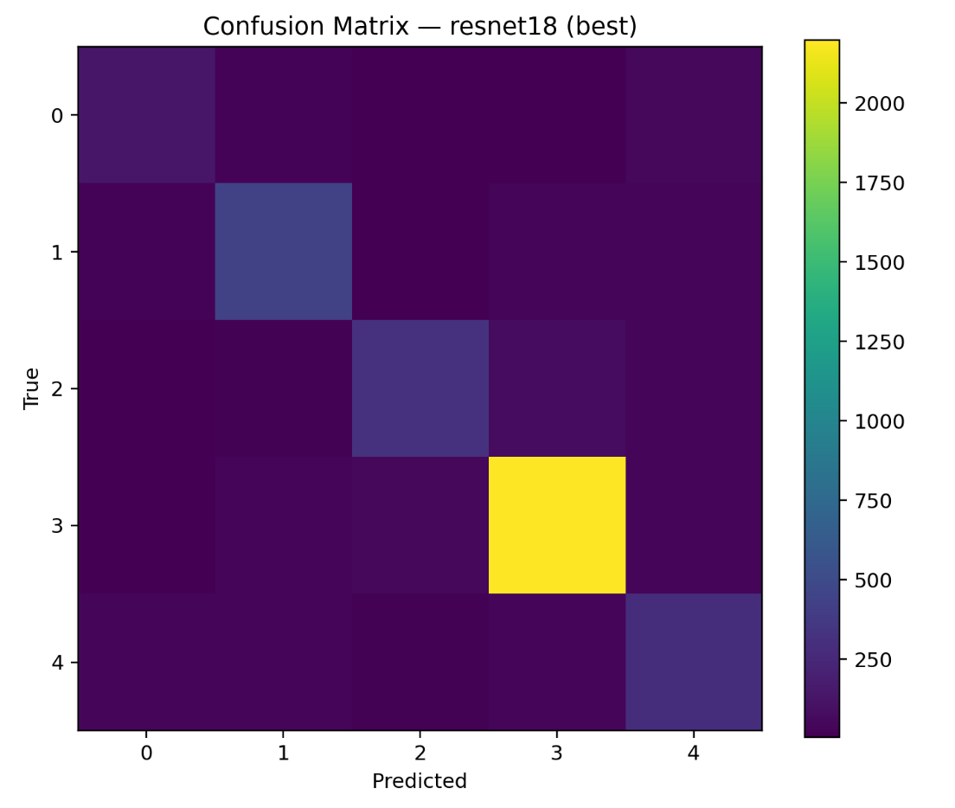

Fig. 1. Confusion matrix of ResNet18 (best-performing model) on the cassava test dataset.

Although the network achieved high global accuracy, the confusion matrix reveals minor sensitivity gaps for minority classes, particularly Cassava Green Mottle. These disparities stem from class imbalance in the dataset. Future work should employ class-weighting, data-resampling, or synthetic augmentation to enhance recall for under-represented categories. Addressing imbalance will be essential for field robustness, where disease prevalence can vary seasonally and geographically.

3.3 Interpretability with Grad-CAM

To evaluate interpretability, Gradient-weighted Class Activation Mapping (Grad-CAM) was used to visualize spatial attention across test samples (Figure 2).
For correctly classified images, activation maps concentrated on lesion regions, mosaic patches or streaks while suppressing background noise. In misclassified examples, the network still attended to leaf tissue rather than irrelevant surroundings, indicating that classification errors originated from inter-class visual similarity, not from arbitrary focus.
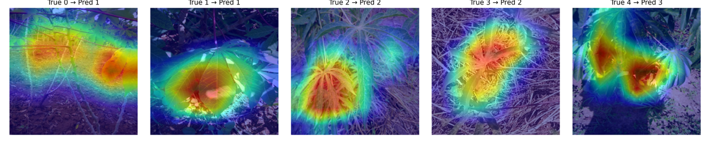
Fig. 2. Grad-CAM visualizations of ResNet18 on cassava test images.

These consistent activation patterns increase confidence in the model’s reliability for automated disease diagnosis in agricultural robotics. In real-world systems, interpretability is vital for operator trust: heatmaps confirming lesion-focused attention can aid agronomists in validating AI predictions. Furthermore, transparent model reasoning supports regulatory acceptance of edge-AI tools in precision agriculture.
3.4 Discussion and Limitations

The comparative results confirm that lightweight architectures can achieve near parity with heavier CNNs while offering superior inference speed and lower memory consumption, key attributes for real-time edge deployment. Among the tested models, EfficientNet-Lite0 provided the best efficiency-accuracy compromise, making it a strong candidate for integration into autonomous ground robots or drone-based crop-monitoring platforms.

However, this benchmark is limited by the controlled nature of the dataset. Images were collected under standardized conditions rather than in dynamic field environments. Consequently, model performance may decline when confronted with variable lighting, partial occlusion, or motion blur from robotic cameras. Future research should therefore validate these architectures using real-time imagery captured by agricultural robots and drones and explore lightweight transformer-CNN hybrids for further gains in generalization.

4. Conclusion

This research established a comparative benchmark of three convolutional neural network architectures: EfficientNet-Lite0, MobileNetV3-Large, and ResNet18 for cassava leaf-disease classification. The evaluation demonstrated that although ResNet18 achieved the highest test accuracy (85.3 %) and macro-F1 score (0.757), lightweight architectures such as EfficientNet-Lite0 and MobileNetV3-Large attained comparable performance with substantially smaller model sizes and higher inference speeds. These results confirm that well-designed lightweight CNNs can deliver reliable accuracy while maintaining the computational efficiency required for embedded and robotic applications.

Grad-CAM visualizations verified that each model consistently concentrated on disease-affected regions of cassava leaves rather than background artifacts, underscoring interpretability and trustworthiness, two essential factors for adoption in precision-agriculture systems. The combined findings reveal clear trade-offs between model complexity, speed, and transparency, and they position lightweight CNNs as practical candidates for deployment in edge-AI and agricultural-robotics platforms where real-time decision making and low power consumption are critical.

Looking ahead, research should extend this benchmarking to field-collected image streams and real robotic deployments to assess robustness under changing illumination, occlusion, and motion conditions. Integrating lightweight transformer–CNN hybrids, on-device model quantization, and energy-aware optimization could further enhance scalability and sustainability of future AI-driven crop-health monitoring systems.

COMPETING INTERESTS DISCLAIMER:
Authors have declared that they have no known competing financial interests OR non-financial interests OR personal relationships that could have appeared to influence the work reported in this paper.

Disclaimer (Artificial intelligence)

Author(s) hereby declare that NO generative AI technologies such as Large Language Models (ChatGPT, COPILOT, etc.) and text-to-image generators have been used during the writing or editing of this manuscript.

References
[1] Sambasivam G, et al. (2025). A hybrid deep learning model approach for automated detection and classification of cassava leaf diseases. Sci Rep. 15:90646. https://doi.org/10.1038/s41598-025-90646-4
[2] Zeng Z, Li Y, Chen H. (2025). AI-driven smart agriculture using hybrid transformer-CNN models for plant disease detection. Sci Rep. 15:10537. https://doi.org/10.1038/s41598-025-10537-6
[3] Azeta A, et al. (2023). A deep learning approach for cassava leaf disease classification. SSRN. https://doi.org/10.2139/ssrn.4669543
[4] Sharma R, et al. (2024). A systematic review of deep learning techniques for plant diseases. Artif Intell Rev. https://doi.org/10.1007/s10462-024-10944-7

[5] Liu Q, et al. (2024). Deep learning and computer vision in plant disease detection: a comprehensive review. Artif Intell Rev. https://doi.org/10.1007/s10462-024-11100-x

[6] Ngugi HN, Ezugwu AE, Akinyelu AA, Abualigah L, et al. (2024). Revolutionizing crop disease detection with computational deep learning: a comprehensive review. Environ Monit Assess. 196:302. https://doi.org/10.1007/s10661-024-12454-z

[7] Patel A, et al. (2025). A review on automated plant disease detection. SN Appl Sci. https://doi.org/10.1007/s44443-025-00040-3

[8] Zhang Y, et al. (2025). Image recognition technology in smart agriculture: A review. Processes. 13(5):1402. https://doi.org/10.3390/pr13051402

[9] Li X, et al. (2025). AI-IoT based smart agriculture pivot for plant diseases detection and treatment. Scientific-Report. https://doi.org/10.1038/s41598-025-98454-6
[10] Kalezhi J, et al. (2025). Cassava crop disease prediction and localization using InceptionResNet V2. Crop Prot. 182:106606. https://doi.org/10.1016/j.cropro.2024.106606

[11] Costa D, et al. (2025). Deep learning based transfer learning for classification of cassava disease. arXiv preprint. arXiv:2502.19351. https://arxiv.org/abs/2502.19351

[12] Che C, Xue N, Li Z, Zhao Y, Huang X. (2025). Automatic cassava disease recognition
using object segmentation and progressive learning. PeerJ Comput.
Sci. 11:e2721. https://doi.org/10.7717/peerj-cs.2721

[13] Yadav S, et al. (2024). Machine learning and deep learning for crop disease diagnosis: a survey. Agronomy. 14(12):3001. https://doi.org/10.3390/agronomy14123001

[14] Sun J, et al. (2025). Emerging developments in real-time Edge AIoT for agriculture. IoT. 6(1):13. https://doi.org/10.3390/iot6010013

[15] Bello A, et al. (2025). A comprehensive survey on cassava disease detection and classification using deep learning models. Pan Afr J Interdiscip Innov. 2:377. https://doi.org/10.56294/piii2025377

[16] Howard A G, Sandler M, Chu G, Chen L-C, et al. (2019). Searching for MobileNetV3. arXiv preprint.arXiv:1905.02244. https://arxiv.org/abs/1905.02244

[17] Tan M, Le Q. (2019). EfficientNet: Rethinking model scaling for convolutional neural networks. arXiv preprint.arXiv:1905.11946. https://arxiv.org/abs/1905.11946

[18] Lu Y, Yi S, Zeng N, Liu Y, Zhang Y. (2017). Identification of rice diseases using deep convolutional neural networks. Neurocomputing. 267:378–384. https://doi.org/10.1016/j.neucom.2017.06.023

APPENDIX

Fig . A1. Confusion matrix of mobilenetv3-large on cassava teST DATASET

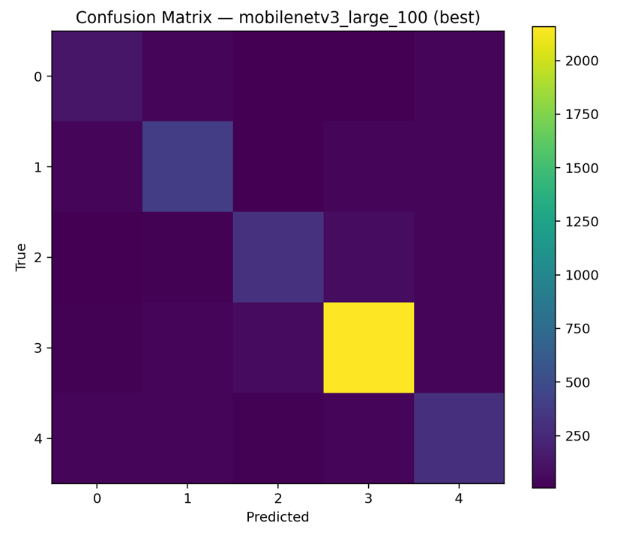

FIG A2. Confusion matrix of efficientnet-lite0 on cassava test dataset

