Effect of Sinusoidal Rigid-Ring Baffle Geometry on Sloshing Dynamics in Long Cylindrical Vessels: A Numerical Study

ABSTRACT
Long Cylindrical Vessels (LCV) usually experience slosh-induced instability arising from oscillations of their fluid content. Flat Rigid-ring Baffle (FRB) commonly used as a slosh-suppression device. Abramson, H.N. (1960) in LCV but its performance has not appreciably suppressed sloshing thus, necessitating continuous efforts to investigate other baffle configurations. This work was designed to investigate sloshing characteristics numerically of LCV equipped with two types of Rigid-ring baffles of varying geometries namely: Sinusoidal Rigid-ring Baffle-1, 0.04m pitch (SNRB1) and Sinusoidal Rigid-ring Baffle-2, 0.04m pitch (SNRB2).and Flat Rigid-ring Baffle (FRB) as baseline at gravity (g = 9.81 m/s²). Adebayo et. al., July, (2022), Adebayo et. al. December, (2022) and Adebayo et. al. August, (2025).
Continuity and Navier-Stokes Equations were used as model governing equations which were developed and solved using Finite Element Analysis technique Mohan, A. (2014), to obtain pressure and velocity which were used to evaluate forces at the cylinder’s wall. These parameters were used to evaluate Damping Ratio (DR) of each baffle at (72, 66 and 59) % standard positions, in a 75% Water-filled Cylinder (WCC) having slenderness ratio of 1.5 excited at frequency of 2 Hz. Data were analysed using descriptive statistics and ANOVA at α _{0.05}
The results showed that Sinusoidal Rigid-ring Baffle has higher damping characteristics than other baffles geometries at (72 and 59) % water-filled positions of the cylinder.
Keywords: Sloshing, Dynamic-System, Damping-ratio, Instability, Baffle.
Introduction
Common reasoning requires a careful handling of a container and its content, adjustment of the carrier’s motion while moving with it to avoid spillage hence, partially filled container has a tendency to oscillate at its free surface (FS), to avoid sloshing of the contained liquid (Adebayo et. al., December, 2022). Sloshing could be defined as to and fro FS motion of liquid in a not-filled to the brim container, due to disturbances by way of perturbations. Long Cylindrical Vessels provides good illustration of the response of liquid in a storage and important criterion to be considered by designers of dynamic systems (DS): such as fuel tanks of aircrafts, liquid rocket engine, ships, automotive vehicles etc., K.M.Tehrani et al., (2007). Holistic study of sloshing captures oscillations of water in lakes and harbours which results in earthquakes, Wei et al., (1996) further illustrates typical example of this phenomenon.
The problem of liquid sloshing majorly involves the estimation of hydrodynamic pressure distribution, forces, moments and natural frequencies of the free-liquid surface. Its magnitude also depends on the container geometry, fluid properties, fluid-filled level, perturbing motion of the container, acceleration field and damping capability of the system (NASA SP-8009). These parameters have a direct effect on the dynamic stability and performance of moving vessels. To eschew catastrophic effect of this phenomenon in LMVs, its natural frequencies (NF) must be widely separated from the sloshing-fluid frequencies (Ibrahim, 1999). None linearity nature of sloshing poses serious challenge in LCV hence, solving such a problem analytically or computationally involves many assumptions thereby causes deviations in the actual values of the solution (Eswaran, 2011). Experimental and Computational Fluid Dynamic (CFD) analysis offers an important tools to analyse the liquid dynamics and the resulting sloshing forces and moments which are the critical quantities in modelling control and stability of dynamic systems.
Baffles are obstructing plates primarily secured within a container to supress slosh C. Bhavya et al., (2013), obstruction of slosh in the course of its oscillatory motion breaks up its waves and dies out hence, lessen Hydrodynamic Pressures (HP) on the container’s wall. Cruciform baffles, Vertical baffles and Horizontal (Ring) baffles are the commonly used baffles and their dimensions are obtained from the analysis of the vehicle (NASA SP-8031 1969).
The focus of this study is to investigate possible baffles configuration that can reduce vibration induced sloshing in a LCVs hence, the specific objectives is:
Investigation of the Effect of Sinusoidal Rigid - ring Baffles (SNRB) on sloshing characteristics in a LCVs.
Dynamic system such as liquid rocket engine in flight, is subjected to translatory and oscillatory distubances from external forces such as guidance and control inputs, aerodynamic perturbations, acoustic perturbation, thrust - induced oscillation, structural flexibility - induced oscillation, dynamic load such as bird shock result in disturbances of the fuel tank and contained liquid. Coupling of any of these modes of oscillation may lead to resonance and structural failure, (Bauer, H. F. 1964) and (Abramson, H.N. 1969). Sloshing modes may also couple with the rigid body and bending modes which may result in stability problems and further aggravated by light damping of the propellant tank, because large vehicles damping is inversely proportional to the tank’s diameter (Panferov et al., 2008). However, the increasing size of space vehicles and their larger tanks diameters lower the natural frequencies of the propellants hence, the effects of propellant sloshing and the vehicle stability becomes extremely critical. At launch, more than ninety per cent of the total mass constitutes liquid propellant, this will requires more control inputs to return the deviated space vehicle to its original trajectory. Furthermore, elastic properties of a rocket structural element initiate vibrations in the neighbourhood of resonance frequency. Beyond instability boundaries, there is tendency for divergence oscillations arising from structural failure that circumvent smooth ride in aerospace systems as reported by Adebayo and Osheku (2012). Sloshing can be induced by tank motions resulting from guidance and control system commands or change in vehicle acceleration, as it occurs when thrust is reduced by engine cut-off or when the vehicle encounters wind shears or gusts. If liquid is allowed to slosh freely, it can produce forces that cause additional vehicle accelerations, which can sensed and responded to by the guidance and control system, forming a close loop that can lead to instability. Structural failure as a result of sloshing could prevent the spacecraft from achieving upper-stage engine start as a result of loss of propellant head at the drain port and eventual loss of propellant through the tank vent system as described in Abramson, H.N. (1969). Flexible vehicles in view of structural oscillations of fluid in tanks, moving masses inside the vehicle and elastic bending of a body surface interacting with a surrounding medium in a broad band of speed variation, can lead to instability of dynamic systems as described in (Nebylov et al. 2005a, 2005b and 2005c).
II Literature Review
Jing-Han et al., (2019) studied sloshing and the effect of vertical baffle attached to the bottom of a tank. Linear Velocity Potential Theory (LVPT) was employed in the study. Their conclusion was that, motion of the baffle, both magnitude and phase can be adjusted simultaneously in reducing the FS elevation and significant reduction of sloshing wave.
Jing-Han et al., (2019) studied sloshing and the effect of vertical baffle attached to the bottom of a tank. LVPT was employed in the study. Their conclusion was that, motion of the baffle, both magnitude and phase can be adjusted simultaneously in reducing the FS elevation and significant reduction of sloshing wave.
Chia Chu et al., (2018) employed both experimental and numerical simulation to investigate sloshing with embedded multiple baffles fixed at bottom of a rectangular tank containing water. Volume of Fluid (VOF) method was employed in solving FS equation. Validation of the simulation results was performed with shaking-table experiment. Determination of the impact of baffle’s height and the space between them on slosh suppression was the objective of the study. Simulation results affected the NF of the tank significantly, as a result of the present of multiple baffles. The reduction of the hydrodynamic force (HF) by the multiple baffle is much than a single baffle also, forces from the tank’s sidewall due to integrated pressure can be represented by slosh-wave amplitude. Frequency, and water depth. Slosh-wave amplitude and HF reduced while, baffles height and its numbers increased hence, there was reduction in impact of baffles on slosh suppression when this equation holds: hd/hw ≥ 0.75 holds.
Mi-AnXue et al., (2017) studied four types of baffles and its effectiveness in slosh suppression under a forcing frequencies of 0.4 ω1 to 1.4 ω1.Effectiveness of the baffle of vertical geometry near the FS is significant in slosh suppression than the one fixed at the bottom of the container. Slosh suppression of perforated baffle of vertical geometry is more significant than surface-piercing counterpart of vertical geometry mounted at the bottom of the tank at broad band frequency region. It was observed that the tank-liquid system first-mode NF was changed with the present of the vertical baffles. The result of the experiment showed that alteration of flow fields and NF may significantly damp HF on the tank walls.
Wenjing et al,. (2017) studied prediction of sloshing characteristic in a tank undergoing a motion using numerical approach, and the results was compared with measurements of a model test. Four numerical techniques namely Finite Volume-of-Fluid (VoF) technique, none-compressible VoF technique, compressible VoF method and none-compressible coupled Level-Set (clsVoF) were investigated. Obtained results showed that method of compressible VoF was better in obtaining more precise predictions of sloshing.
Mi-An Xue et al,. (2012) investigated sloshing characteristic using double-phase fluid to solve the governing Navier-Stokes equations. Horizontal, perforated-vertical and their combination excited harmonically were considered. The results, shows that serious dynamic impact pressures often occurred at the neighbourhood of FS. The result also showed that the nonconventional combinatorial baffles possess better damping characteristics than conventional baffles. Perforated baffle reduced weight without compromising the rigidity.
Rakheja et al., (2010) investigated impact of different baffle geometries on liquid sloshing. Conventional lateral baffle perform better than oblique baffle in damping the slosh under longitudinal acceleration excitation but, oblique baffle minimised longitudinal, lateral forces and moment when the tank accelerated longitudinally and laterally.
Takabatake et al., (2008) studied structural failure caused by liquid sloshing. Their observation was that, some petroleum tanks were damaged due to fuel slosh during 2003 Tokachi-oki, Japan. There was a prediction of occurrence of severe earthquake within 50 years, likely to cause another havoc hence, splitting wall was developed as a novel technique to supress slosh. Experiments were performed to validate numerical simulation for the study. Results obtained from the experiment indicated that the technique will reduce sloshing excited by sinusoidal force effectively. The results of both investigations modes agreed and they concluded that the proposed device could be effective in preventing ground motion.
III. Computational Modelling Tool
Sinusoidal Rigid - ring Baffle was selected for numerical set up, dimension was selected to ensure geometrical similarity with the numerical equivalent hence, the baffle set up characteristics are listed below:
Baffle pitch: 0.0200 m and 0.0400 m
Tank is 75 % filled with water
Baffle positions: 72 %, 66 %, 59 % respectively)
Tank size: 0.6 m (height); 0.4 m (diameter).
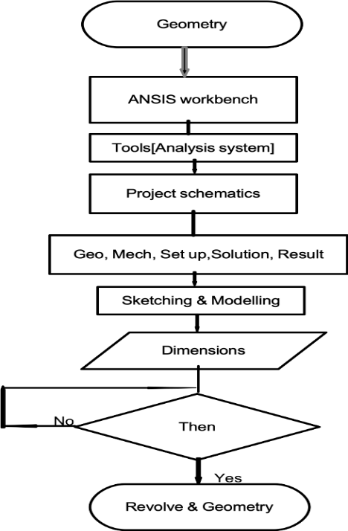

Fig. 1. Flow – Chart illustration of geometry creation (ANSYS CFX Workbench 15.0 November, 2013)
Figures 2 and 3 show the Tank-Baffles geometries drawn in ANSYS representing graphical illustration of Sinusoidal Rigid-ring Baffle (SNRB1and SNRB2) of 0.1m of thickness and pitch values of 0.02 m and 0.04 m respectively.
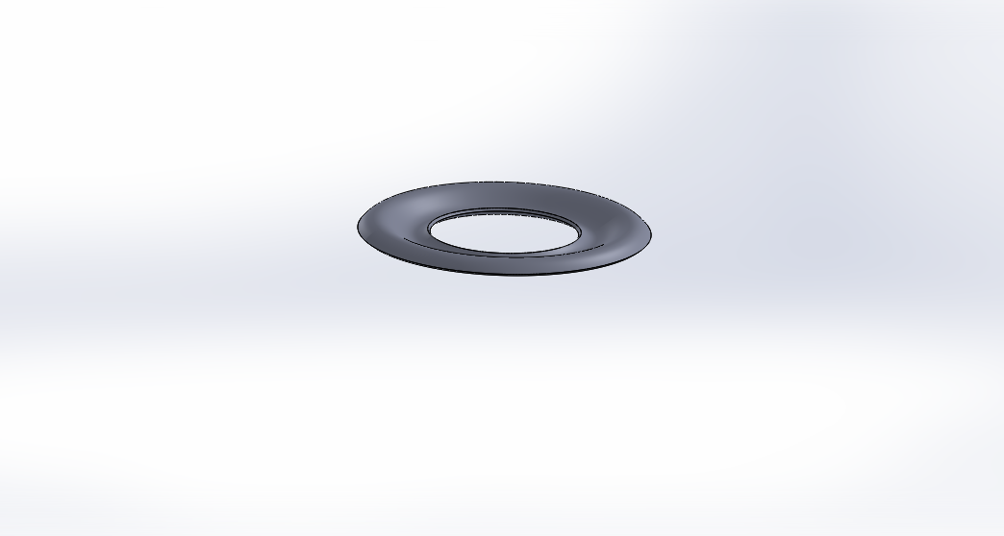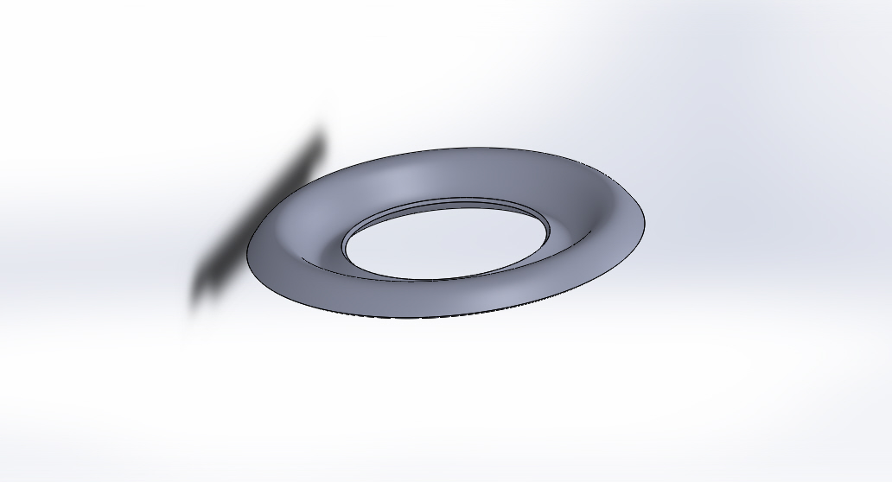
Fig. 2. SNRB1 (0.02 m pitch) Fig. 3. SNRB2 (0.04 m pitch)
(SolidWorks 2014)

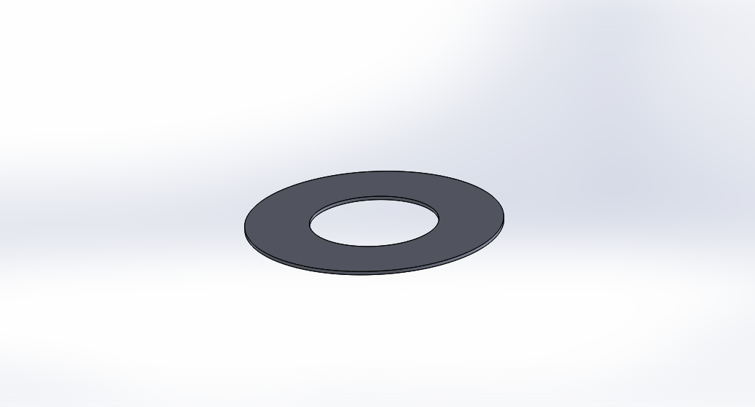
Fig. 4. CAD of Flat Rigid-ring Baffle of 0.1 m width (SolidWorks 2014)

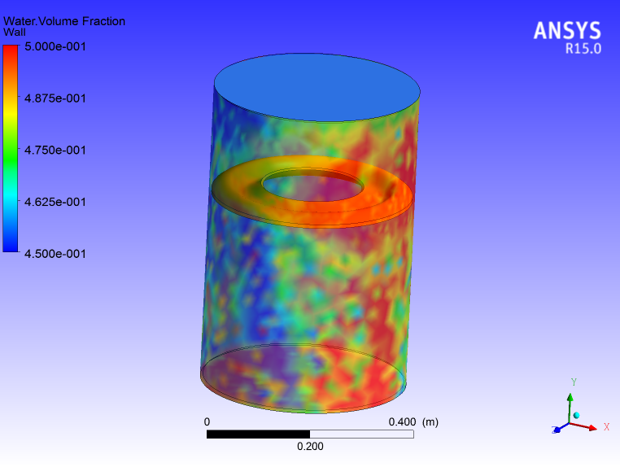
Fig. 5. Finite Element Model of the Tank-water system and embedded sinusoidal baffle (ANSYS CFX-Solver Modelling Guide, November 2013. User’s Guide Release 15.0, ANSYS Inc. USA).
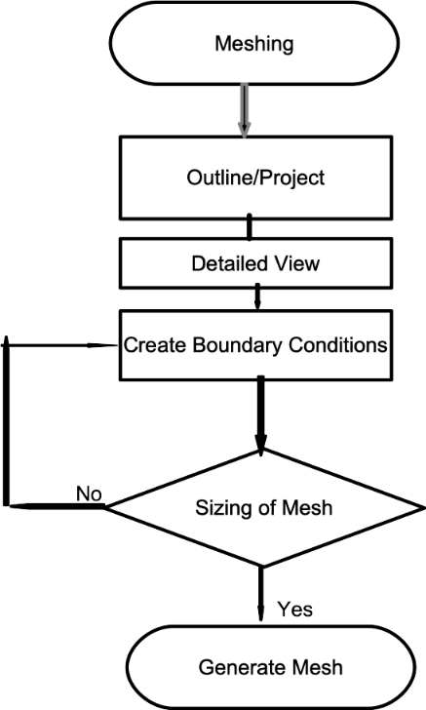
Fig. 6. Algorithm for generating Finite Element Model of the Tank-water system.

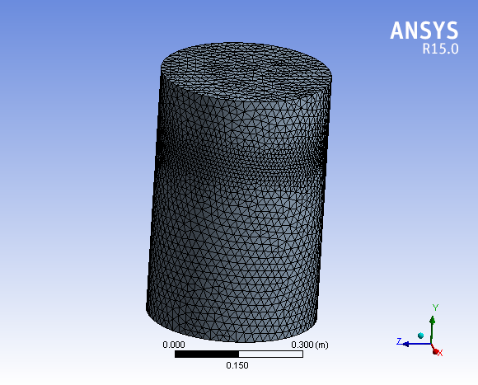
Fig. 7. Illustration of a sample of finite element of the tank, baffle and the test fluid (water) while (ANSYS Modelling Meshing Guide, 15.0 November, 2013).

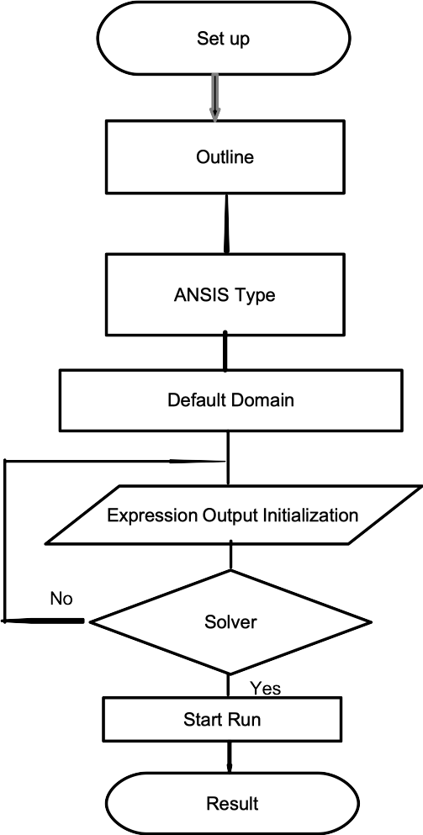
Fig. 8. Algorithms for problem set-up.

Equation of Motion
The dynamic of fluid while in motion could be represented mathematically by equations derived from conservation of mass and Navier-Stokes equation. Çengel, Y.A. and Cimbala, J., M. (2006). These equations were solved using commercially available software, ANSYS solver to obtain pressure and velocity which are used to evaluate the forces at the walls of the tank.
The basic differential equation that a velocity potential must satisfy everywhere in the
liquid volume is the condition of liquid incompressibility, which is given by:
$\frac{∂u}{∂x}+\frac{∂v}{∂y}$ + $\frac{∂w}{∂z}$= 0 (1)
This equation is also known as Continuity Equation, where Eq. (2) represents general differential and compressible form of this equation.
$\frac{∂ρ}{∂t}+\vec{V}.\left(p\vec{V}\right)=0$ (2)
Where $\vec{∇}$ is the component of velocity vector in x, y, z axes respectively.
Momentum Equation (incompressible Navier–Stokes equation in vector form)
$ρ\frac{D\vec{V}}{Dt}=-\vec{∇}p+ρ\vec{g}+μ∇^{2}\vec{V }$ (3)
$∇^{2}=\frac{∂^{2}}{∂x^{2}}+\frac{∂^{2}}{∂y^{2}}+\frac{∂^{2}}{∂z^{2}}$ (4)
Where, $∇^{2}$ is the Laplacian operator, in Cartesian coordinate, $\vec{g}$ is acceleration due to gravity in vector form.
Integration of these governing equations yields non-steady version of Bernoulli’s equation for a potential flow without vorticity as:
$\frac{∂ϕ}{∂t}+\frac{p}{ρ}+gz+\frac{1}{2}\left(u^{2}+v^{2}+w^{2}\right)=f\left(t\right)$ (5)
where, Φ. P, ρ and g are the velocity potential, fluid pressure, fluid density and effective gravity acting in the negative z direction (this is equivalent to laboratory value but in opposite direction to the axial acceleration for a space vehicle) respectively. Small values of velocities u, v, and w were assumed, for the squared and higher power terms of these values to be negligible in comparison to those terms that are linear for linearization of the equation. Existence of the derivative of the velocity potential with physical meaning facilitates addition of time function to the definition of Φ. Hence, constant of integration f (t) in Eq. (5) is absorbed into the definition of Φ, linearised form of the equation (5) is in the form of Eq. (6), as detailed by Franklin (2000)
hence,
$\frac{∂∅}{∂x}+\frac{p}{ρ}+gz=0$ (6)
Boundary Conditions (BC) at the Free Surface
The walls BC and FS of the tank could be satisfied by solution of any mathematical function that satisfy equation (1). Also, Equation (6) is used to derive one of the BC at the FS. There is a free movement of the surface hence, insignificant values of the gas density in comparison to the liquid pressure at the surface, makes it equal to gas static pressure $p_{0}$ at the FS. Nonsteady Bernoulli’s equation at the FS is given by Franklin (2000) in the form
$\frac{∂ϕ\left(x, y, z, t\right)}{∂t}+gδ\left(x, y, t\right)=\frac{p_{0}}{ρ}$,
for $z=\frac{h}{2}$ (7)
Free surface small displacement is represented by δ(x, y, and t) and the height above FS is given in the form
z = h/2 (8)
Unlinearised Eq. (7) would be solved at the point of displacement, therefore
z = h/2 + δ (9)
of the FS instead of equilibrium position
i.e.
z = h/2. The difference between the two conditions (z = h/2 and z = h/2 + δ) results in higher order term of δ, which could be neglected. For small value of g, surface tension effect is significant to be considered in Equation (7). Gas pressure retains its value as ${ p}_{0}$ but, pressures values of liquid and gas are not the same at the FS and the adjacent side, this difference is a function of surface curvature and tension. Equation (7) represents the “dynamic” state at the FS. Relationship between displacement at the surface δ and the component of the velocity along vertical axis of the liquid at the FS requires kinematic analysis. In a linearised form, this condition is simply.
$\frac{∂δ}{∂t}=w=\frac{∂φ}{∂z }$ , for $\frac{h}{2}$ (10)
Combining Equations (7) and (10) and writing it in terms of $φ (or δ)$ and differentiate with respect to t and z respectively, combine both equations to eliminate$φ (or δ)$ output to be,
$\frac{∂^{2}φ}{∂t^{2}}+\frac{∂φ}{∂z}=0$ for $\frac{h}{2}$ (11)
Natural frequency of the sloshing is an integral part of the time derivative of $φ$ in Eq. (11) which shows a direct relationship to the imposed gravitational field, earlier mentioned.
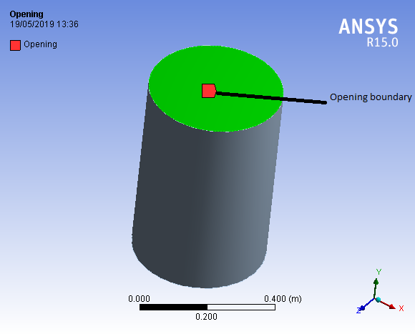
Fig. 9. Opening Boundary conditions
Boundary Conditions at the Tank Walls
Assumption of negligible values of viscosity and viscous stresses render these quantities unsuitable for defining boundary condition (BC) at the wall hence, the value of velocity perpendicular to the wall’s plane of the tank, which is equal to $V_{n}$ is more appropriate, (n stands for normal direction) and condition of “no-slip” is not applicable hence slipping is allowed in the direction parallel to the wall. For a stationary tank, the BC at the wall is the normal velocity component of the liquid to the wall and is equal to zero. The value represents the standard type of BC value problem. Assumption of oscillation of the liquid–tank system, leads to a problem of non-standard boundary value, solvable by employing Fourier series. Problem that involves non-oscillatory motion of tank which results to none standard problem could be transform to standard boundary value mathematically by representing liquid motion in two parts. Rigid body (RB) motion similar to tank’s motion, and liquid motion relative to the RB motion. This approach is similar to what is obtainable in solid mechanics to analyse particle’s motion relative to a coordinate system in motion as detailed by Franklin (2000) hence, transformation in term of velocity potential is cast in this form;
${Φ=∅}_{c}+∅$ (12)
where $Φ$ is the velocity potential, $∅_{c}$ and $∅$ are the potential for the tank’s rigid body motion and a motion of the liquid relative to the rigid body motion respectively hence, BC for Φ at the wall of the tank’s wall reduces to.
$\frac{∂∅_{c}}{∂n}=V_{n}$ (13)
$\frac{∂∅}{∂n}=0$ (14)
Where, $V_{n}$ is the liquid velocity perpendicular to the plane of the wall, and n stands for the normal or perpendicular direction.
This could not be applied to tank in rotational motions as velocity potential of the tank motion would have a non-zero value of vorticity. Sloshing problem is linear hence, it requires solving problems of different tank motion based on their configurations and integrate the results to obtain velocity potential for the whole motion (Franklin, 2000).
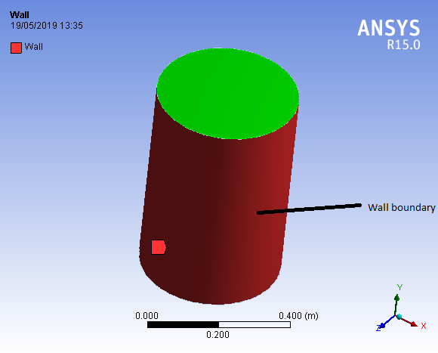
Fig. 10. Wall boundary conditions
$F_{x}= \sum_{c}^{wetted area}{\left(p_{c}* {\vec{A}}_{cx}\right)}$ (15)
${ F}_{y}=\sum_{c}^{wetted area}{\left(p_{c}* {\vec{A}}_{cy}\right)}$ (16)
$F_{z}=\sum_{c}^{wetted area}{\left(p_{c}* {\vec{A}}_{cz}\right)}$ (17)
Equations. 15 to 17 are the force application obtained from the force aggregate at the wall of the cylinder.
Miles’ equation (Performance Evaluation Index)
For a flat rigid-ring baffle in a cylindrical tank, the damping ratio as a function of baffle depth d should be estimated from Miles’ equation (Miles, J. W. 1956), as a measure of the baffle performance index which is given in this from:
$ξ=\frac{δ}{2π}=2.83e^{-4.60\frac{d}{R} {\left[\frac{2W}{R}-{\left(\frac{W}{R}\right)}^{2}\right]}^{\frac{2}{3}}}{\left(\frac{η}{R}\right)}^{\frac{1}{2}}$ (18)
$ξ ,$damping ratio; $w ,$ baffle width; $η,$ maximum slosh-wave height at the wall and$δ$, the damping factor (or logarithmic decrement) and R, tank radius. The term in brackets is the fraction of the tank area covered by the baffle (Miles, 1958).
IV. Comparison and Validation Study
Numerical results of the three baffles with pitch values of 0.0200 m and 0.0400 m respectively were carried out to compare the variations of damping coefficients.
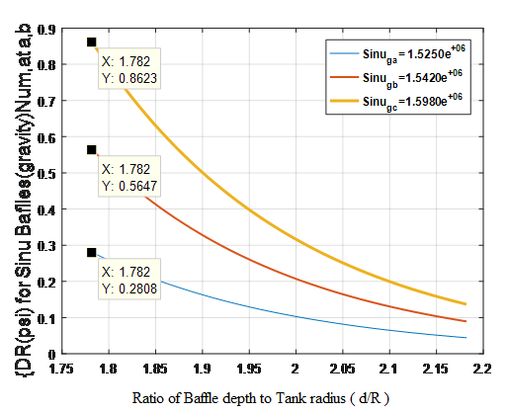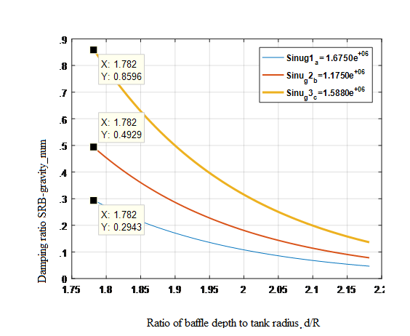
Fig. 11. SNRB1 and SNRB2 are the graphs showing DR values at different positions of the tank-water along the tank depth (Simple and Easy Tutorial on FFT Fast Fourier Transform Matlab Part 1 (1) item type MP4 Video).

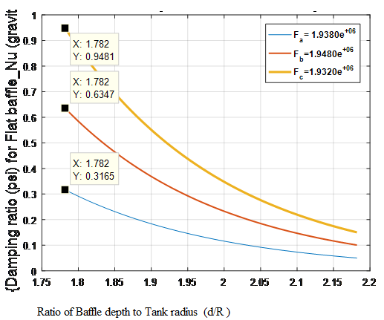
Fig. 12. FRB graphs showing DR values at different position of the tank-water along the tank depth.
The effect of pitch variation on the damping ratio of the baffles numerical results
Figures 11 and 12 are the graphs of SNRB1 and SNRB2, increment of the pitch from 0.02m to 0.040m showed increase in the DR at (72 and 59)% standard positions of the tank and reduction of DR at 62% baffle position. ln comparism, SNRB has lesser DR at 62 % water-filled position than FRB at the same position when the pitch has not increased. When the pitch increased from 0.02 m to 0.04 m, DR for SNRB increased slightly but still less in value compare to the value of DR of FRB at (62 and 59) % water-filled position of the tank
Table 1.Values of Slosh-Wave Amplitude and DR for SNRB Simple FFT and Filtering Tutorial with Matlab – Code Project).
Baffle config-  urations | Slosh-Wave Amplitude  Numerical | Damping  Ratio
SNRB 1  0.020m  Numerical | 1.5250e+06  1.5420e+06  1.5980e+06 | 0.2808  0.5647  0.8623
SNRB 2  0.040m  Numerical | 1.6750e+06  1.1750e+06  1.5880e+06 | 0.2943  0.4929  0.8596

Table 2. Values of Slosh-Wave Amplitude and DR for FRB (Simple FFT and Filtering Tutorial with Matlab – Code Project) .
Baffle config-  urations | Slosh-Wave Amplitude  Numerical | Damping  Ratio
FRB  Numerical | 1.9380e+06  1.9480e+06  1.9320e+06 | 0.3165  0.6347  0.9481

(V) Conclusion
Numerical investigation of damping effects of three type of baffles was carried out, Sinusoidal Rigid Ring Baffle, secured at 0.4364 m (72 %) below the free surface of the tank provided less damping compared to Flat Rigid Ring Baffles secured at the same position. When the pitch of the baffle was increased from 0.0200 m to 0.0400 m, DR appreciated at the same position by 0.0135 which represents 4.59 % of the value before increment. This is not significant hence, increasing the pitch of this baffle at this position is not necessary.

Disclaimer (Artificial intelligence)

Option 1:

Author(s) hereby declare that NO generative AI technologies such as Large Language Models (ChatGPT, COPILOT, etc.) and text-to-image generators have been used during the writing or editing of this manuscript.

Option 2:

Author(s) hereby declare that generative AI technologies such as Large Language Models, etc. have been used during the writing or editing of manuscripts. This explanation will include the name, version, model, and source of the generative AI technology and as well as all input prompts provided to the generative AI technology

Details of the AI usage are given below:
1.
2.
3.

References
Abramson, H.N., (1966). The dynamic behaviour of liquids in moving containers. NASA SP-106. NASA Special Publication, 106.
Abramson, H.N., (1969). Slosh suppression report. NASA, Washington DC, SP-8031.
Adebayo, M. A. (2009). Bending modes Control of Aerospace Vehicles. International Institute for advance Aerospace Technologies, At. Petersburg State University of Aerospace Instrumentation, 67, Bolshaya Morskaya, St. Petersburg, 190000, Russia.
Adebayo, M. A. (2010). Algorithms of bending modes Control of Aerospace Vehicles. International Institute for advance Aerospace Technologies, At. Petersburg State University of Aerospace Instrumentation, 67, Bolshaya Morskaya, St. Petersburg, 190000, Russia.
Matthew Adebayo and Charles Attah Osheku (2012) ‘‘On Structural Vibration and Flexural Modes Determination of Aerospace Vehicles’’ Vol. 1, Issue 1. (Pp.21-37)|2012 eCanadian Journal of Technology and Scientific Management
Adebayo, M., Dare, A. A., & Salau, T. O. (July, 2025). Numerical investigation of sloshing
Characteristics in long moving vessels with embedded convex rigid-ring baffle in
gravity environment. Journal of Engineering Research
and Reports. Volume 27 [Issue 8] Date of Publication: 2025-08-07 Validation
Link: https://doi.org/10.9734/jerr/2025/v27i81606
Adebayo, M., Dare, A. A., & Salau, T. O. (April, 2022). Numerical investigation of sloshing
Characteristics in long moving vessels with embedded concave rigid-ring baffle in
gravity environment. Journal of Engineering Research and
Reports22 (5): 1-13, 2022; Article no.JERR.85439ISSN: 2582-2926
Adebayo, M., Dare, A. A., & Salau, T. O. (December, 2022). Experimental investigation of
Embedded Concave Baffle in a Long Moving Vessels at Gravity and Microgravity
Environments International journal of Advances in Engineering and Management
(IJAEM) ISSN: Received 25 January, 2022, Accepted 02 April, 022, Published 07
April. 20222395-5252 Volume 4, Issue 11, pp: 911-923 www.ijaem.net
Bauer, H.F., 1962. The Damping Factor Provided by Flat Annular Ring Baffles for Free Fluid Surface Oscillations. MSFC, Rept. No. MTP-AER0-62-81,(Nov. 13, 1962).
Bauer, H.F., (1964). Fluid oscillations in the containers of a space vehicle and their influence upon stability. National Aeronautics and Space Administration; [For sale by the Office of Technical Services, Department of Commerce, Washington, DC 20230].
Çengel, Y.A. and Cimbala, J., M. (2006). Fluid mechanics fundamentals and applications.
Chia Chu. 2018 .Slosh-induced hydrodynamic force in a water tank with multiple baffles National Central University. Article in Ocean Engineering.
Cole Jr, H.A. and Gambucci, B.J., 1961. Measured two-dimensional damping effectiveness of fuel-sloshing baffles applied to ring baffles in cylindrical tanks.
Eswaran, M. and Saha, U.K., (2011). Sloshing of liquids in partially filled tanks–a review of experimental investigations. Ocean Systems Engineering, 1(2), pp.131-155.
pp.198-205.
Rakheja S, Tehrani KM, Stihacu I. (2010) Three Dimensional Analysis of Transient Slosh
within a partially-filled tank equipped with baffle. Journal of Vehicle System
Dynamics. 2010; 45:526-548.
Ibrahim I. M. (1999). Anti-Slosh Damper Design for Improving the Roll Dynamic Behavior of Cylindrical Tank Trucks vol. 108, section 2. Journal of commercial vehicles (1999), pp. 535-541 (7 pages) published By. SAE International

Jing-Han Wang and Shi-Li Sun (2019). Sloshing characteristics of a swaying
rectangular tank with a rolling baffle. Journal of Engineering Mathematics volume 119, pages23–41
Miles, J.W., (1956). On the Sloshing of Liquid in a Cylindrical Tank. Rep. No.AM 6-5. GM-TR-18, Guided Missile Res. Div., The Ramo-Wooldridge Corp.
Miles, J.W., (1958). Ring damping of FS oscillations in a circular tank. J. Appl. Mech, 25(2), pp.274-276.
Mohan, A., (2014). Finite element analysis on trapezoidal tank to suppress sloshing effect. International Journal of Innovative Research in Advanced Engineering, 1(10), pp.121-125.
Nebylov, A.V., A.I. Panferov and S.A. Brodsky (2005a). Flexible aerospace vehicles simulation and nonlinear control synthesis. Proceedings of 16th IFAC World Congress, Prague.
Nebylov, A.V., S.A. Brodsky and A.I. Panferov (2005b). Peculiarities of Stabilization and Guidance Systems for Flexible Vehicles and Software Package for Such Systems Simulation and Design. Proceedings of II European conference for aerospace sciences, TsAGI-ONERA, Moscow.
Nebylov, A.V., S.A. Brodsky and A.I. Panferov (2005c). Mathematical Models, Designing, Analysis and Synthesis of Control Systems of Complex Flexible Objects. Proceedings of International Conference "Physics and Control", Saint Petersburg.
Panferov A.I., Nebylov A.V. and Brodsky, S.A., (2008). Mathematical Modeling, Simulation and Control of Flexible Vehicles. Proceedings of 17th IFAC World Congress, Seoul, 16071-16077
Takabatake, D., Sawada, S., Yoneyama, N. and Miura, M., (2008), October. Sloshing reduction effect of splitting wall in cylindrical tank. In The 14th World Conference on Earthquake Engineering” October (pp. 12-17).

