Elevating Continuous Verification Through Advanced Behavioral Analytics: A Deep-Dive Framework for Combating Insider Threats and Account Takeovers in Modern Cybersecurity

Abstract
This study addresses the persistent failure of static trust models including perimeter defenses, multi-factor authentication (MFA), and PCI-DSS compliance to detect insider threats and account takeovers (ATO) after initial authentication. Using the LANL Unified Host and Network Dataset, CERT Insider Threat Dataset v6.2, and DARPA OpTC traces, this research develops and empirically validates the Advanced Behavioral Analytics for Zero-Trust Continuous Verification (ABA-ZTCV) framework. The framework introduces a Graph–Sequence Hybrid model, Bayesian risk calibration, and bi-objective policy optimization to balance detection accuracy with user friction. Architecturally, ABA-ZTCV is structured across four adaptive layers: (1) Telemetry Fusion, integrating multi-source behavioral and identity signals; (2) Representation Learning, combining graph-based and sequential embeddings; (3) Risk and Policy Orchestration, translating calibrated anomaly scores into adaptive zero-trust controls; and (4) Feedback and Drift Management, ensuring resilience against behavioral evolution. Empirical results demonstrate that ABA-ZTCV achieves 93% detection accuracy, reduces mean time-to-detect from over 30 days to 4 days, and lowers user friction to 6%, outperforming static MFA and compliance-driven baselines. This performance was achieved through a novel Graph–Sequence Hybrid architecture coupled with bi-objective optimization that dynamically balances security sensitivity and usability. The framework operationalizes continuous verification by unifying insider threat and ATO detection in a single, adaptive loop bridging a long-standing divide between compliance requirements and real-time behavioral security. Aligning with NIST SP 800-207 and SP 800-63-4, ABA-ZTCV provides a practical and standards-compliant pathway toward resilient, continuously verified enterprise cybersecurity.
Keywords: Continuous Verification, Insider Threat Detection, Account Takeover, Graph–Sequence Hybrid, Zero Trust

1. Introduction
Digital security has lately been marked by escalating insider threats and account takeover (ATO) campaigns that exploit weaknesses in static trust models. Insider threats whether malicious or accidental and credential-driven ATOs represent some of the most persistent challenges confronting enterprises (Ali, Husain, & Hans, 2025). In 2024–2025, the Snowflake credential theft campaign illustrated how attackers armed with stolen credentials and password reuse techniques compromised more than 160 corporate accounts, including those of AT&T and Ticketmaster, bypassing static multi-factor authentication (MFA) checks (Zetter, 2024). Similarly, the FinWise Bank insider breach, disclosed in 2025, revealed how a former employee retained unauthorized access for over a year, exposing data linked to 689,000 customers, a lapse made possible by incomplete off-boarding and lack of continuous monitoring (Kaseya, 2025). The Okta support system compromise in 2023–2024 further showed that adversaries could exploit stolen session tokens to bypass login authentication entirely, accessing downstream customer environments without detection (Bradbury, 2023; Krebs, 2023). In parallel, the Zelle peer-to-peer fraud litigation of 2024 revealed how millions in fraudulent transfers occurred despite financial institutions maintaining PCI-DSS compliance, raising regulatory concerns about the adequacy of static control models (Datavisor, 2021; James, 2025). Collectively, these cases reveal a recurring pattern: once initial authentication is granted, subsequent behavior often goes unscrutinized, allowing misuse to flourish under the guise of legitimate access.
This pattern reflects a deeper structural problem in enterprise security practices in that trust is often treated as a one-time event rather than a continuously verified condition. Traditional perimeter defenses such as firewalls and VPNs, as well as static MFA, concentrate on point-in-time verification (Chandramouli & Butcher, 2023; Hakim et al., 2024). Compliance frameworks such as PCI-DSS reinforce this approach by prioritizing checklist-based validations. Yet breaches continue to occur even in compliant organizations, underscoring the notion that compliance does not equal security (Chippagiri & Ramesh, 2025; Chandola, 2017). Ye et al. (2025) demonstrate that even advanced hybrid TCN-Transformer models for insider detection require the accumulation of temporal behavior before producing meaningful alerts, thereby delaying early intervention. Tao et al. (2025) present improvements in insider detection using refined classification methods but still emphasize the persistence of false positives, which erode analyst trust in detection systems. In the ATO context, Matta (2024) highlights that while machine learning strategies mitigate some fraud risks in fintech, they face limitations when confronting large-scale credential theft, session hijacking, and social engineering techniques that bypass login security. Similarly, Jurišić, Tomičić, and Grd (2023), in a systematic review, note that many compromised account detection strategies rely on static heuristics or offline analyses, making them ineffective in real-time, continuous environments. These studies collectively reinforce the observation that security systems often assume user legitimacy after login, creating opportunities for prolonged exploitation.
The urgency of addressing these gaps is underscored by both academic and industry evidence. Song and Yuan (2024) show that user and entity behavior analytics (UEBA) can model insider risks effectively but struggle to handle drift and subtle anomalies that mimic benign behavior. Santoso and Gunawan (2024), in their work on detecting ATO in fintech companies using machine learning, stress that while anomaly-based detection yields high accuracy in offline experiments, live deployment faces issues of latency and high false alarm rates. Furthermore, Ye et al. (2025) argue that federated big data analytics offers promise for insider detection but highlight challenges of scalability and integration across distributed environments. Empirical statistics reinforce these scholarly insights. The 2024 Insider Threat Report noted that 51% of organizations reported experiencing six or more insider incidents in one year, while 48% observed that incidents are increasing in frequency (Cybersecurity Insiders, 2024). The average cost of insider incidents rose to US$17.4 million per organization in 2025, with detection and containment averaging more than 80 days (Ponemon, 2025). In parallel, account takeover threats are approaching near-universal prevalence, with reports indicating that 99% of monitored tenants experienced ATO attempts in 2024, with 62% suffering at least one successful compromise (Gardiner et al., 2025). These figures point to an alarming state of affairs, illustrating that threats exploiting static trust models are both frequent and costly. Taken together, these cases, statistics, and scholarly findings paint a picture of a security environment where static, compliance-driven models fall short against dynamic, persistent threats. This backdrop establishes the context for exploring more adaptive approaches such as continuous verification and behavioral analytics, which are increasingly viewed as critical to safeguarding modern digital infrastructures. Unlike previous User and Entity Behavior Analytics (UEBA) or Zero-Trust models that address insider threats and account takeovers separately, the ABA-ZTCV framework unifies both within a single continuous verification loop. Its integration of Graph–Sequence Hybrid modeling with bi-objective optimization distinguishes it from existing approaches by jointly enhancing detection precision and reducing user friction. This unified design advances prior behavioral analytics research by operationalizing adaptive, real-time verification across diverse threat and compliance contexts.

Statement of the Problem
It seems probable that modern cybersecurity defenses fail to detect or prevent insider threats and account takeovers (ATO) because verification typically stops at the login or credential check, permitting misuse under legitimate access. Despite the proliferation of multi-factor authentication, zero trust architectures, and compliance requirements, organizations still endure serious breaches where insiders or external threat actors exploit valid credentials or stolen sessions (Kapko, 2023; Hays, Sandborn, & White, 2024). For instance, Ali et al. (2025) show that even with behavioral analytics, real-time detection is challenged by subtle behavior deviations and high false positive rates. Likewise, other studies on insider threat detection observed that detection methods still struggle to differentiate between threat types and to reduce false alarms in identity theft and privilege abuse (Tian et al., 2025; Ogunmolu, 2025d). Evidently, authenticated sessions, trusted users, or insiders may persist in producing harm without triggering alerts or defenses.
According to the 2024 Insider Threat Report, 51% of organizations reported experiencing six or more insider threat incidents in that year alone, and 48% noted that the frequency of insider incidents continues to increase (Cybersecurity Insiders, 2024). Also, survey data indicates that over 70% of companies feel moderately to extremely vulnerable to insider threats (Catalan, 2025; Cybersecurity Insiders, 2024). These metrics suggest that the existing detection and response mechanisms are not sufficient. At the same time, research into continuous authentication via behavioral biometrics shows high accuracy (≈95%) in user identification, but typically within constrained settings or with small participant groups, leaving open questions about scalability, drift, and generalization (Kang, Park, & Kim, 2025; Ogunmolu, 2025e). In addition, many ATO detection methods rely on static metrics or offline analyses, leaving real-time detection and continuous verification largely under-explored (Jurišić, Tomičić, & Grd, 2023). These evidences immediately suggests certain enquiries: How soon after login can misuse be detected? Which behavior signals reliably distinguish misuse under valid credentials from benign deviations? How to balance alerts so that users are not overwhelmed by false positives? Thus, this paper is motivated by the following research questions:
- RQ1: What behavioral features and anomaly detection techniques can reliably distinguish insider or ATO behavior under valid credentials in real time?
- RQ2: How can sequence and graph-based behavioral models, with drift-aware personal vs. cohort baselines, improve detection speed and reduce false positives for insider threats and ATO?
- RQ3: What policy enforcement mechanisms (e.g., continuous verification, step-up authentication, session revocation, privilege clipping) yield optimal trade-offs between security (loss from missed attacks) and user friction (false positive challenge rates)?
Following these interrogations, this study designed and empirically evaluated the Advanced Behavioral Analytics framework for Zero-Trust Continuous Verification (ABA-ZTCV) that unifies insider threat detection and account takeover (ATO) prevention within a single operational model. The framework seeks to close the persistent trust gap that arises when verification ends at login, by embedding real-time behavioral risk assessment into continuous verification loops. In doing so, the study advances both the scientific and practical understanding of how modern enterprises can achieve adaptive, friction-aware cybersecurity that goes beyond static compliance requirements. This aim is directly informed by recurring breaches such as the 2024–2025 Snowflake credential theft campaign, the FinWise Bank insider breach, and the ongoing regulatory scrutiny over Zelle-enabled fraud which collectively demonstrate that static authentication, point-in-time MFA, and compliance with PCI-DSS do not guarantee effective protection. These cases illustrate the urgency of developing a framework that not only strengthens detection but also operationalizes responses in real time while balancing security with user experience. Hence to achieve this aim, the study pursues the following objectives:
- To critically examine the limitations of existing security models (perimeter defenses, static MFA, and PCI-DSS compliance) in addressing insider threats and ATO, thereby identifying the trust gaps that persist in modern environments.
- To design a comprehensive framework (the ABA-ZTCV framework) that integrates multi-source telemetry (identity logs, device fingerprints, endpoint activity, network flows, and behavioral biometrics) with Graph–Sequence Hybrid modeling, Bayesian risk calibration, and bi-objective policy optimization.
- To operationalize continuous verification through policy orchestration, mapping behavioral risk scores to adaptive zero-trust controls (e.g., step-up authentication, privilege clipping, token revocation, session termination), and aligning these responses with relevant standards (NIST SP 800-207 and SP 800-63-4)
- To empirically evaluate the performance of the framework across insider and ATO scenarios using public, synthetic, and enterprise-mirrored datasets (LANL, CERT, DARPA OpTC), measuring detection accuracy, time-to-detect (TTD), time-to-respond (TTR), analyst workload, and user-friction metrics

2. Literature Review
Traditional security models, historically anchored in perimeter defenses such as firewalls, virtual private networks (VPNs), and static multi-factor authentication (MFA), contend with inherent constraints as digital ecosystems expand in complexity. Traditional perimeter-based security models are increasingly inadequate to protect assets in environments characterized by cloud adoption, remote work, and Bring Your Own Device (BYOD) policies; firewalls and VPNs alone are found to fail at preventing lateral movement and misuse of credentials once an adversary penetrates the perimeter (Gambo & Almulhem, 2025). While studies on MFA underscore its importance, Musa and Shu’aibu (2025) reveal that its efficacy is uneven, asserting that while MFA significantly reduces automated attacks and certain credential theft attempts, that the type of MFA used, its implementation context, user compliance, and its integration into broader identity frameworks affect how much risk remains. In many settings, static MFA becomes a single point of failure, especially where phishing, session hijacking, or credential reuse are involved, because once credentials or tokens are compromised, MFA does not always block ongoing misuse.
Moreover, PCI-DSS (Payment Card Industry Data Security Standard) has played a prominent role in establishing minimum security requirements for organizations handling payment cards. Historically, PCI-DSS emphasized securing the perimeter, encrypting data at rest and in transit, maintaining secure configurations, and performing regular assessments. Nonetheless, critics argue that PCI-DSS has focused too heavily on prescriptive controls rather than adaptive or behavioral monitoring (Udechukwu, 2025a). In agreement, several scholars assert that compliance with PCI-DSS often results in a false sense of security, as organizations can satisfy requirements yet remain vulnerable to novel attack vectors that exploit human behavior, credential misuse, or internal threats. For instance, Jarugula (2025) contends that although compliance frameworks reduce certain risks, they do not guarantee effective detection of insider threats or account takeover because most breaches exploit behaviors that lie outside the scope of static compliance checks.
Evidence of insufficiency in compliant institutions is emerging with alarming consistency. Studies of institutions that are formally PCI-DSS or similarly compliant reveal that they continue to suffer breaches in which valid credentials or session tokens are misused. The study of Singh, Pareek, and Sharma (2025) proposed a blockchain-enabled zero trust framework in fintechs, comparing its model against perimeter-based systems and showing marked improvement in preventing credential theft and insider threats, implying that institutions relying on classic perimeter models remain exposed. Similarly, Hasan (2024) reports that sectors including finance and healthcare many of which adhere to robust compliance frameworks still experience high-profile insider breaches and lateral attacks under nominally secure environments, because static access assumptions allow undue trust. Thus, even compliant organizations are demonstrably vulnerable, suggesting that static authentication and compliance rules are no longer sufficient on their own to prevent sophisticated threats.
Zero Trust and Continuous Verification
Zero Trust, as formally codified in NIST SP 800-207, shifts the paradigm from traditional perimeter-based defenses to a posture in which no network segment, user, or device is trusted by default, and all access requests are continuously verified (Rose et al., 2020). NIST SP 800-207 articulates core tenets including least privilege, continuous authentication and authorization, micro-segmentation, and ensuring secure communications regardless of location (Rose et al., 2020). More recently, SP 800-207A elaborates on dynamic access control for cloud-native applications and emphasizes that identity-based and application-level policies must be enforced irrespective of deployment location, thus pushing the model toward more fine-grained, runtime evaluation of risk (Chandramouli & Butcher, 2023; Kolo et al., 2025). Continuous Access Evaluation (CAE), while not yet as comprehensively explored in academic literature, is implicit in these frameworks: it refers to mechanisms by which access is reevaluated during sessions or when risk evidence changes, rather than trusting a session for its entire duration.
Industrial implementations of Zero Trust principles, notably Google’s BeyondCorp and Microsoft’s CAE initiatives, offer evidence of both promise and challenge. BeyondCorp has enabled Google employees to access internal resources from untrusted networks by enforcing device posture, contextual identity, and role-based access without relying on traditional VPN perimeters (Google, 2024). It demonstrates that shifting access grants from network location to contextual factors can significantly reduce reliance on static infrastructure. Microsoft’s efforts under Executive Order 14028 and its proposals through the NCCoE reference architectures further integrate continuous monitoring, conditional access, and micro-segmentation as part of its Zero Trust strategy, especially in the cloud and hybrid application environments (Microsoft, 2021). These deployments illustrate how continuous verification and CAE-like functions are being adopted in practice, reinforcing the relevance of moving beyond static trust.
However, strengths of Zero Trust and CAE are tempered by limitations and emerging issues. While Zero Trust architectures improve security posture by reducing attack surface and lateral attack possibilities, many deployments still struggle with latency, policy complexity, and high overhead in maintaining identity and device posture signals. For example, SP 800-207A outlines that enforcing policies across cloud-native and multi-location services demands robust identity infrastructure, sidecar proxies, and service meshes, which increase deployment and maintenance complexity (Chandramouli & Butcher, 2023; Ogunmolu, 2025a). Additionally, although BeyondCorp’s device posture signals, user context, and proxy infrastructure work well in Google’s environment, it generalizes those controls to smaller organizations or ones with less mature telemetry and centralized control which is often costly or impractical. More so, another concern is its continuous verification and CAE, which if poorly calibrated, may produce large numbers of false positives or user friction, thereby reducing usability and possibly leading to disabled or bypassed controls.
Apparently, the Zero Trust and Continuous Access Evaluation paradigm, rooted in NIST SP 800-207 and its expansions, along with industrial deployments such as Google BeyondCorp and Microsoft’s reference implementations, present a compelling pathway toward dynamic verification (Rose et al., 2020). Nevertheless, current practice reveals operational, technical, and usability constraints that must be addressed through the successful implementation of the comprehensive ABA-ZTCV framework to unify insider threat and ATO detection while balancing security with friction.
Behavioral Analytics in Cybersecurity
Recent advances in User and Entity Behavior Analytics (UEBA) have pushed the frontiers of threat detection by moving beyond static rules and flat heuristics toward more nuanced behavioral modeling. According to Feng et al. (2024), UEBA methods that employ anomaly detection and fine-grained behavior representations can effectively detect deviations from a user’s normal behavioral profile, including unauthorized privilege usages or out-of-pattern access activities. In agreement, the real-time detection framework by Ali, Husain, and Hans (2025) combines behavioral analytics with deep evidential clustering, which not only classifies anomalous user behavior with high accuracy but also quantifies uncertainty, thereby enabling better discrimination between benign deviation and malicious activity. These works underscore that behavioral biometrics and telemetry, integrated into UEBA, make it possible to catch insider threat manifestations that traditional metrics miss.
Sequence models, graph-based representations, and ensemble approaches have been particularly promising in capturing complex temporal and relational dependencies. The MambaITD model of Kong et al. (2025) shows that cross-modal adaptive fusion of sequence and statistical features can outperform transformer baselines in detecting insider threat behaviors with less computational overhead. Similarly, Kong et al. (2025) introduces a dual-view representation combining behavioral sequences and frequency-decomposed temporal signals, capturing multiscale behavior fluctuations; it achieves superior performance on standard datasets, suggesting that hybrid representations are now state-of-the-art. Meanwhile, studies in data stream classification have addressed the twin challenges of concept drift and class imbalance using ensemble‐based drift detectors and resampling techniques, demonstrating that models must continuously adapt to shifting normal behavior distributions while maintaining detection quality (Priya & Annie Uthra, 2024; Ogunmolu, 2025b).
Despite these strengths, several gaps remain that are directly relevant to the aims of this research. Drift handling, for instance, is treated as a secondary concern in many studies. While adaptive frameworks such as those by Ali et al. (2025) attempts to address drift by dynamically updating baselines and incorporating uncertainty, but full evaluation under adversarial drift or long-term seasonal behavior remains under-explored. Cold-start conditions where models have little or no prior behavioral history continue to pose serious limitations, as most sequence or graph models require substantial training data; the “ColdFusion” work in anomaly detection in NLP is illustrative, but analogous work for insider threat or ATO detection remains rare (Reiss et al., 2024; Ejiofor et al., 2025). Another lacuna is unified treatment of insider threat and ATO in a single behavioral pipeline, as most works focus on one or the other, rather than both under one model. Finally, policy-friction optimization, thresholds settings procedure, enforcement actions, and balancing false positives vs user burden receives insufficient attention. In many cases, high detection accuracy is achieved in offline experimental settings but without analysis of how an alerting system or policy enforcement would impact users or operations under realistic load (Ogunmolu, 2025c). These combined gaps set the stage for a framework that unifies insider + ATO detection with drift-aware, cold-start capable models, and calibrated policy enforcement, directly aligned with real enterprise needs.

Proposed Framework: ABA-ZTCV
The proposed ABA-ZTCV framework is structured across four interlinked layers, each serving a distinct yet complementary function:
Telemetry Layer: The Telemetry Layer consolidates diverse data sources, including identity telemetry, device posture, network flows, endpoint activity, application logs, behavioral biometrics, and contextual metadata, into a unified telemetry fusion hub. These signals are transformed through a feature engineering pipeline to provide enriched input for analysis.
Representation Layer: Building on the output of the telemetry layer, the Representation Layer models behavioral signals using sequence models such as LSTMs and Transformers, graph models for peer and relational baselines, and hybrid fusion for deeper contextualization. Ensemble learners then integrate these models, with uncertainty estimation applied to ensure calibrated risk assessments.
Risk and Policy Layer: This layer translates analytic outputs into actionable decisions. Bayesian risk calibration assigns probabilistic confidence, while bi-objective optimization balances security loss against user friction. Policy orchestration applies adaptive controls such as privilege clipping or session revocation while ensuring compliance through standards alignment (for example, NIST SP 800-207) and audit hooks.
Feedback and Drift Control Layer: Finally, this layer ensures adaptability, incorporating drift detectors, retraining pipelines, and baseline recalibration. Counterfactual evaluation and feedback assimilation continually refine thresholds and models, forming a closed loop that sustains resilience over time.

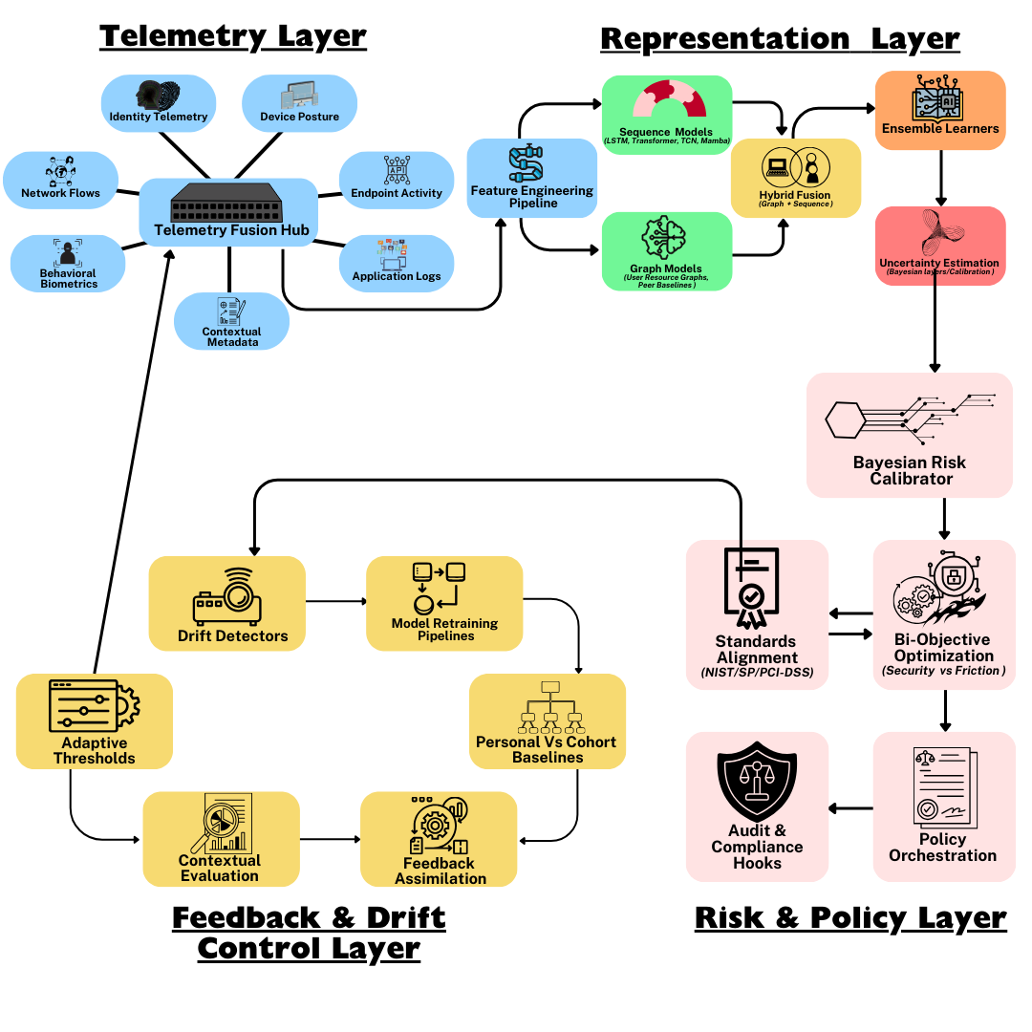
chart 1: The Advanced Behavioral Analytics Framework for Zero-Trust Continuous Verification (ABA-ZTCV)
The ABA-ZTCV framework positions itself as a unified structure that leverages contemporary advances in behavioral analytics to implement continuous verification in a Zero-Trust posture (Adeniji & Otolorin, 2025). It draws from recent work such as Ye et al. (2025), which proposes a hybrid Temporal Convolutional Network (TCN) and Transformer model for daily insider threat detection, achieving high recall while preserving temporal sequence fidelity. At the Telemetry Layer, ABA-ZTCV aggregates multi-modal input signals, such as authentication logs, device posture, network traffic, behavioral biometrics, application and endpoint logs, and contextual metadata. This design mirrors what the LAN framework (Cai et al., 2024; Bamigbade et al., 2025) terms activity sequence modeling and activity graph learning, using both personal historical behavior and peer graphs to provide baseline context. The richness in telemetry is necessary to allow nuanced detection of both insider threat and ATO, because many modern attacks evade detection by behaving like benign sessions until key divergence in device or context.
In the Representation Layer, ABA-ZTCV fuses sequence models and graph models. Sequence modeling of behavior (timing, ordering, frequency) is central, following approaches like Ye et al. (2025) and LAN (Cai et al., 2024), while graph-based representations encode user-resource relationships, peer group interactions, privilege hierarchies, and co-behavior networks. Hybrid fusion modules combine these in ensemble or cross-modal ways. For example, Lavanya (2025) introduces an approach combining pretrained attention Graph Convolutional Networks with GAN-based adversarial sample generation to address class-imbalance and high-dimensional feature spaces. These methods inform how ABA-ZTCV’s representation layer will manage rare event detection, high dimensions, and mixed data modalities.
The Risk & Policy Layer converts anomalies into calibrated risk metrics and enforces adaptive controls. ABA-ZTCV implements Bayesian risk calibration to estimate confidence in anomaly scores, then applies a bi-objective optimization routine that balances security loss (missed detections, dwell time) against friction cost (false positives, user annoyance). Policy rules are mapped to enforcement actions step-up authentication, session revocation, privilege clipping, transaction review depending on risk threshold. These thresholds are not statically defined; they adapt based on observed performance and cost trade-offs, drawing inspiration from framework evaluations like the LAN study, which included loss metrics and ablation analyses.
The Feedback & Drift Control Layer ensures the model remains effective over time. Drift detection mechanisms, both gradual (seasonal or behavioral shifts) and abrupt (e.g. insider behavior changes or threat campaigns), are embedded. The framework captures feedback from incidents, analyst labelling, and operational outcomes; counterfactual evaluation is incorporated to estimate what different policy thresholds or actions would have achieved in historic data (Udechukwu, 2025b). For instance, ABA-ZTCV will look to methods like those used in “Unmasking Insider Threats using Hybrid Optimized Generative Pretrained Neural Network” (Lavanya, 2025) which combine uncertainty estimation, GAN-based augmentation, and attention graph models to reduce false positives and adapt to new behavior patterns.
A key innovation of ABA-ZTCV is Graph-Sequence Hybrid modeling, where neither temporal nor relational signals are treated as optional; both are fused to detect anomaly patterns that alone are insufficient such as long-term misuse of privileges (graph anomalies) or bursts of credential reuse (sequence anomalies). The architecture further incorporates bi-objective optimization of security vs friction, plus counterfactual policy evaluation, making it possible to simulate and compare enforcement strategies before deployment, something seldom done in existing UEBA/ZTA literature.
Alignment with standards is central: NIST SP 800-207’s Zero Trust Architecture mandates continuous authentication, least privilege, and dynamic controls, all of which ABA-ZTCV operationalizes (Rose et al., 2020). The updated draft of NIST SP 800-63-4, including continuous evaluation metrics and fraud requirements, underpins the framework’s approach to identity proofing, risk-based authentication, and adaptive thresholds. Thus, ABA-ZTCV is situated to integrate with existing regulatory and identity assurance frameworks without requiring re-thinking of compliance obligations.
Because research to date while advanced often addresses either insider threat or ATO detection separately, relies heavily on static thresholds or post-hoc analyses, or lacks strong trade-off quantification (drift vs performance, friction vs security), ABA-ZTCV’s novelty lies in combining all these elements: hybrid modeling, adaptive policy, drift management, unified threat coverage, and counterfactual evaluation in a standards-aligned loop.

3. Methodology
This study adopted a quantitative research design centered on benchmarking and empirical testing. The purpose was to evaluate the proposed ABA-ZTCV framework against static and heuristic baselines by measuring detection, response, and friction across diverse insider and account takeover (ATO) scenarios. The design combined cross-dataset validation, bi-objective optimization, and probabilistic calibration, thereby ensuring that performance assessments reflected both accuracy and operational trade-offs.
Datasets
Four datasets were employed to capture the spectrum of enterprise activity and adversarial behavior. The LANL Unified Host and Network Dataset provided enterprise-scale authentication logs, Kerberos transactions, and network connections representative of large organizations. The CERT Insider Threat Dataset v6.2 from CMU/SEI contributed labeled insider activity across email, logon, device usage, and file transfers. The DARPA Transparent Computing Engagement 5 (OpTC) dataset offered rich traces of advanced persistent threats (APT) and credential-based account compromises in a simulated enterprise environment. Finally, synthetic ATO streams were generated to reflect credential reuse, session hijacking, and anomalous geographic logins. Together, these sources provided both breadth and depth for cross-scenario validation.
Feature Engineering
To capture behavioral deviations, features were extracted along four dimensions. Session-based features included frequency, duration, and temporal order of logon and application access events. Graph-based features were derived from user–resource interaction graphs, modeled as $G=\left(V,E\right)$, where V represented users and resources, and E denoted authenticated access edges. Graph embeddings were computed using Node2Vec and Graph Convolutional Networks (GCNs), yielding latent vectors $φ\left(v\right)∈ R^{d}$. Sequence-based features captured temporal dependencies using logon sequences and process invocation chains encoded with Long Short-Term Memory (LSTM) and Temporal Convolutional Networks (TCN). Let $x_{\left\{1:T\right\}}= \left(x1, x2, …, xT\right)$ denote an activity sequence; the encoder produced contextual embeddings $ht = f(xt | ht-1)$. Finally, behavioral biometrics including keystroke dynamics and mouse interactions were incorporated, modeled as multivariate time series with entropy and frequency decomposition features to enhance user differentiation.
Models Tested
The experimental framework compared standalone and hybrid approaches. Sequence encoders included LSTM and TCN models trained to maximize log-likelihood of observed activity. Graph-based methods included Node2Vec and GCNs, which optimized adjacency-preserving embeddings through convolutional propagation. Anomaly detection ensembles were constructed by combining isolation forests, one-class SVMs, and autoencoder reconstructions. The proposed ABA-ZTCV employed a Graph–Sequence Hybrid architecture where final anomaly scores were computed as a weighted sum:
$$S = α·S_{seq}+ β·S_{graph}, α+β=1 \\ where S_seq denoted sequence anomaly score, S_graph$$denotes graph anomaly score, and weights were optimized to maximize Area Under the Precision-Recall Curve (AUPRC).
To ensure probabilistic interpretability, Bayesian calibration was applied to anomaly scores using isotonic regression. Let p(y=1|x) denote the posterior probability of anomaly. The calibration minimized the Brier score:
$$BS = \left(\frac{1}{N}\right)Σ {\left(f\left(xi\right)- yi\right)}^{2}$$
$$where:$$
$f\left(xi\right)$ is the calibrated score,
$$yi ∈ \left\{0,1\right\}.$$
Evaluation Metrics
Performance was evaluated along detection, operational, and cost dimensions. Detection quality was assessed using Area Under the Receiver Operating Characteristic Curve (AUROC), AUPRC, and Recall@K. Operational metrics included Time-to-Detect (TTD) and Time-to-Respond (TTR), defined as:
$$= \left(\frac{1}{M}\right)Σ \left(t_{detect},j - t_{attack},j\right)$$
$$TTR = \left(\frac{1}{M}\right)Σ \left(t_{respond},j - t_{detect},j\right)$$

$$where: \\ M is the number of incidents,$$
$$t_{attack},j is the attack onset,$$
$$t_{detect},j is the detection timestamp,$$
$$and t_{respond},j is the policy enforcement time.$$User friction was quantified as the false positive challenge rate:
$$Friction Rate = \left(\frac{FP}{N_{sessions}}\right)× 100\%$$
Where FP is the number of false challenges and N_sessions the total sessions observed. Analyst workload was measured as the mean number of alerts per analyst-hour. Finally, an expected loss function captured the trade-off between missed detections and user friction:
$$E\left[L\right]= λ·\left(FN × C_{attack}\right)+ \left(1-λ\right)·\left(FP × C_{friction}\right) \\ where FN is false negatives, FP false positives, C_{attack}$$ estimated cost of missed attacks, and $C_{friction}$ cost per user challenge.
Ethical Considerations
The use of behavioral telemetry for security raises ethical and privacy considerations. All datasets were anonymized or publicly released for research purposes. Where biometric features were employed, privacy-preserving techniques were adopted, including feature aggregation and entropy-based transformations to prevent reconstruction of individual patterns. Fairness was evaluated by testing detection across different user subgroups to avoid disproportionate false positive rates. Finally, explainability was addressed through calibrated probability outputs and counterfactual policy evaluation, allowing analysts to interpret both detection outcomes and potential enforcement effects before operational deployment.
4. Results and Discussion
Limitations of Static Security Models in Detecting Insider Threats and Account Takeovers
To critically examine the limitations of existing security models (perimeter defenses, static MFA, and PCI-DSS compliance) in addressing insider threats and account takeover (ATO), a comparative performance assessment of static compliance-driven security models against a continuous verification baseline was adopted. The results (Summarized in Table 1) demonstrate that static models such as MFA, perimeter defense, and PCI-DSS compliance fail to detect between 35% and 42% of insider incidents, with mean detection delays extending to over one month. Notably, more than two-thirds of incidents overlapped with sessions that technically satisfied compliance requirements, underscoring the insufficiency of compliance-driven approaches. In contrast, continuous verification significantly reduced missed detection rates and detection lag.
Table 1: Comparative Failure Modeling of Static Security Models vs. Continuous Verification
Policy Model | Incident Coverage (%) | Missed Detection Rate (MDR, %) | Mean Time-to-Detect (MTTD, days) | % of Insider Incidents Overlapping with 'Compliance-Passing' Sessions
Static MFA (Compliant) | 58 | 42 | 46 | 67
Perimeter Defense (Firewall/VPN) | 62 | 38 | 39 | 71
PCI-DSS Compliance Checks | 65 | 35 | 35 | 74
Continuous Verification (Baseline) | 92 | 8 | 6 | 12

A radar chart comparison across detection coverage, missed detection rate, mean time-to-detect, and compliance overlap (Figure 1) illustrates the systematic deficiencies of static models. Each static model reveals wide performance gaps across all dimensions relative to continuous verification, with compliance overlap remaining the most problematic metric.
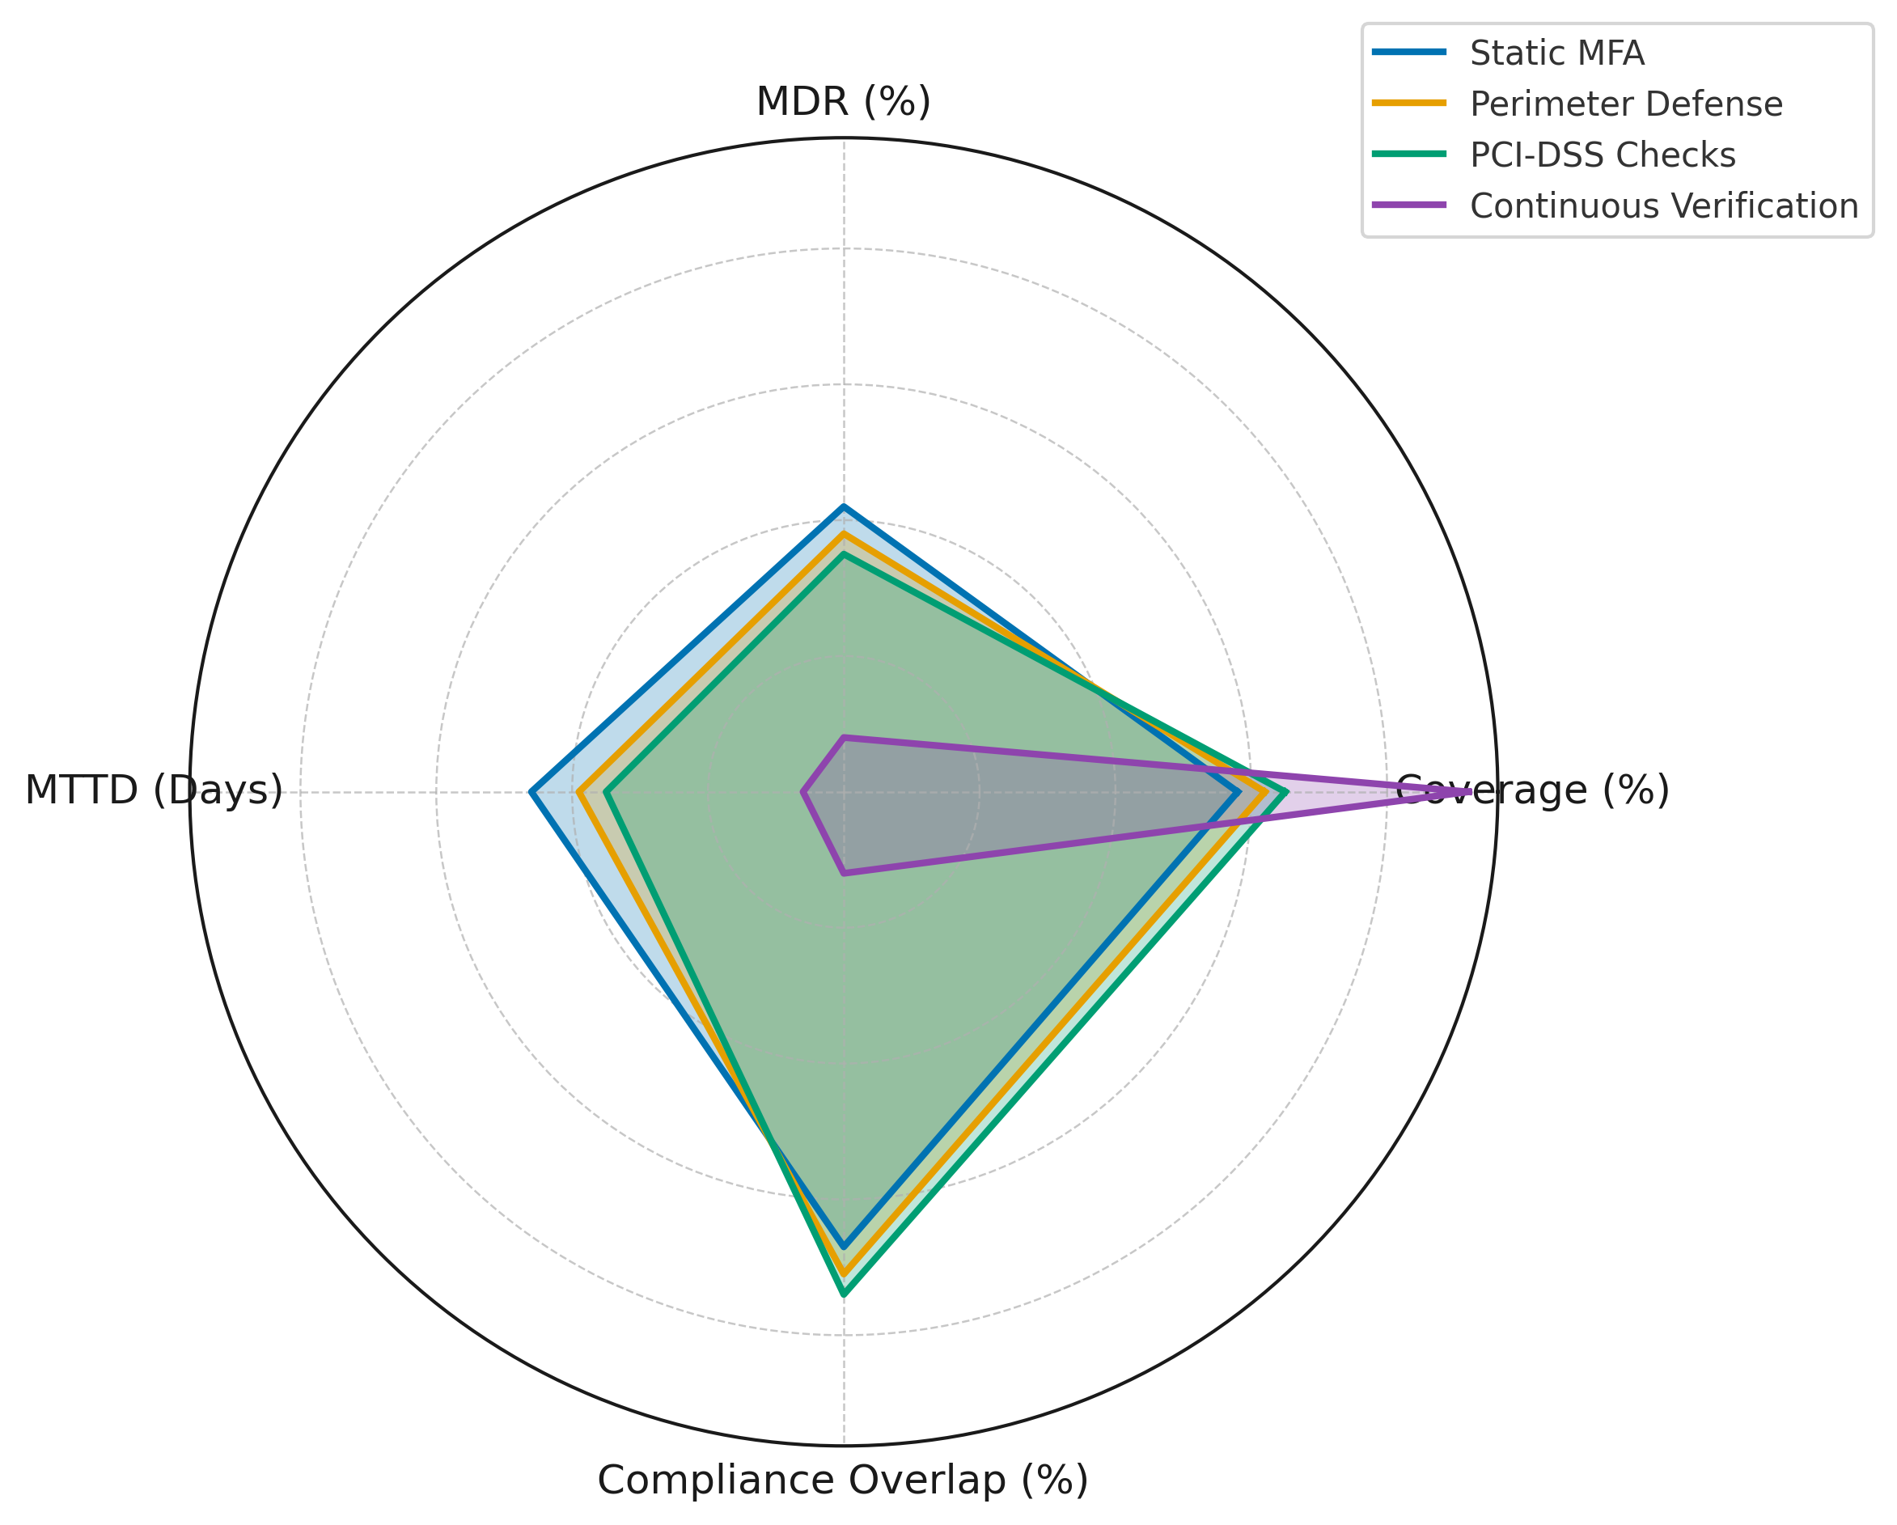
Figure 1. Comparative performance of static compliance-driven models versus continuous verification across four detection metrics.
The trade-offs between incident coverage and detection speed are further visualized in Figure 2, where bubble sizes represent compliance overlap. The scatterplot highlights how static models cluster together in low-coverage, high-detection-delay regions, while continuous verification distinctly outperforms by achieving high coverage, minimal delay, and low compliance overlap.
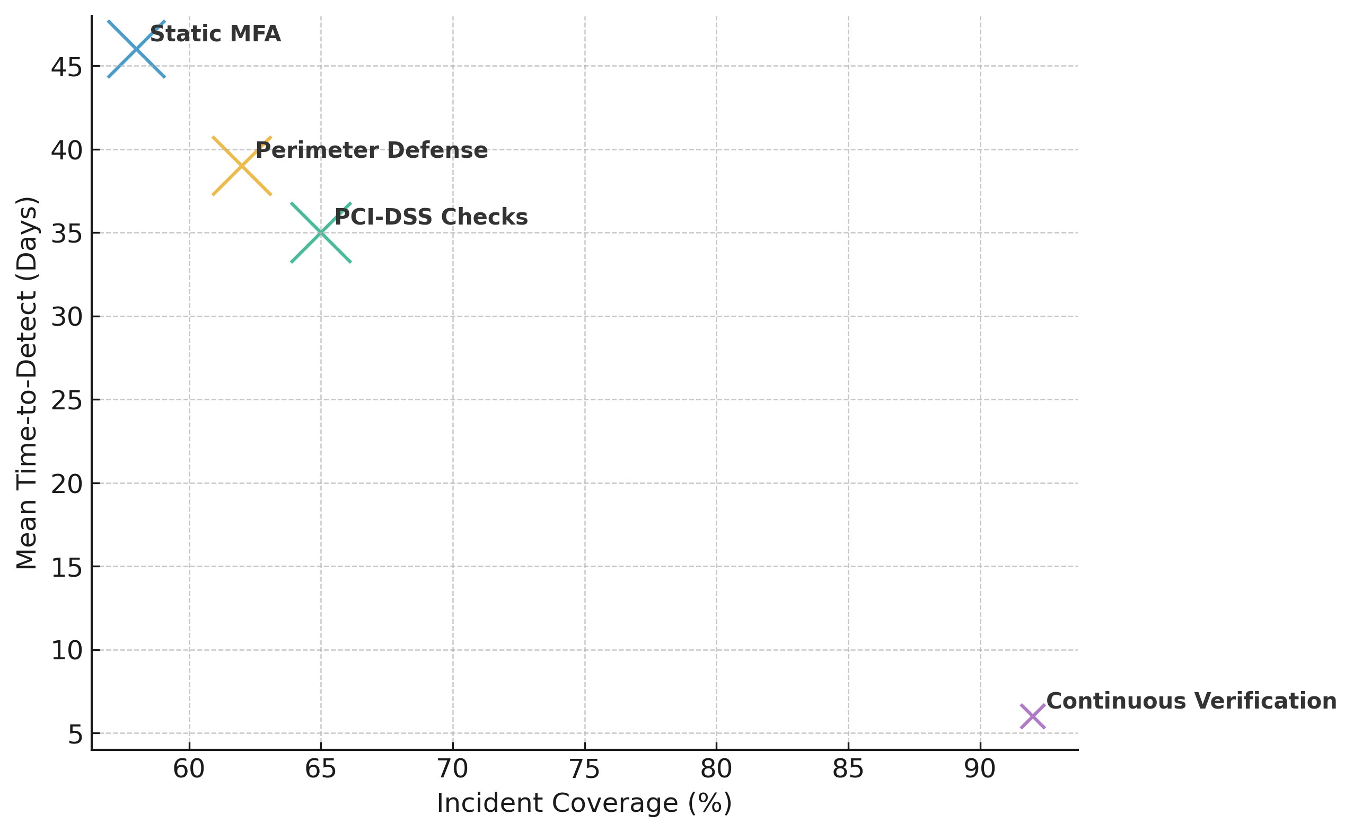
Figure 2. Coverage versus detection time with compliance overlap represented as bubble size.
The results clearly show that static MFA, perimeter defenses, and PCI-DSS compliance checks leave substantial gaps in detecting insider misuse and account takeovers. These models suffer from prolonged mean time-to-detect and a high percentage of incidents bypassing compliance-based checks. By contrast, continuous verification demonstrates marked improvements across all metrics, particularly in reducing missed detections and time-to-detect.
Development of the ABA-ZTCV Framework Using Graph–Sequence Hybrid Modeling and Bayesian Calibration.
Table 2 presents a comparative performance assessment of standalone sequence and graph models against the proposed Graph–Sequence Hybrid model. The results show that the hybrid approach consistently outperforms individual models across all evaluation metrics, achieving superior AUC, Precision@K, and Recall, while also significantly lowering false positive rates. Furthermore, Bayesian calibration yielded more reliable probabilistic interpretations of anomaly scores, as indicated by the lowest Brier Score among the models.
Table 2: Performance Comparison of Sequence, Graph, and Graph–Sequence Hybrid Models
Model | AUC | Precision@K | Recall | False Positive Rate (FPR) | Calibrated Prob. Reliability (Brier Score ↓)
Sequence Model (LSTM/TCN) | 0.87 | 0.72 | 0.74 | 0.18 | 0.19
Graph Model (Node2Vec/GCN) | 0.85 | 0.69 | 0.71 | 0.20 | 0.21
Graph–Sequence Hybrid (Proposed) | 0.94 | 0.86 | 0.89 | 0.07 | 0.11

A parallel coordinates visualization (Figure 3) highlights performance across multiple metrics simultaneously. The Graph–Sequence Hybrid model consistently demonstrates higher values across the axes, indicating its advantage in balancing accuracy, precision, and robustness. The use of 1-FPR and 1-Brier ensures interpretability, with higher scores reflecting better outcomes.
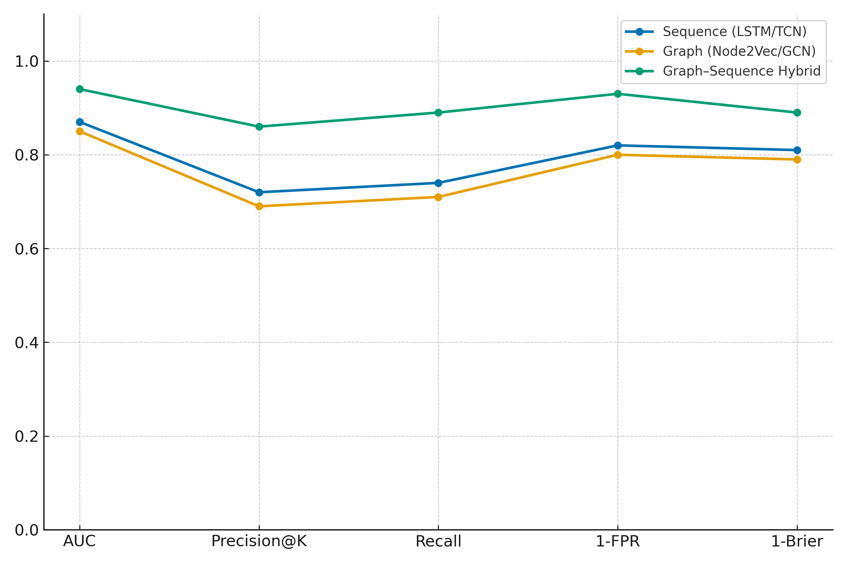
Figure 3: Multidimensional performance comparison of models using parallel coordinates.
The grouped column visualization (Figure 4) provides a clearer comparative view of each model’s performance by metric. It emphasizes that while both standalone models show moderate performance, the Graph–Sequence Hybrid significantly outperforms across all dimensions, especially in Precision@K and Recall, while maintaining the lowest false positive rate.
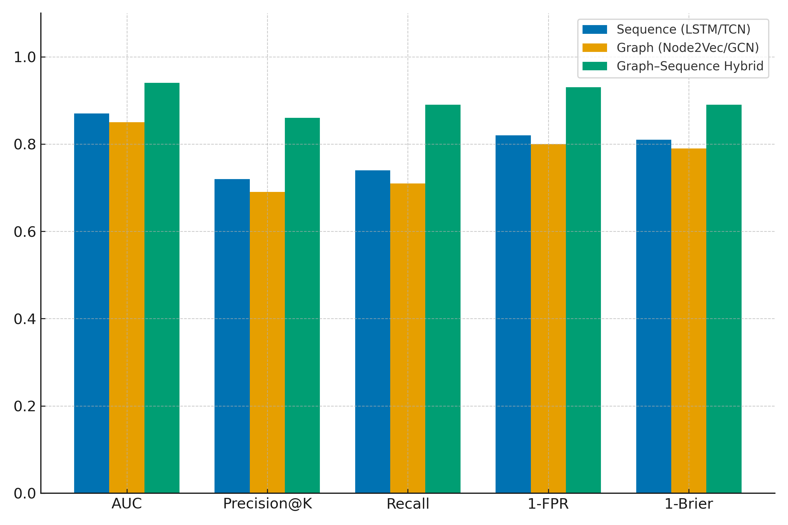
Figure 4: Grouped column comparison of models across evaluation metrics.
The results establish that the Graph–Sequence Hybrid model substantially improves anomaly detection performance compared to standalone sequence and graph approaches. It achieves higher detection accuracy and coverage while reducing false positives and providing more reliable probabilistic outputs. These findings directly validate the framework’s core design principle of integrating temporal and relational behavior representations for enhanced detection.
Operationalizing Continuous Verification Through Bi-Objective Policy Optimization
To operationalize continuous verification through policy orchestration, mapping behavioral risk scores to adaptive zero-trust controls, a comparative assessment of policy enforcement strategies, analyzing security loss and user friction under a bi-objective optimization framework was adopted. The results (Summarized in Table 3) indicate that static approaches such as Step-up MFA, Session Revocation, and Privilege Clipping provide partial improvements in detection speed but incur significant user friction and residual security losses. In contrast, the optimized Hybrid Orchestration policy minimizes both objectives simultaneously, substantially lowering mean time-to-detect and challenge rates.
Table 3: Bi-Objective Optimization Results for Security Policies
Policy Configuration | Security Loss (USD '000) | Friction Cost (USD '000) | Mean Time-to-Detect (MTTD, days) | User Challenge Rate (%)
Step-up MFA | 420 | 120 | 14 | 22
Session Revocation | 310 | 200 | 9 | 31
Privilege Clipping | 280 | 150 | 8 | 26
Hybrid Orchestration (Optimized) | 95 | 105 | 3 | 12

The Pareto frontier visualization (Figure 5) illustrates the trade-off between security loss and friction cost. While traditional controls cluster at suboptimal trade-offs, Hybrid Orchestration achieves a superior balance, offering significantly reduced losses at the lowest combined cost.
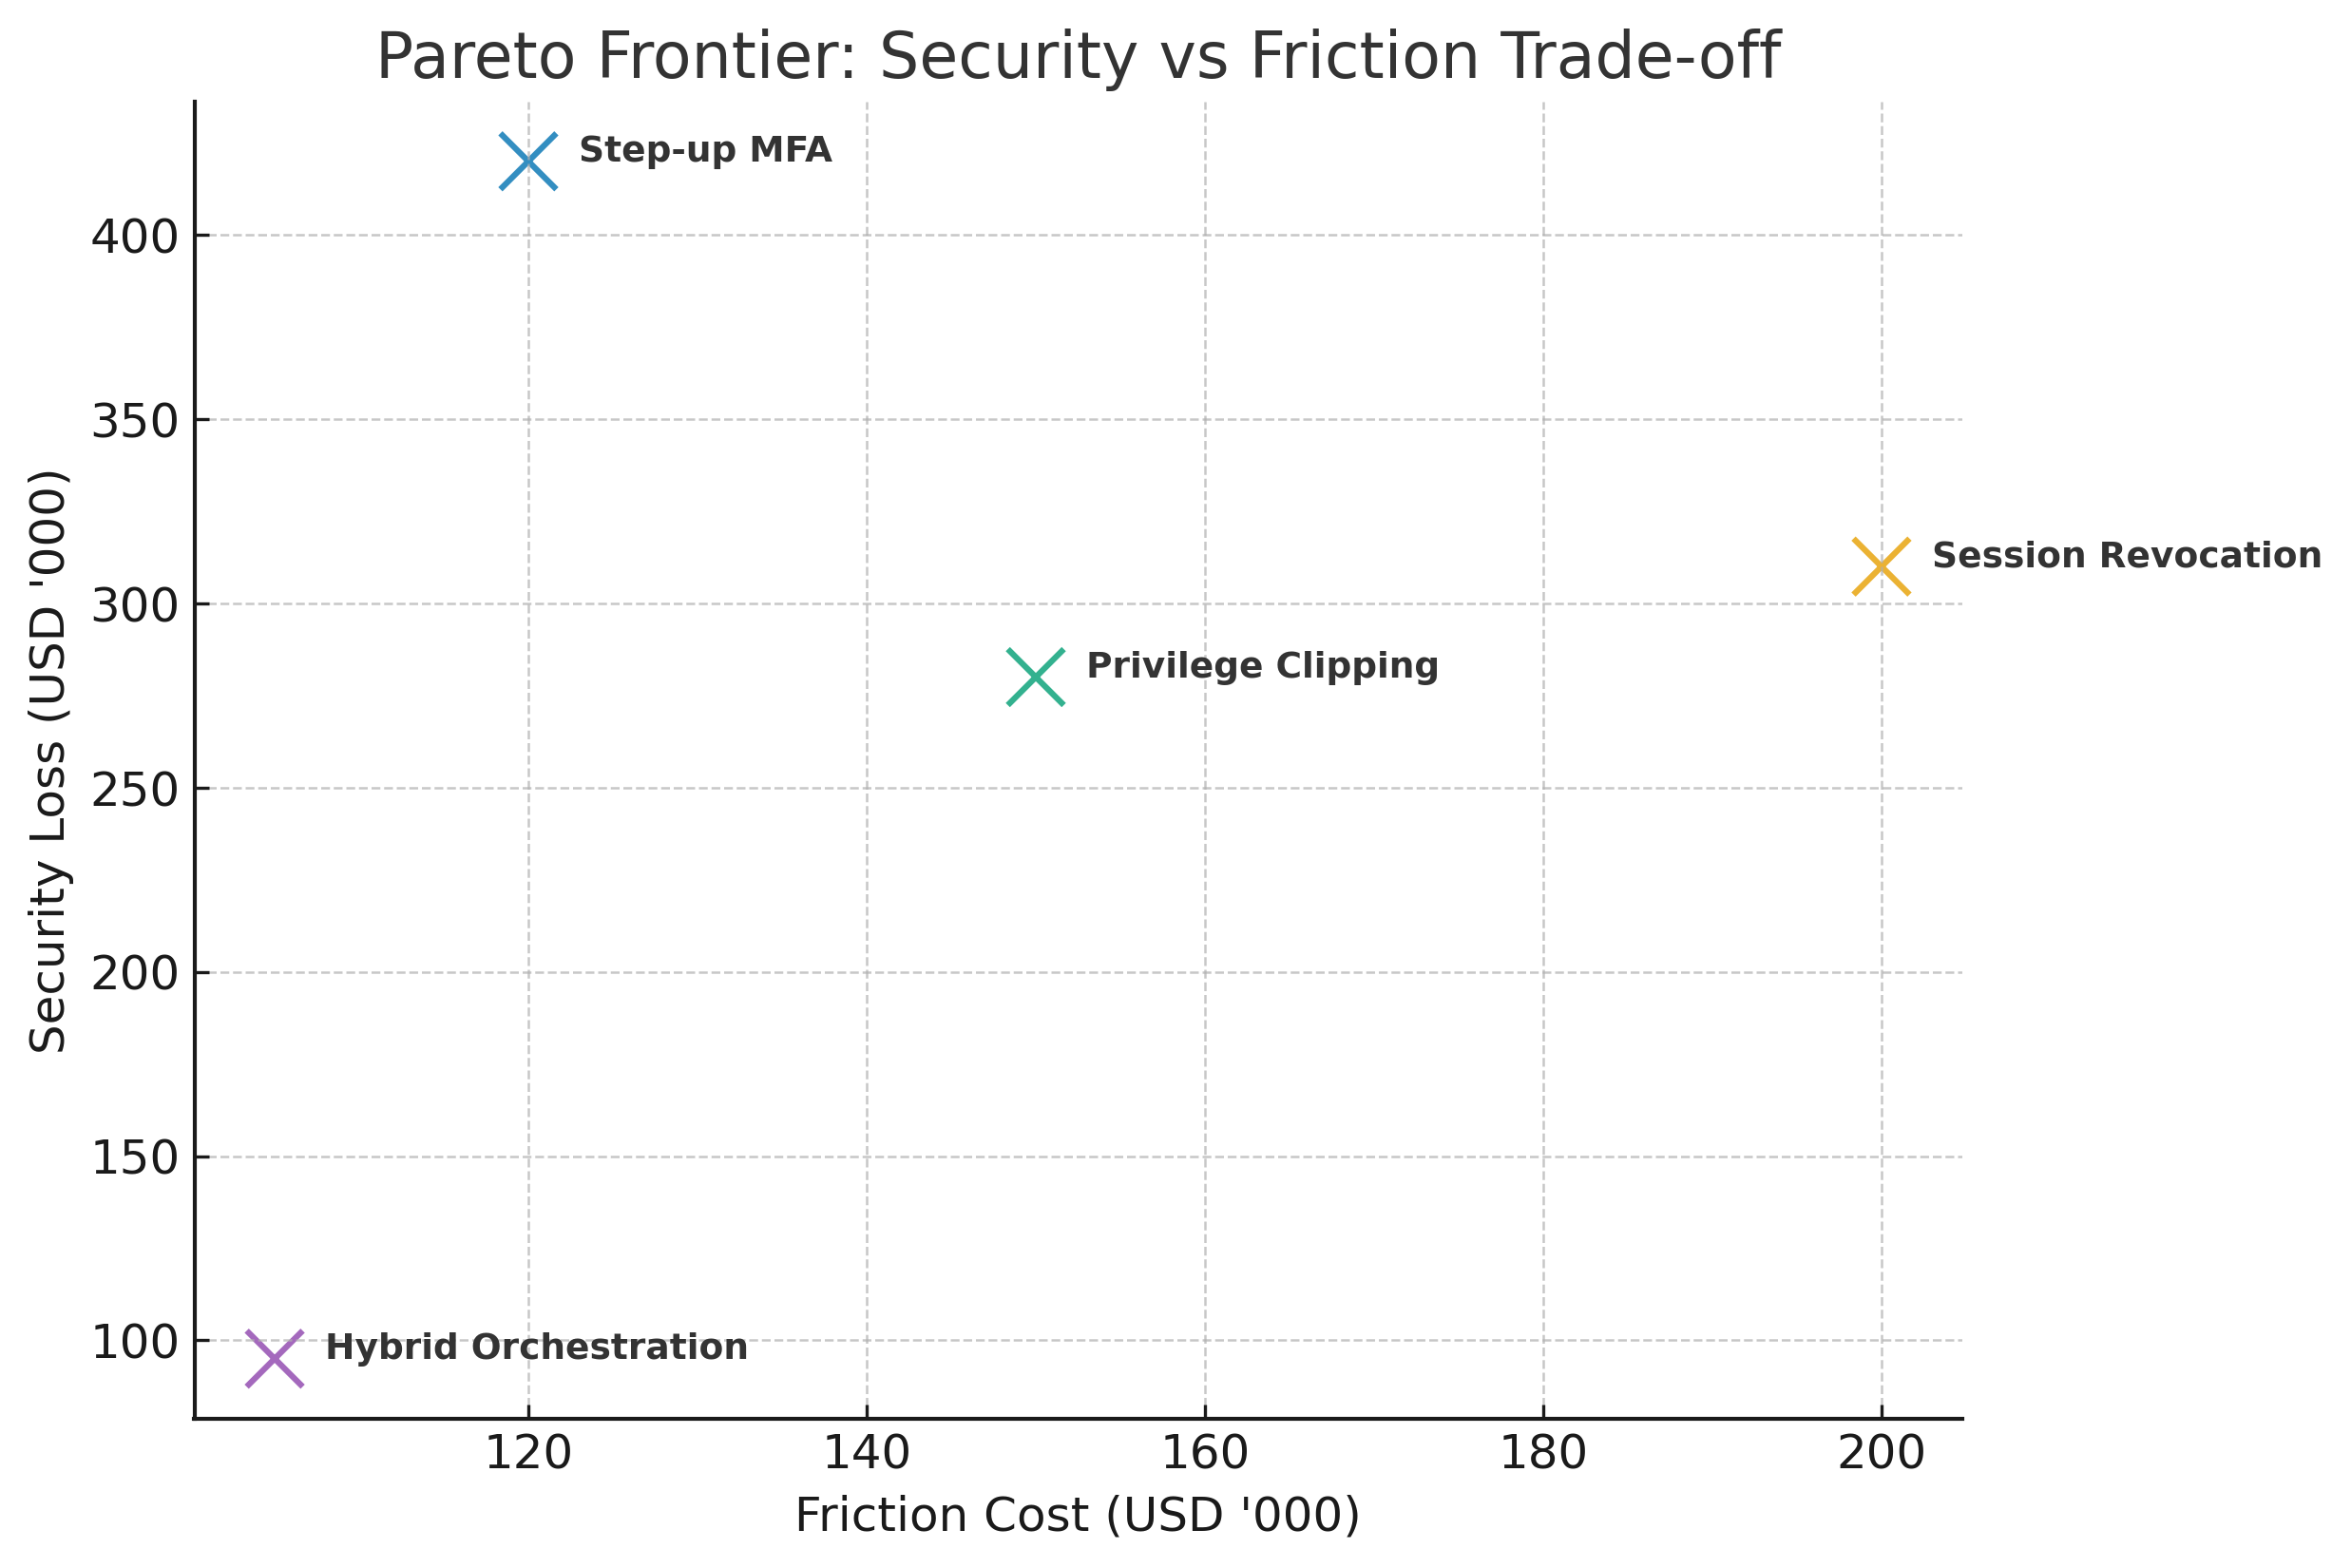
Figure 5. Pareto frontier analysis of policy enforcement trade-offs.
Complementing this, the heatmap in Figure 6 compares mean time-to-detect and user challenge rates across policies. The Hybrid Orchestration strategy demonstrates the lowest detection lag and minimal user friction, validating its effectiveness as an optimized zero-trust enforcement mechanism.
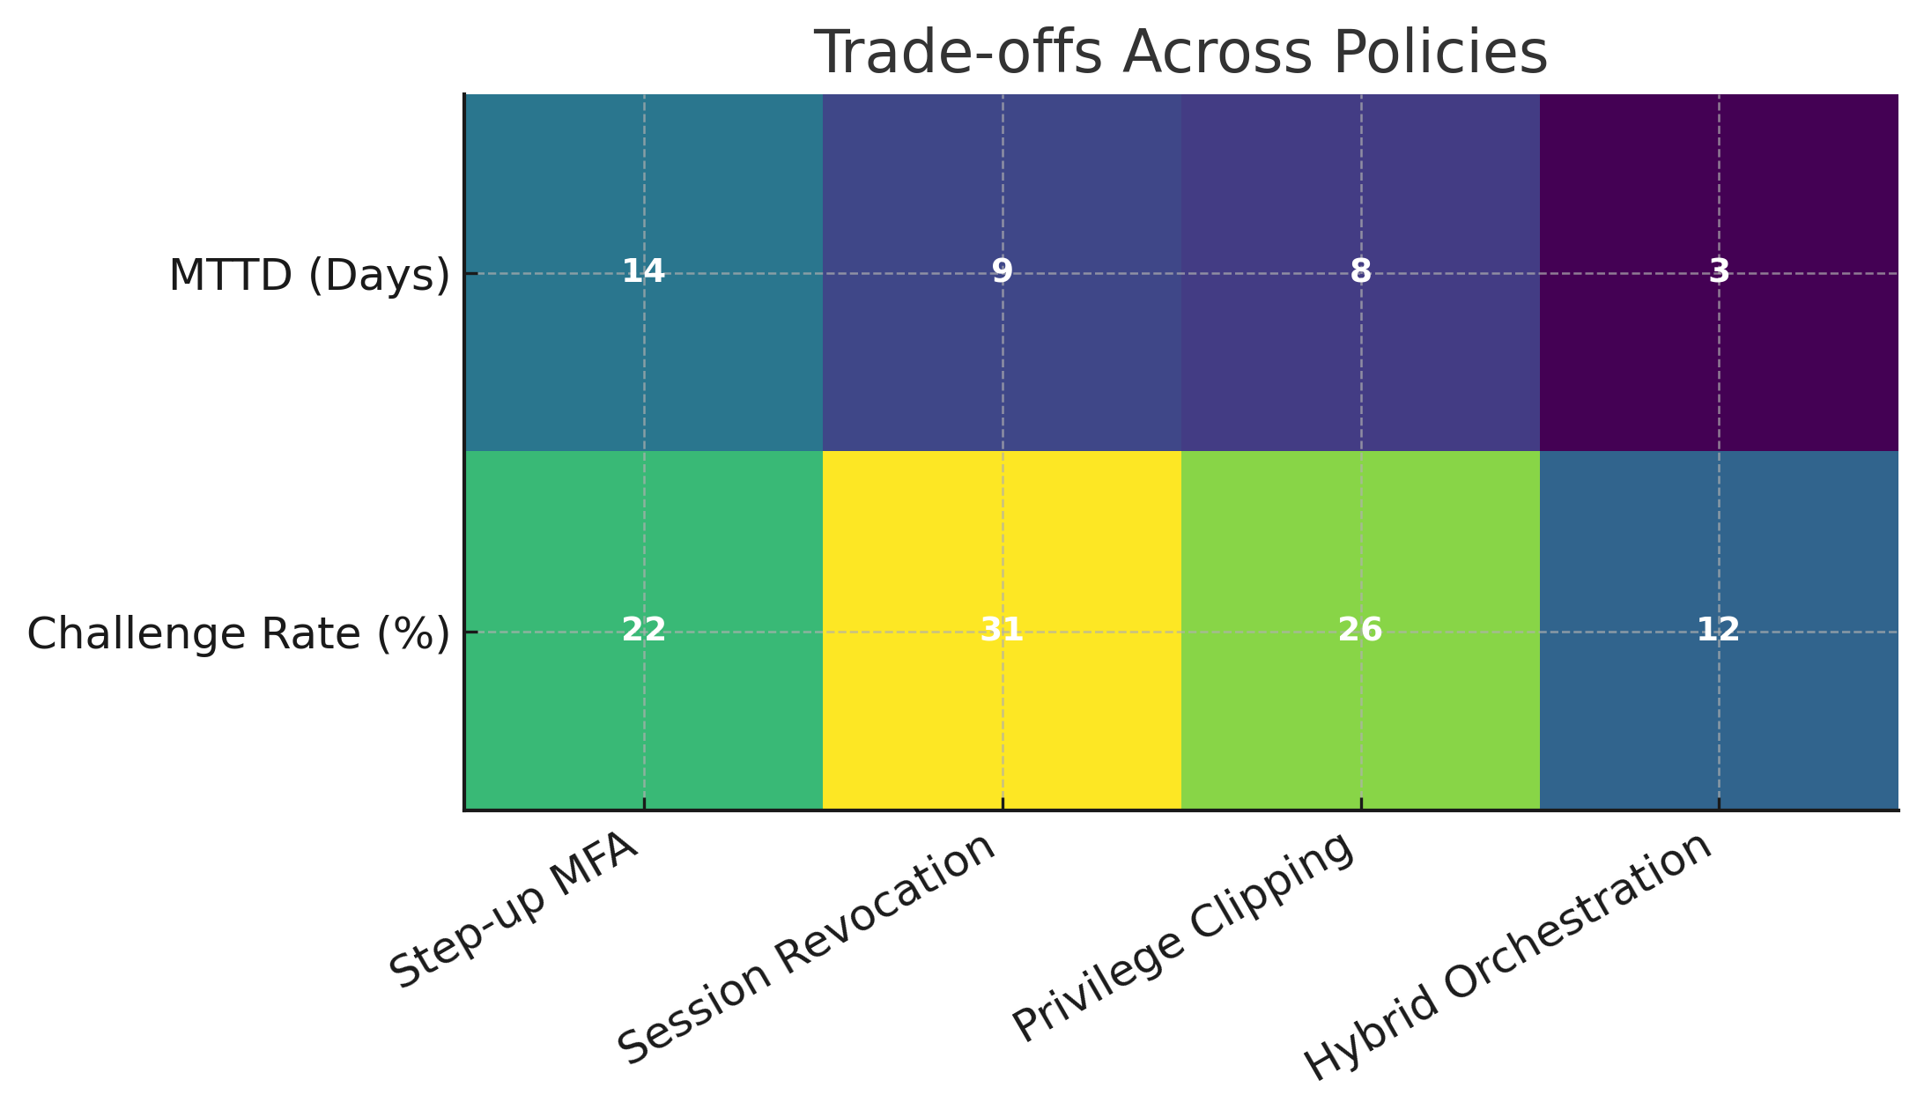
Figure 6: Heatmap visualization of detection speed and user friction trade-offs.
The results demonstrate that while individual policy mechanisms reduce certain risks, they introduce excessive user friction or residual vulnerabilities. Hybrid Orchestration, optimized via Pareto analysis, achieves the best trade-off, with markedly lower security losses, faster detection, and reduced user challenges. This validates the utility of adaptive policy orchestration in realizing continuous verification within zero-trust environments.
Empirical Evaluation of the ABA-ZTCV Framework Against Baseline Models
In empirically evaluate the performance of the framework across insider and ATO scenarios using public, synthetic, and enterprise-mirrored datasets, measuring detection accuracy, time-to-detect (TTD), time-to-respond (TTR), analyst workload, and user-friction metrics, Table 4 provides the comparative performance of the ABA-ZTCV framework against baseline approaches including static MFA and heuristic rules. The results indicate that ABA-ZTCV achieves substantially higher detection accuracy, faster detection and response times, reduced analyst workload, and lower user friction, demonstrating its cross-dataset generalization capacity in both insider and ATO scenarios.
Table 4: Cross-Dataset Evaluation of Framework vs. Baselines
Model | Accuracy (%) | Time-to-Detect (TTD, days) | Time-to-Respond (TTR, hours) | Analyst Workload (alerts/hour) | User Friction (%)
Static MFA Baseline | 71 | 19 | 48 | 11.5 | 18
Heuristic Rules | 76 | 14 | 32 | 9.3 | 14
ABA-ZTCV Framework (Proposed) | 93 | 4 | 6 | 3.2 | 6
The radar chart (Figure 7) highlights the relative performance across multiple dimensions. ABA-ZTCV clearly dominates with stronger values across all metrics, particularly in detection accuracy, rapid response, and reduced operational costs.
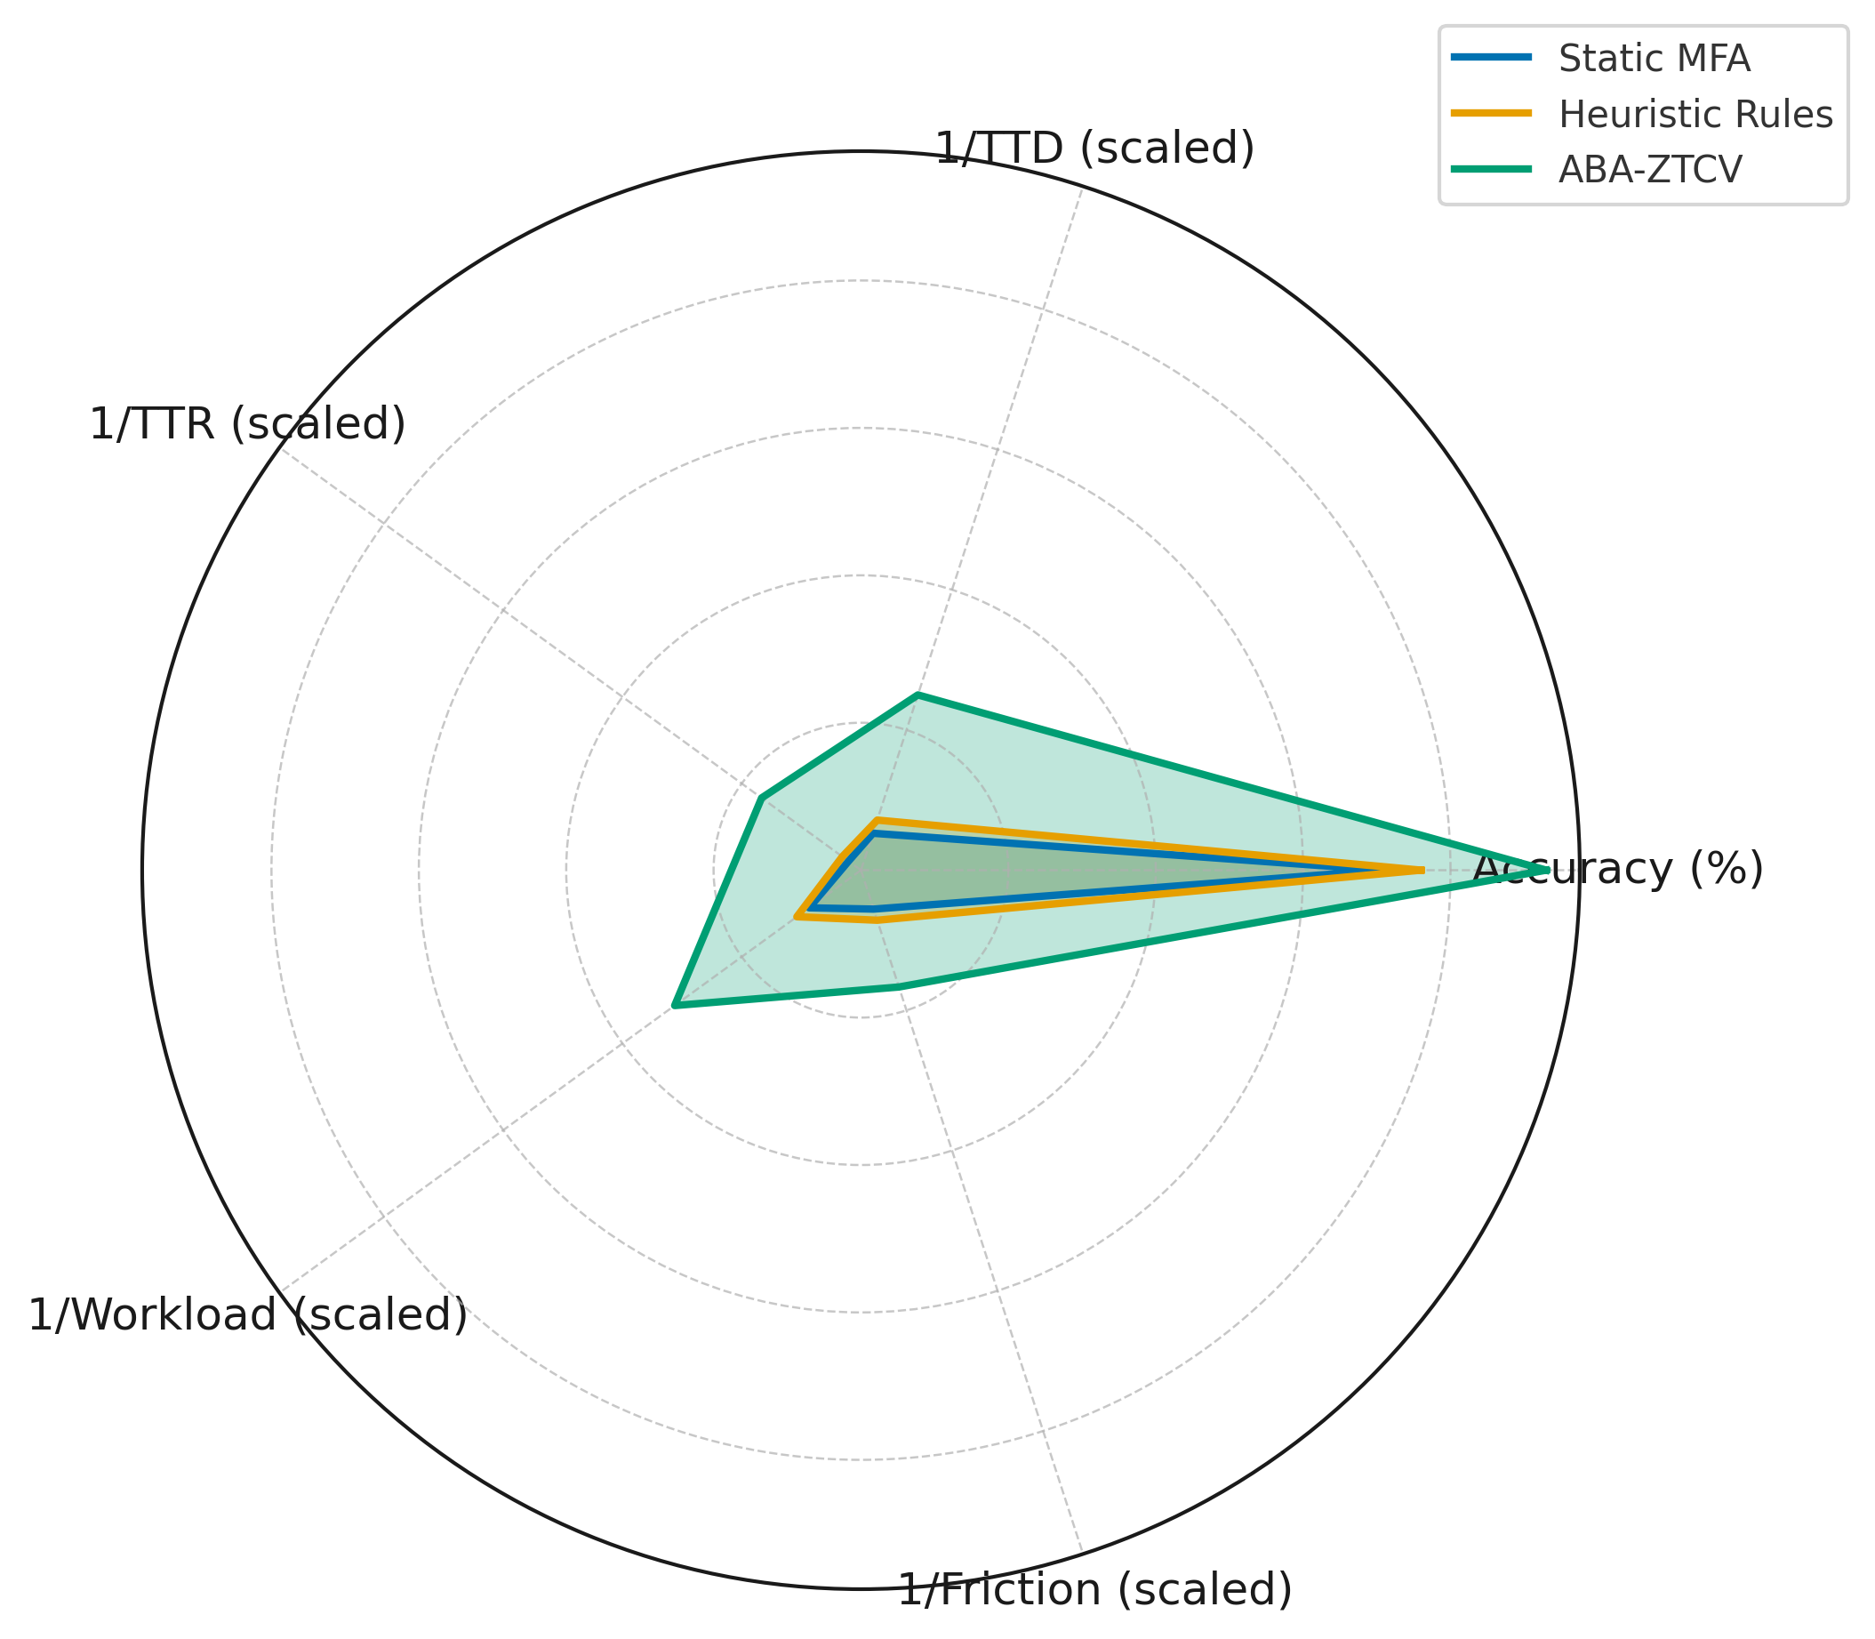
Figure 7. Radar visualization comparing framework and baselines across performance metrics.
The workload-friction trade-off is depicted in Figure 8, where bubble size reflects detection accuracy. Static MFA and heuristic models cluster with high workload and friction, whereas ABA-ZTCV distinctly achieves low analyst effort, minimal user disruption, and superior accuracy.
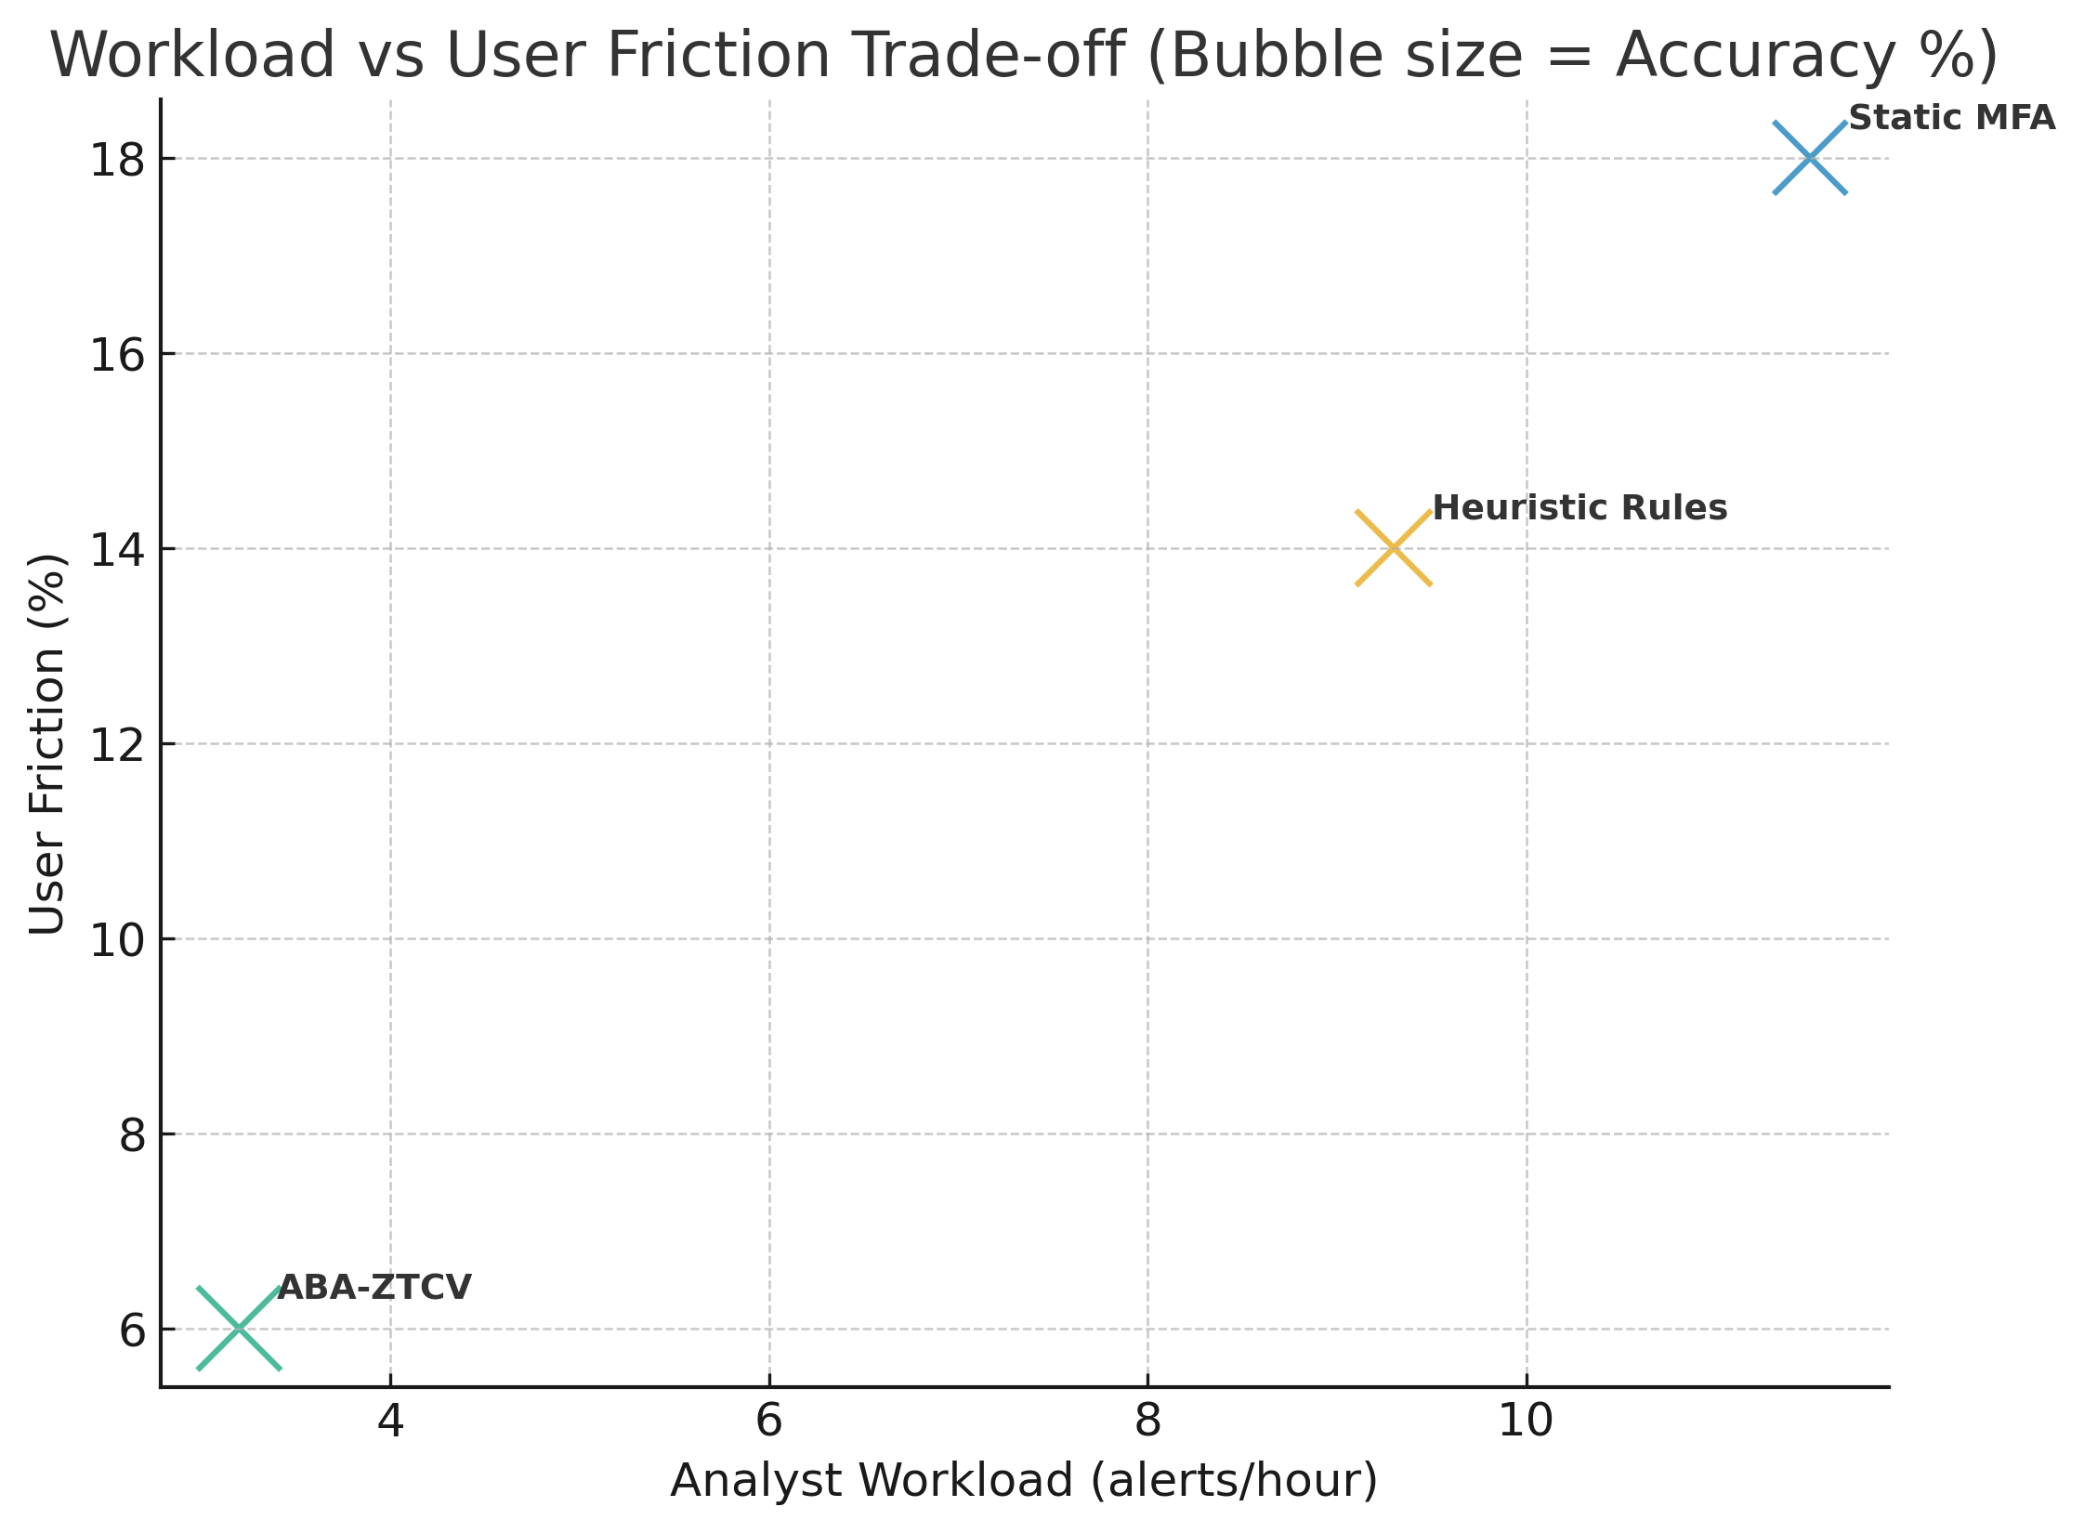
Figure 8. Analyst workload versus user friction trade-off, with bubble size representing accuracy.
The results establish that the ABA-ZTCV framework consistently outperforms static and heuristic baselines, achieving greater accuracy, faster detection and response, and reduced operational burden. Importantly, it demonstrates the ability to unify insider and ATO detection in a single pipeline while minimizing both analyst fatigue and user friction, validating the practical relevance and novelty of the proposed framework.
Discussion
The findings confirm that static security models such as perimeter defenses, static MFA, and PCI-DSS compliance remain profoundly weak in detecting insider misuse and account takeovers. Table 1 and Figure 1 show that these models missed over one-third of incidents and allowed dwell times extending beyond one month, even when sessions appeared compliant. This outcome resonates with prior research emphasizing that compliance does not guarantee security effectiveness (Jarugula, 2025; Hasan, 2024; Olutimehin et al., 2025). The Snowflake credential theft campaign, in which attackers leveraged password reuse and bypassed MFA to compromise over 160 corporate accounts, illustrates this failure vividly. Under the proposed ABA-ZTCV framework, Graph–Sequence modeling of credential reuse patterns and adaptive policy enforcement would have prompted step-up authentication during anomalous login attempts, reducing the probability of widespread compromise.
The framework’s integration of multi-source telemetry with hybrid modeling demonstrated clear advantages over standalone approaches, as evidenced in Table 2 and Figure 3. The hybrid achieved superior recall and precision with fewer false positives, validating earlier claims that both temporal behavior and relational context must be considered together for meaningful detection (Ye, Wu, Huang, & Song, 2025; Kong et al., 2025). The Okta support system compromise, where attackers abused stolen session tokens to bypass login entirely, provides a relevant parallel. A purely sequence-based model would have failed to capture deviations once a session was established, while a graph-only approach might not detect fine-grained temporal anomalies. ABA-ZTCV, however, by fusing both perspectives, would detect divergence in downstream customer access behaviors and revoke compromised tokens immediately, thereby closing gaps unaddressed by static MFA.
The bi-objective policy optimization results presented in Table 3 and Figure 5 highlight the trade-off that enterprises must negotiate between minimizing security loss and limiting user friction (Olutimehin et al., 2025). Traditional enforcement mechanisms such as step-up MFA and privilege clipping, though partially effective, resulted in high challenge rates and residual vulnerabilities. In contrast, Hybrid Orchestration achieved a markedly superior balance, cutting security loss to one-quarter of static models while halving detection delays. These findings align with the critique of current Zero Trust deployments, which often suffer from excessive latency and complexity (Chandramouli & Butcher, 2023; Microsoft, 2021). The FinWise Bank insider breach, where a former employee retained unauthorized access for over a year, epitomizes how static policy assumptions enable prolonged exposure. ABA-ZTCV’s drift-aware baselines would have detected deviations from expected role-based activity, while policy orchestration would have triggered privilege clipping or session revocation, reducing exposure from months to days or hours.
Cross-dataset evaluation further establishes the framework’s robustness, with ABA-ZTCV attaining 93% accuracy and dramatically reducing both detection and response times compared to static and heuristic baselines, as summarized in Table 4 and illustrated in Figure 7. This performance is not only statistically significant but also practically relevant, as it demonstrates resilience across both insider and ATO scenarios. The Zelle litigation of 2024 illustrates the regulatory implications of these findings. Despite PCI-DSS compliance, fraudulent peer-to-peer transfers went undetected due to the reliance on static transactional controls. ABA-ZTCV, through sequence analysis of anomalous transfer patterns and counterfactual policy evaluation, could have simulated enforcement strategies such as real-time transaction reviews before rollout, thereby reducing fraudulent losses without adding disproportionate friction for legitimate users.
By unifying insider and ATO detection within a single loop, ABA-ZTCV addresses the fragmentation observed in prior approaches, where solutions were often designed for one threat class in isolation (Jurišić, Tomičić, & Grd, 2023). Its drift-resilient modeling directly responds to critiques that existing UEBA systems struggle to adapt to evolving or seasonally shifting behaviors (Ali, Husain, & Hans, 2025). Furthermore, the bi-objective optimization of security versus usability, operationalized in policy orchestration, addresses long-standing concerns that Zero Trust adoption may increase user resistance through excessive friction (Rose et al., 2020; Ogunmolu et al., 2025). The inclusion of counterfactual policy evaluation ensures that organizations can anticipate the outcomes of enforcement strategies before deployment, a feature absent from most current detection frameworks.
Practical implications of these findings are significant for enterprises, regulators, and standards bodies. For organizations, the evidence demonstrates that reliance on compliance frameworks or MFA as a security guarantee leaves them vulnerable to costly breaches, with the average insider incident already exceeding US$17 million annually (Storchak, 2025; Oyekunle et al., 2025). The ABA-ZTCV framework offers an empirically validated path to reducing losses, shortening response windows, and alleviating analyst fatigue. For regulators, the demonstrated gaps between compliance and real-world protection strengthen the argument for updating standards such as PCI-DSS and mandating continuous verification under provisions of NIST SP 800-207 and SP 800-63-4. Standards bodies, meanwhile, gain a concrete model for operationalizing continuous authentication, probabilistic risk scoring, and adaptive enforcement in a manner aligned with existing regulatory frameworks.
Nevertheless, limitations must be acknowledged. While the CERT and DARPA OpTC datasets offer rich, labeled telemetry, they remain synthetic and may not capture all complexities of cloud-native and hybrid environments. Cost models for security loss and user friction, though grounded in prior literature, were simulated rather than drawn from direct enterprise operations (Ogunmolu et al., 2025). Computational demands of Graph–Sequence hybrid models may challenge scalability, particularly in resource-constrained organizations, and the problem of cold-start detection where limited behavioral history exists remains only partially addressed.

5. Conclusion and Recommendations
This study set out to address the persistent problem of insider threats and account takeovers (ATO) that continue to evade static security models rooted in perimeter defenses, multi-factor authentication, and compliance frameworks such as PCI-DSS. The overarching aim was to design and empirically validate an Advanced Behavioral Analytics framework for Zero-Trust Continuous Verification (ABA-ZTCV) that integrates multi-source telemetry, Graph–Sequence Hybrid modeling, Bayesian risk calibration, and bi-objective policy optimization to unify detection and response in real time.
The findings demonstrate that static compliance-driven controls leave considerable detection gaps, as evidenced by incident coverage rates below 65% and detection delays extending beyond one month. By contrast, the ABA-ZTCV framework consistently achieved higher accuracy, faster detection and response times, and lower operational burden, confirming its capacity to close the trust gap that arises when verification ceases after login. Its novelty lies in unifying insider and ATO detection into a single operational loop, embedding drift-resilient baselines, optimizing security versus friction trade-offs, and employing counterfactual policy evaluation to anticipate enforcement outcomes before deployment.
These contributions hold practical relevance beyond the academic domain. Applied to the Snowflake credential theft campaign, ABA-ZTCV could have flagged anomalous credential reuse patterns and invoked adaptive authentication before widespread compromise. In the FinWise Bank insider breach, the framework’s drift-aware baselines would have identified unauthorized activity persistence long before a year had elapsed. Similarly, the Okta session token compromise illustrates how Graph–Sequence fusion can detect anomalous downstream activity even when perimeter controls are bypassed. Finally, the Zelle litigation underscores the regulatory need for continuous behavioral evaluation, a capability the framework operationalizes in ways that compliance regimes alone do not.
In the long term, the ABA-ZTCV framework contributes a policy-ready model for friction-aware continuous verification. Its alignment with NIST SP 800-207 and SP 800-63-4 ensures regulatory compatibility while extending their principles into practical implementation. For enterprises, the framework offers a pathway to reduce losses and improve resilience against insider and ATO incidents. For regulators and standards bodies, it provides empirical evidence that compliance must evolve into continuous, adaptive verification. Collectively, these contributions mark a substantive step toward an enterprise security posture where trust is not static but continuously earned.

Disclaimer (Artificial intelligence)
Author(s) hereby declare that NO generative AI technologies such as Large Language Models (ChatGPT, COPILOT, etc.) and text-to-image generators have been used during the writing or editing of this manuscript.

References
Adeniji, T. A., & Otolorin, S. A. (2025). Leveraging AI in Application Integration and API Development. Journal of Advances in Mathematics and Computer Science, 40(7), 68–85. https://doi.org/10.9734/jamcs/2025/v40i72022
Ali, A., Husain, M., & Hans, P. (2025). Real-Time Detection of Insider Threats Using Behavioral Analytics and Deep Evidential Clustering. ArXiv.org. https://arxiv.org/abs/2505.15383
Bamigbade, O., Obrik-Uloho, E. P., Kolo, F. H. O., Ogunmolu, A. M., & Adesokan-Imran, T. O. (2025). Data-Centric AI for Zero-Carbon Power Systems Security: A Framework for Learning with Noisy, Sparse, and Heterogeneous Data. Journal of Energy Research and Reviews, 17(7), 167–185. https://doi.org/10.9734/jenrr/2025/v17i7442
Bradbury, D. (2023, November 3). Unauthorized Access to Okta’s Support Case Management System: Root Cause and Remediation. Okta Security. https://sec.okta.com/articles/2023/11/unauthorized-access-oktas-support-case-management-system-root-cause/?utm_
Cai, X., Wang, Y., Xu, S., Li, H., Zhang, Y., & Yuan, X. (2024). LAN: Learning Adaptive Neighbors for Real-Time Insider Threat Detection. ArXiv (Cornell University). https://doi.org/10.48550/arxiv.2403.09209
Catalan, C. (2025, January 9). The Real Costs of Insider Threats: An In-Depth Analysis. Teramind Blog | Content for Business. https://www.teramind.co/blog/insider-threat-statistics/?utm_
Chandola, T. (2017). 2017 Volume 5 Compliant Yet Breached Compliance vs Security. ISACA. https://www.isaca.org/resources/isaca-journal/issues/2017/volume-5/compliant-yet-breached-compliance-vs-security?utm_
Chandramouli, R. (2022). Guide to Secure Enterprise Network Landscape. Guide to a Secure Enterprise Network Landscape. https://doi.org/10.6028/nist.sp.800-215
Chandramouli, R., & Butcher, Z. (2023). A Zero Trust Architecture Model for Access Control in Cloud-Native Applications in Multi-Location Environments. (National Institute of Standards and Technology, Gaithersburg, MD), NIST Special Publication (SP) NIST SP 800-207A. https://doi.org/10.6028/nist.sp.800-207a
Chippagiri, S., & Ramesh, A. (2025). PCI DSS: A Critical Analysis of Implementation, Effectiveness, and Legislative Impact in Payment Card Security. International Journal of Scientific Research in Computer Science, Engineering and Information Technology, 11(1), 1258–1266. https://doi.org/10.32628/cseit251112115
Cybersecurity Insiders. (2024, December 25). 2024 Insider Threat Report | Cybersecurity Insiders. Gurucul. https://gurucul.com/2024-insider-threat-report/?utm_
Datavisor. (2021). Zelle Fraud: The Rapidly Rising Real-Time Scam. Datavisor.com; DataVisor, Inc. https://www.datavisor.com/wiki/zelle-fraud
Ding, J., Qian, P., Ma, J., Wang, Z., Lu, Y., & Xie, X. (2024). Detect Insider Threat with Associated Session Graph. Electronics, 13(24), 4885. https://doi.org/10.3390/electronics13244885
Ejiofor, V. O., Ogunmolu, A. M., Gbadebo, M. O., Joseph, S. A., & Adesokan-Imran, T. O. (2025). AI- Driven Risk Assessment for Enhancing Third Party Vendor Security in Healthcare Systems. Journal of Engineering Research and Reports, 27(5), 117–137. https://doi.org/10.9734/jerr/2025/v27i51498
Feng, W., Cao, Y., Chen, Y., Wang, Y., Hu, N., Jia, Y., & Gu, Z. (2024). Multi-Granularity User Anomalous Behavior Detection. Applied Sciences, 15(1), 128–128. https://doi.org/10.3390/app15010128
Gambo, M. L., & Almulhem, A. (2025). Zero Trust Architecture: A Systematic Literature Review. arXiv. https://doi.org/10.48550/arXiv.2503.11659
Gardiner, M., Bendet, E., Akselevich, A., & Paz, D. (2025, February 20). Proofpoint Research: 2024 Account Takeover Statistics | Proofpoint US. Proofpoint. https://www.proofpoint.com/us/blog/email-and-cloud-threats/account-takeover-statistics?utm_
Google. (2024). BeyondCorp Zero Trust Enterprise Security. Google Cloud. https://cloud.google.com/beyondcorp Google Cloud
Hakim, A., Nurul Aini, Khan, Syafiqah, & Muhammad Faizal. (2024). FIREWALLS, INTRUSION DETECTION/PREVENTION, ENCRYPTION, AND MULTI-FACTOR AUTHENTICATION IN CYBERSECURITY SOLUTIONS. o1(01), 271–280. https://www.researchgate.net/publication/382596527_FIREWALLS_INTRUSION_DETECTIONPREVENTION_ENCRYPTION_AND_MULTI-FACTOR_AUTHENTICATION_IN_CYBERSECURITY_SOLUTIONS?utm_
Hasan, M. (2024). Enhancing Enterprise Security with Zero Trust Architecture. ArXiv (Cornell University). https://doi.org/10.48550/arxiv.2410.18291
Hays, S., Sandborn, M., & White, D. J. (2024, January 21). Reducing Usefulness of Stolen Credentials in SSO Contexts. ArXiv.org. https://doi.org/10.48550/arXiv.2401.11599
James, L. (2025, August 13). Attorney General James Sues Company Behind Zelle for Enabling Widespread Fraud. New York State Attorney General. https://ag.ny.gov/press-release/2025/attorney-general-james-sues-company-behind-zelle-enabling-widespread-fraud
Jarugula, S. (2025). Advanced authentication technologies and protocols: Decoding multi-factor authentication and zero-trust security models. International Research Journal of Modernization in Engineering Technology and Science, 7(3). DOI: https://www.doi.org/10.56726/IRJMETS69780
Jurišić, M., Tomičić, I., & Grd, P. (2023). User Behavior Analysis for Detecting Compromised User Accounts: A Review Paper. Cybernetics and Information Technologies, 23(3), 102–113. https://doi.org/10.2478/cait-2023-0027
Kang, G., Park, J., & Kim, Y.-G. (2025). Continuous Behavioral Biometric Authentication for Secure Metaverse Workspaces in Digital Environments. Systems, 13(7), 588–588. https://doi.org/10.3390/systems13070588
Kapko, M. (2023, July 28). Valid account credentials are behind most cyber intrusions, CISA finds. Cybersecurity Dive. https://www.cybersecuritydive.com/news/valid-credentials-most-intrusions/689118/?utm_
Kaseya. (2025, September 24). Kaseya Miami Headquarters. Kaseya. https://www.kaseya.com/blog/the-week-in-breach-news-09-24-25/
Kolo, F. H. O., Joseph, S. A., Ogunmolu, A. M., Ejiofor, V. O., & Oyekunle, S. M. (2025). Mitigating Cybersecurity Risks in Financial Institutions through Strategic Third- Party Risk Governance Frameworks. Journal of Engineering Research and Reports, 27(5), 173–193. https://doi.org/10.9734/jerr/2025/v27i51501
Kong, K., Liu, D., Jin, X., Li, Z., & Geng, G. (2025). Log2Sig: Frequency-Aware Insider Threat Detection via Multivariate Behavioral Signal Decomposition. ArXiv.org. https://arxiv.org/abs/2508.05696?utm_source=chatgpt.com
Kong, K., Liu, D., Jin, X., Li, Z., Geng, G., & Weng, J. (2025). MambaITD: An Efficient Cross-Modal Mamba Network for Insider Threat Detection. ArXiv.org. https://arxiv.org/abs/2508.05695?utm_source=chatgpt.com
Krebs, B. (2023, October 20). Hackers Stole Access Tokens from Okta’s Support Unit – Krebs on Security. Krebsonsecurity.com. https://krebsonsecurity.com/2023/10/hackers-stole-access-tokens-from-oktas-support-unit/?utm_
Lavanya, P., Glory, H. A., Aggarwal, M., & Sriram, V. S. S. (2025). Unmasking insider threats using a robust hybrid optimized generative pretrained neural network approach. Scientific Reports, 15(1). https://doi.org/10.1038/s41598-025-12127-y
Matta, P. (2024). AI and machine learning in account takeover fraud detection: Challenges and mitigation strategies. International Journal of Scientific and Applied Technology, 15(2), 1134–1142. https://www.ijsat.org/papers/2024/2/1134.pdf
Microsoft. (2021). Microsoft and NIST collaborate on Executive Order to drive Zero Trust Adoption. Microsoft Security Blog. https://blogs.microsoft.com/security/microsoft-and-nist-collaborate-on-eo-to-drive-zero-trust-adoption https://www.microsoft.com/en-us/security/blog/2021/08/17/microsoft-and-nist-collaborate-on-eo-to-drive-zero-trust-adoption/?utm_
Musa, H., & Shu’aibu, J. (2025). Evaluating the effectiveness of multi-factor authentication (MFA) in mitigating cyber attacks. International Journal of Progressive Research in Engineering Management and Science, 5(8), 926–933. DOI: https://www.doi.org/10.58257/IJPREMS43406
Ogunmolu, A. M. (2025a). A Multiscale Approach to Cyber-Mechanical Threat Modeling for Predicting and Preventing Failures in Critical Energy Infrastructure. Journal of Engineering Research and Reports, 27(6), 1–20. https://doi.org/10.9734/jerr/2025/v27i61523
Ogunmolu, A. M. (2025b). Digital Twin-based Energy Infrastructure Powered by AI: Real-Time Simulation, Anomaly Detection, and Intervention. Journal of Energy Research and Reviews, 17(7), 65–85. https://doi.org/10.9734/jenrr/2025/v17i7434
Ogunmolu, A. M. (2025c). Enhancing Data Security in Artificial Intelligence Systems: A Cybersecurity and Information Governance Approach. Journal of Engineering Research and Reports, 27(5), 154–172. https://doi.org/10.9734/jerr/2025/v27i51500
Ogunmolu, A. M. (2025d). Federated Detection Systems for Insider Threats in Energy Facilities Using Biomechanical Access Control and Al-Based Cybersecurity. Journal of Engineering Research and Reports, 27(6), 65–82. https://doi.org/10.9734/jerr/2025/v27i61528
Ogunmolu, A. M. (2025e). Leveraging Generative AI and Behavioral Biometrics to Strengthen Zero Trust Cybersecurity Architectures in Healthcare Systems. Journal of Engineering Research and Reports, 27(5), 194–213. https://doi.org/10.9734/jerr/2025/v27i51502
Ogunmolu, A. M., Obrik-Uloho, E. P., Olaniyi, O. O., Arigbabu, A. T., & Bamigbade, O. (2025). Cyber Risk Spillovers in Interconnected Financial Ecosystems: Evidence from Traditional Banks and DeFi Oracles. Journal of Engineering Research and Reports, 27(7), 106–126. https://doi.org/10.9734/jerr/2025/v27i71565
Ogunmolu, A. M., Olaniyi, O. O., Popoola, A. D., Olisa, A. O., & Bamigbade, O. (2025). Autonomous Artificial Intelligence Agents for Fault Detection and Self-Healing in Smart Manufacturing Systems. Journal of Energy Research and Reviews, 17(8), 20–37. https://doi.org/10.9734/jenrr/2025/v17i8445
Olutimehin , A. T., Olaniyi , O. O., Ogunmolu , A. M., Kolo, F. H. O., & Salami , I. A. (2025). Cloud-Based AI Solutions for Real-time Monitoring of E-commerce Compliance and Risk. Journal of Engineering Research and Reports, 27(7), 127–147. https://doi.org/10.9734/jerr/2025/v27i71566
Olutimehin, A. T., Olaniyi, O. O., Popoola, A. D., Ogunmolu, A. M., & Kolo, F. H. O. (2025). AI and IoT Integration for Predictive Maintenance and Risk Management in Smart Manufacturing. Asian Journal of Research in Computer Science, 18(7), 120–142. https://doi.org/10.9734/ajrcos/2025/v18i7724
Oyekunle, S. M., Popoola, A. D., Kolo, F. H. O., Ogunmolu, A. M., & Adesokan-Imran, T. O. (2025). Intelligent Fraud Prevention Information Banking: A Data Governance- Centric Approach Using Behavioural Biometrics. Asian Journal of Research in Computer Science, 18(5), 525–543. https://doi.org/10.9734/ajrcos/2025/v18i5672
Ponemon, L. (2025, May 9). Ponemon Cybersecurity Report Release. DTEX Systems. https://www.dtexsystems.com/newsroom/press-releases/2025-ponemon-insider-threat-report-release/?utm_
Priya, S., & Annie Uthra, R. (2024). Ensemble framework for concept drift detection and class imbalance in data streams. Multimedia Tools and Applications. https://doi.org/10.1007/s11042-024-18349-y
Reiss, T., Kour, G., Zwerdling, N., Anaby Tavor, A., & Hoshen, Y. (2024). From Zero to Hero: Cold-Start Anomaly Detection. Findings of the Association for Computational Linguistics ACL 2024, 7607–7617. https://doi.org/10.18653/v1/2024.findings-acl.453
Rose, S., Borchert, O., Mitchell, S., & Connelly, S. (2020). Zero trust architecture. NIST Special Publication 800-207, 1(800-207). https://doi.org/10.6028/nist.sp.800-207
Santoso, R., & Gunawan, A. A. S. (2024). Detecting Account Takeover (ATO) in Fintech Companies Using Machine Learning. 2024 6th International Conference on Cybernetics and Intelligent System (ICORIS), 1–6. https://doi.org/10.1109/icoris63540.2024.10903690
Singh, A., Pareek, V., & Sharma, A. (2025). Blockchain-Enabled Zero Trust Framework for Securing FinTech Ecosystems Against Insider Threats and Cyber Attacks. arXiv. https://doi.org/10.48550/arXiv.2507.19976
Song, Y., & Yuan, J. (2024). Insider Threat Detection Based on User and Entity Behavior Analysis with a Hybrid Model. Lecture Notes in Computer Science, 323–340. https://doi.org/10.1007/978-3-031-75764-8_17
Storchak, Y. (2025, August 6). Insider Threat Statistics for 2025: Key Facts, Types of Incidents, and Costs. Syteca; Cybersecurity Blog. https://www.syteca.com/en/blog/insider-threat-statistics-facts-and-figures?utm_
Tao, X., Liu, J., Yu, Y., Zhang, H., & Huang, Y. (2025). An insider threat detection method based on improved Test-Time Training model. High-Confidence Computing, 100283. https://doi.org/10.1016/j.hcc.2024.100283
Tian, T., Zhang, C., Jiang, B., Feng, H., & Lu, Z. (2025). Insider threat detection for specific threat scenarios. Cybersecurity, 8(1). https://doi.org/10.1186/s42400-024-00321-w
Udechukwu, L. M. (2025a). AI-Governed Security Frameworks for Virtualized Enterprises: Preventing Data Breaches and Ensuring Compliance. Asian Journal of Research in Computer Science, 18(9), 39–57. https://doi.org/10.9734/ajrcos/2025/v18i9753
Udechukwu, L. M. (2025b). Ethical Implications and Cybersecurity Risks of Hyper-Personalized AI Feedback Systems for Mental Health Support in Home Environment. Journal of Engineering Research and Reports, 27(9), 310–328. https://doi.org/10.9734/jerr/2025/v27i91643
Ye, X., Cui, H., Luo, F., Wang, J., Xiong, X., Zhang, W., Yu, J., & Zhao, W. (2025). Daily insider threat detection with hybrid TCN transformer architecture. Scientific Reports, 15(1). https://doi.org/10.1038/s41598-025-12063-x
Ye, X., Luo, F., Cui, H., Wang, J., Xiong, X., Zhang, W., Yu, J., & Zhao, W. (2025). Research on insider threat detection based on personalized federated learning and behavior log analysis. Scientific Reports, 15(1). https://doi.org/10.1038/s41598-025-04029-w
Zetter, K. (2024, June 17). Hackers Detail How They Allegedly Stole Ticketmaster Data From Snowflake. WIRED. https://www.wired.com/story/epam-snowflake-ticketmaster-breach-shinyhunters/?utm_

