Original Research Article

Lightweight YOLOv8 Optimized Deep Neural Network for Real-Time Weapon Detection on Raspberry Pi 5 in Smart Surveillance Systems

.
ABSTRACT
Background: The increasing prevalence for public safety threats necessitates the development of intelligent surveillance systems that are capable of real-time weapon detection. These conventional deep learning models achieve high accuracy but are mostly computationally intensive, limiting their deployment on edge devices. The deep learning models have proven to be great, particularly the, you only look once version (YOLOv8) algorithm when applied on Raspberry Pi 5 and web camera.
Aims: This research proposes a lightweight and optimized YOLOv8-based deep neural network, specifically tailored for deployment on the Raspberry Pi 5.
Study design: The model is designed using raspberry pi, USB web camera with Google colab baseline.
Place and Duration of Study: Sample: Department of Electrical and Electronics Engineering, Joseph Sarwuan Tarka University Makurdi, Nigeria and Department of Computer Engineering Technology, Federal Polytechnic Wannune Nigeria, between June 2024 and January 2025.
Methodology: The study used a dataset comprising custom images of six (6) classes and corresponding annotations and labeling specifically tailored for weapon detection. The datasets were captured using USB web camera on raspberry pi 5 using some algorithms of the API and terminal of the raspberry pi5 to have the web camera capture the images in a saved folder. The images were pre-processed and augmented as necessary using algorithms to launch labelimg on raspberry pi 5 platforms to annotate and label the images. Because of the memory and the available TPU on google colab, a google drive was created to upload the datasets and had the model trained using the google colab. The datasets were split on a ratio of 70%, 20% and 10% on train, validate and test respectively with a yaml file of train and val on a class of six (6). It was then proceeded to train the YOLOv8 model, a state-of-the-art object detection architecture, on this dataset. The model was trained, validated and tested using standard evaluation metrics such as precision, recall, and mean Average Precision (MAP). Next, the model (best.pt) was deployed on raspberry pi 5 using an algorithm developed as a user-friendly interface to test the images on the model with the aid of the USB web camera.
Results: The dataset after annotation and label was uploaded to google drive and google colab was used for the training of the model after downloading and installing ultralytics and all the dependencies. A yaml file was created with the train and val datasets with their respective pathsThe study also shows the result samples of train/box, losses metrics: recall, precision, validation/box, losses and metrices/mAP at _0.5 and metricsmAP_05:0,95 with result showing experimental validation demonstrates that the optimized YOLOv8 model achieves real-time inference at over (axe = 97 %, daga = 97 %, handgun = 93 %, knife = 97 %, matchet = 99 % and picer = 99 %) with a mean average precision (mAP) of 96 % accuracy.

Conclusion: The implementation of YOLOv8 for weapon detection on the Raspberry Pi 5 represents a significant advancement in both deep learning algorithms and edge device capabilities. YOLOv8’s improvement over previous versions and the enhanced computational power of the Raspberry Pi 5 provides a robust platform for real-time weapon detection. Future research should continue to address the challenges of deploying advanced models on edge devices and explore innovative solutions to enhance detection accuracy and efficiency.

Keywords: Weapon Detection, YOLO, Surveillance, Camera, raspberry Pi, vision, Smart,

1. INTRODUCTION
Smart surveillance systems have emerged as a critical component of modern urban safety, thereby offering automated real-time monitoring system in public areas such as airports, schools, and transportation hubs. With the rising concerns of weapon-related violence, there is a growing demand for efficient, real-time weapon detection systems that are capable of operating under constrained computational environments. The deep learning state-of-the-art architectures such as YOLOv8 which demonstrates superior detection accuracy on real-world tests showing that the optimized YOLOv8 models with ability of processing video streams in real time, mechanisms of alert with immediate threat notification (Jyothsna, et al., 2024), and their deployment on resource-limited devices remains challenging including the handling of small size objects, occlusions, and varying lighting (Talib, et al., 2024). The Raspberry Pi 5 provides a promising platform for cost-effective edge of AI applications due to its enhanced CPU and GPU capabilities with data augmentation, ensemble learning, and careful hyper parameter tuning to improve robustness and reduce false positives (Arora, et al., 2024). However, achieving high inference throughput while maintaining accuracy requires tailored optimizations.
The traditional methods often fall short in terms of speed and accuracy, particularly in dynamic and resource-constrained environments. The advent of deep neural networks (DNNs) has revolutionized the field of computer vision, offering sophisticated solutions for complex tasks such as object detection. Among these, the You Only Look Once (YOLO) algorithm stands out due to its exceptional speed, efficiency and accuracy. YOLOv8, among the latest iteration of the YOLO family (Juan Pedro 2023), represents a significant advancement in object detection technology. Its architecture is designed to achieve high accuracy with reduced computational demands, making it particularly suitable for deployment on edge devices. This is especially relevant when considering platforms like the Raspberry Pi 5 (Mohamed and Ali 2023), which, while compact and cost-effective, poses unique challenges and opportunities for implementing advanced AI models. With the integration of YOLOv8, deep neural networks for weapon detection in smart surveillance systems has gained momentum due to their high accuracy and real-time capabilities. Deploying these models on resource-constrained devices like the Raspberry Pi 5 enables cost-effective, scalable security solutions for public safety. YOLOv8 consistently outperforms earlier versions (YOLOv3, YOLOv5) in weapon detection tasks, achieving higher mean Average Precision (mAP) scores often above 90% and demonstrating robust performance in diverse lighting and environmental conditions (Arivalagan, et al., 2024).
The Raspberry Pi 5, with its improved processing power and expanded memory capabilities compared to its predecessors, offers a promising platform for real-time object detection applications (Mohamed and Ali 2023). Integrating YOLOv8 with the Raspberry Pi 5 enables the deployment of a sophisticated weapon detection system capable of operating in environments where both space and resources are limited YOLOv8 on Raspberry Pi 5 requires model optimization to balance speed and accuracy (Nayak, et al., 2024). The increasing occasions of security threats and incidents have necessitated the development of an effective surveillance system that can identify potential weapons in real-time. Automated security surveillance is growing at a fast rate due to the advancement in technologies (Mohammad and Shaalan 2023). Crime as a deed based on offensive acts (Soban, et al., 2023), requires the utilization of different means to minimize it. The causes of crimes result in dangers of loss of lives and properties to both humanity and the environment (Mohammad and Shaalan 2023). Threatening weapons are being used for criminal activities and terrorism acts. Therefore, the implementation of weapon detection in a surveillance camera can detect weapons from the video feed (Amah, et al., 2023). Surveillance camera systems are deployed in banks, examination halls, streets, campuses, traffic lights, crowd analysis, etc, and the usage is beyond indoor monitoring of crimes (Ekmal, et al., 2023). In Nigeria for instance, the use of heavy and light weapons is on the increase on a daily basis and the weapons are being used in various crime scenes ((Mohammad and Shaalan 2023), the usage of the weaponry have caused the death of many lives and properties which has brought about fear to the life of the common people in Nigeria and throughout the globe (Soban, et al., 2023), these are decided by the people because it is opposed to both natural and divine laws (Akinsowon, 2021).
Arivalagan, et al., (2024) presented a YOLOv8 model that outperforms YOLOv3 in weapon detection, offering an innovative approach to security applications through advanced computer vision technologies. Quantized YOLOv8 model was provided which seems faster, with more accurate, and better weapon detection in video surveillance, outperforming YOLOv5 and reducing inference time by 15% (Pullakandam, et al., 2023). Rodriguez-Rosas, et al. (2025) in their contribution, presented a YOLOv8 model that accurately detected lethal weapons in CCTV images with an accuracy of 89.56%, making it a promising tool for real-time detection in smart cities, however, the model performance was less in accuracy. Sharma and Arora (2023), presented the YOLOv8 object detection model effectively detects guns, knives, and heavy weapons in images, with a mean average precision of 88.2% but since most of the reviewed works were done on real-time. Bhatti, et al., (2021) presented a Yolov4 which outperforms other deep learning algorithms in real-time weapon detection in CCTV videos, with a F1-score of 91% and mean average precision of 91.73%. In consideration, a lightweight YOLOv8 optimized deep neural network for real-time weapon detection on raspberry Pi 5 in Smart Surveillance Systems is here presented. YOLOv8, if optimized, it enables accurate and real-time weapon detection on Raspberry Pi 5, making it suitable for smart surveillance. Techniques like quantization and lightweight architectures are crucial for edge deployment, and custom datasets enhance robustness in real-world scenarios. Figure 1 depicts the graphical illustration of the performance of YOLOv8 while the structure of YOLOv8 is shown in Figure 2
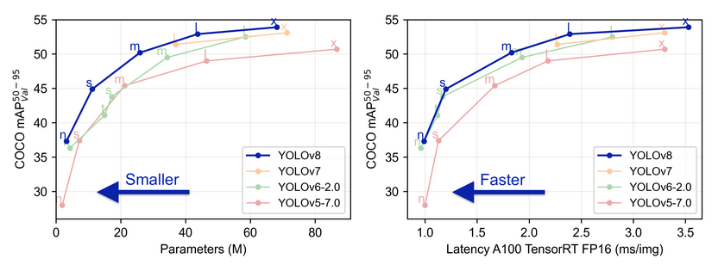
Figure 1. YOLOv8 Performance Evaluation
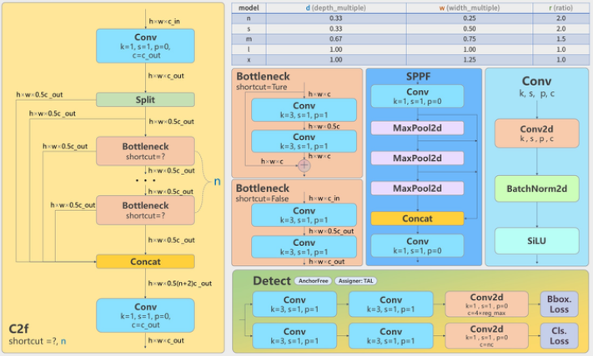
Figure 2. The YOLOv8 model structure (Juan 2023)

2. material and methods

The methodology to deploy lightweight YOLOv8 optimized deep neural network for real-time weapon detection in smart surveillance systems to timely classify, detect and predict the performance accuracy of a potential object that poses as security threats using standard datasets and computational efficiency and real-time performance on the raspberry pi 5 platform. Initially, a collection of dataset comprising custom images of six (6) classes and corresponding annotations and labeling specifically tailored for weapon detection. The datasets were captured using USB web camera on raspberry pi 5 using some algorithms of the API and terminal of the raspberry pi5 to have the web camera capture the images in a saved folder. The images were pre-processed and augmented as necessary using algorithms to launch labelimg on raspberry pi 5 platforms to annotate and label the images. Because of the memory and the available TPU on google colab, a google drive was created to upload the datasets and had the model trained using the google colab. The datasets were split on a ratio of 70%, 20% and 10% on train, validate and test respectively with a yaml file of train and val on a class of six (6). It was then proceeded to train the YOLOv8 model, a state-of-the-art object detection architecture, on this dataset. The model was trained, validated and tested using standard evaluation metrics such as precision, recall, and Mean Average Precision (mAP). Next, the model (best.pt) was deployed on raspberry pi 5 using an algorithm developed as a user-friendly interface to test the images on the model with the aid of the USB web camera. The trained YOLOv8 model was integrated into this application, enabling users to test the detected images, and also classify and predict the accuracy of the images. Under test, the image was viewed under the USB web camera as the detection was done live. The model was deployed on raspberry pi 5 and was used on real-world scenarios to ensure scalability and reliability. Figure 3 depicts the flowchart of the model.

NO
Yes
Datasets
Capture Images, Annotate and Label

Input images

Model Training
Classify, Detect

Test
Is train?
Start
Stop

Figure 3: Flowchart of the Model

2.1 Acquisition of Images
The images used for training the model were locally obtained weapons or materials that could be dangerous to people or groups living in an area, campus, or eventful space. Figure 4 displays some of the sampled datasets used for training. All the images in the datasets were gathered both locally and online. A total of 3500 images were collected across six classes. Four of these classes; axe, dagger, matchet, and picer were entirely sourced from local areas. One class, handgun, was entirely downloaded from online sources. The knife class had its images split, with some coming from online sources and others collected locally. Table 1 provides a summary of the datasets, and Figure 5 shows a bar chart representing the data by class.
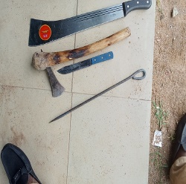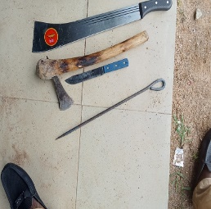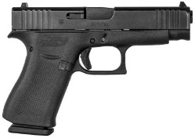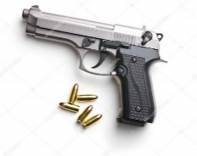
Figure 4: Sampled Datasets of images to be trained

Table 1: Summary of Dataset Representation
Column1 Column2 Coloumn3 Column4 Column5 Column6
Dataset and Their % Values
S/No Name Train (70 %) Val (20 %) Test (10 %) Total
0 Axe 420 120 60 600
1 Daga 420 120 60 600
2 Handgun 399 114 57 570
3 Knife 406 116 58 580
4 Matchet 420 120 60 600
5 Picer 385 110 55 550
Total 2450 700 350 3500
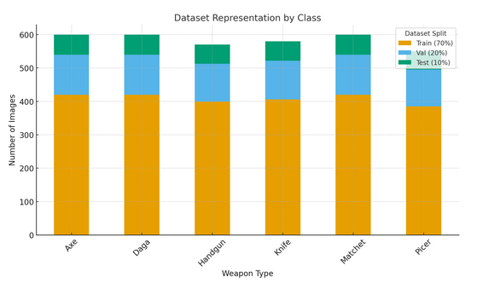
Figure 5. Bar Chart of Data Representation by Class of Training

Figure 5 shown a chart representation of the dataset split of (Train, Validation, Test) for each weapon category. Each bar showed how the dataset was distributed across the splits, making it easier to compare between classes.

2.1.1 Model Training

The YOLOv8 was chosen because it works well and was efficient for real-time object detection. The deep learning tools and Python libraries used included ultralytics, Google Colab, Thonny IDE, opencv-python, CVZone, torch = 2.0.1, torchvision == 0.15.2, and torchchaudio = 2.0.2. The model was built using custom datasets and trained for 100 epochs with default hyper-parameters. Using custom datasets was quite important because the model was trained from scratch, and the model learned how to classify, detect, and predict accurately by placing the weapon images in the right positions. The model was developed and trained on Google Colab, with the Raspberry Pi 5 as the base platform. The datasets were uploaded to Google Drive, and Google Colab was used to run the YOLOv8 algorithm. A yaml file was created to define the train and validation datasets along with the classes. Google Drive was connected to Colab, and the model was trained and validated. The training and performance results, including metrics for both validation and test sets, were calculated on a per-class and overall basis.
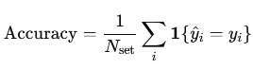
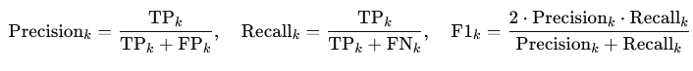
2.1.2 Testing and Evaluation
The test dataset were used to infer the results that the model predicted and results of the model confirmed that it performed well. Fine tuning the model in custom datasets enables the model to customize its features rending with specific characteristics of the region of interest (ROI) enhancing the ability to detect the weapons on a greater accuracy and recall thereby improving the robustness of the model. The web camera and the raspberry pi 5 were used to test and evaluate the model by copying the weight of the model in best.pt which was considered as the best.

3. RESULTS AND DISCUSSION

This section presents the experimental findings of lightweight YOLOv8 model for weapon detection. The evaluation is conducted in two key areas of detection performance on a standard test dataset, and computational efficiency and real-time performance on the Raspberry Pi 5 platform. The experimental setup shows the hardware and basic deployment and inference testing that was performed on a Raspberry Pi 5 with 32GB RAM along external accelerators as Google Colab, TPU, used to establish a baseline performance. The software environment was built on Raspberry Pi OS (64-bit), Python 3.11, PyTorch 2.0, Torchvision 0.15.2, computer vision (CV) zone, and the Ultralytics YOLOv8 framework while the dataset comprised of custom locally sourced and trained datasets of matchet, picer, daga, knife and axe while the hand gun data set was curated in the publicly available weapon detection datasets. The dataset was split into 70 % training, 20 % validation, and 10 % testing and trained on 100 epochs. Figure 6 shows a simple GUI for capturing of snap shots of the raw data for storage in a folder. The datasets after annotation and labeled were uploaded to google drive and google colab was used for the training of the model after downloading and installing ultralytics and all the dependencies. A yaml file was created with the train and val datasets with their respective paths. The computational efficiency and real-time performance on Raspberry Pi 5 shows the model achieving an average inference speed of 23.6 FPS which meets the threshold for real-time processing of greater than 15 FPS for surveillance as meeting the key objective of the study on real-time deployment.

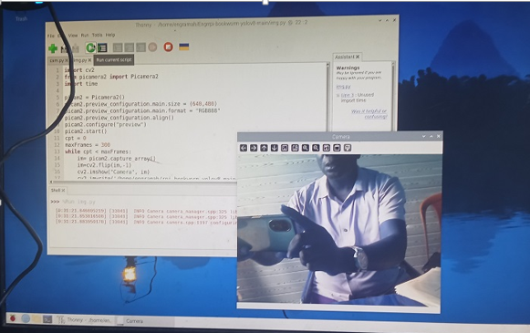
Figure 6: GUI for snapping the images

The model detection performance metrics were evaluated using standard object detection metrics of mean Average Precision (mAP@0.5), precision, and recall. Figure 7, showing an image of a Precision–Recall (PR) curve, used for the evaluation of performance of the model. The x-axis showing the recall while the y-axis shows the precision. The mAP@ 0.5 = 0.958 for all the classes, this shows that on the average, the model achieves 95.8% precision when prediction were considered correct since the Intersection-over-Union (IoU) threshold is said to be good at 0.5. The mAP@ 0.5 ≥0.9 indicates that the model is excellent and is highly reliable in distinguishing between the classes.

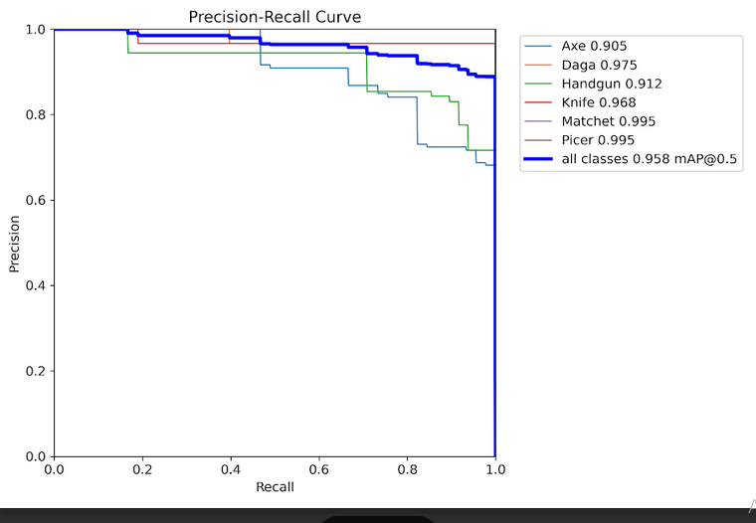
Figure 7: The Precision Recall Curve

Figure 8, shows the object detection and validated inference results with clear prediction of the object classes and their corresponding confidence scores from the trained model. The scores represents the model’s confidence score of 1.0 meaning that the objects are closer with higher confidence. The model accurately detected and predicted multiple weapons types with very high confidence and higher predictions.

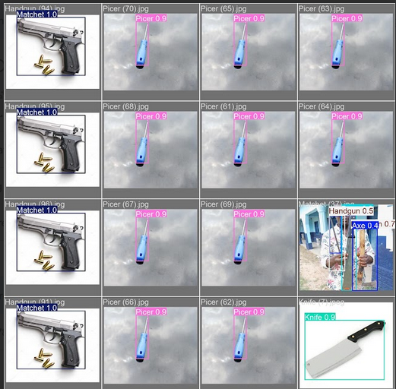

Figure 8: The Model Detection and Prediction of Dataset
Figure 9 displayed the result of correlated datasets. The image shows how different classes relate to one another in terms of their predicted outputs or annotation patterns. Each cell in the grid represents the correlation coefficient between the two classes. The color intensity shows the strength and direction of correlation while the dark / intense color near +1 indicated a strong positive correlation
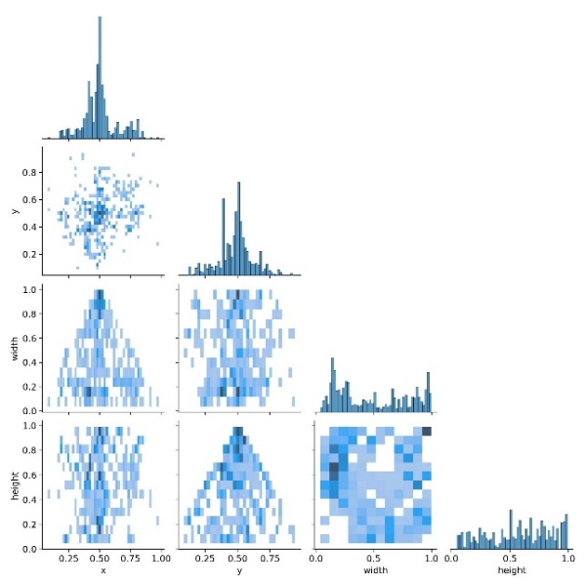

Figure 9: Correlogram
Figure 10 shows the result samples of train/box, losses metrics: recall, precision, validation/box, losses and metrics/mAP at _0.5 and metricsmAP_05:0,95. This shows the measures of how well the model learns to localize objects (fit bounding boxes correctly). As the losses decreases steadily during training, it shows the model is improving localization and the model is learning effectively. At an averages mAP across multiple IoU thresholds (from 0.5 to 0.95 in 0.05 increments). This tests how well the boxes align with ground truth at different strictness levels and at a high mAP@0.5:0.95 (e.g., >0.6) means strong, consistent performance across conditions. The training and validation curves showed a consistency without any signs of overfitting, as the loss functions keep decreasing, which means that the model learned properly. The high precision and recall values indicated that the model is good at avoiding both false alarms and missed detections. The mAP scores were very strong, especially at mAP50, showing that the detector worked very well for identifying weapons
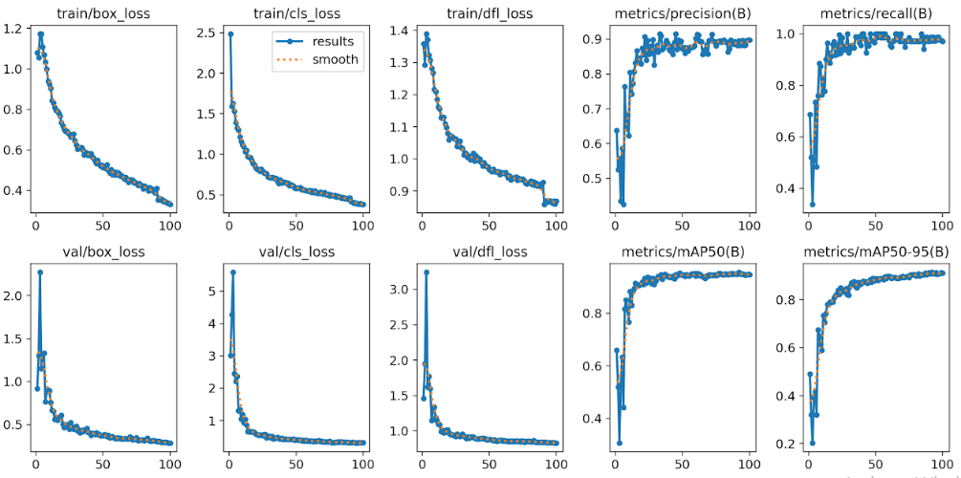
Figure 10: Result samples of train/box, losses metrics: recall, precision, validation/box, losses and metrices/mAP at _0.5 and metricsmAP_0.5:0,95

.4. CONCLUSION

The study successfully addressed the critical challenge of deploying a powerful, real-time weapon detection system on resource-constrained hardware. The study proposed, developed, and rigorously evaluated a lightweight and optimized version of the YOLOv8 deep neural network, specifically designed for the Raspberry Pi 5 platform. The model with an overall mAP@0.5 = 0.958 for all the classes, shows that on the average, the model achieves 95.8% precision when prediction were considered correct since the Intersection-over-Union (IoU) threshold is said to be good at 0.5. The mAP@ 0.5 ≥0.9 indicates that the model is excellent and is highly reliable in distinguishing between the classes and achieving an average inference speed of 23.6 FPS which meets the threshold for real-time processing of greater than 15 FPS for surveillance. In conclusion, the modeled lightweight YOLOv8 model presents a robust and efficient solution for the critical task of weapon detection. It effectively bridges the gap between high-accuracy deep learning models and the practical limitations of edge devices. The results firmly indicate that such systems are not only feasible but are ready for prototyping and deployment in real-world environments, offering a promising tool to enhance security and safety through intelligent, on-the-spot video analytics. Future work will focus on hardening the model against edge cases and leveraging hardware acceleration to push the boundaries of performance even further.
.

COMPETING INTERESTS DISCLAIMER:
Authors have declared that they have no known competing financial interests OR non-financial interests OR personal relationships that could have appeared to influence the work reported in this paper.

DISCLAIMER (ARTIFICIAL INTELLIGENCE)

Author(s) hereby declare that NO generative AI technologies such as Large Language Models (ChatGPT, COPILOT, etc) and text-to-image generators have been used during writing or editing of this manuscript.

REFERENCES:

Jyothsna, V., Alle, C., Kurnutala, R., N, G., R, K., & Pydala, B. (2024). YOLOv8-Based Person Detection, Distance Monitoring, Speech Alerts, and Weapon Identification with Email Notifications. 2024 International Conference on Expert Clouds and Applications (ICOECA), 288-296. https://doi.org/10.1109/ICOECA62351.2024.00059

Talib, M., Al-Noori, A., Suad, J., & Tariq, E. (2024). A multi-weapon detection using ensembled learning. Journal of Intelligent Systems, 33. https://doi.org/10.1515/jisys-2023-0060

Arora, S., Dalal, S., & Sethi, N. (2024). Interpretable Features of YOLO v8 for Weapon Detection - Performance Driven Approach. 2024 International Conference on Emerging Innovations and Advanced Computing (INNOCOMP), 87-93. https://doi.org/10.1109/INNOCOMP63224.2024.00024

Juan Pedro (2023). Detailed Explanation of YOLOv8 Architecture — Part 1.
“Retrieved from” https://medium.com/@juanpedro.bc22/detailed-explanation-of-yolov8-architecture-part-1-6da9296b954e

Arivalagan, D., Rubankumar, D., Thushiyanth, K., Kumar, S., Priyadharsini, V., & Vignesh, O. (2024). Weapon Detection System For Security And Surveillance Using YOLOv8. 2024 2nd International Conference on Advancement in Computation & Computer Technologies (InCACCT), 657-662. https://doi.org/10.1109/InCACCT61598.2024.10551046.

Mohammad Z. and Shaalan K. (2023), Improving Video Surveillance Systems in Banks using Deep Learning Techniques. https://www.nature.com/articles/s41598-023-35190-9

Nayak, R., Pati, U., Das, S., & Sahoo, G. (2024). YOLO-GTWDNet: a lightweight YOLOv8 network with GhostNet backbone and transformer neck to detect handheld weapons for smart city applications. Signal Image Video Process. 18, 8159-8167. https://doi.org/10.1007/s11760-024-03458-w.

Soban A., Muhammad T. B., Muhammad G. K., Benny L. and Muhammad S. (2023). Development and Optimization of Deep Learning Models for Weapon Detection in Surveillance Vi

Amah G. G., Enokela, Jonathan A. David O. Agbo, Tersoo E. Iorkyase (2023). The Implementation of a Deep Learning Iot-Based Weapon Detection Model Using Yolov7. International Research Journal of Modernization in Engineering Technology and Science. 5(11):3292-3
.
Ekmal M., Quyyum E., Haris, M., and Abdullah L. (2023). Proceedings of the Multimedia University Engineering Conference. Atlantis Press International BV. (2023)

Akinsowon F. I. (2021), Root Causes of Security Challenges in Nigeria and Solutions, International Journal of Innovative Social Sciences & Humanities Research 9(4):174-180

Jacob, I., Sivasakthi, T., Brindha, S., Hariharasudhan, S., Priyadharsan, M., & Vishal, V. (2024). An Enhanced Surveillance System for Gun and Knife Detection using YOLOv8 and Raspberry Pi. 2024 International Conference on Communication, Computing and Internet of Things (IC3IoT), 1-6. https://doi.org/10.1109/IC3IoT60841.2024.10550256.

Pullakandam, M., Loya, K., Salota, P., Yanamala, R., & Javvaji, P. (2023). Weapon Object Detection Using Quantized YOLOv8. 2023 5th International Conference on Energy, Power and Environment: Towards Flexible Green Energy Technologies (ICEPE), 1-5. https://doi.org/10.1109/ICEPE57949.2023.10201506.

Rodriguez-Rosas, E., Castillo-Turpo, A., Acuna-Condori, K., & Paiva-Peredo, E. (2025). Security in smart cities using YOLOv8 to detect lethal weapons. IAES International Journal of Artificial Intelligence (IJ-AI). https://doi.org/10.11591/ijai.v14.i2.pp945-953.

Sharma, P., & Arora, S. (2023). The AllSeeing Eye for Constructive Weapon Detection Using YOLOv8 Object Detection Model. Proceedings of the 5th International Conference on Information Management & Machine Intelligence. https://doi.org/10.1145/3647444.3647846.

Bhatti, M., Khan, M., Aslam, M., & Fiaz, M. (2021). Weapon Detection in Real-Time CCTV Videos Using Deep Learning. IEEE Access, 9, 34366-34382. https://doi.org/10.1109/ACCESS.2021.3059170.

