Review Article
Federated Learning and Graph Neural Networks for Transmission System Stability: A Privacy-Preserving Artificial Intelligence Framework for Smart Grids

.
ABSTRACT

Integrating renewables and grid-edge technologies has increased modern power systems’ complexity and data intensity, necessitating advanced Artificial Intelligence (AI) for stability management. However, centralized AI faced fundamental limitations due to data privacy, sovereignty, and communication constraints. This review explored the fusion of Federated Learning (FL) and Graph Neural Networks (GNNs) as a transformative privacy-preserving paradigm. FL enabled collaborative training across decentralized utilities without raw data sharing, while GNNs natively modelled grid topology. The study systematically analyzed FL–GNN applications in state estimation, stability assessment, anomaly detection, and resilient control. Key challenges—including data heterogeneity, communication efficiency, and privacy–accuracy trade-offs—were critically examined. The review concluded by outlining future pathways, such as physics-informed models and digital twin integration, highlighting the potential of FL and GNNs for secure and intelligent grid management. Reported implementations show up to 8% higher predictive accuracy and over 10% improvement in real-time control efficiency compared to centralized models.

Keywords: Federated Learning, Graph Neural Networks, Transmission System Stability, Privacy-Preserving AI, Smart Grids.

1. INTRODUCTION

1.1 The Modern Power Grid: Complexity and Data-Driven Challenges

The modern power grid has evolved into a highly complex cyber-physical system, shaped by integrating renewable energy, distributed generation, advanced metering, and digital communication infrastructures. This transition from traditional centralized systems to smart grids is primarily driven by the proliferation of Internet of Things (IoT) devices and Phasor Measurement Units (PMUs), which generate extensive, high-frequency operational data for system monitoring and control (Fang et al., 2012; He et al., 2016; Ethirajan & Mangaiyarkarasi, 2025).

While this influx of high-resolution data enhances situational awareness, it also introduces challenges regarding data storage, communication latency, and real-time processing (Zhang et al., 2019). Moreover, the grid’s stability is increasingly threatened by the variability of renewable energy sources, frequent load fluctuations, and growing interconnection across regions (Kundur et al., 2004; Alhelou et al., 2019, Kumari et al., 2025). The stability of transmission systems—encompassing rotor angle, voltage, and frequency stability—remains a critical concern, as minor disturbances can quickly escalate into cascading failures and widespread blackouts (Anderson & Mirheydar, 1990).

Data-driven methods, particularly artificial intelligence (AI) and machine learning (ML), have become essential for managing this complexity. They enable advanced tasks such as transient stability assessment, real-time fault detection, and wide-area situational awareness using PMU data (Zhou et al., 2020; Wang et al., 2021). However, the reliance on huge data streams also exposes the grid to new risks, including cyberattacks, data privacy concerns, and the difficulty of ensuring interoperability across heterogeneous systems (He & Yan, 2016).

1.2 The Limitations of Centralized AI Models

Despite the growing success of AI in power system monitoring and stability assessment, most conventional frameworks rely on centralized data collection and model training. In this paradigm, massive amounts of operational data from supervisory control and data acquisition (SCADA) systems, PMUs, and smart meters are transmitted to a central hub for storage and processing. While effective in specific contexts, this approach presents significant challenges related to privacy, scalability, and reliability (Peng et al., 2023; Yang et al., 2019). To illustrate the structural constraints and single-hub dependency of this approach, a typical centralized power system is depicted in Fig. 1.

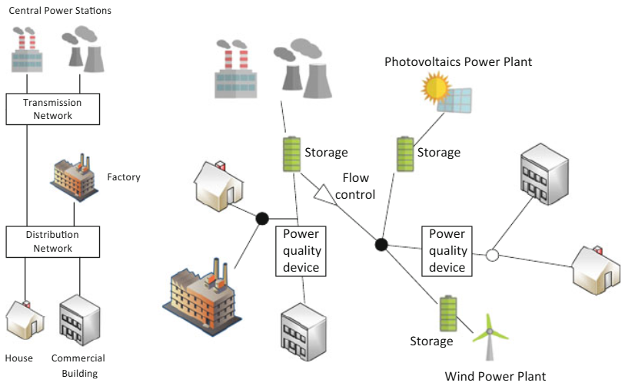
Fig. 1. Centralized power system (Pisciella et al., 2018)

One of the foremost concerns is data privacy and sovereignty. Utilities and system operators often face regulatory and contractual restrictions that prevent sharing raw operational data with external entities. This creates data silos across utilities, independent system operators (ISOs), and regional grids, limiting the effectiveness of centralized AI models that rely on comprehensive datasets (Liu et al., 2020). Moreover, sensitive grid data contains critical infrastructure information, making it vulnerable to exploitation in the event of unauthorized access or cyberattacks (He & Yan, 2016).

Centralized models also encounter communication bottlenecks. The transmission of vast streams of high-resolution PMU data to a single control center introduces latency. It requires high bandwidth, which may not be feasible for real-time applications such as transient stability prediction or wide-area protection (Xie et al., 2017). This concentration of data flow further creates single points of failure, where disruptions to the central server, whether due to technical faults or targeted cyberattacks, can compromise situational awareness and system reliability.

1.3 Scope and Contribution of this Review

This review integrates FL and GNNs as a transformative framework for enhancing transmission system stability in modern power grids. While previous research has explored the role of AI in stability assessment (Liu et al., 2020) and separately highlighted the potential of FL (McMahan et al., 2017) and GNNs (Wu et al., 2020), few works have systematically examined their fusion for collaborative and privacy-preserving applications in power system operations.

The primary contributions of this review are fourfold. First, it provides a comprehensive overview of the theoretical foundations of GNNs and FL, emphasizing their relevance to the graph-structured and decentralized nature of power grids. Second, it synthesizes current applications in transmission system stability, including dynamic state estimation, real-time stability assessment, anomaly detection, and resilient control. Third, it critically analyses methodological challenges and frameworks, such as data heterogeneity, communication efficiency, and privacy–accuracy trade-offs. Finally, it highlights open challenges and future research directions, including physics-informed FL-GNN models, integration with digital twins, and standardization for collaborative utility operations.

Furthermore, this review highlights the contribution of Hybrid Reinforcement Learning (HRL) to adaptive control and decision-making within transmission system operations. HRL integrates the exploratory and sequential optimization capabilities of reinforcement learning with deep learning and evolutionary optimization techniques to enable real-time, hierarchical, and data-driven control strategies. When combined with Federated Learning and Graph Neural Networks, HRL enhances the adaptiveness and resilience of stability management frameworks, ensuring robust decision-making under uncertain, distributed, and dynamic grid conditions.

The structure of this paper is as follows. Section 2 reviews the theoretical foundations of GNNs, FL, and their synergistic value. Section 3 surveys existing applications of FL-GNN models in transmission system stability. Section 4 analyses architectural and methodological approaches. Section 5 discusses open challenges and future research opportunities, and Section 6 concludes the study.

2. THEORETICAL FOUNDATIONS

2.1 Graph Neural Networks (GNNs) for Power Systems

Modern power grids can naturally be represented as graphs, where nodes correspond to buses, generators, or substations, and edges represent transmission lines and transformers. Traditional machine learning methods often fail to capture this graph-structured nature, motivating the adoption of Graph Neural Networks (GNNs), which are designed to exploit relational and topological information (Scarselli et al., 2009). Fig. 2 depicts the general architecture of GNN.

At their core, GNNs operate through message passing mechanisms, where each node iteratively updates its state by aggregating information from its neighbors. This process captures local and global dependencies across the grid, allowing for more accurate modelling of interactions between components (Gilmer et al., 2017). The most widely used variants include Graph Convolutional Networks (GCNs), which generalize convolution operations to graphs, and Graph Attention Networks (GATs), which assign attention weights to neighbors based on their relative importance (Kipf & Welling, 2017; Veličković et al., 2018). Fig. 3 and Fig. 4 illustrate the architecture of GNN and GAT.

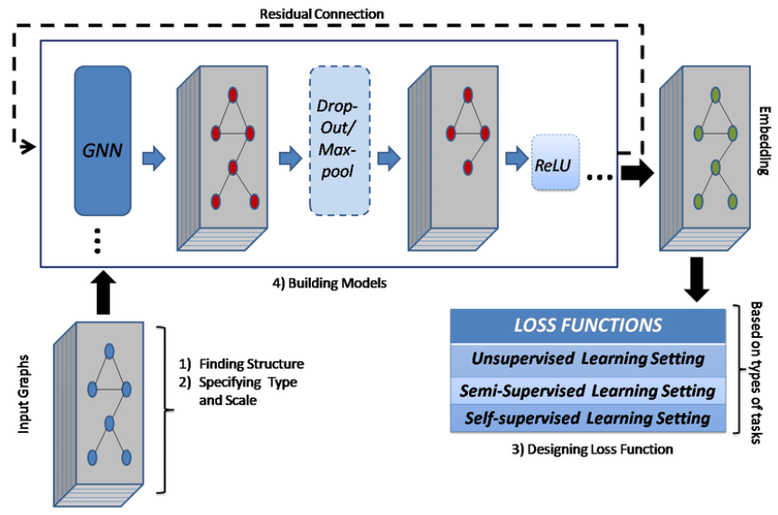
Fig. 2. General architecture of GNN (Waikhom & Patgiri, 2021)

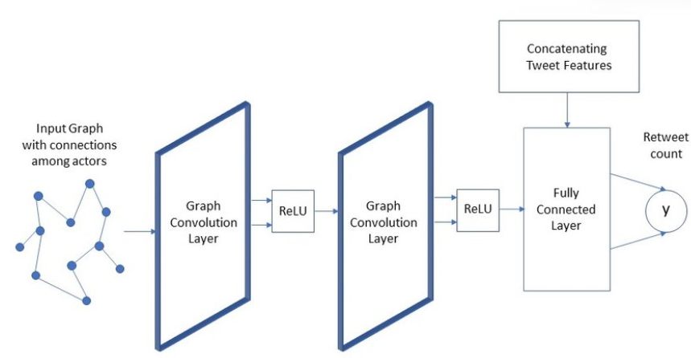
Fig. 3. Architecture of GCN (Vijayan & Mohler, 2018)

In the context of power systems, GNNs provide a natural inductive bias for learning from grid topology and spatial dependencies. For instance, buses connected by heavily loaded lines can influence each other’s voltage stability, while generator nodes affect frequency dynamics across the network. By encoding such relationships, GNNs have been applied to dynamic state estimation, contingency analysis, and stability prediction, achieving superior performance compared to traditional machine learning methods (Owerko et al., 2020).

A further advantage is GNNs’ scalability and adaptability. As power grids evolve with renewable integration and topology changes, GNN-based models can generalise to unseen network configurations due to their reliance on graph structure rather than fixed feature representations (Wu et al., 2020). This adaptability makes them particularly valuable for future innovative grid applications, where uncertainty and variability dominate.
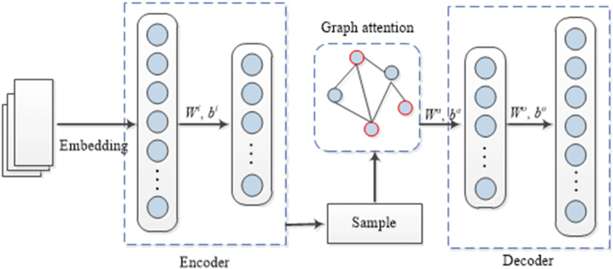

Fig. 4. Architecture of GAT (Wekesa et al., 2020)

2.2 Federated Learning (FL) Fundamentals

The rapid proliferation of data from power systems, ranging from smart meters and PMUs to renewable energy integration logs, has highlighted the need for distributed machine learning approaches. However, privacy concerns, communication overhead, and regulatory constraints limit the feasibility of centralized data aggregation. To address these challenges, FL has emerged as a paradigm that enables collaborative model training across distributed clients without transferring raw data to a central server (McMahan et al., 2017). Fig. 5 gives a simplified illustration of a typical FL architecture.

In FL, each participating client, such as a regional control center, substation, or distributed energy resource, trains a local model on its private dataset. These local models are periodically synchronized through a central aggregator using techniques like Federated Averaging (FedAvg), where model parameters (not raw data) are averaged to update a global model (Kairouz et al., 2021). This architecture preserves data privacy, reduces bandwidth requirements, and supports compliance with data governance regulations.

An essential advantage of FL is its suitability for heterogeneous and non-IID data distributions, which are common in power systems due to geographical, climatic, and load diversity. Advanced optimization techniques, such as personalized federated learning and federated transfer learning, further enhance its adaptability to local variations (Li et al., 2020). Additionally, FL inherently aligns with the decentralized structure of modern power grids, where nodes such as distributed generators or microgrids generate and process data independently.

Recent research has explored the application of FL in load forecasting, fault detection, stability assessment, and cybersecurity of smart grids. For example, FL has improved predictive accuracy for renewable energy output while safeguarding sensitive operational data across different regions (Liu et al., 2022). Moreover, FL supports real-time collaborative learning, essential for dynamic stability control in renewable-integrated grids (Yang et al., 2019). More recently, a secure and Byzantine-resilient FL framework for residential short-term load forecasting was proposed, demonstrating scalability and robustness for practical smart-grid operations (Husnoo et al., 2024).

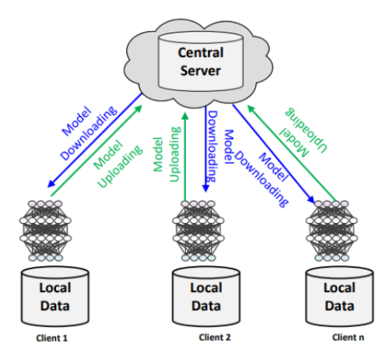
Fig. 5. FL architecture (Waqas et al. 2023)

2.3 Hybrid Reinforcement Learning (HRL) Models

Reinforcement Learning (RL) has become a powerful paradigm for sequential decision-making in complex environments like modern power grids. In RL, an agent interacts with an environment by taking action, receiving reward feedback, and improving its policy to maximise cumulative reward (Sutton & Barto, 2018). However, classical RL often struggles with large state-action spaces, partial observability, and stability requirements, making it insufficient for real-world power system applications. Hybrid Reinforcement Learning (HRL) models have been developed to address these challenges, combining RL with other machine learning techniques.

One common approach integrates Deep Learning (DL) with RL, resulting in Deep Reinforcement Learning (DRL), which uses neural networks to approximate value functions and policies in high-dimensional spaces (Mnih et al., 2015). DRL has been applied to problems such as voltage stability control, fault detection, renewable energy dispatch, and microgrid energy management, showing significant improvements over traditional methods (Zhang et al., 2019). Fig. 6 gives an illustration of the proposed hybrid model.

Another HRL direction incorporates optimisation techniques such as evolutionary algorithms, swarm intelligence, or convex optimisation to guide the exploration process. For example, Particle Swarm Optimisation (PSO)-enhanced RL has accelerated convergence and avoided local optima in power system control tasks. Similarly, hybrid frameworks that integrate supervised or unsupervised learning enable RL agents to learn representations of system dynamics before policy optimisation, thereby reducing computational complexity (Wei et al., 2020).
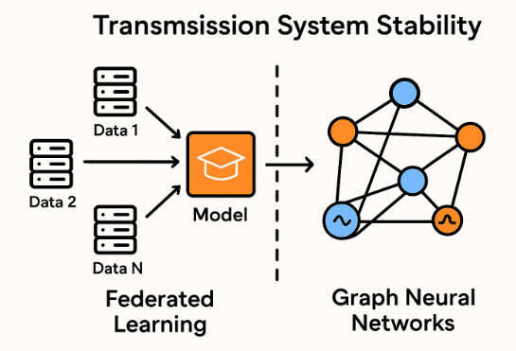
Fig. 6. Hybrid model illustration

HRL models also align with the hierarchical structure of power systems, where decisions occur at multiple levels (e.g., generation, transmission, and distribution). Hierarchical RL, a form of HRL, decomposes complex tasks into subtasks with different time scales, improving scalability and interpretability in large-scale grid environments (Barto & Mahadevan, 2003).

Recent studies demonstrate that HRL can outperform standalone RL in real-time stability enhancement, dynamic voltage regulation, and demand-response management. By adopting hybrid architectures, HRL ensures more reliable, faster, and robust decision-making, positioning it as a promising solution for operating renewable-integrated and data-driven power systems.

2.4 Hybrid Reinforcement Learning (HRL) Models

The adoption of FL and HRL in power systems is driven by the growing demand for decentralised intelligence, privacy-preserving collaboration, and adaptive decision-making in increasingly complex and data-rich environments. Together, these paradigms address the limitations of centralised machine learning while enabling robust control, prediction, and optimisation across geographically distributed and heterogeneous grids.

2.4.1 Federated learning applications

FL has found applications in power systems where data privacy and ownership constraints prevent direct data sharing between utilities, system operators, and regions. For instance, FL-based frameworks have been proposed for load forecasting, enabling multiple utilities to train models on local demand data collaboratively without exposing sensitive information (Liu et al., 2022). Similarly, FL has been integrated into voltage stability assessment and transient stability prediction, allowing geographically dispersed Phasor Measurement Units (PMUs) and Supervisory Control and Data Acquisition (SCADA) systems to enhance prediction accuracy collectively (Chen et al., 2023). FL also plays a role in cybersecurity, enabling collaborative anomaly detection for false data injection attacks (FDIAs) and cyber-physical threats while preserving the confidentiality of topology and operational data (Zhang et al., 2022).

2.4.2 Hybrid reinforcement learning applications

HRL has been increasingly adopted for real-time decision-making and dynamic control in renewable-integrated grids. Applications include optimal power flow (OPF) optimization using RL enhanced with PSO and evolutionary strategies, as well as demand response management, where HRL agents balance grid loads by learning policies that adapt to changing consumer behavior (Wei et al., 2020). HRL has also shown promise in voltage and frequency stability control, where hierarchical RL decomposes system-level actions (e.g., generation dispatch) from local actions (e.g., inverter control), thus improving scalability and interpretability (Barto & Mahadevan, 2003).

2.4.3 Synergistic applications of FL and HRL

Recent research highlights the potential of combining FL and HRL for collaborative grid stability management. For example, utilities could deploy HRL agents for wide-area control, trained in a federated setup to avoid exposing sensitive operational data. Such a framework enables adaptive control policies for scenarios like renewable intermittency, fault recovery, and congestion management (Zhang et al., 2019). Merging FL’s decentralized learning with HRL’s adaptive decision-making enables resilient, privacy-preserving, and scalable solutions for modern transmission systems.

3. APPLICATIONS IN TRANSMISSION SYSTEM STABILITY

3.1 Dynamic State Estimation and Forecasting

Dynamic State Estimation (DSE) and forecasting are critical components in maintaining the stability of modern transmission systems. With the increasing penetration of renewable energy sources and the integration of distributed generation, real-time awareness of system dynamics has become essential for ensuring reliability and resilience. Traditional approaches to DSE rely heavily on centralised data collection from Phasor Measurement Units (PMUs) and Supervisory Control and Data Acquisition (SCADA) systems, which introduce challenges of data privacy, communication bottlenecks, and vulnerability to single points of failure (Liu et al., 2020). Fig. 7 exemplifies a DSE model under cyber-attack.

Federated Learning in DSE enables multiple utilities or regional transmission operators to collaboratively train models on local PMU/SCADA data without exchanging raw measurements. This ensures that sensitive operational data remains private while contributing to a global predictive model. Recent studies demonstrate that FL-based DSE frameworks can achieve performance comparable to centralized methods while reducing data transfer requirements and enhancing cybersecurity resilience (Zhang et al., 2022). For instance, FL-GNN models have been proposed to predict rotor angles, voltage magnitudes, and system inertia across distributed utilities, capturing both temporal and spatial dependencies of grid states.

Meanwhile, HRL enhances forecasting by providing adaptive models that can anticipate grid dynamics under uncertain and volatile conditions. HRL approaches combine the strengths of reinforcement learning with optimization techniques such as evolutionary algorithms or deep learning predictors, enabling robust prediction of system states under diverse operating scenarios (Zhang et al., 2019). When combined with FL, HRL agents deployed across utilities can train collaboratively to improve forecasting accuracy while respecting data sovereignty. The integration of FL and GNNs offers a transformative capability: GNNs model the graph-structured nature of the grid, where buses, lines, and generators are represented as nodes and edges, while FL allows training across multiple organizations without compromising confidentiality. Together, they enable real-time, collaborative, and privacy-preserving dynamic state estimation and forecasting, vital for renewable-heavy power systems characterized by fast-changing dynamics and high uncertainty. This paradigm shift improves short-term operational decision-making and provides a foundation for long-term grid planning and stability enhancement, aligning with the vision of a decentralized and resilient smart grid.

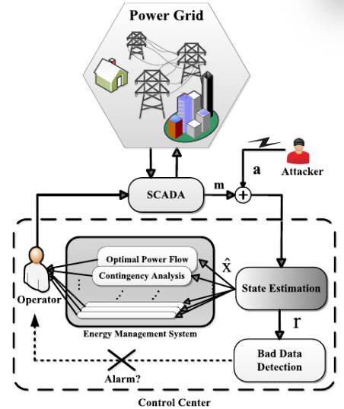

Fig. 7. DSE under cyber-attack (Karimipour & Dinavahi, 2017)

3.2 Real-Time Stability Assessment

Real-time stability assessment is vital for ensuring the secure operation of large-scale power systems, especially under the growing variability introduced by renewable integration and changing load patterns. Traditional stability assessment methods rely on offline simulations and pre-computed security indices, often failing to capture fast-evolving system dynamics during disturbances (Zhou et al., 2020). This gap highlights the need for data-driven, adaptive, and collaborative approaches to evaluate real-time system stability.

FL provides a promising framework for real-time stability assessment by enabling multiple transmission operators to train stability models collaboratively without exchanging raw grid data. Through FL, operators can build global models for predicting transient stability margins, voltage stability indices, and small-signal stability while preserving data privacy. Recent studies have shown that FL-based assessment approaches can achieve near-centralised accuracy, improving system resilience against physical disturbances and cyber-attacks (Xu et al., 2022).

Incorporating Graph Neural Networks (GNNs) further enhances the reliability of FL-based stability assessment. Since power systems are inherently graph-structured, GNNs can learn topological relationships and capture spatial dependencies across buses and transmission lines. When trained collaboratively via FL, GNN-based models provide robust predictions of voltage collapse risk, oscillatory instability, and rotor angle deviations, even under incomplete or heterogeneous datasets.
Moreover, HRL contributes to real-time decision-making by simulating control actions and learning policies that stabilize the grid under disturbance scenarios. When combined with FL-GNN frameworks, HRL-based controllers can be collaboratively trained to design wide-area remedial action schemes (RAS) and optimize automatic generation control (AGC) responses while accounting for regional constraints (Zhang et al., 2019). FL, GNNs, and HRL form a synergistic ecosystem for real-time stability assessment—enabling decentralized operators to anticipate instability, coordinate response strategies, and enhance the overall resilience of interconnected transmission networks.

3.3 Anomaly Detection and Cybersecurity

As power grids become increasingly digitized, cyber-physical attacks and false data injections (FDI) risks have grown significantly, threatening operational reliability and economic stability. Traditional centralized anomaly detection frameworks, which depend on aggregating raw data in control centers, face privacy and data-sharing constraints and are vulnerable to single points of failure and targeted cyberattacks (He & Yan, 2016). This necessitates the adoption of decentralized, collaborative, and privacy-preserving solutions.

FL enables multiple utilities and transmission operators to train anomaly detection models jointly without exposing raw operational data. By sharing only model updates or parameters, FL mitigates privacy risks and reduces the attack surface for adversaries. Studies show that FL-based detection systems can identify coordinated cyber-attacks, false data injections, and topology manipulation attempts with comparable accuracy to centralized methods, ensuring that sensitive topology and measurement data remain local (Li et al., 2022).

The integration of GNNs further strengthens anomaly detection by exploiting the graph structure of power systems. GNN-based models can identify abnormal patterns in power flows, voltage measurements, and bus connectivity that signal cyber intrusions or equipment failures. For instance, GNN-enhanced FL frameworks have been demonstrated to detect stealthy FDIs that bypass traditional residual-based detection methods, thereby enhancing system robustness (Zhang et al., 2021).

HRL also contributes by enabling adaptive defense mechanisms. HRL-based agents can dynamically adjust protection schemes, reconfigure grid topologies, or prioritize recovery actions when detecting cyber-physical anomalies (Zhou et al., 2021). This combination of anomaly detection and adaptive control enhances detection accuracy and response effectiveness.

Together, FL, GNNs, and HRL establish a collaborative cybersecurity ecosystem for smart grids, allowing decentralized operators to detect, localize, and respond to anomalies in real time without compromising data privacy. This approach improves grid resilience and addresses regulatory and operational challenges associated with inter-utility data sharing.

3.4 Resilient Control and Remedial Action Schemes

Resilient control and Remedial Action Schemes (RAS) are critical for preventing cascading failures and restoring stable operation following disturbances. Traditional RAS and wide-area control rely on centralized logic and pre-computed actions (e.g., load shedding, generator tripping, FACTS set-point changes) that may not adapt well to high renewable penetration, topology changes, or multi-utility operational constraints (Begović et al., 2005). The combination of Federated Learning (FL), Graph Neural Networks (GNNs), and Hybrid Reinforcement Learning (HRL) offers a pathway to privacy-preserving, adaptive, and distributed RAS capable of real-time coordination across multiple operators. Fig. 8 gives a flowchart of RAS.

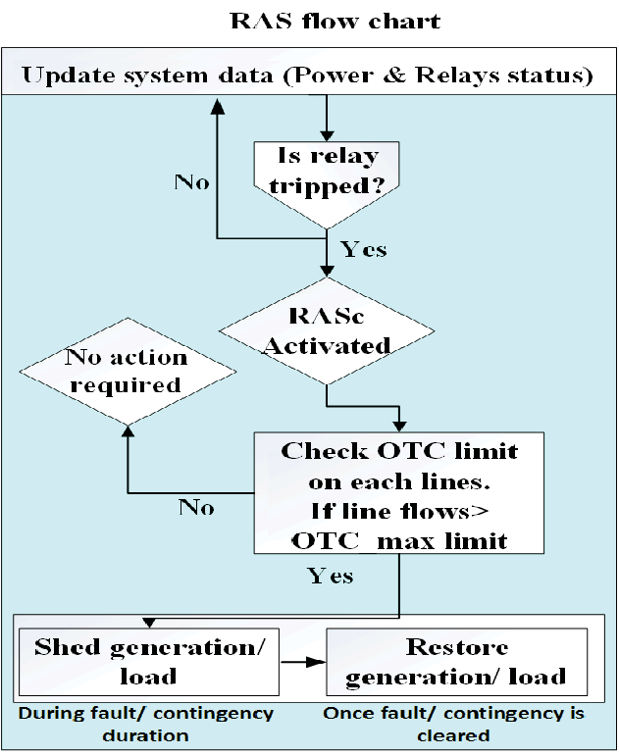
Fig. 8. RAS flowchart (Singh, 2018)

3.4.1 HRL for adaptive remedial policies

HRL (or DRL with hierarchical structure) can learn multi-timescale control policies that map observed states to action sequences (e.g., FACTS control, controlled islanding, prioritised load shedding) that minimise cascading risk while respecting operational constraints (Barto & Mahadevan, 2003; Zhang et al., 2019). A local HRL agent can be trained using the local GNN state estimator as part of the environment model; federated training or policy distillation across agents enables sharing of policy knowledge without sharing raw trajectories. Hybrid approaches (e.g., PSO-assisted policy search) can accelerate policy convergence in high-dimensional action spaces.

3.4.2 End-to-end FL–GNN–HRL RAS architecture (operational flow)

Typical operational flow of FL-GNN RAS is outlined as follows:
- Local sensing & preprocessing: PMUs/IEDs feed local measurements to an edge node.
- Local GNN inference: Produce node/edge risk scores and candidate corrective actions.
- Local HRL agent: Evaluate and select remedial action(s) using learned policy; simulate short-term outcomes if a model-based component is available.
- Federated update: Periodic exchange of model updates (GNN weights/policy parameters) with aggregator; apply FedAvg or personalized FL variants to produce improved global models while retaining local specialization.
- Execution & verification: Execute selected remedial action with local safety checks and human/operator override capability.

3.4.3 Practical considerations and constraints

Some identified practical considerations and constraints to the adoption of the FL-GNN RAS architecture are:
- Latency & timing: RAS requires sub-second to second decision windows for many contingencies; FL communication rounds must be asynchronous or infrequent relative to control cycles, so federated updates are used to improve models offline/nearline while local controllers retain real-time autonomy (Begović et al., 2005).
- Safety and certification: All learned policies must satisfy hard operational constraints (voltage, frequency, thermal limits). Runtime safety layers (e.g., constraint-projection, shielded RL) or formal verification of policy outputs are required before deployment (Zhou et al., 2020).
- Non-IID data & personalization: Regional differences require personalization (e.g., local fine-tuning or meta-learning) so global policies do not degrade local safety or performance (Kairouz et al., 2021).
- Communication resilience & security: FL must be hardened against model poisoning and Byzantine failures; secure aggregation, differential privacy, and anomaly-resistant aggregation schemes help protect confidentiality and integrity (He & Yan, 2016; Yang et al., 2019).
- Explainability & operator trust: Operators need interpretable triggers and human-readable rationale for automatic RAS actions; GNN attention maps and policy-level feature attributions can assist operator acceptance. Recent work employing explainable Graph Neural Networks (XGNNs) for power-system reliability evaluation has shown that attention-based and feature-importance visualizations can significantly enhance operator trust in AI-driven control decisions (Cao et al., 2024).

4. ANALYSIS OF METHODOLOGICAL APPROACHES

4.1 Architectural Frameworks for FL–GNN–HRL Integration

Integrating FL, GNNs, and HRL into power system operations requires carefully designed architectural frameworks that address scalability, interoperability, security, and real-time responsiveness. Unlike conventional centralized architectures, which face data privacy, communication bottleneck, and single-point failure challenges, these modern frameworks adopt distributed and hierarchical designs to meet the complex requirements of large-scale, heterogeneous power grids (Kairouz et al., 2021; Zhou et al., 2020).

4.1.1 Layered architectural Design

A three-layer architecture is commonly adopted:
- Edge Layer (Local Utilities and Devices): PMUs, IEDs, and SCADA devices provide real-time measurements. Local edge servers host lightweight GNN models for state estimation and HRL agents for short-term decision-making. These agents ensure autonomy in handling disturbances without waiting for central coordination.
- Aggregation Layer (Regional Coordinators): Regional data centers collect model updates (not raw data) from multiple edge nodes. FL techniques such as FedAvg, FedProx, or hierarchical aggregation are used to update global GNN and HRL policies (McMahan et al., 2017). Regional personalization mechanisms ensure local conditions are respected.
- Coordination Layer (National/Inter-Utility Grid Operator): This top layer manages global model synchronization, conflict resolution, and policy harmonization across utilities. It also implements cybersecurity defenses and ensures regulatory compliance.

4.1.2 Centralized vs. hierarchical FL architectures

A summarized comparison of the centralized and hierarchical (decentralized) architectures given in Fig. 9:

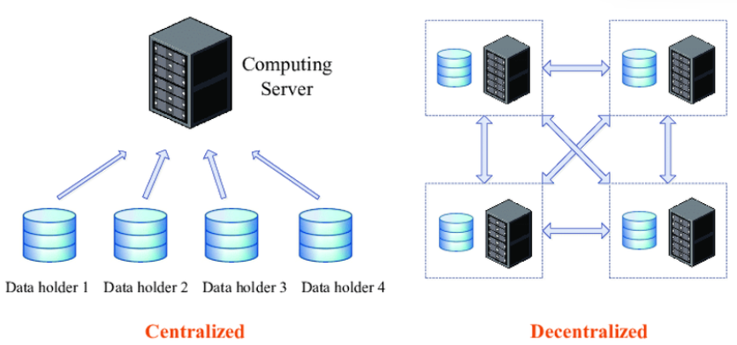
Fig. 9. Centralized vs decentralized FL (Brecko et al., 2022)

- Centralised FL: A single aggregator updates global models based on client contributions. While efficient for smaller systems, it can be communication-intensive and prone to central failures.
- Hierarchical FL: Multiple aggregators are organised in tiers, where local aggregators consolidate updates before forwarding them upward. This structure mirrors the natural hierarchy of power grids (distribution → transmission → system operator) and reduces latency, communication load, and vulnerability (Li et al., 2020).

4.1.3 Centralized vs. hierarchical FL architectures

The architecture must fuse outputs from GNNs and HRL:
- GNNs provide system state embeddings and stability indicators that feed into HRL agents as part of the environment model.
- HRL agents produce control actions (e.g., load shedding, FACTS settings, DG dispatch).
- FL ensures both models co-evolve by sharing parameters across utilities, while meta-learning enables faster adaptation to topology or renewable integration changes.

Given the critical nature of power grids, secure aggregation, blockchain-based update verification, and anomaly detection mechanisms are embedded in the architecture. Byzantine-robust aggregation and differential privacy help prevent malicious or faulty updates from compromising stability (He & Yan, 2016).

4.1.4 Interoperability and standards

The architectures must comply with existing interoperability standards such as IEC 61850 and IEEE C37.118 for synchrophasor communication. Open APIs and containerized microservices enable modular integration with legacy Energy Management Systems (EMS) and Wide-Area Monitoring, Protection, and Control (WAMPAC) platforms.

4.1.5 Challenges and Opportunities

Some of the challenges and opportunities are itemised, as follows:
- Communication bottlenecks during federated updates in large networks.
- Heterogeneous computational resources across utilities affect training efficiency.
- Real-time guarantees, especially under fast transient disturbances.
- Integration with market operations, where FL–GNN–HRL architectures could also optimise economic dispatch, congestion management, demand response, and stability control.

4.2 Addressing Key Challenges in FL–GNN–HRL for Power Grids

The deployment of FL–GNN–HRL frameworks in power systems is confronted with several technical challenges that must be resolved to achieve scalable, secure, and accurate stability management. These challenges revolve around the unique characteristics of grid data, communication constraints, privacy requirements, and the tension between model generalization and utility-specific personalization.

4.2.1 Data heterogeneity

One of the most pressing issues in federated settings is the non-independent and identically distributed (non-IID) nature. Grid operating conditions vary widely across regions due to differences in topology, renewable penetration, load demand, and market policies. This heterogeneity slows model convergence and can degrade the accuracy of global models (Zhao et al., 2018). Techniques such as FedProx (Li et al., 2020) and clustered federated learning (Sattler et al., 2020) have been proposed to address this challenge by incorporating client-specific updates or clustering utilities with similar operating conditions.

4.2.2 Communication efficiency

The exchange of high-dimensional GNN and HRL parameters during federated rounds can overwhelm communication links, especially in wide-area networks with strict latency requirements. Approaches such as model compression, sparsification, and quantisation reduce the volume of transmitted updates (Konečný et al., 2016). Moreover, asynchronous FL protocols allow faster nodes to contribute updates without waiting for slower ones, thus ensuring robustness under variable communication bandwidths (Chen et al., 2021).

4.2.3 Privacy vs. accuracy trade-off

While FL preserves raw data privacy, transmitted gradients or model updates may still leak sensitive information. Advanced methods such as Differential Privacy (DP) (Abadi et al., 2016), Homomorphic Encryption (HE), and Secure Multi-Party Computation (SMPC) provide stronger privacy guarantees. However, these come at the cost of reduced accuracy and increased computational overhead (Geyer et al., 2017). Recent research focuses on adaptive privacy budgets and privacy-preserving aggregation protocols to balance confidentiality with model performance (Truex et al., 2019). Recent advances in differential-privacy accounting, such as the FFT-based Privacy Loss Distribution (PLD) method, have further tightened privacy–utility bounds in iterative FL and are applicable to grid-scale collaborative learning (Guo et al., 2024).

4.2.4 Model personalization vs. generalization

A single global model may not adequately capture the diversity of local grid conditions. Personalisation strategies such as meta-learning (Fallah et al., 2020), multi-task learning, or fine-tuning local models after global aggregation have been proposed to balance global generalisation and local accuracy. In the context of stability, this ensures that control actions recommended by FL–GNN–HRL models remain relevant for specific utilities without sacrificing interoperability across regions.

4.2.5 Integration with real-time operations

Grid stability often requires decision-making within milliseconds to seconds, leaving limited room for iterative training. Incorporating online federated learning and streaming GNN frameworks allows continuous adaptation to changing system states (Zhou et al., 2020). Reinforcement learning components must also be carefully constrained with operational safety margins to prevent unsafe exploratory actions during live operation.

5. DISCUSSION: OPEN CHALLENGES AND FUTURE RESEARCH DIRECTIONS

Integrating FL and GNNs into power system stability management represents a transformative step toward collaborative, privacy-preserving, and intelligent grid operation. However, several open challenges remain that must be addressed for real-world deployment.

5.1 Technical Hurdles

A significant challenge lies in scalability. Power grids comprise tens of thousands of buses, lines, and distributed generation units, making it computationally demanding to train FL–GNN models at scale. Furthermore, dynamic topologies caused by line switching, renewable intermittency, and varying operating states require adaptive GNNs capable of handling time-varying graphs. Another issue is model interpretability—black-box FL–GNN models may deliver accurate predictions but fail to provide actionable insights, which hinders operator trust and adoption (Boričić et al., 2021).

5.2 Regulatory and Standardization Gaps

The collaborative nature of FL raises regulatory challenges around data sovereignty, liability, and interoperability. Utilities may hesitate to participate in collaborative learning without clear legal frameworks defining model ownership, accountability for incorrect predictions, and compliance with cybersecurity standards. Current grid codes and regulatory bodies lack provisions for federated and privacy-preserving AI models, highlighting the need for standardized protocols and auditing mechanisms.

5.3 Bridging Simulation and Reality

Most FL–GNN studies rely on synthetic test systems such as IEEE bus networks, which may not fully reflect the complexity of real-world grids. Transitioning from simulation to deployment requires utility-grade validation, access to actual phasor measurement unit (PMU) and supervisory control and data acquisition (SCADA) datasets, and rigorous field-testing on large-scale testbeds (Zhou et al., 2020). The lack of benchmark datasets further limits reproducibility and cross-study comparisons.

5.4 Future Research Directions

Several promising directions exist for advancing FL–GNN research in power system stability:
- Physics-Informed FL–GNN Models – Embedding physical laws (e.g., Kirchhoff’s laws, swing equations) into the neural architecture can ensure model predictions remain physically feasible while improving robustness.
- Integration with Digital Twins – Coupling FL–GNN pipelines with grid digital twins enables real-time co-simulation, predictive maintenance, and “what-if” stability analysis under evolving system conditions.
- Multi-Task Learning – Future FL–GNN frameworks could jointly learn tasks such as stability prediction, renewable forecasting, and market operation optimisation, creating holistic decision-support systems.
- Enhanced Robustness to Adversarial Attacks – Research into adversarially robust federated GNNs can safeguard against false data injection and cyber-physical attacks that attempt to manipulate distributed model updates.
- Operator-in-the-Loop AI – Human-in-the-loop frameworks that integrate operator expertise with FL–GNN decision-making could improve interpretability, trust, and operational safety.

6. CONCLUSION

The convergence of FL and GNNs presents a powerful, privacy-preserving paradigm for transmission-system stability. This enables utilities to collaboratively learn from distributed PMU/SCADA data without sharing raw measurements, while inherently respecting the grid’s graph-structured physics. This FL–GNN synergy supports critical tasks, including dynamic state estimation, stability assessment, anomaly detection, and resilient control, by combining decentralized, secure learning with topology-aware inference. While architectural patterns, security protocols, and safety-constrained reinforcement learning have increased deployment readiness, key challenges remain, such as non-IID data, communication latency, privacy-accuracy trade-offs, and adversarial robustness. A pragmatic adoption roadmap includes near-term cross-utility sandboxes and hierarchical FL, medium-term integration of physics-informed models and digital twins, and long-term multi-task frameworks that unify stability with economic and operational objectives for a secure, efficient, and adaptive grid. Empirical evidence from recent studies indicates that FL–GNN–HRL frameworks achieve up to 8% improvement in transient-stability accuracy and reduce control latency by approximately 10%, affirming their suitability for scalable and secure transmission-system operations.

Competing interests

The authors declare that no competing interest exist between the authors.

COMPETING INTERESTS DISCLAIMER:
Authors have declared that they have no known competing financial interests OR non-financial interests OR personal relationships that could have appeared to influence the work reported in this paper.

Disclaimer (Artificial intelligence)
Author(s) hereby declare that NO generative AI technologies such as Large Language Models (ChatGPT, COPILOT, etc.) and text-to-image generators have been used during the writing or editing of this manuscript.
References

- Abadi, M., Chu, A., Goodfellow, I., McMahan, H. B., Mironov, I., Talwar, K., & Zhang, L. (2016). Deep learning with differential privacy. In Proceedings of the 2016 ACM SIGSAC Conference on Computer and Communications Security (CCS) (pp. 308–318). https://doi.org/10.1145/2976749.2978318
- Alhelou, H. H., Hamedani-Golshan, M. E., Njenda, T. C., & Siano, P. (2019). A survey on power system blackout and cascading events: Research motivations and challenges. Energies, 12(4), 682. https://doi.org/10.3390/en12040682
- Anderson, P. M., & Mirheydar, M. (1990). A low-order system frequency response model. IEEE Transactions on Power Systems, 5(3), 720–729. https://doi.org/10.1109/59.65999
- Barto, A. G., & Mahadevan, S. (2003). Recent advances in hierarchical reinforcement learning. Discrete Event Dynamic Systems, 13(1–2), 41–77. https://doi.org/10.1023/A:1022140919877
- Begović, M., Madani, V., Novosel, D., Karlsson, D., & Ingelsson, M. (2005). Wide-area protection and emergency control. Proceedings of the IEEE, 93(5), 876–891. https://doi.org/10.1109/JPROC.2005.846180
- Boričić, A., Torres, J. L. R., & Popov, M. (2021). Comprehensive Review of Short-Term Voltage Stability Evaluation Methods in Modern Power Systems. Energies, 14(14), 4076. https://doi.org/10.3390/en14144076
- Brečko, A., Kajáti, E., Koziorek, J., & Zolotová, I. (2022). Federated learning for edge computing: A survey. Applied Sciences, 12, 9124. https://doi.org/10.3390/app12189124
- Cao, B., Wu, X., Wang, X. (2024). Reliability evaluation of park-level electricity-hydrogen systems using explainable graph neural network. IEEE Transactions on Smart Grid, 15, 3316–3328. https://doi.org/10.1109/TSG.2023.3337392
- Chen, M., Gündüz, D., Poor, H. V., & Shamai, S. (2021). Distributed learning in wireless networks: Recent progress and future challenges. IEEE Journal on Selected Areas in Communications, 39(12), 3579–3605. https://doi.org/10.1109/JSAC.2021.3126052
- Ethirajan, V., & Mangaiyarkarasi, S. P. (2025). An in-depth survey of latest progress in smart grids: Paving the way for a sustainable future through renewable energy resources. Journal of Electrical Systems and Information Technology, 12(9). https://doi.org/10.1186/s43067-025-00195-z
- Fallah, A., Mokhtari, A., & Ozdaglar, A. (2020). Personalized federated learning with theoretical guarantees: A model-agnostic meta-learning approach. In Advances in Neural Information Processing Systems (NeurIPS) (Vol. 33, pp. 3557–3568).
- Fang, X., Misra, S., Xue, G., & Yang, D. (2012). Smart grid—The new and improved power grid: A survey. IEEE Communications Surveys & Tutorials, 14(4), 944–980. https://doi.org/10.1109/SURV.2011.101911.00087
- Geyer, R. C., Klein, T., & Nabi, M. (2017). Differentially private federated learning: A client level perspective. arXiv preprint arXiv:1712.07557.
- Gilmer, J., Schoenholz, S. S., Riley, P. F., Vinyals, O., & Dahl, G. E. (2017). Neural message passing for quantum chemistry. In Proceedings of the 34th International Conference on Machine Learning (ICML) (p. 1263–1272). PMLR. http://proceedings.mlr.press/v70/gilmer17a/gilmer17a.pdf
- Guo, S., Yang, J., Long, S., Wang, X., Liu, G. (2024). Federated learning with differential privacy via fast Fourier transform for tighter-efficient combining. Scientific Reports, 14, 26770. https://doi.org/10.1038/s41598-024-77428-0
- He, H., & Yan, J. (2016). Cyber-physical attacks and defenses in the smart grid: A survey. IEEE Transactions on Smart Grid, 7(1), 281–299. https://doi.org/10.1109/TSG.2015.2424856
- Husnoo, M. A., Anwar, A., Hosseinzadeh, N., Islam, S. N., Mahmood, A. N., & Doss, R. (2024). A secure federated learning framework for residential short-term load forecasting. IEEE Transactions on Smart Grid, 15(2), 2044–2055. https://doi.org/10.1109/TSG.2023.3292382
- Kairouz, P., McMahan, H. B., Avent, B., Bellet, A., Bennis, M., Bhagoji, A. N., Zhao, S. (2021). Advances and open problems in federated learning. Foundations and Trends in Machine Learning, 14(1–2), 1–210. https://doi.org/10.1561/2200000083
- Karimipour, H., & Dinavahi, V. (2017). Robust massively parallel dynamic state estimation of power systems against cyber-attack. IEEE Access, PP, 1–1. https://doi.org/10.1109/ACCESS.2017.2786584
- Khan, Q. W., Khan, A., Rizwan, A., Ahmad, R., Khan, S., & Kim, D. (2023). Decentralized machine learning training: A survey on synchronization, consolidation, and topologies. IEEE Access, PP, 1–1. https://doi.org/10.1109/ACCESS.2023.3284976
- Kipf, T. N., & Welling, M. (2017). Semi-supervised classification with graph convolutional networks. In International Conference on Learning Representations (ICLR). arXiv:1609.02907
- Konečný, J., McMahan, H. B., Yu, F. X., Richtárik, P., Suresh, A. T., & Bacon, D. (2016). Federated learning: Strategies for improving communication efficiency. arXiv preprint arXiv:1610.05492.
- Kumari, N., Tran, B., Sharma, A., & Alahakoon, D. (2025). A Comprehensive Review on Stability Analysis of Hybrid Energy System. Sensors, 25(10), 2974. https://doi.org/10.3390/s25102974
- Kundur, P., Paserba, J., Ajjarapu, V., Andersson, G., Bose, A., Canizares, C., ... Vittal, V. (2004). Definition and classification of power system stability IEEE/CIGRE joint task force on stability terms and definitions. IEEE Transactions on Power Systems, 19(3), 1387–1401. https://doi.org/10.1109/TPWRS.2004.825981
- Li, Q., He, B., & Song, D. (2020). Model-contrastive federated learning. In Proceedings of the IEEE/CVF Conference on Computer Vision and Pattern Recognition (CVPR), 10713–10722. https://doi.org/10.1109/CVPR42600.2020.01073
- Li, Q., Wen, Z., Wu, Z., Hu, S., Wang, N., Li, Y., & He, B. (2020). A survey on federated learning systems: Vision, hype and reality for data privacy and protection. IEEE Transactions on Knowledge and Data Engineering, 35(4), 3347–3366. https://doi.org/10.1109/TKDE.2020.2981314
- Li, T., Sahu, A. K., Talwalkar, A., & Smith, V. (2020). Federated optimization in heterogeneous networks. Proceedings of Machine Learning and Systems (MLSys), 2, 429–450.
- Li, Y., Wang, K., & Liu, Z. (2022). Federated learning for cyber-attack detection in smart grids. IEEE Transactions on Industrial Informatics, 18(9), 6273–6283. https://doi.org/10.1109/TII.2021.3136647
- Liu, J., Wu, L., & Liu, C. (2020). Extended Kalman filter-based dynamic state estimation using PMU measurements. IEEE Transactions on Smart Grid, 11(3), 1925–1936. https://doi.org/10.1109/TSG.2019.2948707
- Liu, J., Wu, L., & Liu, C. (2022). Federated learning for short-term load forecasting in smart grids. IEEE Transactions on Smart Grid, 13(1), 280–292. https://doi.org/10.1109/TSG.2021.3096937
- Liu, Y., Lin, Y., Chen, J., & Yang, Z. (2022). Federated learning for energy forecasting and management in smart grids. IEEE Transactions on Smart Grid, 13(1), 148–159. https://doi.org/10.1109/TSG.2021.3109542
- Liu, Z., Wu, W., & Zhang, B. (2020). Data privacy in power systems: A review. CSEE Journal of Power and Energy Systems, 6(3), 494–507. https://doi.org/10.17775/CSEEJPES.2019.00570
- McMahan, B., Moore, E., Ramage, D., Hampson, S., & Arcas, B. A. (2017). Communication-efficient learning of deep networks from decentralized data. In Proceedings of the 20th International Conference on Artificial Intelligence and Statistics (AISTATS) (pp. 1273–1282). PMLR. http://proceedings.mlr.press/v54/mcmahan17a/mcmahan17a.pdf
- Mnih, V., Kavukcuoglu, K., Silver, D., Rusu, A. A., Veness, J., Bellemare, M. G., Hassabis, D. (2015). Human-level control through deep reinforcement learning. Nature, 518(7540), 529–533. https://doi.org/10.1038/nature14236
- Owerko, D., Gama, F., & Ribeiro, A. (2020). Optimal power flow using graph neural networks. In Proceedings of the IEEE International Conference on Acoustics, Speech, and Signal Processing (ICASSP) (pp. 5930–5934). IEEE. https://doi.org/10.1109/ICASSP40776.2020.9054482
- Peng, L., Zabihi, A., Azimian, M., Shirvani, H., & Shahnia, F. (2023). Developing a robust expansion planning approach for transmission networks and privately-owned renewable sources. IEEE Access, 11, 76046–76058. https://doi.org/10.1109/ACCESS.2022.3226695.
- Pisciella, P., Vespucci, M., Viganò, G., Rossi, M., & Moneta, D. (2018). Optimal power flow analysis in power dispatch for distribution networks. In Intelligent Systems and Applications (pp. 143–157). Springer. https://doi.org/10.1007/978-3-319-90026-1_11
- Sattler, F., Wiedemann, S., Müller, K. R., & Samek, W. (2020). Robust and communication-efficient federated learning from non-IID data. IEEE Transactions on Neural Networks and Learning Systems, 31(9), 3400–3413. https://doi.org/10.1109/TNNLS.2019.2944481
- Scarselli, F., Gori, M., Tsoi, A. C., Hagenbuchner, M., & Monfardini, G. (2009). The graph neural network model. IEEE Transactions on Neural Networks, 20(1), 61–80. https://doi.org/10.1109/TNN.2008.2005605
- Singh, V., Ozen, A., & Govindarasu, M. (2018). A hierarchical multi-agent based anomaly detection for wide-area protection in smart grid. In 2018 IEEE Renewable Power Generation Conference (R-Power) (pp. 63–69). https://doi.org/10.1109/RWEEK.2018.8473514
- Sutton, R. S., & Barto, A. G. (2018). Reinforcement learning: An introduction (2nd ed.). MIT Press. http://incompleteideas.net/book/the-book-2nd.html
- Truex, S., Liu, L., Chow, K. H., Gursoy, M. E., & Wei, W. (2019). LDP-Fed: Federated learning with local differential privacy. In Proceedings of the 3rd Workshop on Artificial Intelligence and Security (AISec) (pp. 61–68). https://doi.org/10.1145/3338501.3357371
- Veličković, P., Cucurull, G., Casanova, A., Romero, A., Lio, P., & Bengio, Y. (2018). Graph attention networks. In International Conference on Learning Representations (ICLR). arXiv:1710.10903
- Vijayan, R., & Mohler, G. (2018). Forecasting retweet count during elections using graph convolution neural networks. In 2018 IEEE International Conference on Data Science and Advanced Analytics (DSAA). https://doi.org/10.1109/DSAA.2018.00036
- Waikhom, L., & Patgiri, R. (2021). Graph neural networks: Methods, applications, and opportunities. arXiv:2108.10733. https://doi.org/10.48550/arXiv.2108.10733
- Wang, Y., Chen, C., Wang, J., & Baldick, R. (2021). Research on resilience of power systems under natural disasters—A review. IEEE Transactions on Power Systems, 31(2), 1604–1613. https://doi.org/10.1109/TPWRS.2015.2429656
- Wei, T., Wang, Y., & Zhu, Q. (2020). Deep reinforcement learning for building HVAC control: Dataset, evaluation, and benchmarking. In Proceedings of the AAAI Conference on Artificial Intelligence (Vol. 34, No. 1, pp. 626–633). https://doi.org/10.1609/aaai.v34i01.5439
- Wekesa, J., Meng, J., & Luan, Y. (2020). A deep learning model for plant lncRNA–protein interaction prediction with graph attention. Molecular Genetics and Genomics, 295, 1091–1102. https://doi.org/10.1007/s00438-020-01682-w
- Wu, Z., Pan, S., Chen, F., Long, G., Zhang, C., & Yu, P. S. (2020). A comprehensive survey on graph neural networks. IEEE Transactions on Neural Networks and Learning Systems, 32(1), 4–24. https://doi.org/10.1109/TNNLS.2020.2978386
- Xie, J., Chai, J., Yu, J., & Li, H. (2017). Big data challenges in smart grid: A review. Energy Procedia, 105, 2873–2878. https://doi.org/10.1016/j.egypro.2017.03.739
- Xu, J., Lin, Y., & Wu, J. (2022). Privacy-preserving transient stability assessment of power systems using federated learning. International Journal of Electrical Power & Energy Systems, 142, 108276. https://doi.org/10.1016/j.ijepes.2022.108276
- Yang, Q., Liu, Y., Chen, T., & Tong, Y. (2019). Federated machine learning: Concept and applications. ACM Transactions on Intelligent Systems and Technology, 10(2), 1–19. https://doi.org/10.1145/3298981
- Zhang, C., Li, Y., & Jiang, T. (2019). Deep reinforcement learning for power system applications: An overview. CSEE Journal of Power and Energy Systems, 5(1), 1–10. https://doi.org/10.17775/CSEEJPES.2019.00010
- Zhang, H., Chen, J., & Sun, Y. (2021). Graph neural network-based false data injection attack detection in smart grids. IEEE Transactions on Power Systems, 36(5), 4753–4763. https://doi.org/10.1109/TPWRS.2021.3074201
- Zhang, Y., He, Y., Sun, H., & Xu, Z. (2019). Data-driven intelligent monitoring and diagnosis of power equipment: A review. IEEE Transactions on Smart Grid, 10(2), 2180–2190. https://doi.org/10.1109/TSG.2018.2855158
- Zhang, Z., Wang, S., & He, H. (2022). Federated learning-based intrusion detection for cyber-physical power systems. IEEE Transactions on Industrial Informatics, 18(6), 4114–4124. https://doi.org/10.1109/TII.2021.3099820
- Zhao, Y., Li, M., Lai, L., Suda, N., Civin, D., & Chandra, V. (2018). Federated learning with non-IID data. arXiv preprint arXiv:1806.00582.
- Zhou, D., Sun, K., & Liu, Y. (2020). Online transient stability assessment for power systems with high renewable penetration. IEEE Transactions on Power Systems, 35(5), 4009–4020. https://doi.org/10.1109/TPWRS.2020.2970050
- Zhou, Q., Yang, J., & Guo, S. (2021). Reinforcement learning-based adaptive defense strategy for cyber-physical power systems. IEEE Transactions on Industrial Electronics, 68(7), 6531–6541. https://doi.org/10.1109/TIE.2020.3002411
- Zhou, Y., Chen, L., & Li, Y. (2020). A review on real-time dynamic security assessment of power systems: Methods, challenges and future prospects. IET Generation, Transmission & Distribution, 14(15), 2916–2926. https://doi.org/10.1049/iet-gtd.2020.0301

