Development of an Automatic Assembly System for RV Reducers Using SolidWorks and VB.NET

Abstract: [Objective] RV reducer is one of the core components of industrial robots, but its complex structure makes the design process cumbersome. Therefore, parametric design was applied to certain design aspects of the RV reducer to shorten its design cycle. [Methods] Based on the structural analysis of the RV reducer, this paper takes the RV-110E reducer produced by a certain factory as an example, achieving parametric modeling of the entire RV reducer. Through VB.NET programming language in Visual Studio 2025 software, the program design for the RV reducer assembly process was completed to achieve automated assembly of the RV reducer. [Results] Through the assembly method based on spatial coordinate transformation, a set of automatic assembly programs was designed to assemble the reducer automatically, reducing the assembly time from 6 hours to 5 minutes. [Conclusion] The results demonstrate the rationality and necessity of this program design, which can significantly reduce the design cycle of RV reducers, lower labor costs, and greatly improve production efficiency and yield rate.
Keywords: RV reducer, parametric modeling, spatial coordinate transformation, VB.NET, automatic assembly

0 Introduction
As a planetary transmission device with a two-stage reduction mechanism, RV reducers are widely used in many fields such as industrial robot reducers due to their significant advantages of large transmission ratio, compact size, and high precision ^{[1]} . In traditional manual assembly mode, assembling RV reducers often requires a significant amount of time, especially when there are numerous parts, making it easy to encounter part fitting and interference issues, which in turn prevents the reducer from being used for simulation with the correct assembly. In recent years, computer-assisted technology has developed rapidly. This study utilizes this technology to design a complete virtual assembly scheme, enabling automated virtual assembly of the reducer ^{[2]} . This scheme can correct fitting and interference issues that may occur during the assembly phase ^{[3]} , effectively preventing failures common in manual assembly, significantly reducing the workload in the RV reducer design process, and markedly improving design speed and quality. This method helps designers make real-time modifications based on actual conditions^{[4]} , achieving automation of the design process^{[5]}.

1 Automatic Assembly Principle of RV Reducer
This paper will present the scheme design for the automatic assembly of a reducer in SolidWorks 2025 software. The assembly in SolidWorks 2025 consists of several parts or sub-assemblies. If a part is modified, the entire assembly will automatically update. SolidWorks 2025 offers two assembly technologies: assembly based on part feature references and assembly based on part spatial coordinates^{[6]}
- Assembly based on part feature datum
This method involves selecting geometric features of components as assembly references to perform assembly. Assembly references typically refer to points, lines, and faces of the model. Even when identical components participate in mating, the selected assembly features may differ. After completing the assembly features, the mate function in SolidWorks 2025 is used to apply feature constraints to the components to determine their relative motion relationships. During assembly, a single component can have multiple constraint relationships simultaneously to complete the assembly of the components.
- Assembly Based on Part Spatial Coordinate Transformation
Assembly based on part spatial coordinate transformation, also known as point assembly, is a method that achieves assembly through coordinate transformation of parts. When modeling, we generally complete the process based on the part's coordinates, first selecting an origin coordinate at the center of the part. This coordinate coincides with the origin coordinate in model space. However, after importing the model into assembly space, the center coordinate point of the part no longer coincides with the origin coordinate of the assembly space, because the coordinates of model space and assembly space coexist but do not necessarily overlap. This is because modeling uses the model space origin coordinate as the reference, while assembly uses the assembly space origin coordinate as the reference. This assembly method has high precision.
Based on the two assembly methods mentioned above, this paper adopts an assembly method based on spatial coordinate transformation to complete the automatic assembly of RV reducers.
The essence of spatial coordinate transformation is to describe position transformations using coordinates to determine the spatial position of geometric bodies. The coordinate transformation process involves multiple coordinate systems, including assembly space, model space, and sketch space. Whether it's assemblies, 3D models, or sketches, they all have their own coordinate origins, but they exist in different spaces. Therefore, we need to use spatial coordinates to describe their position transformations, and these spatial coordinate transformations are implemented through mathematical matrix transformations^{[7]}. The mathematical transformation matrix T is as follows
$$T=\left[\begin{matrix}a & b & c & n \\ d & e & f & o \\ g & h & i & p \\ j & k & l & m\end{matrix}\right]$$
In this equation, $\left[\begin{matrix}a & b & c \\ d & e & f \\ g & h & i\end{matrix}\right]$is the submatrix used to describe rotation, where the first row represents rotation around the X-axis, the second row represents rotation around the Y-axis, and the third row represents rotation around the Z-axis; $\left[\begin{matrix}j & k & l\end{matrix}\right]$is the submatrix describing the translation transformation of the object$\left[\begin{matrix}n \\ o \\ p\end{matrix}\right]$is the submatrix describing the projection transformation of the object; $\left[m\right]$is the submatrix describing the overall scaling of the object. The automatic assembly flowchart of SolidWorks 2025 is shown in Figure 1.
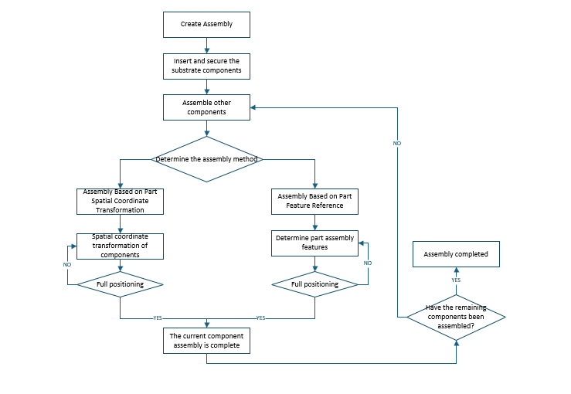
Figure 1 Automatic Assembly Flow Chart

2 Establishment and Call of RV Reducer Model
With the continuous development of virtual prototyping technology, the design of RV reducer virtual prototypes can employ two methods: direct modeling and parametric modeling. The direct modeling method involves researchers manually completing the modeling and assembly work of RV reducer components using 3D modeling software; while the parametric modeling method allows automation of modeling through programming that controls the 3D modeling software, requiring researchers only to input key size parameters of the parts to obtain the desired model. Considering the complexity of the RV reducer structure and the high similarity of product structures among different series, this article will adopt the parametric design method to establish the RV reducer virtual prototype model, which not only improves modeling efficiency but also better accommodates the modeling needs of different series products.
This paper studies the virtual prototype design technology for RV reducers, and conducts secondary development on SolidWorks 2025 to complete the research and development of a parametric design system for RV reducers^{[8]}. The system includes parametric modeling of typical parts of the three-crank RV reducer and point assembly of the virtual prototype.
Due to the different design standards in various regions and industries, designers have different requirements for software when conducting product design^{[9]}. Therefore, SolidWorks provides a large number of API interfaces to meet the specialized needs of users. Designers can perform secondary development on SolidWorks and use programming methods to reduce repetitive tasks, improve work efficiency, and avoid wasting time and energy^{[10]}.
Based on the structural characteristics and intended goals of the RV reducer, this article decides to adopt a development approach primarily based on complete programming with the assistance of macro recording.^{[11]} The chosen programming language is VB.NET, as it has a high compatibility with SolidWorks software, and the parametric design system for the RV reducer will be developed using the compilation platform Visual Studio 2025.
The interface of the RV reducer parametric design system includes three parts: parametric modeling of the RV reducer, virtual prototype assembly, and parametric drawing of engineering diagrams. When users use this system, they need to first select the command to execute. "Parametric modeling" and "Parametric engineering drawing" can only be selected simultaneously. Then, by clicking on the name of the RV reducer components, the system will automatically complete the corresponding command. When the user clicks the "Point assembly" button, the system will perform point assembly on the RV reducer to generate an assembly model. Users can click the "Instructions" button to view the specific operational steps for using this system.
Through SolidWorks 2025 secondary development technology, parametric modeling of all RV reducer parts is performed. When using SolidWorks 2025 for parametric modeling, to reduce workload, programming methods will be used to create part model templates. Taking the cycloidal wheel as an example, when modeling the cycloidal wheel, the epicycloid tooth profile should be drawn first, followed by the drawing of various special-shaped holes, and finally the model should be filleted to ultimately obtain a standard cycloidal wheel 3D model.
When using SolidWorks 2025 for manual modeling, the external epicycloid tooth profile curve can be directly generated using formulas; however, during programming, due to excessive parameters, it is not possible to generate the drawing of the external epicycloid curve. Instead, we can approximate and decompose one tooth profile curve on the external epicycloid into 20 coordinate points, then use curve fitting methods on these coordinate points to finally generate the external epicycloid curve, as shown in Figure 2.
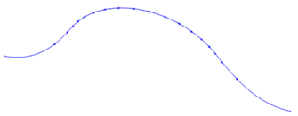
Figure 2 Fitted profile curve of cycloidal gear teeth
Then close the epicycloidal curve, perform a stretching treatment on it to obtain a tooth profile, and process the tooth profile to get the model shown in Figure 3.
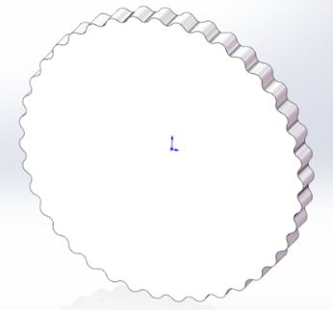
Figure 3 Creating cycloidal gear profile
Create a new reference plane, draw the crankshaft hole, sun gear hole, and sector hole, then perform a cut extrusion to complete the removal of the corresponding holes. Apply fillet treatment to it, and the three-dimensional model of the crankshaft is shown in Figure 4.
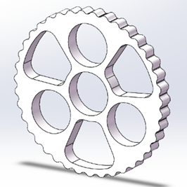
Figure 4 Created cycloidal wheel model
The cycloidal wheel parametric modeling interface contains information such as cycloidal wheel tooth profile parameters and cycloidal wheel structural parameters. When users enter the cycloidal wheel parametric modeling interface, they can input relevant cycloidal wheel information parameters according to the interface prompts, then click the "Start Modeling" button. The program will automatically run in SolidWorks 2025 and draw the 3D model of the cycloidal wheel. Clicking the "Exit Program" button will automatically terminate the system.
The calling of the reducer model is also implemented programmatically.

3 RV Reducer Automatic Assembly Program Design
The automatic assembly of RV reducers is also based on the collaborative working principle of Visual Studio 2025 and SolidWorks 2025, with consistent software settings and parameter modeling. Before assembly, it is necessary to create an assembly template document.
Since an assembly method based on spatial coordinate transformation of parts is selected, this method only requires importing the model into the assembly space and then translating or rotating it. The operational process of this method is relatively simple. Considering the complex structure of RV reducers, this paper encapsulates the operational process of this assembly method as a subroutine to facilitate calling when assembling various parts of the RV reducer.
The assembly process of RV reducer is as follows, with the code not specifically listed:
(1)First, insert cycloidal gear 1 into the assembly, transform the center coordinates of this cycloidal gear to coincide with the origin coordinates of the assembly environment, and use this cycloidal gear as a reference to carry out the automatic assembly of the RV reducer. The SolidWorks 2025 system will default the first inserted part as the reference and fix it. Due to the complex structure of the RV reducer, the variables of the currently inserted model are named in Chinese for the purpose of distinguishing various parts. Among them, "cycloidal gear 1" represents the first inserted cycloidal gear, "cycloidal gear 1X" represents the X coordinate of the inserted cycloidal gear 1 after rotation and translation transformation, "cycloidal gear 1Y" represents the Y coordinate of the inserted cycloidal gear 1 after rotation and translation transformation, and "cycloidal gear 1Z" represents the Z coordinate of the inserted cycloidal gear 1 after rotation and translation transformation. Since in the secondary development of SolidWorks 2025, the default length unit of the SolidWorks 2025 system is "meter", the coordinates need to be "divided by 1000" to convert the unit to "millimeter".
(2) Insert the cycloidal wheel 2 and three planetary gears. The assembly method between the cycloidal wheel 2 and the crankshaft is similar to that of cycloidal wheel 1. Connect the crankshaft and planetary gears through splines, with the central axis of the planetary gear aligning with the central axis of the crankshaft spline. To prevent interference during gear slot assembly, the line connecting the origin on the spline end face of the planetary gear to the lowest point of any gear slot profile should align with the line connecting the origin on the spline end face of the crankshaft to the highest point of any gear slot profile. As shown in Figure 5.
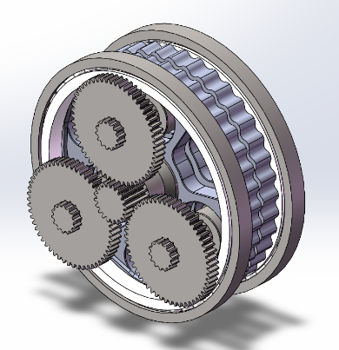
Figure 5 Partial assembly drawing
- Insert the remaining components. The assembly of the input flange and output flange can use the central axis of the planetary gear or the central axis of the crankshaft as positioning reference. The needle gear housing is positioned based on the input and output flanges, while the needle gear set is installed inside the needle gear housing. Finally, insert the sun gear. The fit between the sun gear and planetary gear is also a gear mesh, and its assembly is similar to the fit between the crankshaft and planetary gear.

4 Application and Experimental Verification of Automatic Assembly of RV Reducers
Using the method of spatial coordinate transformation can also achieve high precision in the automatic assembly of RV reducers, with the cycloidal wheel as the center point and other parts undergoing coordinate transformation. Below is a set of coordinates for various parts of the RV reducer generated through a program.
Table 1 Part Spatial Coordinates
Part Name | X-axis | Y-axis | Z-axis
Cycloidal wheel 1 | 0/1000 | 0/1000 | 0/1000
Cycloidal wheel 2 | 0/1000 | -1.5/1000 | 15.5/1000
Crankshaft 1 | 0/1000 | 45.38/1000 | 51.8/1000
Crankshaft 2 | -40.6/1000 | -24.94/1000 | 51.8/1000
Crankshaft 3 | 40.6/1000 | -24.94/1000 | 51.8/1000
Needle bearing 1 | 81.1/1000 | -24.94/1000 | 14.21/1000
Needle bearing 2 | 40.5/1000 | 46.23/1000 | 14.21/1000
Needle bearing 3 | -0.1/1000 | -24.94/1000 | 14.21/1000
Needle bearing 4 | 81.1/1000 | -27.09/1000 | 29.71/1000
Needle bearing 5 | 43.5/1000 | 45.38/1000 | 29.71/1000
Needle bearing 6 | 2.9/1000 | -24.94/1000 | 29.71/1000
Roller bearing 1 | 40.6/1000 | -24.94/1000 | 30.3/1000
Roller bearing 2 | 0/1000 | 45.38/1000 | 30.3/1000
Roller bearing 3 | -40.6/1000 | -24.94/1000 | 30.3/1000
Roller bearing 4 | 40.6/1000 | -24.94/1000 | -17.2/1000
Roller bearing 5 | 0/1000 | 45.38/1000 | -17.2/1000
Roller bearing 6 | -40.6/1000 | -24.94/1000 | -17.2/1000
Main bearing 1 | 85.33/1000 | 15.87/1000 | 30.25/1000
Main bearing 2 | -85.33/1000 | -15.87/1000 | -17.33/1000
Planet gear 1 | 0/1000 | 45.38/1000 | 59.8/1000
Planet gear 2 | -40.6/1000 | -24.94/1000 | 59.8/1000
Planet gear 3 | 40.6/1000 | -24.94/1000 | 59.8/1000
Output flange | 0/1000 | -1.5/1000 | 52.25/1000
Input flange | 0/1000 | -1.5/1000 | -22.12/1000
Needle gear set | 0/1000 | -1.5/1000 | 28.7/1000
Needle gear housing | 0/1000 | -1.5/1000 | 29.2/000
Input shaft | 0/1000 | -1.5/1000 | 45.8/1000
With accurate coordinates, parts can be assembled directly through code calls. Typically, assembly between parts requires manual intervention by mechanical engineers. However, when encountering complex assemblies such as RV reducers, it consumes a significant amount of time.
To quantitatively evaluate the efficiency between the automatic assembly program designed in this study and manual assembly, we designed a task completion experiment. Six mechanical engineering students were recruited and asked to assemble using the same RV reducer parts. The timer started simultaneously for all participants, and the final completion time was recorded. The time statistics are as follows.
Table 2 Manual Assembly Experiment
Student ID | Assembly time (h)
1 | 5.5
2 | 7
3 | 5
4 | 5.5
5 | 6
6 | 7
Mean | 6
Table 3 Automatic Assembly Program Experiment
Name | Assembly Time (Min)
Automatic assembly system | 5
As shown in Table 2, manual assembly takes about 6 hours, while as shown in Table 3, the designed automatic assembly system only requires 5 minutes, with efficiency far exceeding manual assembly.
The automatic assembly program developed in this paper can significantly improve the assembly efficiency of RV reducers, save assembly time and labor costs, and effectively shorten the product design cycle while enhancing R&D efficiency. However, the automatic assembly technology proposed in this paper places extremely strict requirements on the tolerances, geometric tolerances, and surface finish of the parts. Any surface burrs or dimensional deviations may cause problems such as automatic feeding jams. Therefore, the mechanical processing, heat treatment, and other processes of the production machinery must have very high stability requirements.
To verify the accuracy of the simulation model, it is necessary to conduct simulation analysis on the model in the "Analysis" module of Recurdyn software next. This simulation adopts the transmission mode where the pin gear housing is fixed and the output flange provides output. The time required for the RV reducer to rotate one full circle is 4 seconds, so the simulation end time is set to 4.5 seconds and the step size is 450. After completing the settings in the "Dyn/kin" tab, click the "Simulation" button to start the simulation. Once the simulation is completed, all simulation results of the model can be viewed under the "Plot" section.
The correctness of the simulation model can be verified by comparing the simulated angular velocity of typical components in the RV reducer with the theoretical angular velocity. If the two sets of values are identical or the relative error is extremely small, the dynamic simulation model of the RV reducer is considered correct; otherwise, it is not. The formula for relative error is:δ = |Theoretical Value - Simulated Value| / Theoretical Value
The comparison results between the simulated values and theoretical values are presented in Table 1. As shown in the table, the relative errors of the angular velocities of all components are small, with the maximum relative error being 0.002%. Therefore, it can be concluded that the relevant settings of the RV reducer dynamic simulation model are correct, and the obtained simulation model is reliable.
The minor relative error between the simulated angular velocity and theoretical angular velocity of the model arises because contact loads are generated when the various components of the RV reducer undergo relative motion. These loads are nonlinear, and the components deform under the action of such loads, which in turn exerts a slight impact on the simulation accuracy.
Table 4 Comparison of theoretical and simulated values of angular velocity
Part Name | Theoretical value (rad/s) | Actual value (rad/s) | Error (%)
Angular velocity of the sun gear | 174.358 | 174.358 | 0
Crankshaft angular velocity | -61.261 | -61.081 | 0.002
In order to more clearly observe the curves of angular velocity versus time for each component of the RV reducer during the simulation, the angular velocity curves of the sun gear, crankshaft, cycloidal wheel, and output flange are shown in Figures 6and7. From the values in the figures, it can be seen that the sun gear is in an acceleration state within 0–0.2 seconds, and after 0.2 seconds, it remains stable until the end of the motion. After 0.2 seconds of operation, the cycloidal wheel exhibits periodic fluctuations around an angular velocity of 1.569 rad/s, mainly because the cycloidal wheel is subjected to forces from the pin teeth during motion, and the position and number of contact points change continuously when meshing with the pin teeth. As the sun gear is the power input source, its rotation direction is taken as positive. Since the crankshaft rotates in the opposite direction to the sun gear, its angular velocity is negative, while the other components rotate in the same direction as the sun gear, so their angular velocities are positive.
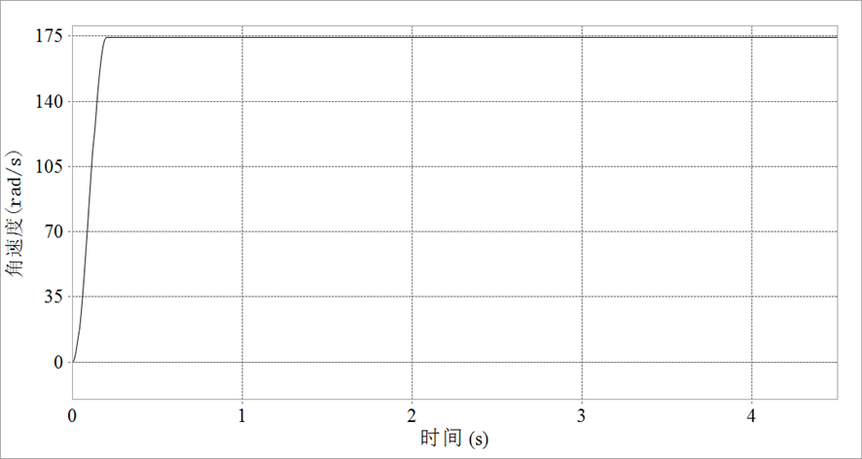
Figure. 6 Angular velocity of the sun gear
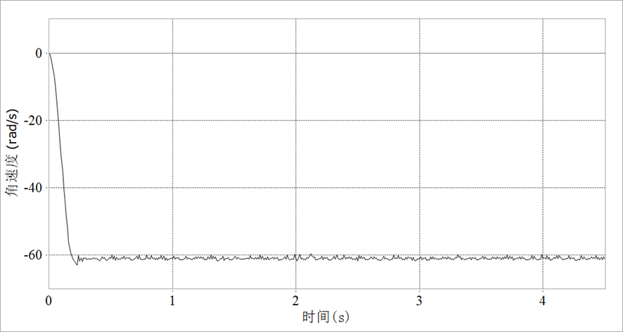
Figure.7 Crankshaft rotation angular velocity

5 Conclusion
Based on SolidWorks 2025 secondary development technology, this paper conducts parametric modeling of all parts of the RV reducer, reducing the time required for repetitive modeling of parts during future RV reducer assembly and improving work efficiency.
The program design for the automatic assembly of RV reducers was completed using the VB.NET programming language within Visual Studio 2025 software, which to some extent reduced the time consumed during reducer assembly and facilitated engineering design.
The developed graphical user interface makes the system simple and convenient, allowing users to automatically draw part drawings and perform automatic assembly just by inputting important data such as feature parameters, thus facilitating engineering applications.
Disclaimer (Artificial intelligence)
Option 1:
Author(s) hereby declare that NO generative AI technologies such as Large Language Models (ChatGPT, COPILOT, etc.) and text-to-image generators have been used during the writing or editing of this manuscript.
Option 2:
Author(s) hereby declare that generative AI technologies such as Large Language Models, etc. have been used during the writing or editing of manuscripts. This explanation will include the name, version, model, and source of the generative AI technology and as well as all input prompts provided to the generative AI technology
Details of the AI usage are given below:
1. No AI used
2.
3.

References
- Hsieh L C , Tang H C , Chen T H ,et al.The Kinematic Design of 2K-2H Planetary Gear Reducers with High Reduction Ratio[J].Applied Mechanics and Materials, 2013, 421:610-615.DOI:10.4028/www.scientific.net/AMM.421.40.
- Zhao S , Liu D , Bai J ,et al.Design and simulation of hydraulic self-driven flood control gate based on ANSYS[J].2024 8th International Conference on Electrical, Mechanical and Computer Engineering (ICEMCE), 2024:1073-1077.DOI:10.1109/icemce64157.2024.10862129.
- Linshan Han, et al."Development and Research Status of RV Reducer."Current Journal of Applied Science and Technology 42.3(2023):41-48.doi:10.9734/CJAST/2023/V42I34060.
- Wang Huiliang, et al."Analysis and experimental study on vibration characteristics of the RV reducer."Advances in Mechanical Engineering 15.6(2023):doi:10.1177/16878132231181328.
- C.-G. Yin,and Y.-S. Ma."Parametric feature constraint modeling and mapping in product development."Advanced Engineering Informatics 26.3(2012):539-552.doi:10.1016/j.aei.2012.02.010.
- Tian Yuan, Wang Xin, Xu Bin, et al. Research and Application of Automatic Assembly Technology Based on Secondary Development of SolidWorks[J]. Mechanical Science and Technology for Aerospace Engineering, 2012, 31(05): 703-707. DOI:10.13433/j.cnki.1003-8728.2012.05.004.
- Ya Zhang."Research on key technologies of remote design of mechanical products based on artificial intelligence."Journal of Visual Communication and Image Representation 60.(2019):250-257.doi:10.1016/j.jvcir.2019.02.010.
- Kamran Ahmad, et al."Progressive failure analysis of helicopter rotor blade under aeroelastic loading."Aviation 24.1(2020):33-41.doi:10.3846/aviation.2020.12184.
- Xu M , Ma M , Wang Z ,et al.Parametric design research of large-scale high-speed shaft system detection device based on solidworks[J].IOP Publishing Ltd, 2024.DOI:10.1088/1742-6596/2803/1/012052.
- Yu Y .The parametric design and intelligent assembly system based on the secondary development of solidworks[J].College of Mechanical Engineer Xi'an University of Science and Technology Xian Shaanxi Province China[2025-10-03].DOI:10.1109/ICCET.2010.5485257.
- Lei L , Tao Y , Guan T M .Parametric Design of Cycloid Gear Based on SolidWorks[J].Advanced Materials Research, 2012, 538-541:3106-3109.DOI:10.4028/www.scientific.net/AMR.538-541.3106.
- Liu, Mingzhou, et al. "Intelligent assembly system for mechanical products and key technology based on internet of things." Journal of Intelligent Manufacturing 28.2 (2017): 271-299. DOI:10.1007/s10845-014-0976-6.
- Li Hao, Wen Xiaoyu, Zhang Xinsheng, et al. Integrated development framework and key technologies for complex product design and manufacturing based on digital twin [J]. Computer Integrated Manufacturing Systems, 2019(6):17. DOI:10.13196/j.cims.2019.06.002.
- Guo Feiyan, Liu Jianhua, Zou Fang, et al. Research on the Current Status and Key Implementation Technologies of Assembly Process Design Driven by Digital Twin [J]. Journal of Mechanical Engineering, 2019, 55(17):23. DOI:10.3901/JME.2019.17.110.
- Li Linli, Li Hao, Gu Fu, et al. Multidisciplinary Collaborative Design Modeling Technology for Complex Mechanical Products Based on Digital Twin [J]. Computer Integrated Manufacturing Systems, 2019(6):13. DOI:10.13196/j.cims.2019.06.001.

