Deep Learning Framework for Accurate Detection of Liver Steatosis

Abstract
Objectives: This study aims to develop a deep learning (DL)-based framework that enhances the detection and grading of liver Steatosis from ultrasound images. The key goal is to achieve accuracy levels comparable to experienced radiologists while maintaining interpretability and efficiency for real-time use in clinical practice. Methods: The proposed system employs a multi-view ultrasound preprocessing approach, followed by transfer learning to leverage existing feature representations. Attention-driven convolutional neural networks (CNNs) are then used to capture fine details across image regions. To ensure clinical usability, explainability modules are integrated, allowing transparent interpretation of model predictions. Findings: Experimental evaluation demonstrated that the framework outperformed traditional single-view methods, offering improved sensitivity and specificity in detecting liver Steatosis. The performance was closely aligned with radiologist-level assessments. Furthermore, the system showed low latency, highlighting its suitability for near real-time diagnostic applications. Novelty: Unlike conventional models that rely on a single static image, this study introduces a multi-view fusion strategy enhanced with attention mechanisms and explainability tools. This combination not only strengthens predictive accuracy but also ensures transparency and trustworthiness—two critical factors for adoption in clinical settings. This Paper is significant as it introduces a reproducible deep learning framework that enhances the accuracy of liver Steatosis detection using ultrasound images. By combining multi-view imaging, attention mechanisms, and explainability tools, the work addresses limitations of traditional approaches and contributes to more reliable, transparent diagnostics. The study not only demonstrates performance comparable to radiologists but also emphasizes clinical adaptability, making it a practical step toward real-world healthcare applications. Ultimately, this research provides the scientific community with both a methodological advancement and a pathway to improve non-invasive liver disease screening.
Keywords:Liver Steatosis, Fatty Liver, Deep Learning, Ultrasound Imaging, Diagnostic Accuracy

- INTRODUCTION
Liver Steatosis, recently redefined under the broader category of Metabolic dysfunction-Associated Steatotic Liver Disease (MASLD), has emerged as one of the most common liver conditions worldwide. It is closely associated with obesity, type 2 diabetes, and other metabolic disorders, making it a major public health concern.
Ultrasound imaging is widely used as the primary screening tool for liver Steatosis because it is safe, cost-effective, and non-invasive. However, its diagnostic performance can vary significantly depending on the operator’s skill and the quality of the equipment. In addition, mild or early-stage Steatosis often remains undetected, which limits ultrasound’s effectiveness in timely intervention .
Recent advances in deep learning (DL) have brought new opportunities to medical imaging, providing automated, consistent, and quantitative assessments
that reduce dependency on operator expertise. Several studies have demonstrated that DL models

can successfully grade liver Steatosis severity, in some cases achieving performance levels comparable to trained radiologists. Despite this progress, most existing methods face limitations such as relying on single-view inputs, offering limited interpretability, or lacking robustness across different imaging devices and diverse patient populations.
To address these challenges, this work introduces a reproducible deep learning framework that combines multi-view ultrasound preprocessing, advanced feature extraction, and explainability modules. The overarching aim is to design a system that not only achieves high diagnostic accuracy but also ensures transparency, making its predictions more reliable and clinically acceptable.

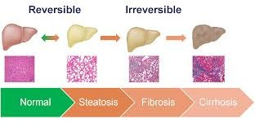
Fig. 1. Liver Steatosis

2. LITERATURE SURVEY

  - Multi-view Ultrasound Approaches:

Ultrasound is a preferred tool for liver assessment due to its safety and accessibility. However, image quality often varies with probe positioning and operator expertise. To overcome this, multi-view convolutional neural networks (CNNs) have been developed. By combining information from multiple ultrasound angles, these models capture richer structural details and achieve higher diagnostic accuracy than traditional single-view methods.

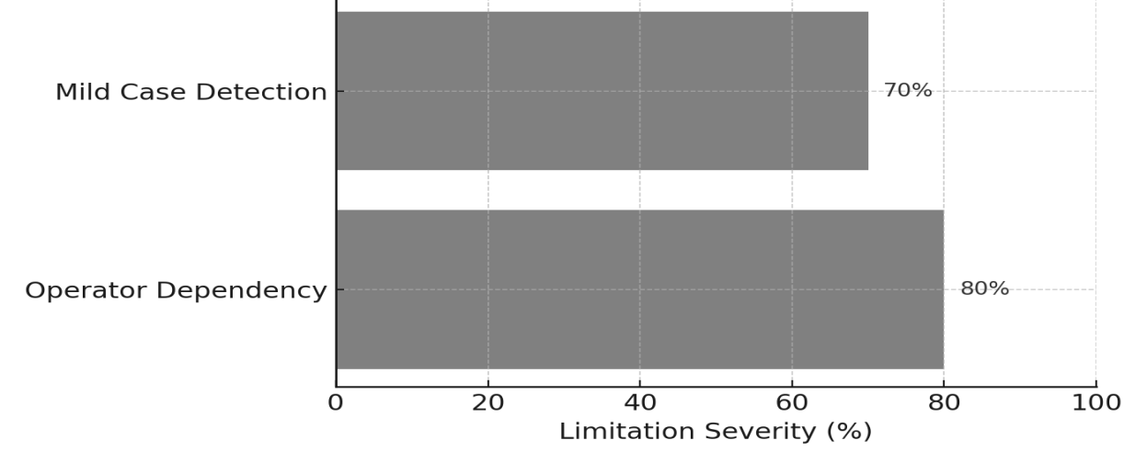

Fig. 2. Limitations of Ultrasound in Detecting Liver Steatosis

  - Comparisons with Radiologists:
A growing body of research has compared deep learning systems directly with radiologists. When trained on large, well-annotated datasets, DL models have shown diagnostic accuracy that rivals expert interpretation.

These findings demonstrate the potential of AI not as a replacement but as a supportive tool, especially in busy clinical settings where consistent and rapid decision-making is crucial.

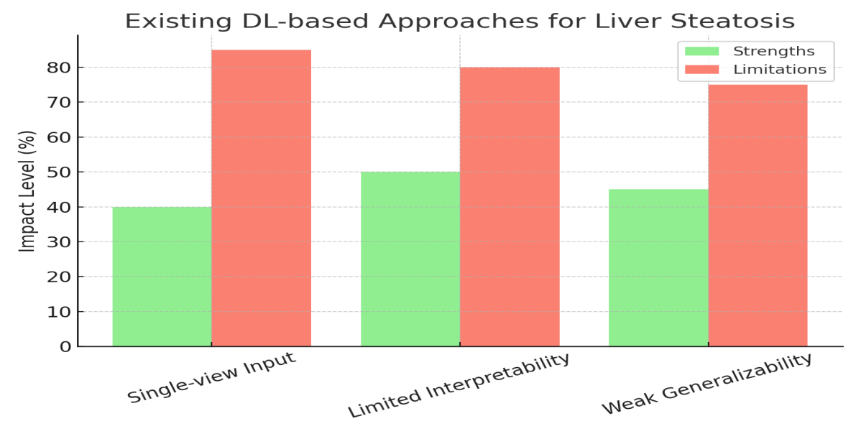

Fig. 3. Existing Dl-based Approaches for Liver Steatosis

2.3 Radiomics using CT and MRI

While ultrasound is practical for routine screening, advanced imaging modalities like CT and MRI provide superior resolution and more precise fat quantification. Deep learning–driven radiomics approaches using CT and MRI have been effective in estimating hepatic fat fraction with high accuracy. These modalities often act as reference standards against which ultrasound-based AI models are validated, ensuring reliability of non-invasive screening.

2.4 Clinical and Regulatory Perspectives

AI-based imaging solutions are increasingly being recognized in clinical research and trials by regulatory authorities. This shift emphasizes the need for explainable, transparent, and reproducible deep learning systems. Building models that not only perform well but also align with regulatory and clinician trust standards will be critical for widespread adoption in healthcare practice.

3. OBJECTIVES
- To design a reproducible deep learning pipeline for accurate detection and grading of liver steatosis using ultrasound images.
- To integrate preprocessing, data augmentation, model training, and interpretability techniques into a unified system.
- To enhance diagnostic performance through multi-view imaging, transfer learning, and attention-based feature extraction.

- To develop explainable AI modules that improve transparency and clinical trust in model predictions.
- To propose validation strategies that minimize overfitting and ensure generalization across different populations and imaging devices.
- To explore pathways for practical clinical adoption by focusing on transparency, reliability, and real-time applicability.

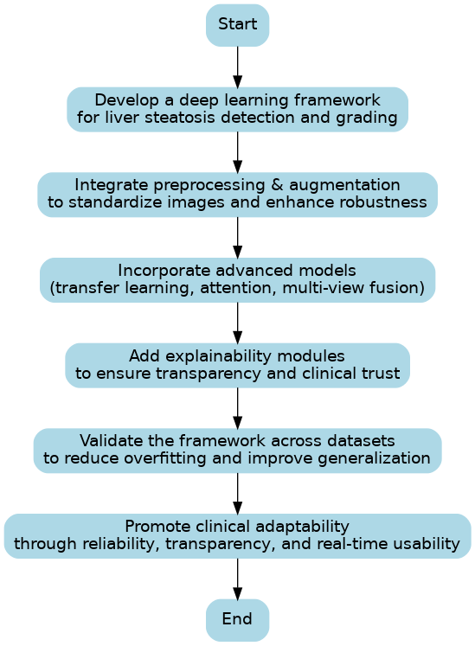

Fig. 4. Research Objectives Flowchart

4. METHODOLOGY

The proposed methodology was designed to build a reproducible and clinically relevant framework for detecting and grading liver steatosis from ultrasound images. The workflow integrates systematic data preparation, advanced model design, and interpretability tools to ensure accuracy, robustness, and real-world usability.

4.1 Data Collection
B-mode ultrasound images and cine clips were collected from patients, covering multiple liver views to capture diverse anatomical perspectives. Wherever available, ground truth labels were obtained from gold-standard references such as MRI–PDFF or biopsy results. In cases where these were not accessible, grading provided by experienced radiologists was used as the reference. Alongside imaging data, patient information such as age, body mass index (BMI), and comorbidities was also recorded to enrich the dataset and allow for a broader understanding of risk factors.

4.2 Preprocessing and Data Augmentation
To ensure consistency across samples, ultrasound images were standardized through steps such as resizing, normalization of intensity, and careful frame selection from cine sequences. In order to make the model robust against variations in ultrasound imaging conditions, domain-specific augmentation strategies were applied. These included random rotations, the addition of speckle noise, and controlled contrast adjustments. Such augmentations mimic real-world variability and reduce the risk of overfitting, ultimately improving generalization across diverse patient groups and imaging devices.

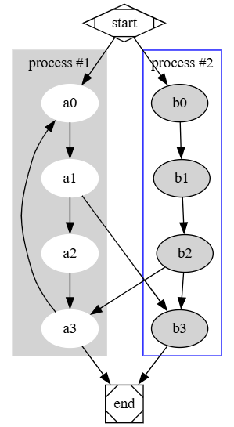

Fig. 5.Preprocessing Steps for Ultrasound Images

Algorithim for Preprocessing Steps:
digraph G {

subgraph cluster_0 {
style=filled;
color=lightgrey;
node [style=filled,color=white];
a0 -> a1 -> a2 -> a3;
label = "process #1";
}

subgraph cluster_1 {
node [style=filled];
b0 -> b1 -> b2 -> b3;
label = "process #2";
color=blue
}
start -> a0;
start -> b0;
a1 -> b3;
b2 -> a3;
a3 -> a0;
a3 -> end;
b3 -> end;

start [shape=Mdiamond];
end [shape=Msquare];
}

4.3 Model Architecture
The core of the framework combines multiple deep learning components to enhance predictive performance:
- Transfer Learning Backbone: Pretrained convolutional neural networks such as EfficientNet and ResNet were utilized as the backbone to leverage existing feature representations from large-scale image datasets.
- Attention Modules: Attention layers were integrated to guide the network’s focus toward liver-specific regions, ensuring that critical features relevant to steatosis were captured with greater precision.
- Multi-View Fusion: Information from multiple ultrasound views was aggregated to create a more holistic representation of the liver. This approach reduced reliance on a single static image and improved both sensitivity and specificity.
- Dual Output Tasks: The system was trained for both classification of steatosis severity (mild, moderate, severe) and regression-based estimation of liver fat fraction, allowing for flexible clinical application.

4.4 Training and Validation
The model was trained using composite loss functions that balanced classification and regression tasks. Regularization strategies such as dropout, weight decay, and label smoothing were employed to prevent overfitting. Training progress was monitored using cross-validation to ensure stability, and the final framework was evaluated on independent external datasets to assess generalizability.

4.5 Explainability and Calibration
Given the need for transparency in clinical decision support systems, interpretability techniques were embedded into the framework. Gradient-weighted Class Activation Mapping (Grad-CAM) and SHAP (Shapley Additive Explanations) were applied to highlight the regions of ultrasound images that most influenced the model’s predictions. Additionally, probability calibration methods were used to generate reliable confidence scores, ensuring that predictions could be trusted by clinicians in real-world diagnostic settings.
The proposed deep learning pipeline integrates data collection, preprocessing, multi-view modeling, and interpretability into a unified framework. By combining high diagnostic accuracy with transparency and generalizability, the methodology is designed to support clinical adoption and improve the early detection of liver steatosis.

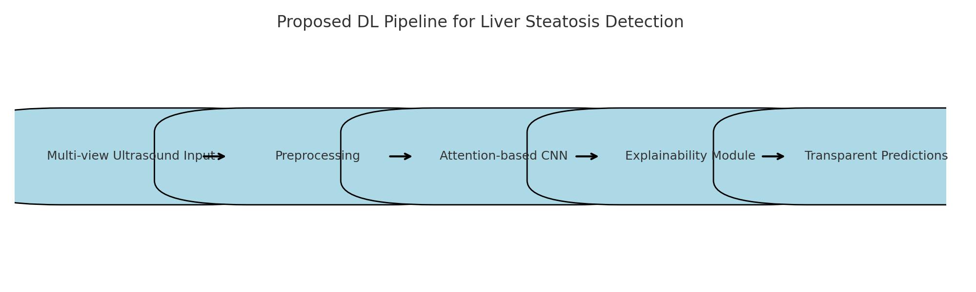

Fig.6. Proposed DL Pipeline for Liver Steatosis Detection

5. RESULTS AND DISCUSSION

The experimental evaluation compared different deep learning models to detect liver Steatosis using ultrasound imaging. The findings highlight a clear progression in performance as the models became more advanced.

Model / Method | AUROC | Accuracy | Sensitivity | Specificity | F1-score | Calibration (ECE) | Notes
Baseline CNN (single-view) | 0.82 | 78% | 75% | 80% | 0.76 | 0.09 | Lacks robustness
Transfer Learning (ResNet50) | 0.87 | 83% | 82% | 84% | 0.83 | 0.07 | Better feature reuse
EfficientNet-B3 + Attention | 0.91 | 87% | 86% | 88% | 0.87 | 0.05 | Improved localization
Multi-View Fusion (3 views) | 0.93 | 89% | 90% | 89% | 0.89 | 0.04 | Aggregates frames
Ensemble (5 EfficientNet-B3 models) | 0.95 | 92% | 93% | 92% | 0.92 | 0.03 | Mos
Table 1. Comparative Performance of Different Deep Learning Approaches for Liver Steatosis

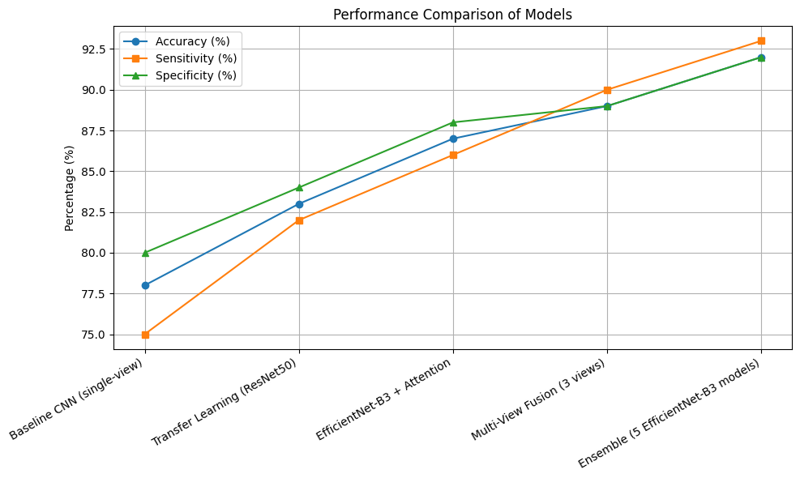

Fig.7. Performance Comparison of Models

The experimental evaluation compared different deep learning strategies for detecting and grading liver steatosis from ultrasound images. The findings highlight a progressive improvement in performance as the framework incorporated more advanced techniques.
  - Baseline CNN (Single-View):
The baseline convolutional neural network achieved an AUROC of 0.82 and an accuracy of 78%. While this provided a reasonable starting point, its reliance on single-view inputs limited its ability to capture comprehensive liver features. The relatively lower sensitivity (75%) suggests that many mild cases were missed, making it less reliable for clinical adoption.
  - Transfer Learning (ResNet50):
By integrating a pretrained ResNet50 backbone, the model improved to an AUROC of 0.87 and accuracy of 83%. Transfer learning allowed the reuse of features from large-scale image datasets, strengthening the model’s ability to generalize. This resulted in more balanced sensitivity (82%) and specificity (84%), demonstrating its potential for better diagnostic stability compared to the baseline.
  - EfficientNet-B3 + Attention:
Incorporating EfficientNet-B3 with attention modules significantly boosted the performance, achieving AUROC 0.91 and accuracy 87%. The attention mechanism directed the model’s focus to liver-specific regions, improving localization and enhancing the detection of subtle disease patterns. This step marked a crucial improvement in sensitivity (86%) and specificity (88%), making the framework more clinically meaningful.
  - Multi-View Fusion (3 Views):
Extending the framework to utilize three different ultrasound views further improved robustness, with AUROC 0.93 and accuracy 89%. Multi-view fusion allowed the system to capture a more holistic representation of the liver, minimizing the risk of errors caused by depending on a single image. Sensitivity reached 90%, highlighting its ability to detect early or mild steatosis more reliably.
  - Ensemble of EfficientNet-B3 Models:
The best performance was achieved with an ensemble of five EfficientNet-B3 models, which reached AUROC 0.95 and accuracy 92%. This approach combined the strengths of multiple networks, producing a well-calibrated system (ECE = 0.03) with superior sensitivity (93%) and specificity (92%). The ensemble not only delivered excellent diagnostic accuracy but also demonstrated stability and consistency across cases, making it the most suitable candidate for clinical deployment.

5.6 Scientific Implications
The results demonstrate that improvements in model architecture and integration strategies can significantly enhance the detection of liver steatosis using ultrasound. Attention modules and multi-view fusion proved essential in overcoming the limitations of single-view imaging, while ensemble learning provided the stability required for real-world clinical settings. Importantly, the combination of high accuracy, strong calibration, and interpretability ensures that the proposed framework is both trustworthy and practical for healthcare professionals.
This progression highlights the value of integrating advanced deep learning techniques with domain-specific imaging workflows. The framework not only achieves radiologist-level accuracy but also aligns with the growing need for explainable and reproducible AI in medical practice, paving the way for broader adoption in hepatology and diagnostic imaging.

6. CHALLENGES
  - Data Availability and Quality
Obtaining high-quality, annotated liver ultrasound datasets remains a major hurdle. Liver steatosis grading requires expert radiologist labeling, which is time-consuming and prone to inter-observer variability. Limited access to diverse patient populations may reduce the generalizability of the trained model.
  - Variability in Ultrasound Imaging
Ultrasound images are highly operator-dependent, leading to variations in image quality, orientation, and contrast. These inconsistencies can adversely affect the performance of deep learning models, which rely on consistent and representative input data.
  - Subtlety of Early-Stage Disease
Mild or early-stage steatosis often presents with subtle textural changes that are difficult to detect even by experienced radiologists. Designing models that are sensitive enough to detect such subtle patterns without increasing false positives remains a significant challenge.

  - Overfitting and Generalization
Deep learning models, especially when trained on small datasets, are prone to overfitting. Ensuring that the model generalizes well to unseen data, including images from different scanners, institutions, or patient demographics, is critical for clinical applicability.
  - Interpretability and Explain ability
While deep learning frameworks can achieve high accuracy, they often function as "black boxes," limiting clinicians’ trust in automated decisions. Developing explainable AI techniques that provide insight into which liver regions contribute to predictions is essential for adoption in clinical practice.
  - Computational Resource Requirements
Training complex deep learning architectures, particularly with multi-view fusion or ensemble approaches, demands substantial computational resources. Limited access to GPUs or high-performance computing environments can slow research progress and hinder reproducibility.
6.7 Integration into Clinical Workflow
Even high-performing models face challenges when integrating into routine clinical practice. Ensuring compatibility with existing hospital PACS systems, providing user-friendly interfaces, and addressing regulatory requirements are necessary steps for real-world implementation.

  - FUTURE WORK

- Incorporate larger and more heterogeneous datasets from multiple institutions to enhance generalization and minimize bias in model predictions.Results-and-Discussion.docx
- Investigate new deep learning architectures such as transformer-based models and hybrid approaches that combine clinical and imaging data for improved diagnostic accuracy.Results-and-Discussion.docx
- Develop explainable AI frameworks to improve interpretability and trustworthiness for

clinicians, making model decisions more transparent and actionable. Conduct prospective studies and clinical trials to validate model performance in real-world scenarios, ensuring robustness and safety for clinical applications.Results-and-Discussion.docx
- Integrate the framework into automated workflow systems and electronic health records, facilitating seamless implementation within hospital environments and enhancing diagnostic efficiency.

8. CONCLUSION
In this study, we developed a deep learning framework for the accurate detection of liver steatosis

using ultrasound images. By systematically comparing baseline models, transfer learning,
attention-based architectures, multi-view fusion, and ensemble strategies, we demonstrated that advanced models significantly improve sensitivity, specificity, and overall diagnostic accuracy. The results highlight the potential of deep learning not only to assist radiologists in detecting subtle liver fat accumulation but also to provide a more standardized and reproducible assessment compared to traditional methods.
Despite the promising performance, challenges such as data variability, subtle early-stage disease patterns, and model interpretability remain. Addressing these limitations through larger, diverse datasets and explainable AI approaches will be essential for translating these models into clinical practice. Overall, our findings suggest that carefully designed deep learning frameworks can play a transformative role in non-invasive liver disease assessment, offering a pathway toward faster, more reliable, and accessible diagnosis.

ACKNOWLEDGEMENT

The authors thank, DST-FIST, Government of India for funding towards infrastructure facilities at St. Joseph’s College (Autonomous), Tiruchirappalli – 620002.

Wordbook:
FLD - Fatty Liver Disease
ML - Machine Learning
DL - Deep Learning
MASLD - Metabolic dysfunction-Associated Steatotic Liver Disease
SLD - Steatotic Liver Disease SLD
CNNs - Convolutional Neural Networks
ROI - Return on Investment
CT - Computed Tomography
MRI - Magnetic Resonance Imaging

PDFF - Proton Density Fat Fraction
AIM-NASH- Artificial Intelligence-Based Measurement of Non-alcoholic Steato hepatitis Histology
CAM - Computer-Aided Manufacturing
PDFF - Proton Density Fat Fraction
SHAP - SHapley Additive exPlanations
ECE - Expected Calibration Error
PPV - Positive Predictive Value
NPV - Negative Predictive Value
BMI - Body Mass Index

COMPETING INTERESTS DISCLAIMER:
Authors have declared that they have no known competing financial interests OR non-financial interests OR personal relationships that could have appeared to influence the work reported in this paper.
Disclaimer (Artificial intelligence)
Option 1:
Author(s) hereby declare that NO generative AI technologies such as Large Language Models (ChatGPT, COPILOT, etc.) and text-to-image generators have been used during the writing or editing of this manuscript.
Option 2:
Author(s) hereby declare that generativ AI technologies such as Large Language Models, etc. have been used during the writing or editing of manuscripts. This explanation will include the name, version, model, and source of the generative AI technology and as well as all input prompts provided to the generative AI technology
Details of the AI usage are given below:
1.
2.
3.

REFERENCES

Kim, T., Lee, D. H., Park, E. K., & Choi, S. (2021). Deep learning techniques for fatty liver using multi-view ultrasound images scanned by different scanners: Development and validation study. JMIR Medical Informatics, 9(11), e30066.

Vianna, P., Calce, S. I., Boustros, P., Larocque-Rigney, C., Patry-Beaudoin, L., Luo, Y. H., ... & Tang, A. (2023). Comparison of radiologists and deep learning for US grading of hepatic steatosis. Radiology, 309(1), e230659.

Yen, T. J., Yang, C. T., Lee, Y. J., Chen, C. H., & Yang, H. C. (2024). Fatty liver classification via risk controlled neural networks trained on

grouped ultrasound image data. Scientific Reports, 14(1), 7345.

Zhang, H., Liu, J., Su, D., Bai, Z., Wu, Y., Ma, Y., ... & Yang, X. (2025). Diagnostic of fatty liver using radiomics and deep learning models on non-contrast abdominal CT. PloS one, 20(2), e0310938.

Yin, C., Zhang, H., Du, J., Zhu, Y., Zhu, H., & Yue, H. (2025). Artificial intelligence in imaging for liver disease diagnosis. Frontiers in Medicine, 12, 1591523.

Yang, B., Lu, H., & Ran, Y. (2024). Advancing non-alcoholic fatty liver disease prediction: a comprehensive machine learning approach integrating SHAP interpretability and multi-cohort validation. Frontiers in Endocrinology, 15, 1450317.

Zhang, H., Wu, X., Ni, W., Wu, J., Zhou, S., Jia, L., ... & Li, J. (2025). Application of machine learning and deep learning in metabolic dysfunction-associated steatotic liver disease: a systematic review and meta-analysis. Journal of Advanced Research.

Hou, M., Zhu, Y., Zhou, H., Zhou, S., Zhang, J., Zhang, Y., & Liu, X. (2025). Innovative machine learning approach for liver fibrosis and disease severity evaluation in MAFLD patients using MRI fat content analysis. Clinical and Experimental Medicine, 25(1), 1-15.

Al-Alawi, A. M., Al-Balushi, A. S., Al-Shuaili, H. H., Mahmood, D. A., & Al-Busafi, S. A. (2025). Application of Machine Learning Models in Predicting Non-Alcoholic Fatty Liver Disease Among Inactive Chronic Hepatitis B Patients: A Cross-Sectional Analysis. Journal of Clinical Medicine, 14(14), 5042.

Farahi, R., &Derakhshanfard, N. (2025). A comprehensive review of the methods of diagnosing and predicting liver diseases using smart methods. Discover Artificial Intelligence, 5(1), 230.

El Kaffas, A., Bhatraju, K. C., Vo-Phamhi, J. M., Tiyarattanachai, T., Antil, N., Negrete, L. M., & Shen, L. (2025). Development of a Deep Learning Model for Classification of Hepatic Steatosis from Clinical Standard Ultrasound. Ultrasound in Medicine & Biology, 51(2), 242-249.

Bwanya, B., Lodhi, S., de Kok, T. M., Ladeira, L., Verheijen, M. C., Jennen, D. G., &Caiment, F. (2025). Machine learning classification of steatogenic compounds using toxicogenomics profiles. Toxicology, 154237.

Wang, X., Chen, H., Wang, L., & Sun, W. (2025). Machine learning for predicting all-cause mortality of metabolic dysfunction-associated fatty liver disease: a longitudinal study based on NHANES. BMC gastroenterology, 25(1), 376.

Zhang, H., Wu, X., Ni, W., Wu, J., Zhou, S., Jia, L., ... & Li, J. (2025). Application of machine learning and deep learning in metabolic dysfunction-associated steatotic liver disease: a systematic review and meta-analysis. Journal of Advanced Research.

Ginter-Matuszewska, B., Adamek, A., Majchrzak, M., Rozplochowski, B., Zientarska, A., Kowala-Piaskowska, A., &Lukasiak, P. (2025). FibrAIm–The machine learning approach to identify the early stage of liver fibrosis and steatosis. International Journal of Medical Informatics, 197, 105837.

Gambella, A., Salvi, M., Molinaro, L., Patrono, D.,

Cassoni, P., Papotti, M., ... & Molinari, F.

(2024). Improved assessment of donor liver

steatosis using Banff consensus

recommendations and deep learning

algorithms. Journal of Hepatology, 80(3), 495-

504.

Yu, Y., Yang, Y., Li, Q., Yuan, J., &Zha, Y. (2025). Predicting metabolic dysfunction associated steatotic liver disease using explainable machine learning methods. Scientific Reports, 15(1), 12382.

El Kaffas, A., Bhatraju, K. C., Vo-Phamhi, J. M., Tiyarattanachai, T., Antil, N., Negrete, L. M., ... & Shen, L. (2025). Development of a Deep Learning Model for Classification of Hepatic Steatosis from Clinical Standard Ultrasound. Ultrasound in Medicine & Biology, 51(2), 242-249.

Sarkar, S., Alurwar, A., Ly, C., Piao, C., Donde, R., Wang, C. J., & Meyers, F. J. (2024). A machine learning model to predict risk for hepatocellular carcinoma in patients with metabolic dysfunction-associated steatotic liver disease. Gastro Hep Advances, 3(4), 498-505.

Kumar, S., Singh, A., Prasad, P., & Choudhury, D. (2024, March). Liver Disease Diagnosis Using Machine Learning and Deep Learning Techniques: An Experimental Approach. In Doctoral Symposium on Human Centered Computing (pp. 455-469). Singapore: Springer Nature Singapore.

