INFLUENCE OF WELLHEAD PRESSURE AND INJECTED GAS SPECIFIC GRAVITY ON OIL PRODUCTION RATE FROM A GAS-LIFTED WELL IN THE NIGER DELTA

ABSTRACT
The Niger Delta, a prolific hydrocarbon province, relies heavily on gas lift systems to enhance oil recovery from wells with declining reservoir energy. While the benefits of gas lift are well-established, its optimization is complex and influenced by key operational and fluid properties. This study uses PROSPER software for nodal analysis to optimize gas lift in a marginal well in the Opolo field, producing 2652.3 STB/day. The analysis examines the combined effects of wellhead pressure (WHP) and injected gas specific gravity (SG) on oil production, using calibrated reservoir, well, and Pressure-Volume-Temperature (PVT) with industry-standard correlations. A sensitivity analysis was performed by simulating three wellhead pressures (100, 250, and 400 psig) and three injection gases, methane (SG: 0.554), nitrogen (SG: 0.967), and carbon dioxide (SG: 1.519), at injection rates of 1, 2, and 3 MMscf/day. The results confirm a strong inverse relationship between WHP and production rate for all gases, with lower WHPs yielding significantly higher oil rates. Gas SG emerged as a critical factor: methane delivered the highest absolute production (up to 7,332.1 STB/day at 100 psig), while nitrogen provided the greatest relative gain (36.09% at 400 psig), reflecting an optimal balance of density and flow characteristics. Carbon dioxide, with the highest SG, consistently showed the smallest production improvements. The study concludes that optimal gas selection is not universal but is contingent on specific well conditions: low-SG gases are generally preferred, with nitrogen being particularly effective for oil rate gains under high wellhead backpressure (400 psig) and high injection rate (3 MMscf/day); and methane excels at low WHP (100 psig) and high injection rate (3 MMscf/day). These findings offer valuable guidance for engineers to optimize gas-lift designs, focusing on key operational parameters and gas properties to boost production efficiency in the Niger Delta and similar regions.

Keywords: Gas Lift Optimization, Wellhead Pressure, Specific Gravity, Nodal Analysis, Niger Delta

- INTRODUCTION
The Niger Delta region, which currently accounts for all of Nigeria’s oil output, remains a critically significant oil-producing area in the world (Africa Oil and Gas, 2025). The region continues to be a primary focus for the world’s energy exploration, with ongoing projects and regulatory frameworks aimed at optimizing resource exploitation (World Bank, 2023). As the largest oil producer in Africa, Nigeria's economy is heavily dependent on the sector, which contributes the vast majority of its export revenue (Wikipedia, 2024; Statista, 2024). Gas-lift systems (Figure 1) are widely employed in this region to enhance the production of oil from wells that have insufficient natural reservoir energy. Gas-lift is a fundamental artificial lift method deployed to enhance oil production from wells with declining reservoir pressure. The process works by injecting high-pressure gas into the wellbore, which reduces the density of the fluid column. This reduction in density lowers the bottom-hole flowing pressure, thereby increasing the drawdown from the reservoir and boosting oil production (Diehl et al., 2018). Although there are other downhole and surface equipment to mitigate pressure losses (Figure 2), the primary objective of gas-lift is to deliver the fluid to the surface while keeping the bottom-hole pressure low enough to provide a high-pressure differential between the reservoir and the bottom of the producing well, as represented by ΔP₁ in Figure 2. Reduction of bottom hole pressure due to gas injection will normally increase the liquid production rate (Diehl et al., 2018). However, the performance and efficiency of gas-lift systems are highly dependent on several parameters, including the wellhead pressure, injected gas velocity, and injected gas density.
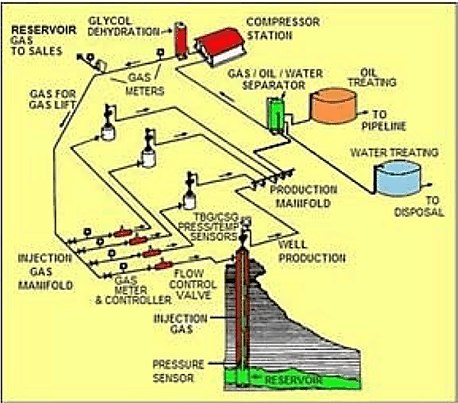
Figure 1: General gas lift system
Source: Campbell (2022).
As the field maturation takes place, the demand for lift gas increases, whereas optimum production is constrained by its availability. Basically, gas lift optimization deals with optimum allocation of lift gas, considering its availability, among the gas-lifted wells for maximizing the production of oil (Diehl et al., 2018; Mahdiani et al., 2019). The type of gas used for a gas lift optimization possesses certain rheological properties that influence the wellbore behaviour differently. High viscosity gases, such as natural gas liquids, can result in poor gas distribution in the well, reducing the effectiveness of the gas lift (Hari et al., 2021; Cao et al., 2022). On the other hand, low viscosity gases flow more easily but may not be as effective in reducing the fluid column's density, which can limit the system’s performance. Dwivedi et al. (2022), Daolun et al. (2022), and Hari et al. (2022) have stated that increased wellhead pressure causes a reduction in pressure drawdown, which in turn reduces oil production rate.
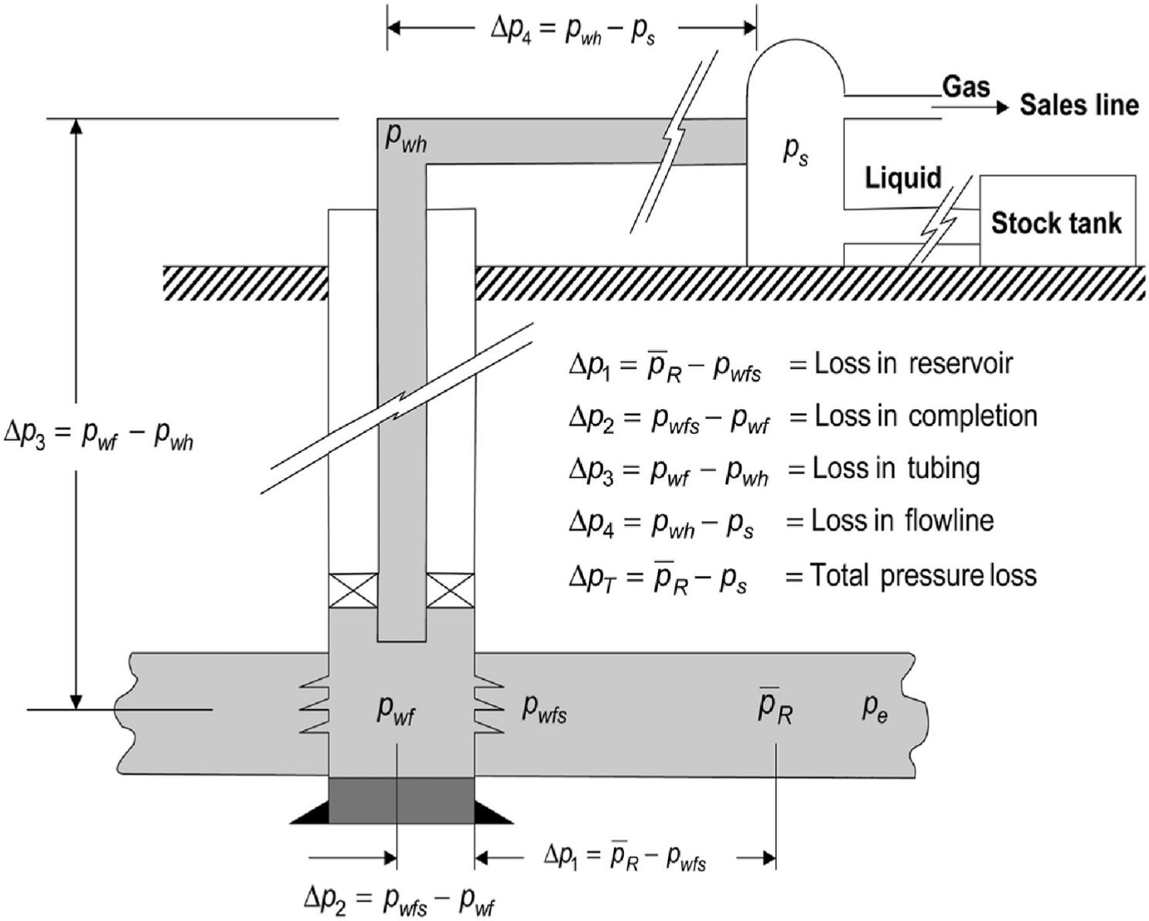
Figure 2: Pressure losses in the production system
Source: Weijermars R. (2024).
In the context of the Niger Delta, these variables are particularly important due to the complex nature of the region's reservoirs, which exhibit a high degree of heterogeneity (Oluwadare et al., 2024). The geological formation of the Niger Delta is characterized by a variety of rock types, porosities, and fluid properties, all of which contribute to fluctuating well performances. As a result, optimization of the gas-lift system requires a detailed understanding of how wellhead pressure and gas density (usually specific gravity when considered in relation to air) influence the overall productivity of the well. By simulating different scenarios, engineers can gain insights into how adjustments in these factors can lead to improvements in well design and gas-lift performance (Raunak and Bhavinay, 2023). Certain studies have been carried out to optimize oil production in the Niger Delta, with a focus on diverse production parameters and relatively few considering injected fluid properties. Oghenegare et al. (2020) conducted a case study on a shut-in well (Well DEF) in the Niger Delta, employing a continuous gas lift mechanism for optimization. They concluded from employing incomplete dataset that Well DEF does not require gaslift mechanism. Independently, the study investigated the effect of gas injection rate, gas gravity, wellhead pressure and water cut, respectively. Although the results showed that gas gravity (0.65 - 1.0 SG) is inversely related to oil rate, it did not account for practical gases by type and considered extremely low wellhead pressures (maximum of 100 psig) for the region. However, Hari et al. (2022) investigated the influence of wellhead pressure, water cut, and gas injection rate on the oil rate from a marginal well under a continuous gas lift system. In the study by Baba et al. (2020), nodal analysis was utilized on the BARBRA-1 well to reduce frictional pressure losses while considering three different artificial lift methods, viz, continuous gas lift, intermittent gas lift, and electrical submersible pump. Okalla et al. (2024) studied the subtle connection between oil rate, GOR, and wellhead pressure. Prosper was fed with fluid properties (oil and gas density, viscosity, and bubble point pressure), reservoir pressure, temperature, tubing and casing specifications, and wellbore geometry that served as input parameters.
The need for more precise simulations and models to predict the impacts of wellhead pressure and gas specific gravity on oil rate has never been more critical. The Niger Delta's extensive use of gas-lift systems presents a unique challenge: optimizing the design of these systems to meet the diverse conditions of different wells and reservoirs. This study, by utilizing PROSPER software for detailed nodal analysis, seeks to address the gaps in understanding and provide practical recommendations for optimizing gas-lifted well performance in this region with the objective of evaluating the influence of varying injected gas specific gravity and wellhead pressure on the oil production rate.
2.0 METHODOLOGY
2.1 Reservoir, Well, and Fluid PVT Data
Well performance and optimization were conducted using PROSPER, a widely recognized software in the industry capable of simulating various completion designs and artificial lift techniques, including gas lift. Nodal analysis was performed under various operating conditions by conducting sensitivity assessments with PROSPER. The data utilized in this analysis were sourced from a marginal well located in the Opolo field within the Niger Delta region. This particular well has consistently produced for more than five years. Given the reservoir’s extended period of activity, it may eventually require artificial lift assistance to maintain output. The reservoir and fluid properties, summarized in Table 1, correspond to a single-stage separation process from reservoir conditions to standard surface conditions.
The reservoir exhibits a pressure of 3000 psig, spans a drainage area of 340 acres, and has a permeability of 80 mD. It features a thickness of 110 ft and a temperature of 250°F. After post-well testing, the mechanical skin and water cut were found to be 2 and 0%, respectively. The well has both a measured and true vertical depth of 8500 ft, confirming it as a vertical well. At the pay zone, the wellbore diameter is 12.25 in. The production casing has an internal diameter of 9.625 in, while the tubing's inner diameter is 4.5 in. A gas lift system has been installed at a depth of 7100 ft. The three injected gases for gas-lift utilization, which are methane, nitrogen, and carbon dioxide, have specific gravities of 0.554, 0.967, and 1.519, respectively, and are free of contaminants. Additionally, a subsurface safety valve is positioned at 700 ft. Figure 3 illustrates the downhole completion configuration with depth.
Table 1: Fluid PVT Properties.
Properties | Values
Solution GOR | 350 scf/STB
Bubble point pressure | 1200 psig
Oil API gravity | 40°
Specific gravity | 0.8
Density | 51.50 lb/ft³
Water salinity | 70,000 ppm

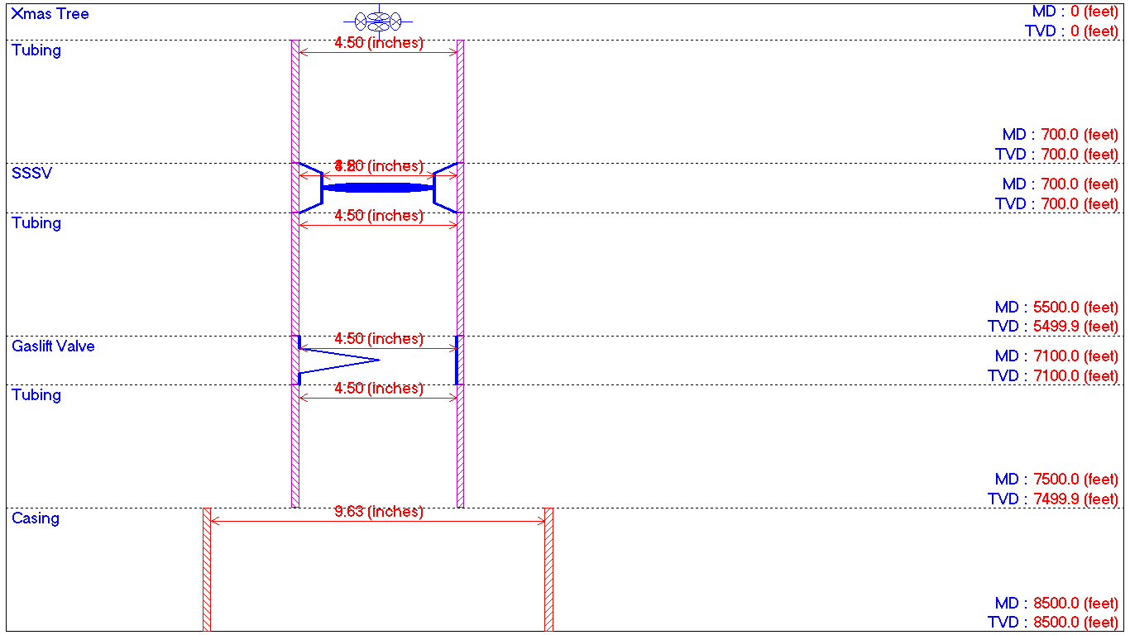
Figure 3: Downhole completion for the gas-lift design.
2.2 Modeling of the Producing Oil Well
The type of fluid is set as oil and water, and the black oil model is selected for simulation. A single-stage separation process is assumed, and the presence of emulsions is disregarded. The viscosity behavior follows a Newtonian fluid model, and flow is assumed to occur through the tubing. The well is classified as a producing well with a cased hole completion. Continuous gas lift is utilized as the artificial lift technique. The model did not account for friction losses in the annular space. Absolute roughness of 0.00014 and 0.0016 inches were obtained for the casing and tubing surfaces, respectively. These are typical values for commercial steel pipes as referenced in standard petroleum engineering handbooks. The inflow configuration is modeled as a single-branch system.
The thermodynamic properties of the reservoir fluid are characterized using PVT parameters such as solution gas-oil ratio (GOR), water salinity, API gravity, and gas specific gravity. Laboratory-measured PVT data is calibrated against black oil correlations to ensure consistency. Oil viscosity and formation volume factor (FVF) are derived using standard analytical equations. Glaso’s correlation (Glaso, 1980) is applied to estimate GOR, oil FVF, and bubble point pressure (BPP), while Beal’s correlation (Beal, 1946) is employed for modeling oil viscosity. The geothermal gradient is determined by assuming a formation temperature of 250°F at a measured depth of 8500 feet. Average heat capacities for oil, gas, and water are taken as 0.53, 0.51, and 1 BTU/lb/°F, respectively. The Beggs and Brill correlation (Beggs and Brill, 1973) is used as the correlation for the surface equipment. The Darcy model is used to evaluate the inflow performance relationship curve (IPRC), and gas injection is implemented at a depth of 7100 feet.
A sensitivity analysis was conducted to evaluate the impact of key operational parameters, including wellhead pressure (WHP) and gas injection rate, on well performance. The sensitivity analysis was conducted using wellhead pressures of 100, 250, and 400 psig. These values were selected to represent a practical operating range for gas-lifted wells in the Niger Delta, reflecting common surface facility constraints and flowline pressures, as indicated by the operational scenarios discussed in similar studies (Nnaemeka et al., 2025; Hari et al., 2022). The injection rates of 1, 2, and 3 MMscf/day were chosen to reflect typical gas lift injection volumes for marginal wells in the region, where gas availability often limits injection rates (Sanni et al., 2020).
Surface chokes primarily control wellhead pressure and are also influenced by downstream facilities such as separators and flowlines, as well as the capacity of the gas compression system (Dabiri et al., 2024). The chosen WHP values represent scenarios where the wellhead choke is adjusted to maintain these pressures, thereby simulating different levels of backpressure on the well. Higher WHPs (e.g., 400 psig) may correspond to situations where facility constraints or compressor discharge limitations restrict pressure reduction, whereas lower WHPs (e.g., 100 psig) represent optimized surface conditions with minimal backpressure.
Methane, nitrogen gas, and carbon dioxide were analyzed using their respective specific gravities of 0.554, 0.967, and 1.519, respectively. The oil production rates were recorded for each of the gases at 100, 250, and 400 psig of wellhead pressure (WHP).

3.0 RESULTS AND DISCUSSION
3.1 Oil Well Performance Under Natural Flow Conditions
The initial step in any gas-lift optimization process is to thoroughly evaluate the well’s inflow and outflow performance to confirm the necessity of artificial lift. As illustrated in Figure 4, the Inflow Performance Relationship (IPR) and Vertical Lift Performance (VLP) curves for the well under natural flow conditions indicate an oil production rate of 2,652.3STB/day. This rate is economically unattractive, and with the anticipated decline in reservoir pressure, the well would eventually cease production. This observation justifies the consideration of an artificial lift system to enhance production.
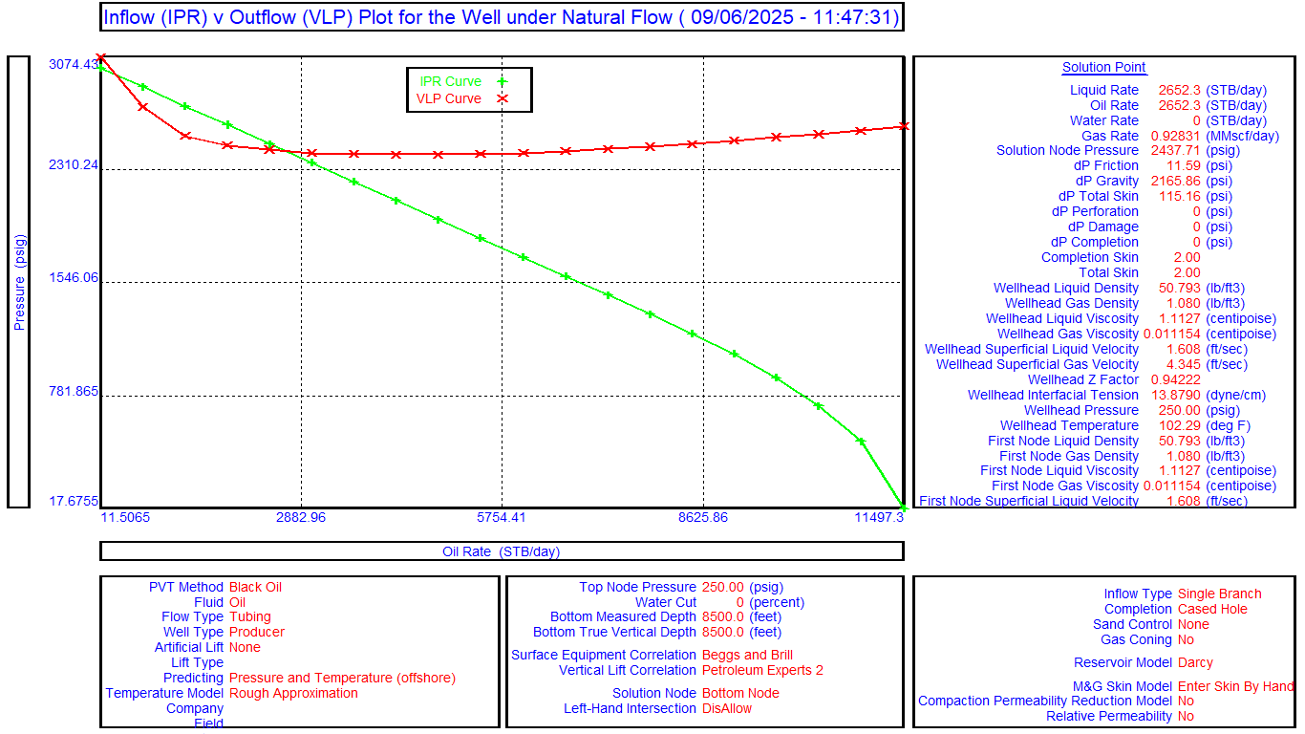
Figure 4: IPR and VLP plot for naturally flowing well
3.2 Effect of Wellhead Pressure and Injected Gas Specific Gravity
Given the proximity of the reservoir to a gas reservoir with a gas-oil ratio (GOR) of 350 scf/STB, gas lift was selected as the preferred artificial lift method due to its operational suitability and cost-effectiveness. The combined effects of wellhead pressure and injected gas specific gravity were investigated using three different injection gases: nitrogen (N₂), methane (CH₄), and carbon dioxide (CO₂). Sensitivity analysis was conducted by varying wellhead pressures at 400 psig, 250 psig, and 100 psig for the three gases as shown in Figures 5, 6, and 7, respectively. The production results for each scenario are summarized in Table 2.
3.2.1 Injection of Nitrogen Gas (N₂)
To evaluate the impact of nitrogen gas injection on well performance, a sensitivity analysis was conducted at a constant injection rate of 1 MMscf/day, with nitrogen having a specific gravity of 0.967. The analysis examined the combined influence of wellhead pressure and injected gas specific gravity, as illustrated in Figure 5.
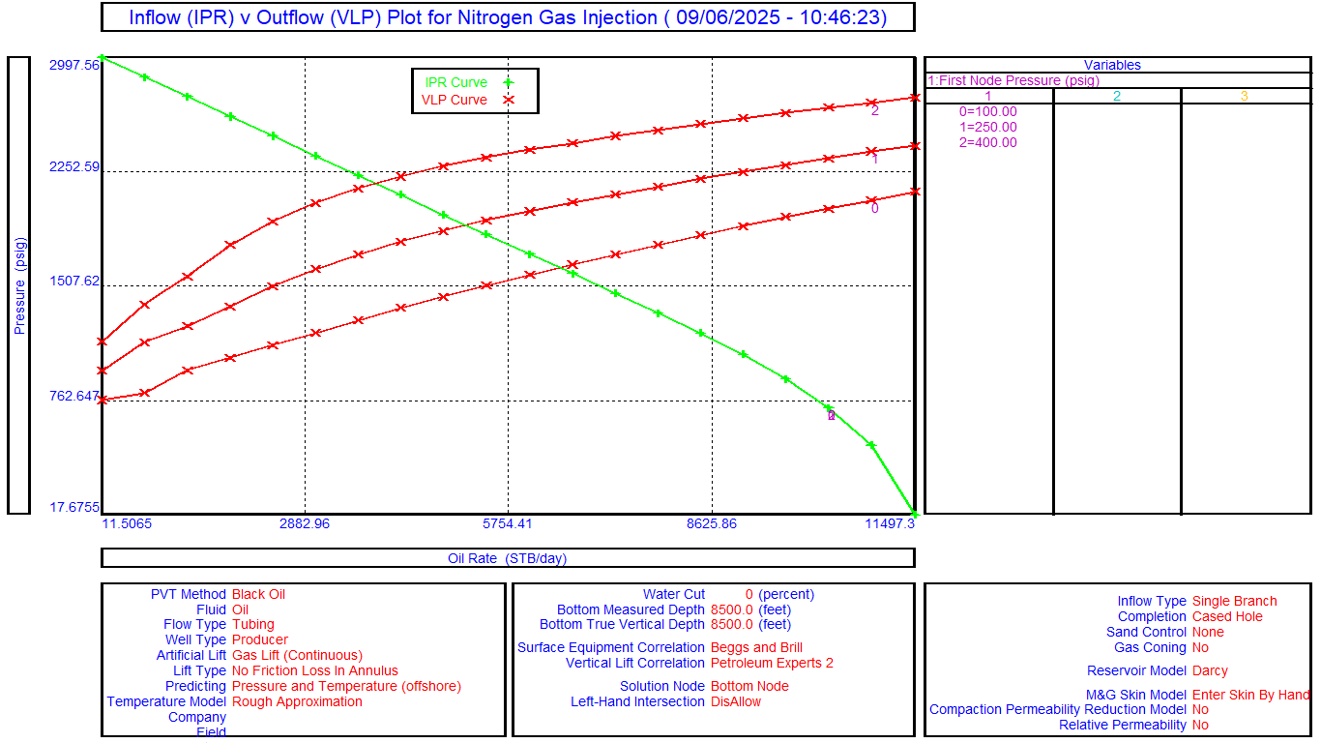
Figure 5: Sensitivity plot of nitrogen gas (N₂) injection.
The results indicate that nitrogen injection significantly enhances oil production, with increases to 6,479.70 STB/day (144.30%), 5,175.4 STB/day (95.13%), and 3,887.80 STB/day (46.58%) at wellhead pressures of 100, 250, and 400 psig, respectively. The performance improvement is notably more pronounced at lower wellhead pressures due to the reduced backpressure, which enhances fluid inflow from the reservoir.
3.2.2 Injection of Methane
The effect of methane injection was also analyzed under the same operational constraints, maintaining a constant injection rate of 1 MMscf/day. Methane possesses a specific gravity of 0.554. As shown in Figure 6 and summarized in Table 1, methane injection resulted in oil production increases of 6,628.10 STB/day (149.90%), 5,407.70 STB/day (103.89%), and 4,230.40 STB/day (59.50%) at WHP of 100, 250, and 400 psig, respectively. Although the improvement trend is similar to nitrogen, the lower specific gravity is evident in marginally higher performance at equivalent operating conditions.
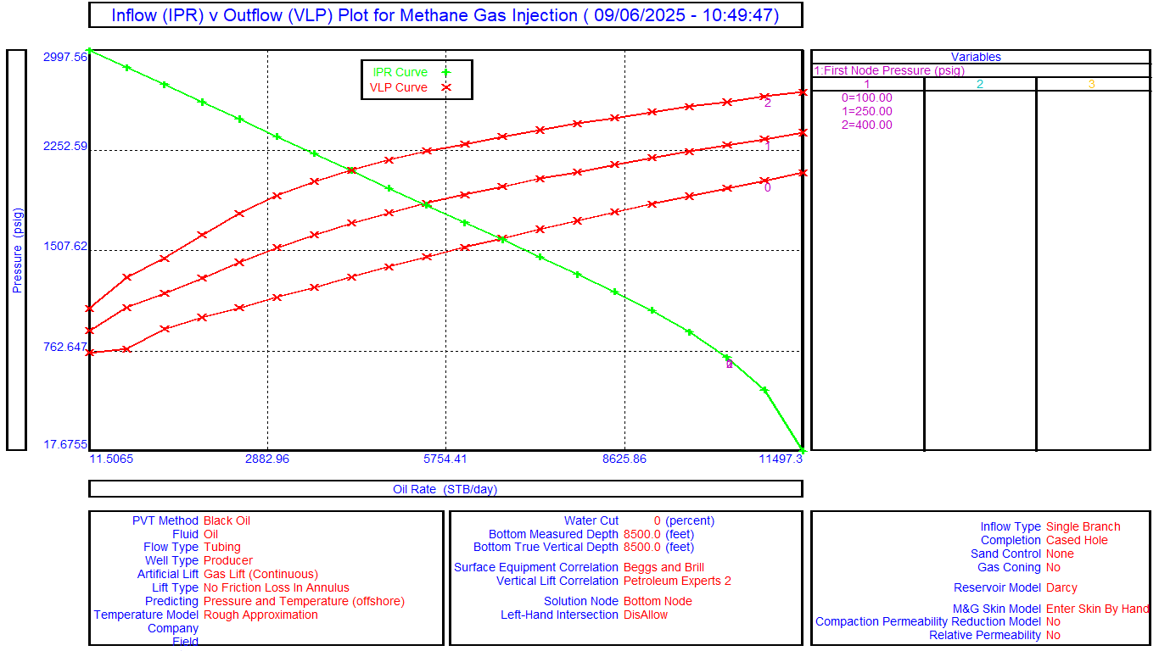
Figure 6: Sensitivity plot of methane injection.
3.2.3 Injection of Carbon Dioxide (CO₂)
Finally, carbon dioxide injection was assessed at the same injection rate of 1 MMscf/day. CO₂ has a specific gravity of 1.519. From the results presented in Figure 7, the oil production rate showed improvements in oil production rate to 6,249.70 STB/day (135.63%), 4,822.30 STB/day (81.82%), and 3,421.30 STB/day (28.99%) at WHP of 100, 250, and 400 psig, respectively. CO₂ exhibits a higher specific gravity compared to nitrogen and methane, which contributes significantly to reduced gas mobility and, consequently, lower oil production rate increments.
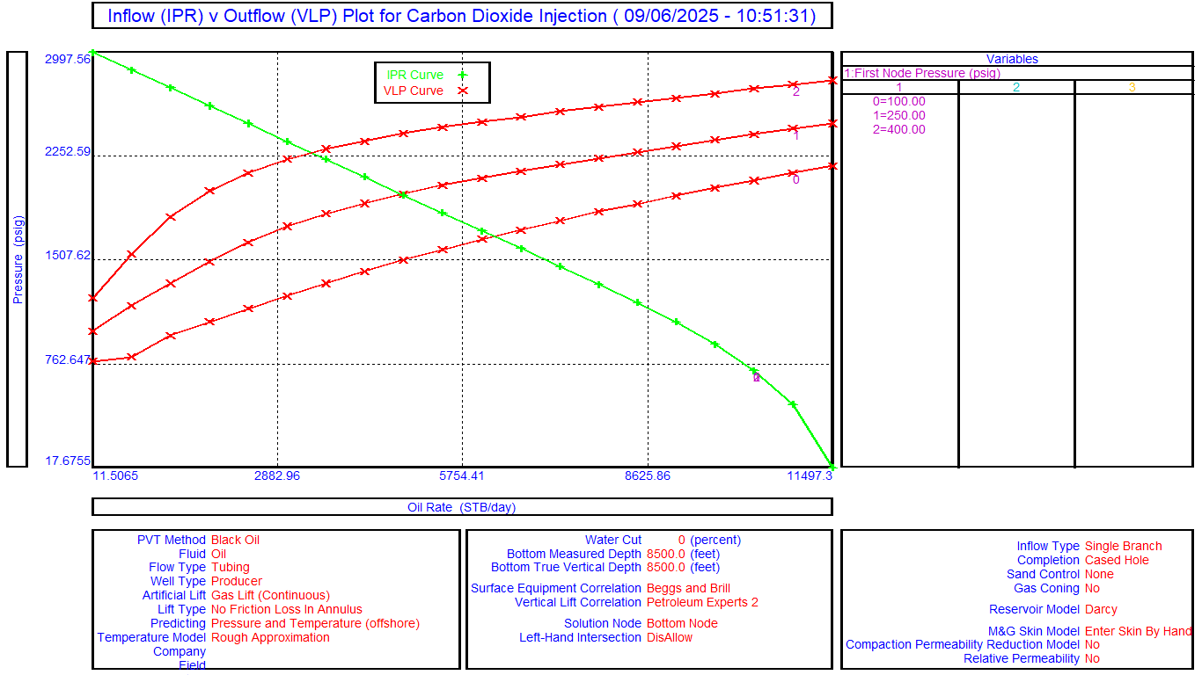
Figure 7: Sensitivity plot of carbon dioxide (CO₂) injection.
Table 2: Summary of sensitivity analysis on WHP, gas specific gravity and injection rates.
Injected Gas Type/SG | Wellhead Pressure (psig) | Gas Injection Rate (MMscf/day)
Injected Gas Type/SG | Wellhead Pressure (psig) | 1 | 2 | 3 | 2 | 3
Injected Gas Type/SG | Wellhead Pressure (psig) | Oil Rate (Qo) (STB/day) |  |  | Oil Rate Gain (%)
CH₄ (0.554) | 400 | 4230.4 | 5194.4 | 5653.0 | 22.79 | 33.63
 | 250 | 5407.7 | 6136.2 | 6489.5 | 13.47 | 20.00
 | 100 | 6628.1 | 7106.2 | 7332.1 | 7.21 | 10.62
N₂ (0.967) | 400 | 3887.8 | 4827.8 | 5290.9 | 24.18 | 36.09
 | 250 | 5175.4 | 5879.2 | 6219.3 | 13.60 | 20.17
 | 100 | 6479.7 | 6921.6 | 7126.5 | 6.82 | 9.98
CO₂ (1.519) | 400 | 3421.3 | 4037.5 | 4349.5 | 18.01 | 27.13
 | 250 | 4822.3 | 5284.0 | 5518.1 | 9.57 | 14.43
 | 100 | 6,249.7 | 6521.8 | 6649.5 | 4.35 | 6.40

3.3 Effect of Gas Injection Rate on the Oil Rate for Each of the Injected Gases
Methane, with the lowest specific gravity among the three gases, exhibits a notable increase in oil production rate as the injection rate rises from 1 to 3 million standard cubic feet per day (MMscf/day). At a wellhead pressure (WHP) of 400 psig, the oil rate increases from 4,230.4 STB/day to 5,653 STB/day, a percentage increase of 33.63%. At 250 psig, the oil rate rises from 5,407.7 STB/day to 6,489.5 STB/day (20.00% increase), and at 100 psig, it goes from 6,628.1 STB/day to 7,106.2 STB/day (10.62% increase). While increasing the methane injection rate consistently boosts oil production, the relative gain diminishes at lower wellhead pressures due to the well's inflow performance relationship and reduced responsiveness to further bottom-hole pressure drawdown.
Nitrogen gas, with a slightly higher specific gravity than methane, shows a consistent improvement in oil production rate with increasing injection rates. At 400 psig, the oil rate increases from 3,887.8 STB/day to 5,290.9 STB/day (36.09% increase), at 250 psig from 5,175.4 STB/day to 6,219.3 STB/day (20.17% increase), and at 100 psig from 6,479.7 STB/day to 7,126.5 STB/day (9.98% increase). Despite its higher specific gravity, nitrogen demonstrates a nearly identical trend of diminishing returns across decreasing wellhead pressures as methane, even yielding a marginally higher relative increase at 400 psig (24.18 vs. 22.79 and 36.09% vs. 33.63%), as shown in Figures 8 and 9 for 2 and 3 MMsf/day injection rates, respectively. This suggests that for these conditions, the injection rate and system pressure have a far greater impact on lift performance than the minor differences in gas properties between N₂ and CH₄.
Carbon dioxide, which has the highest specific gravity, exhibits the least significant percentage increases in oil production at higher WHPs and injection rates. At 400 psig, the oil rate rises from 3,421.30 STB/day to 4,349.5 STB/day (27.13% increase), at 250 psig from 4,822.3 STB/day to 5,518.1 STB/day (14.43% increase), and at 100 psig from 6,249.70 STB/day to 6,649.5 STB/day (6.40% increase). Carbon dioxide produces the least overall gains in oil rate, particularly at higher wellhead pressures, where its 27.13% increase at 400 psig and 3 MMscf/day underperforms compared to methane's 33.63% and nitrogen's 36.09%, indicating that its inferior lifting efficiency due to higher density is most pronounced when the need for effective gas lift is greatest.
Interestingly, nitrogen emerges as the most effective gas for boosting production at the critical high-pressure condition of 400 psig, yielding a 36.09% increase; this is likely because its intermediate properties, slightly higher density than methane yet lower solubility and reactivity than CO₂, strike an optimal balance between reducing hydrostatic head and minimizing frictional losses for this specific well configuration. The largest percentage improvements at 400 psig, as visualized in Figures 8 and 9 for injection rates of 2 MMscf/day and 3 MMscf/day, demonstrate that nitrogen's moderate specific gravity provides superior lift efficiency under high back-pressure conditions. However, its comparative gains diminish at 100 psig, because the well's flow regime becomes less dependent on gas lift efficiency and more limited by reservoir deliverability at lower wellhead pressures.

Figure 8: Plot of oil rate increase at 2MMscf/day injection rate.

Figure 9: Plot of oil rate increase at 3MMscf/day injection rate.
Conversely, as shown in Figure 9, all gases, including nitrogen, provide their smallest relative improvements at low WHP, with increases of only 10.62% for CH_{4,} 9.98% for N₂, and 6.40% for CO₂ at 100 psig. This relationship highlights that the well's flow efficiency is already high at low WHP, and the reservoir's deliverability becomes the limiting factor, making the specific properties of the injection gas less impactful. The superior performance of a specific gas, such as nitrogen at high pressure, is due to its optimal density reducing the hydrostatic column most effectively under those constrained conditions, not its viscosity.
The findings of this study, which demonstrate a clear inverse relationship between wellhead pressure and oil production rate for all injection gases, are consistent with the established principles cited in the literature review. Specifically, Dwivedi et al. (2022) and Hari et al. (2022) stated that increased wellhead pressure reduces pressure drawdown, which in turn diminishes oil production rate, a fundamental mechanism that underpins the trends observed in these simulation results.
Furthermore, the use of PROSPER software for this nodal analysis aligns with methodologies employed in other Niger Delta studies, such as that by Baba et al. (2020), who utilized the software to optimize artificial lift selection for the BARBRA-1 well. However, while their work focused on comparing the efficacy of different lift methods (continuous gas lift, intermittent gas lift, and electrical submersible pump), the present study employed the use of continuous gas lift to provide a novel investigation into the specific impact of injected gas properties, a parameter not deeply explored in the existing regional literature. Similarly, Oghenegare et al. (2020) investigated the independent effect of gas gravity and without practical consideration of gas types. Therefore, this work fills a distinct gap by quantifying how specific gravity directly influences lift efficiency with consideration of operational conditions of wellhead pressure and gas injection rate.
The gas specific gravity is a critical design parameter for gas lift optimization, extending the work of Hari et al. (2022) and Nnaemeka et al. (2025), who investigated wellhead pressure and water cut but did not vary the injected fluid properties. This study thus provides a more granular understanding of the system's behavior, confirming that while wellhead pressure is a dominant variable, the choice of injection gas can significantly modulate the production outcome, especially under high-pressure constraints.
4.0 CONCLUSIONS
From Table 2, a clear inverse relationship between wellhead pressure and oil production rate is observed for all injection gases. The interaction between gas specific gravity and injection rate significantly influences production enhancement, with optimal gas selection being dependent on operational conditions. This study is concluded on the basis that:
- Nitrogen (SG: 0.967) demonstrates superior performance of oil rate gains at higher wellhead pressures, achieving the greatest relative improvement of 36.09% at 400 psig and 3 MMscf/day, indicating its optimal balance between density and flow characteristics for constrained flow conditions.
- Methane (SG: 0.554) provides the highest absolute production rates across all conditions, reaching 7,332.1 STB/day at 100 psig and 3 MMscf/day, making it the most effective gas for maximizing production volume under favorable pressure conditions.
- Carbon dioxide (SG: 1.519) shows the least production improvements across all scenarios, particularly at low WHP, where it achieved only a 6.40% increase at 100 psig and 3 MMscf/day, demonstrating the limitations of high-density gases in gas-lift applications.
Generally, wellhead pressure maintains a consistent inverse relationship with production rate, while gas specific gravity significantly influences the efficiency of production improvement across different pressure regimes.
Overall, this study demonstrates that gas selection for optimal gas-lift performance is not universal and must be tailored to specific well conditions, prioritizing low-specific gravity gases like methane and nitrogen. For future work, field validation with actual gas lift trials using these gases would be necessary to confirm these simulation-derived trends and to quantify any operational challenges not captured in the model, such as corrosion, availability, and surface handling costs. Furthermore, investigating the economic trade-offs between the cost of gas compression and the incremental oil gained would provide a more comprehensive framework for decision-making.

Declaration of Generative AI in Research Writing
The authors hereby declare that Grok 4 AI technology was used during the preparation of this manuscript for the sole purpose of enhancing language, improving grammatical clarity, and refining stylistic flow. All technical and scientific content, including the analysis of results, interpretation of data, formulation of conclusions, and the underlying research concepts, are the original work of the human authors. The authors take full responsibility for the integrity and accuracy of the information presented in this work.

NOMENCLATURE
AAL Annular Absolute Roughness
API American Petroleum Institute
BHP Bottom Hole Pressure
BPP Bubble Point Pressure
CH₄ Methane
CO₂ Carbon Dioxide
FVF Formation Volume Factor
GOR Gas-Oil Ratio
IPR Inflow Performance Relationship
MD Measured Depth
N₂ Nitrogen
ppm Parts Per Million
psig Pounds per Square Inch Gauge
PVT Pressure-Volume-Temperature
Qₒ Oil Production Rate (MMscf/day)
SG Specific Gravity
STB Stock Tank Barrel
TVD True Vertical Depth
VLP Vertical Lift Performance
WHP Wellhead Pressure

COMPETING INTERESTS DISCLAIMER:
Authors have declared that they have no known competing financial interests OR non-financial interests OR personal relationships that could have appeared to influence the work reported in this paper.

REFERENCES
Africa Oil & Gas (2025). Technology, New Basins Take Centre Stage in Nigeria’s Bid to Boost Output. Available at: https://africaoilgasreport.com/ [Accessed 29 September 2025].
Baba Y., Odjugo T., Aliyu A., Okereke N., Oloyede L. and Onifade O. (2020). Optimisation of Artificial Lifts Using Prosper Nodal Analysis for BARBRA-1 Well in Niger Delta. Nigerian Journal of Technological Development, Vol. 17, No. 3, pp. 149-155. : https://www.researchgate.net/publication/346505767
Beal, C. (1946). The Viscosity of Air, Water, Natural Gas, Crude Oil and Its Associated Gases at Oil Field Temperatures and Pressures. American Petroleum Institute, New York, pp. 94-115.
Beggs, H. D. and Brill, J. P. (1973). A study of two-phase flow in inclined pipes. Journal of Petroleum Technology, Vol. 25, No.05, pp. 607-617. https://doi.org/10.2118/4007-PA.
Campbell, J. M. (2022). Overview of gas lift, part 3: Operational field procedure for identifying, selecting and optimizing a gas-lift well. Available at https://www.jmcampbell.com/tip-of-the-month/2022/03/overview-of-gas-lift-part-3-operational-field-procedure-for-identifying-selecting-and-optimizing-a-gas-lift-well/ [Accessed 29 September 2025].
Cao, G., Li, N., Wang, H., Zhong, R. and Shi T. (2022). Real time, automatic injecting of Foaming agent for gas deliquification in CQQK gas field, China: A case study, Paper SPE-210756-MS presented at the Society of Petroleum Engineers (SPE) Asia Pacific Oil and Gas Conference and Exhibition, Adelaide, Australia, October 2022. https://doi.org/10.2118/210756-MS
Dabiri, M.S., Hadavimoghaddam, F., Ashoorian, S., Schaffie, M., and Hemmati-Sarapardeh, A. (2024). Modeling liquid rate through wellhead chokes using machine learning techniques. Scientific Reports Vol. 14, 6945. https://doi.org/10.1038/s41598-024-54010-2
Daolun L., Wang Z., Wenshu Z., Jianjun W., Yong H., Xiaoqing H., and Yue D. (2022). Predicting production-rate using wellhead pressure for shale gas well based on Temporal Convolutional Network. Journal of Petroleum Science and Engineering, Vol 216. https://doi.org/10.1016/j.petrol.2022.110644
Diehl, F.C., Almeida, C.S., Anzai, T.K., Gerevini, G., Neto, S. S., Von Meien, O.F., Campos, M.C., Farenzena, M., Trierweiler, J.O., (2018). Oil production increase in unstable gas lift systems through nonlinear model predictive control. Journal of Process Control, Vol. 69, pp.58–69. https://doi.org/10.1016/j.jprocont.2018.07.009
Dwivedi, V., Al-Zaabi, F., and Jaffres, B. (2022). The benefits of an integrated approach (development, completion, production operation, and integrity) for gas-lift design on an UAE offshore field. Paper SPE-211571-MS presented at the ADIPEC, Abu Dhabi, UAE, October 2022. https://doi.org/10.2118/211571-MS
Glaso, O. (1980). Generalized pressure-volume-temperature correlations. Journal of Petroleum Technology, Vol. 32, pp. 785-795. https://doi.org/10.2118/8016-PA.
Hari, S., Krishna, S., Patel, M., Bhatia, P. and Vij, R. K. (2022). Influence of wellhead pressure and water cut in the optimization of oil production from gas lifted wells. Pet. Res., Vol. 7, No. 2, pp. 253–262. https://doi.org/10.1016/j.ptlrs.2021.09.008
Mahdiani, M. R.and Khamehchi, E., and Suratgar, A.A. (2019). Using modern heuristic algorithms for optimal control of a gas lifted field. Journal of Petroleum Science Engineering, Vol. 183, 106348. https://doi.org/10.1016/j.petrol.2019.106348
Oghenegare, E. E., Idaereesoari H. A., and Okonta N. J. (2020). Gas Lift Optimization of a Mature Well in Niger Delta, Nigeria Using Incomplete Dataset: A Case Study. Engineering Heritage Journal,Vol. 4, No. 1, pp. 15-18. http://doi.org/10.26480/gwk.01.2020.15.18
Okalla, C. E., West, T. K., Dike, C. F., Kerunwa A., and Ndoma-egba, L. E. (2024). Effect of Gas-Oil Ratio on Oil Production for a Niger Delta Well. Journal of Engineering Research and Reports, Vol. 26, No. 5, pp. 294-303. DOI: 10.9734/jerr/2024/v26i51155
Oluwadare, O.A., Folorunso, A.F., Ashiru, O.R., and Otoabasi-Akpan, S.I. (2024). High resolution 3-D seismic and sequence stratigraphy for reservoir prediction in ‘Stephi’ field, offshore Niger Delta, Nigeria. Scientific Reports, Vol. 14, 22390. https://doi.org/10.1038/s41598-024-73285-z
Nnaemeka, U., Kalu, G. O., Ndubuisi, U. O., Ndoma-Egba, L. E., and Dike, C. F. (2025). Evaluation of Key Parameters and Performance Indicators of A-05 Well in the Niger Delta. Journal of Petroleum and Coal, Vol. 67, No. 1, pp. 156 - 163. https://www.researchgate.net/publication/390250112
Raunak, A., and Bhavinay, S. (2023). Prosper Software for Gas Lift System Design and Simulation. International Journal of Research Publication and Reviews, Vol. 4, No. 8, pp. 2874-2884. https://doi.org/10.55248/gengpi.4.823.51837
Sanni, K., Longe, P., and Okotie, S. (2020). New production rate model of wellhead choke for Niger Delta oil wells. Journal of Petroleum Science and Technology, Vol. 10, pp.41–49.
Statista (2024) Nigeria: Crude oil export value versus total export value 2022. Available at: https://www.statista.com/statistics/1177893/crude-oil-exports-value-as-share-of-total-exports-in-nigeria/ (Accessed: 28 September 2025).
Weijermars, R. (2024). Fast production and water-breakthrough analysis methods demonstrated using Volve Field data. Journal of Petroleum Research, Vol. 9, No. 3, pp. 327-346. https://doi.org/10.1016/j.ptlrs.2024.03.001
Wikipedia (2024) Petroleum industry in Nigeria.
Available at: https://en.wikipedia.org/wiki/Petroleum_industry_in_Nigeria (Accessed: 28 September 2025).
World Bank (2023) Nigeria. Global Flaring and Methane Reduction Partnership. Available at: https://flaringventingregulations.worldbank.org/nigeria#section2 [Accessed 29 September 2025].

