Original Research Article

Enhancing Soil Stability: Evaluating the Effectiveness of Terrasil Nanotechnology in Soil Stabilization

.
ABSTRACT

Background: Conventional techniques for stabilizing soil frequently use expensive and occasionally hazardous materials like cement and artificial polymers. Thus, stabilization of soils with chemical additives has drawn up a lot of interest from construction sector, because it can improve the engineering qualities of problematic soils. Nanomaterials have the potential to improve soil qualities without the disadvantages of conventional additives because of their special qualities and high surface area to volume ratio. Terrasil is a water-soluble nanochemical that has demonstrated promise in improving soil qualities by decreasing permeability and boosting strength, thus making it an appealing choice for soil stabilization.
Aims: In this study, the performance and resilience of soils stabilized with Terrasil based on nanotechnology was investigated
Methodology: Two soil samples, Sample A (cohesive) and Sample B (non-cohesive) were treated with Terrasil Nano chemical, at dosages of 0%, 3%, 6%, and 9%. The additive, predetermined dosages of Terrasil, were first diluted in water and then thoroughly mixed with the soil samples to ensure uniform distribution. Geotechnical properties of soil such as CBR, shear strength and consolidation were investigated. The effectiveness of Terrasil stabilization was then evaluated through these geotechnical tests, and the results were compared with untreated soils (0%) and benchmarked against typical performance ranges reported for traditional stabilizers such as lime and cement.
Results: The results shows that there is significant improvement in both CBR and shear strength with increasing Terrasil dosage, particularly for Sample A, where cohesion increased markedly from 23 kN/m² at 0% to 75 kN/m² at 9% dosage. Total settlement decreased significantly with increasing dosage, according to settlement analysis, falling from 0.0369 mm to 0.02405 mm for Sample A and from 0.03117 mm to 0.02428 mm for Sample B. The coefficient of consolidation also demonstrated a downward trend, indicating improved soil stability and reduced compressibility.
Conclusion: This confirms that Terrasil is a dependable additive improving the resilience of soils for performance applications related to highway construction and civil engineering.

Keywords: Terrasil Nano Chemical, Stabilization, Soil, CBR, Shear Strength, Consolidation

1. INTRODUCTION

Cohesive and non-cohesive soils present distinct challenges in civil engineering due to their varying engineering properties, including differences in shear strength, compressibility, and susceptibility to environmental factors such as erosion and settlement (Zabielska-Adamska et al., 2023; Di Nardi et al., 2022). Non-cohesive soils, such as sands and gravels, are typically characterized by low cohesion and high permeability, making them prone to erosion, instability under load, and rapid changes in volume with moisture variations (Pandey and Kumari, 2024; Nzereogu et. al., 2023). Cohesive soils, on the other hand, such as clays and silts, exhibit greater internal bonding but may suffer from problems like high plasticity, poor drainage, and excessive swelling or shrinkage under changing moisture conditions (Utkarsh and Jain, 2024). Both types of soils can compromise the stability of foundations, pavements, and other civil engineering structures due to their inherent weaknesses. Non-cohesive soils, for example, lack internal bonding forces and can fail under cyclic or dynamic loads, as demonstrated in studies where gravelly sand experienced shear failure after repeated loading (Zabielska-Adamska et al., 2023). Similarly, cohesive soils can exhibit excessive settlement or reduced strength when subjected to long-term loading, particularly in saturated conditions (Al-Wakel et. al., 2022). Furthermore, the vulnerability of both soil types to environmental factors such as rainfall, erosion, and seismic activity adds to the complexity of ensuring long-term performance. Soil stabilization has therefore become an essential strategy to improve the mechanical properties and resilience of both cohesive and non-cohesive soils. Traditional methods such as the use of cement, lime, or fly ash have been employed to reduce permeability, increase strength, and mitigate settlement. Traditional methods include the addition of cement, lime, or fly ash to enhance soil stability and reduce permeability. However, these methods often have limitations such as increased cost, environmental concerns, and potential long-term performance issues.
Traditional methods of soil stabilization often rely on costly and sometimes environmentally harmful materials such as cement and synthetic polymers (Archibong, et. al., 2020). These materials are commonly used because they tend to enhance the engineering properties of subgrade soils, such as strength, stiffness, and drainage. However, their use can have significant environmental and economic impacts (Amakye, et. al., 2021; Verma, et. al., 2021). Traditional stabilization techniques often involve the use of lime, cement, or chemicals which improve soil properties by enhancing strength, reducing compressibility, and minimizing volume changes (Barman, and Dash, 2022; Archibong¸et. al., 2020; Gunarathne, et, al., 2020; Sánchez-Garrido, et. al., 2022; Verma, et. al., 2021; Huang, et. al., 2021). However, these methods can be costly and environmentally taxing, especially in regions where these materials are not readily available. These materials are often costly, contribute to carbon emissions, and rely on non-renewable resources, prompting the need for more sustainable alternatives (Tracy and Novak, 2023; Belaïd, 2022; Mohamad, et. al., 2022; Khaiyum, et. al., 2023; Bodor, et. al., 2024; Wanner, 2021). One of the most pressing issues associated with conventional soil stabilizers is their environmental impact (Gunarathne, et, al., 2020; Sánchez-Garrido, et. al., 2022). The production of cement alone is responsible for approximately 8% of global carbon dioxide emissions (Tracy and Novak, 2023; Khaiyum, et. al., 2023). Additionally, the use of synthetic polymers can lead to soil and water pollution due to their non-biodegradable nature (Bodor, et. al., 2024; Wanner, 2021). Lime stabilization, although less carbon-intensive, can alter the pH of the soil, potentially leading to negative ecological impacts, including disruption of local flora and fauna. Moreover, the use of synthetic polymers, which are non-biodegradable, raises concerns about long-term soil and groundwater contamination (Bodor, et. al., 2024; Wanner, 2021). These polymers can persist in the environment for extended periods, leading to microplastic pollution and potential harm to ecosystems (Ali, et. al., 2024; Ziani, et. al., 2023; Alaka and Osman, 2023). The increasing costs and environmental concerns associated with conventional subgrade stabilization methods necessitate the exploration of alternative materials that are both effective and sustainable. Traditional stabilizers such as cement, lime, and synthetic polymers, while effective, contribute to high construction costs and significant environmental impacts due to their production processes and long-term degradation (Jaffar, et. al., 2022). Thus, it becomes necessary to research into other stabilization techniques that causes less environmental degradation. One promising approach to address these challenges is the use of nanotechnology-based additives. In recent years, nanotechnology has emerged as a promising alternative for soil stabilization (Kumar and Devi, 2023).
The stabilization of soils using chemical additives has gained significant attention in the construction industry due to its potential to enhance the engineering properties of problematic soils (Barman and Dash, 2022; Taskin et. al., 2023; Nguyen et al., 2023; Owino et al., 2022). Among various stabilizing agents, nano-based chemicals are emerging as innovative solutions for improving soil strength, durability, and resistance to environmental stresses (Yadav et. al., 2023; Kumar and Devi, 2023). Nanomaterials, due to their unique properties and high surface area to volume ratio, offer potential advantages in enhancing soil properties without the drawbacks associated with traditional additives (Sharma and Kumar, 2024). Terrasil, a water-soluble nano chemical, has shown promise in enhancing soil properties by reducing permeability and increasing strength, making it an attractive option for soil stabilization in diverse applications. Terrasil nano chemical, a nanotechnology-based additive, is designed to interact at the molecular level with soil particles, potentially improving cohesion, shear strength, and overall stability (Karumanchi et. al., 2020). Terrasil nano chemical, offers the potential to improve soil stabilization and mitigate associated engineering problems.
This study focuses on evaluating the effectiveness of Terrasil nano chemical in stabilizing non-cohesive soils. As infrastructure projects increasingly demand sustainable and durable soil stabilization solutions, particularly in regions with problematic soils, this study provides evidence-based data on the effectiveness of Terrasil in improving shear strength, settlement, and consolidation behavior. The findings extend current knowledge on chemical stabilization by demonstrating the advantages of nanochemical treatment over traditional binders. The research aims to assess how the application of Terrasil nano chemical influences critical engineering parameters, including California Bearing Ratio (CBR), shear strength, and consolidation characteristics. These parameters are crucial indicators of soil stability, load-bearing capacity, and settlement behavior, which are essential for determining the suitability of soils in construction projects. By investigating the performance and resilience of non-cohesive soils treated with Terrasil nano chemical, this study seeks to contribute valuable insights into the feasibility and effectiveness of nanotechnology-based solutions in soil stabilization practices.

2. methodology

Soil samples were obtained and classified to assess and deduce soil type (particle size analysis and Atterberg limit test). Natural moisture content of the soil was determined and compaction test was carried out in order to determine the optimum moisture content and maximum dry density of the soil. Finally, shear strength, CBR and Consolidation tests were carried out, in order to determine the effects of varying percentages of Terrasil on the soil samples. All tests were carried out in triplicates to ensure reproducibility, and the results presented represent average values. The effectiveness of Terrasil treatment was evaluated by comparing the performance of stabilized samples with untreated soils in similar conditions.
2.1 Materials Collection
The soil utilized in the study were obtained as a disturbed sample from a borrow pit in Mojuade Area Ibadan, Oyo state. The soil samples were carefully packaged (as shown in Fig. 1 and Fig. 2), air-dried, and transported to the laboratory.
Terrasil Nano chemical is an organosilane compound that was acquired from a chemical trader in Ibadan. It reacts with soil particles, forming hydrophobic layers on the soil surface. Terrasil a water-soluble compound, creates a permanent water-repellent Nano layer on various soil types by converting silanol groups into water-repellent siloxane bonds.
The water to be used in testing and mixing procedures was sourced from the Geotechnical Laboratory of the Civil Engineering Department in Lead city university, Ibadan, Oyo State. This ensured clean, impurity-free water suitable for testing, meeting potable standards. To apply the additive, predetermined dosages of Terrasil (0%, 3%, 6%, and 9% by dry weight of soil) were first diluted in water and then thoroughly mixed with the soil samples to ensure uniform distribution.

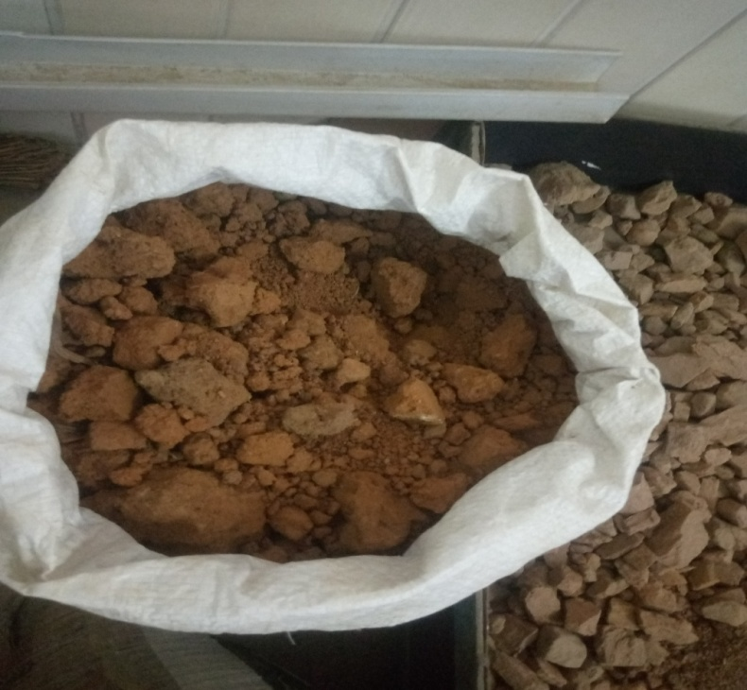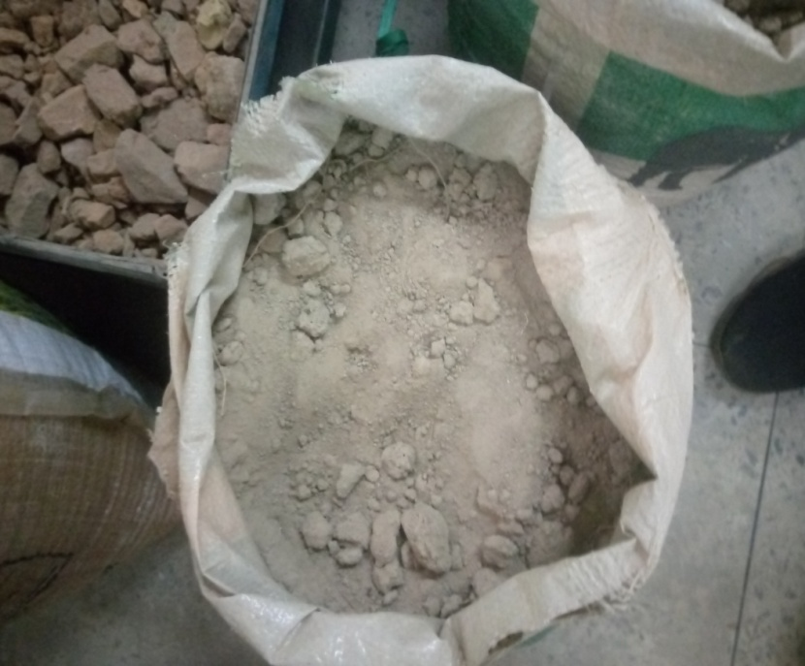
Fig. 1: Soil Sample A Fig. 2: Soil Sample A
2.2 Determination of Moisture Content of the Soil Samples
Using the pycnometer method, the pycnometer was washed, cleaned, and dried. The pycnometer along with its brass cap and washer, was weighed to an accuracy of 1g and recorded as (W₁). A wet soil specimen weighing between 200g to 400g was then placed into the pycnometer and weighed with its cap and washer (M2). Water was filled into the pycnometer containing the wet soil specimen to approximately half its height. The mixture was thoroughly stirred using a glass rod, and additional water was added and stirred until the pycnometer was filled with water, flushing through the hole in the conical cap. Subsequently, the pycnometer was dried externally and weighed (M3). Afterwards, the pycnometer was emptied, meticulously cleaned, filled with water, and weighed again after flushing through the hole in the conical cap (M4). The moisture content was calculated using Equation 3.1.
w = $\frac{M2-M1}{M3-M4}$ x [$\frac{G-1}{G}$ -1] x 100 Equation 1
where M1, M2, M3, and M4 represent the respective masses as described in the procedure for determining moisture content using the pycnometer, and G denotes the specific gravity of the soil solid.
2.3 Particle Size Analysis of the Soil Samples
The soil sample gotten was taken to the Geotechnical laboratory of Civil Engineering Department, Lead city university where particle size analysis was carried starting from washing away of the silt and clay present in the soil sample gotten then oven dried for 12hrs and then cooled in the desiccator before been sieved using an electric sieve shaker comprising sieves with 6.0 mm, 5.6 mm, 2.8 mm, 1.0 mm, 500µm, 335µm, 125µm aperture a base receiver was used for retaining soil that passed through the sieve and they were arranged from the top to the base in this order. The retained sample on each sieve was then observed, weighed and recorded after proper shaking was done. The particle size distribution was obtained and the particle size distribution curve was plotted
2.4 Compaction Test
The maximum dry density (MDD) and optimum moisture content (OMC) of the soil were determined using the Standard Proctor Compaction test. Initially, the soil sample was thoroughly mixed with Terrasil nano chemical at a concentration of 3%. The mixed sample was then compacted in a 4-inch Proctor mold using a mechanical rammer.
Compaction tests were conducted by varying the moisture content of subsequent samples to determine the moisture content at which the soil achieved its maximum dry density. The compaction process involved compacting the soil at different moisture contents and measuring the dry density achieved after each compaction effort. The moisture content corresponding to the highest dry density attained was recorded as the optimum moisture content (OMC), while the corresponding dry density was recorded as the maximum dry density (MDD).
2.5 Determination of Specific Gravity
The specific gravity of the soil samples was determined using a density bottle method. Initially, a clean, dry density bottle with its stopper was weighed and recorded as W1W1W1. The bottle was then filled halfway with the soil sample and reweighed as W2W2W2. Water was added to the bottle and thoroughly mixed with the soil sample, and the bottle was then allowed to settle for an hour. The weight of the bottle and contents after settling was recorded as W3W3W3.
Subsequently, the contents were disposed of, and the bottle was refilled with water and weighed again as W4W4W4. The specific gravity of the soil sample was calculated using Equation 2.
Specific gravity$=\frac{(W2-w1)}{\left(W2-w1\right)-(W3-W4)}$ Equation: 2
W1 = Weight of empty density bottle with stopper (g)
W2 = Weight of empty density bottle with stopper + dry sample (g)
W3 = Weight of empty density bottle with stopper + dry sample + water (g)
W4 = Weight of empty density bottle with stopper + water (g)

2.6 CBR Test
CBR tests were conducted to assess the soil's strength. The soil samples were compacted in five layers with 27 blows at each layer compacted using a 4.5 kg rammer. The specimen for the various percentages (3%, 6%, 9%) were cured and sealed in polythene bags for 3 days. Then tested using the CBR test machine. Readings were taken for top and bottom at penetrations of 2.5 and 5.0 mm.
2.7 Tri-Axial Tests
This test was carried out to determine the mechanical properties of soils, including their shear strength and stress strain. The procedure involves subjecting a cylindrical soil sample to three different stress condition which are axial stress (vertical), radial stress (horizontal) and confining stress (applied uniformly around the sample) using tri-axial test machine.
2.8 Consolidation Test.
The consolidation test was used to determine he compressibility and settlement of the soil using the odometer as the procedure involves soil been subjected to load vertically for 3 days and 7 days respectively for sample at different percentages.
3. results and discussion
Preliminary Tests
The particle size distribution and classification results (Table 1) highlight the distinct differences between Samples A (Fig. 3) and B (Fig. 4). Sample A, with its higher fines content, requires stabilization to reduce plasticity and improve compaction. Sample B, with its higher sand content, benefits from enhanced cohesion and reduced permeability.

Table 1: Preliminary Tests
Tests | Soil Sample A | Soil Sample B
Specific Gravity | 2.04 | 2.4
Moisture Content | 9.64% | 0.84%
Particle Size Analysis
Item | Data A | Data B
Percent gravel | 12 | 0
Percent sand | 33 | 62
Percent fines | 55 | 38
D10 = Size of grains that accounts for 10% of the total (mm) | 0 | 0
D30 = Size of grains that accounts for 30% of the total (mm) | 0 | 0
D60 = Size of grains that accounts for 60% of the total (mm) | 0.2 | 0.2
Cu = Coefficient of Uniformity | 0 | 0
Cc = Coefficient of gradation | 0 | 0
Classification according to USCS | GC or SC (Gravelly clayey soil or Sandy Clayey Soil) | Sand with silt
Classification of the soil according to AASHTO | A – 7 (Clayey soil) Fair to Poor
Grade of Soil Sample | Poorly Graded | Poorly Graded
Group Index | 5.0

Fig. 3: Particle Size Distribution for Fig. 4: Particle Size Distribution for Soil
Soil Sample A Sample B
Sample A consists of 12% gravel, 33% sand, and 55% fines. The high fines content indicates a significant presence of silt and clay particles. This composition suggests that Sample A is likely to have lower permeability, higher plasticity, and greater cohesiveness compared to a soil with a higher sand content. The significant fines content (55%) combined with the presence of gravel and sand indicates that the soil has a considerable amount of clayey material. Sample A is classified as either GC (Gravelly Clayey Soil) or SC (Sandy Clayey Soil) according to the Unified Soil Classification System (USCS). The classification is based on the percentage of gravel (12%), sand (33%), and fines (55%). According to the American Association of State Highway and Transportation Officials (AASHTO) classification system, Sample A falls under the A-7 category, which is designated for clayey soils. The specific designation of A-7 indicates that the soil has poor performance qualities for highway subgrades, with fair to poor drainage and strength characteristics. Sample A has a group index of 5.0, which further quantifies the soil's performance as a subgrade material. A higher group index indicates poorer performance. With a group index of 5.0, Sample A is considered to have fair to poor suitability for use in road construction. The soil is graded as poorly graded, meaning that it lacks a well-distributed range of particle sizes. Poorly graded soils have a narrow range of particle sizes, leading to less dense packing and higher void ratios, which can reduce strength and stability. The presence of 12% gravel can provide some structural stability, but the predominant fines can lead to potential issues such as shrink-swell behavior and poor drainage. The high fines content in Sample A means that it can benefit significantly from stabilization using Terrasil nano chemical.
Sample B comprises 0% gravel, 62% sand, and 38% fines. The high sand content indicates that Sample B has good drainage properties and low plasticity. The 38% fines content, while significant, is lower than that of Sample A, suggesting better overall stability and less shrink-swell potential. The high sand content (62%) and the presence of fines (38%) indicate that the soil is predominantly sandy with a notable silt fraction. The sandy nature of the soil implies good drainage and relatively low plasticity compared to clayey soils. Sample B is also graded as poorly graded, indicating a limited range of particle sizes. Poorly graded sands can have a higher void ratio and may be less stable under load compared to well-graded soils. The composition of Sample B, with its higher sand content, suggests it is inherently more stable than Sample A. However, it still has the tendency to benefit from Terrasil nano chemical treatment, such that the cohesion between sand particles can be improved, and permeability can be reduced, making it less susceptible to water infiltration.

Compaction Test
The compaction data of the soil samples is given on Table 2, and the optimum moisture content (OMC) and maximum dry density (MDD) for sample A and B is show in Fig. 5 and Fig. 6 respectively.
Table 2: Table of OMC and MDD for Soil Samples
Item | Soil Sample A | Soil Sample B
Optimum Moisture Content (%) | 9.3% | 13.2%
Maximum Dry Density (kg/m³) | 1976.2 kg/m³ | 1918 kg/m³
The dry densities of the soil samples were plotted against the moisture content to determine the Optimum Moisture Content (OMC), and Maximum Dry Density (MDD).
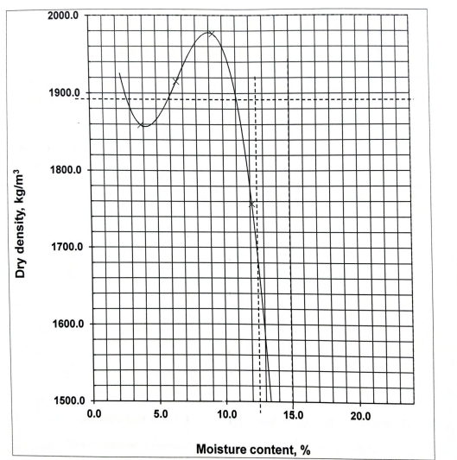
Fig. 5: OMC and MDD of Soil Sample A Fig. 6: OMC and MDD of Soil Sample B

The MDD of 1976.2 kg/m³ of soil sample A, indicates the highest density that the soil can achieve under standard compaction efforts. A higher MDD generally signifies better soil compaction and greater load-bearing capacity, which is essential for construction applications (Dhir et. al., 2017). This value is particularly important for ensuring the soil's stability and strength when used as a subgrade material or in embankments (Salahudeen et. al., 2019). The OMC of 9.3% represents the moisture content at which the soil achieves its maximum density. This value is critical for construction practices as it indicates the ideal moisture level needed during compaction to achieve the best results. If the soil is too dry, it won't compact well, leading to a lower density and weaker structure. Conversely, if it's too wet, the soil can become too soft and also fail to compact properly. Given the high fines content and clayey nature of Soil Sample A, achieving optimal compaction is vital for enhancing its performance.
In soil sample B. the MDD of 1918 kg/m³ indicates the highest density that the soil can achieve under standard compaction efforts. A higher MDD typically signifies better soil compaction and greater load-bearing capacity, which is crucial for construction applications. This value is particularly important for ensuring the soil's stability and strength when used as a subgrade material or in embankments (Salahudeen et. al., 2019). The OMC of 13.2% represents the moisture content at which the soil achieves its maximum density.

CBR Analysis
The California Bearing Ratio (CBR) test results as shown in Table 3 indicates a substantial improvement in soil strength with the addition of Terrasil for both Sample A and Sample B. For Sample A, the untreated soil exhibited a CBR value of 7%, which is indicative of its low bearing capacity. Upon adding 3% Terrasil, the CBR value slightly increased to 7.5%. This modest improvement suggests that the lower dosage may not provide significant stabilization effects. However, at 6% Terrasil, the CBR jumped to 20.3%, demonstrating that a more effective stabilization occurs at this percentage. The addition of 9% Terrasil further increased the CBR to 23.5%, indicating that while there is still improvement, the enhancements are becoming marginal as the dosage approaches higher levels.
Table 3: CBR of Soil Samples at different Treatment Dosage
Sample |  |  | Average CBR (%)
Sample A 0% |  |  | 7
Sample B 0% |  |  | 23.5
Sample A 3% |  |  | 7.5
Sample B 3% |  |  | 28.25
Sample A 6% |  |  | 10.5
Sample B 6% |  |  | 52.5
Sample A 9% |  |  | 20.25
Sample B 9% |  |  | 75

Fig. 7: CBR of Soil Samples at Different Treatment Dosage

In contrast, Sample B displayed a more pronounced response to Terrasil treatment. The initial CBR value of 28.3% for the untreated soil already indicates a better bearing capacity than Sample A. When 3% Terrasil was introduced, the CBR surged to 52.5%, suggesting that even a small amount of Terrasil can lead to significant improvements in soil strength. At 6% Terrasil, the CBR reached an impressive 75%, marking a substantial enhancement in load-bearing capacity. Interestingly, the CBR value remained at 75% at the 9% dosage, indicating that this might be the optimum dosage for Sample B, as further increases did not yield additional benefits.

Shear Strength Analysis
The shear strength of the treated soil samples are shown on Table 4, and Fig. 8. In soil sample A, it is observed that is the dosage increased from 0% to 9%, there is a notable increase in cohesiveness of the soil. Likewise, an increase is observed in the shear strength of the soil, with a minor plateau between 3% and 6% and a notable increase at 9%, showing that the shear strength increased with dosage. For soil sample 2, Cohesion stays at 0 throughout Sample B, indicating that the increase in friction angle is the only factor contributing to the improvement in shear strength. As angle of internal friction increases, the shear strength steadily rises, demonstrating how Terrasil improves frictional resistance or particle interlock. Although the mechanisms are different, Terrasil increases shear strength in cohesive and cohesionless soils. In sample A, both cohesion and angle of internal friction are enhanced, however, in sample B, only the angle of internal friction increases. It can also be noted that both samples reached their maximum shear strength at 9% Terrasil dosage with sample A having a shear strength of 220.3085 N/m² (30.89% increase) and sample B having a shear strength of 193.1378 N/m² (67.2% increase).

Table 4: Shear Strength of Soil Samples Treated with Terrasil at Varying Dosages
% of Terrasil | Sample A |  |  |  | Sample B
Dosage | 0% | 3% | 6% | 9% | 0% | 3% | 6% | 9%
Cohesion, C | 23 | 50 | 70 | 75 | 0 | 0 | 0 | 0
Angle of internal friction, Ø | 36° | 35° | 32° | 36° | 30° | 39° | 41° | 44°
Shear strength (N/m²) | 168.31 | 190.04 | 194.97 | 220.31 | 115.47 | 161.96 | 173.86 | 193.12

Fig. 8: Shear Strength of Soil Samples at Different Treatment Dosage

Consolidation of Soils
The total settlement as well as consolidation rate of the soil samples are depicted on Table 5 and Fig. 9. From the figure, it is seen that with increasing Terrasil dosage, the average rate of consolidation in sample A decreases dramatically, going from 0.0369 mm at 0% to 0.02405 mm at 9%. Likewise in sample B, the settlement decreases from 0.03117 mm at 0% to 0.02428 mm at 9%, showing a similar pattern. The very loose or compressible soil was indicated by the initially high minimum settlement at 0% (0.7047 mm), which was significantly improved with treatment. This pattern, indicates better soil stiffness and load bearing capacity of the soil. Additionally, the coefficient of consolidation gradually declines, suggesting slower consolidation, which is frequently associated with increased soil stability and decreased compressibility. The soils exhibit the lowest settlement values at 9% dosage, indicating the greatest improvement in their structural performance. As a result, Terrasil works well to improve problematic soils' compressibility and consolidation properties. Overall, the findings of this study shows that Terrasil greatly lowers overall settlement and improves consolidation behaviour for both soil types
Table 5: Total Settlement and Co-efficient of Consolidation for Soil Samples Treated with Terrasil at Varying Dosages)
Treatment Dosage | Total Settlement (mm) | Coefficient of Consolidation (m²/yr)
Treatment Dosage | Total Settlement (mm) | Minimum | Maximum | Average
Sample A
0 % | 0.0775 | 0.000781 | 0.116927 | 0.03691
3 % | 0.0264 | 0.000731 | 0.078895 | 0.02696
6 % | 0.0264 | 0.000722 | 0.080272 | 0.02935
9 % | 0.0120 | 0.000684 | 0.079463 | 0.02405
Sample B
0 % | 0.7047 | 0.000719 | 0.088761 | 0.03117
3 % | 0.0630 | 0.000663 | 0.077458 | 0.02753
6 % | 0.0280 | 0.000519 | 0.079035 | 0.02790
9 % | 0.0260 | 0.000656 | 0.078910 | 0.02428

4. Conclusion

Terrasil improves the strength and stability of the soil, making it more appropriate for foundation applications, as confirmed by the rise in CBR values for the treated samples. When compared to the untreated soil, the CBR values exhibit significant improvements at higher Terrasil concentrations. Likewise, the addition of Terrasil consistently raises the soil's shear parameters, according to the shear strength tests. The soil's overall stability and resistance to shear stresses are improved by the improvement in both cohesion and the angle of internal friction. The most notable increases in shear strength were observed at higher concentrations of Terrasil, suggesting that the stabilising effect of Terrasil is proportional to its soil concentration. The consolidation test results demonstrate a marked improvement in the soil’s consolidation properties with the addition of Terrasil. As the percentage of Terrasil increased, the soil's compressibility decreased, leading to reduced settlement under applied loads. The coefficient of consolidation (Cv) decreased with higher Terrasil content, indicating that while the rate of consolidation slowed, the overall consolidation characteristics improved. The preconsolidation pressure also increased with higher Terrasil concentrations, reflecting enhanced soil resistance to consolidation.
Based on the results, for the best soil property improvement, a Terrasil concentration of 9% is recommended. This dosage provides the best balance between enhanced strength, reduced compressibility, and improved consolidation characteristics. Higher concentrations of Terrasil lead to better performance, but the marginal gains in consolidation rate may not justify excessively high additions.
While the study demonstrates that Terrasil nanochemical significantly enhances soil strength, durability, and consolidation characteristics, it is limited to the soil types investigated. Further research is recommended to validate performance across a broader range of soil conditions and in direct long-term field comparisons with conventional stabilizers. Nonetheless, this work represents one of the first systematic evaluations of Terrasil in local soils and contributes to the growing body of knowledge on sustainable nanotechnology applications in geotechnical engineering.
4.1 AREAS OF FURTHER RESEARCH
The following recommendations are given in light of the research's findings.
i. Conduct long-term field studies to evaluate the durability and performance of Terrasil-treated soils over extended periods. Assess how factors such as weathering, moisture changes, and traffic loads impact the soil's stability and the effectiveness of Terrasil treatment over time.
ii. Investigate the effects of Terrasil on various soil types, including silts, clays, and sands, to determine if the observed improvements are consistent across different soil conditions. This will help in understanding the broader applicability of Terrasil and its limitations.
iii. Study the environmental impact of using Terrasil, including any potential leaching effects or interactions with groundwater.

COMPETING INTERESTS DISCLAIMER:
Authors have declared that they have no known competing financial interests OR non-financial interests OR personal relationships that could have appeared to influence the work reported in this paper.

Disclaimer (Artificial intelligence)
Option 1:
Author(s) hereby declare that NO generative AI technologies such as Large Language Models (ChatGPT, COPILOT, etc.) and text-to-image generators have been used during the writing or editing of this manuscript.
Option 2:
Author(s) hereby declare that generative AI technologies such as Large Language Models, etc. have been used during the writing or editing of manuscripts. This explanation will include the name, version, model, and source of the generative AI technology and as well as all input prompts provided to the generative AI technology
Details of the AI usage are given below:
1.
2.
3.

References
Al-Wakel, D., Rahil, F., & Abdulrasool, A. (2022). Behavior of Circular Footings on Cohesive Soils Confined With A Shear Resistance Wall. International Journal of GEOMATE. 23. 90-99. 10.21660/2022.99.3642.
Alaka, S. A., & Osman, Y. (2023). Assessment of Municipal Solid Waste Management in Oyo State, Nigeria: Challenges and Solutions. IIARD International Journal of Geography and Environmental Management (IJGEM), 9(6), 78–90. https://doi.org/10.56201/ijgem.v9.no6.2023.pg78.90
Ali, N., Khan, M. H., Ali, M., Ahmad, S., Khan, A., Nabi, G., Ali, F., Bououdina, M., & Kyzas, G. Z. (2024). Insight into microplastics in the aquatic ecosystem: Properties, sources, threats and mitigation strategies. Science of The Total Environment, 913, 169489. https://doi.org/10.1016/j.scitotenv.2023.169489
Amakye, S., Abbey, S., Booth, C., Mahamadu, A. (2021). Enhancing the Engineering Properties of Subgrade Materials Using Processed Waste: A Review. Geotechnics. 1. 10.3390/geotechnics1020015.
Archibong, G., Sunday, E., Akudike, J., Okeke, O., & Amadi, C. (2020). A Review of the Principles and Methods of Soil Stabilization. 2488-9849.
Barman, D., & Dash, S. K. (2022). Stabilization of expansive soils using chemical additives: A review. Journal of Rock Mechanics and Geotechnical Engineering, 14(4), 1319-1342. https://doi.org/10.1016/j.jrmge.2022.02.011
Belaïd, F. (2022). How does concrete and cement industry transformation contribute to mitigating climate change challenges? Resources, Conservation & Recycling Advances, 15, 200084. https://doi.org/10.1016/j.rcradv.2022.200084
Bodor, A., Feigl, G., Kolossa, B., Mészáros, E., Laczi, K., Kovács, E., Perei, K., & Rákhely, G. (2024). Soils in distress: The impacts and ecological risks of (micro)plastic pollution in the terrestrial environment. Ecotoxicology and Environmental Safety, 269, 115807. https://doi.org/10.1016/j.ecoenv.2023.115807
Dhir, R. K., Brito, J. D., Mangabhai, R., & Lye, C. Q. (2017). Use of Copper Slag in Geotechnical Applications. Sustainable Construction Materials: Copper Slag, 211-245. https://doi.org/10.1016/B978-0-08-100986-4.00006-7
Di Nardi J., Palermo, M., Pagliara, S., and Bombardelli, F.A. (2022). "Jet Scour in Cohesive and NonCohesive Soil" in "9th IAHR International Symposium on Hydraulic Structures (9th ISHS)". Proceedings of the 9th IAHR International Symposium on Hydraulic Structures – 9th ISHS, 24-27 October 2022, IIT Roorkee, Roorkee, India. Palermo, Ahmad, Crookston, and Erpicum Editors. Utah State University, Logan, Utah, USA, 10 pages (DOI: 10.26077/e166-a040) (ISBN 978-1-958416-07-5).
Gunarathne, V., Gunatilake, S. R., Wanasinghe, S. T., Atugoda, T., Wijekoon, P., Biswas, J. K., & Vithanage, M. (2020). Phytoremediation for E-waste contaminated sites. Handbook of Electronic Waste Management, 141-170. https://doi.org/10.1016/B978-0-12-817030-4.00005-X
Huang, J., Kogbara, R. B., Hariharan, N., Masad, E. A., & Little, D. N. (2021). A state-of-the-art review of polymers used in soil stabilization. Construction and Building Materials, 305, 124685. https://doi.org/10.1016/j.conbuildmat.2021.124685
Karumanchi, Meeravali & Ruben, Nerella & Kodi, Rangaswamy. (2020). Stabilization of soft-clay using nanomaterial: Terrasil. Materials Today: Proceedings. 27. 10.1016/j.matpr.2020.01.384.
Khaiyum, M. Z., Sarker, S., & Kabir, G. (2023). Evaluation of Carbon Emission Factors in the Cement Industry: An Emerging Economy Context. Sustainability, 15(21), 15407. https://doi.org/10.3390/su152115407
Kumar, Amit & devi, Kiran. (2023). Application of Nanotechnology in Soil Stabilization. Journal of Building Material Science. 5. 25-36. 10.30564/jbms.v5i2.5913.
Mohamad, N., Muthusamy, K., Embong, R., Kusbiantoro, A., & Hashim, M. H. (2022). Environmental impact of cement production and Solutions: A review. Materials Today: Proceedings, 48, 741-746. https://doi.org/10.1016/j.matpr.2021.02.212
Nguyen, B. P., Nguyen, T. T., Nguyen, T., & Guo, W. (2023). Analytical model for consolidation and bearing capacity of soft soil stabilized by combined PVD-deep cement mixing columns. Bulletin of Engineering Geology and the Environment, 82(7), 286.
Nzereogu, S. K., Igwe, O., Emeh, C. O., Ukor, K. P., & Echezona, P. E. (2023). Comparative analysis of the expansion rate and soil erodibility factor of some gullies in Nnewi and Nnobi, Southeastern Nigeria. Scientific Reports, 13(1), 1-20. https://doi.org/10.1038/s41598-023-42320-w
Owino, A. O., Nahar, N., Hossain, Z., & Tamaki, N. (2022). Dimensional influence of basalt fiber reinforcements on the consolidation behaviour of rice husk ash stabilized soils. Construction and Building Materials, 339, 127686.
Pandey, S., & Kumari, N. (2024). Utilisation of agricultural waste biopolymer for soil erosion management. Role of Green Chemistry in Ecosystem Restoration to Achieve Environmental Sustainability, 249-260. https://doi.org/10.1016/B978-0-443-15291-7.00019-5
Salahudeen, A. B. & Sadeeq, J. (2019). Strength Improvement of Weak Subgrade Soil Using Cement and Lime. FUOYE Journal of Engineering and Technology. 4. 34 - 39. 10.46792/fuoyejet.v4i1.249.
Sánchez-Garrido, A. J., Navarro, I. J., & Yepes, V. (2022). Evaluating the sustainability of soil improvement techniques in foundation substructures. Journal of Cleaner Production, 351, 131463. https://doi.org/10.1016/j.jclepro.2022.131463
Sharma, R., & Kumar, V. (2024). Nano enabled agriculture for sustainable soil. Waste Management Bulletin, 2(1), 152-161. https://doi.org/10.1016/j.wmb.2024.01.002
Taskin, R., Das, N., Neog, M., Konwar, M., & Laskar, A. (2023). Soil Stabilisation Using Chemical Additives in Connection with Road Construction.
Tracy, B. and Novak, A. (2023). (Internet Source): Cement industry accounts for about 8% of CO2 emissions. One startup seeks to change that || Available online: https://www.cbsnews.com/news/cement-industry-co2-emissions-climate-change-brimstone/ [Assessed September 14th, 2024]
Utkarsh, & Jain P. K. (2024) Enhancing the properties of swelling soils with lime, fly ash, and expanded polystyrene -A review. Heliyon. 10(12):e32908. doi: 10.1016/j.heliyon.2024.e32908. PMID: 38975161; PMCID: PMC11226918.
Verma, H., Ray, A., Rai, R., Gupta, T., & Mehta, N. (2021). Ground improvement using chemical methods: A review. Heliyon, 7(7), e07678. https://doi.org/10.1016/j.heliyon.2021.e07678
Wanner, P. (2021). Plastic in agricultural soils – A global risk for groundwater systems and drinking water supplies? – A review. Chemosphere, 264, 128453. https://doi.org/10.1016/j.chemosphere.2020.128453
Yadav, N., Garg, V. K., Chhillar, A. K., & Rana, J. S. (2023). Recent advances in nanotechnology for the improvement of conventional agricultural systems: A review. Plant Nano Biology, 4, 100032. https://doi.org/10.1016/j.plana.2023.100032
Zabielska-Adamska, K., Dobrzycki, P., & Wasil, M. (2022). Estimation of Stiffness of Non-Cohesive Soil in Natural State and Improved by Fiber and/or Cement Addition under Different Load Conditions. Materials, 16(1), 417. https://doi.org/10.3390/ma16010417
Ziani, K., Ioniță-Mîndrican, B., Mititelu, M., Neacșu, S. M., Negrei, C., Moroșan, E., Drăgănescu, D., & Preda, T. (2023). Microplastics: A Real Global Threat for Environment and Food Safety: A State of the Art Review. Nutrients, 15(3). https://doi.org/10.3390/nu150306

