THE POTENTIAL OF HYDROGEN GAS IN GAS LIFTING OIL WELL

ABSTRACT
Hydrogen gas usage is expanding into various sector of our economy due to its physio-chemical properties, as well as political and economic attentions in response to rising energy demand and low carbon requirements. During the net-zero carbon transition period, oil and gas industries will continue to devise new strategies to improve oil production and also meet the low carbon requirements. Firstly, this work presents a brief overview of the production, transportation, compression, storage, deblending and usage of hydrogen gas. The potential of using hydrogen-natural gas blends for gas lifting oil wells was studied, considering Well-X (that has experienced natural gas lift for years, and a foam-assisted gas lift trial was currently conducted) n the Niger Delta. The gas lifted well was modelled to match the production data from the test conducted on Well-X pre-foam assisted gas lift field trial on the well. Then, further analysis of the well performance was carried out. Oil rate increment between 10 and 22 stb/d was obtained from the well performance simulations for various hydrogen-natural blends, which is insignificant when compared to the reported 280 bbls/d oil rate increment of the foam-assisted gas lift field trial. Furthermore, irrespective of the hydrogen-natural gas blends, gas injection rate has significant influence on the profitability of the production strategy. However, the 30 % hydrogen-natural gas lift case has the least positive NPV values, due to the high electrolytic hydrogen production costs of $1.11 per kg considered.
Keywords: Hydrogen gas; Green energy; Natural gas; artificial lift; green hydrogen usage.
1.0 Introduction
Over 70% of all matters contain hydrogen. This element has the lowest atomic weight, and both in gaseous and liquid state, the density is quite low; about 0.00523 lb/ft3 when in gaseous form. Hydrogen molecule has critical temperature, pressure and volume of 33.25 K (–239 °C), 1.28 MPa and 64.99 cm³/mol, respectively [1]. Messaoudani et al. [2] presented a comparison table of the values of relevant properties of methane and hydrogen, showing that the physio-chemical properties of hydrogen vary significantly from those of methane. Hydrogen is highly combustible with a water vapor product, when it burns. It can be safely released into the atmosphere because of its non-polluting nature [3]. Hydrogen gas can be produced from various sources and processes. It can be compressed and either transported to end-users or stored (Figure 1).

Figure 1: Pressure-dependent relationship between hydrogen and methane at 80
°F (Data extracted from [4]).

The production of hydrogen can be from steam reforming of methane (grey hydrogen), coal gasification (black hydrogen), and while hydrogen produced from water electrolysis, wind or very low-carbon grid electricity is called green hydrogen. At the moment, only 2% of the world’s hydrogen production comes from water electrolysis [5]. Hydrogen production via electrolysis from (sea) water requires desalination process, electrolyzer (e.g polymer electrolyte membrane (PEM)), and a compression stage (usually to compress the gas from 30 bars to the required transportation or storage pressure). By today’s technology, green hydrogen production is currently about 15 Euros per Kg [6], which is high due to the high investment for electrolyzer. The blue, grey, brown and black hydrogen production from carbon related sources are relatively cheap costs. For example, grey hydrogen currently costs an average of about $1.50/kg, as compared with roughly $6/kg of green hydrogen [7].
Tom et al. [8] presented a techno-economic study that quantifies current and future hydrogen production costs; their results showed that the most crucial factors for the overall costs of large-scale hydrogen production configurations are the amount of electricity consumed, its source and price, the (firm) supply of PV (photovoltaic) and wind electricity, and investments for system components. At suitable location, Hydrogen production costs of 3.7 Euro per kg H₂ are feasible at present for hybrid systems and might be reduced to about 2 Euro per kg H₂ in 2040.
Hydrogen gas compression, also requires gas compression stations - where gas compression takes place, are very vital elements in gas transmission systems. To increase the pressure of the hydrogen gas to a level that makes it practical for transportation and storage in tanks or underground reservoirs, compressors are used. The major compression technologies used for hydrogen applications are similar to that of natural gas; the positive displacement, dynamic and the non-mechanical compressors. The choice of the suitable compressor during design work and the selection stage is determined primarily by flow rates, gas composition, suction pressure and temperature, discharge pressure, structural features (for reciprocating compressors: number of cylinders, cooling, flow control) and number units [9]. Other general factors considered are; CAPEX, OPEX, efficiency, MTBF, technology maturity and pulsations, vibrations and noise. Figure 2 [10] (from EFRC, 2022) shows compressor map with current industrial references (dots) and performance ranges (lines) for pure hydrogen applications. Centrifugal compressors are absent in the map, as no industrial references were found on pure hydrogen for active field of development in industry.
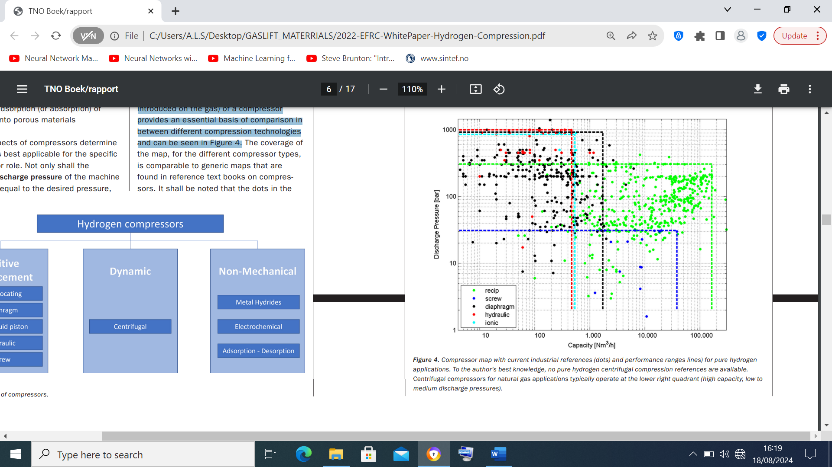
Figure 2: Compressor map with current industrial references (dots) and performance ranges (lines) for pure hydrogen applications [10] (EFRC, 2022)

Zabrzeski et al. [11], in their study of a hydrogen-natural gas mixture compression transporting through high pressure gas pipelines, showed that the greater the distance, the greater the difference between the required compression ratio for varying hydrogen-natural gas mixtures, and significant power requirement can be obtained from a small amount of hydrogen.
To assure steady supply at periods of lower production, hydrogen gas is stored in various media. High-pressure hydrogen storage tanks (typically in the range of 350–700 bar to enable a larger amount of hydrogen to be stored in a smaller volume) are expected at different scales at several locations, both onshore and offshore [12]. For a larger capacity and on longer time period, salt caverns are currently prepared as underground hydrogen storage sites, with expected discharge pressures of up to 200 bara.
Relevant standards for pure hydrogen transportation pipelines have been given by many countries; for example, ASME B31.12–2019 [13], CGAG-5.6-2005 - revised in 2013 [14], AIGA 033/06–2006 [15]. Many of these standards covers aspects of design, construction, operation, and maintenance of long-distance piping, sub-piping, and service piping systems of transportation of hydrogen, hydrogen mixtures, and liquid hydrogen (with volume fraction of less than 10 %) from the manufacturing plant to the place of use. Existing natural gas transmission network can be used but issues such as; increase of corrosivity of pipes caused by the presence of hydrogen or its increased emissivity compared to natural gas components [16], need to be managed. However, studies have shown that the maximum amount of hydrogen that will not significantly affect transport safety and use of the entire mixture is 10% ([17], 20-30% [18, 19] and even 50% or more [20] depending on the criteria taken into account.
Hydrogen deblending is the reverse process of blending and allows to extract pure hydrogen for specific uses. Techniques such as pressure swing adsorption, membranes and sieves are the most potential ones for deblending process. The deblending efficiency depends on the hydrogen concentration in methane but several other important factors have to be considered when choosing the most suitable technology, such as permeability, selectivity, stability of the membrane material, etc [21].
Hydrogen has been in our economy for decades now, and its use is expanding into various sectors of our economy because of its physio-chemical properties. For instance, hydrogen is an essential raw material for many industrial processes such as; fertiliser manufacturing, metal production and methanol production. Hydrogen can also be used as fuel for space rockets and vehicles. It can also serve as an energy carrier. Sakthivel [22] presented some of main applications of hydrogen. Figure 3 shows a schematic of a hydrogen-natural gas lift system, considering a water electrolytic hydrogen gas production.

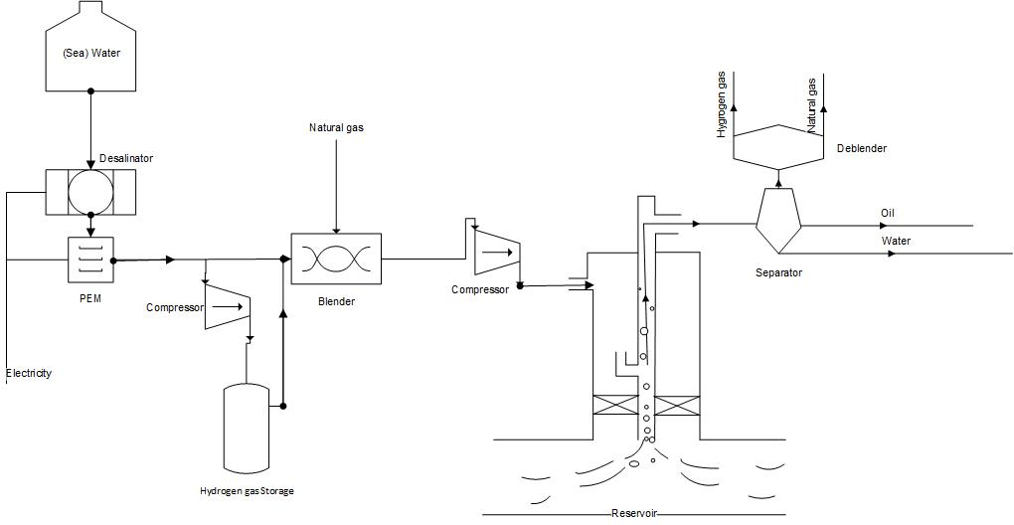
Figure 3: schematic of a hydrogen-natural gas lift system, considering a water electrolytic hydrogen gas production

2.0 Potentials of gas lifting oil wells with hydrogen gas
Gas lift is among the most widely used artificial lift methods to increase oil production from matured fields. High pressure gas is injected into the tubing, through the annulus at a valve operating point or injection orifice, and mixes with the produced fluid from the reservoir resulting in increase in production due to reduction of the fluid mixture density and hydrostatic pressure. Among the gases commonly used for gas lifting are natural gas, nitrogen, and carbon dioxide. Each gas possesses distinct characteristics that influence its suitability for different reservoir conditions and production objectives. For example, in regions like the Permian Basin in Texas, Niger Delta, Middle East, where natural gas is abundant, natural gas lift operations are commonly used due to its cost-effectiveness and operational efficiency [23]; in offshore operations such as those in the North Sea, where wells encounter high GOR or have corrosive gases, nitrogen gas lift operations to mitigate corrosion risks and enhance lifting efficiency are common [24]; in regions, where CO₂ (which can be sourced from industrial processes, natural reservoirs, or flue gas capture, offering potential environmental benefits [25] injection is part of EOR strategies, CO₂ gas lift operations are also employed.
All these conventional gas lift gases can be aided with chemicals to improve the productivity of wells. The foam (chemical) reduces the slippage between gas and liquid phases resulting in improved liquid lifting capacity of the gas lift system. Reported field trials [26, 27] have shown improved production.
With the pressing need for the oil and gas sector to align with global sustainable goals, particularly during the transition to a net-zero carbon future, several technologies that are both efficient and environmentally sustainable to improve hydrocarbon productions are currently being explored and implemented. Thus, the technical aspect of this work involves the investigation of the potentials of hydrogen gas for lifting oil wells, using a production system software. The modeled oil well under study is located in a matured oil field in the Niger Delta region of Nigeria.

2.1 Description of the oil well case
Well-X with 3 ½" production tubing, in an onshore FENE field in the Niger Delta, has experienced natural gas lift for years, and recently a foam-assisted gas lift trial was carried out. Recent well test Pre-deployment of foam-assisted gas lift showed that the oil production is approximately 500 bopd and average GOR of 715 scf/bbl. The foam-assisted gas lift field trial resulted in 280 bopd incremental net oil gain and a cumulative gain of 2510 bbls of oil over the 9-day trial period. Details can be found in Felix et al. [27]. A summary of relevant data of the Well-X is presented in Table 1.
2.2 Hydrogen – Natural Gas lift well Performance Simulation
A commercial production system simulator (through nodal analysis that considers the steady state relationship between pressure drop and flow rate) was used to model the Well-X performance for 100 % natural gas lift scenario and a range of mixtures (10 – 90 %) of hydrogen-natural gas lift cases. The mixture density was calculated using Equation 1:
$$ρ_{m}={λ_{H_{2}}ρ}_{H_{2}}+λ_{{CH}_{4}}ρ_{{CH}_{4}}$$ | (1)
where, $ρ_{m}$ is the mixture density. $λ_{H_{2}}$, $λ_{{CH}_{4}}$ are fractions of the hydrogen and natural gases, respectively, and $ρ_{H_{2}}$, $ρ_{{CH}_{4}}$ are densities (lb/ft³) of the hydrogen and natural gases, respectively.
The steps taken for the gas lift well performance simulation are as follows: the fluid was described using black oil [28], the inflow performance relationship - IPR) and flow up the tubing to the tubing head (vertical lift performance - VLP) were modeled using Darcy inflow related equation and pressure gradient correlations that combines flow regime and hold predictions.

2.2 Simulation results of the Hydrogen-Natural Gas lift well
The gas lifted well was modelled to match the production data from the test conducted on Well-X pre-foam assisted gas lift field trial on the well; three vertical lift correlations were investigated: Mukerjee and Brill [29]; Hagedorn and Brown [30], and a recent pressure gradient correlation (in this work, term ‘in-house’) developed with multiphase flow experimental data obtained from various oil densities and viscosities, and pipe sizes. Figure 4 shows the predicted oil rate from the well performance analysis of both a natural gas lift (i.e 0 % hydrogen gas) and a 10 % hydrogen gas blend for the different vertical lift correlations considered in the study. The in-house VL model predicted the oil rate from the well test with a 1.67 % error, while Mukerjee-Brill and Hagedorn-Brown predicted the oil rate with approximate error of 17.8 % and – 11 %, respectively. Therefore, further analysis of the well performance was carried out using the in-house VL correlation.
Figure 4: Oil rate predictions, with the vertical lift (VL) correlations

Figure 5 presents the predicted oil rates (and the incremental oil rate) for various percentage of hydrogen-natural gas blends, with a gas injection rate of 0.30 MMscf/d. There was increase in oil production rate, as the amount of hydrogen gas in the blend increases. The injected hydrogen-natural gas blend has a reduced density and lightens the fluid column more than that of a 100% natural gas. The increase in oil rate is small (10–22 stb/d) compared to the 280 bbl/d observed in the foam-assisted gas lift field trial. The foam-assisted gas lift performs dual functions – lightening the fluid column and reducing water production.
Figure 5: Oil rates (and the incremental oil rate) for varying hydrogen-natural gas blends, with a gas injection rate of 0.30 MMscf/d.

Further simulations on injection rates, under various gas-oil (GOR) ratio and hydrogen-natural gas blends, show that oil rate increment can be improved when the high-pressure injection gas can be at the optimum level. From Fig. 6, for 0 – 10 % hydrogen gas blends and GOR of 600 – 700 scf/bbl considering a 76.4 % water cut, the oil rate increment is quite significant (from less than 11 stb/d of the base case to as high as 220 stb/d for the 0.35 MMscf/d of injected gas) as the injection rate increases toward the optimum level. However, thorough analysis of the results shows that, there is still no more increase in oil rate beyond the 10 to 22 stb/d mark, observed with the 0.3 MMscf/d gas injected, for various hydrogen-natural blends.
Figure 6: Oil rate increment for varying GOR and hydrogen-natural gas blends, with gas injection rate of 0.4 MMscf/d

2.3 Economics of Hydrogen-Natural gas lift scenario
A simplified economic evaluation was carried out to assess the investment of using hydrogen-natural gas lift to increase oil production. Costs such as (green) hydrogen gas production from water electrolysis and cost of gas injected are considered. But primary operational costs (e.g compression cost and deblending cost) are excluded. The cost of hydrogen gas and natural gas injected are estimated using Equation 2 and 3, respectively.
$$C_{H_{2}}=\left(λ_{H_{2}}\right)*\left(Q_{inj},\frac{scf}{d}\right)*\left({PC}_{H_{2}},\frac{\$}{lb}\right)*{(ρ}_{H_{2}}, \frac{lb}{{ft}^{3}})$$ | (2)

$$C_{{CH}_{4}}=\left(λ_{{CH}_{4}}\right)*\left(Q_{inj},\frac{scf}{d}\right)*P_{{CH}_{4}}(\frac{\$}{scf})$$ | (3)

where, $C_{H_{2}}$, $C_{{CH}_{4}}$, are estimated cost of Hydrogen gas and natural gas injected, $, respectively; $Q_{inj}$, injected gas rate, $\frac{scf}{d}$; ${PC}_{H_{2}}$, hydrogen gas production cost, $\frac{\$}{lb}$; $P_{{CH}_{4}}$, price of natural gas, $\frac{\$}{scf}$; $ρ_{H_{2}}$, hydrogen gas density, $\frac{lb}{{ft}^{3}}$; $λ_{H_{2}}$ and $λ_{{CH}_{4}}$ are input fractions of hydrogen and natural gas injected.
The revenue was calculated using the incremental oil production rate, and considering current oil price of $78.62/barrel for Bonny light (oilprice.com), but revenue from sale of the produced gas is not included in the analysis. Table 2 provides an overview of the assumptions, together with information sources and comments, adopted in the economic analysis. A gas lift system lifetime of 1 years has been assumed. Since discount rates of hydrogen production systems usually in the range of 5 to 8% [31], and the discount rate typically used in the oil and gas industry, most especially by local producers, is 10 %, we have performed a discounted cash flow analysis between 5 and 25%.

2.3.1 Economic results
Figure 7 shows the net present value (NPV) of the hydrogen-natural gas lift cases studied for injection rates of 0.3 MMscf/d (base case) and 0.4 MMscf/d, with gas mixture ratios of 10 %, 20 %, and 30 %. The secondary y-axis represents negative NPV values (in thousands of dollars) of all cases for gas injection rate of 0.3 MMscf/d. Under this gas injection rate, the gas lift approach, irrespective of the mixture ratio, is not profitable. The figure also shows positive NPV values for the 0.4 MMscf/d with varying gas mixture ratios. All cases give NPV values above $ 6 Millions at 10 % discount rate; indicating a tremendous profit for a year. This also shows how a gas lift injection rate variation of 0.05 MMscf/d can change an unprofitable gas lift system to a rewarding production strategy. However, the 30 % hydrogen-natural gas lift case has the least positive NPV values due to the high electrolytic hydrogen production costs of $1.11 per kg considered. Once, there is material efficiency in PEM electrolysers to reduce green hydrogen gas production, gas-lifting with hydrogen-natural gas strategies may be lucrative.

Figure 7: Net present value (NPV) of the hydrogen-natural gas lift cases studied

3. CONCLUSION
This paper discussed briefly the production, transportation, compression, storage, deblending and usage of hydrogen gas. It also presented simplified well performance evaluation on the potential of applying hydrogen gas for gas lifting oil wells, considering WELL-X data in the Niger Delta. A commercial production system simulator (through nodal analysis that considers the steady state relationship between pressure drop and flow rate) was used to model the Well-X performance for 100 % natural gas lift scenario and a range of mixtures (10 – 90 %) of hydrogen-natural gas lift cases. For a gas injection rate of 0.3 MMscf/d, the oil rate increment between 10 and 22 stb/d was obtained for various hydrogen-natural blends., which was insignificant when compared to the reported 280 bbls/d oil rate increment of the foam-assisted gas lift field trial. Further simulations on injection rates, under various gas-oil (GOR) ratio and hydrogen-natural gas blends, showed that oil rate increment can be improved when the high-pressure injection gas can be at the optimum level. In summary, the results showed that gas injection rate, irrespective of the hydrogen-natural gas mixture, greatly influence the profitability of the production strategy.
The simplified economic analysis carried out showed that, under the 0.3 MMscf/d injection rate, the gas-lift project is unprofitable, a negative NPV values running into thousands of dollars. While, with the injection rate of 0.4 MMscf/d, the NPV value was over $ 6 Millions considering discount rate of 10 %. The hydrogen-natural gas blends did not improve the profitability of the gas lift project due to the current high electrolytic hydrogen production.

COMPETING INTERESTS DISCLAIMER:
Authors have declared that they have no known competing financial interests OR non-financial interests OR personal relationships that could have appeared to influence the work reported in this paper.

Disclaimer (Artificial intelligence)
Author(s) hereby declare that NO generative AI technologies such as Large Language Models (ChatGPT, COPILOT, etc.) and text-to-image generators have been used during the writing or editing of this manuscript.

REFERENCE
[1] Züettel, A. Hydrogen storage methods. Naturwissenschaften 91, 157–172, (2004).
[2] Messaoudani, Z.I., Rigas, F., Binti Hamid, M.D., Che Hassan, C.R. Hazards, safety and knowledge gaps on hydrogen transmission via natural gas grid: a critical review, Int. J. Hydrogen Energy 41 (2016) 17511–17525.
[3] Godula-Jopek, A. Hydrogen production: by electrolysis. Ed. 1. Wiley-VCH Verlag GmbH & Co. KgaA, Germany (2015).
[4] Hydrogen Fuel Cell Engines and Related Technologies: Rev 0, December 2001.
[5] Rissman, J., Bataille, C., Masanet, E., Aden, N., Morrow III, W.R., Zhou, N., Elliott, N., Dell, R., Heeren, N. and B. Huckestein, B. et al. (2020). Technologies and policies to decarbonise global industry: Review and assessment of mitigation drivers through 2070. Appl. Energy, (2020), 266, 114848.
[6] Bauer, C., Heck, T., Schneider, S., Sanjaykumar, H., Terlouw, T., Treyer K., and Zhang, X., Electricity storage and hydrogen: Technologies, costs and environmental burdens, PSI, Paul Scherrer Institut technical report, (2021).
[7] Collins, L. Green hydrogen cheaper than unabated fossil-fuel H₂ by 2030: hydrogen council. Recharge. London, UK (2020).
[8] Terlouw, T., Bauer, C., McKenna R. and Marco Mazzotti M. Large-scale hydrogen production via water electrolysis: a techno-economic and environmental assessment, Energy Environ. Sci., (2022), 15, 3583:
[9] Akhtar, M. S. Selection and optimization of centrifugal compressors for oil and gas applications (2002) GPA Europe Spring Meeting; Bergen, Norway
[10] Hydrogen applications (EFRC, 2022)
[11] Zabrzeski L., Janusz, P., Liszka, K., Laciak, M. and Szurlej, A. Hydrogen-natural gas mixture compression transporting through high pressure gas pipelines; IOP Conf. Ser.: Earth Environ. Sci. 214 012137 (2019).
[12] Sdanghi, G., Maranzana, G., Celzard, A., and Fierro V. Towards Non-Mechanical Hybrid Hydrogen Compression for Decentralized Hydrogen Facilities. Energies, 13 (12) (2020).
[13] ASME B31.12–2019. Hydrogen Piping and Pipelines. American Society of Mechanical Engineers (2019).
[14] CGAG-5.6-2005. Hydrogen Pipeline Systems. Revised (2013). Compressed Gas Association, Inc. (2005).
[15] AIGA 033/06. Hydrogen Pipeline Systems. Asia Industrial Gases Association (2014).
[16] Dodds P.E., and Demoullin S. Conversion of the UK gas system to transport hydrogen International Journal of Hydrogen Energy (2013), 38, 7, 189-200.
[17] Klaus, A. and Pinchbeck, D. Admissible hydrogen concentrations in natural gas systems Gas for energy (2013) 3.
[18] Kippers, M. J., de Laat, J. C. and Hermkens, R. J. M. Pilot project on hydrogen injection in natural gas on Island of Ameland in the Netherlands, International Gas Union Research Conference, Seoul (2011).
[19] International Energy Agency. PH4/24: Reduction of CO₂ emissions by adding hydrogen to natural gas (2003).
[20] De Vries, H., Florisson, O. and Tiekstra, G. C. Safe operation of natural gas appliances fueled with hydrogen/natural gas mictures (progress obtained in the NATURLHY-project) International Conference on Hydrogen Safety (2007).
[21] Gas Infrastructure Europe (2021). How to transport and store Hydrogen - facts and figure.
[22] Sakthivel, S. Hydrogen economy offers low-emissions fuel to combat air pollution. Gulf Energy, (2021) Houston, TX, US.
[23] Johnson, B. (2020). Gas Lift in the Permian Basin.
[24] Davies, P., Osman, H., and Vasquez, F.. Managing the impact of high GOR gas lift in mature North Sea wells. Offshore Europe Conference & Exhibition. SPE-181632-MS, (2016).
[25] Brown, A., and White, B. Carbon Dioxide (CO₂) Enhanced Oil Recovery (EOR) (2019) (Vol. 1). Elsevier.

[26] Farag A. and Robertson, T., Nederlandse Aardolie Maatschappij B.V; M. Kerem, M. Foam Assist in a Gas-Lifted Oil Well, Paper SPE-184217- MS, presented at the SPE Middle East Artificial Lift Conference and Exhibition held in Manama, Kingdom of Bahrain, 30 Nov.-1 Dec. 2016.

[27] Okoro, F., Arochukwu, E., Abuah, N., Marcus, I., Nnanna, E., Onuigbo-Nweze, C., and Iheanyi Eke I. A Successful Foam Assisted Gas Lift Trial in a Matured Niger Delta Field; SPE-217208-MS Paper presented at the SPE Nigeria Annual International Conference and Exhibition held in Lagos, Nigeria 31 Jul. - 2 Aug. 2023.

[28] Whitson, C.H. and Brulé, M.R. Phase Behavior. SPE Monograph Series 20. (2000) Richardson, TX: SPE
[29] Mukherjee, H. And Brill, J.P. Pressure Drop Correlations for Inclined Two-Phase Flow. ASME Journal of Energy Resources Technology (1985b) 107 (4): 549-554.
[30] Hagedorn, A.R. and Brown, K.E. Experimental Study of Pressure Gradients occuring during Continuous Two-Phase Flow in Small Diameter Vertical Conduits. J Pet Technol: (1965) 475-484. SPE 940-PA.
[31] Christensen, A. International Council on Clean Transportation, Washington, DC, USA, 2020, pp. 1–73.
[32] HenryHub, 29/08/24), www.eia.gov
[33] Oilprice.com; www.oilprice.com

TABLE 1: SUMMARY OF DATA FOR WELL-X
Properties | Values
Injection depth (ft) | 3013
Tubing diameter (inches) and depth(ft) | 3.5 and 5484
Tubing diameter (inches) and depth (ft) | 2 7/8 and 5491-5571
Sand control | Internal gravel pack
Average water cut | 76.4%
Ave. Liquid rate before foam-gas injection from well test (b/d) | 2544
Ave. Net oil (bopd) | 597
Ave. GOR (SCF/BBL) | 715
Ave. Flowing tubing head pressure (psig) | 105
Gas lift rate (MMscf/d) | 0.302
THP (psig) | 105
Casing size | 7-inches
Casing depth (ft) | 5760
Packer depth (ft) | 5484
Reservoir Temp. oF | 145
Reservoir thickness ft | 28
Reservoir porosity | 0.23
Reservoir Permeability mD | 896
Oil gravity API | 25
Oil FVF Bo | 1.15
Oil viscosity cP | 1.2
Inj gas specific gravity | 0.7
Post - Foam assisted | Results
Foam dosage (l/d) | 805
Foam dosage (ppm) | 2000
BS&W | 67%
Net Oil (bopd) | 815
Gross rate (b/d) | 2528

Table 2: Summary of information economic variables and values, assumptions and sources
Variables | Values |  |  |  |  |  | Source/comments
 | Base Case |  |  | Case 1
Gas Injection Rate (MMscf/d) | 0.3 | 0.3 | 0.3 | 0.4 | 0.4 | 0.4 | Simulated conditions
Hydrogen -natural gas blend (%) | 10 | 20 | 30 | 10 | 20 | 30 | Simulated conditions
Cost of Hydrogen gas production ($/lb) | 0.503 | 0.503 | 0.503 | 0.503 | 0.503 | 0.503 | Source: [8] Tom et al. (2022) (3.7 Euro per kg ($1.11/kg==$0.503/lb))
Cost of Hydrogen gas injected per day ($) | 950.67 | 1901.34 | 2852.01 | 1267.56 | 2535.12 | 3802.68 | Equation 2
Cost of natural gas injected per day ($) | 731.7000 | 650.4 | 569.1 | 975.6 | 867.2 | 758.8 | Equation 3; (using Natural gas price of $2.17/MMBTU==$2.17/1000 scf) [32] Source: HenryHub, 29/08/24)
Total cost of the injected gas per day ($) | 1682.37 | 2551.74 | 3421.11 | 2243.16 | 3402.32 | 4561.48 | Summation of results from Equation 2 and 3
Total cost of the injected gas per year ($) | 614065.05 | 931385.1 | 1248705.15 | 818753.4 | 1241846.8 | 1664940.2 | Calculated
Operational cost (e.g compression cost, deblending cost) | Not considered | Not considered | Not considered | Not considered | Not considered | Not considered | Not considered
Incremental produced oil per day (stb/d) | 11.2664 | 12.6352 | 13.9332 | 294.8676 | 294.018 | 292.1536 | Simulated results
Incremental produced oil sale per day ($) | 885.764368 | 993.3794 | 1095.428 | 23182.49 | 23115.7 | 22969.12 | [33] Oilprice.com; Bonny light ($78.62/bbl)
Gas lift System lifetime (year) | 1 | 1 | 1 | 1 | 1 | 1 | Economic assumption
Oil cumulative Sale per year ($) | 323303.9943 | 362583.48 | 399831.22 | 8461608.9 | 8437231 | 8383729 | Calculated
Sale of natural gas (Revenue) | Not considered | Not considered | Not considered | Not considered | Not considered | Not considered | Not considered
Discount rate (%) | 5 – 25 | 5 - 25 | 5 - 25 | 5 - 25 | 5 - 25 | 5 - 25 | Economic assumption
NPV

