Original Research Article
Protection Challenges of PV Integration in the Cameroon Southern Interconnected Power Network

ABSTRACT

Integrating photovoltaic energy into existing electricity grids has become a common practice in the recent decades. However this interconnection must be carefully planned in order to avoid their adverse impacts on the network operations. The aim of this study was to investigate the impacts photovoltaic (PV) integration may have on the protection of the Southern Interconnected Network (SIN) of Cameroon. In first time generalized fault study simulations were conducted for both three and single phase faults. Battery energy storage systems (BESS) were added to each of three PV plants connected to the network, and then monitors were used to identify contribution of each component to the network fault currents. Impacts of PV on fuse, relay, and recloser operations were also assessed. Simulation results showed both decreases and increases in fault currents at different buses during generalised faults studies, but the differences were more severe with the single line to ground faults. The above findings are useful when calculating protective devices ratings in case of PV integration. Contributions of 683.694 A and 259.498 A from both the PV plant and the BESS at B15NGOUS1 bus respectively were recorded. There were also contributions of 42.274 A and 23.428 A to the fault currents from PV plants at B15BASS21 and B10ALU buses respectively while their corresponding BESSs rather take 10.289 A and 6.448 A in that order. The simulations results also showed that PV integration increases the fault critical clearing time by 0.444 seconds and 13.728 seconds for fuse and relay respectively, while there was no impact on fault clearing time in the case of recloser. From the findings it is obvious that PV integration into the SIN may affect the network protection arrangements by changing both fault currents and clearing time. Therefore, it is highly recommended to consider protection upgrades especially fuses and relays when planning PV integration into existing grids in general and into the SIN particularly.

Keywords: Photovoltaic integration, storage systems, generalized fault study, protection arrangement

1. INTRODUCTION

“Network protection is one of operation aspects that is affected by PV integration. When a PV installation is located far away from a substation with loads between them, the power can flow in opposite directions from the two sources toward the loads. Power flow can change direction in distribution power systems when the PV generation is larger than local consumption” [1], [2]. “Back-feeding occurs when PV generation on a feeder exceeds feeder demand and losses and the excess power flows into parallel feeders through a substation bus or flows out of the substation. This can occur when PV penetration is high during low-load periods. As the penetration level increases, back-feeding occurs more often and at a higher loading level” [1]. “The major problem when integrating distributed generators into the distribution power grid is that the distribution systems are designed as radial networks, delivering the power in a unidirectional way. The coordinated operation of circuit breakers with overcurrent relays, reclosers, and fuses to protect this unidirectional radial power grid from both temporary and permanent faults has been well established. However, with a high penetration of distributed generators, new multisource network become active, and the conventional protection setup becomes unsuitable for such a scenario” [3]. “Modification in fault current level, reduction in reach of impedance relays, sympathetic tripping, islanding, and loss of protection coordination are the key protection issues introduced by PV integration” [2], [3], [4].
“Cameroon is looking forward to implementing a solar PV electrification of some cities under a program named Cameroon 2020 Photovoltaic Power Project. Cameroon 2020 Photovoltaic Power Project targets standalone rural villages as well as grid-connected urban underserved populations. In the Cameroon 2020 Photovoltaic Power Project initiative the government targets to develop 500 MW of installed PV capacity throughout the country in future” [5]. For a proper implementation technical feasibility studies are required including on the potential impacts and changes in protection systems. This research aim was to identify the impacts PV integration may have on the protection arrangements of the Southern Interconnected Network of Cameroon. The research will provide the Cameroonian energy stakeholders with insights of necessary considerations to maintain sure network protection while bringing in PV systems. Although several current studies pay more attention on developed grids, this manuscript presents an insight from the Cameroonian Southern Interconnected Network, offering valuable background for similar systems in sub-Saharan Africa and other developing economies.

2. literature review

2.1 Background
Considering the impacts of PV integration on the protection of the hosting network is a shared recommendation from many researchers that worked on different case studies. Studies show that a lot of issues regarding protection operations come with PV integration, among others we can mention; reverse power flow, islanding, protective devices failures etc.[6], [7]

2.2 Overview of protection issues related to PV integration
As illustrated by [2][3] modifications in fault current occur when inverter interfaced DG units are used in a grid by limiting the fault current to a lower value. As fault current is not too high as compared to load current some of the relays do not trip, and those that respond to fault operate with time delay. The undetected fault spreads out in the system and can damage the equipment. Fault impedance also decreases when DG is connected into network in parallel with the other devices. When faults occurs downstream of the point of common coupling, both the main source and DG contribute to fault current. Relays placed at upstream of DG measure fault current supplied by upstream source. The authors also show the impact of DG integration on the reduction in reach of impedance relays, which is the maximum fault distance that triggers the relay in a certain impedance zone or in a certain time because of its configuration. It was proved that when faults occur downstream of the bus with DG connected to the utility network, impedance measured by the relay located in upstream is higher than real fault impedance. This affects grading of relays and causes delayed operation or sometimes relay does not operate at all. Another protection problem with DG as identified by authors [2], [4], is what is called sympathetic tripping which is defined as a condition which could occur when a protection breaker trips for faults in adjacent feeders. The authors show that the addition of distributed generators within a distribution network implies a protection problem, since it will cause higher fault levels and sympathetic tripping due to power flow and fault current now becoming bi-directional.
Islanding was identified by the authors [2] as another protection issue related to DG integration into the grid. Islanding occurs when PV generation continues to send power to a port of the power system that has been separated from the utility grid after a fault occurred. Typically, this is not desirable because an island can cause safety issues for maintenance crews. In addition, power quality can deteriorate because the system voltage and frequency are no longer available [1][3]. If a DG continues to supply power despite the disconnection of utility, the fault might persist as it is fed by DG.
Another protection issue that was identified by the authors [4] is the loss of coordination between automatic re-closer and fuses. Re-closers are frequently used to clear transient faults, while fuses are used to clear permanent faults. This is typically used on medium voltage overhead lines where transient faults due to falling branches or lightning occurs frequently. The authors demonstrated that with the addition of PV between a re-closer and the fuse, during a fault F2, the fuse will see more fault current due to the additional fault current contributed by PV. The current seen by the re-closer will be I (fault-grid) and the current seen by the fuse will be I (fault-total). This will cause for a transient fault, the fuse to blow before even the fast curve of the re-closer could clear the fault and coordination between the re-closer and the fuse is lost.
The authors [8] used digital simulation and electrical network (DIgSILENT) and other software to analyse power system stability with different perspectives. Various scenarios of PV system integration into the grid were considered and simulations were successfully run for power system stability analysis. [8] for instance making use of a well-known IEEE-9 bus power system, that they modified by adding a PV plant in DIgSILENT Powerfactory environment, they performed an impact of PV integration analysis. Three different transient cases i.e. load and line disconnections, as well as a 3-phase short circuit fault were considered. In all cases, two sub-cases were considered to assess the impact of PV system location on the power system stability. Different Control Options (DCO) was considered for proper PV integration into the grid. Among the obtained results of the studied cases the one concerning the impact on fault situation are summarized below. In 3-phase short circuit case, it was observed that DCO show similar responses according to the location of the fault. However, if the fault location is close to the PV plant, the voltage on Bus- 9 drops more. It was concluded that the reactive power generation of the PV plant is increased more in remote fault (Bus-5) case.
A. Saif in [9] used Simulink to model a multi-machine system for transient stability analysis. Power system modelling considerations were discussed in details and different simulations were performed for validation. The system chosen for the study is a Three Machine, Nine nodes and Six lines system. The disturbance initiating the transient is a three phase fault occurring near bus 7 at the end of line 5–7. The fault is cleared by opening line 5–7. The report provides useful information about multi-machine power system modelling for stability purposes.
Studies on protection issues related to PV integration into existing grids as well as development of mitigation techniques have been worked on by researchers in the recent decades.[10], [11][12]

3. methodology
For the purpose of the study on the potential impacts PV and battery storage system integration may have on the SIN protection, the network was first modelled in OpenDSS software and three types of protective devices namely fuse, recloser, and relay were considered alternatively for simulations. Different fault scenarios were considered for dynamic simulations and the impacts of both PV and BESS identified. The following scenarios were taken into account during the simulations in OpenDSS software:
Scenario 1: Generalised three phases and single phase to ground faults are at different times automatically placed at each bus of the network without PV, and then dynamic simulations run to check all fault currents.
Scenario 2: Generalised three phases and single phase to ground faults are at different times automatically placed at each bus of the network with PV, and then dynamic simulations run to check all fault currents.
Scenario 3: a three phase fault was introduced at bus B15NGOUS1and a monitor (M1) at line B4 which links B15NGOUS1 and B15NGOUS2 buses to record fault current for this particular line without PV.
Scenario 4: a three phase fault was introduced at bus B15NGOUS1and a monitor (M1) at line B4 which links B15NGOUS1 and B15NGOUS2 buses to record fault current for this particular line with PV systems at B1OALU, B15BASS21, and B15NGOUS1 buses.
Scenario 5: Battery energy storage is added to each of the PV systems in scenario 4, and separate monitors for each PV system and each BESS was used to identify their respective contributions to the fault current.
Scenario 6: fuse, recloser, and relay were considered one by one at the B15NGOUS1 bus, and then dynamic simulations run for the network with PV but no fault, with fault but no PV, and with both fault and PV cases.
Figure 1 shows the flowchart of the simulations for PV impacts on the network protection.
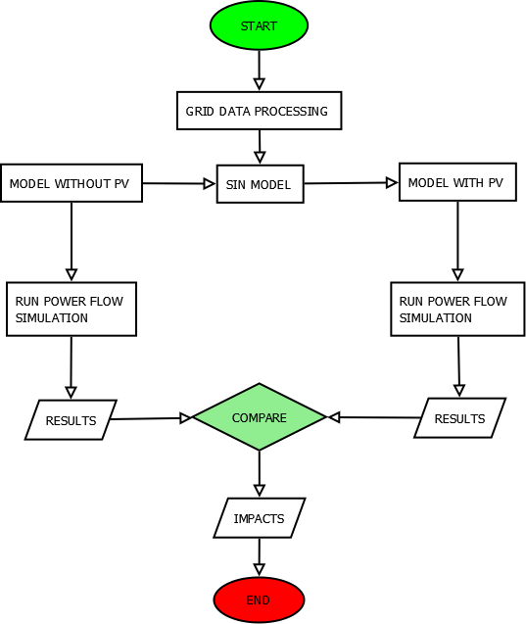
Fig. 1. Flowchart of the simulations
4. results and discussion

4.1 Impact of PV on three phase fault currents at different buses of the SIN
The simulation results for fault currents at the various buses (scenario 1) are shown in Fig.2a and Fig. 2b, for both the transmission and distribution buses respectively. The significance of this generalized fault study was to know if PV interconnection may affect the fault current at each bus and therefore implying any upgrade of the protection devices there. As it can be seen from Fig. 1a and Fig. 1b, with PV plants at three locations in the distribution network the impacts on fault currents are diverse. From the results it is obvious that there are some increases in fault currents at certain buses and decreases at others. As shown by the figures fault currents increases appear mostly for transmission buses while most decreases are obtained at the distribution buses. Different factors justify diversity in PV impact on fault currents; among others PV locations in the distribution network supply opposite currents to the initial one mostly in distribution network therefore causing decreases in the fault currents. In some cases the impacts are not much noticeable and this may change with the amount of PV integrated into the network.

Fig. 2 a. Transmission buses fault currents with and without PV.

Fig. 2b. Distribution buses fault currents with and without PV.

4.2 Impact of PV on single phase to ground fault currents at different buses of the SIN
Figures 3a and 3b show the fault currents comparisons for both transmission and distribution buses for case scenario 2.

Fig. 3 a. Transmission buses single line to ground fault current with and without PV.

Fig. 3b. Distribution buses single line to ground fault current with and without PV.
Like for three-phase generalized fault study the impact of PV integration on fault currents at the various buses in diverse but with bigger differences. As shown in Fig. 3a and Fig. 3b there are some very big differences in fault currents levels with and without PV. Unlike the three phase faults that completely shut some network paths, in case of single phase to ground faults all the paths of the network remain in connections and therefore allowing very high fault currents to be supplied from different sources. From these generalized fault studies it is important to consider protection upgrade when planning PV integration.

4.3 Impact of PV on three phase fault current for the B4 line
The simulation results of scenario 3 and 4 for both no PV and with three 10 MW PV plants at different locations in distribution network are shown in Fig. 4a and Fig. 4b.
This is an isolated case for deep evaluation of the impact of PV integration on fault current. From results presented in the figures the integration of PV at three locations in the distribution network caused some slight increase in the three-phase fault current. For the case of network without PV when the fault was introduced at 0.02 second the current changed from 62.5668 A to 6892.61 A, while for the network with PV the current passed from 418.535 A to 6893.98 A.
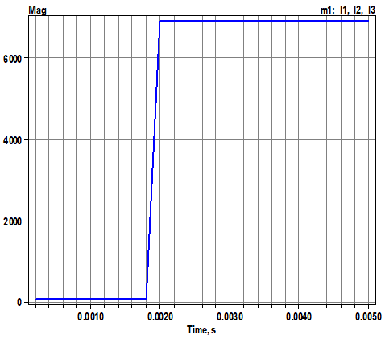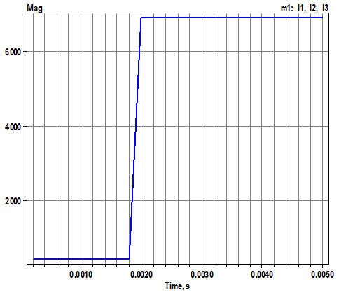
Fig. 4 a. Fault current without PV. Fig. 4b. Line current with 30MW PV.
From the above figures we can see a slight difference of 1.37 A in fault currents for the two scenarios; and this is because the shorted bus accommodates one of the three PV plants which limits its contribution to fault current in line B4. The slight difference is mostly supplied by the other two PV plants to this line B4.

4.4 Fault currents contributions of the PV plants and the BESSs
Results for fault currents contribution (scenario 5) of each component are presented in Fig. 5 a to f. The monitors’ readings on the contributions of differents PV plants and the corresponding BESSs on different fault currents in the grid as presented in Fig. 5(a-f) show how much these components impact the currents during fault conditions.
From Fig. 5(a), when the fault occurs the PV plant at B15NGOUS1 current contribution passes from 347.306 A to 1031 A which means a total of 683.694 A contribution to fault currents in the network, while its battery current changes from 483.8 A to 743.298 A to fault currents with fault currents contribution of 259.498 A.
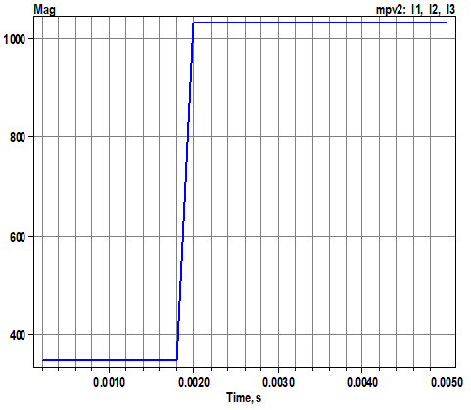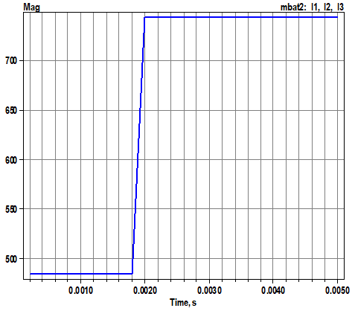
(a) contribution by PV at B15NGOUS1 (b) contribution by BESS at B15NGOUS1
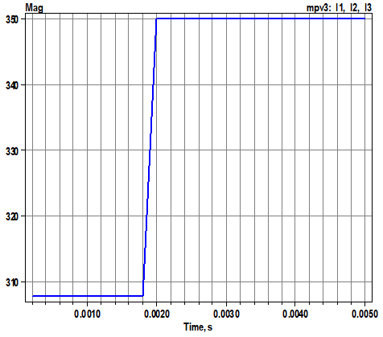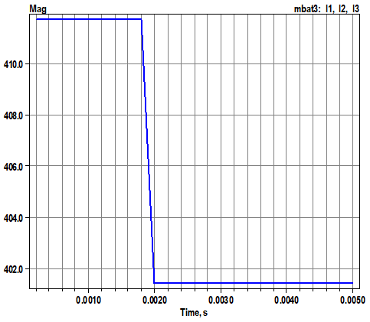
(c) contribution by PV at B15BASS21 (d) contribution by BESS at B15BASS21

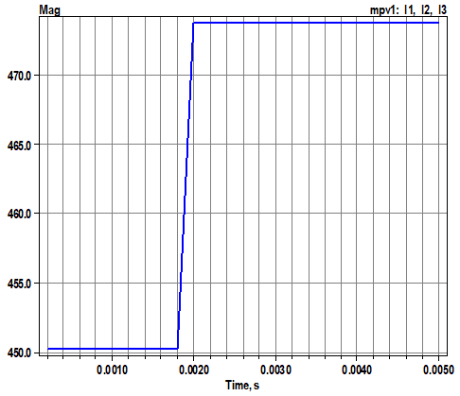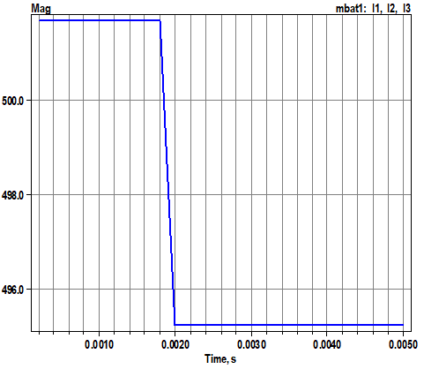
(e) contribution by PV at B10ALU (f) contribution by BESS at B10ALU
Fig. 5 (a, b, c, d, e, f): Contributions to the fault currents by PV plants and BESSs.

PV plant at B15BASS21 bus adds 42.274 A to the fault currents equivalent of variation from 307.714 A to 349.988 A of its current during fault. As for the PV plant at B10ALU, its current passed from 450.242 A to 473.67 A giving a contribution of 23.428 A to the network fault currents. As for the batteries at both B15BASS21 and B10ALU, they don’t give any significant contributions to the network fault currents as their currents are reduced by 10.289 A and 6.448 A respectively. The above results show high contributions to fault currents by both the PV palnt and BESS at B15NGOUS1, because this is the faulty bus and therefore these components see a very high demand there. For the BESSs at both B15BASS21 and B10ALU, they rather tend to charge during the fault conditions as they see high power supply from all over the network during the fault conditions.

4.5 Impact of PV on fuse operation
Simulations results of the impact of PV on the fuse fault clearing time are shown in Fig. 6a in comparison with those for no PV case in Fig. 6b.
The fuses were considered to carry up to 125% of the normal operation currents in line B4 for both the no PV and with PV scenarios. As shown in Fig. 6a, when a fault occurs at one second it took around 0.02 seconds for the fuse to clear the fault in the scenario of the network without PV.
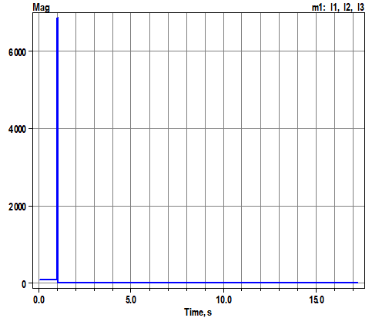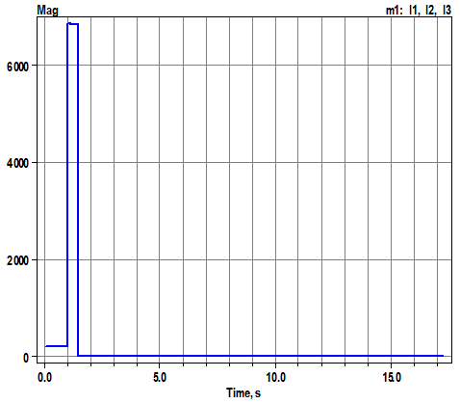
Fig. 6a. Fault clearing time without PV Fig. 5b. Fault clearing time with PV
In the scenario when the network has three PV plants in the distribution, when the fault occurred at one second it took around 0.464 seconds for the fuse to clear the fault as illustrated in Fig. 6b. comparing the two scenarios it is easy to see that PV integration increases the fault critical clearing time by 0.444 seconds, and this enormous time for the fault to cause damages.

4.6 Impact of PV on relay operation
Results for relay operation in case of a three phase fault are illustrated in Fig. 6a and Fig. 6b for no PV and with PV scenarios respectively.

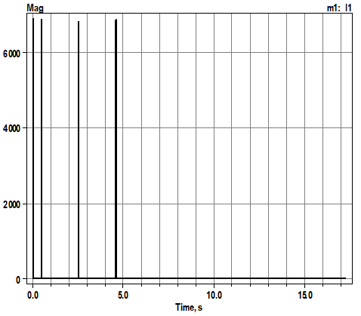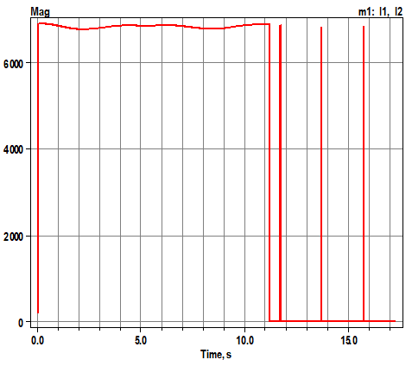
Fig. 6 a. Fault clearing time without PV Fig. 6 b. Fault clearing time with PV
Over-current relays were considered to operate at 125% of the normal operations currents in both no PV and with PV scenarios, and results are shown in Fig. 6a and Fig. 6b. the relays are set to perform three tripping tials before deciding whether to cut the current off if the fault persists. From relay tripping results for no PV case as presented in Fig. 6a, when a fault occurred at 0.002 second it took around 0.02 second for the relay to perform the first tripping trial followed by the other two separated by 2.044 seconds between them. The fault was completely cleared after 4.588 seconds. On the other side as shown in Fig. 6b, it took the relay around 11.212 seconds to perform the first tripping trial when the fault occurred in the network with three PV plants in distribution and a total of 15.772 seconds for the fault to completely cleared. The difference is too big between the two scenarios, and that is why relays must be looked at when planning PV integration into the network.

4.7 Impact of PV on recloser operation
The recloser three phase fault clearing operations in both no PV and with PV scenarios are shown in Fig. 7a and Fig. 7b respectively.
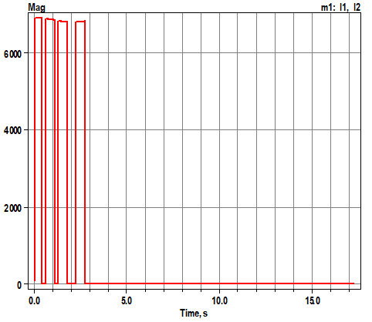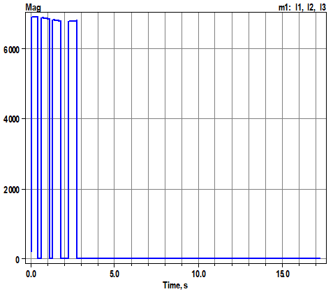
Fig. 7 a. Fault clearing time without PV Fig. 7b. Fault clearing time with PV
The results for reclosers operations in fault clearing for both no PV and with PV scenarios presented in Fig. 7a and Fig. 7b show that there are no differences in operation for the two cases. In both scenarios when a fault occurred at 0.002 seconds it took the reclosers that are set to perform three tripping trials a total of 2.754 seconds to clear the fault.

5. Conclusion and recommendations

An impact study of PV integration on the protection of the Southern Interconnected Network of Cameroon was successfully carried out. In first time generalized fault study simulations were conducted for both three and single phase faults. The aim of the above simulations was to evaluate how PV integration may affect the fault currents at different buses in the network which is important for protection planning in case of these interconnections. Both decreases and increases in fault currents at different buses were recorded but the differences were more severe with the single line to ground faults. The above findings are useful when calculating protective devices ratings in case of PV integration. Battery energy storage systems were added to each of three PV plants connected to the network, and then monitors were used to identify contribution of each component to the network fault currents. The results showed more contributions of 683.694 A and 259.498 A from both the PV plant at B15NGOUS1 bus and the BESS at the same bus respectively. These high contributions were justified by the fact that the bus in concern was the faulty one which makes a high demand from the two components there. There were also contributions of 42.274 A and 23.428 A to the fault currents from PV plants at B15BASS21 and B10ALU buses respectively while their corresponding BESSs rather take 10.289 A and 6.448 A in that order. During fault case high currents are drawn from different generators around the network, which make the BESSs tend to charge as if there is over production. Impacts of PV on fuse, relay, and recloser operations were also assessed. The simulations results showed that PV integration increases the fault critical clearing time by 0.444 seconds and 13.728 seconds for fuse and relay respectively, while there was no impact on fault clearing time in the case of recloser. From the findings of this research and in the framework of Cameroon 2020 initiative, it is recommended to the Cameroonian energy planners to consider upgrading the network protection arrangements especially fuses and relays before executing the PV integration projects. Considering other PV penetration level and considering advanced technologies such as Internet of Things for protection analysis are the areas for future research exploration.

AcknowledgEments

The authors would like to acknowledge the financial support from the European Union through a scholarship under the Mobility for Innovative Renewable Energy Technologies (MIRET).

DISCLAIMER (Artificial intelligence)
Author(s) hereby declare that NO generative AI technologies such as Large Language Models (ChatGPT, COPILOT, etc.) and text-to-image generators have been used during the writing or editing of this manuscript.

References

[1] K. Hao et al., “Mitigating the Impacts of Photovoltaics on the Power System,” in Power and Energy Automation Conference, Washington, 2017, pp. 1–10.
[2] P. Sudhakar, S. Malaji, and B. Sarvesh, “Protection issues of Power Systems with PV Systems Based Distributed Generation,” IOSR J. Electr. Electron. Eng., vol. 9, no. 3, pp. 18–27, 2014.
[3] B. Frede, Y. Yongheng, Y. Dongsheng, and W. Xiongfei, “Distributed Power-Generation Systems and Protection,” in Proceedings of The IEEE, 2017, pp. 1311–1331. doi: 10.1109/JPROC.2017.2696878.
[4] H. L. R. Van Der Walt, R. C. Bansal, and R. Naidoo, “PV based distributed generation power system protection : A review,” Renew. Energy Focus. ELSEVIER, vol. 24, no. 00, pp. 33–40, 2018. doi: 10.1016/j.ref.2017.12.002.
[5] D. K. Kidmo, K. Deli, and B. Bogno, “Status of renewable energy in Cameroon,” Renew. Energy Environ. Sustain., vol. 2, no. 6, pp. 1–11, 2021.
[6] M. Usama et al., “A comprehensive review on protection strategies to mitigate the impact of renewable energy sources on interconnected distribution networks,” IEEE Access, vol. 9, pp. 35740–35765, 2021. doi: 10.1109/ACCESS.2021.3061919.
[7] S. Rong and L. He, “Impact of Photovoltaic Generation Integration on Protection of Distribution Systems,” in Energy Proceedings, 2020, pp. 1–5. doi: 10.46855/energy-proceedings-7038.
[8] B. Çavdar, Ö. Akyazi, E. Sahin, and F. Nuroglu, “Voltage Stability Analysis of a Large Scale PV Plant for Different Control Options,” Sak. Univ. J. Sci. SAUJS, vol. 25, no. 64755, pp. 914–925, 2021. doi: 10.16984/saufenbilder.808343.
[9] A. Saif, “Simulation of Multi-Machine Transient Stability,” 2010.
[10] F. Alasali, A. S. Saidi, N. El-Naily, O. Alsmadi, M. Khaleel, and I. Ghirani, “Assessment of the impact of a 10-MW grid-tied solar system on the Libyan grid in terms of the power-protection system stability,” Clean Energy, vol. 7, no. 2, pp. 389–407, 2023. doi: 10.1093/ce/zkac084.
[11] F. Alasali et al., “The Performance and Robustness of Power Protection Schemes for Grid-Connected PV Systems Under Varied Smart Inverter Controllers,” Int. J. Energy Res., vol. 2024, pp. 1–29, 2024. doi: 10.1155/2024/6805410.
[12] Y. Liang et al., “A Current Selective Tripping Protection Scheme for the Distribution Network with PV,” Sustainability, vol. 15, no. 13109, pp. 1–18, 2023. doi: 10.3390/su151713109.

