In Vitro Effect of Physicochemical Properties on the Growth of Fusarium oxysporum f. sp. ciceri. Causing wilt of Chickpea (Cicer arietinum L.)
Abstract
Wilt of chickpea caused by Fusarium oxysporum f. sp. ciceri. is an emerging threat to chickpea production particularly under stress conditions such as high temperature and low soil moisture. This study showed response of culture media, different temperatures and pH levels on the growth of Fusarium oxysporum f. sp. ciceri. causing chickpea. The fungus was isolated from different locations of Satna, M.P. and was purified for further studies through tip and single mycelium. Pure culture was with white fluffy mycelium. Potato dextrose agar (PDA) was found best medium for culturing the fungus in laboratory. Optimum mycelial growth was achieved at temperature 26°C and pH 6 in laboratory conditions. The results showed that the fungus Fusarium oxysporum f. sp. ciceri. causing Wilt disease in chickpea favors in slightly acidic.
Keywords: Chickpea; Fusarium oxysporum f. sp. ciceri; wilt; Temperature, pH.
1.Introduction
“Chickpea (Cicer arietinum L.) variously known as Gram pois, hoes, hommes, grao-de-beco, garbanzo and Bengal gram. Pulse crops play an important role in Indian agriculture, the chickpea is an important winter grain legume having extensive geographical distribution. Fusarium wilt of chickpea mostly occur in 32 countries across 6 continents” Butler (1918). Chickpea being rich in protein 25.3-28.9%, Calcium from 115.0 to 226.5 mg, and Magnesium from 128 to 188.6 mg. They also contain Vitamin C at 12.48 mg per 100g. (Begum et al (2023), Badola et al. (2023), (Hulse, 1991). “Fusarium wilt is one of the major diseases of chickpea and they were found that at national level the yield losses up to the tune of 9-41 percent” (khan et al. 2004). In addition to the cultivated cicer arietinum, 42 wild Species are known to exist. All-India Chickpea production in year 2023-24 115.76 lakh tones. In the year 2023-24 Rabi season, Madhya Pradesh (MP) cultivated 23.46 lakh hectares under chickpea, making it a major producer in India, according to the DPD, Bhopal (ANGRAU) Bengal gram Outlook Report. “Chickpea wilt caused by F. oxysporum f. sp. ciceri was first reported from India” by Butler (1918). “It is soil and seed borne, facultative, saprophyte and survive in soil for two to three years” (Haware et al. 1978). “Fusarium oxysporum f. sp. ciceri is considered to be the primary cause of wilt disease in chickpea” (Chattopadhyay and Sen Gupta, 1967). The objective of the present study was to find out effect of culture media, temperatures and pH levels against the growth of Fusarium oxysporum f. sp. ciceri causing Wilt of chickpea. Wilt of chickpea caused by Fusarium oxysporum f. sp. ciceri. is an emerging threat to chickpea production particularly under stress conditions such as high temperature and low soil moisture. This study showed response of culture media, different temperatures and pH levels on the growth of Fusarium oxysporum f. sp. ciceri. causing chickpea.
2.Materials and Methods
2.1 Survey of the Disease
A roving survey was carried out to record the severity/ incidence of Fusarium wilt in chickpea. The survey was conducted during the Rabi season of 2024-25 in Sohawal block of Satna district, Madhya Pradesh.

Percent Disease Incidence = | Number of infected plants | $×$100
Percent Disease Incidence = | Total number of plants | $×$100

2.2 Isolation, Identification and Purification of Fungus
Naturally affected plants of chickpea showing symptoms of wilt disease were collected during kharif season 2024-25 from different surveyed fields and research field of AKS. University, Satna (M.P). Infected plants apparently showing typical wilt symptoms were collected and brought to the laboratory for initial examination. The white fungal mycelium showing on the infected stem and roots of chickpea was inoculated separately on PDA medium in petri plate and the petri plates were incubated at 26 ± 1°C in BOD incubator for 7 days. Pure cultures were obtained by using the hyphal tip culture methods on the medium. The fungus was identified morphologically on the basis of following characters- a) color of hyphae, b) color and morphology of colony, c) Microconidia and Macroconidia d) septation of conidia e) Resting structure chlamydospore.
2.3 Selection of Suitable Culture Medium
Three culture media, viz., corn meal agar, Sabouraud dextrose agar (SDA), and potato dextrose agar (PDA) are used to select one for fast growth of the fungus. These culture media are prepared and sterilized as per the standard protocol and poured into 90 mm polyethylene Petri plates in a laminar air flow. Twenty ml of melted medium is poured into each sterilized Petri plate and allowed to solidify at room temperature. A five mm disc of the test fungus is cut with the help of a sterilized cork borer from a five-day-old culture grown on a PDA Petri plate and placed in the center of each Petri plate. A total of five replicates of each culture medium is maintained. All inoculated Petri plates are incubated in a BOD incubator at 26 ± 1°C for 7 days. Radial growth of the test fungus is observed at 3, 5, and 7 Days After Inoculation (DAI). The data are tabulated to determine the best medium for fungal growth.
2.4 Effect of Temperatures on Mycelial Growth
Three replicates with PDA culture medium were inoculated with discs of 5mm diameter cut from 3-5 days old culture of Fusarium oxysporum f. sp. ciceri. Inoculated petri plates (each three replicates) were incubated at six different temperatures: 10°C, 15°C, 20°C, 25°C, 30°C, and 35°C up to 7 DAI. Two-dimensional average radial growth was measured at 3, 5, and 7 days after inoculation (DAI) and tabulated for statistical analysis. When maximum radial fungal growth was found from any tested temperatures, two lower and two upper ranges of temperatures of maximum growth temperature were also tried to find out the optimum temperature. The experiment was arranged in a Completely Randomized Design (CRD) with five replications.
2.5 Effect of pH levels on Mycelial Growth
Suitable culture medium (Potato dextrose agar) was prepared and divided into seven separate parts (according to pH levels) in conical flasks. There were Seven different level of pH ranging from 5.0 to 8.0 with a difference of 0.5 were adjusted by using either N/10 HCl or N/10 NaOH before autoclaving the PDA medium. For each pH value, 3 replications were maintained. The Petri dishes containing sterilized medium was inoculated with 5 mm mycelium disc and incubated at 26±1ºC. Observations were taken after 3,5 and 7days of inoculation for mycelial growth.
3 RESULTS AND DISCUSSION
3.1 Survey of the Disease
Fusarium wilt symptoms initially appeared as vein clearing on the outer portion of younger leaves and downward drooping of older leaves. (Fig. 1A) The seedlings were drooped down followed by sudden death. (Fig.1B) The infected root, collar region and main stem showing the typical symptoms and browning of the vascular tissues is strong evidence of the disease. (Fig. 1C) The foliage shows the chlorosis before wilting. Further with the time of infection and growth of the plant symptoms appear during flowering and pod maturation. A roving survey was carried out to record the severity/ incidence of Fusarium wilt in chickpea. The survey was conducted during the Rabi season of 2024-25 in Sohawal block of Satna district, Madhya Pradesh. The number of fields in sohawal block of Satna visited in 12, with a distance of 5-7 km. revealed that in the Five villages, surveyed during rabi (2024-2025), the average incidence of wilt ranged from 11% (Jiganhat) to 17% (AKS University) percent. However, the chickpea crop grown in the village of AKS University was found to suffer more with wilt incidence of 17 percent with overall average incidence of wilt (13.2 %). The second highest average wilt incidence of 15 percent was recorded from the Sohawal followed by the village of Amoudha (12%), Dadhiya (11%). average wilt incidence. Comparatively minimum average wilt incidence of 11 percent was recorded in the village of Jiganhat.
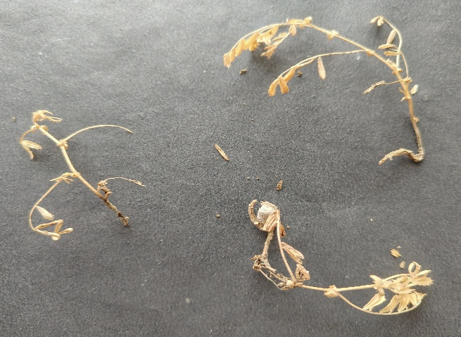
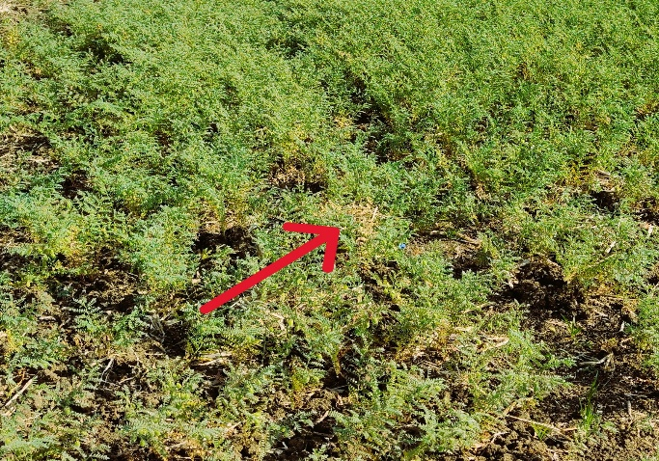
A
B

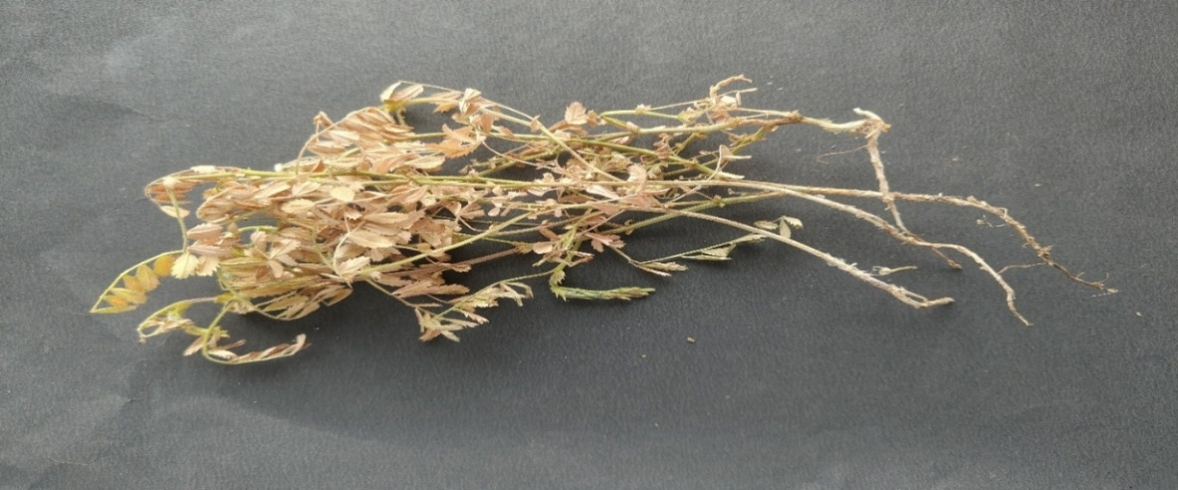
C

Fig. 1. Symptoms of the disease; Wilted plants patches on field (A), Wilted Seedlings drooped down (B), collar & roots of infected Whole young plant (C)
3.2 Isolation and Identification of the Fungus (Fusarium oxysporum f. sp. ciceri)
The pathogen was isolated by selecting chickpea plants showing typical wilting symptoms and placing small bits of infected root on Potato Dextrose Agar as described under material and methods after a week’s incubation period, when the Mycelium where observed they were white in colour (Fig.2A). The slide culture technique was prepared and observed under microscope first at 10 x power and then at 40 x magnification revealed presence of micro conidia, macro conidia (2-3) septate and chlamydospores (Fig.3 A, B). Based on this microscopy the pathogen was identified as F. oxysporum f. sp. ciceri (Fig.2B, C). The Pathogen was most frequently isolating from the infected roots on potato dextrose agar medium.

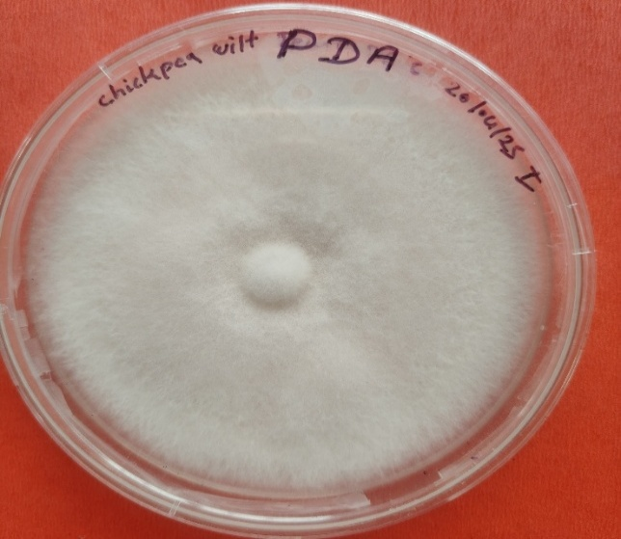
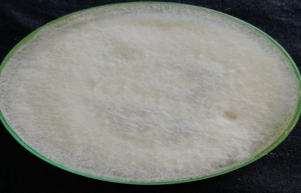
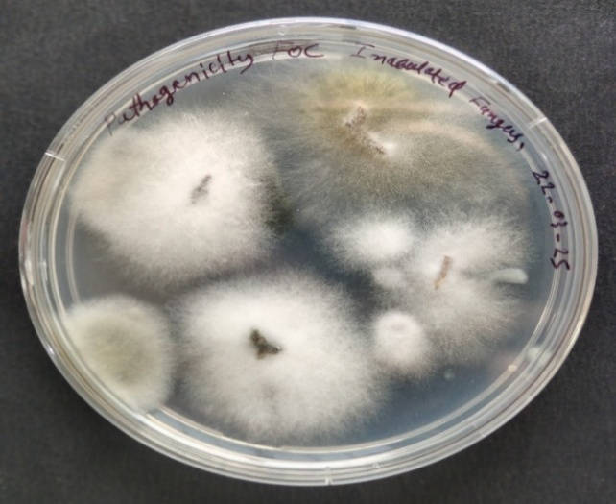
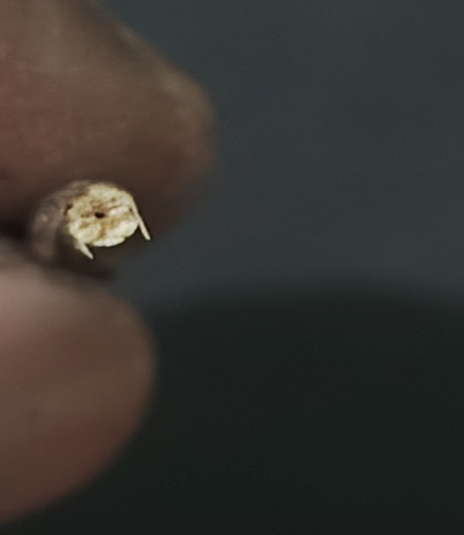
A
C
A
B

Fig.2 (A) cross section of stem showing discoloration of vascular system
(B) Mycelial growth from the infected stem and root
(C) Pure culture of Foc isolated from infected chickpea

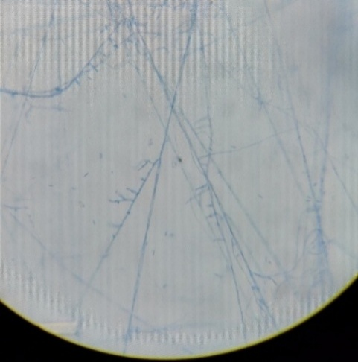
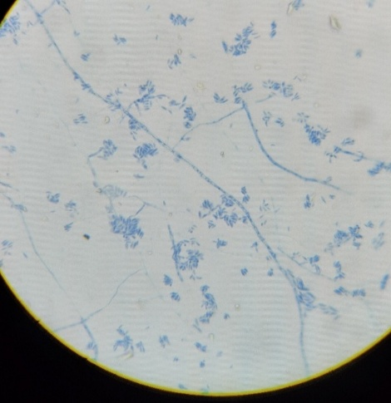
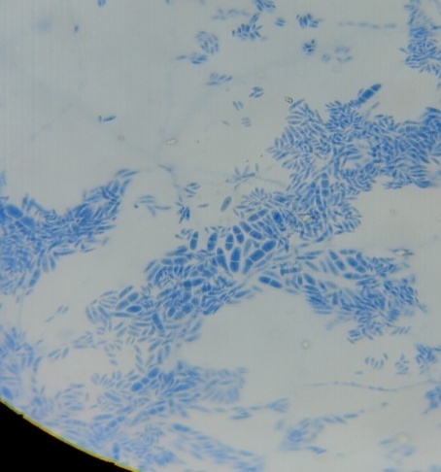

A
B
C

Fig.3 (A) Mycelium, (B) Microconidia, (C) Macroconidia
3.3 Selection of Suitable Culture Medium
The results presented in Table 1 and Fig. 4 clearly indicated that PDA supported higher radial growth of the fungus as compared to CMA and SDA. The radial growth of fungus (Fusarium oxysporum f. sp. ciceri) was found sparse on CMA and Very Sparse on SDA (Fig. 4). Maximum growth was observed on PDA 39.50mm, 68.50mm, and 89.60mm at 3, 5 and 7 DAI respectively followed by Corn meal extract medium (25.80mm, 43.30mm, 63.80mm), Sabouraud dextrose agar (20.40mm, 33.20mm, 53.00mm) at 3, 5, and 7 Days after inoculation at 26 ± 1 °C temperature (Table 1). Since, fungus growth were very dense on PDA therefore, PDA was more suitable than other two (SDA & CMA) culture media.
Table 1. Growth of Fusarium oxysporum f. sp. ciceri on different culture media
Nutrient media | Mycelial growth (mm)
Nutrient media | 3 DAI* | 5 DAI* | 7 DAI*
Potato dextrose agar | 39.50 | 68.50 | 89.60
Corn meal Agar medium | 25.80 | 43.30 | 63.80
Sabouraud dextrose agar | 20.40 | 33.20 | 53.00
C.V. (%) | 4.22 | 1.80 | 1.96
SE(m)± | 0.54 | 0.38 | 0.60
CD (1%) | 1.68 | 1.21 | 1.88
F-Tab | 6.93 | 6.93 | 6.93
SEm+ = Standard Error of Mean (plus/minus), C.D. (P =.01) = Critical Difference at Probability Level = 0.01, C.V. (%) = Coefficient of Variation (in percent), F – Tab = Fisher’s Tabulated Value, F-Cal = Fisher’s calculated value
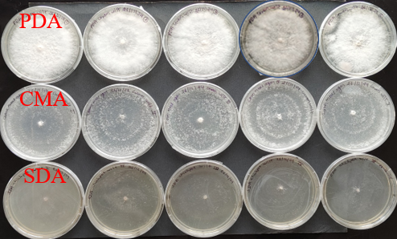

Fig. 4. Growth of Fusarium oxysporum f. sp. ciceri on different culture media at 7 DAI

Fig.5 Effect of different nutrient medium on mycelial growth of Foc
3.4 Effect of Temperature on Growth
Analysed Data obviously indicated that the use of different Nutrient Media could cause significant effect on the mycelial growth of Fusarium oxysporum f. sp. ciceri. Maximum mycelial growth was supported at 26°C growth 39.16mm, 68.50mm, and 89.33mm at 3, 5, and 7DAI respectively followed by 27°C, 25°C, 24°C and minimum growth was recorded at 35°C, 10°C and 15°C. Significant differences in growth were observed across all tested temperatures (Table 2 & Fig. 6, Fig. 7).

Temp. range  (°C) | Mycelial growth (mm)
Temp. range  (°C) | 3 DAI* | 5 DAI* | 7 DAI*
10 | 10.50 | 16.83 | 24.00
15 | 11.33 | 21.33 | 32.16
20 | 13.00 | 27.00 | 38.00
24 | 21.33 | 41.83 | 59.83
25 | 26.66 | 48.66 | 65.83
26 | 39.16 | 68.50 | 89.33
27 | 32.83 | 57.83 | 82.33
30 | 17.00 | 26.33 | 35.16
35 | 8.33 | 10.50 | 11.00
C.V. (%) | 6.34 | 3.96 | 4.11
SE(m) ± | 0.73 | 0.81 | 1.15
CD (1%) | 2.19 | 2.42 | 3.45
F-Tab | 3.71 | 3.71 | 3.71
Table 2. Effect of Different Temperatures on the radial growth of Fusarium oxysporum f. sp. ciceri.
SEm+ = Standard Error of Mean (plus/minus), C.D. (P =.01) = Critical Difference at Probability Level = 0.01, C.V. (%) = Coefficient of Variation (in percent), F – Tab = Fisher’s Tabulated Value, F-Cal = Fisher’s calculated value

Fig.6 Effect of different temperature levels on mycelial growth of Fusarium oxysporum f. sp. ciceri.
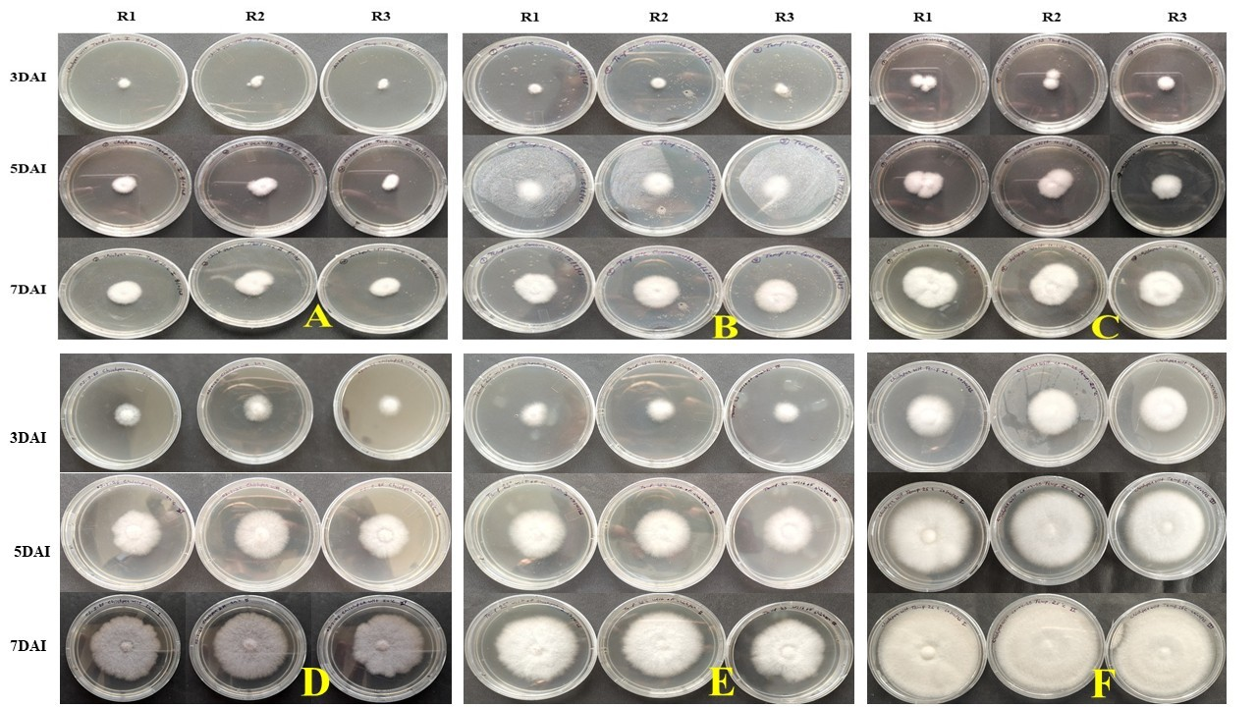

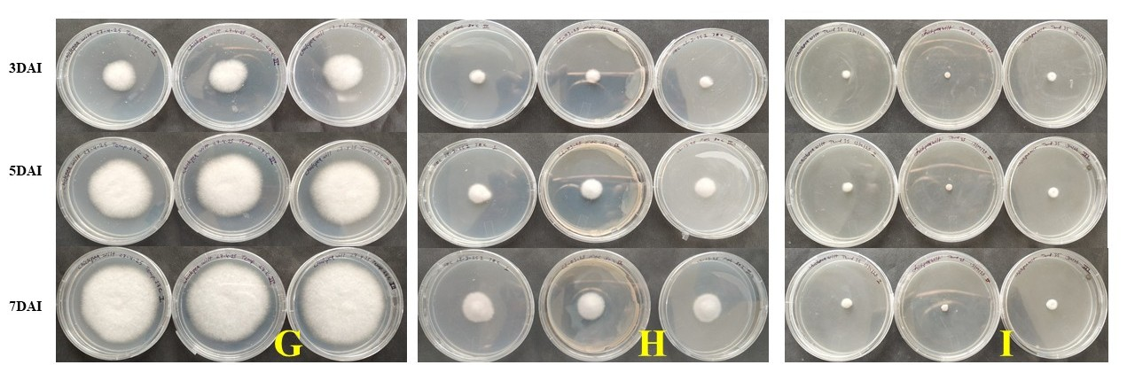

Fig.7. Effect of temperature; effect of 10°C (A), effect of 15°C (B), effect of 20°C (C), effect of 24°C (D), effect of 25°C (E) effect of 26°C (F) effect of 27°C (G) effect of 30°C (H) and effect of 35°C (I) on radial growth of Fusarium oxysporum f. sp. ciceri.

3.5 Effect of pH on Growth of Fusarium oxysporum f. sp. ciceri
Data revealed that the mycelial growth of Fusarium oxysporum f. sp. ciceri have been significantly affected by the various pH levels Table 3, graphically represented in fig- 8. Analysed Data clearly indicated that the use of different pH levels was significantly affect the mycelial growth of Fusarium oxysporum f. sp. ciceri. Maximum mycelial growth was supported at 6 pH 42.33mm, 65.66mm, and 86.33 mm at 3, 5, and 7 DAI respectively followed by 6.5pH, and 5.5pH minimum growth was recorded at 5pH, 8pH, and 7.5pH. Desai et al. (1994) reported that “all the four races of F. oxysporum f. sp. ciceri recorded maximum growth at pH 6.0”. Farooq et al. (2005) studied “the impact of pH on the mycelial growth of F. oxysporum f. sp. ciceri and determined that the most suitable pH levels for growth were 6.0 and 7.0”.
pH | Mycelial growth (mm)
pH | 3 DAI* | 5 DAI* | 7 DAI*
5 | 35.66 | 51.66 | 67.66
5.5 | 39.33 | 63.16 | 76.00
6 | 42.33 | 65.66 | 86.33
6.5 | 41.50 | 62.33 | 80.00
7 | 40.33 | 61.33 | 75.33
7.5 | 38.00 | 60.50 | 72.33
8 | 35.83 | 57.16 | 70.83
C.V. (%) | 2.09 | 2.30 | 2.10
SE(m) ± | 0.47 | 0.80 | 0.91
CD (1%) | 1.44 | 2.45 | 2.80
F-Tab | 4.46 | 4.46 | 4.46
Table 3. Effect of various pH level on the radial growth of Fusarium oxysporum f. sp. ciceri.

SEm+ = Standard Error of Mean (plus/minus), C.D. (P =.01) = Critical Difference at Probability Level = 0.01, C.V. (%) = Coefficient of Variation (in percent), F – Tab = Fisher’s Tabulated Value, F-Cal = Fisher’s calculated value

Fig. 8 Effect of different pH levels on mycelial growth of Fusarium oxysporum f. sp. ciceri.

A roving survey was carried out to record the severity/ incidence of Fusarium wilt in chickpea. The survey was conducted during the Rabi season of 2024-25 in Sohawal block of Satna district, Madhya Pradesh. The number of fields in sohawal block of Satna visited in 12, with a distance of 5-7 km. revealed that in the Five villages, surveyed during rabi (2024-2025), Fusarium wilt symptoms initially appeared as vein clearing on the outer portion of younger leaves and downward drooping of older leaves. (Fig. 1A) Found such as a similar disease incidence Shrivastava et al. (2021) Conducted a survey on “chickpea wilt disease incidence during, the rabi seasons 2018-19 and 2019-20, covering 180 chickpea fields from 60 locations in 10 tehsils under Vidisha district, distributed under Vindhya plateau zone of M.P. The seedlings were drooped down followed by sudden death. (Fig.1B) The infected root, collar region and main stem showing the typical symptoms and browning of the vascular tissues is strong evidence of the disease”. (Fig. 1C) Haware and Nene (1980) found that “chickpea plants experiencing early wilting result in greater losses compared to those that wilt later. However, seeds from plants that wilt later are lighter, rougher, and duller than those from healthy plants”. Nikam et al. (2011) observed that the early signs of chickpea wilt included light yellowing and drooping of leaves, eventually leading to the wilting of the plant.
The pathogen was isolated by selecting chickpea plants showing typical wilting symptoms and placing small bits of infected root on Potato Dextrose Agar as described under material and methods after a week’s incubation period, when the Mycelium where observed they were white in colour (Fig.2A). The slide culture technique was prepared and observed under microscope first at 10 x power and then at 40 x magnification revealed presence of micro conidia, macro conidia (2-3) septate and chlamydospores (Fig.3 A, B). Based on this microscopy the pathogen was identified as F. oxysporum f. sp. ciceri (Fig.2B, C). The Pathogen was most frequently isolating from the infected roots on potato dextrose agar medium. Soni et al. (2023) studied “the isolates of Fusarium oxysporum f. sp. ciceri from two district of Bundelkhand region and studied their phenotypic and pathogenic variability”. “Pigmentation of FOC isolates have a wide range includes cottony white, white with ting of orange and white with violet and pale-yellow pigmentation. Macro and microconidia with resting spores (Chlamydospores) were also observed” (Soni et al., 2023).
The results presented in Table 1 and Fig. 4 clearly indicated that PDA supported higher radial growth of the fungus as compared to CMA and SDA. The radial growth of fungus (Fusarium oxysporum f. sp. ciceri) was found sparse on CMA and Very Sparse on SDA (Fig. 4). Maximum growth was observed on PDA 39.50mm, 68.50mm, and 89.60mm at 3, 5 and 7 DAI respectively followed by Corn meal extract medium (25.80mm, 43.30mm, 63.80mm), Sabouraud dextrose agar (20.40mm, 33.20mm, 53.00mm) at 3, 5, and 7 Days after inoculation at 26 ± 1 °C temperature (Table 1). Since, fungus growth were very dense on PDA therefore, PDA was more suitable than other two (SDA & CMA) culture media. Thaware (2015) reported that “among Fusarium isolates grouping most of them in two clusters. In vitro culture media studied, Potato dextrose agar (89.66 mm) and Richard agar medium (85.66) was found significantly highest mean mycelial growth and sporulation”.
Analysed Data obviously indicated that the use of different Nutrient Media could cause significant effect on the mycelial growth of Fusarium oxysporum f. sp. ciceri. Maximum mycelial growth was supported at 26°C growth 39.16mm, 68.50mm, and 89.33mm at 3, 5, and 7DAI respectively followed by 27°C, 25°C, 24°C and minimum growth was recorded at 35°C, 10°C and 15°C. Significant differences in growth were observed across all tested temperatures (Table 2 & Fig. 6, Fig. 7). Paulkar et al. (2002) studied “the effect of temperature, carbon and nitrogen sources and found best growth of F. oxysporum f. sp. ciceri on mannitol, dextrose, sucrose and potassium nitrate nutrients, between 25 to 30 °C”.
4. CONCLUSION
The roving survey conducted during the Rabi season of 2024–25 in the Sohawal block of Satna district, Madhya Pradesh, revealed a notable incidence of Fusarium wilt in chickpea across 12 fields spanning five villages. Initial symptoms observed included vein clearing on younger leaves, downward drooping of older leaves, and eventual plant wilting, consistent with previous findings by Shrivastava et al. (2021), Nikam et al. (2011), and the classical observations of Haware and Nene (1980). Typical internal symptoms such as browning of the vascular tissue were evident, confirming disease presence. The pathogen was isolated on Potato Dextrose Agar (PDA), and microscopic examination showed the presence of microconidia, macroconidia (2–3 septate), and chlamydospores, leading to the identification of the causal organism as Fusarium oxysporum f. sp. ciceri. PDA proved to be the most supportive medium for fungal growth, with maximum radial growth observed at 26 ± 1°C, aligning with reports by Soni et al. (2023) and Thaware (2015). Growth was also significantly influenced by temperature and pH, with optimum mycelial development at 26°C and pH 6.0, confirming earlier studies by Paulkar et al. (2002), Desai et al. (1994), and Farooq et al. (2005). These findings highlight the aggressive nature of F. oxysporum f. sp. ciceri under favorable environmental conditions and reinforce the importance of monitoring and managing wilt incidence to minimize yield losses in chickpea cultivation.

Disclaimer (Artificial intelligence)
Option 1:
Author(s) hereby declare that NO generative AI technologies such as Large Language Models (ChatGPT, COPILOT, etc.) and text-to-image generators have been used during the writing or editing of this manuscript.
Option 2:
Author(s) hereby declare that generative AI technologies such as Large Language Models, etc. have been used during the writing or editing of manuscripts. This explanation will include the name, version, model, and source of the generative AI technology and as well as all input prompts provided to the generative AI technology
Details of the AI usage are given below:
1.
2.
3.

REFERENCES
Arunodhayam, K., Reddy, Eswara, N.P. and Madhuri, V. 2014. Pathogenicity and management of Fusarium wilt of chickpea, Similarities L.- A review. Current Biotica., 7(4): 343-358.
Badola, R., Sangeeta, S. and Rai, S. 2023. Standardization of process for development of instant chickpea using Desi and Kabuli variety. Emirates Journal of Food and Agriculture, 35(3): 210-219.
Begum N, Khan QU, Liu LG, Li W, Liu D and Haq IU. 2023. Nutritional composition, health benefits and bio-active compounds of chickpea (Cicer arietinum L.). Frontiers in Nutrition, 15(22): 4784. doi: 10.3390/ nu15224784.
Butler, E. J. 1918. Fungi and Disease in Plants. Thacker, Spink and Co., Calcutta, India. Pp. 547.
Chaithra, H.R., Manjunatha, H., Saifulla, M. and Pagala, Deepthi 2019. Pathogenic and morphological variability among Fusarium oxysporum f. sp. ciceri isolates causing wilt in chickpea. LEGUME RESEARCH - AN INTERNATIONAL JOURNAL, 42(2): 277-281.
Chattopadhyay, S.B. and Sen Gupta, P.K. 1967. Studies on wilt diseases of pulses I. Variation and taxonomy of Fusarium spp. associated with the wilt disease of pulses. Indian J. Mycol. Res., 5: 45–53.
Chauhan, S.K. 1963. Influence of different soils temperatures on the incidence of Fusarium wilt of gram (C. arietinum L.). Proc Indian Acad Sci., 8: 552-554.
DES, MOAF&W. 2023. Directorate of economics and statistics. Crop production statistics information system, Ministry of Agriculture & Farmers Welfare, India.
DPD, Bhopal .2023 Directorate of Pulses Development, Bhopal. Crop production ANGRAU Crop Outlook Reports of Andhra Pradesh.
Farooq, S., Iqbal, S.M. and Rauf, A. 2005. Physiological Studies of Fusarium oxysporum f. sp. ciceri. Int. J. Agri. Biol., 7(2): 275-277
Gaur, P.M., Samineni, S., Sajja, S. and Chibbar, R.N. 2015. Achievements and challenges in improving nutritional quality of chickpea. Legume perspectives, 09: 31-33.
Ghosh, R., Sharma, M. Telangre, R. and Pande S. 2013. Occurrence and distribution of chickpea diseases in Central and Southern parts of India. American Journal of Plant Sciences, 4: 940-944.
Golakiya, B.B., Bhimani, M.D. and Akbari, L.F. 2018. Characterization of Indian Isolates of Fusarium oxysporum f. sp. ciceri Causing Chickpea Wilt. International Journal of Current Microbiology and Applied Sciences, 7(03): 1152-1162.
Haware, M.P., Nene Y.L. and Rajeswari, R. 1978. Eradication of F. oxysporum f. sp. ciceri transmitted in chickpea seed. Phytopathology, 68: 1364-1367.
Hulse, J. H. 1991. In: Uses of Tropical Grain Legumes, pp. 11–27 (ed. R. Jambunathan). Patancheru, India: ICRISAT.
Karaca, N., Ates, D., Nemli, S., Ozkuru, E., Yilmaz, H., Yagmur, B. and Tanyolac, M.B. 2019. Genome‐Wide Association Studies of Protein, Lutein, Vitamin C, and Fructose Concentration in Wild and Cultivated Chickpea Seeds. Crop Science, 59(6): 2652-2666.
Karimi, K., Amini, J., Harighi, B. and Bahramnejad, B. 2012. Evaluation of biocontrol potential of Pseudomonas and Bacillus spp. against Fusarium wilt of chickpea. AJCS, 6(4): 695-703.
Khan Imran, H.S., Saifulla, M., Mahesh, S.B. and Pallavi, M.S. 2011. Effect of different media and environmental conditions on the growth of Fusarium oxysporum f. sp. ciceri causing Fusarium wilt of chickpea. International Journal of Science Nature, 2(2): 402-404.
Khan, M.R., Khan, S.M. and Mohiddin, F.A. 2004. Biological control of Fusarium wilt of chickpea through seed treatment with the commercial formulation of Trichoderma harzianum and Pseudomonas fluorescens. Phytopathologia Mediterranea, 43: 20– 25.
Khilare, V.C. and Rafi Ahmed 2012. Effect of different media, pH and temperature on the growth of Fusarium oxysporum f. sp. ciceri causing chickpea wilt. Int. J. of Advance Biological Research, 2(1): 99-102.
Kinfe, E., Singh, P. and Fekadu, T. 2015. Physicochemical and functional characteristics of desi and kabuli chickpea (Cicer arietinum L.) cultivars grown in Bodity, Ethiopia and sensory evaluation of boiled and roasted products prepared using chickpea varieties. International Journal of Current Research in Biosciences and Plant Biology, 2(4): 21-29.
Maitlo, S., Rajput, A.Q., Syed, R.N., Khanzada, M.A., Rajput, N.A. and Lodhi, A.M. 2017. Influence of physiological factors on vegetative growth and sporulation of Fusarium oxysporum f. sp. ciceri. Pak. J. Bot., 49(SI): 311-316.
Mergewar, A.R., Mulekar, V.G., Waghmare, S.V. and Dudhe, S.P. 2023. In vitro efficacy of systemic fungicides against Fusarium oxysporum f. sp. ciceri, causing chickpea wilt. The Pharma Innovation Journal, 12(3): 5369-5372.
Nikam, P.S., Jagtap, G.P. and Sontakke, P.L. 2011. Survey, surveillance and cultural characteristics of chickpea wilt caused by Fusarium oxysporium f. sp. ciceri. African Journal of Agricultural Research, 6(7): 1913-1917.
Patil, M., Gupta, o. and Rathod, P.K. 2017. Morphological, cultural and pathogenic variation in races and variant of F. oxysporum f. sp. ciceri from seven locations of central zone of India. International Journal of Applied and Pure Science and Agriculture, 3(1): 66- 74
Paulkar, P.K. and Raut, B.T. 2004. Variability among the isolates of Fusarium oxysporum f. sp. ciceris. Journal of Mycology and Plant Pathology, 34(1): 20-23.
Qureshi, M.A., Arsia, S.K. and Kumar, A. 2021. Variability among the isolates of Fusarium oxysporum f. sp. ciceri in Nimar region of Madhya Pradesh. The Pharma Innovation Journal, 10(4): 46-50.
Sharma, K.D., Chen, W. and Muehlbauer, F.J. 2005. Genetics of chickpea resistance to five races of Fusarium wilt and a concise set of race differentials for F. oxysporum f. sp. ciceri. Plant Disease, 89(4): 385-390.
Shekhawat, D.S., Tiwari, S. and Nathawat, B.D.S. 2021. Fusarium wilt in chickpea (Cicer Arietinum L.) caused by Fusarium oxysporum f. sp. ciceris management through combination of Essential oils and bioagents. Journal of Pharmacognosy and Phytochemistry, 10(1): 901-904.
Shrivastava, A. & Mahajan, K.C. 2021. Survey of Chickpea Wilt caused by Fusarium oxysporum f. sp. ciceri in Vidisha District of Madhya Pradesh. Biological Forum – An International Journal, 13(3a): 84-88.
Singh, R.K., Abul Hasan and Chaudhary, R.G. 2010. Variability in Fusarium oxysporum f. sp. ciceri causing vascular wilt in chickpea. Archives of Phytopathology and Plant Protection, 43(10): 987-995.
Soni, R., Saxena, R.K., Srivastava, M.K. and Singh, H.V. 2023. Phenotypic and Pathogenic Variability in Fusarium Wilt Pathogen Isolated from Bundelkhand Region. Current Agriculture Research Journal, 11(1): 256-276.
Srungarapu, R., Mohammad, L.A., Mahendrakar, M.D., Chand, U., Venkata, R.J., Kondamudi, K.P. and Samineni, S. 2022. Genetic variation for grain protein, Fe and Zn content traits in chickpea reference set. Journal of Food Composition and Analysis, 114: 104774.
Sudharani, Naik, G.B., Naik, M.K., Shivanna, B.K., Satish, K.M. and Sharma, M. 2017. Effect of temperature on the severity of Fusarium wilt of chickpea caused by Fusarium oxysporum f. sp. ciceris. International Journal of Chemical Studies, 7(5): 27-30.
Thaware, D.S., Kohire, O.D. and Gholve, V.M. 2015. Survey of chickpea wilt (Fusarium oxysporum f. sp. ciceri) disease in Marathwada region of Maharashtra state. Adv. Res. J. Crops Improv. 6(2): 134- 138. DOI:10.15740/HAS/ARJCI/6.2/134-138. Wilt Resistance in Pakistan. Ph. D thesis. Quaid-i-Azam University,
Venkataramanamma K., Reddy Bhaskara B.V., Jayalakshmi Sarada R., Jayalakshmi V., Prasad Hari K.V. 2023. Identification of Races of Fusarium oxysporum f.sp. ciceris, Inciting Wilt of Chickpea in Andhra Pradesh and Parts of Telangana. Legume Research, 46(4): 506-512.
Zote, K.K., Mote, T.S., Kulkarni, S.V. and Shaikh, M.H. 1991. Survey of association of fungi with chickpea wilt disease. Paper presented in 4th Annual Meeting (WZ) of IPS Department of Botany, Marathwada University, Aurangabad.

