Original Research Article
Input intensification and surplus production: Assessing the sustainability of paddy cultivation in Telangana
ABSTRACT
This study examines the sustainability of paddy intensification in Telangana during 2014–15 to 2021–22 using time-series trend analysis and Compound Annual Growth Rate (CAGR) estimation. The results show that while the area and production of paddy expanded sharply, productivity gains remained modest, indicating diminishing returns to input intensification. Mechanization increased significantly, accompanied by rising fertilizer and pesticide use and declining farmyard manure application, raising ecological and soil health concerns. The cost of cultivation rose faster than the Minimum Support Price (MSP), compressing farmer profitability and questioning long-term economic viability. Policy interventions promoting balanced nutrient management, diversification, and export facilitation are recommended to ensure long-term sustainability.”
Keywords: Crop diversification, Cost of cultivation, Export, Input use efficiency, Minimum Support Price, Paddy cultivation
1. INTRODUCTION
Paddy is one of the most significant staple crops in India, occupying nearly one-fourth of the gross cropped area and contributing substantially to the food grain output of the country. In 2021–22, India produced approximately 129.5 million tonnes of rice, making it the second-largest producer globally, after China [1]. A consistent increase in the yield of rice was noted for many years. It is mostly grown in Eastern and Southern parts of India as it is a staple food in these areas. It is fundamentally a kharif crop and is mainly grown in rainfed areas that receive heavy annual rainfall. Rice is also grown through irrigation in those areas that receive comparatively less rainfall. In fact, the food security of our nation depends upon the production of rice through an irrigated system [2]. Within India, Telangana has emerged as a major paddy-growing state following its formation in 2014, largely due to concerted efforts in irrigation development, power supply to agriculture, and procurement at the Minimum Support Price (MSP).
Post-bifurcation, the Telangana state government prioritized agricultural revival, notably through schemes like Mission Kakatiya and Kaleshwaram Lift Irrigation Project, leading to enhanced irrigation potential and a significant increase in gross sown area [3]. As a result, the area under paddy cultivation in Telangana has shown a rapid increase from 14.15 lakh hectares in 2014-15 to 36.54 lakh hectares in 2021-22. This expansion recorded a high annual growth rate, reflecting both infrastructural support and farmers' economic response to price incentives and government procurement [4].
However, this growth trajectory raises concerns about sustainability. Increased input intensity, over-reliance on chemical fertilizers and pesticides, stagnant productivity growth, and rising cultivation costs challenge the long-term viability of paddy-based agriculture. Studies indicate that monocropping of paddy leads to deterioration of soil health, decline in groundwater levels, and pest outbreaks [5,6]. Moreover, despite increases in MSP, profitability remains under strain due to disproportionately rising costs [7].
Therefore, it becomes critical to assess the economic, environmental, and policy dimensions of paddy expansion in Telangana, with a view toward balancing productivity, profitability, and sustainability. While previous studies have documented the expansion of paddy area in Telangana [3], few have analyzed its economic and environmental sustainability using recent post-irrigation expansion data [8]. This study fills that gap by evaluating input trends, cost dynamics, and production–consumption balance.
2. MATERIALS AND METHODS
The study was based on the time-series data on area, production and productivity of rice as well as its cost components and MSP in Telangana state collected from various published sources such as the Directorate of Economics and Statistics, Indiastat, UPAG for the period 2014-15 to 2021-22.
The data were summarized, tabulated and analyzed using statistical measures like trend analysis. In order to analyze the growth in area, production and productivity of paddy, compound annual growth rates were computed using the following model [9].
Y = AB^{T}e^{U}
Log (Y) = Log (A) + t Log (B)
CAGR= (Antilog (B)-1) X 100
Where,
Y = dependent variable (area, production, yield, inputs, cost components, MSP)
A = Intercept
t = Year
B = Regression coefficient
CAGR= Compound Annual Growth Rate in terms of percentage.

In addition, the data pertaining to population of Telangana was gathered from Telangana Socio-Economic Outlook Reports of various years. Whereas, the Per Capita Consumption (kg/year) information of rice was obtained from National Sample Survey Office (NSSO) [10] reports – Household Consumption Surveys, Ministry of Statistics and Programme Implementation (MoSPI). Actual rice production data was obtained from Directorate of Economics & Statistics (DES), Telangana; Agricultural Statistics at a Glance, Ministry of Agriculture & Farmers Welfare, GoI.
Consumption requirement and surplus were calculated by using the formulas
$$Consumption Requirement (Lakh Tonnes)=Population (in crore)*Per Capita Consumption (kg/year)÷100$$
$$Surplus \left(Lakh Tonnes\right)=Production-Consumption Requirement$$
3. RESULTS
3.1 National Trends in Paddy Cultivation (2014–15 to 2021–22)
For the period 2014-15 to 2021-22, paddy cultivation in India exhibited moderate but consistent growth in area, production, and productivity (Table.1). The area under paddy increased from 44.11 million hectares in 2014–15 to 46.28 million hectares in 2021–22, reflecting a Compound Annual Growth Rate (CAGR) of 0.69%. Paddy production rose significantly from 105.48 to 129.47 million tonnes, with a CAGR of 3.12%, while productivity improved from 2391 kg/ha to 2798 kg/ha (CAGR: 2.42%) (Table 1). The time trend regression showed strong statistical significance, with R² values of 0.97 for production and productivity, and p-values < 0.01.
Table 1. Trends in Area, Production and Productivity of Paddy in India (2014-15 to 2021-22)
Year | Area (‘000 ha.) | Production (‘000 tonne) | Productivity (Kg./ha.)
2014-2015 | 44110.10 | 105481.90 | 2391
2015-2016 | 43499.20 | 104408.20 | 2400
2016-2017 | 43993.40 | 109698.40 | 2494
2017-2018 | 43774.07 | 112757.60 | 2576
2018-2019 | 44156.44 | 116477.80 | 2638
2019-2020 | 43662.30 | 118870.30 | 2722
2020-2021 | 45768.69 | 124368.30 | 2717
2021-2022 | 46278.68 | 129471.40 | 2798
CAGR (%) | 0.69** | 3.12*** | 2.42***
R-squared | 0.53 | 0.97 | 0.97
t-value | 2.62 | 14.38 | 13.93
Source: https://upag.gov.in/
Note: *** and ** indicates significance level at 1% and 5% respectively
3.2 Trends in Telangana: Area, Production, and Productivity
Telangana experienced rapid expansion in paddy cultivation. The area increased from 14.2 lakh hectares to 36.5 lakh hectares between 2014–15 and 2021–22, registering a CAGR of 17.43% (Table 2). Paddy production surged from 44.4 lakh tonnes to 12.41 million tonnes during the same period (CAGR: 19.59%). Productivity rose modestly from 3138 to 3395 kg/ha (CAGR: 1.84%). Area and production trends were statistically significant, while the productivity trend was not statistically significant (R² = 0.29). Telangana consistently outperformed the national average in paddy productivity, achieving about 3,000 to over 3,600 kg/ha, compared with approximately 2,350 to 2,800 kg/ha for India for the period 2014-15 to 2021-22. Both showed steady growth over time, but Telangana maintained a clear edge across the entire period (Fig. 1).
Table 2. Trends in Area, Production and Productivity of Paddy in Telangana (2014-15 to 2021-22)
Year | Area (‘000 ha.) | Production (‘000 tonne) | Productivity (Kg./ha.)
2014-2015 | 1415 | 4440.80 | 3138
2015-2016 | 1046 | 3047.00 | 2913
2016-2017 | 1682.2 | 5173.40 | 3075
2017-2018 | 915 | 3315.96 | 3624
2018-2019 | 1932 | 6670.01 | 3452
2019-2020 | 2011 | 7427.77 | 3694
2020-2021 | 3186.4 | 10217.13 | 3206
2021-2022 | 3654.9 | 12409.57 | 3395
CAGR (%) | 17.43** | 19.59*** | 1.84^{NS}
R-squared | 0.65 | 0.75 | 0.29
t-value | 3.36 | 4.26 | 1.56
Source: https://upag.gov.in/
Note: *** and ** indicates significance level at 1% and 5% respectively;
NS indicates non-significant
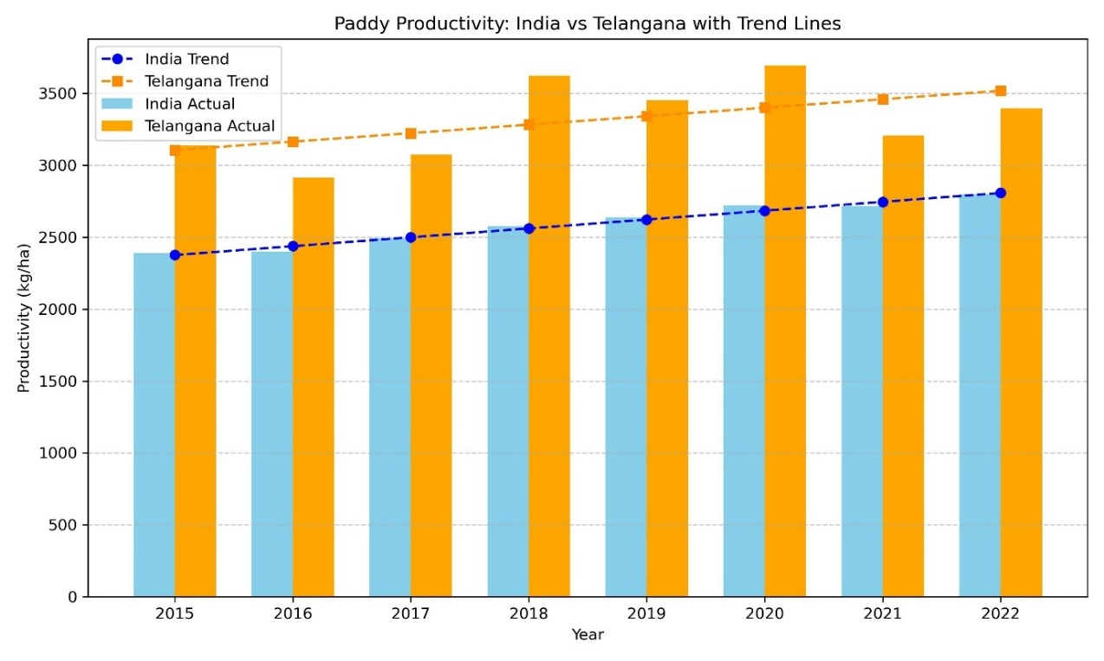
Fig.1 Comparison of Productivity of Paddy in India and Telangana
3.3 Input Use Dynamics in Telangana
During the period 2014–15 to 2021–22, paddy cultivation in Telangana witnessed a substantial rise in input use but only a marginal improvement in yield, which increased from 55.74 to 58.40 q/ha with a non-significant CAGR of 0.27%. Human labour use declined from 503.83 to 424.36 hours/ha (CAGR –3.79%), and animal labour dropped sharply from 8.57 to 2.72 hours/ha (CAGR –15.60%, p < 0.001), indicating a shift toward mechanization, as reflected in a slight increase in machine labour from 17.57 to 19.69 hours/ha (CAGR 1.38%). Fertilizer consumption rose from 248.18 to 295.23 kg/ha (CAGR 2.69%), driven mainly by nitrogen (3.24%) and phosphorus (2.24%), while micronutrient use registered the steepest growth (CAGR 16.54%). In contrast, the application of farmyard manure (FYM) declined drastically from 13.47 to 1.19 q/ha (CAGR –27.05%). Insecticide expenditure also increased sharply from ₹1,464.02/ha to ₹5,001.54/ha (CAGR 19.40%, p < 0.001). Thus, despite higher dependence on fertilizers, pesticides, and mechanization, the corresponding yield gain remained negligible, suggesting declining input-use efficiency in Telangana’s paddy cultivation.

Table 3. Trends in input use pattern of Paddy in Telangana (2014-15 to 2021-22)
Year | Yield (q/ha) | Human  Labour (Hrs.) | Animal  Labour (Hrs.) | Machine  Labour (Hrs.) | Seed  (kg/ha) | Nitrogen  (kg/ha) | Phosphorous  (kg/ha) | Potassium  (kg/ha) | Other fertilizer  (kg/ha) | Total Fertilizers  (kg./ha) | FYM  (q/ha) | Insecticides  (₹/ha)
2014-15 | 55.74 | 503.83 | 8.57 | 17.57 | 76.73 | 139.36 | 66.12 | 39.83 | 2.88 | 248.18 | 13.47 | 1464.02
2015-16 | 54.39 | 515.62 | 9.72 | 17.74 | 73.39 | 136.32 | 66.83 | 41.00 | 1.37 | 245.34 | 9.64 | 2053.46
2016-17 | 58.33 | 472.06 | 6.92 | 16.18 | 74.16 | 136.10 | 60.17 | 40.04 | 3.48 | 239.71 | 3.34 | 1776.39
2017-18 | 50.92 | 403.90 | 5.83 | 16.01 | 70.55 | 185.96 | 80.94 | 46.82 | 3.40 | 317.13 | 8.23 | 3436.45
2018-19 | 56.98 | 388.25 | 4.77 | 17.27 | 40.49 | 160.76 | 72.76 | 38.62 | 1.55 | 273.69 | 8.04 | 3368.69
2019-20 | 58.25 | 382.14 | 5.34 | 17.23 | 70.25 | 169.36 | 66.74 | 38.40 | 4.56 | 279.06 | 4.93 | 3297.16
2020-21 | 52.16 | 392.00 | 3.41 | 18.06 | 62.14 | 158.96 | 72.96 | 42.66 | 8.02 | 282.60 | 1.15 | 5008.76
2021-22 | 58.40 | 424.36 | 2.72 | 19.69 | 65.94 | 170.28 | 78.65 | 41.21 | 5.09 | 295.23 | 1.19 | 5001.54
CAGR (%) | 0.27^{NS} | -3.79** | -15.60*** | 1.38^{NS} | -3.06^{NS} | 3.24* | 2.24^{NS} | 0.142^{NS} | 16.54* | 2.69* | -27.05** | 19.40***
R-squared | 0.02 | 0.61 | 0.91 | 0.27 | 0.14 | 0.45 | 0.30 | 0.003 | 0.40 | 0.44 | 0.67 | 0.89
t-value | 0.31 | -3.04 | -7.99 | 1.48 | -0.97 | 2.19 | 1.61 | 0.13 | 2.006 | 2.17 | -3.50 | 6.83
Source: Authors calculation from plot level summary data of Directorate of Economics and Statistics.
Note: ***, ** and * indicates significance level at 1%, 5% and 10% respectively;
NS indicates non-significant

Table 4. Trends in Cost Components (₹/Quintal) of Paddy in Telangana (2014-15 to 2021-22)
Year | A1 | A2 | B1 | B2 | C1 | C2 | C2 Revised | C3 | A2+FL
2014-15 | 693.41 | 694.26 | 721.36 | 1131.58 | 871.95 | 1282.17 | 1293.13 | 1422.44 | 853.3179
2015-16 | 699.55 | 700.76 | 732.12 | 1157.06 | 896.61 | 1321.55 | 1325.46 | 1458.01 | 872.1236
2016-17 | 656.74 | 661.70 | 694.87 | 1133.68 | 825.51 | 1264.33 | 1268.14 | 1394.95 | 796.9589
2017-18 | 904.44 | 1019.13 | 981.84 | 1599.54 | 1228.47 | 1846.17 | 1854.08 | 2039.49 | 1280.82
2018-19 | 821.76 | 955.44 | 897.97 | 1407.24 | 1041.45 | 1550.72 | 1552.81 | 1708.09 | 1110.554
2019-20 | 856.16 | 978.81 | 897.41 | 1422.00 | 1127.60 | 1652.19 | 1652.19 | 1817.41 | 1226.61
2020-21 | 1052.72 | 1079.45 | 1305.71 | 1093.67 | 1650.06 | 1320.04 | 1876.43 | 1894.50 | 1320.109
2021-22 | 1060.71 | 1090.54 | 1380.60 | 1094.99 | 1680.21 | 1383.89 | 1969.12 | 1987.64 | 1395.605
CAGR (%) | 7.05*** | 7.96*** | 10.14*** | 0.05^{NS} | 10.53*** | 1.38^{NS} | 6.51*** | 5.21** | 8.26***
R-squared | 0.81 | 0.77 | 0.81 | 0.00 | 0.79 | 0.06 | 0.74 | 0.64 | 0.76
t-value | 4.99 | 4.57 | 5.09 | 0.02 | 4.74 | 0.62 | 4.15 | 3.30 | 4.43
Source: DES, DoA&FW, GOI
Note: *** and ** indicates significance level at 1% and 5% respectively;
NS indicates non-significant

3.4 Cost of Cultivation and MSP Trends
The cost of cultivating paddy in Telangana increased substantially over time across all major components (Table.4), indicating an increasing financial burden on farmers.
The A₂ cost (paid-out cost) rose from ₹694.26 to ₹1,090.54 per quintal with a CAGR of 7.96%, while B₁ and B₂ costs, accounting for owned land and capital grew at CAGRs of 10.14% and 0.05%, respectively, though B₂’s growth was statistically insignificant (p = 0.98). More comprehensive cost measures like C₁, C₂, and C₃ also showed upward trends, with C₁ growing at 10.53% CAGR and C₃ at 5.21% CAGR. The A₂+FL cost, reflecting actual farmer expenditure including family labour, increased from ₹853.32 to ₹1,395.61 (CAGR: 8.26%). In parallel, the Minimum Support Price (MSP) for paddy increased from ₹1,360 to ₹1,940 for the common variety and ₹1,400 to ₹1,960 for Grade ‘A’ (CAGRs of 5.51% and 5.2%, respectively), with statistically significant trends (R² = 0.98) (Table 5)
Table 5. Trends in MSP
Commodity | PADDY
Year | Common | Grade 'A'
2014-15 | 1360.0 | 1400.0
2015-16 | 1410.0 | 1450.0
2016-17 | 1470.0 | 1510.0
2017-18 | 1550.0 | 1590.0
2018-19 | 1750.0 | 1770.0
2019-20 | 1815.0 | 1835.0
2020-21 | 1868.0 | 1888.0
2021-22 | 1940.0 | 1960.0
2022-23 | 2040.0 | 2060.0
CAGR | 5.51*** | 5.2***
R² | 0.98 | 0.98
t-value | 16.56 | 18.47
Source: DES, DoA & FW, GOI
Note: *** indicates significance level at 1%
3.5 Production–Consumption Balance in Telangana
Analysis of production and consumption in Telangana during 2014–15 to 2021–22 revealed the significant increase in surplus over the years (Table. 6). The population of Telangana showed increase in trend by 2.09 %. Whereas, production of rice showed an increase of 27.14%. As a result, only 2.09% increase was observed for consumption requirement. The surplus rice produced also shown significant increase by 156.54 lakh tonnes (41.007 in 2014-15 to 197.56 in 2021-22) i.e., by CAGR of 28.52%.
3.6 Net Returns from Major Crops in Telangana (2021–22)
A comparative analysis of net returns (Fig.2) showed that maize cultivation yielded significantly higher returns (₹13,180.77/ha) than paddy (₹221.94/ha). Redgram also showed positive returns (₹1,975.76/ha), whereas other major crops (cotton and soybean) reported negative net returns.

Table 6. Trends in Production and Consumption
Year | *Population (Cr) | *Per Capita Consumption (kg/year) | Rice Production (Lakh Tonnes) | Consumption Requirement (Lakh Tonnes) | Surplus (Lakh Tonnes)
2014-15 | 3.60 | 110.90 | 45.00 | 3.99 | 41.00
2015-16 | 3.68 | 110.90 | 45.71 | 4.08 | 41.63
2016-17 | 3.76 | 110.90 | 98.99 | 4.17 | 94.82
2017-18 | 3.84 | 110.90 | 93.95 | 4.26 | 89.69
2018-19 | 3.92 | 110.90 | 100.03 | 4.35 | 95.68
2019-20 | 4.00 | 110.90 | 178.27 | 4.44 | 173.83
2020-21 | 4.08 | 110.90 | 218.51 | 4.52 | 213.98
2021-22 | 4.16 | 110.90 | 202.18 | 4.61 | 197.56
CAGR (%) | 2.09*** | 0.00^{NS} | 27.14*** | 2.09*** | 28.52***
R-squared | 1.00 | -inf | 0.91 | 1.00 | 0.90
t-value | 118.59 | 0.02 | 7.57 | 118.59 | 7.48
Source: *Household Consumption of Various Goods and Services in India: 68th Round
Note: *** indicates significance level at 1%
NS indicates non-significant.
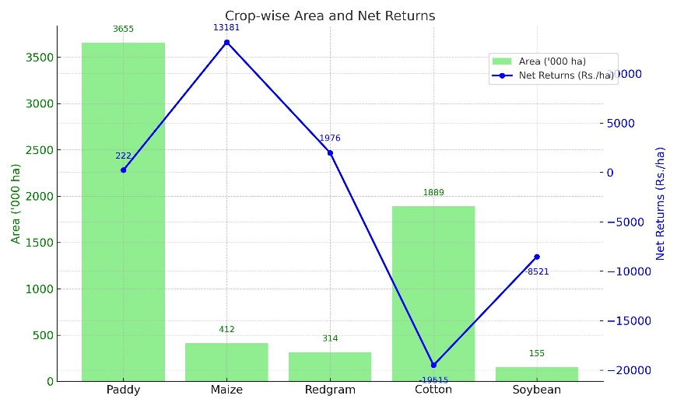
Fig.2 Comparison of area and net returns of major crops in Telangana
4. DISCUSSION
The analysis reveals distinct patterns in the growth trajectory of paddy cultivation at national and state (Telangana) levels. India's steady improvement in production and productivity, with relatively minor area expansion, indicates efficiency gains driven by enhanced varietal adoption, policy support (e.g., MSP, input subsidies), and gradual technology dissemination. In contrast, Telangana’s growth has been primarily area-driven, underscored by significant government investment in irrigation infrastructure and favourable procurement policies. While this has led to sharp increases in production, the relatively modest yield growth and statistically weak productivity trends suggest that output gains have not kept pace with the intensity of resource use.
The input use trends further reveal a mechanization-driven transformation in Telangana’s paddy sector. Rising fertilizer and pesticide consumption indicates a shift toward high-input agriculture. However, the significant decline in FYM application raises concerns about long-term soil health and ecological sustainability. This trend is consistent with earlier findings that in fields under intensive monoculture systems receiving heavy applications of chemical fertilizers without adequate organic amendments, a gradual decline in productivity can occur over time even in irrigated paddy ecosystems [11].
It was also observed that organic fertilizer can serve as a better supplement to inorganic fertilizer, contributing to improved plant growth and yield [12]. This suggests that integrated nutrient management practices and varietal adoption could enhance productivity while safeguarding soil health [13]. Furthermore, it emphasized that agricultural transformation must harmonize growth with inclusiveness and environmental sustainability, ensuring that productivity gains are not achieved at the expense of long-term soil fertility, resource equity, and ecological stability [8]. Together, these insights point to the need for targeted interventions in nutrient and pesticide management, mechanization strategies, and diversification efforts to promote resilient, profitable, and environmentally sound paddy cultivation systems.
Nationally, the post-Green Revolution era in India has been characterized by high input usage coupled with decelerating total factor productivity growth, suggesting that the productivity gains achieved during the 1980s were not sustained into the 1990s raising concerns about the long-term viability of input-intensive agricultural strategies [14].
Escalating cultivation costs, especially the steep rise in A2+FL and C3 costs, have placed additional economic pressure on farmers. While MSPs have risen steadily, their growth has not matched the rate of cost inflation. This widening cost-price gap threatens farm profitability, particularly for smallholders. The situation is compounded by Telangana’s large surplus in rice production. The limited local consumption growth (linked to modest population increase) and exponential rise in surplus production call for the development of export linkages and interstate procurement mechanisms.
The sharp contrast in net returns among major crops underscores the urgent need for diversification. Shifting away from monoculture rice systems towards more varied cropping patterns can play a key role in reducing rural poverty. By encouraging the cultivation of high-value crops and spreading production risks across different enterprises, agricultural diversification not only improves farm incomes but also strengthens overall profitability [15]. Maize, with its superior profitability and relatively lower input requirements, offers a promising alternative to paddy, particularly in water-stressed and ecologically vulnerable zones [16]. Optimized cropping models advocate reducing paddy acreage in favour of maize and pulses [17]. The state government’s emphasis on pulse promotion aligns with these recommendations and needs to be reinforced through region-specific policies, market incentives, and farmer education [18].
Moreover, India’s expanding paddy surplus offers a significant opportunity for rice exports especially non-basmati rice which is a powerful lever to absorb excess production and enhance farmers’ economic resilience [19]. Recent developments lend urgency to this strategy, such as Telangana has already initiated rice exports to the Philippines as a way to offload surplus and gain international market access [20]. Realizing this potential requires improvements in quality control, value addition, crop diversification and export infrastructure. In line with these goals, Professor Jayashankar Telangana Agricultural University (PJTAU) has launched the “Rythu Mungitlo Shastravethalu” initiative, wherein agricultural scientists visit villages to directly interact with farmers, creating awareness on crop diversification, its benefits for soil health, its role in mitigating pest and disease outbreaks, and in reducing excessive use of chemical fertilizers [21].
While Telangana’s paddy cultivation expansion has been impressive in scale, it raises critical sustainability concerns. Future policy directions should prioritize balanced input management, enhance yield response efficiency, and promote strategic diversification to ensure resilient, economically viable, and environmentally sustainable farming systems.
5. CONCLUSIONS
The study reveals that Telangana’s growth in paddy area is significant, reflecting the success of policy and irrigation interventions. However, the modest rise in productivity and significant increase in cultivation costs point to concerns regarding input efficiency and sustainability. It also suggested the need of export of surplus rice and also stresses the need of crop diversification. In this direction, PJTAU (Professor Jayashankar Telangana Agricultural University) has undertaken a proactive initiative called “Rythu Mungitlo Shastravethalu”, wherein agricultural scientists visit villages to interact with farmers. Through this program, scientists created awareness on the importance of crop diversification, its role in improving soil health, mitigating pest and disease outbreaks, and reducing the excessive use of chemical fertilizers. Furthermore, as part of broader market-oriented reforms, the State has also taken steps toward the export of surplus rice. In April 2025, Telangana exported its first-ever consignment of 12,500 metric tonnes of rice particularly the premium MTU-1010/IR64 variety to the Philippines, under a government-to-government (G2G) agreement [22]. This marks a significant milestone toward ensuring the state’s food self-sufficiency and generating additional farm income through global market integration. To sustain this progress, continued government support is essential in terms of policy facilitation and investments in research, extension, marketing infrastructure, and international trade linkages.
6. POLICY IMPLICATIONS
The results of this study highlight the need for policy interventions to ensure that the expansion of paddy cultivation in Telangana remains economically viable and environmentally sustainable. The rapid increase in area and production, driven largely by irrigation development and assured procurement, has been accompanied by rising input intensity, escalating cultivation costs, and declining input-use efficiency. Addressing these challenges requires a balanced approach that integrates productivity enhancement with environmental and financial sustainability.
6.1 Balanced Input and Nutrient Management
The significant increase in chemical fertilizer and pesticide use, along with the drastic decline in organic manure application, underscores the need for policies promoting balanced nutrient management. Strengthening Integrated Nutrient Management (INM) practices through soil health testing, farmer awareness programmes, and incentives for organic inputs is essential to maintain soil fertility and ecological stability. Initiatives such as “Rythu Mungitlo Shastravethalu” should be further expanded to enhance farmer–scientist interaction and promote efficient input use at the field level.

6.2 Cost Management and Profitability Enhancement
The study found that the cost of cultivation (A2+FL) has risen faster than the Minimum Support Price (MSP), resulting in compressed profit margins. Policies should therefore focus on improving input-use efficiency through mechanization support, establishment of custom hiring centres, and adoption of precision agriculture technologies.
6.3 Utilization of Surplus Production and Market Development
With a consistent increase in rice surplus, policies must aim at enhancing market linkages and developing export potential. Strengthening infrastructure for grading, quality certification, and storage will facilitate market diversification. Telangana’s recent rice export initiative to the Philippines provides a promising model that can be scaled up through government-to-government trade arrangements and participation in international rice markets.
6.4 Promotion of Crop Diversification
Overreliance on paddy monoculture poses both ecological and economic risks. Policy emphasis should be placed on encouraging diversification toward maize, pulses, and oilseeds by providing input incentives, technical support, and assured procurement mechanisms. Region-specific diversification models should be developed based on agro-climatic conditions, resource availability, and comparative profitability.
6.5 Research and Policy Coordination
Long-term sustainability requires strong collaboration among research institutions, extension agencies, and policymakers. Strengthening the role of agricultural universities and research organizations in evidence-based policymaking will help design adaptive strategies for resource-efficient and climate-resilient agriculture. Regular monitoring of soil health, water use, and productivity indicators will ensure that policy adjustments are timely and effective.
DISCLAIMER (ARTIFICIAL INTELLIGENCE)
Author(s) hereby declare that NO generative AI technologies such as Large Language Models (ChatGPT, COPILOT, etc) and text-to-image generators have been used during writing or editing of this manuscript.

REFERENCES
- Government of India. Annual Report 2021–22. Ministry of Agriculture and Farmers Welfare, New Delhi (2022).
- Nagarajan, K., Geethalakshmi, V., Thirukumaran, K., Prabhukumar, G., Vijayalakshmi, D. & Prasanthrajan, M. Evaluation of growth and yield parameters of rice under different cultivation methods. Agric. Sci. Digest 44, 232–237 https://doi.org/10.18805/ag.D-5818 (2024).
- Saini, S., Khatri, P. & Kumari, R.V. Agricultural transformation in Telangana: Understanding drivers of growth and planning ahead. Arcus Research Report 3, New Delhi (2023).
- Directorate of Economics and Statistics (DES). Agricultural Statistics at a Glance 2022. Ministry of Agriculture and Farmers Welfare, Government of India (2022).
- Pingali, P. Agricultural growth and economic development: A view through the globalization lens. Agric. Econ. 37, 1–12 (2007).
- FAO. Save and Grow: A Policymaker’s Guide to the Sustainable Intensification of Smallholder Crop Production. Food and Agriculture Organization of the United Nations, Rome (2011).
- Commission for Agricultural Costs and Prices (CACP). Price Policy for Kharif Crops: The Marketing Season 2022–23. Ministry of Agriculture and Farmers Welfare, Government of India (2022).
- Dev, S.M. Transformation of Indian agriculture? Growth, inclusiveness and sustainability. Indian J. Agric. Econ. 74, 1–44 (2019).
- Rajini Devi, D.A. & Uma Reddy, R. Trends in growth rates in area, production and productivity of maize in Karimnagar district of Telangana. Multilogic Sci. 9(31) (2019).
- National Sample Survey Office. Household Consumption of Various Goods and Services in India: 68th Round (July 2011–June 2012). Ministry of Statistics and Programme Implementation, Government of India, https://mospi.gov.in (2014).
- FFTC. Microbial and Organic Fertilizers in Asia. Food and Fertilizer Technology Center, Taiwan (1998).
- Siavoshi, M., Nasiri, A. & Laware, S.L. Effect of organic fertilizer on growth and yield components in rice (Oryza sativa L.). J. Agric. Sci. 3, 217–224 https://doi.org/10.5539/jas.v3n3p217 (2011).
- Karingu, S., Bandumula, N., Reddy, D.S. & Meena, A. Resource use efficiency in paddy cultivation: A comparative study of Telangana Sona and Chintu varieties in Nalgonda District of Telangana State, India. Asian J. Agric. Ext. Econ. Sociol. 40, 237–243 https://doi.org/10.9734/AJAEES/2022/v40i111706 (2022).
- Kumar, P. & Mittal, S. Agricultural productivity trends in India: Sustainability issues. Agric. Econ. Res. Rev. 19, 71–88 (2006).
- Birthal, P.S., Roy, D. & Negi, D.S. Assessing the impact of crop diversification on farm poverty in India. World Dev. 72, 70–92 https://doi.org/10.1016/j.worlddev.2015.02.015 (2015).
- Rajini Devi, D.A., Rajanikanth, E., Gayathri, P. & Sreenivas, G. Determinants, profitability, and constraints of crop diversification in Telangana. AATCC Rev. 12(3), 339–344 https://doi.org/10.58321/AATCCReview.2024.12.03.339 (2024).
- Sneha, V., Reddy, A.A., Lavanya, T., Ravinder, V. & Dhandapani. Economic and environmental trade-offs in shifting area from paddy to maize in post-rainy season under water-scarce ecosystem. Agric. Econ. Res. Rev. 37(Conf. No.), 123–132 https://doi.org/10.5958/0974-0279.2024.00033.2 (2024).
- NABARD. Telangana State Focus Paper 2021–22. National Bank for Agriculture and Rural Development (2021).
- Kumar, D. Value networks in the agrarian south: Rice exports and smallholder livelihoods in India. Agrar. South: J. Polit. Econ. 8(1–2), 89–112 (2019).
- The Siasat Daily. Uttam Kumar flags off first consignment of Telangana rice to Philippines. The Siasat Daily https://www.siasat.com/uttam-kumar-flags-off-first-consignment-of-telangana-rice-to-philippines-3201528/ (2025, March 12).
- PJTAU. Rythu Mungitlo Shastravethalu Programme. Professor Jayashankar Telangana Agricultural University https://www.pjtsau.edu.in (2025).
- Deccan Chronicle. Telangana launches major rice export to Philippines. Deccan Chronicle https://www.deccanchronicle.com/southern-states/telangana/telangana-launches-major-rice-export-to-philippines-1870028 (2025, April 2).

