Effect of Botanical Additives on Growth Performance and Crop Duration of Oyster Mushroom (Pleurotus ostreatus Jacq. P.Kumm.)
ABSTRACT
Introduction: Mushroom cultivation has emerged as a sustainable agricultural enterprise with significant nutritional, medicinal, and economic potential. Oyster mushroom (Pleurotus ostreatus) is particularly valued due to its adaptability to a wide range of lignocellulosic substrates and its relatively rapid growth cycle
Aims: This study aimed to evaluate the effect of selected botanicals on the growth performance of oyster mushroom (Pleurotus ostreatus), focusing on the time required for complete spawn run, primordial initiation, and formation of mature fruiting bodies. The objective was to identify effective bio-additives capable of shortening the crop cycle and improving cultivation efficiency so that multiple harvests ensuring high profitability per year can be achieved.
Study Design: A completely randomized design (CRD) with three replications was used across two consecutive trials.
Place and Duration of Study: The experiments were conducted at the Mushroom Research Laboratory, Department of Plant Pathology, SHUATS, Prayagraj from 2021 to 2023, covering two cropping seasons: 2021–2022 and 2022–2023.
Methodology: Wheat straw substrate was enriched with 2.5% powdered botanicals. Treatments included Allium chinense, Allium sativum, Allium hookeri, Azadirachta indica, Zingiber officinale, Ocimum sanctum, Mentha sp., Solanum aethiopicum, and Curcuma longa, along with an untreated control. Data on spawn run, primordial initiation, and fruiting body formation were collected and analyzed using the critical difference (CD) test at 5% significance.
Results: Allium chinense consistently showed the best performance with the shortest spawn run (14.20 days), earliest primordia initiation (15.90 days), and fruiting body formation (19.90 days). Azadirachta indica (15.90, 18.05, and 22.75 days) and Allium sativum (16.70, 19.00, and 24.80 days) also performed well. Allium hookeri showed moderate benefits, while Zingiber officinale and Mentha sp. produced intermediate results. Solanum aethiopicum, Ocimum sanctum, and Curcuma longa were less effective, but all performed better than the control, which recorded the longest durations (24.45, 27.15, and 32.95 days).
Conclusion: The findings confirm that botanicals, particularly Allium chinense, Azadirachta indica, and Allium sativum, enhance Pleurotus ostreatus growth by reducing crop duration and improving substrate conditions. For farmers, this means faster harvests, lower production costs, reduced crop losses and higher profitability through eco-friendly methods. Future research should focus on optimizing botanical concentrations, testing across mushroom species and exploring their role in improving nutritional quality and sustainable cultivation practices.

Keywords: Allium chinense, Azadirachta indica, wheat straw, botanicals, Pleurotus ostreatus, growth parameters, growth efficiency, sustainable cultivation.

INTRODUCTION

Mushroom cultivation has emerged as a sustainable agricultural enterprise with significant nutritional, medicinal, and economic potential (Carrasco et al., 2018). Oyster mushroom (Pleurotus ostreatus) is particularly valued due to its adaptability to a wide range of lignocellulosic substrates and its relatively rapid growth cycle. The successful cultivation of this species depends on the timely completion of spawn colonization, initiation of primordia and development of mature fruiting bodies. These developmental stages are markedly affected by substrate composition, cultural practices, and interactions with microbial communities (Mkhize et al., 2022). Recent advancements highlight the role of botanicals as natural bio-additives in mushroom cultivation systems. Botanicals contain bioactive metabolites with antimicrobial, nutritional and growth-promoting properties, which may enhance mycelial colonization and fruiting performance. By incorporating botanicals into cultivation substrates, the crop duration may be reduced, yield increased, and biological efficiency improved—offering an eco-friendly alternative to synthetic supplements (Mistry and Parmar, 2024). The present study evaluates the in vivo effects of selected botanicals locally available in the northeastern region of India (Nagaland)—namely Allium chinense, Allium hookeri, Solanum aethiopicum—alongside commonly used botanicals including Allium sativum, Azadirachta indica, Zingiber officinale, Ocimum sanctum, Mentha spp., and Curcuma longa on growth parameters of Pleurotus ostreatus. The experiment was conducted over two consecutive trials (2021–2022 and 2022–2023) to assess the consistency and reproducibility of treatment effects.

MATERIALS AND METHODS

Site of experiment : The experiments were conducted at the Mushroom Crop Room and research laboratory, Sam Higginbottom University of Agriculture, Technology and Sciences, Prayagraj, during 2021–2022 (first trial) and 2022–2023 (second trial).

Experimental materials: Spawn of Pleurotus ostreatus was procured from Directorate of Mushroom Research (DMR), Solan, Himachal Pradesh (Strain – DMRP – 254). Wheat straw served as the basal substrate, enriched with powdered botanicals at standardized concentrations.
Collection of botanicals : Botanical materials were collected from various supermarkets and local markets in Kohima, the capital city of Nagaland. These markets provided access to a wide variety of plant materials including fresh herbs, leafy vegetables, roots, and spices, many of which are deeply embedded in the traditional cuisine and medicinal practices of the region. Careful attention was paid to selecting healthy and representative samples, with priority given to those widely used by indigenous communities. Vendors and shopkeepers contributed valuable insights regarding local names and customary uses of the plants, which were documented alongside the collected specimens. The samples were carefully dried, packaged, and transported under hygienic conditions to preserve their quality and integrity for further experimental use.
Preparation of Botanical Powders
Selected plant materials (leaves, stems, rhizomes or bulbs) were processed into powders for incorporation into the substrate. Freshly collected parts were first washed under running tap water to remove dirt and debris, followed by a final rinse in distilled water to minimize microbial contamination. The cleaned samples were spread thinly on sterile plastic sheets and air-dried under shade for 7–10 days to preserve heat-sensitive bioactive compounds. Once brittle, the dried material was ground into a fine powder using a clean electric grinder, ensuring minimal heat generation to prevent phytochemical degradation. The powder was sieved through a fine mesh to standardize particle size, transferred into heat-resistant glass containers or autoclavable pouches, and sterilized at 121°C and 15 psi for 15–20 minutes. After cooling, the sterilized powders were stored in airtight, labeled containers under clean, dry conditions until use in the treatments.
Spawn Inoculation and Bag Preparation
Spawning was carried out at the rate of 40 g of spawn per kilogram of wet substrate. For the treatment groups, botanical powders were incorporated at 2.5% of the total substrate weight (1 kg) and thoroughly mixed with the moist substrate and spawn using the broadcasting method to ensure uniform distribution. The prepared mixtures were then filled into clean polythene bags, which were secured tightly with nylon strings. Ventilation was provided by making 8–10 small holes in each bag using a sterile nail. Each treatment was replicated ten times to ensure statistical validity and reproducibility. Control bags were prepared using sterilized wheat straw without botanical amendments, inoculated at the same spawn rate, and maintained under identical conditions to serve as a baseline for comparison.
Incubation and Post-Spawning Care
All bags were transferred to a dark incubation room and arranged with a spacing of 20–25 cm to facilitate airflow. During the spawn-run period, the room temperature was maintained between 20 and 25°C with relative humidity ranging from 70 to 85%. Moisture levels were regulated by spraying water on the walls and floor twice daily. The incubation room was kept free from contamination through regular cleaning and disinfection. Bags were left undisturbed until complete mycelial colonization was observed.
Following full colonization, the bags were carefully slit open using a sterilized blade, and the polythene covers were removed. The blocks were then watered lightly 3–4 times daily to maintain optimum moisture. Under these conditions, pinhead formation (primordial initiation) was observed within 3–5 days. During fruiting, the crop room was maintained at 20–25°C with 70–85% relative humidity and adequate ventilation to prevent carbon dioxide accumulation. Diffused natural light was allowed to promote fruiting, while direct sunlight and strong drafts were avoided.
Harvesting
Mature fruiting bodies were harvested manually by gently twisting them clockwise or counterclockwise to avoid damaging the surrounding mushrooms. Harvesting was always carried out before watering to ensure dry, high-quality produce. After harvesting, mushrooms were weighed individually, and data were recorded separately for each treatment. The process was repeated for subsequent flushes, enabling yield comparisons across the first, second and third harvest cycles.
Observations recorded
The growth parameters of Pleurotus ostreatus were recorded from the day of spawning, which was considered as Day 0. The number of days required for complete spawn run was determined by daily observation of the substrate bags until more than 95% of the surface was uniformly covered with dense white mycelium. The time taken for primordial initiation was recorded as the number of days from spawning to the first visible appearance of compact pinheads measuring at least 1–2 mm on the surface of the substrate. Similarly, the number of days for formation of mature fruiting bodies was noted from spawning until fruit bodies reached the harvestable stage, characterized by fully expanded caps with distinct gills visible and cap diameter of approximately 30–50 mm, while the margins were still intact. Observations were made daily at a fixed time under controlled conditions and dates were documented for each parameter. The intervals in days were then calculated for each replicate and averaged across treatments for statistical analysis. Data was statistically analyzed, and treatment means were compared using the critical difference (CD) test at a 5% level of significance.

RESULTS
The pooled analysis of growth parameters clearly demonstrated that the incorporation of botanicals into the substrate positively influenced the crop duration of Pleurotus ostreatus as compared with the untreated control. A marked reduction in the number of days required for complete spawn colonization, primordial initiation, and development of mature fruiting bodies was observed across most treatments, indicating the growth stimulating role of plant-derived bio-additives.
Among all treatments, Allium chinense (T₄) was consistently the most effective. It recorded the shortest spawn run (14.20 days), earliest primordia initiation (15.90 days), and fastest formation of mature fruiting bodies (19.90 days). This represents a reduction of more than 10 days for each parameter when compared with the control (24.45, 27.15, and 32.95 days, respectively). The substantial reduction in crop duration suggests that A. chinense provided a highly conducive environment for both vegetative colonization and reproductive differentiation, thereby accelerating the overall crop cycle. The results highlight its potential as a bio-additive capable of substantially enhancing production efficiency.
Azadirachta indica (T₃) also exhibited a strong stimulatory effect, ranking second after A. chinense. The treatment achieved complete spawn colonization in 15.90 days, primordial initiation in 18.05 days, and fruiting body maturity in 22.75 days, demonstrating the productivity enhancing effect of neem-derived compounds, likely due to the presence of limonoids and other biologically active constituents. Similarly, Allium sativum (T₁) performed well, with colonization, initiation, and maturity recorded at 16.70, 19.00, and 24.80 days, respectively. Garlic’s effectiveness can be attributed to sulfur-rich compounds such as allicin, which may have provided both antimicrobial protection and nutritional enhancement for the developing mycelium.
Allium hookeri (T₆) also proved beneficial, recording a shorter spawn run and fruiting body formation period than the control, though its efficiency was slightly lower than that of A. chinense, neem, and garlic. This highlights the general positive influence of the Allium group on oyster mushroom cultivation. Treatments such as Zingiber officinale (T₅) and Mentha sp. (T₈) produced intermediate values, with moderate improvements across growth parameters, suggesting a partial but not optimum stimulatory effect.
On the other hand, Solanum aethiopicum (T₂), Ocimum sanctum (T₇), and Curcuma longa (T₉) were comparatively less effective. These treatments recorded relatively longer durations for all growth parameters, although still shorter than the untreated control. For instance, Curcuma longa (T₉) required 23.40 days for spawn colonization, 23.85 days for primordia initiation, and 30.25 days for maturity, which is an improvement over the control but considerably slower than the top-performing treatments.
Overall, the control (T₀) consistently exhibited the longest durations for all developmental stages—24.45 days for spawn run, 27.15 days for primordia initiation, and 32.95 days for maturity—clearly establishing the positive effect of botanical supplementation. The results confirm that bio-additives, particularly Allium chinense, Azadirachta indica, and Allium sativum, can shorten the crop cycle by promoting both rapid mycelial colonization and early reproductive development. This accelerated development not only improves yield efficiency but also contributes to sustainable mushroom cultivation by reducing crop duration, thereby enabling more cropping cycles per year, better resource utilization and higher profitability.
Table 1: Effect of treatments on the growth parameters of oyster mushroom (Pleurotus ostreatus)
Treatments | Days taken for complete spawn run | Days taken for primordial initiation | Days taken for formation of mature fruiting bodies
T₀ - Control | 24.45 | 27.15 | 32.95
T₁ - Allium sativum | 16.70 | 19.00 | 24.80
T₂ - Solanum aethiopicum | 21.20 | 25.60 | 29.60
T₃ - Azadirachta indica | 15.90 | 18.05 | 22.75
T₄ - Allium chinense | 14.20 | 15.90 | 19.90
T₅ - Zingiber officinale | 21.35 | 21.25 | 26.70
T₆ - Allium hookeri | 16.70 | 21.25 | 25.00
T₇ - Ocimum sanctum | 22.35 | 23.55 | 27.35
T₈ - Mentha sp. | 20.30 | 21.65 | 28.90
T₉ - Curcuma longa | 23.40 | 23.85 | 30.25
F- test | S | S | S
S. Ed. (±) | 1.63 | 0.76 | 1.99
CD (5%) | 3.67 | 1.72 | 4.49

Fig 1: Graph showing the Effect of treatments on the growth parameters of oyster mushroom (Pleurotus ostreatus)
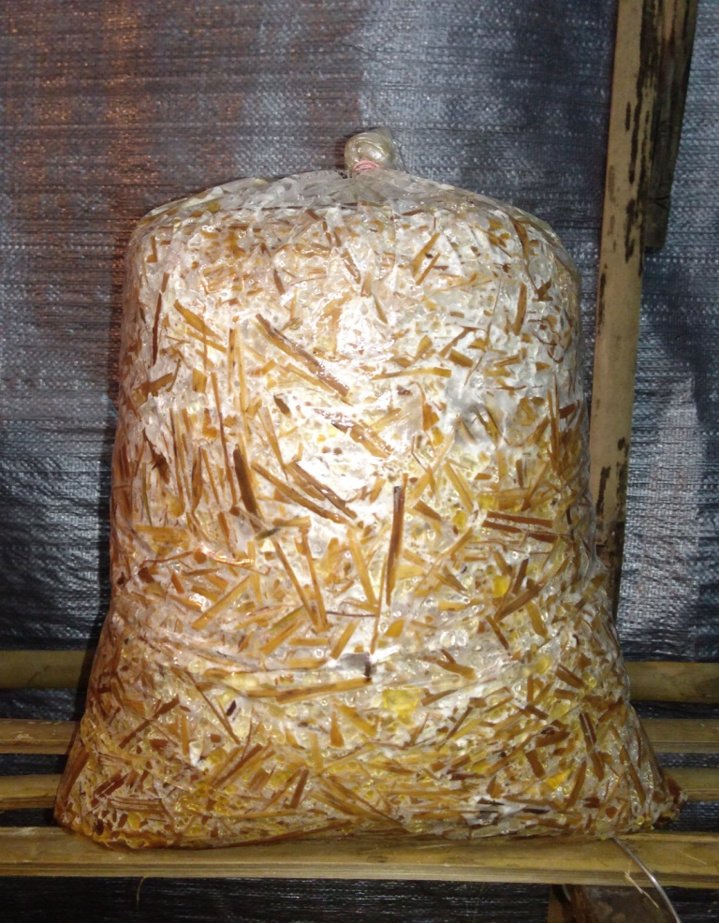

Fig 2: Complete mycelia run
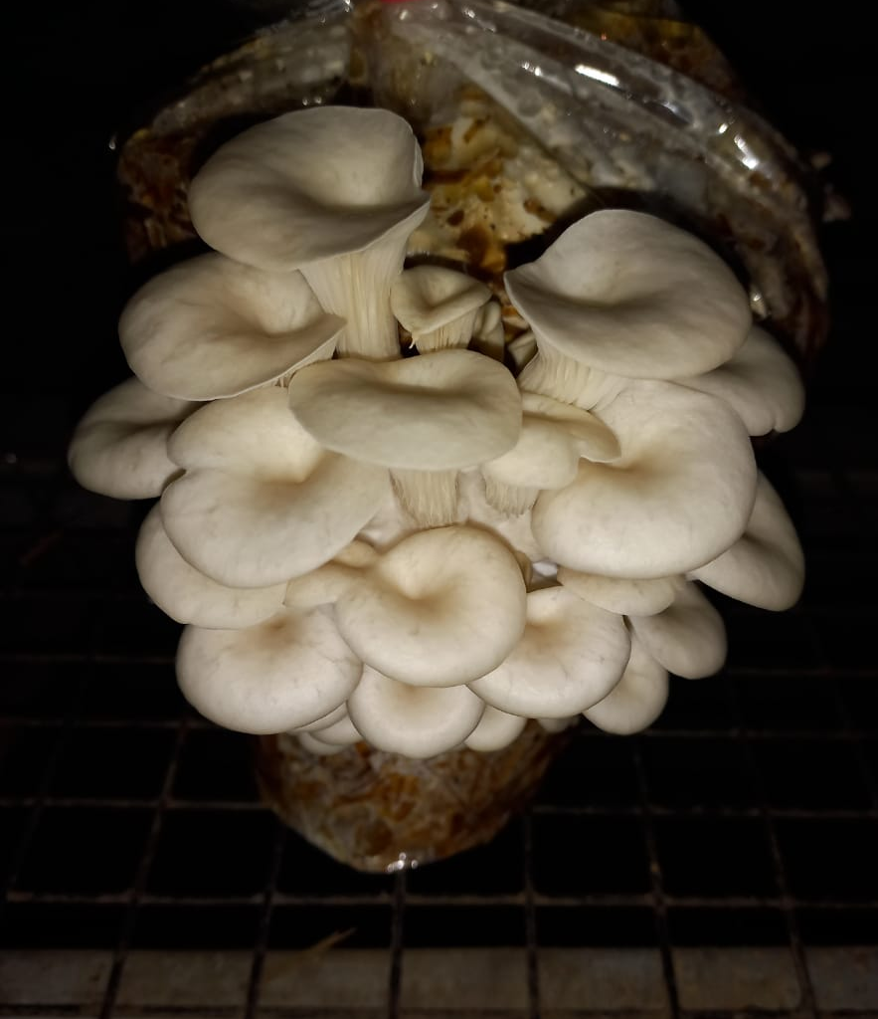
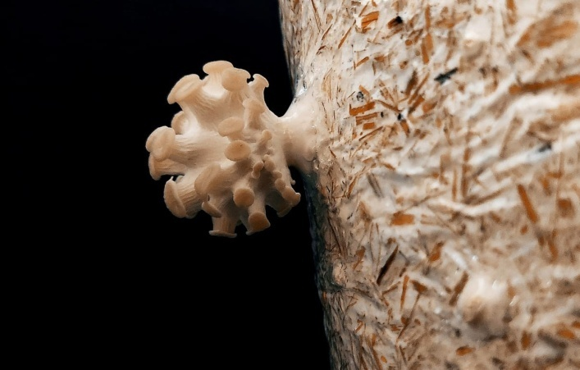

Fig 3: Primordial initiation

Fig 4: Mature fruiting body of Pleurotus ostreatus

DISCUSSION
The present study clearly demonstrates that botanical amendments to the substrate exert a substantial impact on the entire developmental trajectory of Pleurotus ostreatus. In particular, treatments incorporating Allium chinense, Azadirachta indica and other Allium species consistently accelerated spawn colonization, primordia initiation and fruiting body maturation relative to the unamended control.
The superior performance of Allium spp. can plausibly be ascribed to their richness in organosulfur compounds, such as allicin, diallyl disulfide, and related thiosulfinates, which are well documented to exert diverse bioactivities (e.g. antimicrobial, redox modulatory, enzyme-activating) in plant and microbial systems (Jikah et al., 2023). While allicin is often studied for its inhibitory effects on pathogenic fungi (e.g. as an antifungal agent), at appropriately low concentrations in a substrate matrix it may act as a mild elicitor, stimulating adaptive metabolic responses in the mushroom mycelium without exerting outright toxicity (Sarfraz et al., 2020). In such a scenario, the presence of sulfur compounds could drive upregulation of key oxidative enzymes, enhance sulfur metabolism, or prime stress-response pathways, thereby improving hyphal vigor and speed of colonization.
Neem (Azadirachta indica) likewise offers a spectrum of bioactive molecules — notably azadirachtin, limonoids, salannin, nimbin and related triterpenoids — which are widely recognized in plant protection and microbe–plant interface contexts. These compounds may mediate indirect beneficial effects in a mushroom substrate by suppressing opportunistic contaminants or microbial competitors, thus giving P. ostreatus mycelium a competitive advantage. Under reduced microbial load, the mushroom’s vegetative development phase may proceed more efficiently, allowing a shorter colonization period (Sánchez, 2010). Further, some neem metabolites might act as mild growth stimulants or signaling molecules, optimizing nutrient uptake or enzyme secretion during lignocellulose degradation.
Beyond signaling roles or antimicrobial “clean-up,” botanicals may act directly as nutrient supplements. Plant-derived powders or extracts contribute a pool of soluble carbohydrates (e.g. sugars, oligosaccharides), trace elements (e.g. K, Mg, Fe), amino acids or peptides, and phenolic/phenolic glycosides (Kalač, 2016; Bellettini et al., 2019; Mkhize et al., 2022). These compounds can act as co-substrates or cofactors, stimulating enzymatic systems responsible for breakdown of cellulose, hemicellulose and lignin. This in turn accelerates nutrient mobilization and supports a more rapid shift from vegetative to reproductive development. In the literature, substrate supplementation (e.g. with bran, legume wastes, or organic amendments) has been shown to reduce incubation time and enhance yield in P. ostreatus and related species (Mkhize et al., 2022). A specific recent study found that the addition of organic/inorganic supplements to oyster mushroom substrate considerably affected growth and yield, shortening incubation periods (Mistry and Parmar, 2024)
In contrast, botanical treatments such as Curcuma longa (turmeric) and Zingiber officinale (ginger), though rich in beneficial phytochemicals (curcuminoids, gingerols, shogaols), exhibited relatively delayed responses in this study. It is possible that at the concentrations employed, their potent bioactive constituents exerted mild inhibitory or growth retardation effects on the fungal metabolism or enzyme systems. For example, curcumin and related phenolic compounds can act as antioxidants or enzyme inhibitors in certain contexts, possibly interfering with oxidative enzyme activity or microbial respiration when present in excess. Chen et al. (2018) have cautioned that high levels of certain phytochemicals may partially inhibit fungal physiology rather than stimulate it. Similarly, Ocimum sanctum, Mentha spp., and Solanum aethiopicum showed intermediate efficacy — a reflection of their moderate concentrations of bioactive metabolites which may stimulate or inhibit the development depending on dose and context. These findings align with and extend prior reports in the literature (Bellettini et al., 2019) and underscore the potential of botanicals as sustainable, low-cost bio-additives for accelerating mushroom productivity in applied cultivation systems.
CONCLUSION and Future Study
The present investigation provides strong evidence that the incorporation of botanicals into the cultivation substrate exerts a significant positive impact on the growth and developmental cycle of Pleurotus ostreatus. Among the treatments tested, Allium chinense emerged as the most effective bio-additive, drastically reducing the time required for spawn colonization, primordia initiation and fruiting body maturation compared to the untreated control. Its ability to shorten the crop duration by over ten days across multiple parameters highlights its potential to accelerate production cycles, enhance resource use efficiency and ultimately increase cropping intensity within a given timeframe. This acceleration is of particular importance for commercial mushroom growers, as it not only improves turnover but also minimizes risks associated with contamination and environmental fluctuations during prolonged crop durations. In addition, Azadirachta indica and Allium sativum demonstrated notable stimulatory effects, attributable to their rich pool of bioactive metabolites such as alkaloids, flavonoids, sulfur compounds and terpenoids, which may simultaneously act as growth enhancers and protectants against competing microorganisms. Their dual role in supporting fungal metabolism and reducing microbial competition provides a strong basis for their use as sustainable bio-additives in mushroom production systems. Other Allium species, particularly Allium hookeri, also contributed positively, underscoring the broader efficacy of the Allium group in enhancing mushroom growth and yield potential. Conversely, botanicals such as Curcuma longa, Zingiber officinale, Ocimum sanctum, Mentha spp., and Solanum aethiopicum exhibited moderate to limited growth-stimulating effects. While these botanicals still outperformed the untreated control, their relatively slower responses suggest that the concentration, bioavailability and specific biochemical composition of phytochemicals play a decisive role in determining their influence on fungal metabolism. This highlights the importance of dose optimization, appropriate formulation, and targeted application strategies to unlock the full potential of these botanicals in mushroom cultivation.
Overall, the study confirms that substrate enrichment with selective botanicals—particularly Allium chinense, Azadirachta indica, and Allium sativum—can substantially improve the efficiency and sustainability of oyster mushroom production. These findings hold strong practical relevance, as the incorporation of such botanicals provides farmers with cost-effective, eco-friendly alternatives to synthetic chemicals, enabling shorter crop cycles, higher profitability and reduced environmental impact. By promoting organic and sustainable cultivation practices, these botanicals align well with global trends toward cleaner and safer food production systems. Nevertheless, the study also acknowledges certain limitations. The effects of botanicals may vary under different environmental conditions and the optimal concentrations for maximizing growth and yield while avoiding potential inhibitory effects need further refinement. Moreover, large-scale trials under diverse agro-climatic conditions are necessary before the technology can be widely adopted in commercial systems. Future research should therefore focus on investigating scalability under field and industrial conditions, assessing the long-term impacts of botanical supplementation on yield stability and exploring possible improvements in the nutritional, medicinal, and functional quality of mushrooms produced with these natural additives. In addition, integrative studies examining synergistic effects of combined botanicals, as well as their interactions with various agro-waste substrates, could provide deeper insights into designing sustainable, high-yielding cultivation protocols.
ACKNOWLEDGEMENTS
The authors would like to acknowledge Department of Plant Pathology, SHUATS, Prayagraj for the facility and technical support throughout this research.
AUTHORS’ CONTRIBUTIONS: Both authors have contributed towards performing the experiment and compiling the manuscript.
Disclaimer (Artificial intelligence)
Author(s) hereby declare that NO generative AI technologies such as Large Language Models (ChatGPT, COPILOT, etc.) and text-to-image generators have been used during the writing or editing of this manuscript.
REFERENCES
Bellettini, M. B., Fiorda, F. A., Maieves, H. A., Teixeira, G. L., Ávila, S., Hornung, P. S., Júnior, A. M. and Ribani, R. H. (2019). Factors affecting mushroom Pleurotus spp. Saudi Journal of Biological Sciences. 26(4) : 633–646.
Carrasco, J., Zied, D., Pardo-Giménez, A. and Preston, G. M. (2018). Supplementation in mushroom crops and its impact on yield and quality. AMB Express. 8(1) : 146-155.
Chen, W., Gong, L., Guo, Z., Wang, J. and Liu, Y. (2018). Antifungal activity of curcumin against plant pathogenic fungi. Phytopathology. 108(2) : 214–223.
Jikah, T. H., Ma, Z., Wang, J. and Jiang, Y. (2023). Antifungal activity and potential action mechanism of allicin against fungi. Frontiers in Microbiology. 14 : 11-17.
Kalač, P. (2016). Edible mushrooms: chemical composition and nutritional value. Academic Press. https://www.sciencedirect.com/book/9780128044551/edible-mushrooms#book-info
Mistry, R. and Parmar, P. (2024). Effect of different supplementations on growth and yield of oyster mushroom (Pleurotus ostreatus). International Journal of Environment, Agriculture and Biotechnology. 9(2) : 45–52.
Mkhize, S. S., Cedric Simelane, M. B., Mongalo, I. N. and Pooe, O. J. (2022). The effect of supplementing mushroom growing substrates on the bioactive compounds, antimicrobial activity, and antioxidant activity of Pleurotus ostreatus. Biochemistry Research International, 8 (1) : 94-102.
Sánchez, C. (2010). Cultivation of Pleurotus ostreatus and other edible mushrooms. Applied Microbiology and Biotechnology. 85(5) : 1321–1337.
Sarfraz, M., Nasim, M. J., Jacob, C. and Gruhlke, M. C. (2020). Efficacy of allicin against plant pathogenic fungi and unveiling the underlying mode of action employing yeast based chemogenetic profiling approach. Applied Sciences. 10(7) : 25-34.
Sohi, H. S. (1987). Diseases and competitor moulds associated with mushroom culture and their control. Extension Bulletin. 2 : 10-12.

