Contribution of Earth observation data to the management of herder-farmer conflicts in the sub-prefecture of Bouandougou, in the North-West of Ivory Coast

ABSTRACT
This study aims to improve the knowledge of farmers and pastoralists on the management of spatial conflicts through updated information on the dynamics of agriculture-grazing. To achieve this objective, the methodological approach consisted of collecting and processing Landsat satellite images TM, TM+/OLI-TIRS to highlight the dynamics of land cover from 1998 to 2024 in the Bouandougou Sub-Prefecture, on the other hand a socio-economic survey was conducted among the various stakeholders. We obtained performance indicators that are higher than recommended (80% overall accuracy and 75% Kappa coefficient) in the processing of satellite images. The analysis of the dynamics shows that the mosaic shrub savannas annual crops increased by 52.82% from 1998 to 2024, forest islands lost 41.96% of their areas over the same period.
In order to promote peaceful coexistence between farmers and livestock breeders in agro-pastoral regions, the integration of geographic information system tools should be considered to strengthen policy decisions in the management of agro-pastoral conflicts.
Key words: spatial conflicts, dynamic agriculture-grazing, conflicts management, satellite image, land use.

INTRODUCTION
In Africa, relationships between farmers and herders were often characterized by complementarity, cooperation and symbiosis for several centuries (Kate et al., 2015; Bamba et al., 2022). Thus, agricultural products (millet, vegetables, fodder, etc.) were used by herders (food and livestock feed) while farmers used livestock products (meat, milk, manure, etc.) for their own consumption and soil fertilization (Gaye, 2017).
Population growth combined with the effects of climate change and its corollaries (droughts, shortage of arable land, decline in crop yields, etc.), have resulted in the implementation of certain adaptation strategies by farmers and herders which include, among other things: mass migration in search of arable land, anarchic land occupations, mobility in search of regions suitable for transhumance, etc. (Sougnabe, 2003; Bronkhorst, 2012; Tellah et al., 2023). This dynamic has led to an increase in multifaceted conflicts exacerbated by policies of economic interests, religious beliefs or issues of cultural interests and have weakened peace and social cohesion in recent decades on the continent (Kouassi, 2012). Among these many issues, land related conflicts stand out for the scale they have taken in recent years.
In the period 1997-2017, in 16 West African countries, armed conflicts resulted in more than 173,000 civilian deaths per country, of which 10,000 (5.8%) were related to incidents involving pastoralists (IIP) (Krätli and Toulmin, 2020). These incidents involving pastoralists (IIP) include two categories of conflicts, those involving pastoralist groups and militias or insurgent groups on the one hand and those directly related to the practice of agriculture and livestock on the other hand. The latter represent 40% of incidents involving pastoralists.
In Ivory Coast, the breaking of colonial control over land management has allowed public authorities to facilitate access for farmers and migrants, particularly to the main agricultural production factors, namely classified land (Koffié-Bikpo, 2015). The slogan "the land belongs to those who value it" of President Félix Houphouët Boigny in 1963, advocated the reception and settlement of agricultural migrants in rural areas, whether Ivorian or non-Ivorian (Guineans, Burkinabés, Malians, etc.). Thus, their access to land was largely in accordance with administrative authorities and local people. This policy encouraged the influx of agricultural migrants and led to the scarcity of resources over time in rural areas. This has led to the deterioration of social relations instead of being a source of peace and prosperity in rural areas (Koffié-Bikpo, 2015; Oura et al., 2019). The indigenous people, having gradually lost control of their land in the face of the invasion of agricultural migrants, perceive this situation as a threat to the heritage left by their offspring.
Furthermore, the advent of industrial agriculture in Ivory Coast has marked the disruption of management systems that allowed soils sufficient rest for a long period, and to favor agricultural practices based on the conquest of new cultivated land by farmers (Brou and Jean, 2007; Affessi and Gacha, 2016; Fao et al., 2022; Assué et al., 2023). This situation has resulted in the expansion of agricultural areas, and consequently the reduction of grazing areas, the obstruction of access roads to water points in agropastoral regions (Kate et al., 2015; Affessi and Gacha, 2016). However, cohabitation is becoming difficult, creating increased and potentially conflictual spatial competition leading to bloody clashes between farmers and herders (Brou and Jean, 2007; Affessi and Gacha, 2016; Bamba et al., 2022). However, among various forms of conflict, those involving herders and farmers resulted in nearly 4,080 deaths over the period 1997-2017 in Ivory Coast (Krätli and Toulmin, 2020). Added to this is the increase in the number of areas designated as hotspots for herder-farmer conflicts, which increased from two (Abidjan, Sikensi) between 1997-2013 to five regions (Abidjan, Lagune, Jacqueville, Vallée du Bandama and Bouaké) between 2013-2017. Faced with this situation, a reorganization in the management of agro-pastoral areas could contribute to the prevention of possible conflicts and other forms of violence between farmers and herders (Tellah et al., 2023). Indeed, according to Haddouche and Benmansour (2017), remote sensing and GIS are essential in decision-making in the agricultural sector and particularly in the management of agricultural land for the resolution of spatial conflicts. The latter provide information on the former and current state of agricultural land, but also on their evolution over time through future projections. It is in this context that this study is conducted, the general objective of which is to improve the management of conflicts between farmers and herders by providing cartographic data on the dynamics of sites at high risk of conflict in the sub-prefecture of Bouandougou Specifically, it involves producing the land use map of 1998, 2009, 2024 of the sub-prefecture of Bouandougou on the one hand and determining the conflict zones based on the dynamics of land use and the distribution of livestock sites on the other hand.

MATERIAL AND METHODS

Material
This study required the use of spatial data, software, and field equipment.

Spatial Data and Software
A Landsat 5 TM image from 1998, Landsat 7 ETM+ from 2009, and Landsat 9 ETM+/OLI-TIRS from 2024 were used for land cover mapping. These images were supplemented with georeferenced digital layers including road and water networks, administrative entities, and localities in the study area. ENVI 5.3 software was used for spatial analysis and processing of satellite images. QGIS 3.30.1 Desktop software was used for processing and map layout. The Kobotoolbox / Kobocollect applications were used for designing the survey questionnaires, their deployment, and field data collection, respectively. All statistical analyses were performed using Excel 2016 software.

Field Equipment
It consists of a GPS (Global Positioning System) receiver, used for geolocation and recording the geographic coordinates of checkpoints; a machete for clearing passageways; and a smartphone for capturing images and administering survey questionnaires.

Methods
It is primarily based on the use of satellite images to produce land use maps for 1998, 2009, and 2024 for the Bouandougou sub-prefecture and to identify conflict zones based on land use dynamics from 1998 to 2024.

Production of land use maps for 1998, 2009 and 2024
Three high-resolution multispectral images from Landsat 5 TM, Landsat 7 ETM+ and Landsat 9 ETM+ sensors were downloaded from the website https://earthexplorer.usgs.gov of the American platform USGS (United States Geological Survey). The choice of images from these sensors is based on their accuracy, the relevance of their spatial (30 m) and temporal (16 days) resolutions in land cover and land use mapping work, and their color compositions to facilitate the establishment of the land cover map (Coulibaly, 2011; Balestrat et al., 2018). These images then entered a pre-processing process. That of Landsat 5 and 7 level 1, consisted of radiometric and atmospheric correction in order to eliminate anomalies and possible biases recorded during their downloads (Koffi et al., 2018). The FLAASH (Fast Line-of-sight Atmospheric Analysis of Spectral Hypercubes) model was used for this purpose. As for the Landsat 8 level 2 image, it consisted of assembling identical bands of the scenes together to form a larger one (Aka et al., 2022).
After extracting the area of interest, the color composition with the raw bands and the calculation of the biophysical indices (Normalized Vegetation Index “NDVI”, Soil Brightness Index or Normalized Difference Brightness Index “NDBI”) made it possible to highlight certain elements such as vegetation, bare soils or soils with low vegetation cover. The information from the principal component analysis (ACP1-2-3) also made it possible to better discriminate the different types of land use. A field mission was carried out based on this information (N'Da et al., 2008). A sample of coordinates (91 points) of the predefined land use types was integrated into the GPS receiver for verification. During the field mission, the training plots were precisely described to facilitate the classification of the maps as well as their validation. Supervised classification using the Maximum Likelihood (MDV) algorithm was used to develop thematic maps over the study period (Sokeng et al., 2019; Soro et al., 2022). The land use maps of the different periods of the study were validated on the basis of confusion matrix, overall accuracy and kappa coefficient (Kambale et al., 2021; Mengue and Temgoua, 2022). The confusion matrix made it possible to evaluate the classification statistics and the degree of misclassification thematically (Sylla and Hauhouot, 2002). The overall accuracy and Kappa coefficient (K) values obtained confirmed these results Landis and Koch (1977). After validation of the classification, the images are converted from raster mode to vector mode (shapefile) in the QGIS software in order to visualize, interpret and then calculate statistics and the areas of the different land use units for the three periods (1998, 2009 and 2024).

Conflict Areas Based on Land Use Dynamics
To highlight conflict areas based on land use dynamics, survey and spatial data were used. Survey data were collected from seven localities (Bouandougou, Loulou, Safodougou, Badasso, Tabakro, Linguékoro, and Babadougou). These localities were selected based on spatial analysis (satellite images from 1998, 2009, and 2024) and the extent of land use changes occurring in their areas (Agbanou, 2018; Ngo et al., 2018). The survey method is based on semi-structured interviews conducted with 59 farmers and 46 herders, selected randomly so that they could express themselves freely (Dugué et al., 2004). During these interviews, the questions mainly focused on the number of heads, breeding practices, areas exploited and the average number of conflicts per locality. The information from these interviews was overlaid on the land use dynamics maps using QGIS software. The calculation of the rate of change (E) made it possible to evaluate thematically (in hectares and percentage) the evolution of land uses over the study period (Agbanou, 2018; Adjonou et al., 2019; Douffi, 2021).
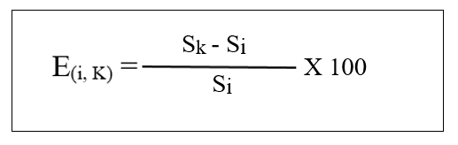
The assessment rate is calculated using the following formula:

(4)

Either: E (i, k) = rate of change (%); Si = area of an occupation category at date t1; Sk = area of an occupation category at date t2 (t2 > t1). Positive values of E(i, k) for an occupation category indicate that there is an extension or evolution of this category. Negative values indicate the regression of the category concerned and values close to zero indicate that the category is relatively stable. Occupation types with the same modes of use (agricultural land or pasture) are grouped together from the merging operation in the QGIS software. Maps of potential conflict zones are then developed based on these new thematic classes. All quantitative analyses were carried out using Excel 2016 software.

RESULTS AND DISCUSSION

Production of land use maps for the Bouandougou sub-prefecture for 1998, 2009, and 2024

Land use types
Visual analysis of the processed images combined with information collected during the field mission identified nine land use types. These are forest islands (FRT_ISL), open wooded savannah forests (OFRT_WSVN), wooded savannahs (WSVN), shrub savannahs (SHR_SVN), shrub savannah mosaics with annual crops (MSHRSVN_AC), perennial cashew crops (P_CHCLT), bare soils with dwellings (BR_GDW), water bodies (WAT_B), and burned sites (BRN_ST).

Assessment and validation of classification
Table I provides information on the performance indicators for the classification of images in the study area. An overall accuracy of 93.61% was recorded for the classification of the 2024 Landsat 9 image. The value of Coefficient Kappa (K) associated with it is 0.92. The 2009 Landsat 7 image classification yielded an overall accuracy of 90.24% and 0.89 for the Kappa (K) index. For the 1998 Landsat 5 image, an overall accuracy of 83.21% and 0.81% for the Kappa coefficient were obtained.
Classification | Sensor | Overall Accuracy  (%) | Kappa Coefficient  (K)
2024 | Landsat 9 ETM+/OLI-TIRS | 93,61 | 0,92
2009 | Landsat 7 TM+ | 90,24 | 0,89
1998 | Landsat 5 TM | 83,21 | 0,81
Table I: Summary of classification performance indicators
The confusion matrices (Tables II, III, and IV) highlight the thematic confusions and the percentages of occupation classes correctly classified in the processing of the 2024, 2009, and 1998 images. Thus, it appears that for the 2024 image, apart from bodies of water, the classes that recorded the highest accuracy values were found in burned sites and bare soils, and in habitation with 99.44% and 98.25%. Furthermore, there was significant thematic confusion between the forest island classes and open forests, wooded savannahs (10.38%); and wooded and shrubby savannahs (4.16%). For the 2009 image, the best-ranked classes are bare soil, dwellings and burnt sites with 99.19% and 98.77% accuracy respectively. On the other hand, the classes open forests wooded savannahs and wooded savannahs, and open forests wooded savannahs and forest islands recorded 22.32% and 15.55% confusion respectively. On the other hand, 97.17 % and 96.16 % accuracy were obtained for shrub savannah and burnt site classes, unlike the forest, wooded savannah and bare soils, habitation and shrub savannah mosaic, annual crops with 27.70 % and 26.90 % respectively for the 1998 image.
Land use  % | FRT_ISL | OFRT_WSVN | WSVN | SHR_SVN | MSHRSVN_AC | P_CHCLT | BR_GDW | BWAT |  | BRN_ST
FRT_ISL | 94,47 | 10,38 | 0,00 | 0,00 | 0,00 | 0,00 | 0,00 | 0,00 |  | 0,00
OFRT_WSVN | 5,43 | 84,83 | 1.97 | 0,19 | 0,00 | 2,01 | 0,00 | 0,00 |  | 0,00
WSVN | 0,11 | 3,66 | 92,26 | 0,74 | 0,09 | 0,50 | 0,00 | 0,00 |  | 0,28
SHR_SVN | 0,00 | 1,02 | 4,16 | 93,88 | 2,49 | 0,13 | 0,00 | 0,00 |  | 0,00
MSHRSVN_AC | 0,00 | 0,00 | 0,00 | 3,15 | 95,84 | 0,00 | 1,75 | 0,00 |  | 0,00
P_CHCLT | 0,00 | 0,10 | 0,66 | 0,09 | 0,00 | 97,37 | 0,00 | 0,00 |  | 0,00
BR_GDW | 0,00 | 0,00 | 0,80 | 1,95 | 1,58 | 0,00 | 98,25 | 0,00 |  | 0,28
BWAT | 0,00 | 0,00 | 0,00 | 0,00 | 0,00 | 0,00 | 0,00 | 100,00 |  | 0,00
BRN_ST | 0,00 | 0,00 | 0,15 | 0,00 | 0,00 | 0,00 | 0,00 | 0,00 |  | 99,44
General Total | 100 | 100 | 100 | 100 | 100 | 100 | 100 | 100 |  | 100
Table II: Classification confusion matrix of Landsat 8 (2024) image
Land use  % | FRT_ISL | OFRT_WSVN | WSVN | SHR_SVN | MSHRSVN_AC | P_CHCLT | BR_GDW | BWAT | BRN_ST
FRT_ISL | 92,98 | 15,55 | 0,70 | 0,00 | 0,00 | 0,18 | 0,00 | 0,40 | 0,57
OFRT_WSVN | 3,38 | 60,98 | 13,92 | 9,54 | 0,20 | 1,56 | 0,00 | 0,00 | 0,66
WSVN | 3,51 | 22,32 | 84,68 | 0,42 | 0,04 | 0,27 | 0,10 | 0,00 | 0,00
SHR_SVN | 0,00 | 0,58 | 0,00 | 87,24 | 0,92 | 0,00 | 0,00 | 0,00 | 0,00
MSHRSVN_AC | 0,00 | 0,50 | 0,00 | 2,10 | 96,99 | 0,00 | 0,71 | 0,00 | 0,00
P_CHCLT | 0,13 | 0,07 | 0,70 | 0,14 | 0,00 | 97,99 | 0,00 | 0,00 | 0,00
BR_GDW | 0,00 | 0,00 | 0,00 | 0,56 | 1,85 | 0,00 | 99,19 | 0,00 | 0,00
BWAT | 0,00 | 000 | 0,00 | 0,00 | 0,00 | 0,00 | 0,00 | 99,20 | 0,00
BRN_ST | 0,00 | 0.00 | 0,00 | 0,00 | 0,00 | 0,00 | 0,00 | 0,40 | 98,77
General Total | 100 | 100 | 100 | 100 | 100 | 100 | 100 | 100 | 100
Table III: Classification confusion matrix of Landsat 7 (2009) image

FRT_ISL : Forest Island; OFRT_WSVN: Open Forest wooded savannah; WSVN : Wooded savannah; SHR_SVN : Shrub savanna; MSHRSVN_AC : Mosaic shrub savannah annual crop; P_CHCLT : Perennial cashew culture; BR_GDW : Bare ground dwelling; BWAT : Body of water; BRN_ST : Burnt site

Table IV: Classification confusion matrix of Landsat 5 (1998) image
Land use  % | FRT_ISL | OFRT_WSVN | WSVN | SHR_SVN | MSHRSVN_AC | P_CHCLT | BR_GDW |  | BWAT | BRN_ST
FRT_ISL | 69,59 | 17,62 | 0,58 | 0,00 | 0,00 | 10,00 |  | 0,00 | 0,00 | 1,52
OFRT_WSVN | 27,70 | 6476 | 4,09 | 0,00 | 0,00 | 7,14 |  | 0,00 | 0,00 | 0,00
WSVN | 0,00 | 15,42 | 88,30 | 1,89 | 0,00 | 0,00 |  | 0,00 | 0,00 | 1,52
SHR_SVN | 0,00 | 0,00 | 5,26 | 97,17 | 1,04 | 0,00 |  | 0,51 | 0,00 | 0,00
MSHRSVN_AC | 0,00 | 0,00 | 0,00 | 0,47 | 80,70 | 0,00 |  | 26,90 | 0,00 | 0,00
P_CHCLT | 2,70 | 2,20 | 0,00 | 0,00 | 0,00 | 82,86 |  | 0,00 | 0,00 | 0,00
BR_GDW | 0,00 | 0,00 | 0,00 | 0,47 | 18,26 | 0,00 |  | 72,59 | 0,00 | 0,00
BWAT | 0,00 | 0,00 | 0,00 | 0,00 | 0,00 | 000 |  | 0,00 | 100,00 | 0,00
BRN_ST | 0,00 | 0,00 | 1,75 | 0,00 | 0,00 | 0,00 |  | 0,00 | 0,00 | 96,96
General Total | 100 | 100 | 100 | 100 | 100 | 100 |  | 100 | 100 | 100
FRT_ISL : Forest Island; OFRT_WSVN: Open Forest wooded savannah; WSVN : Wooded savannah; SHR_SVN : Shrub savanna; MSHRSVN_AC : Mosaic shrub savannah annual crop; P_CHCLT : Perennial cashew culture; BR_GDW : Bare ground dwelling; BWAT : Body of water; BRN_ST : Burnt site

Land Use from 1998 to 2024
Land use statistics from 1998 to 2024 are shown in Table V. It appears that in 1998, land use in the Bouandougou sub-prefecture was largely dominated by wooded savannah, accounting for 36.73% of the total area, followed by open forests, wooded savannahs, and shrub savannahs, with 16.62% and 17.94% of the total area. On the other hand, the burnt site and water body categories only occupied 1.89% and 0.21% of the total area. However, it is noted that in 2009, the open forest, wooded savannah category occupied nearly 30% of the total area, followed by shrub savannahs, wooded savannahs, and perennial cashew crops, with 23.78%, respectively. 16.32% and 14.44% of the total surface area, the water body and bare land housing categories occupy less surface area, i.e. 0.21 and 1.49% of the total surface area. In 2024, shrub savannahs and wooded savannah open forests were the most dominant in terms of land use, accounting for 26.21% and 26.08% of the total area. The forest islands, burnt sites, and water bodies classes represented only 2.84%; 1.01% and 0.47% of the total area.
Table V: Summary of land use statistics for the years 1998, 2009 and 2024
Land use | Yer 1998 |  | Year 2009 |  | Year 2024
Land use | Super (ha) | Prop (%) | Sup (ha) | Prop (%) | Sup (ha) | Prop (%)
FRT_ISL | 11522,9 | 9,01 | 5 871,05 | 4,59 | 6 687,65 | 2,84
OFRT_WSVN | 21262 | 16,62 | 37 919,43 | 29,64 | 61 420,43 | 26,08
WSVN | 46987,9 | 36,73 | 20 873,22 | 16,32 | 34 990,48 | 14,86
SHR_SVN | 22946,9 | 17,94 | 30 421,90 | 23,78 | 61 727,83 | 26,21
MSHRSVN_AC | 8319,94 | 6,5 | 8 383,94 | 6,55 | 14 406,73 | 6,12
P_CHCLT | 6605,59 | 5,16 | 18 478,39 | 14,44 | 48 594,79 | 20,63
BR_GDW | 7611,54 | 5,95 | 1 907,55 | 1,49 | 4 222,44 | 1,79
BWAT | 266,882 | 0,21 | 271,34 | 0,21 | 1 114,44 | 0,47
BRN_ST | 2414,68 | 1,89 | 3 811,68 | 2,98 | 2 380,63 | 1,01
FRT_ISL : Forest Island; OFRT_WSVN: Open Forest wooded savannah; WSVN : Wooded savannah; SHR_SVN : Shrub savanna; MSHRSVN_AC : Mosaic shrub savannah annual crop; P_CHCLT : Perennial cashew culture; BR_GDW : Bare ground dwelling; BWAT : Body of water; BRN_ST : Burnt site

Figures 1, 2, and 3 illustrate the spatial distribution of land use types in 1998, 2009, and 2024 in the Bouandougou sub-prefecture.
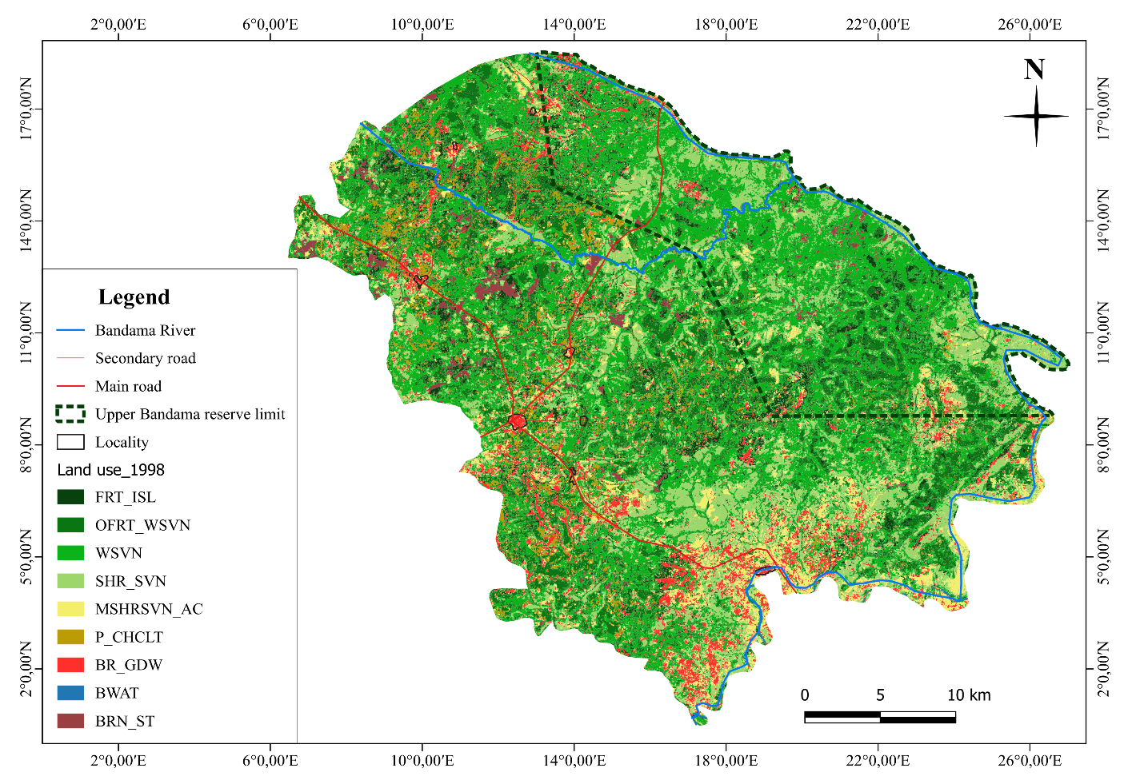

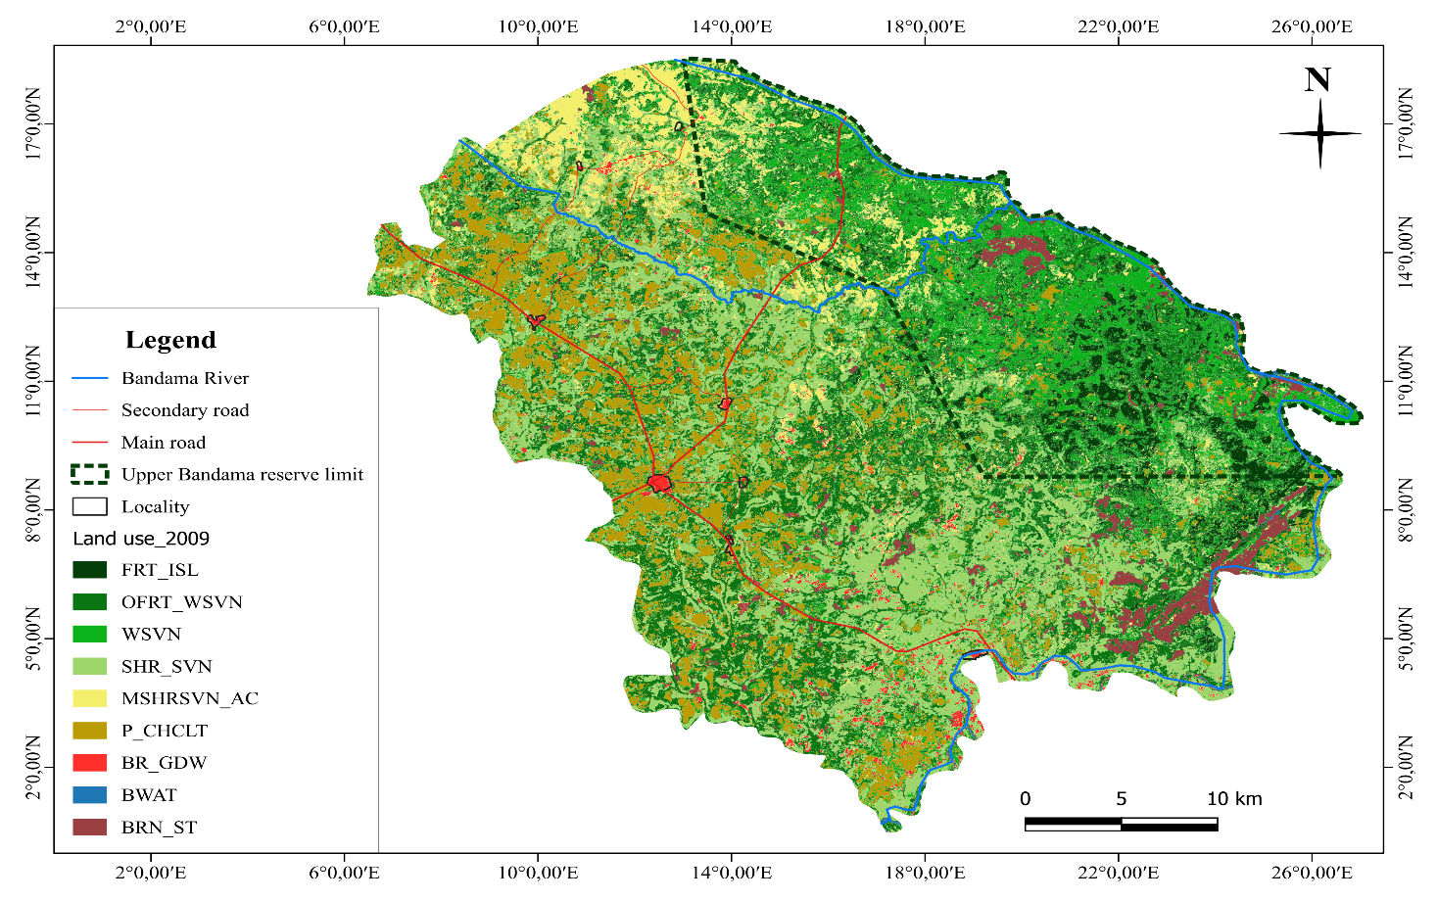
Figure 1: Land use map of Bouandougou sous-prefecture in 1998

Figure 2: Land use map of the Bouandougou sub-prefecture in 2009
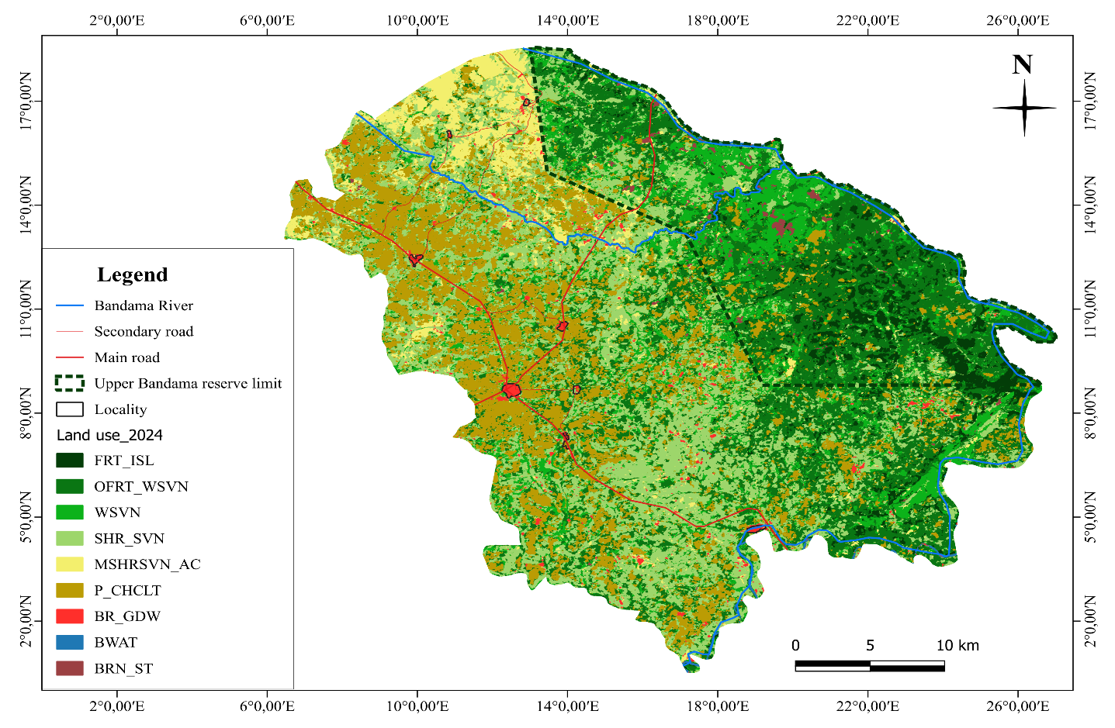

Figure 3: Land use map of the Bouandougou sub-prefecture in 2024

Conflict zones based on land use dynamics

Land Use Dynamics from 1998 to 2024
Land use dynamics were highlighted by the rate of change in land use between 1998 and 2024. Three scenarios were observed: stability, regression, and progression of a land use class over time. Table VI provides a general illustration of this dynamic. It appears that the open forest and wooded savannah class increased by 78.34% of its initial area between 1998 and 2009. This was followed by the burnt site and shrub savannah classes with 57.85% and 32.58%. In contrast, the bare soil dwellings, wooded savannah, and forest patches classes experienced significant declines in area, by 74.94%, 55.58%, and 49.05%, respectively. On the other hand, the shrub savannah mosaic classes and water bodies remained almost stable (0.77 and 1.67%).
It is noted that between 2009 and 2024, all classes experienced an increase in area except for burn sites 37.54 % of their total areas. However-, it is important to note that the increase in area of the mosaic classes shrub savannah annual crop, wooded savannahs and open forests woodes savannahs was more important, i.e. 71.84; 67.63 and 61.98% of their areas. Regarding the period 1998-2024, the classes forest islands bare soils dwellings, wooded savannahs and burnt sites lost respectively 41.96%; 29.41%; 10.12% and 0.30% of their total areas in the profile of mosaics shrub savannahs annual crops, perennial crops cashews, open forests wooded savannahs, shrub savannahs whose areas increased by 52.82%; 36.40%; 35.51% and 34.56%.

Table VI: Evolution of land use classes from 1998 to 2024
Use class | Dynamic
Use class | 1998-2009 |  | 2009-2024 |  | 1998-2024
Use class | Surface (ha) | % Evolution | Surface (ha) | % Evolution | Surface (ha) | % Evolution
FRT_ISL | - 5 651,86 | - 49,05 | 816,61 | 13,91 | - 4 835,25 | - 41,96
OFRT_WSVN | 16 657,39 | 78,34 | 23 500,99 | 61,98 | 40 158,38 | 35,51
WSVN | - 26 114,67 | - 55,58 | 14 117,26 | 67,63 | - 11 997,41 | - 10,12
SHR_SVN | 7 475,00 | 32,58 | 31 305,93 | 10,91 | 38 780,93 | 34,56
MSHRSVN_AC | 64,00 | 0,77 | 6 022,79 | 71,84 | 6 086,79 | 52,82
P_CHCLT | 11 872,81 | 18,74 | 30 116,39 | 16,98 | 41 989,20 | 36,40
BR_GDW | - 5 703,99 | - 74,94 | 2 314,89 | 12,35 | - 3 389,10 | - 29,41
BWAT | 4,46 | 1,67 | 843,10 | 31,72 | 847,56 | 7,36
BRN_ST | 1 396,99 | 57,85 | -1 431,04 | - 37,54 | - 34,05 | - 0,30

FRT_ISL : Forest Island; OFRT_WSVN: Open Forest wooded savannah; WSVN : Wooded savannah; SHR_SVN : Shrub savanna; MSHRSVN_AC : Mosaic shrub savannah annual crop; P_CHCLT : Perennial cashew culture; BR_GDW : Bare ground dwelling; BWAT : Body of water; BRN_ST : Burnt site

Potential conflict zones based on land use dynamics from 1998 to 2024
Figure 4 provides a visual understanding of the dynamics of agricultural land and pastureland. Areas designated as potentially conflict zones are characterized by the presence of pastureland in portions of agricultural land use, on the one hand, and the presence of the river in these same areas, on the other. From 1998 to 2024, we observe an expansion of agricultural land use at the expense of pastureland over time. Agricultural land use, which was concentrated only in the southern and southeastern parts of the country in 1998, had practically invaded almost the entire sub-prefecture by 2024. The transformation of pastureland into agricultural land over time leads to restricted livestock mobility and competition for the same resources (water and land). Furthermore, a significant reconstitution of forests is also observed over time towards the north-eatern and south-eatern part of the sub-prefecture. The low presence of grass cover in these forest (straying, loss, etc.), consequently the crops found there are more often spared from damage.
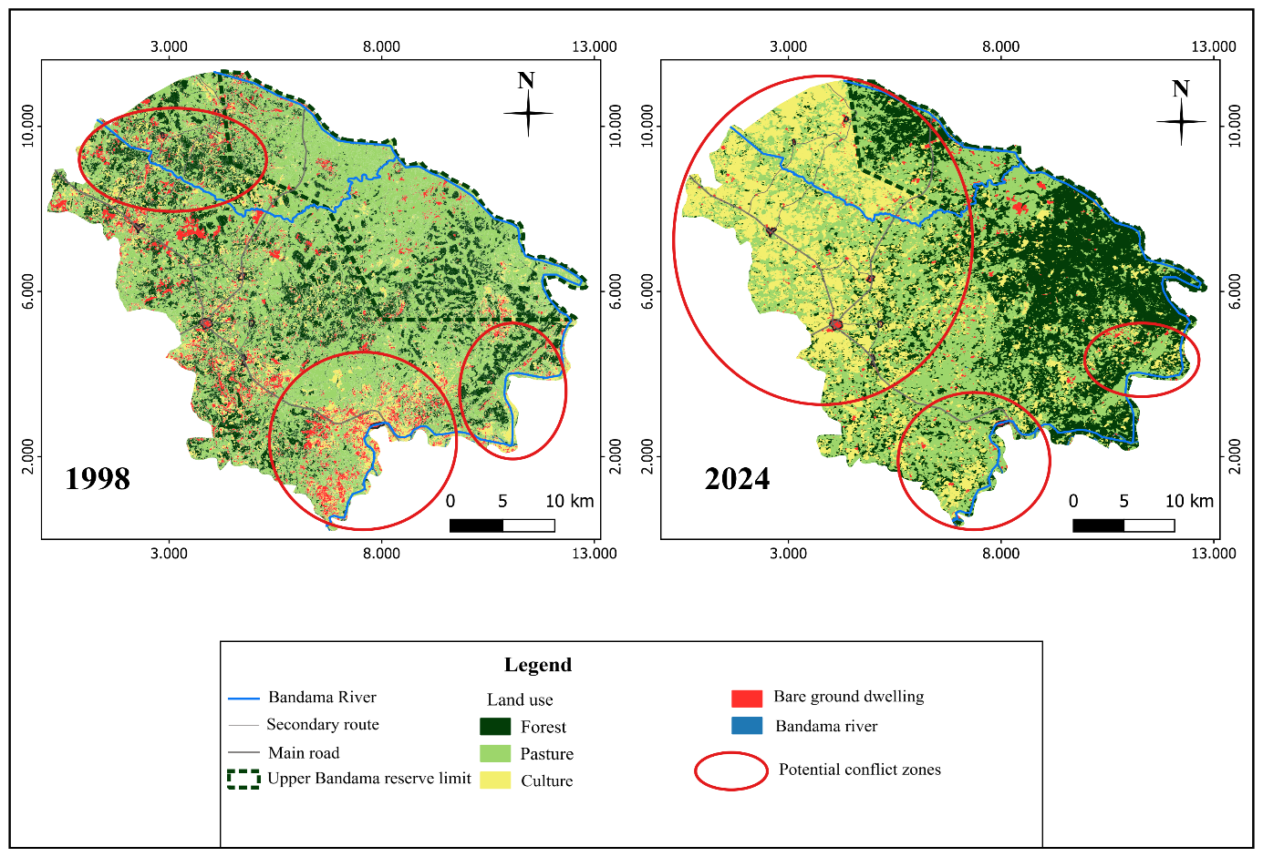

Figure 4: Map of conflict zones based on land use dynamics from 1998 to 2024

Spatial distribution of potential conflict zones based on the average number of animals per locality
Figure 5 shows a strong predominance of agricultural occupations from the potentially less conflict-prone zone to the potentially more conflict-prone zone. The spread of agricultural occupations across the pastures and the presence of the river are imminent factors of conflict in the potentially conflict-prone zone. This partial presence of farms in the pastures obstructs the passage of livestock to graze. In the less conflict-prone area, there is a dominance of pastures and forest formations over farms, which facilitates the mobility of livestock in this area. The potentially more conflict-prone area is characterized by fragmented pastures and a strong presence of farms. However, farms that are not under strict surveillance in this area are constantly confronted with damage from livestock.
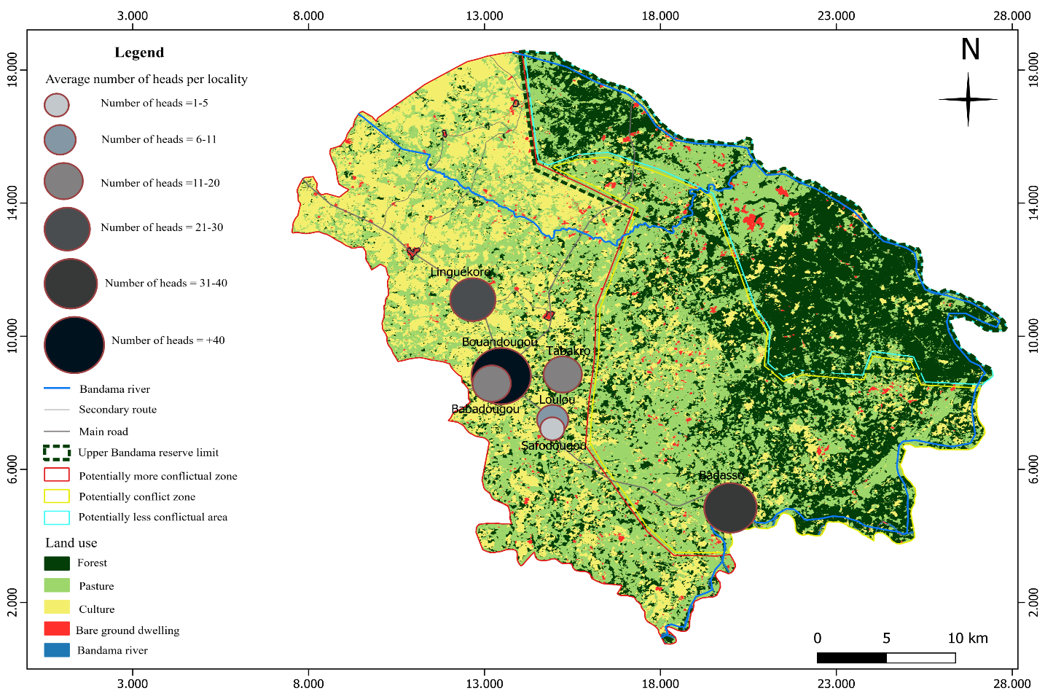
The survey results show that the average number of heads per locality varies from 1 to more than 40 heads. In terms of the average number of heads per locality, the largest was reported in the locality of Bouandougou with more than 40 heads. This locality is quite distant from the Bandama River on both sides (north and southeast) compared to the locality of Badasso whose reported number of heads is between 31 and 40. The latter is the closest to the river compared to the other localities surveyed (Bouandougou, Loulou, Safodougou, Tabakoro, Linguékoro and Babadougou). Several respondents from the said locality emphasized that local transhumance is the most widespread livestock practice in this area, with less monitoring of herds during the dry season. As for the locality of Linguékoro which is close to the northern part of the river, the average number of heads reported is 21 to 30. There is a significant fragmentation of pastures in relation to agricultural occupations. Cashew is the main crop with the association of market gardening crops (onion, tomato, salads, etc.) during the dry season. In the localities of Tabakro, Babadougou, Loulou and Safodougou whose average numbers of heads are respectively 11-20; 6-10 and 1-5, there is also a significant occupation of both farms and pastures. It is important to note that around these localities, we noted the presence of some temporary water reservoirs which serve as a source of watering for the herds.

Figure 5: Spatial distribution of potential conflict zones based on the average number of heads per locality

3.4. Validation of conflicts
The overlay of conflict survey data on the reference occupation map (map 2024) was used to validate conflict zones. Figure 6 shows that the average number of conflicts varies from 1 to 9 per year. However, a significant number of conflicts (7 to 9 conflicts per year) was recorded in the locality of Linguékoro and Badasso, located in the potentially most conflict-prone and conflict-prone zone. In addition to the proximity of the locality of Linguékoro, along the river, is characterized by the scattered distribution of pastures across agricultural lands. The town of Badasso, located in the potentially conflict zone, has small farms visible on the riverbank. Respondents from this town emphasized that agricultural and livestock practices are largely dependent on the Bandama River during the dry season. Survey data show that the number of conflicts recorded in the towns of Tabakro and Bouandougou ranges from 4 to 6 per year. It is also noted that these towns are located in the zone designated as potentially more conflict-prone. Regarding the towns of Loulou, Babadougou, and Safodougou, also located in the potentially more conflict-prone zone, the number of conflicts recorded is 1 to 3 per year. Crops located near transhumance routes are the most exposed to livestock damage. It is important to note that this situation of agriculture-pasture mosaic means that conflicts are more accentuated in these localities.
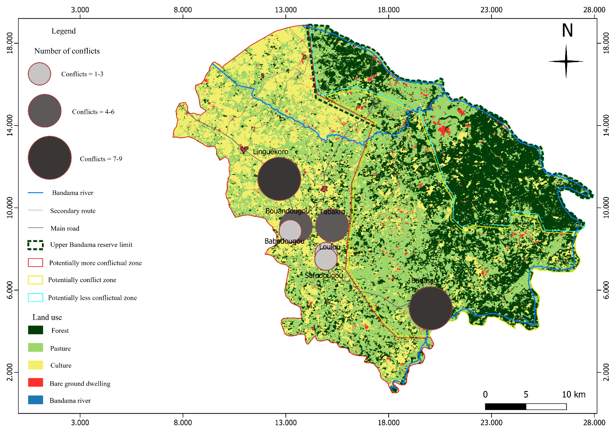

Figure 6: Spatial distribution of conflicts
DISCUSSION
The maximum likelihood classification approach achieved an overall accuracy of 93.61% for the 2024 Landsat 9 ETM+/OLI-TIRS image; 90.24% for the 2009 Landsat 7 TM+ image; and 83.21% for the 1998 Landsat 5 TM image. Their associated Kappa (K) values are 0.92, 0.89, and 0.81, respectively. These results are slightly similar to those obtained by Yao (2019), who studied the dynamics and ecological value of vegetation using Landsat TM, ETM+, and OLI images in the sub-Sudanese sector in northwest Ivory Coast, obtaining 94.53%, 91.05%, and 94.75%. Pontus (2000) mentioned that the Kappa coefficient (K) is a performance indicator in satellite image processing. Its value is considered good and usable from 75%. Indeed, the results of our land use mapping work are statistically satisfactory.
As for thematic confusion, the most significant was noted with the classification of the Landsat 5 TM image of 03/06/1998. These confusions are observed between the classes forest islands and open forests, wooded savannahs and the classes bare soils, dwellings and mosaics, shrub savannahs, annual crops. These two situations are explained, on the one hand by the almost identical reflectance patterns of these two formations linked to the regeneration of leaves at the beginning of the rainy seasons. But also, by the fact that farmers develop their farms during this same period. The dynamics analysis made it possible to assess the evolution of the different land use categories from 1998 to 2024 in the sub-prefecture of Bouandougou. The results of our study showed that the mosaic classes shrub savannahs, annual crops increased by 52.82% of their total areas between 1998 and 2024, while the forest island class lost 41.96% of its area during the same period. This considerable regression of forest areas opposed to the increase in agricultural areas could be explained by the adoption of new agricultural practices by farmers or the change in preferred area of certain crops such as cashew nuts. Indeed, authors such as N'Da et al. (2009); Tiesse et al. (2017) have shown that the increase in agricultural areas is indeed the main factor in the reduction of forest areas. Open forests, wooded savannahs and burnt sites have seen an increase of 78.34 and 57.85% of their areas, unlike bare soils, habitation and wooded savannahs which have lost respectively 74.94 and 55.58% of their areas during the period 1998-2009. This progressive evolution of open forests, wooded savannahs can be linked to the ban on all forms of exploitation in the Haut Bandama fauna and flora reserve, located in the northeastern and eastern part of our sub-prefecture.
Tra Bi (2013) mentioned this observation in his study on the impact of human activities on vegetation and land use through the use of remote sensing and attests that human pressure is at the origin of the degradation of the vegetation cover. The highest rate of progression was noted in the mosaic shrub savannah annual crop class with 71.84% of their areas, while the area of burned sites was reduced by 37.54% during the period 2009-2024. This reduction in the area of burned sites is mainly explained by the establishment of new farms and the transformation of old ones. In addition to these findings, the areas designated as potentially conflicting based on agricultural occupations were largely concentrated towards the southern and southeastern part of the sub-prefecture in 1998. These areas are almost present throughout the sub-prefecture in 2024, with a high concentration of agricultural occupations towards the western and northwestern part. This situation could also be due to the settlement of agricultural migrants in Bouandougou following the military-political crises that Ivory Coast experienced in 2002, which led to the massive displacement of urban dwellers to rural areas. UNOWAS (2018), in its report on pastoralism and security in West Africa and the Sahel, stated that agriculture competes with livestock farming when land has high crop potential.
The Bouandougou sub-prefecture is experiencing parallel dynamics between agriculture and livestock farming. These two activities, which require the same resources (water, land), which are often limited, give rise to conflicts between farmers and herders. Our study revealed that the highest number of conflicts was recorded in the localities of Linguékoro and Badasso. These two localities, in addition to their proximity to the Bandama River, also note fragmentation of pastureland. According to Assi et al. (2022); Gnanvi (2024), the competitive relationship for space and water poses serious problems of cohabitation between farmers and livestock breeders in rural areas. It should be noted that agriculture and livestock breeding are the main income-generating activities for the populations of the aforementioned localities.

CONCLUSION
This study highlighted the evolution of different forms of land use over time and space. Based on the results, digital image processing combined with ground truth data made it possible to identify nine land use classes, including: forest patches, open forests, wooded savannahs, wooded savannahs, shrub savannahs, shrub savannah mosaics, annual crops, perennial cashew crops, bare soils and housing, bodies of water, and burned sites. The image processing performance evaluation yielded satisfactory results for the different dates (1998, 2009, 2024), with the respective overall accuracy values: 83.21%, 90.24%, and 93.61%, and the associated Kappa (K) coefficients are 0.81; 0.89 and 0.92.
The analysis of the dynamics showed that the area of forest patches was reduced by 41.96% between 1998 and 2024. On the other hand, that of shrub savannah mosaics annual crops increased by 52.82%, the area of open forests, wooded savannahs and burnt sites increased by 78.34 and 57.85% while bare soils and wooded savannahs lost 74, 94% and 55.58% of their areas between 1998 and 2009. On the other hand, burnt sites declined by 37.54% of their areas between 2009 and 2024, the shrub savannah mosaics, annual crops and wooded savannahs gained respectively 71.84 and 67.63% of their areas over the same period. A large number of violent conflicts have been recorded in localities near the river.
Despite the results obtained in this study, it would be interesting to consider a prospective land use modeling study for the establishment of transhumance corridors in the Bouandougou sub-prefecture.
In summary, we make the following recommendations:
- promote the settlement of domestic livestock during the rainy season or create grazing reserves for breeders in the sub-prefecture
- implement a sustainable development policy for the agro-pastoral sector.

Disclaimer (Artificial intelligence)
Option 1:
Author(s) hereby declare that NO generative AI technologies such as Large Language Models (ChatGPT, COPILOT, etc.) and text-to-image generators have been used during the writing or editing of this manuscript.
Option 2:
Author(s) hereby declare that generative AI technologies such as Large Language Models, etc. have been used during the writing or editing of manuscripts. This explanation will include the name, version, model, and source of the generative AI technology and as well as all input prompts provided to the generative AI technology
Details of the AI usage are given below:
1.
2.
3.

REFERENCES
Adjonou, K., Bindaoudou, IAK., Idohou, R., Salako, V., Kakaï RG., & Kokou, K. (2019). Satellite monitoring of the spatio-temporal dynamics of land use in the Mono transboundary biosphere reserve between Togo and Benin from 1986 to 2015. Hal Open Science, 2(7), 1-25.
Affessi, AS. & Gacha, F.G. (2016). Determinants of the recurrence of conflicts between Baoulé farmers and Fulani herders in the Gbêkê region (Côte d’Ivoire). African Agronomy, 27(3), 315-24.
Agbanou, BT. (2018). Land Use Dynamics in the Natitingou-Boukombé Sector (Northwest Benin): From Diachronic Analysis to Prospective Modeling. Doctoral Thesis, University of Abomey-Calavi, Benin, 271p.
Aka, KSR., N'Da, DH., Koffi, N., & Bohoussou, NC. (2022). Comparative Study of Sentinel-2 and Landsat-8 Oli in the Assessment of Land Use at the Azagny Ramsar Site, Southern Côte d'Ivoire. Africa Science, 20(5), 48-63.
Assi, TM., Djessou, FMHET., & Koné, KD. (2022). Relationships between Farmers and Herders in the Context of Climate Change: Case of the Boundiali Region in Northern Côte d'Ivoire. 16th Social Science Research Days, December 15-16, 2022, Côte d'Ivoire, pp. 1-18.
Assué, Y.J.A., N’Gomory, K.F., & Kouassi, K.C.V. (2023). Dynamics of cashew cultivation and risk of food insecurity in the sub-prefecture of Katiola (Côte d'Ivoire). Europan Scientific Institute, 4(4), 441-461.
Balestrat, M., Chéry, JP., Valette, E., & Barbe, E. (2018). Monitoring land cover and land use changes for understanding peri-urban dynamics, Montpellier (France), 19p.
Bamba, L., Kouakou, K.I. & Traoré, N.D.M. (2022). Agro-pastoral conflicts in Côte d’Ivoire (Case of Bouna). International Journal of Management Sciences, 5(2), 875-901.
Barima, YSS., Barbier, N., Bamba, I., Traore, D., Lejoly J., & Bogaert J. (2009). Landscape dynamics in the forest-savanna transition environment of Côte d’Ivoire. TROPICAL WOODS & FORESTS, 299(1), 15-25.
Bronkhorst, S. (2012). Resource scarcity and conflict between pastoralists and farmers in South Kordofan, Sudan. Climate Migrations, 88(3), 112-133.
Brou, YT., & Jean L. C. (2007). Peasant visions of environmental in Ivory Coast. Annales de Geographie, 116(653), 65-87.
Coulibaly, T. (2011). Spatial distribution, management and exploitation of groundwater: the case of the Katiola department, savannah region of Côte d’Ivoire. Doctoral thesis, Université Paris Est, Paris, France, 142p.
Dugué, P., Koné, F. R., Koné G., & Akindes, F. (2004). Social organization and resource use: Agricultural production and livestock in the central cotton basin of Côte d’Ivoire: A history. Cahiers Agricultures, 504(9), 504–509.
Douffi, K.G.C. (2021). Spatial distribution and dynamics of the palmyra palm population, Borassus Aethiopum Mart, using remote sensing and geographic information systems (GIS) in the Lamto reserve (central Côte d’Ivoire). Doctoral Dissertation, Nangui Abrogoua University, Abidjan, Côte d'Ivoire, 253p.
FAO. European Union., & CIRAD. (2022). Food System Profile - Côte d'Ivoire: Enabling the Sustainable and Inclusive Transformation of Our Food Systems. National Report, Côte d'Ivoire, 52p.
Gnanvi, AD. (2024). Conflicts between Farmers and Herders in the Municipality of Djidja: A Situational Analytical Approach. Editions Francophones Universitaires d'Afrique, 5(3), 53-75.
Gaye, JBS. (2017). Conflicts between Farmers and Herders in a Context of Asymmetric Threats in Mali and Burkina Faso. Green Eyez Design SARL, Sub-Saharan Africa Competence Center, Dakar-Fann (Senegal), 36p.
Haddouche, D., & Benmansour, N. (2017). Mapping of Agricultural Land Use. Case of the Municipality of Tabia, Wilaya of Sidi Bel Abbés. Agriculture and Forestry Journal, 1(1), 62-67.
INS. (2015). Directory of Localities (BERE Region). General Population and Housing Census Report (RGPH), Béré (Côte d'Ivoire), 29p.
Kambale, NN., Dramani, R., Mulondi, KG., Muhindo, S W., Biaou, SSH., & Natta K.A. (2021). Spatio-temporal dynamics of land use and forest cover in the Fresh Highlands of Lubero (DR Congo), 45(4), 641-58.
Kate, S., Hounmenou, GC., Amagnide, A., Houndonougbo, PV., Tchobo, A., Tente, B., Diarra, S. & Sinsin, B. (2015). Climate change, current mechanism for preventing and managing conflicts between farmers and herders in agro-pastoral cotton-producing areas in northern Benin: the case of the Banikoara commune. African Crop Science Journal, 23(1), 1-21.
Koffi, D K., Drabo, O., Ouoba, AP., Dapola, CED., & Tchamie TTK. (2018). Land use analysis for monitoring landscape changes in the Ouatchi territory in southeastern Togo between 1958 and 2015. Cahiers du cerleshs, 55(2), 203-228.
Koffié-Bikpo, CY., & ADAYE, AA. (2015). Geography of land conflicts in the region n of Bas-Sassandra, Côte d'Ivoire. Geography Review of the University of Ouagadougou, 1(4), 1-21.
Kouassi, KA. (2012). Land Conflict Management in Gwa Country, Côte d'Ivoire. EL-Jabamol, 4, 322-336.
Krätli, C., & Toulmin, S. (2020). Conflict between Farmers and Herders in Sub-Saharan Africa. Research Report, London, 115p.
Landis, JR., & Koch, GG. (1977). The Measurement of Observer Agreement for Categorical Data Published by: Biometric, 33(1), 159-174.
Lecerf R. (2008). Monitoring land cover and use changes of anthropogenic and climatic origin at the regional scale by medium-resolution remote sensing (Application to Brittany). Doctoral thesis, University of Rennes 2, European University of Brittany, Rennes (France), 327p.
Mbevo, FP., Tchindjang, M., & Fendoung, EF. (2015). Remote sensing analysis of the vulnerability of the Mabe mangrove reserve to climate change. Territoire d’Afrique, 2100(9), 53-65.
Mengue, NY., & Temgoua, YW. (2022). Quantifying soil dynamics for agricultural use in the city of Yaoundé (CAMEROON). Revue Espaces Africains, 1(5), 124-149.
N'Da, HD., N'guessan, EK., Egnankou, MW., & Affian, K. (2009). Contribution of remote sensing to monitoring deforestation in Marahoué National Park (Côte d'Ivoire). Teledetection Review, 8(1), 17-34.
N'Da, DH., Yao, CYA., Kouakou, ENG., Kone, M., & Sagne, YC. (2008). Analysis of the Floristic Diversity of Marahoué National Park, Central-West Côte d'Ivoire. Africa Science, 04(3), 552-579.
Ngo, M R., Sanou, P., Toure, I., Tchindjang, M., Makak, JS. (2018). Diachronic analysis of land use for the design of a geo-referenced database for monitoring territorial dynamics in the rural commune of Koumbia in Burkina Faso. Scientific and Technical Review of Forests and Environment of the Congo Basin, 10(4), 23-35. https://doi.org/10.5281/zenodo.1215893
Ouadjane, Y., Yacine, EAA., Benzougagh, B., Nassiri, L., & Ibijbijen J. (2021). Water erosion risk assessment and mapping of vulnerable areas using the Rusle method coupled with GIS and remote sensing in the Agoudal watershed upstream of the Imilchil Valley (Central High Atlas, Morocco). European Scientific Journal, 17(21), 66.
Pontius, GJR. (2000). Maps, quantification error versus location error in categorical comparison. Photogrammetric Engineering and Remote Sensing, 66(8), 1011-1016.
Sokeng, JVC., Lucette, AY., Vincent, A.T., Fernand, KK., CORGNE, S., Rudant, JP., Ouattara, TA., Sorho, FM., Yao, N., & Kouame, NP. (2019). Remote sensing monitoring of land use for the promotion of integrated agriculture and forestry development in Côte d'Ivoire. hal.science, 3(1), 1-18.
Oura, KR., Kouassi, KS., & Koffi, SY. (2019). Involuntary population displacement and land conflicts in Ayaou-Sokpa (Ayaou-Sran sub-prefecture, central Côte d’Ivoire). European Scientific Journal, 2(15), 85-102.
Soro, GE., Anouman, DGL., Goula Bi, TA., & Srohorou, B. (2014). Characterization of meteorological drought sequences at various time scales in a Sudanese-type climate: the case of the extreme northwest of Côte d’Ivoire. Larhyss Journal, 18(8), 107-124.
Soro, TD., Ble, LO., Koua, TJJ., Adjiri, OA., Ahoussi, KE., Soro, G., Oga, Y., Marie, S., & Soro, N. (2022). Monitoring of Land Cover and Land Use Dynamics in the High Bandama Watershed at Tortiya (Northern Côte d’Ivoire) and Its Impact on Runnoff. EWASH & TI Journal, 6(1), 754-760.
Sougnabe, SP. (2003). Farmer-Herder Conflicts in the Sudanian Zone of Chad: A Comparative Study of Two Regions: Moyen-Chari and Mayo-Kebbi. Changing Spaces, Actors Facing New Challenges, May 27-31, 2002, Garoua, Cameroon, pp. 1-9.
Sylla, D., & Hauhouot, C. (2002). Land Cover Dynamics in the Dense Zone of Korhogo Using a Pixel-by-Pixel Approach. Journal of Tropical Geography and Environment, 2(2), 31-39.
Tellah, M., Bechir, AB., Ahourdet, CG., & Logtene, MY. (2023). Impact of transhumance corridor marking on the occurrence of conflicts related to access and use of pastoral resources in the Biltine department, Chad. Journal of Animal & Plant Sciences, 55(2), 10120-10133.
Tiesse, CB., Wandan, EN., & N’Da, HD. (2017). Contribution of remote sensing for spatio-temporal monitoring of land use in the mountainous region of Tonkpi (Ivory Coast). European Scientific Journal, 13(15), 310-329.
Tra-bi, ZA. (2013). Study of the impact of anthropogenic activities and climate variability on vegetation and land use, using remote sensing and agricultural statistics, in the Bouregreg watershed (Morocco). Doctoral thesis, Félix Houphouët Boigny University, Abidjan, Ivory Coast, 192p.
Tra-Bi, ZA., Brou, YT., & Mahe, G. (2015). Remote sensing analysis of bioclimatic conditions in Vegetation in the Forest-Savannah Contact Zone of Côte d'Ivoire: Case of the Baoulé "V." International Climatological Association Conference, July 1, 2015, Liège, Belgium, pp. 78-83.
UNOWAS. (2018). Pastoralism and Security in West Africa and the Sahel. UNOWAS Report, West Africa and the Sahel, 108p.
Yao K. (2019). Dynamics and Ecological Value of Vegetation in the Sub-Sudanese Sector, Dianra Department (Northwest Côte d'Ivoire). Doctoral Thesis, Félix Houphouët Boigny University, Abidjan, Côte d'Ivoire, 251p.

