Research Article
NOVCOM Technology for Coirpith-Based Pro-Tray Media: Addressing Limitations to Enhance Seedling Quality and Uniformity

Abstract
Healthy, uniform nursery seedlings are the foundation to productive and sustainable cropping systems. Yet, high-quality coir pith pro-tray media — free of salts, phytotoxins and enriched with microbiota — remains scarce at scale. It suffers from inherent limitations such as high Na⁺ content, phytotoxic phenolics, and slow decomposition, while the absence of rapid, low-cost conversion technologies constrains nursery performance and resource-efficient agriculture. These challenges are amplified under climate change, where resilient, nutrient-efficient seedlings are critical for adaptation.
NOVCOM Technology provides a breakthrough by converting recalcitrant coir pith into a stable, low-salt pro-tray substrate within just 40 days (compared to 12 months conventionally). This accelerated transformation directly addresses a long-standing bottleneck in nursery management. In paired laboratory–nursery–field trials, NOVCOM consistently improved substrate quality by reducing organic C (≈40.6% to ≈30.3% in fresh feedstock), selectively modifying lignin (22–30% reduction vs. conventional), lowering C:N ratios, and drastically reducing water-soluble Na⁺ and EC to levels compatible with sensitive seedlings—changes captured by composite quality indices (PCS, SSS, SGPS, CPMQI). As a result, NOVCOM-raised seedlings exceeded phytotoxicity benchmarks (germination index >1.0), showed >95% germination for test vegetables, and delivered superior vigor in pro-tray trials—greater root length, root : shoot balance, and seedling biomass. Field transplant trials further validated faster establishment and higher survival, underscoring NOVCOM’s potential to produce healthier, more resilient seedlings at scale.

Critically, seedlings grown in NOVCOM media carried a high-density beneficial microbiome into the rhizosphere, producing 2–4 times increases in culturable bacteria, fungi, and actinomycetes within one month. These microbial shifts, coupled with rises in labile organic C and available P, enhanced nutrient mobilization and rhizosphere health with only minor, short-term N drawdown. This positions NOVCOM as not just a substrate, but as a vehicle for precision microbial inoculation and early plant vigor. Beyond agronomy, NOVCOM offers a decisive climate co-benefit. By diverting raw coir pith from unmanaged anaerobic decomposition, the process reduces methane emissions by over 99%, mitigating an average of ~5300 kg CO₂-eq per ton of waste. This positions NOVCOM as both an agronomic innovation and a climate-smart solution, turning agro-waste into a valuable input while contributing to greenhouse-gas mitigation. In short, NOVCOM transforms an abundant agro-waste into a high-performance, climate-smart pro-tray medium in just 40 days. For farmers, it means healthier seedlings, better survival, and resilience under climate stress. For policymakers and extension agencies, it represents a scalable technology that unites productivity with sustainability—a model for climate-resilient agriculture in the 21st century.

Key words : Coir pith, Novcom technology, Lignin breakdown, phytotoxicity, GHG Mitigation

Introduction
Coir pith, the lignocellulosic by-product of coconut husk processing, is a major agro-industrial waste stream that poses both environmental and agronomic challenges. Raw coir pith is highly recalcitrant—comprising roughly 30–46% lignin, 32–50% cellulose and variable hemicellulose—and in India generates millions of tonnes annually that are commonly left in open dumps. Unmanaged heaps undergo anaerobic breakdown, emitting methane and producing toxic leachates; during dry spells they can self-ignite, worsening air pollution and fire risk (Vaithilingam, 2025). Concurrently, nursery-based pro-tray systems have become central to intensive vegetable and horticultural production because they save water, reduce pesticide use and improve crop uniformity. India’s seedling industry (≈300 billion seedlings yr⁻¹) creates a large demand for tray media—estimated several million tonnes annually—yet conventional coir conditioning is slow, unstandardized and problematic. Raw coir’s high C:N (~100+:1), elevated lignin, excessive water retention and soluble salts commonly yield substrates with EC above nursery thresholds, promote anaerobic microsites and pathogen proliferation, and ultimately cause poor seedling performance.
NOVCOM Technology offers a rapid alternative: an energy-activated botanical consortium coupled with controlled physicochemical conditions that converts raw coir pith into a semi-stabilized, pathogen-free pro-tray substrate in 40 days. Developed by Dr. Phalguni Das Biswas, NOVCOM Technology accelerates selective lignin modification, reduces soluble salts and largely eliminates methanogenesis associated with open dumping (reported >99% methane reduction), thereby substantially lowering the carbon footprint of coir pith handling (IPCC, 2006). Beyond emissions avoidance, NOVCOM-treated media are biologically enriched and deliver high-density microbial consortia to the rhizosphere at transplanting, improving germination uniformity, root development and early vigor in trial crops.

This paper evaluates NOVCOM’s physicochemical and biological transformations of coir pith, quantifies environmental impacts (including greenhouse-gas avoidance), and assesses seedling performance under controlled nursery and field conditions. By addressing the twin problems of waste valorization and reliable tray-media production, NOVCOM has the potential to convert a problematic residue into a high-performance, climate-positive substrate that supports sustainable, resource-efficient seedling production. (IPCC, 2006.)

Materials and methods
Study area. Trials were conducted from April 2024 to January 2025, with coir pith media development (NOVCOM and conventional) carried out at Prakruti Agrotech, Madapura, Ramnagar District, Karnataka (13°03′N, 79°05′E; 600 m). Seedling evaluations and field transplants were performed in Nadia District, West Bengal (23°40′N, 88°26′E; 17 m) under joint oversight of IORF and Nadia KVK. Details of the methodology are available in the Coir Pith Pro-Tray Development Report (2025) (Dey et al, 2025)

Novcom Technology : Developed by Dr. P. Das Biswas, NOVCOM Technology offers a rapid, low-cost composting solution that small and marginal farmers can easily adopt without specialized infrastructure. In just 30 days, it converts any type of bio-degradable raw materials including diverse lignocellulosic wastes like coir pith, rice husks, and woody residues—into a pathogen- and weed-free growing medium using high-temperature regimes. By harnessing an energy-activated botanical consortium and optimized physicochemical conditions, NOVCOM efficiently degrades even the most recalcitrant biomass. Its versatility across raw materials, minimal input requirements, and scalable design underscore its high adoption potential, promoting sustainable waste valorization and eco-friendly cultivation practices for resource-limited communities.

Novcom Coir Pith Pro-Tray Development Method
For the preparation of Novcom-treated coir pith media, 10 tons of raw coir pith was initially moistened with water until leachate began to appear, indicating saturation. The material was then left to rest for 1 to 2 hours. After this pre-moistening phase, 1.5 liters of Novcom solution, diluted at a 1:20 ratio with water, was sprayed evenly in layers during the heap construction process. The compost heap was constructed with dimensions of approximately 12 feet in length, 10 feet in width, and 6 feet in height. The heap was compressed firmly from all four sides, ensuring a flat top (not dome-shaped). Achieving a uniform mix of the Novcom solution with the raw coir pith, along with proper compaction and adequate heap height, is critical for the effectiveness of the bioconversion process. On the 10th day, the heap was dismantled, water was added if necessary to maintain optimal moisture, and the heap was reconstructed in the same manner. During this reformation, an additional 1 liter of Novcom solution (again diluted at 1:20) was sprayed layer by layer. The same procedure was repeated on the 20th day. After the final reconstitution, the heap was left undisturbed for a curing period of 20 days, with occasional watering if required to maintain appropriate moisture levels. By the 40th day, the process was considered complete. The matured coir pith was then sieved and prepared for use as a pro-tray seedling media, offering a biologically enriched and structurally improved growing substrate for healthy plant development.

Treatment protocol
In the conventional coir pith media development program, raw coir pith was mixed with gypsum (25 kg per ton of coir pith) and urea (4 kg per ton of coir pith) and heaped under open air conditions for 12 to 15 months. In the experimental protocol, we used coir pith of three different ages—fresh (0 day), 2-month-old, and 4-month-old—both as raw coir pith and coir pith mixed with gypsum and urea, as done in the conventional method. These coir pith samples were then treated using the Novcom technology, with each heap comprising 10 tons and replicated three times. Samples were collected on the 0th, 10th, 20th, 30th, and 40th day from both the Novcom-treated and conventional coir pith heaps, following standard sampling procedures. The conventional heaps were maintained for their respective 12-month aging periods, and samples were again collected for laboratory quality analysis as well as seedling germination and vigour testing in pro-trays.

Biodegradation and Development of Pro-tray media with Novcom Technology :
Novcom integrates an Element Energy Activation (EEA) framework with targeted microbial ecology and process engineering to convert recalcitrant coir pith into a low-salinity, lignin-modified pro-tray substrate in about 40 days. Controlled moisture, compaction and periodic micro-dosing of potentized botanical extracts activate native cellulolytic and hemicellulolytic consortia, promoting selective depolymerization of accessible polysaccharides while conserving structural lignin for root anchorage. Concurrently, engineered cation-exchange dynamics—enhanced by gypsum-derived Ca²⁺ and mobilized Mg²⁺—displace soluble Na⁺/K⁺ into non-soluble forms, lowering media solubility and electrical conductivity toward target values (< ~2 dS·m⁻¹) without excessive leaching. Mild thermophily (≈40–55 °C) and even oxygen distribution prevent hot spots and enable actinomycete-mediated lignin modification and lignin-peroxidase activity, volatilizing inhibitory phenolics and reducing C:N toward ~28:1 without full humification. pH is maintained near 6.0–6.8 and available N stabilized (~0.5–1.0%), avoiding severe immobilization and ionic shocks that impair seedlings. The result is targeted biodegradation—salt binding, partial lignin alteration, reduced bulk organic load and preserved structure—yielding a stable, biologically enriched pro-tray medium optimized for uniform, healthy seedling establishment.

How Novcom technology based pro-tray media helps to develop healthy seedlings
Novcom-treated pro-tray media uses an Element Energy Activation (EEA) approach combined with targeted microbiology to produce an energetically and biologically optimized substrate that promotes vigorous seedling establishment. Potentized botanical extracts activate dormant indigenous microbes, driving rapid colonization by beneficial bacteria, fungi and actinomycetes. Controlled compaction, moisture gradients and occasional thermal peaks remove phytotoxic build-ups, volatilize inhibitory compounds, and ensure even oxygen and nutrient distribution, preventing hypoxic zones. Cation-exchange dynamics and amendments stabilize soluble salts and maintain pH and C:N balance, while selective depolymerization of polysaccharides yields readily available substrates without losing structural lignin for root anchorage. Seedlings sown into this medium encounter primed microbial consortia that produce growth-promoting substances and improve nutrient mobilization; combined with optimal aeration and moisture, this results in faster radicle elongation, greater root mass, higher chlorophyll and improved stress tolerance—delivering more uniform, resilient seedlings at transplant.
Quality Analysis of Novcom Coirpith Protray material
Samples from all heaps were split: one portion for microbial and phytotoxicity assays and one air-dried for physicochemical and nutrient analyses including lignin. Moisture, pH, organic carbon and total volatile solids followed; EC was measured at 1:1.5 (Coir Board). Water-soluble Na⁺/K⁺ was determined by flame photometry and microbes (bacteria, fungi, actinomycetes) enumerated on Thornton’s, Martin’s and Jensen’s media (Black, 1965). Total N, P, K used acid digestion, germination-index bioassay employed cucumber; lignin.
Seed Germination and Vigour Assays
Tomato (Solanum lycopersicum L. cv. Pusa Ruby), cauliflower (Brassica oleracea var. botrytis L. cv. Snowball-16), and chilli (Capsicum annuum L. cv. Calwonder) were sown in 98-cell pro trays filled with NOVCOM-treated and conventional media. Germination percentage, shoot length, and leaf number were recorded on the 10th, 15th, 20th and 30th days after sowing under a polyhouse. Three replicate trays were used. On the 30th day, root length and architecture were also assessed.

Field Transplantation and Growth Monitoring
Seedlings at the 4-leaf stage were transplanted into randomized complete block design plots (5 m²) at Satyapole village, Nadia district, West Bengal. Each treatment had three replicates. Survival rate, shoot height, and biomass were recorded 30 days post-transplanting.

Rhizosphere Microbial Analysis
Root-zone soil samples (30 days post-transplant) were serially diluted and plated on selective media to enumerate bacteria, fungi, and actinomycetes following Weaver et al. (1998).

Development of Quality Indices for Comparative Evaluation of Pro-Tray Media
Three indices were developed to evaluate coir pith as pro-tray seedling media: Physico-Chemical Score (PCS), Seedling Suitability Score (SSS), and Seedling Growth Potential Score (SGPS). These were further integrated into a composite Coir Pith Pro-Tray Media Quality Index (CPMQI) for holistic quality assessment. The full methodological details are documented in the Coir Pith Pro-Tray Development Report (2025) (Dey et al, 2025).

Physico-Chemical Score (PCS)
PCS evaluates compost maturity by integrating organic carbon (OC) degradation, lignin degradation, and the OC:lignin ratio. OC and lignin degradations were linearly scaled (higher-is-better) between 0.1–1.0, while the OC:lignin ratio was scored as lower-is-better (Velasquez et al., 2007). OC degradation reflects mineralization of cellulose, hemicellulose and soluble organics, thereby reducing nitrogen immobilization and phytotoxicity (Bernal et al., 2009), whereas partial lignin degradation improves wettability and porosity but should be limited to preserve media structure. The OC:lignin ratio captures the balance between labile and recalcitrant fractions—its decline signals increased maturity. Together, PCS captures both chemical and structural changes that predict microbial activity, nutrient release, and porosity relevant to seedling establishment.

Seedling Suitability Score (SSS) : SSS integrates electrical conductivity (EC), sodium (Na⁺), and potassium (K⁺) into a single index:

Here, 2 dS m⁻¹ is the EC threshold for substrates (Tanji, 1991), Na⁺ safety limit is 350 ppm and K⁺ safety limit is 2000 ppm . The reciprocal form penalizes high salinity or ion toxicity.

Seedling Growth Potential Score (SGPS)
SGPS integrates Phytotoxicity , Germination Index (GI) and Biomass Accumulation (seedling dry weight):
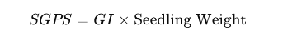
GI reflects seed germination and root elongation relative to controls, while biomass quantifies nutrient uptake and vigor. This dual approach distinguishes media that permit germination from those supporting robust growth.

Coir Pith Pro-Tray Media Quality Index (CPMQI)
To synthesize the above, PCS, SSS, and SGPS were normalized (0.1–1.0, higher-is-better) and averaged:
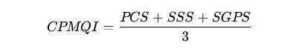​
This ensures that improvement in one parameter cannot mask deficiencies in others, providing a balanced evaluation of carbon maturity, ionic safety, and biological performance.

Rationale
The CPMQI is based on the principle that effective seedling substrates require mature carbon pools, safe ionic balance, and biological support. PCS quantifies labile carbon mineralization (Swift et al., 1979), SSS penalizes salinity deviations (Tanji, 1991), and SGPS integrates germination resilience and vigor. By equal-weighting all domains, CPMQI provides a reproducible, dimensionless tool for batch-to-batch quality control, process optimization, and product differentiation.
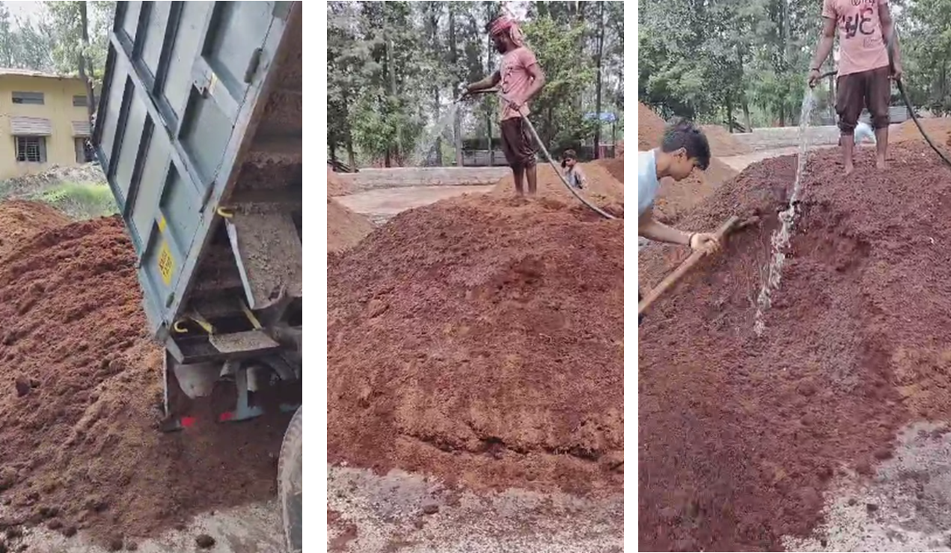
Pic 1 : Development of Novcom Coirpith Pro tray media at Ramnagar, Karnataka

Chart 1: Classification of Quality Indices
Classification of Physico-Chemical Score (PCS) |  |  |  |  | Seedling Suitability Score (SSS)
PCS Range | Class | Interpretation |  |  | SSS Range | Class |  | Interpretation
<0.25 | Poor | Immature, unstable, high risk of phytotoxicity. |  |  | <5.0 | Poor |  | Osmotic stress/ion toxicity; unsuitable.
0.25–<0.50 | Acceptable | Partially matured; further conditioning needed. |  |  | 5.0–7.5 | Acceptable |  | Marginal quality; usable with amendments.
0.50–<0.75 | Good | Mature, stable, generally suitable. |  |  | 7.5–15.0 | Good |  | Safe EC/ion levels; suitable for most seedlings.
≥0.75 | Very Good | Highly matured, structurally balanced; optimal for trays. |  |  | >15.0 | Very Good |  | Optimal ionic balance; highly suitable for trays.
Seedling Growth Potential Score (SGPS) |  |  |  | Coir Pith Pro-Tray Media Quality Index(CPMQI)
SGPS Range | Class | Interpretation |  |  | CPMQI Range | Class | Interpretation
<6.0 | Poor | High phytotoxicity/weak growth; unsuitable. |  |  | <0.25 | Poor | Major deficiencies; reprocessing required.
6.0–10.0 | Acceptable | Moderate; limited biomass gain. |  |  | 0.25–0.50 | Acceptable | Moderately suitable; minor amendments advised.
10.0–15.0 | Good | Supports healthy germination and early growth. |  |  | 0.50–0.75 | Good | Meets most benchmarks; suitable for routine use.
>15.0 | Very Good | Excellent vigor and uniform development. |  |  | >0.75 | Very Good | Optimal substrate; ideal for premium propagation.

Results and Discussion
Coir pith, inherently lignin-rich with a high C:N ratio and soluble salts, requires stabilization before serving as a nursery substrate. Conventional composting generally needs 8–12 months to yield partially matured media of inconsistent quality. In contrast, NOVCOM technology, through controlled bio-oxidative processing, achieves accelerated organic carbon mineralization, lignin modification, and salt reduction within ~40 days. These transformations, quantified through composite indices (PCS, SSS, SGPS, CPMQI) and critical parameters (organic carbon, lignin, Na⁺, germination index), enable a robust comparison of compost maturity and seedling performance.

Comparative Physicochemical and Nutrient Profiles
Tables 1–3 highlight the comparative evaluation of NOVCOM (40 days) versus conventional composting (12 months) using untreated and gypsum–urea-pretreated coir pith. Across all feedstock types (fresh, 2-month, 4-month), NOVCOM consistently reduced organic carbon and lignin more effectively, indicating rapid degradation of labile and recalcitrant fractions. In fresh untreated coir pith, organic carbon decreased from 40.55% (conventional) to 30.29% (NOVCOM), while lignin dropped from 40.80% to 31.59%. Treated materials showed similar patterns, with C:N ratios falling sharply—34.82 (untreated) and 18.09 (treated) under NOVCOM, compared to 66.48 and 26.73 for conventional composts. Even after four months, NOVCOM composts maintained lower ratios, reflecting active nitrogen immobilization, improved mineralization, and a more balanced nutrient profile.

Nutrient enrichment was also evident. Total N rose from 0.61% to 0.87% in untreated, and from 1.51% to 1.67% in treated substrates under NOVCOM, with corresponding increases in P. Ash content—an indicator of mineralization—was significantly higher, particularly in treated material (45.62% vs. 27.35%), confirming greater organic matter turnover. These results validate the design principles of NOVCOM, where a high-moisture, aerated environment combined with microbial regeneration promotes efficient degradation, nutrient cycling, and stable humus formation within a fraction of conventional timelines.

Reduction of Soluble Salts and Electrical Conductivity
Another significant outcome was the reduction of soluble salts. NOVCOM consistently lowered Na⁺, K⁺, and electrical conductivity (EC) across all feedstock types. In fresh untreated material, Na⁺ decreased from 3,050 to 2,005 ppm, with EC reduced from 3.09 to 2.21 dS·m⁻¹. In gypsum–urea-treated substrates, Na⁺ declined from 2,737 to 1,820 ppm, and EC from 3.23 to 2.51 dS·m⁻¹. Even in older feedstock, reductions were substantial; alleviating osmotic stress that otherwise hampers seedling growth.

Mechanistically, this reduction arises from three processes: (i) enhanced leaching of salts due to aerated, moisture-optimized conditions; (ii) accelerated humification, forming humic–organomineral complexes that increase cation exchange capacity and immobilize Na⁺ and (iii) gypsum amendment, where Ca²⁺ displaces Na⁺ through exchange reactions, improving Ca²⁺:Na⁺ ratios and reducing sodicity risks. While microbial immobilization may transiently lower salts, NOVCOM ensures durable stabilization.
The EC values achieved (~2.0–2.5 dS·m⁻¹) fall within the optimal nursery range (1.0–2.5 dS·m⁻¹; Bunt, 1988), minimizing salinity-induced stress. Thus, NOVCOM not only accelerates compost maturity but also produces a physiologically favorable substrate for seedling emergence and uniform growth.

Phytotoxicity Reduction and Bioassay Performance
Phytotoxicity bioassays (Tables 1–3) showed that Novcom-treated coirpith media consistently enhanced seedling emergence, root elongation, germination index (GI), and biomass compared to conventional composts. In fresh untreated coirpith, Novcom raised GI from 0.84 to 1.03, emergence from 93.55% to 103%, and root elongation from 89.55% to 99.75%. In gypsum–urea-treated substrates, GI rose from 0.84 to 1.01, with proportional improvements in emergence and root growth. All Novcom products exceeded the non-phytotoxic threshold of 0.8 (Zucconi et al., 1981), while several conventional products remained borderline inhibitory. This superior performance stems from Novcom’s accelerated humification, salt reduction, and microbial regeneration, which eliminate phytotoxic organic acids, phenolics, and immature lignocellulosic fragments. Such stabilization directly reduces osmotic stress and biochemical inhibition, ensuring nursery-ready substrates. By enabling rapid, stable media production, Novcom significantly enhances seedling vigor and reduces establishment risks.

Table 1 : Comparative Study of quality of coirpith pro-tray media with fresh (0 day) raw coirpith & Gypsum+Urea treated coir pith
Sl. No. | Test Parameters | Fresh (0 day) raw coirpith |  |  |  |  | Fresh (0 day) raw coirpith amended with gypsum (25kgt⁻¹) and urea (4 kg^{t-1})as per conventional method
Sl. No. | Test Parameters | Control 1 (0 day )[Day of experiment Initiation] |  | Control 2 (40 day) after initiation of experiment | Pro-Tray material developed under Novcom Technology  (40 Days) | Pro-Tray material developed under Conventional Method  (12 months) | Control 1 (0 day ) |  | Control 2 (40 day ) after initiation of experiment | Pro-Tray material developed under Novcom Technology  (40 Days) | Pro-Tray material developed under Conventional Method  (12 months)
PHYSICOCHEMICAL PARAMETERS
1 | Moisture (%) |  | 72.28 | 68.39 | 79.75 | 65.22 | 67.74 |  | 65.22 | 81.16 | 82.63
2 | pH (H₂O) (1:10) |  | 5.39 | 5.31 | 5.74 | 5.01 | 5.69 |  | 5.59 | 5.65 | 5.36
3 | EC (dSm⁻¹) (1:10) |  | 3.29 | 3.25 | 2.21 | 3.09 | 4.58 |  | 4.51 | 2.51 | 3.23
4 | Ash Content (%) |  | 10.25 | 12.07 | 45.48 | 27.01 | 10.14 |  | 14.81 | 45.62 | 27.35
5 | Volatile Solids(%) |  | 89.75 | 87.93 | 54.52 | 72.99 | 89.86 |  | 85.19 | 54.38 | 72.65
6 | Organic carbon (%) |  | 49.86 | 48.85 | 30.29 | 40.55 | 49.92 |  | 47.33 | 30.21 | 40.36
NUTRIENT & NUTRIENT DYNAMICS
7 | Total N (%) |  | 0.56 | 0.54 | 0.87 | 0.61 |  | 1.43 | 1.38 | 1.67 | 1.51
8 | Total P₂O₅ (%) |  | 0.16 | 0.13 | 0.19 | 0.16 |  | 0.17 | 0.17 | 0.21 | 0.18
9 | Total K₂O (%) |  | 3.87 | 3.8 | 3.19 | 3.54 |  | 3.55 | 3.57 | 3.66 | 3.54
10 | C:N |  | 89.04 | 90.46 | 34.82 | 66.48 |  | 34.91 | 34.30 | 18.09 | 26.73
MATURITY & PHYTOTOXICITY PARAMETERS
11 | Seedling Emergence (% Over Control) |  | 82 | 81 | 103 | 93.55 |  | 80.51 | 83.25 | 102.96 | 96.1
12 | Root Elongation (% Over Control) |  | 81.33 | 78.36 | 99.75 | 89.55 |  | 84.53 | 80.25 | 97.82 | 87.9
13 | Germination Index |  | 0.67 | 0.63 | 1.03 | 0.84 |  | 0.68 | 0.67 | 1.01 | 0.84
 | PHYTOTOXICITY BIOASSAY
14 | Avg. Seedling Weight Over Control (%) |  | 78.2 | 76.7 | 126.4 | 96.8 |  | 86 | 83 | 119.5 | 105.4
15 | Water soluble Na (ppm) |  | 6438 | 6374 | 2005 | 3050 |  | 6200 | 6490 | 1820 | 2737
16 | Water soluble K (ppm) |  | 20750 | 20700 | 8500 | 10500 |  | 20250 | 19500 | 7750 | 8400
LIGNIN STUDY
17 | Acid insoluble lignin (%) |  | 42.82 | 42.82 | 30.83 | 39.85 |  | 43.2 | 42.83 | 30.58 | 39.21
18 | Acid soluble lignin (%) |  | 1.42 | 1.39 | 0.76 | 0.95 |  | 0.89 | 1.02 | 1.03 | 1.02
19 | Total lignin (%) |  | 44.24 | 44.21 | 31.59 | 40.8 |  | 44.09 | 43.85 | 31.61 | 40.23

Table 2 : Comparative Study of quality of coirpith pro-tray media with 2 month old raw coirpith & Gypsum+Urea treated coir pith
Sl. No. | Test Parameters | 2 month old raw coirpith |  |  |  | 2 month old coirpith amended with gypsum (25kgt⁻¹) and urea (4 kg^{t-1})as per conventional method
Sl. No. | Test Parameters | Control 1 (0 day )[Day of experiment Initiation] | Control 2 (40 day) after initiation of experiment | Pro-Tray material developed under Novcom Technology  (40 Days) | Pro-Tray material developed under Conventional Method  (12 months) | Control 1 (0 day ) Day of experiment Initiation] | Control 2 (40 day ) after initiation of experiment | Pro-Tray material developed under Novcom Technology  (40 Days) | Pro-Tray material developed under Conventional Method  (12 months)
PHYSICOCHEMICAL PARAMETERS
1 | Moisture (%) | 68.39 | 65.22 | 78.68 | 68.5 | 65.22 | 66.93 | 80.33 | 82.63
2 | pH (H₂O) (1:10) | 5.31 | 5.37 | 5.81 | 5.01 | 5.59 | 5.52 | 5.66 | 5.36
3 | EC (dSm⁻¹) (1:10) | 3.25 | 4.01 | 2.32 | 3.09 | 4.51 | 4.59 | 2.97 | 3.23
4 | Ash Content (%) | 12.07 | 14.81 | 46.65 | 27.01 | 14.81 | 16.70 | 47.10 | 27.35
5 | Volatile Solids(%) | 87.93 | 85.19 | 53.35 | 72.99 | 85.19 | 83.30 | 52.90 | 72.65
6 | Organic carbon (%) | 48.85 | 47.33 | 29.64 | 40.55 | 47.33 | 46.28 | 29.39 | 40.36
NUTRIENT & NUTRIENT DYNAMICS
7 | Total N (%) | 0.54 | 0.57 | 0.82 | 0.61 | 1.38 | 1.32 | 1.68 | 1.51
8 | Total P₂O₅ (%) | 0.13 | 0.13 | 0.18 | 0.16 | 0.14 | 0.15 | 0.19 | 0.18
9 | Total K₂O (%) | 3.8 | 3.57 | 3.11 | 3.54 | 3.57 | 3.61 | 3.51 | 3.54
10 | C:N | 90.46 | 83.04 | 36.15 | 66.48 | 34.30 | 35.06 | 17.49 | 26.73
MATURITY & PHYTOTOXICITY PARAMETERS
11 | Seedling Emergence (% Over Control) | 81 | 88 | 102.87 | 93.55 | 83.25 | 95 | 104.2 | 96.1
12 | Root Elongation (% Over Control) | 78.36 | 90 | 98.61 | 89.55 | 80.25 | 83.25 | 98.56 | 87.9
13 | Germination Index | 0.63 | 0.79 | 1.01 | 0.84 | 0.67 | 0.79 | 1.03 | 0.84
 | PHYTOTOXICITY BIOASSAY
14 | Avg. Seedling Weight Over Control (%) | 76.7 | 82.12 | 121.1 | 96.8 | 83 | 86.1 | 126.8 | 105.4
15 | Water soluble Na (ppm) | 6374 | 5850 | 1910 | 3050 | 6490 | 6300 | 1720 | 2737
16 | Water soluble K (ppm) | 20700 | 20250 | 8400 | 10500 | 19500 | 16771 | 7475 | 8400
LIGNIN STUDY
17 | Acid insoluble lignin (%) | 42.82 | 42.8 | 28.67 | 39.85 | 42.83 | 42.7 | 28.85 | 39.21
18 | Acid soluble lignin (%) | 1.39 | 1.33 | 0.74 | 0.95 | 1.02 | 0.91 | 0.66 | 1.02
19 | Total lignin (%) | 44.21 | 44.13 | 29.41 | 40.8 | 43.85 | 43.61 | 29.51 | 40.23

Table 3 : Comparative Study of quality of coirpith pro-tray media with 4 month old raw coirpith & Gypsum+Urea treated coir pith
Sl. No. | Test Parameters | 4 month old raw coirpith |  |  |  | 4 month old coirpith amended with gypsum (25kgt⁻¹) and urea (4 kg^{t-1})as per conventional method
Sl. No. | Test Parameters | Control 1 (0 day )[Day of experiment Initiation] | Control 2 (40 day) after initiation of experiment | Pro-Tray material developed under Novcom Technology  (40 Days) | Pro-Tray material developed under Conventional Method  (12 months) | Control 1 (0 day ) Day of experiment Initiation] | Control 2 (40 day ) after initiation of experiment | Pro-Tray material developed under Novcom Technology  (40 Days) | Pro-Tray material developed under Conventional Method  (12 months)
PHYSICOCHEMICAL PARAMETERS
1 | Moisture (%) | 65.22 | 62.85 | 81.24 | 68.5 | 66.93 | 62.99 | 79.61 | 82.63
2 | pH (H₂O) (1:10) | 5.37 | 5.22 | 5.68 | 5.01 | 5.52 | 5.39 | 5.59 | 5.36
3 | EC (dSm⁻¹) (1:10) | 4.01 | 3.97 | 2.47 | 3.09 | 4.59 | 5.19 | 2.77 | 3.23
4 | Ash Content (%) | 14.81 | 16.21 | 50.39 | 27.01 | 16.70 | 17.70 | 49.94 | 27.35
5 | Volatile Solids(%) | 85.19 | 83.79 | 49.61 | 72.99 | 83.30 | 82.30 | 50.06 | 72.65
6 | Organic carbon (%) | 47.33 | 46.55 | 27.56 | 40.55 | 46.28 | 45.72 | 27.81 | 40.36
NUTRIENT & NUTRIENT DYNAMICS
7 | Total N (%) | 0.57 | 0.56 | 0.69 | 0.61 | 1.32 | 1.31 | 1.79 | 1.51
8 | Total P₂O₅ (%) | 0.13 | 0.1 | 0.27 | 0.16 | 0.15 | 0.28 | 0.32 | 0.18
9 | Total K₂O (%) | 3.57 | 3.02 | 3.12 | 3.54 | 3.61 | 3.54 | 3.38 | 3.54
10 | C:N | 83.04 | 83.13 | 39.94 | 66.48 | 35.06 | 34.90 | 15.54 | 26.73
MATURITY & PHYTOTOXICITY PARAMETERS
11 | Seedling Emergence (% Over Control) | 88 | 89 | 104.1 | 93.55 | 95 | 100 | 104 | 96.1
12 | Root Elongation (% Over Control) | 90 | 87.3 | 98.5 | 89.55 | 83.25 | 85.98 | 98.56 | 87.9
13 | Germination Index | 0.79 | 0.78 | 1.03 | 0.84 | 0.79 | 0.86 | 1.03 | 0.84
 | PHYTOTOXICITY BIOASSAY
14 | Avg. Seedling Weight Over Control (%) | 82.12 | 78 | 125.4 | 96.8 | 86.1 | 88 | 127.8 | 105.4
15 | Water soluble Na (ppm) | 5850 | 4880 | 1920 | 3050 | 6300 | 2950 | 1344 | 2737
16 | Water soluble K (ppm) | 20250 | 20000 | 8350 | 10500 | 16771 | 13021 | 4875 | 8400
LIGNIN STUDY
17 | Acid insoluble lignin (%) | 42.8 | 42.74 | 27.83 | 39.85 | 42.7 | 42.21 | 28.04 | 39.21
18 | Acid soluble lignin (%) | 1.33 | 1.21 | 0.71 | 0.95 | 0.91 | 0.9 | 0.69 | 1.02
19 | Total lignin (%) | 44.13 | 43.95 | 28.54 | 40.8 | 43.61 | 43.11 | 28.73 | 40.23

Comparative impact of coirpith age and gypsum–urea pretreatment on end-product quality:

Effect of Coirpith Age : Across coirpith ages (fresh, 2 months, 4 months), Novcom technology delivered consistent results, largely independent of raw material pre-aging. In all age classes, Novcom products showed lower organic carbon and lignin, higher ash, and reduced C:N ratios compared with 12-month conventional composts, indicating faster mineralization and lignocellulose depolymerization. At 4 months (Table 3), C:N fell to ~39.9 (untreated) and ~15.5 (gypsum–urea Novcom) versus ~66.5 and ~26.7 under conventional composting; Na⁺ declined from 3,050 to 1,920 ppm; EC dropped from 3.09 to 2.47 dS m⁻¹. These chemical improvements were reflected in biology: germination indices exceeded the non-phytotoxic threshold (GI ≈1.03), and seedling emergence, root elongation, and biomass were consistently higher in Novcom products.

This resilience stems from engineered coupling of bio-oxidative kinetics and matrix chemistry. Novcom maintains aerated, moist conditions that foster a rapid thermophilic–mesophilic succession of ligninolytic fungi and cellulolytic bacteria, overcoming lignin-related bottlenecks (Tuomela et al., 2000). This accelerates aromatic cleavage and cellulose–hemicellulose deconstruction, producing lignin declines within 40 days, while conventional windrows often stall. Concurrent humification enhances cation-exchange capacity (CEC) through organo-mineral associations, explaining sustained Na⁺ and EC reductions. Moisture–air management also enables leach–flush cycles, removing salts and preventing anaerobic metabolite buildup.

Impact of Gypsum–Urea Pretreatment
Gypsum–urea pretreatment synergizes with Novcom, improving both chemistry and biology. Calcium from gypsum displaces Na⁺ from exchange sites, enhancing leaching and improving Ca²⁺:Na⁺ balance, thereby lowering EC and improving structural stability (Qadir et al., 2007). This flocculation improves aeration and water retention, producing stable aggregates. Urea supplies readily available N, quickly assimilated under Novcom’s oxygen-rich regime, stimulating microbial growth and enzyme synthesis for rapid lignin–cellulose breakdown. Together, N enrichment and Ca-mediated flocculation accelerate decomposition and C:N reduction even in lignin-rich coirpith. Although gypsum–urea may transiently increase ionic strength, Novcom’s leach–flush dynamics and humic fraction expansion convert soluble ions into stable organo-mineral complexes. Within 40 days, these amendments contribute to long-term stability and nutrient buffering.

The combined effect narrows differences between fresh and pre-aged coirpith. While conventional composting depends on pre-aging to reduce salts and initiate lignin breakdown, Novcom’s intensified transformation largely eliminates this dependency, producing chemically stable, low-salt, plant-safe media from coirpith aged 0–4 months. This flexibility has clear operational implications: nurseries can process heterogeneous feedstocks without long staging, standardize media quality, and shorten turnaround times. The convergence of low EC, balanced C:N, and partial lignin depolymerization aligns with accepted maturity benchmarks (Zucconi et al., 1981), explaining consistent improvements in germination, emergence, and biomass.

Organic Carbon Dynamics
OC trends illustrate decomposition rates under different systems (Fig. 1). Controls retained very high OC (~49.9%), showing negligible mineralization. Conventional 12-month composts reduced OC only to ~40.5%, an ~18.9% decrease, reflecting passive degradation under variable field conditions. By contrast, Novcom achieved far greater OC loss in just 40 days: fresh feedstock ≈30.3%, 2-month ≈29.6%, and 4-month ≈27.6%—representing 39–46% further reduction compared with conventional. This rapid decline reflects intensive microbial mineralization of labile fractions under controlled aeration and moisture, along with selective lignin transformation. Agronomically, reduced OC lowers C:N, reduces microbial immobilization, improves wettability and porosity, and produces mature, seedling-ready media in weeks.

Lignin Transformation
Lignin content reflects compost maturity and stability. Conventional 12-month compost contained ~40.8% total lignin, whereas Novcom reduced this to ~31.6% (fresh), ~29.4% (2-month), and ~28.5% (4-month) (Fig. 2)—a 22–30% reduction in one-sixth the time. Acid-insoluble lignin followed the same trend, dropping from ~39.8% to ~27.8–30.8%. Acid-soluble lignin remained low, indicating selective depolymerization rather than full mineralization. This selective transformation improves wettability, porosity, and root penetration while maintaining structural integrity. The effect is process-driven, though gypsum–urea contributes to N balance and pH stabilization.

Sodium Reduction and Salinity Control
Excess soluble Na⁺ inhibits germination by increasing osmotic stress. Controls showed very high Na⁺ (~6,300–6,400 ppm), typical of raw coirpith. Conventional composting reduced this moderately to ~2,737–3,050 ppm, still unsafe for sensitive seedlings (Fig. 3). Novcom, however, reduced Na⁺ substantially: fresh ≈1,720–1,910 ppm, 2-month ≈1,344–1,820 ppm, and 4-month similar values, amounting to 35–60% lower than conventional products. These reductions reflect controlled leach–flush cycles and increased sorption capacity through humification. In amended batches, gypsum-derived Ca²⁺ further displaced Na⁺. Lower Na⁺ directly corresponded with reduced EC and higher seedling suitability, as reflected in bioassay results.

Phytotoxicity
Bioassays confirmed chemical improvements. Germination index (GI) values were extremely low for controls (~21–23%), indicating severe phytotoxicity from salts, C:N imbalance, and phenolics. Conventional products improved GI only to ~58–61%, below the ≥80% maturity threshold (Zucconi et al., 1981). Novcom products consistently surpassed this benchmark: fresh ≈88–90%, 2-month ≈92–94%, and 4-month ≈96–98% (Fig. 4). This represents 50–65% improvement over conventional and >300% over raw coirpith. Rapid detoxification under Novcom arises from accelerated breakdown of phenolics and lignin derivatives, reduced Na⁺ and EC, and improved nutrient balance. As a result, Novcom substrates reliably support uniform seedling establishment.

Index-Based Evaluation of Coir Pith Pro-Tray Media Quality
The comparative evaluation of four indices—Physico-Chemical Score (PCS), Seedling Suitability Score (SSS), Seedling Growth Potential Score (SGPS), and Coir Pith Pro-Tray Media Quality Index (CPMQI)—provides an integrated perspective on the maturity, functional readiness, and overall quality of the tested substrates.

Physico-Chemical Maturity (PCS). Control material showed strongly negative PCS (≈ −0.26), reflecting immaturity with high C:N, undecomposed lignin, and phytotoxins. Conventional 12-month compost reached only ≈0.12–0.13 (“Acceptable”), indicating incomplete stabilization. NOVCOM-processed substrates recorded ≈0.51–0.73, approaching “Very Good” (≥0.75). This rapid stabilization confirms that NOVCOM’s optimized thermophilic–mesophilic regime accelerates carbon mineralization, lignin depolymerization, and salt leaching, achieving maturity in 40 days instead of a year.

Seedling Suitability (SSS). Control SSS (≈3.29–3.32) confirmed raw coir’s unsuitability. Conventional compost improved moderately (≈6.45–7.33), supporting partial establishment. NOVCOM substrates achieved substantially higher SSS—fresh (≈9.02/9.68), 2-month (≈9.24/9.87), and 4-month (≈9.18/13.05)—indicating two- to fourfold gains. Improvements reflect reduced salinity, balanced nutrients, enhanced porosity, and increased germination index (Zucconi et al., 1981).

Seedling Growth Potential (SGPS). Control SGPS (≈4.29/4.79) reflected poor germination and weak post-emergence growth. Conventional product reached ≈6.67/7.26, showing modest improvement. NOVCOM substrates scored much higher—fresh (≈10.67/9.90), 2-month (≈11.72/12.57), and 4-month (≈12.02/12.26)—representing 60–80% gains over conventional and up to 167% over control. These gains reflect improved nutrient equilibrium, lower EC, and favorable root-zone conditions supporting vigorous seedling growth.

Overall Quality (CPMQI). The integrated CPMQI confirmed substrate suitability by combining PCS, SSS, and SGPS. Control CPMQI was negative (≈ −0.11), indicating unsuitability. Conventional compost improved slightly (≈0.23–0.27). NOVCOM products achieved ≈0.59–0.63 (fresh), 0.70–0.75 (2-month), and 0.75–0.84 (4-month), marking 7–9-fold gains over control.

The index-based assessment demonstrates that NOVCOM technology ensures rapid biochemical stabilization, improved germination performance, and superior seedling growth, producing a chemically stable, biologically safe, and agronomically functional medium in just 40 days—compared to 12 months in conventional processing.

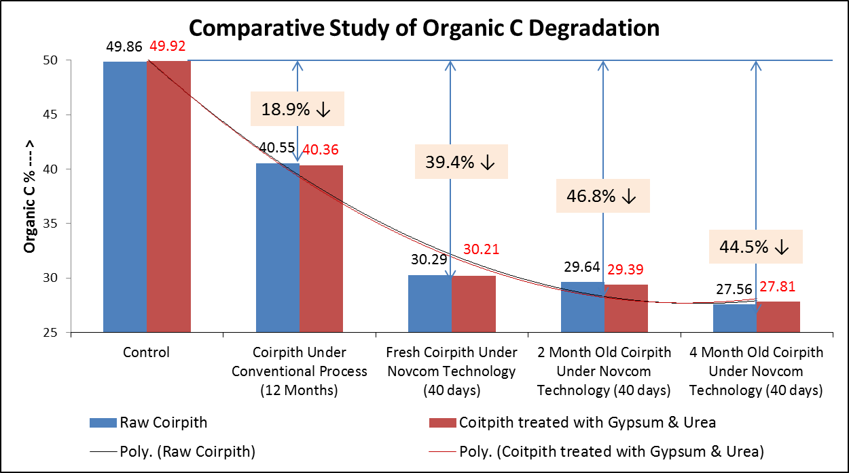
Fig 1 : Comparative study of Organic carbon degradation under Novcom technology in comparison to conventional pro-tray media.

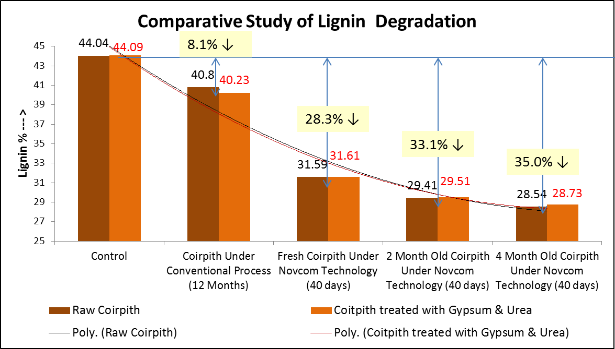
Fig 2 : Comparative study of Lignin degradation under Novcom technology in comparison to conventional pro-tray media.
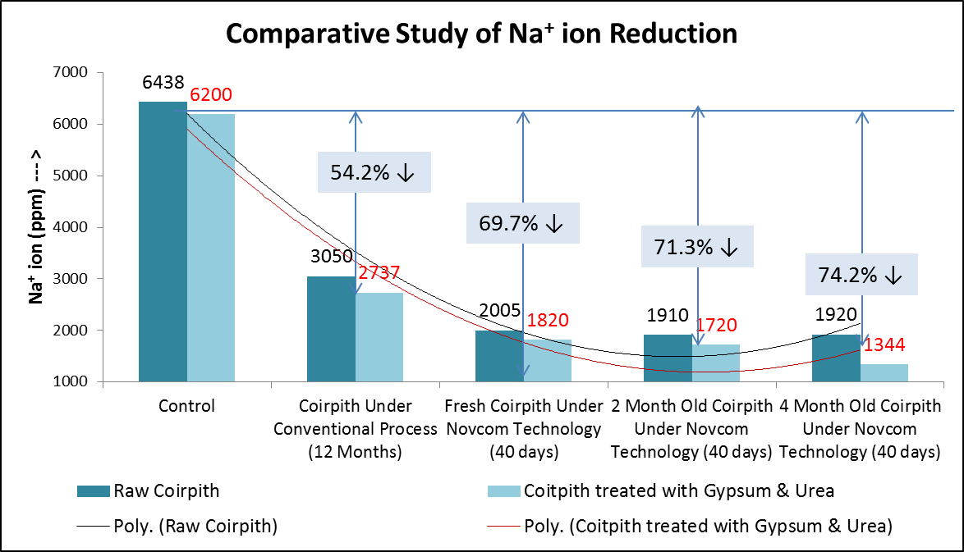
Fig 3 : Comparative study of Na⁺ ion reduction under Novcom technology in comparison to conventional pro-tray media.
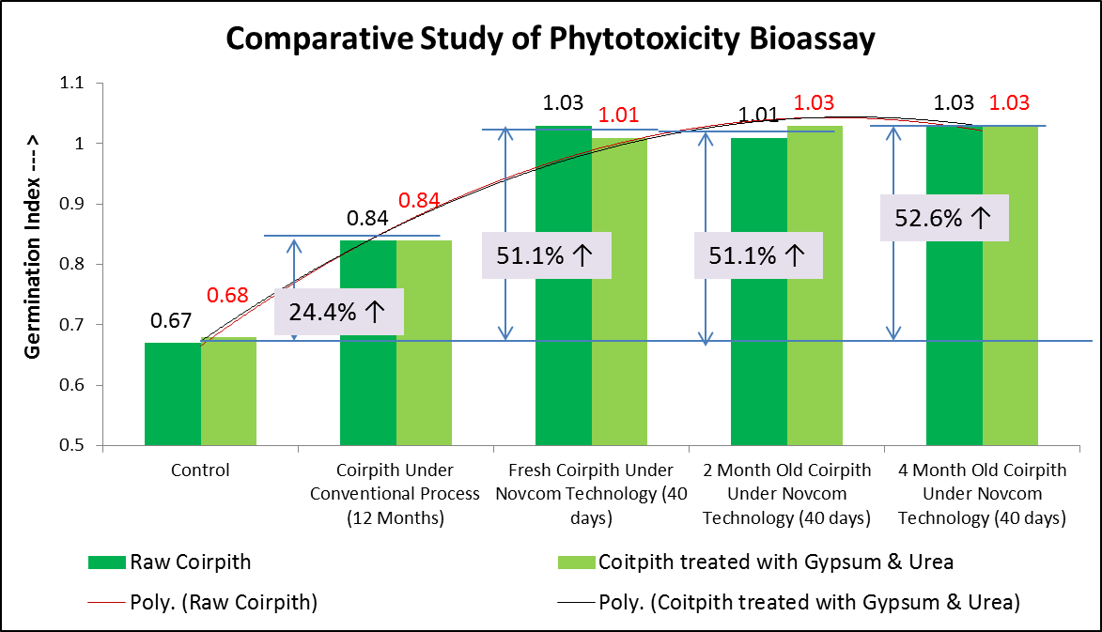
Fig 4 : Comparative study of Phytotoxicity Bioassay under Novcom technology in comparison to conventional pro-tray media.

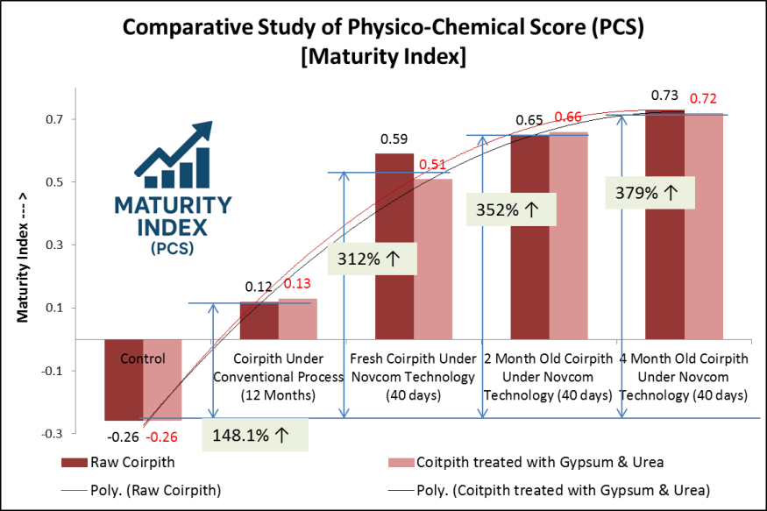
Fig. 5: Comparative study of Physico-Chemical Score (PCS) – Maturity Index of coirpith pro-tray media under Novcom technology in comparison to conventional pro-tray media
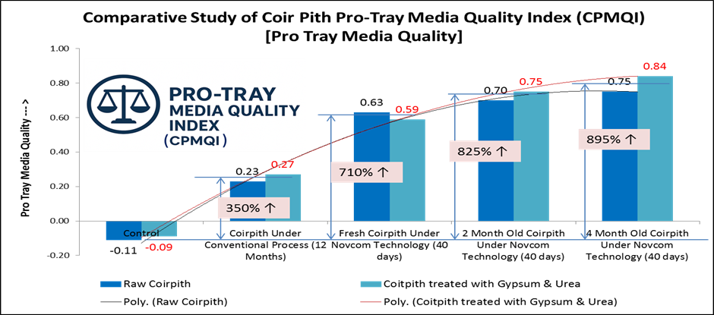
Fig. 6: Comparative study of Coir Pith Pro-Tray Media Quality Index (CPMQI) of coirpith pro-tray media developed under Novcom technology in comparison to conventional pro-tray media
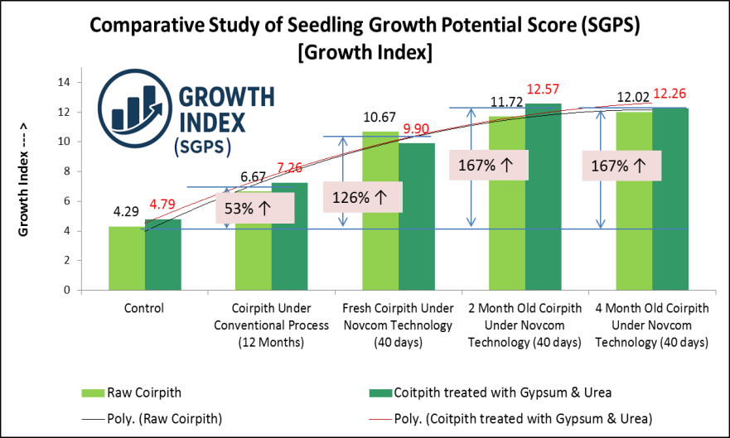
Fig. 7: Comparative study of Seedling Growth Potential Score Score (SGPS) – Growth Index of coirpith pro-tray media under Novcom technology in comparison to conventional pro-tray media

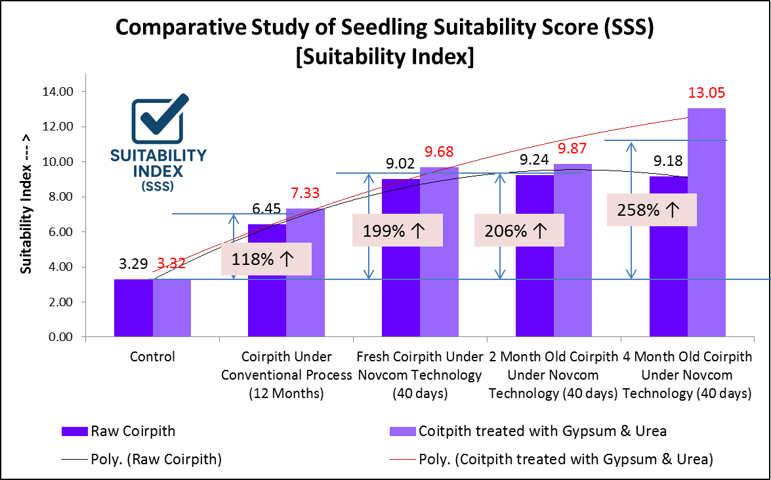
Fig. 8: Comparative study of Seedling Suitability Score (PCS) – Suitability Index of coirpith pro-tray media under Novcom technology in comparison to conventional pro-tray media

Comparative study of Seedling Vigor and Root Development in Novcom-Treated Coirpith Pro-Tray Media Compared to Conventional Substrates

Comparative Performance of Seedlings
Table 4 shows that Novcom-treated coir pith consistently outperformed both untreated and conventional substrates in promoting seedling vigor. Gains were most pronounced in root growth and root:shoot allocation, although germination percentage, leaf numbers, and shoot elongation also improved. Across cauliflower, tomato, and chilli, Novcom substrates (fresh, 2-month, 4-month) promoted stronger seedling establishment. In only-coirpith media, 4-month Novcom enhanced root length by 16.5% (cauliflower), 20.3% (tomato), and 26.7% (chilli). With gypsum+urea pretreatment, improvements rose to 23.2%, 28.5%, and 37.5% respectively, confirming a synergistic effect. Root:shoot ratios also increased significantly; in tomato, the ratio improved from 0.39–0.43 (conventional) to 0.49 (Novcom), reflecting greater below-ground allocation and resilience potential.

Mechanisms Driving Root Enhancement
These root gains align with physicochemical changes in Novcom-processed media. Lower lignin fractions, reduced C:N ratio, greater nutrient availability, and decreased soluble Na collectively facilitated root penetration and elongation (Bernal et al., 2009). Better porosity supported aeration and reduced mechanical impedance, while lowered phytotoxins and salinity reduced metabolic stress (Khan et al., 2006). Gypsum+urea pretreatment amplified these effects by correcting Ca:Na imbalances and providing labile N to stimulate microbial lignocellulose degradation. Among crops, chilli showed the strongest synergistic response, with a 37.5% root length increase under gypsum+urea+Novcom.

Table 4 : Comparative study of seedling development of coir pith growing media developed under conventional and Novcom treatment
Sl. No. | Parameters |  | Only Coir Pith |  |  |  |  | Coir Pith treated with Gypsum and urea treatment
Sl. No. |  |  | Control | Coirpith Under Conventional Process (12 Months) | Fresh Coirpith Under Novcom Technology (40 days) | 2 Month Old Coirpith Under Novcom Technology (40 days) | 4 Month Old Coirpith Under Novcom Technology (40 days) | Control | Coirpith Under Conventional Process (12 Months) | Fresh Coirpith Under Novcom Technology (40 days) | 2 Month Old Coirpith Under Novcom Technology (40 days) | 4 Month Old Coirpith Under Novcom Technology (40 days)
Germination %
1 | Germination % | Cauliflower | 2.04 | 83.67 | 85.71 | 87.76 | 90.82 | 7.14 | 87.76 | 88.78 | 88.78 | 90.82
2 | Germination % | Tomato | 5.10 | 86.73 | 90.82 | 89.80 | 91.84 | 15.31 | 90.82 | 89.80 | 93.88 | 93.88
3 | Germination % | Chilli | 8.16 | 90.82 | 95.92 | 95.92 | 96.94 | 18.37 | 92.86 | 96.94 | 97.96 | 96.94
30 day after seed incorporation in growing media
4 | Average Leaf No | Cauliflower | 3.2 | 4.6 | 5.3 | 5.7 | 5.1 | 4.2 | 5.6 | 6.7 | 5.1 | 6.4
5 | Average Leaf No | Tomato | 5.7 | 6.7 | 7.2 | 7.5 | 7.6 | 5.1 | 7.1 | 9.5 | 8.3 | 9.2
6 | Average Leaf No | Chilli | 3.4 | 5.1 | 6.1 | 5.3 | 7.4 | 4.3 | 6.4 | 6.3 | 8.5 | 8.2
7 | Shoot Length (cm) | Cauliflower | 6.42 | 11.15 | 11.05 | 11.11 | 11.19 | 7.19 | 11.98 | 11.96 | 11.68 | 12.24
8 | Shoot Length (cm) | Tomato | 7.424 | 11.42 | 11.52 | 11.49 | 11.69 | 7.09 | 12.56 | 12.78 | 12.62 | 13.09
9 | Shoot Length (cm) | Chilli | 4.73 | 8.76 | 8.74 | 8.84 | 9.21 | 4.97 | 9.51 | 9.76 | 9.81 | 10.01
10 | Root Length(cm) | Cauliflower | 3.81 | 5.65 | 6.12 | 6.39 | 6.58 | 3.89 | 5.96 | 6.89 | 6.91 | 7.34
11 | Root Length(cm) | Tomato | 2.8 | 4.87 | 5.59 | 5.67 | 5.86 | 2.83 | 4.92 | 6.05 | 6.15 | 6.32
12 | Root Length(cm) | Chilli | 2.49 | 4.3 | 4.89 | 4.92 | 5.45 | 2.58 | 4.67 | 5.21 | 5.32 | 6.42
13 | Root: Shoot Ratio | Cauliflower | 0.59 | 0.51 | 0.55 | 0.58 | 0.59 | 0.54 | 0.50 | 0.58 | 0.59 | 0.60
14 | Root: Shoot Ratio | Tomato | 0.38 | 0.43 | 0.49 | 0.49 | 0.50 | 0.40 | 0.39 | 0.47 | 0.49 | 0.48
15 | Root: Shoot Ratio | Chilli | 0.53 | 0.49 | 0.56 | 0.56 | 0.59 | 0.52 | 0.49 | 0.53 | 0.54 | 0.64

Importance of Root:Shoot Ratio
The positive effects extended beyond absolute root length. Novcom substrates consistently increased root:shoot ratios compared to conventional treatments, where ratios often declined. For example, chilli seedlings recorded values of 0.59–0.64 under Novcom, compared to ~0.48–0.52 in conventional substrates. Higher ratios are linked to improved water and nutrient uptake capacity, resilience under stress, and superior transplant establishment . This suggests that Novcom’s structural and biochemical improvements not only accelerate early development but also enhance adaptive capacity post-transplanting.

Seedling Establishment and Growth
Pot trials (Table 5) confirmed that Novcom-raised seedlings established faster and achieved higher vigor indices across crops. Cauliflower seedlings showed height increases of 9.1% (only-coirpith Novcom) and 13.0% (gypsum+urea+Novcom); tomato increased by ~10%; chilli by 16.7–25.4% depending on treatment. Leaf production followed similar patterns, with Novcom plants producing 1–2 extra leaves per seedling. Field trials (Table 6) at Satyapole, Nadia, further validated these outcomes. Compared with conventional compost, Novcom media increased seedling height by 9.6–13.1% in cauliflower, 2.2–6.2% in tomato, and 9.4–19.4% in chilli. These consistent results demonstrate that nursery-stage advantages translate effectively under field conditions.

Physiological and Agronomic Mechanisms
Novcom compost’s performance can be explained by three interlinked mechanisms: (i) improved substrate environment, (ii) enhanced nutrient dynamics, and (iii) reduced phytotoxicity. Improved aeration and porosity facilitated gas exchange and root exploration, while balanced nutrient availability supported steady uptake (Bustamante et al., 2008). Gypsum–urea pretreatment further reduced sodicity stress, improving osmotic conditions and Ca availability The observed increase in root length and root:shoot ratio directly improved soil exploitation efficiency, enhancing post-transplant recovery. Simultaneously, higher leaf number increased canopy photosynthetic capacity and accelerated biomass accumulation. These traits reinforce earlier evidence that superior nursery media lead to sustained field vigor and higher yield potential (Gallegos-Cedillo et al, 2021).

Rhizosphere Responses and Microbial Augmentation
Transplanting Novcom-raised seedlings also transferred an enriched rhizosphere microbiome. Within one month of field establishment, microbial counts were significantly higher compared to conventional seedlings: bacterial populations increased by 2.9–4.7×, fungi by ≈1.8×, and actinomycetes by ≈2×. Fresh Novcom and gypsum+urea+Novcom treatments showed the strongest increases. This microbial enrichment stems from both the carrier effect of coirpith and stimulation by root exudates (Mendes et al., 2011; Bais et al., 2006). Actinomycete proliferation supported further lignocellulose breakdown and secondary metabolite production (Barka et al., 2015), while phosphate-solubilizing microbes improved phosphorus mobilization. This suggests that Novcom seedlings not only benefit themselves but also improve soil biological functioning at transplant sites.

Rhizosphere Chemistry Shifts
Novcom-treated seedlings influenced soil chemistry in ways favorable to establishment. Soil pH remained stable, but EC decreased slightly (≈1–8%), reducing salinity stress. Organic C content increased by 19–26%, compared to 1–5% in controls, reflecting improved soil organic matter inputs. Available P rose by 20–29%, enhancing early nutrient access. Available N showed temporary drawdown due to seedling uptake and microbial

Table 5 : Post Transplantation growth of seedling developed under conventional and Novcom treated Coirpith Growing media in Pot Study (30 days after Transplanting)
Sl. No. | Parameters | Raw Coir Pith |  |  |  |  | Coir Pith treated with Gypsum and urea treatment
Sl. No. | Parameters | Control | Coirpith Under Conventional Process (12 Months) | Fresh Coirpith Under Novcom Technology (40 days) | 2 Month Old Coirpith  Under  Novcom Technology (40 days) | 4 Month Old Coirpith  Under Novcom Technology (40 days) | Control | Coirpith Under Conventional Process (12 Months) | Fresh Coirpith Under Novcom Technology (40 days) | 2 Month Old Coirpith Under Novcom Technology (40 days) | 4 Month Old Coirpith Under Novcom Technology (40 days)
Crop Variety : Cauliflower
1 | Seedling Height (inch) | 12.52 | 15.63 | 16.63 | 16.45 | 17.04 | 14.2 | 16.1 | 16.9 | 17.5 | 18.2
2 | No of leaves | 5.2 | 6.8 | 7.2 | 7.5 | 8.1 | 6.1 | 7.6 | 7.6 | 8.2 | 8.7
Crop Variety : Tomato
3 | Seedling Height (inch) | 23.22 | 29.24 | 31.24 | 30.12 | 32.14 | 24.1 | 32.7 | 32.62 | 34.21 | 34.78
4 | No of leaves | 21.4 | 29.5 | 34.6 | 32.5 | 36.2 | 23.6 | 30.1 | 35.6 | 35.7 | 38.6
Crop Variety : Chilli
5 | Seedling Height (inch) | 15.52 | 18.2 | 20.12 | 22.35 | 21.24 | 16.24 | 23.2 | 23.6 | 24.2 | 25.4
6 | No of leaves | 16.5 | 21.2 | 24.5 | 26.2 | 27.1 | 18.4 | 26.3 | 27.6 | 30.2 | 32.4

Table 6 : Post Transplantation growth of seedling developed under conventional and Novcom treated Coirpith Growing media at field level (30 days after Transplanting)

Sl. No. | Parameters | Raw Coir Pith |  |  |  |  | Coir Pith treated with Gypsum and urea treatment
Sl. No. | Parameters | Control | Coirpith Under Conventional Process (12 Months) | Fresh Coirpith Under Novcom Technology (40 days) | 2 Month Old Coirpith  Under  Novcom Technology (40 days) | 4 Month Old Coirpith  Under Novcom Technology (40 days) | Control | Coirpith Under Conventional Process (12 Months) | Fresh Coirpith Under Novcom Technology (40 days) | 2 Month Old Coirpith Under Novcom Technology (40 days) | 4 Month Old Coirpith Under Novcom Technology (40 days)
Crop Variety : Cauliflower
1 | Seedling Height (inch) | 13.96 | 18.23 | 19.27 | 19.87 | 20.62 | 16.2 | 19.62 | 20.14 | 20.95 | 21.5
2 | No of leaves | 6.2 | 9.4 | 10.2 | 10.6 | 11.1 | 6.6 | 9.7 | 10.3 | 10.6 | 11.2
Crop Variety : Tomato
3 | Seedling Height (inch) | 25.62 | 32.26 | 33.01 | 33.28 | 32.97 | 25.21 | 32.96 | 32.59 | 32.82 | 35.01
4 | No of leaves | 24.5 | 30.6 | 35.2 | 33.9 | 36.2 | 24.5 | 32.1 | 32.5 | 36.8 | 39.6
Crop Variety : Chilli
5 | Seedling Height (inch) | 17.3 | 20.6 | 23.1 | 24.5 | 24.5 | 17.6 | 28.8 | 28.87 | 30.21 | 31.51
6 | No of leaves | 21.4 | 25.6 | 27.5 | 29.4 | 30.5 | 24.1 | 28.6 | 29.5 | 31.4 | 32.6

Table 7 : Comparative assessment of soil properties in root rhizosphere following transplantation of Novcom coirpith pro-tray seedlings versus conventional nursery and conventionally processed coirpith
Sl. No. | Parameters |  | Raw Coir Pith |  |  |  |  | Coir Pith treated with Gypsum and urea treatment
Sl. No. | Parameters | Soil Sampling | Control (Seedling grown in conventional nursery) | Coirpith Under Conventional Process (12 Months) | Fresh Coirpith Under Novcom Technology (40 days) | 2 Month Old Coirpith Under Novcom Technology (40 days) | 4 Month Old Coirpith Under Novcom Technology (40 days) | Control | Coirpith Under Conventional Process (12 Months) | Fresh Coirpith Under Novcom Technology (40 days) | 2 Month Old Coirpith Under Novcom Technology (40 days) | 4 Month Old Coirpith Under Novcom Technology (40 days)
Soil Physico-chemical Properties
1 | Soil pH (H₂O) | After 1 month | 6.12 | 6.09 | 6.19 | 6.23 | 6.57 | 6.05 | 5.91 | 5.96 | 5.99 | 6.27
1 | Soil pH (H₂O) | Before transplanting | 6.07 | 6.07 | 6.13 | 6.17 | 6.5 | 6.09 | 5.81 | 5.9 | 5.9 | 5.93
2 | EC | After 1 month | 0.125 | 0.121 | 0.123 | 0.131 | 0.129 | 0.108 | 0.13 | 0.123 | 0.137 | 0.129
2 | EC | Before transplanting | 0.131 | 0.129 | 0.127 | 0.135 | 0.131 | 0.111 | 0.131 | 0.133 | 0.139 | 0.139
3 | Org C (%) | After 1 month | 0.79 | 0.82 | 0.86 | 0.89 | 0.98 | 0.7 | 0.76 | 0.8 | 0.83 | 0.88
3 | Org C (%) | Before transplanting | 0.75 | 0.72 | 0.72 | 0.73 | 0.78 | 0.69 | 0.71 | 0.73 | 0.74 | 0.74
4 | Av N (kg/ha) | After 1 month | 304 | 309 | 302 | 301 | 305 | 301 | 304 | 306 | 321 | 326
4 | Av N (kg/ha) | Before transplanting | 310 | 311 | 311 | 313 | 319 | 295 | 306 | 309 | 331 | 337
5 | AV P₂O₅ (kg/ha) | After 1 month | 79 | 69 | 77 | 98 | 88 | 91 | 97 | 91 | 102 | 97
5 | AV P₂O₅ (kg/ha) | Before transplanting | 65 | 57 | 61 | 87 | 77 | 86 | 85 | 76 | 79 | 83
6 | Available K₂O (kg/ha) | After 1 month | 345 | 341 | 341 | 347 | 353 | 332 | 356 | 341 | 342 | 349
6 | Available K₂O (kg/ha) | Before transplanting | 351 | 352 | 351 | 356 | 361 | 341 | 351 | 351 | 353 | 363
Soil Biological Properties (cfu per gm moist soil)
7 | Total Bacteriax 10⁵ | After 1 month | 47 | 59 | 113 | 128 | 105 | 65 | 137 | 187 | 198 | 157
7 | Total Bacteriax 10⁵ | Before transplanting | 29 | 28 | 39 | 36 | 29 | 38 | 35 | 40 | 51 | 43
8 | Total Fungi x 10³ | After 1 month | 41 | 47 | 59 | 57 | 76 | 26 | 47 | 56 | 69 | 71
8 | Total Fungi x 10³ | Before transplanting | 37 | 35 | 32 | 20 | 31 | 22 | 20 | 21 | 28 | 29
9 | Total Actinomycetes x 10³ | After 1 month | 17 | 19 | 22 | 27 | 28 | 21 | 23 | 27 | 37 | 36
9 | Total Actinomycetes x 10³ | Before transplanting | 12 | 9 | 11 | 8 | 12 | 13 | 10 | 12 | 13 | 13

immobilization, but this is typical in active rhizospheres. Potassium levels remained steady. These changes highlight enhanced microbial enzyme activity, nutrient solubilization, and organic matter turnover. Agronomically, this translates to improved nutrient coupling between soil and plant, reduced dependency on synthetic fertilizers, and early vigor gains (Lal, 2004).

Implications for Sustainable Agriculture
The combined evidence highlights Novcom’s ability to transform coir pith into a superior nursery substrate. Faster stabilization of coir pith, coupled with improved physicochemical properties and enriched microbiomes, results in stronger root systems, higher vigor, and better field establishment. These advantages lower crop failure risk, reduce nursery-to-field transplant shock, and enhance soil fertility. Importantly, Novcom seedlings reduce reliance on mineral fertilizers by improving nutrient uptake efficiency and rhizosphere functioning, aligning with sustainability goals (Tilman et al., 2002). Future work should employ molecular microbiome profiling, enzyme activity assays, and long-term yield monitoring to further quantify Novcom’s contribution to soil health and productivity. Nevertheless, current evidence establishes Novcom as both an agronomic innovation and an ecological solution for sustainable intensification of vegetable nursery systems.

Coir Pith as a Landfill Waste: Pollution Risks and Greenhouse Gas Emission Potential
Coir pith should be managed and regulated as an agro-industrial landfill waste because its physicochemical properties (very high lignin content, large organic-C fraction and extremely elevated C:N ratios) render it highly recalcitrant and prone to prolonged anaerobic zones and persistent leachates; these characteristics lead both to chronic eco-toxicological impacts (phenolic/tannin leachates that suppress soil enzymes and aquatic oxygen demand) and substantial methane generation under anaerobic disposal (Bera et al., 2025). Laboratory and field characterisations report lignin contents of ~20–40% and C:N often >80–100:1 in coir residues, which limits microbial degradation and favors slow hydrolysis followed by methanogenesis (Bera et al., 2025). Importantly, at present, because of its physicochemical complexity and limited on-site valorisation options, coir pith is frequently dumped in peripheral or low-lying areas of coir-processing sites where it forms leachate pools and dust sources that impair soil and water quality; documented incidents and regulatory reviews have led state and national pollution control authorities to escalate enforcement and to treat coir-pith management as a priority (CPCB, 2016; TNPCB, 2023; Bera et al., 2025). Given both the local pollution risks and the substantial methane-generation potential when disposed anaerobically, policy and industry should prioritise controlled storage, aerobic valorisation (e.g., Novcom composting), co-digestion or gas-capture solutions and apply inventory-grade emission calculations to guide mitigation and circular-economy options (Seal et al., 2015; Zhu et al., 2020). Theoretical and inventory methods therefore recommend applying IPCC mass-balance or first-order decay formulations (DDOCm, DOCf, MCF, oxidation) to translate measured degradable organic carbon into CH₄ mass and then into CO₂-equivalents using an explicit GWP time horizon (IPCC, 2019; IPCC, 2021). Empirical assessments and carbon-footprint tools reported for untreated coir pith indicate very large CH₄-based burdens (order of magnitude ~5.9×10³ kg CO₂-eq t⁻¹ when short-term methane GWP metrics are used), whereas properly engineered aerobic bioconversion (e.g., NOVCOM composting) reduces methanogenesis by orders of magnitude and produces stable soil amendment (Bera et al., 2025; Seal et al., 2013).

Novcom Technology, Coirpith Valorization, and Carbon Credit Opportunity
Adoption of Novcom technology for coir-pith pro-tray media represents a rapid, scalable valorization pathway that both improves seedling quality and creates a credible basis for carbon credits. Conventional coir-pith management is slow and poorly controlled (8–12 months), often creating anaerobic microsites that emit methane (CH₄)—a potent short-lived climate forcer with ~80× CO₂ warming over 20 years (IPCC, 2021a)—and yields chemically and biologically inferior substrates prone to phytotoxicity. Such practices therefore fail to deliver measurable sequestration benefits and can be disqualified from carbon markets.
By contrast, Novcom proceeds via controlled aerobic biodegradation, conditioning coir-pith in about 40 days and eliminating the methanogenesis pathway at source; methane avoidance alone is a quantifiable mitigation claim. Novcom also produces highly biologically enriched media (microbial densities reported at 10¹⁴–10¹⁶ cfu g⁻¹) that act as precision inoculants when seedlings
are transplanted, enhancing rhizosphere activity. Field observations indicate rapid soil organic carbon (SOC) increases (reported 15–25% within one month), improved phosphorus solubilization, and sustained microbial turnover—outcomes that raise nutrient-use efficiency and reduce reliance on synthetic fertilizers, thereby indirectly lowering nitrous oxide (N₂O) risk. Novcom removes a longstanding valorization bottleneck: it converts an abundant waste stream—previously a source of dust, leachate and land-use inefficiency—into a climate-positive bio-resource by shortening processing time from ~1 year to ~40 days, enabling large-scale, sustainable utilization. Mechanistically, Novcom’s aerobic, high-moisture, microbially guided process stabilizes organic matter, enhances humification and cation-exchange buffering, and produces a structurally intact, low-salinity substrate that supports uniform seedling establishment and soil health improvement.
From a carbon-market perspective, Novcom aligns with additionality, permanence and sustainability principles: it replaces “business-as-usual” anaerobic dumping (additionality), stabilizes organic matter and promotes accrual of stable SOC (permanence) and delivers agronomic co-benefits—reduced pollution, lower fertilizer needs, improved resilience—that avoid negative externalities (sustainability) (UNFCCC, 2012; Gold Standard, 2022; Lal, 2004; Seal et al., 2013). Empirical and modelling studies support long-term SOC accrual via stabilized amendments and microbial community enhancement (Smith et al., 2008). In sum, Novcom transforms coir-pith from a methane-emitting residue into a climate-smart, value-added substrate with measurable emission avoidance and soil-carbon benefits, positioning it as a robust candidate for tradable carbon credits while delivering tangible agronomic co-benefits (Bera et al., 2025).

Calculation of GHG Emission Potential from Biowaste (Primarily Landfill Materials) as per IPCC Guideline (Utilizing Carbon Assessment Tool: ACFA- Version 2.0)

GHG emission (MT in CO₂ equivalent) | = | [(LMT x LFF x MCF x DOC x DOCF x F x  16/12 - R) x (1 - OX)] x GWP_{CH4}
Where,
LMT : Total Landfill Material(MT)
LFF : Fraction of Landfill Material disposed at site (if 100 % landfill material which is
generated is deposited at site, then LFF value will be 1.0, default value)
MCF : Methane correction factor (fraction) (IPCC default value is 0.6, when there is no
specific information)
DOC : Degradable organic carbon (fraction) (kg C/ kg landfill material
DOC_{F}: Fraction DOC dissimilated (IPCC default is 0.77)
F : Fraction of CH₄ in landfill gas (IPCC default is 0.5)
16/12 : conversion of C to CH₄
R: Recovered CH₄ (MT) (in general value is 0 if not any specific treatment plants in
disposal sites to recover methane
OX: oxidation factor (fraction – IPCC default is 0)
GWP_{CH4}: 75 (based on 24 year time horizon)

Why GWPCH₄: 75 (24-Year Horizon) is the Most Scientific Choice for Waste-Related Emissions
Methane (CH₄) is a short-lived climate pollutant with an atmospheric lifetime of approximately 12 years, exerting most of its radiative forcing within the first two decades after emission (Forster et al., 2021; Joos et al., 2013). Traditional reliance on the 100-year global warming potential (GWP₁₀₀ = 27.9–29.8 for methane, IPCC AR6) substantially underestimates methane’s near-term warming contribution, diluting its short-lived but intense climate forcing when compared to long-lived gases such as CO₂ and N₂O (Cain et al., 2019). In waste-sector emissions, including unmanaged landfill and agro-industrial residues like coir pith, methane is generated in rapid pulses after anaerobic decomposition. These emissions largely decay within 20–30 years, aligning poorly with the 100-year averaging window (Bera et al., 2025).
Recent research (Abernethy & Jackson, 2022) recommends a 24-year horizon ending in 2045 as the most policy- and physics-relevant time frame, directly aligning with the Paris Agreement’s 1.5 °C goal. This yields a GWPCH₄ of ~75, which more accurately reflects methane’s contribution to near-term warming than either the GWP₂₀ (~82.5) or GWP₁₀₀ (~27.9). The 24-year horizon corrects for the shortcomings of GWP₂₀, which exaggerates short-term forcing but ignores post-2045 contributions, and of GWP₁₀₀, which heavily discounts urgent near-term risks. For the waste sector in particular, where methane emissions are strongly front-loaded and mitigation options (e.g., composting, gas capture) can deliver rapid benefits, adopting GWPCH₄: 75 ensures emission inventories are aligned with both the physical decay profile of methane and the temporal requirements of the 1.5 °C carbon budget (IPCC, 2021).
Therefore, applying a 24-year horizon with GWP_{CH}₄: 75 represents the most scientifically consistent approach for calculating greenhouse gas emission potentials from waste. It ensures inventories neither underestimate the near-term warming threat nor misrepresent the urgency of methane mitigation, thus supporting both accurate climate science and effective waste-policy design (Bera et al, 2023).
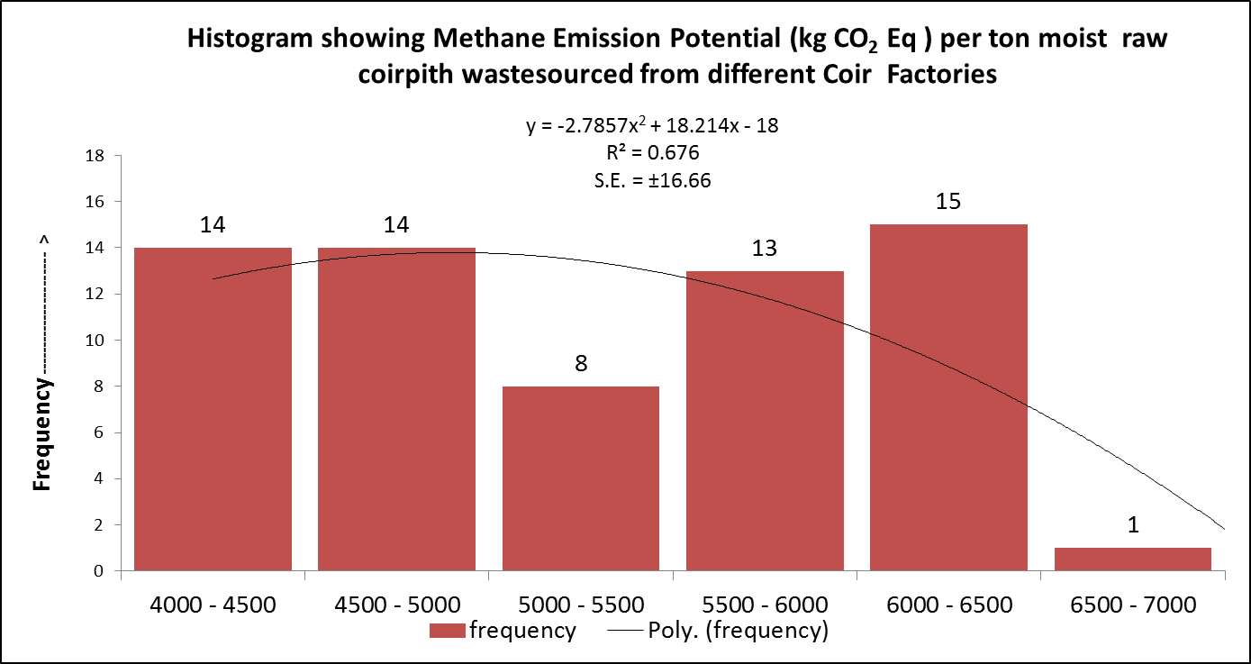
Fig 9 : Frequency distribution of GHG emission potential of coir pith sourced from different coirpith factories

GHG Emission Potential from Coirpith waste- A detailed Study
The methane emission potential of raw coir pith waste was assessed using 65 samples collected from coir factories across Karnataka during 2022–23 to 2024–25. Estimation followed the methodological framework of the Intergovernmental Panel on Climate Change (IPCC, 2006, 2019) to quantify methane generation in terms of carbon dioxide equivalent (CO₂-eq) per ton of moist raw coir pith. The calculated emission potential, based on a 24-year time horizon, ranged between 4413 and 6963 kg CO₂-eq ton⁻¹, with a mean value of approximately 5300 kg CO₂-eq ton⁻¹. The distribution of emission potential across the collected samples is represented in the histogram (Fig. 4). The data demonstrate that the majority of samples clustered within the 5000–6500 kg CO₂-eq ton⁻¹ range, which accounted for nearly two-thirds of the total dataset. The highest concentration of samples (15 out of 65) occurred in the 6000–6500 kg CO₂-eq ton⁻¹ class, followed by 13 samples in the 5500–6000 kg CO₂-eq ton⁻¹ class. Lower ranges of 4000–5000 kg CO₂-eq ton⁻¹ also showed substantial representation (14 samples each), whereas only one sample was recorded at the uppermost class of 6500–7000 kg CO₂-eq ton⁻¹. The fitted polynomial regression (R² = 0.676; S.E. ±16.66) captured the general trend in the frequency distribution, highlighting a unimodal pattern with the peak centered on 6000–6500 kg CO₂-eq ton⁻¹. This distribution indicates that raw coir pith waste, if left unmanaged, possesses a substantial greenhouse gas (GHG) emission potential. The long-tail occurrence of higher emission values, though limited in frequency, further underscores the variability among samples sourced from different factories. Overall, these findings emphasize that untreated coir pith is a significant methane emission source, and its management through sustainable practices such as controlled aerobic composting (e.g., Novcom method) is critical for reducing climate impacts.

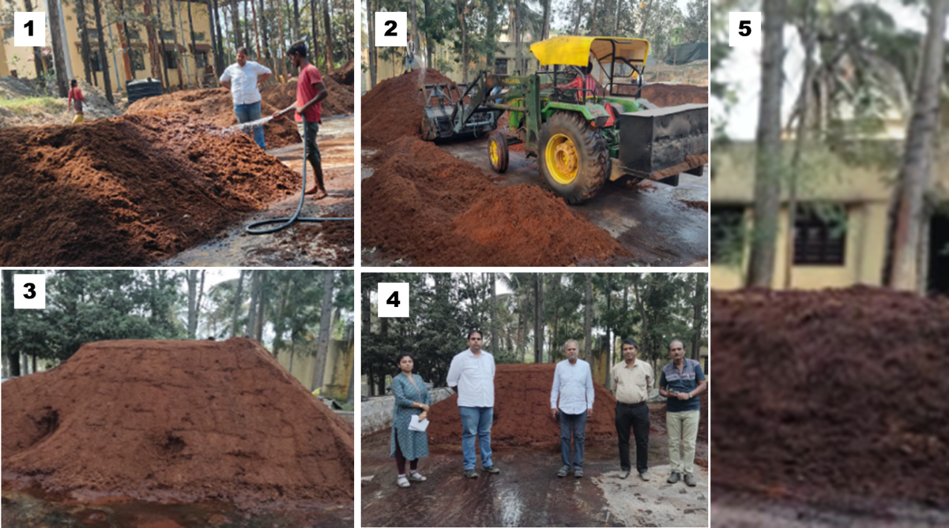

Pic 2 : Development of Novcom coir pith pro tray media at Ramnagar, Karnataka.

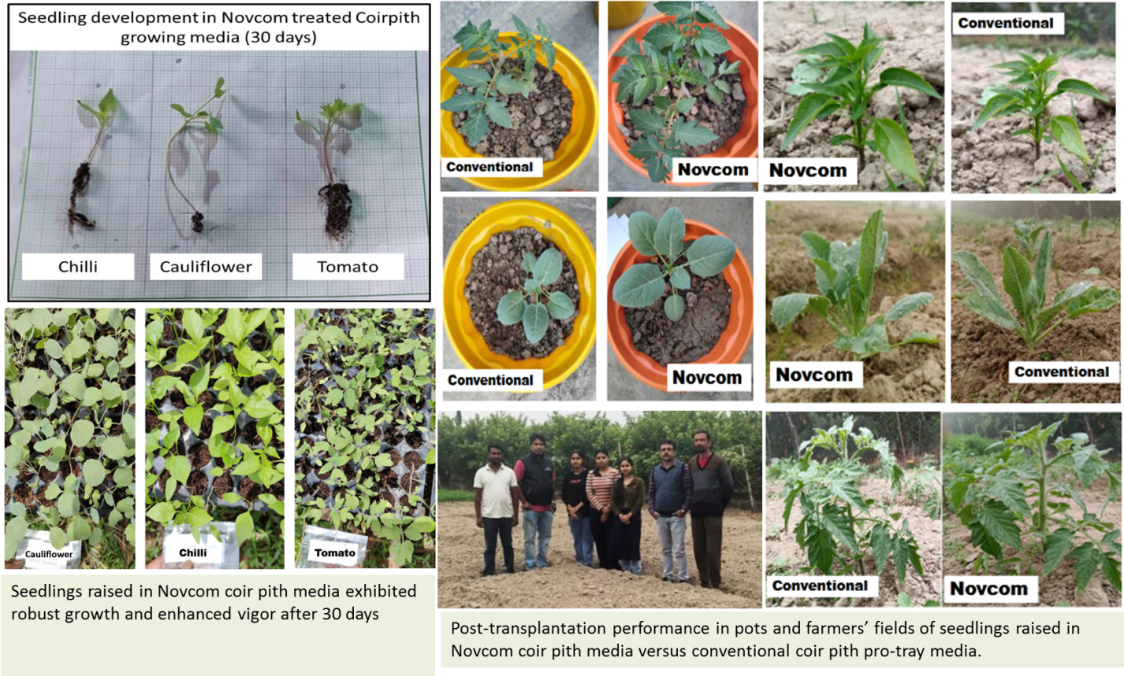
Pic 3 : Healthy seedling development using Novcom coir pith pro-tray media

Conclusion
This study demonstrates that converting coir pith into a properly conditioned pro-tray medium delivers durable agronomic and ecological gains well beyond substrate improvement. Seedlings raised in these biologically enriched medium establish faster, carry high-density microbial consortia into the field, strengthen early plant–soil functional coupling, and catalyze rhizosphere processes that enhance nutrient mobilization and reduce reliance on mineral fertilizers. Practically, the technology resolves two bottlenecks: valorizing abundant coir waste into a predictable nursery input and enabling cost-effective microbial delivery at transplanting and contributing to sustainability through improved nutrient-use efficiency, soil biological resilience, reduced waste pollution, and >99% methane mitigation. For safe and scalable adoption, emphasis must be placed on product quality control, biosecurity safeguards, and integration with adaptive nutrient management to avoid transient nutrient drawdowns. Future research should track persistence of functional microbiomes across cycles, link soil–plant interactions to yield and quality, and evaluate lifecycle economics and risks. Confirmed durable gains would position conditioned coir pro-tray media as a practical, climate-smart input for resilient and resource-efficient agriculture.

DISCLAIMER (ARTIFICIAL INTELLIGENCE) : We hereby declare that No generative AI technologies such as Large Language Models (ChatGPT, COPILOT, etc) and text-to-image generators have been used during writing or editing of this manuscript.

COMPETING INTERESTS : Authors have declared that no competing interests exist

References
- Abernethy, S., & Jackson, R. B. (2022). Global temperature goals should determine the time horizons for greenhouse gas emission metrics, Environ. Res. Lett. ;17: 024019.
- Bais HP, Weir TL, Perry LG, Gilroy S, Vivanco JM (2006). The role of root exudates in rhizosphere interactions with plants and other organisms. Annu Rev Plant Biol. 57:233-66. doi: 10.1146/annurev.arplant.57.032905.105159. PMID: 16669762.
- Barka EA, Vatsa P, Sanchez L, Gaveau-Vaillant N, Jacquard C, Meier-Kolthoff JP, Klenk HP, Clément C, Ouhdouch Y, van Wezel GP. (2015). Taxonomy, Physiology, and Natural Products of Actinobacteria. Microbiol Mol Biol Rev., Nov 25;80(1):1-43.
- Bera R. , Datta A., Bose S., Barik A. K. , Mallick R., Ganguli M., Narasimhan V. L. , Quah E., Mukherjee K., Bhattacharya P., and Seal. A. (2023). “Technological Breakthrough for Large Scale Bioconversion of Coir Pith towards Sustainable Soil Health Management and Development of Source Point Methane Abatement Model”. International Journal of Environment and Climate Change, 13 (7):75–102.
- Bera R, Dey, P., Bhattacharya, P., Barik A.K., Narasimhan V.L., and Quah E. (2025). “Review of Coir Pith As Agro‐industrial Waste: Environmental Challenges and Management Approaches”. Journal of Agriculture and Ecology Research International, 26 (2):19–36.
- Bustamante MA, Moral R, Paredes C, Pérez-Espinosa A, Moreno-Caselles J, Pérez-Murcia MD.(2008). Agrochemical characterisation of the solid by-products and residues from the winery and distillery industry. Waste Manag. 28(2):372-80.
- Cain, M., Lynch, J., Allen, M. R., Fuglestvedt, J. S., Frame, D. J., & Macey, A. H. (2019). Improved calculation of warming-equivalent emissions for short-lived climate pollutants. npj Climate and Atmospheric Science, 2, 29.https://doi.org/10.1038/s41612-019-0086-4
- Central Coir Research Institute (CCRI). (2018). Annual Report 2017–18. Government of India, Coir Board. Available at http://coirboard.gov.in/?page_id=199
- Central Pollution Control Board (CPCB). (2016). Enforcement Framework for Effective Implementation of Hazardous and Other Wastes (Management and Transboundary Movement) Rules, 2016. Delhi, Available at https://cpcb.nic.in/uploads/hwmd/Guidelines_HW_1.pdf
- Dey, P., Bera R, Dutta, A, S, Bose and K Mukhipadhyay (2025). NOVCOM Technology: Overcoming Limitations of Coirpith-Based Portray Media for Healthy and Uniform Seedling Production, Page 1-78, DOI: 10.13140/RG.2.2.16534.82241;
- Food and Agriculture Organization (FAO). (2020). FAOSTAT: Crops and livestock products. Rome: FAO. Available at https://www.fao.org/faostat/en/#data/QCL
- Forster, P., T. Storelvmo, K. Armour, W. Collins, J.-L. Dufresne, D. Frame, D.J. Lunt, T. Mauritsen, M.D. Palmer, M. Watanabe, M. Wild, and H. Zhang, 2021: The Earth’s Energy Budget, Climate Feedbacks, and Climate Sensitivity. In Climate Change 2021: The Physical Science Basis. Contribution of Working Group I to the Sixth Assessment Report of the Intergovernmental Panel on Climate Change [Masson-Delmotte, V., P. Zhai, A. Pirani, S.L. Connors, C. Péan, S. Berger, N. Caud, Y. Chen, L. Goldfarb, M.I. Gomis, M. Huang, K. Leitzell, E. Lonnoy, J.B.R. Matthews, T.K. Maycock, T. Waterfield, O. Yelekçi, R. Yu, and B. Zhou (eds.)]. Cambridge University Press, Cambridge, United Kingdom and New York, NY, USA, pp. 923–1054, doi:10.1017/9781009157896.009.
- Gold Standard Foundation (2022). Principles & Requirements. Gold Standard for the Global Goals. https://globalgoals.goldstandard.org/101-par-principles-requirements/?utm_source=chatgpt.com
- Government of Tamil Nadu. (2024). Tamil Nadu Coir Policy 2024: Government of Tamil Nadu, Available at https://cms.tn.gov.in/cms_migrated/document/docfiles/coir_policy_ 2024.pdf? utm_source=chatgpt.com
- Intergovernmental Panel on Climate Change (IPCC). (2006). 2006 IPCC Guidelines for National Greenhouse Gas Inventories: Volume 5 – Waste. Eggleston, H. S., Buendia, L., Miwa, K., Ngara, T., & Tanabe, K. (Eds.). IGES, Japan. Retrieved from https://www.ipcc-nggip.iges.or.jp/public/2006gl/
- Intergovernmental Panel on Climate Change (IPCC). (2019). 2019 Refinement to the 2006 IPCC Guidelines for National Greenhouse Gas Inventories. Geneva: IPCC.
- IPCC. (2006). 2006 IPCC Guidelines for National Greenhouse Gas Inventories. Institute for Global Environmental Strategies (IGES).
- IPCC. (2019). 2019 Refinement to the 2006 IPCC Guidelines for National Greenhouse Gas Inventories — Volume 5: Waste (methodologies for solid waste disposal). Intergovernmental Panel on Climate Change.
- IPCC. (2021). Climate Change 2021: The Physical Science Basis. Contribution of Working Group I to the Sixth Assessment Report. Cambridge University Press.
- IPCC. (2021a). Climate Change 2021: The Physical Science Basis (AR6) — for methane GWP values. Intergovernmental Panel on Climate Change.
- Jones, D. L., Hodge, A., & Kuzyakov, Y. (2004). Plant and mycorrhizal regulation of rhizodeposition. New Phytologist, 163(3), 459–480.
- Joos, F., Roth, R., Fuglestvedt, J. S., Peters, G. P., Enting, I. G., von Bloh, W., … Weaver, A. J. (2013). Carbon dioxide and climate impulse response functions for the computation of greenhouse gas metrics: A multi-model analysis. Atmospheric Chemistry and Physics, 13(5), 2793–2825.
- Khan, M. A., Ungar, I. A., & Showalter, A. M. (2006). The effect of salinity on growth, water status and ion content of a leaf-succulent perennial halophyte, Suaeda fruticosa (L.) Forssk. Journal of Arid Environments, 67(3), 475–483. https://doi.org/10.1016/j.jaridenv.2006.02.002
- Lal, R. (2004). Soil carbon sequestration impacts on global climate change and food security. Science, 304(5677), 1623–1627.
- Mendes, R., Kruijt, M., de Bruijn, I., Dekkers, E., van der Voort, M., Schneider, J. H. M., Raaijmakers, J. M. (2011). Deciphering the rhizosphere microbiome for disease-suppressive bacteria. Science, 332(6033), 1097–1100.
- Paredes, C., Roig, A., Bernal, M. P., Sánchez-Monedero, M. A., & Cegarra, J. (2000). Evolution of organic matter and nitrogen during co-composting of olive mill wastewater with solid organic wastes. Biology and Fertility of Soils, 32, 222–227. https://doi.org/10.1007/s003740000246
- Seal A., Bera R., Datta A., Saha S., Chatterjee A.K., Barik A.K., Nath R. and D. Mazumdar (2015). Successful Biodegradation of coir pith waste using Novcom Composting Method : A Case Study from Vaniampara Rubber Estate, India. Journal of Pharmaceutical and Scientific Innovation, 4(1) : 73-77
- Smith, P., Martino, D., Cai, Z., Gwary, D., Janzen, H., Kumar, P., … Smith, J. (2008). Greenhouse gas mitigation in agriculture. Philosophical Transactions of the Royal Society B: Biological Sciences, 363(1492), 789–813. https://doi.org/10.1098/rstb.2007.2184
- Swift, M. J., Heal, O. W., & Anderson, J. M. (1979). Decomposition in terrestrial ecosystems. University of California Press.
- Tamil Nadu Pollution Control Board (TNPCB). (2023). Available athttps://www.greentribunal.gov.in/sites/default/files/news_updates/2823_1.pdf?utm_source=chatgpt.com .
- Tanji, K. K. (1991). Agricultural salinity assessment and management. American Society of Civil Engineers (ASCE).
- Tilman, D., Cassman, K. G., Matson, P. A., Naylor, R., & Polasky, S. (2002). Agricultural sustainability and intensive production practices. Nature, 418(6898), 671–677.
- UNFCCC (2012). Clean Development Mechanism: Tool for the demonstration and assessment of additionality (Version 07.0.0). United Nations Framework Convention on Climate Change (UNFCCC). https://cdm.unfccc.int/methodologies/PAmethodologies/ tools/am-tool-01-v7.0.pdf
- Vaithilingam S. (2025) Chapter 17 - Efficacy of coir pith based cyanobacterial biofertilizer in enhancing soil fertility and biomass, Editor(s): Ajay Kumar, Joginder Singh, Ana Maria Queijeiro López, Ravindra N Kharwar, In Plant and Soil Microbiome, Microbial Inoculants, Academic Press, 2025, Pages 333-357, ISBN 9780443235603, https://doi.org/10.1016/B978-0-443-23560-3.00018-8.
- Velasquez, E., Lavelle, P., Andrade, M. (2007). GISQ, a multifunctional indicator of soil quality. Soil Biology & Biochemistry 39, 3066–3080.
- Weaver, R. W., (1994). Methods of Soil Analysis, Part 2: Microbiological and Biochemical Properties (Soil Science Society of America Book Series). Madison, WI: Soil Science Society of America.
- Zucconi, F., Pera, A., Forte, M., & De Bertoldi, M. (1981). Evaluating toxicity of immature compost. BioCycle, 22, 54–57.
- Gallegos-Cedillo, Victor M., Fernando Diánez, Cinthia Nájera, and Mila Santos. (2021). "Plant Agronomic Features Can Predict Quality and Field Performance: A Bibliometric Analysis" Agronomy 11, no. 11: 2305. https://doi.org/10.3390/agronomy11112305

