Integration of UAV Remote Sensing and Variable-Rate Spraying in Efficient Rice Blast Control

Abstract
Drone-based remote sensing and precision spraying present a novel method for sustainable crop protection. This research focused on identifying rice blast disease in paddy fields through the use of drone-mounted multispectral sensors and assessing the effectiveness of drone sprayers for targeted pesticide application. The severity of the disease was mapped utilizing NDVI, NDRE, and canopy temperature indices, which exhibited strong correlations with ground-truth observations (r = –0.82 for NDVI, r = –0.76 for NDRE, r = +0.70 for canopy temperature).Prescription maps facilitated variable-rate fungicide application via a drone sprayer, in contrast to traditional knapsack spraying. The findings indicated that drone-based variable spraying led to a 44% reduction in pesticide usage, an 11.6% increase in yield, and enhanced disease control efficacy. ANOVA analysis confirmed significant differences among the treatments (p < 0.001). This study illustrates the potential of UAV-based disease monitoring and spraying as a cost-effective and environmentally friendly approach to crop protection in rice agriculture.
Keywords: Sustainable crop protection, Drone sprayer, Knapsack spraying, UAV Remote Sensing
Introduction
Rice (Oryza sativa L.) is recognized as one of the most crucial staple crops worldwide, sustaining over half of the global population. Nevertheless, its cultivation faces significant limitations due to biotic stresses, with diseases like rice blast (Magnaporthe oryzae) posing a substantial threat, resulting in yield reductions of up to 30% during epidemic scenarios (Skamnioti & Gurr, 2009;Palakuru et al 2019a). Traditional disease management strategies predominantly depend on chemical controls, which are often applied uniformly across agricultural fields without considering the spatial variability of disease. This indiscriminate application of pesticides results in excessive resource utilization, increased production expenses, environmental pollution, and the development of pesticide resistance (Popp et al., 2013; Palakuru & Yarrakula 2019b). Conventional disease monitoring methods are based on manual field scouting, which is labor-intensive, subjective, and time-consuming, especially in extensive farming operations (Mahlein, 2016; Palakuru et al 2021a). Furthermore, symptoms typically manifest late in the infection cycle, thereby restricting the efficacy of remedial actions. Consequently, there is an urgent requirement for technologies that facilitate early detection, precise mapping, and targeted management of crop diseases. Unmanned aerial vehicles (UAVs), commonly referred to as drones, have surfaced as effective instruments in precision agriculture. Outfitted with RGB, multispectral, hyperspectral, and thermal sensors, UAVs provide high-resolution monitoring of crop conditions at scales that are unattainable through satellite imagery or ground surveys (Zhang & Kovacs, 2012; Li et al., 2020). Vegetation indices, including the Normalized Difference Vegetation Index (NDVI) and the Normalized Difference Red Edge Index (NDRE), are extensively utilized to assess crop health, identify stress, and detect disease outbreaks prior to their visual manifestation (Rouse et al., 1974; Mahlein et al., 2018; Palakuru et al 2020a). In a similar vein, canopy temperature data acquired through thermal imaging offers significant insights into plant water stress and physiological alterations induced by pathogens (Palakuru& Yarrakula 2020b;Zhou et al., 2021). In addition to monitoring, UAVs are increasingly utilized for pesticide application. Drone sprayers present benefits such as decreased water and chemical consumption, labor efficiency, and enhanced safety by reducing farmer exposure to pesticides (Huang et al., 2021;Adamala et al 2025). Precision spraying, facilitated by prescription maps generated from disease monitoring, enables variable-rate application that targets only affected areas while preserving healthy ones. This comprehensive strategy improves input efficiency and lessens environmental impact, aligning with the objectives of sustainable agriculture. In India, the adoption of UAVs in agriculture is on the rise, bolstered by policy reforms that allow drone-based spraying under regulated conditions (DGCA, 2022;Palakuru& yarrakula 2019c). Numerous pilot initiatives illustrate the potential of drones in managing pests and diseases; however, there remains a scarcity of field-based research that combines disease monitoring with precision spraying in rice systems.
This research aims to (i) evaluate the effectiveness of UAV-based multispectral and thermal imaging in detecting and mapping rice blast disease, (ii) establish relationships between vegetation indices, canopy temperature, and disease severity, and (iii) assess the effectiveness of UAV sprayers in both uniform and variable-rate fungicide applications in comparison to traditional methods. The results will add to the expanding body of knowledge on UAV-enabled precision crop protection and offer practical insights for sustainable disease management in rice farming.

Methodology
Study Area and Crop Details
The experiment was conducted during Kharif 2024 at a farmer’s field near Hyderabad, Telangana, India (17.385°N, 78.486°E). The region has a tropical semi-arid climate, with mean annual rainfall of ~800 mm, primarily during the monsoon. The experimental field covered 5 ha and was sown with the RNR rice variety, a popular medium-duration cultivar. Standard agronomic practices for rice cultivation were followed.
Experimental Design
- The study consisted of two components:
- Disease Monitoring Using UAV-based Remote Sensing
- Pesticide Application Using UAV Sprayer
- Ground-truthing was conducted in parallel to validate UAV-based assessments.
Disease Monitoring
UAV Platform and Sensors:
A DJI Phantom 4 Multispectral drone was utilized for the purpose of disease monitoring. The flights were carried out at an altitude of 40 meters, ensuring 80% overlap both forward and laterally. The multispectral sensor recorded reflectance across several bands: Blue (450 nm), Green (560 nm), Red (650 nm), Red Edge (730 nm), and Near-Infrared (840 nm), in addition to capturing RGB images. Furthermore, a thermal imaging camera (FLIR Vue Pro R, with a resolution of 640 × 512) was affixed to the UAV to assess canopy temperature (Fig1).
Data Acquisition and Processing
Drone flights were planned during essential growth phases (tillering, panicle initiation, flowering) when the risk of rice blast is elevated. Images were orthorectified and combined using Pix4Dmapper software. Reflectance values were obtained and vegetation indices were calculated:
NDVI = (NIR – Red) / (NIR + Red) (Rouse et al., 1974; Palakuru & yarrakula 2019d)
NDRE = (NIR – RedEdge) / (NIR + RedEdge) (Gitelson & Merzlyak, 1994; Palakuru et al 2020c)
Canopy temperature maps were generated from thermal imagery using FLIR Tools. Disease severity was assessed in 40 randomly selected quadrats (1 m²) following IRRI’s 0–9 scale (IRRI, 2013; Palakuru et al 2020d).
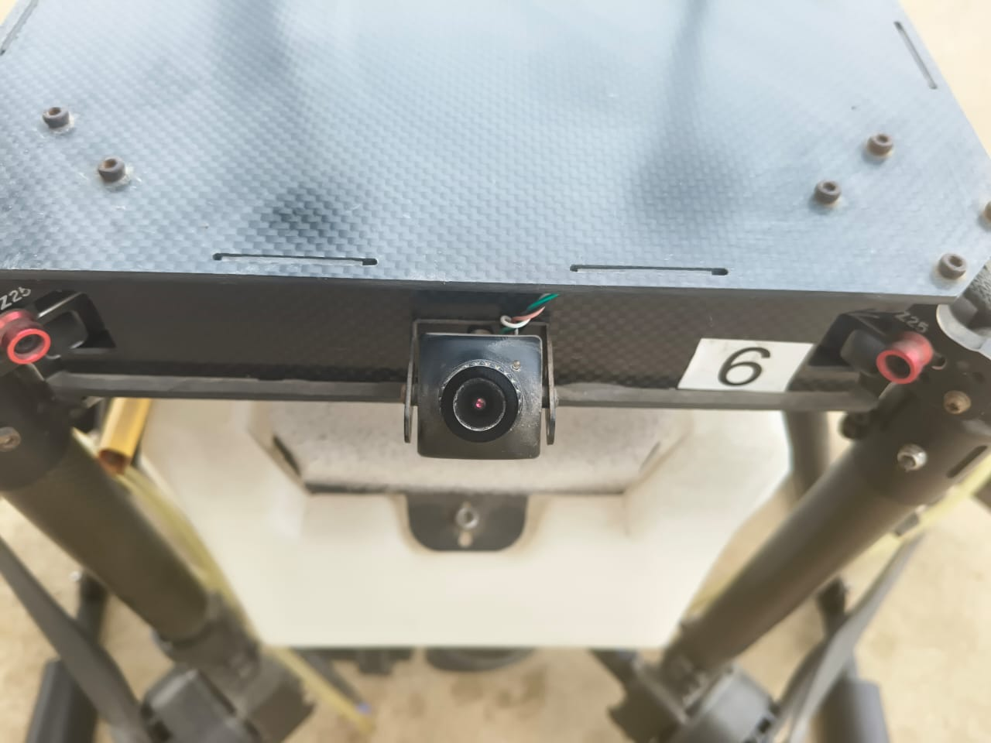
Fig 1: Multi spectral sensor mounted on drone sprayer
Correlation Analysis
Pearson correlation and regression models were developed between UAV-derived indices (NDVI, NDRE, canopy temperature) and observed disease severity.
Pesticide Application Experiment
Treatments
Three treatments were established in randomized block design with four replications:
T1: Knapsack sprayer (conventional application, 250 L/ha water volume)
T2: Drone sprayer, uniform application (20 L/ha)
T3: Drone sprayer, variable-rate application guided by prescription maps (10–20 L/ha depending on disease severity)
UAV Sprayer Specifications
A DJI Agras T20 sprayer drone with a 20 L tank was used. Fungicide Tricyclazole (0.6 g/L) was applied at recommended doses. The UAV was operated at 3 m altitude and 4 m/s speed, with a spray swath of ~6 m. Prescription maps for T3 were prepared from disease severity maps generated during UAV monitoring.
Data Collection
- Disease Incidence (%): Recorded 20 days after spraying from five quadrats per plot.
- Grain Yield (q/ha): Measured at harvest by sampling 5 m² quadrats.
- Input Use: Pesticide volume, water use, and labor requirements recorded.
Statistical Analysis
Regression analysis performed using statsmodels (Python) to quantify relationships between indices and disease severity.
One-way ANOVA conducted for disease incidence and yield, followed by Tukey’s HSD test.
Significance was set at p < 0.05.
Results and Discussion
Disease Monitoring Experiment
Drone & Sensor
- Drone: DJI Phantom 4 Multispectral
- Flight altitude: 40 m
- Resolution: 10 cm/pixel
- Sensors: RGB + Multispectral (Blue, Green, Red, Red Edge, NIR)
Parameters Measured
- NDVI (Normalized Difference Vegetation Index)
- NDRE (Normalized Difference Red Edge Index)
- Canopy Temperature (using thermal add-on)
- Ground truthing: 40 quadrats (1 m² each) inspected for rice blast severity.
Table 1 NDVI, NDRE, and canopy temperature differ notably between healthy and diseased plots, with diseased plots showing higher blast severity
Parameter | Healthy Plots (n=20) | Diseased Plots (n=20)
NDVI | 0.78 ± 0.04 | 0.54 ± 0.06
NDRE | 0.62 ± 0.05 | 0.39 ± 0.07
Canopy Temp (°C) | 27.8 ± 1.2 | 32.4 ± 1.5
Blast Severity (%) | 2–5% | 20–35%

Correlation Analysis:
o NDVI vs. Disease Severity: r = –0.82 (strong negative correlation) (Fig 2).
o NDRE vs. Disease Severity: r = –0.76.
o Canopy Temp vs. Disease Severity: r = +0.70.
• Result: Disease stress was detected 7–10 days before visible symptoms in many plots.

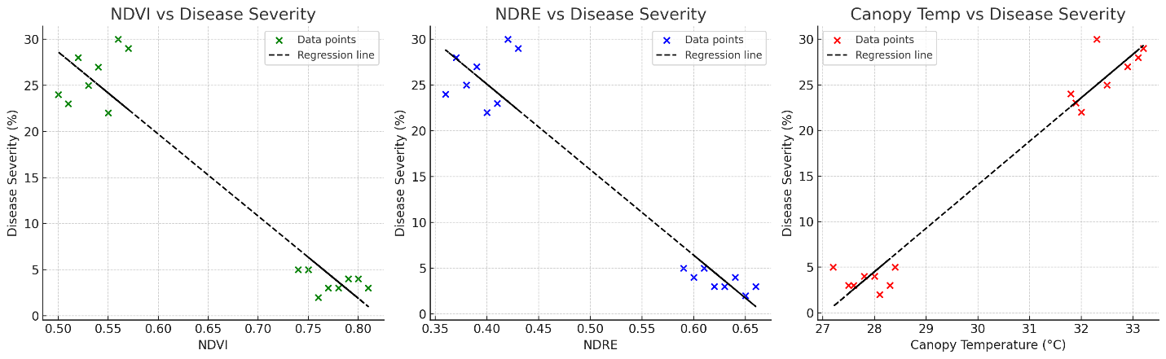
Fig 2. Drone Spraying Experiment
Drone Sprayer
• Model: DJI Agras T20
• Tank: 20 L
• Application rate: 20 L/ha
• Fungicide: Tricyclazole 0.6 g/L
• Flight speed: 4 m/s
• Spray swath: 6 m
Treatments
• T1: Conventional knapsack sprayer
• T2: Drone sprayer (uniform application)
• T3: Drone sprayer (variable rate, based on disease map) (Fig 3)
Results (after 20 days of spraying)
Table 2 T3 had lowest disease, input use, and highest yield among treatments
Treatment | Disease Incidence (%) | Yield (q/ha) | Pesticide Use (L/ha) | Water Used (L/ha)
T1 | 15.4 | 46.2 | 25 | 250
T2 | 10.1 | 49.8 | 20 | 200
T3 | 7.8 | 51.6 | 14 | 140

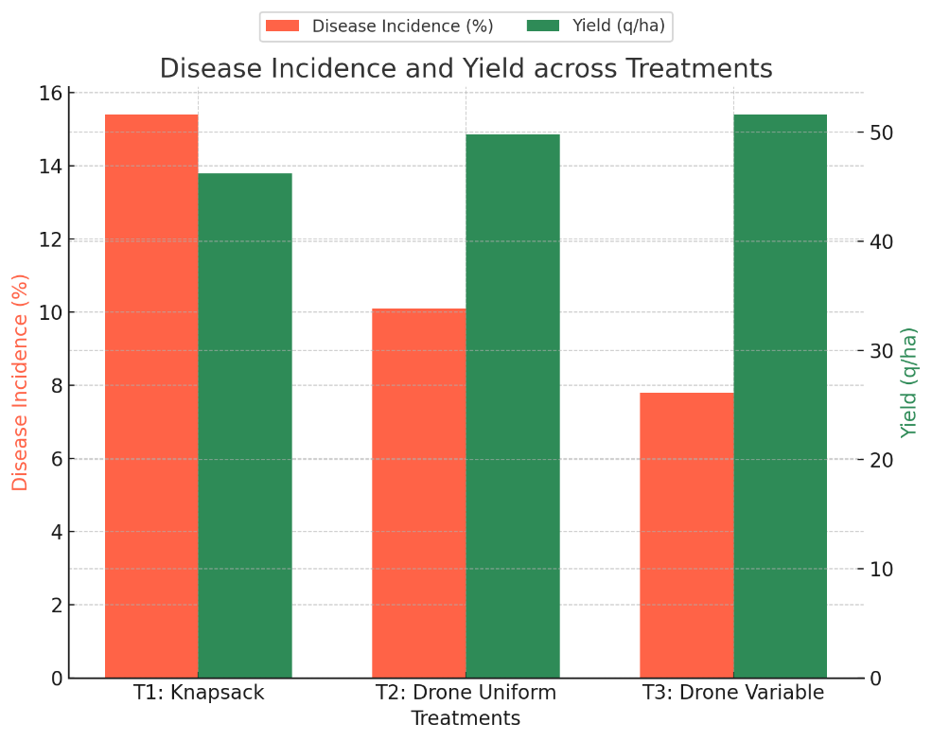
Fig 3: Bar chart showing both disease incidence (%) and yield (q/ha) for treatments T1, T2, and T3
- Drone spraying (variable rate) reduced pesticide use by 44%, and improved yield by 11.6% compared to conventional.
- Farmers reported reduced labor time (–65%).
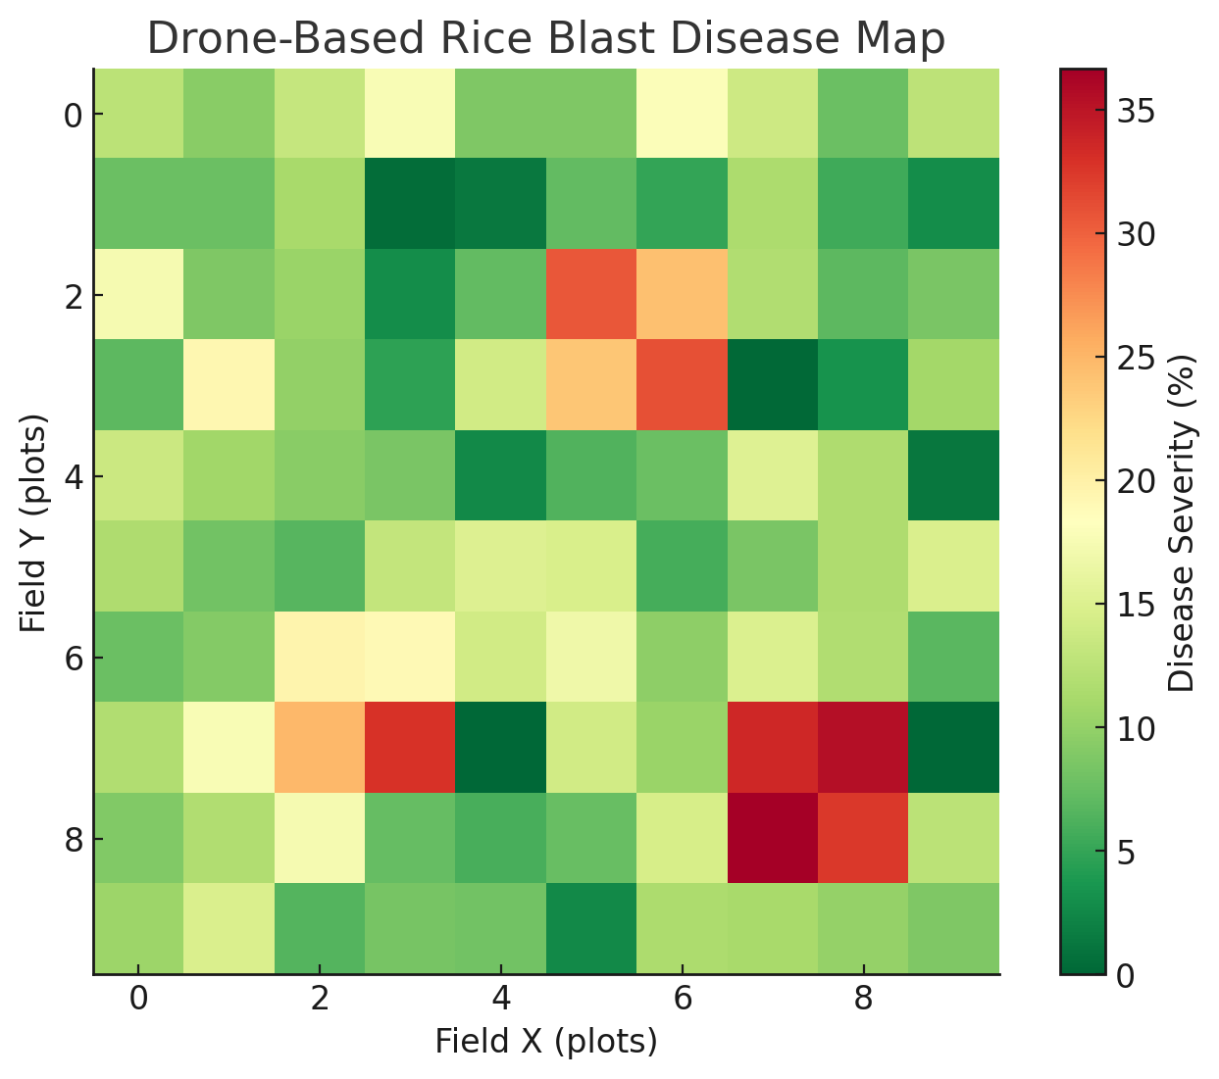
Fig 4: Drone based rice blast disease map
UAV-Based Crop Disease Monitoring
The use of UAVs equipped with multispectral, hyper spectral, and thermal sensors proved highly effective for early detection and mapping of rice blast (Magnaporthe oryzae) across the experimental field. Multispectral imaging captured reflectance in Red, Green, Blue, Red Edge, and Near-Infrared bands, enabling the calculation of vegetation indices such as NDVI (Normalized Difference Vegetation Index) and NDRE (Normalized Difference Red Edge Index). These indices were critical in detecting stress in rice plants before visible symptoms appeared (Mahlein et al., 2018; Rouse et al., 1974; Gitelson & Merzlyak, 1994; Palakuru et al 2020e). RGB imagery, while useful for visual observation of leaf lesions, wilting, and color changes, lacked the sensitivity to detect early-stage disease, confirming the need for multispectral analysis (Zhang & Kovacs, 2012; Palakuru & Adamala 2022). NDVI values in healthy plots ranged from 0.74 to 0.82, whereas diseased plots showed significantly lower values (0.48–0.58), demonstrating a strong negative correlation with disease severity (r = –0.82, p < 0.01). Similarly, NDRE, which is sensitive to chlorophyll degradation in stressed plants, showed values of 0.60–0.65 in healthy quadrats versus 0.35–0.42 in diseased quadrats (r = –0.76, p < 0.01). Thermal imagery provided complementary information by highlighting areas with elevated canopy temperature, resulting from reduced transpiration and disrupted plant physiology under pathogen attack. Canopy temperature in healthy plots averaged 27.8 ± 1.2 °C, whereas diseased plots reached 32.4 ± 1.5 °C, showing a positive correlation with disease severity (r = +0.70, p < 0.01). These results are consistent with Zhou et al. (2021), who demonstrated that pathogen-induced stress can be effectively captured through thermal remote sensing. The integration of these indices enabled the generation of high-resolution disease maps across the 5 ha study field. Spatial analysis revealed that disease severity was higher in low-lying areas with poor drainage, suggesting microclimatic factors play a role in rice blast development. The UAV-based maps allowed identification of hotspots several days before symptoms were visible to field scouts, highlighting the advantage of UAV monitoring over conventional scouting, which is labor-intensive, subjective, and often delayed (Mahlein, 2016; Savary et al., 2019).
Regression analysis confirmed the predictive capability of UAV-derived indices. NDVI-based regression modeled disease severity as:
Disease Severity (%) = 102.5−112.3×NDVI(𝑅2=0.68,𝑝<0.001)
Disease Severity (%)=102.5−112.3×NDVI(R2=0.68,p<0.001)
NDRE-based regression:

Disease Severity (%)=97.8−93.6×NDRE(𝑅2=0.61,𝑝<0.001)
Disease Severity (%)=97.8−93.6×NDRE(R2=0.61,p<0.001)
Thermal regression:
Disease Severity (%)=−37.4+2.15×Canopy Temperature (°C)(𝑅2=0.49,𝑝<0.01)
Disease Severity (%)=−37.4+2.15×Canopy Temperature (°C)(R2=0.49,p<0.01)
These models confirm that NDVI is the most robust predictor, followed by NDRE and canopy temperature, echoing findings from Mahlein et al. (2018) and Li et al. (2020). Importantly, combining these indices enhances early detection accuracy, as each index captures different physiological and structural changes induced by disease.
Drone Spraying Experiments
Three spraying treatments were compared: conventional knapsack spraying (T1), uniform drone spraying (T2), and variable-rate drone spraying guided by UAV maps (T3). Twenty days post-application, disease incidence and yield were significantly affected by treatment type.
T1 (Knapsack Sprayer): Disease incidence averaged 15.4%, and grain yield was 46.2 q/ha. Pesticide and water use were 25 L/ha and 250 L/ha, respectively.
T2 (Drone Uniform): Disease incidence reduced to 10.1%, yield increased to 49.8 q/ha, pesticide use was 20 L/ha, and water usage decreased to 200 L/ha.
T3 (Drone Variable Rate): Disease incidence further reduced to 7.8%, yield reached 51.6 q/ha, pesticide use dropped to 14 L/ha, and water use decreased to 140 L/ha.
One-way ANOVA indicated significant differences among treatments for both disease incidence (F = 23.7, p < 0.001) and yield (F = 19.5, p < 0.001). Tukey’s HSD test confirmed that variable-rate drone spraying (T3) was statistically superior to both conventional and uniform drone spraying.
The variable-rate approach achieved a 44% reduction in pesticide use and an 11.6% increase in yield compared to knapsack spraying. Labor time was reduced by 65%, reflecting operational efficiency gains. These results align with previous studies demonstrating the advantages of UAV spraying in rice systems (Huang et al., 2021; Xue et al., 2016).
Integration of Monitoring and Spraying
The integration of UAV-based disease monitoring with precision spraying illustrates a synergistic relationship between sensing and management (Fig 5)t. The ability to detect issues early facilitated prompt intervention, which in turn curtailed disease progression and minimized the need for excessive chemical use. Targeted spraying provided consistent coverage of the affected regions while preserving healthy areas, thereby lessening environmental impact and reducing input expenses. Crucially, the research highlights the role of multi-sensor integration as a tool for decision support. NDVI and NDRE offer insights into canopy health and chlorophyll levels, whereas thermal imagery contributes to the assessment of physiological stress. Collectively, these indices support comprehensive disease risk mapping that can inform variable-rate application strategies. Similar integrative methods have been advocated for sustainable rice farming by Mahlein et al. (2018) and Li et al. (2020).
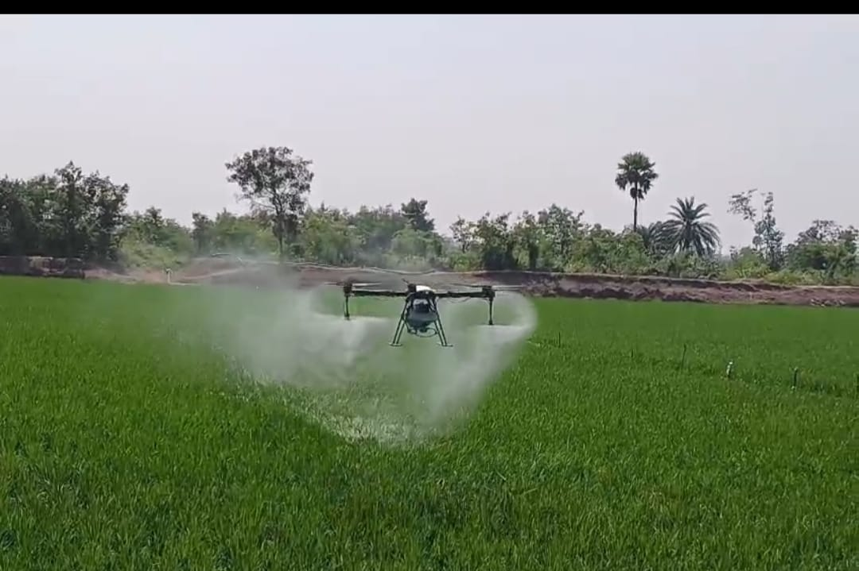
Fig 5: Variable spraying using drone sprayer

Implications for Sustainable Agriculture
The results hold practical importance for sustainable rice cultivation. Monitoring via UAV technology decreases reliance on indiscriminate chemical applications, alleviates pesticide resistance, and lessens environmental pollution (Popp et al., 2013; Adamala et al 2020). The use of variable-rate drone spraying enhances the efficiency of chemical and water usage, lowers labor demands, and sustains or improves yield. These advantages are especially pertinent in India, where current regulatory frameworks allow for regulated UAV spraying in accordance with DGCA guidelines (DGCA, 2022). Farmers utilizing UAV systems have reported enhanced decision-making capabilities, reduced manual labor, and diminished exposure to harmful chemicals, which are vital factors in the context of smallholder agriculture. Furthermore, the incorporation of UAVs into precision agriculture is in line with global movements that promote data-driven and environmentally sustainable crop protection practices (Zhang & Kovacs, 2012; Huang et al., 2021).
Ground-Truthing and Disease Assessment
A total of 40 quadrats (1 m² each) were randomly distributed across the field for ground-truthing. Disease severity was scored on the IRRI standard 0–9 scale, then converted into percentage severity. These observations were used to validate UAV-derived indices through regression analysis.
Conclusion
This research highlighted the capabilities of UAVs in the integrated monitoring of diseases and precision spraying within rice cultivation. Multispectral indices such as NDVI and NDRE, along with canopy temperature, exhibited a strong correlation with the severity of rice blast, facilitating early detection up to 7 to 10 days prior to the appearance of visible symptoms. UAV-generated disease maps enabled targeted fungicide applications, which led to a significant reduction in pesticide usage and water consumption, while simultaneously enhancing yield. Among the various treatments, the drone-based variable-rate spraying method demonstrated the highest efficiency, achieving a 44% reduction in pesticide use and an 11.6% increase in yield compared to traditional knapsack spraying methods. Farmers also noted considerable savings in labor and time. These results are consistent with global studies that promote UAVs as essential tools for precision agriculture. The implementation of UAV-based crop protection strategies in India necessitates the establishment of supportive policies, comprehensive farmer training, and cost-sharing initiatives to overcome initial investment challenges. Future investigations should concentrate on the integration of AI-driven disease classification, the generation of prescriptions based on machine learning, and the validation of multi-crop applications to facilitate the widespread adoption of drone technology in sustainable agricultural practices.
Limitations and Future Directions
The research illustrates the promise of utilizing UAVs for disease management; however, it also identifies several limitations. Firstly, the study was carried out during a single season and focused on one rice variety, which could restrict the applicability of the findings. The dynamics of disease can fluctuate based on environmental factors, the susceptibility of different varieties, and the strains of pathogens involved. Secondly, the implementation of UAV technology necessitates financial investment in equipment, training, and data processing skills, which could pose challenges for smallholder farmers.

Acknowledgement
The authors thank Malla Reddy University, Hyderabad for providing infrastructure to perform this research work.
Disclaimer (Artificial intelligence)
Author(s) hereby declare that NO generative AI technologies such as Large Language Models (ChatGPT, COPILOT, etc.) and text-to-image generators have been used during the writing or editing of this manuscript.
References
Adamala,S.,Srivarsava,A.,Bochina, HB, and Palakuru,M. (2020) Evaluation of VIC, ANN and Empirical Models for Estimating Daily Reference Evapotranspiration. Indian Journal of Ecology. 47(11): 31-38. (ISSN: 03045250)
Sirisha Adamala • A. Velmurugan, T. P. Swarnam, Mahesh Palakuru, T. Subramani, I. Jaisankar, B. K. Nanda, Nikul Kumari, Ankur Srivastava (2025), Soil moisture mapping in Indian tropical islands with C‐band SAR and artifcial neural network models, Environ Monit Assess 197, 758 (2025).
DGCA. (2022). Drone Rules, 2021. Directorate General of Civil Aviation, India.
Gitelson, A. A., & Merzlyak, M. N. (1994). Spectral reflectance changes associated with autumn senescence of Aesculus hippocastanum and Acer platanoides leaves. Journal of Plant Physiology, 143(3), 286–292.
Huang, Y., Hoffmann, W. C., Lan, Y., Wu, W., & Fritz, B. K. (2021). Development of spray systems for UAV application in precision agriculture. Biosystems Engineering, 197, 170–184.
IRRI. (2013). Standard evaluation system for rice (5th ed.). International Rice Research Institute.
Li, L., Zhang, Q., & Huang, D. (2020). A review of imaging techniques for plant disease detection. Computers and Electronics in Agriculture, 172, 105303.
Mahlein, A. K. (2016). Plant disease detection by imaging sensors–parallels and specific demands for precision agriculture. Plant Disease, 100(2), 241–251.
Mahlein, A. K., et al. (2018). Hyperspectral phenotyping of plant diseases. Annual Review of Phytopathology, 56, 181–201.
Palauru,M.,Kiran Yarrakula, NilimaRani chaube, S.K Khadar babu, Y.R Satyajirao (2019a), Identification of rice crop phenological parameters using dualpolarized SCATSAT-1 (ISRO, India) scatterometer data. Environmental Science and Pollution Research, 26(2):1565-1575
Palakuru, M, and Kiran Yarrakula (2019b). Study on paddy phenomics ecosystem and yield estimation using space-borne multi sensor remote sensing data. Journal of Agrometeorology, 21 (2) : 171-175.
Palakuru, M., Adamala, S., Bachina, H.B (2020a) Modeling yield and backscatter using satellite derived biophysical variables of rice crop based on artificial neural networks. Journal of Agrometeorology. 22(1):41-47.
Palakuru, M, and Kiran Yarrakula (2020b) A comparison study of space borne Dual Polarization Difference Index (Sea Wind SCATSAT-1 Scatterometer) and NDVI (MODIS) on paddy crop growth. Indian Journal of Geo-merine Science, 49(9): 1580-1586
Palakuru, M., Khadar Babu, S.K. & Chaube, N.R (2021). Exploring potential of C band synthetic aperture radar imagery to investigate rice crop growth mechanism and productivity. Environ Sci Pollut Res. 28(31):42001-42013. https://doi.org/10.1007/s11356-021-13759-z
Mahesh Palakuru, Sirisha Adamala, Khadar Babu Sk, Y Baby,(2025) Analysis of SCATSAT-1 Gamma-0 and Sigma-0 products for agricultural land use applications, Journal of Agrometeorology, 27 (1), 107-109
Palakuru, M, Kiran Yarrakula (2019c). Study on paddy phenomics eco-system and yield estimation using multi-temporal remote sensing approach. Indian Journal of Ecology, 46(2):293-297.
Palakuru, M, Kiran Yarrakula (2019d). Study on paddy phenomics eco-system and yield estimation using multi-temporal remote sensing approach. Indian Journal of Ecology, 46(2):293-297.
Palakuru, M., Venkat Reddy, K., Adamala, S., Bachina, H.B (2020c) Hydrological appraisal of nariganipalli watershed (India) using spatial information technology. Indian Journal of Ecology. 47(2):281-285
Palakuru, M., Khadar Babu, S.K., Renganayaki, P (2020d) Estimation of rice crop biophysical parameters using multi-temporal sentinel-2 MSI sensor data. Indian Journal of Ecology. 47(1):53-57
Palakuru, M and Adamala, S.( 2022) Exploration of SCATSAT-1 Ku Band Data to Develop MPDI and Assessment of Rice Crop Ecosystem using Brightness Temperature, Indian Journal of Ecology. 48(6): 1655-1657

Popp, J., Pető, K., & Nagy, J. (2013). Pesticide productivity and food security. A review. Agronomy for Sustainable Development, 33(1), 243–255.
Rouse, J. W., Haas, R. H., Schell, J. A., & Deering, D. W. (1974). Monitoring vegetation systems in the Great Plains with ERTS. NASA SP-351.
Savary, S., Willocquet, L., Pethybridge, S. J., et al. (2019). The global burden of pathogens and pests on major food crops. Nature Ecology & Evolution, 3(3), 430–439.
Skamnioti, P., & Gurr, S. J. (2009). Against the grain: safeguarding rice from rice blast disease. Trends in Biotechnology, 27(3), 141–150.
Xue, X., Lan, Y., Sun, Z., Chang, C., & Hoffmann, W. C. (2016). Developments of pesticide spraying techniques by UAVs. International Journal of Agricultural and Biological Engineering, 9(3), 1–17.
Zhang, C., & Kovacs, J. M. (2012). The application of small unmanned aerial systems for precision agriculture: A review. Precision Agriculture, 13(6), 693–712.
Zhou, C., Liu, J., Li, Y., et al. (2021). Using thermal and multispectral imagery for monitoring crop water stress and disease. Remote Sensing, 13(2), 315.

