Genetic diversity analysis in wheat (Triticum Aestivum L.) genotypes under late sown condition using PCA and Cluster Analysis
ABSTRACT
Determination of genetic diversity is useful for plant breeding and hence production of more efficient plant species under different conditions. Accordingly, the most common wheat (Triticum aestivum L.) 16 genotypes were cultivated in North eastern plain zone regions of Uttar Pradesh were grown and analyzed for genetic diversity. A field experiment was conducted at the experimental farm of the Centre for Research and Development, Gaunar, Deen Dayal Upadhyay, from December 18, 2024, to April 23, 2025, to assess genetic variability, heritability, and Diversity. The study involved 16 genotypes including two check, laid out in a randomized block design (RBD) with three replications. The 16 genotypes were grouped into three clusters, with Cluster III having the maximum number of genotypes, followed by Cluster II and Cluster I. These clusters have maximum divergence in genotypes, making them suitable for hybridization programs. Cluster II and Cluster III have largest inter cluster distance. The performance of genotypes PBW-752, 10th HPYT-414, and to a lesser extent 12th HPYT-586, highlights their potential as superior lines for yield improvement under late-sown conditions.
Keywords: Wheat, genetic diversity, PCA, clustering
INTRODUCTION
Bread wheat (Triticum aestivum L. em. Thell), an allohexaploid species (2n = 6x = 42), Wheat is counted among the ‘big three’ cereal crops, with over 600 million tonnes being harvested annually. It is also unrivalled in its range of diversity and the extent to which it has become embedded in the culture and even the religion of diverse societies. Wheat production is forecasted to reach 100 million metric tonnes in the upcoming season, driven by higher yields due to favorable weather conditions compared to the previous year. Additionally, ICAR has projected that wheat production needs to increase by 140 million metric tonnes by 2050. In the agricultural year 2022–23, wheat was cultivated over an area of 318 lakh hectares in India. The crop recorded an average yield of 3,543 kilograms per hectare, resulting in a total production of 1,127.4 lakh tonnes. (Source: Reserve Bank of India)
The genetic divergence is playing a vital role in Bread Wheat. Multivariate techniques such as metro glyph, D square analysis, Principal component analysis and cluster analysis use to estimate genetic diversity. Principal component analysis, multivariate analysis and cluster analysis are commonly used in plant breeding for assessment of genetic variability. (Khodadadi et al., 2011)
Despite its importance Wheat faces challenges like low productivity, disease and environmental stress. To address these breeding programs the following experiment is performed estimating the mean performance and Analysis of variance to identify the best performing among the genotypes.
This study aims to identify the key traits that contribute to the differentiation of selected wheat genotypes based on similarities in one or more characteristics. It also seeks to classify these genotypes into distinct groups. Genetic diversity analysis plays a crucial role in helping breeders select genetically diverse parents to enhance desirable traits. Therefore, the present study was conducted to assess the extent of genetic variation among wheat breeding genotypes and to classify this variation based on yield components and their interrelationships.
MATERIALS AND METHOD
The present experiment was conducted during the Rabi season on 18 December, 2024 at the Centre for Research and Development Farm, Gaunar, Gorakhpur, Uttar Pradesh. The experimental site is situated between 26°42′N to 22°09′N latitude and 83°36′E to 47°05′E longitude, at an altitude of 75 meters above mean sea level. This region falls under agro-eco zone (Northern Gangetic Alluvial Plain) of Uttar Pradesh. The experimental material comprised 16 wheat genotypes, including two check varieties (HD2967 and Karan Vandana), and was laid out in a Randomized Block Design (RBD) with three replications. Each genotype was sown in 15 rows within a net plot size of 10.92 m².
Observations were recorded for yield and yield-contributing traits. In each plot, data were collected from 10 randomly selected and tagged plants, except for days to 50% flowering, foliar blight score, and lodging, which were recorded on a plot basis. The morphological traits evaluated included days to 50% flowering, days to maturity, plant height, spike length, flag leaf length, flag leaf width, number of grains per spike, number of spikes per square meter, foliar blight score, lodging, 1000-grain weight, and grain yield.
The Data was Analysed using various statistical and genetic methods including Principal component Analysis and Mahabalonis D2 statistics for study of genetic divergence. Cluster diagram In D2 analysis a line diagram constructed with the help of D2or D values.
RESULTS AND DISCUSSION
Principal Component Analysis (PCA) and Cluster Analysis are essential multivariate tools in plant breeding for assessing genetic diversity and classifying genotypes. PCA reduces data dimensionality by transforming correlated traits into uncorrelated principal components, capturing the major variation in fewer variables (Jolliffe & Cadima, 2016). In Indian wheat genotypes, PCA has been used to identify key yield-related traits and classify genotypes based on trait contribution (Chaudhary et al., 2020). When combined with Cluster Analysis, it allows effective grouping of genotypes, aiding in the selection of diverse and promising parents for
Traits | Eigenvalue | Percentage of variance | Cumulative percentage of variance
DTF | 4.982 | 41.517 | 41.517
HSW | 2.005 | 16.704 | 58.221
NSPM | 1.651 | 13.761 | 71.982
NGPS | 1.251 | 10.428 | 82.410
FB | 0.735 | 6.128 | 88.538
PH | 0.659 | 5.488 | 94.027
FLL | 0.243 | 2.023 | 96.050
SL | 0.206 | 1.716 | 97.766
PL | 0.152 | 1.269 | 99.035
FLW | 0.065 | 0.546 | 99.580
L (%) | 0.035 | 0.289 | 99.869
GY | 0.016 | 0.131 | 100.000
breeding programs.
Table-1 The Eigen values and percentage of variance explained by different components

Table-2 Principal component analysis of 12 accessions of Triticum aestivum
Traits | PC1 | PC2 | PC3 | PC4 | PC5 | PC6 | PC7 | PC8 | PC9 | PC10 | PC11 | PC12
DTF | 0.2373 | -0.4474 | 0.2354 | 0.37598 | -0.01615 | -0.01322 | 0.0065 | 0.26499 | -0.3305 | 0.453806 | 0.33158 | -0.2253
HSW | -0.3925 | -0.1013 | -0.1675 | -0.1983 | -0.14954 | -0.2208 | 0.2802 | 0.13552 | 0.42848 | 0.334576 | 0.49433 | 0.2454
NSPM | 0.2727 | -0.0801 | 0.2155 | -0.1757 | -0.69881 | 0.3837 | 0.3895 | -0.1849 | -0.0116 | -0.11785 | 0.05356 | 0.0583
NGPS | -0.3134 | 0.2422 | -0.1017 | 0.24039 | 0.25774 | 0.5207 | 0.4877 | 0.10761 | -0.2667 | 0.229483 | -0.15581 | 0.1993
FB | -0.1818 | 0.3584 | -0.0922 | 0.37791 | -0.48324 | -0.5399 | 0.0802 | -0.1322 | -0.3011 | 0.131678 | -0.17335 | -0.0041
PH | -0.3628 | 0.1153 | 0.3077 | 0.04432 | -0.26816 | 0.2347 | -0.243 | 0.3563 | 0.36800 | 0.18113 | -0.30792 | -0.4265
FLL | -0.165 | -0.262 | 0.5597 | 0.14607 | 0.224432 | -0.3388 | 0.4816 | -0.0052 | 0.14620 | -0.33239 | -0.19919 | 0.0105
SL | -0.3283 | -0.0152 | 0.3735 | 0.31854 | -0.07135 | 0.2083 | -0.453 | -0.2695 | -0.0375 | -0.14775 | 0.296015 | 0.46212
PL | -0.333 | -0.1308 | 0.0648 | -0.4835 | -0.12453 | -0.0749 | -0.090 | 0.4478 | -0.5809 | -0.23953 | 0.012331 | 0.09540
FLW | -0.4042 | -0.1424 | -0.2212 | 0.05264 | 0.020158 | 0.1211 | 0.0973 | -0.3932 | -0.1309 | -0.26456 | 0.315013 | -0.63172
L (%) | 0.0055 | 0.375 | 0.4826 | -0.4490 | 0.207737 | -0.0858 | 0.0141 | -0.3649 | -0.17092 | 0.416033 | 0.123465 | -0.15233
GY | -0.2064 | -0.5789 | -0.1323 | -0.1575 | -0.05161 | 0.0059 | -0.103 | -0.4001 | -0.0552 | 0.364217 | -0.50175 | 0.1371

Table 3- Inter-intra Cluster
Cluster | Cluster 1 | Cluster 2 | Cluster 3
Cluster 1 | 3.699797 | 6.895757 | 4.346673
Cluster 2 | 6.895757 | 3.296825 | 6.937035
Cluster 3 | 4.346673 | 6.937035 | 3.508904

Table 4: Number and Name of different Genotypes of the three clusters
Cluster | No. of Genotypes | Name of Genotypes
Cluster 1 | 10 | CRD Gehu-3, CRD Gehu-4, 10th HPYT-414, 12th HPYT-416, 12th HPYT-586, 12th HPYT-516, 12th HPYT-417, PBW-752, CRD Gehu-1-11, HD-2967
Cluster 2 | 2 | HD-3298, CRD Gehu-1
Cluster 3 | 4 | CRD Gehu-2, HUW-838, DBW-332, Karan Vandana

Fig1- BCA Biplot
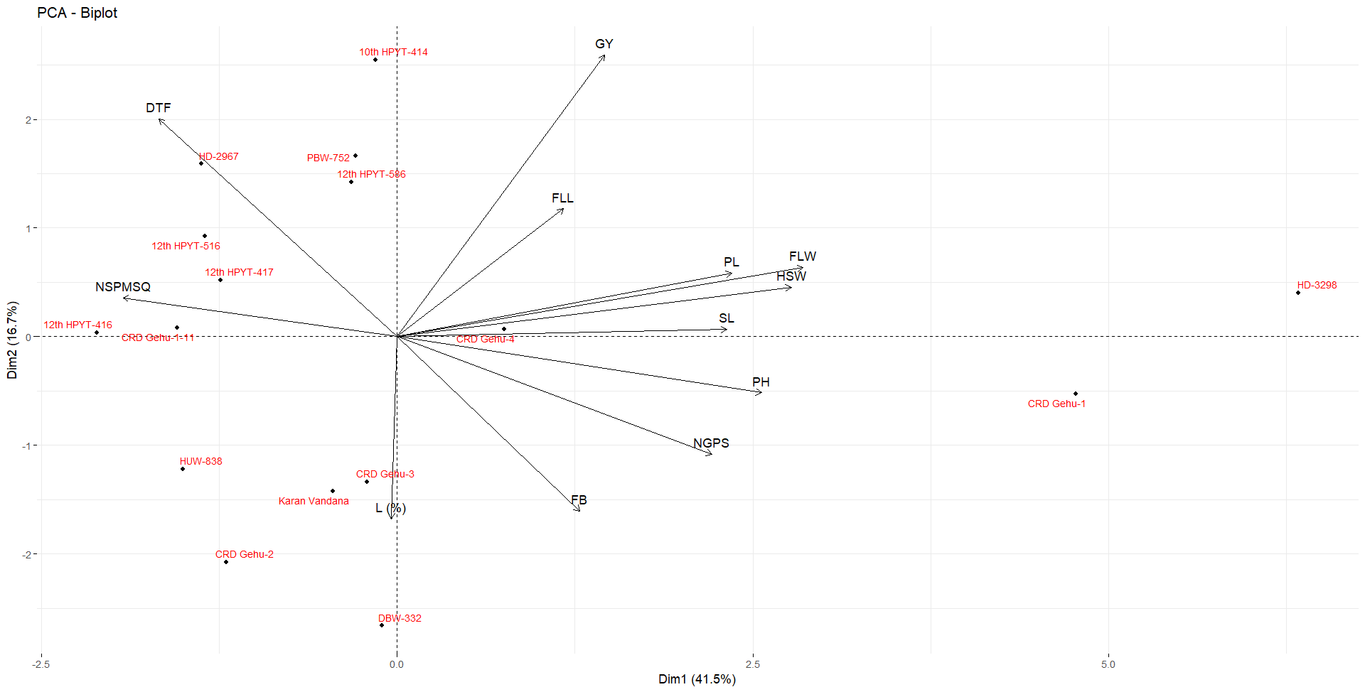

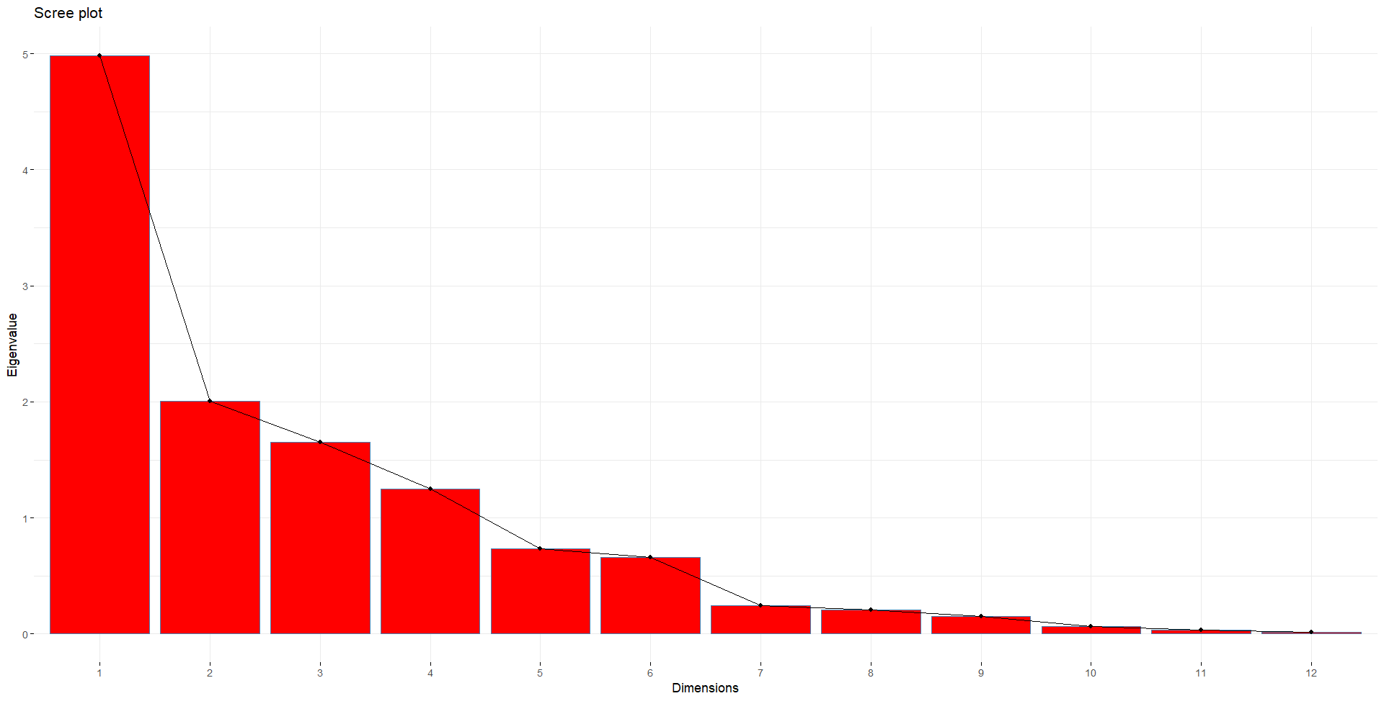
Fig-2 Scree Plot

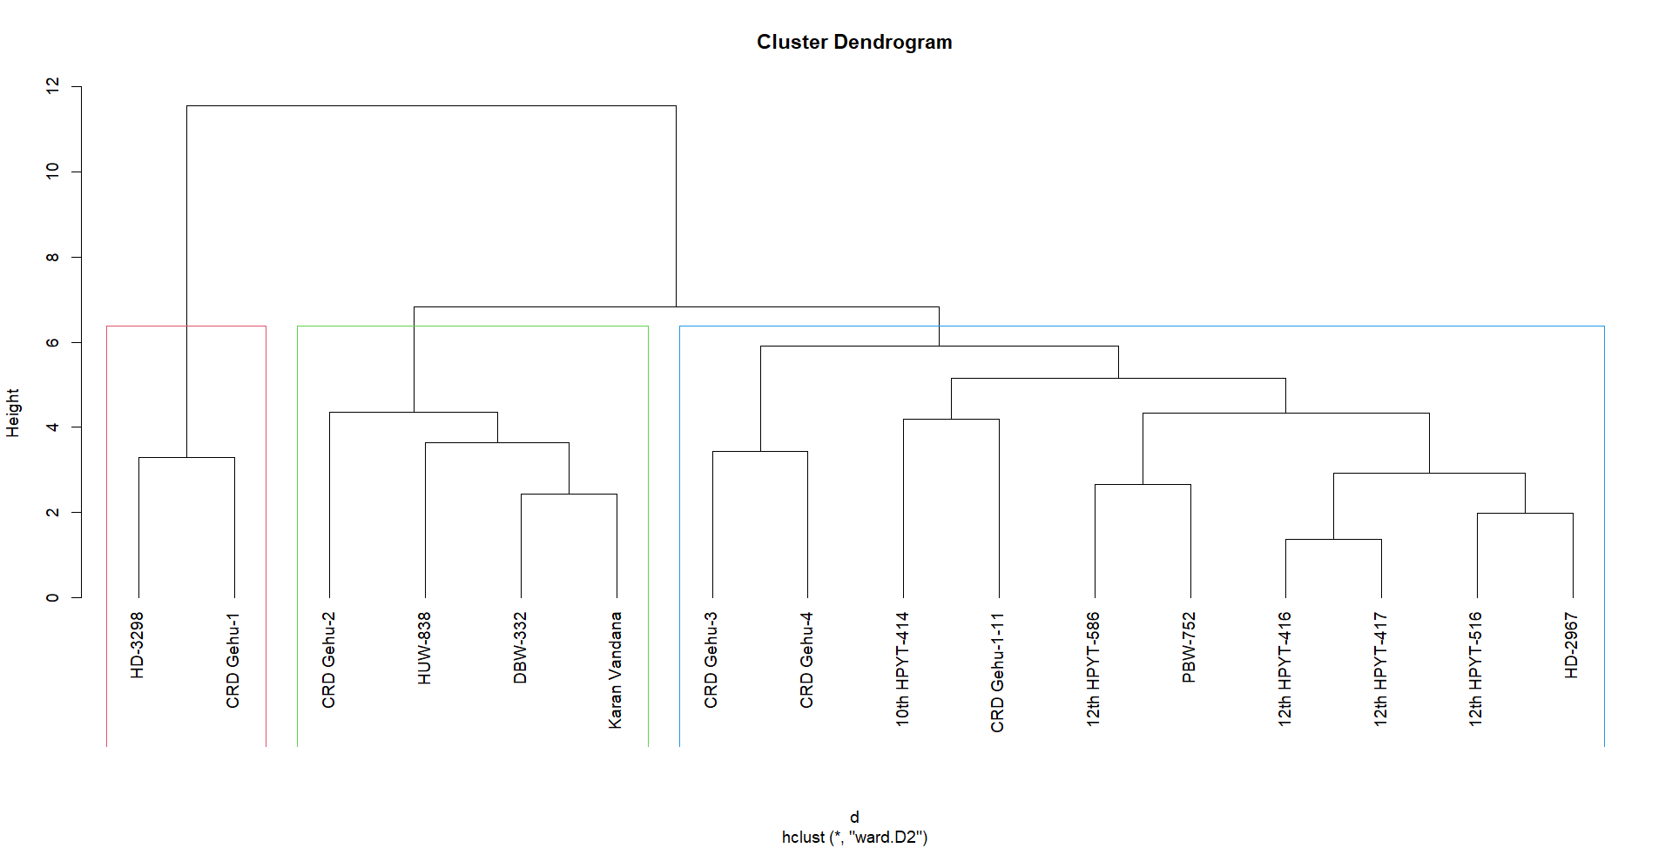
Fig 3- Cluster Dendrogram

Principal Component Analysis (PCA) was carried out to assess the contribution of various traits to the total variability among the wheat genotypes. The analysis revealed that the first four principal components had eigenvalues greater than one and together accounted for 82.41% of the total phenotypic variation, indicating their significance in explaining the majority of the variability present in the dataset.
The first principal component (PC1) exhibited the highest eigenvalue (4.982) and explained 41.52% of the total variation, with major contribution from days to 50% flowering (DTF). The second component (PC2) contributed 16.70% of the variation and was primarily associated with 1000-grain weight (HSW). The third component (PC3) explained 13.76% of the variation and was influenced mainly by the number of spikes per square meter (NSPM), while the fourth component (PC4) contributed 10.43%, with a significant loading from the number of grains per spike (NGPS).
Subsequent components individually accounted for less than 7% of the variance and were considered less influential in explaining overall diversity. Traits such as foliar blight score (FB), plant height (PH), and flag leaf length (FLL) contributed moderately, whereas traits like flag leaf width (FLW), lodging percentage (L), and grain yield (GY) had minimal contributions to the principal components. [Table-1]
These findings suggest that phenological and yield-contributing traits, particularly DTF, HSW, NSPM, and NGPS play a key role in determining the genetic variability among the studied wheat genotypes.

Trait Contributions to Principal Components
The principal component loading matrix revealed the contribution of individual traits to each principal component (Table 2). In PC1, which explained the highest variation (41.52%), major contributors were 1000-grain weight (HSW: –0.3925), plant height (PH: –0.3628), spike length (SL: –0.3283), and peduncle length (PL: –0.3330), indicating their strong influence on overall genotype differentiation.
PC2, accounting for 16.70% of the variance, was mainly influenced by grain yield (GY: –0.5789), days to 50% flowering (DTF: –0.4474), and foliar blight score (FB: 0.3584), suggesting an inverse relationship between yield and early flowering.
PC3 was largely defined by flag leaf length (FLL: 0.5597), lodging percentage (L: 0.4826), and spike length (SL: 0.3735), indicating these traits' combined role in distinguishing genotypes along this component.
In PC4, significant loadings were observed for DTF (0.3759), FB (0.3779), and PL (–0.4835), while other components showed smaller, more dispersed trait contributions.
These results suggest that early phenological traits, spike-related traits, and yield components play a central role in genetic differentiation among the studied wheat genotypes.[Table-2]
Cluster Distance Analysis
The intra-cluster distances were highest in Cluster 1 (3.69), followed by Cluster 3 (3.50), and lowest in Cluster 2 (3.29), indicating greater genetic uniformity within Cluster 2. The highest inter-cluster distance was observed between Cluster 2 and Cluster 3 (6.93), suggesting maximum genetic divergence, while the lowest was between Cluster 1 and Cluster 3 (4.34). These results highlight the potential of selecting genotypes from distant clusters for hybridization to exploit heterosis. [Table-3]
Cluster Dendrogram Analysis
Hierarchical cluster analysis using Ward’s method grouped the 16 wheat genotypes into three major clusters (Figure 3), indicating substantial genetic diversity. Cluster I included HD-3288 and CRD Gehu-1, showing close similarity. Cluster II comprised CRD Gehu-2, HUW-638, DBW-322, and Karan Vandana. The largest group, Cluster III, contained most of the genotypes, including advanced lines and checks like HD-2967 and PBW-752, indicating broader variability. The clustering pattern aligns with PCA results, supporting the potential of selecting divergent genotypes for effective hybridization. (Mohammadi & Prasanna, 2003)

CONCLUSION
The present study revealed substantial genetic variability among wheat genotypes using principal component and cluster analyses. PCA identified key traits such as days to 50% flowering, 1000-grain weight, number of spikes per square meter, and number of grains per spike as major contributors to genetic divergence. Cluster analysis further grouped genotypes into three distinct clusters, with maximum inter-cluster distance observed between Clusters 2 and 3, indicating potential for selecting genetically diverse parents. These findings provide valuable insights for designing effective breeding strategies aimed at improving yield and other agronomic traits in wheat.
Application of research:
This research highlights the significant genetic variability and diversity among Wheat genotypes, which can be effectively utilized by plant breeders and scientific community for selecting high-yielding and desirable traits in future crop improvement programs.
Abbreviations:
CRD – Centre for Research and Development PCA - Principal Component Analysis
Disclaimer (Artificial intelligence)
Option 1:
Author(s) hereby declare that NO generative AI technologies such as Large Language Models (ChatGPT, COPILOT, etc.) and text-to-image generators have been used during the writing or editing of this manuscript.
Option 2:
Author(s) hereby declare that generative AI technologies such as Large Language Models, etc. have been used during the writing or editing of manuscripts. This explanation will include the name, version, model, and source of the generative AI technology and as well as all input prompts provided to the generative AI technology
Details of the AI usage are given below:
1.
2.
3.

REFERENCES
Chaudhary, H. B., Lal, G. M., & Kumar, S. (2020). Multivariate analysis in bread wheat (Triticum aestivum L.) for yield and yield contributing traits. International Journal of Current Microbiology and Applied Sciences, 9(2), 1234–1243.
Chaudhary, H. B., Lal, G. M., & Kumar, S. (2020). Multivariate analysis in bread wheat (Triticum aestivum L.) for yield and yield contributing traits. International Journal of Current Microbiology and Applied Sciences, 9(2), 1234–1243.
Directorate of Economics and Statistics. (2021). Agricultural Statistics at a Glance 2021. Ministry of Agriculture and Farmers’ Welfare, Government of India.
Jolliffe, I. T., & Cadima, J. (2016). Principal component analysis: A review and recent developments. Philosophical Transactions of the Royal Society A: Mathematical, Physical and Engineering Sciences, 374(2065), 20150202.
Joshi, A. K., Mishra, B., Chatrath, R., Ortiz Ferrara, G., & Singh, R. P. (2007). Wheat improvement in India: present status, emerging challenges and future prospects. Euphytica, 157(3), 431-446.
Kaur, S., Sahu, V. S. and Mari,G. S.2009. Physiological response of wheat genotypes to post anthesis hyperthermal stress under late sown conditions. Crop Improve.,36(2):83-90.
Kaur, R.P., Saini, D. P. and Jaiswal, J. P. 2008. Genetic variability studies in wheat under timelyand late sown irrigated conditions. Pantnagar J. Res., 6(1):101-105.
Kumar, P., A. Sarangi, D. K. Singh and Parihar, S.S. 2014. Wheat performance as influenced by saline irrigation regimes and cultivars. J. Agri.Search.,1(2): 66-72
Ministry of Agriculture and Farmers’ Welfare. (2021). Agricultural Statistics at a Glance 2021. Government of India.
Mukherjee, D. 2012. Effect of different sowing dates on growth and yield of wheat (Tritium aestivum L ) cultivars under mild hill situation of West Bengal. Indian J. Agron.57(2):152-156.
Panse, V.G. and Shukhatme, P.V. (1967). Statistical Methods for Agricultural Workers, IInd Ed., ICAR. New Delhi. 381.
Rao, C. R. (1952). Advanced statistical methods in biometric research. John Wiley & Sons.
Shewry, P. R. (2009). Wheat. Journal of experimental botany, 60(6), 1537-1553.
United States Department of Agriculture. (2022). Wheat: World markets and trade. Foreign Agricultural Service, United States Department of Agriculture.
Upadhyaya, N., & Bhandari, K. (2022). Assessment of different genotypes of wheat under late sowing condition. Heliyon, 8(1).
Singh, B., Meena, R. P., & Singh, R. P. (2019). Genetic diversity analysis in wheat (Triticum aestivum L.) using multivariate techniques. Journal of Pharmacognosy and Phytochemistry, 8(4), 3098–3103.
Sharma, J. R. (1998). Statistical and biometrical techniques in plant breeding. New Age International.
Dey A., “Rice and wheat production in India: An overtime study on growth and instability”. Journal of Pharmacognosy and Phytochemistry (2020) 9(2) 158-161, ISSN: 2349-8234.
Krishnan P, Praharaj C, Kantharajan G, “A Scientometric Analysis of Research on Pulses in India During 2000–2017”. Agricultural Research (2022) 11(3) 565-578.
Khodadadi, M., Fotokian, M. H., & Miransari, M. (2011). Genetic diversity of wheat (Triticum aestivum L.) genotypes based on cluster and principal component analyses for breeding strategies. Australian Journal of Crop Science, 5(1), 17-24.
Mohammadi, S. A., & Prasanna, B. M. (2003). Analysis of genetic diversity in crop plants—salient statistical tools and considerations. Crop Science, 43(4), 1235–1248. https://doi.org/10.2135/cropsci2003.1235

