Differential expression of Morphogenesis of the tuberization in two varieties of yam (Dioscorea cayenensis-rotundata)

17 .
18 ABSTRACT
19
Micro-plant studies have shown that the Microtuberization is affected by plant growth regulators such as Naphthalene acetic acid, gibberrellic acid and jasmonic acid. Yams exhibit variations in dormancy break, which could be responsible for the early maturity of certain varieties. The present study aimed to understand the origin of the early maturity of the Kponan yam variety. This was studied through morphological observation of tuberization during the first month and monitoring until tuber maturity. Two varieties, Kangba and Kponan, belonging to the species Dioscorea cayenensis-rotundata, were used. An experimental field was set up in 20 cm x 20 cm nursery bags. For monitoring purposes, the mass and length of the tuber were determined. Early emergence was sometimes observed 10 days ± 1 after planting. Most emergence ranged from 22 days ± 2 to 35 days ± 5 for the Kponan variety. For the Kangba variety, seeds without buds on the day of planting showed emergence 34 days ± 3 to 45 days ± 2 after being placed in bags. Early emergence was observed at 27 days in two plants. From the date of emergence in the field, the first visible sign of tuberization in the Kponan variety appears between 48 ± 4 and 57 ± 3 days. For Kangba, this period ranges from 48 ± 2 days to 71 ± 4 days after emergence in the field. The earliness of the Kponan variety is due to the dual earliness of field emergence and tuber initiation. The Kponan yam tuber is morphologically shorter and has a larger diameter than the Kangba tuber, which would explain, on the one hand, the higher position of the Kangba variety on the length growth curve and, on the other hand, the higher mass of the Kponan variety tubers.
20
21 Keywords: Tuber, tuber growth, yam, morphology, nursery bag
22

1. INTRODUCTION
- The tuber morphogenesis of yam can be divided into three stages: initiation stage, expansion stage, and maturation stage. The expansion stage can be divided into three periods: early expansion stage, middle expansion stage, late expansion stage. Tuber morphogenesis is a complex physiological process regulated by heredity, environment, and hormones. The induction and growth of microtubers in vitro were controlled by nutrients, and sucrose concentration was the most crucial factor affecting tuberization and frequency of proliferation in yams (Zhou et al., 2020). The yam is a climbing plant belonging to the genus Dioscorea and the monocotyledonous
- class. The plant consists of two main parts: the aerial part, consisting of foliage, and the
- underground part, consisting of roots and tubers. The tuber is a storage organ rich in starch
- and certain micronutrients. The presence of these nutrients: lipids, fiber, vitamins, alkaloids,
- sterols, steroids, proteins, carbohydrates, cardioglycosides, and terpenoids has been reported
- by these authors as well as by micro (Fe, Cu, Mn, Zn, Mb, and Cl) and macro minerals (K, Cl,
- P, Ca, Mg, and Na). Depending on the nature of its constituents, the yam tuber can be used
- for food or medicinal purposes. The species D. opposita, widely cultivated in China, is prized
- in traditional medicine for its therapeutic properties (Ge et al 2023; Cui et al 2023; Tareen et
- al 2025). In West Africa, most of the species cultivated are used for food. These varieties,
- which are very rich in starch, are suitable for traditional dishes such as fufu, foutou, mash,

- frying, and others (Obidiegwu 2020; Singh and Twinkle 2022). The yam therefore
- constitutes an essential source of food, employment, income and a vital component of food
- security in the region (Zangoma et al 2025).
- The yam tuber contains within it a functional dynamism responsible for its evolution from
- initiation to the next dormancy break, passing successively through stages of growth, maturity,
- and dormancy. During the growth phase, the histological study conducted by Degbeu et al.
- 2019 showed the existence of a longitudinal growth gradient whose point of growth is the apex
- and the sense of maturity of the distal part at the proximal end. The cambium generates cells
- at the lower end of the apex. These very vacuolated cells differentiate and will form the median
- and proximal parts of the tuber. This cambium-generating activity would cease when the tuber
- becomes mature. The existence of this gradient has an impact on the technological suitability
- of the different parts of the yam tuber. Thus, the suitability for cooking decreases from the
- proximal part to the distal end. Firmness and dry matter decrease from the proximal part to
- the distal end of the tuber (Brunnschweiler, 2004).
- At maturity, the tuber enters a period of dormancy, defined as the period during which
- endogenous metabolic activity is reduced and there is no intrinsic bud growth, although it
- retains the potential for future growth (IIe et al 2006, Nwogha et al 2022). The duration of
- dormancy depends on the species, storage conditions, weather conditions and the degree of
- maturity of the tuber or the time of tuber harvest (Hamadina 2011; Nwogha 2022; Zangoma
- et al 2025). In general, D. alata varieties have a long dormancy period (three to four months)
- compared to those of D. cayenensis-rotundata (one to one and a half months) (Craufurd et
- al 2001; Wickham 2019). Early varieties harvested in August begin to break dormancy in
- January. This is four to five months after harvest. Once dormancy is broken, the shoot
- develops, producing leaves and branches, leading to the plant's volubility. At the same time,
- the underground roots develop and the mother tuber that gave rise to the plant begins to
- degenerate (Trouslot 1985). Tuberization is a physiological process that can be influenced by
- various factors, such as carbohydrate source and concentration, plant growth regulators, and
- light intensity. In species with storage organs, this process can be induced during in vitro
- cultivation from nodal and apical explants, resulting in the production of microtubers.
- These microtubers can be used as propagative material and for distribution of pathogen-free plant
- material in germplasm exchange programs (dos Santos et al., 2025).
- The initiation of tuberization is identified by the appearance of “suber bursting” at the base of
- the stem in plants propagated by tuber fragments. In yam plants grown from seed, the initiation
- of tuberization is manifested by a bulge located between the starting point of the main root
- and the base of the first scale leaf of the main axis (Trouslot 1985). Micro-plant studies have
- shown that Microtuberization is affected by plant growth regulators such as Naphthalene
- acetic acid, gibberellic acid and jasmonic acid (Balogun 2006; Hamadina et al 2010).
- Since dormancy breaking is the first stage in the natural regeneration process of the tuber, its
- variability could impact the second stage, which is the initiation of tuberization. This is the
- research hypothesis of the present study, the objective of which is to understand the origin of
- the precocity of the Kponan yam variety. In this study, the morphological aspect of tuberization
- of two yam varieties (Kponan and Kangba) of the species Dioscorea cayenensis-rotundata
- was analysed. The Kponan variety is early maturing, and the Kangba variety is late maturing. 73

2. MATERIAL AND METHODS

2.1 Materiel
- The kangba and kponan varieties of yam, belonging to the species Dioscorea cayenensis-
- rotundata, were used as plant material. The fragmentation process produced pieces of yam
- with an average mass of 137.3 ± 35.6 g for the kponan variety and 93.5 ± 28.9 g for the kangba
- variety. For this study, the head of the tuber was avoided as much as possible to ensure
- uniformity of emergence. The seedlings are at the end of dormancy, i.e., at the beginning of
- germination. Most of them have a bud characteristic of dormancy emergence. Three samples
- with shoots measuring 2.5 cm, 3 cm, and 12 cm, respectively, were observed for the kponan
- variety
84

2.2 Methods

2.2.1 Setting up the plots

- The field was created at Nangui Abrogoua University on an area of 50 m². The land is fallow
- soil. During periods of low or no rainfall, the plants were watered once or twice a week as
- needed. The bags were filled with forest soil enriched with pig manure. The stakes used were
- Chinese bamboo is placed between the rows of bags. The bags were used to ensure the even
- distribution of soil nutrients and to allow each plant to have the same nutrients. The seeds
- were planted in 20 cm x 20 cm nursery bags and arranged in rows 1 m apart, with 0.5 m
- between bags. After the yams were bagged, the field was visited weekly to monitor “field
- emergence,” i.e., the appearance of the bud above the mound (Trouslot, 1985), in this case
- the bag. Once the bud has appeared above the bag, the date is recorded and will serve as a
- reference point for monitoring tuberization. 97

2.2.2 Sampling technique
- The tubers were harvested at different times by cutting them with a stainless-steel knife. This
- allows the tuber to be separated from the pre-tuber. The tubers were harvested at the
- beginning of tuberization at the stage when the suber bursts, which is the first visible sign of
- tuberization (day 0; day 7; day 15; day 30 and day 40). Monitoring then took place from the
- 16th week after the seeds were bagged until the 26th week, i.e., weeks 16, 18, 20, 22, 24, and
- 26. Week 26 corresponds to the onset of leaf yellowing. At each harvest period, the size of
- the tuber was measured using a Mitutoyo caliper (Braive Instrument, Belgium) and the mass
- was determined using a Scaltec scale (Heiligenstadt, Germany). 107

3. RESULTS

3.1 Sprouting period of yam cutting after planting and tuber initiation
- Three cutting samples of Kponan had buds measuring 2.5 cm, 3 cm, and 13.3 cm,
- respectively, or 1, 3, and 6 scale leaves on the day of planting on 20 plants of the Kponan
- variety. For these three samples, growth resumed 16, 9, and 6 days after planting,
- respectively. The emergence period for these three plants appears to be scattered. This
- represents an average of 10 days ± 5. Most emergence ranges from 22 days ± 2 to 35 days
- ± 5. Late emergence 56 days after planting was observed (table 1). For the Kangba variety,
- cutting without buds, on the day of planting, shows emergence 34 days ± 3 to 45 days ± 2 after
- being placed in bags. Early emergence was observed at 27 days in two plants.
- From the date of emergence in the field, the first visible sign of tuberization in the Kponan
- variety appears between 48 ± 4 and 57 days ± 3. Unlike the emergence period in the field, the
- bursting stage is not dispersed. The average is around 53 days ± 5. Plants with late emergence
- initiate tuberization earlier, at 32 days after emergence in the field. For the kangba variety, this
- period extends from 48 ± 2 days to 71 days ± 4 after emergence in the field. This period is
- longer compared to observations made on the kponan variety (p < 0.05).
- In general, after planting on April 14, 2007, suber bursting appears from 71 days ± 5, or 10
- weeks to 86 days ± 3 (12 weeks) in the kponan variety. In the kangba variety, this period is
- around 95 days ± 4 after planting, or 13 weeks.
127
128 Table 1: Sprouting period of yam cutting and tuber initiation

varieties Appearance of sprouting
(number of days)
10 days ± 5 (3 budding plants)
28 days ± 1 (2 ungerminated plants)
Tuber initiation Planting date-tuber initiation

57 days ± 3
55 days

Kponan

Kangba
22 days ± 2 (6 ungerminated plants)
35 days ± 5 (5 ungerminated plants)
56 days (1 ungerminated plants)
27 days (2 ungerminated plants)
34 days ± 2 (7 ungerminated plants)
43 days ± 2 (7 ungerminated plants)
53 days ± 7
48 days ± 4
32 days
71 days ± 4
62 days ± 5
50 days ± 3
71 days ± 5 to 86 days ± 3

95 days ± 4

45 days ± 2 (4 ungerminated plants) 48 days ± 2

129

3.2 Development of the emerging tuber
- The first visible sign of tuberization is the rupture of the suber covering the base of the stem
- (Fig. 1A and 1B). Over the following days, the bursting spreads as the proliferation of the
- underlying tissue intensifies. The suber disintegrates and disappears under the effect of this
- proliferation at the apical end of the tuber (Fig. 1C and 1D). At the beginning of tuberization,
- new roots appear. These roots have a white membrane that is not suberized, unlike the first
- roots. From the 7th day onwards, a tuber bud is visible (Fig. 1C and 1D). The base of the stem
- begins to develop into a new tuber or neo-tuber, while the mother tuber (cutting) shrinks (Fig.
- 1A) and eventually degenerates (Fig.1B). It will form the pre-tuber at harvest.
- In the Kponan variety, the onset of tuberization is accompanied by total degeneration of the
- yam cutting. This is not the case with the Kangba variety, where the rest of the seed is still
- visible. The yam of the Kangba variety have simply shriveled. In addition, the
- arrangement of the new roots differs between the two varieties. In Kangba, the new roots
- appear on the new tuber (Fig. 1C). This is not the case with the Kponan variety (Fig. 1E).
- Seven days after the start of tuberization, the new tuber of the latter has a bulbous shape
- characteristic of a tuber. In the Kangba variety, however, the arrangement of the new roots on
- the new tuber is characteristic of a woody mass. The apical end of the developing tuber is light
- yellow in both the Kponan and Kangba varieties. It is covered with a cap.
- From the seventh day onwards, the organ thus formed hypertrophies longitudinally and radially
- to produce a more rounded tuber on the 21st day (Figs. 2A and 2B). Three weeks after the
- start of tuberization, the mother tuber disappears completely. The protrusion at the base of
- The stem is more intense at the apical end and is responsible for the tuber’s growth significantly
- in length. This results in a cylindrical-conical tuber with a rounded and slightly tapered apical
- end, reflecting the predominance of apical meristem activity. As the tuber's growth in length
- intensifies, suberization of the outer layer or skin of the yam can be observed at the proximal
- end. The intensity of this suberization decreases from the proximal part toward the distal end.
- Suberization is more pronounced in the Kponan variety at the proximal part of the tuber at 18
- weeks after planting (Fig. 2C). It extends to the entire tuber at 22 weeks after planting (Fig.
- 2E). In the Kangba variety, suberization begins in the proximal part at 18 weeks after planting
- (Fig. 2D). However, this phenomenon is more visible at 22 weeks after planting (Fig. 2F). The
- distal end remains unsuberized. 161
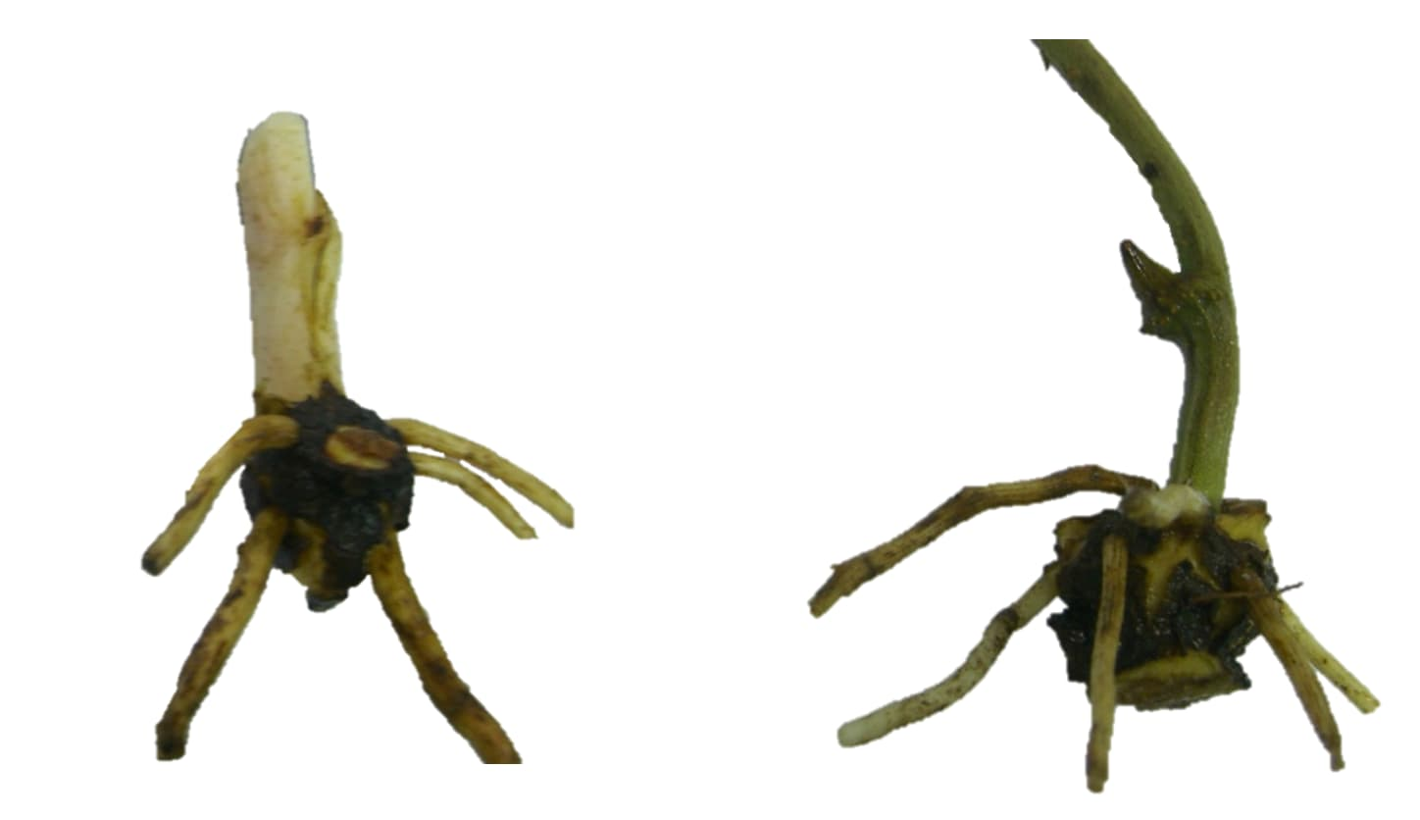
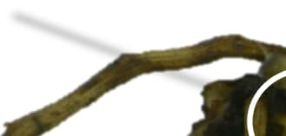

















162
Stem
Scale leaf
Part attached to the mother tuber (cutting)
Inter-node

Ruptured suber
Roots
A
B
Part attached to the mother tuber (cutting)
163
164
165
166
167
168
169
170
171
172
173
174
175
176
177
178
179
180

181
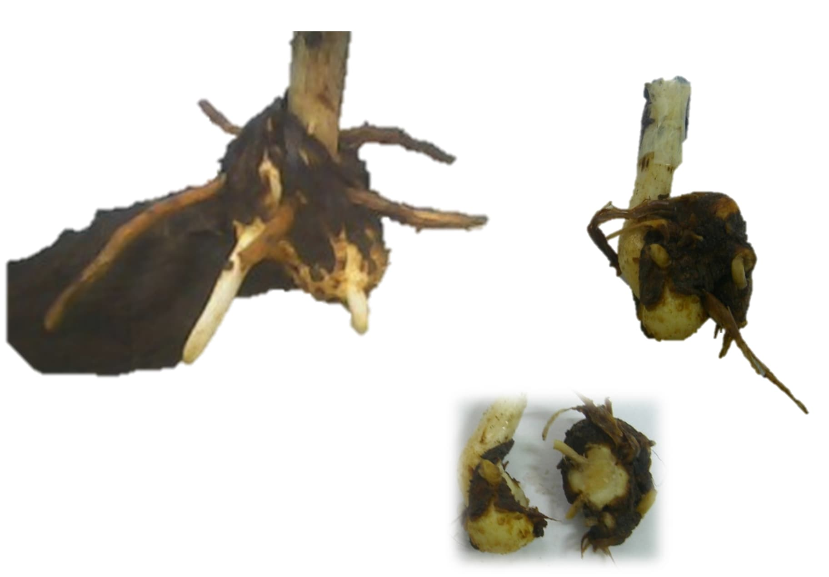







182
Degenerating scale leaf
Stem
New tuber growing
New roots
D
C
Rest of the mother tuber (cutting)
E
183
184
185
186
187
188
189
190
191
192
193
194
195
196
197
198
199
200
201
202
203
204
205
206
207
208
209
- Fig. 1. Earlier stage of tuberization. The tuber initiation is materialized by the rupture of the
- suber (A, B). The following days, the protuberance of meristem cells lead to the tuber formation
- and growing observable seven days after rupture of the suber (C, D). The cutting is observable
- for var. kangba (C), not for var. kponan (E). Scale bars: 1 cm 214
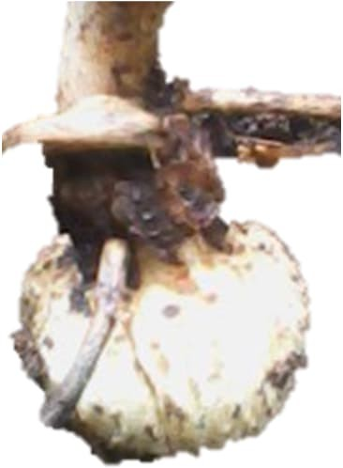
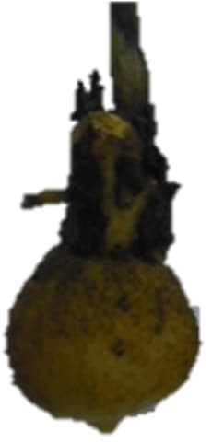



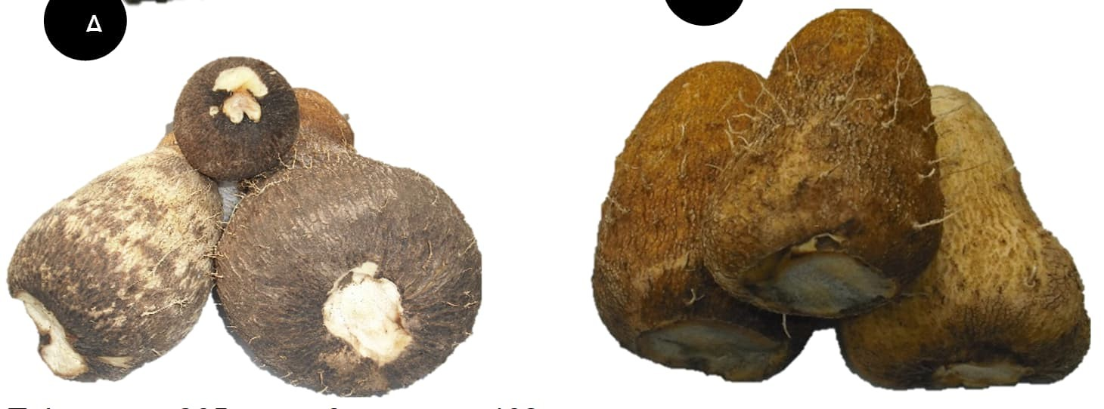

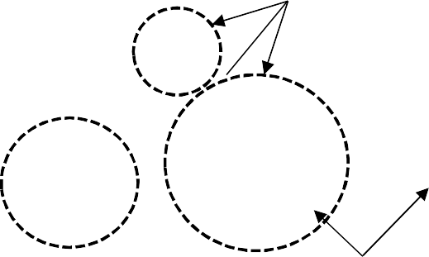

215
Stem

Roots
Tuber
B
Suberization of the proximal part
Non-suberized parts
C
D
216
217
218
219
220
221
222
223
224
225
A
226
227
228
229
230
231
232
233


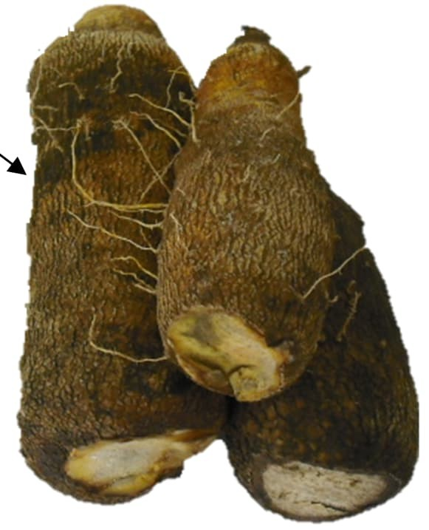
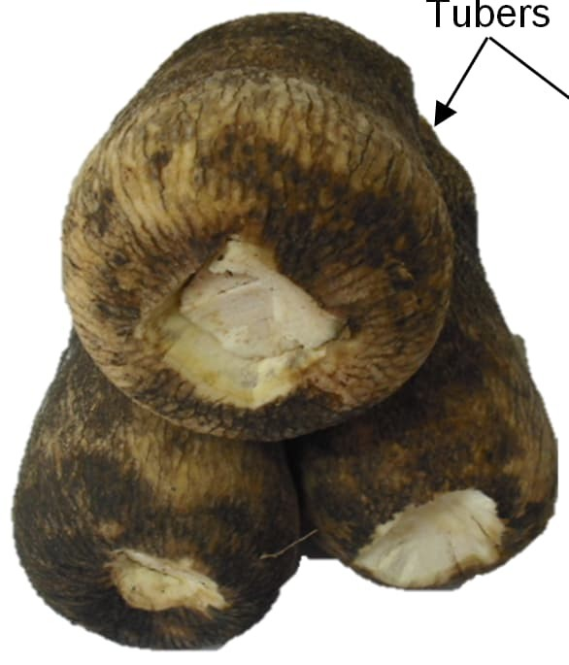



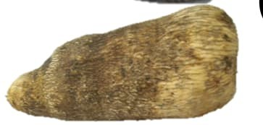
234
Distal part non-
E
F
235
Tubers
236
237
238
239
240
241
242
243
244
245
246
247
248
249
250
251
252
253
- Fig. 2: Yam tubers at different stages of maturity. A, B are respectively tubers of. var. Kponan
- and Kangba at twenty-one days after the rupture of the suber. C and E are tubers of var.
- Kponan at respectively eighteen and twenty-two weeks after the cutting were bagged. D and
- F are tubers of var. Kponan at respectively eighteen and twenty-two weeks after the cutting
- were bagged.
259

3.3 Evolution of the size and mass of the emerging tuber
- From the seventh day onwards, the mass of the tuber formed is around 1.56 ± 1.2 g and 1.35
- ± 0.1 cm in length (Kponan variety) (Table 2). The Kangba variety has approximately the same mass and size (1.47 ± 1.1 g A; 1.2 ± 0.3 cm). Two weeks after the start of tuberization, the mass of the Kponan variety tubers is higher than that of the Kangba variety. From the 21st day after the start of tuber initiation, the mass of the tubers was greater in the Kponan variety (15.3 ± 4 g to 36.25 ± 5.3 g). The size remained the same.
267
268 Table 2: Changes in tuber mass and length over 40 days after the suber burst stage

 | varieties | Days | Mass (g) | Length (cm)
 |  | 7 | 1,56 ± 1,2 | 1,35 ± 0,1
 |  | 15 | 4,5 ± 1,8 | 2,02 ± 0,2
 | Kponan | 21 | 15,3 ± 4 | 3,2 ± 0,3
 |  | 30 | 36, 25 ± 5,3 | 5,2 ± 1,4
 |  | 40 | 121,5 ± 26,6 | 9,4 ± 0,11
 |  | 7 | 1,47 ± 1,1 | 1,2 ± 0,3
 |  | 15 | 3,18 ± 1,3 | 2,1 ± 0,1
 | Kangba | 21 | 10,45 ± 3,4 | 3,02 ± 0,5
 |  | 30 | 31,73 ± 5,1 | 4,6 ± 1,8
 |  | 40 | 114,49 ± 13 | 12,3 ± 2
269

3.4 Changes in tuber weight and length from the sixteenth week after planting
- The evolution of tuber length and mass was monitored starting in the second month after the
- first visible sign of tuberization appeared, i.e., 16 weeks after planting (Fig. 3A). Tuber growth,
- which began in the first few weeks after the suber burst, intensified until the 22nd week after
- sowing, i.e., three months after the start of tuberization. From this period onwards, tuber
- growth slowed down and tended to stabilize until the 26th week after planting. The growth of
- kponan yam tubers is greater until the 17th week. Beyond this period, the length growth of
- kangba tubers becomes more significant, until tuber growth stops at the 26th week. As for the
- evolution of tuber mass (Fig. 3B), it becomes significant from the 20th week onwards. This
- increase in tuber mass tends to stabilize from the 24th week onwards for the kponan variety.
- For the kangba variety, tuber mass continues to increase even beyond week 26. Comparison
- of the average tuber mass of the two varieties shows a significant difference (p < 0.05). 282
283
400
350
300
250
200
150
100
50
0
kangba
kponan
16 18 20 22 24
A
26
Weekday period
2500
2000
1500
1000
500
kangba
kponan
0
B
16
18
20
22
24
26
Weekday period
284
285
286
287
288
Tuber lenght (mm)
289
290
291
292
293
294
295
296
297
298
299
300
301
302
303
304
305
306
307
308
Tuber mass (g)
309
310
311
312
313
314
315
316
317
318
319
320
321 Fig. 3: Changes in tuber length and mass during tuberization. A) Tuber length; B) Tuber mass 322

4. DISCUSSION
- The development of the tuber was monitored from the emergence of the main stem above the
- bag to the formation of the tuber. The three plants bearing a bud on the day of planting indicate
- a resumption of stem growth 6 to 16 days after planting, or an average of 10 days ± 5. The
- resumption of stem growth depends on the level of development of the preformed bud. Based
- on observations, the more developed the bud, the earlier the resumption of growth. However,
- in practice, shoots that are too long are removed by farmers, as the tuber bearing the bud
- would be weakened by excessive depletion of its reserves (Trouslot 1985). The period of
- dormancy in the field for most yam cuttings of the two varieties Kponan (22 to 35 days) and
- Kangba (34 to 43 days) falls within the range (14 to 91 days) reported by Hamadina (2011).
- This period varies greatly according to previous studies and is influenced by regulatory
- hormones (Nwogha 2022; Zangoma et al. 2025). Cuttings of the Kponan variety germinate
- quickly compared to those of the Kangba variety. This could be due to varietal differences
- (Wickham 2019). In in vitro yam stem fragment cultures, tuberization begins after three weeks
- under normal conditions and one week when phytohormones are used (Jova et al., 2011).
- From the date of planting to the initiation of tuberization, cuttings of the Kponan variety tuberize
- quickly compared to those of Kangba. This could partly explain the earliness of the Kangba
- variety. Visual observation of the onset of tuberization also shows that the tuber used as a
- cutting disappears in Kponan, while it is still present in the Kangba variety. This could also
- explain the earliness of Kponan. Similarly, the fiber content of the mother tuber could have an
- impact on the earliness of tuberization initiation. Fiber-rich tubers such as Kangba tend to
- shrivel, thus delaying this phenomenon. Those of the Pkonan variety, being less fibrous, rot
- quickly and tuberize sooner. The same applies to morphological observations of the different
- stages of tuberization, where the tuber becomes corky earlier in the Kponan variety than in
- the Kangba variety. However, suberization is characteristic of tuber maturity, based on
- observations. At 22 weeks after planting, the tubers of the Kponan variety are completely
- suberized, while those of the Kangba variety show a growing distal end. The Kponan variety
- produces early tubers that are larger in mass than those of the Kangba variety. The Kponan
- yam tuber is morphologically shorter and has a larger diameter than the Kangba tuber, which
- would explain, on the one hand, the higher position of the Kangba variety on the length growth
- curve and, on the other hand, the higher mass of the Kponan variety tubers. 354

4. CONCLUSION
- Generally speaking, after planting on April 14, 2007, the suber bursts after 71 days ± 5, or 10
- weeks for the Kponan variety, and 95 days ± 4 (13 weeks) for the Kangba variety. The mass
- growth of tubers of the Kponan variety is stronger than that of the Kangba variety. The Kponan
- variety initiates tuberization and early maturity compared to Kangba. 360
361

373
Disclaimer (Artificial intelligence)
Option 1:
Author(s) hereby declare that NO generative AI technologies such as Large Language Models (ChatGPT, COPILOT, etc.) and text-to-image generators have been used during the writing or editing of this manuscript.
Option 2:
Author(s) hereby declare that generative AI technologies such as Large Language Models, etc. have been used during the writing or editing of manuscripts. This explanation will include the name, version, model, and source of the generative AI technology and as well as all input prompts provided to the generative AI technology
Details of the AI usage are given below:
1.
2.
3.

REFERENCES
- Ge, M., Ruan, Y., Liu, M., Wang, L., Wen, C., & Ma, B. (2023). Recent advances on chemical
- constituents of Dioscorea opposita and their biological activities. Food Nutrition Chemistry,
- 1(2), 1-13. doi: 10.18686/fnc.v1i2.66

- Cui, Y., Zhou, Y., Li, Y., Wang, J., Li, D., & Chen, F. (2023). Chinese Yam and Its Active
- Components Regulate the Structure of Gut Microbiota and Indole-like Metabolites in
- Anaerobic Fermentation In Vitro. Nutrients, 15, 5112. doi.org/10.3390/nu15245112

- Tareen, M. B. K., Saeed, N., Sultan, M., Chen, X., Li, J., & Yan, S. (2025). Yam as functional
- food: bioactive properties, health benefits, and applications. Nutrition and Health, 2(16), 1-29.
- doi.org/10.1007/s44403-025-00022-3.

- Obidiegwu, J. E., Lyons, J. B,. & Chilaka, C. A. (2020). The Dioscorea Genus (Yam)—An
- Appraisal of Nutritional and Therapeutic Potentials. Foods, 9, 1304.
- doi:10.3390/foods9091304

- Singh, P., & Twinkle, (2022). Bioactive components, food applications and health benefits of
- yam (Dioscorea spp.): A review. The Pharma Innovation Journal 2022; 11(6): 2092-2102.
- https://www.thepharmajournal.com

- Zangoma, F. A., Dandago, M. M. A., IZGE, A. T., Mercy, K. I., Salamatu, A. S., &. Zebere, G.
- C. (2025). Postharvest physiology and storage of root and tuber crops in sub saharan Africa.
- International Academic Research Consortium Journals, 12(2), 49-63. https://arcnjournals.org

- Brunnschweiler, J. (2004). Structure and texture of yam (Dioscorea spp.) and processed yam
- products. These of Doctor of Natural Sciences, University of Zurich, p162.

- Ile, E. I., Craufurd, P. Q., Battey, N. H, & ASIEDU, R. (2006). Phases of Dormancy in Yam
- Tubers (Dioscorea rotundata). Annals of Botany, 97: 497–504. doi:10.1093/aob/mcl002

- Nwogha, B. J. S., Wosene, A. G., Raveendran, M., Oselebe, H. O., Jude E. Obidiegwu, J. E.,
- & Amirtham, D. (2022). Global Journal of Science Frontier Research: G Bio-Tech & Genetics,
- 22(2), 54.

- Hamadina, E. I. (2011). The control of yam tuber dormancy: a framework for manipulation.
- International Institute of Tropical Agriculture, 61p.

- Craufurd, P. Q., Summerfield, R. J, Asiedu, R., & Prasad, P. V. V. (2001). Dormancy in yams.
- Expermental Agriculture. 37, 147-181.

- Wickham, L. D. (2019). Successful manipulation of the growth cycle of yam (Dioscorea spp.)
- for year-round production for food security and climate change. Tropical Agriculture, 98(3),
- 326-336.

- Trouslot, M. F. (1985). Analyse de la croissance et morphogenèse de l’igname Dioscorea
- complexe D. cayenensis – D. rotundata. Thèse présentée à l’université de Clermont –
- Ferrand. ORSTOM, Paris, 371p.

- Balogun, M. O., Fawole, I., Ng, S. Y. C., Ng, N. Q., Shiwachi, H. & Kikuno, H. (2006).
- Interaction among cultural factors in microtuberization of white yam (Dioscorea rotundata).
- Tropical Science, 46(1): 55–59.

- Hamadina, E. I., Craufurd, P. Q, Battey, N. H., & Asiedu, R. (2010). In vitro micro-tuber
- initiation and dormancy in yam. Annals of Applied Biology, 157, 203-2012. doi:10.1111/j.1744-
- 7348.2010.00418.x

- Jova, M. C., Kosky, R.G., Cabrera, A.R., Feria, D. M., Perez, M.B., Vega, V. M. & Torres, J.L.
- (2011). Performance of yam microtubers from temporary immersion system in field conditions.
- African Journal of Biotechnology, 10 (46): 9268-9271.
- Zhou, Y., Luo, S., Hameed, S., Xiao, D., Zhan, J., Wang, A., & He, L. (2020). Integrated mRNA and miRNA transcriptome analysis reveals a regulatory network for tuber expansion in Chinese yam (Dioscorea opposita). BMC genomics, 21(1), 117.
- dos Santos, C. A., Gois, I. B., de Fátima Arrigoni-Blank, M., de Jesus Santos, L., Prata, L. C. D., Rodrigues, T. C., & Blank, A. F. (2025). In vitro tuberization of yam (Dioscorea sp.): influence of sucrose, light spectra, and plant growth regulators. Scientia Plena, 21(1).
419
420
421
422

