Original Research Article
Computational evaluation of indole alkaloids from Rauwolfia vomitoria as potential anticancer agents: molecular docking and ADME profiling

ABSTRACT
Background
Cancer continues to pose a major global health challenge, particularly in low- and middle-income countries, where treatment costs and accessibility remain limiting. Natural products such as Rauwolfia vomitoria have shown significant promise as alternative sources of bioactive anticancer compounds. This study evaluated the anticancer potential of two key indole alkaloids—Ajmalicine and Alstonine—through molecular docking and in silico pharmacokinetic and toxicity profiling.
Methods
A computational approach was employed using Schrödinger Maestro Suite (2023-3) for docking simulations, SwissADME for ADMET analysis, and ProTox-III for toxicity prediction. Six cancer-associated targets—BCL-2, PI3K, EGFR, STAT3, HDAC, and NF-κB—were selected to compare binding affinities and drug-likeness properties of the alkaloids against known inhibitors.
Results
Both compounds exhibited favorable pharmacokinetic profiles with high gastrointestinal absorption and good drug-likeness scores. Alstonine demonstrated superior binding affinities against BCL-2 (–5.042 kcal/mol), PI3K (–6.017 kcal/mol), and STAT3 (–5.877 kcal/mol), comparable to known inhibitors such as Lisaftoclax and Napabucasin. Hydrogen bonding analysis revealed strong, short-range interactions (<2.0 Å) contributing to binding stability. Toxicity predictions classified both alkaloids as Class 3 (LD₅₀ = 215–300 mg/kg), indicating moderate toxicity that warrants optimization. ADME predictions revealed good oral bioavailability, high gastrointestinal absorption, and blood–brain barrier permeability.

Conclusion
Alstonine displayed the most promising anticancer potential, with favorable pharmacokinetic properties and multi-target binding profiles. These findings highlight the potential of Rauwolfia vomitoria alkaloids as lead scaffolds for anticancer drug development. Experimental validation and structural refinement are recommended to advance these compounds toward clinical applicability.
Keywords: Rauwolfia vomitoria, Ajmalicine, Alstonine, Molecular docking, ADME, Toxicity prediction, Cancer therapeutics, Indole alkaloids, Computational pharmacology
INTRODUCTION
Cancer remains a major global health challenge, accounting for approximately 10 million deaths annually (1). Despite significant strides in oncology, current chemotherapeutic regimens are plagued by issues such as systemic toxicity, resistance, and limited specificity (2). As a result, there is increasing interest in natural products as alternative sources for safer and more effective anticancer agents (3,4). Examples of potent natural anticancer agents includes Paclitaxel (from Taxus brevifolia), Camptothecin (from Camptotheca acuminata), and Vincristine and Vinblastine (from Catharanthus roseus) (2).

In sub-Saharan Africa, common cancers include cervical cancer, breast cancer, prostate cancer, liver cancer, and colorectal cancer. Cervical cancer remains the most frequent cancer among women in the region, accounting for nearly 100,000 new cases and over 60,000 deaths annually (5). Breast cancer, although increasingly detected, still leads to high mortality due to poor health-seeking behaviour, diagnostic delays and treatment affordability (6,7). In men, prostate cancer and liver cancer are among the leading causes of cancer-related deaths.

The socioeconomic reality of cancer care in Nigeria and similar LMIC settings justifies an urgent need for affordable, locally sourced, and effective cancer treatments. Imported chemotherapeutics such as doxorubicin, paclitaxel, and cisplatin are not only expensive but often associated with severe side effects and drug resistance (8). Targeted therapies represent a shift from non-specific cytotoxic drugs to agents that attack specific molecular vulnerabilities in cancer cells. Some key therapeutic targets for tumor progression includes: Histone Deacetylases (HDACs), Epidermal Growth Factor Receptor (EGFR), Phosphoinositide 3-Kinase (PI3K), Signal Transducer and Activator of Transcription 3 (STAT3), B-cell lymphoma 2 (BCL2), and Nuclear Factor kappa-light-chain-enhancer of activated B cells (NF-κB).
Rauwolfia vomitoria, a medicinal shrub native to West Africa and already integrated into the ethnomedical framework of many Nigerian communities, has attracted considerable scientific interest for its potent antitumor and chemopreventive activities. The plant’s pharmacological properties are primarily attributed to its diverse array of indole alkaloids, including alstonine, ajmalicine, reserpine, and reserpinine, which exhibit broad cytotoxic and antiproliferative effects across several human cancer models. These compounds exert their effects through multiple mechanisms, such as the induction of apoptosis, cell cycle arrest, modulation of oxidative stress, and inhibition of angiogenesis and metastasis (9, 10).
Studies have shown that R. vomitoria extracts demonstrate selective cytotoxicity against malignant cells while sparing normal cell lines. An ethanol root extract of R. vomitoria significantly inhibited proliferation in prostate, breast, and colon cancer cell lines in a dose-dependent manner, primarily through caspase-mediated apoptosis and DNA fragmentation (11- 15)
Among its diverse alkaloids, ajmalicine and alstonine have attracted attention due to their notable pharmacological activities. Ajmalicine has been recognised for its antihypertensive and neuroprotective properties, while alstonine has demonstrated potential antipsychotic and anticancer effects in preclinical studies. Alstonine has also been reported to alter tumor cell redox balance and interfere with mitochondrial bioenergetics, contributing to reduced tumor cell viability and enhanced apoptosis (16, 17). However, their anticancer mechanisms and pharmacokinetic profiles remain underexplored, particularly through computational modelling approaches.
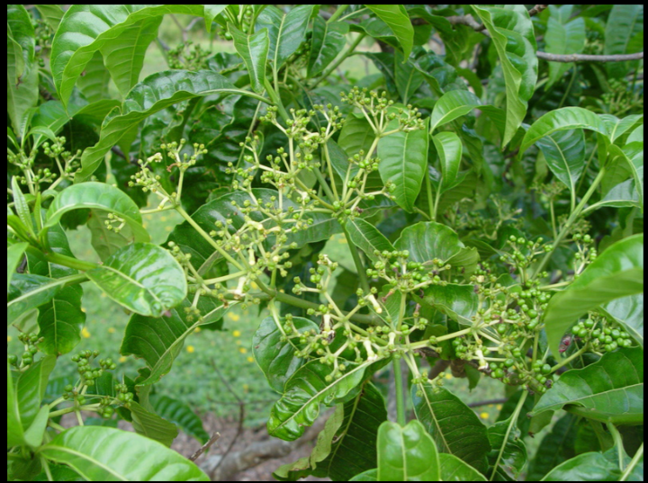
Pic 1: Rauwolfia vomitoria (National Tropical Botanical Garden, 2019)
Molecular docking and ADMET (Absorption, Distribution, Metabolism, Excretion, and Toxicity) profiling are critical tools in modern drug discovery. These in silico methods allow researchers to predict how small molecules interact with biological targets and assess their pharmacokinetic suitability (18). Early computational evaluations significantly reduce the cost and time of drug development by identifying promising compounds before in vitro or in vivo validation (19).

The aim of this study is to evaluate and compare the anticancer potential of ajmalicine and alstonine from Rauwolfia vomitoria with known inhibitors using molecular docking and in silico ADMET profiling against selected cancer-associated targets.

METHODOLOGY

2.1 Study Design
This study employed a comparative in-silico computational approach to evaluate the anticancer potential of two bioactive indole alkaloids—ajmalicine and alstonine—isolated from Rauwolfia vomitoria. The methodology was designed to simulate their molecular interactions with cancer-associated protein targets and to predict their pharmacokinetic and toxicity profiles using established molecular docking and ADMET prediction platforms. This multi-step strategy integrated ligand preparation, target protein selection, molecular docking, and computational pharmacokinetics to identify the most promising anticancer candidate.

2.2. Computational Environment and Software
All computational analyses were conducted using a standard Windows-based personal computer system. The following tools and software were employed:
SwissADME (http://www.swissadme.ch) – for pharmacokinetic and drug-likeness profiling, version 1.0 (accessed February 2025)
ProTox-III (https://tox.charite.de/protox3/index.php?site=compound_input) – for in silico toxicity prediction, version 3.0 (accessed February 2025)
Schrödinger Maestro Suite (2023-3) – for protein and ligand preparation, grid generation, and molecular docking simulations

2.3. Compound Selection and Retrieval
Two naturally derived alkaloids—Ajmalicine and Alstonine—from Rauwolfia vomitoria were selected for evaluation. These were compared with six known inhibitors: Gefitinib, Napabucasin, Apelisib, Mesalazine, Romidepsin, and Lisaftoclax.
Chemical Structures: All compounds were retrieved from the PubChem database in SMILES (Simplified Molecular Input Line Entry System) format and 3D SDF format.
Compounds were converted as needed for downstream analysis using Maestro's structure conversion and preparation tools.

2.4. Target Protein Selection and Preparation
Six cancer-associated target proteins were selected based on therapeutic relevance: HDACs, BCL2, STAT3, EGFR, PI3K, and NF-κB.
The Protein Structures were retrieved from the Protein Data Bank (PDB) in PDB format, and only high-resolution crystal structures were selected to ensure docking accuracy.

2.5. Protein Preparation
Protein preparation was conducted using Schrödinger's Protein Preparation Wizard. It included the removal of water molecules and non-essential heteroatoms.
Also, there was the addition of hydrogens, correction of bond orders, and energy minimisation using the OPLS_2005 force field.

2.6. Ligand Preparation
Ligands were prepared using Schrödinger’s LigPrep module.
The process included: 3D structure generation; Protonation state prediction (at pH 7.0 ± 0.5); Tautomer generation and geometry optimisation; Energy minimisation using the default force field.

2.7. ADMET and Toxicity Prediction
To assess the drug-likeness and pharmacokinetic profiles of the compounds:
SwissADME was used to predict parameters such as: Gastrointestinal (GI) absorption, Lipophilicity (LogP), Drug-likeness (based on Lipinski, Ghose, Veber, etc), Bioavailability scores and blood-brain barrier permeability
ProTox-III was utilised to evaluate the LD₅₀ (median lethal dose), Hepatotoxicity, Carcinogenicity, Cytotoxicity and immunotoxicity.

2.8. Molecular Docking Simulation
Receptor Grid Generation: Grids were centred around the active binding sites of each target protein based on co-crystallised ligands or literature-defined pockets.
Molecular docking was performed using Glide (SP mode) within the Schrödinger Suite.
Scoring Metrics include: Glide docking scores (binding affinity); Hydrogen bonding and hydrophobic interaction profiles; Pose analysis and binding site compatibility.

2.9. Comparative Evaluation
Docking results for ajmalicine and alstonine were systematically compared with known inhibitors for each protein.
Key evaluation criteria included: Binding affinity (Glide score); Binding pose and interaction residues; Correlation with ADMET and toxicity profiles

RESULTS & DISCUSSIONS

The basic physicochemical properties of the promising compounds as well as standard drugs from the docking result are presented in Tables 1, 2, and 3.

In-Silico Pharmacokinetic and Drug-Likeness Prediction
The ADME (Absorption, Distribution, Metabolism, and Excretion) analysis was performed to predict the pharmacokinetic properties and drug-likeness of the compounds using the SwissADME platform. The results are summarized in Table 4 and 5.

Table 1: Basic physicochemical properties and computational descriptors of Ajmalcine, Alstonine and the six known inhibitors
screened compounds
Compound | Formula | MW | No. Heavy atoms | No. Aromatic heavy atoms | Fraction Csp3 | No.Rotatable bonds | No. H-bond acceptors | No. H-bond donors | Molar Refractivity
Alstonine | C₂₁H₂₀N₂O₃ | 348.4 | 26 | 13 | 0.33 | 2 | 4 | 0 | 99.59
Ajmalicine | C₂₁H₂₄N₂O₃ | 352.43 | 26 | 9 | 0.48 | 2 | 4 | 1 | 103.47
Gefitinib | C₂₂H₂₄ClFN₄O₃ | 446.9 | 31 | 16 | 0.36 | 8 | 7 | 1 | 121.66
Napabucasin | C₁₄H₈O₄ | 240.21 | 18 | 11 | 0.07 | 1 | 4 | 0 | 62.21
Alpelisib | C₁₉H₂₂F₃N₅O₂S | 441.47 | 30 | 11 | 0.47 | 7 | 7 | 2 | 111.31
Mesalazine | C₇H₇NO₃ | 153.14 | 11 | 6 | 0 | 1 | 3 | 3 | 39.83
Lisaftoclax | C₄₅H₄₈ClN₇O₈S | 882.42 | 62 | 27 | 0.38 | 14 | 10 | 3 | 245.68
Romidepsin | C₂₄H₃₆N₄O₆S₂ | 540.7 | 36 | 0 | 0.62 | 2 | 12 | 4 | 156.44

Table 2: Lipophicility of Ajmalcine, Alstonine and the six known inhibitors
Compound | TPSA | iLOGP | XLOGP3 | WLOGP | MLOGP | Silicos-IT Log P | Consensus Log P
Alstonine | 53.35 | 3.18 | 2.58 | 3.45 | 2.21 | 2.78 | 2.84
Ajmalicine | 54.56 | 3.18 | 2.75 | 2.47 | 2.13 | 2.78 | 2.66
Gefitinib | 68.74 | 4.04 | 4.11 | 4.32 | 2.82 | 4.31 | 3.92
Napabucasin | 64.35 | 1.83 | 2.28 | 2.26 | 0.09 | 3.31 | 1.95
Alpelisib | 129.45 | 2.14 | 3.22 | 4.52 | 1.59 | 3.68 | 3.03
Mesalazine | 83.55 | 0.28 | 1.32 | 0.68 | -0.7 | 0.02 | 0.32
Lisaftoclax | 192.32 | 5.4 | 7.45 | 7.92 | 2.48 | 4.19 | 5.49
Romidepsin | 193.3 | 3.24 | 2.24 | -0.09 | 0.18 | 1.5 | 1.41

Table 3: Predicted water solubility of Ajmalcine, Alstonine and the six known inhibitors
Compound | ESOL Log S | ESOL Solubility (mg/ml) | ESOL Solubility (mol/l) | ESOL Class | Ali Log S | Ali Solubility (mg/ml) | Ali Solubility (mol/l) | Ali Class | Silicos-IT LogSw | Silicos-IT Solubility (mg/ml) | Silicos-IT Solubility (mol/l) | Silicos-IT class
Alstonine | -3.86 | 4.77E-02 | 1.37E-04 | Soluble | -3.35 | 1.56E-01 | 4.48E-04 | Soluble | -4.92 | 4.14E-03 | 1.19E-05 | Moderately soluble
Ajmalicine | -3.88 | 4.63E-02 | 1.31E-04 | Soluble | -3.55 | 9.92E-02 | 2.81E-04 | Soluble | -4.38 | 1.47E-02 | 4.16E-05 | Moderately soluble
Gefitinib | -5.05 | 3.95E-03 | 8.83E-06 | Moderately soluble | -5.26 | 2.46E-03 | 5.50E-06 | Moderately soluble | -7.94 | 5.14E-06 | 1.15E-08 | Poorly soluble
Napabucasin | -3.15 | 1.69E-01 | 7.05E-04 | Soluble | -3.27 | 1.29E-01 | 5.39E-04 | Soluble | -4.8 | 3.82E-03 | 1.59E-05 | Moderately soluble
Alpelisib | -4.42 | 1.70E-02 | 3.85E-05 | Moderately soluble | -5.61 | 1.08E-03 | 2.45E-06 | Moderately soluble | -5.22 | 2.63E-03 | 5.96E-06 | Moderately soluble
Mesalazine | -1.96 | 1.68E+00 | 1.10E-02 | Very soluble | -2.68 | 3.23E-01 | 2.11E-03 | Soluble | -0.82 | 2.31E+01 | 1.51E-01 | Soluble
Lisaftoclax | -9.4 | 3.49E-07 | 3.96E-10 | Poorly soluble | -11.32 | 4.22E-09 | 4.78E-12 | Insoluble | -12.85 | 1.26E-10 | 1.43E-13 | Insoluble
Romidepsin | -4.47 | 1.83E-02 | 3.38E-05 | Moderately soluble | -5.93 | 6.28E-04 | 1.16E-06 | Moderately soluble | -4.39 | 2.20E-02 | 4.07E-05 | Moderately soluble

Table 4: Predicted pharmacokinetics (ADME) parameters of Ajmalcine, Alstonine and the six known inhibitors
Compound | GI absorption | BBB permeant | Pgp substrate | CYP1A2 inhibitor | CYP2C19 inhibitor | CYP2C9 inhibitor | CYP2D6 inhibitor | CYP3A4 inhibitor | log Kp (cm/s)
Alstonine | High | Yes | No | No | Yes | No | Yes | Yes | -6.59
Ajmalicine | High | Yes | Yes | No | No | No | Yes | No | -6.5
Gefitinib | High | Yes | No | No | Yes | Yes | Yes | Yes | -6.11
Napabucasin | High | Yes | No | Yes | Yes | No | No | Yes | -6.15
Alpelisib | Low | No | Yes | No | Yes | No | No | Yes | -6.71
Mesalazine | High | No | No | No | No | No | No | No | -6.3
Lisaftoclax | Low | No | Yes | No | No | No | No | Yes | -6.39
Romidepsin | Low | No | Yes | No | No | No | No | No | -8.01

Table 5: Predicted drug-likeness, medicinal chemistry and lead-likeness pharmacokinetics parameters of Ajmalcine, Alstonine and the six known inhibitors
Compound | Lipinski #violations | Ghose #violations | Veber #violations | Egan #violations | Muegge #violations | Bioavailability Score | PAINS #alerts | Brenk #alerts | Leadlikeness #violations | Synthetic Accessibility
Alstonine | 0 | 0 | 0 | 0 | 0 | 0.85 | 0 | 0 | 0 | 4.32
Ajmalicine | 0 | 0 | 0 | 0 | 0 | 0.55 | 1 | 0 | 1 | 4.57
Gefitinib | 0 | 0 | 0 | 0 | 0 | 0.55 | 0 | 0 | 3 | 3.26
Napabucasin | 0 | 0 | 0 | 0 | 0 | 0.55 | 1 | 0 | 1 | 3.09
Alpelisib | 0 | 0 | 0 | 0 | 0 | 0.55 | 0 | 0 | 1 | 3.95
Mesalazine | 0 | 3 | 0 | 0 | 1 | 0.56 | 0 | 2 | 1 | 1.03
Lisaftoclax | 2 | 4 | 2 | 2 | 4 | 0.17 | 0 | 2 | 3 | 6.95
Romidepsin | 1 | 3 | 1 | 1 | 1 | 0.55 | 0 | 3 | 1 | 7.19

In-Silico Toxicity Prediction
Toxicity profiles were predicted using the ProTox-III online platform for all compounds. The results for the oral median lethal dose (LD₅₀) and corresponding toxicity class are presented in Table 6.
Table 6: Predicted LD₅₀ and Toxicity Class
Compound | Predicted LD₅₀ (mg/kg) | Toxicity Class
Alstonine | 215 | 3
Ajmalicine | 300 | 3
Alpelisib | 1000 | 4
Gefitinib | 2935 | 5
Napabucasin | 2400 | 5
Mesalazine | 2800 | 5
Lisaftoclax | 611 | 4
Romidepsin | 5000 | 5

Alstonine and Ajmalicine were predicted to be more toxic (Class 3) than all the known inhibitors, which were classified in either Class 4 or 5. For organ toxicity, Alstonine was predicted to be active for neurotoxicity, nephrotoxicity, respiratory toxicity, and immunotoxicity. Ajmalicine was predicted to be active for neurotoxicity, nephrotoxicity, respiratory toxicity, carcinogenicity, immunotoxicity, and clinical toxicity. In contrast, Gefitinib was predicted to be active for hepatotoxicity, neurotoxicity, respiratory toxicity, immunotoxicity, and clinical toxicity.

Molecular Docking and Binding Affinity Analysis
Molecular docking simulations were performed to evaluate the binding affinity of Ajmalicine and Alstonine against six key cancer-associated proteins. The binding poses and interactions were analyzed to understand their potential as inhibitors. The results, including key scoring metrics, are compiled in a single table for comprehensive comparison.

3.3.1. Docking to the BCL-2 Protein
The docking scores for the BCL-2 protein showed that the known inhibitor, Lisaftoclax 1, had the most favorable binding affinity with a Glide GScore of -5.782 and an impressive MMGBSA dG Bind of -61.56 (Table 7). This was significantly more favorable than the natural alkaloids. Among the alkaloids, Alstonine showed a better Glide GScore (-5.042) than Ajmalicine 1 (-3.789). However, Ajmalicine 1 had a more negative MMGBSA dG Bind of -37.94, suggesting a potentially more stable binding interaction despite the lower Glide score. The docking analysis for Ajmalicine revealed three different poses, with Ajmalicine 1 exhibiting key interactions, including a Pi-pi stacking with the PHE 71 residue. Lisaftoclax 1 also showed a strong Pi-pi stacking interaction with PHE 63, in addition to multiple hydrogen and halogen bonds (Figure 1 ).
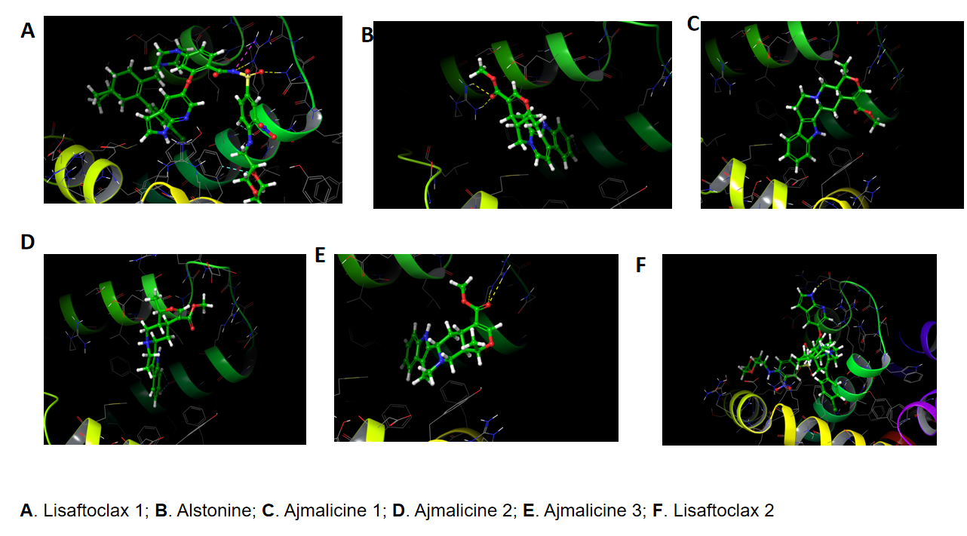
Figure 1. The docked poses of Ajmalicine, Alstonine, and the known inhibitor Lisaftoclax1 and 2 with the BCL-2 protein (PDB ID: 2W3L).

3.3.2. Docking to the PI3K Protein
The PI3K protein docking results highlighted Alpelisib (Figure 2) as the most potent binder with a Glide GScore of -9.706 and an MMGBSA dG Bind of -60.10 (Table 7). Alstonine showed a comparable affinity with a Glide GScore of -6.017 and a dG Bind of -53.33. It formed hydrogen bonds with VAL 826 and SER 831. Ajmalicine 1 had a less favorable score (Glide GScore: -5.023; MMGBSA dG Bind: -51.27).
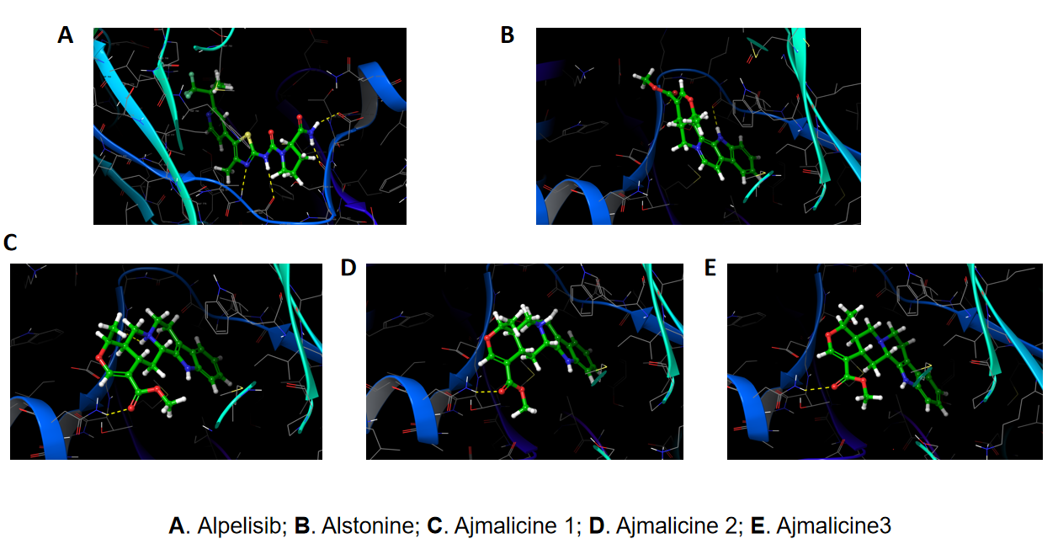
Figure 2. The docked poses of Ajmalicine, Alstonine, and the known inhibitor Alpelisib with the PI3K protein (PDB ID: 5DXU).

3.3.3. Docking to the EGFR Protein
Gefitinib, the known inhibitor, displayed the highest binding affinity for the EGFR protein, with a Glide GScore of -10.456 and an MMGBSA dG Bind of -61.02 (Table 7). Both Ajmalicine 1 and Alstonine showed significantly weaker binding to EGFR (Figure 3). Ajmalicine 1 had a Glide GScore of -4.624 and a dG Bind of -39.14, forming hydrogen bonds with THR 766, MET 769, and ASP 831. Alstonine had a slightly better Glide score of -4.959 and a dG Bind of -45.96, along with salt bridges and aromatic H-bonds with ASP 831.

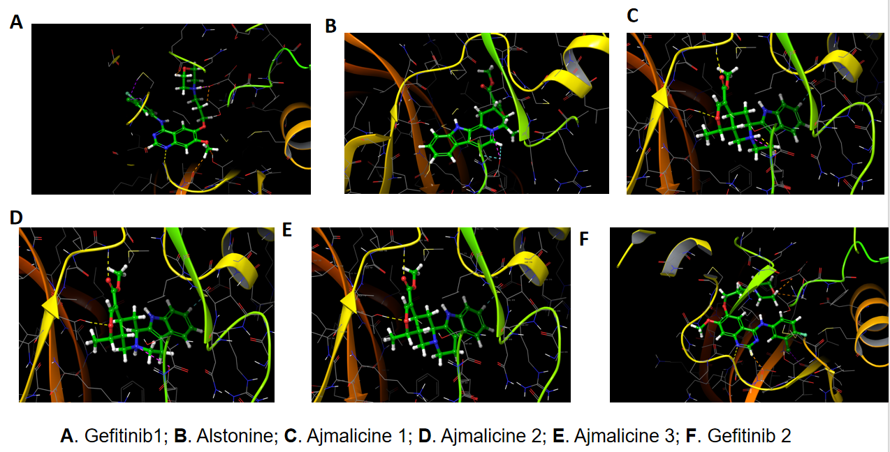
Figure 3. The docked poses of Ajmalicine, Alstonine, and the known inhibitor Gefitinib with the Epidermal Growth Factor Receptor (EGFR) protein (PDB ID: 1M17).

3.3.4. Docking to STAT3, HDAC, and NF-κB Proteins
STAT3: Alstonine exhibited a comparable binding affinity to the known inhibitor, Napabucasin, with a Glide GScore of -5.877 and an MMGBSA dG Bind of -48.51, which was slightly better than Napabucasin's GScore of -5.467 and dG Bind of -48.33.
HDAC: Romidepsin, the known inhibitor, showed the strongest binding with a Glide GScore of -6.215 and a dG Bind of -34.82, which was a higher affinity than both natural compounds.
NF-κB: Mesalazine showed the most favorable binding with a Glide GScore of -3.683 and a dG Bind of -11.27, a higher affinity than both Ajmalicine and Alstonine.

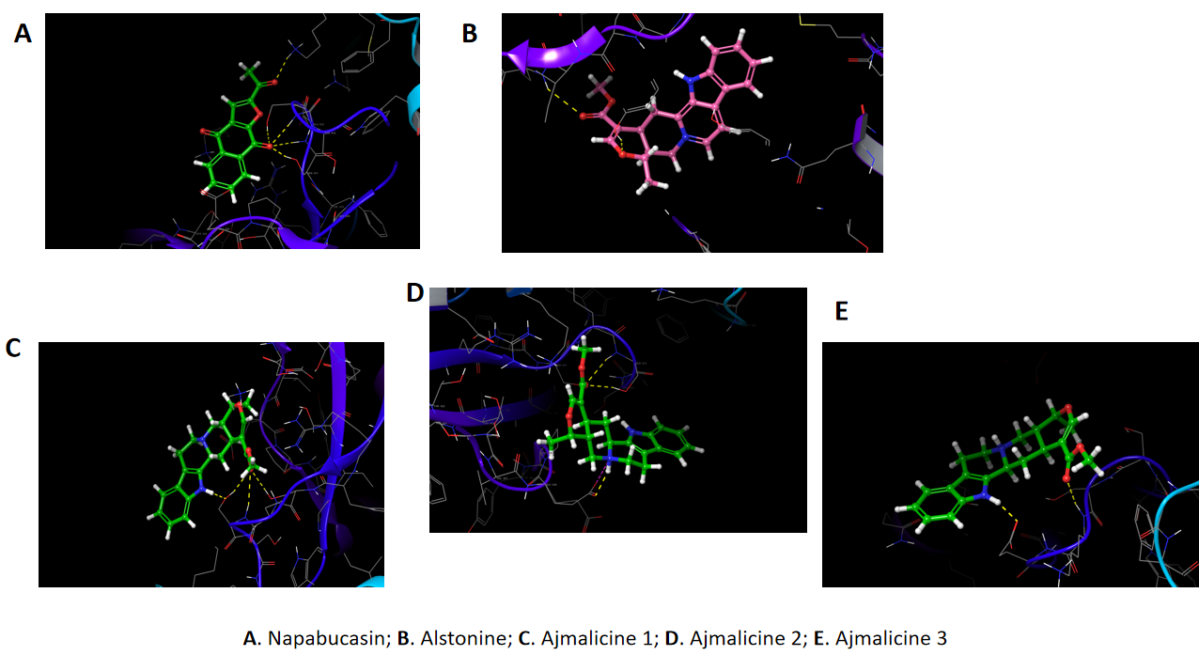
Figure 4. The docked poses of Ajmalicine, Alstonine, and the known inhibitor Napabucasin with the STAT 3 protein.

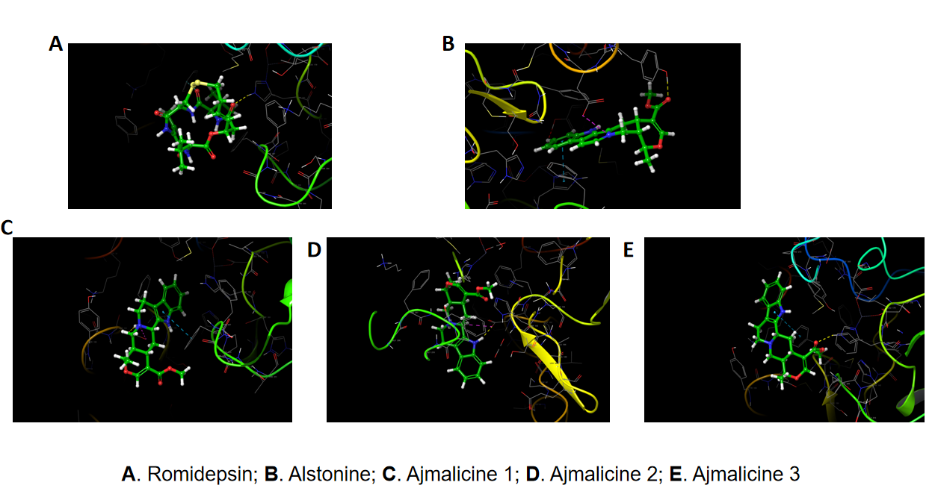
Figure 5. The docked poses of Ajmalicine, Alstonine, and the known inhibitor Romidepsin with the HDAC protein (PDB ID: 1T67).

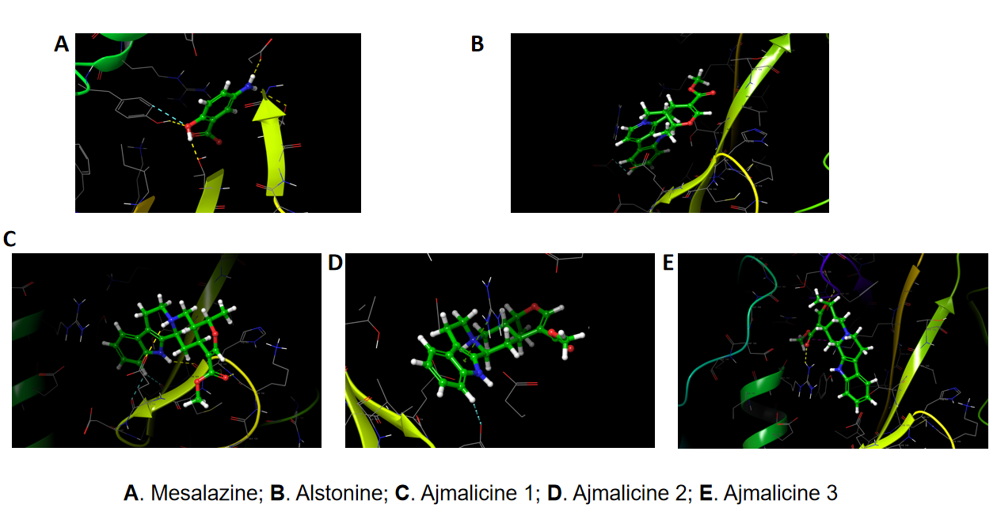

Figure 6. The docked poses of Ajmalicine, Alstonine, and the known inhibitor Mesalazine with the NF-κB protein (PDB ID: 8QTD).

Table 7: Molecular Docking Scores and Binding Affinity of Compounds to Target Proteins
Protein | Target Compound | Docking Score | XP GScore | Glide GScore | Glide Emodel | Prime Energy | MMGBSA dG Bind | H-Bonds Length
BCL-2 | Alstonine | -5.042 | -5.042 | -5.042 | -33.231 | -6275.1 | -31.05 | AGR 88 - 1.84A  AGR 88 - 2.73A
BCL-2 | Ajmalicine 1 | -3.240 | -3.789 | -3.789 | -42.074 | -6278.6 | -37.94 | ARG 105 - 2.73A
BCL-2 | Ajmalicine 2 | -4.154 | -4.703 | -4.703 | -41.662 | -6274.4 | -34.63 | Nil
BCL-2 | Ajmalicine 3 | -4.004 | -4.303 | -4.303 | -34.924 | -6271.2 | -26.17 | ARG 105 - 1.96A  ARG 105 - 2.12A
BCL-2 | Lisaftoclax 1 | -3.568 | -5.782 | -5.782 | -75.884 | -6257.2 | -61.56 | ARG 105 - 2.22A  ASN 105 - 1.55A
BCL-2 | Lisaftoclax 2 | -0.375 | -0.389 | -0.389 | -86.587 | -6265.5 | -60.36 | ASP 99 - 1.58A
PI3K | Alstonine | -6.017 | -6.017 | -6.017 | -51.841 | -40547.7 | -53.33 | VAL 826 - 2.71A  SER 831 - 2.07A
PI3K | Alpesilib | -9.706 | -9.706 | -9.706 | -87.451 | -40580.1 | -60.10 | VAL 828 - 2.59A and 2.41A  ASP 832 - 2.38A  SER 831 - 1.80A
PI3K | Ajmalicine 1 | -4.475 | -5.023 | -5.023 | -45.232 | -40525.4 | -34.11 | ASN 836 - 2.06A  SER 831 - 2.36A
PI3K | Ajmalicine 2 | -2.517 | -3.065 | -3.065 | -41.853 | -40524.0 | -33.74 | ASN 836 - 2.03A
PI3K | Ajmalicine 3 | -6.066 | -6.364 | -6.364 | -42.210 | -40516.1 | -20.51 | ASN 836 - 2.27A
EGFR | Alstonine | -4.959 | -4.959 | --4.959 | -52.582 | -45.96 | -12531.9 | Nil
EGFR | Ajmalicine 1 | -4.075 | -4.624 | -4.624 | -53.093 | -12521.9 | -39.14 | THR 766 - 2.06A  MET 769 - 2.38A  ASP 831 - 2.44A
EGFR | Ajmalicine 2 | -2.581 | -3.130 | -3.130 | -47.126 | -12514.3 | -32.55 | THR 766 - 2.09A  MET 769 - 2.01A
EGFR | Ajmalicine 3 | -4.309 | -4.608 | -4.608 | -53.146 | -12516.1 | -29.09 | THR 766 - 2.00A  MET 769 - 2.14A
EGFR | Gefitinib 1 | -8.656 | -9.071 | -9.071 | -76.716 | -12550.2 | -58.25 | MET 769 - 2.16A  ASP 831 - 2.09A
STAT3 | Alstonine | -2.505 | -2.505 | -2.505 | -35.884 | -23221.4 | -36.53 | TYR 657 - 2.08A  MET 660 - 2.71A
STAT3 | Napabucasin | -4.141 | -4.141 | -4.141 | -35.601 | 23181.1 | -29.50 | SER 613 - 2.25A and 2.41A  SER 611 -1.96A  GLU 612 - 2.06A  LYS 557 - 2.23A
STAT3 | Ajmalicine 2 | -2.885 | -3.434 | -3.434 | -37.223 | -23203.3 | -23.18 | SER 613 - 2.78A and 1.95A  GLU 638 - 1.87A
STAT3 | Ajmalicine 3 | -1.532 | -1.831 | -1.831 | -37.983 | -23210.8 | -25.44 | SER 613 - 1.84A, 2.02A, and 2.08A
STAT3 | Ajmalicine 1 | 0.267 | -1.192 | -1.192 | -43.651 | 23230.0 | -34.86 | GLU 616 - 1.74A  LYS 615 - 2.02A
HDAC | Alstonine | -3.422 | -3.422 | -3.422 | -28.716 | -14477.6 | -22.46 | TYR -1.80A
HDAC | Ajmalicine 1 | -3.533 | -4.082 | -4.082 | -32.470 | -14476.7 | -25.14 | ASP 101 - 1.97A
HDAC | Ajmalicine 2 | -2.140 | -2.689 | -2.689 | -38.411 | -14473.1 | -22.68 | ASP 101 - 1.76A
HDAC | Ajmalicine 3 | -2.116 | -1.817 | -1.817 | -33.235 | -14472.5 | -25.06 | HIE 180 - 2.12A
HDAC | Romidepsin | -2.895 | -2.895 | -2.895 | -33.136 | -14521.3 | -18.81 | HIE 180 - 2.12A
NF-κB | Alstonine | -2.225 | -2.225 | -2.225 | -37.151 | -8086.9 | -28.09 | Nil
NF-κB | Ajmalicine 1 | -1.486 | -2.035 | -2.035 | -34.473 | -8082.2 | -29.91 | HIS 117 - 1.99A  GLU 119 - 2.80A  CYS 118 - 2.21A
NF-κB | Ajmalicine 2 | -2.668 | -3.217 | -3.217 | -29.289 | -8064.1 | -12.61 | Nil
NF-κB | Ajmalicine 3 | -1.518 | -1.817 | -1.817 | -37.444 | -8080.0 | -20.59 | ARG 163 - 2.10A  PHE 227 - 1.95A
NF-κB | Mesalazine | -3.679 | -3.683 | -3.683 | -20.151 | -8104.5 | -11.27 | GLY 119 - 2.72A  TYR 165 - 2.02A  THR 124 - 1.69A  ASP 120 -1.94A

The present study employed a comparative in-silico approach to evaluate the anticancer potential of two naturally derived indole alkaloids, Ajmalicine and Alstonine, against six cancer-associated proteins. The integrated use of pharmacokinetic profiling, toxicity prediction, and molecular docking simulations provided insights into their potential as lead candidates relative to established anticancer drugs.
The SwissADME predictions demonstrated that both Ajmalicine and Alstonine possess favorable pharmacokinetic properties, including high gastrointestinal absorption and compliance with Lipinski’s rule of five. These findings align with earlier reports suggesting that alkaloid scaffolds often exhibit drug-like characteristics, making them attractive candidates for further development (20, 21). Notably, both compounds were predicted to cross the blood-brain barrier (BBB), a feature that could expand their therapeutic potential to malignancies with central nervous system involvement. However, BBB penetration also raises concerns about off-target neurological effects, warranting careful experimental validation (22). BBB permeability should be carefully evaluated through neurotoxicity screening in subsequent experimental studies.
The toxicity predictions revealed that Ajmalicine and Alstonine were classified as Class 3 toxicants (LD₅₀ between 200–300 mg/kg), indicating higher toxicity compared to several reference inhibitors such as Gefitinib and Napabucasin. This finding underscores the importance of balancing efficacy with safety when developing plant-derived compounds (23). Furthermore, Ajmalicine was predicted to exhibit multiple toxicities, including carcinogenicity and immunotoxicity, which may limit its therapeutic window. In contrast, Alstonine showed a slightly lower toxicity profile, suggesting that structural modifications could enhance its safety while retaining anticancer activity.
The docking studies highlighted distinct differences in the binding affinities of Ajmalicine and Alstonine across the six target proteins. For BCL-2, a key anti-apoptotic protein, Alstonine demonstrated stronger binding than Ajmalicine, although Lisaftoclax outperformed both. This is consistent with previous findings where small molecules with high-affinity interactions at the BH3 binding groove of BCL-2 induced apoptosis in cancer cells (24).
In the case of PI3K, Alstonine again showed promising binding affinity, approaching that of Alpelisib, a clinically approved PI3K inhibitor. This suggests a possible role for Alstonine in modulating PI3K-driven oncogenic pathways, which are implicated in tumor progression and therapy resistance (25). Conversely, the weak binding of both compounds to EGFR highlights their limited utility against EGFR-driven malignancies, in contrast to the potent binding observed with Gefitinib.
For STAT3, Alstonine showed binding comparable to Napabucasin, a known STAT3 inhibitor, supporting the potential of natural alkaloids to modulate transcription factors central to cancer progression (26). However, both compounds exhibited poor docking scores against HDAC and NF-κB, suggesting limited roles in epigenetic or inflammatory signaling inhibition. These results reflect the compound-specific nature of alkaloid-protein interactions and emphasize the need for target prioritization.
When compared with standard inhibitors, Ajmalicine and Alstonine displayed moderate docking scores, suggesting that while they may not rival synthetic drugs in potency, they could serve as lead scaffolds for drug optimization. The multifunctional binding capacity of Alstonine, particularly across BCL-2, PI3K, and STAT3, positions it as a more promising candidate than Ajmalicine. Previous research has documented similar multitarget potential for plant-derived alkaloids, often providing a basis for semi-synthetic derivative development (3).
Hydrogen bonding is one of the most important non-covalent forces that govern molecular recognition and stability in protein–ligand interactions. The length of a hydrogen bond is a critical determinant of its strength, with shorter bonds (<2.0 Å) generally regarded as strong and highly stabilizing, whereas longer bonds (>2.5 Å) are weaker and contribute less to overall binding affinity (27, 28). In this study, evaluation of H-bond lengths across BCL-2, PI3K, EGFR, STAT3, HDAC, and NF-κB revealed a consistent trend linking H-bond geometry to binding energies.Compounds forming short H-bonds, particularly those <2.0 Å, demonstrated enhanced stability within their binding pockets. For instance, Lisaftoclax established a very strong H-bond with ASN 105 at 1.55 Å in BCL-2, correlating with its superior MMGBSA binding energy. Similarly, Ajmalicine showed strong interactions with ARG 105 at 1.96 Å and 2.12 Å in BCL-2, supporting the idea that such short-range interactions anchor ligands effectively (29). By contrast, ligands with fewer or no H-bonds, such as Alstonine with EGFR and NF-κB, demonstrated weaker binding, highlighting the central role of hydrogen bonding in stabilizing ligand–protein complexes (30).
A positive association between the number and quality of H-bonds and the binding free energy was also evident. Napabucasin, for example, formed multiple H-bonds with STAT3 (1.96–2.41 Å), aligning with its favorable binding free energy. This supports the notion that multiple moderate-strength bonds (2.0–2.5 Å) can collectively stabilize the complex, compensating for the absence of ultra-strong interactions (31, 32). Residue-specific contributions were also apparent. In BCL-2, ARG 105 consistently acted as a hydrogen bond donor/acceptor across ligands, while in PI3K, ASN 836 and SER 831 were frequently involved in short and stabilizing interactions. In EGFR, MET 769 and ASP 831 facilitated strong H-bonds with Gefitinib, consistent with previously reported binding mechanisms of EGFR inhibitors (33). In contrast, HDAC and NF-κB exhibited fewer strong H-bonds, suggesting that in these targets, hydrophobic or van der Waals forces may contribute more significantly to ligand stability, as observed in prior structural studies (34, 35).

Limitations and Future Directions
Although in-silico methods offer a rapid and cost-effective means of drug discovery, the predictive models employed in this study have inherent limitations. The docking scores do not fully capture protein flexibility or the dynamics of ligand-protein interactions in vivo. Additionally, ADMET and toxicity predictions require experimental validation in cellular and animal models. Future work should include molecular dynamics simulations, in vitro cytotoxicity assays, and structure-activity relationship (SAR) studies to refine the pharmacological potential of these alkaloids.

Conclusion
Overall, this study demonstrated that Alstonine shows greater promise than Ajmalicine as an anticancer scaffold, with favorable pharmacokinetic properties and notable activity against BCL-2, PI3K, and STAT3. Despite predicted toxicity concerns, these findings highlight the potential of indole alkaloids as sources of novel anticancer agents. Experimental validation and structural optimization are essential next steps to translate these computational predictions into clinically relevant outcomes.

Ethical Approval

As this is an in-silico study, it involved no human or animal subjects, and thus, ethical approval was not required. All data utilised were retrieved from publicly accessible databases and used under their terms of use.

COMPETING INTERESTS DISCLAIMER:
Authors have declared that they have no known competing financial interests OR non-financial interests OR personal relationships that could have appeared to influence the work reported in this paper.
Disclaimer (Artificial intelligence)
Author(s) hereby declare that NO generative AI technologies such as Large Language Models (ChatGPT, COPILOT, etc.) and text-to-image generators have been used during the writing or editing of this manuscript.

REFERENCES
- Sung, H., Ferlay, J., Siegel, R. L., Laversanne, M., Soerjomataram, I., Jemal, A., & Bray, F. (2021). Global cancer statistics 2020: GLOBOCAN estimates of incidence and mortality worldwide for 36 cancers in 185 countries. CA: A Cancer Journal for Clinicians, 71(3), 209–249. https://doi.org/10.3322/caac.21660
- Chunarkar-Patil, P., Kaleem, M., Mishra, R., Ray, S., Ahmad, A., Verma, D., Bhayye, S., Dubey, R., Singh, H. N., & Kumar, S. (2024). Anticancer Drug Discovery Based on Natural Products: From Computational Approaches to Clinical Studies. Biomedicines, 12(1), 201. https://doi.org/10.3390/biomedicines12010201
3. Newman, D. J., & Cragg, G. M. (2020). Natural Products as Sources of New Drugs over the Nearly Four Decades from 01/1981 to 09/2019. Journal of natural products, 83(3), 770–803. https://doi.org/10.1021/acs.jnatprod.9b01285
4. Enyi, E. O. & Ekpunobi, N. F. (2022). Secondary metabolites from endophytic fungi of Moringa oleifera: antimicrobial and antioxidant properties. Journal of Microbiology and Experimentation 10(5):150‒154. https://doi.org/10.15406/jmen.2022.10.00367
5. Ferlay, J., Laversanne, M., Ervik, M., Lam, F., Colombet, M., Mery, L., & Bray, F. (2021). Global cancer observatory: Cancer today. International Agency for Research on Cancer. Retrieved from https://gco.iarc.fr/
6. Ekpunobi, N. F., Obidi, N. O., Idowu, O., Okoye, L. C., Agu, C. K., Ogunsanya, T., Ogbodo, U. C., & Uwanta, L. I. (2025). Knowledge and awareness of breast cancer symptoms, risk factors, and early detection methods among Nigerian university students. World Journal of Advanced Research and Reviews, 25(2), 1129-1138. https://doi.org/10.30574/wjarr.2025.25.2.0332

7. Sunmonu, A. and Ekpunobi, N. (2023). Larvicidal potential of silver nanoparticles synthesized from Ocimum gratissimum leaf extracts against anopheles' mosquito. GSC Biological and Pharmaceutical Sciences. 25. 41-48. https://doi.org/10.30574/gscbps.2023.25.3.0517

8. Oluwasanu, M. M., Adejumo, P. O., Sun, Y., Onwuka, C., Ntekim, A., Awolude, O. A., Aniagwu, T. I., Kotila, O. A., Brown, B. J., Ogbole, G. I., Dzekem, B. S., Ajani, O., Huo, D., Babalola, C. P., Ojengbede, O., Hammad, N., & Olopade, O. I. (2024). Challenges and Recommendations for Improving Cancer Research and Practice in Nigeria: A Qualitative Study With Multi-Stakeholders in Oncology Research and Practice. Cancer control : journal of the Moffitt Cancer Center, 31, 10732748241298331. https://doi.org/10.1177/10732748241298331
9. Ogbole, O. O., Akinleye, T. E., Segun, P. A., Faleye, T. C., & Adeniji, A. J. (2018). In vitro antiviral activity of twenty-seven medicinal plant extracts from Southwest Nigeria against three serotypes of echoviruses. Virology journal, 15(1), 110. https://doi.org/10.1186/s12985-018-1022-7
10. Kumar, S., Kumari, D., & Singh, B. (2022). Genus Rauvolfia: A review of its ethnopharmacology, phytochemistry, quality control/quality assurance, pharmacological activities and clinical evidence. Journal of ethnopharmacology, 295, 115327.
11. Yu J, Chen Q. Antitumor Activities of Rauwolfia vomitoria Extract and Potentiation of Gemcitabine Effects Against Pancreatic Cancer. Integr Cancer Ther. 2014;13:217–225.
12. Yu, J., Ma, Y., Drisko, J., & Chen, Q. (2013). Antitumor Activities of Rauwolfia vomitoria Extract and Potentiation of Carboplatin Effects Against Ovarian Cancer. Current therapeutic research, clinical and experimental, 75, 8–14. https://doi.org/10.1016/j.curtheres.2013.04.001
13. Dong, R., Chen, P., & Chen, Q. (2018). Inhibition of pancreatic cancer stem cells by Rauwolfia vomitoria extract. Oncology Reports, 40, 3144 - 3154.
14. Fang, T., Xue, Z. S., Li, J. X., Liu, J. K., Wu, D., Li, M. Q., Song, Y. T., Yun, S. F., & Yan, J. (2021). Rauwolfia vomitoria extract suppresses benign prostatic hyperplasia by reducing expression of androgen receptor and 5α-reductase in a rat model. Journal of integrative medicine, 19(3), 258–264. https://doi.org/10.1016/j.joim.2020.12.002
15. Wang, Y. X., Lin, C., Cui, L. J., Yang, W. H., Li, Q. M., Liu, Z. J., & Miao, X. P. (2021). Rauwolfia vomitoria Extract Represses Colorectal Cancer Cell Autophagy and Promotes Apoptosis. Pharmacology, 106(9-10), 488–497. https://doi.org/10.1159/000512614
16. Elisabetsky, E., & Costa-Campos, L. (2006). The alkaloid alstonine: a review of its pharmacological properties. Evidence-based complementary and alternative medicine : eCAM, 3(1), 39–48. https://doi.org/10.1093/ecam/nek011.
17. Kumar, S., & Singh, B. (2022). An Overview on Bioactives and Pharmacology of Rauvolfia vomitoria Afzel. Bioactives and Pharmacology of Medicinal Plants, 303-312.
18. Pires, D. E., Blundell, T. L., & Ascher, D. B. (2015). pkCSM: Predicting Small-Molecule Pharmacokinetic and Toxicity Properties Using Graph-Based Signatures. Journal of medicinal chemistry, 58(9), 4066–4072. https://doi.org/10.1021/acs.jmedchem.5b00104
19. Ferreira, L. G., Dos Santos, R. N., Oliva, G., & Andricopulo, A. D. (2015). Molecular docking and structure-based drug design strategies. Molecules (Basel, Switzerland), 20(7), 13384–13421. https://doi.org/10.3390/molecules200713384
- Lipinski C. A. (2004). Lead- and drug-like compounds: the rule-of-five revolution. Drug discovery today. Technologies, 1(4), 337–341. https://doi.org/10.1016/j.ddtec.2004.11.007
21. Daina, A., Michielin, O., & Zoete, V. (2017). SwissADME: a free web tool to evaluate pharmacokinetics, drug-likeness and medicinal chemistry friendliness of small molecules. Scientific reports, 7, 42717. https://doi.org/10.1038/srep42717
22. Pardridge W. M. (2012). Drug transport across the blood-brain barrier. Journal of cerebral blood flow and metabolism : official journal of the International Society of Cerebral Blood Flow and Metabolism, 32(11), 1959–1972. https://doi.org/10.1038/jcbfm.2012.126
24. Kale, J., Osterlund, E. J., & Andrews, D. W. (2018). BCL-2 family proteins: changing partners in the dance towards death. Cell death and differentiation, 25(1), 65–80. https://doi.org/10.1038/cdd.2017.186

25. Fruman, D. A., Chiu, H., Hopkins, B. D., Bagrodia, S., Cantley, L. C., & Abraham, R. T. (2017). The PI3K Pathway in Human Disease. Cell, 170(4), 605–635. https://doi.org/10.1016/j.cell.2017.07.029

26. Yu, H., Pardoll, D., & Jove, R. (2009). STATs in cancer inflammation and immunity: a leading role for STAT3. Nature reviews. Cancer, 9(11), 798–809. https://doi.org/10.1038/nrc2734
27. McDonald, I. K., & Thornton, J. M. (1994). Satisfying hydrogen bonding potential in proteins. Journal of Molecular Biology, 238(5), 777–793.
28. Jeffrey, G. A. (1997). An Introduction to Hydrogen Bonding. Oxford University Press.
29. Desiraju, G. R., & Steiner, T. (2001). The Weak Hydrogen Bond. Oxford University Press
30. Bissantz, C., Kuhn, B., & Stahl, M. (2010). A medicinal chemist’s guide to molecular interactions. Journal of Medicinal Chemistry, 53(14), 5061–5084.
31. Fersht, A. (1999). Structure and Mechanism in Protein Science: A Guide to Enzyme Catalysis and Protein Folding. W. H. Freeman.
32. Hubbard, R. E., & Haider, M. K. (2010). Hydrogen bonds in proteins: role and strength. In Encyclopedia of Life Sciences. Wiley.
33. Stamos, J., Sliwkowski, M. X., & Eigenbrot, C. (2002). Structure of the epidermal growth factor receptor kinase domain alone and in complex with a 4-anilinoquinazoline inhibitor. Journal of Biological Chemistry, 277(48), 46265–46272.

34. Marks, P. A., & Breslow, R. (2007). Dimethyl sulfoxide to vorinostat: development of this histone deacetylase inhibitor as an anticancer drug. Nature Biotechnology, 25(1), 84–90.
35. Gilmore, T. D., & Gerondakis, S. (2011). The c-Rel transcription factor in development and disease. Genes & Cancer, 2(7), 695–711.

