Original Research Article
Preparation and dietary evaluation of fortified yoghurt with snail shells
ABSTRACT
The study aimed to develop fortified yoghurt made with snail shell powder, a natural and non-toxic compound rich in calcium carbonate (approximately 95% inorganic minerals) and other essential minerals, such as manganese, iron, copper, zinc, and sodium, to increase its nutritional benefits. It also contains chitosan, a valuable carbohydrate. The yoghurt was enhanced with additional ingredients like strawberry, cinnamon, cardamom, and honey, which is more important than the control yoghurt because it combines traditional dairy nutrition with added functional benefits from natural ingredients. These additions enhance the yoghurt's nutritional value, improve health benefits, and create a more appealing sensory profile. Strawberries contribute natural antioxidants and vitamins; cinnamon and cardamom offer anti-inflammatory and digestive-supporting compounds and honey brings antimicrobial and energy-boosting properties. Cinnamon and cardamom have been linked to improved blood sugar regulation and lipid metabolism, which can contribute to the prevention of metabolic syndrome. Chia seeds, rich in omega-3 fatty acids, fiber, and essential minerals, support heart health and help maintain healthy cholesterol levels. Honey adds antimicrobial properties and promotes gut health in combination with the probiotics found in yoghurt. Snail shell, as a natural source of calcium and other trace minerals, contributes to bone health and helps in preventing deficiencies that could lead to conditions like osteoporosis. Three distinct experimental versions of the fortified yoghurt have been created to added varying the amount of snail shell powder, accompanied by various analyses, including proximate analysis, mineral content evaluation, antioxidant, total polyphenol, flavonoid assessment and microbial analysis. The fortified yoghurt exhibited a superior nutritional profile, boasting high levels of carbohydrates, proteins, and essential minerals like sodium, calcium, and iron. Notably, it demonstrated enhanced antioxidant activity, with increased polyphenol and flavonoid content compared to control(plain) yoghurt. Additionally, the fortified yoghurt contained beneficial bacteria, further contributing to its potential health benefits.
Keywords: Snail shell powder; calcium carbonate; strawberries; digestive-supporting; chia seeds

1. INTRODUCTION
Snail shells are a natural source rich in calcium carbonate, making them a valuable resource for the food industry due to their non-toxic, low-cost, and eco-sustainable nature. They contain essential minerals like phosphorus, manganese, iron, copper, zinc, sodium, and potassium, as well as organic compounds such as proteins, lipids, and polysaccharides. Snail shells are also a rich source of chitosan, a natural carbohydrate with antibacterial and antifungal properties, which has been shown to inhibit the growth of Staphylococcus aureus and reduce diabetic ulcers caused by the bacteria. The use of chitosan can also reduce the need for synthetic food preservatives. Furthermore, chitosan has demonstrated significant immune-modulating responses against cancer and anti-tumor activity, with an efficacy rate of 87-96%. The calcium carbonate in snail shells can help prevent multiple chronic diseases and reduce the risk of cancer. As a result, snail shells are used as a calcium supplement to prevent osteoporosis. The calcium carbonate in snail shells can also synthesize hydroxyapatite, which has high binding activity to proteins and other materials, and has been shown to reduce tumor size and inhibit the proliferation of cancer cells, particularly in human breast cancer [Joice Junita Imelda Rompas et al.2003]. The use of snail shell powder can lead to the development of new healthy food products, such as fortified yoghurt with enhanced nutritional value. [Angela Giorgia Potortiet et al.2024].
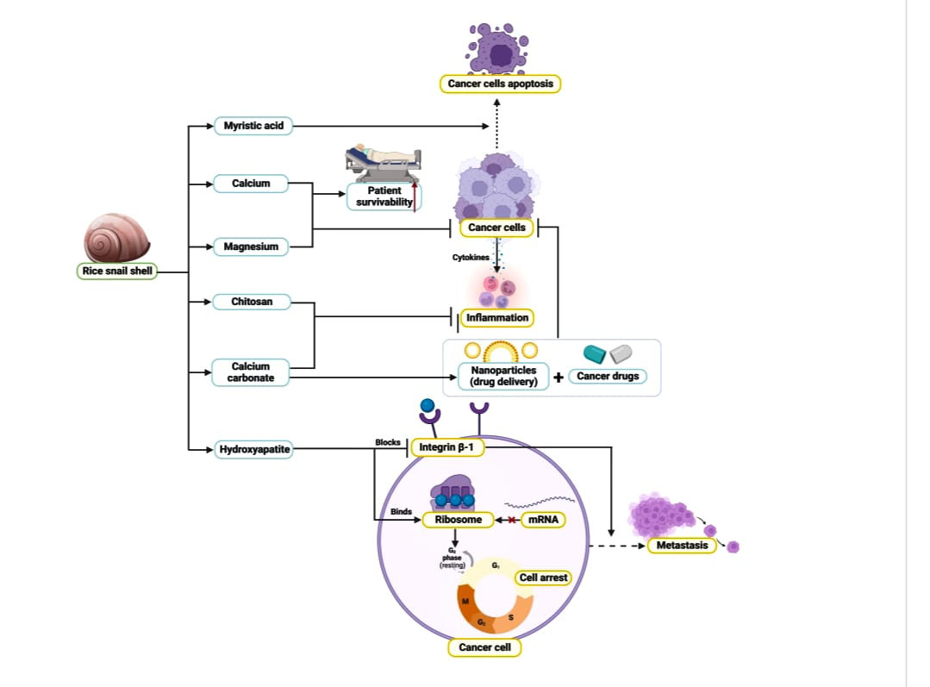
Figure 1: Beneficial role of snail shell powder [Joice Junita Imelda Rompas et al.2003]
Cow's milk is a nutrient-dense liquid rich in macronutrients (protein, fat, carbohydrates) and micronutrients, including calcium, vitamin D, B vitamins, phosphorus, and potassium. It contains high-quality proteins like casein and whey, supporting muscle protein synthesis and recovery. Additionally, low-fat and fermented dairy products may help reduce hypertension due to their calcium, potassium, magnesium, and bioactive peptides [Elliot et al., 2006; Elwood et al., 2004; Soedamah-Muthu et al., 2011].
Yoghurt is a fermented milk product containing probiotics like Streptococcus thermophilus and Lactobacillus bulgaricus, which support gut health, lower cholesterol, and prevent diarrhea. Rich in protein, calcium, B vitamins, and probiotics, yoghurt offers numerous health benefits, including improved digestion, balanced gut microbiota, and potential alleviation of symptoms of irritable bowel syndrome (IBS) and lactose intolerance [Roberfroid et al., 2010]. The regular yoghurt consumption has been associated with lower blood pressure and improved cholesterol profiles, particularly when consuming low-fat varieties [ Marteau et al., 2001]. It is an excellent source of calcium, phosphorus, and vitamin D (in fortified varieties), all essential for maintaining strong bones and preventing osteoporosis [Weaver et al., 2013].
Strawberries are rich in phenolic compounds, serving as a valuable source of antioxidants, particularly anthocyanin. The addition of strawberries enhances the sensory properties of products, such as texture, color, aroma, and taste. Strawberries also contain essential fatty acids and are an excellent source of manganese, providing a significant amount of potassium, thereby contributing to their nutritional value [Forentina Maria Titin Supriyanti et al,2022]. Strawberries ware rich in essential nutrients and bioactive compounds, particularly vitamin C, folate, fiber, and phenolic compounds such as anthocyanin and elegiac acid. These compounds contribute to several health-promoting effects. It was high in antioxidants, which help neutralize free radicals and reduce oxidative stress-a factor in chronic diseases like cancer and cardiovascular diseases and have anti-inflammatory effects. The regular consumption of strawberries may reduce inflammatory markers such as C-reactive protein (CRP), potentially lowering the risk of chronic inflammation-related conditions [Basu et al., 2010]. Dietary intake of strawberries has been associated with improved lipid profiles, blood pressure regulation, and endothelial function [Erlund et al., 2008; Xiao et al., 2019]. The flavonoids in strawberries may help slow cognitive decline and improve memory by reducing neuroinflammation and oxidative damage [Krikorian et al., 2010]. Polyphenols in strawberries, such as elegiac acid and anthocyanin, have demonstrated anti-carcinogenic properties in both in vitro and in vivo studies [Seeram et al., 2006]. Strawberries may improve insulin sensitivity and help regulate blood glucose levels, which is beneficial for metabolic syndrome and type 2 diabetes management [Edirisinghe et al., 2011].
Chia seeds, derived from Salvia hispanica L., are a rich source of alpha-linolenic acid (ALA), fiber, and antioxidants. They may support heart health by reducing inflammation, improving cholesterol profiles, and lowering blood pressure and triglycerides. Chia seeds are also rich in essential minerals like calcium, phosphorus, and magnesium, promoting bone strength and density. Their incorporation into products can enhance nutritional value, support lactic acid bacteria growth, and improve characteristics like viscosity, color, and antioxidant effects. Chia seeds are small edible seeds from the plant Salvia hispanica L., native to Central America. Chia seeds are among the richest plant sources of alpha-linoleic acid (ALA), which may support heart health, reduce inflammation, and improve cholesterol profiles [Ayerza & Coates, 2005].Due to their combination of fiber, ALA, and antioxidants, chia seeds may help lower blood pressure, triglycerides, and LDL cholesterol [Nieman et al., 2009].It is rich in calcium, phosphorus, and magnesium, essential for bone strength and density [Ullah et al., 2016].The seeds are added to the fortify products, offering a rich content of crude protein, dietary fiber, antioxidants such as phenolic compounds, and omega-3 fatty acids, particularly alpha-linolenic acid. The incorporation of chia seeds can enhance the growth of lactic acid bacteria and improve product characteristics, including viscosity, color, syneresis, and antioxidant effects [Jussara Kowaleski et al., 2020].
Spices like cinnamon and cardamom serve as excellent functional flavoring agents, offering health benefits such as antioxidant, antimicrobial, anti-inflammatory, and anti-carcinogenic properties. When combined with yoghurt, these spices may enhance therapeutic properties, impact probiotic viability, and inhibit pathogens [Vijayalakshmi V et al.,2013]. The cinnamon contains high levels of polyphenols that help neutralize free radicals, reducing oxidative stress that contributes to chronic diseases [Ranasinghe et al., 2013]. It suppresses inflammatory cytokines and enzymes such as COX-2, aiding in the management of inflammation-related conditions [Sankaranarayanan et al., 2024]. It enhances insulin sensitivity and lowers fasting blood glucose, which is beneficial for type 2 diabetes management [Khan et al., 2003; Akilen et al., 2010]. Regular intake of cinnamon has been shown to reduce total cholesterol, LDL (bad cholesterol), and triglycerides, while increasing HDL (good cholesterol) [Qin et al., 2010]. It has antimicrobial activity. Cinnamon exhibits antibacterial and antifungal properties, particularly against E. coli, Candida albicans, and Listeria monocytogenes [Nematollahi et al., 2020; Tran et al., 2020] Cardamom has traditionally been used to relieve indigestion, gas, stomach cramps, and nausea. It stimulates gastric secretions and acts as a carminative [Nag et al., 2023]. Cardamom contains flavonoids and terpenes that exhibit strong antioxidant activity, reducing oxidative stress and suppressing pro-inflammatory markers [Majdalawieh & Carr, 2010]. Clinical trials have shown that regular cardamom intake can reduce systolic and diastolic blood pressure, likely due to its diuretic effect and antioxidant activity [Verma et al., 2012]. It has essential oil which effective against a wide range of pathogens including E. coli, Staphylococcus aureus, and Candida albicans [Ravindran et al., 2004]. Preclinical studies suggest that cardamom can inhibit cancer cell proliferation, induce apoptosis, and prevent chemically induced tumour in animal models [Almeer et al., 2021]. It is use in Ayurveda and Unani medicine, cardamom helps relieve cough, asthma, and bronchitis due to its expectorant and bronchodilator properties [Jamal et al., 2006].
Honey is a natural sweet substance produced by honeybees (Apis mellifera) from the nectar of flowers. It contains a complex mixture of sugars (mainly fructose and glucose), enzymes, amino acids, vitamins, minerals, and potent bioactive compounds such as flavonoids and phenolic acids. That is scavenge free radicals and reduce oxidative stress, which may help prevent chronic diseases [Alvarez-Suarez et al., 2010]. Although high in natural sugars, honey has a lower glycaemic index than refined sugar and may improve glycaemic control when used moderately [Yaghoobi et al., 2008]. Unliked many probiotic-fortified yoghurts that use artificial sweeteners and flavoring agents [Vijayalakshmi V et al,2013], this dissertation explores the use of natural sweeteners like honey. Honey, composed of water, fructose, glucose, and sucrose, offers anti-mutagenic, antibacterial, and antioxidant properties. Adding honey to yoghurt can enhance its physicochemical, microbiological, and sensory properties, making it a suitable food option, particularly for children [Fatma Coskun., et al.2019]. This natural approach to sweetening yoghurt is beneficial for both manufacturers and consumers [Vijayalakshmi V et al., 2013].
The aim of the study is to formulate a fortified yoghurt with added snail shell powder, strawberry, chia seeds, spices and honey. It is considered innovative because it integrates underutilized and culturally unique ingredients like snail shell powder into a familiar food matrix. Using such non-traditional sources of minerals reflects a novel approach to food fortification. The product also aligns with growing trends in functional foods, clean-label ingredients, and natural fortification strategies, making it a unique and forward-thinking contribution to the field of dairy innovation and nutrition
2. METHODOLOGY
2.1 Raw material
Fortified yoghurt making raw materials are purchased from the local market which includes milk, yoghurt, strawberry, chia seeds, cinnamon, cardamom, honey. The novel ingredient snail shell was collected from pond.
2.2 Pre-preparation of snail shell powder
The snail shell was rinsed under running distilled water and then soaked in distilled water for 1-2 hours. After that, an acetic acid solution was prepared to wash the snail shell to prevent contamination. It was dried and ground, and lastly, it was strained using a strainer. It is a rich source of calcium. Snail shells are composed mainly of calcium carbonate (CaCO₂), making them an excellent natural source of calcium, useful in treating calcium deficiencies and as a supplement in food and feed [Niba et al., 2022]. The Snail shell-derived calcium carbonate has shown potential in bone graft materials and bio ceramics due to its biocompatibility and similarity to human bone composition [Onwubu et al., 2016]. When processed into nano-form or used as powders, snail shells may contribute to wound healing and display antimicrobial activity against common pathogens [Fadhilah et al., 2024; Ahmed et al., 2022]. Snail shell powder is used for wastewater treatment, particularly in the removal of heavy metals and acid neutralization [Nguyen et al., 2023]. Researchers have developed toothpaste and oral care formulations incorporating snail shell-derived calcium, which has shown promise in enamel remineralization and reducing hypersensitivity [Aliyyu et al., 2024; Ordu et al., 2024].
Snail shell is rinse under running distilled water then soaked in distilled water for 1-2 hours. The detailed method of preparation of snail shell powder is mentioned in Figure 2.
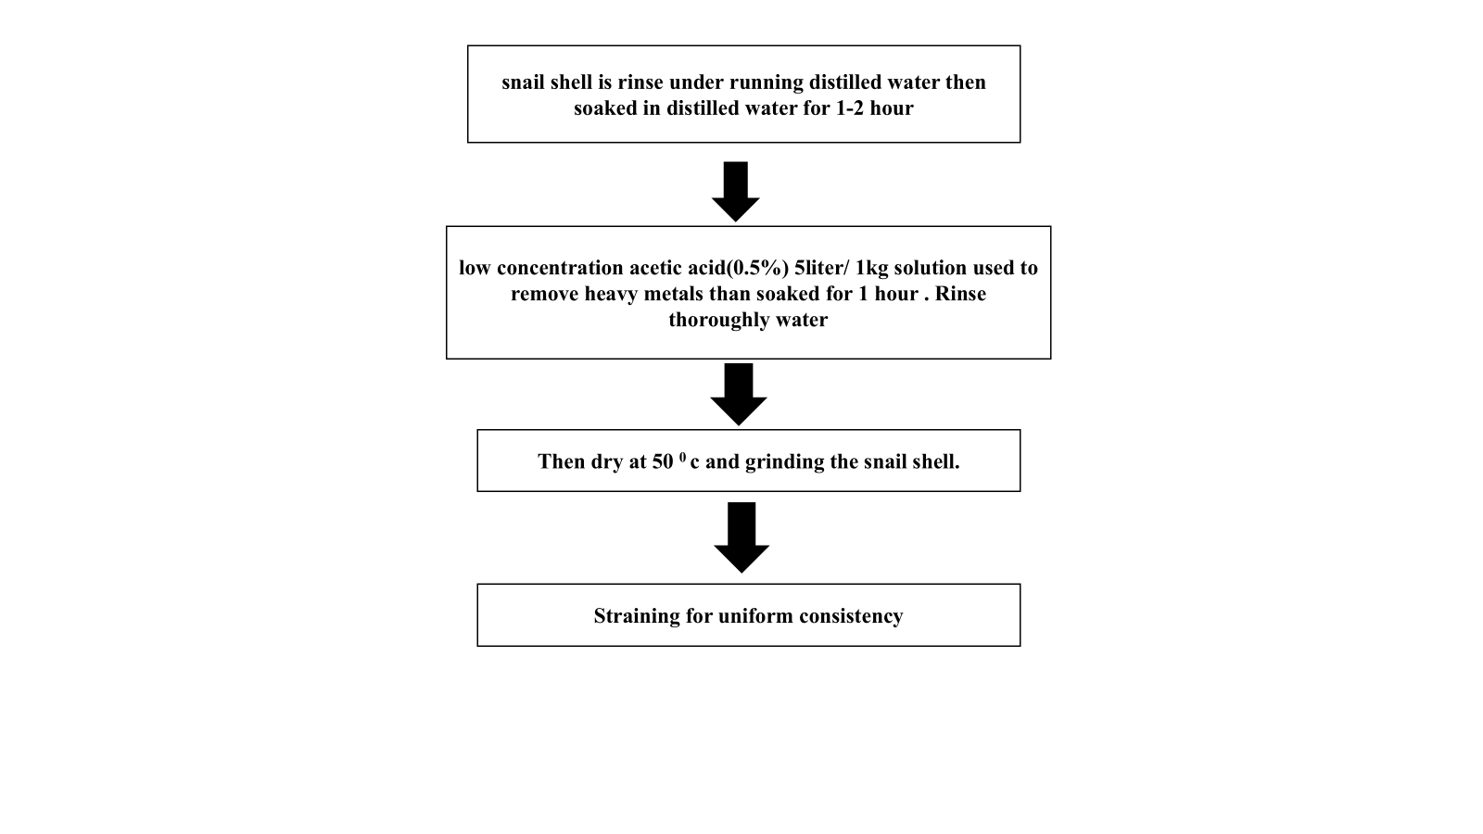
Figure 2: Prepared snail shell powder

2.3 Pre-preparation of the others ingredients
Pasteurized milk at 63°C (145°F) for 30 minutes using an induction cooktop, provided you can maintain a precise temperature control. Induction cooktops can heat liquids quickly and efficiently, making them suitable for pasteurization. When heating milk on an induction cooktop, it's best to use lower temperatures to prevent scorching or boiling over, as milk can easily burn or stick to the bottom of the pan. A lower temperature setting can help to maintain a gentle simmer, preserving the milk's texture and flavour thereafter cooling at room temperature to maintain the milk quality.
Fresh strawberries are washed and hulled, with stems and leaves removed. They are then blended in a mixer or food processor until smooth. The seeds can be strained. The puree is used immediately or stored in airtight containers in the refrigerator or freezer.
Cinnamon sticks and cardamom seeds are dried in a low-temperature oven (150°F - 200°F) for 1-2 hours. The dried cinnamon sticks and cardamom seeds are then ground separately into fine powders using a spice grinder or mortar and pestle. The seeds are removed from the cardamom pods before drying. Finally, the cinnamon and cardamom powders are combined in desired proportions and the mixture is stored in an airtight container to preserve flavor and aroma.
Table 1: Ingredient composition of different fortified yoghurt sample
Product name | Milk (ml) | Yoghurt (gm) | Strawberry (gm) | Chia seeds(gm) | Cinnamon (gm) | Cardamon (gm) | Honey (gm) | Probiotic capsule (gm) | Snail  Shail powder (gm)
A | 76.91 | 3.84 | 15.38 | 1.92 | 0.007 | 0.0007 | 1.98 | 0.5107 | 0.007
B | 76.91 | 3.84 | 15.38 | 1.92 | 0.007 | 0.0007 | 1.98 | 0.5107 | 0.003
C | 76.91 | 3.84 | 15.38 | 1.92 | 0.007 | 0.0007 | 1.98 | 0.5107 | 0.0007
D | 76.91 | 3.84 | 15.38 | 1.92 | 0.007 | 0.0007 | 1.98 | 0.5107 | 0.0003

2.4 Formulation of fortified yoghurt
The glass bowl, measuring cylinder and spatula were placed in the autoclave and under UV lights for 15 minutes for sterilization. After UV sterilization, the laminar flow was activated. The milk is measured by sterilized measuring cylinder and the other ingredients - yoghurt, strawberry puree, cinnamon-cardamom powder, honey, and snail shell powder, probiotic capsule ware weighted desirable weight by the weighing machines are typically called balances or scales. The weighed ingredients were then taken to the laminar flow for yoghurt preparation. Firstly, the yoghurt was spread to the bowl inner wall by the sterilized spatula. Then, the pasteurized milk, strawberry puree, cinnamon-cardamom powder, snail shell powder, honey, and probiotic capsule were added and mixed. The bowl was transferred to a bacteriological incubator at 34°C for overnight, where the yoghurt was allowed to form. The next day, the yoghurt was poured into the refrigerator for chilling. The preparation method is demonstrated in Figure 3 below.

The glass bowl, measuring cylinder and spatula were placed in the laminar flow and under UV lights for 15 minutes for sterilization. After UV sterilization, the laminar flow was activated
Spread the yoghurt to the bowl inner wall by the sterilized spatula
Taken sterilized glass bowl

The next day, the yoghurt was form and poured into the refrigerator
Added the pasteurized milk, strawberry puree, cinnamon-cardamom powder, snail shell powder, honey, and probiotic capsule, chia seed to the bowl
The bowl was transferred to a bacteriological incubator at 34°C for overnight

Figure 3: Formulation of fortified yoghurt
2.5 Process of control yoghurt
Plain yoghurt was prepared by having milk fermented with specific bacterial cultures under controlled conditions. The process begins with fresh milk, which was first heated to approximately 85–90°C, by which whey proteins ware denatured and unwanted microbes are eliminated. This step is taken to improve the final texture and stability of the yoghurt. After the milk has been heated, it was cooled to around 42–45°C, at which the yoghurt cultures can grow optimally. At this stage, a starter culture typically containing Lactobacillus delbrueckii, L.bulgaricus and Streptococcus thermophilus was added to the milk. The inoculated milk was then incubated at the same temperature for several hours, usually between 4 to 8 hours, until the desired acidity and consistency (pH around 4.5) are reached. Once fermentation has been completed, the yoghurt is cooled to refrigeration temperature (around 4°C), by which bacterial activity is halted and quality is preserved. It can then be stored and consumed as plain yoghurt. Careful control of temperature and culture activity has been noted to be essential for achieving consistent product quality and microbiological safety in yoghurt production.
2.6 Evaluation of proximate composition:
Proximate composition of fortified yoghurt was established as per “A Laboratory Manual Of Food Analysis” total ether extract as fat, ash, moisture, and crude fibre. Carbohydrate content was calculated by Anthrone method, total protein content was calculated by Biuret method, total fat content by Soxhlet method [Shalini Sehgal, 2016].
2.7 Estimation of mineral content:
Using ICPOES and Flame Photometer mineral content was detected. All the chemicals used for the study were of AR grade [Jussara Kowaleski et al., 2020].
2.8 Estimation of physical analysis
pH analysis A Kent EIL 7020 type pH meter was used to measure the pH level. The pH meter was analysed pH of the control sample and each fortified yoghurt sample upon maturation were obtained. Titratable acid (as percentage w/w tartaric acid) Various types and concentrations of each fortified yoghurt were identified using the Association of Analytical Chemists' (1990) methodology. Titration using a 0.1N NaOH solution was used to measure acidity, which was then represented as a percentage of tartaric acid. The indicator that was used was phenolphthalein [Shalini Sehgal, 2016].
2.9 Estimation of total phenolic content
1 gram of sample is filtered with distilled water and 1 ml of these filtered sample is taken and 2.5 ml of folin reagent and 2.5 ml sodium carbonate solution is added and vortexed. Then it is kept in a dark place for 30 minutes and the absorbance is measured at 765 nm [Forentina Maria Titin Supriyanti et al,2022]

2.10 Estimation of antioxidant activity
0.5gm of sample is filtered with distilled water. than vortex 15-20 mins and filer the samples. And taken 1 ml of filter water added 1 ml of methanol and 1 ml of DPPH. The disappearance of the DPPH (1, 1-Diphenyl-2-picryl hydrazyl) radical absorption at 517 nm by the action of antioxidant is measured spectrophotometry in a methanolic solution until the absorbance remains constant [Forentina Maria Titin Supriyanti et al,2022].
2.11 Estimation of flavonoid activity
1 gram of sample is filtrate with distilled water and 2 ml of these filtrate sample is taken and ethanolic AlCl₃ is add and vortex. Then incubate for 60 minutes in dark room and the absorbance is measured at 420 nm [Forentina Maria Titin Supriyanti et al,2022].
2.12 Sensory evaluation
Sensory evaluation of fortified yoghurt was involves assessing it quality based on appearance, colour, flavour and so on. This helps to determine its freshness, shelf life, stability. The judgement was made by rating product on a 9 points hedonic scale with corresponding descriptive terms ranging from “like extremely” to “dislike extremely” as shown below. The panelists were instructed to rinse their mouths with water after analysed each sample and not to make comments during evaluation to prevent influencing other panelists [Forentina Maria Titin Supriyanti et al.,2022].
Table 2. Score card
9. like extremely | 6.like slightly | 3. Dislike moderately
8. like very much | 5. neither like not dislike | 2. Dislike very much
7.like moderately | 4, Dislike slightly | 1.Dislike extremely

2.13 Microbial load
Microbial load was analysed by using standard protocols. The sample(1gm) was serial diluted by distilled water(9ml) and this was repeated 5 times. Then the spread plate method was used for the estimation of microorganisms. This was analysed by using Nutient Agar (NA) for bacteria. Microbial load was analysed on initial day [Elie Al-Kadamany et al.,2003].
2.14 Statistical Analysis
All the experiments were performed in triplicates and completely randomized design was carried out for the experimental values in order to know the significant difference [Elie Al-Kadamany et al.,2003].
3. RESULTS AND DISCUSSION
Figure 4 shows the pictures of control and formulated yoghurt.

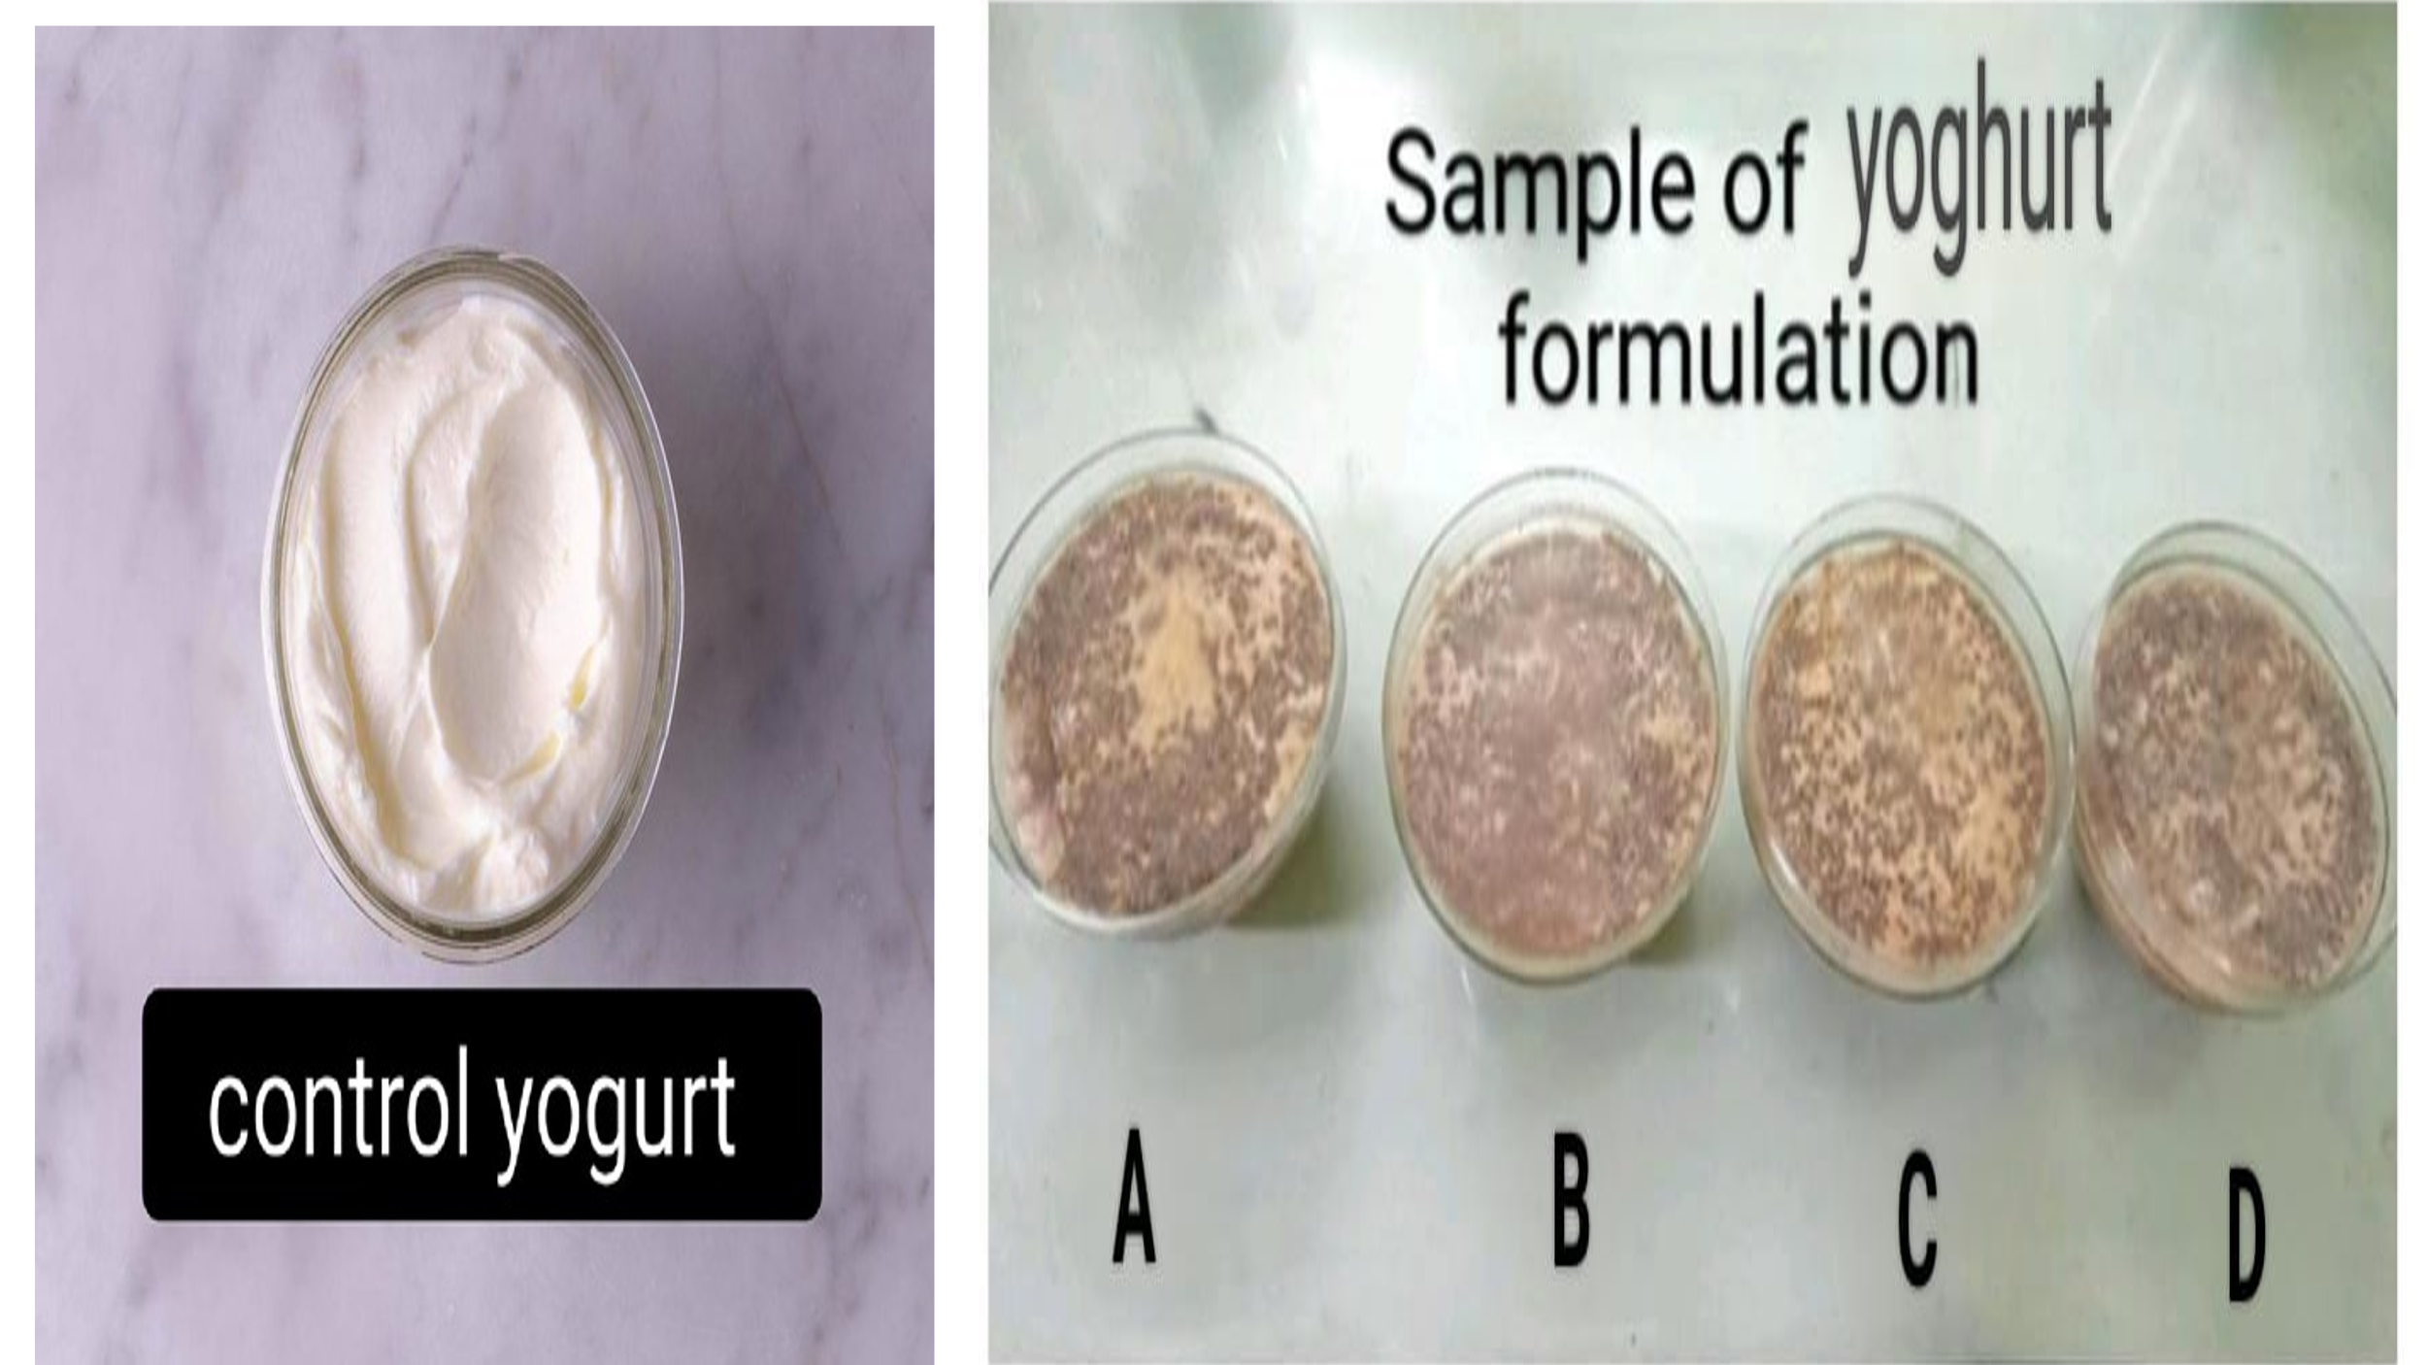
Figure 4: Control and Formulated Yoghurt

3.1 Changes in proximate composition
Table 3: Proximate Values of fresh & storage fortified yoghurt
Sl. No. | Parameters | Control |  | A |  | B |  | C |  | D
Sl. No. | Parameters | Fresh | Stored | Fresh | Stored | Fresh | Stored | Fresh | Stored | Fresh | Stored
1 | Carbohydrate (g/100g) | 4.40±  0.02 | 4.45±  0.03 | 7.59±  0.06 ^{a, c, d, e} | 7.66±  0.12 ^{a, c, d, e} | 7.33±0.06 ^{a, b, d, e} | 7.12 ±0.03 ^{a, b, d, e} | 7.29±  0.11 ^{a, b, c, e} | 7.08 ±0.06 ^{a, b, c, e} | 7.30 ±  0.09 ^{a, b, c, d} | 7.20 ±0.07 ^{a, b, c, d}
2 | Protein  (g/100g) | 4.00±  0.003 | 3.89±0.02 | 4.85±  0.04 ^{a, c, e} | 4.66±  0.07 ^{a, c, d, e} | 4.82±0.03 ^{a, b, d, e} | 4.70±  0.02 ^{a, b, d, e} | 4.85±  0.04 ^{a, c, e} | 4.60 ±  0.03 ^{a, b, c, e} | 4.88 ±  0.06 ^{a, b, c, d} | 4.30 ±  0.05 ^{a, b, c, d}
3 | Fat (g/100g) | 3.10 ±0.005 | 3.22 ±0.01 | 3.52 ±0.03 ^{a, c, d, e} | 3.62 ±0.04 ^{a, c, d, e} | 3.83 ±0.05 ^{a, b, d, e} | 4.06±0.04 ^{a, b, c, d, e} | 3.65±0.05 ^{a, b, c, e} | 3.87±0.09 a^{, b, c, d, e} | 3.55±  0.02 ^{a, b, c, d} | 3.72±0.08 ^{a, b, c, d}
4 | Moisture (g/100g) | 85.55±0.05 | 85.65±0.11 | 79.78±0.99 ^{a, c, d, e} | 80.12±0.77 ^{a, c, d, e} | 79.48±0.22 ^{a, b, d, e} | 79.79±0.12 ^{a, b, d, e} | 80.00 ±0.18 ^{a, b, c, e} | 80.13 ±  1.19 ^{a, b, c, e} | 79.23 ±  1.33 ^{a, b, c, d} | 81.56 ±  0.99 ^{a, b, c, d}
5 | Total Ash  (g/100g) | 1.80 ±0.01 | 1.70 ±0.01 | 2.40 ±0.04 ^{a, d, e} | 2.40 ±0.05 ^{a, d, e} | 2.40 ±0.05 ^{a, d, e} | 2.40±0.05 ^{a, d, e} | 2.50±0.56 ^{a, b, c, e} | 2.40 ±0.07 ^{a, b, c} | 2.90±  0.01 ^{a, b, c, d} | 2.40±0.07 ^{a, b, c}
6 | Crude Fiber  (g/100g) | 1.15 ±0.02 | 1.09 ±0.01 | 1.86 ±0.03 ^{a, c, d, e} | 1.44 ±0 .02 ^{a, c, d, e} | 2.05 ±0.03 ^{a, b, e} | 1.93±0.04 ^{a, b, d, e} | 2.01±0.01 ^{a, b, e} | 1.92±  0.05 ^{a, b, c, e} | 2.14±  0.05 ^{a, b, c, d, e} | 1.84±  0.04 ^{a, b, c, d}
7 | Energy (kcal) | 61.50 ±0.67 | 61.20 ±1.09 | 84.32±0.99 ^{a, c, d, e} | 84.66 ±  1.22 ^{a, c, d, e} | 84.30±0.45 ^{a, b, d, e} | 84.35±0.45 ^{a, b, d, e} | 84.32 ±1.34 ^{a, b, c, e} | 84.30 ±  2.13 ^{a, b, c, e} | 84.31 ±  1.33 ^{a, b, c, d} | 84.22 ±  0.09 ^{a, b, c, d}
Values are Mean ± S.D. (n=3)
ª Comparison between Control and Fortified Samples
^{b} Comparison between A and other samples
^{c} comparison between B and other sample
^{d} comparison between C and other sample
^{e} comparison between D and other sample

Table 3 presents the proximate composition of total carbohydrates in fresh and 15-day stored yoghurt samples. The fresh fortified yoghurt samples had carbohydrate contents ranging from 7.29 g/100g to 7.59g/100g, significantly higher than the fresh control yoghurt (4.40g/100g). This difference is attributed to the addition of strawberry and honey, which are rich in natural sugars like fructose and glucose. After storage, the carbohydrate contents of the fortified yoghurt samples ranged from 7.08 g/100g to 7.66 g/100g, while the control yoghurt's carbohydrate content remained relatively stable at 4.45 g/100g. Notably, storage affected the carbohydrate levels differently across samples, with Sample A showing an increase and the others exhibiting a decrease.
Table 3 presents the results of the proximate composition analysis for total protein. The protein content of fresh fortified yoghurt samples varied from 4.88 g/100g to 4.82 g/100g, and the stored fortified yoghurt sample varied from 4.70 g/100g to 4.30 g/100g. The fresh and stored control yoghurt samples contain 4.00 g/100g & 3.89 g/100g, respectively. Protein content was higher in the fortified yoghurt sample than the control yoghurt because the ingredients like chia seeds (rich in protein and also contain essential amino acids), strawberry (small amounts of protein), naturally boost the protein level beyond the control yoghurt.
Table 3 presents the proximate composition of total fat in fresh and 15-day stored yoghurt samples. The fresh fortified yoghurt samples showed fat contents ranging from 3.52 g/100g to 3.83 g/100g, higher than the fresh control yoghurt (3.10 g/100g). This increase is primarily due to the incorporation of chia seeds, which are abundant in omega-3 fatty acids, monounsaturated, and polyunsaturated fats, along with the contribution from added spices. After storage, the fat content of the fortified yoghurt samples ranged from 3.62 g/100g to 4.06 g/100g, while the control yoghurt exhibited a slight decrease to 3.22 g/100g. Notably, storage influenced the fat levels more prominently in the fortified samples, reflecting the stability and richness of the added ingredients.
Table 3 displays the proximate analysis of total moisture content. The moisture content of the fresh fortified yoghurt samples ranged from 79.23 g/100g to 80.00 g/100g, whereas the stored fortified yoghurt samples had a range of 79.79 g/100g to 81.56 g/100g. In contrast, the control samples exhibited higher moisture content, with the fresh control sample at 85.55 g/100g and the stored control sample at 85.65 g/100g. The lower moisture content in the fortified yoghurts compared to the control yoghurt can be attributed to the addition of chia seeds, which can absorb 10-12 times their weight in water, forming a gel-like texture. Additionally, honey's hygroscopic properties allow it to attract and bind water, while the snail shell and spices contribute to increased solids, further reducing moisture content.
Table 3 presents the proximate composition of total ash and crude fiber ware found the fresh and 15 days stored yoghurt samples. The fresh fortified yoghurt samples total ash content varied from 2.40 g/100g to 2.90 g/100g. In contrast, the fresh control yoghurt was found total ash content of 1.80 g/100g. After storage, the ash contents of the fortified yoghurt samples ware 2.40 g/100g while the control yoghurt's ash content remained low at 1.70 g/100g. The crude fiber contents of fresh and storage fortified yoghurt samples varied from 1.86% to 2.14 g/100g & 1.44 g/100g to 1.93 g/100g. Compared to the control, the yoghurt is fresh and has a storage value (1.15 g/100g and 1.70 g/100 gm) of crude fibre content that is lower than that of the fortified yoghurt. The ash and crude fibre content of fortified yoghurt was high due to added chia seeds (rich in soluble and insoluble fibre) & Strawberries (natural fruit fibre contains pectin and cellulose).
Table 3 presents the results of the proximate composition analysis for energy. The energy content of fresh fortified yoghurt samples varied from 84.32 g/100g to 84.30 g/100g, and the stored fortified yoghurt sample varied from 84.66 g/100g to 84.22 g/100g. The fresh and stored control yoghurt sample contains 61.50 g/100g & 61.20 g/100g, respectively. Energy content was higher in the fortified yoghurt sample than in the control yoghurt because the added ingredients contribute additional calories from natural sugars, carbohydrates, and fats. Honey is a significant source of natural sugars, which increases the calorific value. Strawberries, while relatively low in calories, still provide natural fruit sugars and carbohydrates. Cinnamon and cardamom contain small amounts of fats and carbohydrates, which contribute modestly to the energy content.

3.2 Estimation of mineral content
Table 4: Mineral content (mg/100g) of fresh & stored fortified yoghurt
Sample | Sodium |  | Potassium |  | Calcium |  | Phosphorous |  | Iron
Sample | Fresh | Storage | Fresh | Storage | Fresh | Storage | Fresh | Storage | Fresh | Storage
Control | 37.00 | 36.98 | 94.73 | 93.44 | 138.00 | 136.77 | 93.00 | 92.39 | 0.12 | 0.10
A | 39.00 | 38.77 | 89.20 | 89.00 | 152.40 | 152.00 | 73.85 | 73.09 | 0.42 | 0.41
B | 39.02 | 38.78 | 89.23 | 88.05 | 152.44 | 152.10 | 73.44 | 73.00 | 0.42 | 0.41
C | 39.02 | 38.69 | 89.24 | 88.89 | 152.46 | 151.33 | 73.90 | 73.29 | 0.42 | 0.41
D | 39.04 | 39.00 | 89.24 | 89.01 | 152.50 | 152.30 | 73.67 | 73.22 | 0.43 | 0.41

Table 4 and Figures 5-7 present the mineral content of fresh and 15-day stored yoghurt samples. The fresh fortified samples exhibited varying levels of minerals: sodium (39.00-39.04 mg/100g), potassium (89.20-89.24 mg/100g), calcium (152.40-152.50 mg/100g), phosphorus (73.44-73.90 mg/100g), and iron (0.42-0.43 mg/100g). In contrast, the control yoghurt had lower levels of sodium (37 mg/100g), calcium (138 mg/100g), and iron (0.12 mg/100g), but higher levels of potassium (94.73 mg/100g) and phosphorus (93-98 mg/100g). The fortified yoghurt samples showed slight variations in mineral content during storage: sodium (38.77-39.00 mg/100g), potassium (88.05-89.01 mg/100g), calcium (151.33-152.00 mg/100g), phosphorus (73.00-73.29 mg/100g), and iron (0.41 mg/100g). The higher levels of sodium, calcium, and iron in the fortified samples can be attributed to the added ingredients, which are naturally rich in these minerals. Specifically, chia seeds and snail shell contributed to the increased calcium and iron content, while cinnamon, cardamom, and strawberries added to the iron levels. Honey may have contributed trace minerals. Conversely, the fortified samples had lower potassium and phosphorus levels, likely due to the reduced proportion of milk, which is the primary source of these minerals in yoghurt.
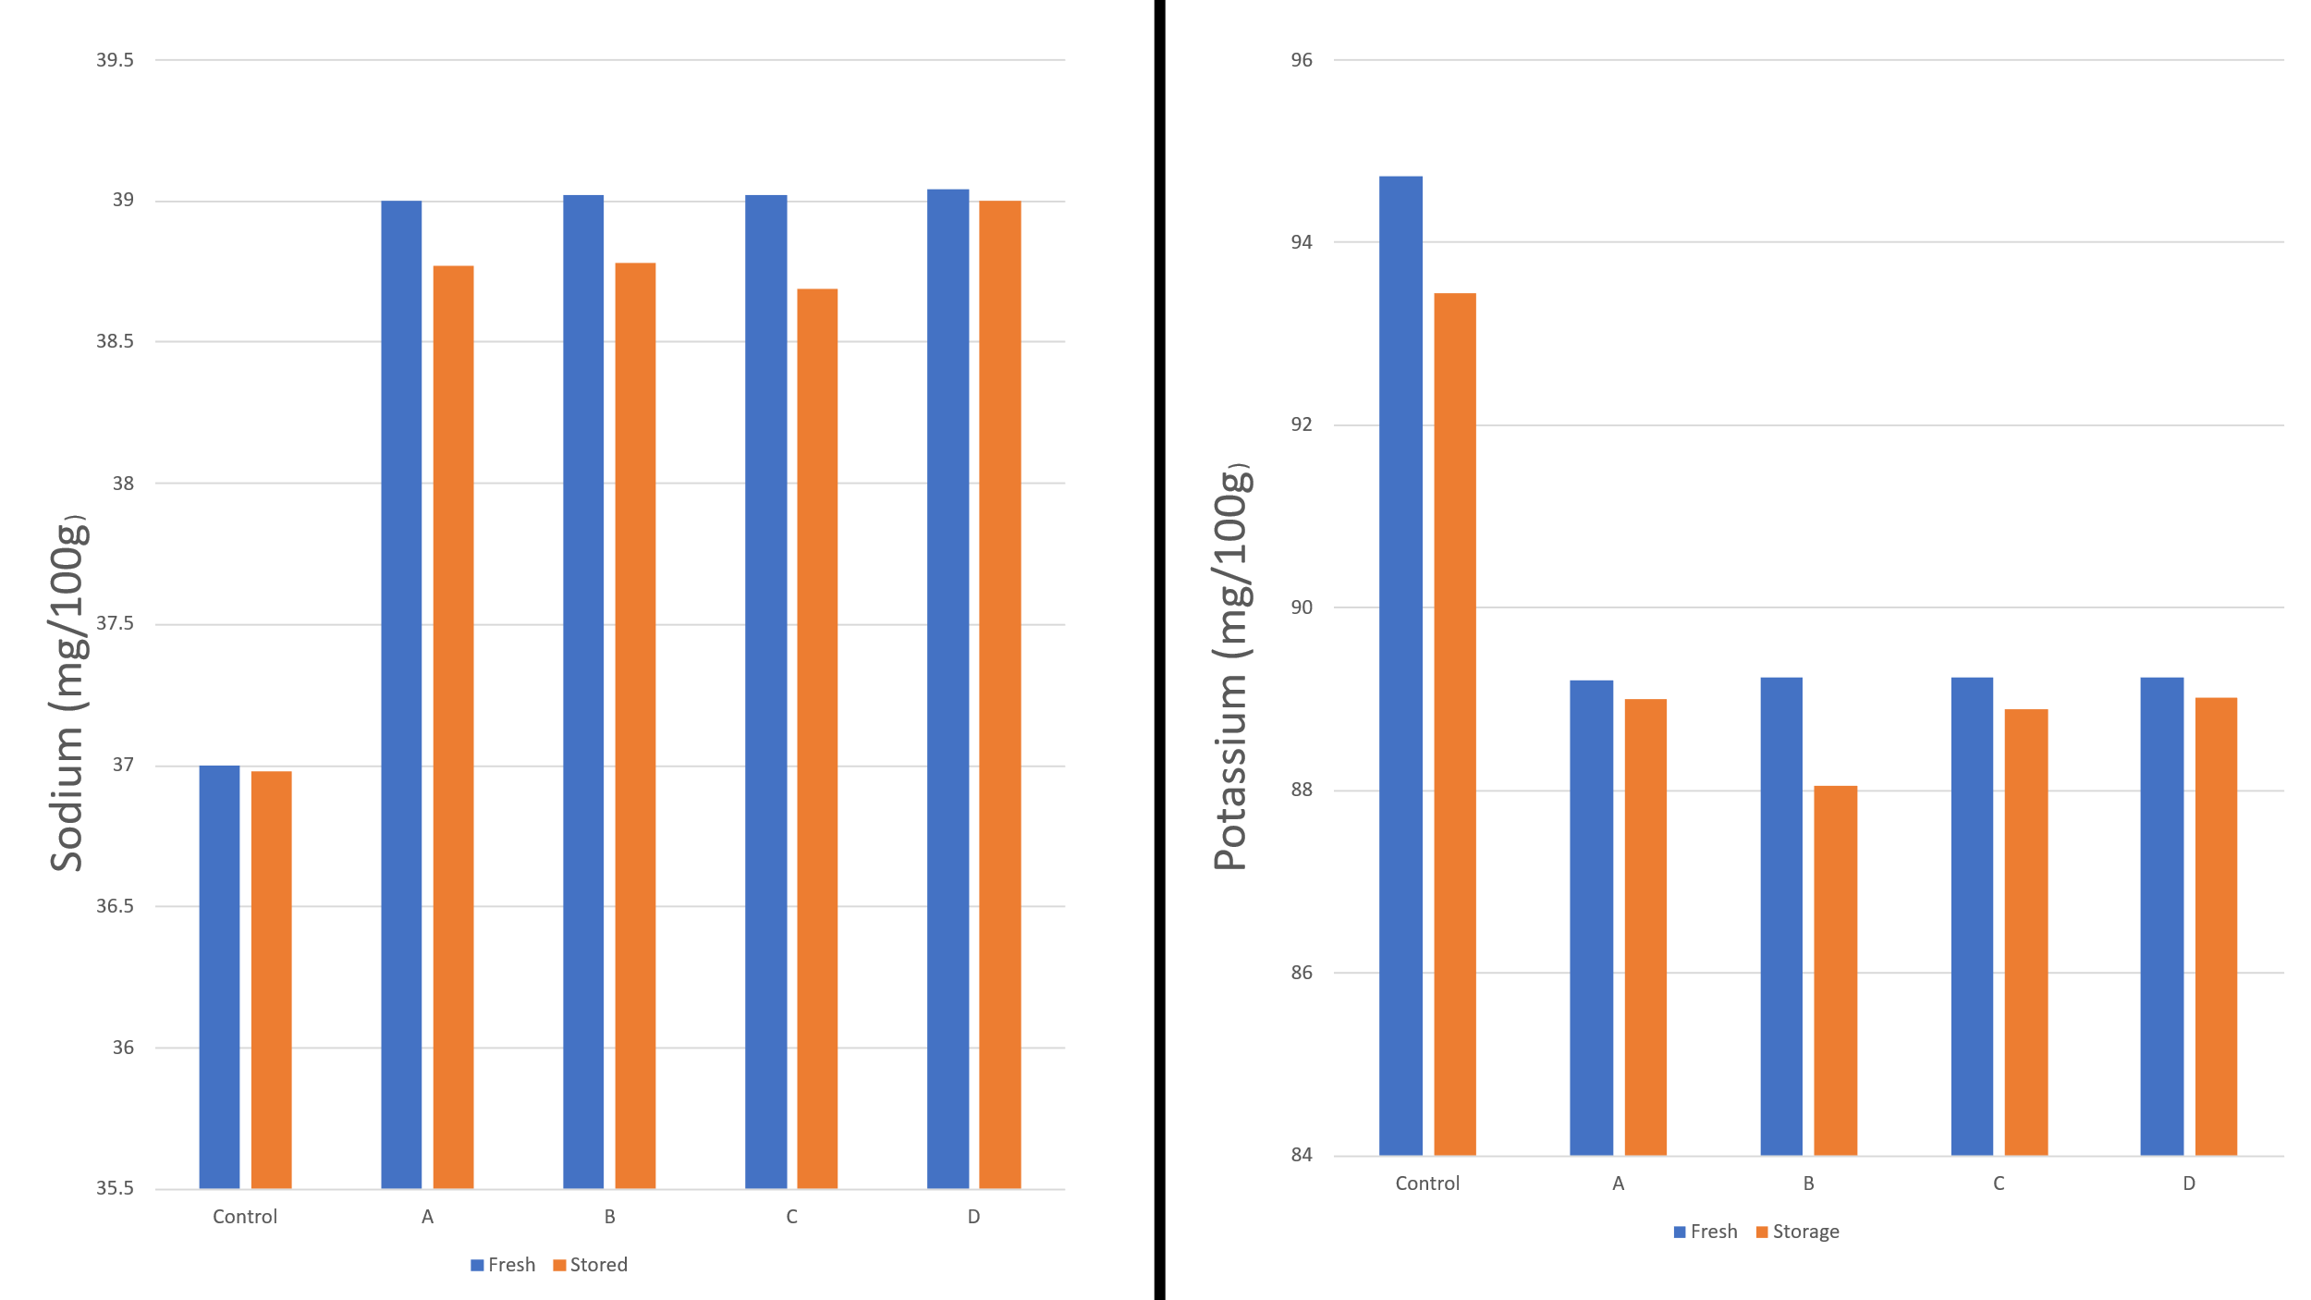
Figure 5: Difference in sodium & potassium content between control and samples both prepared fresh and of stored samples
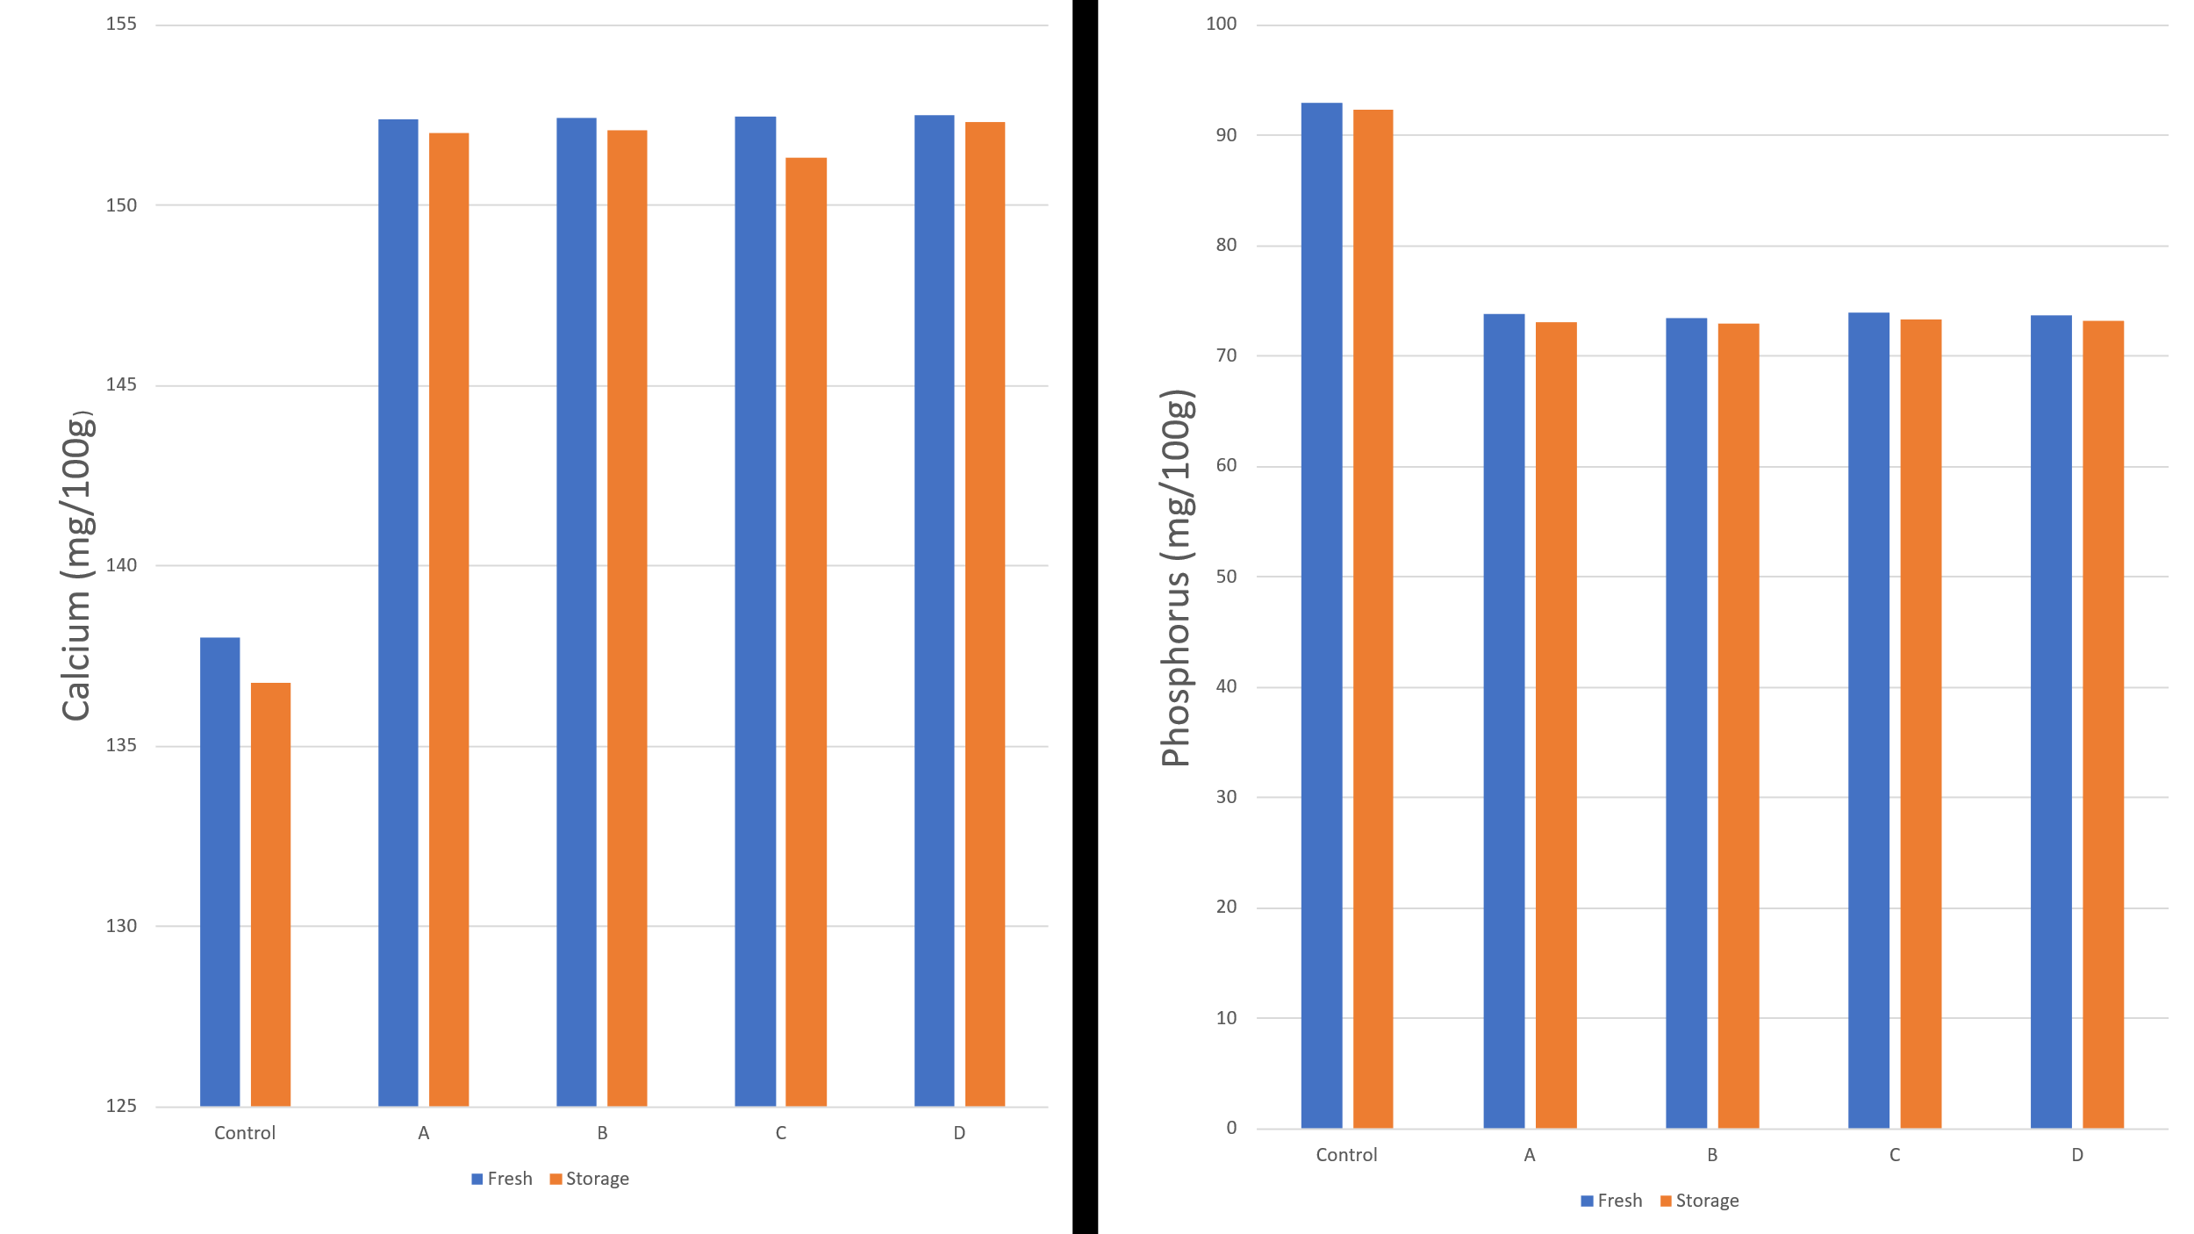
Figure 6: Difference in calcium & phosphorus content between control and samples both prepared fresh and of stored samples

Figure 7: Difference in iron content between control and samples both prepared fresh and of stored samples

3.3 Estimation of physico-chemical properties
Table 5: Estimation of physical analysis of new fortified yoghurt
Sl. No. | Parameters | Control |  | A |  | B |  | C |  | D
Sl. No. | Parameters | Fresh | Storage | Fresh | Storage | Fresh | Storage | Fresh | Storage | Fresh | Storage
1 | pH | 4.38 ±0.11 | 5.57±0.12 | 5.19±0.08 ^{a, c, d, e} | 5.84 ±0.22 ^{a, c, d, e} | 5.45±0.12 ^{a, b, d, e} | 5.79 ±0.28 ^{a, b, d, e} | 5.09±0.04 ^{a, b, c, e} | 5.70 ±0.09 ^{a, b, c, d, e} | 4.93±0.11 ^{a, b, c, d, e} | 5.80±0.10 ^{a, b, c, d}
2 | Acidity (%) | 10.00±0.11 | 8.30±0.22 | 9.10±0.11 ^{a, c, d, e} | 7.67±0.05 ^{a, c, d, e} | 8.21±0.04 ^{a, b, d, e} | 6.30±0.12 ^{a, b, d, e} | 8.00±0.23 ^{a, b, c, e} | 5.60±0.04 ^{a, b, c, e} | 7.62±0.05 ^{a, b, c, d} | 5.61±0.08 ^{a, b, c}  ^{, d}

Values are Mean ±S.D. (n=3)
ª Comparison between Control and Fortified Samples (p<0.05)
^{b} Comparison between A and other samples (p<0.05)
^{c} Comparison between B and other sample (p<0.05)
^{d} Comparison between C and other sample (p<0.05)
^{e} Comparison between D and other sample (p<0.05)
Table 5 presents the physical analysis of pH and acidity in fresh and 15-day stored yogurt samples. The fresh fortified yogurt samples had pH values ranging from 4.93 to 5.45, which were higher than the fresh control yogurt (pH 4.38). This increase can be attributed to the alkaline nature of certain ingredients, particularly snail shell, which neutralizes acidity and elevates pH. After 15 days of storage, the pH values of the fortified yogurt samples increased to a range of 5.57-5.84, similar to the control yogurt, which reached a pH of 5.57.
The acidity of fresh fortified yogurt samples ranged from 7.6 to 9.1, which was lower than the fresh control yogurt (10). After storage, the acidity levels of the fortified yogurt samples decreased to 5.6-7.67, whereas the control yoghurt's acidity decreased to 8.3. Notably, storage led to a reduction in acidity across all yogurt samples, with a more pronounced effect observed in the fortified samples compared to the control. This suggests that the added ingredients may have influenced the yogurt's acidity during storage.
3.4 Estimation of antioxidant activity
Table 6: Estimation of % radical scavenging activity of Fresh & Storage fortified yoghurt
Sample | % Radical Scavenging Activity
Sample | Fresh | Storage
Control | 24.56 ±0.09 | 23.59 ±0.67
A | 43.22 ±1.22 ^{a, c, d, e} | 42.09 ±0.05 ^{a, c, d, e}
B | 43.89 ±1.08 ^{a, b, d, e} | 42.33 ±0.11 ^{a, b, d, e}
C | 43.67 ±0.06 ^{a, b, c, e} | 42.04 ±0.13 ^{a, b, c, e}
D | 44.03 ±0.33 ^{a, b, c, d} | 43.55 ±0.99 ^{a, b, c, d}
Values are Mean ±S.D. (n=3)
ª Comparison between Control and Fortified Samples (p<0.05)
^{b} Comparison between A and other samples (p<0.05)
^{c} Comparison between B and other sample (p<0.05)
^{d} Comparison between C and other sample (p<0.05)
^{e} Comparison between D and other sample (p<0.05)
Table 6 presents the antioxidant activity of fresh and 15-day stored yogurt samples. The fresh fortified yogurt samples exhibited significantly higher antioxidant activity (43.22-44.03%) compared to the fresh control yogurt (24.56%). This enhancement is attributed to the presence of natural ingredients rich in bioactive compounds, including strawberries (vitamin C, anthocyanins, and phenolic compounds), cinnamon and cardamom (essential oils and flavonoids), honey (polyphenols and enzymes), and chia seeds (polyphenols and omega-3 fatty acids). After storage, the antioxidant activity of fortified samples slightly decreased (42.04-43.55%) but remained higher than that of the control yoghurt (23.59%).
3.5 Estimation of total polyphenol activity
Table 7: Estimation of polyphenol activity of fresh & Storage fortified yoghurt
Sample | mg GAE/g
Sample | Fresh | Storage
Control | 0.525 ±0.002 | 0.501 ±0.003
A | 0.600 ±0.001 ^{a, c, d, e} | 0.533 ±0.004 ^{a, c, d, e}
B | 0.704 ±0.006 ^{a, b, d, e} | 0.644 ±0.010 ^{a, b, d, e}
C | 0.736 ±0.012 ^{a, b, c, e} | 0.717 ±0.012 ^{a, b, c, e}
D | 0.774 ±0.040 ^{a, b, c, d} | 0.728 ±0.005 ^{a, b, c, d, e}
Values are Mean±S.D. (n=3)
ª Comparison between Control and Fortified Samples (p<0.05)
^{b} Comparison between A and other samples (p<0.05)
^{c} Comparison between B and other sample (p<0.05)
^{d} Comparison between C and other sample (p<0.05)
^{e} Comparison between D and other sample (p<0.05)
Table 7 shows the polyphenol activity of fresh & Storage fortified yoghurt. The polyphenol activity value of fresh fortified yoghurts varied from 0.600 mg GAE/g to 0.774 mg GAE/g & storage fortified yoghurts varied from 0.533 mg GAE/g to 0.728 mg GAE/g. The fresh and stored control yoghurt sample contains 0.525 mg GAE/g &0.501 mg GAE/g respectively. The polyphenol activity is higher in the fortified yoghurt samples compared to control yoghurt because the added ingredients are naturally rich sources of polyphenolic compounds. Strawberries contribute significantly due to their high content of phenolic acids such as ellagic acid and gallic acid, which are known for their strong polyphenol activity. Cinnamon and cardamom also enhance this effect, as they contain a variety of polyphenols that contribute to the yoghurt's overall antioxidant potential. Honey further adds to the polyphenol activity through its plant-derived phenolic constituents. Chia seeds play an important role as well, as they are naturally rich in polyphenolic acids that are retained even after processing.
3.6 Estimation of flavonoid activity
Table 8: Estimation of flavonoid activity of new fresh & Storage fortified yoghurt
Sample | mg quercitin/g
Sample | Fresh | Storage
Control | 0.09 ±0.001 | 0.09 ±0.002
A | 2.41 ±0.01 ^{a, c, d, e} | 1.11 ±0.06 ^{a, c, d, e}
B | 2.43 ±0.02 ^{a, b, d, e} | 1.13 ±0.01 ^{a, b, e}
C | 2.44 ±0.01 ^{a, b, c, e} | 1.16 ±0.02 ^{a, b,}
D | 2.45 ±0.05 ^{a, b, c, d} | 1.21 ±0.03 ^{a, b, c}
Values are Mean ±S.D. (n=3)
ª Comparison between Control and Fortified Samples (p<0.05)
^{b} Comparison between A and other samples (p<0.05)
^{c} Comparison between B and other sample (p<0.05)
^{d} Comparison between C and other sample (p<0.05)
^{e} Comparison between D and other sample (p<0.05)
Table 8 presents the flavonoid activity of fresh and stored yoghurt samples. The fresh fortified yoghurt samples exhibited flavonoid activity ranging from 2.40 to 2.45 mg quercetin/g, markedly higher than the fresh control yoghurt (0.09 mg quercetin/g). This increase is attributed to the incorporation of ingredients such as strawberry, cinnamon, cardamom, and honey, all of which are naturally rich in flavonoids. Specifically, strawberry contributes anthocyanins and quercetin, cinnamon provides pro-anthocyanidins, cardamom contains kaempferol and quercetin, and honey also supplies flavonoids. After storage, the fortified yoghurt samples showed flavonoid activity ranging from 1.11 to 1.21 mg quercetin/g, while the control yoghurt remained constant at 0.09 mg quercetin/g. Notably, storage resulted in a reduction of flavonoid activity in all fortified samples compared to their fresh counterparts.
3.7 Organoleptic changes
Table 9: Sensory evaluation changes of different samples
Characteristics | Control | A | B | C | D
Color | 6.80 ±0.22 | 8.11 ±0.23 ^{a, c, d, e} | 8.12 ±0.20 ^{a, b, d, e} | 7.90 ±0.08 ^{a, b, c, e} | 8.10 ±0.02 ^{a, b, c, d}
Flavor | 6.90 ±0.03 | 7.50 ±0.22 ^{a, d, e} | 7.48 ±0.99 ^{a, b, d, e} | 7.39 ±0.90 ^{a, b, e} | 7.30 ±0.05 ^{a, b, d}
Taste | 6.81 ±0.09 | 8.19 ±0.10 ^{a, c, d} | 8.15 ±0.04 ^{a, b, d, e} | 8.10 ±0.12 ^{a, b, c, e} | 8.00 ±0.09 ^{a, c, d}
Odor | 6.00 ±0.11 | 7.82 ±0.09 ^{a, c, d, e} | 7.56 ±0.19 ^{a, b, d, e} | 7.89 ±0.19 ^{a, b, c, e} | 7.55 ±0.10 ^{a, b, c, d}
Texture | 6.85±0.10 | 7.09 ±0.11 ^{a, d, e} | 7.23 ±0.03 ^{a, d, e} | 7.16 ±0.05 a^{, b, c, e} | 7.08 ±0.03 ^{a, b, c}
Appearance | 6.21 ±0.08 | 8.54 ±0.19 ^{a, c, d, e} | 8.66 ±0.11 ^{a, b, d, e} | 8.59 ±0.19 ^{a, b, c, e} | 8.44 ±0.03 ^{a, b, c, d, e}
Overall acceptability | 6.05 ±0.02 | 8.63 ±0.06 ^{a, c, d, e} | 8.45 ±0.19 ^{a, b, d, e} | 8.54 ±0.11 ^{a, b, c, e} | 8.44 ±0.11 ^{a, b, c, d}
Values are Mean ±S.D. (n=3)
ª Comparison between Control and Fortified Samples (p<0.05)
^{b} Comparison between A and other samples (p<0.05)
^{c} Comparison between B and other sample (p<0.05)
^{d} Comparison between C and other sample (p<0.05)
^{e} Comparison between D and other sample (p<0.05)
Table 9 shows the organoleptic properties of control and fortified yoghurt. The organoleptic properties of control and fortified yoghurt, evaluated based on color, flavor, taste, odor, texture, appearance, and overall acceptability. The fresh fortified samples recorded scores of 7.9 to 8.12 (color), 7.3 to 7.5 (flavor), 8.0 to 8.19 (taste), 7.55 to 7.89 (odor), 7.08 to 7.23 (texture), 8.66 to 8.44 (appearance), and 8.44 to 8.63 (overall acceptability). In contrast, the control samples showed comparatively lower scores: 6.8 (color), 6.9 (flavor), 6.81 (taste), 6.0 (odor), and 6.05 (overall acceptability). Overall, the fortified yoghurt exhibited superior sensory attributes compared to the control, mainly due to the added ingredients that enhanced flavor, aroma, texture, and visual appeal. The yoghurt fortified with strawberries provides a wide spectrum of bioactive compounds that influence texture and flavour. The natural sweetness and vibrant colour of strawberries make the yoghurt more visually attractive and palatable [Supriyanti et al.,2022]. It can maintain the desirable sensory qualities to protect from lipid oxidation and extend the shelf life during storage. The incorporation of fruits such as strawberries into the yoghurt acts as an excellent source of therapeutic agents, natural antioxidants, and also increases the organoleptic properties [Priyashantha et al.,2025]. Including cinnamon and cardamom contributes warm, pleasant aromas and a mild spiced flavor that enriches the overall sensory experience [Guldane et al.,2025; Ismael et al.,2024]. Honey adds a smooth sweetness that balances the tartness of the yoghurt, creating not only an enjoyable taste profile [Suharto et al.,2024] but also enhances consumer acceptance more than the control (plain) yoghurt [Mohan et al.,2020]. Chia seeds added in a moderate amount improved the texture by introducing a slight crunch or gel-like consistency that adds interest to the mouthfeel [ Nakov et al.,2024] and influences the nutritive value, increasing consumer preference [Ribes et al.,2021]. The addition of snail shell, rich in minerals, may subtly enhance the texture and perceived richness of yogurt without affecting its flavor or aroma. In contrast, plain yogurt has a more acidic and uniform taste profile. The incorporation of natural additives with distinct flavors and aromas creates a more complex and appealing product, increasing overall acceptability and boosting the mineral profile. This results in a more dynamic and nutritious yogurt product.
3.8 Microbial Load Data
The microbiological analysis of the fortified yoghurt (Sample A) assessed its safety, quality, and shelf life by evaluating the total viable count and bacterial colony distribution, with results presented in Table 10 and Figure 8. The addition of chia seeds exhibits a protective effect by inhibiting the growth of harmful microorganisms, such as Enterobacteria, yeasts, and molds, coagulase-positive staphylococci, Salmonella, and Listeria monocytogenes. Furthermore, chia seeds help maintain high counts of lactic acid bacteria (LAB) above 10⁷ CFU/g even after 21 days of storage, ensuring a stable and safe product. [Nakov et al.,2024]. Research suggests that yogurt fortified with ingredients like chia seeds, honey, and spices, such as cinnamon and cardamom, offers probiotic and therapeutic benefits during refrigerated storage. Chia seeds, in particular, are nutrient-dense, providing fiber, protein, and omega-3 fatty acids. When added to yogurt, they create a filling snack or breakfast, boosting the fiber and protein content. This combination supports weight loss efforts and provides a nutritious start to the day A study by Karnal et al. found that yogurt prepared with calcium-rich eggshell powder exhibited a similar microbial load, indicating potential benefits. [kamal et al.,2021].
Table 10: Estimation of Microbial load of fresh fortified yoghurt
Sample A | Microbial count (CFU/ml)
10⁻³ | 505
10⁻⁴ | 152
10⁻⁵ | 42

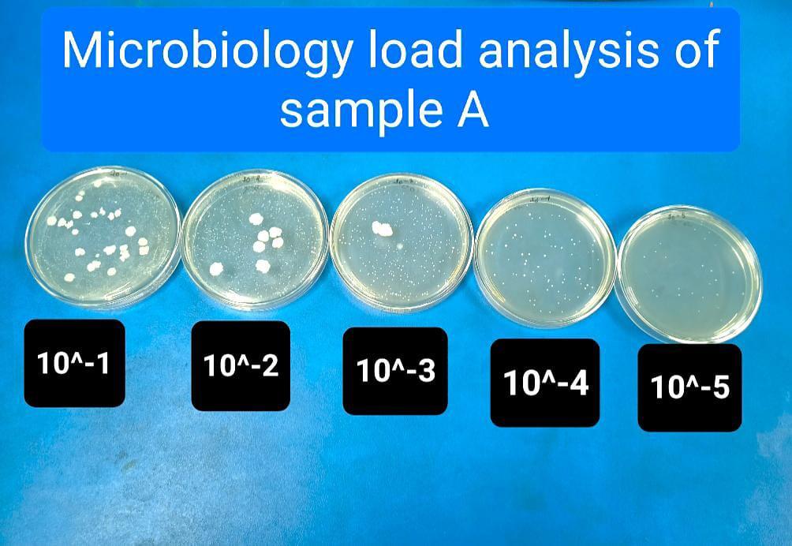
Figure 8: Microbial load data of Sample A
4. CONCLUSION
The fortified yogurt, enriched with strawberries, cinnamon, cardamom, honey, and snail shell powder, exhibited superior nutritional and health-promoting properties compared to plain yogurt. Notably, each of experiment (like – proximate, mineral content, physio-chemical, antioxidant, polyphenol, flavonoid activity) the fresh stage of the control &fortified yogurt showed better values than the 15-day storage stage. The synergistic effects of these ingredients provided enhanced antioxidant, anti-inflammatory, and antimicrobial properties which can help prevent chronic diseases like cardiovascular disorders, diabetes, and certain cancers [Almeer et al., 2021; Ranasinghe et al.,2012; Majdalawieh et al.,2010; Rompas et al.,2023]. Additionally, it supported immune function [Battino et al.,2021], bone health [Suandork et al.,2024], and heart health [Ahmed et al., 2022], making it a valuable health-promoting food option for overall well-being.
COMPETING INTEREST
Authors have declared that they have no known competing financial interests OR non-financial interests OR personal relationships that could have appeared to influence the work reported in this paper.
Author(s) hereby declare that NO generative AI technologies such as Large Language Models (ChatGPT, COPILOT, etc.) and text-to-image generators have been used during the writing or editing of this manuscript.

Reference
- Ahmed, H. Y., Safwat, N., Shehata, R., Althubaiti, E. H., Kareem, S., Atef, A., Qari, S. H., Aljahani, A. H., Al-Meshal, A. S., Youssef, M., & Sami, R. (2022). Synthesis of natural nano-hydroxyapatite from snail shells and its biological activity: Antimicrobial, antibiofilm, and biocompatibility. Membranes, 12(4), 408. https://doi.org/10.3390/membranes12040408.
- Al-Kadamany, E., Khattar, M., Haddad, T., & Toufeili, I. (2001). Estimation of shelf-life of concentrated yogurt by monitoring selected microbiological and physicochemical changes during storage. Leben-Wiss U-Technol, 36, 407–414.
- Aliyyu, W. C., Riva, F. A., Anabel, S. M. P., Dwiandhono, I., Satrio, R., & Sari, D. N. I. (2024). Nano-hydroxyapatite toothpaste of rice field snail shell combined with basil leaf extract as a remineralizing and antibacterial agent to prevent dental caries. Journal of Clinical and Experimental Dentistry, 16(11), e1323–e1331. https://doi.org/10.4317/jced.62073.
- Almeer, R. S., Alnasser, M., Aljarba, N., & AlBasher, G. I. (2021). Effects of Green cardamom (Elettaria cardamomum Maton) and its combination with cyclophosphamide on Ehrlich solid tumors. BMC Complementary Medicine and Therapies, 21(1), 133. https://doi.org/10.1186/s12906-021-03305-2.
- Alvarez-Suarez, J. M., Giampieri, F., & Battino, M. (2010). Honey as a source of dietary antioxidants: Structures, bioavailability, and evidence of protective effects against human chronic diseases. Current Medicinal Chemistry, 17(31), 3898–3913.
- Ayerza, R., & Coates, W. (2005). Chia: Rediscovering a forgotten crop of the Aztecs. University of Arizona Press.
- Battino, M., Giampieri, F., Cianciosi, D., Ansary, J., Chen, X., Zhang, D., Gil, E., & Forbes-Hernández, T. (2021). The roles of strawberry and honey phytochemicals on human health: A possible clue on the molecular mechanisms involved in the prevention of oxidative stress and inflammation. Phytomedicine, 86, 153170. https://doi.org/10.1016/j.phymed.2020.153170.
- Basu, A., Rhone, M., & Lyons, T. J. (2010). Berries: Emerging impact on cardiovascular health. Nutrition Reviews, 68(3), 168–177.
- Coskun, F., & Dirican, L. K. (2019). Effects of pine honey on the physicochemical, microbiological and sensory properties of probiotic yoghurt. International Journal of Agriculture and Natural Sciences, 24(2). DOI: intang/10.1500/24018

- Edirisinghe, I., Banaszewski, K., & Cappozzo, J. (2011). Strawberry anthocyanin and its effect on postprandial inflammation and insulin response. British Journal of Nutrition, 106(6), 913–922.
- Elliot, T. A., Cree, M. G., & Sanford, A. P. (2006). Milk ingestion stimulates net muscle protein synthesis following resistance exercise. American Journal of Clinical Nutrition, 83(4), 1033–1040.
- Elwood, P. C., Pickering, J. E., & Fehily, A. M. (2004). Milk drinking, ischaemic heart disease and ischaemic stroke II: Evidence from cohort studies. European Journal of Clinical Nutrition, 58(5), 718–724.
- Erlund, I., Koli, R., & Alfthan, G. (2008). Favorable effects of berry consumption on platelet function, blood pressure, and HDL cholesterol. The American Journal of Clinical Nutrition, 87(2), 323–331.
- Fadhilah, D., Santoso, P., & Maliza, R. (2024). Utilisation of snails for wound healing: A review. Journal of Tropical Biodiversity and Biotechnology, 9(3), 90236. https://doi.org/10.22146/jtbb.90236.
- Güldane, M. (2025). Effect of enrichment with spice extracts on yoghurt quality: Optimizing the extraction process and sensory properties. Food Measurement, 19, 4354-4367. https://doi.org/10.1007/s11694-025-03257-y.
- Illupapalayam, V. V., Smith, S. C., & Gamlath, S. (2013). Consumer acceptability and antioxidant potential of probiotic-yogurt with spices. LWT – Food Science and Technology, 55(2), 255–262.
- Ismael, F. N., Alameri, Z. H. A., Kadhim, A. A., Hussein, A. A., Mahdi, S. A. A. W., Awda, J. M., & Hadi, S. T. (2024). Improving the sensory and chemical characteristics of functional yogurt fortified with cardamom extract (Elettaria cardamomum L.). Functional Foods in Health and Disease, 14(10), 676-687. https://doi.org/10.31989/ffhd.v14i10.1454.
- Kamel, B. S., Alzahrani, H. A., & Zayan, A. F. (2021). Development of yogurt fortified with eggshell-derived calcium nanopowder: Physicochemical, microbiological and sensory evaluation. Journal of Food Processing and Preservation, 45(12), e16057. https://doi.org/10.1111/jfpp.16057.
- Khan, A., Safdar, M., & Khan, A. (2003). Cinnamon improves glucose and lipids of people with type 2 diabetes. Diabetes Care, 26(12), 3215–3218.
- Kowaleski, J., Quast, L. B., Steffens, J., Lovato, F., dos Santos, L. R., da Silva, S. Z., de Souza, D. M., & Felicetti, M. A. (2020). Functional yogurt with strawberries and chia seeds. Food Bioscience, 36, 100726.
- Krikorian, R., Shidler, M. D., & Nash, T. A. (2010). Blueberry supplementation improves memory in older adults. Journal of Agricultural and Food Chemistry, 58(7), 3996–4000.
- Majdalawieh, A. F., & Carr, R. I. (2010). In vitro investigation of the potential immunomodulatory and anti-cancer activities of black pepper and cardamom. Journal of Medicinal Food, 13(2), 371–381.
- Marteau, P., Minekus, M., & Havenaar, R. (2001). Survival of lactic acid bacteria in a dynamic model of the stomach and small intestine. International Journal of Food Microbiology, 70(1–2), 189–202.
- Mohan, A., Hadi, J., Gutierrez-Maddox, N., Li, Y., Leung, I. K., Gao, Y., ... & Quek, S. Y. (2020). Sensory, microbiological and physicochemical characterisation of functional manuka honey yogurts containing probiotic Lactobacillus reuteri DPC16. Foods, 9(1), 106.
- Nag, M., & Shahi, S. (2023). Medicinal uses of Foeniculum vulgare Mill and small cardamom: A review. Journal of Advanced Zoology, 44(S-3), 1347–1352. https://doi.org/10.17762/jaz.v44iS-3.1645.
- Nakov, G., Ninova-Nikolova, N., Ivanova, N., Raykova, V., Trajkovska, B., Lučan Čolić, M., Lukinac, J., & Jukić, M. (2024). Yogurt enriched with chia seeds: Physicochemical, microbiological, and sensory changes during storage. Fermentation, 10(8), 431. https://doi.org/10.3390/fermentation10080431.
- Nematollahi, Z., Ebrahimi, M., Raeisi, M., Dadban Shahamat, Y., Ghodsi Moghadam, M., Hashemi, M., Shabani, S., & Shirzad, H. (2020). The antibacterial activity of cinnamon essential oil against foodborne bacteria: A mini-review. Journal of Health Education and Health Promotion, 6(3), 1. https://doi.org/10.29252/jhehp.6.3.1.
- Nguyen, T. H. N., Vo, D. L., & Fujita, T. (2023). A critical review of snail shell material modification for applications in wastewater treatment. Materials, 16(3), 1095. https://doi.org/10.3390/ma16031095.
- Niba, A. T., Unji, O. S., Tuncha, N. P., & Takwe, H. (2022). Effect of calcium source in supplemental diets on the growth performance and carcass characteristics of the Giant African Land Snails (Archachatina marginata) in the Western Highlands of Cameroon. Open Journal of Animal Sciences, 12, 537–545. https://www.scirp.org/journal/ojas.
- Nieman, D. C., Gillitt, N. D., & Jin, F. (2009). Chia seed supplementation and disease risk factors in overweight women: A metabolomics investigation. Journal of Alternative and Complementary Medicine, 15(7), 700–708.
- Ordu, J. I., & Aguma, I. F. (2024). Evaluation of formulated herbal toothpaste containing Aloe vera gel and extracted calcium carbonate from the shell of Buccinum undatum (whelk snail). International Journal of Research and Scientific Innovation, 11(3), 1–14. https://doi.org/10.51244/IJRSI.2024.1103001.
- Priyashantha, H., Madushan, R., Pelpolage, S. W., Wijesekara, A., & Jayarathna, S. (2025). Incorporation of fruits or fruit pulp into yoghurts: Recent developments, challenges, and opportunities. Frontiers in Food Science and Technology, 5, 1581877. https://doi.org/10.3389/frfst.2025.1581877.
- Potortì, A. G., Messina, L., Licata, P., Gugliandolo, E., Santini, A., & Di Bella, G. (2024). Snail shell waste threat to sustainability and circular economy: Novel application in food industries. Sustainability, 16(2), 706. https://doi.org/10.3390/su16020706.
- Qin, B., Panickar, K. S., & Anderson, R. A. (2010). Cinnamon: Potential role in the prevention of insulin resistance, metabolic syndrome, and type 2 diabetes. Journal of Diabetes Science and Technology, 4(3), 685–693.
- Ranasinghe, P., Jayawardana, R., Galappaththy, P., Constantine, G. R., de Vas Gunawardana, N., & Katulanda, P. (2012). Efficacy and safety of “true” cinnamon (Cinnamomum zeylanicum) as a pharmaceutical agent in diabetes: A systematic review and meta-analysis. Diabetic Medicine, 29(12), 1480-1492. https://doi.org/10.1111/j.1464-5491.2012.03718.x.
- Ranasinghe, P., Pigera, S., & Premakumar, G. A. S. (2013). Medicinal properties of ‘true’ cinnamon (Cinnamomum zeylanicum): A systematic review. BMC Complementary and Alternative Medicine, 13, 275.
- Ravindran, Babu, P. N., & Shylaja, M. (2004). Cardamom: The genus Elettaria. CRC Press.
- Ribes, S., Fuentes, A., & Barat, J. M. (2021). Chia (Salvia hispanica L.) mucilage as a fat replacer in yogurt: Effects on physicochemical, rheological, and sensory properties. LWT - Food Science and Technology, 146, 111427. https://doi.org/10.1016/j.lwt.2021.111427.
- Roberfroid, M., Gibson, G. R., & Hoyles, L. (2010). Prebiotic effects: Metabolic and health benefits. British Journal of Nutrition, 104(S2), S1–S63.
- Rompas, J. J. I., Laatung, S., Gunawan, W. B., Widayanti, I. S., Yusuf, V. M., Yusuf, T. W., Salindeho, N., Samtiya, M., & Nurkolis, F. (2023). Rice field snail shell anticancer properties: An exploration opinion. Frontiers in Oncology, 13(1).
- Sankaranarayanan, J., Lee, S. C., Kim, H. K., Kang, J. Y., Kuppa, S. S., & Seon, J. K. (2024). Cinnamaldehyde-Mediated Suppression of MMP-13, COX-2, and IL-6 Through MAPK and NF-κB Signaling Inhibition in Chondrocytes and Synoviocytes Under Inflammatory Conditions. International Journal of Molecular Sciences, 25(23), 12914. https://doi.org/10.3390/ijms252312914.
- Seeram, N. P., Adams, L. S., & Zhang, Y. (2006). Blackberry, black raspberry, blueberry, cranberry, red raspberry, and strawberry extracts inhibit growth and stimulate apoptosis of human cancer cells in vitro. Journal of Agricultural and Food Chemistry, 54(25), 9329–9339.
- Sehgal, S. (2016). A laboratory manual of food analysis. Department of Food Technology, Bhaskaracharya College of Applied Science, University of Delhi. I.K. International Publishing House Pvt. Ltd.
- Suandork, P., & Hongsuwong, M. (2024). Synthesis of biocompatible hydroxyapatite from quail eggshell, oyster shell, and periwinkle snail shell. Journal of Applied Research Science and Technology, 23(3), 257693. https://ph01.tci-thaijo.org/index.php/rmutt-journal/article/view/257693.
- Suharto, E. L., & Ferawati. (2024). Exploration of consumer preferences: Sensory evaluation of synbiotic yoghurt with honey. Andalasian Livestock, 1(2), 144–149. https://doi.org/10.25077/alive.v1.n2.p144-149.2024.
- Supriyanti, F. M. T., Roslina, D., Zackiyah, Z., & Hanifa, I. (2022). Strawberry-fortified yogurt: Production, sensory, antioxidant activity test, and model for practicum. Indonesian Journal of Science and Technology, 7(3), 551–564. https://doi.org/10.17509/ijost.v7i3.51520.
- Tran, H. N. H., Graham, L., & Adukwu, E. C. (2020). In vitro antifungal activity of Cinnamomum zeylanicum bark and leaf essential oils against Candida albicans and Candida auris. Applied Microbiology and Biotechnology, 104(20), 8911–8924. https://doi.org/10.1007/s00253-020-10829-z.
- Ullah, R., Nadeem, M., & Khalique, A. (2016). Nutritional and therapeutic perspectives of chia (Salvia hispanica L.): A review. Journal of Food Science and Technology, 53(4), 1750–1758.

- Verma, S. K., Jain, V., & Singh, D. P. (2012). Effect of Greater cardamom (Amomum subulatum Roxb.) on blood lipids, fibrinolysis and total antioxidant status in patients with ischemic heart disease. Asian Pacific Journal of Tropical Disease, 2(1), Article S2222-1808(12)60255-2. https://doi.org/10.1016/S2222-1808(12)60255-2.
- Weaver, C. M., Gordon, C. M., Janz, K. F., et al. (2016). The National Osteoporosis Foundation’s position on peak bone mass development and lifestyle factors: A systematic review and implementation recommendations. Osteoporosis International, 27(4), 1281–1386.
- Xiao, D., Huang, L., Edirisinghe, I., & Burton-Freeman, B. (2019). Effect of strawberry intake for 4 weeks on vascular endothelial function and blood pressure in adults with moderate hypercholesterolemia (P06-128-19). Current Developments in Nutrition, 3(Suppl 1), nzz031.P06-128-19. https://doi.org/10.1093/cdn/nzz031.P06-128-19.
- Yaghoobi, N., Al-Waili, N., & Ghayour-Mobarhan, M. (2008). Natural honey and cardiovascular risk factors: Effects on blood glucose, cholesterol, and body weight. Journal of Medicinal Food, 11(2), 300–303.

