Ethnopharmacological study of plants used against malaria by traditional healers in the district of Dikodougou, North Côte d'Ivoire

Abstract
Traditional medicine (TM) has been a cornerstone of healthcare in many cultures, particularly in Africa. TM has played an integral role in managing diseases such as malaria. In Côte d'Ivoire, limited access to medical facilities brought indigenous communities to use on herbal medicine to prevent and manage malaria. As part of the effort to discover new bioactive molecules from plants, a study was conducted on medicinal plants used to treat malaria in the Dikodougou district. The survey was based on questionnaires and interviews with fifteen traditional practitioners who had knowledge of antimalarial medicinal plants. A total of 24 species of medicinal plants were identified. The most representatives plants families were Fabaceae, Asteraceae, Rubiaceae, Meliaceae, and Phyllanthaceae. Cassia sieberiana DC (Fabaceae) was much more species cited, at 35.29%. Pericopsis laxiflora (Benth. ex Baker) Meeuwen (Fabaceae) followed with 23.53%, followed by Sarcocephalus latifolius Sin (Rubiaceae), Tamarindus indica L (Fabaceae), and Flueggea virosa (Roxb. ex Willd.) Royle (Phyllanthaceae). The parts of plants frequently used by traditional healers were leaves (51.11%), followed by roots (28.89%) and seeds (11.11%). The most preparation methods used by traditional healers was decoction (50%) and maceration (40%). Evaluating the antimalarial properties of the most commonly cited species would validate the knowledge and practices of traditional practitioners in the Dikodougou district.

Keywords : Medicinal plants; malaria; traditional healers; Dikodougou; Côte d'Ivoire.

- INTRODUCTION
Malaria remains a major public health concern due to its association with high rates of morbidity and mortality [1]. Medicinal plants have been used for centuries in traditional medicine to treat this disease. These plants are promising, sustainable alternative to synthetic drugs, especially given persistent treatment resistance and limited access to modern care [2]. The development of new drugs could be enhanced by using African medicinal plants with antimalarial properties, as highlighted by recent studies. [3, 4, 5, 6]. These plants have been used in traditional African medicine for long time so far [6, 7, 8, 9]. They are an important natural source of biomolecules that are likely to have a wide variety of pharmacological properties. These properties could cure or treat numerous human pathologies, including malaria. Over the past few decades, a significant number of studies have been conducted in Côte d'Ivoire, with a predominant focus on ethnobotanical surveys of medicinal plants. These studies have been carried out by researchers such as Rasmane et al, Koffi et al, Kipré et al, Sylla et al, Bla et al, N'Guessan, Zirihi and Koné [10, 11, 12, 13, 14, 15, 16, 17]. In Côte d'Ivoire, from 80% to 91% of the population relies on traditional medicine for primary health care [18, 19]. Medicinal plants are a valuable part of Africa's cultural heritage. Over time, they have proven effective in treating various diseases and continue to be a significant source for developing many modern medicines [10]. However, many of these plant studies have not been followed up on. Among the plants used to treat malaria in Côte d'Ivoire, some could be developed into effective malaria treatments [20]. This is evident with quinine and artemisinin, which are molecules derived from traditional medicine [21].
As part of the search for new natural molecules with anti-plasmodial effects to fight against malaria parasites, this study employs an ethnobotanical approach. The study was conducted in the Dikodougou health district to identify locally used plants for treating malaria. This is an area where malaria infections are associated with age and the rainy season [22].

2. MATERIALS AND METHODS
2.1. Location
It is located in the Poro, region of the Savanes district in the north of Côte d'Ivoire. According to the 2021 General Census of Population and Housing, Dikodougou has a population of 102,115 inhabitants and a surface area approximately 2,472 km², resulting in an average density of 30 inhabitants per km² [18]. It is bordered by the Niakaramandougou department to the southeast, Mankono to the south, and the Korhogo department to the north and west. The population of Dikodougou consists of native Sénoufo (Koufoulo and Fodonon) and non-native people from various regions of Côte d'Ivoire, including the Malinké, Akan, and Wê. There are also non-native people from ECOWAS countries.
2.2. Collection method
The survey was conducted among fifteen traditional practitioners who had knowledge of antimalarial medicinal plants. The survey was conducted in 2021. The traditional healers were asked to complete a questionnaire including information on their profile (age, sex, ethnicity, level of education, profession, and marital status). Regarding the plant, the survey focused on which organs were used, how they were prepared, and their therapeutic and culinary uses.
2.3. Herbarium identification
Plant identification was carried out at the Centre National de Floristique (CNF) of the Université Félix Houphouët-Boigny in Abidjan-Cocody. The APG IV (2016) nomenclature was used to update the names of plant species.
2.4. Calculation of Citation Frequency
The citation frequency for each of the plants surveyed was obtained using the formula described by Gbekley et al [19] and Orsot [23].
The Citation Frequency (CF) of a species = (number of citations of the species/total number of citations of all species) x (100).

FC= 𝑛/𝑁 𝑥 100

FC: Frequency of quotation; n: number of people who quoted the species; N: total number of people surveyed

2.5. Data analysis
The data collected was statistically analyzed and processed using EXCEL and GraphPad-Prism version 8.0.1 (GraphPad Software, Inc.).
3.RESULTS
The survey was conducted with 15 traditional healers, most of whom were male. A total of 24 species, belonging to 14 families and two genera, were recorded. Figure 1 shows that the most represented families were Fabaceae, Asteraceae, Rubiaceae, Meliaceae, and Phyllanthaceae. The most cited species was Cassia sieberiana DC. (Fabaceae), at 35.29%. Following it were Pericopsis laxiflora (Benth. ex Baker) Meeuwen (Fabaceae), Sarcocephalus latifolius (Rubiaceae), Tamarindus indica (Fabaceae), and Flueggea virosa (Phyllanthaceae), with 23.53% (Table I).

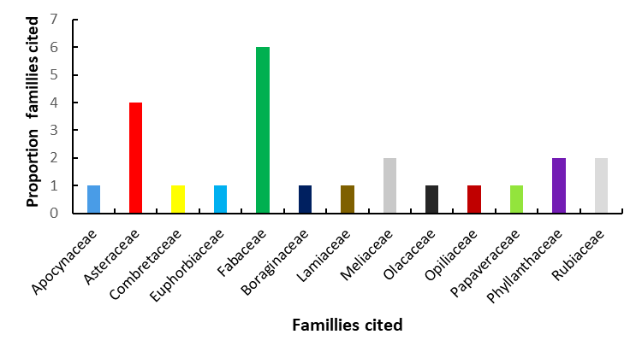
Figure 1 : Famillies cited

Table I: Antimalarial plants used by Dikodougou traditional healers
 | Taxa | Famillies | Vernacular names | Number  of  citation | Fréquency of citation | N°d’herbier
1 | Vitex madiensis oliv | Lamiaceae | Gnahamm | 3 | 17,64 | UCJ017513
2 | Senna occidentalis Link | Fabaceae | Badjangue | 1 | 5,88 | UCJ009170
3 | Sarcocephalus latifolius (Sm.) E.A.Bruce | Rubiaceae | Sehoundôlôgue ; N’zahom ; Zanvelem | 4 | 23,53 | UCJ015407
4 | Calotropis procera W. T. Aiton | Apocynaceae | Gnonpidjiha | 1 | 5,88 | UCJ002511
5 | Trichilia emetica | Sapindaceae | Korokoum | 2 | 11,76 | UCJ012332
6 | Senna allata (L) Roxb | Fabaceae | Lôhôpkanithonlom | 3 | 17,64 | UCJ009126
7 | Cassia sieberian DC | Fabaceae | Pongoule | 6 | 35,29 | UJC009184
8 | Vernonia amygdalena Delile | Acteraceae | Gnamsoro | 2 | 11,76 | UCJ003893
9 | Pseudocedrela kotschyi (Schweinf.) | Meliaceae | Soheome | 2 | 11,76 | UCJ012320
10 | Olax subscorpioides Oliv. | Olacaceae | Sissesgnonrigui | 2 | 11,76 | UCJ013253
11 | Pericopsis laxiflora (Benth.ex-Baker) Meeuwen | Fabaceae | Djim | 4 | 23,53 | UCJ009931
12 | Gymnanthemum amygdalinum (Delile) Sch.Bip. ex Walp. | Asteraceae |  | 1 | 5,88 | UCJ003893
13 | Flueggea virosa (Roxb. ex Willd.)Royle | Phyllanthaceae | Gramadienne Môgôcolo-calaman (Dioula); mokokoana, mokrodoma (Malinké) | 4 | 23,53 | UCJ006375
14 | Anthostema senegalense A.Juss. | Euphorbiaceae | Lôhôphanam | 2 | 11,76 | UCJ005739
15 | Acanthospermum hispidum DC. | Asteraceae | Nibon | 3 | 17,64 | UCJ003383
16 | Combretum molle R.Br. ex G.Don | Combretaceae | Mahadjam | 1 | 5,88 | UCJ002995
17 | Aspilia bussei O.Hoffm & Muschl. | Asteraceae |  | 1 | 5,88 | UCJ003451
18 | Entada mannii (Oliv.) Tisser. | Fabaceae | Zananairai | 2 | 11,76 | UCJ009707
19 | Heliotropium indicum L. | Heliotropiaceae | Gernangue | 1 | 5,88 | UCJ001745
20 | Tamarindus indica L. | Fabaceae | Machinhan | 4 | 23,53 | UCJ009522
21 | Argemone mexicana L. | Papaveraceae | Winibgêni | 2 | 11,76 | UCJ014170
22 | Phyllanthus amarus Schumach. & Thonn. | Phyllanthaceae | Samanwarni | 3 | 17,64 | UCJ006242
23 | Opilia amentacea Roxb. | Opiliaceae | Mougouleouleou | 2 | 11,76 | UCJ013379
24 | Morinda lucida Benth | Rubiaceae | Chongolime | 2 | 11,76 | CSRS005805

3.1.Ethnobotanical characteristics
Parts of plants used
The survey revealed that Dikodougou traditional healers most frequently used leave (51.11%), followed by root (28.89%) and seed (11.11%) (Figure 2).

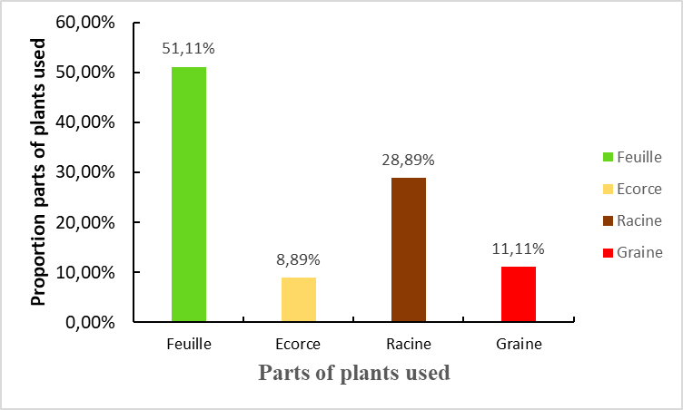

Figure 2 : Parts of plants used

3.2. Plants preparation methods
The figure 3 shows that a decoction (50%) is the most commonly used preparation method among traditional therapists, followed by maceration (40%).

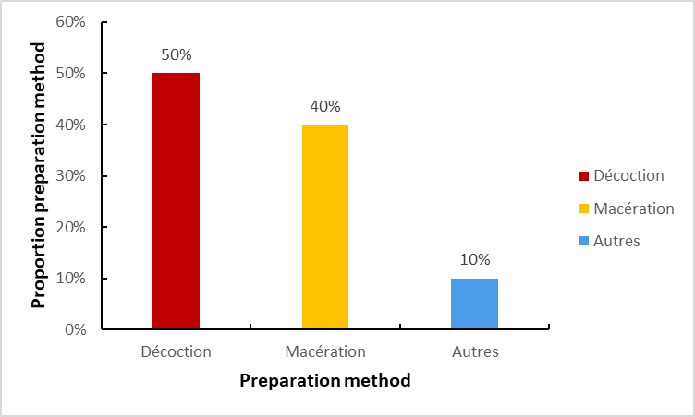
Figure 3 : Plants preparation methods

3.3. Method of administration
These recipes were consumed orally in the form of a drink (52.94%). In some cases, patients were asked to purge (Figure 4).

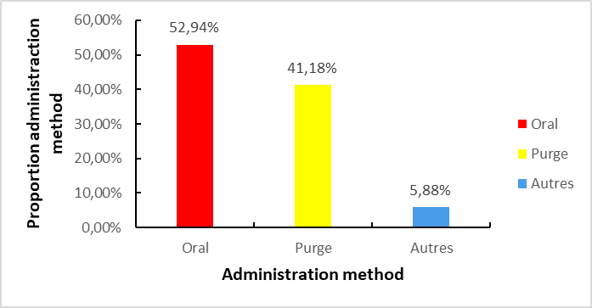
Figure 4 : Administraction method

4. DISCUSSION
This study aimed to identify the antimalarial plants used by traditional healers in the Dikodougou department. Fifteen traditional healers participated in the study, all of whom were men. According to Gbekley et al. [19], knowledge of traditional medicine recipes is, first and foremost, a family secret passed down through custom and oral tradition from generation to generation. In some cultures, men are the guardians of tradition and bearers of knowledge, particularly in traditional medicine. This was the case for our respondents. Studies by Doumongue et al. [24] have shown that men represent 88% of the workforce, while women account for only 12%.
Analysis of data from an ethnobotanical survey of local populations revealed that the Fabaceae family is the most commonly cited for therapeutic uses. This predominance is not surprising, as it has been widely documented in numerous ethnobotanical studies in West Africa and globally in tropical regions [25, 26]. The Fabaceae family is characterized by its morphological diversity, including trees, shrubs, and herbaceous plants. This structural diversity makes them accessible and useful in a variety of contexts, including medicinal, culinary, and forage applications, as well as for improving soil fertility through biological nitrogen fixation. Fabaceae have a wide range of recognized pharmacological properties, including anti-inflammatory, antimicrobial, antiparasitic, antidiabetic, and wound-healing activities [27]. Certain species, such as Cassia sieberiana, Pterocarpus erinaceus, and Albizia lebbeck, are highly valued for their medicinal properties. The abundance of these leaves is widely reported in ethnobotanical literature from West Africa and other tropical regions [28, 10, 29]. There are several reasons for this preference. Leaves are easily accessible organs that are generally harvested without felling or destroying the plant. This harvesting method favors durability in their use [30]. They also contain numerous bioactive secondary metabolites, including alkaloids, flavonoids, tannins, terpenes, and saponins. These metabolites are recognized for their antimicrobial, anti-inflammatory, antimalarial, and antioxidant properties [31]. Decoction is the most common method for extracting active ingredients. It is typically used for woody or hard plant parts, such as roots and bark, and sometimes seeds, which require prolonged extraction to release their bioactive compounds. According to Hostettmann et al. [31], heat favors the extraction of certain water-soluble secondary metabolites, such as tannins, saponins, and alkaloids. This may explain why this method is popular for treating various ailments [32]. The preference for decoction and maceration aligns with the results of several ethnobotanical studies in West Africa. These studies also highlight the simplicity of implementing these techniques and their perceived efficacy among traditional practitioners [27, 33].
The survey data reveal a clear predominance of the oral route of administration, accounting for 52.94% of cases, typically in the form of a drink. This method is preferred for treating systemic or internal diseases, such as digestive disorders, infections, malaria, and metabolic disorders. It has also been noted that, in some cases, administration takes the form of purging via the rectal route. This method induces the elimination of toxins through the deliberate induction of diarrhea. This practice reflects the idea that illness is caused by an accumulation of harmful substances in the body that must be removed to restore balance. Several authors, including Kipré et al. [12], Sylla et al. [13], and Rasmane et al., have highlighted the oral route of administration, which is mainly used in malaria treatments. Several of the plants mentioned by traditional practitioners in this study have been previously reported by other authors in different ethnopharmacological studies conducted in Côte d'Ivoire and other African countries [10, 11, 12, 13, 14, 34, 35, 36]. This suggests that these plants are recognized as having therapeutic value for treating malaria, demonstrating a certain convergence of traditional knowledge. However, some plants remain poorly documented despite being frequently cited.

5.CONCLUSION
The ethnobotanical survey conducted among traditional healers in the Dikodougou region allowed us to document the local knowledge of using medicinal plants to treat various ailments, such as malaria. The results revealed a diverse array of plant species. This study underscores the abundance of local knowledge in herbal medicine and emphasizes the importance of promoting and preserving this intangible heritage, especially given the risks of losing this knowledge amid modernization and cultural erosion. To further this study, it would be useful to supplement the survey with phytochemical and pharmacological analyses of the most frequently cited plants. This would allow us to scientifically validate their efficacy and assess their safety. Additionally, raising awareness about good harvesting practices and the preparation of remedies could contribute to the more sustainable and safer use of local plant resources.

6. RECOMMENDATIONS
It is important to set up routine tests (efficacy and toxicity) among traditional healers.

CONSENT
It is not applicable.

ETHICAL APPROVAL
It is not applicable.

Disclaimer (Artificial intelligence)
Author(s) hereby declare that NO generative AI technologies such as Large Language Models (ChatGPT, COPILOT, etc.) and text-to-image generators have been used during the writing or editing of this manuscript.

Référence
1. Kassimu KR, Ali AM, Omolo JJ, Mdemu A, Machumi F, Ngasala B. The efect of an anti-malarial herbal remedy, Maytenus senegalensis, on electrocardiograms of healthy Tanzanian volunteers. Malaria Journal. 2024 ; 23:103. https://doi.org/10.1186/s12936-024-04935-w
2. Raut SS, Dhole YR, Deshmukh SP. Role of medicinal plant in treatment of malaria. GSC Biological and Pharmaceutical Sciences. 2025 ; 30(01), 178-185
3. Kabre Z, Yerbanga RS, Meda RN-T, Haro A, Fofana A, Kam SE, Zongo E, Koama BK, Belèm H, Kagambèga W, Ouoba HY, Some AF, Ouedraogo GA, Ouedraogo J-B. Traditional Uses of Seven Medicinal Plants for Malaria Treatment in Bobo-Dioulasso, Burkina Faso. Advances in Infectious Diseases. 2025 ; 15, 79-95. https://doi.org/10.4236/aid.2025.151007
4. Bekono BD, Ntie-Kang F, Onguéné PA, Lifongo LL, Sippl W, Fester K. The Potential of Anti-Malarial Compounds Derived from African Medicinal Plants: A Review of Pharmacological Evaluations from 2013 to 2019. Malaria Journal. 2020; 19 : 183. https://doi.org/10.1186/s12936-020-03231-7
5. Agbodeka K, Gbekley HE, Karou SD, Anani K, Simplice J. Antiplasmodial activity of West African medicinal plants: Literature review. International Journal of Innovation and Scientific Research. 2017; 28: 121-129.
6. Amoa Onguéné P, Ntie-Kang F, Lifongo LL, Ndom JC, Sippl W, Mbaze LM. The Potential of Anti-Malarial Compounds Derived from African Medicinal Plants. Part I: A Pharmacological Evaluation of Alkaloids and Terpenoids. Malaria Journal. 2013; 12 : 449. https://doi.org/10.1186/1475-2875-12-449
7. Gyasi R, Buor D, Adu-Gyamfi S, Adjei PO, Amoah PA. Sociocultural Hegemony, Gendered Identity, and Use of Traditional and Complementary Medicine in Ghana. Women & Health. 2017 : 58, 598-615.
8. Piba SC,Tra Bi FH, Konan D, Bitignon BGA, Bakayoko A. Inventory and availability of medicinal plants in the Yapo-abbé classified forest, Ivory Coast. European Scientific Journal. 2015; 11 (24): 161-181.
9. Abdullahi A. Trends and Challenges of Traditional Medicine in Africa. African Journal of Traditional, Complementary and Alternative Medicines. 2011 ; 8 : 115-123. https://doi.org/10.4314/ajtcam.v8i5ss.5
10. Rasmane NAK, Tano KD, Koffi AJ, Yavo W, Kone M W. Ethnobotanical study of plants used in the treatment of malaria in Abengourou, Ivory Coast. Africa Science. 2023; 23(3): 65 – 77.
11. Koffi AJ, Tano KD, Kangah OMA, Rasmane NAK, Kroa E, Dable MT, Yavo W. Ethnopharmacological Study of Plants Used Against Malaria by Traditional Healers in the Department of Bouna, North-Eastern Côte d’Ivoire. Journal of Advances in Medical and Pharmaceutical Sciences. 2020; 22 (10):11-22.
12. Kipré GR, Offoumou MBR, Silue KD, Bouabre GM, Zirihi Guédé N, Djaman AJ. Ethnopharmacological study of antimalarial plants in the department of Agboville, southeastern Côte d'Ivoire. Journal of Applied Biosciences. 2017;109:10618-10629.
13. Sylla Y, Silué KD, Ouattara K, Koné MW. Ethnobotanical study of plants used against malaria by traditional therapists and herbalists in the district of Abidjan (Ivory Coast). International Journal of Biological and Chemical Sciences. 2018;12(3):1380-1400.
14. Bla KB, Trebissou JND, Bidie AP, Assy YJ, Zihiri-Guedé N, Djaman AJ. Ethnopharmacological study of antimalarial plants used in the Baoulé-N'Gban of Toumodi in the center of Côte d'Ivoire. Journal of Applied Biosciences. 2015;85:7775-7783.
15. N’Guessan K, Tra-Bi FH, Koné MW. Ethnopharmacological study of antimalarial plants used in traditional medicine among the Abbey and Krobou of Agboville (Ivory Coast). Ethnopharmacologia. 2009;44:42-50.
16. Zirihi GN, Kra AKM, Dibie ET. Botanical study and evaluation of the antifungal activities of Mitracarpus villosus (MV) (Rubiaceae) and Spermacoce verticillota (SV) (Rubiaceae) on the in vitro growth of A. fumigatus. Journal of Medicine and Pharmacy. 2007;9-17.
17. Kone D. Ethnobotanical investigation of six Malian medicinal plants, extraction, identification of alkaloids, characterization, quantification of polyphenols: study of their antioxidant activity. Doctoral thesis, University of Bamako, Mali. 2008;18.
18. RGPH (General Population and Housing Census). Final Global Results. 2021; 37p.
19. Gbekley E.H., Karou D.S., Gnoula C., Agbodeka K., Anani K., Tchacondo T., Agbonona., B.A.Tawilak. & Simpore J. Ethnobotanical study of plants used in the treatment of diabetes in traditional medicine in the Maritime region of Togo. Pan-African Medical Journal. 2015; 20: 437-452.

20. KIPRE Gueyraud Rolland, OFFOUMOU M’Bai Rostand, SILUE Kigbafori Dieudonné, BOUABRE Guy Martial, ZIRIHI Guédé Noel, DJAMAN Allico Joseph. (2017). Enquête ethnopharmacologique des plantes antipaludiques dans le département d’Agboville, sud-est de la Cote d’Ivoire. Journal of Applied Biosciences 109: 10618-10629.

21. Le Bras J., Musset L., Clain J. (2006) Les résistances aux médicaments antipaludiques, Médecine et Maladies Infectieuses, 36, 401–405. doi: 10.1016/j.medmal.2006.05.005

22. Kangah, O.; Zongo, I.; Haro, A.; Yavo, W. (2025). Assessing the Acceptability and Feasibility of Five Cycles of Seasonal Malaria Chemoprevention in Côte d’Ivoire. Trop. Med. Infect. Dis. , 10, 10. https://doi.org/10.3390/ tropicalmed10010010

23. Orsot B. Ethnobotanical study of medicinal plants used in the treatment of skin diseases by the Abbeys of the Agboville Department (Côte d'Ivoire) and evaluation of the antifungal activity of extracts from four plants on Sclerotium rolfsii, a phytopathogen. Doctoral thesis, Botany, Félix HOUPHOUET-BOIGNY University, Côte d'Ivoire. 2016; 168 p.
24. Doumongue T, Koula FC, Bledu KM, Gbekley EH, Effoe S, Hoekou YP, Donyoh K, Batawila K, Karou DS, Tchacondo T. Ethnobotanical study of plants used in the treatment of nervous system disorders in traditional medicine in Togo. International Journal of Biological and Chemical Sciences. 2023; 17(4): 1371-1383.
25. Adjanohoun JE, Aboubakar N, Dramane K, Ebot ME, Ekpere JA, Enow-Orock EG, Focho D, Gbile ZO, Kamanyi A, Kamsu Kom J, Keita A, Mbenkum T, Mbi CN, Mbiele AL, Mbome IL, Mubiru NK, Naney WL, Nkongmeneck B, Satabie B, Sofowora A, Tamze V, Wirmum CK. Traditional Medicine and Pharmacopoeia: Contribution to Ethnobotanical and Floristic Studies in Cameroon. CSTR/OUA, CNPMS, Porto-Novo. 1996.
26. Burkill H.M. The useful plants of West Tropical Africa. Royal Botanic Gardens, Kew. 1995; 3.
27. Ouattara B, KRA AM, Coulibaly A, Guédé-Guina F. Efficacy of the ethanolic extract of Thonningia sanguinea on cryptococcus neoformans. Cahiers santé. 2007; 17(4): 219-222.
28. Lawaly MM, Idrissa M, Khalid I. Medicinal plants used in the treatment of diarrhea in Niger: an ethnobotanical study. Algerian Journal of Natural Products. 2017; 4(3): 475-482. DOI: https://doi.org/10.5281/zenodo.1069669.
29. Yao KB, Diabagate A, Kroa E, Bakary C, Konate I. Ethnobotanical Survey of Medicinal Plants Used in the Treatment of COVID-19 Symptoms in Côte d'Ivoire. European Scientific Journal. 2024; 20(36), 192.
30. Gnagne AS, Camara D, Fofie NBY, Bene K, Zirihi GN. Ethnobotanical study of medicinal plants used in the treatment of diabetes in the Zuénoula Department (Côte d’Ivoire). Journal of Apped Biosciences. 2017; 113(1): 11257.
31. Hostettmann K, Marston A, Ndjoko K, Wolfender JL. The potential of African medicinal plants as a source of drugs. Current Organic Chemistry. 2000; 4(10), 973–1010.
32. Bwassiwe H, Metowogo K, Aklesso P, Mouzou R, Tossou R, Ahounou J, Eklu-Gadegbekou K, Dansou P, Aklikokou K. Ethnobotanical survey of plants used in the traditional treatment of muscle contusions in Togo. Journal. Ivorian. Sciences and Technology. 2014; 24: 112–130.
30. Koudouvo K, Dolo A, Denou A, Sanogo R, Essien K, Agbonon A, Diallo D, Kokou KI, Agban A, Hoekou Y, Pissang P, Tchacondo T, Batawila K. Ethnobotanical study of plants with antiparasitic activities used in traditional medicine in the Doufelgou prefecture in northern Togo. Journal of Applied Biosciences. 2020; 148: 15176.
33.E. M. Kalonda, M. K. Mbayo, S. K. Muhume, M. Kasereka1, J.M. Mulamba1, H.M. Manya, J.B.S. Lumbu , F.M. Misakabu, F. M. Kasali, P.T Mpiana. (2014). Ethnopharmacological survey of plants used against malaria in Lubumbashi city (D.R. Congo).Journal. of Advanced Botany and Zoology,1 (2), ISSN: 2348 – 7313, 8P

34.Maloba Mwinensenge James, Mbayo Kitambala Marsi, Monga Mulunda Mikael, Dikala Otete François, Kanda Kabeya Justin, Muamba Malangu Lambert, Ngoy Kihuya Edouard, Lumbu Simbi Jean Baptiste. (2025). Enquête ethnobotanique sur les plantes médicinales utilisées dans le traitement des mycoses humaines à Lubumbashi et ses environs (RD Congo). Journal of Applied Biosciences 206: 21838 – 21851 ISSN 1997-5902

36.Joseph Fara Koumassadouno, Nadège Adoukè Agbodjato, Michel Mathurin Kamdem, Martial Nounagnon, Mamadou Samba Barry and Mamadou Cellou Baldé. (2025) Ethnobotanical survey of plants used in the management of malaria in the Guinée Forestière region, Guinea. World Journal of Advanced Research and Reviews, 26(02), 4518-4528

