COMPARATIVE EVALUATION OF APICAL SEALING ABILITY FOLLOWING CANAL PREPARATION WITH DIFFERENT INSTRUMENTATION TECHNIQUES

Abstract
Background: Success in root canal therapy is dependent on effective cleaning, shaping, and establishment of a fluid tight apical seal. Instrumentation techniques significantly influence canal morphology and the quality of obturation.
Aim: To evaluate and compare the apical sealing ability of obturations after canal preparation with different instrumentation techniques.
Materials and Methods: In this in vitro study -Forty extracted mandibular premolars with single canals were standardized to 14 mm root length and randomly assigned to four groups (n=10 each). Group 1 – Step back technique with stainless steel hand files; Group 2 – Modified step back technique with hand files; Group 3 – Crown down technique with greater taper manual NiTi files; Group 4 – Crown down technique with greater taper rotary NiTi files. Following cleaning and shaping, all canals were obturated with gutta-percha and bioceramic sealer by lateral condensation. Coronal access was sealed with glass ionomer cement, and samples were stored at 37°C for 24 hours. Root surfaces were coated with varnish except for the apical 3 mm and immersed in 1% methylene blue dye for 72 hours. Longitudinal sections were examined under stereomicroscope at 30× magnification, and dye penetration was measured using ImageJ software. Data were statistically analyzed with ANOVA and Tukey’s test.
Results: Mean dye penetration was highest in Group 1 (1.37 ± 0.24 mm), followed by Group 2 (1.06 ± 0.32 mm), Group 3 (0.78 ± 0.18 mm), and lowest in Group 4 (0.62 ± 0.16 mm). Significant differences were observed between step back and crown down groups (p < 0.05). No significant difference was noted between manual and rotary crown down groups.
Conclusion: Crown down instrumentation using greater taper NiTi files provided superior apical sealing compared to step back methods. Incorporating coronal pre-flaring and progressive taper preparation enhances obturation quality. Both manual and rotary crown down techniques are effective, though rotary instruments improve efficiency.
Keywords: Apical seal, crown down technique, step back technique, nickel–titanium files, microleakage, endodontics.
Introduction
Endodontic therapy aims to eliminate microorganisms from the root canal system and prevent reinfection through a fluid-tight seal [1]. Success depends not only on microbial control via irrigation and disinfection but also on proper canal shaping and three-dimensional obturation to maintain long-term periapical health [2].
The apical seal is critical, as microleakage through the apical foramen or dentinal tubules allows bacterial ingress or toxin leakage, leading to persistent or recurrent periradicular disease [3,4]. Chemo-mechanical preparation should therefore remove infected dentin while creating a canal morphology that permits optimal obturation [5]. Schilder’s concept of “cleaning and shaping” emphasizes that shaping enhances cleaning, and both are essential for a hermetic seal [6].
Historically, stainless steel hand files were used, with the step back technique establishing an apical stop followed by coronal flaring [7,8]. Limitations included ledging, transportation, or zipping in curved canals [9]. The modified step back improved canal integrity [10], but both techniques often failed to achieve consistently tapered preparations.
The crown down technique, introduced by Marshall and Pappin [11], starts with coronal enlargement and progresses apically, improving irrigant penetration, debris removal, and minimizing apical extrusion [12]. NiTi instruments further revolutionized preparation due to superelasticity and shape memory, allowing safer negotiation of curved canals and greater taper preparations for better obturation adaptation [13,14].
Biologically, the step back technique may push debris into the apical third, compromising the seal [15], whereas crown down methods enhance irrigant efficacy, reduce bacterial load, and produce favorable taper for lateral or vertical condensation, supporting superior apical sealing [16–18].
Assessment of apical seal is commonly performed using dye penetration, fluid filtration, bacterial leakage, or radioisotope tracing [19]. Dye penetration, particularly with methylene blue, is widely used for its simplicity, reproducibility, and similarity in molecular size to bacterial toxins [20–23].
Despite numerous studies comparing step back and crown down techniques, results remain inconsistent [24–26], likely due to differences in instrument systems, taper design, operator skill, and evaluation methodology. With the increasing use of modern NiTi systems and greater taper instruments, it is clinically relevant to reassess apical sealing ability. Most research has focused on shaping and cleanliness, with fewer studies specifically evaluating apical seal quality across instrumentation techniques.
Objective: This study aims to evaluate and compare the effect of step back, modified step back, and crown down techniques—manual and rotary—on apical sealing ability using dye penetration as a microleakage assessment tool.
Materials and Methods
Sample Selection and Preparation
Forty freshly extracted human mandibular premolars were collected for this study. The teeth were extracted for orthodontic or periodontal reasons and obtained with informed consent.
Inclusion criteria:
- Single-rooted mandibular premolars with single canals.
- Fully formed apices without resorption.
- Straight canals with less than 10° curvature, measured using Schneider’s method [27].
Exclusion criteria:
- Teeth with calcified canals, cracks, fractures, or previous endodontic treatment.
- Teeth with carious lesions extending beyond the cementoenamel junction.
After extraction, all teeth were cleaned of soft tissue and calculus using ultrasonic scalers and stored in 0.1% thymol solution at 4°C until use. To standardize the length, crowns were sectioned at the cementoenamel junction using a low-speed diamond disc under copious water cooling, maintaining a uniform root length of 14 mm.
Therefore, to minimize anatomical variability, only single-rooted mandibular premolars with a single straight canal (<10° curvature) and fully developed apices were selected. Teeth exhibiting multiple canals, calcified or obliterated canals, root curvatures exceeding 10°, resorption, open apices, or accessory apical foramina were excluded. As all samples were extracted and stored in thymol, pulpal status was standardized as non-vital before instrumentation.
Working Length Determination
A size #10 K-file (Dentsply Maillefer, Ballaigues, Switzerland) was inserted into the canal until its tip was visible at the apical foramen. The working length was determined by subtracting 1 mm from this measurement, standardizing it to 13 mm for all samples [28].
Grouping of Samples
The sample size for the present study was estimated using GPower software (latest ver. 3.1.9.7; Heinrich-Heine-Universität Düsseldorf, Düsseldorf, Germany).
Samples were randomly assigned into four groups (n = 10 per group) according to the canal instrumentation technique used:
- Group 1: Step back technique using stainless steel hand K-files.
- Group 2: Modified step back technique using stainless steel hand K-files.
- Group 3: Crown down technique using greater taper NiTi hand files.
- Group 4: Crown down technique using greater taper NiTi rotary instruments.
Instrumentation Protocols
Group 1 – Step Back Technique
Instrumentation was performed manually using stainless steel K-files (Mani Inc., Japan). A size #15 file was introduced up to working length, and the canal was enlarged sequentially up to size #40 at the apex. Successively larger files were used, each withdrawn 1 mm short of the previous working length, creating a gradually tapered canal [29].
Group 2 – Modified Step Back Technique
Instrumentation followed the same approach as Group 1 but incorporated intermediate file sizes between successive enlargements. This modification was aimed at producing a smoother taper and minimizing abrupt changes in canal diameter [30].
Group 3 – Crown Down with Manual NiTi Files
Preparation was initiated using greater taper (0.06–0.08) NiTi hand files for coronal enlargement, followed by progressively smaller files toward the apex. The final apical preparation was standardized to size #40, creating a continuous taper from coronal to apical third [6].
Group 4 – Crown Down with Rotary NiTi Files
Rotary ProTaper Universal NiTi files (Dentsply Maillefer, Ballaigues, Switzerland) were used with a torque-controlled motor (X-Smart, Dentsply). The shaping sequence began with larger taper instruments for coronal flaring, followed by progressively smaller taper finishing files for apical shaping. The final apical size was standardized to F4 (size 40, 0.06 taper) [31].
Irrigation Protocol
Throughout instrumentation, canals were irrigated with 2.5% sodium hypochlorite (NaOCl) using a 27-gauge side-vented needle (Monoject, USA) inserted 1–2 mm short of working length. After completion of instrumentation, 5 ml of 17% ethylenediaminetetraacetic acid (EDTA) was used for one minute to remove the smear layer, followed by a final rinse with 5 ml of distilled water. The irrigation regimen was standardized across all groups [32,33].
Obturation Procedure
Canals were dried with sterile paper points and obturated using the cold lateral condensation technique with standardized gutta-percha cones (Dentsply Maillefer) and a bioceramic sealer (EndoSequence BC Sealer, Brasseler USA). Excess gutta-percha was seared off with a heated instrument at the orifice, and the access cavity was sealed with glass ionomer cement (Fuji II, GC Corporation, Tokyo, Japan) [34].
Storage and Dye Penetration Method
Following obturation, all specimens were stored at 37°C and 100% humidity for 24 hours to ensure complete setting of the sealer. Each root was then coated with two layers of nail varnish, leaving the apical 3 mm uncoated.
The teeth were immersed in 1% methylene blue dye for 72 hours at room temperature. After immersion, samples were rinsed under running water for 15 minutes, and the nail varnish was carefully removed. Each root was sectioned longitudinally along its long axis using a diamond disc under water cooling to obtain two halves for examination [35].
Microscopic Evaluation
The extent of dye penetration was evaluated under a stereomicroscope (Leica Microsystems, Germany) at 30× magnification(Fig 1-4). Digital images were captured, and the linear extent of dye penetration was measured in millimeters using ImageJ software (National Institutes of Health, Bethesda, USA) [19].
Statistical Analysis
The collected data were documented as the mean ± standard deviation (SD). To assess for significant differences across the four experimental groups, a one-way ANOVA was performed. Post hoc analysis, utilizing Tukey's honest significant difference (HSD) test, allowed for specific comparison between all pairs of groups. All statistical computations were carried out using SPSS version 20.0 (IBM Corp., Armonk, NY, USA). Results were considered statistically significant when the p-value was < 0.05. [36].

Results
The mean depth of dye penetration varied across the groups, with the highest leakage observed in canals prepared with the step back technique and the least leakage in canals prepared with the crown down technique using rotary NiTi instruments.(Table 1)
- Group 1 (Step back): 1.37 ± 0.24 mm
- Group 2 (Modified step back): 1.06 ± 0.32 mm
- Group 3 (Crown down with manual NiTi): 0.78 ± 0.18 mm
- Group 4 (Crown down with rotary NiTi): 0.62 ± 0.16 mm
The results demonstrated a progressive reduction in dye penetration from step back to modified step back, to crown down manual, and finally crown down rotary.(Graph 1)
Comparative Analysis
Statistical analysis using one-way ANOVA revealed a significant difference among the four groups (p < 0.05). Further pairwise comparison using Tukey’s post hoc test showed:
- Group 1 vs Group 2: Significant difference, indicating that the modified step back technique provided a better apical seal than the conventional step back technique.
- Group 1 vs Group 3/4: Highly significant differences, confirming that crown down methods (manual and rotary) performed better than step back.
- Group 2 vs Group 3/4: Significant differences, suggesting superiority of crown down techniques even over the modified step back approach.
- Group 3 vs Group 4: No statistically significant difference, although Group 4 showed slightly lower mean leakage values.
Interpretation of Findings
The step back technique showed the highest degree of apical leakage, which may be attributed to the lack of coronal pre-flaring and the greater potential for canal irregularities created during preparation. The modified step back technique improved the seal compared to the conventional approach, likely due to its improved taper and file sequencing.
The crown down groups, particularly those instrumented with greater taper NiTi instruments, provided the most favorable results. These findings suggest that progressive tapering of canals from coronal to apical and the inherent flexibility of NiTi instruments result in more centered canal shaping, improved adaptation of obturating materials, and thus, better apical sealing ability.
Summary of Results
- Among all groups, Group 1 (step back) exhibited the highest mean dye penetration (1.37 ± 0.24 mm), indicating the poorest apical seal.
- Group 4 (crown down rotary NiTi) demonstrated the least dye penetration (0.62 ± 0.16 mm), reflecting the best apical seal.
- Both crown down groups (manual and rotary) significantly outperformed step back groups in terms of apical sealing.
- No statistically significant difference was noted between manual and rotary crown down groups, although rotary instruments provided slightly improved sealing.
DISCUSSION
The present study evaluated the influence of four instrumentation techniques—step back, modified step back, crown down with manual NiTi, and crown down with rotary NiTi—on the apical sealing ability of obturated root canals. The results demonstrated that the crown down groups achieved a superior apical seal compared to both step back techniques, with the least dye penetration observed in the crown down rotary group.
Interpretation of Findings
The higher leakage observed in the step back group can be attributed to the lack of coronal pre-flaring and the tendency of stainless steel files to create irregular canal shapes and accumulate debris apically [37]. The modified step back approach improved the taper and reduced abrupt diameter transitions, but the absence of coronal enlargement limited irrigant penetration, which may explain its inferior seal compared to crown down techniques [38].
The crown down approach promotes a progressive taper from coronal to apical, allowing irrigants to penetrate more effectively, debris to be removed coronally, and obturation materials to adapt more intimately to canal walls [18,39]. NiTi instruments further enhance this outcome due to their flexibility, which preserves canal centering and reduces procedural errors [40]. This combination of optimal taper, effective irrigation, and centered apical shaping likely accounts for the significantly lower leakage in Groups 3 and 4.
Although the difference between manual and rotary crown down groups was not statistically significant, the slightly better performance of rotary files may be due to their constant rotational motion, uniform taper, and reduced operator variability, resulting in smoother canal walls and more predictable obturation [40].
Biological and Mechanical Rationale
The superior performance of crown down instrumentation can be explained by several factors:
- Coronal pre-flaring removes interferences and improves irrigant access to the apical third, enhancing cleanliness and sealer adaptation [41].
- Continuous taper produced by crown down shaping facilitates uniform sealer distribution and cone fit [28].
- Flexibility of NiTi files reduces transportation and maintains a centered apical preparation, improving obturation quality [13].
- Reduced apical extrusion limits debris compaction, which contributes to a more consistent apical seal [42].
An in-vitro study similarly reported lower microleakage following crown down preparation compared to step back methods, reinforcing that improved taper and irrigation dynamics directly enhance sealing [43].
Comparison with Recent Literature
Recent reviews have supported the clinical superiority of modern NiTi systems, reporting improved canal cleanliness and periapical healing compared with traditional stainless steel instruments [45]. However, these studies also note that final clinical outcomes depend not only on shaping design but also on the quality of obturation and coronal sealing. This aligns with our interpretation that shaping technique alone does not guarantee success but provides the foundation for optimal obturation.
Clinical Implications
The clinical relevance of this study lies in demonstrating that effective coronal enlargement and progressive taper creation through crown down instrumentation improve sealer adaptation and reduce microleakage risk. As canal anatomy, irrigant dynamics, and obturation quality are interdependent, clinicians should adopt preparation techniques that enhance apical cleanliness and shape regularity.
Rotary crown down techniques, by standardizing taper and reducing working time, offer practical benefits in clinical endodontics, improving both treatment efficiency and consistency of results.
Limitations and Future Scope
Despite standardized methodology, this in-vitro study cannot fully replicate clinical variables such as pulpal status, canal curvature, or accessory foramina, which may influence apical sealing in vivo. Future research incorporating micro-CT analysis, bacterial leakage models, and in-vivo validation could further clarify how canal anatomy and clinical factors interact with instrumentation design.
Conclusion
Conclusion:
This study demonstrates that crown down preparation, using either manual or rotary NiTi files, achieves superior apical sealing compared to step back techniques. Its advantages—coronal pre-flaring, improved taper, enhanced irrigation, and better maintenance of canal curvature—promote optimal gutta-percha and sealer adaptation, reducing microleakage.
Clinical Implications:
Crown down shaping creates a biologically and mechanically favorable canal for obturation. NiTi rotary systems enhance efficiency and reduce operator fatigue, while manual NiTi crown down remains a reliable alternative when rotary systems are unavailable.
Future Scope:
- Long-term in vivo studies to validate apical seal durability.
- Comparative studies with modern rotary/reciprocating NiTi systems, including heat-treated files.
- Micro-CT evaluations of canal shaping, voids, and sealer penetration.
- Investigations on the interaction of obturation techniques with instrumentation methods.

Limitations of the Study:
- In Vitro Design: Does not replicate the dynamic oral environment; factors like blood contamination, periapical pressure, and host response are not simulated.[19]
- Sample Size: Limited to 40 teeth, which may not capture full anatomical variability.
- Assessment Method: Dye penetration has inherent limitations; alternative methods like fluid filtration or bacterial leakage could provide complementary data.[46]
- Instrumentation Systems: Only the ProTaper rotary system was tested; results may differ with other contemporary rotary or reciprocating systems.
- Clinical Variability: Standardization could not fully account for variations in pulpal status, complex canal anatomy, or multiple apical foramina, which may influence apical sealing in vivo.

Disclaimer (Artificial intelligence)
Option 1:
Author(s) hereby declare that NO generative AI technologies such as Large Language Models (ChatGPT, COPILOT, etc.) and text-to-image generators have been used during the writing or editing of this manuscript.
References
- Sjögren U, Hägglund B, Sundqvist G, Wing K. Factors affecting the long-term results of endodontic treatment. J Endod. 1990;16(10):498–504. DOI: 10.1016/S0099-2399(07)80238-2
- Nair PNR. Pathogenesis of apical periodontitis and the causes of endodontic failures. Crit Rev Oral Biol Med. 2004;15(6):348–81. DOI: 10.1177/154411130401500602
- Swanson K, Madison S. An evaluation of coronal microleakage in endodontically treated teeth. J Endod. 1987;13(12):571–4. DOI: 10.1016/S0099-2399(87)80164-8
- Friedman S, Mor C. The success of endodontic therapy—healing and functionality. J Calif Dent Assoc. 2004;32(6):493–503. DOI: 10.1016/S0099-2399(07)80238-2
- Ørstavik D, Pitt Ford TR. Essential Endodontology: Prevention and Treatment of Apical Periodontitis. 2nd ed. Oxford: Blackwell Munksgaard; 2008.
- Schilder H. Cleaning and shaping the root canal. Dent Clin North Am. 1974;18(2):269–96.
- Grossman LI. Endodontic Practice. 11th ed. Philadelphia: Lea & Febiger; 1988.
- Clem WH. A standardized technique for root canal preparation. J Am Dent Assoc. 1969;79(5):1171–5. DOI: 10.14219/jada.archive.1969.0357
- Thompson SA, Dummer PMH. Shaping ability of ProFile.04 Taper Series 29 rotary nickel–titanium instruments in simulated root canals. Int Endod J. 1997;30(1):8–15. DOI: 10.1111/j.1365-2591.1997.tb01235.x
- Ingle JI, Bakland LK, Baumgartner JC. Ingle’s Endodontics. 6th ed. Hamilton: BC Decker; 2008.
- Marshall FJ, Pappin JB. Crown-down pressureless preparation. Dent Clin North Am. 1984;28(4):639–50.
- Reddy SA, Hicks ML. Apical extrusion of debris using two hand and two rotary instrumentation techniques. J Endod. 1998;24(3):180–3. DOI: 10.1016/S0099-2399(98)80183-5
- Walia HM, Brantley WA, Gerstein H. An initial investigation of the bending and torsional properties of Nitinol root canal files. J Endod. 1988;14(7):346–51. DOI: 10.1016/S0099-2399(88)80191-4
- Schäfer E, Oitzinger M. Cutting efficiency of five different types of rotary nickel–titanium instruments. J Endod. 2001;27(5):398–400. DOI: 10.1097/00004770-200105000-00010
- Walton RE. Histologic evaluation of different methods of enlarging the pulp canal space. J Endod. 1976;2(10):304–11. DOI: 10.1016/S0099-2399(76)80170-1
- Gambarini G. Shaping and cleaning the root canal system: a scanning electron microscopic evaluation of a new instrumentation technique. Int Endod J. 1999;32(3):165–71. DOI: 10.1046/j.1365-2591.1999.00224.x
- Wu MK, Wesselink PR. A primary observation on the preparation and obturation of oval canals. Int Endod J. 2001;34(2):137–41. DOI: 10.1046/j.1365-2591.2001.00350.x
- Buchanan LS. The standardized-taper root canal preparation—Part 1. Concepts for variably tapered shaping instruments. Int Endod J. 2000;33(6):516–29. DOI: 10.1046/j.1365-2591.2000.00384.x
- Camps J, Pashley D. Reliability of dye penetration studies. J Endod. 2003;29(9):592–4. DOI: 10.1097/00004770-200309000-00012
- Oliver CM, Abbott PV. Correlation between clinical success and apical dye penetration. Int Endod J. 2001;34(8):637–44. DOI: 10.1046/j.1365-2591.2001.00442.x
- Wu MK, De Gee AJ, Wesselink PR. Leakage of four root canal sealers at different thicknesses. Int Endod J. 1994;27(6):304–8. DOI: 10.1111/j.1365-2591.1994.tb00267.x
- Barthel CR, Zimmer S, Trope M. Bacterial leakage in obturated root canals after exposure to saliva. J Endod. 1999;25(9):583–6. DOI: 10.1016/S0099-2399(99)80277-5
- Wu MK, Fan B, Wesselink PR. Leakage along apical root fillings in curved root canals. Int Endod J. 2000;33(4):326–32. DOI: 10.1046/j.1365-2591.2000.00346.x
- Majida F, Qureshi R, Jabeen N. Comparative evaluation of apical seal in step-back and crown-down techniques. Pak Oral Dent J. 2011;31(1):69–72.
- Schäfer E, Vlassis M. Comparative investigation of two rotary nickel–titanium instruments: ProTaper versus RaCe. Int Endod J. 2004;37(4):239–48. DOI: 10.1111/j.1365-2591.2004.00799.x
- Weine FS, Kelly RF, Lio PJ. The effect of preparation procedures on original canal shape and on apical foramen shape. J Endod. 1975;1(8):255–62. DOI: 10.1016/S0099-2399(75)80174-5
- Schneider SW. A comparison of canal preparations in straight and curved root canals. Oral Surg Oral Med Oral Pathol. 1971;32(2):271–5. DOI: 10.1016/0030-4220(71)90230-1
- Peters OA. Current challenges and concepts in the preparation of root canal systems: a review. J Endod. 2004;30(8):559–67. DOI: 10.1097/01.DON.0000129039.59003.9D
- Walton RE, Torabinejad M. Principles and Practice of Endodontics. 4th ed. Philadelphia: Saunders Elsevier; 2009.
- Weine FS. Endodontic Therapy. 6th ed. St. Louis: Mosby; 2004.
- Sattapan B, Nervo GJ, Palamara JE, Messer HH. Defects in rotary nickel–titanium files after clinical use. J Endod. 2000;26(3):161–5. DOI: 10.1097/00004770-200003000-00008
- Zehnder M. Root canal irrigants. J Endod. 2006;32(5):389–98. DOI: 10.1016/j.joen.2006.01.014
- Torabinejad M, Handysides R, Khademi AA, Bakland LK. Clinical implications of the smear layer in endodontics: a review. Oral Surg Oral Med Oral Pathol Oral Radiol Endod. 2002;94(6):658–66. DOI: 10.1067/moe.2002.129842
- Al-Haddad A, Che Ab Aziz ZA. Bioceramic-based root canal sealers: a review. Int J Biomater. 2016;2016:9753210. DOI: 10.1155/2016/9753210
- Wu MK, Wesselink PR. Endodontic leakage studies reconsidered. Part I. Methodology, application and relevance. Int Endod J. 1993;26(1):37–43. DOI: 10.1111/j.1365-2591.1993.tb00547.x
- Altman DG. Practical Statistics for Medical Research. London: Chapman and Hall; 1991.
- Gutmann JL, Lovdahl PE. Problem Solving in Endodontics: Prevention, Identification, and Management. 5th ed. St. Louis: Mosby; 2011. p. 122–45.
- Goerig AC, Michelich RJ, Schultz HH. Instrumentation of root canals in molar using the step-down technique. J Endod. 1982;8(12):550–4. DOI: 10.1016/S0099-2399(82)80015-0
- Schäfer E, Vlassis M. Comparative investigation of two rotary nickel–titanium instruments: ProTaper versus RaCe. Part 1. Shaping ability in simulated curved canals. Int Endod J. 2004;37(4):229–38. DOI: 10.1111/j.1365-2591.2004.00798.x
- Schäfer E, Vlassis M. Efficiency of rotary nickel-titanium K3 instruments compared with stainless steel hand K-Flexofile. Int Endod J. 2006;39(10):768–76. DOI: 10.1111/j.1365-2591.2006.01168.x
- Pécora JD, Capelli A, Guerisoli DMZ, Spanó JCE, Estrela C. Influence of cervical preflaring on apical file size determination. Int Endod J. 2005;38(7):430–5. DOI: 10.1111/j.1365-2591.2005.00971.x
- Al-Omari MA, Dummer PMH. Canal blockage and debris extrusion with eight preparation techniques. J Endod. 1995;21(3):154–8. DOI: 10.1016/S0099-2399(06)80443-7
- Vula V, Ajeti N, Kuçi A, Stavileci M, Vula V. An In Vitro Comparative Evaluation of Apical Leakage Using Different Root Canal Sealers. Med Sci Monit Basic Res. 2020 Nov 25;26:e928175. doi: 10.12659/MSMBR.928175. PMID: 33235182; PMCID: PMC7702640.
- Gambarini G. Shaping and cleaning the root canal system: a complex interplay of different factors. Aust Endod J. 2009;35(2):82–8. DOI: 10.1111/j.1747-4477.2009.00164.x
- Bürklein S, Arias A. Effectiveness of root canal instrumentation for the treatment of apical periodontitis: A systematic review and meta-analysis. Int Endod J. 2023 Oct;56 Suppl 3:395-421. doi: 10.1111/iej.13782. Epub 2022 Jun 23. PMID: 35670625.
- Siqueira JF Jr, Rôças IN, Favieri A, Lima KC. Chemomechanical reduction of the bacterial population in the root canal after instrumentation and irrigation with 1%, 2.5%, and 5.25% sodium hypochlorite. J Endod. 2000;26(6):331–4. DOI: 10.1097/00004770-200006000-00008

TABLES AND GRAPHS
TABLE 1 :- Comparison of mean depth of dye penetration (in mm) b/w 4 groups using One-way ANOVA Test
Groups | N | Mean | SD | Min | Max | p-value
Group 1 | 10 | 1.37 | 0.24 | 1.0 | 1.7 | <0.001*
Group 2 | 10 | 1.06 | 0.32 | 0.6 | 1.5 | <0.001*
Group 3 | 10 | 0.78 | 0.18 | 0.5 | 1.1 | <0.001*
Group 4 | 10 | 0.62 | 0.16 | 0.4 | 0.9 | <0.001*

G
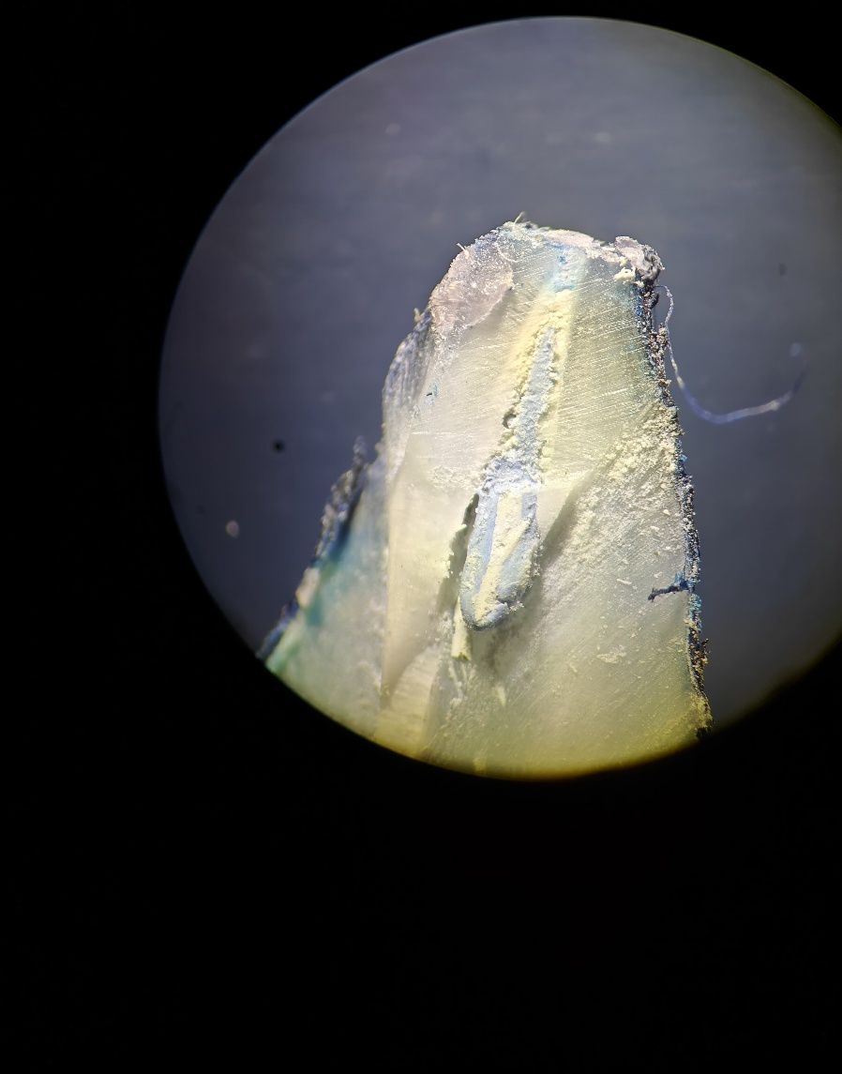
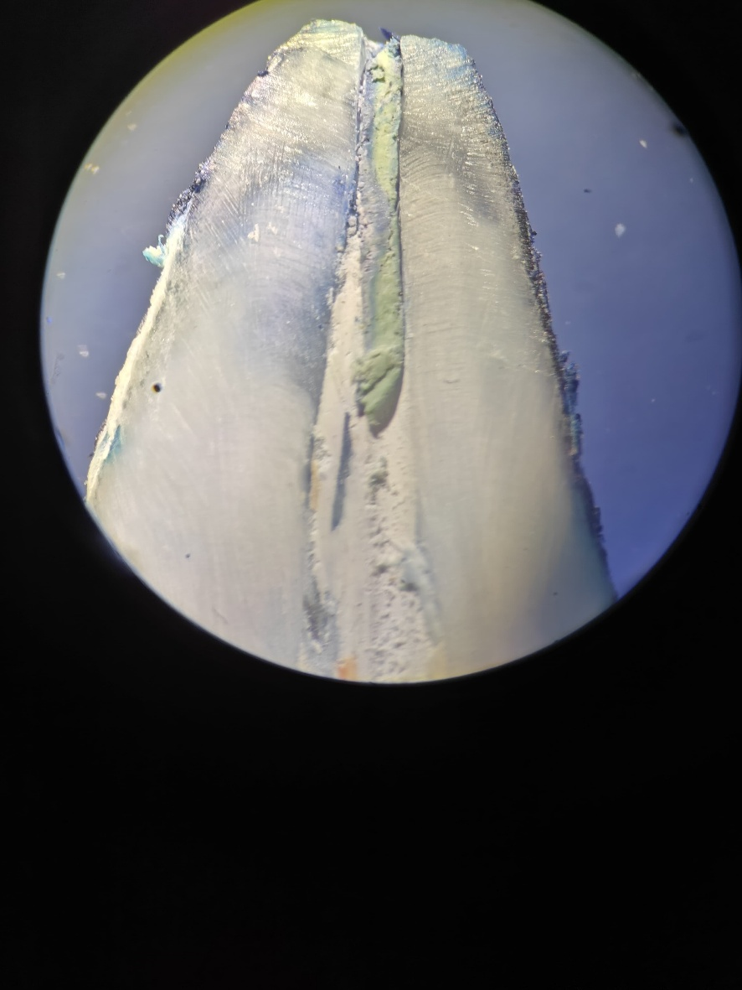
FIG 1. Stereomicroscopic Images Of Dye Penetration at 30x Mangification
Group:-2 Modified step back technique
Group 1:- Step back technique

Group 4:- Crown down technique (Rotary instruments with greater taper)

Group 3:- Crown down technique (Manual NiTi with greater taper)

