Molecular Mechanisms and Emerging Therapeutic Targets in Diabetic Nephropathy: An Updated Review

Abstract:
Diabetic nephropathy (DN), a common and severe complication of diabetes, is the leading cause of end-stage kidney disease (ESKD). The present review is to explore the underlying mechanisms, molecular signaling pathways, biomarkers, therapeutic targets, and interventional strategies involved in DN. Chronic hyperglycemia induces metabolic and hemodynamic disturbances that promote oxidative stress, inflammation and fibrosis through key pathways such as the polyol pathway, advanced glycation end-products (AGEs), protein kinase C (PKC) and the renin-angiotensin-aldosterone system (RAAS). Biomarkers including albuminuria, serum creatinine, TGF-β, IL-6, and KIM-1 are valuable for early diagnosis and disease monitoring. Targeting ANG-II, AGE’s and PKC forms the basis for multiple treatment strategies along with combination therapies particularly sodium-glucose cotransporter-2 (SGLT2) inhibitors and RAAS blockers offering superior outcomes. Additionally, emerging interventions like dietary modulation and cell-based therapies hold therapeutic potential. A multifaceted, early-intervention approach is crucial for effective DN management and slowing disease progression.
Keywords:
Diabetic nephropathy, biomarkers, molecular pathways, RAAS, SGLT2 inhibitors, therapeutic targets, cell therapy

Introduction:
“Diabetic neuropathy (DN) is among the most prevalent chronic complications of types 1 and 2 diabetes mellitus (T1DM and T2DM), significantly compromising patients’ quality of life and contributing to elevated morbidity and mortality rates” [1]. “Diabetic nephropathy (DN), a major microvascular complication of diabetes mellitus, significantly contributes to the global burden of chronic kidney disease (CKD) and end-stage renal disease (ESRD). It is characterized by elevated urinary albumin excretion and a progressive decline in glomerular filtration rate (GFR)” [6]. The onset and development of DN results from a complex interplay between genetic predisposition and environmental factors [2,7]. “The emerging therapeutics, including novel target-based pharmacotherapy, cell therapies, and dietary regulation, are leading to new hopes for DN management” [3,4]. Histopathological changes associated with DN include thickening of the glomerular and tubular basement membranes, mesangial matrix growth, podocyte injury and loss, tubulointerstitial fibrosis, and arteriolar hyalinosis. Additionally, DN is strongly linked with an increased risk of cardiovascular disease, which is a leading cause of mortality among affected individuals [8]. “The advent of sodium–glucose cotransporter 2 inhibitors followed by nonsteroidal mineralocorticoid receptor antagonists and, to some extent, glucagon-like peptide 1 receptor agonists (GLP-1 RAs) has ushered in a resounding paradigm shift that supports a pillared approach in maximizing treatment to reduce outcomes” [5].
“Epidemiologically, DN affects approximately one-third of individuals who are suffering with type 1 diabetes mellitus and about 25% of those with type 2 diabetes” [4]. “The global prevalence of diabetes is expected to rise from 6.4% (285 million) in 2010 to 7.7% (439 million) by 2030, with developing countries accounting for the majority (approximately 69%) of this increase” [10,11].
At the molecular level, “chronic hyperglycemia initiates several intracellular pathways, including increased activity of the polyol and hexosamine pathways, formation of advanced glycation end-products (AGEs), generation of reactive oxygen species (ROS) and activation of protein kinase C (PKC). These changes get stimulated by altering growth factor-β (TGF-β), mitogen-activated protein kinase (MAPK), G-protein signaling, the JAK-STAT pathway and cyclin-dependent kinases. Aberrant expression of matrix metalloproteinases (MMPs), extracellular matrix (ECM) components and their inhibitors has also been observed in DN” [12].
Potential Mechanisms:
Cellular and Molecular Mechanisms in Disease Progression:
Diabetic nephropathy (DN), a major microvascular complication of diabetes mellitus, is characterized by progressive renal damage resulting from chronic hyperglycemia. The underlying molecular and cellular mechanisms contributing to DN are multifactorial and intricately interconnected. Key pathological processes include the accumulation of advanced glycation end products (AGEs), excessive production of reactive oxygen species (ROS), initiation of the diacylglycerol–protein kinase C (DAG–PKC) signaling pathway, dysregulation of autophagy, and stimulation of the renin–angiotensin–aldosterone system (RAAS). These mechanisms collectively contribute to glomerular injury, mesangial expansion, tubulointerstitial fibrosis, and eventual decline in renal function [13,14,15.16].
Renin–Angiotensin–Aldosterone System (RAAS)
RAAS plays a vital role in regulating systemic blood pressure, fluid balance, and tissue perfusion. However, in the diabetic milieu, chronic hyperglycemia leads to persistent activation of RAAS, both systemically and locally within the kidney. This dysregulation contributes significantly to DN pathogenesis by inducing renal vasoconstriction, oxidative stress, inflammation, and fibrotic remodelling.
Among the key effectors of RAAS angiotensin II and aldosterone exert profound deleterious effects. Angiotensin II promotes endothelial dysfunction through increased expression of endothelin-1, enhanced production of nitric oxide (NO), activation of cyclooxygenase (COX), and stimulation of protein kinase C (PKC). Additionally, “it upregulates pro-inflammatory and pro-fibrotic mediators such as transforming growth factor-beta (TGF-β), nuclear factor-kappa B (NF-κB), tumor necrosis factor-alpha (TNF-α), and testosterone, leading to increased ROS production and fibrotic matrix deposition” [17].
Aldosterone, through its interaction with the mineralocorticoid receptor (MR), triggers transcription of inflammatory and fibrotic genes, contributing to vascular and myocardial fibrosis. The activation of MR in renal tissues promotes inflammation, tubulointerstitial fibrosis, and structural damage to nephrons, accelerating DN progression. The pathological actions of aldosterone further underscore the importance of MR antagonists in nephroprotective therapy [17].
Reactive Oxygen Species (ROS)
Reactive oxygen species (ROS) function as intracellular signaling molecules under physiological conditions, playing roles in cell proliferation, differentiation, and survival. However, in the diabetic state, persistent hyperglycemia disrupts the redox balance, resulting in excessive ROS generation. This oxidative stress is central to the pathophysiology of DN.
Elevated glucose levels enhance ROS production via multiple pathways: mitochondrial oxidative phosphorylation, glucose auto-oxidation, activation of NADPH oxidase and the formation of AGEs. ROS species such as superoxide anion (O₂⁻), hydrogen peroxide (H₂O₂), hydroxyl radical (•OH), and peroxynitrite (ONOO⁻) damage cellular macromolecules and organelles, inducing inflammation, apoptosis, and fibrosis in renal tissues [12]. In glomerular mesangial cells, ROS upregulate extracellular matrix (ECM) proteins, β1 integrins and plasminogen activator inhibitor-1 (PAI-1), mimicking hyperglycemia-induced cellular responses.
Advanced Glycation End Products (AGEs)
AGEs are formed through a non-enzymatic glycation process known as the Maillard reaction, wherein reducing sugars react with amino groups on proteins, lipids, and nucleic acids. This reaction initially forms a Schiff base which reorganizes into a more stable Amadori product (e.g., glycated hemoglobin, HbA1c), and ultimately gives rise to AGEs through oxidative and structural modifications
Autophagy
Autophagy is a highly conserved lysosomal degradation pathway essential for the removal of damaged proteins, organelles, and aggregates, thereby maintaining cellular homeostasis under stress conditions. In the framework of DN, autophagic activity is markedly impaired due to hyperglycemia, oxidative stress and AGE accumulation [5,12]. In renal cells particularly podocytes and proximal tubular epithelial cells deficient autophagy contributes to the growth of cellular debris, mitochondrial dysfunction, and enhanced susceptibility to apoptosis. Podocytes are vital for maintaining the integrity of the glomerular filtration barrier, and their injury leads to proteinuria and glomerulosclerosis.
Diacylglycerol–Protein Kinase C (DAG–PKC) Pathway
The DAG–PKC signaling pathway acts as a pivotal role in mediating glucose-induced renal injury. Under hyperglycaemic conditions, increased glycolytic flux elevates the intracellular concentrations of glyceraldehyde-3-phosphate and glycerol-3-phosphate, leading to enhanced synthesis of diacylglycerol (DAG). DAG, in turn, activates specific isoforms of PKC, particularly PKCα and PKCβ, which are implicated in the development of DN. PKC activation triggers a cascade of events including the upregulation of TGF-β and connective tissue growth factor (CTGF), resulting in increased production of fibronectin and collagen IV. PKCβ also boosts the activity of NADPH oxidase, thereby amplifying ROS production and oxidative stress. Both PKCα and PKCβ contribute to increased vascular endothelial growth factor (VEGF) expression and albuminuria, promoting glomerular hypertrophy, capillary leakage, and glomerulosclerosis [8,9].
Epithelial-Mesenchymal Transition (EMT)
Epithelial-mesenchymal transition (EMT) is a complex biological process in which epithelial cells lose their distinctive structural and functional features, such as tight cell-to-cell adhesion and apical-basal polarity, and acquire mesenchymal characteristics like enhanced motility, invasiveness and increased production of extracellular matrix mechanisms. This transformation occurs under both physiological conditions (such as during embryogenesis and wound healing) and pathological conditions, including diabetic nephropathy (DN).
Markers of EMT:
Epithelial cells are characterized by markers such as E-cadherin and cytokeratin’s, which maintain epithelial integrity and adhesion. When undergoing EMT, these markers are downregulated, while mesenchymal markers including α-smooth muscle actin (α-SMA), vimentin, and fibroblast-specific protein 1 (FSP1) become upregulated, indicating a shift towards a more fibroblast-like, migratory phenotype.
Classification of EMT:
Type I EMT occurs during embryonic development and generates mesenchymal cells essential for tissue and organ formation.
Type II EMT is associated with tissue regeneration and fibrosis contributes to the generation of fibroblasts in chronic inflammatory and fibrotic diseases.
Type III EMT is linked to cancer progression, where malignant epithelial cells acquire invasive and metastatic abilities through genetic and epigenetic changes.
Molecular Pathways Triggering EMT:
Multiple intracellular signaling pathways contribute to the commencement and evolution of EMT, often activated by hyperglycemia and other stressors in DN.
TGF-β/Smad Pathway: Hyperglycemia activates the transforming growth factor- β (TGF-β) and its downstream Smad signaling, which endorses the transcription of EMT-related genes. This pathway stimulates the formation of protein complexes like ShcA/Grb2/Sos, ultimately leading to EMT activation in podocytes specialized glomerular epithelial cells essential for maintaining the filtration barrier.
PI3K/Akt Pathway: TGF-β also enhances phosphoinositide 3-kinase (PI3K)-Akt signaling, stabilizing and accumulating β-catenin, a transcriptional co-activator that regulates genes necessary for EMT progression in podocytes.
mTOR Signaling and Autophagy: Abnormal stimulation of the mammalian target of rapamycin complex 1 (mTORC1) disrupts cell junction proteins and induces endoplasmic reticulum (ER) stress, facilitating EMT-like phenotypic changes in podocytes. Conversely, AMP-activated protein kinase (AMPK) promotes autophagy by inhibiting mTORC1 through TSC1/2-Rheb signalling, which helps mitigate EMT progression by clearing damaged cellular components.
Endoplasmic Reticulum Stress (ERS): Hyperglycemia-induced ER stress activates pathways such as MAPK and NF-κB via TRB3 signaling, which can further enhance EMT and inflammatory responses.
Role of Inflammation and NF-κB:
Inflammatory mediators like advanced glycation end products (AGEs), mechanical stress, and high glucose levels activate nuclear factor kappa B (NF-κB), a key transcription factor in DN pathogenesis. NF-κB regulates expression of chemokines, adhesion molecules, and pro-inflammatory cytokines, which contribute to kidney tissue injury and EMT induction.
JAK-STAT Pathway:
The Janus kinase/signal transducer and activator of transcription (JAK-STAT) signaling system is critically involved in mediating inflammatory and fibrotic responses in DN. Overexpression of JAK-STAT components has been detected in glomerular cells during early DN, where it promotes NF-κB activation then amplifies inflammatory cascades, exacerbating EMT and renal damage.
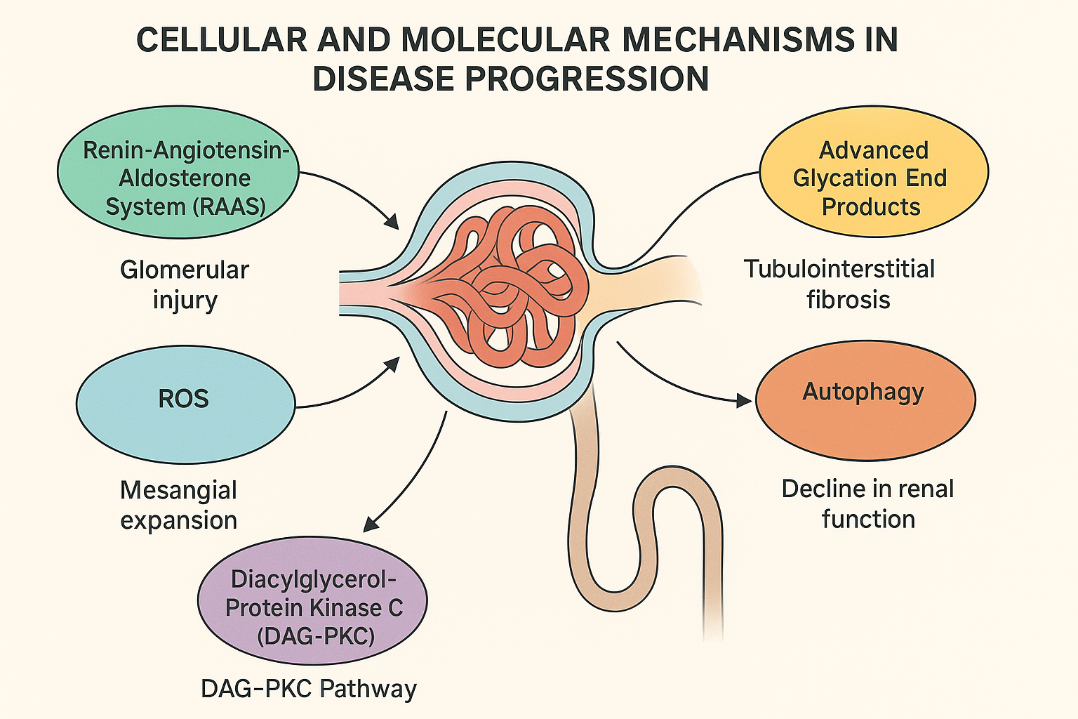
Nrf2-Keap1 Pathway and Oxidative Stress: Oxidative stress plays a central role in EMT and DN progression. The transcription factor nuclear factor erythroid 2-related factor 2 (Nrf2) regulates antioxidant defense mechanisms by inducing cytoprotective genes. Under normal conditions, Nrf2 is sequestered and degraded by its inhibitor Keap1. Oxidative stress disrupts this interaction, allowing Nrf2 to translocate into the nucleus, bind to antioxidant response elements (ARE), and promote expression of multiple antioxidant enzymes. Activation of the Nrf2/Keap1 pathway thus provides a protective effect against oxidative damage and EMT in renal cells. Studies have demonstrated that Nrf2 deficiency results in aggravated kidney injury, highlighting its potential therapeutic role in DN.
Fig 1: Molecular Signaling Pathways:
MAPK Signaling Pathway in Diabetic Nephropathy (DN)
The mitogen-activated protein kinase (MAPK) signaling cascade is a highly conserved intracellular pathway composed of a sequence of serine/threonine protein kinases. This pathway act as an amplification system that transduces extracellular signals into cellular responses, thereby regulating various cellular processes. “The central framework of the MAPK pathway involves a three-tiered kinase module: a MAP kinase (MAP3K) phosphorylates and activates a MAP kinase kinase (MAP2K), which subsequently phosphorylates and activates MAP kinase (MAPK). The MAPK family is subdivided into four major subgroups based on structure and function: extracellular signal-regulated kinases 1 and 2 (ERK1/2), c-Jun N-terminal kinases (JNK1/2/3 or SAPK), p38 mitogen-activated protein kinases (p38MAPKs), and ERK5/BMK1” [38]. Together with upstream stimuli and downstream effectors, these pathways form a complex and dynamic network that controls gene expression to coordinate essential cell functions (19).
PK Signaling Pathway
The p38MAPK subgroup is crucial in regulating cellular responses to stress and inflammation and plays an indispensable role in DN development. Experimental evidence has revealed that high glucose (HG) conditions induce phosphorylation and initiation of p38MAPK in renal mesangial cells (MCs), which outbursts in increased synthesis of fibronectin (FN), a key module of the extracellular matrix (ECM). Pharmacological inhibition of p38MAPK can attenuate ECM buildup in MCs, thereby preventing thickening of the glomerular basement membrane (GBM) and slowing DN progression. Additionally, hyperglycemia-induced activation of the renin-angiotensin-aldosterone system (RAAS) further contributes to renal injury through the p38MAPK pathway in diabetic patients. These findings underscore the importance of exploring the p38MAPK signaling cascade in DN.
The diabetic microenvironment characterized by high glucose concentration encompasses numerous pathological stimuli including pro-inflammatory cytokines, reactive oxygen species (ROS), angiotensin II (Ang-II), hyperosmolarity, and other stress factors. These conditions lead to enhanced expression and activity of upstream kinases such as MAP kinase kinase 3, 6, and 4 (MKK3/6/4), which mediate dual phosphorylation at the TGY motif within the activation loop of p38MAPK, triggering its activation [11].
JNK/SAPK Signaling Pathway
c-Jun N-terminal kinases (JNKs) are another critical subgroup of the MAPK family, consisting mainly of three isoforms: JNK1 and JNK2, which are ubiquitously expressed, and JNK3, which is predominantly found in neuronal tissue [61]. In type 2 diabetes mellitus (T2DM) patients and diabetic animal models, environmental stresses such as high glucose and ultraviolet light, as well as inflammatory cytokines like TNF-α, activate upstream MAP3Ks, particularly mitogen-activated protein kinase kinase kinase 1 (MEKK1), initiating the JNK Signaling cascade.
Activated MAP3Ks phosphorylate MAP kinase kinases 4 and 7 (MKK4/7), which in turn phosphorylate and activate JNKs.
ERK Signaling Pathway
The ERK signaling pathway is a central regulatory network controlling cell proliferation, transformation, differentiation, and apoptosis. Despite extensive research over the historical decade that has expanded our understanding of numerous Signaling pathways, the ERK pathway remains complex and not fully understood. Studies have highlighted ERK’s crucial role in intracellular signaling, particularly in integrating gene transcription involved in multiple cellular responses relevant to DN [11]. Growing evidence reveals intricate protein interactions within the ERK pathway, and assessing their significance is vital for developing DN treatments.
TGF-β Signaling Pathway in Diabetic Nephropathy
Transforming growth factor-beta (TGF-β) is a hypertrophic and pro-fibrotic cytokine that is widely expressed across various organs and tissues, playing a critical role in numerous cellular functions. Previous studies have revealed that TGF-β1 expression is pointedly increased in renal cells exposed to high glucose (HG) conditions, as well as in the kidney tissues of diabetic db/db mouse models. TGF-β1 is recognized as a potent multifunctional cytokine that promotes extracellular matrix (ECM) synthesis and inhibits its degradation.
RhoA/ROCK Signaling Pathway in Diabetic Nephropathy
RhoA/ROCK Signaling pathway has recently garnered significant attention due to its life-threatening role in the progress of diabetic complications. Studies have shown increased translocation of RhoA to the renal cortex, and inhibition of the RhoA/ROCK pathway has been found to slow the progression of DN [14]. Furthermore, podocyte-specific activation of RhoA induces proteinuria and podocyte apoptosis, underscoring the importance of this pathway in DN pathogenesis [14].
NF-κB Signaling Pathway in Diabetic Nephropathy (DN)
“The NF-κB Signaling pathway plays a critical role in chronic inflammatory and autoimmune conditions, including DN. Lee et al. observed that in DN, the activity of the NF-κB p65 protein is elevated, along with increased expression of MCP-1 mRNA in both tubulointerstitial and glomerular cells. Their study also revealed that activated NF-κB translocates to the nucleus, initiating the expression of target genes such as TNF-α, iNOS, TGF-β1, IL-1β, and intercellular adhesion molecule-1 (ICAM-1). These downstream inflammatory mediators contribute to sustained and intensified inflammation, leading to excessive fibronectin (FN) production and extracellular matrix (ECM) buildup” [15]. These findings suggest that NF-κB Signaling is a key driver in the pathogenesis and progression of DN.
Wnt Signaling Pathway in Diabetic Nephropathy
The Wnt Signaling pathway is a highly conserved system that influences cell fate by regulating polarization, branching morphogenesis, and proliferation. It consists mainly of two pathways: canonical and noncanonical. Multiple studies highlight the critical role of the canonical Wnt/β-catenin pathway in fibrosis. TGF-β1, in conjunction with integrin-linked kinase and Wnt signaling, activates the Wnt/β-catenin pathway and initiates epithelial-to-mesenchymal transition (EMT), establishing Wnt/β-catenin as a central regulator in DN [8]. One well-known pathological feature of DN is mesangial expansion, which correlates with early renal dysfunction.
JAK-STAT Signaling Pathway in Diabetic Nephropathy (DN)
The Janus kinase (JAK) family and signal transducers and activators of transcription (STAT), collectively known as the JAK/STAT signaling pathway, is a dangerous regulator of numerous cellular processes. Previous studies have demonstrated beneficial effects of angiotensin-converting enzyme inhibitors (ACEIs) and HMG-CoA reductase inhibitors in diabetic rodent models, partially due to the hangup of JAK2. Hyperglycemia and diabetes-induced effects may be mediated by increased reactive oxygen species (ROS), as mesangial cells exposed to high glucose show enhanced phosphorylation and activation of JAK2 and its downstream substrates [13].
7. Other Signaling Pathways Related to Diabetic Nephropathy
Chronic hyperglycemia is a principal contributor to DN. In cultured mesangial cells exposed to high glucose, PKC is activated alongside a rise in intracellular diacylglycerol (DAG). This triggers the DAG/PKC signaling cascade, which initiates the polyol pathway, oxidative stress (OS), and advanced glycation end-products (AGEs) formation processes implicated in diabetic microangiopathy. The mammalian target of rapamycin (mTOR) pathway has recently garnered consideration in the context of DN pathogenesis. Studies in diabetic animal models have revealed that rapamycin, a specific inhibitor of mTOR complex 1 (mTORC1), can reduce glomerular hypertrophy typically observed in early DN stages, as well as mitigate mesangial expansion [8]. Although mTOR signaling is activated in multiple kidney cell types affected by diabetes, its activation in glomerular mesangial cells appears to be responsible for several key pathological changes.
Therapeutic Targets Based on Molecular Mechanisms of Diabetic Kidney Disease
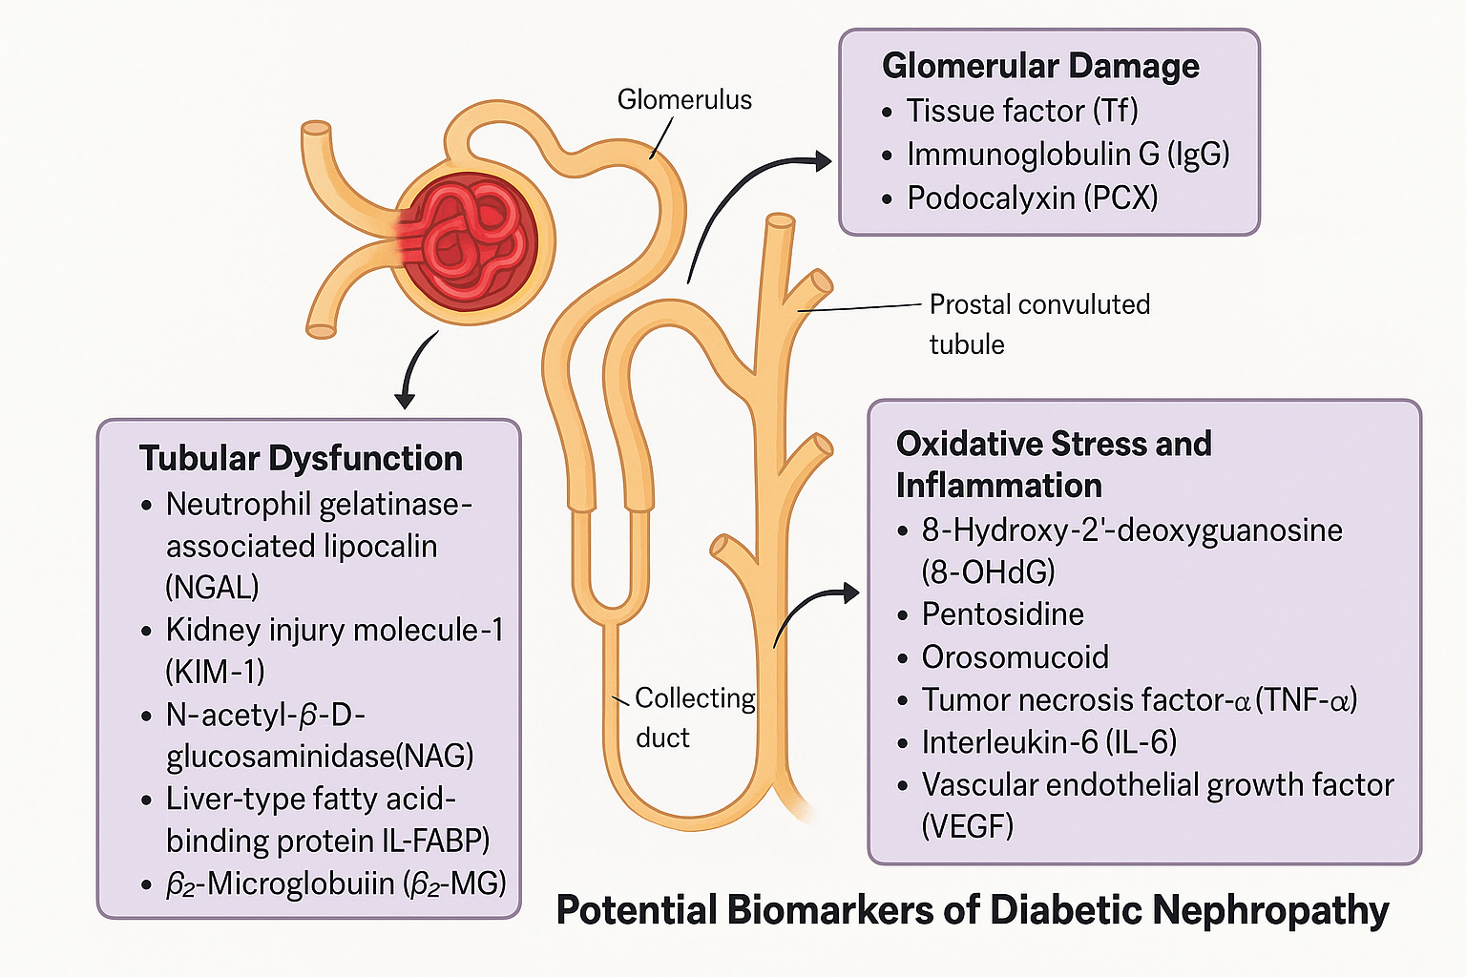
The pathogenesis and development of diabetic kidney disease (DKD) are driven by a complex interplay of metabolic dysregulation, oxidative stress, inflammation, fibrotic pathways, and hemodynamic alterations. Understanding these molecular mechanisms has facilitated the development of targeted therapeutic strategies.
Fig 2: RAAS Blockers
The CSG Captopril trial demonstrated that captopril halved the risk of doubling serum creatinine and DKD-related events (death, dialysis, or transplantation) over three years in type 1 DM patients. This landmark trial paved the way for angiotensin receptor blockers (ARBs) [20,21].
In the RENAAL study, losartan reduced serum creatinine doubling by 25%. The IDNT trial showed irbesartan lowered the risk of a composite endpoint (doubling serum creatinine, ESKD, or death) compared to placebo. In early nephropathy, the DETAIL trial found telmisartan slowed GFR decline over five years. The AMADEO study reported that telmisartan lowered the urine albumin–creatinine ratio by 29.8% compared to 21.4% with losartan. The ONTARGET trial found telmisartan had similar renal risks to ramipril, but combination treatment significantly increased adverse renal outcomes [13].
Mineralocorticoid Receptor Antagonists (MRAs)
MRAs block aldosterone-induced activation of mineralocorticoid receptors (MRs), mitigating downstream inflammatory and fibrotic signalling. Steroidal MRAs, probably spironolactone and eplerenone, are partial MR agonists with proven cardiovascular and antiproteinuric benefits. However, their use is limited by side effects like hyperkalaemia and renal impairment. Finerenone, a nonsteroidal MRA, inhibits MR signalling more selectively, with stronger anti-inflammatory, antifibrotic, and antioxidant effects [10,14].
SGLT2 Inhibitors
Originally developed as glucose-lowering agents, SGLT2 inhibitors (SGLT2is) have redefined DKD management by providing robust cardiorenal protection [9]. These agents enhance glycosuria, reduce intraglomerular pressure via tubuloglomerular feedback, and exert anti-inflammatory and antifibrotic effects. The CREDENCE trial was the first dedicated nephropathy trial using canagliflozin, showing a 30% risk reduction in ESKD, doubling of serum creatinine, or renal/cardiovascular death. The DAPA-CKD trial demonstrated a 44% risk reduction for similar endpoints with dapagliflozin. The EMPA-KIDNEY trial confirmed empagliflozin’s benefit across a broad CKD population, with and without diabetes or albuminuria, reducing renal progression or cardiovascular death by 28% [14]. SGLT2is are now recommended by KDIGO and ADA guidelines as first-line therapy in DKD, especially when added to ACEi/ARB therapy.
GLP-1 Receptor Agonists (GLP-1 RAs)
GLP-1 RAs lower glucose by stimulating insulin and suppressing glucagon secretion, but also demonstrate renal benefits largely independent of glycemic control. These agents reduce inflammation, modulate RAGE signaling, and attenuate fibrosis in kidney cells.
The LEADER trial (liraglutide) showed a 22% reduction in nephropathy events, while SUSTAIN-6 (semaglutide) showed a 36% risk reduction, primarily due macroalbuminuria reduction [200]. AWARD-7 found that dulaglutide preserved eGFR better than insulin glargine [201]. In the REWIND trial, dulaglutide reduced macroalbuminuria by 23% and the renal composite outcome by 15%. AMPLITUDE-O demonstrated that efpeglenatide reduced kidney events by 32%.
Endothelin Receptor Antagonists (ERAs)
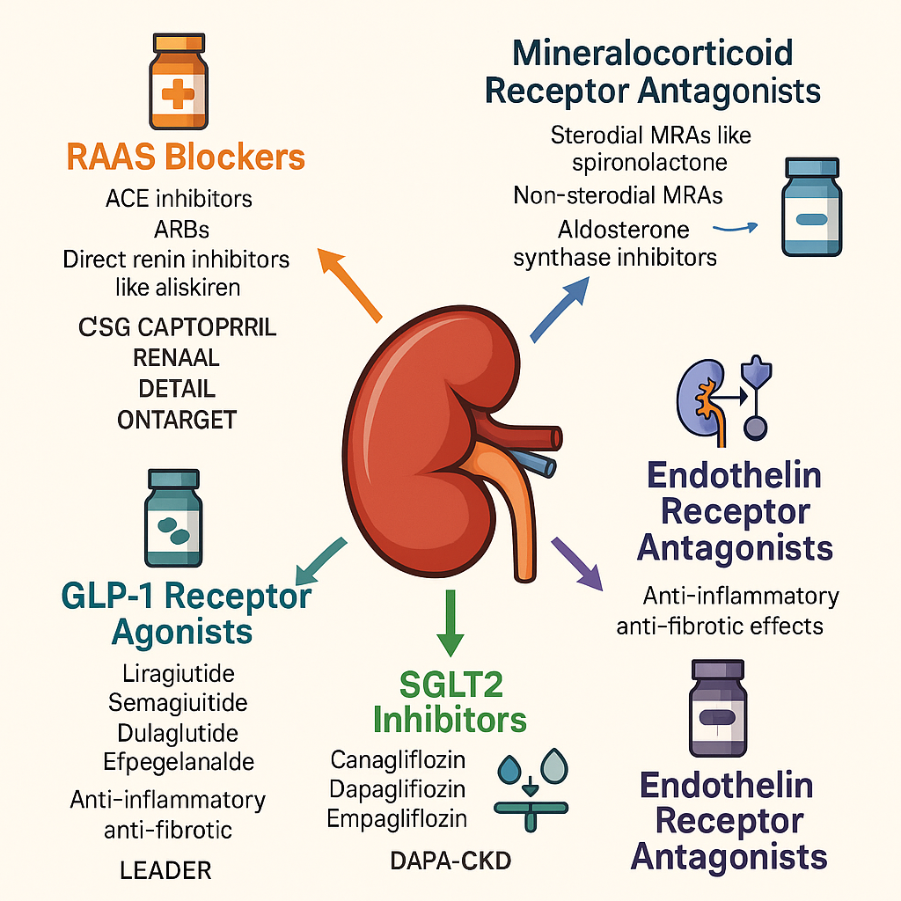
Elevated endothelin-1 (ET-1) levels contribute to vasoconstriction, inflammation and fibrosis in DKD, making ET-1 a viable therapeutic target [10].

Fig.3: Therapeutic Targets Based on Molecular Mechanisms of Diabetic Kidney Disease

Interventional Therapies in DN:

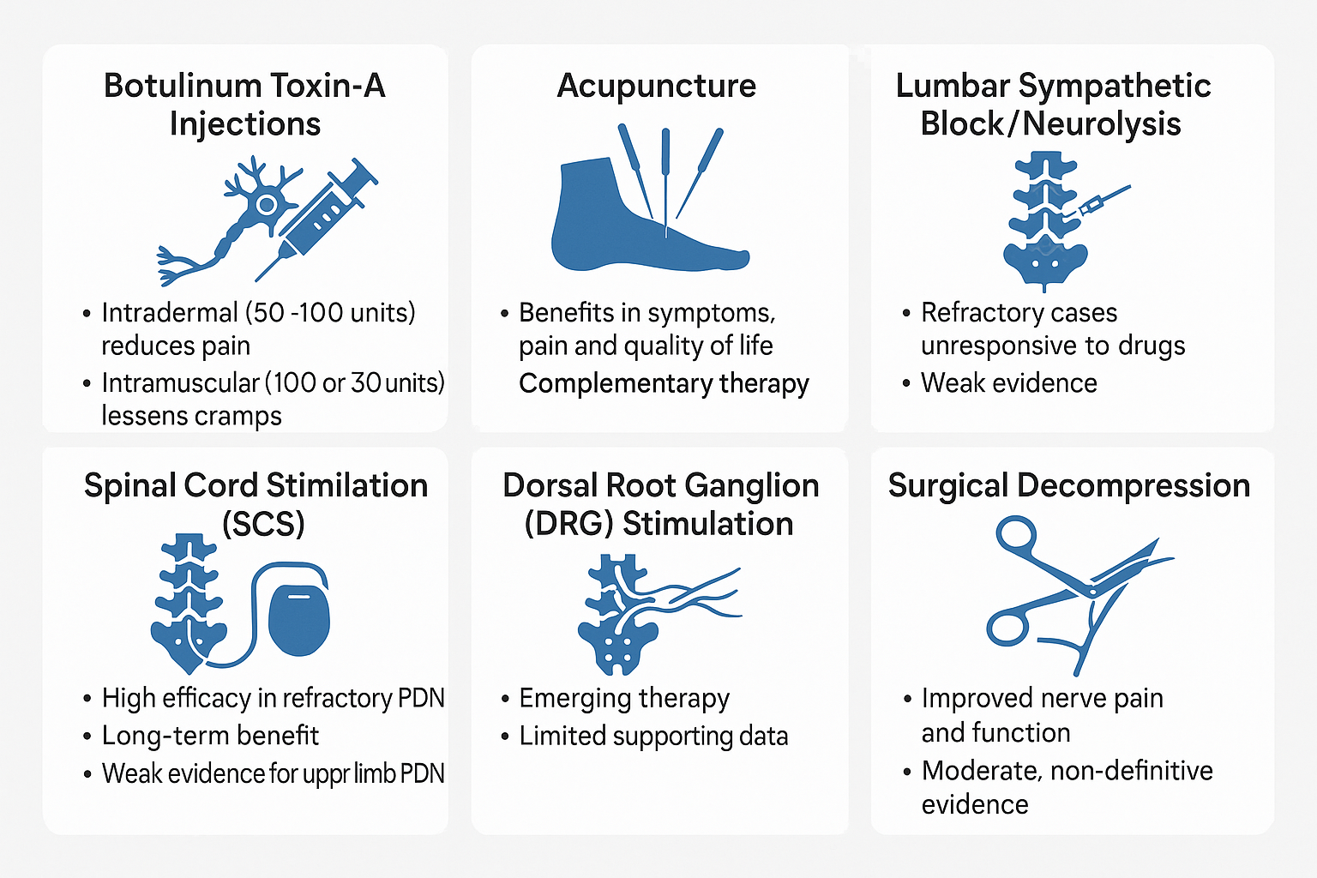
Fig.4: Interventional Therapies in DN
Botulinum toxin A (BTX-A) has shown promising analgesic effects through inhibition of neurotransmitter release and reduction of peripheral and central sensitization. A randomized meticulous trial [206] demonstrated that intradermal BTX-A significantly reduced pain scores in PDN patients over 12 weeks. Acupuncture, rooted in traditional Chinese medicine, modulates endogenous opioid release and neuroinflammation; a meta-analysis confirmed moderate efficacy in reducing PDN symptoms. Lumbar sympathetic block (LSB), which interrupts sympathetic afferents, can improve microcirculation and alleviate pain, as evidenced by a case series reporting sustained relief in diabetic patients after serial blocks. Spinal cord stimulation (SCS), a neuromodulation technique delivering low-voltage electrical currents to the dorsal columns, has shown clinically meaningful pain reduction in PDN. A randomized trial that found 55% of participants had ≥50% pain relief at 6 months with SCS. Dorsal root ganglion (DRG) stimulation, a more targeted form of neuromodulation, provides segmental pain control. The ACCURATE study found DRG stimulation to be superior to SCS in complex regional pain syndrome and is now being investigated for PDN. Lastly, peripheral nerve decompression (PND), based on the hypothesis that chronic compression contributes to neuropathic pain, has shown improvement in pain and sensation post-surgery in selected patients, as reported in diabetic neuropathy cases. Collectively, these interventional options offer varied mechanisms and experimental benefits for patients with stubborn PDN.
Therapy | Level of Evidence | Clinical Role | Limitations
BTX-A injections | 2B+/1B+ | Adjunctive for pain and muscle cramps | Small studies, short follow-up
Acupuncture | 2B+/1B+ | Complementary therapy | Variability in methods, potential bias
Lumbar sympathectomy | 2C+ | Salvage option for refractory PDN | Retrospective data, small studies
SCS (tonic & HF-10) | 1B+ | High efficacy for refractory lower limb PDN | Expensive, invasive, not blinded
DRG stimulation | 2C+ | Experimental, for localized neuropathic pain | Very limited evidence
Surgical decompression | 2B–2C | Select cases with entrapment symptoms | Controversial, lack of sham controls

Table.1: Interventional Therapies in Diabetic Nephropathy
Discussion
Diabetic nephropathy (DN) remains one of the most prevalent and challenging microvascular complications of diabetes mellitus, contributing significantly to end-stage renal disease (ESRD) worldwide. Despite the availability of conventional therapies, the progressive nature of DN underscores the need for a deeper understanding of its molecular and cellular underpinnings to facilitate targeted therapeutic interventions. As the pathogenesis of DN is multifactorial, involving intricate mechanisms like the activation of renin-angiotensin-aldosterone system (RAAS), oxidative stress through reactive oxygen species (ROS), formation and accumulation of advanced glycation end-products (AGEs), autophagy dysregulation, and the diacylglycerol-protein kinase C (DAG-PKC) pathway. These pathways collectively induce glomerular hypertrophy, mesangial expansion, podocyte injury, and tubulointerstitial fibrosis, hallmarks of DN progression. Key signaling molecules and cascades, including MAPK, NF-κB, JAK/STAT, and TGF-β/Smad pathways, further mediate inflammation, fibrosis, and apoptosis in renal tissues.
This review has also emphasized the growing relevance of biomarkers for early diagnosis and progression monitoring in DN. The incorporation of urinary and serum biomarkers, including NGAL, KIM-1, L-FABP, and inflammatory cytokines, into clinical practice could enhance early detection and prognosis assessment.
Conclusion
The complexity of diabetic nephropathy necessitates an integrative therapeutic approach that spans metabolic control, inhibition of key molecular pathways, and organ-protective strategies. Advancements in our understanding of DN pathophysiology have paved the way for targeted therapies and novel interventions that hold promise in delaying progression to ESRD. Future research should prioritize conducting high-quality randomized controlled trials (RCTs) to evaluate the efficacy and safety of both interventional and adjunctive therapies for diabetic nephropathy. Equally important is the standardization and validation of early diagnostic biomarkers to enhance their clinical utility for timely detection and monitoring of disease progression.

Disclaimer (Artificial intelligence)
NO generative AI technologies such as Large Language Models (ChatGPT, COPILOT, etc.) and text-to-image generators have been used during the writing or editing of this manuscript.

References:
- Chen G, Zhang L, Wang Y, Wang J, Yang K, Wang X, Chen X. The NEAT1/miR-124-3p/CCL2 axis in chronic kidney disease progression: integrated bioinformatics analysis and experimental validation. Epigenomics. 2025 Oct;17(14):935-952.PMID: 40838416.
- Qichao Hu, Yanling Zhao, Yuan Chen. Diabetic nephropathy: Focusing on pathological signals, clinical treatment, and dietary regulation. Biomedicine & Pharmacotherapy.2023 Jan; 159 (2023) 114252.
- Ying M, Shao X, Qin H, et al. Disease burden and epidemiological trends of chronic kidney disease at the global, regional, National levels from 1990 to 2019. Nephron. 2024;148(2):113–123.
- The EMPA-KIDNEY Collaborative Group; Herrington WG, Staplin N, Wanner C, Green JB, Hauske SJ, Emberson JR, Preiss D, Judge P, Mayne KJ, Ng SYA, Sammons E, Zhu D, Hill M, Stevens W, Wallendszus K, Brenner S, Cheung AK, Liu ZH, Li J, Hooi LS, Liu W, Kadowaki T, Nangaku M, Levin A, Cherney D, Maggioni AP, Pontremoli R, Deo R, Goto S, Rossello X, Tuttle KR, Steubl D, Petrini M, Massey D, Eilbracht J, Brueckmann M, Landray MJ, Baigent C, Haynes R. Empagliflozin in Patients with Chronic Kidney Disease. N Engl J Med. 2023 Jan 12;388(2):117-127. doi: 10.1056/NEJMoa2204233. Epub 2022 Nov 4. PMID: 36331190; PMCID: PMC7614055.
- Sandra C. Naaman, George L. Bakris; Diabetic Nephropathy: Update on Pillars of Therapy Slowing Progression. Diabetes Care 1 September 2023; 46 (9): 1574–1586.
- Lim A. Diabetic nephropathy complications and treatment. Int J Nephrol Renovasc Dis. 2014;7:361–81. PMID: 25342915
- Reidy K, Kang HM, Hostetter T, Susztak K. Molecular mechanisms of diabetic kidney disease. J Clin Invest. 2014;124(6):2333–40. PMID: 24892707
- Russo G, Piscitelli P, Giandalia A, et al. Atherogenic dyslipidemia and diabetic nephropathy. J Nephrol. 2020;33(5):1001–8. PMID: 32328901
- Duran-Salgado MB, Rubio-Guerra AF. Diabetic nephropathy and inflammation. World J Diabetes. 2014;5(3):393–8. PMID: 24936261
- Reutens AT, Atkins RC. Epidemiology of diabetic nephropathy. In: Lai KN, Tang SCW, editors. Diabetes and the Kidney. Basel: Karger; 2011. p. 1–7.
- International Diabetes Federation. Diabetes Atlas. Available from: (Accessed March 19, 2024).
- Cha DR, Kang YS, Han SY, et al. Role of aldosterone in diabetic nephropathy. Nephrology. 2005;10 Suppl 2:S37–9. PMID: 16174286
- Hagiwara S, Gohda T, Kantharidis P, et al. Potential of modulating aldosterone signaling and mineralocorticoid receptor with microRNAs to attenuate diabetic kidney disease. Int J Mol Sci. 2024;25(2):869. PMID: 38255942
- Bondeva T, Wolf G. Reactive oxygen species in diabetic nephropathy: friend or foe? Nephrol Dial Transplant. 2014;29(11):1998–2003. PMID: 24589719
- Kanwar YS, Wada J, Sun L, et al. Diabetic nephropathy: mechanisms of renal disease progression. Exp Biol Med (Maywood). 2008;233(1):4–11. PMID: 18156300
- Carvalho RH, Ida EI, Madruga MS, et al. Collapse of the endogenous antioxidant enzymes in post-mortem broiler thigh muscles triggers oxidative stress and impairs water-holding capacity. J Food Sci Technol. 2019;56(3):1371–9. PMID: 30956316
- Thomas MC. Advanced glycation end products. In: Lai KN, Tang SCW, editors. Diabetes and the Kidney. Basel: Karger; 2011. p. 66–74.
- Daroux M, Prévost G, Maillard-Lefebvre H, et al. Advanced glycation end-products: implications for diabetic and non-diabetic nephropathies. Diabetes Metab. 2010;36(1):1–10. PMID: 19932633
- An X, Zhang L, Yao Q, et al. The receptor for advanced glycation endproducts mediates podocyte heparanase expression through NF-κB signaling pathway. Mol Cell Endocrinol. 2018;470:14–25. PMID: 28478303
- Sanajou D, Ghorbani Haghjo A, Argani H, Aslani S. AGE-RAGE axis blockade in diabetic nephropathy: current status and future directions. Eur J Pharmacol. 2018;833:158–64.
PMID: 29883668
- Kumar Pasupulati A, Chitra PS, Reddy GB. Advanced glycation end products mediated cellular and molecular events in the pathology of diabetic nephropathy. Biomol Concepts. 2016;7(5–6):293–309. PMID: 27816946

