Case report

Enamel Opacity Management: A Case for Tailored Resin Infiltration and Diagnostic Precision

.
ABSTRACT

Aims: This case addresses an adolescent's aesthetic concerns from dental fluorosis (DF) white spots and molar incisor hypomineralization (MIH) lesions. The goal was to restore smile aesthetics via a conservative, adapted approach.
Presentation of Case: A healthy 14-year-old male presented to a dental school with aesthetic dissatisfaction from mild fluorosis and HMI-TNI_2a (MIH without hypersensitivity, with defect extension less than 1/3) on anterior and posterior teeth. Lesion depth and Icon® (DMG, Hamburg, Germany) resin infiltration application were guided by transillumination. Therapy involved selective enamel reduction and 15% hydrochloric acid cycles exclusively for MIH, followed by resin infiltration (RI) for all areas. Immediate post-treatment evaluation showed significant aesthetic improvement, including reduced opacity, improved color uniformity, and masking of dyschromias.
Discussion: Resin Infiltration (RI) revolutionizes the treatment of DF and HMI, delivering remarkable aesthetics while preserving tooth structure, surpassing traditional restorations. Selective enamel reduction is crucial for deeper lesions. Its success requires meticulous case selection, precise evaluation, and skilled technique, profoundly impacting contemporary dental practice and patient quality of life
Conclusion: This case demonstrates the successful multimodal and personalized treatment of an adolescent's aesthetic concerns, even for MIH and DF lesions initially perceived as moderately severe. The combination of selective enamel reduction for deeper MIH lesions (revealed by transillumination) and resin infiltration for all defects promoted notable aesthetic improvement and high patient satisfaction.

Keywords: Molar hypomineralization; Fluorosis, Dental; Developmental Defects of Enamel; Esthetics; Resin infiltration.

- INTRODUCTION

Adolescents prioritize smile aesthetics, a key driver for dental treatment. Beyond appearance, enamel structural integrity is crucial. Developmental defects (DDE) like MIH and DF (Martins et al., 2024) significantly compromise both aesthetics and dental function, impacting self-esteem. For this demographic, aesthetic perception is subjective; even minor defects can cause considerable social distress and negative self-image.
Molar-incisor hypomineralization (MIH) is clinically characterized by asymmetric, demarcated opacities, with a color spectrum encompassing white, yellow, and brown (Costa-Silva et al., 2011). Enamel affected by MIH exhibits a substantial reduction in both mineral content and quality, evidenced by lower concentrations of calcium and phosphorus, decreased hardness and elastic modulus, increased porosity, and higher levels of carbon and proteins when compared to healthy enamel (Elhennawy et al., 2017). Conversely, dental fluorosis, while also a hypomineralization condition, is clinically differentiated from MIH by its predilection for homologous teeth and its manifestation as diffuse, opaque stains. Dental enamel defects vary in severity, from fine lines to extensive areas with surface and subsurface porosity and can lead to structural surface loss if severe (Thylstrup & Fejerskov, 1978), highlighting the need for effective clinical management. This structural compromise drives the continuous search for effective therapeutic approaches.
For the management of DDE, the Icon system (DMG, Hamburg, Germany) is a widely accepted microinvasive option, frequently combined with dental bleaching and enamel microabrasion when clinically indicated (Casaña-Ruiz et al, 2023, Gupta et al., 2017; Garg et al., 2022). For optimal penetration and clinical effectiveness, it's essential to strictly follow the manufacturer's sequential application instructions for Icon-Etch, Icon-Dry, and Icon-Infiltrant Despite growing clinical interest and research into MIH and various therapeutic approaches, a recent umbrella review (Gevert et al., 2022) highlighted a critical gap in the quality of existing evidence, thereby impeding the establishment of a definitive clinical protocol.
Given this absence of a definitive protocol and the diverse clinical manifestations of DDE, this case report aims to detail the application of RI treatment for intrinsic stains caused by DF and MIH in a 14-year-old adolescent.

2. Presentation of Case

A 14-year-old male patient, in good systemic health, presented to the Western Paraná State University, School of Dentistry, Cascavel, Brazil, reporting aesthetic concerns with his smile. Clinical examination revealed mild fluorosis white spots (Dean, 1934) and irregularly distributed post-orthodontic white spots. Additionally, lesions consistent with enamel hypomineralization (MIH) were identified on teeth: 23, 12, 13, 43 (buccal surface), 16 (mesial surface), and 46 (occlusal surface) (HMI-TNI_2a (MIH without hypersensitivity, with defect extension less than 1/3) (Fig. 1) (Cabral et al., 2020). It's worth noting that although these lesions are classified as MIH without severe hypersensitivity and with limited defect extension, they still represent an initial structural and aesthetic compromise that may progress if left untreated.
To assess lesion depth and assist diagnosis, transillumination was utilized, leveraging the differential optical properties of sound versus demineralized enamel. A monochromatic white light beam, directed onto the lingual/palatal surface (Marouane & Chtioui, 2020), propagates through homogeneous sound enamel with minimal scattering. Conversely, demineralized regions, characterized by increased porosity and altered refractive indices, significantly scatter incident light, thus impeding linear transmission. This results in demineralized areas appearing as opaque "shadows" or darker regions when observed from another surface, thereby effectively revealing subsurface lesions imperceptible during standard clinical inspection. In our specific clinical presentation, employing a Radii Plus LED light source with a diagnostic LED probe in a darkened operatory, this method distinctly identified fluorosis and deep MIH defects in teeth 46, 43, 23, 13, and 12 (Fig. 2) as the light traversed the buccal aspect.
The single-session treatment strategy was tailored to defect severity and location, addressing the mandibular arch first, followed by the maxillary arch. Prior to treatment, prophylaxis was performed using the Air-Flow® Prophylaxis Master and Air-Flow® Powder Soft (E.M.S. Electro Medical System S.A., Nyon, Switzerland). Subsequently, the entire dental arch consistently received a rubber dam; however, teeth 17, 27, 37, and 47 were excluded due to their ongoing eruption. Given the alterations caused by DF, the rubber dam was firmly retracted throughout the acid etching and subsequent Icon® system application phases.
Initially, the treatment focused on the mandibular arch. Enamel microabrasion was conducted on teeth 43 using a multi-bladed bur to address deeper stain. Icon-Etch (15% hydrochloric acid) was applied to teeth 46 through 36 using a microbrush. After a 2-minute application, the acid was removed by suction, followed by 30 seconds of copious rinsing with ligature retraction. An equivalent period of oil/water-free drying was then performed. Subsequently, Icon-Dry (99% ethanol) was applied for 30 seconds under transillumination, utilizing a VALO™ Grand Cordless light and VALO Grand White Light Lens (Ultradent Products Inc., South Jordan, UT USA). Post-treatment, only cervical fluorosis stains and hypomineralized areas on teeth 43 and 46 persisted.
Following, acid was reapplied solely to the defect on tooth 43 (Fig. 3). Subsequently, Icon-Infiltrant was applied to all treated cervical areas under intense ligature retraction and with the operatory light off. After 3 minutes, the infiltrant effectively masked stains and was then light-cured for 40 seconds. For tooth 43 specifically (abraded earlier), the infiltrant was applied to its body for an extended duration of 20 minutes to maximize infiltration depth. This extended infiltration was monitored via transillumination using the same process, after which it was light-cured. Concurrently, infiltrant application and subsequent curing proceeded on other treated teeth as per standard protocol. Finally, any excess interproximal material was removed with dental floss, followed by a final light-curing of these areas. Upon completing all procedures for the mandibular arch, the rubber dam was removed.
Upon completion of the lower arch treatment, attention was then directed to the upper one. Teeth 12 and 13 underwent multi-bladed bur abrasion owing to their deeper hypomineralized defects. The entire arch received the standard etching, which included a 2-minute acid application, rinsing, and drying, followed by a 30-second application of Icon-Dry, all steps performed in accordance with previously detailed protocol. As this application revealed persistent defects, Icon-Etch was reapplied for an additional 4 minutes (teeth 12 and 13). This re-etching successfully masked most fluorosis stains, except for those in the molars cervical-buccal regions which was left as is, with the achieved aesthetic being considered satisfactory.
The hypomineralized defects on teeth 13, 12, and 23, though less pronounced, remained noticeable (Fig. 4); consequently, a third 4-minute etching was exclusively performed. Satisfactory camouflage was ultimately achieved only after a fourth, additional 2-minute application, extending the total etching time to 10 minutes. The Icon-Dry was performed between each acid application. Thereafter, Icon-Infiltrant was applied to all teeth in the arch, followed by a 22-minute wait period. The subsequent steps (monitoring, interproximal excesses removal, light-curing, and rubber dam removal) was previously described for the lower arch.
The teeth were polished using the Twist Gloss CA Diamond Spiral Polishers system in conjunction with Eagle Diamond nanodiamond paste (American Burrs). The immediate outcome is depicted in Figure 5. Subsequently, the abraded teeth (12, 13, and 43) were restored with composite resin during the next appointment, followed by a final polishing procedure to achieve optimal surface finish.

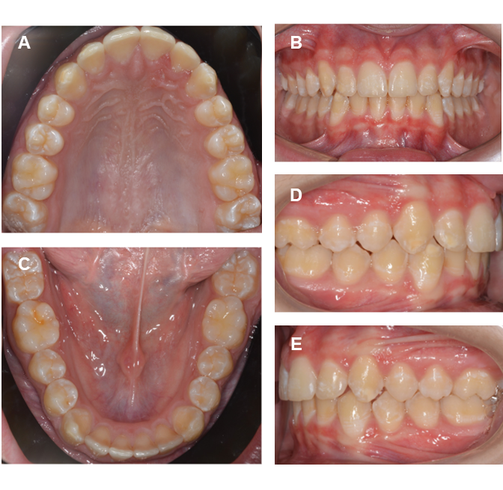
Fig. 1. Initial presentation depicted in views (A-E) showing occlusal ((upper (A)/lower (C)), front (B), right (D), and left (E) arch aspects, revealed characteristic white/cream MIH opacities on teeth #12, #13, #23, #43 (buccal), #46 (occlusal), and #16 (mesial) While not overtly extensive, these defects were the primary source of the patient's aesthetic dissatisfaction, underscoring the subjective impact of developmental enamel defects and their varied presentations. Alongside these, distinct white spot lesions from post-orthodontic effects and DF were noted.

Fig. 2. Transillumination. Teeth #12 (A), #13 (B), and #43 (C).

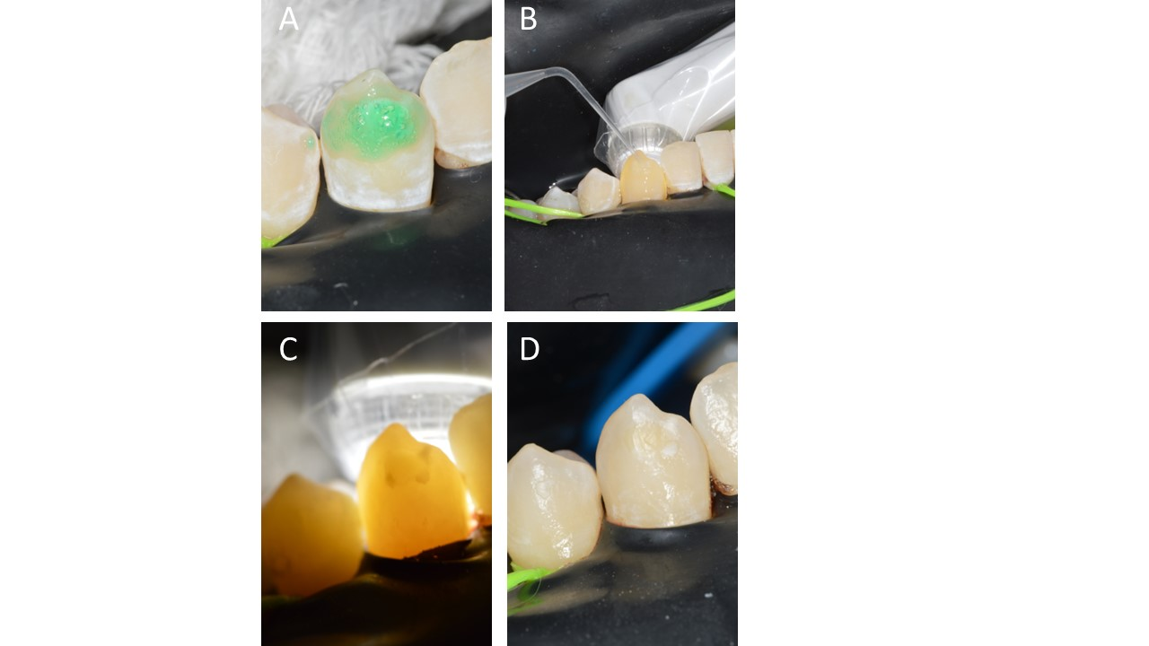

Fig. 3. Tooth #43. (A) Fourth Icon Etch cycle; (B-C) Icon Dry (transillumination); (D) Icon Infiltrant application (D). Arrows: residual Invisalign resin.

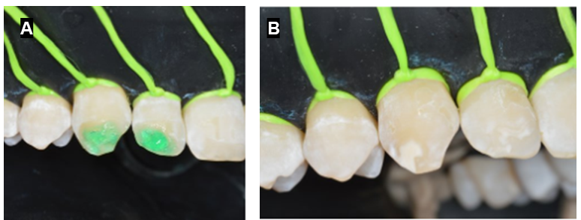
Fig. 4: Teeth #12 and #13. A) Second Icon Etch cycle; B) Post-etch result.
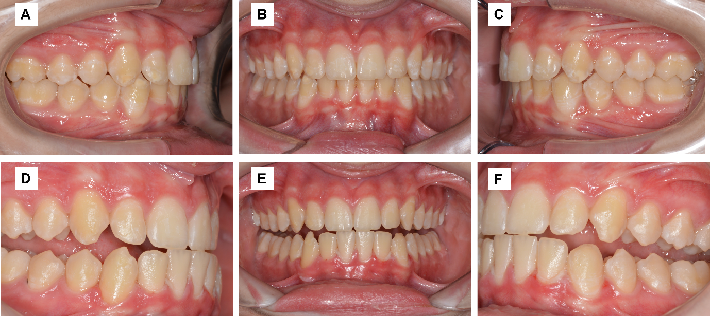

Fig. 5. Initial (A: Right, B: Front, C: Left views) and post-treatment (D: Right, E: Front, F: Left views) results. Immediate post-treatment shows significant reduction of white opacities and dyschromias on teeth #12, #13, #43, and #23, with improved color uniformity and masked defects, addressing aesthetic concerns (cf. Fig. 1 B vs. E).

- discussion

Although the HMI-TNI_2a and DF lesions in this case did not exhibit maximum morphological severity (e.g., extensive structural loss or intense hypersensitivity), the 14-year-old adolescent's aesthetic dissatisfaction was a key driver for intervention. It is crucial to acknowledge that an enamel defect's perceived severity extends beyond objective classification, encompassing its significant psychosocial impact on self-esteem and quality of life, particularly during adolescence. In this sense, a comprehensive, severity-tailored treatment strategy is essential for managing MIH and its manifestations. Resin infiltration can be systematically combined with other dental treatments, such as microabrasion, dental bleaching, and composite resin restoration, to optimize aesthetic and functional outcomes. However, an overview of systematic reviews assessing the quality of evidence for MIH treatment revealed that the available evidence is of low to moderate quality for most interventions. This finding indicates that, for treatments such as resin infiltration (RI) for developmental enamel defects, a limited high-quality evidence base currently exists to support its standalone efficacy for masking (Gevert et al., 2022).
Consequently, treatment decisions necessitate a patient-centered approach, considering the patient's age, expectations, and guardian concerns. This approach was exemplified as the patient's primary aesthetic concern focused solely on hypomineralization defects, not overall tooth shade. Therefore, at-home dental bleaching, that could offer considerable improvement (Wittich et al., 2024), was declined by both the patient and parents due to associated procedural risks, prioritizing specific defect resolution and risk avoidance. Despite a double acid application, cervical DF stains and hypomineralization persisted on teeth 12, 13, 23, 43, and 46, aligning with Alghawe & Raslan's (2024) findings regarding the influence of opacity coloration on acid application numbers. Yellowish stains, such as those on tooth 46, may require multiple acid cycles for complete masking (Kabeel et al., 2024). This outcome supports the removal of altered enamel, in conjunction with two reconditioning procedures, to achieve aesthetic recovery.
Resin infiltration (RI) is crucial for demineralized enamel, particularly in developmental defects. Deeper lesions necessitate intensified protocols, including extended etching, abrasion, or longer infiltration times for full enamel saturation (Srikumar et al., 2024; Marouane & Manton, 2021). Monitoring RI to complete saturation, often 20-22 minutes for specific teeth like #43, is vital (Marouane & Chtioui, 2020). Controlled diagnostic methods like white light transillumination (Blanchet et al., 2023) and the Icon-Dry test (Marouane & Chtioui, 2020) enable real-time visualization of resin penetration and predict outcomes. A personalized approach is essential, as DF may require significantly longer infiltration times (Shahroom et al., 2019). Transillumination (Fig. 2) proved indispensable, revealing significant subsurface enamel compromise even in mild lesions, justifying extended acid etching and infiltration times for complete saturation and reinforcement, validated by Icon-Dry test monitoring.
This case demonstrates that RI is highly effective for mild-to-moderate MIH and DF lesions, not just severe cases (Casaña-Ruiz et al., 2023; Gupta et al., 2017; Garg et al., 2022). This minimally invasive treatment successfully masks dyschromias and opacities, transforming white spots into a translucent, homogeneous appearance, as evidenced by immediate aesthetic improvement and high patient satisfaction (Fig. 5). Resin infiltration also reinforces hypomineralized enamel (Zhao & Ren, 2016; Crombie et al., 2014), preventing defect progression. The varying need for selective reduction between DF and deeper MIH lesions highlights the technique's adaptable nature.

4. Conclusion

This case demonstrates the successful multimodal and personalized treatment of an adolescent's aesthetic concerns, even for Molar Incisor Hypomineralization (MIH) and Dental Fluorosis (DF) lesions initially perceived as moderately severe. The combination of selective enamel reduction for deeper MIH lesions (revealed by transillumination) and resin infiltration for all defects promoted notable aesthetic improvement and high patient satisfaction.

Consent

All authors declare that ‘written informed consent was obtained from the patient (or other approved parties) for publication of this case report and accompanying images. A copy of the written consent is available for review by the Editorial office/Chief Editor/Editorial Board members of this journal.

Ethical approval

This case report followed the guidelines of Resolution 466/12 (National Health Council/MS, December 12, 2012) and was approved by the Human Research Ethics Committee at the State University of Western Paraná (UNIOESTE) (Approval Number: 5,976,302). The patient and their legal guardians were thoroughly briefed on the study's purpose, associated risks, and potential benefits, with an emphasis on their right to voluntary participation and withdrawal. Written informed consent was then secured from the patient and their parents. Furthermore, specific permission for image utilization was also acquired.
DISCLAIMER (ARTIFICIAL INTELLIGENCE)

Author(s) hereby declare that generative AI technologies such as Large Language Models, etc. have been used during the writing or editing of manuscripts. This explanation will include the name, version, model, and source of the generative AI technology and as well as all input prompts provided to the generative AI technology
Details of the AI usage are given below:
Linguistic and stylistic revision of this manuscript was performed using the "Adapta-developed AI model One", enhancing clarity, fluency, and conciseness. The revision process was guided by the following specific prompts:
- "Revise the English text to enhance its fluency and cohesion while maintaining the central idea and references. The final text should be slightly more concise than the original while preserving key content and meaning. Include specific suggestions for: - Improving sentence structure and flow. - Enhancing vocabulary precision. - Eliminating redundant information. - Strengthening logical connections between paragraphs. - Maintaining essential references and context. Provide the revised text with tracked changes to show the original content and the modifications made. Ensure that the final version is clear, concise, and effectively communicates the intended message.”
- "Improve the linguistic quality of the provided text, enhance its cohesion and fluency, while maintaining its original structure, including numbering. Subsequently, translate the revised text into English, ensuring adherence to scientific writing conventions and the clarity typical of academic discourse in English, with particular attention to technical terminology in dentistry."
To ensure the originality and integrity of the work, the final manuscript was subjected to plagiarism detection using the Turnitin platform. The results confirmed that the content meets academic standards for originality.
No AI text-to-image generators were used in the preparation of this manuscript.

References

Martins D. D. S., Ionta F. Q., Pompermaier Garlet G., Lima R. R., & Neves A. A. et al. (2024), Developmental Defects of Enamel. Monogr Oral Sci. 32:10-34. https://doi.org/10.1159/000538850
Costa-Silva C. M., Ambrosano G. M. B., Jeremias F., Souza J. F., & Mialhe F. L. (2011), Increase in severity of molar-incisor hypomineralization and its relationship with the colour of enamel opacity: a prospective cohort study. Int J Paediatr Dent., 21(5):333-341. https://doi.org/10.1111/j.1365-263X.2011.01128.x
Elhennawy K., Manton D. J., Crombie F., Zaslansky P., Radlanski R. J., & Jost-Brinkmann P. G. et al. (2017). Structural, mechanical and chemical evaluation of molar-incisor hypomineralization-affected enamel: A systematic review, Arch Oral Biol., 83:272-281. https://doi.org/10.1016/j.archoralbio.2017.08.008
Thylstrup A., & Fejerskov O. (1978). Clinical appearance of dental fluorosis in permanent teeth in relation to histologic changes. Community Dent Oral Epidemiol, 6(6): 315-328. https://doi.org/10.1111/j.1600-0528.1978.tb01173.x
Casaña-Ruiz M. D., Marqués Martínez L., & García Miralles E. (2023). Management of hypoplastic or hypomineralized defects with resin infiltration at pediatric ages: systematic review. Int J Environ Res Public Health, 20(6):5201. https://doi.org/10.3390/ijerph20065201
Gupta A., Dhingra R., Chaudhuri P., & Gupta A. (2017). A comparison of various minimally invasive techniques for the removal of dental fluorosis stains in children. J Indian Soc Pedod Prev Dent., 35(3):260-268. https://doi.org/10.4103/jisppd.jisppd_138_16
Garg I., Kumar A., & Kumar A. (2022). Comparative Evaluation of Esthetic Improvement of Resin Infiltration (RI), In-office Bleaching (B), Enamel Microabrasion (M) and Resin Infiltration with Double Application of Infiltrant (2RI) on Non-pitted Fluorosis Stains: A Randomized Six-month Interventional Study. Int J Clin Pediatr Dent., 15(1):20-34. https://doi.org/10.5005/jp-journals-10005-2140
Gevert M. V., Soares R., Wambier L. M., Ribeiro A. E,. Avais L. S., & de Souza J. F. et al. (2022). How is the quality of the available evidence on molar-incisor hypomineralization treatment? An overview of systematic reviews. Clin Oral Investig., 26(10):5989-6002. https://doi.org/10.1007/s00784-022-04612-9
Dean H. T. (1934). Classification of mottled enamel diagnosis. J Amer Dent Assoc.; 21(8):1421-1426.
Cabral R. N., Nyvad B., Soviero V. L. V. M., Freitas E., & Leal S. C. (2020). Reliability and validity of a new classification of MIH based on severity. Clin Oral Investig., 24(2):727-734. https://doi.org/10.1007/s00784-019-02955-4
Marouane O., & Chtioui F. (2020). Transillumination-aided infiltration: A diagnostic concept for treating enamel opacities. J Esthet Restor Dent., 32(5):451-456. https://doi.org/10.1111/jerd.12602
Wittich F. K, Cebula M., Effenberger S., Schoppmeier C. M, Schwendicke F., & Barbe A. G. et al. (2024). Masking efficacy of bleaching and/ or resin infiltration of fluorotic spots on anterior teeth - a systematic review and meta-analysis. J Dent., 149:105276. https://doi.org/10.1016/j.jdent.2024.105276
Alghawe S., & Raslan N. (2024). Management of permanent incisors affected by Molar-Incisor-Hypomineralisation (MIH) using resin infiltration: a pilot study. Eur Arch Paediatr Dent., 25(1):105-116. https://doi.org/10.1007/s40368-024-00861-2
Kabeel D. G., Nour K. A., & Sedky R. A. (2024). The effect of resin infiltration technique on the calculated color change of demineralized lesions of different severities. Oper Dent., 49(4):443-454. https://doi.org/10.2341/23-126-L
Srikumar G. P. V., Ghosh M., Kumar A. A., Bardia S., Wasule A., & Beautlin J. S. (2024). An in vitro evaluation of Icon resin infiltrant penetration into demineralized enamel lesions using an indirect staining technique with confocal laser scanning microscope analysis in dual fluorescence mode. J Conserv Dent Endod., 27(4):366-372. https://doi.org/10.4103/JCDE.JCDE_3_24
Marouane O., & Manton D. J. (2021). The influence of lesion characteristics on application time of an infiltrate applied to MIH lesions on anterior teeth: An exploratory in vivo pilot study. J Dent., 115:103814. https://doi.org/10.1016/j.jdent.2021.103814
Blanchet I., Camoin A., Tardieu C., & Jacquot B. (2023). Microabrasion in the management of enamel discolorations in paediatric dentistry: a systematic review. J Clin Pediatr Dent., 47(1):17-26. https://doi.org/10.22514/jocpd.2022.015
Shahroom N. S. B., Mani G., & Ramakrishnan M. (2019). Interventions in management of dental fluorosis, an endemic disease: A systematic review. J Family Med Prim Care., 8(10):3108-3113. https://doi.org/10.4103/jfmpc.jfmpc_648_19
Zhao X., & Ren Y. F. (2016). Surface properties and color stability of resin-infiltrated enamel lesions. Oper Dent., 41(6):617-626. https://doi.org/10.2341/15-319-L
Crombie F, Manton D, Palamara J, & Reynolds E. Resin infiltration of developmentally hypomineralised enamel. Int J Paediatr Dent 2014; 24: 51-55.

