Epidemiological profile and diagnostic trends of meningococcal disease in Brazil across pre-, peri-, and post-pandemic periods

.
ABSTRACT

Aims: To describe the epidemiological profile and diagnostic trends of meningococcal meningitis with meningococcemia in Brazil before, during, and after the COVID-19 pandemic, with emphasis on diagnostic criteria and regional distribution to assess the impact on these patterns.
Study design: Ecological study using national surveillance data from the Notifiable Diseases Information System (SINAN).
Place and Duration of Study: Brazil, covering 01 January 2015 to 31 May 2024.
Methodology: A retrospective, cross-sectional study was conducted using secondary data from the Notifiable Diseases Information System (SINAN) between 2015 and 2024. Confirmed cases in individuals aged 0–18 years were grouped into three periods: pre-pandemic (2015–2019), peri-pandemic (2020–2022), and post-pandemic (2023–2024). Diagnostic methods were categorized as polymerase chain reaction (PCR), culture, clinical criteria Descriptive analyses, Chi-square tests, and multivariate logistic regression were applied. A complete-case analysis was performed after data cleaning to handle missing information. Data were analyzed using R 4.4.2. Pearson’s chi-square test and logistic regression were applied to evaluate associations, with statistical significance set at p < 0.05.
Results: A total of 1,186 confirmed cases in individuals aged 0–18 years were analyzed, 917 (77.3%) pre-pandemic, 174 (14.7%) peri-pandemic, and 95 (8.0%) post-pandemic. Diagnostic confirmation by PCR increased from 42.8% before the pandemic to 63.1% afterward, while clinical criteria decreased proportionally. Significant differences were observed between periods for diagnostic method (p<0.001) and case fatality (p=0.038). The odds of diagnosis by PCR were 1.9 times higher in the post-pandemic period compared with the pre-pandemic baseline (95% CI: 1.35–2.68).
Conclusion: Despite reduced overall case numbers during the pandemic, PCR-based diagnosis expanded substantially, likely reflecting improved laboratory capacity and surveillance integration post-COVID-19. The findings highlight both progress and persistent disparities in meningococcal disease reporting across Brazilian regions.

Keywords: Meningococcal Infections; Meningitis, Meningococcal; Diagnostic Criteria; Epidemiology; Public Health Surveillance.

1. INTRODUCTION

Meningitis, an inflammation of the meninges typically of infectious origin, remains a significant global health concern due to its acute onset and substantial associated morbidity and mortality, particularly among pediatric populations. Bacterial agents represent the most severe forms of the disease, with Neisseria meningitidis, Streptococcus pneumoniae, and Haemophilus influenzae type B accounting for the majority of meningitis-related fatalities worldwide¹. Neisseria meningitidis is particularly concerning due to its potential to cause meningococcemia, an invasive and rapidly progressive condition characterized by hematogenous dissemination and severe systemic inflammatory response^{2]} This manifestation proves especially dangerous for children under five and adolescents, demonstrating high case-fatality rates and frequent neurological sequelae³.
The global burden of meningitis persists despite vaccination advances, with over 236,000 deaths estimated in 2019, predominantly affecting children under five⁴. While high-income countries have achieved substantial reductions through immunization programs, low- and middle-income regions continue to face challenges including suboptimal vaccine coverage, emerging antimicrobial resistance, and limited healthcare acces^{5,6}. Invasive meningococcal disease exhibits both endemic and epidemic patterns, with serogroups A, B, C, W, and Y driving most outbreaks globally⁷.
In Brazil, despite surveillance and immunization advances, meningococcal disease remains a public health priority requiring continuous monitoring to inform prevention and control policies. The Brazilian surveillance system relies on mandatory notification, with laboratory confirmation being essential for etiological identification and timely implementation of response measures, including vaccination campaigns, contact chemoprophylaxis, and intensified surveillance in high-risk regions⁸. Diagnostic approaches encompass cerebrospinal fluid analysis, culture, PCR, and increasingly, genomic sequencing—tools fundamental for both clinical management and public health actions such as genomic surveillance and antimicrobial resistance monitoring^{9,10]} Rapid identification remains crucial given meningococcemia's potential for fulminant progression, with death possible within hours of symptom onset.
Despite this robust surveillance framework, temporal trends in pediatric meningococcemia diagnosis and epidemiology in Brazil, particularly regarding major disruptive events like the COVID-19 pandemic, remain insufficiently explored. This study aims to describe epidemiological characteristics and analyze confirmed cases of meningococcal meningitis with meningococcemia in the pediatric population (0–18 years) in Brazil between 2015 and 2024 using SINAN data. Specifically, we examine incidence trends, diagnostic method distribution, and potential case profile shifts across pre-pandemic, pandemic, and post-pandemic periods.

2. material and methods

Study Design and Data Source
We conducted an observational, retrospective, cross-sectional study using individual-level microdata from the Brazilian Notifiable Diseases Information System (SINAN), that compiles national surveillance data from all federative units and is maintained by the Brazilian Ministry of Health, covering meningococcal meningitis with meningococcemia (ICD-10 A39.2) notified between 1 January 2015 and 31 May 2024. The study population included individuals aged 0–18 years from all Brazilian federal units.

Variables and Period Categorization
Extracted variables included year of notification, age group, sex, diagnostic method (PCR, culture, clinical criteria, or other), and pandemic period. To capture the temporal impact of the COVID-19 pandemic on meningococcal surveillance and diagnostic practices, we categorized the study timeline into three distinct periods: Pre-pandemic (2015–2019), that representing baseline trends before SARS-CoV-2 circulation; Peri-pandemic (2020–2022), encompassing years of disrupted healthcare access and altered disease reporting; Post-pandemic (2023–2024), corresponding to the recovery phase of health systems and normalization of surveillance routines. This classification was chosen based on temporal markers consistent with national COVID-19 epidemiological phases and World Health Organization (WHO) reporting standards.

Statistical Analysis and Data Handling:
Descriptive statistics summarized frequencies and proportions of cases by year, age group, and diagnostic method. The Chi-square test assessed differences between categorical variables, and binary logistic regression was used to estimate adjusted odds ratios (OR) and 95% confidence intervals (CI) for PCR diagnosis according to the epidemiological period. All analyses were conducted using R (version 4.2.3) with a 5% significance level.
All data were reviewed for completeness and consistency before analysis. Records with missing diagnostic method or outcome were excluded (“listwise deletion”), as imputation was deemed inappropriate for surveillance data. This decision was justified to preserve data validity and avoid bias in regression modeling.

3. results and discussion
Results
Analysis of 1,186 confirmed cases revealed notable temporal variation (Figure 1). Case numbers declined steadily from 228 in 2015 to 162 in 2019, followed by a sharp drop to 32 in 2020, coinciding with the onset of the COVID-19 pandemic. Notifications remained low in 2021 (35 cases), then gradually rose in 2022 (61 cases), reaching 93 in 2023. By May 2024, 39 additional cases had been recorded. Overall, reported cases during the pandemic years (2020–2022; n=67) were markedly lower than in the pre-pandemic period (2015–2019; n=917), with partial recovery observed in the post-pandemic phase (2023–2024; n=202). (Figure 1).

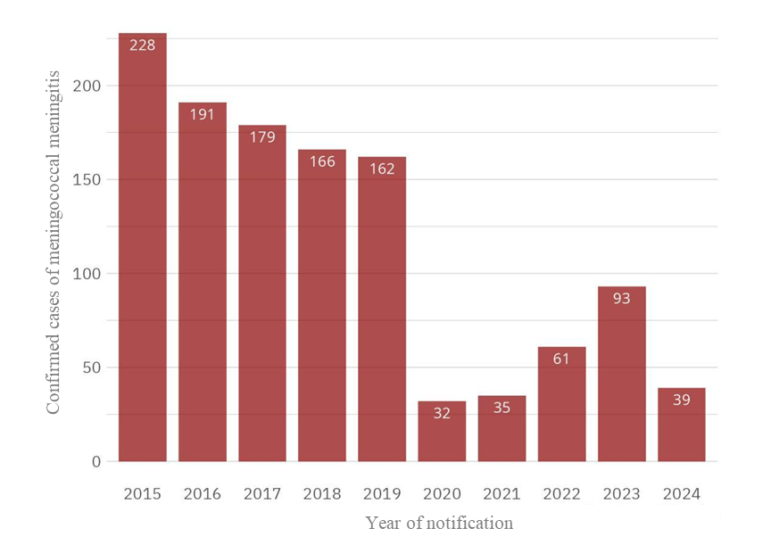
Figure 1. Yearly distribution of confirmed meningococcal meningitis with meningococcemia cases in individuals aged 0–18 years in Brazil.

Significant variation in diagnostic approaches occurred across periods (χ²=61.38; p<0.0001; Cramer's V=0.15). The overall proportion of cases confirmed by PCR increased steadily across the three periods. In the pre-pandemic period (n=917), clinical criteria constituted the most frequent diagnostic method (35.6%), followed by culture (25.0%) and PCR (22.1%). During the pandemic (n=128), clinical criteria increased to 50.0% while culture decreased substantially to 11.7%. PCR remained relatively stable (14.8%). In the post-pandemic period (n=131), PCR became predominant (69.5%), while clinical criteria decreased to 17.0% and culture represented only 7.6% (Figure 2).
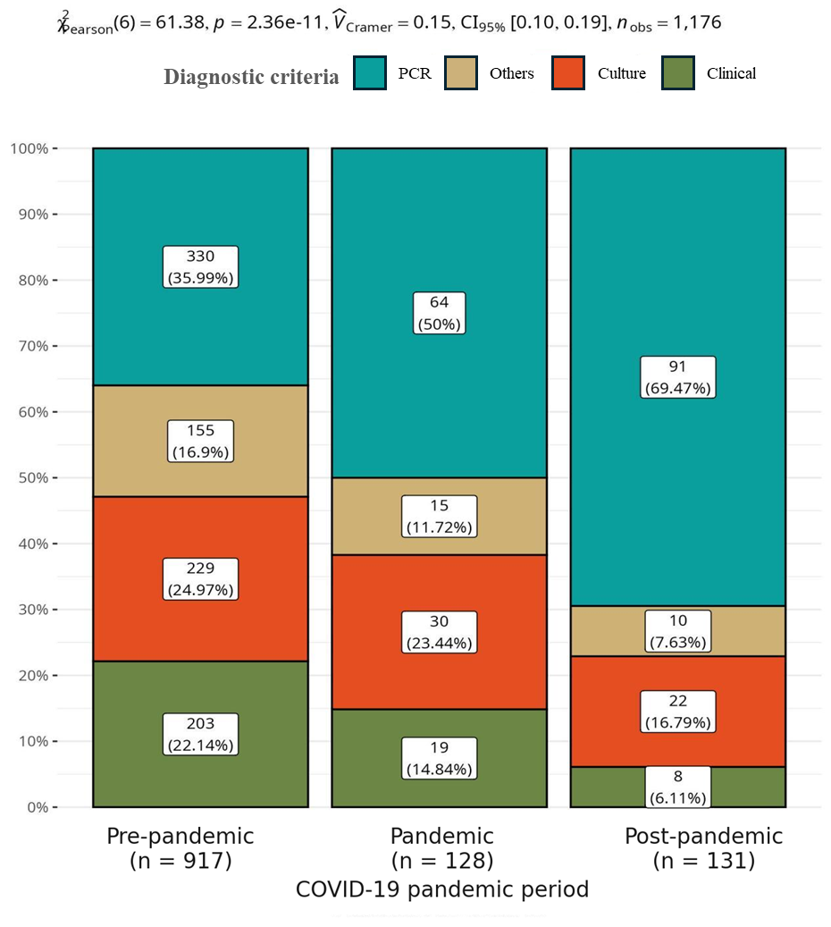
Figure 2. Yearly distribution of diagnostic criteria among confirmed meningococcal meningitis with meningococcemia cases in individuals aged 0–18 years in Brazil, January 2015–May 2024.

Discussion

This study provides an updated epidemiological overview of meningococcal disease in Brazil over a decade marked by the COVID-19 pandemic, highlighting temporal shifts in diagnostic strategies and reporting practices.
Our analysis reveals significant temporal and diagnostic patterns in pediatric meningococcal disease in Brazil across the study period. The pre-pandemic decline (2015-2019) aligns with established trends following the introduction and expansion of the meningococcal C conjugate vaccine in the Brazilian childhood immunization schedule ^{11,12}, consistent with documented vaccination effectiveness^{13,14}.
The dramatic reduction in cases during 2020-2021 corresponds with COVID-19 onset and implementation of non-pharmaceutical interventions, including social distancing, mask mandates, and school closures, reflecting both reduced pathogen circulation ^{15,16}. The subsequent case resurgence from 2022 onward parallels global trends of meningococcal disease rebound following relaxation of public health measures^{17,18}, potentially exacerbated by accumulated vaccination gaps during the pandemic disruption^{19,20}.
The diagnostic shift toward clinical criteria during the pandemic likely reflects healthcare system overload and temporary reductions in laboratory capacity^{9,21}. The subsequent predominance of PCR in the post-pandemic period indicates recovery of molecular diagnostic capabilities and aligns with WHO recommendations prioritizing rapid confirmatory methods^{22,23}. This evolution toward molecular diagnostics enhances surveillance accuracy and represents a positive development in disease monitoring, though maintaining culture capacity remains crucial for antimicrobial resistance surveillance and outbreak investigation²⁴⁻²⁷.

Limitations and Strengths

Limitations of this study include those inherent to secondary data from SINAN, such as underreporting and incomplete records, exacerbated during health system disruptions. The ecological design limits individual-level inferences, and the absence of population denominators restricts incidence rate calculations. Serogroup analysis was also limited by data availability. We addressed these through rigorous data cleaning and complete-case analysis. Nonetheless, our study offers comprehensive national insights into pediatric meningococcal disease trends across a decade that included a major pandemic, providing crucial information for public health planning. Future surveillance should enhance data completeness through active case-finding and laboratory network strengthening.

4. Conclusion

This study demonstrates important temporal and diagnostic changes in meningococcal meningitis with meningococcemia among children and adolescents in Brazil. A significant reduction in cases was observed following the onset of the COVID-19 pandemic, followed by a gradual resurgence, likely associated with relaxation of sanitary measures and resumption of in-person activities. Concurrently, there was a progressive shift from traditional laboratory-based diagnostics to clinical criteria and molecular methods, reflecting both structural limitations and changes in healthcare workflows. These findings highlight the need to reinforce epidemiological surveillance, maintain laboratory infrastructure, and ensure timely, accurate diagnostics to guide vaccination strategies, allocate healthcare resources effectively, and control meningococcal disease. Future research should focus on serogroup-specific incidence, the long-term impact of diagnostic shifts on reporting, and evaluating vaccine effectiveness in post-pandemic contexts.

Consent

This study utilized secondary, aggregated data from the Notifiable Diseases Information System (SINAN) panel (Brazil). As such, individual patient data was not identifiable. Consequently, the analysis did not involve primary data collection or interventions. Due to the retrospective design and the use of aggregated, anonymized data, this study poses no risk of violating participants' privacy or integrity, nor does it contravene current legislation.”

Ethical approval

According to Brazilian National Health Council Resolution No. 510/2016, the data used in this study were considered public access and did not require submission to the Research Ethics Committee. The data were presented in aggregate form, without allowing the identification of individual participants, ensuring privacy and confidentiality.

Disclaimer (Artificial intelligence)
Option 1:
Author(s) hereby declare that NO generative AI technologies such as Large Language Models (ChatGPT, COPILOT, etc.) and text-to-image generators have been used during the writing or editing of this manuscript.
Option 2:
Author(s) hereby declare that generative AI technologies such as Large Language Models, etc. have been used during the writing or editing of manuscripts. This explanation will include the name, version, model, and source of the generative AI technology and as well as all input prompts provided to the generative AI technology
Details of the AI usage are given below:
1.
2.
3.

References

- Global Burden of Disease 2019 Meningitis Collaborators. Global, regional, and national burden of meningitis and its aetiologies, 1990–2019: a systematic analysis for the Global Burden of Disease Study 2019. Lancet Neurol. 2022;21(1):60–89. Global Burden of Disease 2019 Meningitis Collaborators. Global, regional, and national burden of meningitis and its aetiologies, 1990–2019: a systematic analysis for the Global Burden of Disease Study 2019. Lancet Neurol. 2022;21(1):60–89.
- Rausch-Phung EA, Siddiqui JA, Gulick PG. Meningococcemia. In: StatPearls [Internet]. Treasure Island (FL): StatPearls Publishing; 2025 Jan. Rausch-Phung EA, Siddiqui JA, Gulick PG. Meningococcemia. In: StatPearls. Treasure Island (FL): StatPearls Publishing; 2025 Jan.
- Hersi K, Gonzalez FJ, Kondamudi NP. Meningitis. In: StatPearls. Treasure Island (FL): StatPearls Publishing; 2023 Aug.
- World Health Organization. Meningitis [Internet]. Geneva: WHO; 2025 [cited 2025 Jul 14]. Available from: https://www.who.int/news-room/fact-sheets/detail/meningitis.
- Global Burden of Disease Collaborative Network. Burden of disease scenarios for 204 countries and territories, 2022–2050: a forecasting analysis for the Global Burden of Disease Study 2021. Lancet. 2024;403(10440):2204–56.
- Brazil. Ministry of Health. Meningitis [Internet]. Brasília: Ministério da Saúde; [cited 2025 Jul 14]. Available from: https://www.gov.br/saude/pt-br/assuntos/saude-de-a-a-z/m/meningite
- Chhabria D, Anjankar A. An Overview of Meningococcal Disease's Recent Diagnostic and Treatment Model. Cureus. 2023;15(11):e48509.
- Brazil. Ministry of Health. Health and Environment Surveillance Secretariat. Department of Strategic Actions in Epidemiology and Health and Environment Surveillance. Health Surveillance Guide: volume 1. 6th ed. rev. Brasília: Ministério da Saúde; 2024.
- Ciftci E, Ocal D, Somer A, et al. Current methods in the diagnosis of invasive meningococcal disease. Front Pediatr. 2025;13:1511086.
- Rausch-Phung EA, Hall WA, Ashong D. Meningococcal Disease (Neisseria meningitidis Infection). In: StatPearls [Internet]. Treasure Island (FL): StatPearls Publishing; 2025 Jun.
- Presa J, de Almeida R, Spinardi J, et al. Epidemiological burden of meningococcal disease in Brazil: A systematic literature review and database analysis. Int J Infect Dis. 2019;80:137-146. doi:10.1016/j.ijid.2019.01.009.
- Htar MTT, Jackson S, Balmer P, et al. Systematic literature review of the impact and effectiveness of monovalent meningococcal C conjugated vaccines when used in routine immunization programs. BMC Public Health. 2020;20(1). doi:10.1186/s12889-020-09946-1.
- Nunes A, Abreu AJL, Cintra O, et al. Meningococcal disease epidemiology in Brazil (2005–2018) and impact of MenC vaccination. Vaccine. 2021;39(3):605-616. doi:10.1016/j.vaccine.2020.11.067.
- McMillan M, Chandrakumar A, Wang HLR, et al. Effectiveness of meningococcal vaccines at reducing invasive meningococcal disease and pharyngeal Neisseria meningitidis carriage: a systematic review and meta-analysis. Clin Infect Dis. 2021;73(3):e609-e619. doi:10.1093/cid/ciaa1733.
- Alderson MR, Arkwright PD, Bai X, Black S, Borrow R, Caugant DA, Dinleyici EC, et al. Surveillance and control of meningococcal disease in the COVID-19 era: A Global Meningococcal Initiative review. J Infect. 2022 Mar;84(3):289-296. doi: 10.1016/j.jinf.2021.11.016.
- Bloom DE, Bonanni P, Martinón-Torres F, Richmond PC, Safadi MAP, Salisbury DM, et al. Meningococcal Disease in the Post-COVID-19 Era: A Time to Prepare. Infect Dis Ther. 2023 Dec;12(12):2649-2663. doi: 10.1007/s40121-023-00888-w.
- Findlow J, Htar MTT, Villena R, Balmer P. Invasive Meningococcal Disease in the Post-COVID World: Patterns of Disease Rebound. Vaccines (Basel). 2025 Feb 8;13(2):165. doi: 10.3390/vaccines13020165.
- Clark SA, Campbell H, Ribeiro S, Bertran M, Walsh L, Walker A, Willerton L, Lekshmi A, Bai X, Lucidarme J, Ladhani SN, Borrow R. Epidemiological and strain characteristics of invasive meningococcal disease prior to, during and after COVID-19 pandemic restrictions in England. J Infect. 2023 Nov;87(5):385-391. doi: 10.1016/j.jinf.2023.09.002.
- Taha S, Hong E, Denizon M, Falguières M, Terrade A, Deghmane A-E, et al. Increase of invasive meningococcal disease caused by Neisseria meningitidis serogroups C, W, and Y in France in 2022 and 2023. J Infect Public Health. 2023;16(12):1875-8. doi: 10.1016/j.jiph.2023.10.001.
- Clark SA, Campbell H, Mensah AA, Lekshmi A, Walker A, Ribeiro S, et al. An increase in group B invasive meningococcal disease among adolescents and young adults in England following easing of COVID-19 containment measures. J Infect. 2022;84(5):e49-e51. doi: 10.1016/j.jinf.2022.02.022.
- Chhabria D, Anjankar A. An Overview of Meningococcal Disease's Recent Diagnostic and Treatment Model. Cureus. 2023 Nov. doi:10.7759/cureus.48509.
- Millar B, et al. Meningococcal Disease Section 3: Diagnosis and Management. Ulster Med J. 2018;87(2):94–98.
- WHO. Guidelines on meningitis diagnosis, treatment and care. Geneva: World Health Organization; 2025. Available from: https://www.ncbi.nlm.nih.gov/books/NBK614844/
- Itsko M, et al. Enhancing Meningococcal Genomic Surveillance in the Meningitis Belt Using High-Resolution Culture-Free Whole-Genome Sequencing. J Infect Dis. 2022 Sep 4;226(4):729-737. doi: 10.1093/infdis/jiac104. PMID: 35325163; PMCID: PMC11091911.
- Sotheran E, et al. Genomic Surveillance of Invasive Meningococcal Disease During a National MenW Outbreak in Australia, 2017-2018. Open Forum Infect Dis. 2024 May 2;11(6):ofae249. doi: 10.1093/ofid/ofae249. PMID: 38854393; PMCID: PMC11161896.
- Cassiolato AP, Camargo CH, Piccoli Cecconi MC, Christakis S, Gonçalves CR, Campos KR, et al. Genomic characterization of invasive meningococcal X isolates from Brazil, 1992–2022. Int Microbiol. 2024;27(2):499-509. doi: 10.1007/s10123-023-00325-5.
- Arteta-Acosta C, Villena R, Hormazabal JC, Fernández J, Santolaya ME. Whole-genome sequencing of Neisseria meningitidis collected in Chile from pediatric patients during 2016–2019 and coverage vaccine pred. Vaccine. 2024;42(24):5269-77. doi: 10.1016/j.vaccine.2024.06.080.

