Original Research Article

GUT MICROBIOTA IN DIFFERENT STAGES AND SUBTYPES OF COLORECTAL CANCER IN NAIROBI, KENYA

.
ABSTRACT
ABSTRACT:
Background: Sub-Saharan African colorectal cancer (CRC) incidence is rising with delayed diagnosis being common since the population does not have access to many screening programs. Alterations in gut microbiota have been associated with CRC, although not much is known from cohorts in Africa.
Aims: To characterized and compare mucosal gut microbiota in Colorectal Cancer (CRC) stages and pathology subtypes to identify the biomarkers.
Study design: A case-control study
Place and Duration of Study: Department of Pathology, Aga Khan University Hospital (AKU) and Jomo Kenyatta University of Agriculture and Technology (JKUAT), between January 2021- December 2023.
Methodology: We analyzed 60 Formalin-fixed Paraffin wax-embedded (FFPE) colorectal biopsy samples (30 cases and 30 controls) of patients from Aga Khan University Hospital. We processed the tissues histologically, extracted the DNA and analyzed through 16S rRNA gene PCR amplification and sequencing. Taxonomic assignment was calculated by Biological Locus Alignment Sequence Tool (BLAST) against the NCBI 16S microbial database.

Results: Major bacterial species that were found in CRC were Oscillospiraceae bacterium, Clostridales bacterium, Acetivibrio sp., Eubacterium, Texcoconibacillus texcoconensis, and Staphylococcus sp. Stage II CRC was of greater microbial richness than Stage III. Mucinous adenocarcinoma was associated with Firmicutes commensals, and invasive adenocarcinoma with pathogenic members like Bacillus cereus and Staphylococcus spp.

Conclusion: Gut microbiota community structure is stage and subtype-specific in CRC. The shift from commensal to pathogenic bacteria suggests that microbial dysbiosis has the potential to contribute to the development of CRC. Microbiota profiling may assist in the early diagnosis of CRC and guide individualized diagnostic strategies in African populations

Keywords: Humans, Developing Countries, Genes, rRNA, Polymerase Chain Reaction, Biopsy, Colorectal Neoplasms, Mucous Membrane

1. INTRODUCTION

Colorectal cancer (CRC) poses a major health challenge, being the third most frequently diagnosed cancer and the second leading cause of cancer-related deaths worldwide (Ung et al., 2021). The incidence of CRC is rising not only in high income countries but also in middle and low income countries like Kenya, where the disease is detected at an advanced stage because of restricted availability of screening and diagnostic services (Ung et al., 2021; WHO, 2017). Epidemiological data have implicated gut microbiota in CRC initiation and development. Microbial imbalance may potentially enhance tumorigenesis by a number of mechanisms involving chronic inflammation, immune modulation and carcinogenic metabolite formation (Yusuf et al., 2023; Zorron et al., 2020 ; Mizutani et al., 2020; Guo et al., 2022). Some bacterial groups, such as Fusobacterium nucleatum, have been shown to promote colorectal carcinogenesis by E-cadherin/β-catenin signaling modulation through its FadA adhesion (Rubinstein et al., 2013). Similarly, Streptococcus gallolyticus is highly adhesive to colonic colonization and tumor formation (Aymeric et al., 2018).
Studies have demonstrated that the composition of gut microbiota is broadly varied in healthy people and CRC patients, as well as between early and advanced CRC stages (Weir et al., 2013; Zorron et al., 2020). These microbial signatures can serve as potential biomarkers for early diagnosis and therapeutic targets. However, most microbiome CRC studies have been conducted in Western or Asian populations, and few data from African cohorts where environmental, dietary, and genetic factors could influence differences in microbiota composition (Guo et al., 2022; Parker et al., 2020).
We characterized mucosal-associated gut microbiota in patients with different pathology subtypes and stages of colorectal cancer in Nairobi, Kenya. This identified the potentially microbial environment that is associated with CRC in this population, thus guiding locally relevant prevention, diagnosis and treatment strategies.

2. methodology

This was a retrospective case-control study where 60 samples (Fleiss et al., 2004) (30 CRC and 30 normal adjacent tissues) were drawn from Formalin Fixed Paraffin Embedded (FFPE) tissues collected from African patients living in Kenya who presented with colorectal tumor and verified by the pathologists at the Aga Khan University Hospital (AKUH) cancer clinic from January 2017 to December 2018. Confirmed CRC tissues formed the cases while tissues from non-CRC sites from the same patient were considered as the control group.

2.1 Microbial Community
To compare the microbial community in the proximal colon of colorectal cancer and distal non-malignant region, Nucleic acid was extracted from the FFPE sections from the malignant and non-malignant regions. The product was amplified and sequenced using Illumina protocol. The sequences were searched against the NCBI 16S Microbial database using blasting to identify the microbial community present.

2.1.1 Nucleic acid extraction
5 µm of the tissue sections of were used for DNA analysis. Thirty CRC and thirty adjacent normal FFPE samples obtained from patients treated at the AKUH were used to investigate microbial profiles. Sterile gloves, scalpel blades and forceps were used to minimize contamination. Blank reagents were used as control in the analysis to check the possibility of contamination from the reagents. Further contamination minimization were achieved by using nuclease-free water that was filter-sterilized and UV-treated. The quality of water was tested by using microbial DNA primers before use. The work surfaces were decontaminated by washing with 10% chlorine to hydrolyze possible DNA contaminants. Nucleic acid free reagents and aerosol resistant pipette tips were used. All sample racks and reusable equipment were also washed in 10% chlorine and autoclaved after use. 10% chlorine was used to spray pipette handles and working areas then placed in UV chamber for at least 30 minutes after and before use to destroy DNA.
Pre-amplification procedure of mixing and aliquoting reagents was done on the bench top of the UV cabinet. Xylene was used for dewaxing the samples before extraction of the DNA. Total DNA was isolated from samples using AllPrep DNA/RNA FFPE Kit (Qiagen) following the manufacturer’s protocol. The extracted DNA was quantified using the NanoDrop Lite spectrophotometer (ThermoScientific) which ranged from 30-98ng/µl. The availability of microbial DNA was verified by PCR amplification using 16S rRNA specific primers.

2.1.2 Quality Control
Host human genomic DNA from the same FFPE samples served as a negative control while nucleic acid free filtered water (blank) as a second negative control. It was expected that the bacterial 16S rRNA 500 base pair amplicon amplifying in the microbial DNA derived from the FFPE samples was to be positive; the host genomic DNA and nuclease free water was negative for the 500 base pair amplicon. The samples that were positive for bacterial 16S rRNA 500 base pair amplicon were subjected to 16S rRNA sequencing.

2.1.3 16S rRNA Sequencing
FFPE samples derived from 30 CRC and 30 normal tissues were subjected to two-step process of the Illumina protocol. Exactly 500 base pair of 16S rRNA genes were amplified with the universal primers using high-fidelity AB-gene DNA polymerase (ThermoScientific) using (95ºc for 3min, 30 cycles (95ºc for 30s, 55ºc for 30s, 72ºc for 30s), 72ºc for 5 min then finally held at 4ºc) as the PCR condition.

2.2 Pathology subtypes
The sections were processed histologically to identify the pathology subtype. The specimens for histological examination fixed in 10% formalin were processed for paraffin wax embedding. Sections were cut in to 3µm, processed and stained with Hematoxylene-Eosine. Imaging of the histological sections were done using light microscope at 10x magnification. Representative images were captured from sample to demonstrate wide spread cancer of the colorectal and relatively normal colon histology in the controls. This was used to determine the pathology subtype of the CRC.

2.3 Cancer stage
Cancer stage was determined at the endoscopy section during colonoscopy after which biopsy was taken from the section for processing for microscopy. The staging depended on the tumor size, the spread and the invasion of the lymph node. The nucleic acid was extracted from the FFPE sections from each stage. The product was amplified and sequenced using Illumina protocol. The sequences were searched against the NCBI 16S Microbial database using blasting to identify the microbial community present.

2.4 Data processing and analysis
The demographic features were imported into R. version 4.2.2 (2022-10-31 ucrt) for CRC frequency distribution analyses. The Microbial 16S Sequences were classified into Operational Taxonomic Units (OTUs). The Sequences were assigned a putative taxonomy using BLAST (Camacho et al., 2009). The most abundant unique sequence was searched against the NCBI 16S Microbial database using blastn, with the argument -max_target_seqs 20. Resulting hits were sorted first by e-value, then bitscore and the taxonomy of the highest scoring sequence was reported. Microscopy was used to determine the pathology subtype with the help of the pathologist who classified the CRC into different subtypes.

3. results and discussion

.

Age and gender were also considered in this study and majority of the colon cancer cases were above 58 years old. Within this age group, the females were more than males while the males dominated in the age group 48-57. Age group 38-47 were the least affected with the number of males being equal to the number of females.
This study reveals distinct alterations in the gut microbiota composition associated with different stages of colorectal cancer (CRC) among patients in Nairobi, Kenya. Variations were observed between healthy controls and CRC patients, with a notable increase in pathogenic bacterial taxa and a reduction in beneficial commensals in advanced stages of CRC. The microbial diversity and abundance were found to progressively shift with disease severity, suggesting a potential role of gut dysbiosis in CRC progression. These findings underscore the potential of using gut microbiota profiles as non-invasive biomarkers for early detection and staging of colorectal cancer in the Kenyan population.
Figure 1: Residence of the patients with cancer stage distribution
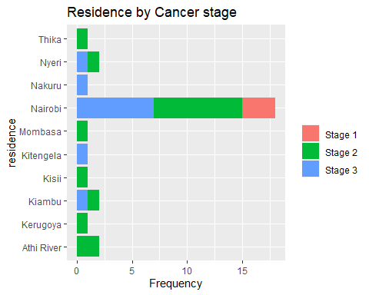

Table 1 Pathology subtype and CRC stage of the subjects
Characteristic | Stage I, N = 3¹ | Stage II, N = 16¹ | Stage III, N = 11¹
Age group
≥58 | 2 (67%) | 11 (69%) | 7 (64%)
38-47 | 0 (0%) | 1 (6.2%) | 0 (0%)
48-57 | 1 (33%) | 4 (25%) | 4 (36%)
Gender
Female | 2 (67%) | 6 (38%) | 4 (36%)
Male | 1 (33%) | 10 (62%) | 7 (64%)
Pathology subtype
Invasive Adenocarcinoma | 3 (100%) | 12 (75%) | 8 (73%)
Mucinous Adenocarcinoma | 0 (0%) | 4 (25%) | 3 (27%)
¹ n (%)

In mucinous adenocarcinoma, the organisms identified were completely different. The non-cancerous tissues were predominated by Bacillus sp, Geobacillus stearothermophilus and Lipophrys pholis. On the other hand, cancerous tissues had nine different species of bacteria.

3.1 Microbial flora in different pathology subtypes
This research examined the microbial profile in relation to two most common histopathological subtypes of colorectal cancer (CRC): mucinous adenocarcinoma (mainly in Stage II) and invasive adenocarcinoma (mainly in Stage III). The findings indicated clearly different microbial communities for both types, proposing the potential for interaction between mucosal microbiota and tumor phenotype.
3.1.1 Microbiota of Mucinous Adenocarcinoma
In mucinous adenocarcinoma tissues, the profile of their microbiota was characterized by Firmicutes-related taxa, including Oscillospiraceae bacterium, Eubacterium, Clostridiales bacterium, Texoconibacillus sp., Xylanivirga bacterium, and Valitelen sp. They were majorly commensal bacteria and most closely linked to dietary fiber fermentation and short-chain fatty acid (SCFA) production, like butyrate, with anti-inflammatory and anti-tumorigenic properties.
This is partly in agreement with a study’s finding of decreased butyrate-producing bacteria in patients with CRC (Weir et al., 2013). However, in the Kenyan cohort, the taxa that continued to be present in early-stage mucinous tumors suggest either a time delay prior to dysbiosis or to a region-specific microbial signature that has the ability to modulate the mucin-enriched environment of this subtype.
Also, Eubacterium and Oscillospiraceae are also "intermediate" microbes with potential roles in health and disease depending on abundance and balance of microbes. That is, in mucinous adenocarcinoma, the microbial environment subtly supports tumor growth at first either by immunomodulating or weakening the mucin barrier.

Figure 2 Cladogram of microbiota identified in mucinous adenocarcinoma
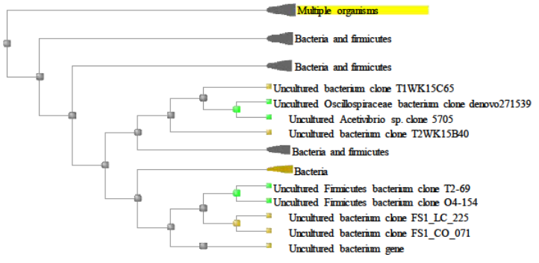

3.1.2 Microbiota of Invasive Adenocarcinoma
In contrast, invasive adenocarcinoma was associated with a significant trend towards pathogenic and opportunistic taxa like Bacillus paramycoides, Bacillus cereus, Bacillus subtilis, Bacillus wiedmanni, Staphylococcus pettenkoferi, Staphylococcus argensis, Vulcanibacillus modesticalous, and Planococcaceae bacterium.
These findings are in agreement with another study where invasive CRC had increased pro-inflammatory and tumor-promoting bacteria (Zorron et al., 2020). Remarkably, Staphylococcus spp. and Bacillus cereus were noted to be involved in toxin production, biofilm formation, and epithelial barrier disruption, which may result in invasion of the tumor and immune evasion.
Additionally, studies have emphasized the significance that microbial succession plays in CRC development, from initial commensal colonization to inflammation-based bacterial domination (Mizutani et al., 2020;. Guo et al., 2022). This present study provides evidence to validate that invasive adenocarcinoma exhibits microbial signatures indicative of dysbiosis at advanced phases, thus possibly escalating tumor aggressiveness.
Contrary to Western literature where Fusobacterium nucleatum, Bacteroides fragilis, and Peptostreptococcus are common in invasive or late subtypes (6,8), the Kenyan study pointed an accusatory finger at environmental and opportunistic taxa (e.g., Vulcanibacillus, Planococcaceae, Staphylococcus) and deduced regional variation in microbial drivers (Rubinstein et al., 2013; Weir et al., 2013). The taxa may reflect local environmental exposure, antibiotic consumption, and diet, all of which shape microbiota profiles.
The correlation of unique microbial signatures with CRC pathology subtypes proves that microbiota not only reflect disease status but can also reconfigure tumor biology via metabolic, inflammatory, or immune-dependent mechanisms. These findings also highlight the importance of region-dependent microbes as biomarkers to guide diagnosis, prognosis, and even microbiota-directed therapy.

Figure 3 Cladogram for microbiota identified in invasive adenocarcinoma
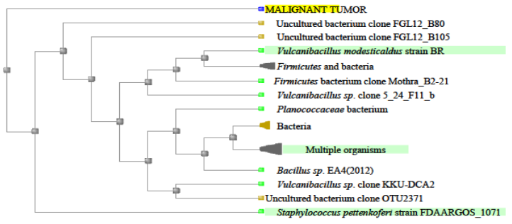

Female patients of age 48-57 and older than 58 years with mucinous and invasive adenocarcinoma had 8 and 6 species of the organisms identified respectively.

3.2 Pathology subtypes
This study exhibited a heterogeneous distribution of colorectal cancer (CRC) pathology subtypes in patients, varying extensively by cancer stage and sex. The most prevalent subtypes identified were mucinous adenocarcinoma and invasive adenocarcinoma, both of which manifested different microbial associations and demographic trends.
Mucinous adenocarcinoma, often characterized by copious secretion of extracellular mucin, occurred predominantly in older female patients (>58 years) at stage II of CRC. The subtype is usually given greater malignant clinical behavior and poorer prognosis than common adenocarcinoma. The microbiota composition in this subgroup showed enrichment with the taxa that may be involved in degradation of mucin and immune evasion, as observed in previous studies for microbial modulation of tumor microenvironments (Mizutani et al., 2020; Zorron et al., 2020).
In contrast, invasive adenocarcinoma was common in 48- to 57-year-old women at stage III. This was the type involving penetrative depth into the colonic wall and surrounding structures that was associated with a distinctive microbial signature. The findings concur with reported research that invasive carcinomas bear bacteria capable of facilitating epithelial-mesenchymal transition and proinflammatory cytokine profiles favorable to tumor invasion and metastasis (Guo et al., 2022; Rubinstein et al., 2013).
The differences in pathology subtypes seen between gender and age could be a reflection of the underlying interactions between host and microbiota, hormonal or genetic vulnerability. All these combined with lifestyle and environmental exposures unique to the Kenyan environment could influence microbial colonization patterns as well as tumor behavior.
It is necessary to know the correlation between CRC pathology subtypes and mucosal microbiota composition for subtype-specific diagnostic and therapeutic strategies. The distinct microbial profiles in specific subtypes can be utilized as potential biomarkers for early diagnosis and prognosis, especially in low-resource settings where conventional diagnostics are not feasible.

Figure 4 Distribution of pathology subtypes by cancer stage
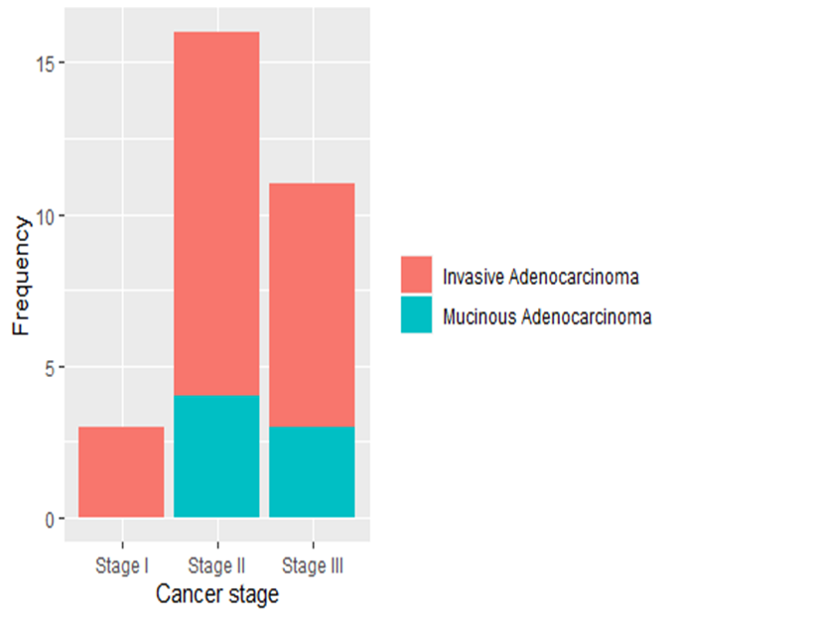

3.3 Microbial community in different CRC stages
A comparative analysis of microbial profiles indicated significant changes in community composition from stage II to stage III colorectal cancer (CRC). Stage II tissues contained Oscillospiraceae, Firmicutes bacterium, Clostridiales, and Bacillus species. In contrast, stage III tissues exhibited a decrease in Oscillospiraceae and Clostridiales, with a significant increase in Bacillus species, notably B. wiedmannii and B. paramycoides. This pattern indicates microbial succession marked by a decrease in commensal taxa and an increase in opportunistic species as CRC advances.
These findings agree in some respects with worldwide literature emphasizing the importance of microbial shifts in the development of CRC but differ significantly in the prevalent organisms reported.
Weir et al. (Rubinstein et al., 2013) found that U.S. CRC patients had higher abundance of Fusobacterium, Porphyromonas, and Peptostreptococcus, and lower levels of beneficial butyrate-producing Firmicutes. Contrarily, this study noted sustained presence of butyrate-associated genera (Eubacterium, Oscillospiraceae) in Stage II tumors, implying that the Kenyan cohort could have a partially functional microbiome even at the onset of disease. This may be due to differences in the intake of dietary fiber, antibiotic use, or genetics.
A study described signature microbiota for invasive vs. early CRC, and invasive tumors harbored more pro-inflammatory and possibly oncogenic bacteria (Zorron et al., 2020). Our study also found Stage III tumors enriched in the organism types such as Bacillus cereus and Staphylococcus pettenkoferi organism types often associated with infection, inflammation, or toxin production.
Rubinstein et al. (Rubinstein et al., 2013) highlighted Fusobacterium nucleatum that was identified as mediating CRC by β-catenin signaling. While F. nucleatum was not present in this Kenyan cohort, enrichment of opportunistic Firmicutes and Staphylococcal species in Stage III tumors might suggest alternative microbial drivers of invasion and inflammation within this group.
Some studies proposed that early microbial changes pave the way for subsequent tumor-fostering species (Mizutani et al., 2020; Guo et al., 2022). The Kenyan cohort demonstrated progression from commensal-like bacteria in Stage II (e.g., Xylanivirga, Valitelen, Texoconibacillus) towards a Bacillus, Staphylococcus, and Planococcaceae species,dominant dysbiotic community in Stage III.

Figure 5 Microbial taxa identified in patients with stage II colorectal cancer (CRC)
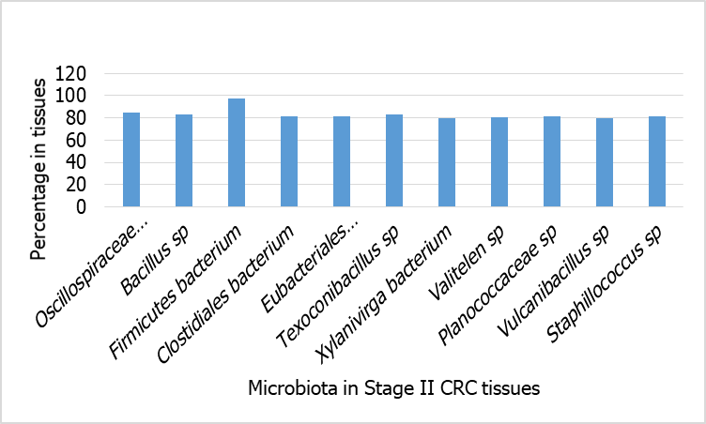

Figure 6 Microbial taxa identified in patients with stage III colorectal cancer (CRC)

4. Conclusion

In this study, tissues from CRC patients showed microbial signatures specific to their subtype and stage. Invasive adenocarcinoma showed an enrichment of pathogenic and opportunistic microbes, whereas commensal, SCFA-producing taxa were found in mucinous adenocarcinoma. As the tumor advanced from Stage II to Stage III, commensals decreased and pro-inflammatory taxa increased, which was indicative of microbial succession. Particularly in low-resource environments, these results highlight the potential of region-specific microbial biomarkers for CRC diagnosis, prognosis, and microbiota-targeted interventions.

Ethical approval

The study was approved by the AKUH Institutional Ethics and Review Committee (ref: 2019IERC-111(v3)) and to National Commission for Science and Technology (NACOSTI-License No: NACOSTI/P//24/37704) for use of medical records to obtain demographic information and for retrieval of FFPE blocks of the identified CRC blocks from the archive. Confidentiality of the information obtained was maintained as the identity of the patients was concealed.

Disclaimer (Artificial intelligence)

Author(s) hereby declare that NO generative AI technologies such as Large Language Models (ChatGPT, COPILOT, etc.) and text-to-image generators have been used during the writing or editing of this manuscript.

References

1. Ung Hs, Ferlay J, Siegel RL, Laversanne M, Soerjomataram I, Jemal A, et al. Global Cancer Statistics 2020: GLOBOCAN Estimates of Incidence and Mortality Worldwide for 36 Cancers in 185 Countries. CA Cancer J Clin. 2021;71(3):209–49.
2. World Health Organization. Promoting early cancer diagnosis. England; 2017 Mar.
3. Yusuf K, Sampath V, Umar S. Bacterial Infections and Cancer: Exploring This Association And Its Implications for Cancer Patients. 2023;24(4).
4. Zorron L, Tao C, Yamamoto K, Honda T, Nakamura M. Microbiota pro fi le is different for early and invasive colorectal cancer and is consistent throughout the colon. 2020;5:433–7.
5. Mizutani S, Yamada T, Yachida S. Significance of the gut microbiome in multistep colorectal carcinogenesis. Cancer Sci. 2020 Mar;111(3):766–73.
6. Guo Q, Qin H, Liu X, Zhang X, Chen Z, Qin T, et al. The Emerging Roles of Human Gut Microbiota in Gastrointestinal Cancer. Front Immunol. 2022;13:915047.
7. Rubinstein MR, Wang X, Liu W, Hao Y, Cai G, Han YW. Fusobacterium nucleatum Promotes Colorectal Carcinogenesis by Modulating E-Cadherin/β-Catenin Signaling via its FadA Adhesin. Cell Host Microbe. 2013 Aug;14(2):195–206.
8. Aymeric L, Donnadieu F, Mulet C, du Merle L, Nigro G, Saffarian A, et al. Colorectal cancer specific conditions promote Streptococcus gallolyticus gut colonization. Proc Natl Acad Sci U S A. 2018 Jan;115(2):E283–91.
9. Weir TL, Manter DK, Sheflin AM, Barnett BA, Heuberger AL, Ryan EP. Stool Microbiome and Metabolome Differences between Colorectal Cancer Patients and Healthy Adults. PLoS One. 2013;8(8).
10. Parker RK, Ranketi SS, Mcnelly C, Ongondi M, Mmed M, Topazian HM, et al. perspectives. 2020;89(6):1234–7.
11. Fleiss JL, Levin B, Cho Paik M. Statistical Methods for Rates and Proportions, Third Edition. Stat Methods Rates Proportions, Third Ed. 2004;1–760.
12. Camacho C, Coulouris G, Avagyan V, Ma N, Papadopoulos J, Bealer K, et al. BLAST+: Architecture and applications. BMC Bioinformatics. 2009;10:1–9.
13. Akkoca AN, Yanık S, Özdemir ZT, Cihan FG, Sayar S, Cincin TG, et al. Original Article TNM and Modified Dukes staging along with the demographic characteristics of patients with colorectal carcinoma [Internet]. Vol. 7, Int J Clin Exp Med. 2014. Available from: www.ijcem.com/
14. Fass OZ, Poels KE, Qian Y, Zhong H, Liang PS. Demographics predict stage III/IV colorectal cancer in individuals under age 50. J Clin Gastroenterol. 2020;54(8):714–9.
15. Martins M, Aymeric L, du Merle L, Danne C, Robbe-Masselot C, Trieu-Cuot P, et al. Streptococcus gallolyticus Pil3 Pilus Is Required for Adhesion to Colonic Mucus and for Colonization of Mouse Distal Colon. J Infect Dis. 2015 Nov;212(10):1646–55.

