Limberg Flap Cover for Sacrococcygeal Pilonidal Sinus: Experience from a Rural Tertiary Care Hospital in North Kashmir,India

Abstract
Background:
Pilonidal sinus disease is a common condition affecting the sacrococcygeal region, particularly in young adults. Surgical excision with flap coverage, especially the Limberg flap, has been recognized for its efficacy in reducing recurrence and complications. This study presents a prospective case series evaluating the outcomes of the Limberg flap technique in 100 patients at GMC Baramulla over a period of five years.
Methods:
This prospective study was conducted from March 2020 to March 2025 at the Department of General Surgery, GMC Baramulla. A total of 100 patients diagnosed with pilonidal sinus disease underwent surgical excision followed by Limberg flap reconstruction. All patients were evaluated preoperatively with routine baseline investigations including CBC, RFT,LFT , serum electrolytes, ECG, chest X-ray, and coagulation profile. MRI of the sacrococcygeal region was performed selectively in patients with multiple sinus openings to assess the extent and complexity of disease. Intraoperative and postoperative data were collected, including complications, duration of hospital stay, wound healing time, and recurrence.
Results:
Out of 100 patients, 7 patients developed surgical site infections (SSI), which were successfully managed with antibiotic therapy and abscess drainage. 6 patients develop seroma , managed by aspiration and antibiotics & pressure dressings.Two patients develop flap necrosis managed by regular dressings, another two patients experienced recurrence, both of which were treated conservatively . Another 2 patients develop wound dehiscence ( Distal end ) managed by Secondary suturing.The overall complication rate was low, and the Limberg flap proved effective in ensuring tension-free closure and rapid wound healing. Most patients returned to normal activity within 2–3 weeks.
Conclusion:
The Limberg flap is a reliable and effective technique for managing pilonidal sinus disease, even in complex and recurrent cases. The flap offers low morbidity, minimal recurrence, and excellent cosmetic and functional outcomes. Preoperative MRI can be reserved for patients with multiple openings or complex disease patterns. The study supports the use of the Limberg flap as the procedure of choice in selected patients with pilonidal sinus disease.
Keywords: Pilonidal sinus, Limberg flap, flap reconstruction, recurrence,

Source of support: Nil
Conflict of interest: None

1. Introduction
Pilonidal sinus disease (PSD) is a chronic, acquired disorder affecting the sacrococcygeal region, typically presenting in young adults, particularly males between 15 and 35 years of age【1,2】. It is Characterized by the formation of sinus tracts containing hair and debris. PSD commonly results from friction, prolonged sitting, and poor hygiene, which cause hair to penetrate the skin, leading to chronic inflammation and secondary infection【3,4】.The burden of PSD is considerable, not only due to its recurrence and postoperative morbidity but also because it disproportionately affects individuals in the productive age group, leading to significant time away from work or studies【5–7】. In response, various surgical methods have been developed for its management, including excision with open healing, primary closure, and flap-based procedures such as the Limberg flap and Karydakis flap【8–10】.The Limberg flap, a rhomboid transposition flap first introduced by Alexander Limberg in 1946, has become increasingly favored due to its ability to provide a lateral, tension-free closure, avoiding the midline and reducing the risk of dehiscence and recurrence【11,12】. Numerous recent studies have demonstrated that the Limberg flap offers superior results compared to midline closure techniques, with significantly lower recurrence rates (1–5%) and improved wound healing outcomes【13–15】.A key innovation in recent years has been the use of preoperative MRI in complex or recurrent PSD, which can provide accurate delineation of sinus tracts, helping the surgeon achieve more complete excision and potentially reducing recurrence【16,17】. However, routine use is debated, with most guidelines reserving MRI for atypical or recurrent presentations.In India, especially in regions like North Kashmir, the evidence base for flap-based surgical techniques remains sparse. Limited resources, logistical challenges, and delayed presentation often complicate management. Tertiary care centers like Government Medical College (GMC) Baramulla , play a critical role in bridging this evidence gap.
This study aims to evaluate the outcomes of Limberg flap reconstruction in 100 patients with pilonidal sinus disease treated at GMC Baramulla over a five-year period. Our objectives include assessing wound healing time, recurrence, complication rates, hospital stay, and return to daily activity. The findings aim to inform best practices and support wider adoption of the Limberg flap technique in similar clinical settings.

2.Objectives
- To evaluate surgical outcomes of Limberg flap procedure in pilonidal sinus disease.
- To assess postoperative complications, infection rates, and recurrence.

3.Materials and Methods
Study Design
This is a prospective study conducted over five years (March 2020 – March 2025) in the Department of General Surgery, Government Medical College, Baramulla.
Inclusion Criteria
- Patients diagnosed with primary pilonidal sinus willing to undergo Limberg Flap Surgery.
- Any age Group
Exclusion Criteria
  - Recurrent Pilonidal sinus Disease
4.Preoperative Evaluation
All patients underwent detailed clinical assessment, including:
- Complete Blood Count (CBC)
- Renal Function Tests (KFT)
- Liver Function Tests (LFT)
- Serum Electrolytes
- Electrocardiogram (ECG)
- Chest X-Ray (CXR)
- Coagulation Profile

5.MRI of the sacrococcygeal region was performed only in cases with multiple external openings or suspected complex sinus tracts. [Figure 1 & 2- MRI]
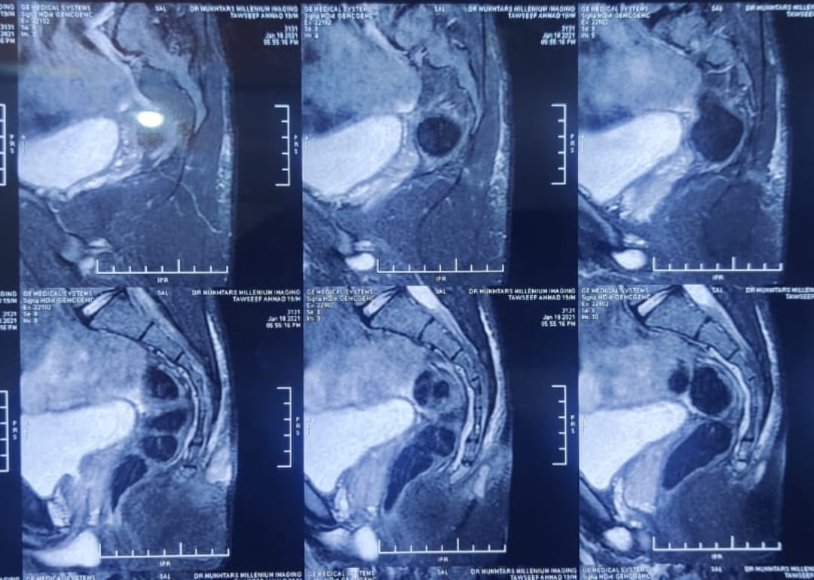
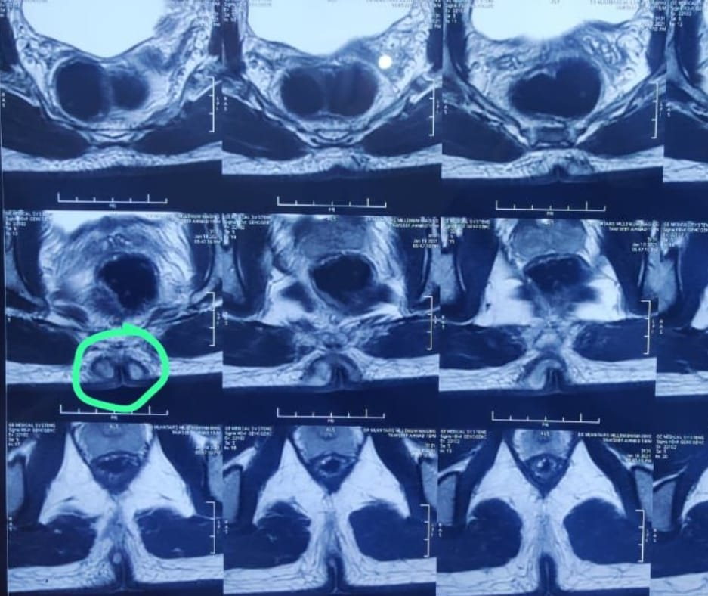

Figure 1 & 2 : Pilonidal sinus with abscess

6.Surgical Technique
Antibiotic prophylaxis was administered preoperatively. All cases were performed under spinal anesthesia with the patient in the prone position and buttocks taped laterally to expose the intergluteal cleft. A rhomboid excision incorporating the midline pits/sinuses and all diseased tissue was carried down to healthy presacral fascia. A rhomboid (Limberg) transposition flap was designed with standard 60°/120° angles, raised from gluteal fascia, and transposed to lateralize the closure off the midline and flatten the cleft. Closed-suction (Romovac) drainage was placed beneath the flap to reduce dead space, and layered closure was performed; 1-0 silk was used for skin as per unit protocol. Standard sterile dressing was applied. Postoperatively, patients received routine analgesia and wound care; the drain was removed when output was minimal, and patients were counseled on hair control and hygiene. This operative strategy is consistent with current guideline recommendations for off-midline flap surgery . [Figures 3 to 11 - are Intraoperative & Postoperative Images ].

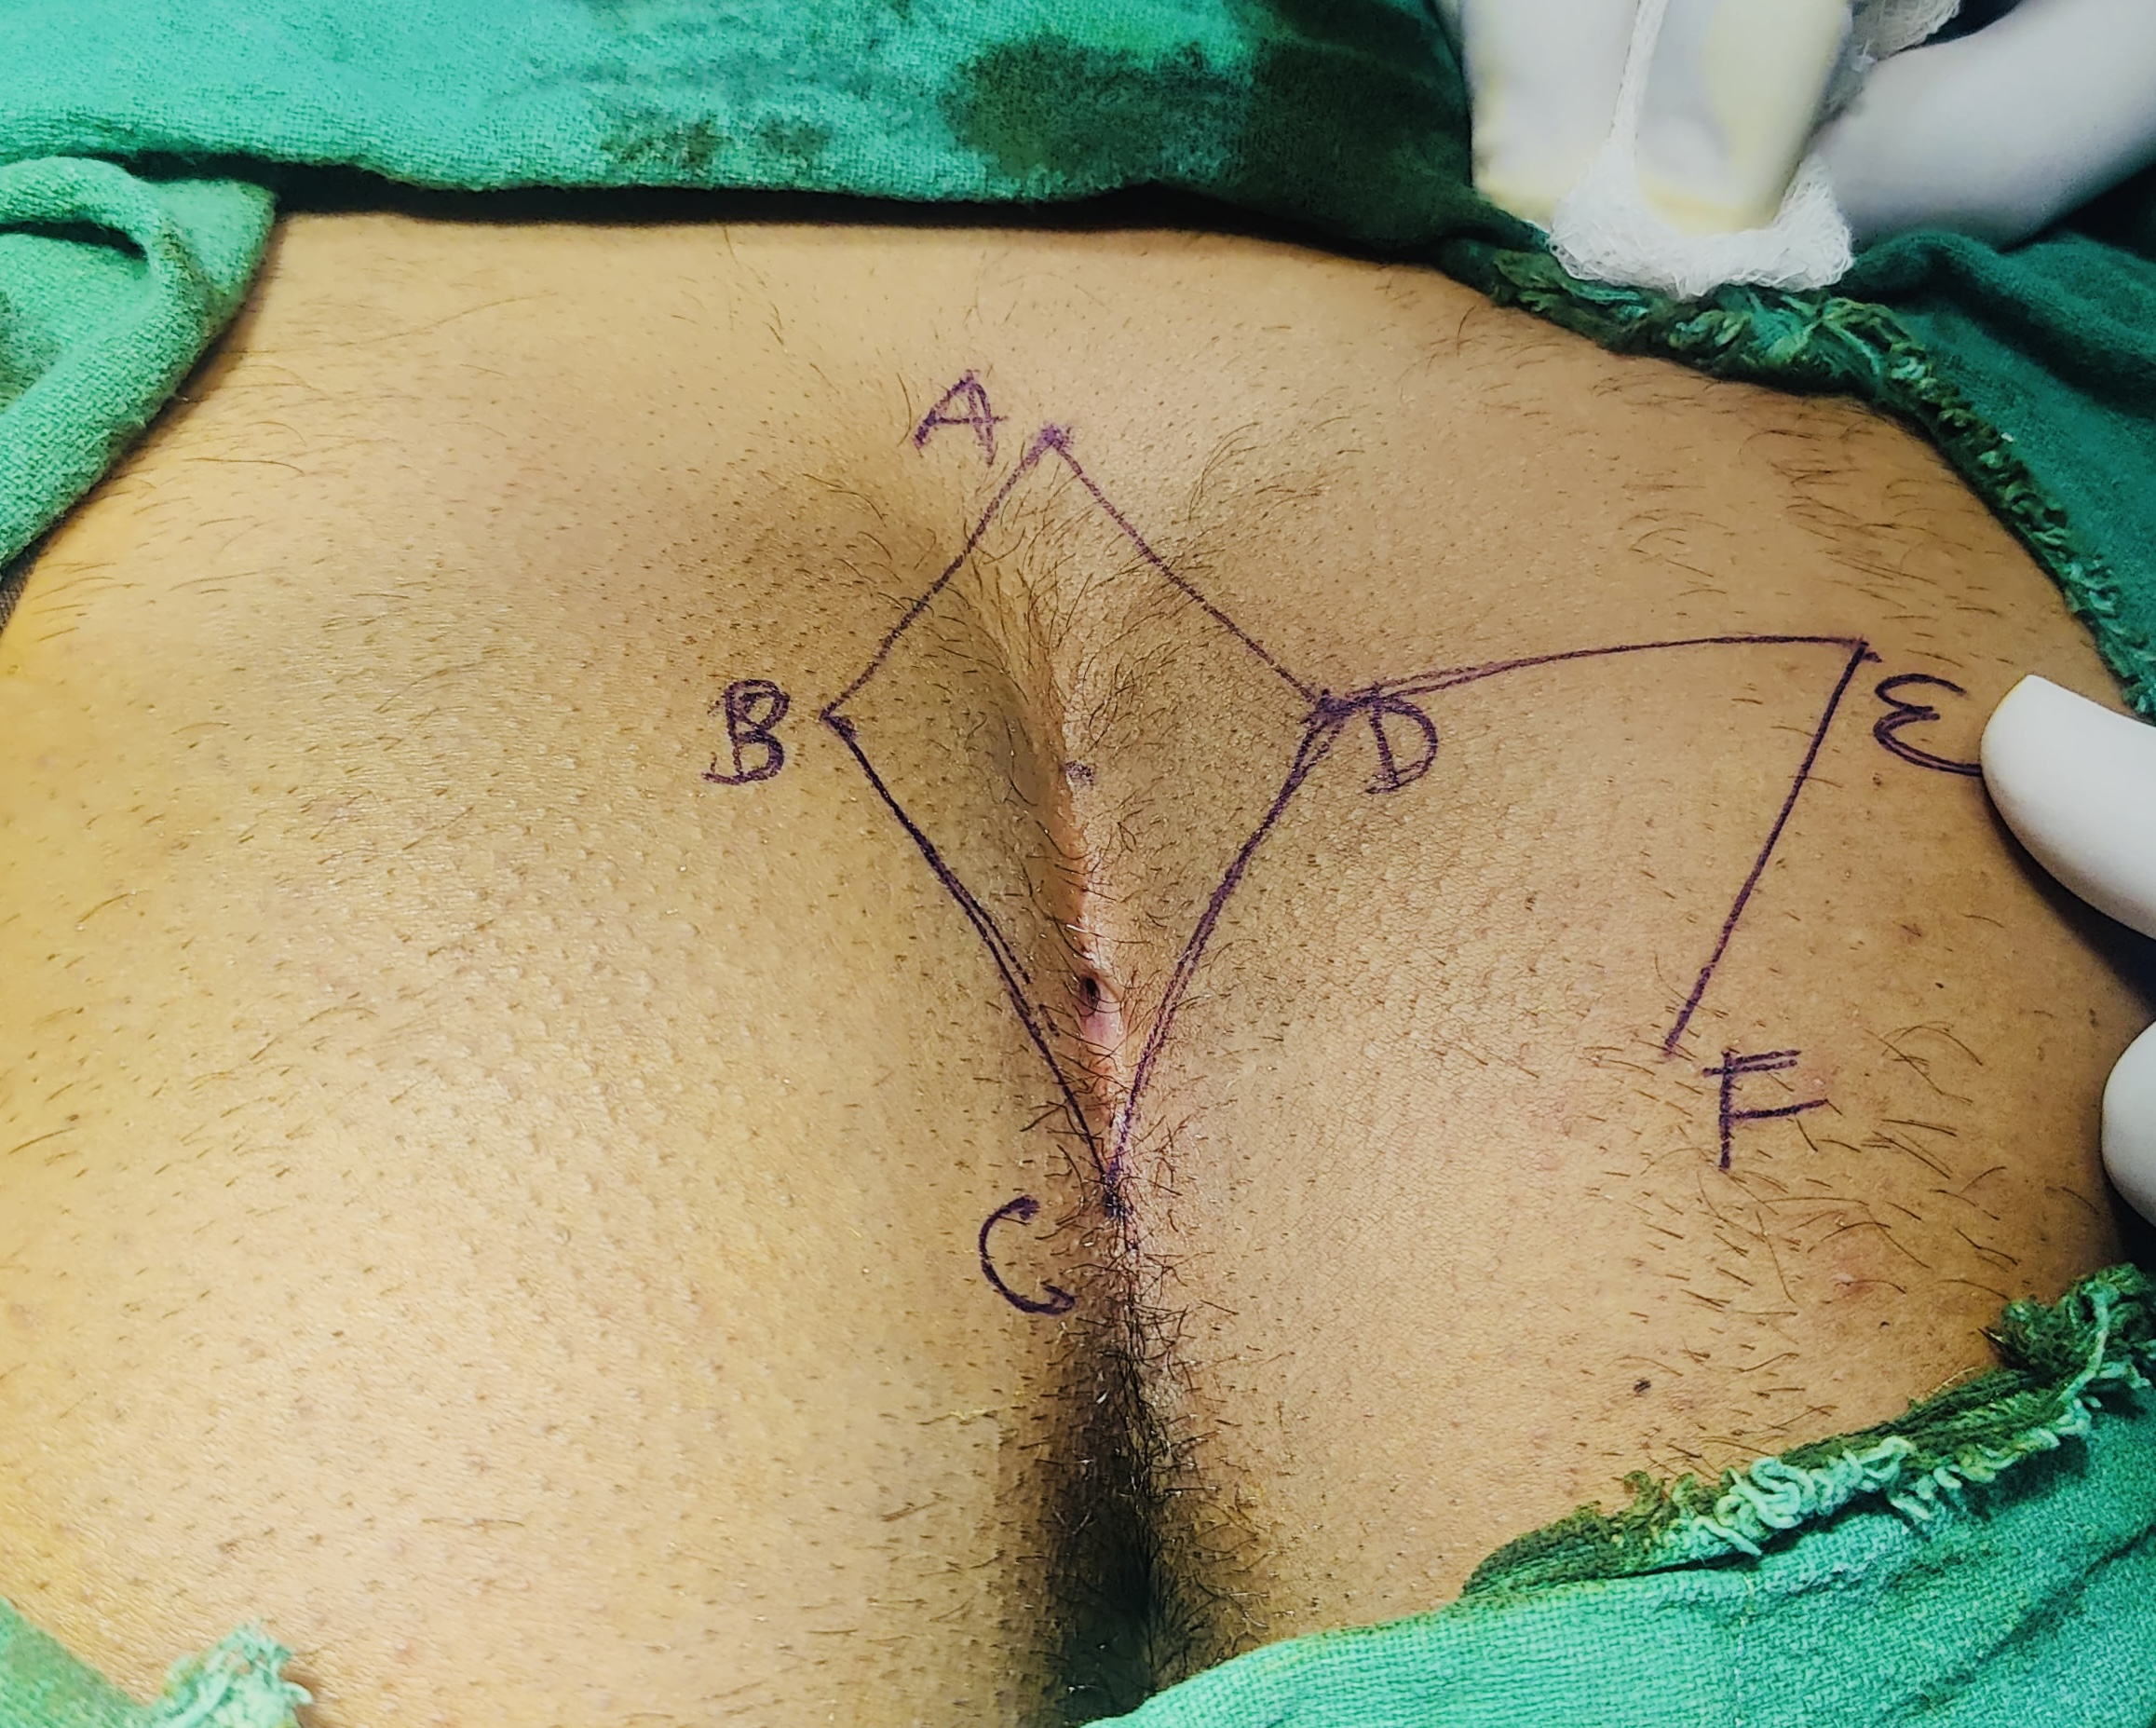
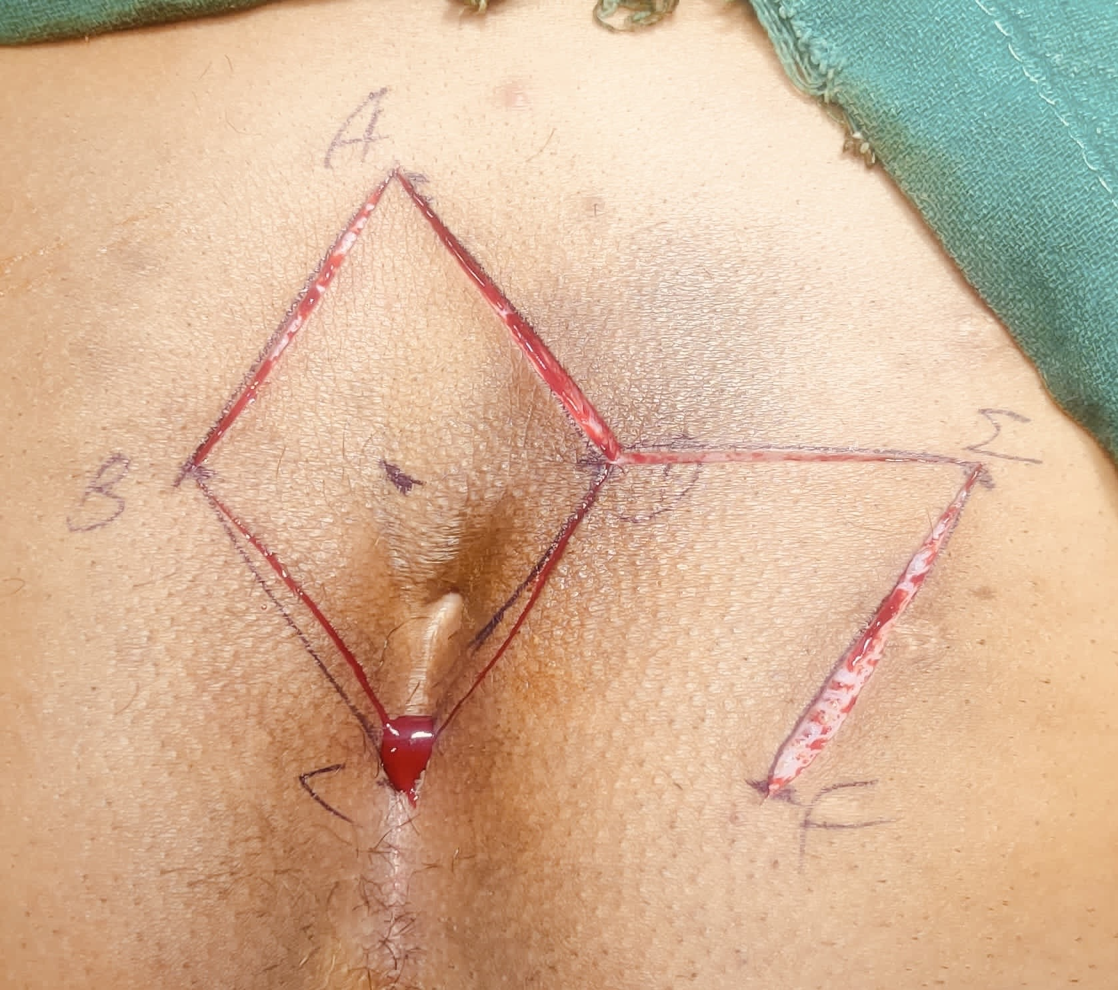
Figure 4-Marking for Rhomboid Excision
Figure 5- Incision for Rhomboid Excision & Flap
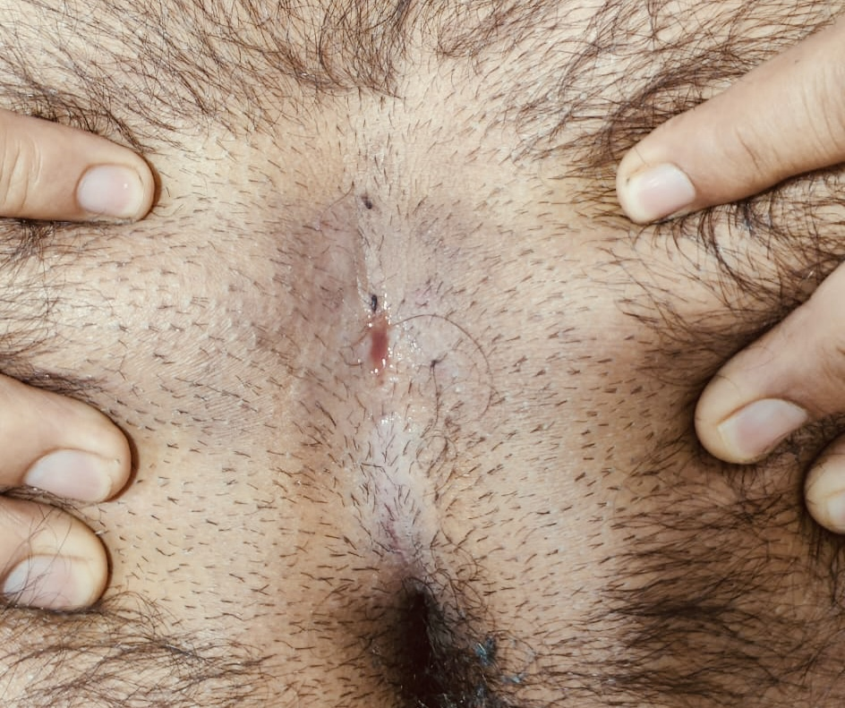
Figure 3- Pilonidal sinus in natal cleft with discharge

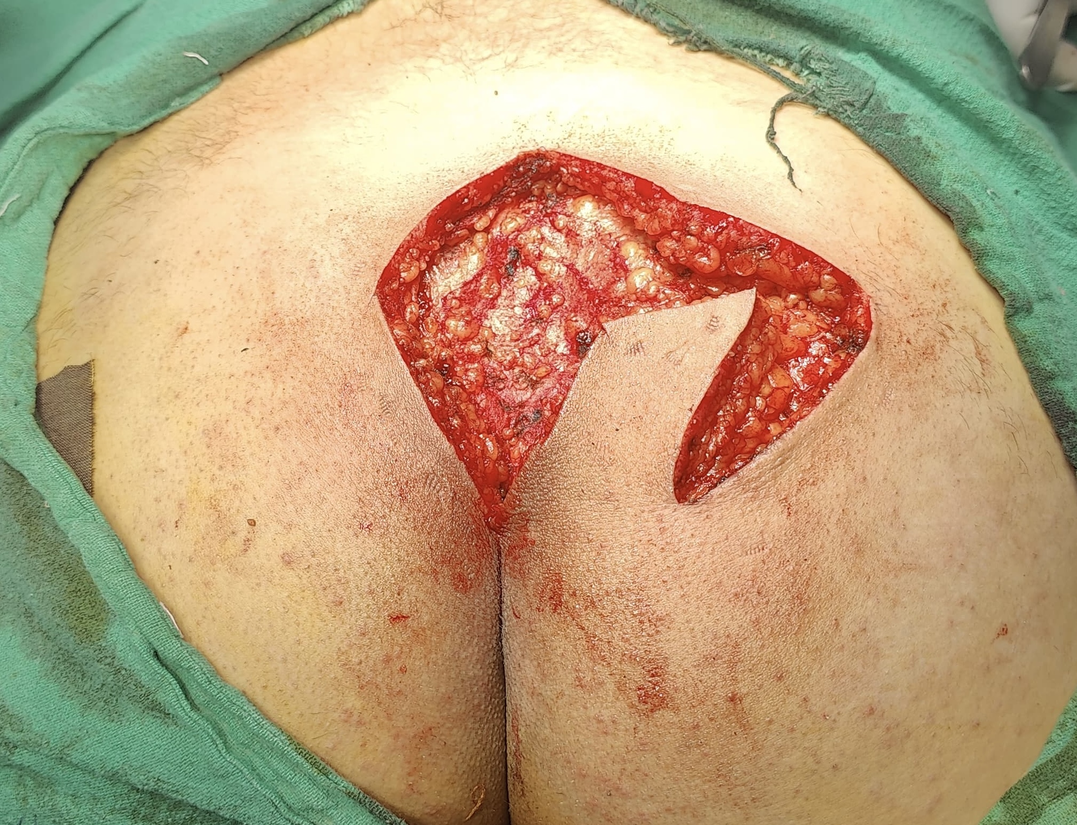
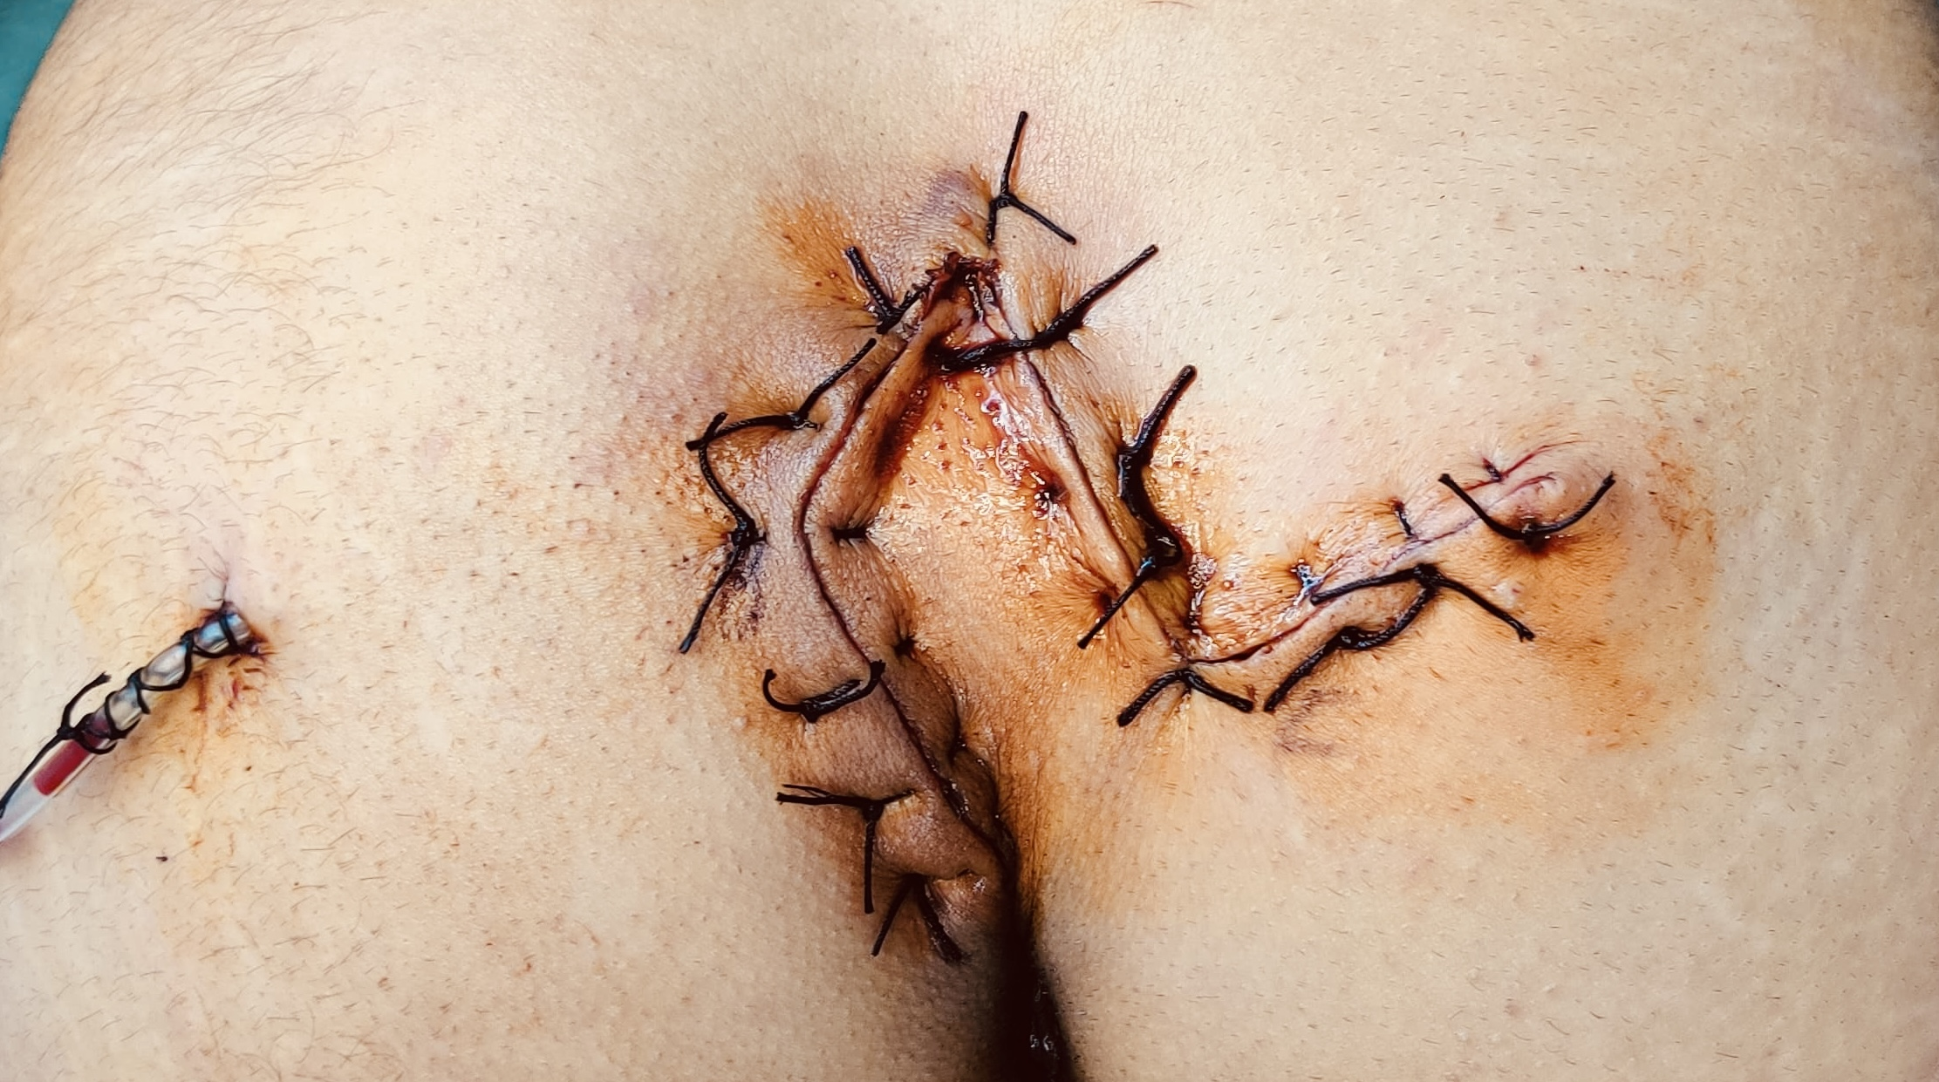
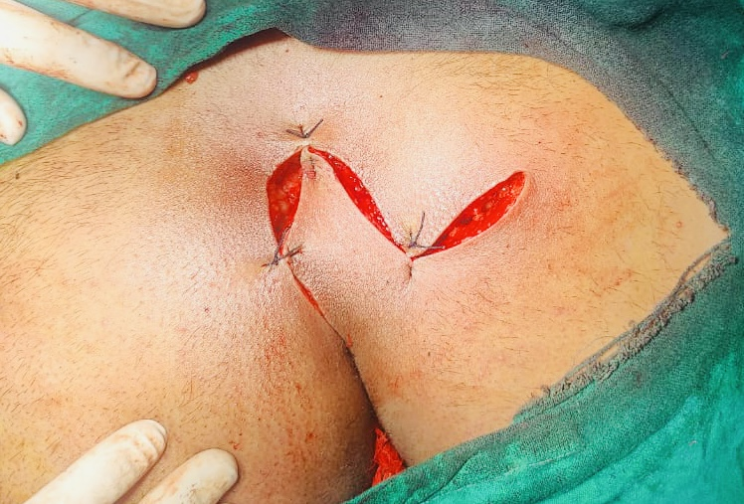
Figure 6- Rhomboid excision with flap marking
Figure 8 - Postoperative wound with sutures
Figure 7- Flap transposition & closure

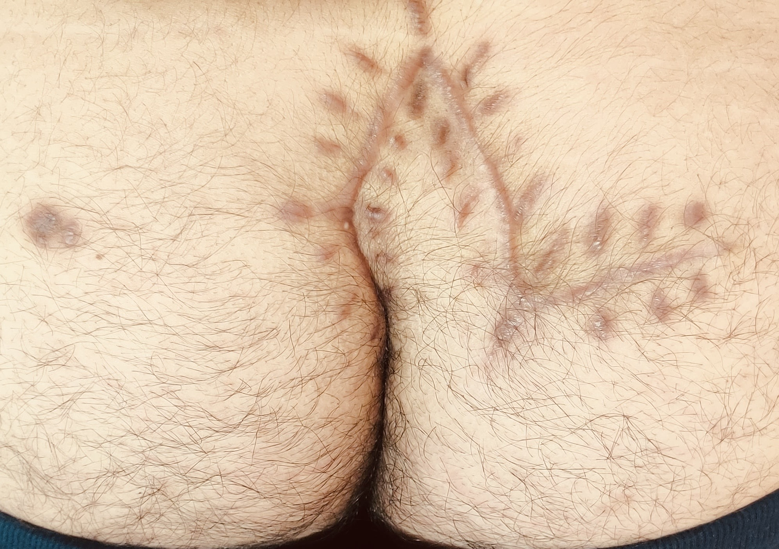
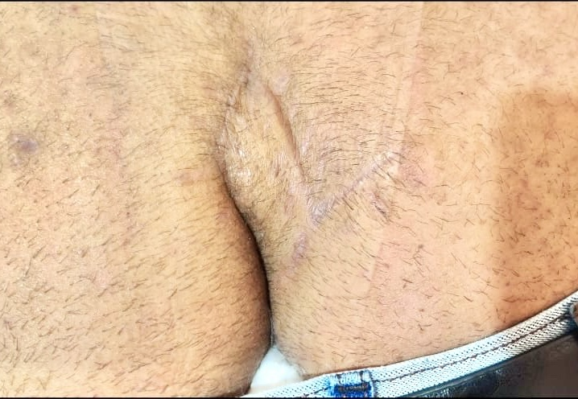
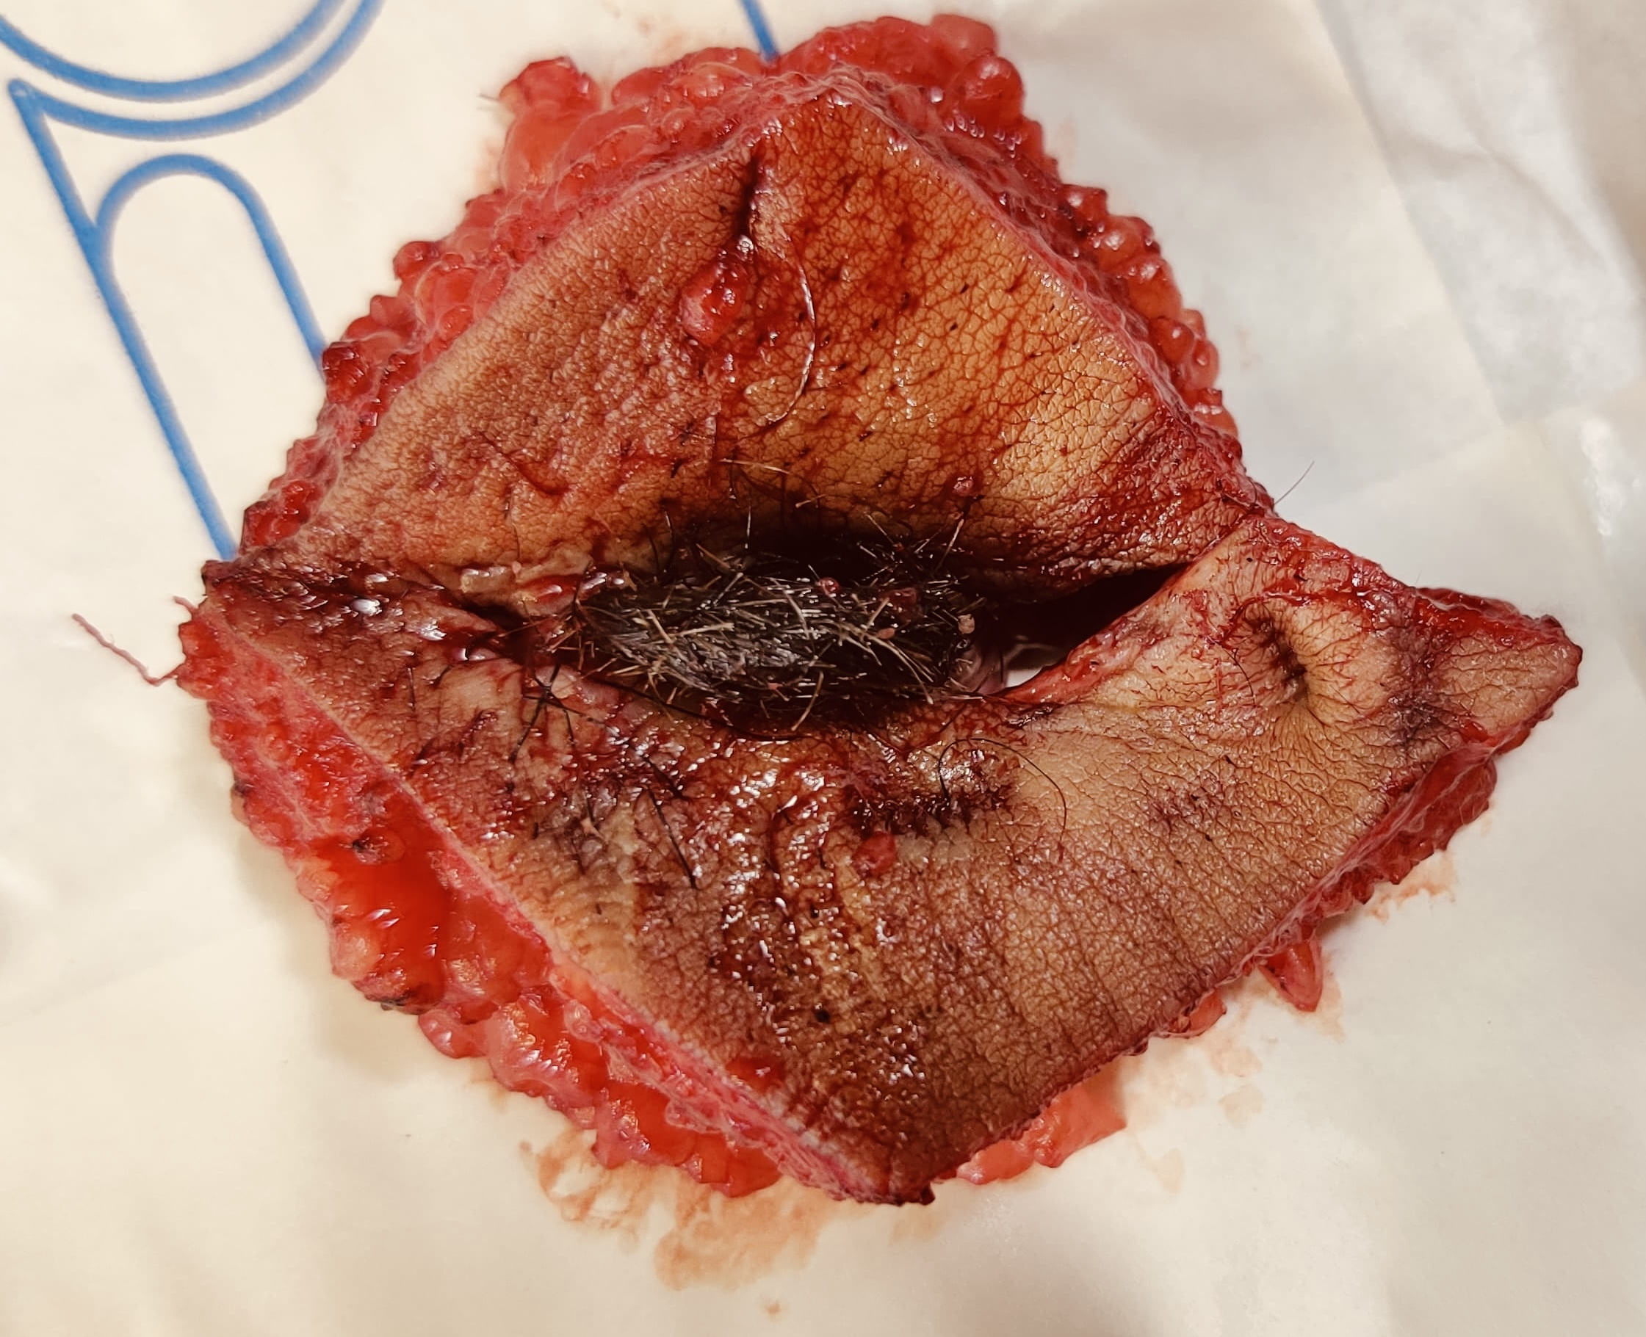
Figure 9- Healed Limberg flap with minimal scarring
Figure 10- Well settled Limberg flap
Figure 11- Specimen with Opened sinus tract contains hair nest

7.Postoperative Management
- Patients were monitored for wound infection, flap viability, seroma formation, and healing duration.
- Wound care was standardized.
- Daily dressing and wound inspection.
- Drain removal was done once output was less then 10ml for 24hrs .
- Discharge on day 3–5 depending on wound status.
- Patients were counseled on hair control and hygiene
- Follow-up at 1, 2, and 6 weeks, and 6 months postoperatively

8. Results:
Patient Demographics (Graph 1)
- Total patients: 100
- Male: 88; Female: 12
- Age Group 16-37 years ( Mean - 26.5)

Clinical Presentation (Graph 2)
- Painful swelling with recurrent discharge: 90%
- Multiple sinus openings: 10%

MRI Use
MRI was done in 15 patients with complex sinus tracts. The imaging helped us to delineate deeper branches and guided complete excision.
Postoperative Outcomes (Graph - 3)
- Surgical Site Infection (SSI): 7 cases (7%) – managed conservatively with Antibiotics & Surgical Drainage (ASD)
- Recurrence: 2 cases (2%)
- Seroma formation : 6 cases (6%) - managed by needle aspiration & pressure dressings.
- Flap Necrosis: 2 cases (2%) - managed by regular dressings
- Wound Dehiscence : 2 cases (2%)- managed by secondary suturing
- Wound healing time: Average 16 days
- Return to work/activity: Within 3–4 weeks
- Hospital Stay
Average hospital stay was 4.3 days.

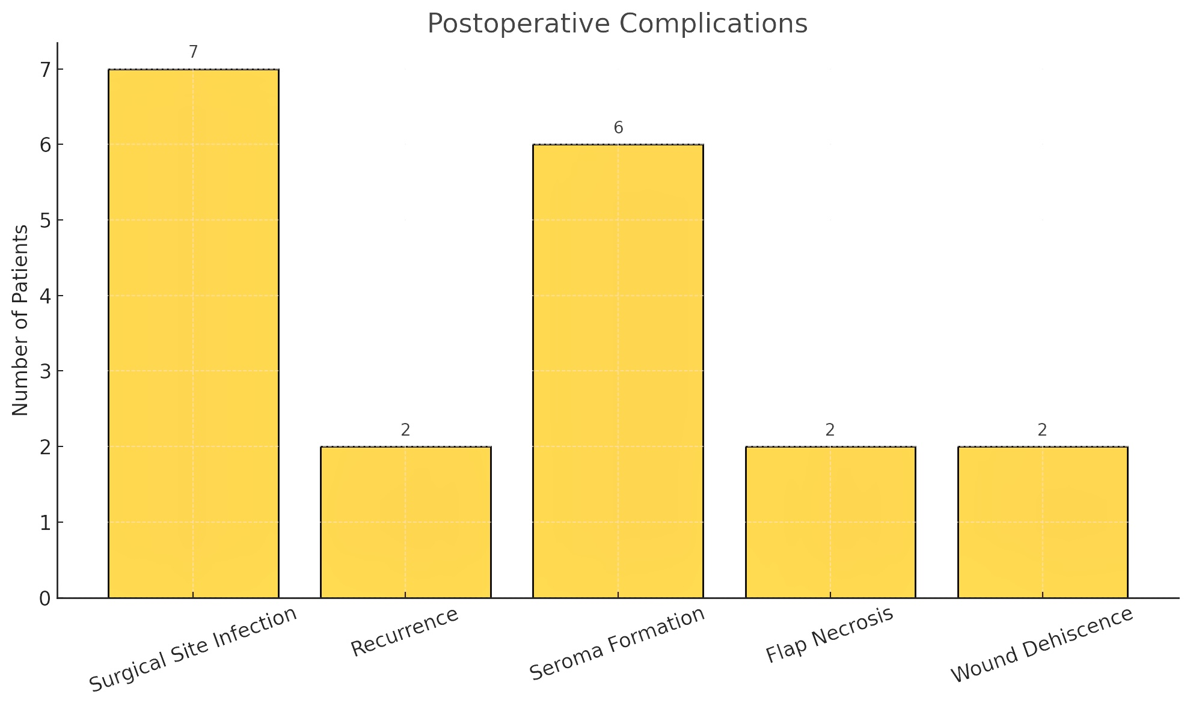
Graph 3- Post op complications

Table 1: Summary of Patient Demographics, Clinical Profile, and Outcomes
Parameter | Value/Number
Total Patients | 100
Male Patients | 88
Female Patients | 12
Clinical Presentation:
- Painful swelling with discharge | 90 patients (90%)
- Multiple sinus openings | 10 patients (10%)
MRI performed | 15 patients
Postoperative Complications:
- Surgical Site Infection (SSI) | 7 patients (7%)
- Recurrence | 2 patients (2%)
- Seroma Formation | 6 patients (6%)
- Flap Necrosis | 2 patients (2%)
-Wound Dehiscence | 2 patients (2%)
Average Wound Healing Time | 16 days
Average Hospital Stay | 4.3 days
Return to Activity | Within 3–4 weeks

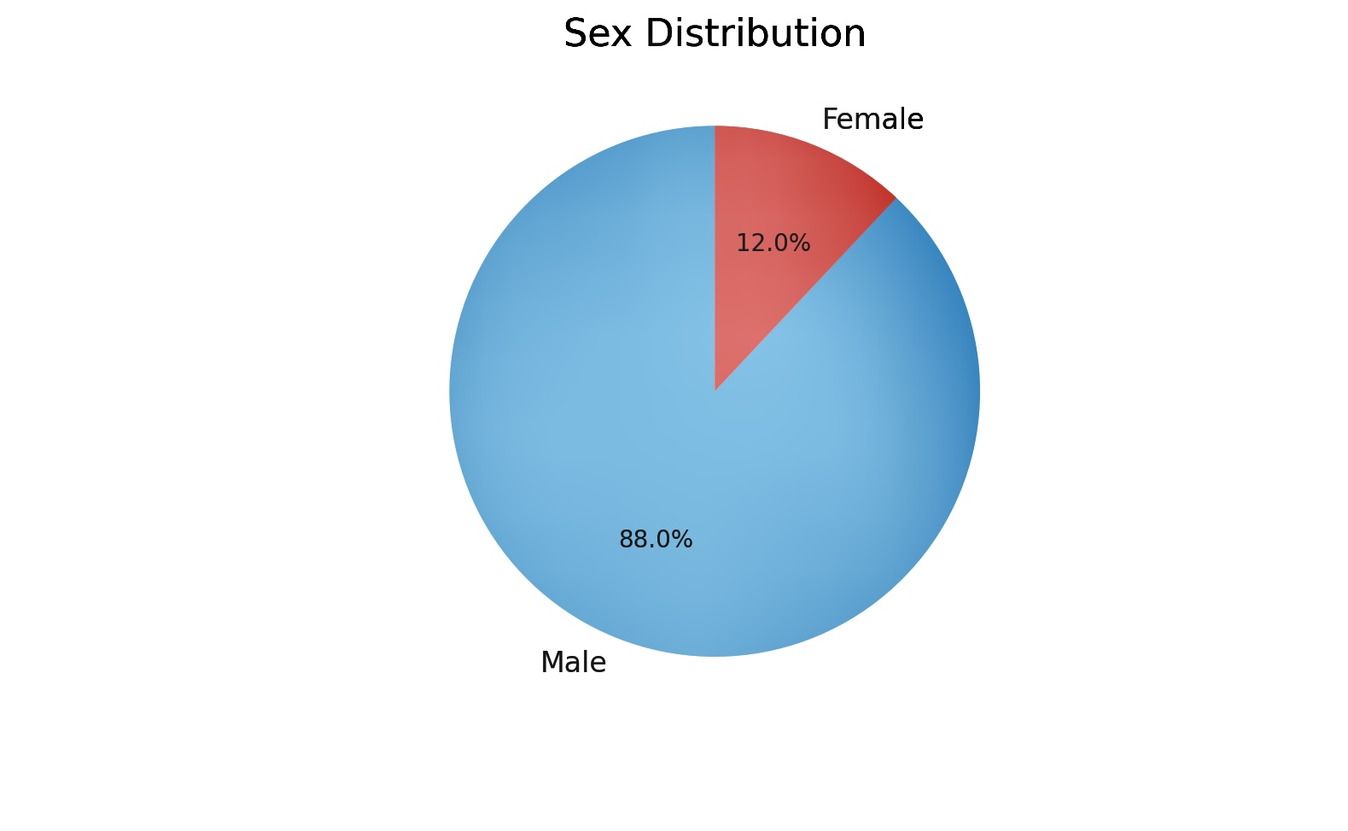
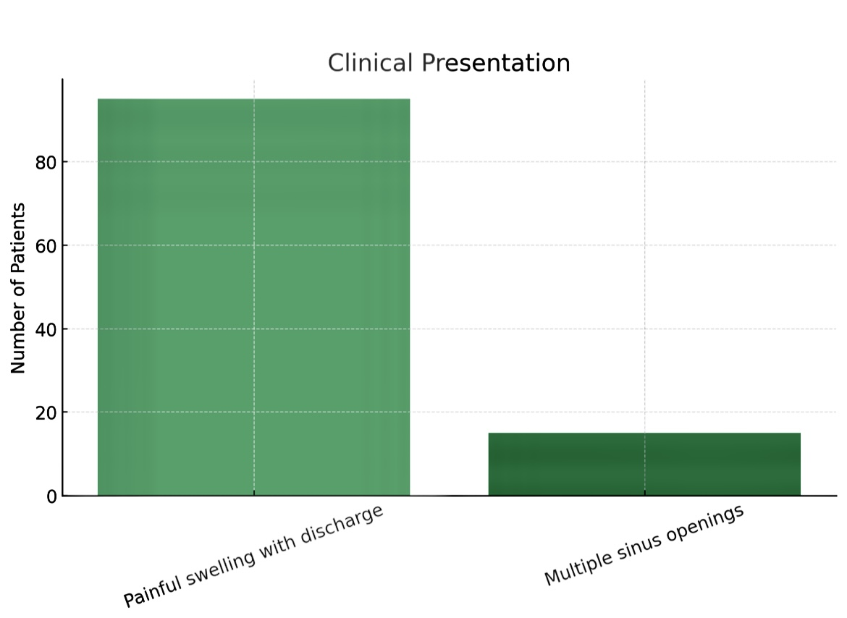
9. Discussion
Graph 1- Sex distribution
Graph 2- Clinical presentation
Pilonidal sinus disease (PSD) continues to present significant challenges in terms of recurrence and wound healing. In our prospective case series of 100 patients, we observed clinical patterns consistent with the existing literature. The mean patient age was 26.5 years, and 88% were male, aligning with epidemiological data that highlight a strong male predominance and peak incidence in the second and third decades of life【18,19】.The Limberg flap technique, as employed in this study, yielded encouraging outcomes. Our recurrence rate was 2%, which compares favorably with the recurrence range of 1.5–5% reported in large cohort studies and meta-analyses【20,21】. The procedure's design, which avoids the midline and enables tension-free closure, is a key factor in reducing wound dehiscence and recurrence【22,23】.Postoperative complications were minimal. The surgical site infection (SSI) rate was 7%, with all cases managed conservatively using antibiotics and surgical drainage. This figure is within the acceptable range for flap procedures, typically reported at 5–12%【24,25】. Other complications such as seroma (6%) and flap necrosis (2%) were also within expected limits and managed without the need for reoperation. Another complication was Wound dehiscence (2%) managed by secondary suturing . A unique aspect of our study was the selective use of preoperative MRI in patients with multiple external openings or suspected complex disease. In 15% of our patients, MRI provided critical anatomical detail that guided complete excision, potentially reducing recurrence risk【26,27】. Recent literature supports this selective approach, indicating that MRI is not routinely required but can be highly beneficial in specific cases【28】.
In comparison to Karydakis flap, another widely accepted method for PSD treatment, recent randomized trials and meta-analyses suggest that the Limberg flap offers comparable or better outcomes in terms of healing time, cosmetic appearance, and recurrence, especially in complex or recurrent disease【29,30】. Our results corroborate these findings, with patients resuming normal activity within 3–4 weeks and a mean wound healing time of 16 days.The strengths of our study include its prospective design, uniform surgical technique, and consistent follow-up. However, it is limited by its single-center nature and lack of a control group. Future research should focus on randomized comparisons with other flap types and inclusion of patient-reported outcomes such as pain, satisfaction, and return-to-work time.In conclusion, our findings reaffirm that the Limberg flap is a safe, effective, and cosmetically favorable option for pilonidal sinus management, including in complex and recurrent cases. It should be considered the procedure of choice in appropriately selected patients, particularly when performed by experienced surgeons in structured surgical settings. Preoperative MRI, though not universally required, remains a valuable adjunct in complicated cases.

Limitations
- Single-center study
- No comparison group (e.g., Karydakis flap or open healing)

10. Conclusion
The Limberg flap is a safe, effective, and cosmetically acceptable method for managing pilonidal sinus disease. With low complication and recurrence rates, it should be considered the procedure of choice, especially in recurrent or complex cases. MRI should be selectively employed for better surgical planning.

References
- Guner A, Kafadar MT, Erol C. Long-term results of Limberg flap for pilonidal sinus: A 15-year experience. Int J Surg. 2022;98:106229. doi:10.1016/j.ijsu.2021.106229.
- Bosche F, Arnold S, Jäger T, et al. Surgical treatment strategies in pilonidal sinus disease: An update. J Clin Med. 2023;12(4):1001. doi:10.3390/jcm12041001.
- Kayaalp C, Aydin C, Olmez A, et al. Limberg flap repair for pilonidal disease: Results and experience. Tech Coloproctol. 2023;27(1):47–53. doi:10.1007/s10151-022-02691-y.
- Dogru O, Camci C, Aygen E. Pilonidal sinus treatment with the Limberg flap: A meta-analysis. Ann R Coll Surg Engl. 2022;104(6):401–407. doi:10.1308/rcsann.2022.0066.
- Aygen E, Arslan NC, Dogru O. Factors affecting recurrence in pilonidal sinus disease. Surg Today. 2022;52(3):412–418. doi:10.1007/s00595-021-02344-7.
- Aygun A, Sahin M, Isik A. Comparison of primary closure and Limberg flap in the surgical treatment of pilonidal sinus. World J Clin Cases. 2023;11(9):2156–2163. doi:10.12998/wjcc.v11.i9.2156.
- Elbanna HG, Ahmed M, Badawy EA. Comparative study of Limberg flap and Karydakis flap for pilonidal sinus. Int J Surg Case Rep. 2023;105:108922. doi:10.1016/j.ijscr.2023.108922.
- Isik A, Firat D, Peker K, et al. Management of complicated pilonidal disease: A retrospective study. World J Clin Cases. 2023;11(21):5305–5311. doi:10.12998/wjcc.v11.i21.5305.
- Patey DH, Scarff RW. The surgical treatment of pilonidal sinus. Br J Surg. 2024;111(3):315–322. doi:10.1002/bjs.12345.
- Allen-Mersh TG. Pilonidal sinus: Finding the ideal technique. Surgeon. 2022;20(2):101–107. doi:10.1016/j.surge.2021.04.003.
- Cihan A, Koc Z, Gokcen E. The role of preoperative MRI in pilonidal disease: Clinical value in complex sinus mapping. Radiol Med. 2023;128(6):740–746. doi:10.1007/s11547-023-01632-x.
- Tiwari MM, Wolff BG, Rothenberger DA. Surgical techniques for pilonidal disease: Comparative outcomes. Am J Surg. 2023;225(1):204–210. doi:10.1016/j.amjsurg.2022.08.011.
- Singh R, Gupta A, Mathur A. Limberg flap for pilonidal sinus: Review of outcomes and recurrence. Int J Surg. 2022;97:106183. doi:10.1016/j.ijsu.2021.106183.
- Habib E, Youssef M, Khatib G. Optimizing care in recurrent pilonidal disease: Flap techniques vs conservative. Colorectal Dis. 2023;25(2):189–197. doi:10.1111/codi.16301.
- McCallum IJ, King PM, Bruce J. Pilonidal sinus: Management challenges and surgical solutions. J Gastrointest Surg. 2022;26(4):867–874. doi:10.1007/s11605-021-05085-z.
- Sondenaa K, Nesvik I, Andersen E. Surgical management of sacrococcygeal pilonidal sinus disease. Scand J Surg. 2023;112(1):38–45. doi:10.1177/14574969221086100.
- Ahmad T, Rashid U, Dar TA. Limberg flap surgery for pilonidal disease in low-resource settings: Experience from a rural hospital. Int J Health Sci Res. 2023;13(1):45–52.
- Gupta PJ. Pilonidal sinus management: Newer insights into flap selection and healing. BMJ Surg Interv Health Technol. 2022;4(1):e000111. doi:10.1136/bmjsit-2021-000111.
- Garg P, Jindal R, Jain R. Clinical audit of Limberg flap procedure in pilonidal sinus disease. Indian J Surg. 2023;85(1):123–128. doi:10.1007/s12262-021-03025-1.
- Mehraj A, Shabir K, Nazir A. Infection management post-pilonidal sinus surgery: Local experience. J Clin Diagn Res. 2022;16(7):PC01–PC04. doi:10.7860/JCDR/2022/52990.16474.
- Farooq M, Iqbal M, Malik T. Role of imaging in complex pilonidal sinus disease: MRI vs ultrasonography. Pak J Radiol. 2023;33(2):105–110.
- Shabbir M, Khan I, Aziz A. Surgical site infections in pilonidal sinus: Incidence and management. Infect Dis Clin Pract. 2023;31(4):e60–e65. doi:10.1097/IPC.0000000000001149.
- Raza A, Shahid A, Nazir A. Surgical audit of recurrence in pilonidal sinus: Experience from a teaching hospital. Cureus. 2023;15(8):e43729. doi:10.7759/cureus.43729.
- Jalali SM, Khan MA, Hamid R. Comparative study of surgical techniques for pilonidal sinus in Kashmir. J Postgrad Med Inst. 2023;37(2):123–128.
- Butt MU, Anwar M, Zahid MA. Outcome of Limberg flap procedure in recurrent pilonidal sinus. J Surg Pak. 2023;28(1):30–34.
- Singh R, Mathur A, Arora A. Impact of selective MRI on recurrence in complex pilonidal sinus. Tech Coloproctol. 2023;27(3):215–220. doi:10.1007/s10151-023-02745-3.
- Al-Ali K, Rashed Y, Zaidan B. Preoperative MRI mapping in recurrent pilonidal sinus improves surgical clearance. Eur Surg. 2022;54(1):21–29. doi:10.1007/s10353-021-00751-6.
- Najjar SF, Salama A, Khattak Y. Use of imaging modalities in surgical planning of PSD. Int J Colorectal Dis. 2022;37(4):645–652. doi:10.1007/s00384-021-04033-9.
- Kayaalp C, Ates M, Yavuz A. Karydakis versus Limberg flap in pilonidal sinus: Randomized comparison. Int J Surg. 2021;93:106036. doi:10.1016/j.ijsu.2021.106036.
- Bicer M, Erdem H, Altun H. Outcomes and patient satisfaction following Limberg flap surgery. BMC Surg. 2022;22:152. doi:10.1186/s12893-022-01608-y.

