COMPARISON BETWEEN CALGITROL SILVER AND CHLORHEXIDINE TULLE-GRAS (BACTIGRAS) DRESSINGS FOR SPLIT-THICKNESS SKIN GRAFT DONOR-SITE WOUND

ABSTRACT

    - Background: Skin grafting is a common procedure designed to close defects in both acute and chronic wounds. Split-thickness skin grafting involves excision of the epidermis and part of the dermis. This technique leaves behind some epidermal tissue and significant dermis in the wound to facilitate the donor site wound healing by re-epithelialization. There is yet no consensus on donor site care. The aim of the study was to compare Calgitrol silver and chlorhexidine tulle- gras (Bactigras) dressings for split-thickness skin graft donor site wound. The specific objectives were to compare the of time of healing, surgical site infection and the pain levels of split thickness skin graft donor site wound dressed with Calgitrol silver and chlorhexidine tulle-gras (Bactigras).
Materials and methods: This study was conducted over a period of 18 months. The study population included male and female patients aged 18 to 65years who needed split thickness skin grafting. Informed consent was obtained before enlisting the subjects into the study. Eligible patients were randomly grouped into A (those whose donor site was dressed with calgitrol silver) and B (those who had bactigras dressing). The parameters that were recorded included degree of healing assessed on 7th,10th,14th,18th,and 21st day post op, incidence of surgical site infection and level of pain perception at donor site on 4th,7th and 14th day post op. Analysis of data was done using Statistical Package for Social Sciences (SPSS) version 20.0. Calculations of mean, standard deviations, and associations between the variables were tested for statistical significance using appropriate statistical tools. p-values less than 0.05 were considered significant.
Results: One hundred patients were recruited for this study. Complete healing occurred in day 7 in 92.9% calgitrol silver group (A) and 7.1% in bactigras group (B) (p=0.001).Similarly, complete healing occurred in day 10 in 88.5% in the group A and 11.5% in group B (p=0.001). All who had surgical site infection were from bactigras group(p=0.001). Of those who had no post-operative pain on the 4th day post op,74.1% were from calgitrol group (p=0.001).
Conclusion: This study has demonstrated that calgitrol silver dressings led to faster rate of healing of split thickness donor site wounds, lesser donor site pain and excellent prevention of surgical site infection.
Key words: Split thickness donor site wound, Calgitrol Silver, Bactigras.

Introduction
Split-thickness skin grafting is the most frequently used procedure for the replacement of damaged or missing skin.¹The management of the donor site wound after split-thickness skin graft harvest is an important clinical issue as patient often reports more pain at the donor site than at the graft recipient site.²⁻⁴ The ideal dressing of skin graft donor site wounds remains controversial and with considerable variations in donor site management between different facilities.⁵ The success of the procedure depends on the complete integration of the graft with the recipient bed and the re-epithelialization of the skin graft donor site.⁶⁻⁹ Depending on the thickness of the split thickness skin graft, the donor site wound should completely re- epithelialize within 7 to 21 days.¹⁰
Calgitrol silver is composed of a two-layer system of polyurethane foam that absorbs wound exudate and a contact layer with an alginate matrix containing silver ions that are released in a moist environment.¹¹ Since silver alginate bonds are weaker than calcium alginate bonds, they rupture first leading to preferential controlled release of silver ions from the matrix which provide for an extended, effective and steady state delivery of ionic silver to the wound site.¹¹ This controlled bioavailability of silver ions ensures high antimicrobial wound activity without risk of over-delivery of silver ions, wound discoloration, systemic absorption, and toxicity.¹²⁻¹⁵
Bactigras is an antimicrobial tulle-gras dressing commonly used for donor site dressings. The paraffin tulle-gras dressing coated with chlorhexidine has soft paraffin base that allows the wound to drain freely.¹⁶Chlorhexidine is an antibacterial agent which is effective against a wide range of Gram-Positive and Gram-Negative bacteria.¹⁷Chlorhexidine can bind to bacteria cell walls at low concentrations, causing an alteration of the bacteria cell osmotic equilibrium and leakage. One of the disadvantages of tulle-gras includes adherence to wounds, which can cause trauma to epithelial cells when removed.¹⁷
This study was carried out to compare the efficacy of Calgitrol silver and Bactigras dressings for split thickness donor site wound with respect to healing rates, donor site pain and surgical site infection among patients who had split thickness grafting.
The outcome of this study will help in identifying a good dressing material for donor site wound to achieve favourable outcome and also generate data which will be helpful in the management of donor site wound.

Materials and methods
This study was conducted over a period of 18 months. The study population included male and female patients, aged 18 to 65years with indication for split thickness skin grafting, who met the inclusion criteria. Patients who do not want to be part of the study or who have underlying disease or conditions that disrupt the wound healing such as immune deficiency, anaemia, steroid use, malignancy, use of cytotoxic drugs or allergic skin disease were excluded from this study. One hundred patients who met the eligibility criteria for this study were recruited. The study participants were randomly assigned to one of two dressing treatment arms (groups A or B). All odd numbered patients were assigned to group A and even numbered patients to group B. All patients were operated under general/regional anaesthesia after obtaining informed consent.
The structured questionnaire was utilized to gather information on demographic characteristics such as age, gender, occupation, aetiology of ulcer, location of recipient site and size of donor site. Donor site was the anterolateral or posterolateral thigh that had not been used before, with the aid of Humby Knife after routine skin preparation. Skin preparation was done using Cetrimide to clean the donor site until there is no stain on the gauze. Thereafter, 10% povidone iodine was applied on the donor site. The Humby knife guard was set at 0.30mm to 0.45mm (0.012 to 0.018 inches). Haemostasis was achieved by applying a sterile abdominal mop containing Adrenaline (1:200,000) solution on the donor site wound and secured with crepe bandage for 7 minutes before application of the dressing after removal. The dressing was done with an innermost layer (Calgitrol Silver or Bactigras), a layer of gauze (capillary layer), absorbent layer (Gamgee) and crepe bandage as the outermost layer. All procedures were carried out by the specialist surgeons.
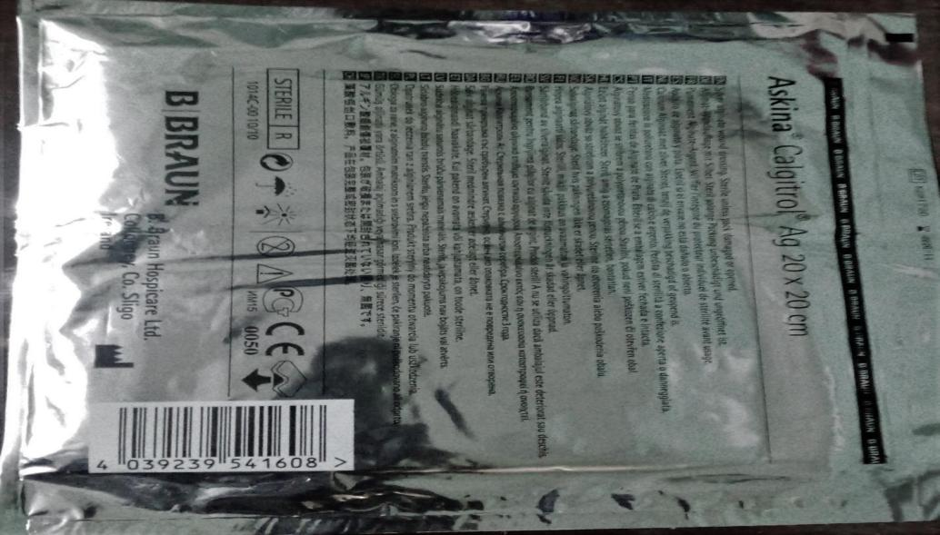

Figure 1 : CALGITRIOL SILVER
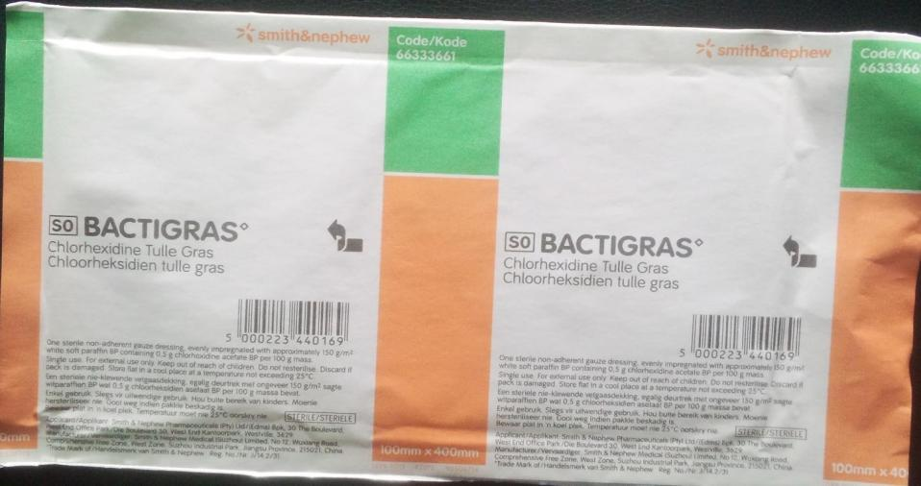
Figure 2 : BACTIGRAS

Intra-operative prophylactic antibiotics was given to all patients based on recipient site wound swab sensitivity pattern and broad spectrum antibiotics given to those who cultured no organism.
Donor site dressing was changed by the researcher at day 7, 10, 14, 18, and 21. Wound was cleansed with normal saline before applying a new dressing on the wound that have not completely re-epithelialized. Wound dressing was done at the bedside using aseptic technique.
Photographs of the wound were taken on day 7, 10, 14, 18 and 21 after the operation when the donor site was expected to have re-epithelialized.
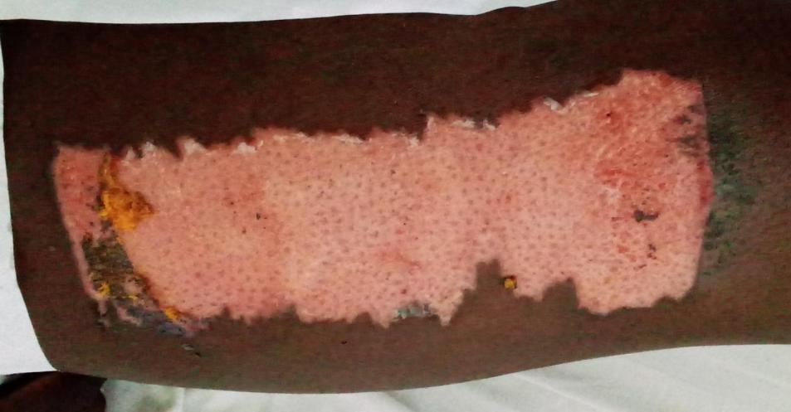
Figure 3: DONOR SITE DRESSED WITH CALGITRIOL SILVER

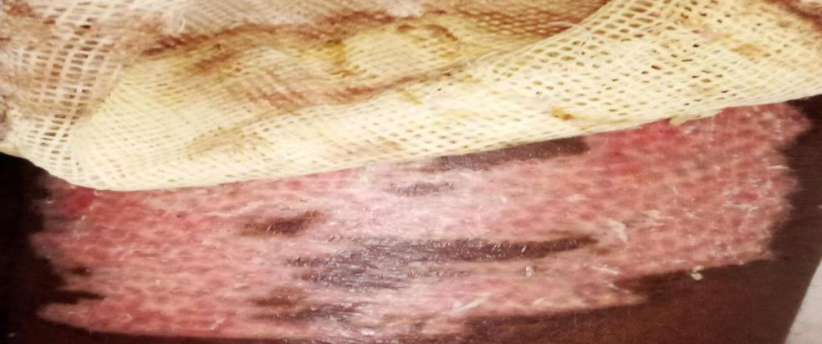
Figure 4: DONOR SITE DRESSED WITH BACTIGRAS
Wounds were considered to be completely re-epithelialized whenever epithelialization was 100%. The level of pain experienced by each patient was determined according to a pain rating scale which contains a range of numbers starting at 0 and going up to 10. The higher the number, the more intense the pain. On this scale, 0 indicates no pain, 1-3 indicates mild pain, 4-6 moderate pain and 7-10 represents severe pain. Pain was assessed at day 4, 7, and 14 after surgery at the same time of the day. Clinical evidence of infection at the donor site such as erythema, induration, undue pain, purulent discharge or foul odour was looked out for.
Data collection was done using a proforma designed for this study. All relevant information were entered into the proforma sheet at the time of presentation, and when subsequent data became available. Data were entered in a spread sheet and analyzed using IBM® SPSS (Statistical Package for Social Sciences) version 20. Calculations of mean, standard deviations, and associations between the variables were tested for statistical significance using appropriate statistical tools. p-values less than 0.05 were considered significant.

Results
Majority of the respondents in either group were aged 20 to 29. The mean ages of both groups were similar. There was equal sex distribution in the Calgitrol Silver group,while males were slightly higher in the Bactrigas group. However, none of these findings were found to be statistically significant.
Table 1: Socio-demographics Characteristics of Respondents in both Calgitrol Silver Bactrigas groups

Total Population
Variables | Calgitrol Silver  n = 50  Freq(%) | Bactrigas  n = 50  Freq(%) | Test Statistics | p value
Age
10 – 19 | 6 (54.5) | 5 (45.5) | Exact 2.913 | 0.817
20 – 29 | 15 (48.4) | 16 (51.6)
30 – 39 | 10 (52.6) | 9 (47.4)
40 – 49 | 9 (56.3) | 7 (43.8)
50 – 59 | 9 (50.0) | 9 (50.0)
60 – 69 | 1 (20.0) | 4 (80.0)
Mean age | 35.1±12.8 | 36.7±14.2
Sex
Male | 25 (49.0) | 26 (51.0) | χ2 0.040 | 0.841
Female | 25 (51.0) | 24 (49.0)
Occupational Level
Skill Level 0 | 18 (56.3) | 14 (43.8) | Exact 2.276 | 0.690
Skill Level 1 | 10 (41.7) | 14 (58.3)
Skill Level 2 | 10 (52.6) | 9 (47.4)
Skill Level 3 | 7 (41.7) | 10 (58.8)
Skill Level 4 | 5 (62.5) | 3 (37.5)

Although the mean sizes of both study groups were different, the findings were not statistically significant.
Table 2: Size of Donor Site in both Calgitrol Silver Bactrigas groups

Total Population
Size of Donor site | Calgitrol Silver  n = 50  Freq(%) | Bactrigas  n = 50  Freq(%) | T test | Degree of freedom | p value
Mean | 275.90 | 223.30 | 1.299 | 98 | 0.197
Standard Deviation | 250.17 | 139.46
Range | 1576 | 560
Minimum | 24 | 40
Maximum | 1600 | 600

Table 3: Time of healing

Total Population
Variables | Calgitrol Silver  n = 50  Freq(%) | Bactrigas  n = 50  Freq(%) | Test Statistics | p value
7th Day Post op
Complete | 26 (92.9) | 2 (7.1) | χ2 28.571 | 0.001
Incomplete | 24 (33.3) | 48 (66.7)
10th Day Post op | n = 24 | n = 48
Complete | 23 (88.5) | 3 (11.5) | χ2 55.656 | 0.001
Incomplete | 1 (2.2) | 45 (97.8)
14th Day Post op | n = 1 | n = 45
Complete | 1 (3.6) | 27 (95.4) | χ2 0.657 | 0.418
Incomplete | 0 (0.0) | 18 (100.0)
18th Day Post op | n = 0 | n = 18
Complete | 0 (0.0) | 17 (100.0) | 0 (0.0) | 0 (0.0)
Incomplete | 0 (0.0) | 1 (100.0)
21st Day Post op | n = 0 | n = 1
Complete | 0 (0.0) | 1 (100.0) | 0 (0.0) | 0 (0.0)
Incomplete | 0 (0.0) | 0 (0.0)
Among all those who achieved complete healing by the 7th day post op, majority, 26 (92.9%) were in the calgitrol silver group. This finding was statistically significant. Similarly, among all those who achieved complete healing by the 10th day post op, majority, 23 (88.5%) were in the calgitrol silver group while the rest 3(11.5%) were in the bactrigas group. This finding was also statistically significant. Majority of those in the bactrigas group achieved healing from 18 days upward.
Table 4: Levels of pain in both Calgitrol Silver Bactrigas groups

Total Population
Variables | Calgitrol Silver  n = 50  Freq(%) | Bactrigas n = 50  Freq(%) | Test Statistics | p value
4th Day Post op
0 | 43 (74.1) | 15 (25.9) | χ2 33.642 | 0.001
1 – 3 | 7 (21.9) | 25 (78.1)
4 – 6 | 0 (0.0) | 10 (100.0)
7 – 10 | 0 (0.0) | 0 (0.0)
7th Day Post op | n = 7 | n = 35
0 | 7 (18.4) | 31 (81.6) | Exact 0.884 | 0.347
1 – 3 | 0 (0.0) | 4 (100.0)
4 – 6 | 0 (0.0) | 0 (0.0)
7 – 10 | 0 (0.0) | 0 (0.0)
14th Day Post op | n = 0 | n = 4
0 | 0 (0.0) | 4 (100.0) | 0 (0.0) | 0 (0.0)
1 – 3 | 0 (0.0) | 0 (0.0)
4 – 6 | 0 (0.0) | 0 (0.0)
7 – 10 | 0 (0.0) | 0 (0.0)
Among all those who had no pain 4 days post op, 43 (74.1%) were from the calgitrol group while the rest, 15 (25.9%) were from the bactrigas group. This finding was statistically significant. No patient in the calgitrol groups experienced pain by the 14th day post op.

``Aetiology of Ulcer

Calgitrol Silver Bactigras
Post infective Ulcer
Iatrogenic Ulcer
Vascular Ulcer
Post Traumatic Ulcer
0
1
2
1
5
5
10
11
13
30

25

20
15
31
35
36
40
Aetiology of Ulcer

Frequncy

Exact = 3.454, p = 0.316

Figure 5: Bar chart showing the causes of ulcer in the two groups.
There was no statistically significant difference between the two groups in terms aetiology of ulcer.

Frequency

Location of Recipient site

Calgitrol Silver Bactigras
Lower Limb
Upper Limb
Trunk
Head and Neck
0
3
1
5
7
8
6
10
10
15
20
25
30
31
34
35
40
Recipient Site

Exact = 1.908, p = 0.582

Figure 6: Bar chart showing the recipient site in both Calgitrol Silver Bactrigas groups
.
Frequency

Frequency

Exact = 4.617, p = 0.041
Infection
Absent
Present
0
4, 100.0%
10
20
Calgitrol Silver
Bactigras
30
40
46
50
50
60
Bar Chart

Figure 7: Bar chart showing the occurrence of surgical site infection in the two groups.
All those who had surgical site infection were from the bactrigas group. This finding was statistically significant.

DISCUSSION
Split thickness donor site wound care is an important issue among plastic surgeons. Several kinds of dressings have been reported to be used, but which is superior has not been determined.⁴
The aim of managing donor site wounds is to promote healing as quickly as possible while minimizing complications.¹⁸
In this study, more patients in the calgitrol silver group attained complete healing 7 days (p=0.001) and 10 days (p=0.001) post op compared to those in the bactigras group (table 3). Jeong et al and Muangman et al noted similar findings reporting 17.25 ± 0.65 days and 14±3.05days respectively for bactigras.¹⁹ Ding et al reported a shorter duration of 7 days for alginate silver.²⁰ The woven nature of calgitrol silver may have provided added scaffold for epithelial migration. In addition, bactigras adhere more to delicate epithelium which are easily damaged during patient movement thereby slowing wound re-epithelialization and healing.
Surgical site infection was found only in the bactigras group(p=0.001). Similar finding was noted by Muangman et al who reported a case of surgical site infection with bactigras
.
Use.¹⁹ Ding et al reported a relatively higher infection infection rate of 10% with alginate silver dressing. This comparatively low infection rate of silver alginate may be due to the sustained release of ionic silver for a period of 7 days. In addition, when the alginate fibres are in contact with wound exudate, the calcium ions in the fibres exchange with sodium ions in the fliud and the fibres are transformed from water insoluble calcium alginate into water- soluble sodium alginate. The spaces between the fibres are closed as it absorbs water trapping any microorganism, giving calgitrol silver its bacteriostatic property.¹⁹
The majority (74.1%) of the study participants who had no post-operative pain on the fourth day post op were from calgitrol group (p=0.001) (table 4) Ding et al reported similar findings with alginate silver.²⁰ This finding is also in tandem with that noted by Muangman et al who reported increasing pain scores with bactigras dressing^{.19} Also, calgitrol silver group had no pain by the seventh day post op. Ding et al reported mild pain beyond 7days. Bactigras group had mild pain during the same period, which was consistent with observations made by Jeong et al.^{19,21} However, Muangman et al reported moderate pain with bactigras use.¹⁹ This may be due to early re-epithelialization noted with calgitrol silver. It could also be as result of the calcium content of calgitrol silver which promotes the coagulation of blood soon after applying calgitrol silver to the donor site. This forms a thin and soft film over the nerve endings of the donor site, thus reducing the level of pain felt with the use of calgitrol silver dressings.²² The friction and shear forces generated by the adherence of bactigras to the delicate epithelium that is repeatedly injured during slight movement of patients may be responsible for pain felt by patients who had bactigras dressings.²³

Conclusion

This study has demonstrated that calgitrol silver has superior effects on split thickness donor site wounds in rate of healing, lesser donor site pain and prevention of surgical site infection. Calgitrol silver should be considered over bactigras as dressing material for split-thickness donor site wound. However, further large scale study is needed to validate the findings in this study.

Limitation

This study was limited by the lack of quantitative and objective measurements of the rate of epithelialization.
Consent
As per international standards, patient(s) written consent has been collected and preserved by the author(s).
Ethical approval
As per international standards written ethical approval has been collected and preserved by the author(s).

Disclaimer (Artificial intelligence)
Author(s) hereby declare that NO generative AI technologies such as Large Language Models (ChatGPT, COPILOT, etc.) and text-to-image generators have been used during the writing or editing of this manuscript.

REFERENCES
- 1. Janis JE, Kwon RK, Attinger CE. The new reconstructive ladder: modifications to the traditional model. Plastic and reconstructive surgery. 2011;127:205S-12S.
- Kazanavičius M, Cepas A, Kolaityte V, Simoliuniene R, Rimdeika R. The use of modern dressings in managing split-thickness skin graft donor sites: a single-centre randomised controlled trial. J Wound Care. 2017;26:281-91.
- Voineskos SH, Ayeni OA, McKnight L, Thoma A. Systematic review of skin graft donor-site dressings. Plastic and reconstructive surgery. 2009;124:298-306.
- Veena PV, Shanthakumar S, Kumaraswamy M, Udayashankar O. Moriarty's sign - predictor of skin graft take. Acta Chir Plast. 2021;63:166-70.
- Mahmoud SM, Mohamed AA, Mahdi SE, Ahmed ME. Split-skin graft in the management of diabetic foot ulcers. J Wound Care. 2008;17:303-6.
- Birchall MA, Varma S, Milward TM. The Moriarty sign: an appraisal. British journal of plastic surgery. 1991;44:149-50.
- Brown JE, Holloway SL. An evidence-based review of split-thickness skin graft donor site dressings. Int Wound J. 2018;15:1000-1009.
- Rakel BA, Bermel MA, Abbott LI, Baumler SK, Burger MR, Dawson CJ, Heinle JA, Ocheltree IM. Split-thickness skin graft donor site care: a quantitative synthesis of the research. Applied Nursing Research. 1998;11:174-82.
- Demirtas Y, Yagmur C, Soylemez F, Ozturk N, Demir A. Management of split-thickness skin graft donor site: a prospective clinical trial for comparison of five different dressing materials. Burns. 2010;36:999-1005.
- Westby MJ, Dumville JC, Soares MO, Stubbs N, Norman G. Dressings and topical agents for treating pressure ulcers. Cochrane Database Syst Rev. 2017;6:CD011947.
- Demirtas Y, Yagmur C, Soylemez F, Ozturk N, Demir A. Management of split-thickness skin graft donor site: a prospective clinical trial for comparison of five different dressing materials. Burns. 2010;36:999-1005.
- An KC, Choi JS, Kim JH, Kim DM. Analysis of factors that affect the outcome of skin grafts. J Korean Orthop Assoc. 2012;47:119-24.
- Ricci E, Pittarello M, Cassino R, Moffa M, Ferrero S, Gondola M, Tonini E. Askina Calgitrol Ag: clinical use of an advanced ionic silver dressing. ActaVulnol 2007; 5:105-111
- Lansdown AB. A pharmacological and toxicological profile of silver as an antimicrobial agent in medical devices. Advances in pharmacological sciences. 2010; 2010.910686.
- Burd A, Kwok CH, Hung SC, Chan HS, Gu H, Lam WK, Huang L. A comparative study of the cytotoxicity of silver‐based dressings in monolayer cell, tissue explant, and animal models. Wound repair and regeneration. 2007;15 (1):94-104.
- Leaper DJ. Silver dressings: their role in wound management. International wound journal. 2006;3 (4):282-94.
- Olson ME, Wright JB, Lam K, Burrell RE. Healing of porcine donor sites covered with silver‐coated dressings. European Journal of Surgery. 2000; 166 (6):486-9
- Bactigras [Smith & Nephew Corporation web site] 2008. Available at: http://wound.smith-nephew.com/hk/Product.asp?NodeId=1786&Tab=1&Hide=
(accessed 12.02.2020)

- Bhatti AZ. Telfa as donor-site dressing. Plastic and reconstructive surgery. 2005 Oct 1;116(5):1578.
- Barnea Y, Amir A, Leshem D, Zaretski A, Weiss J, Shafir R, Gur E. Clinical comparative study of aquacel and paraffin gauze dressing for split-skin donor site treatment. Annals of plastic surgery. 2004 Aug 1;53 2:132-6.
- Muangman P, Nitimonton S, Aramwit P. Comparative clinical study of Bactigras and Telfa AMD for skin graft donor-site dressing. Int J Mol Sci. 2011;12:5031-8.
- Xianchao Ding, Lei Shai, Chang Lia .A randomized comparison study of Aquecel Ag and Alginate Sliver as skin graft donor site dressing.Burns.2013;39 :1547-50.
- Sinha S, Schreiner AJ, Biernaskie J, Nickerson D, Gabriel VA. Treating pain on skin graft donor sites: Review and clinical recommendations. J Trauma Acute Care Surg. 2017 ;83:954-64.
- Ravnskog FA, Espehaug B, Indrekvam K. Randomised clinical trial comparing Hydrofiber and alginate dressings post-hip replacement. Journal of wound care. 2011; 20:136-42.
- Silver, F.H. A Matter of gravity–mechanotransduction: How mechanical forces influence biological materials. Mater. Sci. Eng. Int. J. 2017, 1, 66–68.

