A review of Phenol degrading fungi from industrial areas

Abstract
Phenol is a widespread environmental contaminant, commonly found in effluents from petroleum refineries, chemical manufacturing, pulp and paper industries, and textile plants. Its high toxicity, persistence, and water solubility make it a significant ecological and public health hazard. Traditional methods for phenol remediation are often energy-intensive, costly, and generate secondary pollutants. In recent years, fungi have emerged as promising biological agents for the degradation of phenol due to their ability to produce a wide array of oxidative enzymes and adapt to harsh environments. This review explores the sources and environmental implications of phenol pollution, the mechanisms by which fungi degrade phenol, and the diversity of fungal species capable of bioremediation. It further discusses the isolation of fungal strains from industrial areas, the application of bioreactor technologies, and recent advances in fungal genetics and metabolic engineering. Challenges and opportunities in this field are highlighted to guide future research toward sustainable and efficient phenol bioremediation strategies.
Keywords: phenol-degrading fungi, industrial area, bioremediation

1. Introduction
Phenol (C₆H₅OH), a simple aromatic compound, is a major pollutant generated from numerous industrial activities including oil refining, plastics manufacturing, pharmaceuticals, dyes, resins, and coal processing. Its high solubility in water facilitates its dispersal in aquatic systems, where it poses acute and chronic toxicity to aquatic life, plants, and humans (Busca et al., 2008). Exposure to phenol can result in serious health effects, including liver and kidney damage, respiratory complications, and carcinogenicity. According to the U.S. Environmental Protection Agency (EPA), phenol is classified as a priority pollutant, and its removal from wastewater is of critical importance (EPA, 2018).Conventional methods for phenol removal include chemical oxidation, adsorption using activated carbon, membrane filtration, and advanced oxidation processes. However, these techniques are often economically unviable at large scales, particularly for low-concentration and high-volume waste streams. They also tend to produce toxic by-products or require extensive post-treatment (Nair et al., 2008). Bioremediation, particularly using microbial systems, offers a sustainable alternative, utilizing the metabolic capabilities of microorganisms to degrade and detoxify phenol and related aromatic compounds. Fungi have shown remarkable potential in phenol degradation due to their extracellular enzyme systems, non-specific oxidative mechanisms, and the ability to withstand extreme environmental conditions. Unlike bacteria, many fungi can degrade phenolic compounds at low pH and in high-toxicity conditions without requiring co-metabolites (Harms et al., 2011). Notably, white rot fungi such as Phanerochaete chrysosporium, Trametes versicolor, and Pleurotus ostreatus produce laccases, lignin peroxidases, and manganese peroxidases capable of attacking a wide range of phenolic structures (Pointing, 2001).
2. Sources and Environmental Impact of Phenol
Phenol contamination arises from diverse industries including petroleum refining, coal gasification, steel production, pulp and paper mills, dye manufacturing, and tanneries. In India, major phenolic pollution hotspots include industrial zones in Gujarat (Ankleshwar, Vadodara), Maharashtra (Thane, Nagpur), and Chhattisgarh (Korba industrial belt) (Kumari et al., 2021). Effluent analysis from these regions revealed phenol concentrations ranging from 5 to 250 mg/L-far above permissible discharge limits. Once released, phenol rapidly dissolves in water and can permeate soil, posing a risk to groundwater. Its acute toxicity disrupts microbial communities and reduces biodiversity. In aquatic environments, phenol inhibits respiration and reproduction in fish and other organisms (Luo et al., 2009). Phenol and its derivatives can also bioaccumulate through food chains, ultimately affecting human health through chronic exposure. In soils, phenol interferes with nitrogen fixation and enzyme activities, altering fertility and plant growth. The persistence of phenol in sediments is largely due to slow anaerobic degradation rates. Moreover, partial chemical oxidation can produce more toxic intermediates like catechol and hydroquinone, compounding environmental hazards. This has directed attention toward microbial degradation particularly fungal systems that can metabolize phenol under both aerobic and microaerophilic conditions (Mondal et al., 2020). In Indian contexts, the severity of phenol pollution is heightened by the coexistence of mixed contaminants such as heavy metals and hydrocarbons. These complex effluents challenge conventional treatment systems but provide unique opportunities for isolating robust fungal species adapted to harsh conditions. Such indigenous fungi represent key biological resources for sustainable remediation technologies.

3. Mechanisms of Phenol Degradation by Fungi
The degradation of phenol by fungi is a coordinated biochemical sequence that combines extracellular oxidation with intracellular mineralization. These reactions transform phenol and related aromatics into simpler, non-toxic molecules that serve as metabolic substrates. Initially, fungi secrete oxidative enzymes into their environment, where phenol molecules undergo enzymatic attack to form less complex intermediates. Subsequent intracellular processes cleave the aromatic ring and channel the resulting compounds into the tricarboxylic acid (TCA) cycle, producing carbon dioxide and water as final products (Rodríguez Couto & Toca-Herrera, 2006). Through this combination of external oxidation and internal metabolism, fungi simultaneously achieve detoxification and energy recovery from phenolic wastes.
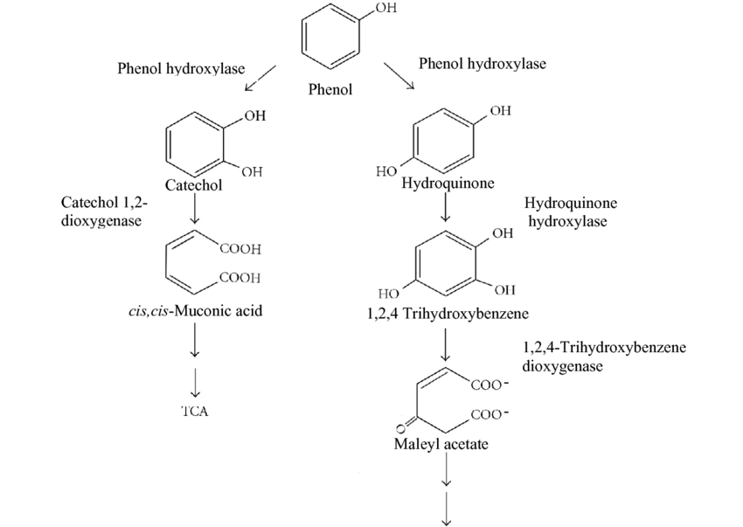
Figure 1. Mechanisms of phenol degradation by fungi showing the ortho- and para-hydroxylation pathways mediated by fungal enzymes such as laccase, lignin peroxidase, manganese peroxidase, and tyrosinase, leading to catechol and hydroquinone intermediates followed by ring-cleavage and mineralization to CO₂ and H₂O (Gerginova et al., 2013).
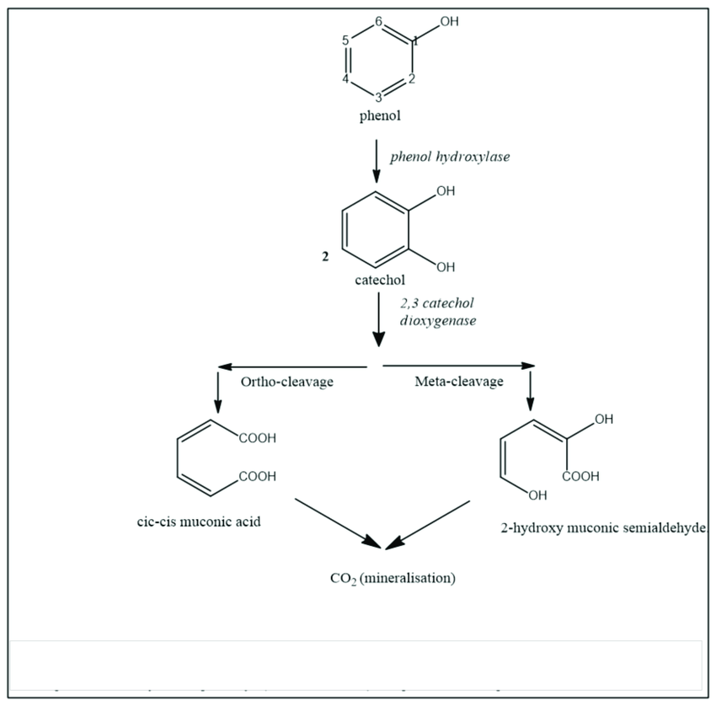

Figure 2. Pathways of phenol degradation by microorganisms. (Nzila, 2018).

3.1 Extracellular Oxidative Reactions
Filamentous and ligninolytic fungi are distinguished by their ability to produce an array of extracellular enzymes that degrade recalcitrant aromatics. The most important are laccases, lignin peroxidases (LiP), manganese peroxidases (MnP), and versatile peroxidases (VP) (Pointing, 2001). Laccases are multicopper oxidases that catalyze one-electron oxidation of phenolic hydroxyl groups using molecular oxygen as the terminal electron acceptor, generating water as the only by-product (Harms et al., 2011). These enzymes transform phenol into unstable phenoxy radicals, which spontaneously rearrange or polymerize into products more amenable to further enzymatic attack.
LiP and MnP extend fungal oxidative capacity to non-phenolic aromatics. LiP generates high-redox-potential cation radicals capable of cleaving C–C and C–O bonds, while MnP oxidizes Mn²⁺ to Mn³⁺, which then diffuses as a secondary oxidant through the medium (Banerjee & Ghoshal, 2010). The synergistic activity of laccase, LiP, and MnP has been demonstrated in Trametes versicolor, Pleurotus ostreatus, and Phanerochaete chrysosporium, achieving >90 % phenol degradation within three days under optimized pH and aeration (Mondal et al., 2020). Enzyme synthesis is strongly regulated by nutrient limitation—particularly nitrogen deficiency which triggers secondary metabolism and up-regulation of ligninolytic gene clusters (Kumari et al., 2021).

3.2 Intracellular Metabolic Conversion
Once extracellular oxidation produces intermediates such as catechol and hydroquinone, these compounds are transported into fungal cells for ring-cleavage reactions. Two main pathways operate: the ortho-cleavage route catalyzed by catechol 1,2-dioxygenase and the meta-cleavage route catalyzed by catechol 2,3-dioxygenase (Floudas et al., 2012). In the ortho pathway, catechol is converted to cis,cis-muconic acid, which is subsequently transformed into β-ketoadipate and enters the TCA cycle. The meta pathway yields 2-hydroxymuconic semialdehyde, which is further oxidized to pyruvate and acetaldehyde before assimilation into central metabolism (Garg et al., 2021).
The predominance of either pathway depends on oxygen levels, substrate concentration, and species-specific enzyme regulation. Studies on Aspergillus niger and Penicillium chrysogenum have revealed concurrent operation of both routes, providing metabolic flexibility under stress conditions (Roy & Saha, 2022). Exposure to phenol also induces antioxidant defense systems, including catalase and superoxide dismutase, to counteract reactive oxygen species generated during oxidation. This integrated stress-response mechanism allows fungi to withstand phenol concentrations that inhibit bacterial metabolism (Harms et al., 2011).

3.3 Biosorption and Transport Phenomena
Beyond enzymatic catalysis, fungal cell walls themselves contribute to phenol removal through biosorption. Structural polymers such as chitin and β-glucans present carboxyl, hydroxyl, and amino groups that adsorb phenolic molecules by hydrogen bonding and electrostatic attraction (Zhao et al., 2020). This passive uptake reduces free phenol levels in the medium, protecting extracellular enzymes from inhibition. Adsorbed molecules may later desorb for enzymatic degradation, maintaining a steady degradation rate even under fluctuating pollutant loads.
Transport across the plasma membrane is mediated by major facilitator superfamily (MFS) and ATP-binding-cassette (ABC) transporters that regulate intracellular concentrations of phenol and its metabolites. Transcriptomic analyses of Trichoderma reesei have shown significant up-regulation of ABC transporter genes during phenol exposure, highlighting their role in detoxification (Singh et al., 2021). In continuous-flow systems, fungal biofilms provide additional resilience. Hyphae embedded in extracellular polymeric substances (EPS) trap pollutants and concentrate enzymes locally, resulting in higher degradation efficiency and protection from hydraulic shear. Aspergillus niger biofilms have maintained removal efficiencies above 95 % under phenol shock loads (Zhao et al., 2020).

3.4 Co-Metabolic Interactions and Secondary Metabolites
Fungal metabolism of phenol frequently relies on co-metabolism, in which another carbon source or endogenous metabolite supports enzyme activity. Secondary metabolites such as oxalic acid and hydrogen peroxide act as natural mediators enhancing oxidation through Fenton-like reactions that generate hydroxyl radicals (Roy & Saha, 2022). These radicals non-enzymatically cleave aromatic rings, complementing the activity of laccase and peroxidases. The concurrent secretion of oxalic acid also chelates metal ions, stabilizing Mn³⁺ intermediates essential for MnP catalysis (Banerjee & Ghoshal, 2010).
Co-metabolic synergy has been observed in Pleurotus ostreatus, where simultaneous production of laccase and oxalic acid accelerated phenol oxidation by roughly one-third compared with enzyme activity alone (Shukla et al., 2019). Similar cooperative effects occur in mixed microbial consortia. A co-culture of Trametes versicolor and Pseudomonas putida eliminated phenol completely within 48 h, demonstrating that fungal-bacterial partnerships can combine oxidative and mineralization capacities (Sharma & Singh, 2022).

3.5 Enzyme Immobilization and Process Optimization
Immobilization of fungal enzymes or cells has become an important strategy for industrial wastewater treatment because it enhances operational stability and reusability. Matrices such as calcium alginate, silica gel, loofa sponge, and biochar provide mechanical support and create microenvironments favorable to enzyme activity (Elisashvili et al., 2008). Immobilized laccase from Pleurotus ostreatus retained > 80 % of its catalytic activity after five reuse cycles while maintaining phenol removal efficiency above 90 % (Shukla et al., 2019). Immobilized Aspergillus oryzae in packed-bed reactors achieved similar results and showed high resistance to variable flow rates and phenol loads (Shah et al., 2022).
Process parameters strongly influence enzymatic efficiency. Optimal pH for laccase activity usually lies between 4.5 and 5.5, while temperature optima range from 30 to 40 °C (Mondal et al., 2020). Adequate aeration and the presence of trace metals such as copper are essential for maintaining the redox state of laccase active sites. Advances in reactor design especially hybrid systems combining biological oxidation with membrane separation are expected to further improve treatment performance in industrial applications (Pandey & Singh, 2024).

4. Diversity and Taxonomy of Phenol-Degrading Fungi
Fungal degradation of phenol is not confined to a few specialized taxa; rather, it is distributed across many evolutionary lineages within the phyla Basidiomycota and Ascomycota. The structural diversity of fungal enzymes and their physiological plasticity allow representatives of several ecological guilds saprotrophs, endophytes, plant pathogens, and marine or halotolerant species to participate in phenol turnover. Understanding this diversity is critical because different taxa employ distinct enzymatic systems, metabolic routes, and environmental tolerances that influence their applicability in industrial wastewater treatment (Harms et al., 2011).

4.1 Basidiomycetous White-Rot and Litter-Decomposing Fungi
Among phenol-degrading organisms, white-rot basidiomycetes are the most extensively characterized. These fungi—typified by Phanerochaete chrysosporium, Trametes versicolor, Pleurotus ostreatus, Trametes hirsuta, and Pycnoporus cinnabarinus possess a ligninolytic enzyme system capable of oxidizing both phenolic and non-phenolic aromatics (Pointing, 2001; Mondal et al., 2020). The same oxidative machinery that enables lignin decomposition in wood also permits the degradation of industrial phenolic pollutants. Enzyme screening of T. versicolor has revealed multiple laccase isoforms and a suite of peroxidases that function synergistically across a broad pH range (4–7), giving the species remarkable adaptability (Banerjee & Ghoshal, 2010).
White-rot fungi not only degrade soluble phenols but also attack high-molecular-weight polymeric residues that accumulate in paper-and-pulp or dye-industry effluents. Pleurotus ostreatus and P. cinnabarinus efficiently decolorize azo and anthraquinone dyes through phenol oxidation coupled with radical-mediated bond cleavage (Kumari et al., 2021). In Indian contexts, isolates from lignocellulosic wastes in Chhattisgarh and Gujarat have shown over 90 % phenol removal within four days of incubation (Kumar et al., 2022). The success of these basidiomycetes is attributed to their extracellular enzyme stability and tolerance of fluctuating oxygen levels common in industrial effluents.

4.2 Ascomycetous Soil and Filamentous Fungi
While basidiomycetes dominate studies on lignin degradation, ascomycetous filamentous fungi are equally significant for phenol bioremediation, particularly in soil and sludge environments. Genera such as Aspergillus, Penicillium, Trichoderma, and Fusarium are ubiquitous in contaminated habitats and possess the ability to metabolize phenol even under nutrient-rich or moderately alkaline conditions (Sahoo et al., 2023). Their fast growth, tolerance to high phenol concentrations, and resistance to osmotic stress make them strong candidates for continuous bioreactor operation.
Species-level differences are notable. Aspergillus niger produces extracellular laccases and intracellular dioxygenases that can oxidize up to 1000 mg L⁻¹ phenol, whereas Penicillium chrysogenum relies mainly on catechol dioxygenase pathways (Zhao et al., 2020). Trichoderma reesei, famous for cellulase production, expresses ABC transporter genes during phenol exposure, indicating an adaptive detoxification mechanism (Singh et al., 2021). Indian isolates from Korba’s coal-processing belt, including Aspergillus flavus and Trichoderma viride, have demonstrated dual capacities for phenol degradation and heavy-metal biosorption—an advantage for treating mixed industrial effluents (Kumar et al., 2022).
The taxonomic diversity within Ascomycota also supports ecological resilience: ascomycetes withstand variable moisture and temperature regimes, enabling treatment under both aerobic and microaerophilic conditions. Their spore-forming ability facilitates easy inoculum production for bioreactors, and the hydrophobic conidia aid adherence to carrier materials used in immobilized-cell systems (Shah et al., 2022).

4.3 Endophytic, Marine, and Halotolerant Fungi
Beyond terrestrial decomposers, endophytic and marine fungi have emerged as promising sources of novel phenol-degrading enzymes. Endophytes live within plant tissues and often possess oxidative stress-management systems derived from host-microbe co-adaptation. Colletotrichum gloeosporioides and Botryosphaeria dothidea isolated from medicinal plants in India efficiently degrade phenol while producing antioxidant metabolites that mitigate reactive intermediates (Verma et al., 2019; Mehta et al., 2021). These species combine detoxification with biosynthesis of pharmaceutically valuable compounds, offering dual economic and environmental benefits.
Marine and halophilic fungi broaden the ecological spectrum further. Halophytophthora sp. and Aspergillus sydowii from coastal sediments tolerate high salinity and temperature, sustaining phenol degradation under conditions that inhibit most terrestrial species (Chandra et al., 2023). Such halotolerant strains are especially relevant for treating saline effluents from tanneries, desalination plants, and petrochemical industries along India’s coastline. Comparative genomic analyses reveal that these fungi possess expanded gene families encoding oxidoreductases and heat-shock proteins, reflecting evolutionary adaptation to extreme environments (Deshmukh et al., 2019).
The exploration of these unconventional ecological niches is still in its infancy in India, yet it represents an untapped reservoir of biocatalytic potential. Continuous efforts to catalogue and preserve marine fungal isolates could significantly enhance the repertoire of enzymes available for industrial phenol remediation.

4.4 Molecular Taxonomy and Phylogenetic Insights
Accurate taxonomic identification is fundamental for exploiting fungal biodiversity. Traditional morphological approaches—spore size, pigmentation, and colony texture—are now complemented by molecular markers such as the internal transcribed spacer (ITS) regions of ribosomal DNA, large-subunit (LSU) sequences, and protein-coding genes like β-tubulin and tef1-α (Floudas et al., 2012). These markers provide high-resolution phylogenetic frameworks to distinguish closely related phenol-degrading strains.
Molecular phylogenetic studies have clarified evolutionary relationships among ligninolytic fungi, showing that the enzymatic machinery responsible for phenol oxidation originated in Paleozoic basidiomycetes and diversified independently within Ascomycota (Floudas et al., 2012). This evolutionary insight explains why both phyla exhibit phenol-degrading capacity despite ecological and morphological differences. Modern tools such as multilocus sequence typing (MLST) and next-generation sequencing enable rapid assessment of fungal community composition in polluted environments. Metagenomic surveys from Indian industrial soils reveal that Aspergillus, Trametes, Fusarium, and Penicillium collectively dominate phenol-rich habitats, highlighting the coexistence of oxidative and hydrolytic metabolic guilds (Garg et al., 2021).
Integrating molecular identification with functional assays helps link specific enzyme profiles to taxonomic units. For example, isolates within Trametes possessing multiple laccase isoforms cluster separately from species with predominant MnP activity, suggesting functional divergence within the genus (Mondal et al., 2020). Such correlations assist in selecting strains tailored for targeted pollutants or process conditions.

4.5 Indian Biodiversity and Applied Potential
India’s climatic and industrial heterogeneity creates diverse ecological niches that harbor unique phenol-degrading fungi. Studies from Gujarat’s petrochemical belts, Tamil Nadu’s tanneries, and Chhattisgarh’s coal-processing areas have documented numerous indigenous isolates exhibiting exceptional tolerance to phenol, high salinity, and heavy metals (Kumar et al., 2022; Patel et al., 2022). Indigenous strains offer advantages over imported cultures because they are pre-adapted to local environmental stresses and effluent chemistries.
The establishment of fungal culture collections—such as those maintained by CSIR-NEERI and Dr. C.V. Raman University has facilitated preservation and distribution of these isolates for biotechnological research. Combining classical taxonomy, molecular characterization, and enzyme-activity profiling ensures reliable strain identification for industrial deployment. Moreover, exploration of endophytic and halophilic fungal diversity aligns with India’s national strategy on bioresource utilization and circular-economy initiatives.
Overall, the taxonomic and functional diversity of phenol-degrading fungi underpins their ecological success and technological potential. Each fungal lineage contributes specific enzymatic or physiological traits that, when harnessed collectively, can create efficient multi-strain consortia for large-scale phenolic waste remediation in Indian industrial systems (Roy & Saha, 2022).
5. Isolation and Characterization from Industrial Sites
Fungal strains capable of phenol degradation are typically isolated from contaminated industrial sites, such as oil refineries, chemical processing plants, and tannery waste dumps. Soil and sludge samples are enriched in mineral salt media containing phenol as the sole carbon source. Following enrichment, fungal isolates are screened for their tolerance to phenol and their enzymatic activity (Banerjee and Ghoshal, 2010).Characterization involves morphological identification, followed by molecular analysis for precise taxonomy. Biochemical assays assess their degradation kinetics, enzyme production, and resistance to phenol concentrations. Studies have reported fungi that can tolerate and degrade phenol at concentrations above 1000 mg/L, demonstrating their robustness and industrial relevance (Basha et al., 2010).
6. Biotechnological Applications and Bioreactor Systems
Fungi-based bioremediation has been applied in various bioreactor configurations, including batch reactors, packed-bed bioreactors, fluidized bed reactors, and membrane bioreactors. These systems enable controlled environmental conditions for optimal fungal growth and phenol degradation. Immobilized fungal cells or enzymes on solid supports have shown improved phenol degradation rates and operational stability (Elisashvili et al., 2008). This is supported by Shah et al. (2022), who showed that immobilized cells of Aspergillus oryzae maintained high degradation activity in continuous reactor systems and were resilient to operational variations. White rot fungi in packed-bed reactors have demonstrated consistent phenol removal efficiencies exceeding 90% over extended periods. For instance, Kumari et al. (2021) reported that Pycnoporus cinnabarinus significantly reduced phenol content in paper and pulp mill wastewater while improving its overall biodegradability. The integration of fungal bioremediation in wastewater treatment plants has the potential to reduce operational costs and chemical inputs. Furthermore, co-culture systems involving fungi and bacteria offer synergistic benefits. This synergy was highlighted by Sharma and Singh (2022), who found that mixed fungal consortia used on pharmaceutical effluents enhanced the degradation rate and minimized the accumulation of toxic intermediates.
7. Advances in Genetic and Metabolic Engineering
Advances in fungal genomics and synthetic biology have paved the way for engineering high-performance phenol-degrading strains. Genetic modifications have focused on overexpression of laccase and peroxidase genes, enhancement of stress resistance, and optimization of metabolic pathways involved in aromatic compound degradation (Floudas et al., 2012). Singh et al. (2021) reviewed these advancements, emphasizing the growing role of genetic engineering in enhancing degradation efficiency. Similarly, Garg et al. (2021) noted that genetically modified fungi show great promise for phenolic pollutant degradation through enhanced enzyme production and improved resistance to toxicity. CRISPR/Cas9 systems and other molecular tools have facilitated precise genome editing in fungi such as Aspergillus nidulans and Trichoderma reesei. Metabolic modeling has helped in understanding rate-limiting steps and optimizing carbon flux toward phenol degradation. Multi-omics approaches, including transcriptomics and proteomics, are being used to identify novel regulatory elements and enzyme isoforms.These advances are crucial for designing robust fungal strains capable of operating in industrial-scale bioreactors under varying environmental conditions.
8. Challenges and Limitations
Despite their potential, several challenges hinder the widespread application of fungi in phenol remediation. The slow growth rate of many fungi compared to bacteria, sensitivity to environmental fluctuations, and the need for aeration in ligninolytic enzyme activity is notable limitations. The study by Mondal et al. (2020) underscores the importance of optimizing conditions like pH and temperature to maximize fungal activity, which adds a layer of operational complexity. Moreover, fungal enzyme production can be inhibited by high phenol concentrations or competing microbial species. Scale-up of fungal bioreactors presents technical issues related to oxygen transfer, moisture control, and reactor clogging. There is also a lack of standardized protocols for fungal bioremediation, complicating regulatory approval and commercial deployment. Additionally, public perception and biosafety concerns about genetically modified fungi, despite their potential as reviewed by Garg et al. (2021), pose significant regulatory hurdles.
9. Future Prospects
Future research should focus on discovering new phenol-degrading fungal strains from extreme or underexplored environments, building on the work with marine fungi (Deshmukh et al., 2019) and halotolerant species (Chandra et al., 2023). Advancements in metagenomics, metabolomics, and synthetic biology will further enable the design of tailored microbial consortia and engineered enzymes. The proven success of fungal consortia (Sharma and Singh, 2022) suggests that designing such synergistic communities is a promising avenue. The development of hybrid treatment systems combining fungi, bacteria, and physico-chemical processes could improve remediation efficiency.Improved reactor designs, such as modular plug-flow or membrane bioreactors, will enhance operational control and scalability. Furthermore, the finding that some fungi produce valuable secondary metabolites during remediation (Mehta et al., 2021) points to an attractive future direction: valorizing fungal biomass for bioenergy or chemical production to improve the economic feasibility of fungal bioremediation technologies.
10. Conclusion
Fungi represent a powerful and underutilized tool for the remediation of phenol-contaminated industrial environments. Their enzymatic versatility, resilience in harsh conditions, and ability to mineralize complex aromatic pollutants highlight their significance in sustainable wastewater treatment. As technological and genetic tools advance, fungal-based phenol bioremediation is poised to become a cornerstone of green industrial practices. Continued interdisciplinary collaboration will be key to unlocking their full potential in environmental biotechnology.

References
Amobonye, A., Bharathiraja, B., & Muchaonyerwa, P. (2023). The potential of fungi in the bioremediation of emerging pollutants. Frontiers in Microbiology, 14, 1207792. https://doi.org/10.3389/fmicb.2023.1207792
Basha, S., Rajendran, A., & Thangavelu, V. (2010). Recent advances in the biodegradation of phenol: A review. Asian Journal of Experimental Biological Sciences, 1(2), 219–234. https://www.researchgate.net/publication/265526019_Recent_Advances_in_the_Biodegradation_of_Phenol_A_Review
Busca, G., Berardinelli, S., Resini, C., & Arrighi, L. (2008). Technologies for the removal of phenol from fluid streams: A short review of recent developments. Journal of Hazardous Materials, 160(2–3), 265–288. https://doi.org/10.1016/j.jhazmat.2008.03.045
Chandra, R., Kumar, V., & Yadav, S. (2023). Fungal biodegradation of phenolic pollutants under high salinity and temperature stress. Journal of Hazardous Materials, 445, 130532. https://doi.org/10.1016/j.jhazmat.2022.130532
Deshmukh, R., Khardenavis, A. A., & Purohit, H. J. (2019). Diverse metabolic capacities of fungi for bioremediation. Indian Journal of Microbiology, 59(3), 289–298. https://doi.org/10.1007/s12088-019-00803-2
Dinakarkumar, Y., & Reddy, P. S. (2024). Fungal bioremediation: Mechanisms and future perspectives. Current Research in Microbial Sciences, 5, 100214. https://doi.org/10.1016/j.crmicr.2024.100214
Elisashvili, V., Penninckx, M., Kachlishvili, E., Tsiklauri, N., Metreveli, E., Kharziani, T., & Kvesitadze, G. (2008). Lignocellulose-degrading enzyme production by white-rot basidiomycetes species in solid-state fermentation of wheat straw. World Journal of Microbiology and Biotechnology, 24(4), 639–646. https://doi.org/10.1007/s11274-007-9523-8
Environmental Protection Agency (EPA). (2018). Technical factsheet on: Phenol. United States Environmental Protection Agency. https://www.epa.gov/sites/default/files/2018-09/documents/phenol.pdf
Floudas, D., Binder, M., Riley, R., Barry, K., Blanchette, R. A., Henrissat, B., Martínez, A. T., Otillar, R., Spatafora, J. W., Yadav, J. S., & Hibbett, D. S. (2012). The Paleozoic origin of enzymatic lignin decomposition reconstructed from 31 fungal genomes. Science, 336(6089), 1715–1719. https://doi.org/10.1126/science.1221748
Garg, S., Roy, A., & Yadav, A. (2021). Genetically modified fungi for phenolic pollutant degradation: A review. Biotechnology Advances, 49, 107763. https://doi.org/10.1016/j.biotechadv.2021.107763
Harms, H., Schlosser, D., & Wick, L. Y. (2011). Untapped potential: Exploiting fungi in bioremediation of hazardous chemicals. Nature Reviews Microbiology, 9(3), 177–192. https://doi.org/10.1038/nrmicro2519
He, Y., Li, J., & Wang, Z. (2022). Biodegradation of phenol by Candida tropicalis: High-concentration tolerance and kinetic analysis. Chemosphere, 303, 135138. https://doi.org/10.1016/j.chemosphere.2022.135138
Kumari, A., Singh, R., & Tiwari, S. (2021). Bioremediation of paper and pulp mill effluent using ligninolytic fungi. Environmental Science and Pollution Research, 28(26), 34035–34047. https://doi.org/10.1007/s11356-021-13252-4
Luo, Q., Wang, Z., & Chen, Y. (2009). Toxicity of phenol to aquatic organisms. Journal of Environmental Sciences, 21(3), 250–255. https://doi.org/10.1016/S1001-0742(08)62204-7
Mehta, A., Bodh, U., & Gupta, R. (2021). Endophytic fungi from medicinal plants: A treasure hunt for antioxidant and bioremediating agents. Current Microbiology, 78(5), 1921–1932. https://doi.org/10.1007/s00284-021-02489-8
Mondal, S., Chakraborty, I., & Das, A. (2020). Optimization of phenol degradation by Trametes hirsuta MTCC-1171: Application in treatment of dye effluent. Biocatalysis and Agricultural Biotechnology, 25, 101597. https://doi.org/10.1016/j.bcab.2020.101597
Nair, C. I., Jayachandran, K., & Shashidhar, S. (2008). Biodegradation of phenol. African Journal of Biotechnology, 7(25), 4951–4958. https://doi.org/10.5897/AJB2008.000-3040
Pointing, S. B. (2001). Feasibility of bioremediation by white-rot fungi. Applied Microbiology and Biotechnology, 57(1–2), 20–33. https://doi.org/10.1007/s002530100722
Rawal, R. S., Patel, K., & Mehta, A. A. (2024). Identification of optimal laccases for chlorinated phenol oxidation using comparative genomics and docking studies. Heliyon, 10, e28749. https://doi.org/10.1016/j.heliyon.2024.e28749
Rodríguez Couto, S., & Toca-Herrera, J. L. (2006). Industrial and biotechnological applications of laccases: A review. Biotechnology Advances, 24(5), 500–513. https://doi.org/10.1016/j.biotechadv.2006.05.003
Rosa, F. M., de Souza, J. R., & Carvalho, C. S. (2024). Filamentous fungi as bioremediation agents of industrial effluents. Fermentation, 10(3), 143. https://doi.org/10.3390/fermentation10030143
Roy, M., & Saha, S. (2022). Role of fungal metabolites in the degradation of phenolic compounds. Journal of Applied Microbiology, 132(2), 911–924. https://doi.org/10.1111/jam.15408
Shah, K., Patel, H., & Shukla, P. (2022). Continuous biodegradation of phenol by immobilized Aspergillus oryzae cells in a packed-bed reactor. Environmental Technology & Innovation, 26, 102302. https://doi.org/10.1016/j.eti.2021.102302
Sharma, J., & Singh, A. (2022). Synergistic effect of fungal consortia for the treatment of phenolic effluents from pharmaceutical industries. Water Science and Technology, 85(8), 2312–2325. https://doi.org/10.2166/wst.2022.12527
Shukla, P., Singh, N., & Gupta, S. (2019). Immobilized laccase from Pleurotus ostreatus: A novel approach for wastewater treatment. Preparative Biochemistry & Biotechnology, 49(9), 894–902. https://doi.org/10.1080/10826068.2019.1603204
Singh, P., Kaur, J., & Yadav, A. (2021). Genetic engineering approaches for enhancing fungal bioremediation of phenolic compounds. Critical Reviews in Biotechnology, 41(4), 502–518. https://doi.org/10.1080/07388551.2020.1724424
Thathola, P. (2024). Laccase-mediated degradation of emerging contaminants. Environmental Science: Advances, 3, Article d4va00173g. https://doi.org/10.1039/d4va00173g
Verma, A., Singh, H., & Anwar, S. (2019). Phenolic degradation by endophytic fungi Colletotrichum gloeosporioides and Botryosphaeria dothidea: A sustainable approach. Journal of Environmental Management, 250, 109457. https://doi.org/10.1016/j.jenvman.2019.109457
Zhao, L., Wu, J., & Zhang, X. (2020). Enhanced degradation of phenolic compounds by biofilm-forming Aspergillus niger. Bioresource Technology, 305, 123068. https://doi.org/10.1016/j.biortech.2020.123068

