Original Research Article
Exploring Antimicrobial Efficacy and Enzymatic Versatility of a Novel Nocardiopsis sp. RB8 Strain.

ABSTRACT
Actinomycetes are well recognized for their ability to produce biologically active compounds and industrially important enzymes. Nocardiopsis species are notable actinomycetes recognized for their ability to produce diverse bioactive metabolites and enzymes. In this study, a slow-growing actinomycete strain, designated Nocardiopsis sp. RB8, was isolated and characterized using phenotypic, biochemical, and molecular approaches. The strain exhibited distinct cultural and morphological features and demonstrated the ability to produce multiple hydrolytic enzymes, along with antimicrobial activity against selected bacterial and fungal pathogens. Antibiotic susceptibility profiling indicated sensitivity to several clinically relevant antibiotics while showing resistance to β-lactam agents. Molecular analysis of the 16S rRNA gene revealed sequence similarity values below the threshold for species-level identification, suggesting that strain RB8 may represent a novel species within the genus Nocardiopsis. In conclusion, the present study demonstrates that Nocardiopsis sp. RB8 possesses significant potential for natural product discovery and industrial enzyme production. These promising attributes warrant further comprehensive genomic and metabolic analysis to confirm the strain’s novelty and to fully elucidate its biotechnological value.
Key words Actinomycetes, pigments, enzymes, antimicrobial activity, antibiotics.
- INTRODUCTION
The marine environment is different from other aquatic environments, as it contains dissolved salts and other minerals. They make up 75% of the entire earth and also adobe for various living organisms. A large number of microorganisms are present in the marine environment. Marine environments include estuaries, mangroves, lagoons, coastal areas, deep seas, and marine organisms. Microorganisms can be in mutualistic relationships with marine organisms like sea grasses, corals, sponges, mollusks, and fishes (Manivasangan et al., 2014). Researchers are curious about the marine organisms and are focusing on investigating in search of novel metabolites to fight against MDR pathogens, which are the present threat in the medical field. Most of the bioactive compounds from the marine environments are obtained from actinomycetes. Actinomycetes are the gram-positive organisms with characteristics of both bacteria and fungi, also called “ray fungi.” These organisms have high G+C content in their genetic material (DNA). Actinomycetes of marine environment have unique capabilities of adaptation, as they are present in different pH, extreme temperatures, humidity, and high salinity. These actinomycetes are found in sediments, and are also interdependent on various marine organisms like seagrass, corals, sponges, and seaweed. Numerous bioactive compounds have recently been discovered from actinomycetes associated with sponges and corals (Fonseca et al., 2025; Sibero et al., 2024). Also, there are have been reports on novel actinomycetes genera found in various marine samples and these organisms have shown metabolites with an array of biological potency, such as antitumor, antimicrobial, anticancer and enzyme inhibitors etc. (Jagannathan et al., 2021). A few of the marine actinomycetes isolated from various marine samples include Streptomyces sp., Micromonospora sp. (Kanchanasin et al., 2024), Nocardiopsis sp. (Sibero et al., 2024), Nocardia sp. (Subash et al., 2024), Saccharopolyspora sp., Kocuria sp., Actinomadura sp., Actinoplanes sp., etc. (Sarkar, & Suthindhiran., 2022). Actinomycetes from various extreme environments are sure to produce some kind of bioactive metabolites with great applications in various industries.
Nocardiopsis is a new genus that belongs to the newly established family Nocardiopsaceae (Rainey et al., 1996). These actinomycetes are found in both terrestrial and marine environments, it was reported that Nocardiopsis sp. were isolated from marine organisms like sponges and corals (Zhang et al., 2013). Actinomycetes belong to this genus produce a wide variety of metabolites that demonstrate significant antimicrobial activity. They are also capable of producing antitumor agents, anticancer agents, antibiotics, sufactants, and broad range of extracellular enzymes (Bennur et al., 2015). These organisms have complicated life cycle until the last stage which is the formation of sporulating aerial mycelia. As these Nocardiopsis genus are reported to be isolated from various environments including extreme habitats, they are quite difficult to grow in laboratory conditions and most of the times, they are hard to retrieve them on sub-culturing. Hence, various enriched and selective media are used for cultivating different actinomycetes genera. In this study, we are isolating actinomycetes from marine samples and characterizing the isolated actinomycetes, with a primary focus on the Nocardiopsis strain from the Puducherry beach site. We will examine their colony characteristics on various selective and enriched media, conduct biochemical characterization, and analyze their enzyme production and antimicrobial properties.
- MATERIALS AND METHODS
  - Sample collection from marine environment:
Three sediment samples were collected from Paradise beach, Puducherry. The site of sample collection was 11°55'13.73 N, 79°49'25.06 E. The samples were sandy in texture and was collected by removing the upper layer of sand and dug a little deep. The sediment samples were collected in a sterile polyethylene zipper bags and transferred to research laboratory, department of Microbiology, Davangere University. The samples were pre-treated with calcium carbonate and air dried at room temperature for 24hr before serial dilution and other isolation methods (Subramani & Aalbersberg., 2013).
  - Isolation of actinomycetes:
Pre-treated marine samples were further processed by two methods for isolation- (i) Samples were serially diluted i.e., spread plate method, (ii) Samples were directly inoculated. Serially diluted, 10⁻³,10⁻⁴ dilutions were inoculated on the starch casein agar plates (Sharma et al., 2021) and the samples which was air dried were directly sprinkled on the plates containing starch casein agar medium, incubated at 37℃ for 5-7 days. The isolated actinomycetes colonies were pure cultured for further identification, characterization and other analysis.

  - Antimicrobial activity:
By agar overlay method, the isolated Nocardiopsis strain was inoculated on SCA medium and was incubated at 37℃ for 5-7 days. Soft nutrient agar (0.5g agar in 100ml) was sterilized, cooled and inoculated with 24hr fresh pathogenic bacterial cultures. It was vortexed and poured on the pre-inoculated SCA plates, spread evenly and incubated for 24- 48hrs at 37$℃$. Observed for inhibition around the colony, measured in mm and noted (Somasundaram et al., 2024).
  - Phenotypic characterization:
Actinomycetes isolated were characterized based on colony morphology, microscopic observation and various biochemical tests. Colony morphology and growth of the isolate were observed on different media such as Starch casein agar, Bennett’s agar (Hirsch, & Christensen., 1983), Actinomycetes isolation agar, Chitin agar (Lingappa & Lockwood., 1961), Kuster’s agar (Mohseni et al., 2013), Humic acid- vitamin agar (Hayakawa, & Nonomura., 1987), Glycerol- asparagine agar, Soyabean-casein agar, Tryptic soy agar (Bala et al., 2012), and Oatmeal agar (Xi et al., 2011). The colony aerial mycelium colour and substrate mycelium colour is observed and also observed for the pigment production. Gram staining was performed to check its Gram’s reaction; coverslip method and slide culture method was performed to know the mycelial structure (Hegazy et al., 2023) and was also observed under Scanning electron microscope for the spore chain structure and arrangements. Biochemical tests such as citrate utilization, triple suage iron test, urease utilization, catalase, KOH, hydrogen sulfide production tests and different carbon source utilization tests were performed. Degradative tests for the isolate to check their ability to degrade the insoluble compounds such as tyrosine, xylan, adenine, guanine and starch was tested by inoculating actinomycetes isolates on modified Bennett’s agar medium and observed for zone of clearance around the colony (Goodfellow., 1971). Antibiotic sensitivity of the isolate was tested by using standard antibiotic discs. Actinomycetes isolate was swabbed on SCA medium and 10 different antibiotics were placed at equal distance, incubated for 3-5 days and observed weather the organism is resistant or sensitive to the particular antibiotic (Williams et al., 1983). Molecular identification of the actinomycetes isolated was done by extracting DNA and 16S rRNA was amplified. The nucleotide sequence was checked for similarity in Genbank data base by using BLAST. The phylogenetic tree was created using the neighbor joining method with the help of MEGA software.
  - Screening of hydrolytic enzymes:
    - Lipase: Tween-20 agar medium was used to screen the enzyme activity of the Nocardiopsis strain (Salehghamari et al., 2023). The isolate was inoculated on Tween-20 agar medium, incubated for 37℃ for 5-7 days. After incubation, the plate was flooded with CaCl₂ solution. Presence of white precipitate around the colony was noted as positive result.
    - Protease: Skim milk agar medium was used to screen the enzyme activity of the isolated strain (Salehghamari et al., 2023). Nocardiopsis stain was inoculated on skim milk agar medium, incubated for 37℃ for 5-7 days. After incubation, the plate was flooded with bromocresol green and zone of clearance around the colony was noted as positive result.
    - Amylase: Starch casein agar medium was used to screen enzyme activity of the strain (Salehghamari et al., 2023). The isolated strain was inoculated on SCA medium, incubated at 37℃ for 5-7 days. After incubation, the plate was flooded with Gram’s iodine solution and the zone of clearance around the colony in dark background was taken as positive result.
    - Cellulase: Carboxymethyl cellulose agar medium was used to screen the enzyme activity of Nocardiopsis strain (Putri & Setiawan., 2019). The isolate was inoculated on CMC medium, incubated at 37℃ for 5-7 days. After incubation, the plate was flooded with 1% congo red solution followed by 1N HCl solution and observed for zone of clearance around the colony after 15-20 mins.
    - Tyrosinase: Tyrosine agar medium was used to screen enzyme activity of the isolated strain (Rudrappa et al., 2022). The isolated strain was inoculated on tyrosine agar medium, incubated at 37℃ for 5-7 days. After incubation. After the incubation period, observed for zone of clearance around the colony and production of dark red pigment noted as positive result and production of melanin pigment.
    - L-Asparaginase: L-asparagine dextrose salt agar medium was used to screen the enzyme activity of Nocardiopsis strain (Usha et al., 2011). The isolated strain was inoculated on the medium, incubated at 37℃ for 3-7 days. The change in colour of the medium from yellow to pink colour considered as positive result.
    - Xylanase: Xylan agar medium was used to screen enzyme activity of this strain (Putri & Setiawan., 2019). Nocardiopsis strain was inoculated the substrate medium, incubated at 37℃ for 5-7 days. After incubation, the plate was flooded with 1% congo red solution followed by 1N NaCl solution and observed for zone of clearance around the colony was noted as positive result.

- RESULTS
  - Isolation of actinomycetes:
Marine ecosystem is different from the terrestrial environment and they vary in significantly in temperature, salinity and pH. The Paradise beach, from where the marine samples was collected is the natural source of various unidentified and novel organisms (Fig 1). The sample from Puducherry beach was carried to laboratory and pre-treated before isolation. The sand samples were pretreated with 0.2% calcium carbonate and air dried at room temperature to reduce the unwanted bacterial and fungal load. The samples were serially diluted up to 10⁻⁷ dilution and 10⁻³ and 10⁻⁴ dilution was inoculated by pour plate method on SCA plates supplemented with antibiotic to avoid contamination. The air-dried samples were directly sprinkled (direct plate method) on the SCA plate and incubated. After incubation period, plates were observed for powdery colonies and such colonies were selected. Thirteen actinomycetes colonies (Fig 2) were isolated and pure culture for further analysis.
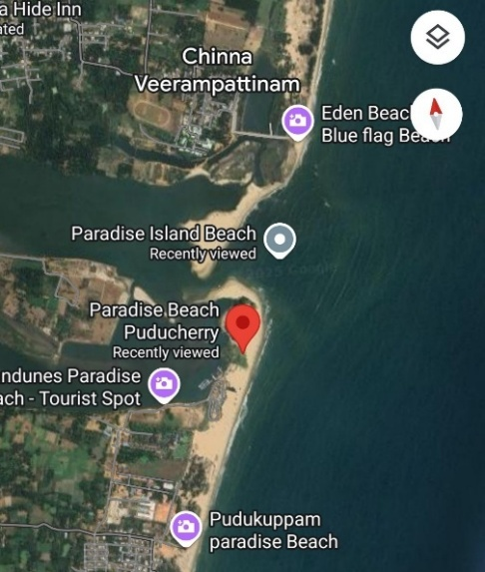
a
b
Fig 1: Sample collection site- (a) Geographical representation of the sample site collected from Puducherry. (b) The marine sand samples collected from Paradise beach.
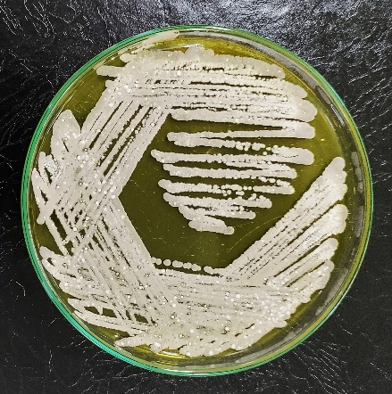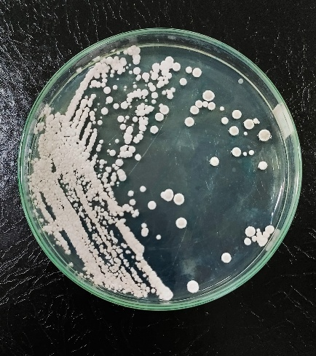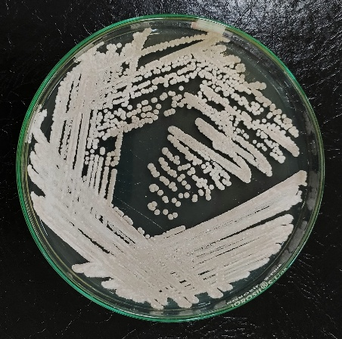
RB1
RB3
RB2
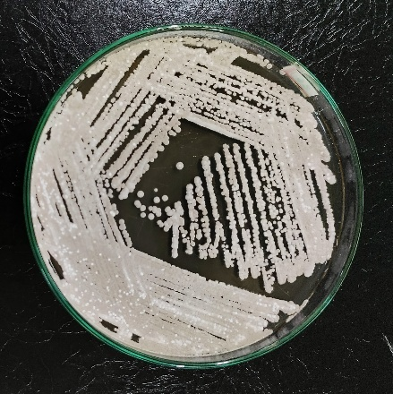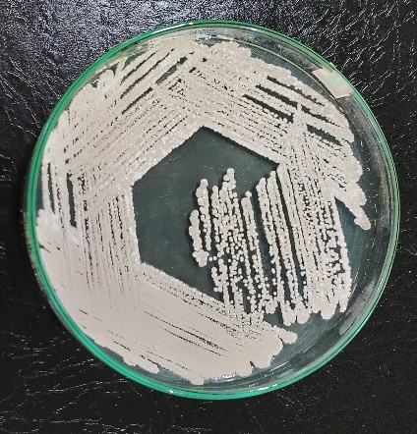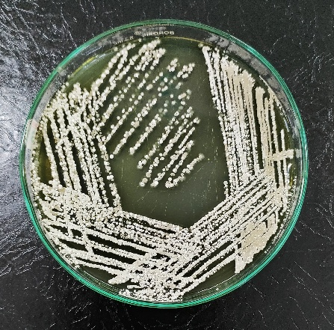
RB6
RB5
RB4
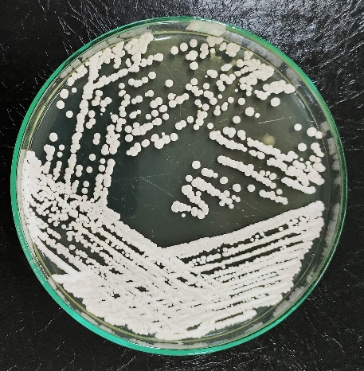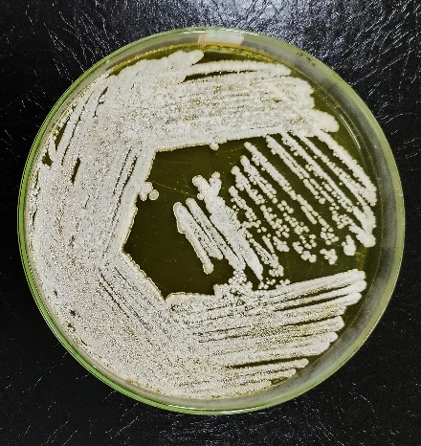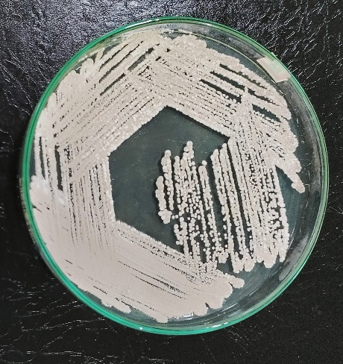
RB12
RB10
RB9
RB7
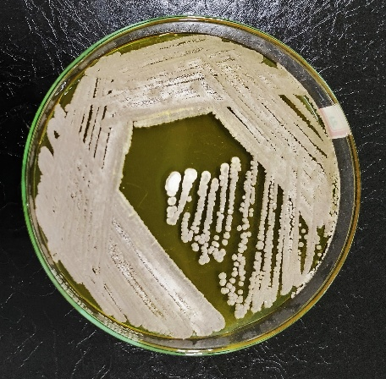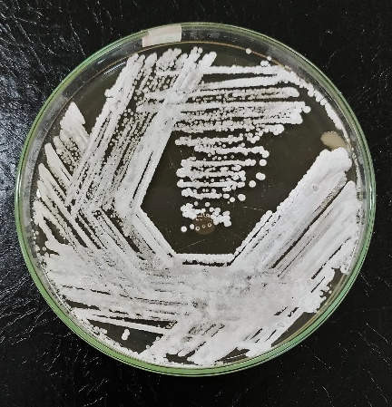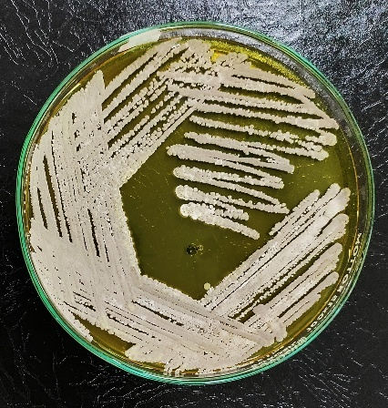
RB11
RB13
Fig 2: Actinomycetes isolated from marine samples on Bennett’s medium.
  - Antimicrobial activity:
The antimicrobial potential of the actinomycetes isolates was evaluated using the agar overlay method against a panel of test organisms, including Staphylococcus aureus, Pseudomonas aeruginosa, Escherichia coli, and Candida albicans. The isolate RB8 exhibited strong antibacterial activity against S. aureus and moderate inhibition against E. coli, as indicated by clear zones of inhibition around the wells. In contrast, P. aeruginosa showed weak sensitivity, with very narrow inhibition zones. The isolate also displayed strong antifungal activity against C. albicans, with distinct zone of growth inhibition observed (Fig 3 & 4). From these results we can say that isolate RB8 produces bioactive secondary metabolites effective primarily against Gram-positive bacteria, fungi and to a lesser extent against Gram-negative bacteria, supporting its potential as a source of novel antimicrobial compounds.

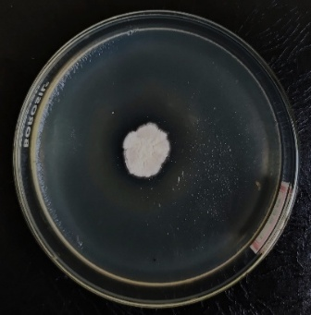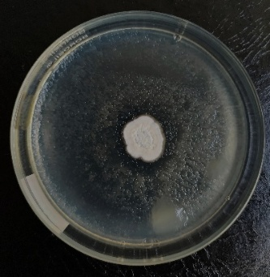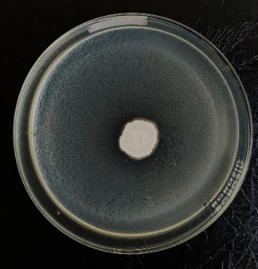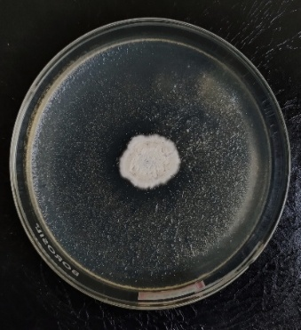
d
c
b
a
Fig 3: Actinomycetes isolate RB 8 tested against test organisms- (a) Staphylococcus aureus, (b) Escherichia coli, (c) Pseudomonas aeruginosa, (d) Candida albicans

Fig 4: Antimicrobial activity of Isolated Nocardiopsis sp. RB8 against human pathogens (zone of inhibition is measured in mm).

  - Phenotypic characterization of Nocardiopsis strain:
Colony morphology of the isolated Nocardiopsis strain RB8 was observed on different media and also noted the biomass of the strain on each media. The organism produced strong earthy odor with reddish brown pigment in SCA media (Fig 5 & Table 1) . The Nocardiopsis strain RB8 exhibited slow growth, requiring more than 7 days of incubation to develop visible colonies on selective media. This extended incubation period is characteristic of certain slow-growing actinomycetes, particularly those within the genus Nocardiopsis, which often require specific nutritional and environmental conditions to initiate and sustain growth. Colony morphology of the isolated showed distict features on each media (Table 2) and same with the growth on different media.
The mycelial structure of Nocardiopsis sp. was examined microscopically using both the cover slip method and the slide culture method (Fig 6). Microscopic observation revealed the presence of well-developed, branched, and septate mycelia, characteristic of actinomycetes. The aerial mycelium appeared abundant and filamentous, while the substrate mycelium was dense and penetrated the agar surface. The scanning electron micrograph of Nocardiopsis sp. reveals a complex and well organized mycelial network. The image (Fig 6c) shows extensively branched, filamentous hyphae with a distinct surface texture, indicative of mature aerial mycelium. The hyphae appear rugged and intertwined, forming a dense mat, which is typical of actinomycete morphology. Notably, spore chains are observed on the aerial hyphae, arranged in spiral to irregular patterns, suggesting sporulation, a key taxonomic feature of Nocardiopsis. The spore surfaces appear smooth to slightly wrinkled, with no ornamentation, consistent with previously described Nocardiopsis species (Chen et al., 2008; Hamedi et al., 2010).
The biochemical characterization of the Nocardiopsis isolate was carried out using a series of standard tests by standard protocols. The results of various tests are shown in Table 3 and these biochemical profiles contribute to the phenotypic identification and metabolic characterization of the Nocardiopsis strains. The results of antibitic sensitivity test indicated variable sensitivity among the antibiotics tested. Nocardiopsis sp. showed clear zones of inhibition around vancomycin, amikacin, ciprofloxacin, ceftizoxime, cefoxitin, and gemifloxacin indicating susceptibility to these antibiotics. In contrast, the strain exhibited resistance to ampicillin, amoxicillin, piperacillin Tazobactam and oxacillin, with no visible inhibition zones formed around the discs (Table 3).
Molecular identification of the isolated Nocardiopsis sp. was carried out through 16S rRNA gene sequencing, a widely accepted method for bacterial taxonomy and phylogenetic analysis. The partial 16S rRNA gene sequence of the actinomycete isolate was subjected to BLAST analysis using the NCBI GenBank database. The isolate showed 95.72% and 94.84% sequence similarity to its closest related type strains within the genus Nocardiopsis. As the observed sequence similarity is below the commonly accepted threshold of 98.7% for species-level identification based on 16S rRNA gene sequences (Stackebrandt, & Goebel., 1994) the results suggest that the isolate may represent a novel species within the genus Nocardiopsis. Further phylogenetic analysis confirmed that the isolate clusters within the Nocardiopsis clade but forms a distinct lineage (Fig 7), supporting its potential novelty.
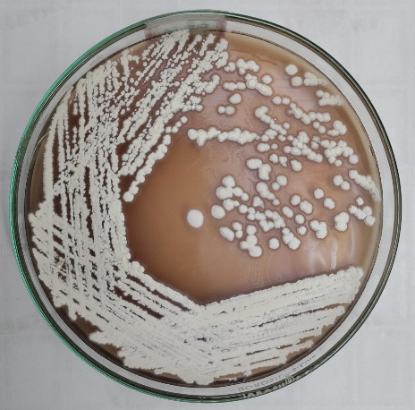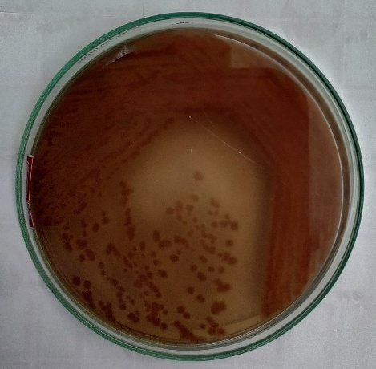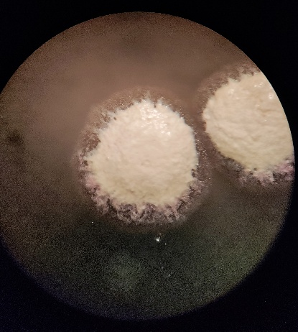
a
b
c
Fig 5: Nocardiopsis sp. RB8 isolated from marine sample- (a) Nocardiopsis sp. RB8 on SCA medium, (b) The substrate mycelia of Nocardiopsis sp. producing diffusible pigment on SCA medium, (c) Colony observation under Stereomicroscope with magnification of 2x.

Table 1: Colony character of Nocardiopsis sp. on SCA medium
Colony features | Ncordiopsis sp. character
Aerial mycelia | White
Substrate mycelia | Brown
Elevation | Slightly raised/ convex
Margin | Slightly undulated
Texture | Chalky
Odor | Earthy
Diffusiable pigment | Reddish brown
Gram staining | Gram positive

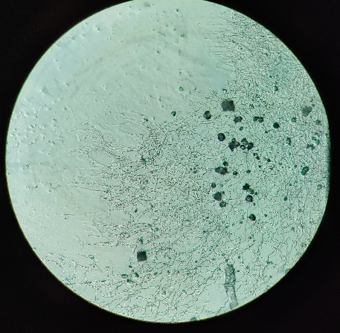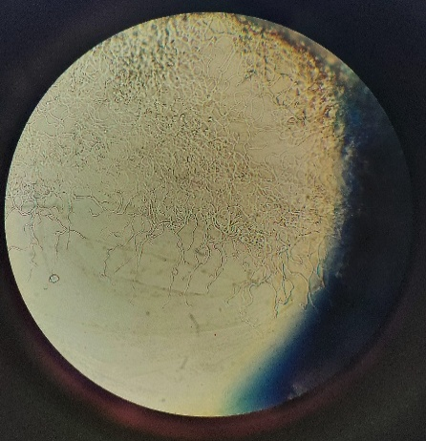
c
a
b
Fig 6: The aerial mycelia of Nocardiopsis sp. RB8 observed under microscope- (a) By coverslip method (40x), (b) By slide culture method (100x), (c) . Aerial mycelia observed under SEM at 3µm scale bar .
Table 2: Colony morphology of Nocardiopsis sp. RB8 on different media
Media | Nocardiopsis sp. RB8
Media | Aerial mycelium | Substrate mycelium
Kuster’s Agar | White colony | -
Chitin Agar | Dark grey colony | -
Humic acid-Vitamin Agar | Dark grey colony | -
Glycerol-Asparagine Agar | Whitish grey colony | -
Soyabean-Casein Agar | White colony | Light brown
Tryptic Soy Agar | White colony | Brown
Bennett’s Agar | White colony | -
Actinomycetes Isolation Agar | White | Dark brown
Oatmeal Agar | Dark grey colony | -

Table 3: Biochemical characteristics of Nocardiopsis sp.
Tests | Results
Citrate utilization | +
Triple sugar iron test | +
Urease utilization | +
Catalase | +
KOH | +
H₂S production | -
Carbon sources  Maltose | +
Sucrose | +
Xylose | +
Raffinose | -
Rhamnose | -
Degradation of  Tyrosine | +
Xylan | +
Adenine | +
Guanine | -
Starch | +
Antibiotic sensitivity  Vancomycin (30mcg) | S
Ampicillin (10mcg) | R
Amikacin (30mcg) | S
Amoxicillin (10mcg) | R
Ciprofloxacin (5mcg) | S
Ceftizoxime (30mcg) | S
Cefoxitin (30mcg) | S
Gemifloxacin (5mcg) | S
Piperacillin Tazobactam (100/10mcg) | R
Oxacillin (1mcg) | R
‘+’- Positive result; ‘-’-Negative result; S- Sensitive; R- Resistant

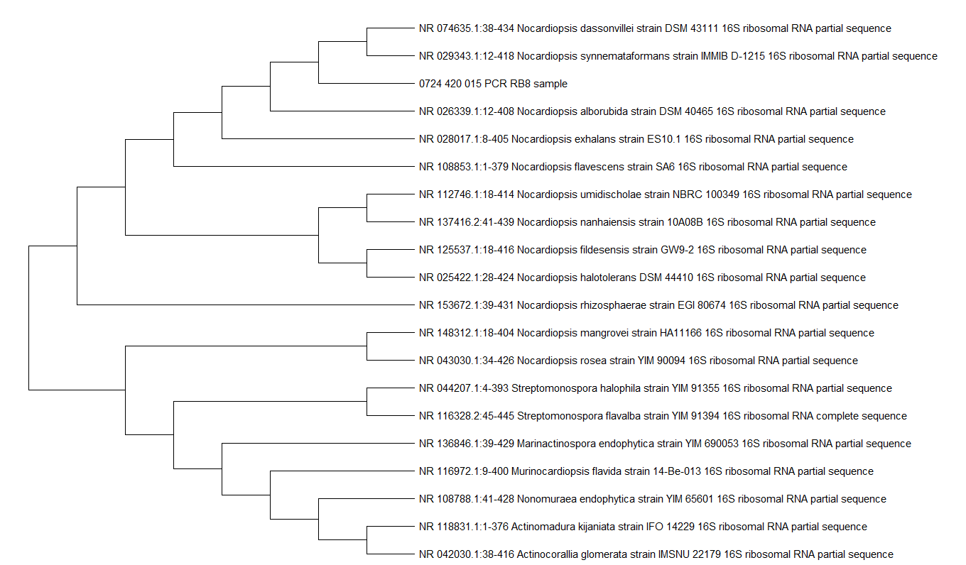

Fig 7: Phylogenetic tree showing the distinct lineage of the isolated marine actinomycetes.
  - Screening of hydrolytic enzyme production:
The Nocardiopsis sp. isolate was screened for the production of various hydrolytic enzymes, including amylase, protease, lipase, cellulase, xylanase, tyrosinase, and L-asparaginase, using specific substrate-based agar media. The isolate showed clear zones of hydrolysis around the colonies on starch agar, skim milk agar, tributyrin agar, and CMC (carboxymethyl cellulose) agar, indicating positive production of amylase, protease, lipase, and cellulase, respectively. Similarly, a pronounced zone of clearance on xylan agar confirmed the production of xylanase. On tyrosine agar, brown to black pigmentation was observed around the colony, indicating positive tyrosinase activity due to melanin formation. The production of L-asparaginase was confirmed on L-asparagine agar by the formation of a pink zone around the colonies after addition of phenol red indicator, suggesting a positive result. These findings revealed that Nocardiopsis sp. possesses a broad spectrum of hydrolytic enzyme activities (Table 4).
Table 4: Different Enzyme hydrolysis by isolate Nocardiopsis sp.
Enzymes | Activity
Amylase | ++
Lipase | -
Protease | -
Cellulase | ++
Tyrosinase | +
Xylanase | ++
L-Asparaginase | +++
+++ : Strong activity; ++ : Moderate activity; + : Weak activity; - : enzyme is not hydrolyzed by the isolate.

- DISCUSSION
Actinomycetes which also known as ‘ray fungi’ are found abundantly in different types of soil and environments. They also produce wide range of bioactive compounds such as antibiotics, antifungal agents, enzyme inhibitors, antitumor agents etc. (Jagannathan et al., 2021). The current interest of the researchers is on exploring the immense number of biogenic bioactive compounds from marine ecosystem. Thirteen (13) actinomycetes colonies were observed on the SCA plates and analyzed. The phenotypic, biochemical, molecular, and functional characterization of the isolated strain Nocardiopsis sp. RB8 highlights its distinct taxonomic and biotechnological potential. The extended incubation period required for visible colony development (>7 days) and the characteristic earthy odor, along with the production of reddish-brown diffusible pigment on starch casein agar (SCA), are consistent with the general features of the genus Nocardiopsis, which are known for their slow growth and production of geosmin and secondary metabolites (Goodfellow & Fiedler, 2010). The colony and mycelial morphologies of RB8, exhibiting chalky texture, branched septate mycelia, and extensive aerial hyphae with spore chains, reaffirm its placement within the actinomycetes. The presence of smooth to slightly wrinkled spores arranged in spiral to irregular chains, as observed under SEM, further supports its taxonomic affinity to Nocardiopsis (Hamedi et al., 2010). Similar characteristics of the actinomycetes strain were observed in the isolates previously reported by Muthukrishnana et al., (2020).
The biochemical and physiological characteristics of RB8 reveal enzymatic versatility. The production of a broad spectrum of hydrolytic enzymes, including amylase, protease, lipase, cellulase, xylanase, tyrosinase, and L-asparaginase, suggests its ecological role in the degradation of diverse organic polymers and bioconversion processes. Such enzyme secretion capabilities are consistent with earlier reports describing Nocardiopsis as an efficient degrader of complex biomaterials (El-Sayed et al., 2024). Notably, the observed tyrosinase activity and melanin formation signify possible stress-protection mechanisms, while the positive L-asparaginase activity highlights its potential in anticancer applications, as microbial L-asparaginases remain important in leukemia treatment (Egler et al., 2016).
The antibiotic sensitivity profile of RB8 demonstrated susceptibility to several clinically relevant antibiotics, such as vancomycin, amikacin, ciprofloxacin, and gemifloxacin, while showing marked resistance to β-lactam antibiotics like ampicillin and oxacillin. Such resistance patterns are commonly observed among actinomycetes, likely due to intrinsic β-lactamase production or structural features of their peptidoglycan, and may provide adaptive advantages in natural environments (Ogawara., 2015).
Importantly, Nocardiopsis sp. RB8 exhibited notable antimicrobial activity, particularly against Staphylococcus aureus and Candida albicans, alongside moderate activity against Escherichia coli. The limited effect on Pseudomonas aeruginosa aligns with the inherent resistance of many Gram-negative bacteria to actinomycete-derived metabolites, owing to outer membrane permeability barriers (Zgurskaya, & Rybenkov., 2020). The activity against both bacterial and fungal test strains underscores the potential of RB8 as a source of novel bioactive secondary metabolites, expanding the repertoire of antimicrobial-producing actinomycetes. These findings are consistent with previous reports describing species of Nocardiopsis as prolific producers of antibacterial, antifungal, and even anticancer compounds (Barka et al., 2016; Rateb et al., 2011).
Molecular identification through 16S rRNA gene sequencing revealed sequence similarity values below the established species-level cut-off (98.7%), with the highest matches being 95.72% and 94.84% to closest type strains in the genus Nocardiopsis. Together with phylogenetic analysis demonstrating a distinct lineage, these results strongly suggest that strain RB8 represents a potential novel species of Nocardiopsis. Such findings are significant given the genus’ recognized capacity to yield novel bioactive natural products from rare actinomycetes, particularly those representing underexplored taxa (Stackebrandt & Goebel, 1994; Hamedi et al., 2010).
The polyphasic characterization of strain RB8 highlights its distinct taxonomic novelty and significant biotechnological potential. The strain demonstrates robust production of multiple hydrolytic enzymes and exhibits strong antimicrobial activity, particularly against Gram-positive bacteria and fungi, positioning it as a promising candidate for future bioprospecting initiatives. To validate its novelty at the species level and to comprehensively characterize the spectrum and mechanisms of its bioactive secondary metabolites, further investigations including whole-genome sequencing, metabolic profiling, and purification of active compounds are indispensable (Govindan et al., 2024; Kanchanasin et al., 2024; Pradhan & Das., 2025).
- CONCLUSION
The present study highlights the isolation and characterization of Nocardiopsis sp. RB8, a slow-growing actinomycete with distinct colony morphology, robust mycelial development, and pigment production. The strain demonstrated broad hydrolytic enzyme activity and notable antimicrobial potential, particularly against Staphylococcus aureus and Candida albicans, underscoring its industrial and therapeutic relevance. Molecular analysis of the 16S rRNA gene indicated sequence similarity values below the accepted species-level threshold, suggesting that RB8 may represent a novel species within the genus Nocardiopsis. Taken together, these findings establish RB8 as a promising candidate for natural product discovery and enzyme-based applications, warranting further genomic and metabolomic investigations to confirm its novelty and explore its biotechnological potential.

DISCLAIMER (ARTIFICIAL INTELLIGENCE)
Author(s) hereby declares that NO generative AI technologies such as Large Language Models (ChatGPT, COPILOT, etc.) and text-to-image generators have been used during the writing or editing of this manuscript.

- REFERENCES
- Bala, M., Kaur, C., Kaur, I., Khan, F., & Mayilraj, S. (2012). Kocuria sediminis sp. nov., isolated from a marine sediment sample. Antonie Van Leeuwenhoek, 101(3), 469-478. https://doi.org/10.1007/s10482-011-9654-2
- Barka, E. A., Vatsa, P., Sanchez, L., Gaveau-Vaillant, N., Jacquard, C., Klenk, H. P., et al., (2016). Taxonomy, physiology, and natural products of Actinobacteria. Microbiology and molecular biology reviews, 80(1), 1-43. https://doi.org/10.1128/mmbr.00019-15
- Bennur, T., Kumar, A. R., Zinjarde, S., & Javdekar, V. (2015). Nocardiopsis species: Incidence, ecological roles and adaptations. Microbiological Research, 174, 33-47. https://doi.org/10.1016/j.micres.2015.03.010
- Chen, Y. G., Cui, X. L., Kroppenstedt, R. M., Stackebrandt, E., Wen, M. L., Xu, L. H., et al., (2008). Nocardiopsis quinghaiensis sp. nov., isolated from saline soil in China. International Journal of Systematic and Evolutionary Microbiology, 58(3), 699-705. https://doi.org/10.1099/ijs.0.65441-0
- Egler, R. A., Ahuja, S. P., & Matloub, Y. (2016). L-asparaginase in the treatment of patients with acute lymphoblastic leukemia. Journal of Pharmacology and Pharmacotherapeutics, 7(2), 62-71. https://doi.org/10.4103/0976-500X.184769
- El-Sayed, M. H., Elsayed, D. A., & Gomaa, A. E. R. F. (2024). Nocardiopsis synnemataformans NBRM9, an extremophilic actinomycete producing extremozyme cellulase, using lignocellulosic agro-wastes and its biotechnological applications. AIMS microbiology, 10(1), 187. https://doi.org/10.3934/microbiol.2024010
- Fonseca, A. C., Ribeiro, I., Girão, M., Regueiras, A., Urbatzka, R., Leão, P., et al., (2025). Actinomycetota isolated from the sponge Hymeniacidon perlevis as a source of novel compounds with pharmacological applications: diversity, bioactivity screening, and metabolomic analysis. Journal of Applied Microbiology, 136(3), lxaf044. https://doi.org/10.1093/jambio/lxaf044
- Goodfellow, M. (1971). Numerical taxonomy of some nocardioform bacteria. Microbiology, 69(1), 33-80. https://doi.org/10.1099/00221287-69-1-33
- Goodfellow, M., & Fiedler, H. P. (2010). A guide to successful bioprospecting: informed by actinobacterial systematics. Antonie Van Leeuwenhoek, 98(2), 119-142. https://doi.org/10.1007/s10482-010-9460-2
- Govindan, R., Gnanasekaran, C., Govindan, R., Muthuchamy, M., Quero, F., Jothi, A., et al., (2024). Anti-quorum Sensing and Anti-biofilm Effect of Nocardiopsis synnemataformans RMN 4 (MN061002) Compound 2, 6-Di-tert-butyl, 1, 4-Benzoquinone Against Biofilm-Producing Bacteria. Applied Biochemistry and Biotechnology, 196(7), 3914-3948. https://doi.org/10.1007/s12010-023-04738-w
- Hamedi, J., Mohammadipanah, F., von Jan, M., Pötter, G., Schumann, P., Sproer, C., et al., (2010). Nocardiopsis sinuspersici sp. nov., isolated from sandy rhizospheric soil. International journal of systematic and evolutionary microbiology, 60(10), 2346-2352. https://doi.org/10.1099/ijs.0.018366-0
- Hayakawa, M., & Nonomura, H. (1987). Humic acid-vitamin agar, a new medium for the selective isolation of soil actinomycetes. Journal of Fermentation Technology, 65(5), 501-509. https://doi.org/10.1016/0385-6380(87)90108-7
- Hegazy, G. E., Olama, Z. A., Abou-Elela, G. M., Ramadan, H. S., Ibrahim, W. M., & El Badan, D. E. S. (2023). Biodiversity and biological applications of marine actinomycetes—Abu-Qir bay, mediterranean sea, Egypt. Journal of Genetic Engineering and Biotechnology, 21(1), 150. https://doi.org/10.1186/s43141-023-00612-8
- Hirsch, C. F., & Christensen, D. L. (1983). Novel method for selective isolation of actinomycetes. Applied and environmental microbiology, 46(4), 925-929. https://doi.org/10.1128/aem.46.4.925-929.1983
- Jagannathan, S. V., Manemann, E. M., Rowe, S. E., Callender, M. C., & Soto, W. (2021). Marine actinomycetes, new sources of biotechnological products. Marine Drugs, 19(7), 365. https://doi.org/10.3390/md19070365
- Kanchanasin, P., Salahong, T., Sripreechasak, P., Suriyachadkun, C., Harunari, E., Igarashi, Y., et al., (2024). Discovery of two new actinobacteria, Micromonospora palythoicola sp. nov. and Streptomyces poriticola sp. nov., isolated from marine invertebrates. Scientific Reports, 14(1), 22140. https://doi.org/10.1038/s41598-024-73040-4
- Lingappa, Y., & Lockwood, J. L. (1961). A chitin medium for isolation, growth and maintenance of actinomycetes. Nature, 189(4759), 158-159. https://doi.org/10.1038/189158a0
- Manivasagan, P., Venkatesan, J., Sivakumar, K., & Kim, S. K. (2014). Pharmaceutically active secondary metabolites of marine actinobacteria. Microbiological research, 169(4), 262-278. https://doi.org/10.1016/j.micres.2013.07.014
- Mohseni, M., Norouzi, H., Hamedi, J., & Roohi, A. (2013). Screening of antibacterial producing actinomycetes from sediments of the Caspian Sea. International journal of molecular and cellular medicine, 2(2), 64.
- Muthukrishnan, P., Mostafa, A. A., Alsamhary, K. I., Abdel-Raouf, N., & Sholkamy, E. N. (2020). Antimicrobial efficacy of Nocardiopsis sp. MK_MSt033 against selected multidrug resistant clinical microbial pathogens. Journal of Infection and Public Health, 13(10), 1522-1532. https://doi.org/10.1016/j.jiph.2020.06.025
- Ogawara, H. (2015). Penicillin-binding proteins in Actinobacteria. The Journal of antibiotics, 68(4), 223-245. https://doi.org/10.1038/ja.2014.148
- Pradhan, D., & Das, M. T. (2025). Antimicrobial potential and extracellular metabolite profiling of bichitrapur mangrove sediment derived Micromonospora sp. BSS-D-04 and Streptomyces sp. BSS-D-05 using LC–MS/MS and GC–MS analysis. Brazilian Journal of Microbiology, 1-17. https://doi.org/10.1007/s42770-025-01710-0
- Putri, A. L., & Setiawan, R. (2019, August). Isolation and screening of actinomycetes producing cellulase and xylanase from Mamasa soil, West Sulawesi. In IOP conference series: earth and environmental science (Vol. 308, No. 1, p. 012035). IOP Publishing.
- Rainey, F. A., Ward-Rainey, N., Kroppenstedt, R. M., & Stackebrandt, E. (1996). The genus Nocardiopsis represents a phylogenetically coherent taxon and a distinct actinomycete lineage: proposal of Nocardiopsaceae fam. nov. International Journal of Systematic and Evolutionary Microbiology, 46(4), 1088-1092. https://doi.org/10.1099/00207713-46-4-1088
- Rateb, M. E., Houssen, W. E., Arnold, M., Abdelrahman, M. H., Deng, H., Harrison, W. T., et al., (2011). Chaxamycins A–D, bioactive ansamycins from a hyper-arid desert Streptomyces sp. Journal of Natural products, 74(6), 1491-1499.
- Rudrappa, M., Kumar, S., Kumar, R. S., Almansour, A. I., Perumal, K., & Nayaka, S. (2022). Bioproduction, purification and physicochemical characterization of melanin from Streptomyces sp. strain MR28. Microbiological Research, 263, 127130. https://doi.org/10.1016/j.micres.2022.127130
- Salehghamari, E., Moradi, M., Sardabi, M., Etesami, S. A., Hassani, G. H., Hosseini, M., et al., (2023). Diversity of actinomycete and their metabolites isolated from Howz Soltan Lake, Iran. Archives of Microbiology, 205(1), 24. https://doi.org/10.1007/s00203-022-03364-0
- Sarkar, G., & Suthindhiran, K. (2022). Diversity and biotechnological potential of marine actinomycetes from India. Indian Journal of Microbiology, 62(4), 475-493. https://doi.org/10.1007/s12088-022-01024-x
- Sharma, A. K., Kikani, B. A., & Singh, S. P. (2021). Diversity and phylogeny of actinomycetes of Arabian Sea along the Gujarat Coast. Geomicrobiology Journal, 38(4), 347-364. https://doi.org/10.1080/01490451.2020.1860165
- Sibero, M. T., Frederick, E. H., Wijayanti, D. P., Haryanti, D., Siswanto, A. P., & Igarashi, Y. (2024). Antimicrobial and cytotoxic properties of actinobacteria associated with a stony coral Fungia sp. from Karimunjawa National Park, Indonesia. Journal of Applied Pharmaceutical Science, 14(1), 132-140. https://dx.doi.org/10.7324/JAPS.2024.139056
- Somasundaram, S., Arulmani, S. R. B., & Ganesan, G. (2024). Screening and characterization of antagonistic Streptomyces sp. JS20 from marine sediment in Vaan Island. The Microbe, 4, 100106. https://doi.org/10.1016/j.microb.2024.100106
- Stackebrandt, E., & Goebel, B. M. (1994). Taxonomic note: a place for DNA-DNA reassociation and 16S rRNA sequence analysis in the present species definition in bacteriology. International journal of systematic and evolutionary microbiology, 44(4), 846-849. https://doi.org/10.1099/00207713-44-4-846
- Subash, H. A., Santhosh, K., Kannan, K., & Pitchiah, S. (2024). Extraction of Keratin degrading enzyme from marine Actinobacteria of Nocardia sp and their antibacterial potential against oral pathogens. Oral Oncology Reports, 9, 100184. https://doi.org/10.1016/j.oor.2024.100184
- Subramani, R., & Aalbersberg, W. (2013). Culturable rare Actinomycetes: diversity, isolation and marine natural product discovery. Applied microbiology and biotechnology, 97(21), 9291-9321. https://doi.org/10.1007/s00253-013-5229-7
- Usha, R., Mala, K. K., Venil, C. K., & Palaniswamy, M. (2011). Screening of actinomycetes from mangrove ecosystem for L-asparaginase activity and optimization by response surface methodology. Pol J Microbiol, 60(3), 213-221.
- Williams, S. T., Goodfellow, M., Alderson, G., Wellington, E. M. H., Sneath, P. H. A., & Sackin, M. J. (1983). Numerical classification of Streptomyces and related genera. Microbiology, 129(6), 1743-1813. https://doi.org/10.1099/00221287-129-6-1743
- Xi, L., Zhang, L., Ruan, J., & Huang, Y. (2011). Nonomuraea maritima sp. nov., isolated from coastal sediment. International journal of systematic and evolutionary microbiology, 61(11), 2740-2744. https://doi.org/10.1099/ijs.0.028266-0
- Zgurskaya, H. I., & Rybenkov, V. V. (2020). Permeability barriers of Gram‐negative pathogens. Annals of the New York Academy of Sciences, 1459(1), 5-18. https://doi.org/10.1111/nyas.14134
- Zhang, X. Y., He, F., Wang, G. H., Bao, J., Xu, X. Y., & Qi, S. H. (2013). Diversity and antibacterial activity of culturable actinobacteria isolated from five species of the South China Sea gorgonian corals. World Journal of Microbiology and Biotechnology, 29(6), 1107-1116. https://doi.org/10.1007/s11274-013-1279-3

