Evaluation of Procalcitonin and C-Reactive Protein as Early Markers for Diagnosis of Neonatal Sepsis

Abstract
Aims: The study aims to assess and compare the sensitivity and specificity of Procalcitonin (PCT) and C-reactive proteins (CRP) in the early diagnosis of neonatal sepsis.
Study design: A prospective multi-centric cross-sectional observational study
Place and Duration of Study: The study was conducted in the neonatal intensive care unit of the 3 selected Lagos State hospitals, namely Gbagada General Hospital, Massey Street Children Hospital, and Lagos Island Maternity Hospital, Lagos State, from January 2023 to January 2024
Methodology: A total of 300 neonates were recruited into this study. Blood samples were obtained before initiation of antibiotics. Blood samples of 300 neonates were analyzed for C-reactive proteins (CRP) and procalcitonin (PCT) from January 2023 to January 2024. CRP and PCT values were analyzed and compared, and their effectiveness as diagnostic markers was determined by using receiver operating characteristic (ROC) curve analysis.
Results: The study group included 61% male and 39% female neonates. The diagnostic accuracy of PCT was higher at 77.9% as compared to 58.1% for CRP (P≤0.05). In the Rate of Characteristics analysis, the Area Under the Curve (AUC) was 0.86 for PCT and 0.75 for CRP, which shows both PCT and CRP to be good diagnostic biomarkers for neonatal sepsis.
Conclusion: The study concluded that procalcitonin and C-reactive protein are good diagnostic biomarkers for the early detection of neonatal sepsis. The synergistic use of Procalcitonin and C-reactive protein enhances the early and accurate detection of bacterial infections, enabling timely and effective therapy that reduces mortality and guides the rational use of antibiotics. Procalcitonin and C-reactive protein should be used together as reliable biomarkers for early neonatal sepsis detection.
Keywords: C-reactive protein, Procalcitonin, Neonates, Neonatal sepsis, Sensitivity and Specificity

Introduction
Neonatal sepsis (NS) is defined as a systemic inflammatory response syndrome (SIRS) occurring in the presence of a suspected or confirmed infection, with or without associated bacteremia, and may be documented by a positive blood culture within the first 28 days of life (Agnche et al.,2020). Neonatal sepsis is a leading cause of morbidity and mortality in children of a certain age group. Despite recent advances in neonatal care, there has been limited progress in the reduction of mortality. Neonatal sepsis can be categorized as Early Onset Sepsis (EOS) and Late Onset Sepsis (LOS) (Shane & Sanchez, 2017). Early onset neonatal sepsis (EOS) is defined as an infection appearing in the first 72 h after the birth of the child, as opposed to late onset neonatal sepsis (LOS), which is an infection occurring more than or equal to 72 h after birth of the child. The source of infection for EOS is highly associated with the organisms carried in the maternal genital tract, leading to vertical transmission, whereas LOS is typically caused by either nosocomial (hospital-acquired) or community-acquired sources (Shane & Sanchez, 2017).
Early diagnosis of neonatal sepsis is often challenging, which has led to the widespread reliance on empirical antibiotic therapy as the primary treatment option. In many hospitals, neonates considered at risk of infection are routinely placed on empirical antibiotics. This practice extends even to preterm infants, who are frequently administered broad-spectrum antibiotics, sometimes in the absence of clear clinical signs of infection. However, empirical therapy is often inappropriate because the use of unnecessary broad-spectrum antibiotics for a prolonged duration of treatment has contributed significantly to an increasing number of multidrug-resistant microorganisms in neonatal intensive care units (Dong & Speer, 2015; Tran et al., 2015). Therefore, improving the timely accuracy of diagnostic tests may decrease the indiscriminate use of antibiotics in cases without sepsis (Ruan et al., 2018).
The development and availability of biomarkers facilitate the early diagnosis of neonatal sepsis, potentially improving the outcomes of neonatal sepsis cases in healthcare facilities. Many biomarkers for sepsis have been investigated to determine their diagnostic usefulness. They are basically grouped as acute-phase proteins, cell surface antigens, cytokines, chemokines, as well as soluble adhesion molecules. Sepsis biomarkers have been extensively studied for their effectiveness in diagnosing neonatal sepsis. An ideal biomarker should demonstrate high sensitivity, specificity, positive predictive value (PPV), and negative predictive value (NPV) (Sharma et al., 2018). Recent studies have evaluated several biomarkers, such as C-reactive protein (CRP), procalcitonin (PCT), and interleukin-6 (IL-6), to enhance the accuracy of sepsis diagnosis (Rashwan et al., 2019; Ruan et al., 2018). C-reactive protein (CRP) is an acute-phase protein synthesized in the liver in response to infection or inflammation. It may be more useful in excluding infections in suspected cases and enabling earlier discontinuation of antibiotics. CRP may be a cost-effective marker, potentially reducing the development of antimicrobial resistance and shortening hospital stay duration (Brown et al.,2020). Procalcitonin (PCT) is the precursor of calcitonin hormone produced in very low concentrations by the cells of the thyroid gland under normal conditions. It is preferentially induced as an acute-phase reactant in bacterial sepsis. It is produced by macrophages and monocytes of various organs during severe bacterial infection in response to bacterial lipopolysaccharide (LPS), which is a potent inducer of PCT into the circulation (Rashwan et al.,2019). Neonatal sepsis remains a major clinical challenge, and physicians continuously seek reliable methods for its early prediction and diagnosis to enable prompt treatment, minimize adverse health outcomes, and ultimately reduce both hospital stay and healthcare costs. In this context, our study was designed to evaluate diagnostic. Since procalcitonin (PCT) is known to rise earlier in neonatal sepsis compared to CRP, we aimed to assess and compare the sensitivity and specificity of PCT and CRP in the early diagnosis of neonatal sepsis.
Materials and Methods
Study Design
A multi-centric cross-sectional observational study was conducted in the neonatal intensive care unit of the 3 selected Lagos State hospitals from January 2023 to January 2024
Ethical Consideration
The Ethical Clearances for this study were obtained from the Babcock University Research and Ethics Committee and the Research and Ethical Committee in the selected Hospitals involved. The study proposal sought approval from each specifically selected hospital through official administrative channels. This study only utilized hospital clinical records. The names of parents/caretakers of the study neonates were not included in data entry and analyses. All identifying data were anonymized.
Population
All neonates that were admitted into the Neonatal units of selected hospitals with risk factors and/or clinical features of suspected neonatal sepsis between January 2023 to January 2024
Inclusion criteria
Neonates with consecutive clinical signs and symptoms of sepsis were admitted into the neonatal unit, or neonates who developed signs and symptoms in the postnatal ward.
Exclusion criteria
Neonates with congenital malformations and inborn errors of metabolism were excluded from the study.
CRP Measurement
CRP analysis was done using the reflectometry and immunoassay technology with standard F Analyzer manufactured by SD BIOSENSOR. Serum CRP level was measured by the CRP latex agglutination test according to the manufacturer’s guidelines. Serum CRP in human specimens reacts with monoclonal anti-CRP as a result of the antigen-antibody reaction. STANDARD F Analyzers analyze the CRP concentration based on programmed algorithms.
PCT Measurement
The serum PCT level was measured based on a fluorescence immunoassay used along with the STANDARD F Analyzer. The samples were prepared using the components of the STANDARD FPCT FIA. After applying the sample mixture to the test device, the complex was formed on the membrane as a result of the antigen-antibody reaction. The intensity of the fluorescence light is scanned and converted into an electric signal, which is proportional to the intensity of fluorescence light produced on the membrane. THE STANDARD F Analyzer can analyze the PCT concentration of the clinical specimen based on a pre-programmed algorithm.
Statistical Analysis.
The receiver operating characteristic (ROC) curve was plotted. Sensitivity, specificity, positive predictive value (PPV), negative predictive value (NPV), and accuracy were calculated. Results were considered statistically significant when p (probability) values were equal to or less than 0.05.
Results
A total of 300 neonates were recruited into this study. There were 183 (61%) males and 117 females (39%). The ages of the subjects ranged between 1 and 28 days. One hundred and seventy-seven (59%) were less than 72 h old, and one hundred and twenty-three (41%) were more than or equal to 72 h old.
Pathogens Found in Sepsis-Affected Neonates
Of the 300 neonates studied, 126 (42%) had a positive blood culture. The 126 isolates were categorized into Early-onset infection (59%) and late-onset infection (41%). Out of the 126 subjects with culture-proven sepsis, 52(41%) were Gram-negative, and 74 (59%) were Gram-positive.
Assessment of Biomarkers in the Early Identification of Neonatal Sepsis
Analyzing the results of sepsis markers revealed that the procalcitonin (PCT) level of all the studied neonates ranged was 0.01 – >50 ng/ml, and the C-reactive protein (CRP) serum level ranged (<1 – 120 mg/dl. A receiver operating characteristic curve (ROC) analysis was performed to determine the diagnostic effectiveness of PCT and CRP for detecting neonatal sepsis.

Diagnostic Performance of Procalcitonin as a Neonatal Sepsis Biomarker Using Receiver Operating Characteristic (ROC)
The diagnostic performance of the biomarkers was quantified in terms of sensitivity and specificity, Positive predictive value (PPV), and Negative predictive value (NPV). In this study, the diagnostic accuracy of Procalcitonin (PCT) was evaluated for its role in identifying neonatal sepsis. Using a cutoff value of ≤0.5 ng/ml, PCT demonstrated a sensitivity of 97.6% and a specificity of 89%. The positive predictive value (PPV) was 97.6%, indicating that almost all neonates with a positive PCT result truly had sepsis. Similarly, the negative predictive value (NPV) was 88.9%, showing that a negative PCT result effectively excluded sepsis in most cases.
The overall diagnostic accuracy of PCT was calculated at 96%, with a highly significant p-value (≤0.05). Furthermore, the Receiver Operating Characteristic (ROC) curve analysis showed an area under the curve (AUC) of 0.86, as seen in Figure 1, confirming the strong discriminatory power of PCT in distinguishing septic neonates from non-septic controls.

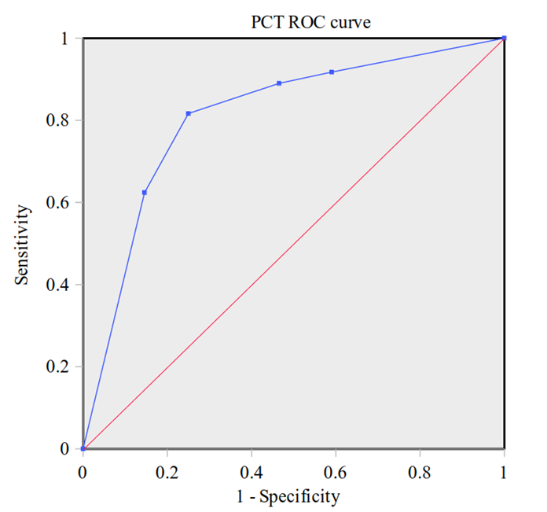
Figure 1: Receiver operating curve for procalcitonin in neonatal Sepsis
PCT Parameters
Sensitivity: 81.6%
Speciﬁcity: 75.0%
PPV: 71.2%
NPV: 84.4%
Accuracy: 77.9%
AUC: 0.86
Sig: 0.001

Diagnostic Performance of C-reactive protein as a Neonatal Sepsis Biomarker Using Receiver Operating Characteristic (ROC)
The diagnostic performance of the biomarkers was quantified in terms of sensitivity and specificity, Positive predictive value (PPV), and Negative predictive value (NPV). This study evaluated the diagnostic accuracy of C-reactive protein (CRP) for neonatal sepsis. Using a cutoff value of ≤2 mg/dL, CRP demonstrated a sensitivity of 89.5% and a specificity of 66.7%. The positive predictive value (PPV) was 92.5%, indicating that most neonates with elevated CRP levels were correctly diagnosed with sepsis. Conversely, the negative predictive value (NPV) was 60%, suggesting that CRP alone had a moderate ability to rule out sepsis in neonates. The overall diagnostic accuracy of CRP was determined to be 86%, with a statistically significant p-value (≤0.05). The Receiver Operating Characteristic (ROC) curve analysis revealed an area under the curve (AUC) of 0.75, as seen in Figure 2, indicating a moderate diagnostic ability of CRP in distinguishing between septic and non-septic neonates.

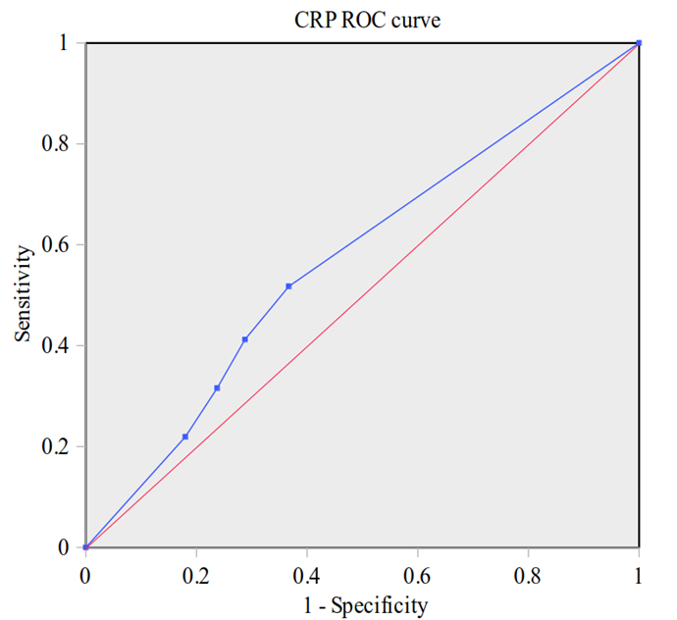
Figure 2: Receiver operating curve for C-reactive protein concerning neonatal Sepsis
CRP Parameters
Sensitivity: 51.7%
Speciﬁcity: 64.3%
PPV: 53.6%
NPV: 61.5%
Accuracy: 58.10%
AUC: 0.75
Sig: 0.027

Comparative Analysis of Diagnostic Accuracy: Procalcitonin (PCT) vs. C-Reactive Protein (CRP)
Accurate and timely diagnosis of neonatal sepsis is critical for improving neonatal survival outcomes. Biomarkers such as Procalcitonin (PCT) and C-Reactive Protein (CRP) are widely employed for this purpose, each offering varying levels of diagnostic reliability. In this study, the area under the curve (AUC) derived from the Receiver Operating Characteristic (ROC) analysis provided a direct comparison of their diagnostic accuracy. PCT demonstrated an AUC of 0.86, indicating good diagnostic performance. In contrast, CRP exhibited an AUC of 0.75, indicating moderate diagnostic performance. The results indicate that PCT outperforms CRP in overall diagnostic accuracy, with PCT’s AUC of 0.86 surpassing CRP’s AUC of 0.75. This superiority suggests that PCT is more suitable for early and accurate detection of neonatal sepsis, particularly in settings where rapid and reliable diagnosis is required to guide timely antimicrobial therapy.

Table 1: The comparative diagnostic Accuracy of the biomarkers
Biomarker | AUC | Interpretation of Diagnostic Accuracy
PCT | 0.86 | Good
CRP | 0.75 | Moderate

Discussion
Although blood culture results are important for diagnosing neonatal sepsis, it has a low success rate in the early diagnosis of sepsis, which is crucial to prevent unnecessary or delayed treatment. Rapid diagnosis of neonatal sepsis is considered a very important issue to prevent a serious outcome; therefore, a rapid test with a high degree of sensitivity, reliability, and predictability is required for the early diagnosis and treatment of neonatal sepsis. Many sepsis biomarkers are emerging to help with early diagnosis, such as Procalcitonin (PCT), C-reactive protein (CRP), and various proinflammatory cytokines that play a role in bacterial sepsis (Adib et al., 2012). The assessment of CRP and PCT as sepsis markers for the early detection of sepsis in newborns was examined in this study.
ROC curve analysis was done to determine the diagnostic usefulness of PCT and CRP for detecting neonatal sepsis. Receiver operating characteristic (ROC) curves for our studied sepsis markers revealed that serum PCT levels with a cutoff value ≥0.5 ng/ml showed the highest sensitivity, specificity, PPV, NPV, and accuracy of 81.6%, 75%, 71.2%, 84.4%, and 77.9%, respectively. The PCT sensitivity and specificity results range from 80% to 100% and 70% to 100%, respectively, and are comparable to those of studies by Adib et al. (2012) and Morad et al. (2020). In this investigation, the CRP exhibited a sensitivity of 51.7%, specificity of 64.3%, PPV of 53.6%, NPV of 61.5%, and substantial accuracy of 58% (P≤0.05) with a threshold value of CRP ≥10 mg/dl. This result is consistent with research that indicated the test's sensitivity ranged from 70% to 93%, specificity from 41% to 98%, PPV from 6% to 83%, and NPV from 97% to 99% (Rashwan et al., 2019; Morad et al., 2020; Ranjan et al., 2019). The increase in CRP levels during the first 24 - 48 h of infection is slow, which negatively affects its sensitivity (Çetinkaya et al.,2009). Additionally, its specificity is negatively impacted when the CRP level rises in noninfected cases. Therefore, rather than being used alone as a sepsis marker, I recommend combining it with other markers to get the best results.
Both CRP and PCT demonstrated high diagnostic values, as indicated by their respective Area under the Curve (AUC) values of 0.75 and 0.86 in the ROC curve. The AUC for PCT was 0.86, which is similar to the report by Park et al. (2014); Vouloumanou et al. (2011). The AUC for CRP in this study was 0.75, similar to reports by Park et al. (2014); Morad et al (2020). In this study, PCT proved to be a more useful marker than CRP in the early diagnosis of sepsis. This is similar to reports done by Al-Zahrani et al. (2015), Ruan et al. (2018), and Morad et al. (2020). PCT seems to be a promising sepsis marker in neonates, as it has many advantages. Its serum levels are correlated with the severity of the infection and promptly decrease following antibiotic therapy (Hasan et al., 2017). It can distinguish between systemic responses caused by bacterial or fungal causes and those caused by viral infections (Al-Zahrani et al., 2015). PCT is superior to CRP in the early diagnosis of neonatal sepsis, in detecting sepsis severity, and in evaluating the response to antibiotic treatment. According to this study, PCT is a more sensitive biomarker than CRP. However, it is important to note that PCT and CRP may have complementary roles, with CRP being useful in monitoring treatment response, while PCT offers greater reliability in the initial diagnosis of sepsis. Overall, the higher AUC and accuracy observed for PCT in this study underscore its superior diagnostic utility for neonatal sepsis. However, given the moderate diagnostic performance of CRP and its established role in tracking treatment response (Hofer et al.,2012), both biomarkers should be used in complementary roles to enhance early detection and patient monitoring.
Conclusion
Procalcitonin (PCT) and C-reactive protein (CRP) are valuable diagnostic markers for the early detection of neonatal sepsis. The use of PCT in diagnosing neonatal sepsis can guide the timely initiation of antibiotics while also preventing unnecessary antibiotic use, which contributes to antimicrobial resistance. By minimizing unnecessary antibiotic use in NICUs, healthcare systems can enhance clinical efficiency and curb the growing threat of antimicrobial resistance.
Disclaimer (Artificial intelligence)
The author (s) hereby declare that NO generative AI technologies such as Large Language Models (ChatGPT, COPILOT, etc.) and text-to-image generators have been used during the writing or editing of this manuscript.

REFERENCES
Adib, M., Bakhshiani, Z., Navaei, F., Saheb Fosoul, F., Fouladi, S., & Kazemzadeh, H. (2012). Procalcitonin: A reliable marker for the diagnosis of neonatal sepsis. Iranian Journal of Basic Medical Sciences, 15(2), 777–782.
Agnche, Z., Yeshita, H. Y., & Gonete, K. A. (2020). Neonatal sepsis and its associated factors among neonates admitted to neonatal intensive care units in primary hospitals in Central Gondar Zone, Northwest Ethiopia, 2019. Infection and Drug Resistance, 13, 3957–3967. https://doi.org/10.2147/IDR.S276693
Al-Zahrani, A. K., Ghonaim, M. M., Hussein, Y. M., Eed, E. M., Khalifa, A. S., & Dorgham, L. S. (2015). Evaluation of recent methods versus conventional methods for diagnosis of early-onset neonatal sepsis. Journal of Infection in Developing Countries, 9(4), 388–393. https://doi.org/10.3855/jidc.5950
Brown, J. V., Meader, N., Wright, K., Cleminson, J., & McGuire, W. (2020). Assessment of C-reactive protein diagnostic test accuracy for late-onset infection in newborn infants: A systematic review and meta-analysis. JAMA Pediatrics, 174(3), 260–268. https://doi.org/10.1001/jamapediatrics.2019.5178
Cetinkaya, M., Ozkan, H., Koksal, N., Celebi, S., & Hacimustafaoglu, M. (2009). Comparison of serum amyloid A concentrations with those of C-reactive protein and procalcitonin in diagnosis and follow-up of neonatal sepsis in premature infants. Journal of Perinatology, 29, 225–231. https://doi.org/10.1038/jp.2008.207
Dong, Y., & Speer, C. P. (2015). Late-onset neonatal sepsis: Recent developments. Archives of Disease in Childhood - Fetal and Neonatal Edition, 100(3), F257–F263. https://doi.org/10.1136/archdischild-2014-306213
Hasan, F., Khan, S. A., Maharoof, M. K., & Muhammed, N. (2017). Role of procalcitonin in early diagnosis of neonatal sepsis. International Journal of Contemporary Pediatrics, 4, 4–7.
Hofer N, Zacharias E, Müller W, Resch B. An update on the use of C-reactive protein in early-onset neonatal sepsis: current insights and new tasks. Neonatology. 2012;102(1):25-36. doi: 10.1159/000336629. Epub 2012 Apr 11. PMID: 22507868.
Morad, E. A., Rabie, R. A., Almalky, M. A., Mohammed, S. H., & Abomughaid, M. M. (2020). Evaluation of procalcitonin, C-reactive protein, and interleukin-6 as early markers for diagnosis of neonatal sepsis. International Journal of Microbiology, 2020, Article 8889086. https://doi.org/10.1155/2020/8889086
Park, I. H., Lee, S. H., Yu, S. T., & Oh, Y. K. (2014). Serum procalcitonin as a diagnostic marker of neonatal sepsis. Korean Journal of Pediatrics, 57(10), 451–456. https://doi.org/10.3345/kjp.2014.57.10.451
Ranjan, N., Kumari, S., Chakrabarty, R., & Nath, G. (2019). Prevalence of aminoglycoside resistance genes and their association with carbapenemase genes among neonatal sepsis isolates in India. Indian Journal of Medical Microbiology, 37(4), 478–483.
Rashwan, N. I., Hassan, M. H., Mohey El-Deen, Z. M., & Ahmed, A. E. (2019). Validity of biomarkers in screening for neonatal sepsis: A single-center hospital-based study. Pediatrics & Neonatology, 60(2), 149–155. https://doi.org/10.1016/j.pedneo.2018.05.001
Ruan, L., Chen, G. Y., Liu, Z., Zhao, Y., Xu, G. Y., Li, S. F., Li, C. N., & Chen, L. X. (2018). The combination of procalcitonin and C-reactive protein or presepsin alone improves the accuracy of diagnosis of neonatal sepsis: A meta-analysis and systematic review. Critical Care, 22(1), Article 316. https://doi.org/10.1186/s13054-018-2236-1
Shane, A. L., Sánchez, P. J., & Stoll, B. J. (2017). Neonatal sepsis. The Lancet, 390(10104), 1770–1780. https://doi.org/10.1016/S0140-6736(17)31002-4
Sharma, D., Farahbakhsh, N., Shastri, S., & Sharma, P. (2018). Biomarkers for diagnosis of neonatal sepsis: A literature review. Journal of Maternal-Fetal & Neonatal Medicine, 31(12), 1646–1659. https://doi.org/10.1080/14767058.2017.1322060
Tran, H. T., Doyle, L. W., Lee, K. J., Dang, N. M., & Graham, S. M. (2015). A high burden of late-onset sepsis among newborns admitted to the largest neonatal unit in central Vietnam. Journal of Perinatology, 35(11), 846-851. https://doi.org/10.1038/jp.2015.94
Vouloumanou, E. K., Plessa, E., Karageorgopoulos, D. E., Mantadakis, E., & Falagas, M. E. (2011). Serum procalcitonin as a diagnostic marker for neonatal sepsis: A systematic review and meta-analysis. Intensive Care Medicine, 37(5), 747–762. https://doi.org/10.1007/s00134-011-2174-8

