Original Research Article

Comparative study of Morphological characteristics of Phytopathogenic fungi Fusarium oxysporum from Allium sativum at Two different Temperatures

ABSTRACT

Aims: It is of great importance to better understand plant pathogenic fungi, to clarify host–pathogen relationships, and to select the most effective disease control strategies. Since temperature is one of the most influential environmental factors shaping host–pathogen interactions and fungal development, this study aimed to evaluate the morphological and developmental differences of Fusarium oxysporum isolated from garlic (Allium sativum) at different temperatures.
Materials and Methods: Fusarium oxysporum isolates obtained from garlic were cultured at 20°C and 27°C. Morphological and developmental traits such as colony diameter, mycelial growth rate, mycelium width, conidial size, and colony color were examined and compared between the two temperature conditions. Statistical analyses were performed using ANOVA to determine significant differences between parameters, with significance set at P < 0.05.
Results: All traits studied, except microconidia length, differed significantly between the two temperatures. Colony diameter, final mycelial growth rate, and mycelium width were greater at 27°C, whereas macroconidia length and width were higher at 20°C. Microconidia width increased at 27°C, while microconidia length showed no significant difference. Colony color darkened progressively at both temperatures, but at 27°C it developed into a very dark bordeaux when viewed from both the front and reverse sides of Petri dishes. Overall, colony growth at 27°C was approximately 22% higher than at 20°C, highlighting the temperature-dependent developmental differences.
Conclusion: The results demonstrate that classical species identification should be based on colonies developed at different temperatures, as morphological traits vary significantly. Inoculum sources responsible for contamination and spread may differ between summer and winter crops. Furthermore, these findings contribute to explaining why certain diseases emerge earlier or later, highlighting the importance of temperature in host–pathogen interactions.

Keywords: Fusarium oxysporum, mycelium, macroconidia, microconidia, colony color, mycelial growth, Allium sativum

1. INTRODUCTION

Fusarium oxysporum is one of the most well-known Fusarium species, which has more than a hundred special forms (formae speciales) within it. The use of the f. sp. in F. oxysporum taxonomy has become a common practice due to the broad morphological differences between them (Leslie & Summerell, 2006). Not only because of genetic variations, but also pathogenic strains of this species are named formae speciales (f. sp.) due to their pathogenic abilities in hosts that are specialized for the host or in a certain proximity (Gordon & Martyn, 1997).
The members of this species occur in a broad ecological niche across various geographical regions, on different hosts, worldwide. There are some studies on the pathogen found in field crops, fruits, vegetables, and ornamental plants, e.g., wheat (Agha et al., 2023), bean (Benchimol‐Reis et al., 2023), apple (Dong et al., 2024), citrus (Dewi et al., 2022), tomato (Muhorakeye et al., 2024), carnation (Bustos-Caro et al., 2024), etc. Some of these studies are aimed at diagnosing the pathogen, some at revealing the degree of damage, and some at developing methods of protection and treatment from the pathogen.
To date, numerous studies have been conducted on both the environmental factors that affect the development of Fusarium species, in addition to the techniques and methods used in their control (Ajmal et al., 2022). For instance, the stimulation of UV-A radiation to tolerance against F. oxysporum f. sp. lycopersici (González-García et al., 2023), usage of macro-elements and iron for controlling F. oxysporum in soybean (Cai et al., 2020), temperature response of chickpea to F. oxysporum f sp. ciceris (Landa et al., 2006), etc., were studied as abiotic environmental factors and F. oxysporum interaction in the scientific area.
Studies about fungal morphology and growth of F. oxysporum indicate that there are some more or less differences between the formae species, even isolates, as related to hosts and working environments (Cha et al., 2007; Teixeira et al., 2017; Hussain et al., 2012).
It is possible to say that these morphological differences in many fungal species are not only genetic, but also environmental factors can mislead the diagnosis based on classical morphology. For this reason, if screening is not conducted at the molecular level, it would be correct to make characterizations based on definitions under various environmental factors. For this purpose, this study aimed to reveal the effect of one of the most important environmental factors, ambient temperature, on the morphology and colony color of F. oxysporum developing in vitro.

2. material and methods

This study was conducted in response to the intense complaint of a farmer. Except for sample collection, the experiment was performed at the Phytopathology Laboratory of Kocaeli University of Türkiye. The fifteen F. oxysporum isolates from diseased garlic plants from only one farm, which is three thousand square meters in Kastamonu, a renowned garlic production city, were found to be pathogenic in pathogenicity tests. The isolates showed identity according to morphological identification tests (Leslie & Summerell, 2006), which were done under a microscope after fifteen days of incubation in PDA medium. A molecular analysis confirmed the isolate as F. oxysporum with high similarity in the NCBI database. This isolate was subsequently used in the experiment. Mycelial growth was determined using 5 mm diameter PDA medium disks obtained from eight-day-old fresh colonies, which were then transferred to 9 cm diameter Petri dishes containing PDA and kept under different temperature regimes: 20 °C and 27 °C, in two incubators under darkness. All features, such as morphology, pigmentation, and growth rates, were evaluated on PDA (Sandoval-Denis et al., 2018; Lombard et al., 2019). Mycelial growth and colony color at the front and back sides of Petri dishes were evaluated every three days, for nine days, and after three measurements, the study ended on the 9th day. Colony diameters were measured with a ruler and color measurements were done with two methods. One of these was the visual scale (through the sense of sight) as points given (White=1 to Dark bordeaux=5), and the second one was optical measurements using the IrfanView digital image processing program, which is a freeware program (http://www.irfanview.com). The program was used to calculate RGB values (Red-Green-Blue) for each pixel, ranging from 0 to 255, and combined to define each pixel’s color (Obert et al., 2023).
Macroconidia, microconidia, and mycelium were measured on the 15th day of incubation by adding 10 mL sterile distilled water to each Petri dish. Colonies were scraped using a Drigalski spatula and filtered. The filtered solutions were observed under light microscope. Besides the two types of spores, the mycelial part was also observed and photographed directly under a microscope with 40x magnification.
The program SPSS 16.0 (SPSS Inc., Chicago, IL, USA) was applied for the analysis of the results with the ANOVA procedure. The experiments were carried out in a completely randomized design comprising eight replicates. The Tukey Test was used to determine the significant differences between treatments (at least P = 0.05). The results in the tables were represented as the mean ± standard error.

3. results and discussion

The colony diameters, mycelial growth rate, and colony colors of F. oxysporum from garlic were observed, measured, and evaluated on the 3rd, 6th, and 9th days of culture. The data indicated that the colony diameter was statistically higher at 27 °C than at 20 °C on all measurement days (Table 1, Figures 1 & 3). However, while faster mycelial growth was observed in the first half of incubation at 27 °C, this speed decreased in later periods, and faster development was observed in the second half of the incubation at 20 °C, in contrast to the heat application (Table 2, Figure 3).

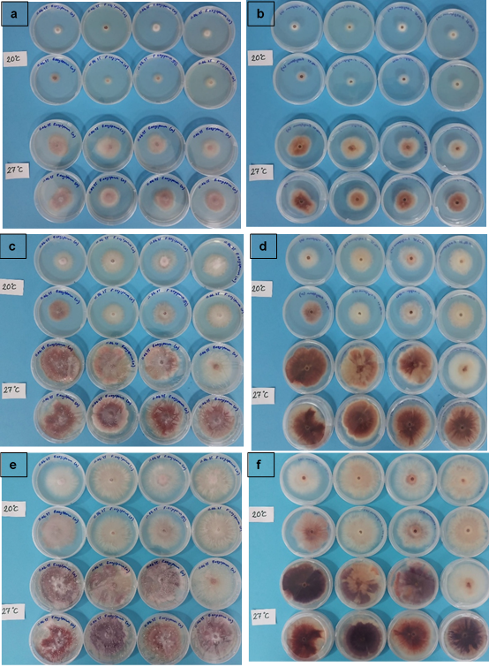

Fig. 1. Colony characteristics of F. oxysporum from garlic on the 3rd day of culture; a) front view, b) back view; on the 6th day of culture; c) front view, d) back view; on the 9th day of culture; e) front view, f) back view
(Note that: the top eight Petri plates at 20 °C, the bottom eight Petri plates at 27 °C).

Table 1. Colony diameter of F. oxysporum from A. sativum at two different temperatures; 20 °C and 27 °C
Temperature | Colony Diameter on the Measurement Days (cm)
Temperature | 3rd day | 6th day | 9th day
20 °C | 1,30^{±0,07} b | 3,38^{±0,39} b | 5,81^{±0,37} b
27 °C | 3,75^{±0,29} a | 6,71^{±0,27} a | 7,76^{±0,35} a
P value | p<0,001 | p<0,001 | p<0,001
Mean | 2,53^{±1,28} | 5,04^{±1,75} | 6,79^{±1,07}
Data represent means ± S.E. (n = 8). Tukey test was used to analyse significant differences in data, and letters represent differences at P < 0.001
Table 2. Daily mycelial growth rate of F. oxysporum from A. sativum at two different temperatures; 20 °C and 27 °C
Temperature | Mycelial Growth Rate at the Measurement Intervals (%)
Temperature | Between  0-3rd day | Between  3rd-6th day | Between  6th-9th day | Between  0-9th day
20 °C | 43,25^{±2,66} b | 68,62^{±10,89} b | 81,50^{±12,18} a | 64,63^{±4,14} b
27 °C | 125.0^{±9,38} a | 98,88^{±8,41} a | 35,00^{±14,99} b | 86,25^{±3,99} a
P value | p<0,001 | p<0,001 | p<0,001 | p<0,001
Mean | 84,13^{±42,74} | 83,75^{±18,23} | 58,25^{±27,39} | 75,44^{±11,84}
Data represent means ± S.E. (n = 8). Tukey test was used to analyse significant differences in data, and letters represent differences at P < 0.001
The width of mycelium, length-width of macroconidia, and microconidia were measured on the 15th day of incubation. Data indicates that the length and width of macroconidia were higher in the incubation at 20 °C than 27 °C (Table 3, Figures 2 & 4). Although this has not been evaluated, it should be noted that it produced very few macroconidia at 20 °C. Microconidia length showed no statistically significant differences between incubation temperatures, but width was narrow at 20 °C, as was the mycelium width (Table 4, Figures 2 & 4), which also showed statistically significant differences towards narrowing at lower temperatures.

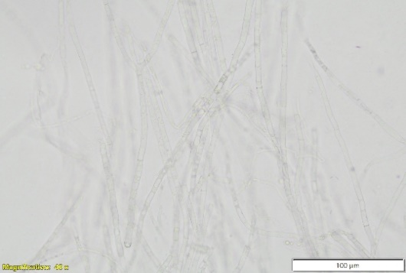
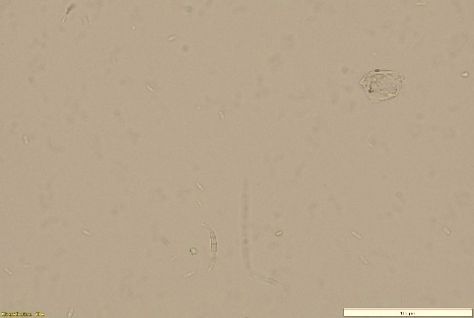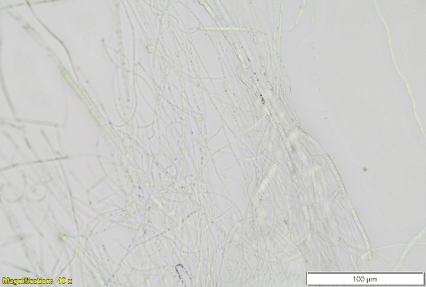
a
b
c
d
Fig 2. F. oxysporum from garlic on the 15th day of culture a) Macroconidia view at 20 °C, b) Microconidia view at 27 °C, Mycelium characteristics of; c) at 20 °C, d) at 27 °C

Table 3. Macroconidium and microconidium features of F. oxysporum from A. sativum at two different temperatures; 20 °C and 27 °C on 15th of culture
Temperature | Features of Macro and Microconidium Structures
Temperature | Macroconidia  Length (μm) | Macroconidia  Width (μm) | Microconidia  Length (μm) | Microconidia  Width (μm)
20 °C | 25,71^{±5,85} a | 3,61^{±0,63} a | 7,23^{±1,04} | 2,47^{±0,42} b
27 °C | 12,24^{±2,10} b | 2,76^{±0,57} b | 6,85^{±0,51} | 3,08^{±0,62} a
P value | P <0,001 | P =0,05 | n.s. | P =0,05
Mean | 18,98^{±8,15} | 3,19^{±0,73} | 7,04^{±0,82} | 2,77^{±0,60}
Data represent means ± S.E. (n = 8). Tukey test was used to analyze significant differences in data, and letters represent differences at P < 0.001, P = 0.05, n.s.: non-significant difference.
Table 4. Mycelial features of F. oxysporum from A. sativum at two different temperatures; 20 °C and 27 °C on 15th of culture
Temperature | Mycelium Width (μm)
20 °C | 2,64^{±0,53} b
27 °C | 4,95^{±0,44} a
P value | P <0,001
Mean | 3,79^{±1,28}
Data represent means ± S.E. (n = 8). Tukey test was used to analyse significant differences in data, and letters represent differences at P < 0.001
Morphological traits of reproductive structures were also significantly affected by temperature. Macroconidia were longer and wider at 20 °C, although fewer in number, whereas microconidial and mycelial widths were greater at 27 °C. These observations suggest that while cooler conditions may support elongation, warmer environments promote volumetric expansion. Such variability highlights the potential for diagnostic inaccuracies when classical morphological criteria are used without accounting for environmental growth conditions, as also noted by Cha et al. (2007) and Teixeira et al. (2017).
Colony colors of F. oxysporum from garlic were observed, measured, and evaluated on the 3rd, 6th, and 9th days of culture. According to the visual scale, the front side of the Petri plates at 20 °C was a little darker than the back side. On the contrary, at 27 °C, the back side of the Petri plates was always darker than the front. However, both the front and back colorations were statistically darker bordeaux at 27 °C compared to 20 °C on all measurement days (Table 5, Figures 1 & 5).
Table 5. Colony color of F. oxysporum from A. sativum at two different temperatures; 20 °C and 27 °C
Temperature | Colony Color (White=1 to Dark Bordeaux=5)
Temperature | 3rd day |  | 6th day |  | 9th day
Temperature | Front | Back | Front | Back | Front | Back
20 °C | 1,13^{±0,35} b | 1,13^{±0,35} b | 1,50^{±0,76} b | 1,38^{±0,74} b | 1,62^{±0,74} b | 1,50^{±0,76} b
27 °C | 2,50^{±0,54} a | 2,75^{±0,70} a | 3,13^{±0,64} a | 3,38^{±1,06} a | 3,63^{±0,74} a | 4,13^{±0,99} a
P value | P <0,001 | P <0,001 | P <0,001 | P <0,001 | P <0,001 | P <0,001
Mean | 1,81^{±0,83} | 1,94^{±0,99} | 2,31^{±1,08} | 2,38^{±1,36} | 2,63^{±1,26} | 2,81^{±1,60}
Data represent means ± S.E. (n = 8). Tukey test was used to analyze significant differences in data, and letters represent differences at P < 0.001

Fig. 3. Effect of incubation at 20 °C and 27 °C on F. oxysporum from A. sativum on the 3rd, 6th, and 9th days of culture; a) Colony diameter (cm) of F. oxysporum from A. sativum at two different temperatures, b) Mycelial growth rate at the measurement intervals of F. oxysporum from A. sativum at two different temperatures (%).
Visual observations were also confirmed using a digital image program. According to the program, red, green, and blue scales were always different in terms of temperature (Tables 6, 7, 8; Figure 6). Especially on the 9th day, the data showed sharp differences between the front and back sides at 27 °C.

Table 6. Colony color of F. oxysporum from garlic at two different temperatures; 20 °C and 27 °C on the 3rd day
Temperature | Colony Color in the 3rd Day
Temperature | Front |  |  | Back
Temperature | Red | Green | Blue | Red | Green | Blue
20 °C | 160,5^{±19,5} | 154,6^{±16,1} a | 151,2^{±16,4} a | 169,2^{±10,2} a | 161,8^{±10,6} a | 151,4^{±12,1} a
27 °C | 154,4^{±5,9} | 134,1^{±6,9} b | 128,5^{±5,6} b | 150,2^{±14,6} b | 111,7^{±25,7} b | 95,8^{±21,6} b
P value | N.S. | P <0,01 | P <0,01 | P <0,01 | P <0,001 | P <0,001
Mean | 157,4^{±14,2} | 144,4^{±16,0} | 139,9^{±16,6} | 160,0^{±15,9} | 136,7^{±32,1} | 123,6^{±33,3}
Data represent means ± S.E. (n = 8). Tukey test was used to analyze significant differences in data, and letters represent differences at P < 0.001, P < 0.01, n.s.: non-significant difference

Table 7. Colony color of F. oxysporum from garlic at two different temperatures; 20 °C and 27 °C on the 6th day
Temperature | Colony Color in the 6th Day
Temperature | Front |  |  | Back
Temperature | Red | Green | Blue | Red | Green | Blue
20 °C | 153,9^{±11,5} a | 145,4^{±17,1} a | 137,5^{±15,4} a | 159,1^{±15,6} a | 148,8^{±23,5} a | 138,7^{±21,2} a
27 °C | 133,9^{±17,6} b | 101,0^{±26,5} b | 98,7^{±21,9} b | 117,6^{±28,6} b | 83,3^{±36,3} b | 75,5^{±31,9} b
P value | P =0,05 | P <0,001 | P <0,001 | P =0,05 | P <0,001 | P <0,001
Mean | 143,9^{±17,7} | 123,2^{±31,4} | 118,1^{±27,2} | 138,3^{±30,9} | 116,1^{±44,9} | 107,1^{±41,6}
Data represent means ± S.E. (n = 8). Tukey test was used to analyze significant differences in data, and letters represent differences at P < 0.001, P = 0.05

Table 8. Colony color of F. oxysporum from garlic at two different temperatures; 20 °C and 27 °C on the 9th day
Temperature | Colony Color in the 9th Day
Temperature | Front |  |  | Back
Temperature | Red | Green | Blue | Red | Green | Blue
20 °C | 160,0^{±9,9} a | 150,7^{±12,8} a | 143,1^{±14,6} a | 163,8^{±13,0} a | 146,4^{±20,5} a | 135,7^{±20,5}a
27 °C | 128,9^{±13,8} b | 101,8^{±24,8} b | 102,9^{±21,6} b | 97,9^{±37,9} b | 73,1^{±37,8} b | 75,8^{±30,9} b
P value | P <0,001 | P <0,001 | P <0,001 | P <0,001 | P <0,001 | P <0,001
Mean | 144,4^{±19,8} | 126,3^{±31,6} | 123,0^{±27,3} | 130,9^{±43,6} | 109,7^{±47,9} | 105,7^{±39,9}
Data represent means ± S.E. (n = 8). Tukey test was used to analyze significant differences in data, and letters represent differences at P < 0.001

Fig. 4. Effect of incubation at 20 °C and 27 °C on F. oxysporum from A. sativum on the 15th of culture a) Features of macroconidium structures of F. oxysporum (μm), b) Features of microconidium structures of F. oxysporum (μm) c) Mycelium width of F. oxysporum (μm).

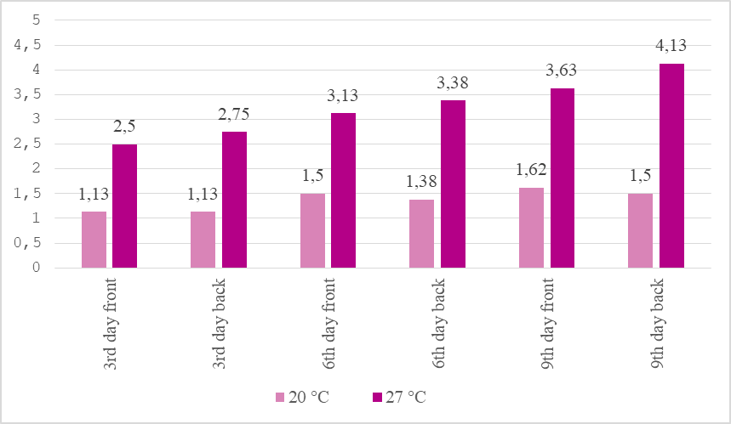
Fig. 5. Effect of incubation at 20 °C and 27 °C on the colony color at the front and back sides of F. oxysporum on the 3rd, 6th, and 9th days of culture, (White=1 to Dark bordeaux=5)
Colony pigmentation exhibited the most visually striking difference between the temperature treatments. At 27 °C, colonies developed a pronounced dark bordeaux coloration, especially on the reverse side of the Petri dishes. Digital image analysis confirmed this, with significantly lower RGB values (indicating darker coloration) compared to those at 20 °C. Color development in Fusarium species is influenced by secondary metabolism and is known to vary under different environmental conditions (Sandoval-Denis et al., 2018).
Effects of temperature differences on F. oxysporum have been studied in some scientific work in vitro or in vivo. In bell pepper pathogens, F. lactis species complex, F. oxysporum, and F. proliferatum were studied to gather some data on environmental factors on the growth and sporulation of the species, including temperature. The data showed that in F. oxysporum, the optimum temperature for colony growth and spore production was 25 °C. Below 5 °C, colony growth and sporulation stopped. Above 35 °C, sporulation sharply decreased (Frans et al., 2017). In a study, besides resistance crucifers, in general, the used cultivar of the family member showed higher susceptibility to F. oxysporum when soil temperature increases from 10 °C to 24 °C (Bosland et al., 1988). In Dendrobium chrysotoxum, F. oxysporum was first reported. In the study, four isolated strains were grown on a PDA medium at 28 °C for a week, and morphological identification, including colony colors, was observed (Yang et al., 2024). According to the results, colonies appeared as white to purplish. Microconidia and macroconidia changed between 2,57-3,38 × 5,25-10,62 µm and 19,32-36,55 × 3,44-5,52 µm in size, respectively. In another study, pathogenic F. oxysporum was isolated and identified from soybean leaves in Bali, and the study was first reported. The two isolates found were pathogenic F. oxysporum, one was white to greenish purple, and the second one was white to purple. In the study, the front and reverse sides, in addition to the center and margin, were found in different colors. The daily growth rates of the isolates were 5,76-5,84 mm, and macroconidia length-width were 35,97-37,31 × 3,43-3,52 µm. The tests were conducted at 26-28 °C in PDA medium (Suanda et al., 2025).
These findings provide important practical implications. The farmers in Türkiye have reported that Fusarium-related symptoms on garlic appear closer to harvest (i.e., in warmer periods), often showing pink to reddish lesions around the false stem near soil level. Our results support this observation, suggesting that higher temperatures favor fungal growth, sporulation, and pigmentation, potentially increasing disease visibility and severity.
From a practical diagnostic perspective, temperature-dependent morphological variations—such as colony color, conidial size, and mycelial width—may complicate accurate identification of F. oxysporum if only classical morphological traits are considered. Incorporating molecular markers, such as TEF1-α (Translation Elongation Factor 1-alpha) or β-tubulin gene sequences, into routine diagnostics could enhance the accuracy of species and forma specialis identification (Yörük and Yli-Mattila, 2024, Shahiba et al., 2022). Furthermore, the expression of TEF1-α is associated with certain regulatory genes involved in cell growth and morphological development (Ahn et al, 2007). Therefore, environmental factors such as temperature changes may indirectly influence TEF1-α expression, contributing to the observed morphological variations. This approach would not only strengthen taxonomic reliability but also enable earlier detection, allowing farmers and plant pathologists to implement timely and targeted disease management strategies under varying environmental conditions.

Fig. 6. Effect of incubation at 20 °C and 27 °C on the colony color at the front and back sides of F. oxysporum with a digital image program on the a) 3rd day b) 6th day c) 9th day
4. Conclusion

Fusarium species exhibit temperature-dependent differences in colony growth, morphology, and pigmentation, with 20 °C causing slower growth, narrower microconidia, and paler colonies compared to 27 °C. These results align with field observations in garlic and emphasize that temperature should be considered in disease diagnosis and management. Moreover, RGB-based digital image analysis offers an objective method to quantify colony pigmentation, enhancing precision in morphological assessments. Overall, understanding thermal effects on Fusarium can improve early detection, taxonomy, and integrated disease control strategies.

Disclaimer (Artificial intelligence)

Author(s) hereby declare that NO generative AI technologies such as Large Language Models (ChatGPT, COPILOT, etc.) and text-to-image generators have been used during the writing or editing of this manuscript.

References

Agha, S. I., Ullah, M., Khan, A., Jahan, N., Ullah, S. M., Tabassum, B., & Hamdard, M. H. (2023). Biocontrol Rhizobacteria enhances growth and yield of wheat (Triticum aestivum) under field conditions against Fusarium oxysporum. Bioengineered, 14(1), 2260923. https://doi.org/10.1080/21655979.2023.2260923
Ahn, J., Hong, J., Lee, H., Park, M., Lee, E., Kim, C., Choi, E., Jung, J., Lee, H. (2007). Translation elongation factor 1-α gene from Pichia pastoris: molecular cloning, sequence, and use of its promoter. Appl Microbiol Biotechnol 74, 601–608 https://doi.org/10.1007/s00253-006-0698-6
Ajmal, M., Hussain, A., Ali, A., Chen, H., & Lin, H. (2022). Strategies for controlling the sporulation in Fusarium spp. Journal of Fungi, 9(1), 10. https://doi.org/10.3390/jof9010010
Benchimol‐Reis, L. L., Bueno, C. J., Carbonell, S. A. M., & Chiorato, A. F. (2023). Fusarium wilt–common bean pathosystem: Pathogen variability and genetic control. Crop Science, 63(5), 2609-2622. https://doi.org/10.1002/csc2.21063
Bosland, P. W., Williams, P. H., Morrison, R. H. (1988). Influence of soil temperature on the expression of yellows and wilt of crucifers by Fusarium oxysporum. Plant Disease, 72(9), 777–780. https://doi.org/10.1094/PD-72-0777.
Bustos-Caro, E., Perez-Mora, W. H., Melgarejo, L. M., & Ardila, H. D. (2024). Physiological and biochemical characterization of a susceptible carnation (Dianthus caryophyllus L.) cultivar to Fusarium oxysporum f. sp. dianthi (Fod). Ornamental Horticulture, 30, e242750. https://doi.org/10.1590/2447-536X.v30.e242750
Cai, H., Tao, N., & Guo, C. (2020). Systematic investigation of the effects of macro-elements and iron on soybean plant response to Fusarium oxysporum infection. The Plant Pathology Journal, 36(5), 398-405. https://doi.org/10.5423/PPJ.OA.04.2020.0069
Cha, S. D., Jeon, Y. J., Ahn, G. R., Han, J. I., Han, K. H., & Kim, S. H. (2007). Characterization of Fusarium oxysporum isolated from Paprika in Korea. Mycobiology, 35(2), 91-96. https://doi.org/10.4489/MYCO.2007.35.2.091
Dewi, O. K. M., Abadi, A. L., & Widyaningsih, S. (2022). Fusarium rot biological control of citrus caused by Fusarium oxysporum. Research Journal of Life Science, 9(2), 91-98. https://doi.org/10.21776/ub.rjls.2022.009.02.5
Dong, Y. H., Han, X. Q., Wang, J. H., Li, B., Meng, X. L., Dai, P. B., ... & Wang, S. T. (2024). Genome Sequence of Fusarium oxysporum f. sp. malus HS2 Causing Apple Replant Disease. PhytoFrontiers, 4(2), 239-242. https://doi.org/10.1094/PHYTOFR-03-23-0036-A
Frans, M., Aerts, R., Van Laethem, S., & Ceusters, J. (2017). Environmental effects on growth and sporulation of Fusarium spp. causing internal fruit rot in bell pepper. European Journal of Plant Pathology, 149, 875-883. https://doi.org/10.1007/s10658-017-1235-4
González-García, Y., Escobar-Hernández, D. I., Benavides-Mendoza, A., Morales-Díaz, A. B., Olivares-Sáenz, E., & Juárez-Maldonado, A. (2023). UV-A radiation stimulates tolerance against Fusarium oxysporum f. sp. lycopersici in tomato plants. Horticulturae, 9(4), 499. https://doi.org/10.3390/horticulturae9040499
Gordon, T. R., & Martyn, R. D. (1997). The evolutionary biology of Fusarium oxysporum. Annual Review of Phytopathology, 35(1), 111-128.
Hussain, M. Z., Rahman, M. A., Islam, M. N., Latif, M. A., & Bashar, M. A. (2012). Morphological and molecular identification of Fusarium oxysporum Sch. isolated from guava wilt in Bangladesh. Bangladesh Journal of Botany, 41(1), 49-54.
Landa, B. B., Navas-Cortés, J. A., del Mar Jimenez-Gasco, M., Katan, J., Retig, B., & Jiménez-Díaz, R. M. (2006). Temperature response of chickpea cultivars to races of Fusarium oxysporum f. sp. ciceris, causal agent of Fusarium wilt. Plant Disease, 90(3), 365-374. https://doi.org/10.1094/PD-90-0365
Leslie, J. F., & Summerell, B. A. 2006. The Fusarium Laboratory Manual. Blackwell Publishing Professional, Iowa, USA ISBN-13: 978-0-8138-1919-8, DOI:10.1002/9780470278376
Lombard, L., Sandoval-Denis, M., Lamprecht, S. C., & Crous, P. W. (2019). Epitypification of Fusarium oxysporum–clearing the taxonomic chaos. Persoonia, 43(1), 1-47. https://doi.org/10.3767/persoonia.2019.43.01
Muhorakeye, M. C., Namikoye, E. S., Khamis, F. M., Wanjohi, W., & Akutse, K. S. (2024). Biostimulant and antagonistic potential of endophytic fungi against Fusarium wilt pathogen of tomato Fusarium oxysporum f. sp. lycopersici. Scientific Reports, 14(1), 15365. https://doi.org/10.1038/s41598-024-66101-1
Obert, K., Schudt, M., & Bentley, I. (2023). Color Saturation: Upper and lower percentage histogram manipulation. American Journal of Undergraduate Research, 20(1), 59-76. https://doi.org/10.33697/ajur.2023.080
Sandoval-Denis, M., Guarnaccia, V., Polizzi, G., Crous, P.W. (2018). Symptomatic citrus trees reveal a new pathogenic lineage in Fusarium and two new Neocosmospora species. Persoonia 40: 1–25. https://doi.org/10.3767/persoonia.2018.40.01
Shahiba, A. M., Jayalekshmy, V. G., Sajeena, A., Chacko, A.. (2022). “Morpho-Molecular Identification and Pathogenicity of Fusarium oxysporum Pathogens Associated With Vascular Wilt in Cowpea (Vigna Unguiculata L.)”. International Journal of Plant & Soil Science 34 (24):937–948. https://doi.org/10.9734/ijpss/2022/v34i242721.
Suanda, I. W., Widnyana, I. K., & Dharmadewi, A. A. I. M. (2025). Isolation and identification of pathogenic Fusarium oxysporum isolated from soybean leaves. Biodiversitas Journal of Biological Diversity, 26(5), 2261-2268. https://doi.org/10.13057/biodiv/d260523
Teixeira, L. M., Coelho, L., & Tebaldi, N. D. (2017). Characterization of Fusarium oxysporum isolates and resistance of passion fruit genotypes to fusariosis. Revista Brasileira de Fruticultura, 39(3), e-415. https://doi.org/10.1590/0100-29452017415
Yang, J., Ahmed, W., Zhang, J., Gao, S., Wang, Z., Yang, H., & Ji, G. (2024). Identification of Fusarium oxysporum causing leaf blight on Dendrobium chrysotoxum in Yunnan Province, China. Life, 14(3), 285. https://doi.org/10.3390/life14030285
Yörük, E.; Yli-Mattila, T. Translation Elongation Factor 1-Alpha Sequencing Provides Reliable Tool for Identification of Fusarium graminearum Species Complex Members. Diversity 2024, 16, 481. https://doi.org/10.3390/d16080481

