Original Research Article
Biosurfactant Production and Antifungal Potential of Bacterial Isolates for Biocontrol of Phytopathogens

Abstract
Biotic stress from phytopathogens like bacteria, fungi, yeasts, and insect pests significantly reduces plant yields. Biocontrol agents and their active compounds offer a sustainable approach to managing these pathogens. In this study, four bacterial isolates Bacillus cereus, B. anthracis, B. velezensis, and Serratia marcescens were screened for biosurfactant production using foam formation, oil spreading, and emulsification activity assays. B. velezensis exhibited the highest foam stability and emulsification activity (E24%). Notably, the maximum growth observed in B. anthracis (OD 1.247±0.002 at 108 h) did not correlate directly with biosurfactant production, indicating that higher bacterial growth does not necessarily lead to increased biosurfactant synthesis. Biosurfactant yields varied across different media: ​Luria-Bertani (LB) medium: B. velezensis produced 0.349±0.004 g/50 mL, followed by B. anthracis (0.215±0.001 g/50 mL), B. cereus (0.210±0.004 g/50 mL), and S. marcescens (0.206±0.003 g/50 mL). Nutrient Broth (NB) medium: S. marcescens yielded the highest biosurfactant production at 0.277±0.001 g/50 mL, with B. velezensis (0.256±0.003 g/50 mL), B. anthracis (0.239±0.003 g/50 mL), and B. cereus (0.230±0.005 g/50 mL) following.​ Potato Dextrose Broth (PDB) medium: B. velezensis again led with 0.316±0.001 g/50 mL, trailed by S. marcescens (0.278±0.004 g/50 mL), B. anthracis (0.262±0.005 g/50 mL), and B. cereus (0.238±0.003 g/50 mL).​ The antifungal efficacy of the biosurfactants was assessed on Potato Dextrose Agar (PDA) plates. B. velezensis demonstrated the highest inhibition percentages against several phytopathogens: Rhizoctonia solani (88.44%), Fusarium udum (82.96%), Helminthosporium maydis (72.68%), F. oxysporum f. sp. Lycopersici (68.07%), and Fusarium solani (68.07%). These findings suggest that B. velezensis biosurfactant is particularly effective against the tested phytopathogens and holds promise as a biocontrol agent in sustainable agriculture.
Keywords: Bacillus velezensis, Biosurfactants, Oil spreading test, Antifungal activity, Biotic stress, Emulsification activity, Foam forming activity.

- INTRODUCTION
In recent years, biosurfactants—important low molecular weight amphiphilic and microbially derived bioactive products made by bacteria, yeast, and fungi have garnered a lot of attention because of their applications in medicine, industry, the environment, and pharmaceuticals, as well as their use in industrial processes like foaming, emulsification, detergency, solubilisation, and wetting properties (Nitschke & Costa 2007; Makkar et al., 2011; Rodrigues et al., 2006). We refer to amphipathic compounds with hydrophilic tails and hydrophobic head ends as biosurfactants (Abbot et al., 2022). These biosurfactants are a better option for use in a variety of formulation developments and aggregation studies because of their distinct qualities, which include low toxicity, high biodegradability, good environmental compatibility, lower critical micelle concentration (CMC), synthesis from renewable resources, high selectivity, high foaming forming ability, target specific activity at a certain temperature, and more salinity and pH (Nitschke M & Costa 2007; Abbot et al., 2022; Chen et al., 2007). Microbial fermentation techniques can also produce biosurfactants using less expensive agricultural based substrates and crop leftovers. Since chemically produced surfactant agents are typically poisonous and non-biodegradable, biosurfactants become increasingly important due to their eco-friendliness and biodegradability (Kumar & Saravanan., 2015). Reducing production costs and increasing biosurfactant production steadily are the primary aspects that significantly impact biosurfactant production efficiency (Kosaric., 1992; Bognolo 1999). It appears that biosurfactants primarily rely on the utilisation of large and inexpensive substrates to maximise growing conditions, which can significantly boost yield (Mukherjee et al., 2006; Mukherjee et al., 2008; Mutaliket al., 2008). The isolation and characterisation of the biosurfactant or biosurfactants produced by extremophiles, such as halophilic and as thermophilic bacteria, have received a lot of attention from researchers (Kumar et al., 2007: Joshi et al., 2008; Mnifet al., 2009). Additionally, endophytic and epiphytic microorganisms produce biosurfactants that aid in seed germination (Saleh et al., 2019). By functioning as biocontrol agents, biosurfactants also prevent phytopathogens from doing their damage and aid in bioremediation. Researchers have looked into rhizospheric bacteria that release compounds that boost the production of plant products since using pesticides on plants should be avoided in order to obtain chemical-free plant goods (Taiwo et al., 2019). The biological control of fungal phytopathogens can be achieved through the use of bacterial biosurfactants, which are abundant in antimicrobial peptides. Bacillus is regarded as a factory that produces secondary metabolite-like compounds on a vast scale that can inhibit the growth of phytopathogens. Microbial biosurfactant molecules, such as lipopeptides (LPs), are powerful, multifunctional tools that can contract with a variety of phytopathogens to restrict their growth. The molecules of biosurfactants are less harmful, biodegradable, and effective at high or low temperatures. They are also resistant to changes in pH and salinity, which makes them a viable substitute for their chemical or chemicals in a variety of applications, such as food, agriculture, and bioremediation (Marchant & Banat.,2012; Mishra, et al., 2021). Therefore, in order to ycelia the loss of crop yield, we examined the ability of specific bacterial isolates to inhibit the phytopathogens, such as, F. oxysporumf sp. Lycopersici, Fusarium udum, Fusarium solani and Rhizoctonia solani.

- Materials and Methods
2.1 Morphological and biochemical tests for isolated microbial isolates
Gram’s staining
Firstly bacterial thin smear(s) of four bacterial strains were prepared. The slides were heat fixed with the gentle heating under burner. Gently flooded the smear with crystal violet (C.V) and kept it for drying for 1 minute. After that tilted the slide and gently rinsed it with tap water and dried. Thereafter smear(s) were flooded with Gram’s iodine and after 1 minute slightly tilted for rinsing with tap water. The smear appeared as purple circle on the slides. Now concentrated alcohol (95%) applied drop by drop for 30 seconds and thereafter immediately rinsed it with water and dried. Thereafter slides flooded with safranin as counter-stain and kept it for 30 seconds and gently rinsed with tap water while keeping the slides slightly tilted until no color appeared in the effluent and then dried with absorbent paper. The slides were observed under the microscope using oil immersion and results recorded accordingly.
Biochemical test(s)
Biochemical test(s) were performed by using the biochemical test kits (HiMedia, Mumbai). The 24 h hour old pure cultures (OD 1.0 at 600 nm) of T1, T2, T3 and T4 isolates placed in particular space for particular test and kits were kept for 24 hours in the BOD incubator. For Indole test, 1-2 drops of kovac’s red reagent were added and color differentiation was observed within 10 seconds. For Methyl Red test, 1-2 drops of methyl red (MR) reagent added and the red color observed. For vogesproskauer’s test, 2 drops of baritt reagent A and 2 drops of baritt reagent B were added and results were observed on the basis of color differentiation and results recorded accordingly.
2.2 Molecular characterization of bacterial isolate(s)
The bacterial isolates T1, T2, T3 and T4 which showed bio-surfactant and antifungal activity, were sent for identification to Bioserve Biotechnologies (India) Pvt. Ltd, Hyderabad, India for characterization by 16S rDNA analysis. The forward and reverse gene sequences of closely related strains were retrieved from a server through the BLAST with the help of CLUSTAL-W program of MEGA software version 10.0 (Tamura et al., 2007). The evolutionary dendrogram was deduced by Neighbor-Joining method (Saitou and Nei, 1987) on the basis of results showed after BLAST (Tamura et al., 2007).
2.3 Screening of bacterial isolates for biosurfactant production
Foam forming activity
In 100 mL of potato dextrose broth, nutritional broth, and Luria bertani broth, each of the 12 distinct combinations of the four microbial isolates (PDBT1, NBT1, LBT1, PDBT2, NBT2, LBT2, PDBT3, NBT3, LBT3, PDBT4, NBT4, and LBT4) was cultivated independently. After that, the flasks were incubated for 96 hours at 37°C at 150 rpm on a shaker incubator. The duration of foam height, foam stability, and foam shape were then used to measure the foam activity (Chayabutra et al., 2001).
Emulsification activity (E24)
Cell-free broth of four distinct bacteria in various media (PDBT1, NBT1, LBT1, PDBT2, NBT2, LBT2, PDBT3, NBT3, LBT3, PDBT4, NBT4, and LBT4) and organic hydrocarbons (benzene, toluene, hexane, and diesel oil) each containing 2.5 mL were inoculated in test tubes and homogenized by vortexing for two minutes at a high speed. The following formula was used to measure the emulsification activity (E24%) after 24 hours (Lai et al., 2009):
E24 (%) = Total height of emulsified layer (mm) × 100
Total height of liquid layer (mm) Oil spreading test
To create a thin oil layer, 40 millilitres of distilled water and 100 microlitres of diesel oil were combined in a Petri dish. Following that, it was topped with thirty microlitres of each of the four distinct bacterial cultures [T1, T2, T3, and T4] supernatants (PDBT1, NBT1, LBT1, PDBT2, NBT2, LBT2, PDBT3, NBT3, LBT3, PDBT4, NBT4, and LBT4). The outcomes were noted and documented appropriately (Plaza et al., 2006).
2.4 Extraction of bio-surfactant from bacteria by an APME (Acid precipitation methanol extraction) method.
Freshly made Potato Dextrose Broth, Nutrient Broth, and Luria Bertani broth were mixed with an innoculum of 5% (v/v) and one O.D. cell of four bacteria. The mixture was then maintained in a shaking incubator at 37°C for 72 hours. A cell-free supernatant was then obtained by centrifuging the culture broth or broths at 10,000 rpm for 10 minutes at 4 °C. 6 N HCl was used to bring the supernatant’s pH down to 3.0. Centrifugation was used to separate the white precipitate pellet for 10 minutes at 4^{ο}C and 10,000 rpm(Gover et al., 2010). Following methanol extraction of the precipitate, biosurfactant was vortexed with methanol, and the eppendroff tubes were refrigerated for antagonistic testing against phytopathogens. Amount of bio surfactant produce by APME method from 50 ml supernatant of each treatment of Bacillus cereus, Bacillus anthracis, Bacillus velezensis and Serratia marcescens.
2.5 Antifungal activity of crude biosurfactant against Fusarium solani, Fusarium udum, Fusarium oxysporum f. sp. Lycopersici and Rhizoctonia solani.
Well diffusion was used to find the antifungal activity (Jasim et al., 2016; Balouiriet al., 2016) .Using a loop, a small mycelium of fungal isolates of Fusarium solani, Fusarium udum, Fusarium oxysporum f. sp. Lycopersici and Rhizoctonia solani were placed in the centre of the Petri plate. The crude preparation of biosurfactants (50 µL) of four bacterium isolates, such as T1, T2, T3, and T4, were placed in the well created by a cork borer at four locations in a triangle in the Petri plate. Plates were cultured at 30°C, and the below mentioned formula was used to determine the % inhibition.
I = 100 (C – T) / C
where I = Percentage inhibition of mycelia growth, C = Growth of pathogen (fungus) in control plate (mm) and T = Growth of pathogen (mm) in dual cultures in tested condition.
3.RESULTS
Microbial isolates’ isolation from rhizosphere soil samples, four microbial isolates (T1, T2, T3, and T4) were obtained. Each of these strains was purified by repeatedly subculturing them in petri plates containing nutrient agar (pH 7.0) and then being stored at 4ºC for additional identification.
Table 1: Bacterial strains growth observation at different wavelengths.
Bacterial isolates | OD at 36 h | OD at 72 h | OD at 108 h
Bacterial isolates | Mean±SE | Mean±SE | Mean±SE
T1 | 0.823±0.001 | 0.993±0.004 | 1.023±0.002
T2 | 1.008±0.004 | 1.222±0.003 | 1.247±0.002
T3 | 0.016±0.001 | 0.214±0.002 | 0.314±0.002
T4 | 0.303±0.009 | 0.498±0.014 | 0.577±0.019
Control(NB) | 0.000±0.000 | 0.000±0.000 | 0.000±0.000
CDat5% | 0.014 | 0.022 | 0.027
SE(m) | 0.004 | 0.007 | 0.008
SE(d) | 0.006 | 0.010 | 0.012
C.V | 1.777 | 2.003 | 2.319
# CD: common difference; SE: Standard error; CV: coefficient of variation
Tables depicts the growth of four bacterial isolates in the nutrient broth after 36 h interval upto 108 h. OD >1.0 of the bacterial cells were obtained in the case of T1 and T2 while T3 and T4 bacteria showed slower growth at 37^{ο}C in the incubator.
Collection and sub-culturing of microbial isolates
Four microbial isolates (T1, T2, T3, and T4) were obtained from the CBS&H, RPCAU, Pusa, Samastipur, Bihar, Department of Microbiology. All of these isolates were subcultured in petri plates with nutrient broth at pH 7.0 following collection.
Using a spectrophotometer set at 640 nm at 36, 72, and 108 hours, the growth of all bacterial strains (T1, T2, T3, and T4) was observed and verified (Table 1). The culture was then preserved in slants in the test tubes and stored in the refrigerator for future research.
3.1 Morphological and biochemical characterization of bacterial isolates
Morphological and biochemical characteristics
Bacterial isolate(s) T1, T2 and T3 were found as Gram +ve, purple rod shaped bacterial cells while T4 was found as Gram –ve bacteria with small rod shaped pink color cells under the microscopes at 1000X (Table 2).
Table 2 — Morphological characteristic of bacterial isolates
Bacterial Isolate | Gram’s staining | Colony colour | Colony shpae | Cell shape
Bacillus cereus | +ve | Purple | Streptobacilli | Rod shaped
Bacillus anthracis | +ve | Purple blue | Streptobacilli | Rod shaped
Bacillus velezensis | +ve | Purple | Streptobacilli | Rod shaped
Serratia marcescens | -ve | Pink | Staphylobacillus | Short rod shaped
3.2 Biochemical tests
In order to identify the bacteria genus and species, biochemical test(s) such as indole, methyl red (MR), vogesproskauer’s (V.P), citrate utilization and some other carbon utilization tests of all four bacterial strains (T1, T2, T3 and T4) were performed by using Himedia kit (KB001). The methyl red, oxidase and glucose utilization test were found +ve for T1 and in T2 one more test vogesproskauer test was positive while other tests were observed –ve (Table 3). Indole, vogesproskauers, rhamnose and sucrose tests were positive while other test found –ve for T3 isolate. Indole, methyl red, citrate utilization and adonitol test were +ve while others were found –ve for T4 bacterial isolate.

Table 3: Biochemical test(s) for bacterial isolates
Test | Bacillus cereus | Bacillus anthracis | Bacillus velezensis | Serratia marcescens
Indole | -ve | -ve | +ve | +ve
Methyl red | +ve | +ve | -ve | +ve
Vogesproskauer | -ve | +ve | +ve | -ve
Citrate utilization | -ve | -ve | -ve | +ve
Glucose | +ve | +ve | -ve | -ve
Adonitol | -ve | -ve | -ve | +ve
Arabinose | -ve | -ve | -ve | -ve
Lactose | -ve | -ve | -ve | -ve
Sorbitol | -ve | -ve | -ve | -ve
Manitol | -ve | -ve | -ve | -ve
Rhamnose | -ve | -ve | +ve | -ve
Sucrose | -ve | -ve | +ve | -ve
Oxidase | +ve | +ve | -ve | -ve

3.3 Molecular characterization of bacteria isolates by 16s rDNA sequencing
The bacterial cultures sent to Bioserve Biotechnologies (India) Pvt. Ltd, Hyderabad for sequencing. Received forward and reverse sequences were merged and FASTA format sequences were further subjected to nucleotide BLAST. The nucleotide sequences analysis with NCBI data bank to retrieve the sequence homology within own bacterial strains. On the basis of sequence homology with the help of RDP (Ribosomal Database Project) and phylogenetic analysis, the bacterial isolate T1, T2, T3 and T4 identified as Bacillus cereus, Bacillus anthracis, Bacillus velezensis and Serratia marcescens respectively (Figure 1-3).
Figure 1: (A) Phylogenetic tree, (B) Ribosomal Database project (RDP) results; and (C) nucleotide BLAST data of bacterial isolate T1 confirm Bacillus cereus bacterium.
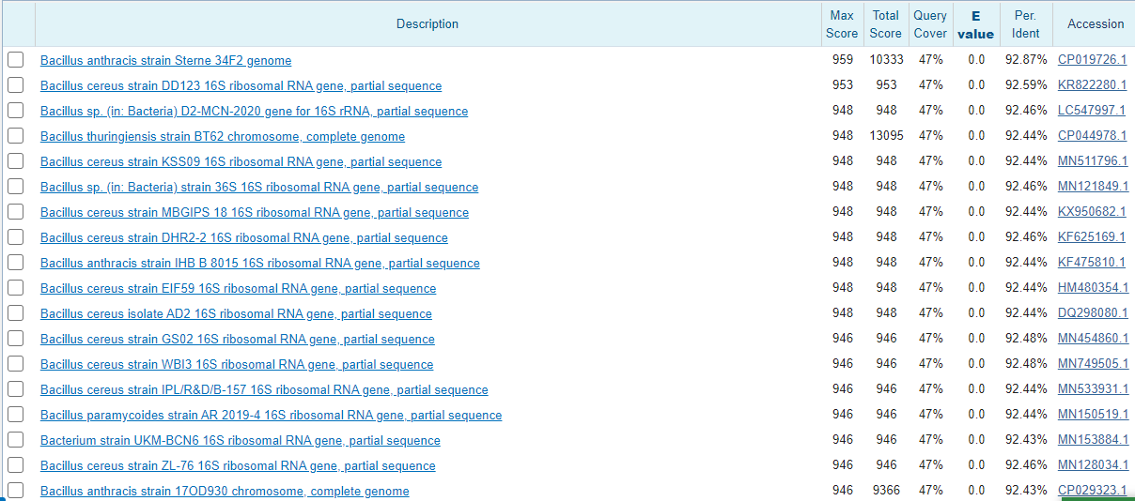
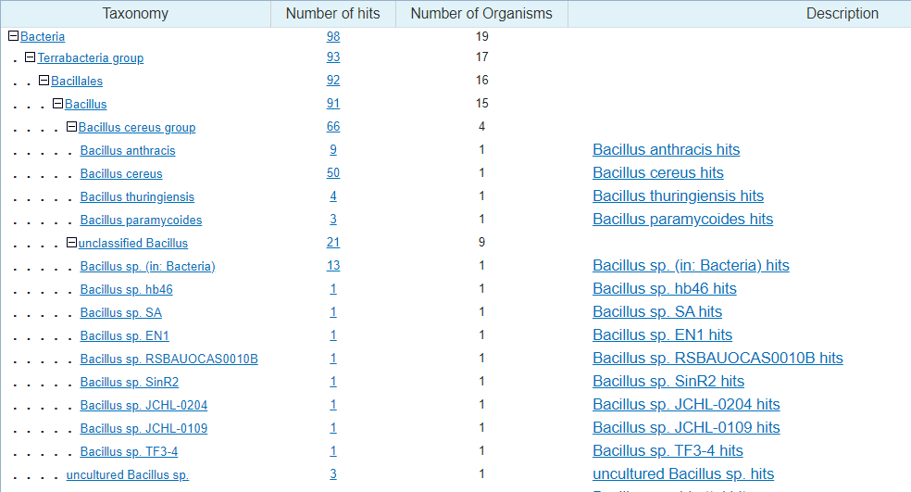
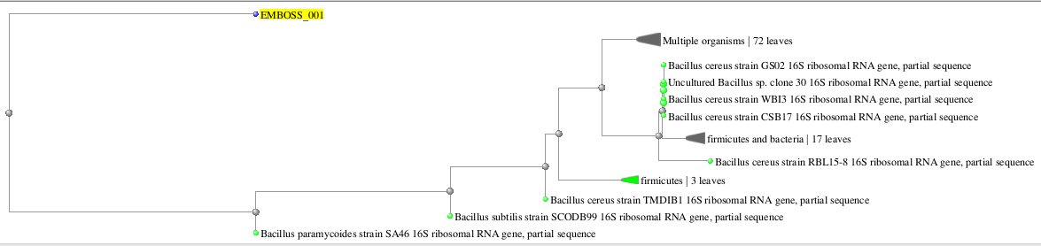
C
B
A
Figure 1: (A) Phylogenetic tree, (B) Ribosomal Database project (RDP) results; and (C) nucleotide BLAST data of bacterial isolate T1 confirm Bacillus cereus bacterium.

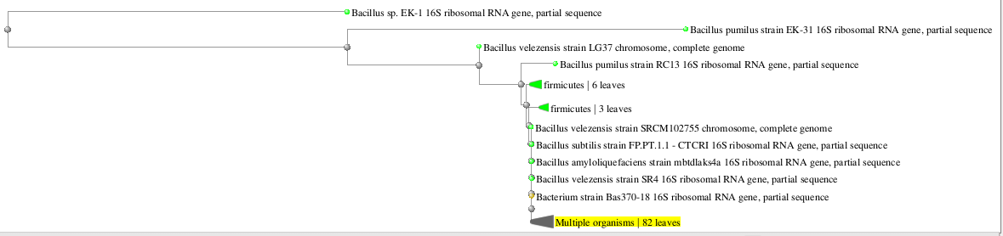
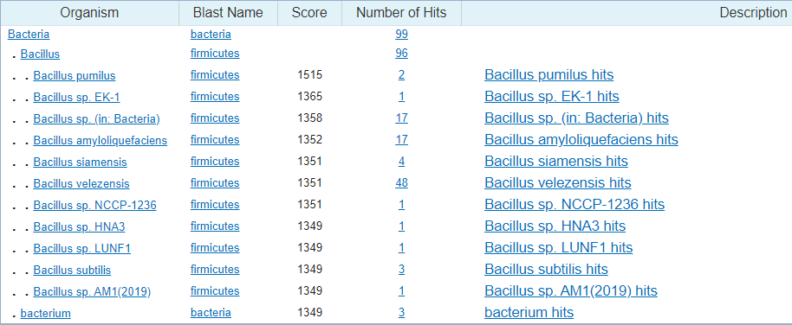
B
Figure 2: (A) Phylogenetic tree, (B) ) Ribosomal Database project (RDP) results of bacterial isolate T3 confirm Bacillus velezensis bacterium.

A

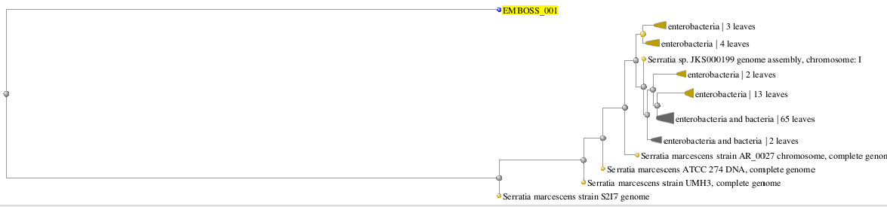
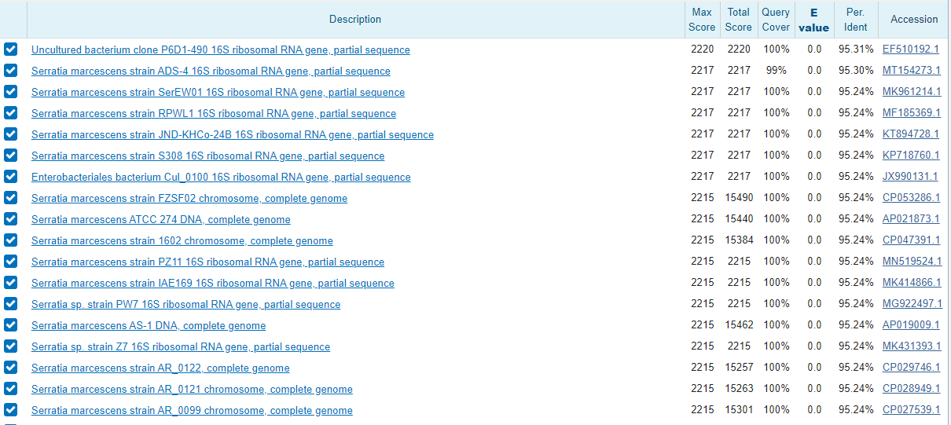
A
Figure 3: (A) nucleotide BLAST data of T4 and (B) Phylogenetic tree confirm Serratia marcescens
B

3.4 Foam forming activity
All four bacteria—Bacillus cereus, Bacillus anthracis, Bacillus velezensis, and Serratia marcescens—were tested for their ability to create foam in three distinct media, including nutrient broth, potato dextrose broth, and Luria Bertani broth. Based on the foam stability time, foam height, and foam characteristics, foam forming activity was identified (Table 4; Fig. 4). In LB broth, PDB, and NB, respectively, B. cereus, B. anthracis, B. velezensis, and S. marcescens exhibited the highest foam-forming activity (Table 4; Figure. 4).

Table 4: foam forming activity of four bacterial isolates
Bacteria | Nutrient Broth | Potato Dextrose Broth | Luria Bertani Broth
Bacteria | Foam properties | Foam properties | Foam properties
Bacillus cereus | + | ++ | ++
Bacillus anthracis | ++ | +++ | ++
Bacillus velezensis | ++ | +++ | +++
Serratia marcescens | +++ | ++ | ++
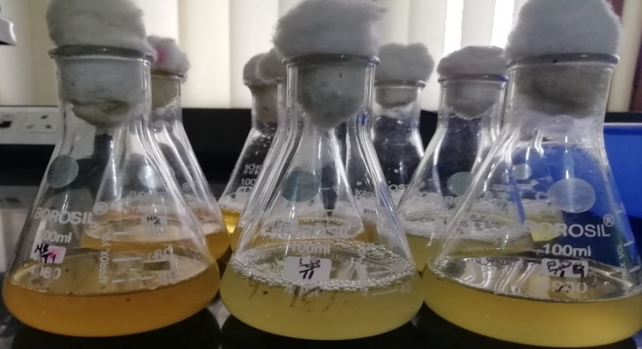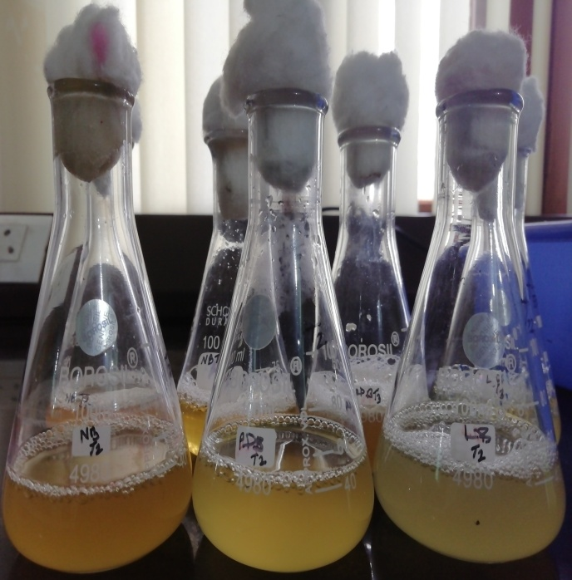
T2
T1
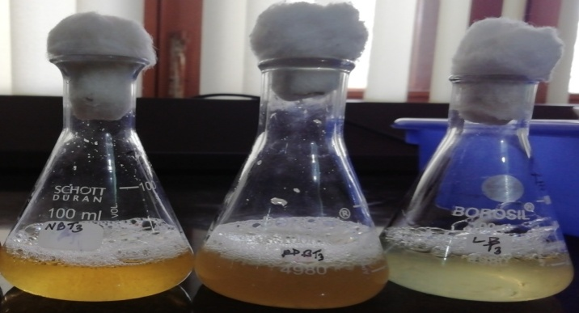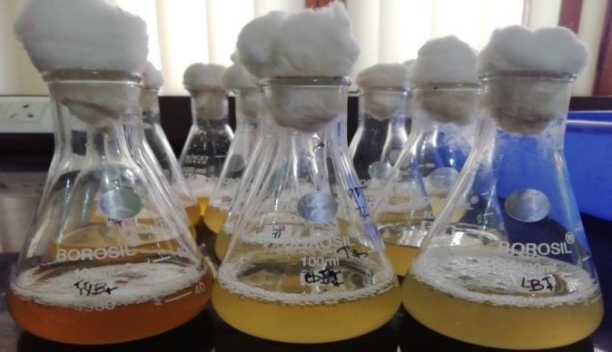
T4
T3
Figure 4: Foam forming activity of Bacillus cereus (T1), Bacillus anthracis(T2), Bacillus velezensis(T3) and Serratia marcescens (T4).

3.5 Emulsification activity of bacteria in with hydrocarbons
The 4 different bacteria with three different media (PDBT1, NBT1, LBT1, PDBT2, NBT2, LBT2, PDBT3, NBT3, LBT3, PDBT4, NBT4 and LBT4) tested for emulsification activity were inoculated in test tubes and homogenized by vortexing for 2 minutes at a high speed whereas for negative control, 2.5 mL of hydrocarbon (benzene, toluene, hexane and diesel oil) mixed with 2.5 mL of potato dextrose broth, nutrient broth and Luria bertani broth were taken separately. Maximum emulsification activity E24% (75%) was observed in the case of Bacillus velezensis with PDB (Table 5; Figure 5-6).
Table 5: Emulsification index (E24) of different hydrocarbons
Bacteria | Media | E24(%) of cell-free broth of different bacteria with different hydrocarbons |  |  |  | Stability (days)
Bacteria | Media | Benzene | Toluene | Diesel oil | Hexane | 1
Bacillus cereus | NB | +ve | +ve | +ve | -ve | 1
Bacillus cereus | LB | +ve | +ve | +ve | -ve | 1
Bacillus cereus | PDB | +ve | +ve | +ve | -ve | 1
Bacillus anthracis | NB | +ve | +ve | +ve | -ve | 1
Bacillus anthracis | LB | +ve | +ve | +ve | -ve | 1
Bacillus anthracis | PDB | +ve | +ve | +ve | -ve | 1
Bacillus velezensis | NB | +ve | +ve | +ve | -ve | 2
Bacillus velezensis | LB | +ve | +ve | +ve | -ve | 2
Bacillus velezensis | PDB | +ve | +ve | +ve | -ve | 2
Serratia marcescens | NB | +ve | +ve | +ve | -ve | 1
Serratia marcescens | LB | +ve | +ve | +ve | -ve | 1
Serratia marcescens | PDB | +ve | +ve | +ve | -ve | 1
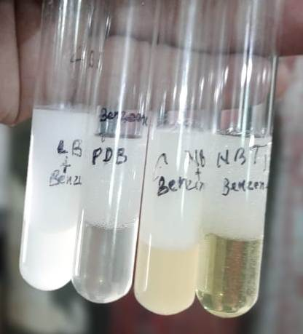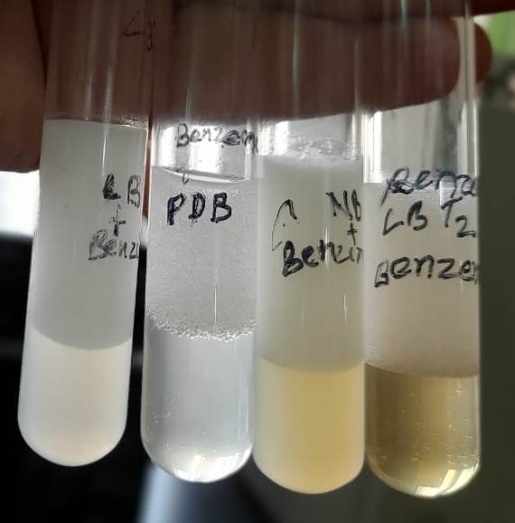
T2
T1
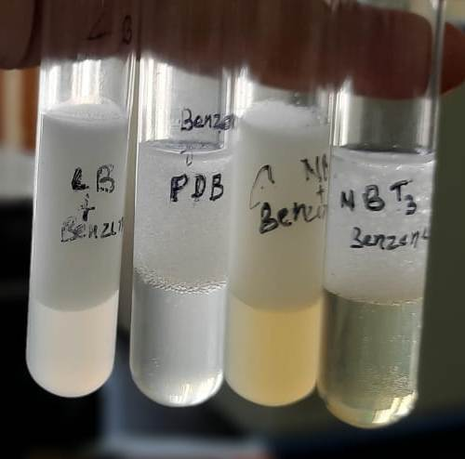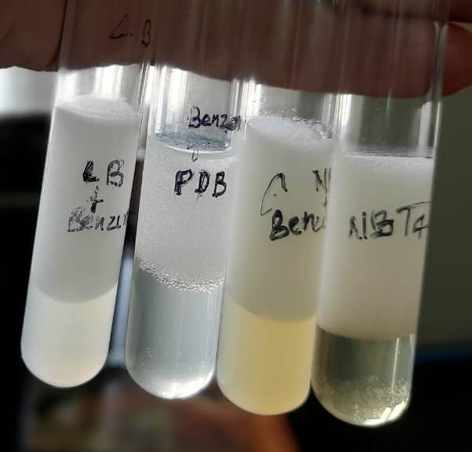
T3
T4
Figure 5: Emulsification activity of Bacillus cereus(T1), Bacillus anthracis(T2), Bacillus velezensis(T3) and Serratia marcescens(T4) in benzene hydrocarbon.

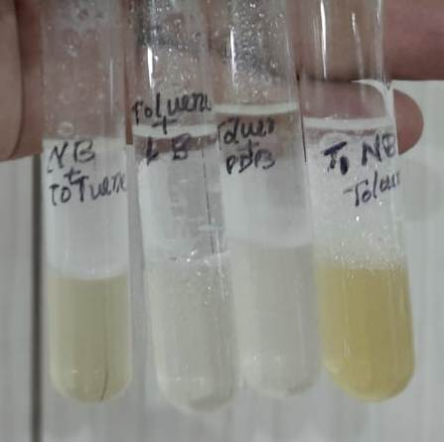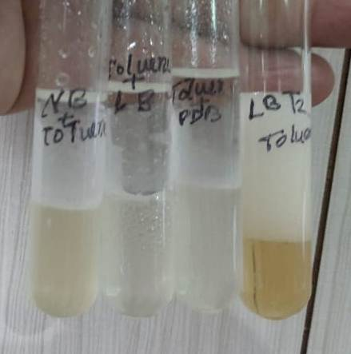
T2
T1
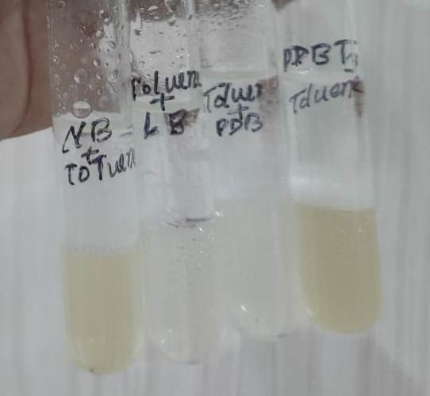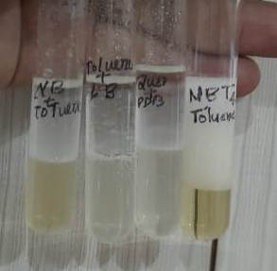
T4
T3
Figure 6: Emulsification activity of Bacillus cereus(T1), Bacillus anthracis(T2), Bacillus velezensis(T3) and Serratia marcescens(T4) in Toluene hydrocarbon.

3.6 Extraction of bio-surfactant from bacteria by an APME (Acid precipitation methanol extraction) method
Biosurfactant yields varied across different media:​Luria-Bertani (LB) medium:B. velezensis produced (0.349±0.004 g/50 mL), followed by B. anthracis (0.215±0.001 g/50 mL), B. cereus (0.210±0.004 g/50 mL), and S. marcescens (0.206±0.003 g/50 mL). Nutrient Broth (NB)medium: S. marcescens yielded the highest biosurfactant production at 0.277±0.001 g/50 mL, with B. velezensis (0.256±0.003 g/50 mL), B. anthracis (0.239±0.003 g/50 mL), and B. cereus (0.230±0.005 g/50 mL) following.​ Potato Dextrose Broth (PDB) medium: B. velezensis again led with 0.316±0.001 g/50 mL, trailed by S. marcescens (0.278±0.004 g/50 mL), B. anthracis (0.262±0.005 g/50 mL), and B. cereus (0.238±0.003 g/50 mL).​ The precipitate was then extracted with methanol and after that, the vortaxing of bio surfactant with methanol was done and the eppendroff tubes were stored in refrigerator for antagonistic test against phytopathogens (Table 6). Amount of bio surfactant produce by APME method from 50 ml supernatant of each treatment of Bacillus cereus, Bacillus anthracis, Bacillus velezensis and Serratia marcescens.
Table 6. Bio-surfactant yield produced by bacteria Bacillus cereus, Bacillus anthracis, Bacillus velezensis and Serratia marcescens in different broth of NB, LB and PDB by APME method
Treatment | Replication |  |  |  | Crude bio surfactant yield (g)/ 50 mL
Treatment | R1 | R2 | R3 | R4 | Mean
LB+Bacillus velezensis | 0.3388 | 0.3559 | 0.3542 | 0.348 | 0.349±0.004
NB+Bacillus velezensis | 0.2514 | 0.2545 | 0.2648 | 0.2547 | 0.256±0.003
PDB+Bacillus velezensis | 0.317 | 0.3135 | 0.3158 | 0.317 | 0.316±0.001
LB+Bacillus anthracis | 0.2186 | 0.2119 | 0.2153 | 0.2144 | 0.215±0.001
NB+Bacillus anthracis | 0.236 | 0.235 | 0.2374 | 0.247 | 0.239±0.003
PDB+Bacillus anthracis | 0.262 | 0.2699 | 0.2488 | 0.2657 | 0.262±0.005
LB+Bacillus cereus | 0.205 | 0.202 | 0.217 | 0.2152 | 0.21±0.004
NB+Bacillus cereus | 0.23 | 0.2149 | 0.238 | 0.2381 | 0.23±0.005
PDB+Bacillus cereus | 0.236 | 0.2345 | 0.2334 | 0.248 | 0.238±0.003
LB+Serratia marcescens | 0.2034 | 0.2036 | 0.2013 | 0.215 | 0.206±0.003
NB+Serratia marcescens | 0.2755 | 0.2795 | 0.2764 | 0.2748 | 0.277±0.001
PDB+Serratia marcescens | 0.2765 | 0.2712 | 0.2756 | 0.2887 | 0.278±0.004

3.7 Antifungal screening of bacterial strains against Fusarium solani, Fusarium udum, Fusarium oxysporum f. sp. Lycopersici and Rhizoctonia solani.
According to Table 7 and Figure 7, Bacillus velezensis was the most effective, exhibiting 70–80% suppression against Fusarium solani, Fusarium udum, Fusarium oxysporum f. sp. Lycopersici and Rhizoctonia solani. Bacillus cereus, B. anthracis, B. velezensis, and Serratia marcescens were among the phytopathogens against which the antifungal activity of crude biosurfactant was investigated (Table 5). Inhibiting the growth by Bacillus velezensis biosurfactant of various phytopathogens, including Fusarium solani (68.07%), Fusarium oxysporum f sp. Lycopersici (72.68%), Fusarium udum (82.69%) and Rhizoctonia solani (88.44%) similar result was reported for Pusillimonas sp.: STT-K15 against some pathogens by Satyam et al., 2025.
Table 7: Antifungal test of biosurfactant against the selected phytopathogens like Fusarium solani, Fusarium udum, Fusarium oxysporum f. sp. lycopersici and Rhizoctonia solani in Petri plate by co-culture method
Treatment | % inhibition
Treatment | Fusarium solani |  | Fusarium udum |  | Fusarium oxysporum f. sp. lycopersici |  | Rhizoctonia solani.
Treatment | Diameter± S.E (cm) | % Inhibition | Diameter± S.E (cm) | % Inhibition | Diameter± S.E (cm) | % Inhibition | Diameter± S.E (cm) | % Inhibition
Control | 7.1±0.06 | 0 | 5.97±0.03 | 0 | 7.067±0.033 | 0 | 8.94±0.06 | 0
Bacillus cereus | 3.5±0.05 | 50.70 | 2.03±0.03 | 65.93 | 2.327±0.163 | 67.07 | 8.95±0.05 | -0.11
Bacillus anthracis | 3.433±0.09 | 51.65 | 2.03±0.03 | 65.93 | 2.033±0.033 | 71.23 | 8.83±0.09 | 1.16
Bacillus velezensis | 2.267±0.03 | 68.07 | 1.02±0.027 | 82.96 | 1.93±0.035 | 72.68 | 1.03±0.03 | 88.44
Serratia marcescens | 3.967±0.06 | 44.13 | 4.13±0.09 | 30.74 | 4.4±0.058 | 37.73 | 8.89±0.06 | 0.49
C.D. | 0.261 |  | 0.152 |  | 0.261 |  | 0.20
SE(m) | 0.082 |  | 0.048 |  | 0.082 |  | 0.06
SE(d) | 0.115 |  | 0.067 |  | 0.116 |  | 0.09
C.V. | 3.489 |  | 2.722 |  | 3.992 |  | 1.49
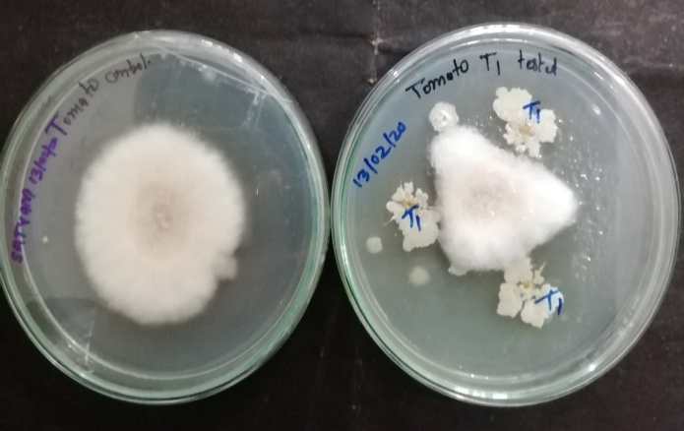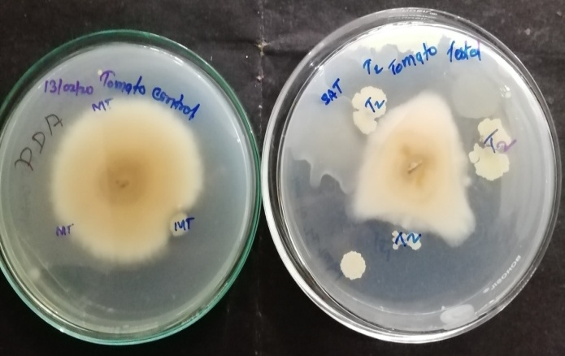
T2
Control
T1
Control
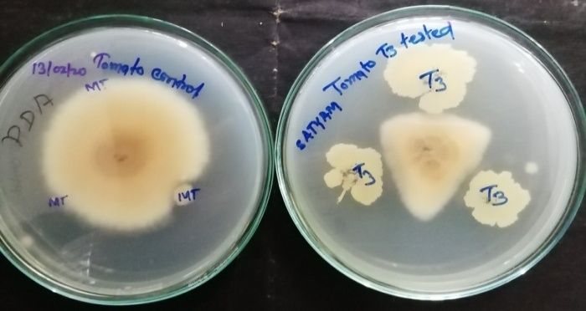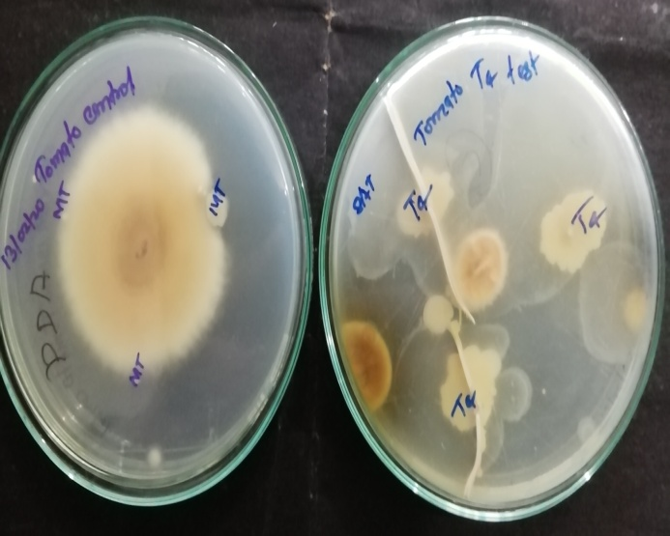
T4
Control
T3
Control
Figure 7.Inhibiton of Fusarim oxysporum f. sp. lycopersici. with Bacillus cereus(T1), Bacillus anthracis(T2), Bacillus velezensis(T3) and Serratia marcescens(T4) respectively.

4. DISCUSSION
Biosurfactants are significant bioactive secondary metabolite molecules that are produced by bacteria, yeast, and certain filamentous fungi during the exponential growth phase or at the beginning of the stationary phase. Because of their many uses, these compounds have attracted a lot of attention in recent years, leading to the development of significant biotechnology products for industrial, medical, and agricultural applications (Nitschke & Costa., 2007; Makkar et al., 2011). Gram staining, 16s rDNA sequencing, and the Ribosomal Database Project (RDP) were used to identify the bacterial isolates T1, T2, T3, and T4 as Bacillus cereus, B. anthracis, B. velezensis, and Serratia marcescens, respectively. Notably, the maximum growth checked by using spectrophotometer at 640 nm in B. anthracis (OD 1.247±0.002), B. cereus (OD 1.023±0.002), Serratia marcescens(OD 0.577±0.019 ) and B. velezensis(OD 0.314±0.002) at 108 h did not correlate directly with biosurfactant production, indicating that higher bacterial growth does not necessarily lead to increased biosurfactant synthesis.​ Bacillus cereus in Luria Bertani broth had the lowest foam height, whereas Bacillus velezensis bacteria had the highest. All4 strains exhibited foaming activity with foam stability of 30–135 minutes, which was below the findings of our study. In nutritional broth, the bacterium Serratia marcescens exhibited the highest foam-forming activity, whereas Luria Bertani and potato dextrose broth showed the lowest. In the Luria Bertani broth with benzene, Bacillus cereus exhibited the highest emulsification activity (E24%) in our investigation, whereas the lowest E24% in the potato dextrose broth was in benzene. Bacillus cereus, B. anthracis, B. velezensis, and Serratia marcescens isolates showed no emulsification activity (E24%) in any broth media when it came to hexane. This might be because hexane has a more complicated structure than the other hydrocarbons that were evaluated. According to a previous study, only four of the thirteen strains (CQ1-45.7±1.17, CQ2- 61.5±1.07, CQ4 -56.8±0.53, and CQ13 -52.4±2.16) exhibited E24% activity, and these strains were solely makers of biosurfactants (Goveret al., 2010)of the four strains, CQ2 had the highest E24, which may reach 61.5±1.07%. For secondary screening to find producers of biosurfactants, he using E24%. Biosurfactant yields varied across different media:​Luria-Bertani (LB) medium:B. velezensis produced 0.349±0.004 g/50 mL, followed by B. anthracis (0.215±0.001 g/50 mL), B. cereus (0.210±0.004 g/50 mL), and S. marcescens (0.206±0.003 g/50 mL). Nutrient Broth (NB)medium: S. marcescens yielded the highest biosurfactant production at 0.277±0.001 g/50 mL, with B. velezensis (0.256±0.003 g/50 mL), B. anthracis (0.239±0.003 g/50 mL), and B. cereus (0.230±0.005 g/50 mL) following.​ Potato Dextrose Broth (PDB) medium: B. velezensis again led with 0.316±0.001 g/50 mL, trailed by S. marcescens (0.278±0.004 g/50 mL), B. anthracis (0.262±0.005 g/50 mL), and B. cereus(0.238±0.003 g/50 mL). This might be due to Bacillus velezensis preferred Luria Bertani broth and Potato dextrose broth. S. marcescens preferred Nutrient broth. Similar outcomes were obtained for Bacillus subtilis PL2015, which produced the best lipopeptide yield of 547 mg/L at pH 7, and B. subtilis KLP2015, which produced the most at 30ºC (545 mg/L) reported by meena et al., 2018. Brevibacterium 7G produced 2.0 g/L of biosurfactants, while Ochrobactrum 1C28 produced 2.5 g/L. The bacterial strains Rhodococcus sp. NJ2 and Pseudomonas sp. BP10 produced biosurfactants at 0.01 g/L and 0.05 g/L, respectively (Kumari et al., 2012). In comparison to untreated control and FOL-inoculated (Abdallah et al., 2016), seven bacterial isolates, Alcaligenes faecalis S18 and B. cereus S42, were the most effective in reducing vascular browning by 95 to 97.5% and yellowing and wilt signs by 94 and 88%, respectively.In greenhouse tests, the incidence of wilt was reduced by almost 70% in egg plants treated with isolates of Bacillus, Pseudomonas, and Enterobacter. The study found that the biosurfactants of Bacillus velezensis inhibited various phytopathogens, including Fusarium solani (68.07%), Fusarium oxysporum f sp. Lycopersici (72.68%), Fusarium udum (82.69%) and Rhizoctonia solani (88.44%) in our study. It is possible that the amphiphilic nature of the biosurfactant produced by Bacillus cereus, B. anthracis, B. velezensis, and Serratia marcescens, which binds with the fungal cell membrane by hydrophobic intractions and damages the cell membrane, is the cause of the activity of bacterial biosurfactants’ percentage inhibition of phytopathogens.The percentage inhibition against Aspergillus niger and Mucor spp. By applying lipopeptides produced by Bacillus subtilis PL2015 was reported to be 41.9% for A. niger and 75.1% for Mucor spp.( Ferhat et al., 2011; meena et al., 2018; meena et al., 2022; Satyam et al., 2023). In conclusion Following morphological, biochemical, and 16s rDNA sequencing, the isolated bacteria were determined to be Bacillus cereus, B. anthracis, B. velezensis, and Serratia marcescens. Oil spreading tests, emulsification activity, and foam forming activity were used to screen all four bacterial isolates for the generation of biosurfactants. The highest amount of biosurfactant (0.349±0.004 g/50 mL) was produced by Bacillus velezensis. According to our findings, the Bacillus velezensis biosurfactant is the most efficient against the phytopathogens that were examined.

CONCLUSION
Isolated bacteria were identified to be Bacillus cereus, B. anthracis, B. velezensis and Serratia marcescens after morphological, biochemical and 16s rDNA sequencing. All four bacterial isolates were screened for biosurfactant production by foam forming activity and emulsification activity. Biosurfactant yields varied across different media:​Luria-Bertani (LB) medium:B. velezensis produced 0.349±0.004 g/50 mL, followed by B. anthracis (0.215±0.001 g/50 mL), B. cereus (0.210±0.004 g/50 mL), and S. marcescens (0.206±0.003 g/50 mL). Nutrient Broth (NB)medium: S. marcescens yielded the highest biosurfactant production at 0.277±0.001 g/50 mL, with B. velezensis (0.256±0.003 g/50 mL), B. anthracis (0.239±0.003 g/50 mL), and B. cereus (0.230±0.005 g/50 mL) following.​ Potato Dextrose Broth (PDB) medium: B. velezensis again led with 0.316±0.001 g/50 mL, trailed by S. marcescens (0.278±0.004 g/50 mL), B. anthracis (0.262±0.005 g/50 mL), and B. cereus (0.238±0.003 g/50 mL). Biosurfactant of all four bacterial isolates checked for fungal inhibiton on PDA plate. The study found that the biosurfactants of Bacillus velezensis inhibited various phytopathogens, including Fusarium solani (68.07%), Fusarium oxysporum f sp. Lycopersici (72.68%),Fusarium udum (82.69%) and Rhizoctonia solani (88.44%) in our study. Our results suggest Bacillus velezensis biosurfactant to be most effective against tested phytopathogens.

Consent (whereever applicable)
No manuscripts will be peer-reviewed
Ethical approval (whereever applicable)
No ethical issue

Disclaimer (Artificial intelligence)
All Author(s) hereby declare that NO generative AI technologies such as Large Language Models (ChatGPT, COPILOT, etc.) and text-to-image generators have been used during the writing or editing of this manuscript.

REFERENCES
Abbot V, Paliwal D, Sharma A & Sharma P, A review on the physicochemical and biological applications of biosurfactants in biotechnology and pharmaceuticals. Heliyon, 8 (2022) e10149.
Abdallah, RAB, Mokni-Tlili S, Nefzi A, Jabnoun-Khiareddine H &Daami-Remadi M, Biocontrol of Fusarium wilt and growth promotion of tomato plants using endophytic bacteria isolated from Nicotianaglauca organs. Biol Control, 97 (2016) 80.
Balouiri M, Sadiki M &Ibnsouda SK, Methods for in vitro evaluating antimicrobial activity: A review. J Pharm Anal, 6 (2016) 71.
Bognolo G, Biosurfactants as emulsifying agents for hydrocarbons. Colloids Surf A: Physicochem and Eng Asp, 152 (1999) 41.
Chayabutra C, Wu J & Ju LK, Rhamnolipid production by Pseudomonas aeruginosaunder denitrification: Effects of limiting nutrients and carbon substrates. BiotechnolBioeng, 72 (2001) 25.
Chen SY, Wei YH & Chang JS, Repeated pH-stat fed-batch fermentation for rhamnolipid production with indigenous Pseudomonas aeruginosa S2. ApplMicrobiolBiotechnol, 76 (2007) 67.
Ferhat S, Mnif S, Badis A, Eddouaouda K, Alouaoui R, Boucherit A, Mhiri N, Moulai-Mostefa, N &Sayadi S, Screening and preliminary characterization of biosurfactants produced by Ochrobactrum sp. 1C and Brevibacterium sp. 7G isolated from hydrocarbon-contaminated soils. IntBiodeterior Biodegradation, 65 (2011) 1182.
Gover M, Nain L, Singh SB & AK, Molecular and biochemical approaches for characterization of antifungal trait of potent biocontrol agent Bacillus subtilis RP24. CurrMicrobiol, 60 (2010) 99.
Jasim B, Sreelakshmi S, Mathew J &Radhakrishnan E, Surfactin, iturin, &fengycin biosynthesis by endophytic Bacillus sp. from Bacopamonnieri. MicrobEcol, 7 (2016) 106.
Joshi S, Bharucha C, Jha S, Yadav S, Nerurkar A & Desai AJ, Biosurfactant production using molasses and whey under thermophilic conditions. BioresourTechnol, 99 (2008) 195.
Kosaric N, Biosurfactants in industry. Pure Appl Chem, 64 (1992) 1731.
Kumar AS, Mody K & Jha B, Evaluation of biosurfactant/bioemulsifier production by a marine bacterium. Bull Environ ContamToxicol, 79 (2007) 617.
Kumar V & Saravanan V, Bio-surfactants-types, sources and applications. Res J Microbiol, 10 (2015) 181.
Kumari B, Singh SN & Singh DP, Characterization of two bio-surfactant producing strains in crude oil degradation. Process Biochem, 47 (2012) 2463.
Lai CC, Huang YC, Wei YH & Chang JS, Biosurfactant enhanced removal of total petroleum hydrocarbons from contaminated soil. J Hazard Mater, 167 (2009) 609.
Makkar RS, Cameotra SS & Banat IM, Advances in utilization of renewable substrates for bio-surfactant production. AMB Exp, 1 (2011) 5.
Marchant R & Banat IM, Biosurfactants: a sustainable replacement for chemical surfactants. Biotechnol Lett, 34 (2012) 1597.
Meena KR, Sharma A, Kumar R & Kanwar SS, Two factors at a time approach by response surface methodology to aggrandize the Bacillus subtilis KLP2015 Surfactin to use as antifungal agent. J King Saud UnivSci, 32 (2018) 337.
Meena, K. R., Satyam, S., Singh, A., Jaiswal, A., & Rai, D. (2022). Benchmarking of different microbes for their biosurfactants antifungal action against plant pathogens. Indian Journal of Experimental Biology (IJEB), 60(12), 931-938.
Mishra N, Agsar D, Deepthi SS, Kattegouda UM, Shetty PR & Pandey V, Novel application of Nerium leaf and Image J software in drop collapse assay for rapid screening of biosurfactant producing microorganisms. Indian J ExpBiol, 59 (2021) 484.
Mnif S, Chamkha M & Sayadi S, Isolation and characterization of Halomonas sp. strain C2SS100, a hydrocarbon‐degrading bacterium under hyper saline conditions. J Appl Microbiol, 107 (2009) 785.
Mukherjee S, Das P & Sen R, Towards commercial production of microbial surfactants. Trends Biotechnol, 24 (2006) 509.
Mukherjee S, Das P, Sivapathasekaran C & Sen R, Enhanced production of biosurfactant by a marine bacterium on statistical screening of nutritional parameters. BiochemEng J, 42 (2008) 254.
Mutalik SR, Vaidya B, Joshi RM, Desai M & Nene SN, Use of response surface optimization for the production of biosurfactant from Rhodococcusspp MTCC 2574. BioresourTechnol, 99 (2008)7875.
Nitschke M & Costa SGVAO, Biosurfactants in food industry. Trends Food SciTechnol, 18 (2007) 252.
Plaza GA, Zjawiony I & Banat IM, Use of different methods for detection of thermophilic biosurfactants producing bacteria from hydrocarbon contaminated bio remediated soils. J Pet Sci Eng, 50 (2006) 71.
Rodrigues L, Banat IM, Teixeira J & Oliveira R, Biosurfactants: potential applications in medicine. J AntimicrobChemother, 57 (2006) 609.
Saitou, N., & Nei, M. (1987). The neighbor-joining method: a new method for reconstructing phylogenetic trees. Molecular Biology and Evolution, 4(4), 406-425.
Saleh D, Jarry J, Rani M, Aliferis KA, Seguin P &Jabaji SH, Diversity, distribution and multi-functional attributes of bacterial communities associated with the rhizosphere and endosphere of timothy (Phleumpratense L.). J Appl Microbiol, 127 (2019) 794.
Satyam, A. M., Kolase, S. V., Narute, T. K., Kale, A. A., Chandanshive, A. V., Durgude, A. G., & Barge, M. S. (2023). Salt and temperature tolerant rhizobacteria: A comprehensive study on biochemical profiling and biocontrol potential.The Pharma Innovation Journal 2023; 12(9): 249-255.
Satyam, AM. Navale, V.K. Bagul and Anuradha Ojha (2025). Isolation, Identification and Characterization of Salt and Temperature Tolerant Pusillimonas sp. STT-K15 with Biocontrol Potential First Time Reported from Tomato Rhizosphere Soil. Microbiology Research Journal International 2025; 35(4): 57-68.
Sun W, Cao W, Jiang M, Saren G, Liu J, Cao J, Ali I, Yu X, Peng C & Naz I, Isolation and characterization of biosurfactant-producing and diesel oil degrading Pseudomonas sp. CQ2 from Changqing oil field, China. RSC Adv, 8 (2018) 39710.
Taiwo LB, Oyedele AO, Ailenokhuoria BV &Okareh OT, Plant–microbes relationships in soil ecological system and benefits accruable to food health. In: Field Crops: Sustainable management by PGPR. (Eds. Maheshwari DK & Dheeman S; Springer International Publishing, Cham.), 2019, pp. 177.
Tamura K, Dudley J, Nei M & Kumar S, MEGA4: molecular evolutionary genetics analysis (MEGA) software version 4.0. MolBiolEvol, 24 (2007) 1596.

