Isolation and Characterization of Streptomyces platensis From Soil and Evaluation of its Activity Against Human Pathogenic Microorganisms
Abstract
The search for novel antibiotics has long been a primary focus of biomedical research, with actinobacteria recognized as one of the most prolific sources of bioactive secondary metabolites. The genus Streptomyces is particularly well known for producing antimicrobial compounds that can serve as alternatives to synthetic antibiotics.
In the present study, Streptomyces strains were isolated from soil samples collected in the Wadi Qandil region, Latakia, using Starch Casein Agar, ISP2 medium, and Actinomyces Isolation Agar. The isolates exhibited gray aerial and substrate mycelia with spiral spore chains and no production of diffusible pigments.
Antimicrobial activity of the isolated Streptomyces sp. was evaluated against clinically relevant human pathogens. The results revealed inhibitory effects against both Gram-negative bacteria (Escherichia coli, Enterococcus faecalis ) and Gram-positive bacteria (Staphylococcus aureus), with larger inhibition zones observed against Gram-positive strains. Using the disk diffusion method, inhibition zones of the ethyl acetate extract ranged from 19.5 mm against E. coli to 25 mm against S. aureus.
These findings highlight the potential of soil-derived Streptomyces as a promising source of natural antimicrobial agents against multidrug-resistant pathogens

Keywords: Streptomyces platensis, ethyl acetate, soil, antagonistic activity, human pathogenic bacteria

. Introduction
One of the major global challenges today is the emergence of antibiotic-resistant bacteria, which has created an urgent need for more effective antimicrobial agents. Consequently, recent studies have focused on utilizing microorganisms as potential sources for the production of antibiotics targeting human pathogenic bacteria that have developed resistance to synthetic drugs [1] One of the major challenges facing the world today is the emergence of antibiotic-resistant bacteria, which necessitates the development of more effective agents. Increasing attention has been directed toward the use of microorganisms for the production of antibiotics against human pathogenic bacteria that exhibit resistance to synthetic antimicrobial drugs [2] Since many of the antibiotics used to treat a wide range of infectious diseases in humans exhibit a limited spectrum of antibacterial activity, particularly due to the emergence of multidrug-resistant (MDR) bacterial strains, the combined use of two or more antimicrobial agents is justified to delay or prevent the potential development of resistant strains. In some cases, a synergistic effect has also been observed [3]. Streptomyces has long been recognized as a primary source for the discovery of natural compounds in medicine and agriculture [4,5]. These compounds have been shown to possess diverse biological activities, including antibacterial, antifungal, antiviral, and anticancer properties. As a result, new drugs and antibiotics have been developed. However, many biologically active compounds from Streptomyces in natural environments have not been discovered in recent decades. For this reason, there is renewed interest in exploring novel Streptomyces species capable of producing multiple bioactive compounds from a single strain, particularly in underexplored natural habitats, which may prove valuable in combating diseases [6] The genus Streptomyces belongs to the group of Gram-positive actinomycetes with a high guanine and cytosine content. These are filamentous, unicellular organisms that form two types of mycelia: aerial mycelium and substrate mycelium [7].Streptomyces species are among the most important and widely distributed bacteria in various environments, particularly in soil [8]. They possess a high capacity for producing biologically active secondary metabolites, such as antibiotics. More than 80% of naturally derived antibiotics originate from Streptomyces and are effective against fungi (antifungal), tumors (antitumor), bacteria (antibacterial), and cancer (anticancer) [9]. These compounds belong to diverse chemical classes, including macrolides, aminoglycosides, tetracyclines, and cephalosporins [10].
Studies have demonstrated the efficacy of organic extracts from Streptomyces sp. against certain pathogenic microorganisms. Ethyl acetate extracts, in particular, exhibited inhibitory activity against Escherichia coli with an inhibition zone of 19 mm and Pseudomonas aeruginosa with an inhibition zone of 20 mm [11] The use of different concentrations of ethyl acetate extract from Streptomyces sp. resulted in varying inhibition zones for each concentration. For Escherichia coli, the inhibition zones measured 11, 14, and 19 mm at concentrations of 25, 50, and 75 µL, respectively, while for Staphylococcus aureus, the inhibition zones were 8, 11, and 14 mm, respectively [12]
. Research Aim and Significance:
The significance of this study stems from the increasing threat posed by human pathogenic bacteria, coupled with their growing resistance to antibiotics, which has escalated into a global health crisis requiring international collaboration to find effective solutions. Accordingly, this research aims to isolate Streptomyces strains from their natural environments, such as soil, due to their vital role as one of the primary producers of antibiotics. The study also includes the evaluation of the antimicrobial efficacy of ethyl acetate extracts obtained from these strains against several human pathogenic bacteria.
.Materials and Methods
1. Soil Sample Collection:
Soil samples were collected during June, July, and August 2024 from the top 0–10 cm layer of the soil in the garden of the Faculty of Science, Latakia. The samples were placed in sterilized containers and transported to the laboratory for cultivation and further study. This research was conducted at the Scientific Research Laboratory of the Department of Plant Biology, Faculty of Science, Tishreen University, during 2024–2025
2. Soil Sample Cultivation:
Five grams of sieved soil, free of gravel, were placed in a sterilized Erlenmeyer flask containing 45 mL of physiological saline and shaken for 30 minutes. Five sets of serial dilutions were prepared (10⁻¹, 10⁻², 10⁻³, 10⁻⁴, 10⁻⁵) [13]. Nalidixic acid (20 mg/mL) and Cycloheximide (50 mg/mL) were added to the culture media to suppress the growth of other microorganisms [14]. Then, 0.1 mL from each diluted tube was spread onto Starch Casein Agar and Isolation Streptomyces Program (ISP2) media. The plates were incubated at 28°C for 7–14 days [15].
3. Isolation of the Genus Streptomyces:
Potential Streptomyces colonies, characterized by the presence of both aerial and substrate mycelia within the agar layer, were isolated and purified on ISP2 medium to obtain pure cultures. Identification was carried out based on morphological, physiological, and biochemical characteristics [16].
Streptomyces isolates were preserved in slant agar tubes at refrigerator temperature [17]. Streptomyces colonies are shown in Figure 1
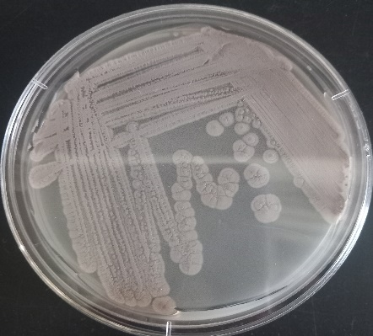

Figure 1: Streptomyces colonies on Starch Casein Agar medium

Human Pathogenic Bacteria:
Pathogenic bacteria were isolated from various clinical samples (urine, blood, ear swabs) obtained from the Laboratory of Latakia University Hospital. The isolates were purified on different media, including MacConkey Agar, Eosin Methylene Blue (EMB) Agar, Blood Agar, and Mueller-Hinton Agar. Identification of the pathogenic bacteria was carried out based on the results of necessary biochemical tests, including oxidase, catalase, indole, methyl red, Voges-Proskauer, citrate utilization, motility, urease, sugar fermentation, H₂S production, gelatin and starch hydrolysis, and nitrate reduction. Confirmation of the identification was performed according to Bergey’s Manual [18].

Table 1 Gram stain identified S. aureus (urine), E. coli (blood), and E. faecalis (posterior diverticulum)
Gram Staining |  | Sample Source | Tested Pathogenic Bacteria
+ | Urine |  | Staphylococcus aureus
- | Blood |  | Escherichia coli
+ | Posterior Diverticulum |  | Enterococcus faecalis

4.Selection of Antibiotic-Producing Streptomyces Isolates:
Streptomyces isolates producing antibiotics were selected by culturing each pure isolate on Starch Casein Agar (SCA) plates, streaked in a straight line at the center of the plate. The plates were then air-dried and incubated at 28°C for 7 days. After the incubation period, a layer of molten Mueller-Hinton Agar, cooled to 45°C, was poured over the plates. Once the surface layer solidified, the plates were refrigerated for 4 hours, allowing the diffusion of antimicrobial compounds produced by Streptomyces into the agar layer.
Subsequently, human pathogenic bacteria were streaked perpendicular to the Streptomyces inoculation line and incubated at 37°C for 18–24 hours. Effective isolates were identified based on the appearance of inhibition zones around the Streptomyces streaks [19]

5.Extraction of Bioactive Compounds from Streptomyces Isolate Using Ethyl Acetate:
The Streptomyces isolate exhibiting antimicrobial activity (as determined by the cross-streak method) was cultured in an Erlenmeyer flask containing ISP-2 medium. The flask was incubated in a shaking incubator at 28°C and 180 rpm for 7–14 days [20]. After incubation, the liquid culture was filtered through Whatman No. 1 filter paper, followed by centrifugation at 10,000 rpm to separate the biomass. The resulting supernatant was transferred to a sterilized Erlenmeyer flask, and an equal volume of the organic solvent, ethyl acetate, was added. The mixture was placed in a shaking incubator at 180 rpm for 2 hours to ensure thorough extraction of bioactive compounds. The contents were then transferred to a separatory funnel and allowed to separate into two layers: an upper layer containing the organic solvent with the extract, and a lower layer containing the culture medium. The lower layer was discarded, and the upper layer was retained. The organic layer was evaporated to dryness using a rotary evaporator at 40°C. The resulting dry extract was stored at −20°C until further analysis [21]
6.Evaluation of the Antibacterial Activity of Streptomyces Extracts Against Human Pathogenic Bacteria:
The antibacterial activity of Streptomyces extracts against selected human pathogenic bacteria was assessed using the disk diffusion method. Sterile filter paper disks (6 mm in diameter) were saturated with 100 µL of Streptomyces extract and allowed to air-dry at room temperature. Filter paper disks saturated with 100 µL of the organic solvent (ethyl acetate) were used as negative controls [22].
To prepare bacterial suspensions, several colonies of pathogenic bacteria grown for 24 hours on Nutrient Agar were suspended in physiological saline to achieve a turbidity equivalent to 0.5 on the McFarland Standard, approximately 1.5 × 10⁸ cells/mL [23]. Alternatively, bacteria grown in Mueller-Hinton Broth were used to reach the same turbidity. Subsequently, 0.1 mL of the bacterial suspension was spread evenly over the surface of Mueller-Hinton Agar plates using a sterile cotton swab. The plates were left at room temperature for 15 minutes to allow absorption of the inoculum. The filter paper disks saturated with the extract or solvent were then placed on the agar surface using sterile forceps. The plates were incubated at 37°C for 24 hours. The appearance of clear inhibition zones around the disks was considered indicative of antibacterial activity. The diameters of the inhibition zones were measured in millimeters using a ruler. The test was performed in triplicate to ensure the reliability of the results [24]
7.Antibiotic Susceptibility Testing of Bacteria:
The susceptibility and resistance of the isolated bacteria to selected antibiotics were tested using the disk diffusion method. This method involves placing disks impregnated with different antibiotics on the surface of Mueller-Hinton Agar plates inoculated with the bacteria. After incubation at 37°C for 24 hours, the diameters of the inhibition zones were measured using a millimeter ruler [25]. The results were then compared with standard tables of inhibition zone diameters according to the Clinical and Laboratory Standards Institute (CLSI) guidelines to determine whether the bacteria were susceptible (S) or resistant (R) to the antibiotics [26].
Table 2: Antibiotics used in the study and their disk concentrations.
Code: concentration | Antibiotic
AMC=10 µg | Amoxicillin
AZM=15 µg | Azithromycin
AK=30 µg | Amikacin
CTX=30 µg | Cefotaxime
CFM=5 µg | Cefixime
CEC=30 µg | Cefaclor
DA=30 µg | Daptomycin

Materials:
The study utilized the following materials: culture media including ISP2 (Isolation Streptomyces Program), SCA (Starch Casein Agar), Mueller-Hinton Agar, and Nutrient Agar (Hi-Media, India); organic solvent ethyl acetate (Sigma-Aldrich, USA) and dimethyl sulfoxide (DMSO); sodium chloride (NaCl); Nalidixic Acid (30 µg); Cycloheximide (50 µg); physiological saline; and selective culture media.
Results and Discussion:
The results of this study demonstrated the susceptibility and resistance of the bacteria to the antibiotics used. Three pathogenic bacterial isolates were obtained from Latakia University Hospital from different clinical samples, including two Gram-positive and one Gram-negative isolate, as shown in Table 3. The table presents the isolated pathogenic bacteria, the diameters of inhibition zones of the antibiotics used as positive controls, the antibiotics used as negative controls indicating resistance, and the results of bacterial susceptibility to DMSO, which served as the negative control for dissolving the Streptomyces extracts, as shown in Table 3.

Table 3: Isolated Pathogenic Bacteria and Sample Source
Test result | Gram Staining | Sample Source | Tested Pathogenic Bacteria
Catalase and coagulase positive | - | Urine | Staphylococcus aureus
Indole positive | + | Blood | Escherichia coli
Positive Fox Proscar | - | Posterior Diverticulum | Enterococcus faecalis
Table 4: Antibiotic Susceptibility and Resistance of Pathogenic Bacteria Against Positive and Negative Controls
Negative control (R)  DMSO | Negative control (R)  Antibiotics | Positive control  (S) | Tested Pathogenic Bacteria
R | AZM | DA=25mm | Staphylococcus aureus
R | CTX-CFM | NIT=13mm | Escherichia coli
R | OX | CN=23mm | Enterococcus faecalis
R = Resistance \ S = Sensitive \ mm = Diameter of bacterial growth inhibition zones

Table 4 shows the results of the antibiotic susceptibility of pathogenic bacterial isolates obtained from various clinical samples. The table indicates that E. coli exhibited resistance to both Cefotaxime and Cefixime, while showing weak sensitivity to Nitazoxanide, with an inhibition zone diameter of 13 mm. Staphylococcus aureus demonstrated high resistance to Azithromycin but high sensitivity to Daptomycin, with an inhibition zone of 25 mm. Enterococcus faecalis was resistant to Oxacillin and sensitive to Gentamicin, with an inhibition zone diameter of 23 mm.
Results of the morphological study of the isolate:
The isolate demonstrated the ability to grow on ISP2 medium after incubation for 7–14 days at 28 °C, producing two types of mycelia: aerial mycelium, which was gray in color, and substrate mycelium, also gray. The isolate did not produce any pigments on the culture medium. As shown in the figure(2)

Figure 2: Streptomyces colonies on Starch Casein Agar
Results of the microscopic study of the isolate:
The microscopic study of the isolate under a light microscope revealed spore chains with a spiral arrangement. The isolate was identified as Gram-positive. As shown in the figure(3)
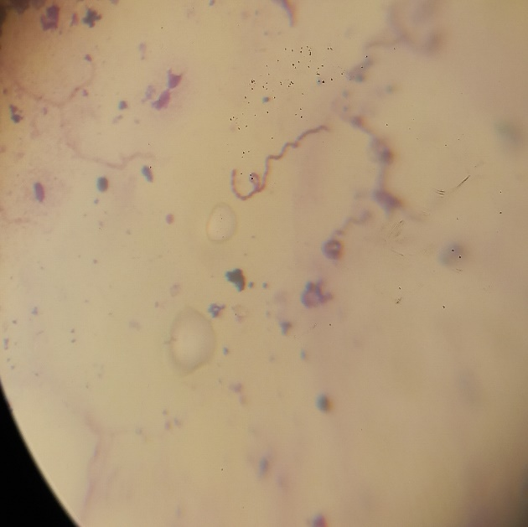
Figure 3: Spiral arrangement of spores

الجدول(1)الوضع التصنيفي لجراثيم Streptomyces حسب دليل الباحث بيرجي لعام 2012 [27]
الوضع التصنيفي
Actinobacteria | Phylum
Actinobacteria | Class
Streptomycetales | Order
Streptomycetaceae | Family
Streptomyces | Genus

Results of the Effect of Ethyl Acetate Extract of Streptomyces platensis:
Table 5: Effect of Ethyl Acetate Extract of Streptomyces platensis on Pathogenic Bacteria
75µg\ml | 50µg\ml | 25µg\ml | Tested Pathogenic Bacteria
15mm | 9mm | - | Staphylococcus aureus
25mm | 20mm | 19mm | Escherichia coli
17mm | 12mm | 10mm | Enterococcus faecalis
The following table illustrates the antagonistic activity of Streptomyces platensis against the tested pathogenic bacteria. The inhibition zone diameters varied according to the concentrations used, with larger zones observed at higher concentrations. Three different concentrations were applied (25, 50, and 75 µg/mL). The results indicate that the ethyl acetate extract of Streptomyces platensis exhibited higher activity against Gram-negative bacteria compared to Gram-positive bacteria, which can be explained by several interrelated mechanisms. Organic solvents such as ethyl acetate are known to extract compounds of semi-polar or non-polar nature, which can interact with lipid-rich membranes. Gram-negative bacteria possess an outer membrane containing lipopolysaccharides and lipids, making them more susceptible to penetration by these compounds and disruption of membrane integrity. In contrast, Gram-positive bacteria have a thick peptidoglycan layer that acts as a mechanical barrier, limiting the permeability of such compounds and reducing their effectiveness. Additionally, some metabolites produced by S. platensis, such as platensimycin and platencin, target fatty acid biosynthesis pathways essential for membrane formation, which represent a more vulnerable point in Gram-negative bacteria than in Gram-positive ones. Therefore, the combined effect of the chemical nature of the extracted compounds and the structural and functional characteristics of bacterial cells likely explains the observed superiority of inhibitory activity against Gram-negative bacteria. The ethyl acetate extract of S. platensis exhibited concentration-dependent antibacterial activity. Gram-negative bacteria, such as Escherichia coli, were the most sensitive, showing large inhibition zones even at the lowest concentration (19 mm at 25 µg/mL), whereas Gram-positive bacteria, including Staphylococcus aureus and Enterococcus faecalis, were less sensitive, with a noticeable reduction in inhibition zone diameter at lower concentrations. These findings reflect the influence of cell wall structure on the permeability of the extracted compounds, which explains the higher effectiveness against Gram-negative bacteria compared to Gram-positive bacteria.
The current study’s results demonstrate that the ethyl acetate extract of S. platensis exhibited concentration-dependent antibacterial activity, with higher efficacy against Gram-negative bacteria such as E. coli compared to Gram-positive bacteria like S. aureus and E. faecalis. These findings are consistent with those reported by Nisha et al. (2025)[28] and Ambarwati et al. (2020)[29], who observed that ethyl acetate extracts from other Streptomyces strains displayed antibacterial activity, particularly against S. aureus, supporting the general notion that compounds extracted from Streptomyces possess antimicrobial properties. However, the spectrum of activity and sensitivity levels differ; in the present study, Gram-negative bacteria were more susceptible than Gram-positive bacteria[30] , a pattern not clearly observed in some previous studies that primarily focused on Gram-positive bacteria. This discrepancy may be attributed to strain-specific variations, the chemical nature of the extracted metabolites, and structural differences between Gram-negative and Gram-positive bacterial cell walls affecting compound permeability
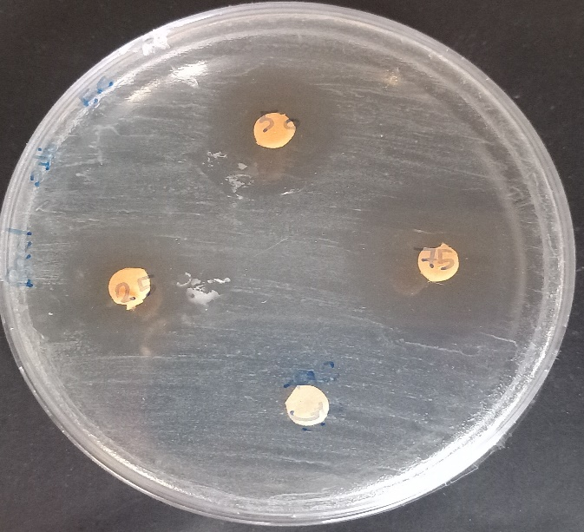
Figure (4) Diameters of rings inhibiting the growth of Escherichia coli bacteria by ethyl acetate extract of Streptomyces platensis bacteria (1) Concentration 75 µg\ml (2) Concentration 50 µg\ml (3) Concentration 25 µg\ml (4) Negative control DMSO

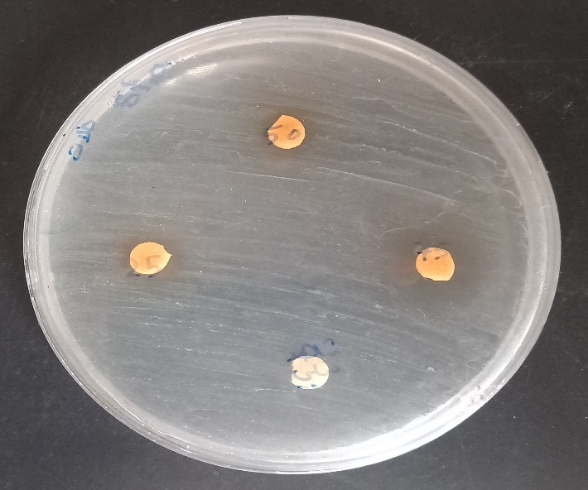
Figure (5) Diameters of rings inhibiting the growth of Staphylococcus aereus bacteria by ethyl acetate extract of Streptomyces platensis bacteria (1) Concentration 75 µg\ml (2) Concentration 50 µg\ml (3) Concentration 25 µg\ml (4) Negative control DMSO

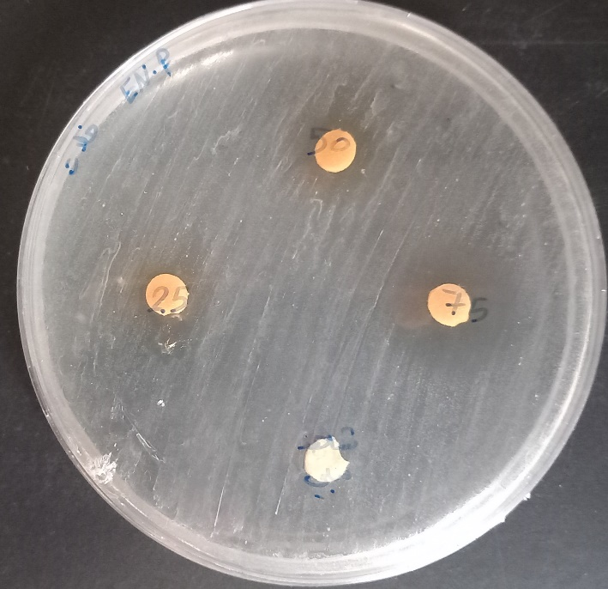

Figure (6) Diameters of rings inhibiting the growth of Enterococcus faecalis bacteria by ethyl acetate extract of Streptomyces platensis bacteria (1) Concentration 75 µg\ml (2) Concentration 50 µg\ml (3) Concentration 25 µg\ml (4) Negative control DMSO

Conclusion:
The use of antibiotics produced from microorganisms is one of the most important methods used to solve the global problem (resistance of human pathogens to industrial antibiotics).
respectively.This study confirmed that S. Platensis is a promising source of novel antibiotics. The combination of microbial isolation, antimicrobial testing successfully enhanced the production of bioactive compounds, contributing to the search for effective antimicrobial agents against resistant pathogens.

I did not use artificial intelligence because this feature is prohibited in Syria.

References

[1] Balouiri, M., Sadiki, M., & Ibnsouda, S. K. (2016). Methods for in vitro evaluating antimicrobial activity: A review. Journal of Pharmaceutical Analysis, 6(2), 71–79.
[2] Subramani, R., & Aalbersberg, W. (2012). Marine actinomyces; An ongoing source of novel bioactive metabolites. Microbiological Research, 167, 571–580.
[3] Bhinge, S. D., Randive, D. S., Bhutkar, M. A., Shejwal, K. P., Jadhav, A. D., & Jadhav, R. P. (2022). Synergistic effects of neem (Azadirachta indica L.) leaves extract with conventional antibiotic against gram positive and negative microorganism. Jordan Journal of Pharmaceutical Sciences, 15(2), 276–288.
[4] Jordan, M. L., & Schlimpert, S. (2025). Microbe Profile: Streptomyces venezuelae—a model species to study morphology and differentiation in filamentous bacteria. Microbiology, 171(3), 001541.
[5] Rammali, S., Rahim, A., El Aalaoui, M., Bencharki, B., Dari, K., Habach, A., & Khattabi, A. (2024). Antimicrobial potential of Streptomyces coeruleofuscus SCJ isolated from microbiologically unexplored garden soil in Northwest Morocco. Scientific Reports, 14(1), 3359.
[6] Al-Saadi, A., Hameed, N., & Jaralla, E. M. (2013). Isolation and identification of Streptomyces from different sample of soils. Journal of Biology and Medical Sciences, 1, 31–36.
[7] Abirami, M., & Kannabiran, K. (2017). Antibiotic potency of extract from Streptomyces isolated from terrestrial soil of Amirthi forest, India. Walailak Journal of Science and Technology, 14(9), 711–721.
[8] Antido, J. W. A., & Climacosa, F. M. M. (2022). Enhanced isolation of Streptomyces from different soil habitats in Calamba city, Laguna, Philippines using a modified integrated approach. International Journal of Microbiology, 2022(1), 2598963.
[9] Al-Shaibani, M. M., Radin Mohamed, R. M. S., Sidik, N. M., Enshasy, H. A. E., Al-Gheethi, A., Noman, E., & Zin, N. M. (2021). Biodiversity of secondary metabolites compounds isolated from phylum Actinobacteria and its therapeutic applications. Molecules, 26(15), 4504.
[10] Chanama, M., Suriyachadkun, C., & Chanama, S. (2023). Streptomyces antimicrobicus sp. nov., a novel clay soil-derived actinobacterium producing antimicrobials against drug-resistant bacteria. PLoS One, 18(5), e0286365.
[11] Tarkka, M., & Hampp, R. (2008). Secondary metabolites of soil streptomycetes in biotic interactions. In Secondary metabolites in soil ecology (pp. 107–126). Springer.
[12] Sholkamy, E. N., Muthukrishnan, P., Abdel-Raouf, N., Nandhini, X., Ibraheem, I. B., & Mostafa, A. A. (2020). Antimicrobial and antinematicidal metabolites from Streptomyces cuspidosporus strain SA4 against selected pathogenic bacteria, fungi and nematode. Saudi Journal of Biological Sciences, 27(12), 3208–3220.
[13] Math, H. H., Nayaka, S., Rudrappa, M., Kumar, R. S., Almansour, A. I., Perumal, K., & Kantli, G. B. (2023). Isolation and characterization of pyraclostrobin derived from soil actinomycete Streptomyces sp. HSN-01 and its antimicrobial and anticancer activity. Antibiotics, 12(7), 1211.
[14] Shang, Z., Sharma, V., Pai, L., Kumar, T., & Patil, S. (2025). Optimizing the production and efficacy of antimicrobial bioactive compounds from Streptomyces kanamyceticus in combating multi-drug-resistant pathogens. Frontiers in Cellular and Infection Microbiology, 14, 1500440.
[15] Selvaraj, J. N., Ganapathi, U., Vincent, S. G. P., Ramamoorthy, S., & Thavasimuthu, C. (2023). Statistical optimization of media components for antibiotic production in Streptomyces sp. CMSTAAHAL-3. Electronic Journal of Biotechnology, 65, 1–13.
[16] Williams, S. T., Goodfellow, M., & Alderson, G. (1989). Genus Streptomyces. In S. T. Williams, M. E. Sharope, & J. M. Holt (Eds.), Bergey’s Manual of Systematic Bacteriology (Vol. 4, pp. 2452–2492). Williams and Wilkins.
[17] Mohseni, M., Norouzi, H., Hamedi, J., & Roohi, A. (2013). Screening of antibacterial producing actinomycetes from sediments of the Caspian Sea. International Journal of Molecular and Cellular Medicine, 2(2), 64.
[18] Garrity, G. M., BEH, J. A., & Lilburn, T. G. (2004). Taxonomic outline of prokaryotes. In Bergey’s Manual of Systematic Bacteriology (2nd ed., p. 401). Springer.
[19] Arifuzzaman, M., Khatun, M. R., & Rahman, H. (2010). Isolation and screening of actinomycetes from Sundarbans soil for antibacterial activity. African Journal of Biotechnology, 9(29), 4615–4619.
[20] Odo, K. E., Agbo, M. O., & Osadebe, P. O. (2022). Extract and fractions from soil bacteria (Streptomyces canus ATCC 12647) possess antimicrobial and anti-oxidative potential in vitro. Jordan Journal of Pharmaceutical Sciences, 15(3), 405–412.
[21] Maleki, H., Dehnad, A., Hanifian, S., & Khani, S. (2013). Isolation and molecular identification of Streptomyces spp. with antibacterial activity from northwest of Iran. BioImpacts, 3(3), 129.
[22] Rammali, S., Rahim, A., El Aalaoui, M., Bencharki, B., Dari, K., Habach, A., & Khattabi, A. (2024). Antimicrobial potential of Streptomyces coeruleofuscus SCJ isolated from microbiologically unexplored garden soil in Northwest Morocco. Scientific Reports, 14(1), 3359.
[23] Maleki, H., Dehnad, A., Hanifian, S., & Khani, S. (2013). Isolation and molecular identification of Streptomyces spp. with antibacterial activity from northwest of Iran. BioImpacts, 3(3), 129.
[24] Şahin, N., & Uğur, A. (2003). Investigation of the antimicrobial activity of some Streptomyces isolates. Turkish Journal of Biology, 27(2), 79–84.
[25] Gajic, I., Kabic, J., Kekic, D., Jovicevic, M., Milenkovic, M., Culafic, M. D., Trudic, A., Ranin, L., & Opaviski, N. (2022). Antimicrobial susceptibility testing: A comprehensive review of currently used methods. National Library of Medicine, 11(4).
[26] Tamma, P. D., Harris, P. N. A., Mathers, A. J. M., Wenzler, E., & Humphries, R. M. (2023). Breaking down the breaking: Rationale for the 2022 Clinical and Laboratory Standards Institute revised piperacillin-tazobactam breakpoints against Enterobacterales. Clinical Infectious Diseases, 77(11), 1585–1590.
[27] Goodfellow, M., Kämpfer, M., & Whitman, W. (2012). Bergey’s Manual® of Systematic Bacteriology: Volume Five, The Actinobacteria, Part A. Springer.
[28] Ambarwati, A., Wahyuono, S., Moeljopawiro, S., & Yuwono, T. (2020). Antimicrobial activity of ethyl acetate extracts of Streptomyces sp. CRB46 and the prediction of their bioactive compounds chemical structure. Biodiversitas Journal of Biological Diversity, 21(8), 3380–3390. https://doi.org/10.13057/biodiv/d210836
[29] Nisha, S. J., Uma, G., Kumar, S., & Citarasu, T. (2025). Optimization and characterization of bioactive secondary metabolites from Streptomyces sp. CMSTAAHL-4 isolated from mangrove sediment. BMC Microbiology, 25(1), 1–13. https://doi.org/10.1186/s12866-025-03912-w
[30] Elshikh, M. S., Al-Harbi, N. A., & Al-Dosary, M. A. (2023). Activity of lactic acid-producing Streptomyces strain CSK1 against Staphylococcus aureus. Jordan Journal of Biological Sciences, 16(2), 359–364.

