A Comprehensive Review on the Phytochemistry and Pharmacological Potential of Lavandula mairei Humbert: An Endemic Moroccan species

ABSTRACT

Lavandula mairei Humbert is an endemic Moroccan plant traditionally used for its medicinal properties. Recent scientific inquiry has begun to validate its ethnobotanical uses and uncover novel applications. This review provides the first comprehensive synthesis of current research on L. mairei. This review aims to collect, analyze, and critically evaluate the available scientific literature on the traditional uses, phytochemistry, pharmacological properties, and non-medicinal applications of Lavandula mairei. Furthermore, it seeks to identify existing research gaps and propose future directions for its sustainable exploitation. The search was conducted utilizing major electronic databases, including Scopus, Web of Science, PubMed, Google Scholar, and ScienceDirect. The literature search was designed to be inclusive of all studies citing "Lavandula mairei". The taxonomic nomenclature and status of the species were confirmed and validated using authoritative online databases, specifically World Flora Online (WFO) and Plants of the World Online (POWO). The essential oil of L. mairei is notably rich in bioactive monoterpenes including carvacrol, 1,8-cineole, and camphor, while its polar solvent extracts are abundant in phenolic compounds such as flavonoids and tannins. Validating traditional uses, scientific studies confirm potent antimicrobial, antioxidant, antidiabetic, and insecticidal activities. It also exhibits unique anti-biofilm properties. Notably, its applications extend to green synthesis of silver nanoparticles and eco-friendly corrosion inhibition, demonstrating remarkable versatility beyond medicine. This review synthesizes current research revealing the significant pharmacological potential and novel bioindustrial applications of L. mairei; however, clinical trials, toxicity studies, and sustainable cultivation methods remain essential.

Keywords: Lavandula mairei, Antioxidant, Antibacterial, Corrosion inhibitor.

- INTRODUCTION
Lavandula mairei Humbert is a species within the section Pterostoechas of the Lavandula genus, endemic to Morocco. A thorough taxonomic revision of native Moroccan Lavandula species has confirmed its distinct status from closely related species within the genus (M Fennane et al., 2007). This is crucial for ensuring the correct identification of plant material in all subsequent research and commercial applications. Traditionally, known by the vernacular name “Guorzghial” its uses align with those of other lavenders, including the treatment of digestive ailments, infections, and inflammatory conditions. Its endemic status and traditional value have spurred scientific interest to validate and explore its potential, positioning it as a promising subject for bioprospecting (Ghanimi et al., 2022a).
- METHODOLOGY
The search was conducted utilizing major electronic databases, including Scopus, Web of Science, PubMed, Google Scholar, and ScienceDirect. The literature search was designed to be inclusive of all studies citing "Lavandula mairei". The taxonomic nomenclature and status of the species were confirmed and validated using authoritative online databases, specifically World Flora Online (WFO) and Plants of the World Online (POWO).
- RESULTS AND DISCUSSION
3.1 Geographical distribution
Based on its geographical distribution, Lavandula mairei is an endemic species primarily confined to the mountainous regions of Morocco, specifically the Saharan Morocco (Ms), Anti-Atlas (AA), and High Atlas (HA) ranges. This restricted distribution highlights its adaptation to semi-arid, high-altitude environments and calcareous, rocky soils characteristic of these Atlas Mountain habitats (M Fennane et al., 2007).
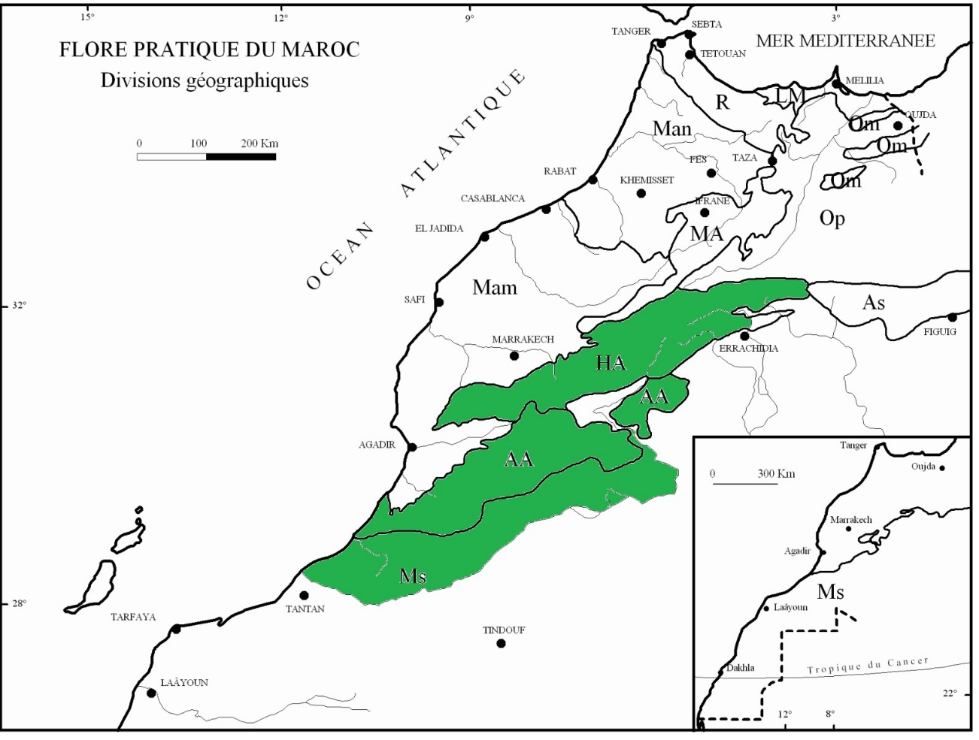
Figure 1: Geographical distribution of Lavandula mairei (Ms: Saharan Morocco -AA: Anti-Atlas- HA: High Atlas) (M. Fennane et al., 2007)
3.2 Botanical description
Lavandula mairei is a dome-shaped subshrub (30–) 40–80 (–100) cm high with fragile branches; leaves ovate to ovate-lanceolate, 2–3 pinnatisect, lobes (1–) 2–3 mm wide, oblong to linear, usually obtuse. Peduncles 30–80 (–150) mm, unbranched, bearing compact imbricate spikes (20–) 40–90 (–150) mm; bracts rhomboid, acuminate to spinescent, 1–1.5× the calyx, green becoming light brown and scabrous with five darker nerves. Calyx 5–6 mm, glandular-hairy; upper teeth triangular, middle tooth shorter, lower pair reflexing; corolla 12–20 mm, tube dilating from 2/3, slightly curved (<45°), with hooked hairs; lobes unequal (lower central c. 2 mm, lower lateral 2–3 mm, upper pair 3–4 mm), all marked with darker nectar-guide lines; flowering February–May and September–October (Upson and Jury, 2002).
3.3 Phytochemical Composition
The bioactivity of L. mairei is attributed to a rich array of secondary metabolites, found in both its essential oil and solvent extracts.
3.3.1 Essential Oil
GC-MS Chemical analyses consistently reveal that the essential oil of L. mairei is dominated by a complex profile of bioactive monoterpenes and sesquiterpenes. Its distinctive chemical signature, characterized by major constituents such as carvacrol, 1,8-cineole, camphor, and linalool (El Hamdaoui et al., 2018; Ousaid et al., 2024), not only differentiates it from related species but also directly underpins its unique biological activities (Sabiri et al., 2022). Furthermore, factors such as wild versus cultivated origin significantly influence the oil's composition, presenting a critical variable for its phytochemical standardization (Ghanimi et al., 2021).
3.3.2 Solvent Extracts
Ethanolic, methanolic, aqueous, and ethyl acetate extracts are rich in phenolic compounds. Quantitative analyses show significant Total Phenolic Content (TPC) and Total Flavanoid Content (TFC), which are directly correlated with its strong antioxidant capacity (Ghanimi et al., 2022b). The extraction method (cold vs. hot) significantly impacts the yield and potency of these antioxidants, with methanolic extracts often showing superior results (Ghanimi et al., 2022b).
3.4 Pharmacological Activities
3.4.1 Antimicrobial and Anti-Virulence Activities
The most comprehensively investigated aspect of L. mairei is its potent antimicrobial action, with promising efficacy against multidrug-resistant (MDR) pathogens. Its essential oil and solvent extracts exhibit broad-spectrum antibacterial activity, impacting both Gram-positive and Gram-negative bacteria. Notably, its most significant therapeutic potential lies in its potent activity against carbapenem-resistant Acinetobacter baumannii (CRAB) (Laktib et al., 2022), listed by the WHO as critical priority pathogen. This high potency is demonstrated by remarkably low Minimum Inhibitory Concentration (MIC) values, suggesting strong bactericidal effects (Laktib et al., 2022).
Beyond direct antibacterial activity, L. mairei essential oil employs a sophisticated anti-virulence strategy. It demonstrates a remarkable capacity to disrupt pathogenic mechanisms by effectively inhibiting bacterial adhesion and eradicating pre-formed biofilms (El Kheloui et al., 2022). This anti-biofilm activity is of critical importance, as biofilms are a primary defense mechanism of MDR pathogens, conferring resistance to antibiotics and enabling persistent infections, particularly on medical devices. The extracts' efficacy is further highlighted by its documented synergy with other medicinal plants, such as Pulicaria mauritanica, enhancing its antibiofilm action against nosocomial infections (SABIRI et al., 2025).
The therapeutic promise of L. mairei oil is amplified by its potential for synergism with conventional antibiotics. The complex synergy of its terpenoid and phenolic constituents likely facilitates a multi-target mechanism of action, which may disrupt bacterial resistance mechanisms and re-sensitize resistant strains to traditional therapeutics, offering a viable strategy to combat the escalating antibiotic resistance crisis (SABIRI et al., 2025).
3.4.2 Green Synthesis of Nanoparticles
A cutting-edge application of L. mairei extends into the field of nanotechnology, where its extracts serve as effective biological tools for the green synthesis of silver nanoparticles (AgNPs) (El Megdar et al., 2024). In this process, phytochemicals within the extract function dually as reducing agents and capping agents (stabilizing the formed nanoparticles), providing an eco-friendly alternative to conventional chemical synthesis methods. The resulting L. mairei-derived AgNPs (Lm-AgNPs) demonstrate significantly enhanced antibacterial and antioxidant activities compared to the crude plant extract alone, a synergistic effect attributed to the combined action of the silver core and the bioactive plant-derived capping agents (El Megdar et al., 2024). Most notably, this approach has been strategically optimized to target a major clinical challenge: combating multidrug-resistant biofilms. Research demonstrates that optimized Lm-AgNPs are highly effective at inhibiting the formation and eradicating pre-existing biofilms of resistant bacterial strains, showcasing a sophisticated, targeted nanotechnological strategy that amplifies the innate bioactivity of L. mairei for advanced therapeutic applications (Megdar et al., 2025).
3.4.3 Antioxidant Activity
The polar extracts of L. mairei demonstrate considerable efficacy as natural antioxidants, a property strongly correlated with their high concentration of phenolic and flavonoid compounds (Sabiri et al., 2022). This robust antioxidant capacity has been quantitatively validated through standardized in vitro assays, including DPPH and ABTS radical scavenging tests, which confirm significant free-neutralizing activity, and the Ferric Reducing Antioxidant Power (FRAP) assay, which indicates potent electron-donating ability. Comparative phytochemical analyses reveal that L. mairei frequently exhibits a superior antioxidant profile relative to other native species such as L. dentata and L. stoechas, a distinction attributed to its richer phytochemical composition (Ghanimi et al., 2021). These findings provide a scientific rationale for its traditional use in mitigating oxidative stress and underscore its significant potential for application as a natural preservative in the food and cosmetic industries, offering a sustainable alternative to synthetic additives.
3.4.4 Antidiabetic Potential
Preliminary investigation into the essential oil has revealed promising antihypertensive and antidiabetic potential in induced type 1 and type 2 diabetic models (Ousaid et al., 2025). The proposed mechanisms may include ACE inhibition, antioxidant protection of pancreatic β-cells, and improvement of insulin sensitivity. In vitro and in silico studies of the essential oil provide a mechanistic basis for this activity, suggesting interaction with key enzymatic targets (Ousaid et al., 2024).
3.5 Insecticidal and Larvicidal Activities :
Beyond its biomedical applications, L. mairei essential oil demonstrates significant potential in the field of agricultural pest management. The oil and its major phenolic monoterpenoid constituent, carvacrol, exhibit potent, multi-faceted insecticidal properties against key stored-product pests, including Sitophilus oryzae (rice weevil) and Tribolium castaneum (red flour beetle) (Ouabou et al., 2024). Their efficacy is demonstrated through three primary modes of action: as a fumigant (toxicity via vapor), a repellent (deterring insects from approaching), and an antifeedant (inhibiting feeding behavior), thereby protecting grain stores through both direct toxicity and behavioral modification. The mechanistic basis for this neurotoxicity is elucidated through in silico studies, which indicate that the bioactive components, notably carvacrol, possess a high binding affinity for and inhibit critical insect neurological enzymes such as acetylcholinesterase (AChE) (Hamdaoui et al., 2025). This inhibition disrupts normal neurotransmission, leading to paralysis and death, and provides a rational, target-based explanation for the observed efficacy. This robust activity profile, combined with a natural and potentially reduced-risk environmental footprint, strongly supports the valorization of L. mairei as a source of eco-friendly biopesticides for integrated pest management (IPM) strategies.
3.6 Industrial Application : Corrosion Inhibition
In a pioneering non-pharmacological application, L. mairei extract has been validated as a highly effective and eco-friendly green corrosion inhibitor for mild steel in aggressive acidic environments, such as those encountered in industrial cleaning and pickling processes (Berrissoul et al., 2020). The inhibition mechanism has been elucidated through a combined experimental and theoretical approach. Computational modeling studies, including molecular dynamics (MD) and density functional theory (DFT) calculations, demonstrate that organic constituents of the extract (e.g., phenolic compounds) spontaneously adsorb onto the metallic surface, forming a stable and protective film that blocks active sites and mitigates acid attack. This adsorption is typically governed by physisorption and/or chemisorption processes, creating an effective barrier against corrosion. This compelling finding transcends traditional botanical uses and opens a significant new avenue for valorizing L. mairei in sectors such as industrial maintenance, materials science, and green chemistry, offering a sustainable and biodegradable alternative to toxic synthetic corrosion inhibitors (Berrissoul et al., 2020).

3.7 Cultivation, Germination, and Conservation
The successful propagation of L. mairei from seed is a critical first step for its cultivation, yet it presents specific agronomic challenges. Seed germination is highly influenced by key environmental factors, including temperature fluctuations, osmotic stress (drought), and ionic stress (salinity), which can significantly reduce germination efficacy. Research indicates that these physiological dormancy barriers can be overcome through strategic pretreatments; most notably, the application of gibberellic acid (GA3) has been shown to markedly enhance germination rates by stimulating the metabolic processes required for radicle emergence (El Hamdaoui et al., 2021). A comprehensive understanding of these precise ecophysiological requirements is not merely agronomically interesting but is fundamental to the successful domestication and large-scale cultivation of this endemic species. The development of optimized germination protocols is therefore a vital conservation strategy, enabling the production of sufficient plant material for commercial and research purposes while alleviating the pressure of overharvesting on vulnerable wild populations, thereby ensuring its long-term ecological sustainability (El Hamdaoui et al., 2021).
- CONCLUSION AND FUTURE PERSPECTIVES
In conclusion, the collective body of research on Lavandula mairei Humbert reveals a remarkably versatile and endemic species with significant multidisciplinary potential. The empirical data robustly validate its traditional ethnobotanical uses, demonstrating potent antibacterial, antioxidant, and antidiabetic activities. Its most compelling and promising application lies in addressing a critical modern healthcare challenge: combating multidrug-resistant, biofilm-forming pathogens such as carbapenem-resistant Acinetobacter baumannii (CRAB), against which it exhibits sophisticated anti-virulence strategies. Furthermore, the utility of L. mairei extends far beyond the pharmacological sphere. Its successful deployment in the green synthesis of silver nanoparticles for enhanced antimicrobial therapy and its efficacy as a sustainable, plant-based corrosion inhibitor exemplify innovative applications in nanotechnology and industrial chemistry, respectively. This breadth of utility, spanning from advanced medicine to green technology, underscores the plant's exceptional value and positions it as a prime candidate for further research and development aimed at sustainable exploitation.

Disclaimer (Artificial intelligence)
Option 1:
Author(s) hereby declare that NO generative AI technologies such as Large Language Models (ChatGPT, COPILOT, etc.) and text-to-image generators have been used during the writing or editing of this manuscript.
Option 2:
Author(s) hereby declare that generative AI technologies such as Large Language Models, etc. have been used during the writing or editing of manuscripts. This explanation will include the name, version, model, and source of the generative AI technology and as well as all input prompts provided to the generative AI technology
Details of the AI usage are given below:
1.
2.
3.

REFERENCES:
Berrissoul, A., Ouarhach, A., Benhiba, F., Romane, A., Zarrouk, A., Guenbour, A., Dikici, B., Dafali, A., 2020. Evaluation of Lavandula mairei extract as green inhibitor for mild steel corrosion in 1 M HCl solution. Experimental and theoretical approach. J. Mol. Liq. 313, 113493.
El Hamdaoui, A., Mechqoq, H., El Yaagoubi, M., Bouglad, A., Hallouti, A., El Mousadik, A., El Aouad, N., Aoumar, A.A. Ben, Msanda, F., 2021. Effect of pretreatment, temperature, gibberellin (GA3), salt and water stress on germination of Lavandula mairei Humbert. J. Appl. Res. Med. Aromat. Plants 24, 100314.
El Hamdaoui, A., Msanda, F., Boubaker, H., Leach, D., Bombarda, I., Vanloot, P., El Aouad, N., Abbad, A., Boudyach, E.H., Achemchem, F., 2018. Essential oil composition, antioxidant and antibacterial activities of wild and cultivated Lavandula mairei Humbert. Biochem. Syst. Ecol. 76, 1–7.
El Kheloui, R., Laktib, A., Elmegdar, S., Fayzi, L., Zanane, C., Msanda, F., Cherifi, K., Latrache, H., Mimouni, R., Hamadi, F., 2022. Anti-adhesion and antibiofilm activities of Lavandula mairei humbert essential oil against Acinetobacter baumannii isolated from hospital intensive care units. Biofouling 38, 953–964.
El Megdar, S., Fayzi, L., Elkheloui, R., Laktib, A., Bourouache, M., El Boulani, A., Abou Oualid, H., Cherifi, K., Msanda, F., Hassi, M., 2024. Biological synthesis of silver nanoparticles from Lavandula Mairei Humbert: antibacterial and antioxidant activities. Curr. Microbiol. 81, 151.
Fennane, M, Ibn Tattou, J., Ouyahya, A., El Oualidi, J., 2007. Flore pratique du Maroc, Vol. II. Trav. Inst. Sci. Rabat.
Fennane, M., Ibn Tattou, M., Ouyahya, A., Eloualidi, J., 2007. Flore pratique du Maroc, manuel de détermination des plantes vasculaire. Travaux de l’institut scientifique, série botanique n° 38, Rabat.
Ghanimi, R., Ouhammou, A., Ahouach, A., Cherkaoui, M., 2022a. Ethnobotanical study on wild edible plants traditionally used by Messiwa people, Morocco. J. Ethnobiol. Ethnomed. 18, 1–12.
Ghanimi, R., Ouhammou, A., Atki, Y. El, 2021. Antioxidant and Antibacterial Activities of Essential Oils from Three Moroccan Species ( Lavandula mairei Humbert , Lavandula dentata L . and , Lavandula stoechas L .) 33, 64–71. https://doi.org/10.9734/JPRI/2021/v33i45B32779
Ghanimi, R., Ouhammou, A., El Atki, Y., Bouchari, M.E.H., Cherkaoui, M., 2022b. The Antioxidant Activities of Ethanolic, Methanolic, Ethyl Acetate, and Aqueous Extracts of the Endemic Species, Lavandula mairei Humbert (A Comparative Study between Cold and Hot Extraction). Ethiop. J. Health Sci. 32.
Hamdaoui, A. El, Mechqoq, H., Oublid, H., Hourfane, S., Yaagoubi, M. El, Aouad, N. El, Msanda, F., 2025. Insecticidal activity of wild and cultivated Lavandula mairei Humbert essential oils against Tribolium castaneum and prediction of potential action mechanisms through molecular docking analysis. Euro-Mediterranean J. Environ. Integr. 1–21.
Laktib, A., Nayme, K., El Hamdaoui, A., Timinouni, M., Hassi, M., Ait Alla, A., Msanda, F., Bourouache, M., El Yaagoubi, M., Mimouni, R., 2022. Antibacterial activity of Lavandula mairei Humbert essential oil against carbapenem-resistant Acinetobacter baumannii. Mediterr. J. Infect. Microbes Antimicrob.
Megdar, S.E.L., Laktib, A., Elkheloui, R., Abou Oualid, H., Diguţă, C.F., Matei, F., Gangloff, S.C., Reffuveille, F., Msanda, F., Hassi, M., 2025. Optimizing Lavandula mairei-mediated silver nanoparticle synthesis for effective inhibition and eradication of multidrug-resistant bacterial biofilms. Colloids Surfaces A Physicochem. Eng. Asp. 714, 136544.
Ouabou, M., Annaz, H., Maggi, F., Ferrati, M., Spinozzi, E., El Amrani, A., 2024. Insecticidal, antifeedant, and repellent effect of Lavandula mairei var. antiatlantica essential oil and its major component carvacrol against Sitophilus oryzae. J. Stored Prod. Res. 107, 102338.
Ousaid, F.E., Guenaou, I., Irahal, I.N., Lahlou, F.A., Errami, A., Ait Si, L., Abdou-Allah, F., Ridaoui, K., Zouheir, Y., Hmimid, F., 2024. The chemical composition, in vitro, and in silico studies of Lavandula mairei essential oil. Sci. African 23, e02062.
Ousaid, F.E., Hmimid, F., Abdou-Allah, F., Ait Si, L., Souidek, M., Lahlou, F.A., Irahal, I.N., Guenaou, I., Hilali, C., Karkouri, M., 2025. Acute toxicity and antidiabetic potential of moroccan Lavandula mairei essential oil in induced type 1 and type 2 diabetes. Pharmacol. Res. Prod. 6, 100162.
Sabiri, M., Barbouchi, M., Benali, T., Hamdi, Z.M., Riff, O., Elhourri, M., Amechrouq, A., 2022. Phenolic content, antioxidant and antibacterial activities of two endemic medicinal plants from morocco: Pulicaria mauritanica coss and Lavandula mairei humbert. Fresenius Environ. Bull. 31, 4336–4342.
SABIRI, M., RADI, F.Z., KACHKOUL, R., EL KARKOURI, J., HAYANI, M., KACHMAR, M.R., AMECHROUQ, A., 2025. Phytochemical study and evaluation of the antibacterial and anti-biofilm activities of ethanolic extracts of Lavandula mairei and Pulicaria mauritanica in the fight against nosocomial infections. Not. Sci. Biol. 17, 12262.
Upson, T.M., Jury, S.L., 2002. A revision of native Moroccan species of Lavandula L. section Pterostoechas Ging.(Lamiaceae). Taxon 51, 309–327.

