Evaluation of MAS-derived Inbreds and Hybrid Variants of Maize Hybrid 'Hema' for Resistance to Late Wilt Disease (Magnaporthiopsis maydis)

Abstract
Late wilt disease (LWD), caused by Magnaporthiopsis maydis, is a serious constraint in maize production , particularly affecting hybrids like ‘Hema’. In this study, 11 inbred lines, developed from the susceptible parent NAI-137 using marker-assisted selection (MAS), were evaluated alongside their hybrids (crossed with Hema's original male parent) under LWD-endemic conditions at Gandhi Krishi Vignana Kendra (GKVK), Bengaluru using an alpha lattice design with three replications. The inbreds displayed enhanced resistance (lowest LWD score: 3.11), and their hybrids exhibited improved agronomic traits. Notably, hybrids H3 and H8 outperformed the check Hema by 11.25% and 2.15% in yield respectively, with superior resistance (scores of 2.8 and 3.8). Statistical analyses revealed significant genetic variation, with strong trait correlations. Principle component analysis (PCA) explained 60.2% of the total variation. Grain yield showed strong positive correlations with cob width, cob weight per plant, and cob length. Cluster analysis grouped the genotypes into two distinct clusters, suggesting clear phenotypic diversity. The results highlight the potential of MAS-derived inbreds for developing high-yielding, disease-resistant maize hybrids suitable for LWD-prone environments.
Key words : Late wilt disease, Maize, Magnaporthiopsis maydis, Hema, Hybrid , Marker assisted selection.
Introduction
Maize (Zea mays L.) plays a multi-functional role, being used for food, feed, fuel, and fodder, earning it the reputation of a "4F crop. Globally, it holds the position of the third most vital cereal crop. It is cultivated over 193.7 million hectares globally, yielding more than 1.12 billion metric tons annually. Leading producers include the USA (377.63 mM tons), China (294.92 mM tons), and Brazil (126 mM tons) (fas.usda.gov, 2024/2025). In India, maize is grown across diverse agro-ecological zones, with southern states contributing notably to national output. Among various production challenges, late wilt disease (LWD)—caused by the soil-borne fungus Magnaporthiopsis maydis is one of the most damaging. The disease appears during the post-flowering stage, leading to rapid wilting, vascular discolouration, stem fragility, and reduced kernel development, often culminating in substantial yield losses (Tej et al. 2018; Degani et al. 2024). Reports indicate LWD can cause yield losses up to 51% in Indian maize fields (Johal et al. 2004), and losses between 3.5% to 38.4% have been associated with M. maydis infection (El- Shehawy et al. 2014). Sunitha (2020) observed that every unit increase in disease score corresponded to a 7.31 g reduction in per-plant yield—translating to an estimated ~19% per hectare loss.
In India, particularly in Karnataka, most maize fields are planted with single-cross hybrids (SCH), which exhibit high vulnerability to LWD. Chemical methods provide short-term control but lack sustainability and are often economically unviable. In contrast, genetic resistance provides a durable and eco-friendly approach for disease management (Kumar et al. 2021). A strategic route involves developing resistant versions of high-performing but susceptible hybrids to stabilize production in endemic zones.
The popular SCH ‘Hema’ (NAI-137 × MAI-105) is appreciated for its yield and adaptability, but its susceptibility to LWD, especially in southern India, is a serious limitation. Research attributes this sensitivity mainly to the female parent NAI-137 (Gangappa et al. 2024). Despite this drawback, NAI-137 carries valuable traits such as early maturity and high productivity. To leverage these traits, Gazala (2021) developed 11 inbred lines from NAI-137 using marker-assisted selection (MAS), aimed at incorporating LWD resistance. However, these lines and their hybrids have not yet been evaluated for field resistance and performance under LWD conditions.
The present investigation was conducted to assess these newly developed inbreds and their corresponding hybrids (crossed with Hema’s male parent) under LWD-endemic conditions. These were compared with the original Hema and its seed parent to identify entries that combine resistance with favourable agronomic performance. This study addresses a key bottleneck in maize productivity and contributes to sustainable breeding strategies tailored for biotic stress resilience.
Objective
To evaluate LWD-resistant inbred lines derived from the female parent of ‘Hema’ and their corresponding hybrids under disease-endemic conditions, aiming to identify genotypes with improved resistance and comparable or superior yield performance.
Material and methods:
Plant Material and Hybrid Development
The experimental material comprised 11 late wilt disease (LWD)-resistant inbred lines developed through marker-assisted selection (MAS) from the susceptible seed parent NAI-137 of the popular hybrid ‘Hema’ (NAI-137 × MAI-105). These MAS-derived inbreds were evaluated alongside the original susceptible parent (NAI-137) and crossed with the male parent MAI-105 to generate 11 hybrid variants of Hema. The characteristics of the traits, along with their measurement methods, are provided in Supplementary Table 1.
Experimental Site and Design
The field evaluation was conducted at the experimental plots of Gandhi Krishi Vignana Kendra (GKVK), Bengaluru (13°05′N, 77°34′E; altitude 924 m above MSL) in rabi season 2022. The experiment followed an alpha lattice design with three replications and 4 blocks. Each genotype was sown in a single 3-meter row with 60 cm inter-row and 30 cm intra-row spacing. Standard agronomic practices and recommended nutrient schedules were followed to ensure optimal crop performance.
Phenotypic Evaluation
Twelve agronomic and disease-related traits were recorded on five randomly selected plants per plot. These included grain yield (GY), cob length (CL), cob width (CW), kernels per row (KPR), kernel rows per cob (KRPC), kernels per cob (KPC), 100-kernel weight (HKW), cob weight per plant (CWP), shelling percentage (SHP), anthesis-silking interval (ASI), days to 50% tasseling (DT), and days to 50% silking (DS). Late wilt disease (LWD) severity was assessed based on visual scoring. Trait descriptions and measurement procedures are detailed in Supplementary Table 1.
Inoculation and LWD Screening
The LWD pathogen (Magnaporthiopsis maydis) was obtained from Bayer Crop Science Ltd., Bengaluru. The culture was purified on Potato Dextrose Agar (PDA) and mass-multiplied in Potato Dextrose Broth (PDB). The pathogen was incubated at 25°C for 15 days to obtain a uniform spore suspension. The inoculum concentration was standardized to 4 × 10⁶ spores mL⁻¹ using a haemocytometer.
At 55 and 65 days after sowing (DAS), 2 mL of inoculum was injected at the second internode above the ground using a sterile syringe. At physiological maturity (110 DAS), stalks were split open, and LWD severity was scored using a modified 1–9 scale (Rakesh et al. 2016), where 1 indicates high resistance and 9 denotes high susceptibility. The classification of disease responses is provided in Table 1.
Statistical Analysis
Phenotypic data were subjected to analysis of variance (ANOVA) using a linear mixed model:
$$G_{ilm}= μ+H_{i}+R_{l}+B_{lm}+ε_{ilm}$$
Where: $G_{ilm}$ is the grain yield of the iᵗʰ hybrid in the mᵗʰ block of the lᵗʰ replication, μ is the overall mean yield, $H_{i}$ denotes the fixed effect of the iᵗʰ hybrid, $R_{l}$ is the effect of the lᵗʰ replication, $B_{lm}$ refers to the random effect of the mᵗʰ incomplete block within the lᵗʰ replication, $ε_{ilm}$ is the random error associated with the observation. Least Significant Difference (LSD) was used for mean comparison, and Pearson’s correlation coefficients were computed between LWD severity and quantitative traits. Principal component analysis (PCA) and two-way cluster analysis (Ward’s method), along with the heat map, were used to classify genotypes based on both phenotype and genotype. All statistical analyses were conducted using R software (version 4.4.0).
Table 1: Modified LWD rating scale
Symptom | Description | Score | Disease response
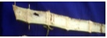 | Indicates 25% of inoculated internode discolored | 1 | Highly resistant
 | 26-50% of inoculated internode discolored | 2 | Resistant
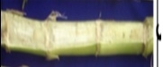 | 51-75% of inoculated internode discolored or 26-50% discoloration with high disintegration of the stalks | 3 | Resistant
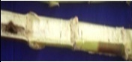 | 76-100% of inoculated internode discolored or 51-75% discoloration with high disintegration of the stalks | 4 | Resistant
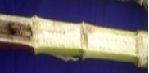 | Discoloration of <50% of adjacent internodes or 76-100% discoloration with high disintegration of the stalks | 5 | Tolerant
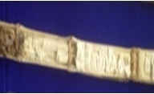 | Discoloration of >50% of adjacent internodes or complete discoloration of the inoculated internode with high disintegration and moderate fibrousness | 6 | Tolerant
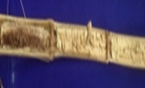 | Discoloration of > 2 internodes or <2 with high disintegration and moderate fibrousness | 7 | Susceptible
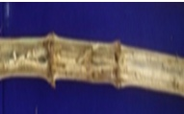 | Discoloration of >3 internodes or <3 with high disintegration and moderate fibrousness | 8 | Highly susceptible
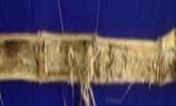 | Discoloration of >3 internodes with complete fibrousness of the stalk and plants killed immediately | 9 | Highly susceptible

Results :

Table 2 : Mean performance of inbreds, hybrids, seed parent (NAI-137), and commercial check Hema under LWD pressure

Inbreds and seed parent
 | ASI | DT | DS | SHP | HKW | CL | CW | GY | KPC | KPR | KRPC | SHP | LWD
mean | 3.59 | 65.78 | 62.14 | 77.3 | 32.18 | 14.27 | 4.62 | 111.76 | 410 | 26.84 | 17.39 | 145.56 | 5.41
SD | 0.57 | 1.6 | 1.61 | 3.85 | 3.38 | 0.88 | 0.15 | 19.73 | 72.65 | 3.3 | 1.11 | 24.40 | 1.17
max | 4.67(I2) | 67(I1 & I2) | 63.67(I6) | 83.06(I4) | 39.7(I2) | 15.57(I2) | 4.81(I10) | 135.22(I10) | 521.3(I4) | 30.7(I10) | 19(I2) | 182.6(I2) | 6.7(I9)
min | 2.67(I6&SP) | 61(I9) | 57.67(I9) | 71.85(I1) | 27.16(I4) | 12.82(I3) | 4.24(I9) | 75.03(I9) | 261.64(I3) | 19.8(I3) | 15.4(I9) | 97.3(I9) | 3.11(I6)
Hema and variants
Mean | 3.7 | 65.14 | 61.45 | 78.58 | 34.38 | 15.68 | 5.1 | 165.32 | 538.18 | 30.98 | 17.46 | 214.49 | 4.49
SD | 0.74 | 1.63 | 1.72 | 3.2 | 2.64 | 0.75 | 0.17 | 8.49 | 56.53 | 2.14 | 1.21 | 16.53 | 1.19
Max | 4.67(H5,H10&H11) | 67.33(H5) | 63(H2) | 84.32(H8) | 40.2(H8) | 16.8(H4) | 5.41(H6) | 180.65(H4) | 623.33(H8) | 33.8(H3) | 19.27(H8) | 252.5(H8) | 6.23(H4)
Min | 2.67(H2,H4&hema) | 61.33(H11) | 56.67(H11) | 73.28(H2) | 29.63(H9) | 14.25(H6) | 4.92(H9) | 148.79(H11) | 454.58(H6) | 27.5(H6) | 15.4(H7) | 197.6(H1) | 2.8(H3)
*Bold represents the inbreds and hybrids showing max and min values
ASI- Anthesis silking interval, DT- Days to 50% tasselling, DS- Days to 50% silking, SHP-Shelling %, HKW-100 kernel weight(g), CL- Cob length(cm), CW- Cob width(cm), CWP- Cob weight per plant(g), KPR- Kernels per row, KRPC-Kernel rows per cob, KPC-Kernels per cob, GY-Grain yield per plant(g)
The derived inbred lines exhibited substantial improvement in LWD resistance compared to the original seed parent, with I6 and I11 recording the lowest LWD scores (3.11 and 4.06, respectively). These resistant inbreds were successfully used as seed parents to develop hybrids, which further enhanced yield potential while maintaining LWD resistance. Among the hybrids, H3 and H1 had the lowest LWD scores (2.8 and 3.11, respectively), while H4(Susceptible) and H3(Resistant) recorded the highest grain yield (180.65 g and 178 g ).Where H3 has high GY followed by being highly resistant to LWD and H8, which is superior to most of the traits ( HKW, KPC, KRPC) and resistant to LWD showed yield similar to Hema. In contrast, Hema remained highly susceptible with an LWD score of 6.23. The hybrids also demonstrated similar flowering synchrony as that of Hema and the seed parent, with ASI as 2.67 in H2 and H4, enhancing reproductive efficiency(Table 2).
The ANOVA revealed highly significant differences (p < 0.001) across all traits, indicating considerable genetic variability contributed by the derived inbreds and susceptible parent to their hybrids. Grain yield (GY), cob-related traits (CL, CW, KPR, KRPC, and KPC), kernel weight (HKW), and shelling percentage (SHP) exhibited notable differences, reflecting the differential genetic potential of derived lines. Late wilt disease (LWD) resistance showed highly significant variance, with resistant inbreds contributing to improved hybrid performance(Table 3). The significant variation observed across hybrids underscores the role of parental genetic background in modulating hybrid performance, aligning with reports by Ayesiga et al. (2025) on the importance of resistant seed parents in generating high-yielding, disease-resistant hybrids.
Table 3. ANOVA showing trait-wise differences across treatments
Inbreds and seed parent |  |  |  | Hema and its variants
Trait | Chisq (trt) | Df | Pr(>Chisq) | Trait | Chisq | Df | Pr(>Chisq)
GY | 66.54 | 11 | 5.502e-10 *** | GY | 45.01 | 11 | 4.823e-06 ***
CL | 27.42 | 11 | 0.003959 ** | CL | 34.67 | 11 | 0.0002807 ***
CW | 46.74 | 11 | 2.386e-06 *** | CW | 200.18 | 11 | < 2.2e-16 ***
KPR | 87.67 | 11 | 4.753e-14 *** | KPR | 61.46 | 11 | 4.94e-09 ***
KRPC | 84.69 | 11 | 1.811e-13 *** | KRPC | 113.30 | 11 | < 2e-16 ***
KPC | 102.45 | 11 | < 2e-16 *** | KPC | 122.73 | 11 | < 2e-16 ***
CWP | 43.55 | 11 | 8.677e-06 *** | CWP | 51.02 | 11 | 4.086e-07 ***
HKW | 194.15 | 11 | < 2.2e-16 *** | HKW | 91.24 | 11 | 9.486e-15 ***
SHP | 63.72 | 11 | 1.869e-09 *** | SHP | 32.76 | 11 | 0.0005736 ***
DT | 875.35 | 11 | < 2.2e-16 *** | DT | 1320 | 11 | < 2.2e-16 ***
DS | 819.9 | 11 | < 2.2e-16 *** | DS | 1196.72 | 11 | < 2.2e-16 ***
ASI | 157.67 | 11 | < 2.2e-16 *** | ASI | 659 | 11 | < 2.2e-16 ***
LWD | 92.71 | 11 | 4.89e-15 *** | LWD | 58289 | 11 | < 2.2e-16 ***
Note – ‘*’,’**’,’***’ represent significance at 0.05, 0.01 and 0.001respectively
ASI- Anthesis silking interval, DT- Days to 50% tasselling, DS- Days to 50% silking, SHP-Shelling %, HKW-100 kernel weight(g), CL- Cob length(cm), CW- Cob width(cm), CWP- Cob weight per plant(g), KPR- Kernels per row, KRPC-Kernel rows per cob, KPC-Kernels per cob, GY-Grain yield per plant(g)

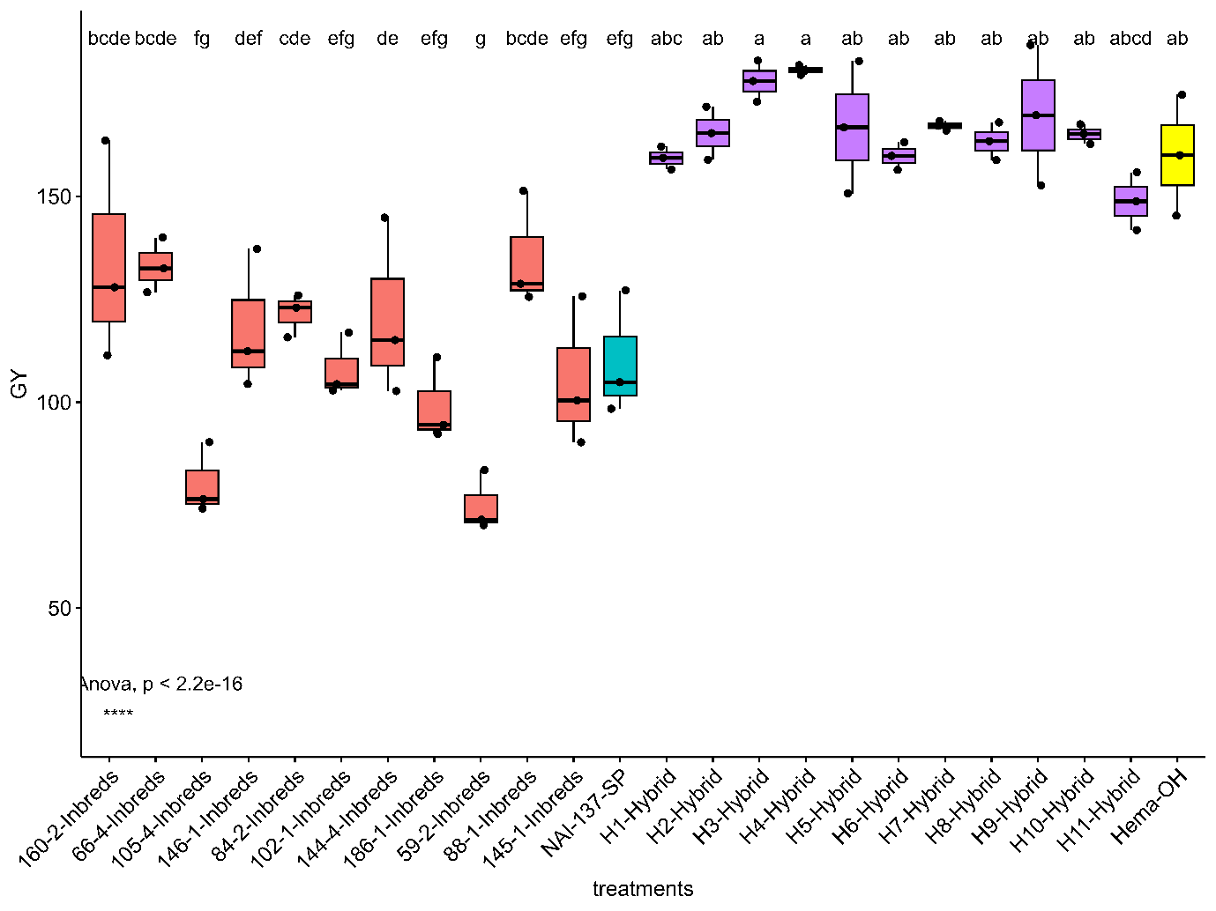
Fig 1 : Grain yield distribution across inbreds, hybrids, seed parent, and Hema
The boxplot in Fig 1 clearly distinguishes the performance of inbreds, seed parent, hybrids, and Hema. Hybrids consistently showed higher grain yield, indicating effective improvement through derived resistant female lines. Inbreds and the seed parent exhibited lower yields, while Hema recorded moderate performance. The colour-coded groups visually emphasise the superiority of hybrids over their parental lines.
Principal component analysis (PCA) is a method for reducing a dataset’s dimensionality. It identifies the linear combination of the dataset variables that exhibit the most variation while remaining linearly uncorrelated. The principal component analysis (PCA) explained 60.2% of the total variation through the first two dimensions (Dim1: 42.5%, Dim2: 17.7%). Cob weight (CW), cob length (CL), kernels per row (KPR), kernels per cob (KPC), and grain yield (GY) showed strong positive associations with Dim1, indicating that these yield-associated traits contributed significantly to variation among the genotypes. In contrast, days to 50% tasseling (DT), days to 50% silking (DS), and kernel row per cob (KRPC) were moderately aligned with Dim2, suggesting their limited contribution to the differentiation of resistant and susceptible lines(Fig 2).
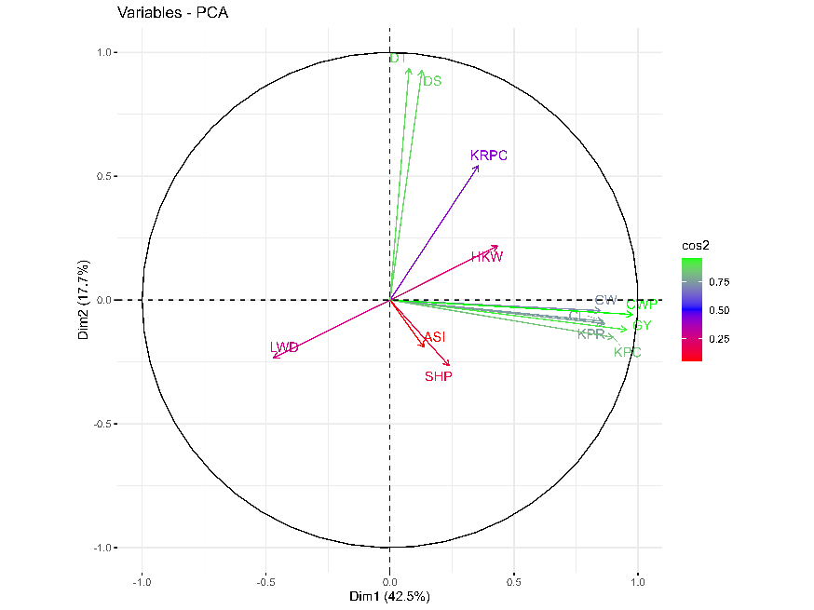
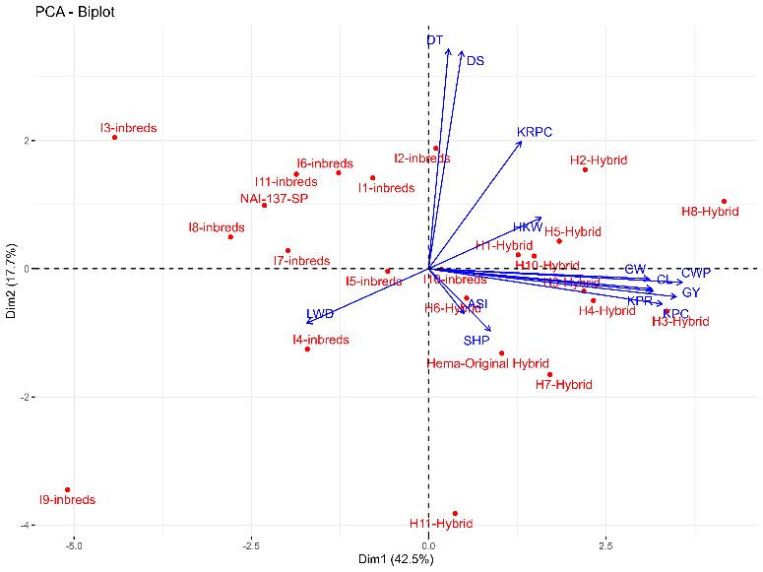
Notably, LWD exhibited a negative correlation with cob and yield-related traits and was positioned opposite to high-yielding traits on the biplot, confirming its detrimental impact on cob and kernel development. The hybrids derived from resistant inbreds clustered away from Hema and seed parents, indicating successful introgression of resistance and enhanced yield potential.

Fig.2 Principal component analysis of yield and LWD traits

The correlation analysis revealed significant associations between grain yield (GY) and key yield-contributing traits in the derived inbred lines. Highly significant positive correlations were observed between GY and cob width (CW; r = 0.86, p < 0.001), cob weight per plant (CWP; r = 0.96, p < 0.001), and cob length (CL; r = 0.53, p < 0.001). Similarly, kernels per cob (KPC; r = 0.81, p < 0.001) and kernels per row (KPR; r = 0.81, p < 0.001) also exhibited strong positive correlations with GY, indicating their potential as key yield determinants. Kernel rows per cob (KRPC) and 100-kernel weight (HKW) showed moderate but positive correlations with GY (r = 0.42 and r = 0.30, respectively)(Fig 3).
Interestingly, LWD (late wilt disease) severity showed a significant negative correlation with cob length (CL; r = −0.45,p<0.05), suggesting that LWD susceptibility in some derived inbreds might reduce cob length, thereby indirectly affecting yield. However, LWD did not exhibit a significant correlation with GY, indicating that the derived inbreds likely possess moderate resistance, preventing yield reduction despite LWD pressure. Days to 50% silking (DS) and anthesis-silking interval (ASI) were weakly associated with GY and other traits, implying minimal influence on yield stability in the evaluated hybrids.
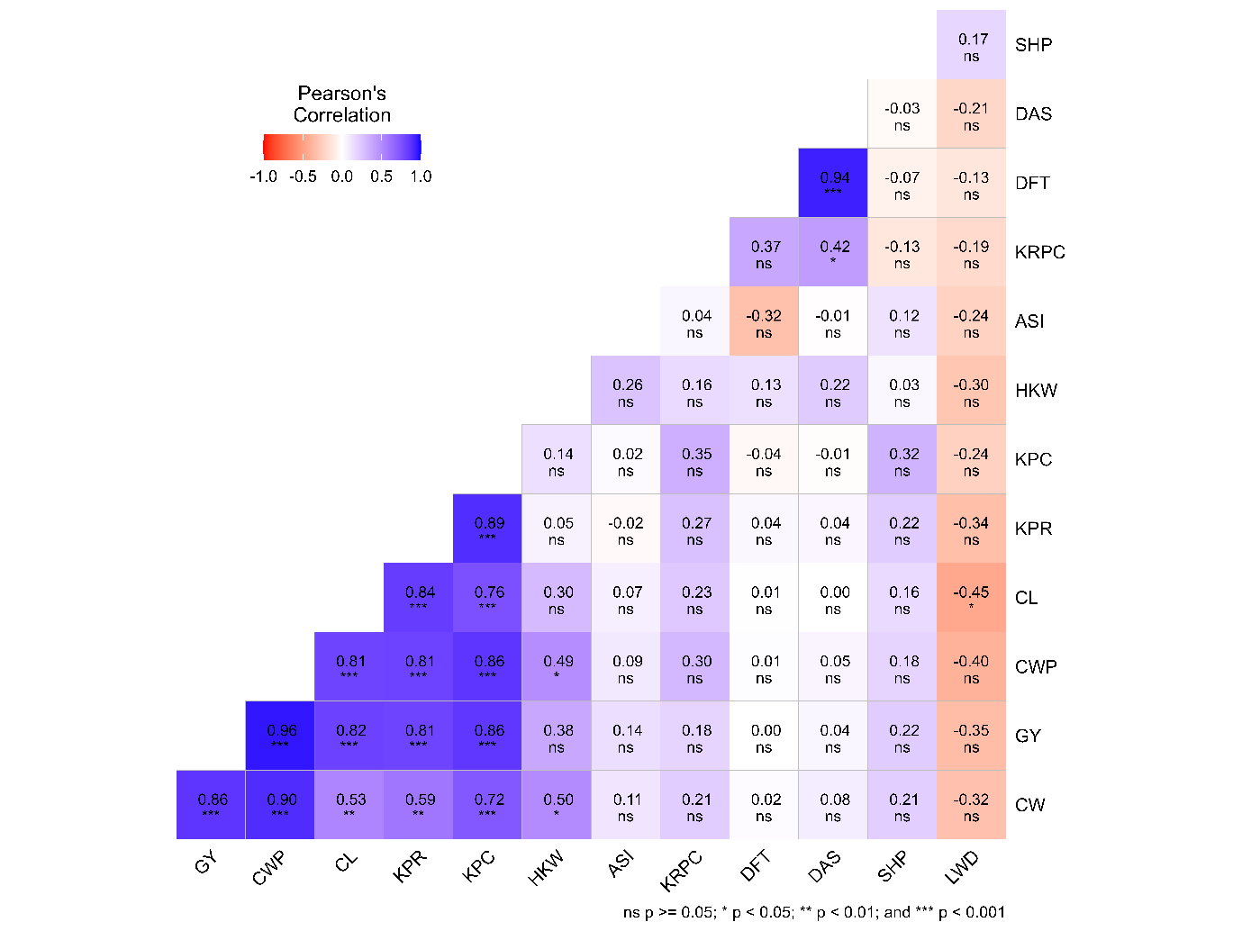
Fig.3 Correlation plot

A two-way hierarchical clustering heatmap was generated using standardized trait data from 24 maize genotypes, including 11 derived inbreds (developed from the seed parent of Hema), their respective hybrids (crossed with the same male parent of Hema), the original seed parent (NAI-137-SP), and the susceptible check variety Hema. The analysis grouped the genotypes into two distinct clusters: Cluster 1 (Red; 8 genotypes) included the original seed parent and several derived inbreds and hybrids(Fig 4). This cluster generally showed higher scores for late wilt disease (LWD) and relatively lower performance for yield-contributing traits such as grain yield (GY), cob weight (CW), kernel weight (HKW), kernels per cob (KPC), and kernels per row (KPR). Cluster 2 (Green; 16 genotypes) contained Hema, several hybrids, and inbreds that mostly showed lower LWD scores, indicating greater resistance to the disease. In addition, this cluster showed enhanced performance for key agronomic traits, reflecting better overall adaptability and productivity under disease pressure(Table 4). Among all genotypes, hybrid H3, followed by H8, which clustered in Cluster 2, stood out for its lowest LWD susceptibility(2.8 and 3.8 ) and highest expression of grain yield(11.25% and 2.15% higher than Hema ) and related traits. This confirms the success of the derived inbred used as the female parent in restoring both disease resistance and yield, despite using the same male parent as the susceptible hybrid Hema.
Table 4. Mean cluster values across the 13 traits
Cluster | Count |  | GY | CL | CW | KPR | KRPC | KPC | CWP | HKW | SHP | DT | DS | ASI | LWD
1 | 8 | mean | 107.7 | 14.2 | 4.6 | 26.5 | 17.1 | 394.0 | 143.1 | 31.7 | 75.0 | 61.6 | 65.1 | 3.5 | 5.2
 |  | SD | 24.8 | 0.8 | 0.2 | 3.8 | 1.0 | 75.6 | 32.3 | 1.6 | 1.9 | 2.8 | 2.4 | 0.6 | 1.2
2 | 16 | mean | 154.0 | 15.4 | 5.0 | 30.1 | 17.6 | 514.3 | 198.5 | 34.1 | 79.4 | 61.9 | 65.6 | 3.7 | 4.8
 |  | SD | 20.9 | 1.0 | 0.2 | 2.6 | 1.2 | 70.3 | 31.0 | 3.5 | 3.2 | 0.8 | 1.1 | 0.7 | 1.3
ASI- Anthesis silking interval, DT- Days to 50% tasselling, DS- Days to 50% silking, SHP-Shelling %, HKW-100 kernel weight(g), CL- Cob length(cm), CW- Cob width(cm), CWP- Cob weight per plant(g), KPR- Kernels per row, KRPC-Kernel rows per cob, KPC-Kernels per cob, GY-Grain yield per plant(g)
Discussion:
Late wilt disease (LWD), caused by Magnaporthiopsis maydis, significantly limits maize production, particularly in susceptible varieties such as Hema. The susceptibility of Hema is primarily attributed to the genetic makeup of the female parent, making it critical to develop resistant inbreds as seed parents. ANOVA showed strong differences (p < 0.001) among treatments for every trait we looked at, confirming that there’s meaningful genetic variation in the material. The derived inbreds, developed from resistant seed parents, showed notable improvements in both LWD resistance and yield-related traits when crossed with the same male parent of Hema. The significantly high Chi-square value for LWD emphasises a major improvement in resistance among hybrids derived from the resistant inbreds, suggesting that resistance alleles contributed by the derived inbreds effectively mitigated the genetic vulnerability inherited from the female parent of Hema.
Significant variation in kernel and yield-related traits across treatments suggests that the derived inbreds not only conferred disease resistance but also contributed positively to hybrid performance. Similar trends were observed by Singh et al. (2020), who evaluated 97 newly developed winter maize inbred lines and found that certain lines exhibited superior agronomic traits, indicating their potential to enhance hybrid performance. Additionally, Eze et al. (2020) examined the performance of maize hybrids derived from elite cultivars and found that hybrids developed from genetically diverse inbreds demonstrated improved grain yield and stability across different environments. This aligns with what Matongera et al. (2023) found, who showed that the use of stress-resilient inbreds led to superior hybrid performance under combined biotic and abiotic stresses.
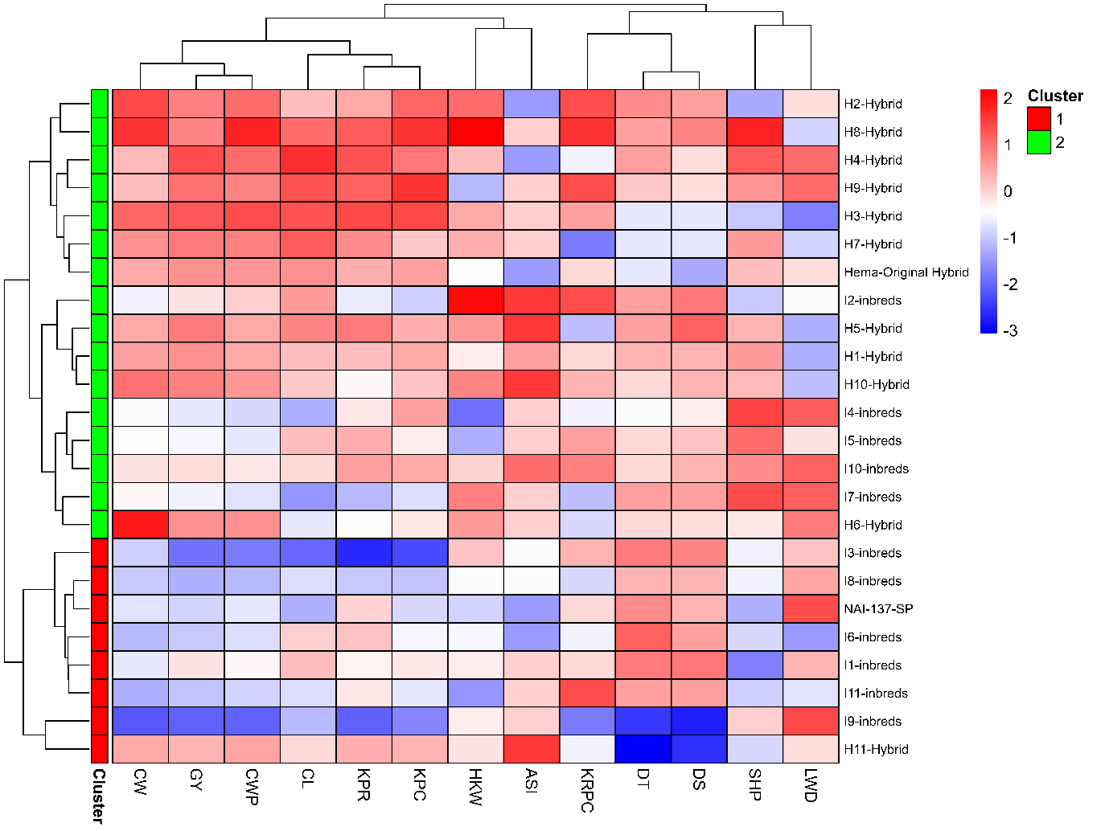
Fig.4 Two-way clustered heat map
The observed differences in shelling percentage (SHP), 100-kernel weight (HKW), and cob weight (CW) further indicate that the derived inbreds introduced beneficial genetic variability, enhancing hybrid vigour. Similar improvements in kernel traits and their contribution to yield stability were also highlighted by Ma et al. (2021) and Qu et al. (2024), emphasising the relevance of kernel-related traits in maize breeding under stress-prone conditions.
Reduction in LWD susceptibility across derived inbred hybrids reinforces findings by Kumar et al. (2009), who demonstrated that the introgression of resistant alleles in female parents can effectively control disease severity. This is in line with studies by Zhu et al. (2021) and Gazala et al. (2021), who reported the effectiveness of MAS-derived inbreds in managing soil-borne diseases in maize breeding programs. These results underscore the potential of derived inbreds to serve as superior seed parents, ensuring enhanced disease resilience and improved yield attributes under diverse environments.
The superior performance of the derived inbreds confirms the effectiveness of breeding strategies aimed at improving LWD resistance. Their incorporation as seed parents in hybrid development led to enhanced disease resistance and yield stability. Reduced LWD scores in hybrids like H3 and H1 suggest effective transmission of resistance, while the higher grain yield in H3 and H8 indicates that resistance was incorporated without yield penalties. The similar ASI as that of Hema in the hybrids further supports better reproductive success, ensuring stable grain set under stress conditions. The significant variation observed among hybrids suggests that selecting optimal inbred-hybrid combinations remains crucial for maximizing both yield and disease resistance in breeding programs (Ghazy et al. 2024).
The significant correlations between yield traits and GY suggest that selection for high cob weight, cob length, and kernels per cob can effectively enhance yield in maize. We also found that traits like KPC, KPR, and CWP were strongly linked to higher yields just like Singh et al. (2020) noted when they highlighted kernel traits as good yield indicators. In support, Khulbe et al. (2020) demonstrated that kernel number and cob weight are among the most heritable and selection-efficient traits for grain yield improvement in multiple environments.
The significant negative correlation between LWD and cob length suggests that LWD may shorten cob length, which could potentially limit grain-filling capacity. This aligns with reports by Degani et al. (2022) and Shofman et al. (2022), where LWD susceptibility in genotypes led to poor cob development and reduced grain filling. However, the absence of a significant correlation between LWD and GY in this study suggests that the derived inbreds possess moderate resistance, likely buffering yield losses even under LWD pressure. Similar observations were reported by Degani (2021) who showed that moderately resistant lines maintained better yield despite pathogen pressure.
This study demonstrates the successful development of high-yielding, LWD-tolerant hybrids through the utilization of derived inbred lines as female parents. From the PCA results, clustering of hybrids with high KRPC, KPR, GY, CWP, and HKW underscores the importance of these traits in enhancing maize productivity. The negative association of LWD with yield, as indicated by the vector direction, highlights the critical role of LWD resistance in improving performance. These findings align with those of Degani et al. (2022), who reported that late wilt disease negatively affects vascular efficiency and kernel development in susceptible maize hybrids . Similarly, Kamara et al. (2021) emphasized the importance of selecting inbred lines with strong general combining ability for both grain yield and LWD resistance, identifying specific inbred lines exhibiting favourable genetic effects for these traits. Biradar (2019) also demonstrated that hybrids with favourable specific combining ability effects for grain yield and LWD resistance can be effectively developed by selecting appropriate parental lines, enhancing the potential for producing hybrids that perform well under LWD pressure.
The wide dispersion of inbred lines in the PCA further indicates substantial genetic diversity, which offers valuable resources for future breeding efforts. Hybrids H2–H10 exhibited enhanced performance, demonstrating the effective introgression of resistance and yield traits from the newly developed inbreds. The orthogonal positioning of DS and DT vectors in the PCA implies that these traits influence maturity independently and can be exploited in selection for earliness.
Cluster analysis clearly reflects the phenotypic advancements and genetic improvements achieved through the incorporation of resistant inbreds. Although Hema was also grouped in Cluster 2, its high susceptibility to late wilt disease (LWD) indicates that cluster membership does not always correlate with resistance levels. This observation reinforces the importance of assessing individual genotype performance within clusters. Similar insights were provided by Pande et al. (2022), who emphasized the necessity of genotype-specific disease assessments in clustering-based resistance studies. Additionally, Qiu et al. (2023) identified that resistance to multiple foliar diseases in maize is governed by numerous loci with small effects, and that clustering based on genetic markers may not fully capture the complexity of disease resistance traits.
The derived inbreds and their hybrids, particularly H3 and H8, exhibit strong potential for developing high-yielding, LWD-resistant maize varieties. H3 and H8 demonstrated 11.25% and 2.15% higher yields than Hema, respectively, coupled with the lowest LWD scores of 2.8 and 3.8. These traits suggest their adaptability to stress-prone environments. However, to confirm their stability and facilitate large-scale deployment, continued multi-environment evaluations are essential. Employing combined stability analyses and GGE biplot methods can effectively identify hybrids with consistent performance across diverse conditions (Ruswandi et al. 2022) .​
Conclusion :
This study highlights the successful introgression of LWD resistance into elite maize genetic backgrounds without compromising yield potential. Derived inbreds from the susceptible seed parent NAI-137, when crossed with the original male parent, produced hybrids with improved resistance and agronomic performance. Hybrids like H3 and H8 outperformed the commercial check, Hema, in both disease resistance and yield traits. The significant genetic variation and strong positive correlations among yield components suggest that MAS-derived inbreds are valuable resources for future hybrid development. These findings offer a practical solution for stabilizing maize yields in LWD-endemic regions and underscore the importance of parental selection in hybrid breeding programs.
Data Availability
The datasets generated during the current study are available from the corresponding author upon reasonable request.
Conflict of Interest
The authors declare that they have no conflict of interest.

Disclaimer (Artificial intelligence)

Author(s) hereby declare that NO generative AI technologies such as Large Language Models (ChatGPT, COPILOT, etc.) and text-to-image generators have been used during the writing or editing of this manuscript.

References :
Ayesiga, S. B., Rubaihayo, P., Sempiira, J. B., Adjei, E. A., Dramadri, I. O., Oloka, B. M., et al. (2025). Combining ability and gene action for resistance to Fusarium ear rot in tropical maize hybrids. Frontiers in Plant Science, 16, 1509859.
Beera, B. (2021). Assessment of grain yield potential and its stability of maize (Zea mays L.) hybrids selected based on their tolerance to late wilt disease (LWD). Dissertation, University of Agricultural Sciences, Bangalore.
Biradar, M. (2019). Identification of high yielding and late wilt (Harpophora maydis) disease resistant hybrids of maize (Zea mays L.). Dissertation, University of Agricultural Sciences, Bangalore.
Degani, O. (2021). A review: Late wilt of maize the pathogen, the disease, current status, and future perspective. Journal of Fungi, 7(11), 989.
Degani, O., Ayoub, A., Dimant, E., & Gordani, A. (2024). Antagonistic interactions between maize seeds microbiome species and the late wilt disease agent, Magnaporthiopsis maydis. Frontiers in Fungal Biology, 5, 1436759.
Degani, O., Chen, A., Dor, S., Orlov-Levin, V., Jacob, M., Shoshani, G., et al. (2022). Remote evaluation of maize cultivars susceptibility to late wilt disease caused by Magnaporthiopsis maydis. Journal of Plant Pathology, 104(2), 509–525.
El-Shehawy, A., Ata, A., & El-Ghonemy, M. (2014). Impact of late wilt caused by Cephalosporium maydis on maize grain yield and protein content. Egyptian Journal of Phytopathology, 42, 1–10.
Eze, C. E., Akinwale, R. O., Michel, S., & Bürstmayr, H. (2020). Grain yield and stability of tropical maize hybrids developed from elite cultivars in contrasting environments under a rainforest agro-ecology. Euphytica, 216, 1–13.
Gangappa, E., Ramesh, S., Vedashree, M. S., Raghu, R., & Swamy, D. (2021). Marker-assisted mapping and backcross breeding for late wilt disease resistance in NAI-137, the seed parent of public bred single cross maize (Zea mays L.) hybrid Hema. Research Square, Preprint.
Gazala, P., Gangappa, E., Ramesh, S., & Swamy, D. (2021). Comparative breeding potential of two crosses for response to late wilt disease (LWD) in maize (Zea mays L.). Genetic Resources and Crop Evolution, 68, 1751–1757.
Ghazy, N. A., Al-Zaban, M. I., Safhi, F. A., Aljabri, M., Kafsheer, D. A., Ben Abdelmalek, I., et al. (2024). Unraveling genetic variation and inheritance patterns in newly developed maize hybrids for improving late wilt disease resistance and agronomic performance under artificial inoculation conditions. Life, 14(12), 1609.
Johal, L., Huber, D. M., & Martyn, R. (2004). Late wilt of corn (maize) pathway analysis: intentional introduction of Cephalosporium maydis. In Pathways Analysis for the Introduction to the U.S. of Plant Pathogens of Economic Importance (pp. 1–20). Purdue University, West Lafayette, IN.
Kamara, M. M., Rehan, M., Ibrahim, K. M., Alsohim, A. S., Elsharkawy, M. M., Kheir, A. M., et al. (2020). Genetic diversity and combining ability of white maize inbred lines under different plant densities. Plants, 9(9), 1140.
Khulbe, R. K., Sharma, D., Pattanayak, A., & Kant, L. (2020). Genetic variability, association and contribution of different characters towards grain yield in sweet corn (Zea mays var. saccharata) in North Western Hills. Indian Journal of Hill Farming, 33(2), 254–260.
Kumar, K. A., Gangappa, E., Ramesh, S., & Swamy, D. (2021). Identification of high yielding inbred lines resistant to late wilt disease caused by Harpophora maydis in maize. Electronic Journal of Plant Breeding, 12, 151–158.
Kumar, S., Sandhu, J. S., Gupta, S. K., Dikshit, H. K., & Gupta, S. (2009). Broadening genetic base of pulse crops: present status and future strategies. In Legumes for Ecological Sustainability (pp. 332–341). Indian Institute of Pulse Research, Kanpur, India.
Ma, J., & Cao, Y. (2021). Genetic dissection of grain yield of maize and yield-related traits through association mapping and genomic prediction. Frontiers in Plant Science, 12, 690059.
Matongera, N., Ndhlela, T., van Biljon, A., & Labuschagne, M. (2023). Predicting zinc‐enhanced maize hybrid performance under stress conditions. Food and Energy Security, 12(4), e479.
Qiu, Y., Adhikari, P., Balint-Kurti, P., & Jamann, T. (2024). Identification of loci conferring resistance to four foliar diseases of maize. G3: GenesGenomesGenetics, 14(2), jkad275.
Qu, J., Yu, D., Gu, W., Khalid, M. H. B., Kuang, H., Dang, D., et al. (2024). Genetic architecture of kernel-related traits in sweet and waxy maize revealed by genome-wide association analysis. Frontiers in Genetics, 15, 1431043.
Rakesh, B., Gangappa, E., Gandhi, S. G., Gowda, R. V., Swamy, S. D., Ramesh, S., et al. (2016). Modified method of screening maize inbred lines to late wilt disease caused by Harpophora maydis. Mysore Journal of Agricultural Sciences, 50(4), 684–690.
Rakshit, S., Santosh, H. B., Sekhar, J. C., Nath, R., Shekhar, M., Chikkappa, G. K., et al. (2011). Analyses of genetic diversity among maize inbred lines differing for resistance to pink borer and post-flowering stalk rot. Journal of Plant Biochemistry and Biotechnology, 20, 173–181.
Ruswandi, D., Syafii, M., Wicaksana, N., Maulana, H., Ariyanti, M., Indriani, N. P., et al. (2022). Evaluation of high yielding maize hybrids based on combined stability analysis, sustainability index, and GGE biplot. BioMed Research International, 2022, 3963850.
Shofman, G., Bahouth, M., & Degani, O. (2022). Aggressive strains of the late wilt fungus of corn exist in Israel in mixed populations and can specialize in disrupting growth or plant health. Fungal Biology, 126(11–12), 793–808.
Singh, S. B., Kasana, R. K., Kumar, S., & Kumar, R. (2020). Assessing genetic diversity of newly developed winter maize (Zea mays L.) inbred lines. Indian Journal of Plant Genetic Resources, 33(1), 68–76.
Sunitha, N. C., Gangappa, E., Gowda, R. P. V., & Hemareddy, H. B. (2022). Discovery of genomic regions associated with resistance to late wilt disease caused by Harpophora maydis (Samra, Sabet and Hing) in maize (Zea mays L.). Journal of Applied Genetics, 63, 185–197.
Tej, R., Rodríguez-Mallol, C., Rodríguez-Arcos, R., Karray-Bouraoui, N., & Molinero-Ruiz, L. (2018). Inhibitory effect of Lycium europaeum extracts on phytopathogenic soil-borne fungi and the reduction of late wilt in maize. European Journal of Plant Pathology, 152, 249–265.
Zhu, M., Tong, L., Xu, M., & Zhong, T. (2021). Genetic dissection of maize disease resistance and its applications in molecular breeding. Molecular Breeding, 41(5), 32.

