Floral Biology and Pollination behaviour in Caygua ( Cyclanthera pedata L. Schrad.)

ABSTRACT
A total of six genotypes collected locally were raised in randomized complete block design (RCBD) and replicated four times for conducting this investigation. Floral traits such as flower diameter, flower length, pedicel length days to first male and female flowering, sex ratio, pollen germination and pollen viability were observed. The minimum days taken to first male flowering was 26.75 and earliest female flowering took 27.75 days. The most favourable sex ratio was recorded at 17.25 male per female flowers. Anthesis started from 4.00 a.m. and continued to till 9 a.m. in all the 6 genotypes observed. The peak period of anther dehiscence was recorded between 5.00 am to 7.00 am. The maximum pollen germination obtained was 66.66% while maximum pollen viability was 94.37%. Hand pollination proved to be better for fruit set as compared to insect pollination. Stigma receptivity determined by fruit set method was recorded maximum during full bloom stage followed by bud stage and least in withering stage. Knowledge of floral biology is important to carry out successful plant breeding programme as it helps in understanding and determining the breeding behaviour of particular plant species.
Key words: Caygua, Floral Biology, Pollination, pollen germination

INTRODUCTION
Cyclanthera pedata L. Schrad., commonly known as caygua or stuffing cucumber, is an herbaceous, climbing vine in the Cucurbitaceae family that is cultivated as a fruit vegetable. In Uttarakhand, India, it is locally referred to as Ram Karela or Meetha Karela. It is thought to have originated from Andean region or “Sierra” (Dietschy, 1953; Popenoe, 1989; Macbride, 1937; Montoro et al., 2001; Pertuze et al., 2020). From sea level to over 2,500 meters above sea level, it can withstand both hot and cold temperatures. Today, caygua is grown all over the world, having been brought to Africa, China, Nepal, and Europe. This species has only been grown traditionally in a few Alpine Valleys in the Lombardy region (Northern Italy), such as the Camonica Valley, where the vegetable is known as "Ciuenlai," for at least 50 years (Rossi et al. 2019; Giupponi et al. 2020; Zuccolo et al. 2023). In spite of its capacity to thrive under a wide range of environmental conditions, Macchia et al. (2009) noted that caygua plants prefer tropical and subtropical climates. Their findings indicate an average growth temperature mainly between 12 and 18°C, with an optimum relative humidity of 80–90%. They also report that caygua grows best in deep, well-drained soil with a neutral pH around 6.0 to 7.0. Additionally, it tends to perform better under shade, meaning that direct sunlight on its leaves should be minimized. Where climatic conditions are favourable for growth, such as in tropical or subtropical regions and shaded environments, the plant’s growth cycle can extend to about three to four months. Harvest typically begins roughly 100 to 120 days after planting and continues for 45 to 60 days. The growing habit is annual, climbing plants having tendrils, leaves are palmate and flowers are small, unisexual and are borne at leaf axillary buds. Fruit is ovoid in shape and fruit type is pepo (Cappelletti, 1976; Macbride, 1937). Flowers pale yellow; male flowers in 20-50-flowered panicle on up to 20 cm long peduncle, pedicel filiform, less than 1 cm long, calyx with linear segments, corolla with triangular ovate segments, filaments connate, anthers circular; female flower with similar calyx and corolla, ovary 2-3 mm long. Seeds black, 10-12 mm long, margin dentate, not exploding when mature (Grubben and Denton, 2004). Young caygua fruits are eaten fresh in salads or sautéed, while ripe fruits are often stuffed like peppers with meats, cheeses, or herbs; they can also be fried, breaded, or baked. Beyond culinary uses, it is valued in South American folk medicine for anti-inflammatory, hypoglycemic, and cholesterol-lowering effects, with several studies supporting these claims. In Peru, seed infusions are traditionally used to help control hypertension, and fruit juice is believed to assist in managing cholesterol and blood pressure, with additional traditional notes on cardiovascular and circulatory benefits (Orsini et al. 2019).
The knowledge of floral biology is essential for guiding plant-breeding programs because it reveals how a species tends to reproduce, which directly shapes the choice of breeding strategies; for naturally homozygous crops, progressing lines into fixed varieties is feasible, while heterozygous crops require developing segregating populations to capture desirable traits, making cross-breeding plans, hybrid formation, and selection schemes fundamentally different. A solid understanding of floral traits including flowering time, receptivity, and compatibility enables precise planning for intraspecific and interspecific hybrids, optimizes pollination control, and accelerates the achievement of target performance in new varieties. To identify what limits reproductive success in a species, a thorough understanding of the reproductive biology of a plant requires an investigation of pollination biology which include pre-pollination events like pollen production, release, viability, and germination and post-pollination events like stigma receptivity (Bhatnagar & Kumari, 2024).
Caygua is an under utilized vegetable crop with scant information and literature available in the existing literature. So, the present study was undertaken with the objective to study the various components of floral biology of six different genotypes of caygua (Cyclanthera pedata L. Schrad).

MATERIALS AND METHODS

Six genotypes of caygua were collected locally from different regions of Uttarakhand varying in altitudes and were raised with a spacing of 1m×1m in randomized complete block design (RCBD) with four replications. The genotypes were named with the prefix ‘L.C.’ meaning ‘Local Cultivar’ followed by the name of the region from which they were procured. The treatment details are mentioned as follows: L.C. Bharsar (T₁), L.C. Sainji (T₂), L.C. Buransi (T₃), L.C. Dooni Pak (T₄), L.C. Pauri (T5) and L.C. Pabau (T₆).
Days to first flowering was recorded for both male and female flowers by counting the days from transplanting until the day on which first flower opened on the selected plants of each treatment and averaged over replications. Length and diameter of different floral parts were measured using digital vernier calliper when the flowers were freshly opened and bloomed. Sex ratio was determined by counting male and female flowers on five different nodes and internodes of each plant from each treatment and averaged over replications. The sex ratio was determined by using following formula: Sex ratio = Number of male flowers/ number of female flowers (Marie and Mohamed, 2010). For time of anthesis, data was collected consecutively for 5 days. Each day 20 flower buds (both male and female), 10 each of 2 selected plants from each replication were selected and tagged. The next day observation on anthesis in the selected buds was recorded at hourly intervals from 4.00 hrs to 10.00 hrs. As soon as anthesis was observed, the bud was removed so as to avoid counting the same bud again. Anther dehiscence stages were recorded based on the extent of pollen release and anther opening. Care was taken to avoid damaging the tissue with excessive tapping force (Manjunath, K. 2016). For observing pollination percentage by insects 10 flower buds from each plant of different genotypes of each replication were selected and allowed to openly pollinate and for observing pollination percentage by hand 10 flower buds from each plant of different genotypes of each replication were selected and pollinated by hand and bagged. The percentage of fruit set was recorded (Hossain et al. 2018). Pollen germination was recorded by placing the pollen grains on a slide consisting of the germination medium i.e. 15 % sucrose + 0.25% boric acid + 300 mg of calcium nitrate and incubated for 24 hours (Rathod et al. 2018). The pollen viability and longevity were determined by acetocarmine test (Kumari et al. 2009). The statistical analysis was carried out in accordance to the statistical procedures suggested by Gomez and Gomez (1984). Data analysis was done using GRAPES, KAU using multiple comparison test (“Tukey’s HSD test”).

RESULT AND DISCUSSION
Mean performance of all the floral biology characters studied are presented in Table 1 and 2. Anthesis started at 4.00 a.m. and continued till 9 a.m. in all the 6 genotypes observed. The peak period of anthesis and anther dehiscence for all the genotypes was recorded from 5 am to 7 am. This is in accordance with the early morning flowering pattern found in other cucurbit species such as bittergourd (Raj et al., 1993).
The earliest female flowering was recorded in T₂ (27.75 days) and earliest male flowering was recorded in T₄ (26.75 days). The days to first female flowering ranged from 27.75 to 33.12 days in the six different genotypes while days to first male flowering ranged from 26.75 to 31.62 days indicating a slightly protandrous nature of caygua. Similar findings were reported by Radha (2014) in bittergourd and Kumkum et al. (2023) in snake gourd. This variablility in flowering time of the different caygua genotypes may be attributed to differences in genetic or physilogical responses to environmental stimuli. Breeding cycles that seek for quick generation turnover may benefit more from genotypes with earlier flowering (Gwanama et al., 2001 and Singh et al., 2018).
The flower diameters in caygua genotypes ranged from 6.11 mm to 7.41 mm in case of female flowers with highest the value recorded in T₂ (7.41 mm) while in male flowers it ranged from 6.40 mm to 7.38 mm with T₄ having the highest value (7.38 mm). Similar findings were reported by Asna et al. (2020) in bittergourd. Flowers with larger diameters are favoured for breeding programmes in order to facilitate insect visits and increase pollination rates.
The length of the female flowers ranged from 2.05 to 2.85mm whereas in case of male flowers the range of length was from 1.99 to 2.33mm. The maximum value for flower length was recorded in T₂ and T₁ for female and male flowers respectively. Similar findings were reported by Asna et al. (2020) in bittergourd. Flower length particularly in female flowers may influence pollinator attraction and consequently reproductive efficiency. Thus selection for desirable female flower length could be beneficial in breeding programmes.
Compared to male pedicel lengths, which ranged from 4.27 mm to 5.38 mm, female pedicel lengths varied less, ranging from 0.71 mm to 1.47 mm. This suggests that pedicel length variability is higher in male blooms. Breeding may benefit from selection based on male pedicel length, particularly to improve pollinator access or flower placement features. The pedicel serves as a bridge between the fruit and plant, providing a channel for transporting nutrients to the fruit during its growth and development. If the pedicel is too long or too short, the fruit will bend and produce a deformed fruit. Pedicel length in cucumbers is an essential parameter in molecular genetics and cucumber breeding (Yane et al. 2024).
The lengh of the style ranged from 2.61 mm to 3.29 mm in all the genotypes studied. The highest value for style length was found in T₄ (3.29 mm). Style length influences pollen compatibility and reach, it can have an effect on effective fertilisation. Breeding techniques that aim to increase reproductive efficiency may benefit from genotypes with longer styles since they may have reproductive benefits under specific circumstances as pollinator visitation efficiency is indirectly related to style length (Feng et al. 2022).
The most favourable sex ratio was recorded in T₄ (17.25) while the least desirable sex ratio was recorded in T₆ (23.75). These results are in accordance with Belavadi (2019) and Khairiya et al. (2023). A lower sex ratio could lead to a higher yield by producing more number of fruits per plant (Kumari et al. 2017).
Fruit set in caygua genotypes by insect pollination recorded a success percentage ranging from 55.00% to 68.75% with the highest value recorded in T_{2.} On the other hand, fruit set by hand pollination showed a success rate between 78.75% and 91.25% with the highest value recorded in T₂. This suggests that hand pollination worked better and was more reliable for all genotypes. For consistent outcomes in controlled breeding, hand pollination is the favoured method due to its greater and steadier success rates. However, for open-field production systems, insect pollination optimisation is still essential. The results were in accordance with Deyto et al., 2009.
Variability in pollen germination rates was moderate, ranging from 57.77% to 66.66% between genotypes. Similar results have been found in a study conducted by Rathod et al. 2018. In breeding, higher pollen germination rates are advantageous because they guarantee better fertilisation and higher fruit set. Breeding programs aimed at increasing production may find it essential to choose genotypes with greater pollen germination rates.
Pollen viability ranged from 90.05% to 94.37% on the first day exhibiting a strong potential in all genotypes. Viability ranged from 53.75% to 62.63% by third day and further declined to 16.13% to 25.38% by fifth day. These results are in accordance with Rathod et al. 2018. Breeding programs benefit from genotypes with higher pollen viability and longer viability (longevity) at the third and fifth days, particularly in controlled or open-pollinated settings where longer pollen viability can increase fertilisation success. As pollen lifetime declines, pollen viability drops by the third and fifth days.
Maximum fruit set was observed at the full bloom stage, followed by the bud and withering stages across all genotypes. L.C. Buransi recorded the highest fruit set (90%) at full bloom, while L.C. Sainji and L.C. Pauri recorded the lowest (70%). At the bud stage, L.C. Bharsar, L.C. Pauri, and L.C. Pabau showed the highest (40%) and L.C. Dooni Pak the lowest fruit set (20%). During the withering stage, L.C. Bharsar and L.C. Pauri had the highest fruit set (30%) while L.C. Dooni Pak had none. The full bloom stage is optimal for fruit set, indicating peak pollination efficiency. Genotypic variations suggest inherent reproductive differences affecting yield potential. This result is in partial accordance with Naik et al. (2013).
Conclusion
This study revealed significant variation among genotypes of caygua in terms of flowering behavior, floral traits, and reproductive efficiency. L.C. Dooni Pak exhibited the earliest male flowering, largest male flower diameter, style length and the most favourable sex ratio whereas L.C. Bharsar recorded the longest male flowers . Among female flowers, the earliest flowering and longest flowers were recorded in L.C. Sainji while L.C. Buransi recorded the highest pedicel length and flower diameter. Anthesis and anther dehiscence peaked between 5:00–7:00 a.m., indicating an optimal pollination window. L.C. Bharsar exhibited superior pollen viability and germination, whereas L.C. Pauri showed highest pollen longevity. Stigma receptivity, assessed through fruit set, was highest during the full bloom stage, followed by the bud and withering stages. L.C. Sainji demonstrated the highest fruit set under both hand and open pollination, reinforcing the importance of full bloom for reproductive success. These findings provide valuable insights into genotype selection and pollination strategies of Caygua for optimizing fruit set and yield in temperate conditions.

Disclaimer (Artificial intelligence)
Option 1:
Author(s) hereby declare that NO generative AI technologies such as Large Language Models (ChatGPT, COPILOT, etc.) and text-to-image generators have been used during the writing or editing of this manuscript.

REFERENCES
Asna, A. C., Joseph, J., & Joseph John, K. (2020). Botanical description of bitter gourd. In The bitter gourd genome (pp. 7-31). Cham: Springer International Publishing.
Belavadi, V. V. (2019). Floral biology and pollination in Cucumis melo L., a tropical andromonoecious cucurbit. Journal of Asia-Pacific Entomology, 22(1), 215-225.
Bhatnagar, S., & Kumari, R. (2024). Floral biology, pollination biology, and breeding mechamism mechanisms reveal challenges to the restoration of Buchanania lanzan, a vulnerable plantspecies.Flora,311,152448. https://doi.org/10.1016/j.flora.2024.152448
Cappelletti, C. 1976. “Trattato di botanica”. 3rd ed., UTET: Torino Italy.
Deyto, R., and Cervacia, C. R. 2009. Floral biology and pollination of ampalaya (Momordica charantia L.). Philippine Agricultural Scientist. 92(1): 8-18.
Dietschy, H. 1953. L’antica medicina peruviana. Ciba. Milano. 40: 1318-1345.
Feng, X., Zhang, L., Li, Y., Li, X., & Wu, F. (2022). Morphological and Genetic Diversity of Cucumber (Cucumis sativus L.) Germplasm from China. Plants, 11(1), Article 20. https://doi.org/10.3390/plants11010020
Giupponi L, Pilu R, Scarafoni A and Giorgi A (2020) Plant agro biodiversity needs protection, study and promotion: results of research conducted in Lombardy region (North ern Italy). Biodivers Conserv 29:409–430.
Gomez, K. A., and Gomez, A. 1984. Statistical Procedure for Agricultural Research- Hand Book. John Wiley and Sons, New York. 680p.
Gomez, K. A., and Gomez, A. 1984. Statistical Procedure for Agricultural Research- Hand Book. John Wiley and Sons, New York. 680p.
Gopinath, P. P, Parsad, R, Joseph, B, Adarsh, V. S.,(2020). GRAPES: General Rshiny Based Analysis Platform Empowered by Statistics. https://www.kaugrapes.com/home. version 1.0.0. DOI: 10.5281/zenodo.4923220.
Grubben, G. J. H., and Denton, O. A. (Editors). 2004. Plant resources of tropical Africa. 2 Vegetables. PROTA Foundation, Wageningen, Netherlands /Backhuys Publishers, Leiden, Netherlands /CTA,Wageningen, Netherlands. 668pp.
Gwanama, C., Botha, A. M., & Labuschagne, M. T. (2001). Genetic effects and heterosis of flowering and fruit characteristics of tropical pumpkin. Plant Breeding, 120(3), 271-272.
Hossain, M. S., Yeasmin, F., Rahman, M. M., Akhtar, S and Hasnat, M. A. (2018). Role of insect visits on cucumber (Cucumis sativus L.) yield. Journal of Biodiversity Conservation and Bioresource Management, 4(2), 81-88.
Khairiya, P., Singh, J., & Singh, D. (2023). Heterosis Analysis for Growth and Yield Attributes in Sponge Gourd [Luffa cylindrica (Roem) L.]. Biological Forum -an International Journal, 15(5), 441. https://www.researchtrend.net/bfij/pdf/63%20Heterosis-Analysis-for-Growth-and-Yield-Attributes-in-Sponge-Gourd-[Luffa-cylindrica-(Roem)-L.]-Priyanka-Khairiya-63.pdf
Kumari. A,, Komal, R. and Pandey, A. (2009). In Vitro Pollen Germination, Pollen Tube Growth and Pollen viability in Trichosanthes dioica Roxb. (Cucurbitaceae). The International Journal of Plant Reproductive Biology, 1: 147-151.
Kumari, P., Kumari, R., Rani, N., Verma, R. B., and Verma, R. K. 2017. Genetic divergence of bitter gourd (Momordica charantia L.) for sixteen important yield attributing traits. Current Journal of Applied Science and Technology. 23:2,1-11.
Kumkum, M & Pramanik, Subrota & Rahman, M & Bahadur, Maniruzzaman & Sikder, Sripati. (2023). Exogenous Application Of Gibberellic Acid (GA3) Improves Femaleness And Fruit Yield Of Snake Gourd. Journal of Science and Technology. 21. 2959-3239. 10.59125/JST.21103.
Macbride, J. F., 1937. Cucurbitaceae flora of Peru. Field Museum of Natural History, Botanical Series, 13(6/2): 321–383.
Macchia, M., Montoro, P., Ceccarini, L., Molfetta, I and Pizza, C. (2009). Agronomic and phytochemical characterization of Cyclanthera pedata Schrad. cultivated in central Italy. African Journal of Microbiology Research, 3(8), 434-438.

Manjunath, K. (2016). Studies on flower visitors of sponge gourd (Luffa cylindrica (L.) Roem) and their role in fruit set [Master's thesis, University of Agricultural Sciences, GKVK, Bengaluru]. KrishiKosh.
Marie, I.A. and H.G. Mohammed. 2010. Effect of foliar application of potassium and IAA on growth and yield of two cultivars of squash (Cucurbita pepo L.). Journal of Tikrit University for Agricultural Eciences. 10(2): 229 - 242.
Montoro, P., Carbone, V., De Simone, F., Pizza, C. De Tommasi N. 2001. Studies on the
constituents of Cyclanthera pedata fruits: isolation and structure elucidation of new flavonoid glycosides and their antioxidant activity. Journal of Agriculture Food Chemistry 49(11): 5156-5160.
Naik, A., Akhtar, S., Thapa, U., Chattopadhyay, A., and Hazra. P. 2013. Floral biology and interspecific and intergeneric crossibility of teasle gourd. International Journal of Vegetable Science.1:263-273.
Nepi, M., and Pacini, E. 1993. Pollination viability and pistil receptivity in Cucurbita pepo. Annals of Botany. 72: 527-536.
Orsini, F., Vovk, I., Glavnik, V., Jug, U and Corradini, D. (2019). HPTLC, HPTLC-MS/MS and HPTLC-DPPH methods for analyses of flavonoids and their antioxidant activity in Cyclanthera pedata leaves, fruits and dietary supplement. Journal of Liquid Chromatography & Related Technologies, 42(9-10), 290-301.
‌Pertuzé, R., Baginsky, C., Medina, C., Bello, M., & Araya, A. (2020). A South American forgotten vegetable: Cyclanthera pedata (L.) Schrad, a contribution to its agronomic management. Acta Horticulturae, 1297, 37–42.

Popenoe, H. 1989. Lost crops of the incas: little known plants of the Andes with promise for worldwide cultivation. 428: 206-209.
Rani, K. R. (2014). Performance of bitter gourd genotypes for yield and earliness. Annals of Plant and Soil Research, 16(4), 330-333.
Raj, N. M., Prasanna, K. P., & Peter, K. V. (1993). Bitter gourd: Momordica spp. In Genetic improvement of vegetable crops (pp. 239-246). Pergamon.
Rathod, V. K., Behera, T. K., Munshi, A. D., Kumar, D., Jat, G. S., Krishnan G, B., and Sharma, N. 2018. Pollen viability and in vitro pollen germination studies in Momordica species and their intra and interspecific hybrids. International Journal of Chemical Studies. 6(6): 32-40.
Rossi, G., Guzzon, F., Canella, M., Tazzari, E. R., Cauzzi, P., Bodino, S. and Ardenghi, N. M. (2019). Le varietà agronomiche lombarde tradizionali a rischio di estinzione o di erosione genetica. Ortive e Cerealicole: Uno Sguardo D’insieme; Pavia University Press: Lombardia, Italy.
Singh, J., Singh, M. K., Kumar, M., Kumar, V., Singh, K. P., & Omid, A. Q. (2018). Effect of integrated nutrient management on growth, flowering and yield attributes of cucumber (Cucumis sativus L.). International Journal of Chemical Studies, 6(4), 567-572.
Yane, S., Zhuo, D., Chengzhen, S., Dun, B., & Haonan, C. (2024). Cytokinin-related genes regulate cucumber fruit pedicel length. Scientific Reports, 14(1), 23361.
Zuccolo, M., Pedrali, D., Leoni, V., Borgonovo, G., Bassoli, A., Giorgi, A., & Giupponi, L. (2023). Characterization of an Italian landrace of Cyclanthera pedata (L.) Schrad. of herbal and horticultural interest. Genetic Resources and Crop Evolution, 70(5), 1455-1469.

Sr. No. | Treatment Notation | Genotypes | DFFF | DFMF | FDF (mm) | FDM (mm) | FLF (mm) | FLM (mm) | PLF (mm) | PLM (mm)
1 | T₁ | L.C. Bharsar | 29.25^{b} | 27.12 ^{b} | 6.11 ^{c} | 7.18 | 2.06^{b} | 2.33 | 1.28 ª | 4.60^{bc}
2 | T₂ | L.C. Sainji | 27.75 ^{b} | 28.12 ^{b} | 7.41 ^{ab} | 6.69 | 2.85ª | 2.04 | 0.71^{b} | 4.74 ^{abc}
3 | T₃ | L.C. Buransi | 33.12 ª | 30.87 ª | 7.73 ª | 6.84 | 2.55^{ab} | 2.16 | 1.47 ª | 4.27 ^{c}
4 | T₄ | L.C. Dooni Pak | 29.00 ^{b} | 26.75 ^{b} | 6.33 ^{bc} | 7.38 | 2.05 ^{b} | 1.99 | 1.31 ª | 5.24^{ab}
5 | T₅ | L.C. Pauri | 29.62 ^{b} | 27.75 ^{b} | 7.09^{abc} | 6.40 | 2.25 ^{b} | 2.19 | 1.23 ª | 4.53 ^{bc}
6 | T₆ | L.C. Pabau | 32.37ª | 31.62 ª | 6.87 ^{abc} | 6.97 | 2.18 ^{b} | 2.20 | 1.31 ª | 5.38ª
 |  | CV | 4.48 | 4.29 | 10.52 | 6.12 | 14.22 | 7.24 | 18.46 | 9.95
 |  | CD @5% | 2.03 | 1.85 | 1.09 | NS | 0.49 | NS | 0.33 | 0.71
 |  | SEm | 0.67 | 0.61 | 0.36 | 0.29 | 0.16 | 0.07 | 0.11 | 0.23
Table 1: ANOVA of different floral characters of Caygua.

DFFF- Days taken to first female flowering, DFMF- Days taken to first male flowering, FDF- Flower diameter female, FDM- Flower diameter male, FLF- Flower length female, FLM- flower length male, PLF- Pedicel length female, FLM- Pedicel length male

Table 1 : Continue
Sr. No. | Treatment Notation | Genotypes | SL (mm) | SR | HP (%) | IP (%) | PG (%) | PV1 (%) | PV3 (%) | PV5 (%)
1 | T₁ | L.C. Bharsar | 2.71^{b} | 23.00^{ab} | 86.25^{ab} | 67.50^{ab} | 66.66 ª | 94.37 ª | 59.00^{ab} | 22.38^{ab}
2 | T₂ | L.C. Sainji | 2.61 ^{b} | 19.00^{bc} | 91.25 ª | 68.75 ª | 64.89^{ab} | 93.21^{ab} | 55.00 ^{bc} | 20.25^{bc}
3 | T₃ | L.C. Buransi | 2.75 ^{b} | 18.00 ^{c} | 78.75 ^{b} | 65.00^{ab} | 58.76 ^{c} | 91.05 ^{bc} | 54.88 ^{bc} | 20.00^{bc}
4 | T₄ | L.C. Dooni Pak | 3.29 ª | 17.25 ^{c} | 80.00 ^{b} | 58.75^{bc} | 57.77 ^{c} | 90.05 ^{c} | 56.88 ^{bc} | 23.88^{ab}
5 | T₅ | L.C. Pauri | 2.69 ^{b} | 19.00^{bc} | 80.00 ^{b} | 65.00^{ab} | 64.58^{ab} | 92.99^{ab} | 62.63 ª | 25.38 ª
6 | T₆ | L.C. Pabau | 3.00 ^{ab} | 23.75 ª | 81.25 ^{b} | 55.00 ^{c} | 61.38 ^{bc} | 92.10^{abc} | 53.75 ^{c} | 16.13 ^{c}
 |  | CV | 10.29 | 14.42 | 6.75 | 9.15 | 5.12 | 1.71 | 4.86 | 14.56
 |  | CD @5% | 0.44 | 4.34 | 8.44 | 8.73 | 4.81 | 2.37 | 4.18 | 4.68
 |  | SEm | 0.14 | 1.44 | 2.80 | 2.89 | 1.59 | 0.78 | 1.38 | 1.55
SL- Stigma length, SE- Sex ratio, HP- Hand pollination, IP- Insect pollination, PG- Pollen germination, PV1, PV2 and PV3- Pollen viability at day 1, 2 and 3 respectively

Table 2: Stigmatic receptivity per cent of Cyclanthera pedata L. Schrad. flower based on fruit set method at different stages of stigma.
Sr. No. | Treatment Notation | Genotypes | Age of stigma | Number of buds pollinated | Number of fruit set | Per cent of fruit set (%)
1. | T₁ | L.C. Bharsar | A | 10 | 4 | 40
1. | T₁ | L.C. Bharsar | B | 10 | 8 | 80
1. | T₁ | L.C. Bharsar | C | 10 | 3 | 30
2. | T₂ | L. C. Sainji | A | 10 | 3 | 30
2. | T₂ | L. C. Sainji | B | 10 | 7 | 70
2. | T₂ | L. C. Sainji | C | 10 | 2 | 20
3. | T₃ | L. C. Buransi | A | 10 | 3 | 30
3. | T₃ | L. C. Buransi | B | 10 | 9 | 90
3. | T₃ | L. C. Buransi | C | 10 | 2 | 20
4. | T₄ | L.C. Dooni Pak | A | 10 | 2 | 20
4. | T₄ | L.C. Dooni Pak | B | 10 | 8 | 80
4. | T₄ | L.C. Dooni Pak | C | 10 | 0 | 0
5. | T₅ | L.C. Pauri | A | 10 | 4 | 40
5. | T₅ | L.C. Pauri | B | 10 | 7 | 70
5. | T₅ | L.C. Pauri | C | 10 | 3 | 30
6. | T₆ | L.C. Pabau | A | 10 | 4 | 40
6. | T₆ | L.C. Pabau | B | 10 | 8 | 80
6. | T₆ | L.C. Pabau | C | 10 | 2 | 20
Where, A = bud stage, B = full bloom and C = withering stage.

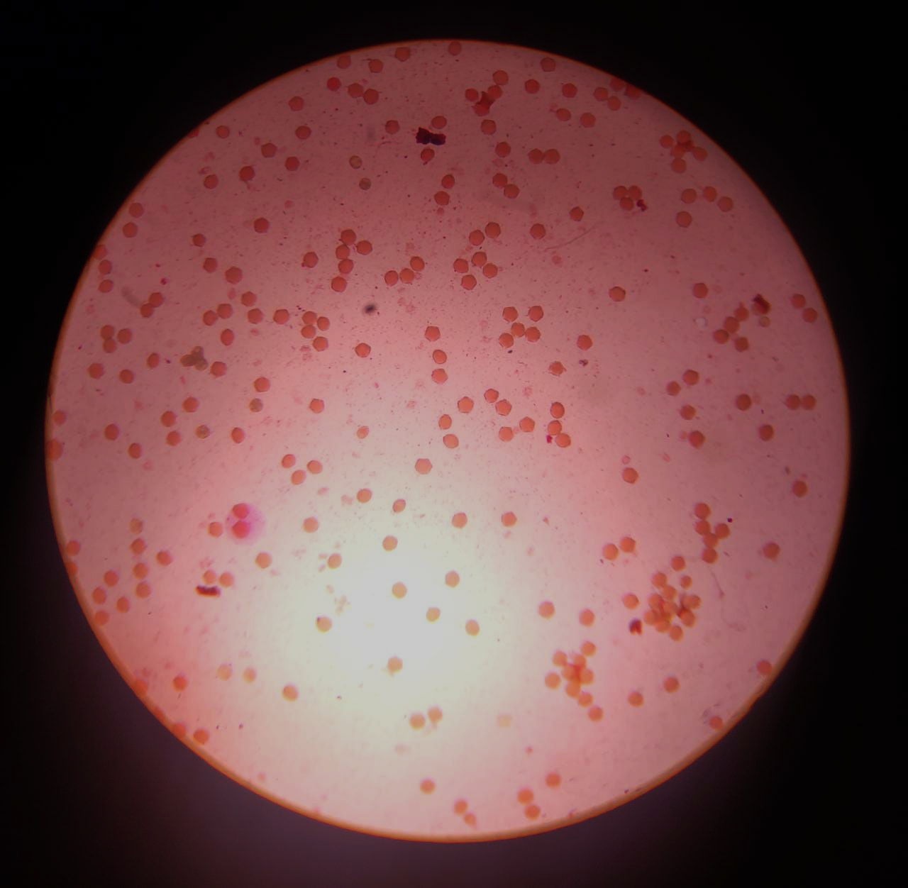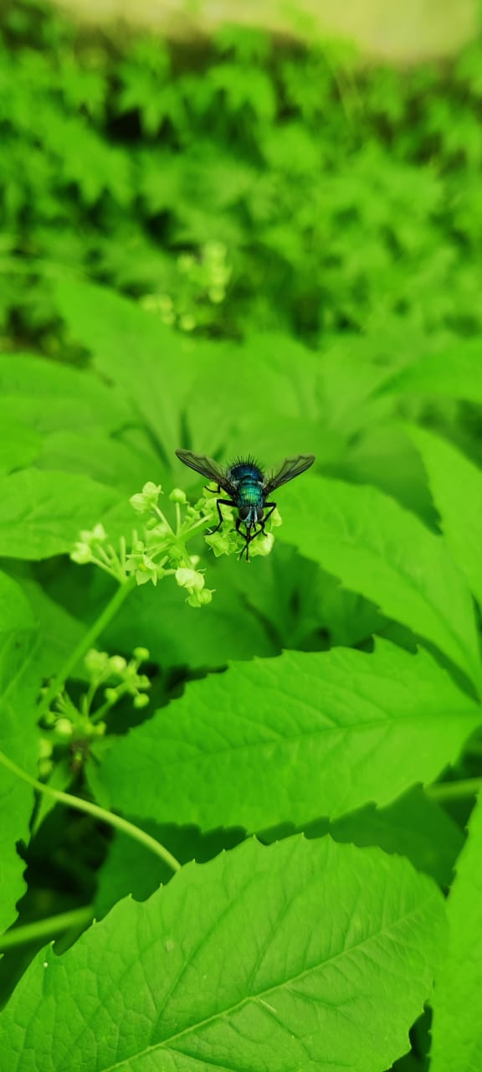
Non-viable pollen
Viable Pollens

Image 1: Pollen viability in Cyclanthera pedata L. Schrad.
Image 2: Pollination by insects in Cyclanthera pedata L. Schrad.

