Review Article
An Overview of Coconut Haustorium: Nutritional Significance, Bioactive Constituents, and Prospects for Functional Food Development
ABSTRACT
Coconut haustorium, also known as coconut apple or sprouted coconut, is an underutilized by-product of the mature coconut that forms during germination. It serves as a nutrient reservoir for the developing embryo and exhibits unique biochemical, functional, and nutraceutical properties. Recent studies highlight its richness in carbohydrates, dietary fibre, protein, minerals, vitamins, and phytonutrients such as phenolics and flavonoids, which contribute to its antioxidant potential. The coconut haustorium’s low fat and cholesterol content, along with its bioactive compounds, make it a promising ingredient for functional food formulations. Studies have indicated that coconut haustorium can be effectively incorporated into bakery products, extruded snacks, and other value-added foods to enhance their nutritional profile without compromising sensory quality. However, limited awareness and scientific exploration have restricted its commercial utilization. Expanding research on its biochemical composition, processing stability, and consumer acceptability can help establish coconut haustorium as a sustainable functional ingredient in food industries. This review highlights its compositional and functional attributes, emphasizing the need for further research and product innovation to promote its application in functional foods, cosmetics, and pharmaceuticals.
Keywords: Coconut haustorium, value addition, functional foods, antioxidant activity, coconut sprouts
INTRODUCTION
The coconut palm (Cocos nucifera L.), often referred to as the “tree of heaven” or Kalpavriksha, is renowned for its exceptional versatility, as nearly every part of the plant holds nutritional, industrial, or economic significance. In India, approximately 10 million people depend directly or indirectly on coconut cultivation and related industries for their livelihood (Subramanian et al., 2024). The country ranks first globally in coconut production and third in area under cultivation, with Kerala, Tamil Nadu, Karnataka, and Andhra Pradesh contributing over 90% of the national yield (CDB, 2025). Grown predominantly in tropical regions, the coconut is a vital food and oilseed crop, providing various edible products such as the kernel, tender coconut, water, and sap. These components are rich in essential nutrients, vitamins, and minerals, making them highly valuable for the food, pharmaceutical (Sathanya et al., 2024), and cosmetic industries (Manivannan et al., 2018).
Extensive studies on the phytochemical composition of coconut and its by-products have revealed a wealth of bioactive compounds, including alkaloids, flavonoids, phenols, and tannins (Manivannan et al., 2018), known for their antibacterial, antifungal, antioxidant, antiviral, and anti-inflammatory properties (Zeng et al., 2024). For instance, coconut husk extracts exhibit notable activity against Vibrio species (Olatunde et al., 2019), while oils derived from dried kernels and fresh coconut milk have demonstrated antioxidant, cytoprotective (Illam et al., 2017), anti-inflammatory (Narayanankutty et al., 2018), hypoglycemic, and anticancer effects (Narayanankutty et al., 2020).
Among the relatively underexplored parts of the coconut, the haustorium, also known as the coconut apple, serves as the germinating cotyledon and nutrient reservoir for the developing embryo. It is rich in minerals, amino acids, antioxidants, and diverse phytochemicals (Tonpe et al., 2014), offering superior nutritional and functional attributes compared to the endosperm. Despite its promising composition and health potential, coconut haustorium remains an underutilized resource. Comprehensive and standardized studies focusing on its phytochemical profile, biological activities, and potential applications are still limited, underscoring the need for further systematic research in this area.
2. COCONUT HAUSTORIUM
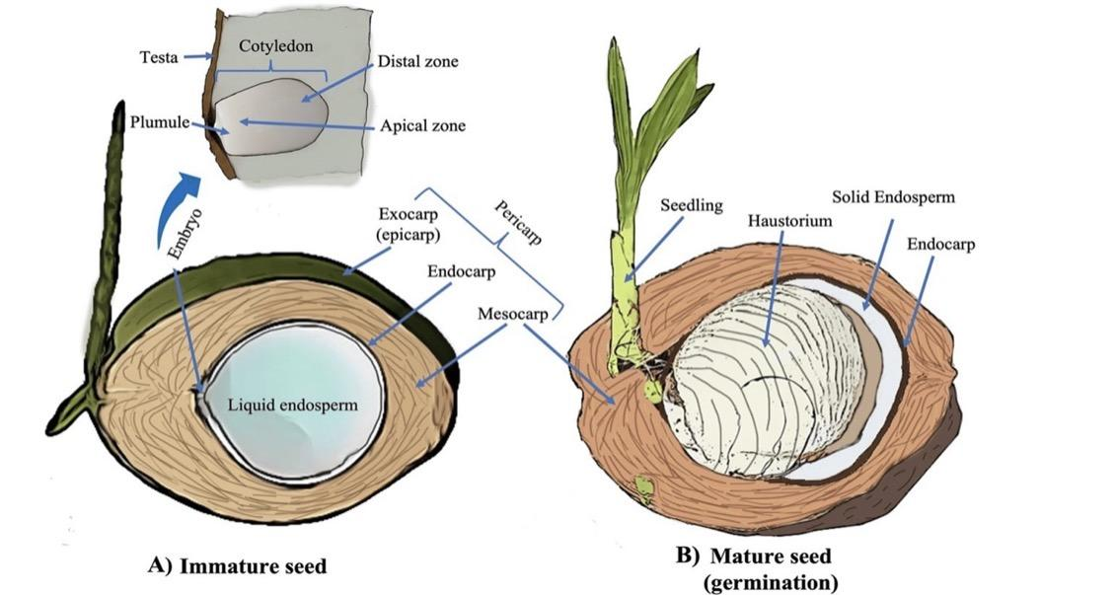
Figure 1. (A) Immature coconut (B) Mature germinating coconut (Tzec-Simá et al. 2022)
The coconut haustorium is a soft, spongy, and edible structure that develops inside the coconut cavity during germination, utilizing coconut water and nutrients from the endosperm. Functioning as the cotyledon, it nourishes the developing embryo by converting stored lipids into soluble sugars, thereby supplying the energy required for seedling growth (Chikku and Rajamohan, 2012). Structurally, the haustorium consists of two distinct regions, an outer oil-rich layer and an inner carbohydrate-dense core, the latter comprising nearly 66% of its total composition, with sugars contributing about 64% of this fraction (Manivannan et al., 2018). During germination, it actively absorbs triacylglycerols from the endosperm, which promotes nutrient mobilization and supports embryo development (Li et al., 2019).
Nutritionally, the haustorium is abundant in proteins, essential minerals, polyphenols, alkaloids, and antioxidants, which together contribute to its antibacterial, anti-inflammatory, and immune-boosting properties (Manivannan et al., 2016). It also contains key phytochemicals and energy-rich compounds, making it a valuable ingredient for functional and nutraceutical applications. Research indicates that the coconut haustorium retains significant levels of minerals, starch, and phenolic compounds throughout germination, maintaining its nutritional quality (Job et al., 2021). Furthermore, its fatty acid profile is closely associated with lipid-to-sugar conversion processes, underscoring its vital metabolic function (Beveridge et al., 2022).
Despite this impressive nutritional and bioactive profile, coconut haustorium remains largely underutilized and is frequently discarded as an industrial by-product (Manivannan et al., 2016). Owing to its crisp texture, natural sweetness, and high nutrient content, it has gained growing attention as a functional food component. Recent studies by Ramesh et al. (2024) have described it as the “coconut treasure” or “coconut heart,” emphasizing its therapeutic and nutraceutical potential for use in innovative, value-added food formulations.
3. Biochemical Constituents of Coconut Haustorium: Bioactive compounds and its properties
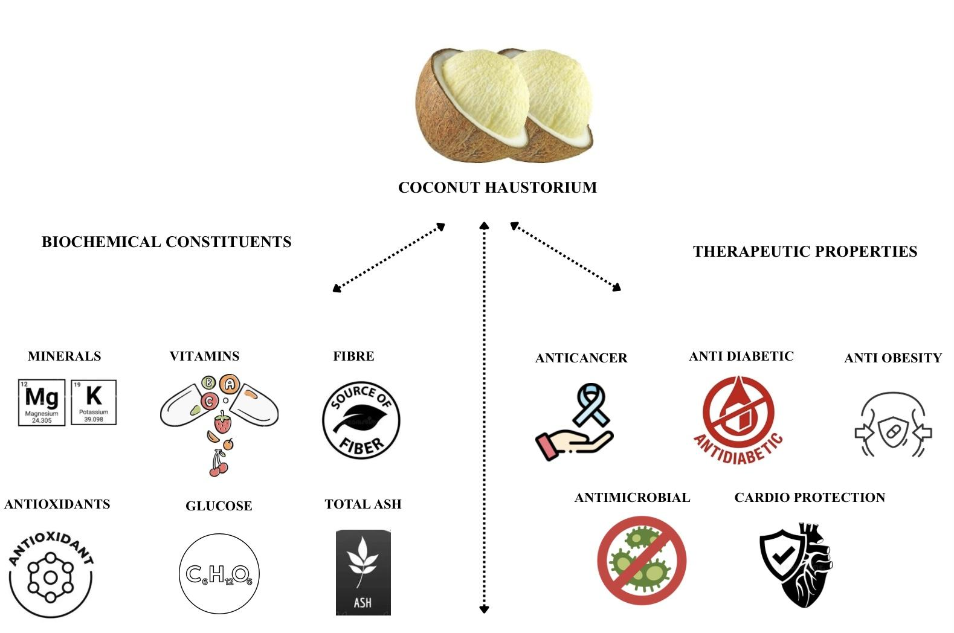
Figure 2. Biochemical and therapeutic properties of Coconut haustorium on human beings
Coconut haustorium, a lesser-explored edible tissue of Cocos nucifera L., has attracted growing scientific interest due to its rich biochemical composition and potential health-promoting properties. Early investigations by Syme et al. (1975) and Kumar et al. (2004) revealed that coconut-derived tissues contain several pharmacologically active substances, including alkaloids, steroids, amino acids, terpenoids, vitamins, and minerals. These bioactive compounds—particularly L-arginine, potassium, and magnesium—play crucial roles in cardiovascular health by supporting vascular function and regulating blood pressure.
Changes in fatty acid composition during germination were examined by Balachandran and Arumughan (1995), who observed a decline in lauric acid from 35.88% to 25.01% and an increase in linoleic acid from 3.00% to 9.86% between the 10th and 22nd weeks of sprouting. This shift from medium-chain to long-chain fatty acids highlighted the dynamic metabolic activity of the haustorium. Manivannan et al. (2016) further reported that the haustorium contains a complex mixture of fatty acids such as caproic, caprylic, capric, lauric, myristic, palmitic, stearic, oleic, and linoleic acids, along with substantial quantities of proteins, amino acids, phenols, flavonoids, terpenoids, carbohydrates, steroids, saponins, and tannins. Among amino acids, aspartic acid was predominant, followed by alanine, proline, and glutamic acid, with total protein content ranging from 4.95% to 6.25%. Sulfur-containing amino acids such as cysteine and methionine were also present.
Manivannan et al. (2018) confirmed that the coconut haustorium’s strong antioxidant potential, attributing it to its high phenolic acid concentration, particularly ferulic acid, with total phenolic content around 146 ± 14.3 mg GAE per 100 g (dry weight). Similarly, Smita et al. (2018) found that unpeeled haustorium exhibited higher phenolic levels (175.5 ± 6.87 mg GAE g⁻¹) than peeled samples (166.67 ± 6.11 mg GAE g⁻¹), suggesting that the outer layer significantly contributes to its antioxidant capacity.
During germination, the haustorium absorbs triacylglycerols from the endosperm and converts lipids into sugars that serve as an energy source for the embryo (Li et al., 2019). This conversion underscores its essential role in nutrient mobilization and metabolic regulation. Gowrie and Valli (2021) also detected cardiac glycosides among its secondary metabolites, indicating potential therapeutic applications against cardiovascular diseases and certain cancers. Using mass spectrometry, Hee et al. (2020) identified key phenolic compounds such as gallic acid, p-coumaric acid, ferulic acid, and trans-cinnamic acid, as well as flavonoids including catechin, myricetin, hesperetin, and kaempferol, which are compounds known to enhance antioxidant and antimicrobial properties.
Mineral composition analysis by Manivannan et al. (2018) revealed that the haustorium is a rich source of essential elements like calcium, potassium, magnesium, phosphorus, manganese, iron, copper, and zinc. A detailed study by Manju et al. (2021) confirmed the abundance of macronutrients such as potassium, phosphorus, calcium, and magnesium, along with trace elements including iron, manganese, zinc, and copper. Potassium was identified as the dominant mineral, accounting for approximately 5% of the dry weight, while the West Coast Tall variety showed particularly high concentrations of calcium (690 ppm) and magnesium (241.5 ppm). The coconut haustorium also contained minimal levels of anti-nutritional factors such as tannins, oxalates, and phytic acid, supporting its suitability for human consumption. Nutrient profiling further revealed that carbohydrates constitute about 66% of its composition, with sugars comprising roughly 64% of this fraction, making it a significant source of energy and dietary fibre. Its composition also makes it suitable for use in infant foods, particularly for lactose-intolerant children. Additionally, Manju et al. (2021) reported considerable vitamin content, including Vitamin C (36.67–61.23 mg 100 g⁻¹), Vitamin E (7.13–48.9 mg 100 g⁻¹), and Niacin (0.23–21.92 mg 100 g⁻¹), which contribute to its nutraceutical and cosmetic potential.
Fatty acids, fundamental components of triacylglycerols, phospholipids, and other complex lipids, are essential for human health and metabolism. Studies by Li et al. (2019) and Beveridge et al. (2022) demonstrated dynamic changes in fatty acid composition during germination, showing that medium-chain fatty acids such as lauric and myristic acids initially increase and later decline with maturity. Although unsaturated fatty acids were detected, they were present in relatively small quantities (Narayanankutty et al., 2022).
The amino acid composition of haustorium also provides insight into its nutritional quality. Essential amino acids such as histidine, isoleucine, leucine, lysine, methionine, phenylalanine, threonine, tryptophan, and valine which are critical for protein synthesis and metabolic regulation (Yoneda et al., 2009). Research by Zhang et al. (2022) and Norma et al. (2024) confirmed the presence of 17 amino acids, including these essential ones, in coconut haustorium. Glutamic acid was found to be the most abundant (110.80–145.92 mg per g protein), while lysine-rich samples were identified as promising raw materials for the preparation of haustorium-based value-added products such as milk and syrup.
Spectroscopic analyses conducted by Gowrie and Valli (2021) detected various functional groups such as esters, carboxylic acids, alkanes, and alcohols, confirming the complex biochemical nature of the haustorium. FT-IR analysis of both fresh and dried samples also revealed antioxidant-related functional groups, substantiating its bioactive potential.
Phenolic profiling studies by Narayanankutty et al. (2022) and Kim et al. (2023) identified gallic, ferulic, cinnamic, and coumaric acids as dominant phenolic compounds, with ferulic acid concentrations ranging from 4.27 ± 0.50 mg 100 g⁻¹ to over 2,000 µg g⁻¹, as reported by Archana and Lekshmi (2024). The total phenolic content ranged between 83–150 mg GAE 100 g⁻¹, confirming the haustorium’s strong antioxidant potential. Similarly, flavonoid analyses by Narayanankutty et al. (2018) and Kannaian et al. (2020) revealed total flavonoid contents ranging from 1.19 to 73.5 mg QE 100 g⁻¹, with myricetin being the predominant compound, followed by hesperetin, kaempferol, and catechin. Valli and Sezhian (2021) further reported that terpenoids and saponins were more abundant than flavonoids and phenolics, with total terpenoid and saponin contents of 3.77 g and 3.16 g per 100 g, respectively.
4. Health Benefits of Coconut Haustorium
4.1 Anticancer property
Coconut haustorium contains several bioactive compounds that contribute to its notable anticancer potential. Ferulic acid, one of its key phenolic constituents, exists predominantly in a bound form, linked to lignin and polysaccharides through ether and ester bonds. Under alkaline hydrolysis, it can be liberated into its free form, enhancing its bioavailability (Kim et al., 2006). This compound is well known for its therapeutic value, particularly in preventing or mitigating diseases such as cancer, diabetes, hypertension, and neurodegenerative disorders like Alzheimer’s disease, as well as in reducing skin pigmentation (Zhao and Moghadasian, 2008).
In addition to ferulic acid, the haustorium is rich in other bioactive molecules, including quinoline, flavones, acetylenic acid, and oleic acid, all of which exhibit strong anti-inflammatory and anticancer properties (Gopalakrishnan and Vadivel, 2011). Among these, quinoline, which constitutes about 15.53% of the haustorium’s bioactive profile, has demonstrated efficacy against both chloroquine-sensitive and chloroquine-resistant parasites. Oleic acid contributes additional pharmacological benefits, such as anti-inflammatory, anticancer, anti-androgenic, and hypocholesterolemic effects, as well as 5-α reductase inhibition and dermatological applications.
Furthermore, various bioactive constituents of the haustorium have shown antiepileptic and antitumor activities, with potential to inhibit cancer progression at multiple stages of development (Wierzbicka et al., 2012). Terpenoids, abundant in the haustorium and commonly synthesized in higher plant tissues, are particularly recognized for their cancer-preventive properties (Ludwiczuk et al., 2017). Similarly, saponins present in the haustorium exhibit hemolytic and wound-healing activities and have been reported to possess significant anticancer potential (Parimalam et al., 2021).
4.2 Cardiovascular and digestive wellness
The coconut haustorium is a nutrient-dense and bioactive component of the coconut fruit, rich in quinones, proteins, carbohydrates, flavonoids, cardiac glycosides, phenols, tannins, fixed oils, lipids, amino acids, and various fatty acids. Its consumption has been linked to several gastrointestinal health benefits, particularly in alleviating peptic ulcers resulting from Helicobacter pylori infections or the use of non-steroidal anti-inflammatory drugs (Bandyopadhyay et al., 2001). The amino acid L-arginine, along with minerals such as potassium and magnesium, enhances its cardioprotective capacity by supporting cardiovascular function (Kumar et al., 2009).
Additionally, coconut the haustorium provides a beneficial combination of low calorie content, high dietary fibre, and digestive enzymes, all of which aid in improving metabolism and promoting digestive health. Chikku and Rajamohan (2012) demonstrated its cardioprotective and antioxidant effects in an animal study, where rats pretreated with coconut haustorium extract before isoproterenol-induced myocardial infarction exhibited lower heart injury markers, enhanced antioxidant enzyme activity, and reduced myocardial lipid peroxidation. Furthermore, triterpenoid squalene, identified in coconut sprouts through mass spectrometry and molecular docking, has shown significant anti-ulcer potential against H. pylori, indicating its role in gastrointestinal protection and possible prevention of colorectal cancer (Mohan et al., 2018).
Coconut haustorium also contains omega-3 fatty acids, which are known to improve cardiovascular health by reducing low-density lipoprotein (LDL) cholesterol and lowering the risks of heart attacks and strokes. Recent findings have also highlighted its antidiarrheal activity and positive effects on gut microbiota (Wahyu et al., 2021). Overall, the coconut haustorium demonstrates multifaceted nutraceutical properties, offering cardioprotective, antioxidant, gastrointestinal, and metabolic health benefits.
4.3 Anti-inflammatory and anti-diabetic property
Excessive activation of phagocytes and the overproduction of free radicals and reactive oxygen species are known to cause tissue damage during inflammatory responses (Lewis, 1989). Studies have shown that fresh coconut sprouts exhibit stronger anti-inflammatory activity compared to dried ones, with the effect increasing proportionally with dosage (Mitchell and Cotran, 2003). Inflammation typically arises from protein denaturation during trauma or infection, leading to redness, pain, swelling, and the activation of inflammatory cells that facilitate tissue defense and healing (Leela and Mohan, 2011).
Coconut haustorium contains several bioactive compounds with potent anti-inflammatory and antioxidant properties. Myricetin, one of its key constituents, has been reported to protect against oxidative stress and skin photoaging (Jung et al., 2010). The presence of oleic acid contributes additional pharmacological benefits, including anti-inflammatory, antiandrogenic, cholesterol-lowering, and cancer-preventive effects (Gopalakrishnan and Vadivel, 2011). Flavonoids in the haustorium further enhance its therapeutic potential by exhibiting antibacterial, anti-inflammatory, antiangiogenic, and antiallergic activities (Hossain et al., 2013). Moreover, phenolic compounds such as gallic acid, p-coumaric acid, ferulic acid, and catechin have been identified, and methanolic extracts of coconut haustorium have been shown to protect intestinal epithelial cells from fluoride-induced oxidative stress by boosting glutathione levels and reducing apoptosis (Appaiah et al., 2014; Job et al., 2021).
Beyond its anti-inflammatory potential, coconut haustorium also exhibits notable anti-diabetic properties. Its flavonoids contribute to both antioxidant and hypoglycemic effects (Sarian et al., 2017). The haustorium demonstrates strong α-amylase and α-glucosidase inhibitory activities, indicating its capacity to regulate postprandial blood glucose levels (Narayankutty et al., 2022). Additionally, the high potassium content promotes vasodilation and improved blood circulation, thereby reducing the risk of cardiovascular complications such as heart attacks and strokes.
4.4 Anti-microbial and anti-obesity property
Coconut haustorium is rich in bioactive compounds such as terpenoids and flavonoids, which are responsible for its strong antioxidant, anti-inflammatory, antibacterial, antiviral, and antimalarial activities (Indumathi et al., 2014; Li et al., 2018). These phytochemicals not only enhance the haustorium’s antimicrobial potential but also play key roles in gene regulation, apoptosis induction, antiproliferative effects, and modulation of inflammatory responses. The antibacterial efficacy of coconut haustorium has been demonstrated through methanolic extracts, where a concentration of 100 µg produced the largest inhibition zone of 32 ± 0.6 mm against Shigella flexneri, while the smallest zone (5 ± 0.1 mm) was observed against Escherichia coli (Gowrie and Valli, 2017). The weak inhibition against E. coli suggests that consumption of fresh haustorium does not disrupt the beneficial gut microbiota, while still offering protection against pathogenic bacteria.
Beyond its antimicrobial potential, coconut haustorium also exhibits significant anti-obesity properties due to the presence of natural lipase enzymes. These enzymes catalyze the hydrolysis of triglycerides, diglycerides, and monoglycerides into free fatty acids and glycerol, thus facilitating fat metabolism (Sana et al., 2004). The lipase activity in haustorium has been reported as 0.0581 U mg⁻¹ (Su’i et al., 2010), with stability even in acidic environments, making it effective for fat digestion (Almeida et al., 2016). Budyghifari et al. (2019) further demonstrated that heating coconut haustorium at 60°C for 12 hours resulted in a 97% reduction in cholesterol levels, confirming the functional activity of its lipase enzymes. These enzymes exist in a naturally immobilized and stable form, maintaining activity at room temperature and minimizing contamination risks, thereby enhancing the haustorium’s potential as a functional ingredient for promoting lipid metabolism and cardiovascular health.
4.5 Antioxidant activity
Coconut haustorium demonstrates significant antioxidant potential, largely due to its rich content of vitamin C, terpenoids, and phenolic compounds (Gowrie and Valli, 2017). Vitamin C functions as a vital physiological antioxidant (Frei et al., 1989) and also helps regenerate other antioxidants in the body, such as vitamin E (Jacob and Sotoudeh, 2002). Reactive oxygen species (ROS) and other free radicals, generated endogenously through metabolic processes or from external sources, can oxidize cellular macromolecules,including proteins, lipids, carbohydrates, enzymes, and nucleic acids, resulting in impaired immune function, tissue damage, and cell death. Oxidative stress is implicated in several chronic human disorders, including atherosclerosis, arthritis, and cancer. Studies have shown that the bioactive compounds in coconut haustorium efficiently scavenge free radicals, comparable to standard antioxidants like ascorbic acid. Specifically, Smita et al. (2018) reported that peeled coconut haustorium flour exhibited notable DPPH radical scavenging activity, with an IC50 value of 67.2 ± 1.25 mg TE, highlighting its strong antioxidant capability. This property underlines the potential of coconut haustorium as a functional ingredient for reducing oxidative stress and enhancing overall health.
5. Utilization of coconut haustorium in the development of functional foods and beverages
Farmers frequently encounter difficulties with coconut haustorium because of its high perishability and limited shelf life. To overcome this, adding value to coconut haustorium not only helped to minimize waste but also boosted farmers' earnings.
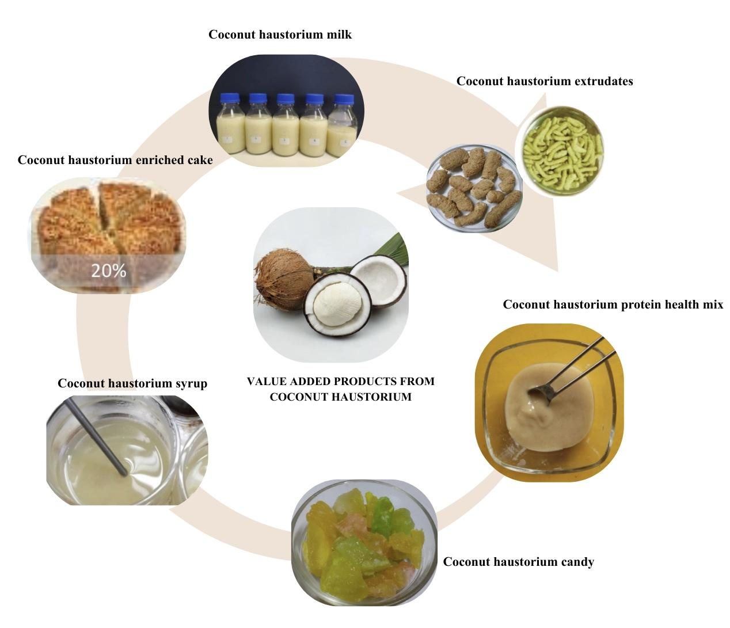
Figure 3. Value added products developed from coconut haustorium
Coconut haustorium candy: Coconut haustorium was transformed into a gelatinous candy through a structured process involving osmotic treatment and sugar infusion. Initially, the haustorium was cleaned, sliced into approximately 1-inch pieces, and pre-treated with 1% calcium hydroxide followed by 1% alum to enhance structural firmness. The slices were then rinsed and soaked in a 50° Brix sugar solution for 2–3 hours. Osmotic dehydration was continued by boiling the mixture with citric acid until the Brix level reached 65°, followed by reheating to achieve a final Brix of 70°. Any subsequent decrease in Brix was corrected through additional heating. After cooling, flavors and colors were added to enhance sensory appeal, with studies showing that flavors such as strawberry, lemon, litchi, mango, pineapple, guava, chili, chili-pepper, and lemon-mint paired well with the candy. This process highlighted the potential of coconut haustorium as a versatile ingredient in value-added confectionery products (Joy et al., 2017)
Protein health mix: A nutritious protein mix was developed using coconut haustorium and virgin coconut oil (VCO) residue as primary components. The haustorium was collected and blanched in a 0.05% potassium metabisulfite (KMS) solution before use. The formulation consisted of arrowroot powder (22%), haustorium powder (20%), VCO residue (20%), sprouted green gram powder (8%), milk powder (10%), and sugar (20%), along with added flavoring agents and a small amount of salt for taste improvement. In a hot air oven, each component was dried independently for one to two hours at 90°C. The components are dried, then pounded into a powder and sealed in pouches of laminated aluminium foil (Joy et al., 2017).
Coconut haustorium flour: Smita et al. (2018) conducted a study evaluating the physicochemical, functional, morphological, and antioxidant characteristics of coconut haustorium flour, comparing peeled and unpeeled samples. The results showed significant differences in color, flow properties, amylose content, and chemical composition between the two types of flour. Notable variations were identified in the water solubility index, swelling capacity, and pasting properties, such as pasting point, peak viscosity, hold viscosity, and final viscosity. Moreover, the starch content was found to be higher in peeled coconut haustorium flour (20.47 ± 0.57 g per 100 g) than in its unpeeled counterpart (14.62 ± 1.45 g per 100 g). Scanning electron microscope analysis of the granule morphology revealed that the granules of both flours varied in shape from oval to irregular. Similarly, Siahaya et al. (2021) determined the optimal drying parameters for producing coconut haustorium flour, reporting that drying at 50 °C for 8 hours resulted in flour containing 11.74% moisture, 8.17% fat, 11.72% protein, 7.49% ash, and 11.84% crude fibre. These compositional qualities indicated its suitability for use in food formulation.
Coconut haustorium based extrudates: Extrusion, a widely adopted technique in the snack food industry, has become increasingly significant in recent years. Adding coconut haustorium to extruded snacks offers a nutritious alternative to conventional products, as the haustorium is a rich source of phytonutrients. The inclusion of this ingredient in extruded formulations has been found to enhance the presence of beneficial compounds such as phenolics and flavonoids, contributing to the development of healthier snack options. Manivannan et al. (2018) used coconut haustorium flour instead of maize while developing extrudates with rice flour. At concentrations of 0%, 10%, 20%, and 30% (w/w), haustorium was used in place of maize in a flour blend of rice and maize (1:1). The mixture was further processed using a twin-screw extruder. Analysis was done on the effects of adding haustorium on the various chemical and physical properties of the extrudates. These properties included bulk density, expansion ratio, water absorption and solubility indices, compressive strength, hardness, breaking force, as well as color characteristics such as hue and chroma values. Based on its biochemical profile and overall sensory acceptability, a blend of 50% rice, 30% maize, and 20% haustorium was determined to be the most effective for producing healthy and nourishing extrudates. The findings showed that the inclusion of haustorium significantly affected these characteristics and that the extrudates containing haustorium were longer, darker, firmer, less expanded, and richer in minerals, protein, phenolics, and flavonoids. They also showed increased antioxidant activity.
Coconut haustorium ready to serve beverage: As a prospective substitute for coconut water, drinks derived from coconut haustorium provide a number of health advantages, including blood pressure regulation, digestive assistance, increased hydration, decreased risk of heart disease, and assistance with renal diseases (Senarath and Perera, 2018). The widely used RTS (Ready-to-Serve) drinks typically have a minimum of 10% fruit juice, 0.3% acid and not less than 10% TSS. Using coconut haustorium, a novel beverage was created by Rajeshwari et al .2024 which contrasted with the popular refreshing beverage. Coconut water, sugar, citric acid, 0.2% pectin, and 18% coconut haustorium made up the most popular version of the beverage. This beverage's total phenolic content was greater than that of coconut water, according to analysis.
Coconut haustorium wine: In a study by Mohan et al. (2018), coconut sprouts were assessed as a potential substrate for wine production and found to be an excellent base for creating wine. When coconut haustorium was fermented using the yeast, Saccharomyces cerevisiae, the result was a distinctive beverage with significant health benefits. The coconut sprouts were chopped into small pieces, blended into a paste with 500ml of distilled water, and then 250ml was used as a control, while the remaining 250ml was fermented to create the sample.Ten millilitres of water were used to dissolve one gram of yeast, which was then combined with wine and allowed to sit at room temperature. A 2% starter culture was added to the prepared must to start the fermentation process. After thoroughly mixing the must, it was stored in a cold, dry location to ferment. For 20 days, fermentation was carried out. At 5-day intervals, aliquots were extracted from the sample and used for carrying out various analytical procedures. During the 20-day evaluation period of the wine, a decline in total phenolic content was observed. Other quality parameters such as electrical conductivity, yeast population, and antioxidant activity were also monitored. After 20 days of storage, the wine achieved an overall sensory rating of 7 out of 10 and had an alcohol concentration of 9.1%. The probiotics present in the coconut haustorium-based wine were found to have potential benefits for gut health and digestion. Moreover, its electrolyte content particularly sodium, potassium, and bicarbonates may help reduce the risk of heart-related ailments.
Coconut haustorium filled Tarts: Terana (2023) explored the incorporation of coconut haustorium into tart fillings at four inclusion levels (0–200 g). The formulation with 200 g of coconut haustorium achieved the highest sensory acceptance, with mean overall scores of 8.74 from experts and 8.71 from consumers. This version also exhibited enhanced nutritional value, comprising 19.8% fat, 6.16% protein, 21.3% moisture, 1.27% ash, and 51.7% carbohydrates, categorizing it as an energy-dense product.
Osmo-dehydrated coconut haustorium: Archana and Lekshmi (2024) investigated the development of osmo-dehydrated coconut haustorium by optimizing factors like immersion time and osmotic solution concentration. The study assessed its nutritional quality and consumer acceptance by analyzing mass transfer, physical characteristics, biochemical composition, and sensory properties. The findings indicated that osmotic dehydration was a highly effective method for boosting haustorium's value and prolonging its shelf life. After being dehydrated for 180 minutes at a concentration of 60° Brix, coconut haustorium was discovered to be both more nutrient-dense and well accepted by the consumers. This study showed how coconut haustorium can be used to make new and practical products for the food industry, such as a snack with a long shelf life and a lot of demand.
Coconut haustorium enriched cashew nut cake: Ashok et al. (2025) replaced cashew powder in cake formulations with 0–30% coconut haustorium. At 20% substitution, nutritional improvements were observed: protein increased to 8.8 g per 100 g (from 2.7), fibre to 2.3 g per 100 g (from 0.9), and ash to 2.1 g per 100 g (from 1.5). Fat decreased to 8.4 g per 100 g (from 13), while antioxidant activity significantly increased to 76.5% inhibition compared to 49.2% in the control. Total phenolics also increased to 5954.7 mg per 100 g from 3275.1 mg per 100 g in control. Sensory evaluation confirmed enhanced acceptability of the haustorium-enriched cake.
Coconut haustorium enriched Kodo millet extrudates: Gaikwad et al. (2024) formulated Kodo millet-based snacks enriched with coconut haustorium, which enhanced the expansion ratio from 2.69 to 3.315. The fortified snacks also showed an increase in total phenolic content to 197.8 mg gallic acid equivalent per 100 g, compared to 182.7 mg GAE per 100 g in the control, and a rise in antioxidant activity from 38.17% to 42.13%. Despite slight reductions in protein and fat content, notable improvements were observed in functional characteristics such as water absorption capacity, which rose from 4.83 g g⁻¹ to 6.87 g g⁻¹. Additionally, the treated snacks exhibited a softer texture (106.27 N) and greater porosity, enhancing their crispiness and overall consumer appeal.
Coconut haustorium milk and syrup: Coconut haustorium can be processed into a nutrient-rich, plant-based milk, which serves as a base for developing haustorium syrup with natural sweetness and a pleasant, aromatic flavor. The copra from sprouted coconuts retains a substantial amount of coconut oil, making it suitable for various food applications. The haustorium milk was recovered at a rate of 73.39%, producing an opaque liquid with 7.20 ± 0.42° Brix, resembling cow’s milk in color, with a sweet taste and fresh coconut aroma. The haustorium syrup was obtained from this haustorium milk with recovery rates of 12%, 15%, and 20%, featuring a creamy, viscous texture and a mildly sweet coconut flavor and fragrance (Norma et al., 2024).

6. Challenges in Utilizing Coconut Haustorium
The utilization of coconut haustorium faces several challenges, which have limited its commercial and nutritional applications despite its rich bioactive and nutritional profile. One major concern is the variability in nutrient composition among different coconut varieties. For instance, the West Coast Tall variety has been reported to contain high levels of anti-nutritional factors such as tannins, oxalates, and phytic acid, complicating the selection of varieties that provide balanced essential nutrients (Manju et al., 2021).
Another significant limitation is its extremely short shelf life, typically lasting only two days without refrigeration, making storage and distribution challenging. Appropriate packaging strategies are therefore critical to extend its usability (Preethi and Anil, 2023). Additionally, haustorium is relatively low in certain nutrients, such as key amino acids and calcium, necessitating external supplementation for formulating a nutritionally balanced diet (Rajeshwari et al., 2024). Nonetheless, its high carbohydrate content and lauric acid concentration make it suitable for specific populations, such as lactose-intolerant children.
From an industrial perspective, coconut haustorium remains largely underutilized due to its marginal economic value, delicate structure, and difficulties in processing and preservation. Additionally, the lack of traditional use and inadequate market development has resulted in haustorium often being discarded as waste. Although some researches have explored its potential as a functional ingredient or food additive, these initiatives are still in early stages and have not yet achieved widespread adoption (Smita et al., 2019).
Future efforts must focus on extending shelf life, improving processing techniques, and enhancing market awareness. Furthermore, in-depth molecular studies, in vivo experiments, and clinical trials are required to validate its pharmacological potential, biocompatibility, and efficacy, thereby supporting its development into sustainable functional foods, nutraceuticals, or even drug delivery systems. Comprehensive research could transform coconut haustorium from an underutilized by-product into a valuable resource with therapeutic, nutritional, and economic significance.

7. Conclusion
his review underscores the remarkable biochemical and therapeutic potential of coconut haustorium, an often-overlooked yet highly nutritious by-product of the germinating coconut. Rich in proteins, dietary fibre, essential minerals, and diverse bioactive compounds including alkaloids, phenolics, flavonoids, terpenoids, and saponins, the haustorium exhibits significant antioxidant, anti-inflammatory, anticancer, cardioprotective, and antimicrobial activities. Its balanced fatty acid profile and abundance of vitamins C and E further contribute to its role in promoting immune function, cardiovascular health, and metabolic regulation. The demonstrated health benefits such as reduction of oxidative stress, management of peptic ulcers, and enzyme-inhibitory effects relevant to diabetes control make it a promising ingredient for functional and therapeutic food development.
Despite these attributes, coconut haustorium remains underutilized and is frequently discarded as waste. To unlock its full potential, future research should focus on comprehensive characterization of its bioactive components, optimization of processing and preservation methods, and evaluation of its functional efficacy through in vivo and clinical studies. Additionally, exploring its incorporation into nutraceuticals, dietary supplements, and cosmeceutical formulations could open new avenues for product innovation and economic value addition. Promoting awareness, developing scalable processing technologies, and establishing quality standards will further facilitate its commercialization. Harnessing the nutritional and pharmacological benefits of coconut haustorium can thus transform this neglected by-product into a sustainable and valuable functional ingredient for the food and health industries.
DISCLAIMER (ARTIFICIAL INTELLIGENCE)
Author(s) hereby declare that NO generative AI technologies such as Large Language Models (ChatGPT, COPILOT, etc.) and text-to-image generators have been used during the writing or editing of this manuscript.

COMPETING INTERESTS
Authors have declared that no competing interests exist.

References (Arranged in the order of occurance)
Subramanian, P., Gupta, A., Gopal, M., Selvamani, V., Mathew, J., Surekha, and Indhuja, S. 2024. Coconut (Cocos nucifera L.). In Soil Health Management for Plantation Crops: Recent Advances and New Paradigms (pp. 37-109). Singapore: Springer Nature Singapore.
Sathanya, P. S., Vignesh, S., and Baskaran, N. (2024). Palmyra and coconut haustorium: A comprehensive review on nutritional composition, bioactive potential, value-added products and its health benefits. Food Chemistry Advances, 5, 100836.
Manivannan, A., Manikantan, M. R. A. M., Balasubramanian, K. B., Hebbar, K., Santosh R., and Kanade, A. 2018. Physiochemical and nutritional characterization of coconut (Cocos nucifera L.) haustorium based extrudates. LWT. 89: 171-178
Zeng, Y. Q., He, J. T., Hu, B. Y., Li, W., Deng, J., Lin, Q. L., and Fang, Y. 2024. Virgin coconut oil: A comprehensive review of antioxidant activity and mechanisms contributed by phenolic compounds. Critical Rev. Food Sci. and Nutr., 64(4), 1052-1075.
Olatunde, O. O., Benjakul, S., and Vongkamjan, K. 2019. Coconut husk extract: antibacterial properties and its application for shelf-life extension of Asian sea bass slices. Int. J. Food Sci. Technol., 54(3), 810-822
Illam, S. P., Narayanankutty, A. and Raghavamenon, A. C. 2017. Polyphenols of virgin coconut oil prevent pro-oxidant mediated cell death. Toxicol. Mech. Methods. 27(6): 442-450.
Narayanankutty, A., Job, J. T., Kuttithodi, A. M., Sasidharan, A., Benil, P. B., Ramesh, V., and El-Din, M. M. E. 2023. Proximate composition, antioxidant, anti-inflammatory and anti-diabetic properties of the haustorium from Coconut (Cocos nucifera L.) and Palmyra palm (Borassus flabellifer L.). Journal of King Saud University-Science, 35(1), 102404.
Tonpe, K. K., Sakhare, V. P. and Sakhale, C. N. 2014. Design and Performance of Coconut De-Shelling Machine. Int. J. Eng. Res. Appl. 4(7): 39-44.
Tzec-Simá M., Félix J.W., Granados-Alegría M., Aparicio-Ortiz M., Juárez-Monroy D., Mayo-Ruiz D., Vivas-López S., Gómez-Tah R., Canto-Canché B., Berezovski, M.V. and Islas-Flores I. 2022. Potential of Omics to Control Diseases and Pests in the Coconut Tree. Agronomy, 12, 3164.
Chikku, A. M. and Rajamohan, T. 2012. Dietary coconut sprout beneficially modulates cardiac damage induced by isoproterenol in rats. Bangladesh J. Pharm. 7: 258-6.
Li, J., Wang, Y., Yang, Y., Kareem, A., and Wang, R. 2019. Analysis of sugars and fatty acids during haustorium development and seedling growth of coconut. Agr. J. 111(5): 2341-2349
Manivannan, A., Bhardwaj, R., Padmanabhan, S., Suneja, P., Hebbar, K. B., and Santosh R. K. 2016. Biochemical and nutritional characterization of coconut (Cocos nucifera L.) haustorium. Food Chem. 238: 153-159.
Beveridge, F. C., Kalaipandian, S., Yang, C., and Adkins, S. W. (2022). Fruit biology of coconut (Cocos nucifera L.). Plants, 11(23), 3293.
Ramesh, S. V., Krishnan, V., Praveen, S., and Hebbar, K. B. 2021. Dietary prospects of coconut oil for the prevention and treatment of Alzheimer’s disease (AD): A review of recent evidences. Trends Food Sci. Technol., 112, 201-211.
Syme, S. L., Marmot, M. G., Kagan, A., Kato, H., and Rhoads, G. 1975. Epidemiologic studies of coronary heart disease and stroke in Japanese men living in Japan, Hawaii, and California: Introduction. Am. J. Epidemiol. 102(6): 477-80.
Kumar, S. H., Farvin, S. K. H., Anandan, R., Shiny, K. S., Sankar, T. V., and Thankappan, T. K. 2004. Effect of squalene on tissue defense system in isoproterenol-induced myocardial infarction in rats. Pharmacol Res. 50(3) :231-6.
Balachandran, C. and Arumughan, C. 1995. Biochemical and cytochemical transformations in germinating coconut (Cocos nucifera Linn.). JAOC. 72: 1385-1391.
Smita, M., Bashir, M., and Haripriya, S. 2018. Physicochemical and functional properties of peeled and unpeeled coconut haustorium flours. J. Food measurement characterization.13(1): 154
Gowrie, U. S. and Valli, A. S. 2021 Bioprospecting and Therapeutic Applications of Cocos nucifera L. Sprouts. Int. J. Curr. Res. Rev. 9(3): 35- 42.
Maryani, Y., Rochmat, A., Khastini, R. O., Kurniawan, T., and Saraswati, I. 2021. Identification of macro elements (sucrose, glucose, and fructose) and micro elements (metal minerals) in the products of palm sugar, coconut sugar, and sugar cane. In 2nd and 3rd International Conference on Food Security Innovation (ICFSI 2018-2019) (pp.271–274). Atlantis Press.
Manju, M., Aiswarya, A., Bindu, R. N. and Laija, S.N. 2021. Nutritional analysis of haustoria from three varieties of coconut (Cocos nucifera L.). Ann. Food Sci. Technol. 22(3): 362-368
Yoneda, J., Andou, A., and Takehana, K. 2009. Regulatory roles of amino acids in immune response. Current Rheumatology Rev., 5(4), 252–258.
Zhang, Y., Kan, J., Tang, M., Song, F., Li, N., and Zhang, Y. 2022. Chemical composition, nutritive value, volatile profiles, and antioxidant activity of coconut (Cocos nucifera L.) haustorium with different transverse diameter. Foods. 11(7): 916- 923.
Norma, H., Rosalizan, S., Mirfat, A. H. S., Noor Ismawaty, N., Mohd Effendi, M. N., Umikalsum, M. B., Zaulia, O., Mazidah, M., Rozlaily, Z., Asraf Hadi, A. S., Muhammad Faris, M. R., Noor Safura, S., Zulkefli, A. R., and Muhammad Faidhi, T. 2024. Evaluations on the physical, chemical, and nutritional analyses of coconut haustorium. Food Res., 8(4), 136–141.
Kim, R. H., Lee, S. J., Lee, K., Hwang, K. T., and Kim, J. 2023. Profiling of phenolic acids, flavonoids, terpenoids, and steroid derivatives in coconut (Cocos nucifera L.) haustorium. Food Sci. Biotechnol. 32(13):1841-1850.
Archana, A. K. and Lekshmi, G. P. R. 2024. Standardization of process variables for the development of osmo-dehydrated coconut haustorium. Asian J. Dairy Food Res.42(2):1-8.
Kannaian, U. P. N., Edwin, J. B., Rajagopal, V., Shankar, S. N., and Srinivasan, B. 2020. Phytochemical composition and antioxidant activity of coconut cotyledon. Heliyon. 6(2): 3411.
Valli, A. S. and Sezhian, U. 2021. Bioprospecting and Therapeutic Applications of Cocos nucifera L. Sprouts. Int. J. Current Res. Rev. 13: 35-42.
Kim, K. H., Tsao, R., Yang, R., Cui, S. W. 2006. Phenolic acid profiles and antioxidant activities of wheat bran extracts and the effect of hydrolysis conditions. Food Chem. 95: 466-473.
Zhao, Z. and Moghadasian, M. H. 2008. Chemistry, natural sources, dietary intake, and pharmacokinetic properties of ferulic acid: a review. Food Chem. 10(9): 691-702.
Gopalakrishnan, S. and Vadivel, E., 2011. GC-MS analysis of some bioactive constituents of Mussaenda frondosa Linn. Int. J. Pharma. Bio Sci. 2(1): 313-320.
Wierzbicka, M. M., Czeczot, H. 2012. Flavonoids in the prevention and treatment of cardiovascular diseases. Polski Merkuriusz Lekarski 32: 50-54.
Ludwiczuk, A., Skalicka-Woźniak, K., and Georgiev, M. 2017. Terpenoids. In: Badal, S. and Delgoda, R. (ed.), Pharmacognosy Fundamentals, Applications and Strategies. Academic press, Jamaica, pp. 233-266.
Parimalam, M., Pushpa, V. R., Deepak, K. K. 2021. Study of phytochemical screening and gc-ms analysis of two extracts of coconut haustorium. J. Adv. Sci. Res.12 (02): 348-353.
Bandyopadhyay, D., Biswas, K., Bhattacharyya, M., Reiter, R. J. and Banerjee, R. K .2001. Gastric toxicity and mucosal ulceration induced by oxygen-derived reactive species, protection by melatonin. Curr. Mol. Med. 1(4): 501-1.
Kumar, P., Goyal, M., and Agarwal, J. L. 2009. Effect of L-arginine on electrocardiographic changes induced by hypercholesterolemia and isoproterenol in rabbits. Indian Pacing Electrophysiol J. 9(1): 45-52.
Chikku, A. M. and Rajamohan, T. 2015. Coconut Haustorium Maintains Cardiac Integrity and Alleviates Oxidative Stress in Rats Subjected to Isoproterenol-induced Myocardial Infarction. Indian J. Pharma. Sci. 74(5): 397–402
Mohan, S. M. R., Sayoojya, K. P., Souparnika, A. P., Sowparnika, K., Pournami T. S., Sabu, K. R., Rajesh, B. R., and Chandran, P. 2018. Production of coconut sprout wine using Saccharomyces cerevisiae and its physico-chemical analysis. Food Process. Technol. 6(5): 445-449.
Wahyu Y. T. M., Rokiban, A., and Putu, S. 2021. Antidiarrheal effect of ethanol fraction of coconut fruit (Cocos nucifera L.) on white mice (Mus musculus). SNPPM-3 (Nas. Research Seminar, and Community Service). 3
Lewis. 1989. Anti-inflammatory drugs from plants and marine sources. Agents Actions Suppl. 27: 3-373
Mitchell, R. N. and Cotran, R. S. 2003. Acute and chronic inflammation. In: Robbins Basic Pathology Saunders, Philadelphia, USA;7:33-59.
Leela, P. G., Mohan, S. D. 2011. In vitro anti-inflammatory activity of methanol extract of Enicostemma axillare. Int. J. Drug Dev. Res. 3(3):189-96.
Jung, S. K., Lee, K. W., Kim, H. Y., Oh, M. H., Byun, S., Lim, S. H., Heo, Y. S., Kang, N. J., Bode, A. M., Dong, and Z., Lee, H. J. 2010. Myricetin suppresses UVB- induced wrinkle formation and MMP-9 expression by inhibiting Raf. Biochem. Pharmacol. 79: 1455-1461.
Hossain, S. J., Tsujiyama, I., Mubassara, S., and Aoshima, H. 2013. Anti-histamine release and anti-inflammatory activities of aqueous extracts of citrus fruits peels. Oriental Pharma. Exp. Med. 13: 175-180.
Appaiah, P., Sunil, L., Prasanth-Kumar, P. K., Gopala-Krishna, A. G. 2014. Composition of coconut testa, coconut kernel, and its oil. J. Am. Oil Chem. Soc. 91: 917-924.
Job, J. T., Rajagopal, R., Alfarhan, A., Ramesh, V., and Narayanankutty, A. 2021. Toxic effects of fluoride in intestinal epithelial cells and the mitigating effect of methanol extract of coconut haustorium by enhancing de novo glutathione biosynthesis. Environ. Res. 200, 111717
Sarian, M. N., Ahmed, Q. U., Mat So'ad, S. Z., Alhassan, A. M., Murugesu, S., Perumal, V., Syed Mohamad, S. N. A., Khatib, A., and Latip, J. 2017. Antioxidant and antidiabetic effects of flavonoids: a structure-activity relationship-based study. Biomed. Res. Int. 8386065.
Indumathi, C., Durgadevi, G., Nithyavani, S., and Gayathri, K. 2014. Estimation of terpenoid content and its antimicrobial property in Enicostemma litorrale. Int. J. Chem. Tech. Res. Coden. 6: 4264 - 4270.
Sana, N. K., Hossain, I., Haque, E. M. and Ranajit, K. S. 2004. Identification, purification and characterization of lipase from germinating oil seeds (Brassica napus L.). Pakistan J. Biol. Sci. 7(2): 246–252.
Su’I, M., Harijono, Y. and Aulani’am, A. 2010. Hydrolysis activity of lipase enzyme from coconut haustorium for coconut oil. Agritech. 30(3) :164–172.
Almeida, A. F., Dias, K. B., Silva, A. C. C., Terrasan, C. R. F., Tornisiello, S. M. T., & Carmona, E. C. 2016. Agroindustrial wastes as alternative for lipase production by Candida viswanathii under solid-state cultivation: Purification, biochemical properties, and its potential for poultry fat hydrolysis. Enzyme Res., 2016, 1–15.
Budyghifari, L., Arista, S. S. D., Suloi, A. N. F., and Laga, A. 2019. Profile of decreasing fat and cholesterol in chicken meat using lipase enzyme from coconut haustorium. Earth Environ. Sci. 3(1): 355-361.
Frei, B., England, L., Ames, B. N. 1989. Ascorbate is an outstanding antioxidant in human blood plasma. PNAS. 86(16): 6377-6381.
Jacob, R. A., Sotoudeh, G. 2002. Vitamin C function and status in chronic disease. Nutr. clin care. 5(2): 66-72.
Joy, A.J., Praseetha, K.C., and Toffiya Sunil, T.S. 2017. Preservation techniques for coconut haustorium. PMFME
Senarath, S. A. C. T., and Perera, O. D. A. N. 2018. Development and quality evaluation of ready-to-serve (RTS) beverage from coconut haustorium without any chemical preservatives. Sri Lanka Association for the Advancement of Science Proceedings of the 74th Annual Sessions, 60-63.
Rajeshwari, E. R., Sathanya, P. S., Vignesh, S., and Baskaran, N. 2024. Palmyra and coconut haustorium: a comprehensive review on nutritional composition, bioactive potential, value-added products, and its health benefits. Food Chemistry Advances, 5.
Terana, C. C. 2023. Acceptability of coconut (Cocos nucifera) apple tart filling recipe: Techno guide for Extension program. J. Applied Natural Sci., 15(2), 542 - 548.
Ashok, A., Alwin Ignatius, T., Dhiyoof Yusrin, P., and Jithin, J. 2024. Valorization of coconut haustorium, a value-added ingredient in a cashew-based baked dessert. TIJER, 11(5).
Gaikwad, S., Kamatchi Devi, S., Hegde, K. R., and Hema, V. 2025. Effect of hot air-assisted radio frequency technology on the nutritional and functional properties of developed Kodo millet-based snacks fortified with coconut haustorium powder. J. Food Meas. Charac.. 19(9).
Preethi, G. L., and Anil, B. 2023. Antioxidant Activity, Nutrient Analysis and Sensory Evaluation of Coconut Apple. Int. J Current Sci. Res. Rev., 6, 4688-4693.
Kumar, S. A., Negi, A., Santhoshkumar, P., Moses, J. A., & Sinija, V. R. N. (2025). Coconut: Expanding avenues in processing and an exposition on non‐conventional value‐added products. Journal of the Science of Food and Agriculture, 105(3), 1522-1532.
Souza Dias, D., Monteiro Ribeiro, L., Sérgio Nascimento Lopes, P., Aclécio Melo, G., Müller, M., & Munné-Bosch, S. (2018). Haustorium–endosperm relationships and the integration between developmental pathways during reserve mobilization in Butia capitata (Arecaceae) seeds. Annals of Botany, 122(2), 267-277.
Chaudhary, P., Agri, U., Chaudhary, A., Kumar, A., and Kumar, G. 2022. Endophytes and their potential in biotic stress management and crop production. Frontiers in microbiology, 13, 933017.

