Growth Performance of White Pekin Duck in farmers field condition

Abstract

Duck farming.has great potential of income generation with minimum investment as it is an old traditional practice in hill district of Manipur. Scientific interventions directed towards improvement in duck rearing practices can play a pivotal role in making it a self-sustainable and lucrative venture. The present study was conducted under Front-Line Demonstration (FLD) programme of KVK Chandel to evaluate different economic parameters under backyard system of rearing of White Pekin ducks in the hill district of Manipur. The study was conducted for a period of two years starting from 2022-24 covering 3 villages viz Modi, Lambung and Kapam village from Chandel district. A total of 15 beneficiaries having 5 farmers per village who are having prior experience in duck farming were selected for the study. Each beneficiary (Farmer) was provided with 30 numbers of 2 weeks old White Pekin ducklings at the ratio of (1:1) male, female fifteen nos each per farmer. Subsequently,a total of 450nos of ducklings were reared under semi-intensive system with supplementation of locally available feedstuff. They were offered optimal amount of feed that included a mixture of grains, crushed maize, boiled and broken rice, kitchen waste and local grasses etc. The ducklings were provided with all necessary health care support besides vaccinating them against duck plague.Body weight was recorded at fornightly interval from second week onwards till 16th week of age for male and female both. The results of the study revealed that the average body weight of ducks at 2nd , 4th , 6th ,8th 10th 12th ,14th and 16th week of age .Initial body weight was recorded as198$.45±$2.69, 156.36$±$2.03 grams respectively for male and female at 2nd week and final recorded body weight at 16th week were recorded as 3480.06$±4.09 and 2985.15±5.06$ .The Feed Conversion Ratio (FCR) could be estimated as 3.07$±$0.35 at 16 week(4month). whereas the mortality rate was recorded to be 4.4±0.24. The dressing percentage recorded was 68.87±0. The estimated benefit cost ratio was 3.12±0.26. The findings of the study clearly indicate that backyard rearing of White Pekin duck is a promising venture for the resource-poor farmers.

Keywords: White Pekin duck, backyard farming, Growth, mortality

Introduction

Duck farming is an age-old traditional practice in Manipur that has great potential of income generation at minimum investment. Scientific interventions directed towards improvement in duck rearing practices can play a pivotal role in making it a self-sustainable and lucrative venture among the various species of poultry. Indigenous duck breeds constitute more than 90% of the total duck population and contribute about 7-8% of the total egg produced in country. In Manipur Duck rearing is mostly a traditional and house-hold practice for women and rural farmers. Recently duck farming is gaining popularity as component of livelihood and employment generation (Bhuiyan et al., 2024). In the North-Eastern part of India including Manipur, duck meat is cherished and is an important meat in different celebrations and festivities. As a result, duck farming is receiving attention from different stakeholders including scientific and extension communities thereby bolstering the availability of nutritious duck meat as well as eggs. Lately, duck growers including women self-help groups in the villages are adopting farming of White Pekin ducks owing to their fast growth and market demand coupled with its easy forward marketing linkages and appreciable economic. Duck farming in Manipur has a potential for sustainable income in both organized farming and backyard system of rearing. In most of the times, to avoid high-cost involvement of commercial feeds, duck growers in villages use a single diet approach in which duck feed, comprising rice bran, broken rice with other locally available feed materials are used for the entire life cycle of the [7,8]. Duck supplements their feed by eating fallen grains, snails, earthworms, insects, and small fishes. Ducks are hardy, easily brooded and resistant to common avian diseases. Although it is more economical to raise ducks either for egg or meat purpose introducing backyard duck farming with improved breed will provide subsidiary income from meat and eggs at an earlier age requiring lower inputs, minimal human attention with higher income generating activity especially for the rural women. Among the meat purpose breeds, White Pekin duck is one of the most popular duck breed [9,10]. It is fast growing and has low feed consumption with fine quality meat. Feed conversion ratio of white Pekin duck is also very high. Considering the above facts ,present study was undertaken to evaluate the performance of White Pekin breed of duck for meat purpose chandel district.

Materials and methods

The present study was conducted as a part of Front Line Demonstration programme at different location at chandel district of Manipur under Krishi Vigyan Kendra Chandel from 2022-24 to evaluate the growth performances of White Pekin ducks rearing in backyard system as duckery farming plays a vital role and also promising tool for economic upliftment of resource for poor farmers in enhancing house hold income. A total of 450 numbers of 2 week old White Pekin ducklings were distributed to 15 farmers under Front line demonstrations in different locations of the district. Each farmer was provided 30 numbers of 2 weeks old ducklings of White Pekin ducklings at 1:1 ratio of male and female ducks.The first two weeks ducklings were kept under brooding that were initially kept under artificial brooding for a period upto 2 weeks.After attaining 2 week onwards ducklings were reared under semi- intensive system at three villages of Chandel district. Subsequently, the ducklings were reared under semi- intensive system with supplementation of locally available feedstuff. They were offered optimal amount of feed that included a mixture of grains, crushed maize, boiled and broken rice, kitchen waste etc. supplemented with commercially available mineral mixture. The ducklings were provided with all necessary health care support besides vaccinating them against duck plague. The pre-trained beneficiaries were selected for the study.
Management and Feeding System:

During brooding period of first two weeks from day old to second week ducklings were fed with broiler starter and rice bran @ 3:1 with adlib water. Thereafter, ducklings were allowed to scavenge for a part of the day and gradually scavenging time is increased in backyard system of duck rearing at farmers field condition at Lambung,Modi and komlathabi villages of Chandel district. During the day time, ducks were allowed to forage and scavenge for the whole day in nearby ponds and other water bodies. During scavenging ducks had the access to natural vegetation, azolla, snails, insects, earthworm, fallen grains, kitchen waste and other edible items. Besides scavenging ducks were offered limited amount of feed twice daily at forenoon and afternoon made of mixture of grains, crushed maize, boiled and broken rice and select kitchen wastes @ at least 100 g/duck/day. Mineral mixtures were supplemented with feed @ 1 tsf for 25 ducks alternate days upto eight weeks to avoid mineral deficiency and metabolic dysfunctions.

Health care
Ducks were vaccinated for duck plague vaccine at the age of 45 days. During 1st week ducklings were provided with vitamin B complex in water as well @ 1 tsf for all the duckling before distribution to farmers in order to improve proper body weight for enhancing growth production..

Performance Parameters
Live body weights of ducks were recorded from 2nd week onwards till 16 th week in every two weeks interval to see the growth performance for both male and female ducks. Mortality pattern and disease incidences were also recorded during the study period. Mortality in ducks was recorded for whole period. Rearing cost was recorded as per existing market price for different inputs to assess the cost benefit of rearing under backyard system of rearing.

Results and Discussion
The mean for various traits of White Pekin duck reared in backyard system at Chandel district of Manipur has been presented in Table1 showing higher body weight gain in male than female ducks from initial body weight at 2nd week onwards till 16th week of age .Initial body weight were recorded as 198$.45±$2.69, 156.36$±$2.03 in 2nd week for male and female respectively and final body weight at 16th week were recorded as 3480.06$±4.09$ and2985.15$±$5.06 for male and female white pekin ducks respectively which is presented in Table 1.

Table 1 Growth performance of White Pekin duck(gm) reared under backyard system (fortnightly interval)

Age in week | Male Body Weight in (g) | Female Body weight in (g)
2nd | 198$.45±$2.69 | 156.36$±$2.03
4th | 786$.80±$2,08 | 588.97$±$1.87
6th | 1174$.83±$3.54 | 952.32$±$3.02
8th | 1570$.50±$5.78 | 1327.33$±$4.70
10th | 2085$.35±$4.67 | 2013.24$±$3.14
12th | 2587.45$±$7,03 | 2367.56$±$6.09
14th | 2968.55$±$3.86 | 2695.15$±$3.73
16th | 3480.06$±4.09$ | 2985.15$±$5.06

Fig 1. Growth performance of white pekin duck
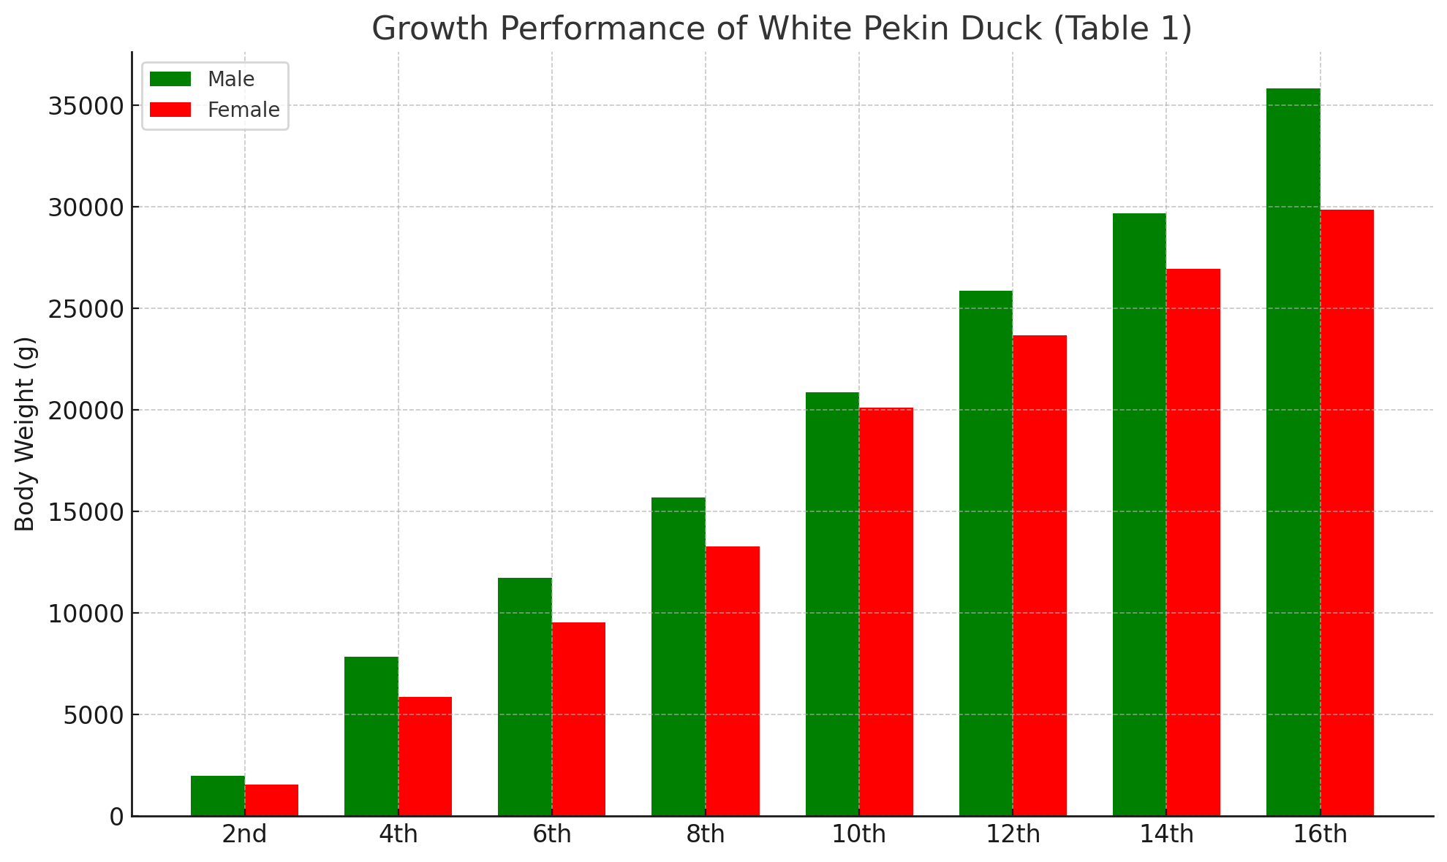

Economic traits of White Pekin duck
The mortality percentage of White Pekin ducks was recorded as 4.6% in males and 4.2% in females, indicating good survivability under the managemental conditions adopted. The low mortality rate reflects the adaptability of the breed to field and semi-intensive systems, as also observed by Singh et al. (2018) and Borah et al. (2020), who reported mortality rates ranging between 3–6% in Pekin ducks reared under smallholder systems.
The feed conversion ratio (FCR) was found to be 2.98 in males and 3.17 in females, indicating that male ducks exhibited slightly better feed efficiency than females. This variation could be due to the higher growth rate and feed utilization efficiency in males. Comparable FCR values were reported by Das et al. (2021), who documented FCR values ranging from 2.8 to 3.2 for Pekin ducks under semi-intensive and intensive rearing systems. The dressing percentage observed in this study was 68.87 ± 0.43.
The dressing yield obtained reflects the superior meat quality and carcass characteristics typical of this breed. Such high dressing percentages make White Pekin ducks a profitable option for small and commercial farmers alike.
The benefit-cost (B:C) ratio was found to be 3.12 ± 0.26 based on pooled data, indicating strong economic viability. Similar profitability levels were reported by Patil et al. (2021), who found B:C ratios ranging from 2.8 to 3.3 under field and organized farm conditions. This highlights that White Pekin duck rearing ensures a substantial return on investment due to their rapid growth, efficient feed utilization, and high dressing percentage.

Table 2 Showing the Economic traits of White Pekin duck

Parameters | Male White Pekin duck |  | Female White Pekin duck | Pooled
Mortality (%) | 4.6 | 4.2 |  |  | 4.4±0.24
FCR | 2.98 | 3.17 |  |  | 3.07$±$0.35
Dressing percentage (%) | 70 | 67 |  |  | 68.87±0.43
B:C ratio | 3.23 | 3.05 |  |  | 3.12±0.26

Fig 2. Economic traits of white pekin duck
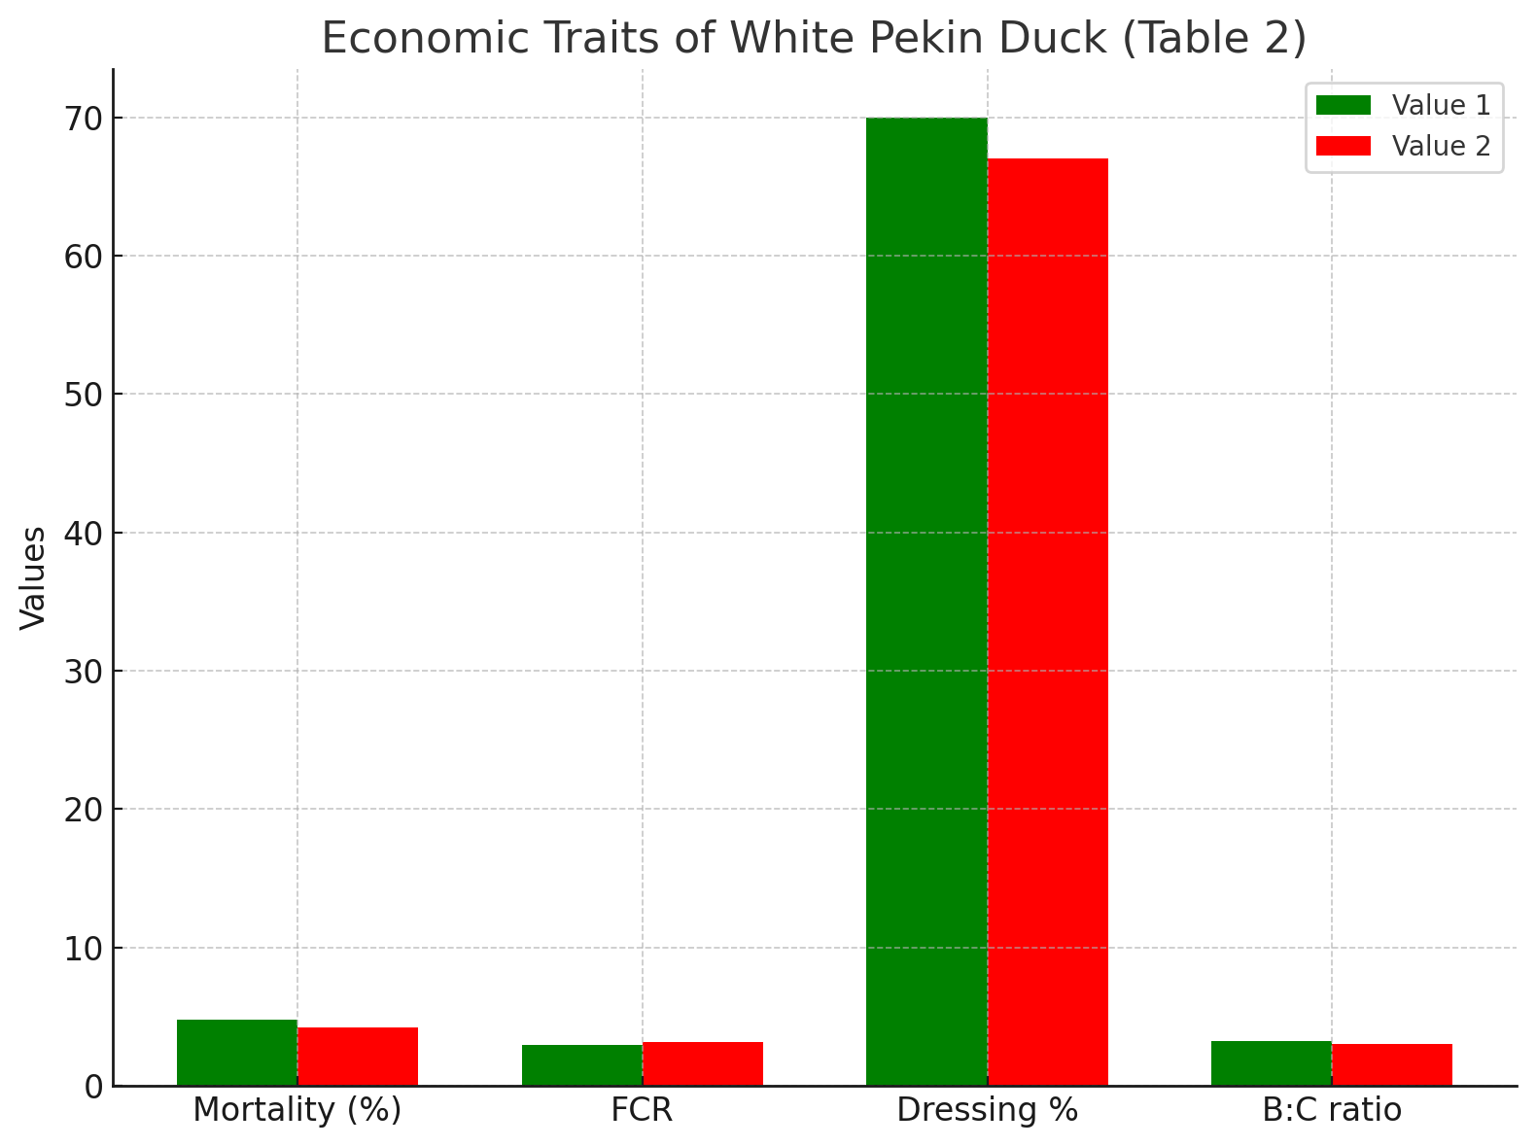

Body weight

. Present findings were lower than the findings recorded by Devaki⁴ in their study on performance of White Pekin in Integrated Farming System where they were recorded 1780g in 60 days old. However, Rabbani⁵ was reported at per growth rate in Maize based diet where they were recorded 1485.41 g at 8 weeks age. The body weight gain received in 90 days under backyard system is to the mark of satisfactory for limited and recycling input and farmers were complacent with the result.

Feed Conversion Ratio
Feed conversion ratio (FCR) was found to be 3.07±0.35 in the present study is lower than Rabbani⁵ reported rate of FCR (3.16) in their study on White Pekin and Devaki⁴ reported3.75 FCR in their study.Lower FCR in present study might be due to feed composition and farming condition in backyard system or rearing. Rice bran and broken rice were major by-products from rice mills which were incorporated in the feed. These two ingredients are cheap and easily available locally in Chandel district. Ducks feeding on aquatic plants such as azolla and snails, worms etc. provided nutritional supply and substantially contributed to lowering feeding cost.

Dressing percentage
Dressing percentage of White Pekin duck in the present study was found to be 68.87±0.43 percent. Present findings were in accordance with the findings recorded by Kokoszynski⁶ in which they were recorded 68.7% in male and 69.0% in female White Pekin Duck. However, present findings were lower than the findings recorded by Steczny⁷ in his study where they were reported 70.1±0.2 in male and 70.4± 0.2 percent in female White Pekin duck respectively.

Mortality and Adaptability
In the present study, mortality of ducks was recorded to be 4.5±0.26 percent, most of which was found during brooding period. Mortality included small, weak duckling and accidental reasons. Thus, the adaptability of white Pekin breed in backyard rearing system in the climatic condition of Chandel district of Manipur was found suitable.

Economics of rearing White Pekin duck

The benefit cost ratio of White Pekin duck was recorded as3.12±0.26 which indicates that the rearing of White Pekin duck is economical and viable for meat production purpose Rearing White Pekin ducks has a transformative impact on the farming community, providing a sustainable and accessible avenue for traditional and backyard systems. The breed's remarkable attributes, including a fast growth rate, low extra effort requirements, and high dressing percentage, enhance farmers' satisfaction and economic returns.
Conclusion
The rearing of White Pekin ducks plays a significant role in transforming rural livelihoods by offering a sustainable and easily adoptable enterprise under both traditional and backyard rearing systems. Owing to their rapid growth rate, minimal management requirements, and superior dressing yield, White Pekin ducks contribute greatly to enhancing farmers’ income and satisfaction. Their adaptability to varied environments makes duck farming more inclusive, attracting farmers from diverse socio-economic backgrounds. Hence, White Pekin duck farming stands as a valuable socio-economic asset, promoting community development and financial empowerment among resource-The combination of low mortality, efficient feed conversion, and high dressing yield underscores the adaptability and economic advantage of White Pekin duck farming under Indian agro-climatic condition, and ultimately strengthening the resilience and prosperity of the rural farming sector.

Disclaimer (Artificial intelligence)

Option 1:

Author(s) hereby declare that NO generative AI technologies such as Large Language Models (ChatGPT, COPILOT, etc.) and text-to-image generators have been used during the writing or editing of this manuscript.

Option 2:

Author(s) hereby declare that generative AI technologies such as Large Language Models, etc. have been used during the writing or editing of manuscripts. This explanation will include the name, version, model, and source of the generative AI technology and as well as all input prompts provided to the generative AI technology

Details of the AI usage are given below:

1.

2.

3.

References

1 Bhuiyan, M. S. A., Ebnat, R., Nandita, D., Mou, M. A., Rhidoy, M. F. A., & Amin, M. R. (2024). Genetic Evaluation of Pekin, Nageswari and Pekin× Nageswari Crossbred Duck for Growth and Egg Production Traits Under Intensive Management Condition. Poultry Science Journal, 12(1), 129-137.
2.Patil, S., Khune, V. N., & Karunamay, S. (2020). Duck farming: A potential to reduce poverty in rural households in Indian communities–A review. The Pharma Innovation Journal, 9(4), 130-135.

3.Devaki K, Senthilkumar K, Nisha PR. Performance of Pekin ducks and Desi ducks under integrated farming system at Kancheepuram district in Tamil Nadu. Journal of Krishi Vigyan. 2019;8(1):217-220.
4..Kokoszyński D, Wasilewski R, Saleh M, Piwczyński D, Arpášová H, Hrnèar C, et al. Growth performance, body measurements, carcass and some internal organscharacteristics of Pekin ducks. Animals. 2019;9(11):963
5.Rabbani MAG, Das SC, Ali MA, Hassan MR, Ali MY. Growth performance of Pekin ducks under full confinement system fed diets with various nutrient concentrations. Asian Journal of Biological Sciences. 2019;12(4):717-723.
6. Steczny K, Kokoszyński D, Bernacki Z, Wasilewski R, Saleh M. Growth performance, body measurements, carcass composition and some internal organ characteristics in young Pekin ducks. South African
7. Sun, P. X., Shen, Z. J., Tang, J., Huang, W., Hou, S. S., & Xie, M. (2019). Effects of ambient temperature on growth performance and carcass traits of male growing White Pekin ducks. British Poultry Science, 60(5), 513-516.
8. Jones, T. A., & Dawkins, M. S. (2010). Environment and management factors affecting Pekin duck production and welfare on commercial farms in the UK. British Poultry Science, 51(1), 12-21.

9. Kokoszyński, D., Wasilewski, R., Stęczny, K., Bernacki, Z., Kaczmarek, K., Saleh, M., ... & Biegniewska, M. (2015). Comparison of growth performance and meat traits in Pekin ducks from different genotypes. European Poultry Science, 79, 1-11.

10. Xie, M., Jiang, Y., Tang, J., Wen, Z. G., Huang, W., & Hou, S. S. (2014). Effects of stocking density on growth performance, carcass traits, and foot pad lesions of White Pekin ducks. Poultry Science, 93(7), 1644-1648.

