Genetic diversity analysis in mungbean (Vigna radiata L.) genotypes using SSR markers

ABSTRACT
Background:
Nineteen mungbean [Vigna radiata (L.) Wilczek] genotypes were assessed for molecular diversity using simple sequence repeat (SSR) markers.
Methods:
A total of 26 SSR primer pairs were employed to evaluate genetic variation among the genotypes. The amplified products were scored in a binary format, and similarity coefficients were calculated using Jaccard’s method in NTSYS-pc version 2.1. A dendrogram was generated using the Unweighted Pair Group Method with Arithmetic Mean (UPGMA).
Results:
Among the 26 SSR primers screened, eleven exhibited polymorphism, while thirteen were monomorphic and two did not yield any amplification. Genetic similarity coefficients ranged from 0.22 to 1.00, with an average of 0.61. The genotypes SML-668 and MGG-551 showed complete genetic similarity (1.00), whereas Tarm-18 and GP-2-57 were the most divergent (0.30). These results suggest that SSR markers are effective tools for distinguishing mungbean genotypes and for identifying suitable parental combinations for breeding programs.
Keywords: Vigna radiata, SSR markers, genetic similarity, molecular diversity, UPGMA
.

I. INTRODUCTION
Ⅰ. INTRODUCTION
Pulse crops form a crucial component of sustainable agricultural systems owing to their ability to adapt to diverse climatic conditions and their significant role in improving nutritional security and soil fertility. Mungbean (Vigna radiata (L.) Wilczek) is one of the most important pulse crops grown in India, widely valued for its short duration, high yield potential, and nutritional richness. It serves as an excellent source of protein (25–28%) and is rich in dietary fibre, antioxidants, folic acid, vitamin B₆, and magnesium, thereby contributing substantially to human nutrition and health (Mahalingam, 2018).
Apart from its nutritional significance, mungbean plays an important ecological role through biological nitrogen fixation mediated by Rhizobium species, which enhances soil fertility and reduces the need for synthetic fertilizers (Shiv et al., 2017). These characteristics make mungbean a dual-purpose crop, beneficial for both farmers and soil ecosystems.
However, morphological characterization of crop genotypes often reflects environmental effects rather than pure genetic variation. Therefore, molecular markers that are independent of environmental influences are more reliable for assessing genetic diversity at the DNA level (Nath et al., 2017). Among molecular markers, simple sequence repeats (SSRs) are particularly advantageous because of their co-dominant inheritance, high polymorphism, abundance, and reproducibility (Sanghani et al., 2015).
SSRs have been extensively used in crop genetics for the identification of closely related genotypes, analysis of population structure, and marker-assisted selection in various legumes, including Vigna species (Kaur et al., 2018; Panigrahi et al., 2020). Their high degree of variability makes them suitable for the detection of genetic relationships and for establishing the genetic base of germplasm collections.
Given the importance of genetic diversity in breeding programs, the present investigation was undertaken to evaluate the molecular diversity among nineteen mungbean genotypes using SSR markers. The findings of this study are expected to aid in identifying genetically distinct parental lines for use in hybridization and to support genetic improvement and germplasm management in mungbean
.
II. MATERIAL AND METHODS
Plant material and DNA extraction
Nineteen elite mungbean genotypes (Table 1) were utilized for molecular characterization. The experiment was conducted during Rabi 2020 at the Regional Agricultural Research Station (RARS), Warangal. Fresh young leaves (21–28 days old) were collected for genomic DNA extraction following the protocol of Lin et al. (2001) with minor modifications
SSR-PCR amplification
Twenty-six SSR primers were initially screened across the nineteen genotypes. Of these, eleven primers produced clear, polymorphic, and reproducible amplification profiles. PCR reactions were performed using 30 ng µl⁻¹ template DNA. The amplification program comprised an initial denaturation at 94 °C for 4 min, followed by 35 cycles of 94 °C for 1 min, primer-specific annealing (Table 2) for 1 min, and extension at 72 °C for 1 min. A final extension was carried out at 72 °C for 7 min, and the products were stored at 4 °C. Amplicons were separated on 4% agarose gels in 1× TAE buffer containing ethidium bromide (10 mg ml⁻¹) and visualized using a SYNGENE gel documentation system
Data analysis
The presence or absence of SSR bands was scored in binary form (1 = present, 0 = absent). The data matrix was used to compute Jaccard’s similarity coefficients among all genotypes using NTSYS-pc 2.1. Cluster analysis was performed through the UPGMA algorithm to generate a dendrogram illustrating genetic relationships among the entries

III. RESULTS AND DISCUSSION
A total of 26 SSR markers were evaluated, of which 11 were polymorphic, 13 monomorphic, and 2 non-amplifying. The 11 polymorphic primers produced 29 alleles, with 2–3 alleles per locus and an average of 2.63. The polymorphic information content (PIC) ranged from 0.54 (CEDG-225) to 0.88 (CEDG-067), averaging 0.76, indicating the effectiveness of the selected primers in detecting allelic diversity.
Jaccard’s similarity coefficients among genotypes varied between 0.22 and 1.00 (mean = 0.61), suggesting moderate diversity within the tested material. The polymorphism level (42.3%) implied that although variability existed, several SSR loci were conserved among the genotypes. Similar findings were reported by Wang et al. (2018) and Kaur et al. (2016), who also observed moderate diversity in self-pollinated mungbean populations. The dendrogram generated by UPGMA (Fig. 2) grouped the nineteen genotypes into three major clusters at a similarity coefficient of 0.40.
Cluster I contained eight genotypes (IPM-205-7, GAM-5, VGG-17-002, VGG-17-048, Pusa Bold, GP-3-11, MGG-295, and WGG-42), and was further divided into subclusters I-A and I-B. Cluster II comprised nine genotypes (SML-668, WGG-37, MGG-551, MGG-351, MGG-385, MGG-399, Vamban-2, IC-249570, and IC-436528) and was split into subgroups II-A and II-B. The pair SML-668 and MGG-551 exhibited complete similarity (1.00), reflecting close genetic relatedness. Cluster III consisted of two divergent genotypes, Tarm-18 and GP-2-57, sharing the lowest similarity (0.30).
The observed clustering pattern demonstrates the ability of SSR markers to discriminate among closely related genotypes. The divergence of Tarm-18 and GP-2-57 suggests their potential as promising parents for developing high-yielding hybrids with improved variability. Comparable clustering patterns have been documented by Honglin et al. 2015, Prathap et al. (2015), Kaur et al. (2016), Singh et al. (2017), Kanavi et al. (2019) and Tabasum et al. (2020).
Overall, the study validates SSR markers as a dependable and reproducible system for evaluating molecular diversity in Vigna radiata. Such analyses contribute to the conservation and utilization of genetic resources and facilitate targeted selection in breeding programs
Ⅳ. CONCLUSION
The present investigation demonstrated that SSR markers are highly efficient for assessing molecular diversity among mungbean genotypes. The moderate range of similarity coefficients observed indicates the existence of a reasonably broad genetic base within the evaluated germplasm. The genotypes SML-668 and MGG-551 were genetically identical, whereas Tarm-18 and GP-2-57 exhibited maximum divergence. These genetically distinct genotypes may serve as suitable parents for hybridization programs aimed at broadening the genetic base and improving productivity in mungbean. The generated molecular data provide valuable insights for future marker-assisted breeding and germplasm management initiatives.

Disclaimer (Artificial intelligence)
Option 1:
Author(s) hereby declare that NO generative AI technologies such as Large Language Models (ChatGPT, COPILOT, etc.) and text-to-image generators have been used during the writing or editing of this manuscript.
Option 2:
Author(s) hereby declare that generative AI technologies such as Large Language Models, etc. have been used during the writing or editing of manuscripts. This explanation will include the name, version, model, and source of the generative AI technology and as well as all input prompts provided to the generative AI technology
Details of the AI usage are given below:
1.
2.
3.

REFERENCES
- Chen, H., Wang, L., Wang, S., Liu, C., Blair, M.W and Cheng, X. (2015). Transcriptome Sequencing of mung bean (Vigna radiata L.) genes and the identification of EST-SSR Markers. PLoS ONE. 10(4): e0120273
- Kanavi, M.S.P., Rangaiah, S and Krishnaprasad, B.T. (2019). Molecular Characterization and Genetic Diversity Analysis through SSR Markers in Germplasm Lines of Greengram [Vigna radiata (L.) Wilczek]. International Journal of Bio-Resource and Stress Management. 10(3): 298-305.
- Kaur, G., Joshi, A and Jain, D. (2018). SSR-Marker Assisted Evaluation of Genetic Diversity in Mungbean (Vigna radiata (L.) Wilczek) Genotypes. Brazilian Archives of Biology and Technology. 61.
- Kaur, G., Joshi, A., Jain, D., Choudary, R and Vyas, D. (2016). Diversity analysis of greengram (Vigna radiata (L.) Wilczek) through morphological and molecular markers. Turkish Journal of Agriculture and Forestry. 40: 229-240.
- Kumararathna, M.J.M.P., Kumar, W.M.R., Perera, A.M and Ariyawansha, S. (2013). Estimation of phenotypic diversity of local and exotic mungbean (Vigna radiata (L.) Wilczek) germplasm in Srilanka. Annals of Srilanka. 15: 273-282.
- Lin., Rong-Cheng, Zai-Song Ding., Liang-Bi Li., Ting-Yun Kung. (2001). A rapid and efficient DNA mini preparation suitable for screening transgenic plants. Plant Molecular Biology Reporter. 19(4): 379-379.
- Mahalingam, A. (2018). Genetic divergence among greengram (Vigna radiata (L.) Wilczek) germplasm collections. Electronic Journal of Plant Breeding. 9(1): 350-354
- Nath, A., Maloo, S.R., Barman, K.K., Meena, B.L., Devi, G., Yadav, G.S., and Tak, S. (2017). Molecular characterization of green gram (Vigna radiata (L.) Wilczek) for future breeding programme. International Journal of Current Microbiology and Applied Sciences. 6(6): 1385-1398.
- Panigrahi, K.K., Panigrahi. P., Mohanty, A., Mandanl, P and Satapathy, B. (2020). Development of new microsatellite markers for DNA fingerprinting pattern of blackgram (Vigna mungo L. Hepper) and greengram (Vigna radiata L. Wilczek). Genetika. 52(3): 1161-1179.
- Prathap, A., Malviya, N., Tomar, R., Maurya, R.K., Singh, N.P., John, J and Madhavan, L. (2015). Genome scanning of Asiatic Vigna species for discerning population genetic structure based on microsatellite variation. Molecular Breeding. 8(2): 172- 178.
- Sanghani, J.M., Golakiya, B.A., Dhedhi K.K and Patel S.V. (2015). Molecular characterization of mungbean (Vigna radiata L.) genotypes through RAPD, ISSR and SSR markers. Legume Research-An International Journal. 38(4): 452-456.
- Shiv, A., Ramtekey, V., Vadodariya, G.D., Modha, K.G and Patel, R.K. (2017). Genetic Variability, Heritability and Genetic Advance in F3 Progenies of Mungbean [Vigna radiata (L.) Wilczek]. International Journal of Current Microbiology and Applied Sciences. 6(12): 3086-3094.
- Singh, S.K., Lavanya, R.G., Bhat, K.V., Babu, G.S., Arya, L., Verma, M., Hussain, Z., Roy, S., Rathi, R.S and Mishra, A.K. (2012). Microsatellite markers revealed genetic diversity in mungbean mutant lines. Indian Journal of Hill Farming. 25(1):38-43.
- Singh, V., Yadav, R.K., Yadav, N.R., Yadav, R., Malik, R.S and Singh, J. (2017). Identification of genomic Regions/genes for high iron and zinc content and cross transferability of SSR markers in mungbean (Vigna radiata L.). Legume Research-An International Journal. 40(6): 1004-1011.
- Tabasum, A., Hameed, A and Asghar, M.J. (2020). Exploring the Genetic Divergence in Mungbean (Vigna radiata L.) Germplasm Using Multiple Molecular Marker Systems. Molecular Biotechnology. 62(11): 547-556.
- Wang, L., Bai, P., Yuarf, X., Chen, H., Wang, S., Wang, S., Chen, X and Cheng, X. (2018). Genetic diversity assessment of a set of introduced mung bean accessions (Vigna radiata L.). The Crop Journal 6: 207–213.

Figure 1. PCR amplification of 19 genotypes with SSR marker CEDG 141. The lane numbers written on the gel corresponds to the list of mungbean genotypes as given in table 1.

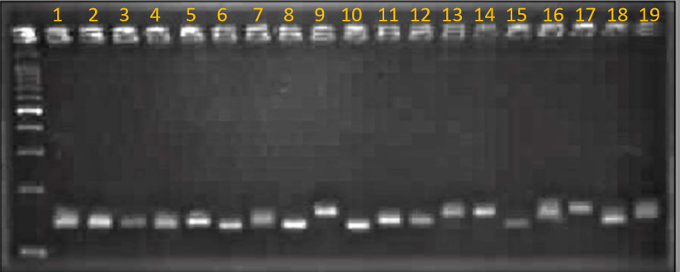

S. No | Entry | Source
1 | IPM-205-7 | IIPR, Kanpur
2 | GAM-5 | PRS, Vadodara, Gujarat
3 | VGG-17-002 | NPRC, Vamban, Tamil Nadu
4 | VGG-17-048 | NPRC, Vamban, Tamil Nadu
5 | Pusa bold | IIPR, Kanpur
6 | GP-3-11 | IIPR, Kanpur
7 | SML- 668 | PAU, Ludhiana, Punjab
8 | WGG-42 | RARS, Warangal
9 | WGG-37 | RARS, Warangal
10 | MGG-295 | ARS, Madhira
11 | MGG-351 | ARS, Madhira
12 | MGG-551 | ARS, Madhira
13 | MGG-399 | ARS, Madhira
14 | MGG-385 | ARS, Madhira
15 | GP-2-57 | IIPR, Kanpur
16 | TARM-18 | BARC, Mumbai
17 | Vamban-2 | NPRC, Vamban, Tamil Nadu
18 | IC-436528 | NBPGR, New Delhi
19 | IC-249570 | NBPGR, New Delhi
Table 1. List of 19 mungbean varieties used for molecular diversity analysis

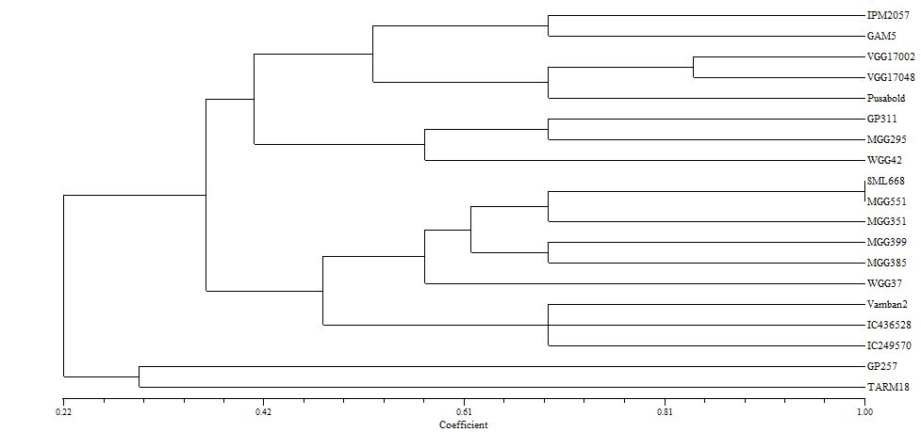
III
II
I
Figure 2. Dendrogram of 19 genotypes using SSR markers

Table 2. List of primers and their Tm used in the present study
S. No | Primer Name | Primer Sequence | Annealing temp in º C
1 | CEDG 204 F | CCTTGGTTGGAGCAGCAGC | 60
1 | CEDG 204 R | CACAGACACCCTCGCGATG | 60
2 | CEDG 139 F | CAAACTTCCGATCGAAAGCGCTTG | 65
2 | CEDG 139 R | GTTTCTCCTCAATCTCAAGCTCCG | 65
3 | CEDG 268 F | CATCTCCCTGAAACTTGTG | 55
3 | CEDG 268 R | GCTATCAATCGAGTGCAG | 55
4 | CEDG 030 F | TGAGGGAATGGGAGAGAGGC | 60
4 | CEDG 030 R | TCCGCAGATAGAGGCTCACG | 60
5 | CEDG 092 F | TCTTTTGGTTGTAGCAGGATGAAC | 65
5 | CEDG 092 R | TACAAGTGATATGCAACGGTTAGG | 65
6 | CEDG 022 F | AGGAATGTGAGATTTG | 55
6 | CEDG 022 R | AATCGCTTCAAGGTCAAGCC | 55
7 | CEDG 024 F | CATCTTCCTCACCTGCATTC | 60
7 | CEDG 024 R | TTTGGTGAAGATGACAGCCC | 60
8 | CEDG 198 F | CAAGGAAGATGGAGAGAATC | 60
8 | CEDG 198 R | CCTTCTAAGAACAGTGACATG | 60
9 | CEDG 133 F | GCATACATAATGTGGTGAGATG | 60
9 | CEDG 133 R | GTCTCGTGCCTTTCACAC | 60
10 | CEDG 141 F | CCAGGCATCCATGATGACC | 65
10 | CEDG 141 R | GAAGTTGTTGGTAATGGTTGCCTC | 65
11 | CEDG 225 F | GAGGAAGTGTTGCAGCACC | 60
11 | CEDG 225 R | GTAGACTCTGCAGAGGGATG | 60
12 | CEDG 284 F | GGTGCTAACGTTGGAAACTGAG | 65
12 | CEDG 284 R | CACTCCATTCTGAGGATCAATCC | 65
13 | CEDG 077 F | ATCCCGTGACCCTTCTTCCT | 60
13 | CEDG 077 R | GCTCAAGCGAAAACCCAGCA | 60
14 | CEDG 127 F | GGTTAGCATCTGAGCTTCTTCGTC | 65
14 | CEDG 127 R | CTCCTCACTTGGTCTGAAACTC | 65
15 | CEDG 014 F | GCTTGCATCACCCATGATTC | 60
15 | CEDG 014 R | AAGTGATACGGTCTGGTTCC | 60
16 | CEDG 020 F | TATCCATACCCAGCTCAAGG | 60
16 | CEDG 020 R | GCCATACCAAGAAAGAGG | 60
17 | CEDG 067 F | AGACTAAGTTACTTGGGCAACCAG | 65
17 | CEDG 067 R | TGACGGCCCGGCTCTCC | 65
18 | CEDG 059 F | AGAAAAGGGTGGCCTCGTTG | 60
18 | CEDG 059 R | GCAGGCATTTCCATCGCAG | 60
19 | CEDG 112 F | GCAATATTCGCATTATTCATTCA | 60
19 | CEDG 112 R | GTGTTTCAAAGCACTATACTTAA | 60
20 | CEDG 269 F | CTGTTACGGCACCTGGAAAG | 65
20 | CEDG 269 R | GCAGAGACACACCTTAACCTTG | 65
21 | CEDC 011 F | GTCCGACTTTATGTGTGGAG | 60
21 | CEDC 011 R | TTTCTAGTTCCAGCCCCGAC | 60
22 | CEDG 056 F | TTCCATCTATAGGGGAAGGGAG | 65
22 | CEDG 056 R | GCTATGATGGAAGAGGGCATGG | 65
23 | CEDG 180 F | GGTATGGAGCAAAACAATC | 55
23 | CEDG 180 R | GTGCGTGAAGTTGTCTTATC | 55
24 | CEDG 044 F | TCAGCAACCTTGCATTGCAG | 60
24 | CEDG 044 R | TTTCCCGTCACTCTTCTAGG | 60
25 | CEDG 104 F | TATGGCCCGAGCAAACCTTG | 60
25 | CEDG 104 R | CCGTTCGGTCTTCGGTTGAA | 60
26 | CEDG 008 F | GCTCAAGCGAAAACCCAGCA | 60
26 | CEDG 008 R | CTCCTCACTTGGTCTGAAACTC | 60

