Original Research Article

Physicochemical and Anatomical Characteristics for assessment of Wood quality of Azadirachta indica A. Juss.

ABSTRACT

The Evaluation of Physicochemical and Anatomical Characterization of Azadirachta indica A. Juss. Wood was carried out in the Department of Forest Products and Utilisation, College of Forestry, Odisha University of Agriculture and Technology, Bhubaneswar. Sample tree was harvested at stump height from Balasore district of Odisha and the harvested logs were air dried for 1month from which wood disc of 2 inch thickness was transversely cut. From sapwood and heartwood portion of the disc, six sample cuboids were prepared and taken for estimation of its Physicochemical and Anatomical Characteristics. The colour of wood was studied on basis of visual interpretation where the heart wood found to be Reddish to Reddish brown and the Sapwood found to be light yellow in colour. The species found to be fast growing on basis number of growth rings per unit radius length. The heartwood percentage was very high about 90.1% and moisture content of the air dried heartwood sample wood found to be 27.91% with respect to its oven dry weight. The shrinkage in volume of heartwood found to be very less (6.86%) which not much affect the properties of wood. The air dry specific gravity (0.87) and standard specific gravity (0.63) of the heartwood found to be high and can categorised under class of moderately Heavy–Heavy. The Holocellulose (58.73% & 63.04%), Cellulose content (32.34% & 38.03%) and Lignin content (30.79% & 28.98%) found in Heartwood and Sapwood respectively favouring its utilisation for composite and improved woods, pulp and paper, furniture etc. As the number of anatomic features affects the density, durability and other quality of wood, the parenchyma and vessels number were estimated in cross-sectional (1.06&2.55 ; 5.73&4.35), radial (2.86&1.05 ; 2.12&4.45) and tangential section (4.48&3.18 ; 3.38&1.59) of Heartwood and Sapwood respectively.

Key Words: Specific gravity, Holocelluose, Lignin, Vessels , Parenchyma

Introduction
Azadirachta indica A. Juss. commonly known as Neem is a fast growing tree belonging to family Meliaceae distributed widely in evergreen, moist deciduous and dry deciduous forest areas. The tree grows and naturally regenerates well in conditions prevailing from Coastal area to drier tracts because of its wide adaptability to different climatic and edaphic conditions. The species reported to be native to India, Bhutan and Countries of South-east Asian region (Roshan & Verma, 2015). The tree is also found growing profusely in west Africa, planted in Caribbean (Couletal.,1990) and Central America countries like Mexico (Roshan & Verma, 2015). In India Neem is distributed naturally in the states under the Peninsular region below 24ºN latitude but has been introduced in most of the states as a potential multipurpose fast growing tree in urban and wasteland plantations.
A.indica is a large tree which generally attain a height of 15-20m and rarely 30-35m known for its multiple utilisations as a NTFPs like seed oil, biopesticides, seed cakes as fertilisers, soil conditioner, active principles from different parts having anti-carcinogenic, anti-pyretic, anti-oxidants, anti-inflammatory, antifungal, anti-gastric, anti-diabetic, diuretic etc. (Islas et al., 2020 ; Singh,2019 and Roshan &Verma,2015).Besides that as a major forest produce its timber has been used for the manufacture of plywood, block board, window and door frames, shutters, wagon and carriage, furniture, cabinets, boat and ships, agricultural implements, match splints, decorative flooring and wall panelling because of its durability, moderate weight, proper strength, dimensional stability, easy workability and better finishing qualities with appealing colour, grain and texture (Deoreetal.,2020). The wood also having medicinal and pesticidal value. Activated charcoal prepared from it act as an efficient adsorbent in removal of heavy metals, dyes and other organic pollutants from effluent (Sing et al., 2024). Neem wood are also reported to be used for pulp and paper making (Sinha,2008) and recent uses in wood polymer composites (Yadav etal.,2024&Nagamadhuet al.,2020)).In Odisha, traditionally the Neem wood is being used for making deities of Lord Jagannath, Balabhadra and Subhadra since the inception of the Shree Jagannath Temple at Puriway 12th Century back and it is being replaced maximum after 19 yrs. This also supports the nativeness of the species in India, easy workability and also its durability. The mechanical, electrical, thermal, acoustic property of wood decides the proper utilisation of wood and these properties of wood depends either directly or indirectly on its physical, chemical and anatomical characters. These characteristics of wood vary between different species, as well as with in the individuals of a species from one locality to another as reported for A. indica (Iqbal et al.,2010) and ultimately affecting the quality of the final product derived from it . The physical, chemical and anatomical characters also vary in heartwood and sapwood of same tree. The tree wood was collected from Balasore which is a Coastal district of Odisha where it grows and regenerates naturally in forests and wastelands, planted in Urban plantations and farmlands. The present study emphasises on assessment of basic Physical, Chemical and Anatomical characteristics of Heartwood and Sapwood of A.indica for better utilisation in future.

2.Materials and Methods
2.1 Site Description and Sample collection
Balasore is one of the Coastal Districts of Odisha located at 20.48-21.59 North Latitude and 86.16 - 87.29 East Longitude. It’s climate is generally hot and humid with May as the hottest month and December the coolest. Monsoon arrives every year in the district from mid-June with average rainfall of the District is 156.84 cm with 62 rainy days per year from June--December accounting75% of the total rainfall. The wood samples were collected from one-month air dried felled tree of Kuruda Village under Balasore block of the district. The wooden disc of 2 inch thickness was crosscut from the basal portion of the felled tree from which 6 cuboid shaped wood blocks were cut considered as replications under each treatment i.e. Heartwood and Sapwood. The wood samples were further treated and evaluated in the Laboratory of Department of Forest Products and Utilisation, College of Forestry, OUAT, Bhubaneswar, Odisha.

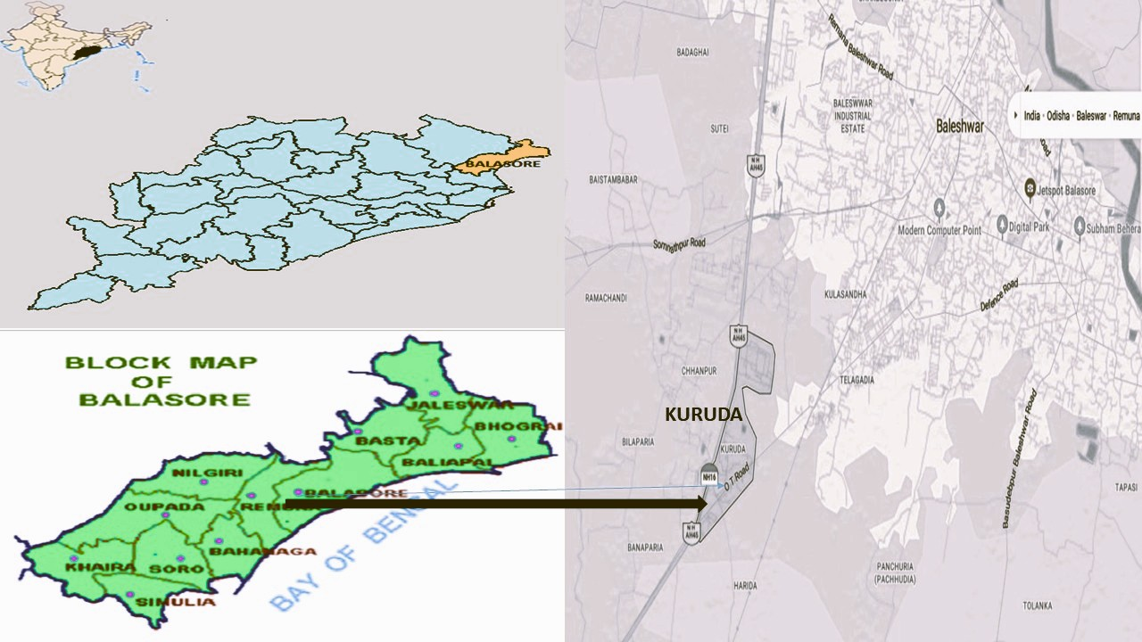
Figure-1:Place of Collection (Kuruda in Balasore District and Wood Disc of Azadirachtaindica

2.2 Observations recorded regarding physical characters
The cuboid length, breadth and height were taken respectively in Longitudinal, Tangential and Radial direction of the tree log from which the disc is cut. Observations was recorded from Sample disc like mid diameter (cm) using measurement scale and no. of growth rings were counted on basis of which the growth rate of plant was analysed. Length (cm), Breadth(cm), Height(cm), Green biomass (g), air dry biomass (g), oven dry biomass (g) were recorded from the sample cuboids of Sapwood and Heartwood from which volume, Density and Specific Gravity were estimated.

2.2.1 Air and Oven Dry Weight
Air Dry Weight of the Heartwood and Sapwood cuboids were recorded using the digital weighing machines which were then dried at oven conditions at 102ºC till constant weight is achieved. The Oven Dry Weight of Heartwood and Sapwood samples were recorded from which moisture content in each case was calculated.

MC_{O} (%) = (A_{W}-O_{W}) x100 / O_{W}
MC_{A} (%) = (A_{W}-O_{W}) x100 / A_{W}

Where, MC_{O} (%) is Moisture content (%) on Oven dry wt. basis
MC_{A}(%) is Moisture content (%) on Air dry wt. basis
A_{W} is Air dried weight of cuboid
O_{W} is Oven dried weight of cuboid

2.2.2 Density & Specific Gravity Estimation
Length (cm), breadth(cm), height(cm) cuboids measured by Vernier calliper for each sample block of Heartwood and Sapwood and Volume was calculated.
DW_{A} = A_{W} / V_{A}
DW_{O} = O_{W} / V_{O}

Where, DW_{A} is Density of Air dried Wood
DW_{O} is Density of Oven Dry Wood
A_{W} is Air dried weight of cuboid
O_{W} is Oven dried weight of cuboid
V_{A} is Volume in Air dry condition
V_{O} is Volume in oven dry condition

Specific gravity estimation was carried out separately for both Sapwood and Heartwood by water displacement method. Specific gravity like Specific gravity in Air dry condition, Specific gravity in Oven dry condition and Standard Specific gravity were determined for each cuboid from sapwood and heartwood.
Specific Gravity at Air Dry Condition = Weight of the wood sample at Air dry condition / Weight of equal volume of water displaced by the Air dry wood sample at 4°C.
Specific Gravity at Oven Dry Condition = Weight of the wood sample at Oven dry condition / Weight of equal volume of water displaced by the oven dry wood sample at 4°C.
Standard Specific Gravity =Weight of the wood sample at Oven Dry condition / Weight of equal volume of water displaced by the Fresh wood sample at 4°C.

Basing on Standard specific gravity/Density/Specific gravity, the wood was categorised as Lighter, Moderately heavy, Heavy as per the classification by the book Indian Forest utilisation Volume-I by FRI and Mehta (2008).

2.2.3 Sapwood and Heart Proportion in Wood Disc
As the disc was not a perfect circular shape the diameter was measured from different directions and the average diameter was calculated from which average radius estimated and used for calculation of Total Area of Wood disc, Area of Heartwood and Sapwood.
Total area of the Wood disc = πR²
Total area of Heartwood = πr²
Area of Sapwood = π (R²- r²)

Sapwood: Heart wood Proportion on basis of area = π (R²-r²) / πr²
Where R = Average radius of the wood Disc.
r = Average radius of the Heartwood portion of the Disc.

2.3 Cellulose, Hemicellulose and Lignin content of Wood sample
Cellulose, Hemicellulose and Lignin content of Wood sample was estimated by modified method of Moubasher et al.(1982). 2g of saw dust kept in a Thimble was extracted by Soxhlet apparatus using Solvent system Ethanol-Toluene (2:1) for 6 hours till solvent in the extractor becomes colourless. The extracted wood dust was washed thoroughly and kept in Oven at 65°C overnight and weight was recorded. The oven dried wood dust was then divided into two equal parts of which one part is considered as A fraction. Second part of residue was treated with 24% KOH for 4hrs at room temperature, washed thoroughly with distilled water dried at 80°C over night and the dry weight taken as B fraction. The same samples again treated with 72% H₂SO₄ for 3hrs to hydrolyse the cellulose and then further refluxed with 5% H₂SO₄ for 2hrs. The Lignin obtained was filtered using a weighed filter paper and H₂SO₄ was removed completely by washing it with distilled water. The filter paper containing lignin dried at 80°C in oven for overnight and dry weight of lignin determined [(Wt.of Filter paper+ Lignin) - Wt. of filter paper] and recorded as C fraction. From the above taken weights Cellulose, Hemicellulose and Lignin were calculated as follows
Cellulose = B-C
Hemicellulose-A-B

Lignin-C

2.4 Anatomical Properties of Wood samples of Azadirachta indica

For estimation of Anatomical features, all six wood blocks were to be macerated in distilled water for 10 days till it gets soft. Thin sections were prepared using microtome from Radial, Cross-sectional and Tangential planes of each wood block separately for Heartwood and Sapwood. It were then dehydrated with 50% Ethanol followed by staining with Safranin for 1 minute, washing with 50% Ethanol to remove excess Safranin stain, further stained with Fast green for 30 seconds and finally washed with distilled water to remove excess Fast Green stain. The sample is then assembled in a slide using glycerol. Images were captured using digital microscope connected to a computer. Anatomical observations recorded were Vessel no. /mm² area and Ray Parenchyma no. /mm². in Radial, Cross sectional and Tangential sections.
Vessels in Cross-sectional area are categorised under different class as
Scanty-<2.5/mm² ; Moderately Numerous-2.5-20/mm² and Very Numerous->20/mm²

Ray Parenchyma are categorised as

ApotrachealType (Terminal/Initial, Diffuse, Retculate/Net like)

Paratracheal (Vasicentric,Aliform/Eyelet, Banded)
Categorised as per Numbers: 1. Few-< 5 Rays/mm 2. Numerous->10 rays/mm
2.5 Statistical Analysis
Comparison of Mean of Sapwood and Heartwood for Physiochemical and Anatomical Characters were done by Two Sample Test (Welch) significance test (Significant difference :p value < 0.05 & Non-Significant difference :p value > 0.05).
3.Results and Discussion

3.1 Physical Properties of Wood Samples of Azadirachta indica
The Physical properties of A.indica wood collected from Kuruda of Balasore district of Odisha were recorded for Sapwood and Heartwood. The colour of wood was studied on basis of visual interpretation where the Heartwood found to be Reddish to Reddish brown whereas the Sapwood found to be light yellow in colour (Figure-2). The findings are in accordance with the Colour of Heartwood and Sapwood of A. indica mentioned by Deore et al. (2020). The dark Colour of Heartwood may be due to deposition and /or oxidation of chemicals present in it. Total no. of Growth ring recorded to be 43 and average no. of Growth ring present /centimetre found to be 0.91 which indicates the tree growth rate is fast as the average of each ring width is between 0.5-2.5cm. Heartwood and Sapwood area was determined from the Cross section of the disc cut from the basal portion of the stem. The ratio was found 9.18:1 indicating 90.1 % Heartwood and 9.9% Sapwood.

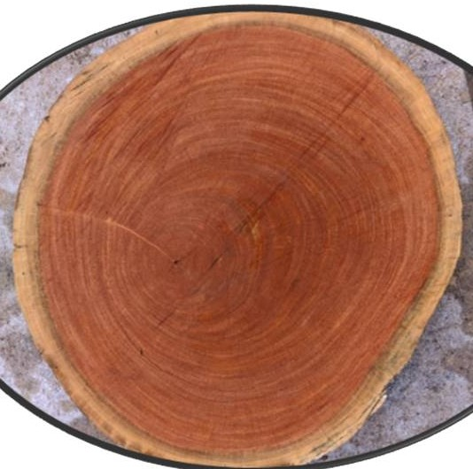
Figure-2: Wood Disc of Azadirachta indica A. Juss.

The weight of the Sapwood and Heartwood cuboids differs in both air dry and oven dry conditions (Table-1).The average air dry weight of Heartwood Cuboid sample (29.10g) was 7.18% more than that of of Sapwood which may be due to higher deposition of chemical in Heartwood. However, the average Oven dry weight of Heartwood (22.75g) is 0.306 % less than Sapwood which may be mainly due to degradation and /or loss of chemicals in Heartwood along with the moisture present in Heartwood during heating at higher temperature. However, this difference was found to be statistically non-significant(Table-3). Moisture content in Heartwood on air dry and oven dry weight (21.82%and 27.91%) is 36.88% and 47.12% respectively higher than that of Sapwood. However, it may be because of moisture absorbed binds to deposited gums, dyes and other polar phytochemicals tissues and forming complex structure which disables to evaporate absorbed water even at oven temperature from Heart wood (Table-1).

Table-1: Weight and Moisture Content(%) in Air Dry Wood samples
Air Dried Wood  Sample | Air Dry Weight (g) | Oven Dry Weight (g) | Moisture Content(%)  (Air Dry Weight Basis) | Moisture Content(%) (Oven Dry Weigh Basis)
Sap Wood | 27.15 | 22.82 | 15.94 | 18.97
Heart Wood | 29.1 | 22.75 | 21.82 | 27.91
MEAN | 28.12 | 22.78 | 18.88 | 23.44

In air dried wood samples, Density of Heartwood (1.1gcm⁻³) found to be 48.65% higher than density of Sapwood, whereas, for Oven dried wood samples, density of Heartwood (0.93 gcm⁻³) found to be 50% higher than that of Density of Sapwood. Considering Sapwood, the average density for air dried samples (0.74 gcm⁻³) found to be 16.21% more than its density in oven dry condition (0.62 gcm⁻³). Similarly, for Heartwood, the average density in air dry condition (1.1 gcm⁻³) was found to be 15.45% more than its Oven dry condition (0.93 gcm⁻³) (Figure-3). The higher density in Heartwood may be more depositions of phytochemicals and higher cell thickening. Wood Density is a major character on which the utilisation of the wood are decided which acts a good indicator for strength, stiffness and dimensional stability (Josue., 2004; Oyagade & Fabiyi, 2002; Akpan & Olufemi, 2007; Poku et al., 2001 & Oluwadare & Somorin, 2007). Density of A. indica in both sapwood - heart wood ranges from 0.62 gcm⁻³- 0.93 gcm⁻³whichwere in close to findings of average density (0.56 gcm⁻³-0.85 gcm⁻³) recorded by Koul et al. (1990). The higher density may be broadly attributed to the genotypic and environmental conditions. Similar studies also carried out with average density (0.64 gcm⁻³– 0.70 gcm⁻³) by Sotannde (2010) and average density (0.63 gcm⁻³– 0.70 gcm⁻³) by Akpan & Olufemi (2007).

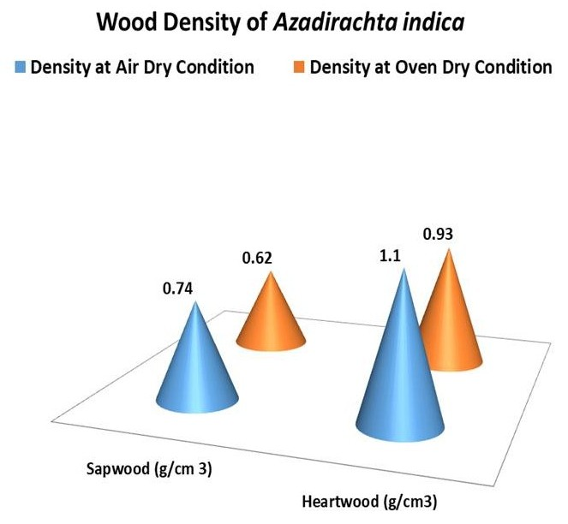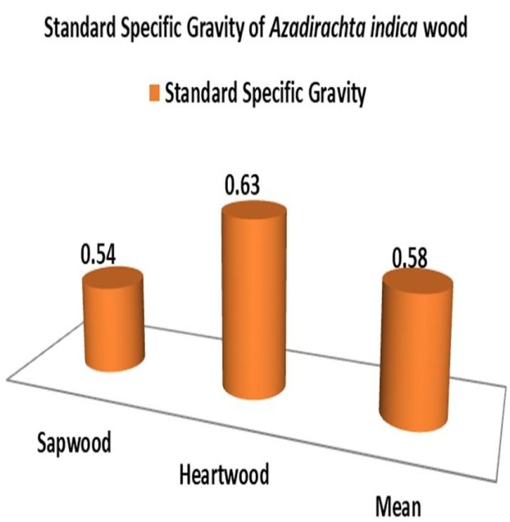
Figure-4: Standard Specific Gravity of Heartwood and Sapwood of Azadirachta indica
Figure-3: Density (gcm⁻³) of Heartwood and Sapwood of Azadirachta indica

Table -2: Specific Gravity of Heartwood and Sapwood of Azadirachta indica
Specific Gravity of Wood | Sapwood | Heartwood | Mean
Air Dry Specific gravity | 0.78 | 0.87 | 0.82
Oven Dry Specific gravity | 0.69 | 0.97 | 0.83

Specific gravity is a similar measure as density. Wood Specific gravity of air dry heart wood (0.87) which was found to be 11.53% more than the Specific gravity of air dry Sap wood, whereas, Specific gravity of oven dry Heart wood (0.97) was 40.58% higher than oven dry Sap wood. Considering Sapwood, the average Specific gravity in air dry condition (0.78) was found to be 13.04% more than its Specific gravity in oven dry condition. Similarly, for Heartwood, the average specific gravity in air dry condition (0.97) was found to be 15.45% more than its Oven dry condition (Table-2). The Standard Specific gravity of heartwood found to be 16.66% higher in heartwood (0.63) than Sap wood (Figure-4).

As the Standard specific gravity of Sapwood and Heartwood ranges between 0.54-0.63, it can be considered under the category range of Moderately Heavy-Heavy. The species can be utilised for furniture makings, veneer wood for peeling and slicing, sheet making and lining, artifacts and parquets.

Shrinkage takes place during the process of drying or seasoning of timber. Wood shrinks at different rate in along length (Longitudinal), breadth (Tangential) and height (radial) of cuboid samples evaluated from Sapwood and Heartwood. Incase of Both Sapwood and Heartwood, least Shrinkage was occurred along Longitudinal direction (Figure-5), followed by Radial direction (Figure-6) and Maximum Shrinkage along Tangential direction (Figure-5) . The pattern of result is also inconformity with the findings of shrinkage test on A. indicia reported by Sotannde et al. (2010). Similar type of work is also done by Wang et al. (2018) on Pinus radiata. In case of sapwood cuboids, Shrinkage occurred in Longitudinal (0.7%) and Tangential (5.71%) were found to be 40% and 44.55% respectively higher than Heart wood. However, Shrinkage recorded in Radial for Heart wood cuboid (3.21%) found to be 23.07% more than Sapwood. The volumetric shrinkage is 12.85% in Sapwood which is 87.31% more than volumetric shrinkage of Heartwood(Figure-5) which not much affects the properties of wood. This unequal shrinkage in different directions attributed to the anisotropic behaviour of wood which affects mainly the mechanical property of wood. The higher density of hardwood found to have low shrinkage than Sapwood and this finding also matches the finding of Sotannde et al. (2010).

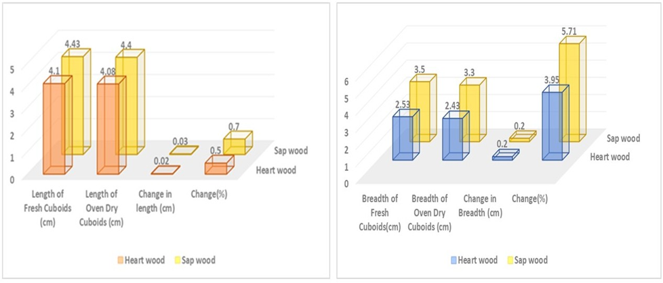

Figure 5: Shrinkage (%) in Length (Longitudinal)and Breadth (Tangential) of Sapwood and Heart wood
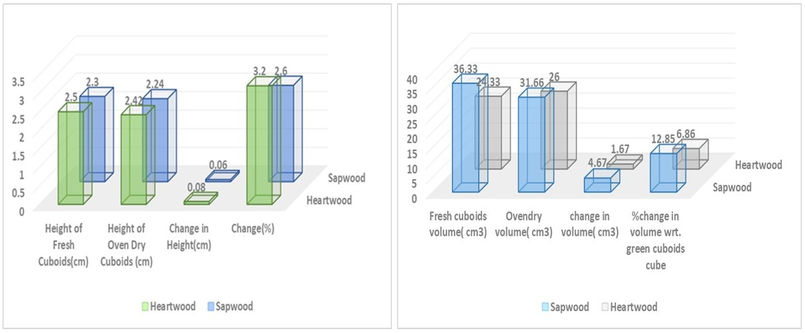

Figure-6: Shrinkage (%) in Height (Radial) and Volume of Sap wood and Heart wood

3.2 Chemical Properties of Wood Samples of Azadirachta indica

The Alcohol-Toluene extract from the Heartwood (10.48%) found to be 31.33% more than that of Sapwood(Figure-7 & 8) which is because of more deposition of phytochemicals like gum, tannin, dyes, phenols etc in heart wood than sapwood which also enhances the durability of wood by its insecticidal, fungicidal, microbial and antioxidant properties. Higher heartwood extractives than Sapwood are reported by Wei et al.(2022) in Dalbergia oliveri , Li et al.(2019) in Cunninghamia lanceolata and Morais & Pereira (2012) in Eucalyptus globulus. The Hemicellulose content of the Heartwood (26.39%) found to be 5.52% more than that of Sapwood whereas the lignin content of the Heartwood (30.79%) found to be 6.25% more than that of Sapwood (Figure-7 & 8) . Lignin content of Heartwood and sapwood was found to be statistically non-significant(Table-3). Higher Hemicellulose in Heartwood than Sapwood has been reported by Li et al. (2019) in Cunninghamia lanceolata. Higher Lignin content in Heartwood than Sapwood reported in Mazri et al. (2022) in Fraxinus, Jia et al. (2017) in Oak, Lourenço (2015) in Tectona grandis, Dünisch et al. (2010) in Robinia pseudoacacia and Picea abies by Bertaud (2004). However, the Cellulose (38.03%)and Holocellulose content (63.04%) of the Sapwood found to be 17.59% and 7.34% respectively higher than Heartwood. Dzurenda et al, (2023) reported Higher Holocellulose and Cellulose in Sapwood of Fagus sylvatica where as only higher Holocellulose content in Sapwood reported by Wei et al.(2022) in Dalbergia oliveri.

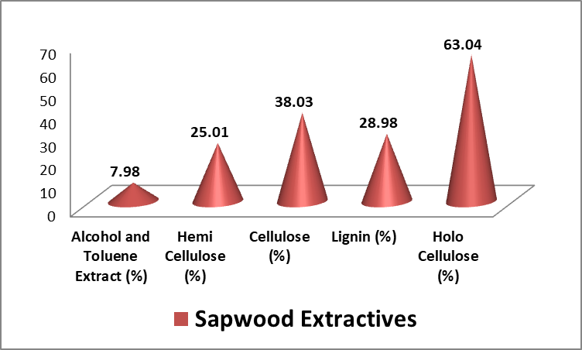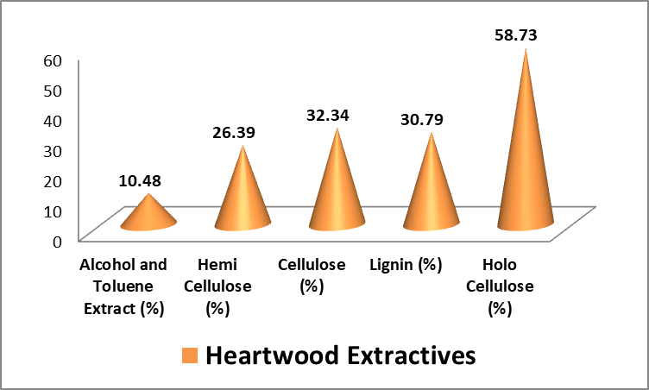Figure-7:Sapwood Extractives(%) of A.indicaFigure-8:Heartwood Extractives(%) of A. indica

3.3 Anatomical Properties of Wood Samples of Azadirachta indica
The anatomical study of Heartwood and Sapwood revealed the following major anatomical features in Cross-sectional, Radial and Tangential Section. Incase of Heartwood ,the average number of Vessels found to be 5.73, 2.12 and 3.38per mm² , whereas , Ray Parenchyma 1.06, 2.86 and 4.48 per mm² in Cross section , Radial section and Tangential section respectively. However, in case of Sapwood, the average number of Vessels found to be 4.35, 4.45 and 1.59 per mm²,whereas , Ray Parenchyma were recorded 2.55,1.05 and 3.18 per mm² in Cross-sectional, Radial and Tangential section respectively (Figure-9).The average vessel number in Cross-sectional area of Heartwood and Sapwood samples categorises it under class of moderately numerous whereas number of rays can be classed under few widely spaced.
The cross sectional features of the wood showed diffuse porus pattern, Vessels are mostly circular with lumen size varies from small to large, are solitary or in radial multiples of 2 or 3. Axial Parenchyma is Vascicentric or Banded Paratracheal type. Ray cells are Uniseriate to Multiseriate (2-3) (Figure-10).The findings were also in lieu with the anatomical features findings in A. indica by Nair (1998).
Martı´nez-Cabrera et al. (2009) revealed that low density wood from wet sites have high proportion of Rays than dry sites. Here, the site is not wet and cross-section has few (1.66-2.55) rays and no. of pores in cross-section are moderately numerous favouring higher density of wood putting the species under category of Moderately Heavy. Normally, Fibres provides mechanical support to the tree while Vessels helps in conduction and Parenchyma in both storage and conduction. But in a study carried out by Zhang et al.(2023) revealed that strong wall vessels helps in mechanical support, blunt cracking and seizes horizontal cracking whereas the ray cells helps in arresting the axial cracking.
Parenchyma amounting 40% of wood volume with high variation among different species and within individual of same species (Spicer, 2014; Morris et al., 2016 ; Fonti et al.2015 & vonArx et al.,2017).Physiological role played by Parenchyma includes storage and transport of non-structural carbohydrates (Johnson et al., 2012 & Plavcová et al., 2016),vessel refilling after clotting and regulating hydraulic flow (De Boer and Volkov, 2003 & Secchi et al., 2017), and accumulation secondary metabolites and active principles of antimicrobial, disease and pest resistance nature and development of heartwood (Spicer, 2005; Morris et al., 2016). Again the functionality within parenchyma depends upon the orientation and connectivity of parenchyma cells as radially arranged ray cells or axially arrangement related to vessels like Apotracheal or Paratracheal (Carlquist, 2001). This not only helps in Taxonomic classification point of view but also variation in Appearance, Chemical and Mechanical properties of wood.
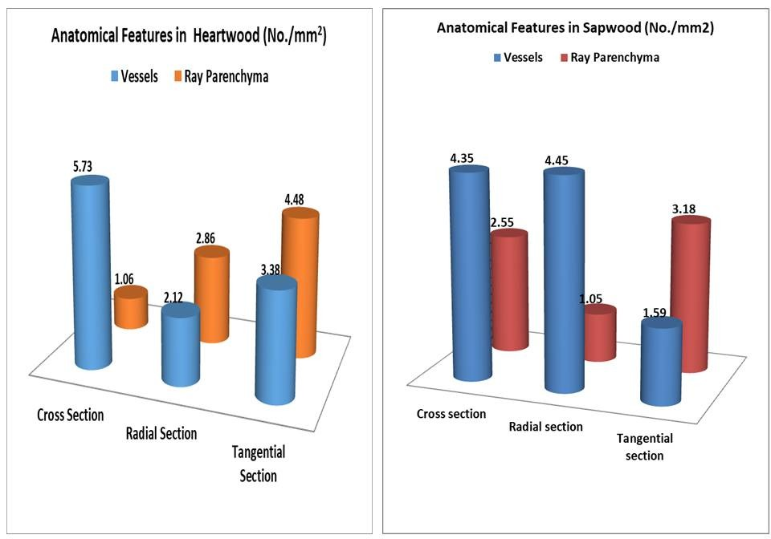
Figure- 9: Anatomical Features of Heartwood and Sapwood of A.indica
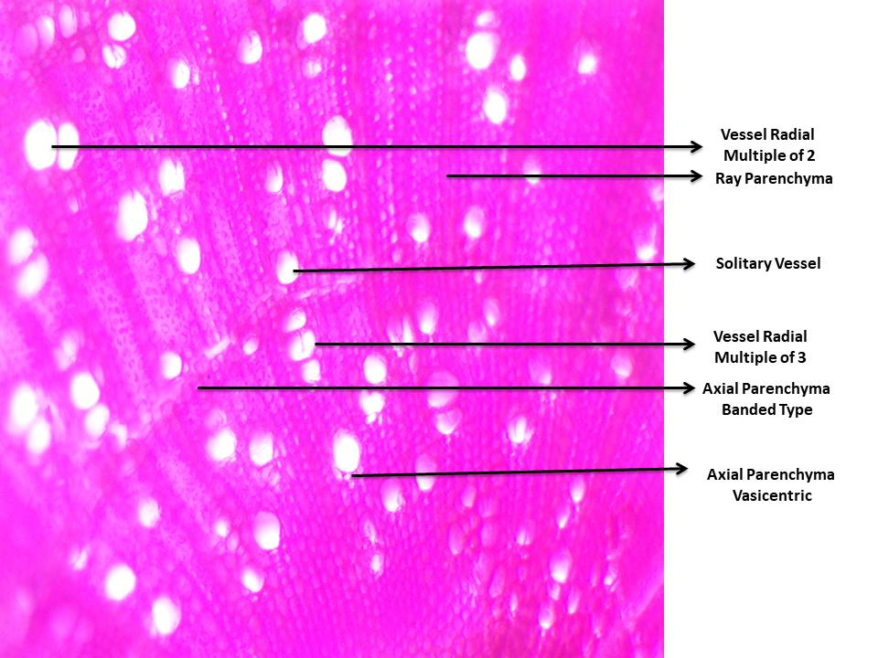
Figure- 10: Cross-sectional Features of A.indica Wood

Air Dry Weight | Oven Dry Weight | Moisture Content on Air Dry Weight Basis | Moisture Content on Oven Dry Weight Basis
0.00007276 (S) | 0.8754 (NS) | 0.00005134 (S) | 0.00008829 (S)
Air Dry Density | Oven Dry Density | Standard Specific Gravity | Air Dry Specific Gravity
0.0001822 (S) | 6.328e-9 (S) | 0.00002523 (S) | 0.000001419 (S)
Oven dry specific gravity | Longitudinal Shrinkage | Tangential Shrinkage | Radial Shrinkage
2.271e-7 (S) | 3.405e-9 (S) | 4.441e-16 (S) | 0.00001512 (S)
Volumetric Shrinkage | Alcohol-Toluene extract | Hemicellulose | Cellulose
0.000005919 (S) | 1.653e-7 (S) | 0.02685 (S) | 0.000007373
Holocellulose | Lignin | Crosssectional Vessels Number | Tangential Vessel Number
0.001282 (S) | 0.06845 (NS) | 0.000003129 (S) | 6.493e-7
Radial Vessel Number | Crosssectional Parenchyma Number | Tangential ParenchymaNumber | Radial Parenchyma Number
0.00003237 | 3.267e-7 | 1.726e-9 | 2.607e-13
Table-3 Comparison of Mean of Sapwood and Heartwood for Physiochemical and Anatomical Characters

(Two Sample Test (Welch) significance test) : S- Significant , NS-Non significant

4. Conclusion
Azadirchta indica A. Juss. timber evaluated found to be a fast growing species with higher proportion of Heartwood .Although it shows an anisotropic behaviour but the volume shrinkage is low which may not affect the wood properties to a greater extent. The moderate number conducting tissues like vessel and less ray parenchyma found in such wood growing conditions may increased its density/specific gravity. The Holocellulose content of the sample tree found to be high and can be used for making Pulp and Paper and modified woods. Proper Lignin content and higher wood extractive present in the wood will make it more durable and diversified construction purposes. The Physiochemical and anatomical characters evaluated from the sample tree of this locality ameliorate the quality of this fast growing multipurpose tree species. Similar type studies can be taken up selecting more number of sample trees from different edaphic, climatic and altitudinal variations to identify the changes in Physicochemical and Anatomical Characteristics which will be helpful in differentiating the quality of wood growing in different conditions.

5. Acknowledgement
The author acknowledges Odisha University of Agriculture and Technology, Bhubaneswar, Odisha, India-751003 for providing facility to carry out the research work.

6. Disclaimer (Artificial Intelligence)
Author(s) hereby declare that NO generative AI technologies such as Large Language Models (ChatGPT, COPILOT, etc.) and text-to-image generators have been used during the writing or editing of this manuscript.
7. Declarations
Conflicts of interest : The authors declare that they have no conflicts of interest.
8. References

- Akpan, M. & Olufemi, B.(2007). Quantitative studies on density of neem (Azadirachta indica A. Juss.) wood for utilization as timber in northeastern Nigeria. University of District Colobia UDC 630*33/.35/669. 1-7p.
- Bertaud, F. & Holmbom, B.(2004). Chemical composition of earlywood and latewood in Norway spruce heartwood, sapwood and transition zone wood. Wood Science and Technology, 38: 245-256.
- Carlquist, S. (2001) Comparative Wood Anatomy: Systematic, Ecological, and Evolutionary Aspects of Dicotyledon Wood. Springer-Verlag Press, Germany.448pg.
https://doi.org/10.1007/978-3-662-04578-7
- De Boer, A. H., & Volkov, V.(2003). Logistics of water and salt transport through the plant: structure and functioning of the xylem. Plant, Cell & Environment, 26(1): 87-101. https://doi.org/10.1046/j.1365-3040.2003.00930.x
- Deore C.R., Jadhav H.S., Patil M.S., Thakur A.M. & Bhavsar A.M.(2020). Anatomical variation of timber wood forest product in some common species of angiosperm and their systematic enumeration useful for taxonomic significance, Plant Archives, 20 ( 2) : 3399-3404
- Duenisch, O., Richter, H.G. & Koch, G.(2010). Wood properties of juvenile and mature heartwood in Robinia pseudoacacia L.Wood Science and Technology, 44: 301- 313.
- Dzurenda, L. & Dudiak, M. & Kučerová, V.(2023). Differences in Some Physical and Chemical Properties of Beechwood with False Heartwood, Mature Wood and Sapwood. Forests,14(6): 1123.
- Fonti, P., Tabakova, M.A., Kirdyanov, A.V. , Bryukhanova,M. & von Arx. G. (2015) Variability of ray anatomy of Larix gmelinii along a forest productivity gradient in Siberia. Trees 29: 1165–1175. https://doi.org/10.1007/s00468-015-1197-0
- Islas, J.F., Acosta, E., G-Buentello, Z., Delgado-Gallegos, J.L., Moreno-Treviño, M. G., & Escalante, B. & Moreno-Cuevas, J.E.(2020). An Overview of Neem (Azadirachta indica) and Its Potential Impact on Health. Journal of Functional Foods ,74: 1-13.
- Johnson,D.M., McCulloh,K.A., Woodruff,D.R. & Meinzer,F.C.2012. Hydraulic safety margins and embolism reversal in stems and leaves: Why are conifers and angiosperms so different?. Plant Science: 195:48-53,
- Josue, J.(2004). Some wood properties of Xylia xylocarpa planted in Sabah. Sepilok Bulletin 1: 1-15.
- Iqbal, M., Jura-Morawiec, J., & WŁoch, W. (2010). Foliar characteristics, cambial activity and wood formation in Azadirachta indica A. Juss. as affected by coal–smoke pollution. Flora-Morphology, Distribution, Functional Ecology of Plants, 205(1), 61-71.
- Koul, O., Isman, M. B., & Ketkar, C.M.(1990). Properties and uses of neem, Azadirachta indica. Can. J. Bot. 68:1-11.
- Lourenço, A., Neiva, D.M. & Gominho, J.,Marques, A.V. & Pereira,H. (2015). Characterization of lignin in heartwood, sapwood and bark from Tectona grandis using Py–GC–MS/FID. Wood Sci Technol, 49: 159–175.
- Martínez-Cabrera H.I., Jones C.S., Espino S. & Schenk H.J.(2009). Wood anatomy and wood density in shrubs: Responses to varying aridity along transcontinental transects. American Journal of Botany, 96(8):1388-1398.
- Mehta, T.(2008). A Handbook of Forest Utilization. International Book Distributors (Dehra Dun): 298p.ISBN:8170893151.
- Morris, H., Plavcová, L., Cvecko, P., Fichtler, E., Gillingham, M.A.F., Martínez-Cabrera, H.I., McGlinn,D.J., Elisabeth Wheeler,E., Zheng,J., Ziemińska,K. & Jansen,S.(2016). A global analysis of parenchyma tissue fractions in secondary xylem of seed plants. NewPhytologist,209:1553-1565.
- Moubasher, A.H., Hafez, S. I. ,. Aboelfattah,H. M. & Moharrarh, A. M.(1982). Fungi of wheat and broad bean straw compost. II. Thermophilic fungi. Mycopathologia, 783:169-176.
- Nagamadhu M., Vijay Kumar S., Ravi Kumar S., Suraj R.& Mohan Kumar, G. C.(2020). Materials Today: Proceedings,24 : 2265–2273.
- Nair, M. N. B.(1988). Wood anatomy and heartwood formation in Neem (Azadirachtaindica A. Juss.), Botanical Journal of the Linnean Society, 97(1) : 79–90.
- Oluwadare, A.O. & Somorin,O.A.(2007). Preliminary reports on utilization potential of Gliricidia sepium for timber. Research J. of Forestry: 1(2): 80-85.
- Oyagade, A.O. & Fabiyi,J.S.(2002). Density variation in plantation grown Nauclea diderrichii. J. Trop. For. Resources, 18(1): 26-34.
- Plavcová L., Hoch G., Morris H, Ghiasi S., Jansen S.2016.The amount of parenchyma and living fibers affects storage of nonstructural carbohydrates in young stems and roots of temperate trees. American Journal of Botany:103(4):603-612. doi: 10.3732/ajb.1500489
- Poku, K., Wut, Q. & Vlosky,R.(2001). Wood properties and their variations within the tree stem of lesser-used species of tropical hardwood from Ghana. Wood and Fibre Science, 33(2): 284-291.
- Roshan, A. & Verma, N.K.(2015) A Brief Study on A. Indica and Its Application: A Review. Research Journal of Phytomedicine, 1: 1-3.
- Secchi F., Pagliarani C., Zwieniecki M.A.2017. The functional role of xylem parenchyma cells and aquaporins during recovery from severe water stress. Plant Cell Environ. : 40(6):858-871. doi: 10.1111/pce.12831.
- Singh , P., Sharma, S., Singh, K., Singh, P.K., Chowdhury, F .I., Yahya, M.Z.A., Yusuf, S.N.F., Diantoro, M. Latif, F.A. & Singh, N.B.(2024). Recent development on neem (Azadirachta indica) biomass absorbent: Surface modifications and its applications in water remediation. Chemical Physics Impact, 9 : 100773 (1-23).
- Singh, R.K.(2019). Ethnomedicinal properties of Azadirachta indica (Neem Tree), Research Review International Journal of Multidisciplinary, 4 (3):2586-2592.
- Sinha, A.S.K.(2008). Neem (Azadirachta indica) as alternative wood fibre source with environmental advantages & medicinal properties for pulp & paper industries. TAPPI Press - Paper Conference and Trade Show, PaperCon '08. 5. 3314-3326.
- Sotannde, O.A., Oluyege, A.O., Adeogun, P.F. & Maina, S.B.(2010). Variation in Wood Density, Grain Orientation and Anisotropic Shrinkage of Plantation Grown Azadirachta Indica.Journal of Applied Sciences Research, 6(11): 1855-1861.
- Spicer, R.(2005) Senescence in secondary xylem: Heartwood formation as an active developmental program. In: Holbrook, N.M. and Zwieniecki, M.A., Eds., Vascular Transport in Plants, Elsevier Academic Press, Amsterdam, 457-475. doi:10.1016/B978-012088457-5/50024-1
- Spicer,R.(2014).Symplasmic networks in secondary vascular tissues: parenchyma distribution and activity supporting long-distance transport. Journal of Experimental Botany, 65(7): 1829–1848, https://doi.org/10.1093/jxb/ert459

- Yadav J., Ramkumar,P.L. & Parwani, A.K.(2024). Characterization of Azadirachta indica Natural Cellulosic Fibre and Its Polymer Composites. Arabian Journal for Science and Engineering,50:13635–13647.

- von Arx, G., Arzac, A., Fonti, P., Frank, D., Zweifel, R., Rigling, A., Galiano, L., Gessler, A., & Olano, J. M.(2017). Responses of sapwood ray parenchyma and non-structural carbohydrates of Pinus sylvestris to drought and long-term irrigation. Functional Ecology, 31(7), 1371-1382. https://doi.org/10.1111/1365-2435.12860
- Wei L, Ma R, Fu Y.2022. Differences in Chemical Constituents between Dalbergia oliveri Heartwood and Sapwood and Their Effect on Wood Color. Molecules :27(22):7978. doi: 10.3390/molecules27227978.
- Zhang,H., Zhu,P., Wang,Z., Fucheng Ma, Hongmei Ji & Xiaowu Li,.(2023). Combined effect of rays and vessels to achieve high strength and toughness in balsa wood, Materials Letters, (352):1-4, 135137.

