Original Research Article
FIRST REPORT OF INFECTIOUS SPLEEN AND KIDNEY NECROSIS VIRUS (ISKNV) INFECTION IN DWARF GOURAMI (TRICHOGASTER LALIUS) FROM INDIA

ABSTRACT
Infectious Spleen and Kidney Necrosis Virus (ISKNV), a member of the genus Megalocytivirus within the family Iridoviridae, has emerged as a significant pathogen in both ornamental and food fish species globally affecting the aquaculture industry. This study reports the molecular detection and phylogenetic characterization of ISKNV in two ornamental fish species namely dwarf gourami (Trichogaster lalius) and angelfish (Pterophyllum scalare). Out of 38 samples screened, two were found positive for major capsid protein (MCP) gene with a 563 bp product by using OIE-recommended primers. The sequence analysis using BLAST, revealed 98.40% and 98.76% nucleotide identity with reference ISKNV strains for dwarf gourami and angelfish, respectively. Phylogenetic analysis of MCP gene sequences, clustered the isolates from this study within the ISKNV clade. Clinically, the infected angelfish exhibited whirling behavior and internal signs such as hepatic hemorrhage and splenomegaly, while the dwarf gourami remained asymptomatic. These findings underscore the potential for subclinical ISKNV infections and highlight the risk of viral dissemination through transboundary ornamental fish trade and cohabitation practices in local shops. This study represents the first confirmed report of ISKNV infection in dwarf gourami from India and emphasizes the need for enhanced molecular surveillance and biosecurity measures in ornamental aquaculture systems.
Keywords: ISKNV; Megalocytivirus; Dwarf gourami; splenomegaly; Phylogenetic analysis

- INTRODUCTION
Ornamental fishes are considered as the living jewels of aquatic systems gaining its importance due to their aesthetic beauty and imminent economic opportunities. Currently, ornamental fish keeping is one of the most popular avocations across the globe (Kundu et al., 2019; Stevens et al., 2017). Globally, the export value of ornamental fish reached approximately USD 5.88 billion in 2022, with projections suggesting it may rise to USD 11.30 billion by 2030, driven by a compound annual growth rate (CAGR) of 8.5% (Grand view research, 2023). In India, the ornamental fish sector including breeding, rearing, trade, aquarium accessories, aquatic plants, and decorative items is currently valued at around ₹3,000 crore (USD 360 million). Kolkata remains the dominant export hub, accounting for nearly 90% of the country’s ornamental fish exports (Tandel et al., 2024). Back in 1976, only 32 countries were involved in the export-import of ornamental fishes but today more than 150 countries are actively involving in the trade (Raja et al., 2019). Even though there are more than 2500 ornamental fish species in the trade including marine and fresh water fish species, only 30 freshwater fish species dominate the world market (Dey, 2016). India is one among the countries which is blessed with rich amount of fish biodiversity from the geological hotspots including various indigenous species distributed all along the country (Mukherjee et al., 2014; Raja et al., 2019). North-eastern states, Himalayan rivers, Western ghats, Lakshadweep, Andaman & Nicobar Islands are the major geological hotspots for 377 indigenous freshwater ornamental fishes few fish species are endemic to particular region. These regions possess exceptionally high degree of biodiversity and endemism with the prominent species belongs to the groups like loaches, barbs, gobies, catfishes, and eels from these geological hotspots (Raja et al., 2019). Based on endemic and other ornamental fish, the export trade of Indian ornamental trade is approx. 6 crores which accounts for 0.3% of the global export. Indian has good domestic market with the trade value of 25 crores and growing every year (Satam et al., 2018). With the huge untapped resources, India aquarist is interested in expanding the industry with multi-species trade in India and worldwide. The desire to fetch new species led to the import of ornamental fishes from different parts of the world to culture and breed in hatchery and grow in the farm to meet the rising demand (Giri, 2018).
Live trade of fishes will facilitate transboundary movement of infectious diseases with huge economic loss (Go & Whittington, 2006). Among different pathogens (virus, bacteria, parasite, protozoa and fungi), viral and bacterial diseases are the major reason for the acute mortalities in the commercial culture systems around the globe (Escobar et al., 2018; Mukherjee et al., 2014). Since last two decades, various studies regarding infectious diseases have shown us that there is a gradual increase in the number of viruses isolated from different commercially important fish species in India (Azad et al., 2005; Behera et al., 2018; Girisha et al., 2020, 2021; Swaminathan et al., 2016). Rise in the transboundary movement of ornamental fishes as well as intensification of the surveillance under the NSPAAD (National Surveillance Programme for Aquatic Animal Diseases) program has resulted in an increased diagnosis for viruses from family Iridoviridae (iridovirids) (Girisha et al., 2021). Iridovirids are double stranded DNA viruses with a genome size of 140 – 303 kbp infecting different fish, shellfish and amphibians. A special distinguishing characteristic of the iridoviral genome is, they are circularly permuted and terminally redundant. Nevertheless, considering this feature the genome size will be reduced to 103 – 220 kbp (Chinchar et al., 2017; Tsai et al., 2005). Members of Iridoviridae family possess a large icosahedral virion, an internal lipid membrane located between outer capsid and a viral core. Viruses in this family do not require a viral envelope to infect, instead they are released as naked virus particles which are cell associated for viral replication and infection cycle (Chinchar et al., 2009). Iridoviruses can cause severe systemic infections in poikilothermic vertebrates and invertebrates across the globe (Go et al., 2006; Halaly et al., 2019; Lancaster et al., 2003; Williams, 1996; Williams et al., 2005).
According to the 10th report of International Committee on Taxonomy of Viruses (ICTV), members of family Iridoviridae are classified into two subfamilies: Alphairidovirinae and Betairidovrinae(Chinchar et al., 2017; Halaly et al., 2019). Members infecting amphibians, reptiles and bony fishes are grouped under the former subfamily comprising the genera Lymphocystivirus, Ranavirus, and Megalocytivirus. Whereas, the latter subfamily comprising the genera Iridovirus, Chloriridovirus and Decapodiridovirus which can infect the invertebrates like insects and crustaceans (Chinchar et al., 2020; Whittington et al., 2010). Of late, Megalocytivirus have been found to drawn the attention of whole fishery community due to the severe economic and ecological impacts on both wild and cultured fish species (Halaly et al., 2019; Kurita & Nakajima, 2012). Spread of Megalocytivirus across the globe is mainly due to the movement of infected ornamental fishes for trade without screening for the pathogens (Go & Whittington, 2006; Nolan et al., 2015). Outbreaks of the Megalocytivirus could cause severe mortalities in ornamental, farmed and wild fishes along with huge economical loss to the ornamental farms and reported for the first time in Germany in 2016 and in India in 2020 (Girisha et al., 2021; Jung et al., 2016). Even at severe conditions, the clinical signs observed are common with most of the Megalocytivirus infections and hence it is tedious to identify the infections (Johan & Zainathan, 2020). With a little genetic difference, the genus is classified into 3 major groups represented by red sea bream iridovirus (RSIV), infectious spleen and kidney necrosis virus (ISKNV) and turbot reddish body iridovirus (TRBIV) and causes red sea bream iridovirus disease (RSIVD).
ISKNV being an emerging fish viral disease in ornamental industry, has a greater risk of spreading into various countries which are involved in ornamental fish trade (Girisha et al., 2021; Swaminathan et al., 2021). After the first report in China (He et al., 2000), ISKNV has been reported from Australia (Go & Whittington, 2006), South Korea (Joon et al., 2008), Germany (Jung et al., 2016), Malaysia (Subramaniam et al., 2014), Thailand (Thanasaksiri et al., 2019), Africa (Ramírez et al., 2021) and recently identified from India (Girisha et al., 2021) in ornamental fishes. ISKNV have been implicated infections in more than 52 ﬁsh species (Wang et al., 2007) ISKNV has a wide host range that continues to expand as new susceptible species are added, and it can be transmitted easily within natural aquatic systems. In short, ISKNV's ability to infect many different species and its high contagious rate in water bodies make it a formidable and difficult-to-manage viral threat. ISKNV infected fish shows general clinical signs like abnormal swimming, anorexia, pale gills, and dull body pigmentation. In severe conditions, surface clinical signs like petechial haemorrhages under abdomen, base of fins and around the eye can be observed externally. Internally, major target organs of ISKNV are spleen and kidney which will be enlarged during the infection resulting in splenomegaly and nephromegaly, respectively. Whereas, organs like liver and heart will turn pale during the infection (He et al., 2000; Jung et al., 2016). In 2020, the first report of infectious spleen and kidney necrosis virus in India was detected in 10 different fish species (Girisha et al., 2021).. In the present study, ISKNV infection was detected in dwarf gourami (Trichogaster lalius), which is the first report of ISKNV in dwarf gourami from India.
- MATERIALS AND METHODS
2.1 Sample collection
Fish samples were collected randomly from different ornamental fish retail units for screening of Infectious spleen and kidney necrosis virus from Mangaluru region. Moribund fishes displaying abnormal swimming behaviour, faded body colour, anorexia, pale gills with clinically unhealthy symptoms were collected. During the study, a total of 38 fish samples belonging to different families (Table 1) were collected and brought to Aquatic Animal Health laboratory, College of Fisheries, Mangaluru, India. All the live fish samples were euthanized and either dissected freshly under aseptic condition or preserved at -80°C until further processing.
Table 1: Family wise sample data of all the fish samples collected from Mangaluru.
Sl. No. | Name of the Family | Representative sample name | No. of samples | Total
1 | Cyprinidae | Gold fish (Carassius auratus) | 5 | 9
1 | Cyprinidae | Koi carp (Cyprinus carpio koi) | 2 | 9
1 | Cyprinidae | Zebra fish (Danio rerio) | 2 | 9
2 | Poeciliidae | Molly (Peocilia sphenops) | 8 | 12
2 | Poeciliidae | Platy (Xiphophorus maculatus) | 1 | 12
2 | Poeciliidae | Guppy (Poecilia reticulata) | 3 | 12
3 | Cichilidae | Angel (Pterophyllum scalare) | 8 | 15
3 | Cichilidae | Angel (Pterophyllum altum) | 4 | 15
3 | Cichilidae | Discuss (Symphosodon discuss) | 1 | 15
3 | Cichilidae | Ramirezi (Mikrogeophagus ramirezi) | 2 | 15
4 | Osphronemidae | Dwarf gourami (Trichogaster lalius) | 2 | 2
Total |  |  | 38 | 38

2.2 DNA extraction
Genomic DNA was extracted following the protocol (Otta et al., 2003), with minor modifications to optimize yield and purity. Tissue samples (~100 mg) were placed in sterile microcentrifuge tubes and homogenized using 800 µl of tissue digestion buffer comprising 10 mM Tris-HCl (pH 8.0), 0.1 M EDTA (pH 8.0), 0.5% Triton X-100, 6 M guanidine hydrochloride, and 0.1 M sodium acetate. Homogenization was performed using sterile disposable sticks under aseptic conditions. The homogenates were incubated at ambient temperature (28 ± 1°C) for 30 minutes, followed by centrifugation at 6,000 × g for 10 minutes. The resulting supernatant was transferred to fresh microcentrifuge tubes, and an equal volume of phenol:chloroform:isoamyl alcohol (25:24:1) was added. The mixture was vortexed briefly and centrifuged at 10,000 × g for 10 minutes. The upper aqueous phase containing DNA was carefully transferred to a new tube and subjected to precipitation by adding 2–3 volumes of chilled absolute ethanol with a gentle mix. The samples were centrifuged at 14,000 × g for 20 minutes to pellet the DNA. The DNA pellet was washed twice with 70% ethanol, vacuum dried, and subsequently resuspended in 100 µl of either sterile injection-grade water or 1X TE buffer (pH 8.0), prepared by mixing 1 ml of 1 M Tris-HCl, 200 µl of 0.5 M EDTA, and 98.8 ml of autoclaved distilled water. DNA concentration and purity were assessed spectrophotometrically at 260 nm using a NanoDrop 1000™ spectrophotometer (Thermo Fisher Scientific, USA). Extracted DNA was either stored at −20°C/−80°C for long-term preservation or used immediately for downstream PCR applications.
2.3 PCR based diagnosis for viruses
All fish-derived DNA samples were initially screened using two primer sets recommended by the World Organisation for Animal Health (OIE), targeting the PstI restriction fragment and DNA polymerase regions of the viral genome (Kurita et al., 1998). The first primer pair, 1F (5′-CTCAAACACTCTGGCTCATC-3′) and 1R (5′-GCACCAACACATCTCCTATC-3′), amplifies the PstI fragment, while the second pair, 4F (5′-CGGGGGCAATGACGACTACA-3′) and 4R (5′-CCGCCTGTGCCTTTTCTGGA-3′), targets the DNA polymerase gene. A sample that tests positive with both sets of primers indicates the presence of RSIV, whereas a sample that is positive only with the first set of primers (PstI restriction fragment primers) is indicative of ISKNV infection. Samples that tested positive in the initial screening were further validated using ISKNV-specific major capsid protein (MCP) primers, mF2 (5′-CGTGAGACCGTGCGTAGT-3′) and mR2 (5′-AGGGTGACGGTCGATATG-3′), which amplify a 563 bp fragment of the MCP gene (Wang et al., 2007). Polymerase chain reaction (PCR) was conducted in a total reaction volume of 30 µl, containing 2.0 µl of template DNA, 1X assay buffer (10 mM Tris-HCl, pH 9.0; 1.5 mM MgCl₂; 50 mM KCl; 0.01% gelatin), 200 µM of each deoxyribonucleotide triphosphate (dATP, dCTP, dGTP, dTTP), 10 pM of each primer, and 0.6 U of Taq DNA polymerase (Genei, Bangalore, India). Amplifications were performed using a programmable thermal cycler (Eppendorf, India) under standardized cycling conditions for different viruses using primers was followed as per (Nithin et al., 2021) Nithin et al., 2021. Each PCR assay included both positive and negative controls to validate amplification specificity and ensure procedural integrity.
2.4 Purification of the amplicon
PCR-amplified products targeting the MCP gene (primers mF1-mR1) were purified using the HiPurA™ PCR Product Purification Kit (HiMedia, India), following the manufacturer’s protocol with minor procedural adjustments. Briefly, five volumes of PCR binding solution (SPB) were added to one volume of PCR product in a sterile 2 ml capped microcentrifuge tube and mixed thoroughly by pipetting. The mixture was transferred to a HiElute™ Miniprep Spin Column (capped) and centrifuged at 12,000 × g for 1 minute. The flow-through was discarded, and 700 µl of diluted wash solution was added to the column, followed by centrifugation at 13,000 rpm for 1 minute. After discarding the flow-through, the column was centrifuged again at 12,000 × g for 1 minute to remove residual ethanol. The spin column was then transferred to a fresh, uncapped 2 ml collection tube, and DNA was eluted by adding 50 µl of elution buffer to the center of the column membrane. After a 1-minute incubation at room temperature, the column was centrifuged at 12,000 × g for 1 minute. The eluted DNA was either used immediately for sequencing or stored at −20°C/−80°C for future applications.
2.5 Sequencing and phylogenetic analysis
Purified PCR products were subjected to Sanger sequencing at Bioserve Biotechnologies (India) Pvt. Ltd., Hyderabad, India. Raw sequence data were analyzed using BioEdit Sequence Alignment Editor (version 7.0.5.2). Multiple sequence alignment was performed using the Multialign online tool, and homology searches were conducted using the Basic Local Alignment Search Tool (BLAST) available through the National Center for Biotechnology Information (NCBI). Phylogenetic relationships were inferred using MEGA X software (version 10.0.5) employing the Neighbor-Joining method. Bootstrap analysis was performed with 1,000 replicates to assess the robustness of the tree topology.
- RESULTS
3.1 Clinical signs observed in the ISKNV infected fish
A total of 38 ornamental fishes were screened for ISKNV by using PCR by targeting spleen, kidney, liver and gill samples. Only two ornamental fishes were found positive for ISKNV out of 38 fish samples collected with a percentage incidence of 5.2% and negative for all the other viruses. Behavioral changes like whirling movement in the tank was observed in both dwarf gourami and angel fish during the collection of the samples. Along with the behavioral changes, the ISKNV infected fishes showed a few usual external clinical signs of a viral infection viz., body discolorations and abdominal swelling in dwarf gourami and angel fish respectively (Figure 1A and 1C). Internally, enlargement of kidney (nephromegaly) was observed in dwarf gourami (Figure 1B) and angel fish (Figure 1F). Many of the samples of angel fish collected have shown the abdominal swelling with fluid (Figure 1C), haemorrhages patches on liver (D), and enlargement of spleen (splenomegaly-Figure 1E & 1F) observed in angel fish.
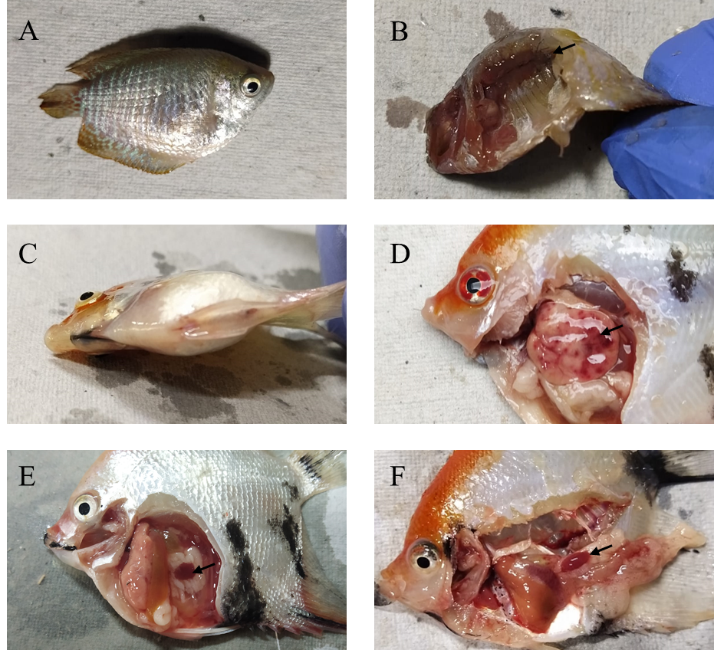
Fig. 1. Clinical signs observed in ISKNV infected fish.
Body discolouration (A) and enlarged kidney (B) observed in dwarf gourami. Swollen abdomen (C), patches of haemorrhages on liver indicated by arrow (D), enlargement of spleen (E & F) observed in angel fish indicated by arrow.
3.2 ISKNV confirmation through conventional PCR assay
Infection of ISKNV was screened by performing PCR targeting Pst I restriction fragment and DNA polymerase, and then confirmed by MCP gene of ISKNV. The ISKNV infected fishes displayed positive results for MCP (Figure 2A) and Pst I restriction fragment genes (Figure 2B), whereas negative result for DNA polymerase thus ruling out the RSIV (Figure 2C). These results confirm the detected virus as ISKNV (Figure 2) in collected samples.
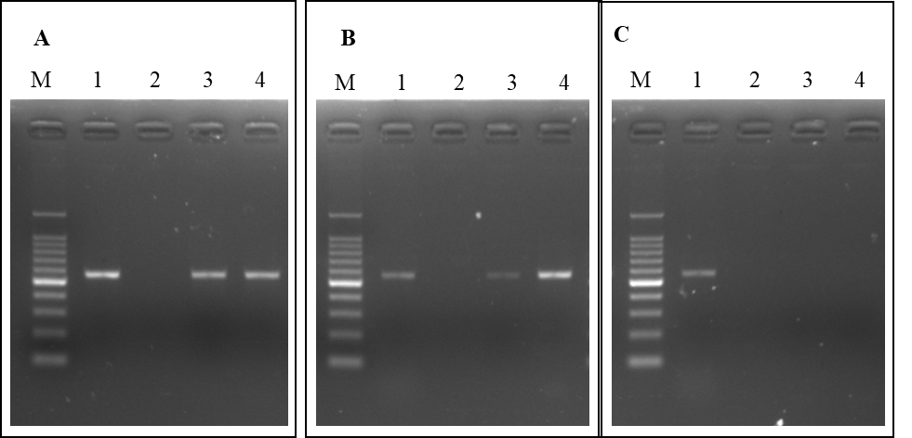
Fig. 2. Confirmation of ISKNV through agarose gel electrophoresis assay. PCR amplicons of ISKNV MCP gene (A), Pst I restriction fragment gene (B) and DNA polymerase gene (C).
Lane M: 100bp DNA ladder, Lane 1: Positive control, Lane 2: Negative control, Lane 3: Dwarf gourami DNA, Lane 4: Angel fish DNA
3.3 Sequencing and phylogenetic analysis of MCP gene
PCR-amplified MCP gene products from both dwarf gourami and angelfish were subjected to Sanger sequencing to further confirm the ISKNV. Sequence analysis confirmed that the MCP amplicons from both species were of identical length, measuring 563 bp. Comparative BLAST analysis against the NCBI GenBank database revealed high nucleotide sequence identity, with 98.40% for the dwarf gourami-derived strain and 98.76% for the angelfish-derived strain. The ISKNV sequences obtained in this study showed complete identity with 32 reference ISKNV strains available in GenBank, indicating strong genetic conservation across ornamental fish hosts. The validated MCP gene sequences were subsequently used to construct a phylogenetic tree (Figure 3) to elucidate the evolutionary relationships among ISKNV isolates.
The MCP gene sequences of the two ISKNV strains identified in this study were aligned with 32 reference sequences representing the genus Megalocytivirus. Phylogenetic analysis revealed three distinct clusters corresponding to the ISKNV, RSIV, and TRBIV genotypes. The ISKNV strains from dwarf gourami and angelfish grouped within the ISKNV clade, clustering closely with the ISKNV strain previously reported from black molly in India. All ISKNV sequences exhibited high genetic similarity and formed a distinct clade, clearly separated from the RSIV and TRBIV clusters, indicating conserved lineage-specific divergence within the genus

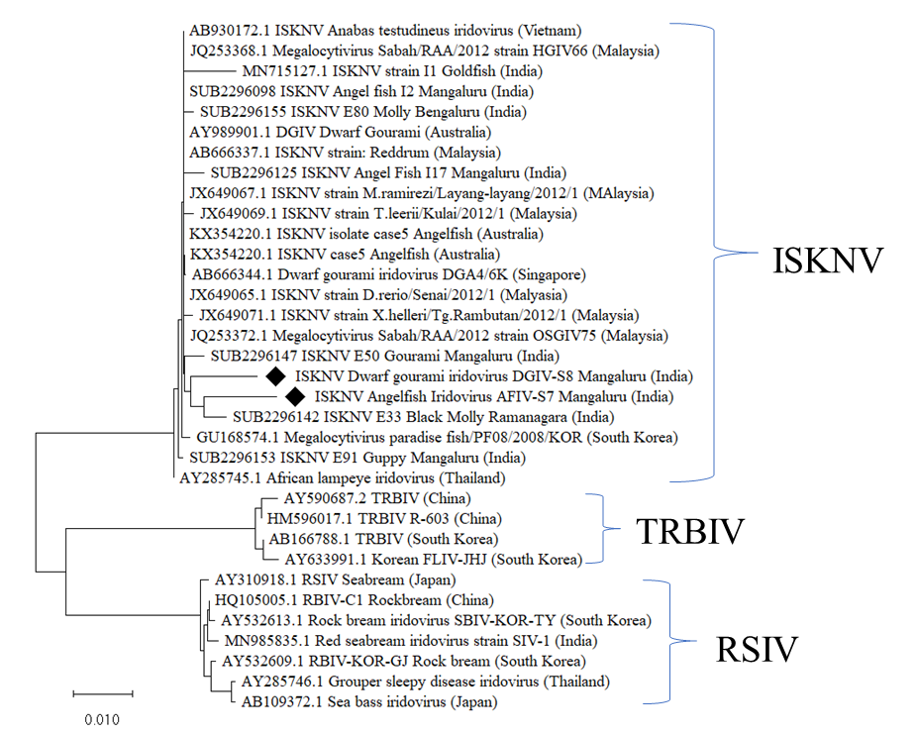
Figure 3: Phylogenetic tree, based on the MCP gene sequences of ISKNV detected in this study. The 34 sequences of MCP gene were aligned using cluster W. The evolutionary history of ISKNV was inferred using the Neighbor-Joining method. The percentage of replicate trees in which the associated taxa clustered together in the bootstrap test (1000 replicates) is shown next to the branches. Evolutionary analyses were conducted in MEGA X software. The sequences of different strains of ISKNV, RSIV and TRBIV were analyzed along with the two sequences obtained in this study (indicated by ♦).
4. DISCUSSION
Systemic iridoviral diseases have emerged as significant threats to global aquaculture, affecting a wide range of fish species with increasing frequency across multiple countries (He et al., 2000; Inouye et al., 1992). Among these, Infectious Spleen and Kidney Necrosis Virus (ISKNV), a member of the family Iridoviridae, is recognized for its capacity to cause systemic infections and high mortality in both ornamental and food fish species (Jung et al., 2016). Natural outbreaks of ISKNV have been documented with severe pathological manifestations and substantial economic losses (Girisha et al., 2021; He et al., 2000; Mohr et al., 2015; Ramírez et al., 2021; Zainathan et al., 2019), and its pathogenicity has also been confirmed under experimental conditions (He et al., 2002; Shin et al., 2014; Xu et al., 2008). In the present study, ISKNV infection was detected in naturally infected ornamental fishes exhibiting high mortality across aquarium shops and hatchery units. The first report of ISKNV was in mandarin fish (Siniperca chuatsi) in China (He et al., 2000), and subsequent reports have confirmed its presence in both ornamental and food fish species across various countries. Notably, transboundary movement of ornamental fish has been implicated as a primary route of ISKNV introduction in many regions (Mohr et al., 2015). Apart from its impact on ornamental fish, ISKNV has also been associated with significant natural mortalities in commercially important food fish species such as tilapia in Africa (Ayiku et al., 2024; Ramírez et al., 2021) and groupers in Southeast Asian countries(Fusianto et al., 2023). For instance, ISKNV was first reported in angelfish (Pterophyllum sp.) in Germany (Jung et al., 2016) and in Poeciliidae and Osphronemidae families in Malaysia (Zainathan et al., 2017). In the present study, ISKNV infection was confirmed in naturally infected ornamental fishes, further highlighting the ongoing expansion of the pathogen's host range in India, notably including the first confirmed report of ISKNV infection in dwarf gourami (Trichogaster lalius) from India.
ISKNV is known to infect over 50 fish species (Wang et al., 2007). In India, recent surveillance identified ISKNV in 16 samples representing 10 ornamental fish species, including commercially important species such as koi carp (Cyprinus carpio var koi), guppy (Poecilia reticulata), angelfish (Pterophyllum scalare), and goldfish (Carassius auratus) (Girisha et al., 2021). In the present investigation, ISKNV was detected in two out of 38 samples, specifically in angelfish (Pterophyllum scalare) and dwarf gourami (Trichogaster lalius). Interestingly, the infected dwarf gourami appeared asymptomatic, whereas the angelfish exhibited whirling behaviour, a hallmark of ISKNV-associated neurological disturbance. Similar asymptomatic infections have been reported in Korea, where 61% of ISKNV-positive ornamental fish showed no clinical signs (Joon et al., 2008), and in Malaysia, where 36 ISKNV-positive samples from five species were clinically healthy (Subramaniam et al., 2014). The challenge posed by ISKNV is frequently compounded by the presence of secondary or co-infecting pathogens. A major recent finding addresses this critical synergy: Kushala et al. (2025) recently documented the first case of co-infection of ISKNV with two opportunistic bacterial pathogens, Aeromonas hydrophila and Aeromonas dhakensis, in the native Canara pearlspot (Etroplus canarensis) from the Western Ghats, India. Other similar native fish species like E. maculatus (Kushala et al., 2024) and E. suretensis (Swaminathan et al., 2022) has shown susceptibility towards ISKNV. Persistent subclinical infections have also been documented in 47 fish species (Wang et al., 2007), and in India, ISKNV has been detected in both symptomatic and asymptomatic ornamental fish (Girisha et al., 2021). Clinically, ISKNV-infected fish may present with abdominal distension, erratic swimming, anorexia, pale gills, and reduced responsiveness (He et al., 2002; Suebsing et al., 2016), and internally it exhibits hepatic haemorrhage and enlargement of the spleen and kidney (Dheeraj et al., 2025; Liu et al., 2019). Consistent with these findings, the infected fishes in this study internally exhibited abdominal distension, body discoloration, haemorrhagic liver, and organomegaly.
The major capsid protein (MCP) gene, a highly conserved region within the Megalocytivirus genus, serves as a reliable molecular marker for ISKNV detection and phylogenetic analysis (Kurita & Nakajima, 2012). In this study, MCP gene amplification and sequencing confirmed ISKNV infection, with nucleotide sequence identities of 98.40% (dwarf gourami) and 98.76% (angelfish) compared to reference strains in the NCBI GenBank. Comparable sequence identities have been reported in Indian ornamental fish isolates, showing 99.86%–100% similarity to strains from Japan and Australia (Girisha et al., 2021), and in Malaysian isolates with 97%–100% similarity (Zainathan et al., 2017). Molecular characterization via the major capsid protein (MCP) gene confirmed both new Indian isolates grouped within the established ISKNV clade. This genetic analysis aligns with the growing body of evidence, including recent whole-genome sequencing efforts, that global spread has resulted in highly similar isolates across continents. Detailed genomic studies of ISKNV from diverse hosts across Southeast Asia confirm that isolates maintain very high sequence similarity despite being separated by host and geography, strongly supporting the role of trade in the pathogen's wide distribution (Fusianto et al., 2023). Earlier Indian studies, such as the whole genome sequence analysis of ISKNV from angelfish (Pterophyllum scalare) (Kushala, Nithin, Girisha, Dheeraj, Vinay, Naveen Kumar, et al., 2025), similarly confirmed the close genetic relationship of Indian isolates to international strains, reinforcing the hypothesis of a shared global reservoir linked to the ornamental trade. ISKNV from tilapia also showed 100% identity with reference strains (Ramírez et al., 2021), and (Subramaniam et al., 2014) reported 99.80%–100% similarity in ornamental fish isolates. Phylogenetic analysis of MCP gene sequences within the Megalocytivirus genus typically reveals three major clades: RSIV, ISKNV, and TRBIV (Kurita & Nakajima, 2012). In this study, phylogenetic reconstruction using 32 reference sequences and two isolates from the present investigation confirmed this tripartite clustering. The ISKNV isolates from dwarf gourami and angelfish grouped within the ISKNV clade, closely aligning with the ISKNV strain previously reported from molly fish in India. This molly strain also showed phylogenetic proximity to Malaysian ISKNV isolates (Girisha et al., 2021), suggesting a possible link between regional and international ISKNV transmission routes.
Although definitive transmission pathways remain elusive, transboundary movement of ornamental fish is widely considered a major contributor to ISKNV dissemination. Additionally, cohabitation of imported and native fish stocks may facilitate horizontal transmission. Experimental studies have demonstrated that cohabitation significantly increases ISKNV spread (Go & Whittington, 2019; He et al., 2002). The detection of ISKNV in dwarf gourami in this study represents the first confirmed report of infection in this species from India, underscoring the need for enhanced surveillance and biosecurity measures in ornamental fish trade. Moreover, while MCP sequencing confirms taxonomic identity, whole-genome sequencing of representative isolates (and comparison with global ISKNV genomes) would provide higher resolution for inferring transmission pathways, assessing genetic variants potentially associated with host range or virulence, and detecting recombination or gene gain/loss events in the future studies.
- CONCLUSION
This study confirms the presence of Infectious Spleen and Kidney Necrosis Virus (ISKNV) in two ornamental fish species namely dwarf gourami and angelfish from India, marking the first report of ISKNV infection in Trichogaster lalius. The continued identification of ISKNV in new ornamental hosts and its involvement in lethal viral-bacterial co-infections with MDR bacteria (Kushala et al., 2025) underscores the severity of the threat this exotic pathogen poses. Since ISKNV has the potential to jump to economically important food fish, urgent and stringent biosecurity measures are mandatory. Molecular characterization and phylogenetic analysis of the MCP gene revealed close genetic relatedness to previously reported Indian and Malaysian strains, highlighting the potential for transboundary transmission. The findings underscore the importance of routine molecular surveillance and stringent biosecurity measures to mitigate the spread of ISKNV within ornamental aquaculture systems. We strongly reiterate the necessity of implementing mandatory PCR-based health certification for all live ornamental fish stocks, both for import and domestic distribution, to effectively mitigate the transboundary spread of ISKNV and associated multi-drug-resistant pathogens.
CONSENT
Not applicable
ETHICAL APPROVAL
This study was conducted in accordance with the ethical standards and all procedures involving animals were performed in compliance with relevant guidelines and regulations.

Disclaimer (Artificial intelligence)
Author(s) hereby declares that NO generative AI technologies such as Large Language Models (ChatGPT, COPILOT, etc.) and text-to-image generators have been used during the writing or editing of this manuscript.

REFERENCES
Azad, I. S., Shekhar, M. S., Thirunavukkarasu, A. R., Poornima, M., Kailasam, M., Rajan, J. et al. (2005). Nodavirus infection causes mortalities in hatchery produced larvae of Lates calcarifer: First report from India. Diseases of Aquatic Organisms, 63(2–3), 113–118. https://doi.org/10.3354/dao063113
Behera, B. K., Pradhan, P. K., Swaminathan, T. R., Sood, N., Paria, P., Das, A., et al. (2018). Emergence of Tilapia Lake Virus associated with mortalities of farmed Nile Tilapia Oreochromis niloticus (Linnaeus 1758) in India. Aquaculture, 484(Linnaeus 1758), 168–174. https://doi.org/10.1016/j.aquaculture.2017.11.025
Chinchar, V. G., Hick, P., Huang, J., Ince, I. A., Jancovich, J. K., Marschang, R., et al. (2020). Virus Taxonomy The ICTV Report on Virus Classification and Taxon Nomenclature Iridoviridae Chapter Iridoviridae Virion Morphology. 1–30.
Chinchar, V. G., Hick, P., Ince, I. A., Jancovich, J. K., Marschang, R., Qin, Q., et al. (2017). ICTV virus taxonomy profile: Iridoviridae. Journal of General Virology, 98(5), 890–891. https://doi.org/10.1099/jgv.0.000818
Chinchar, V. G., Hyatt, A., Miyazaki, T., & Williams, T. (2009). Poor Viral Relations No Longer. Current Topics in Microbiology and Immunology, 328, 123–170.
Dey, V. K. (2016). The Global Trade in Ornamental Fish. INFOFISH International, 4(Figure 1), 52–55.
Dheeraj, S. B., Girisha, S. K, Nithin, M. S., Kushala, K. B., Dharshan, K. S., Harshitha, H., et al. (2025). Determining lethal dose (LD50) and pathological effects of ISKNV in monosex gift tilapia (Oreochromis niloticus). International Journal of Advanced Biochemistry Research, 9(2S), 435–443. https://doi.org/10.33545/26174693.2025.v9.i2sf.3791
Escobar, L. E., Escobar-Dodero, J., & Phelps, N. B. D. (2018). Infectious disease in fish: global risk of viral hemorrhagic septicemia virus. Reviews in Fish Biology and Fisheries, 28(3), 637–655. https://doi.org/10.1007/s11160-018-9524-3
Fusianto, C. K., Becker, J. A., Subramaniam, K., Whittington, R. J., Koda, S. A., Waltzek, T. B., et al. (2023). Genotypic Characterization of Infectious Spleen and Kidney Necrosis Virus (ISKNV) in Southeast Asian Aquaculture. Transboundary and Emerging Diseases, 2023. https://doi.org/10.1155/2023/6643006
Giri, S. S. (2018). Aquaculture Performance of Grass Carp, Common Carp and Indian Major Carps in Mid-altitude Area in Punakha District of Bhutan. August 2020.
Girisha, S. K., Kushala, K. B., Nithin, M. S., Puneeth, T. G., Naveen Kumar, B. T., Vinay, T. N., et al. (2021). First report of the infectious spleen and kidney necrosis virus (ISKNV) infection in ornamental fishes in India. Transboundary and Emerging Diseases, 68(2), 964–972. https://doi.org/10.1111/tbed.13793
Girisha, S. K., Puneeth, T. G., Nithin, M. S., Naveen Kumar, B. T., Ajay, S. K., Vinay, T. N., et al. (2020). Red sea bream iridovirus disease (RSIVD) outbreak in Asian seabass (Lates calcarifer) cultured in open estuarine cages along the west coast of India: First report. Aquaculture, 520, 734712. https://doi.org/10.1016/j.aquaculture.2019.734712
Go, J., Lancaster, M., Deece, K., Dhungyel, O., & Whittington, R. (2006). The molecular epidemiology of iridovirus in Murray cod (Maccullochella peelii peelii) and dwarf gourami (Colisa lalia) from distant biogeographical regions suggests a link between trade in ornamental fish and emerging iridoviral diseases. Molecular and Cellular Probes, 20(3–4), 212–222. https://doi.org/10.1016/j.mcp.2005.12.002
Go, J., & Whittington, R. (2006). Experimental transmission and virulence of a megalocytivirus (Family Iridoviridae) of dwarf gourami (Colisa lalia) from Asia in Murray cod (Maccullochella peelii peelii) in Australia. Aquaculture, 258(1–4), 140–149. https://doi.org/10.1016/j.aquaculture.2006.04.033
Go, J., & Whittington, R. (2019). Experimental transmission of infectious spleen and kidney necrosis virus (ISKNV) from freshwater ornamental fish to silver sweep Scorpis lineolata, an Australian marine fish. Diseases of Aquatic Organisms, 137(1), 1–22. https://doi.org/10.3354/dao03422
Halaly, M. A., Subramaniam, K., Koda, S. A., Popov, V. L., Stone, D., Way, K., et al. (2019). Characterization of a novel Megalocytivirus isolated from European chub (Squalius cephalus). Viruses, 11(5), 1–10. https://doi.org/10.3390/v11050440
He, J. G., Wang, S. P., Zeng, K., Huang, Z. J., & Chan, S.-M. (2000). Systemic disease caused by an iridovirus-like agent in cultured mandarinfish, Siniperca chuatsi (Basilewsky), in China. In Journal of Fish Diseases (Vol. 23).
He, J. G., Zeng, K., Weng, S. P., & Chan, S.M. (2002). Experimental transmission, pathogenicity and physical-chemical properties of infectious spleen and kidney necrosis virus ISKNV. Aquaculture (Vol. 204). www.elsevier.comrlocateraqua-online
Inouye, K., Yamano, K., Maeno, Y., Nakajima, K., Matsuoka, M., Wada, Y., et al. (1992). Iridovirus Infection of Cultured Red Sea Bream, Pagrus major. Fish Pathology, 1(27), 19–27.
Johan, C. A. C., & Zainathan, S. C. (2020). Megalocytiviruses in ornamental fish: A review. Veterinary World, 13(11), 2565–2577. https://doi.org/10.14202/VETWORLD.2020.2565-2577
Joon, B. J., Ho, Y. K., Lyu, J. J., Ji, H. L., Nam, G. P., Joong, K. K., et al. (2008). Outbreaks and risks of infectious spleen and kidney necrosis virus disease in freshwater ornamental fishes. Diseases of Aquatic Organisms, 78(3), 209–215. https://doi.org/10.3354/dao01879
Jung, S. V., Adamek, M., Wohlsein, P., Wolter, J., Wedekind, H., & Steinhagen, D. (2016). First outbreak of an infection with infectious spleen and kidney necrosis virus (ISKNV) in ornamental fish in Germany. Diseases of Aquatic Organisms, 119(3), 239–244. https://doi.org/10.3354/dao02995
Kundu, S., Rath, S., Laishram, K., Pakrashi, A., Das, U., Tyagi, K., et al. (2019). DNA barcoding identified selected ornamental fishes in Murti river of East India. Mitochondrial DNA Part B: Resources, 4(1), 594–598. https://doi.org/10.1080/23802359.2018.1561220
Kurita, J., & Nakajima, K. (2012). Megalocytiviruses. Viruses 4(4), 521–538. https://doi.org/10.3390/v4040521
Kurita, J., Nakajima, K., Hirono, I., & Aoki, T. (1998). Polymerase chain reaction (PCR) amplification of DNA of Red Sea Bream Iridovirus (RSIV). Fish Pathology, 1(33), 17–23.
Kushala, K. B., Nithin, M. S., Girisha, S. K., Dheeraj, S. B., Harshitha, H., Suresh, T., et al. (2024). Emergence of infectious spleen and kidney necrosis virus (ISKNV) as the aetiological agent for mass mortality in Etroplus maculatus in Mangaluru, India. Journal of Experimental Zoology India, 27(1), 0–000. https://doi.org/10.59467/jez.2024.27.000
Kushala, K. B., Nithin, M. S., Girisha, S. K., Dheeraj, S. B., Vinay, T. N., Miles, D. L., et al. (2025). Co-infection of infectious spleen and kidney necrosis virus, Aeromonas hydrophila, and Aeromonas dhakensis in native endemic Canara pearlspot Etroplus canarensis of Western Ghats, India. Aquaculture International, 33(4), 1–20. https://doi.org/10.1007/S10499-025-01924-X/METRICS
Kushala, K. B., Nithin, M. S., Girisha, S. K., Dheeraj, S. B., Vinay, T. N., Naveen Kumar, B. T., et al. (2025). First documentation of whole genome sequence analysis for infectious spleen and kidney necrosis virus (ISKNV) isolated from angel fish (Pterophyllum scalare) in India. Aquaculture, 597. https://doi.org/10.1016/j.aquaculture.2024.741906
Lancaster, M. J., Williamson, M. M., & Schroen, C. J. (2003). Iridovirus-associated mortality in farmed Murray cod (Maccullochella peelii peelii). Australian Veterinary Journal, 81(10), 633–634. https://doi.org/10.1111/j.1751-0813.2003.tb12512.x
Liu, L., Yu, L., Fu, X., Lin, Q., Liang, H., Niu, Y., et al. (2019). First report of megalocytivirus (Iridoviridae) in cultured bluegill sunfish, Lepomis macrochirus, in China. Microbial Pathogenesis, 135. https://doi.org/10.1016/j.micpath.2019.103617
Mohr, P. G., Moody, N. J. G., Williams, L. M., Hoad, J., Cummins, D. M., Davies, K. R., et al. (2015). Molecular confirmation of infectious spleen and kidney necrosis virus (ISKNV) in farmed and imported ornamental fish in Australia. Diseases of Aquatic Organisms, 166(2) 103 –110. Inter-Research. https://doi.org/10.3354/dao02896
Mukherjee, M., Dutta, A., & Kashem, A. (2014). Development of Ornamental Fisheries in India and the Challenges of Disease. 2(1), 14–23.
Nithin, M. S., Girisha, S. K., Kushala, K. B., Chandan, D. V., Puneeth, T. G., Naveen, K., et al. (2021). Novel lytic bacteriophages (AhFM4 & AhFM5) as bio-control measures against multidrug resistant biofilm producing Aeromonas hydrophila (AhZ1K). Aquaculture, 544, 737106. https://doi.org/10.1016/J.AQUACULTURE.2021.737106
Nolan, D., Stephens, F., Crockford, M., Jones, J. B., & Snow, M. (2015). Detection and characterization of viruses of the genus Megalocytivirus in ornamental fish imported into an Australian border quarantine premises: An emerging risk to national biosecurity. Journal of Fish Diseases, 38(2), 187–195. https://doi.org/10.1111/jfd.12222
Otta, S. K., Karunasagar, I., & Karunasagar, I. (2003). Detection of monodon baculovirus and whitespot syndrome virus in apparently healthy Penaeus monodon postlarvae from India by polymerase chain reaction. Aquaculture, 220(1–4), 59–67. https://doi.org/10.1016/S0044-8486(02)00340-X
Raja, K., Ananda, P., Padma, S., & Sampathkumar, S. J. (2019). Present and future market trends of Indian ornamental fish sector. International Journal of Fisheries and Aquatic Studies, 7(2). www.fisheriesjournal.com
Ramírez, P. J. G., Paley, R. K., Hunt, W., Feist, S. W., Stone, D. M., Field, T. R., et al. (2021). First detection of infectious spleen and kidney necrosis virus (ISKNV) associated with massive mortalities in farmed tilapia in Africa. Transboundary and Emerging Diseases, 68(3), 1550–1563. https://doi.org/10.1111/tbed.13825
Satam, S. B., Sawant, N. H., Ghughuskar, M. M., Sahastrabuddhe, V. D., Naik, V. V., Pagarkar, A. U., et al. (2018). Ornamental Fisheries: A new Avenue to Supplement Farm Income. Advance Agriculture Research and Technology, 2(2), 193–197.
Shin, G. W., White, S. L., Dahms, H. U., Jeong, H. D., & Kim, J. H. (2014). Disease resistance and immune-relevant gene expression in golden mandarin fish, Siniperca scherzeri Steindachner, infected with infectious spleen and kidney necrosis virus-like agent. Journal of Fish Diseases, 37(12), 1041–1054. https://doi.org/10.1111/jfd.12182
Stevens, C. H., Croft, D. P., Paull, G. C., & Tyler, C. R. (2017). Stress and welfare in ornamental fishes: what can be learned from aquaculture? Journal of Fish Biology, 91(2), 409–428. https://doi.org/10.1111/jfb.13377
Subramaniam, K., Shariff, M., Omar, A. R., Hair-Bejo, M., & Ong, B. L. (2014). Detection and molecular characterization of infectious spleen and kidney necrosis virus from major ornamental fish breeding states in Peninsular Malaysia. Journal of Fish Diseases, 37(7), 609–618. https://doi.org/10.1111/jfd.12152
Suebsing, R., Pradeep, P. J., Jitrakorn, S., Sirithammajak, S., Kampeera, J., Turner, W. A., et al. (2016). Detection of natural infection of infectious spleen and kidney necrosis virus in farmed tilapia by hydroxynapthol blue-loop-mediated isothermal amplification assay. Journal of Applied Microbiology, 121(1), 55–67. https://doi.org/10.1111/jam.13165
Swaminathan, T. R., Johny, T. K., Nithianantham, S. R., Sudhagar, A., Pradhan, P. K., Sulumane Ramachandra, K. S., et al. (2022). A natural outbreak of infectious spleen and kidney necrosis virus threatens wild pearlspot, Etroplus suratensis in Peechi Dam in the Western Ghats biodiversity hotspot, India. Transboundary and Emerging Diseases, 69(5), e1595–e1605. https://doi.org/10.1111/tbed.14494
Swaminathan, T. R., Kumar, R., Dharmaratnam, A., Basheer, V. S., Sood, N., Pradhan, P. K., et al. (2016). Emergence of carp edema virus in cultured ornamental koi carp, Cyprinus carpio koi, in India. Journal of General Virology, 97(12), 3392–3399. https://doi.org/10.1099/jgv.0.000649
Swaminathan, T. R., Raj, N. S., Preena, P. G., Pradhan, P. K., Sood, N., Kumar, R. G., et al. (2021). Infectious spleen and kidney necrosis virus-associated large-scale mortality in farmed giant gourami, Osphronemus goramy, in India. Journal of Fish Diseases, August, 1–11. https://doi.org/10.1111/jfd.13519
Tandel, D., Patel, V., Kotadiya, D., & Borichangar, R. (2024). Ornamental fisheries: trends, market dynamics and future projections. 05, 14–17. https://krishiscience.in/
Thanasaksiri, K., Takano, R., Fukuda, K., Chaweepack, T., & Wongtavatchai, J. (2019). Identification of infectious spleen and kidney necrosis virus from farmed barramundi Lates calcarifer in Thailand and study of its pathogenicity. Aquaculture, 500, 188–191. https://doi.org/10.1016/j.aquaculture.2018.09.035
Tsai, C.T., Ting, J.W., Wu, M.H., Wu, M.F., Guo, I.C., & Chang, C.Y. (2005). Complete genome sequence of the grouper iridovirus and comparison of genomic organization with those of other iridoviruses. Journal of Virology, 79(4), 2010–2023. https://doi.org/10.1128/jvi.79.4.2010-2023.2005
Wang, Y. Q., Lü, L., Weng, S. P., Huang, J. N., Chan, S. M., & He, J. G. (2007). Molecular epidemiology and phylogenetic analysis of a marine fish infectious spleen and kidney necrosis virus-like (ISKNV-like) virus. Archives of Virology, 152(4), 763–773. https://doi.org/10.1007/s00705-006-0870-4
Whittington, R. J., Becker, J. A., & Dennis, M. M. (2010). Iridovirus infections in finfish-critical review with emphasis on ranaviruses. Journal of Fish Diseases, 33(2), 95–122. https://doi.org/10.1111/j.1365-2761.2009.01110.x
Williams, T. (1996). Iridoviruses. 46(March 1954).
Williams, T., Barbosa-Solomieu, V., & Chinchar, V. G. (2005). A Decade of Advances in Iridovirus Research. Advances in Virus Research, 65(05), 173–248. https://doi.org/10.1016/S0065-3527(05)65006-3
Zainathan, S. C., Balaraman, D., Ambalavanan, L., Krishna Moorthy, P., Kumar Palakrishnan, S., & Ariff, N. (2019). Molecular screening of infectious spleen and kidney necrosis virus in four species of Malaysian farmed ornamental fish. Malaysian Applied Biology, 48(1).
Zainathan, S. C., Johan, C. A. C., Subramaniam, N., Ahmad, A. A., Halim, N. I. A., Norizan, N., et al. (2017). Detection and molecular characterization of Megalocytivirus strain ISKNV in freshwater ornamental fish from Southern Malaysia, 10. http://www.bioflux.com.ro/aacl

