Original Research Article
Optimizing Cucumis sativus L. Yield and Disease Suppression by integration of Poultry Manure and Biofungicides

ABSTRACT
This study investigated the synergistic effects of poultry manure and fungicide application on cucumber (Cucumis sativus L.) growth, yield, and disease control. Declining soil fertility and fungal diseases pose significant constraints to cucumber production in Cameroon, necessitating sustainable and cost-effective solutions. Field experiments were conducted using a completely randomized design with three replicates, evaluating three poultry manure levels (3, 6, and 10 t/ha) and two fungicide application rates (50 and 75 ml/15 L) of both organic and synthetic formulations. Parameters assessed included vine length, leaf number, collar diameter, fruit yield, days to germination, anthesis, and fruiting, and disease incidence. Analysis of variance revealed significant effects of both poultry manure and fungicide type on all parameters. The application of 10 t/ha poultry manure plus 50 ml/15 L organic fungicide treatment resulted in the highest collar diameter (4.6 cm) and relative leaf area (5280.8 cm²). Maximum vine length (55.8 cm) was recorded with 6 t/ha poultry manure plus 75 ml/15 L synthetic fungicide treatment. The highest yield (199.8 t/ha), shortest germination period (3.3 days), and lowest disease incidence (8.34%) occurred with 10 t/ha poultry manure plus 75 ml/15 L organic fungicide treatment. Control plants exhibited the poorest growth, including the vine lenth (27.7 cm), collar diameter (2.4 cm), leaf area (3037.0 cm²), and yield (0.6 t/ha), along with the longest germination period (6 days) and highest disease incidence (74.8% in leaves, 62.4% in fruits).These findings demonstrate the synergistic benefits of integrating poultry manure and organic fungicide application for enhanced cucumber production and disease suppression in Cameroon, thereby offering a sustainable and cost-effective alternative to synthetic fungicides. This research addresses a critical gap in knowledge by providing empirical evidence of the combined effects of organic amendments and biofungicides on cucumber productivity, offering a novel framework for sustainable agricultural practices.
Keywords: Cucumber, Poultry manure, Biofungicides, Disease incidence, Sustainable agriculture

Introduction

Cucumber (Cucumis sativus L.), a widely cultivated member of the Cucurbitaceae, ranks among the top five most-grown vegetables globally, with origins traced back over 3,000 years to Northwest India (Eifediyi & Remison, 2010; (Food and Agriculture Organization of the United Nations, 2023). It is the fourth most important vegetable in Asia after tomato, cabbage, and onion and second only to tomato in Western Europe (Food and Agriculture Organization of the United Nations, 2023).

The Cucurbitaceae includes 90 genera and over 750 species with notable agricultural value (Kozik & Paris, 2016). Within its Cucumis genus, C. anguria, C. sativus, and C. melo are widely cultivated for food and commerce (Kozik & Paris, 2016). Most commercial cucumber hybrids are gynoecious, producing exclusively female flowers to maximize fruit yield (Grumet et al., 2023). European greenhouse varieties often exhibit parthenocarpic traits, developing seedless fruits independent of pollination (Dhall et al., 2024).

Cucumber exhibits variability in fruit size, shape, skin colour, and nutrient composition, largely influenced by genetic and environmental factors (Tswanya & Olaniyi, 2016). Optimal yield requires 100–150 kg/ha nitrogen, 50–80 kg/ha phosphorus, and 100–200 kg/ha potassium, deficiencies of these nutrients result in poor fruit set and reduced marketability (Jamir et al., 2022). Besides its economic significance, cucumber provides vitamins A, B, C, and K, along with minerals such as potassium, magnesium, and calcium, supporting hydration, detoxification, and cardiovascular health (Sharma et al., 2018). Cucurbitacins, flavonoids, and tannins contribute to its antioxidant and anti-inflammatory properties, while fisetin exhibits neuroprotective and anticancer potential (Varela et al., 2022; Ravula et al., 2021).

Despite its importance, cucumber production in Cameroon suffers from soil fertility depletion, worsened by shortened fallow periods due to population growth (Fonmboh et al., 2020). Farmers rely on external inputs like poultry manure, which enhances soil structure and microbial activity (Fonmboh et al., 2020; Egbe et al., 2023). Cameroon produces 1.5 million tonnes of poultry manure annually, serving as a viable organic fertilizer (Agbede, 2025). Studies show its effectiveness in improving cucumber yield, though logistical challenges such as bulkiness and labour-intensive application hinder its widespread use (Ngosong et al., 2019; Agbede et al., 2025). Integrating poultry manure with mineral fertilizers and biochar has been proposed for sustainable production (Ravula et al., 2021; Sharma et al., 2023).

Cucumber is vulnerable to fungal diseases like powdery mildew (Podosphaera xanthii), downy mildew (Pseudoperonospora cubensis), and Plectosporium blight (Plectosporium tabacinum), limiting productivity. Though synthetic fungicides provide control, their environmental risks, resistance development, and high costs necessitate alternatives (Ravula et al., 2021). Biofungicides offer eco-friendly solutions with biodegradability and minimal harm to beneficial organisms. Extracts from Senna alata, Allium sativum (garlic), and Zingiber officinale (ginger) have demonstrated antimicrobial efficacy, yet systematic evaluations in Cameroon remain scarce (Gurjar et al., 2012; Pathak et al., 2017).

This study explores the combined effects of poultry manure and biofungicides on cucumber yield and disease suppression, aiming to improve productivity through cost-effective, sustainable strategies.
The study was carried out in the Research field of the Department of Plant Science at the University of Buea located between Latitude 40⁰ 91¹ N and longitude 90⁰ 17¹E with an elevation of 582m above sea level (Figure 1) (Egbe et al., 2023). The area has a humid tropical climate with an annual rainfall of about 2800 mm (Egbe et al., 2023). It has a mean annual temperature of 28ºC and an average humidity of 85%. The annual sunshine is estimated between 900-12000 hours per annum (Egbe et al., 2023). The soil type of Buea is basically volcanic which makes it suitable for agriculture (Mfombep et al., 2016) but the soils have been over cultivated leading to decline in fertility. The site before the commencement of the study was a fallowed land of two years and was dominated by Pinnesetum purpureum (spear grass).
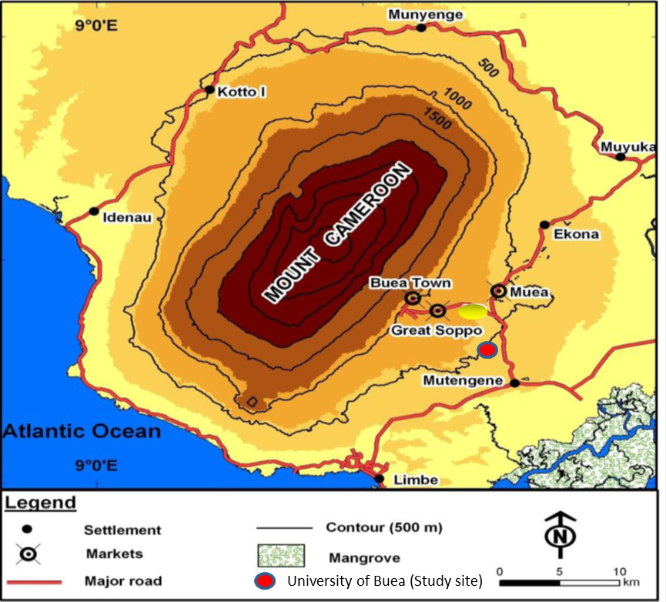
Figure 1. Location of the University of Buea and its environs around Mt. Cameroon

Land preparation and field establishment
An area of 54 by 14m was cleared and portion of land, 52m by 10m was divided into 3 blocks of 51m by 2m, each separated from the other by a 2m path. Each block was further subdivided into 13 plots of 3m by 2m separated by buffer of 1m. Within each plot, were ridges of 30 cm high, 3m long and 2m wide.
Poultry manure was collected a poultry farm and 3.5 kg of poultry manure was weighed in triplicates and their initial weights recorded. They were oven dried at 105⁰ C for 72 hours and their dry weight recorded.

Soil collection and preparation
Top soil (0-15cm) was collected at different points in the experimental plot using the soil auger and bulked. The bulked sample was air-dried, sieved using a 2 mm sieve and coded for some routine chemical analysis. pH was determined in H₂O and KCl using a pH meter (McLean, 1982). Organic carbon was measured via Walkley-Black wet oxidation (Nelson & Sommers, 1982), while total nitrogen was analysed using the Kjeldahl method (Bremner & Mulvaney, 1982). Available phosphorus was quantified using Bray-1 extraction (Bray & Kurtz, 1945). Exchangeable bases (K⁺, Mg²⁺, Ca²⁺) were determined via ammonium acetate extraction (Thomas, 1982), and cation exchange capacity (CEC) was assessed through NH₄OAc at pH 7 (Rhoades, 1982).
Poultry manure was incorporated into the soil using the strip application method at a depth of 15 cm, two weeks prior to planting, following the protocol described and calibrated based on Egbe et al. (2023). Application rates were categorized as low (3 t/ha), optimal (6 t/ha), and high (10 t/ha).This was to allow the organic manure to decompose thus preventing the scorching of the seeds by the uric acid released during the decomposition of organic manures. Two seeds of “Murano 2 F1” variety was sown per hole at a spacing of 75 by 50 cm at a depth of 2.5cm. It was later thinned after two weeks to one pant per stand to give a population of 26,700 plants/ha.
Treatments were allocated to the plots and each treatment had 3 replicates (Table 1).
BankoTM D 450 SC (CalliGhana) contained 400 Chlorothalonil and 50 Difenoconazole, functioning as both a contact and systemic fungicide. Its mode of action involved inhibiting respiration and impeding the development of numerous fungi. BankoTM D 450 SC manufacturer’s instructions showed that it can prevent and treat blight, anthracnose, powdery and down mildew, grey leaf spot, Sigatoka, and gray mold. The standard application rate is indicated at 1 litre/ha, with treatments administered at intervals of 5 days during vegetative growth and 7 days prior to harvest. The amount of the fungicide used was calibrating from the manucturer’s recommendations, adjusting fungicide amounts to volume per hectare based on the given ratio (50 mL/15 L → 1 L per hectare) (Table 1). Spraying of the fungicide was done from the third week to the eighth week after planting.

Table 1. Treatment Allocation
Treatments | Allocation
1 | Poultry manure at 3 tons/ha + organic fungicide at 50ml/15L
2 | Poultry manure at 3 tons/ha + organic fungicide at 75 ml/15L
3 | Poultry manure at 3 tons/ha + Synthetic fungicide at 50ml/15L
4 | Poultry manure at 3 tons/ha + Synthetic fungicide at 75ml/15L
5 | Poultry manure at 6 tons/ha+ Organic fungicide at 50ml/15L
6 | Poultry manure at 6 tons/ha + Organic fungicide at 75ml/15L
7 | Poultry manure at 6 tons/ha + Synthetic fungicide at 50ml/15L
8 | Poultry manure at 6 tons/ha + Synthetic fungicide at 75ml/15L
9 | Poultry manure at 10 tons/ha + Organic fungicide at 50ml/15L
10 | Poultry manure at 10 tons/ha + Organic fungicide at 75ml/15L
11 | Poultry manure at 10 tons/ha + Synthetic fungicide at 50ml/15L
12 | Poultry manure at 10 tons/ha + Synthetic fungicide and 75ml/15L
13 | Control

The field was weeded manually using a hoe. A total of three weeding periods were carried out for adequate weed control at 3, 5 and 7 weeks after planting.
Preparation of organic fungicides
A botanical fungicide was formulated using Zingiber officinale Roscoe (ginger), Senna alata (L.) Roxb. (candlestick plant), and Allium cepa L. (onion) according to the guidelines of Chiejina & Onaebi (2014) and Omokhua & Kalagbor, (2015).. S. alata leaves were dried at 60°C, finely milled, and incorporated at 4% w/v (40 g per litre of ethanol). Fresh ginger and onion were separately milled and standardised to 3.2% w/v (32 g per litre of ethanol) and 1.6% w/v (16 g per litre of ethanol), respectively. The mixture was extracted in 1 litre of ethanol over 72 hours, filtered, and stored at 4°C for preservation. Application was conducted using a knapsack sprayer (Evolution 16) at 4:00–5:00 PM, ensuring optimal absorption and disease suppression in cucumber cultivation at 1 litre per hectare foliar spray per week (Egbe et al., 2023).
Staking
Cucumber plants were trained using stakes and chord trellising to enhance vertical growth, reduce disease incidence, and improve fruit quality following the methods of Nweke et al (2013). Wooden stakes (2–2.5 m) were used to supported the vines, while nylon chords guided tendrils upward. Staking was done at three weeks after planting to prevent trail of the vines on the ground which might lead to the production of fruits with yellow bellies, overcrowding of the vines and subsequent attack by mould due to high humidity (Figure 2). Quadrats containing 5 plants were marked out per plot, that is15 plants per treatment were tagged and measured for the vegetative characters at 2, 3, 5 and 6 weeks after planting. The following parameters were measured:
Plant height: Using a flexible tape, the height of cucumber plants was measured and recorded in centimetres (cm) from the surface of the soil to the apex of the shoot.
Relative leaf area: This was measured using the non-destructive method by measuring the length and width of the leaf and the relative leaf area was determined by calculating the product of the length and the width of the leaf.
Leaf number: This was measured by counting the total number of fully opened leaves of the tagged plants.
Collar diameter: This was measured to the nearest cm using the Vernier calliper at 10 cm from soil surface.
Days to 50% flowering (Anthesis) and fruiting were assessed using visual count, .
Disease incidence for leaves and fruits was calculated by using the formula below
D1 (%) = $\frac{X}{Y} ×100$
Where: D1= disease incidence, X= number of infected leaves or fruits, Y = total number of leaves or fruits
Reproductive success was calculated by using the formula below

Reproductive success =$\frac{X}{ Y} ×100$
Where X=Number of fruits and Y = total number of flowers

Harvesting of the cucumber fruits commenced at six weeks after planting when the fruits had turned deep green in colour. Harvesting was done by handpicking with a sharp knife and the matured fruits were harvested on weekly basis. At every harvest the fruit girth was assessed by using a vernier calliper, and the fruit length was measured by using a flexible tape before the fruit was weighed using a 10 kg scale. The cumulative weights of the entire harvests (9 harvests) were summed up for data analysis

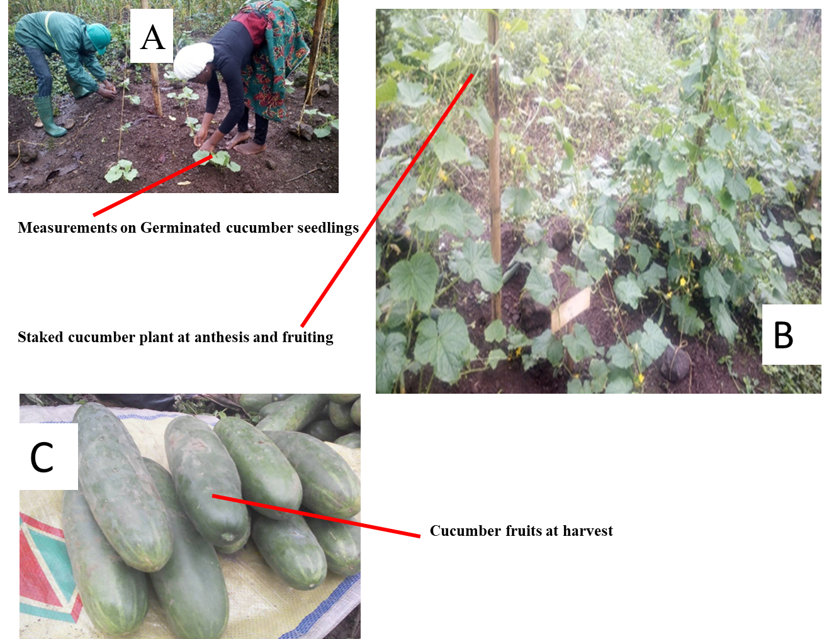

Figure 2. Growth progression of cucumber plants—early recruitment (A), support stalking (B), and final fruit harvest (C)

A field trial was conducted to evaluate the economic performance of cucumber production under thirteen agronomic treatment regimens (T1–T13). Each treatment varied in operational inputs and cultivation practices. Yield data were recorded in metric tons per hectare (t/ha). To reflect market conditions, the local price of cucumbers was set at 50 XAF/kg for the season. Post-harvest losses, stemming from spoilage, mechanical damage during handling, and inadequate storage, were estimated at 30%, reducing marketable yield to 70% of total harvest. Gross sales revenue was calculated as:

Sales Revenue (XAF) = Yield (t/ha) × 1,000 × 0.70 × 50

Total production cost per hectare was computed by summing operational expenses and input costs. Net benefit was defined as the difference between sales revenue and total production cost. The benefit-cost ratio (BCR) was calculated as:

BCR = Sales Revenue/Total Production Cost

Statistical significance of treatment effects on yield and profitability was assessed using one-way ANOVA, with a threshold of P < 0.001 considered significant.

Data analysis
Quantitative data on the growth parameters were subjected to Analysis of Variance, correlations and principal component analysis using MINITAB version 17.0. Tukey test was used to separate treatment means and all statistics were done at α = 0.05.
RESULTS
Table 2. Initial soil chemical properties of the land prior to experiment
Parameter | Level
pH in H₂O | 5.22
pH in KCl | 4.70  2.33%
Organic Carbon (%) | 4.70  2.33%
Total Nitrogen (%) | 0.24%
Available P (mg kg ⁻¹ soil) | 11.81
K⁺ (Cmol kg⁻¹ soil) | 0.12  2.45
Mg ²⁺(Cmol Kg⁻¹ soil)) | 0.12  2.45
Ca ²⁺ (Cmol kg⁻¹ soil) | 8.86
CEC (Cmol kg⁻¹ soil) | 16.78
Carbon/Nitrogen ratio | 9.71%

The soil is sandy-loam soil with an organic matter content of 4.01% and it was acidic (Table 2)
Effects of treatments on vine growth of cucumber
Effects of treatments on vine length of cucumber were not significantly different at 2 WAP. Significant differences were observed at 3WAP to 7WAP. Table 3 indicates that there was a significant difference in the vine length (P < 0.5) between the treatment means and the control. The highest plant vine length was obtained with plant treated with 10t/ha poutry manner & 75 ml of synthetic fungicide, T12 (151 cm), followed by T10 (149cm) which were grown under poultry manure at 10t/ha while the least was observed with plant in the control plot, T13 (27.7 cm).

Effects of treatments on vine collar diameter of cucumber
The collar diameter of Cucumber was influenced by different fertiliser and fungicide treatments (Table 1). All treatment means of collar diameter of the plant at P = 0.001 were significantly higher than that of the control mean diameter. The highest mean collar diameter was obtained in plants treated with1ot/ha poultry manner plus 50 ml organic fungicide, T9 (4.60 cm), followed by T12 (4.51 cm) while the least was noted with plants in control at 2.4 cm.

Effects of treatments on number of leaves of cucumber
The number of leaves was influenced by each treatment as presented in Table 3. There were significant differences between the treatments and the control and leaf number showed that plants treated with T12 had the highest leave number (34) and those in control having lowest leaf number (15). At all levels of fertiliser application, treatments having an increase amount of fertiliser application had significantly higher number of leaves. The leaf area also differed significantly at P = 0.05. The largest leaves (6206.0 cm²) were observed in the 3t poultry manure plus 75 ml/15 ml organic fungicide (T2) while the smallest leaf areas (3037.0 cm²) were observed in the control treatment.

Table 3. Effects of treatments on vegetative growth
Treatments |  | Vine length  (cm)/  plant |  | Collar diameter(cm)/  plant |  | Leaf number  /plant | Leaf area/  plant  (cm²)
T1: Poultry manure at 3 tons/ha +  organic fungicide at 50ml/15L | 35.2^{bc} |  | 3.7 ^{bcd} |  | 29 ^{ab} |  | 3801.4 ^{ab}
T2: Poultry manure at 3 tons/ha +  organic at 75 ml/15L | 40.9^{abc} |  | 3.5 ^{cd} |  | 24ª |  | 6206.0 ª
T3: Poultry manure at 3 tons/ha +  Synthetic fungicide at 50ml/15L | 38.4^{abc} |  | 3.5^{cd} |  | 28ª |  | 3777.0^{ab}
T4: Poultry manure at 3 tons/ha +  Synthetic fungicide at 75ml/15L | 41.4^{abc} |  | 3.6^{cd} |  | 36ª |  | 3784.0^{ab}
T5: Poultry manure at 6 tons/ha+  Organic fungicide at 50ml/15L | 45.3^{abc} |  | 4.2^{abd} |  | 21ª |  | 3949.4^{ab}
T6: Poultry manure at 6 tons/ha +  Organic fungicide at 75ml/15L | 47.3^{abc} |  | 4.2 ^{abcd} |  | 20 ª |  | 4016.0 ^{ab}
T7: Poultry manure at 6 tons/ha+  Synthetic fungicide at 50ml/15L | 45.2^{abc} |  | 4.2 ^{abcd} |  | 21ª |  | 3999.0 ^{ab}
T8: Poultry manure at 6 tons/ha +  Synthetic fungicide at 75ml/15L | 46.9^{abc} |  | 4.1 ^{abcd} |  | 22ª |  | 4222.0^{ab}
T9: Poultry manure at 10 tons/ha+  Organic fungicide at 50ml/15L | 53.4^{ab} |  | 4.6ª |  | 20ª |  | 4889.0 ^{ab}
T10: Poultry manure at 10 tons/ha +  Organic fungicide at 50ml/15L | 52.2^{ab} |  | 4.2ª |  | 24ª |  | 5280.8 ^{ab}
T11: Poultry manure at 10 tons/ha +  Synthetic fungicide at50ml/15L | 46.9^{abc} |  | 4.2^{abc} |  | 26ª |  | 5027.8^{ab}
T12: Poultry manure at 6 tons/ha +  Synthetic fungicide at 75ml/15L | 55.8ª |  | 4.5 ^{ab} |  | 20ª |  | 5030.0 ^{ab}
T13: Control | 27.7^{c} |  | 2.4^{d} |  | 16^{b} |  | 3037.0^{b}
P- values | 0.001 |  | 0.001 |  | 0.001 |  | 0.001
Means with the same letter along the column are not significantly different at P=0.05. Larger values are better than smaller values.
The effects of treatment on reproductive growth of cucumber
Effect of treatment on number of flowers at 50%
The number of flowers produced by Cucumis sativus L. was significantly influenced by the applied treatments (P = 0.001) (Table 4). Plants treated with 10t/ha poultry manure combined with 75ml/15ml synthetic fungicide (T12) exhibited the highest mean flower count per hectare of 1,253,000, followed by those in T9 treatment (1,145,000). In contrast, the control plots recorded the lowest mean flower production of 213,000 flowers per hectare. However, no statistically significant differences were observed among plants in treatments T6, T7, and T9, indicating comparable floral responses under these conditions.

Effects of treatments on number of fruits, fruit girth and yield
The number of fruits, fruit length, and girth exhibited statistically significant differences across treatments (P < 0.001) (Table 4). The highest fruit count per hectare (222,000) and yield (199.8 t/ha) were observed in plants treated with 10 t/ha poultry manure combined with 75 ml/15 ml organic fungicide (T10). These plants produced some of the largest fruits, with an average girth of 6.8 cm and a length of 22 cm. Conversely, crops in the control treatment yielded the lowest fruit count per hectare (6,000), the smallest fruits with an average length of 7 cm and girth of 2.2 cm, and the lowest overall yield (0.6 t/ha).

Table 4. Effects of the treatments on the reproductive parameters
Treatment | Number of Flowers/ha  *1000 | Number of Fruits /ha *1000 | Fruit  length | Fruit  girth | Average  Fruit  weight  (Kg) | Yield t/ha
T1: Poultry manure at 3 tons/ha + organic fungicide at 50ml/15L | 693de | 72^{c} | 14^{c} | 4.5^{c} | 0.5de | 36^{fg}
T2: Poultry manure at 3 tons/ha + organic at 75 ml/15L | 827^{cde} | 73^{c} | 16^{bc} | 4.9^{bc} | 0.3e | 21.9^{fg}
T3: Poultry manure at 3 tons/ha + Synthetic fungicide at 50ml/15L | 907^{bcde} | 50^{c} | 15^{bc} | 4.6^{bc} | 0.6^{cde} | 30.0^{fg}
T4: Poultry manure at 3 tons/ha + Synthetic fungicide at 75ml/15L | 907^{bcde} | 79^{c} | 14^{c} | 4.3^{c} | 0.6^{cde} | 47.4^{ef}
T5: Poultry manure at 6 tons/ha + Organic fungicide at 50ml/15L | 987^{abcd} | 117^{bc} | 15^{bc} | 4.8^{bc} | 0.6^{cde} | 70.2de
T6: Poultry manure at 6 tons/ha + Organic fungicide at 75ml/15L | 907^{bcde} | 133^{b} | 18^{abc} | 5.6^{abc} | 0.5de | 66.5de
T7: Poultry manure at 6 tons/ha + Synthetic fungicide at 50ml/15L | 880^{bcde} | 70^{c} | 18^{abc} | 5.4^{abc} | 1.2ª | 84.0de
T8: Poultry manure at 6 tons/ha + Synthetic fungicide at 75ml/15L | 1013^{abcd} | 154^{ab} | 18^{ab} | 5.6^{abc} | 0.7^{bcde} | 107.8^{cd}
T9: Poultry manure at 10 tons/ha + Organic fungicide at 50ml/15L | 1145^{ab} | 178^{ab} | 19^{ab} | 5.9^{ab} | 0.8^{bcde} | 142.4^{bc}
T10: Poultry manure at 10 tons/ha + Organic fungicide at 75ml/15L | 933^{abcd} | 222ª | 22ª | 6.8ª | 0.9^{abc} | 199.8ª
T11: Poultry manure at 10 tons/ha + Synthetic fungicide at 50ml/15L | 827^{cde} | 165^{ab} | 21ª | 6.5ª | 1.0^{abc} | 165.0^{ab}
T12: Poultry manure at 10 tons/ha + Synthetic fungicide at 75ml/15L | 1253ª | 168^{ab} | 22ª | 6.8ª | 0.7^{bcde} | 117.6^{cd}
T13: Control | 213^{f} | 6^{d} | 7^{d} | 2.2^{d} | 0.1^{f} | 0.6^{h}
±S.E | 68 | 17 | 0.64 | 0.19 | 0.1 | 16.7
LSD (0.05) | 209 | 52 | 1.97 | 0.59 | 0.3 | 51.4
P- value | <0.001 | <0.001 | <0.001 | <0.001 | <0.001 | <0.001
Means with the same letter along the column are not significantly different at P=0.05. Larger values are better than the smaller values.

Effects of treatments on germination, flowering and fruiting

Effects of treatments on germination
The seeds in control plots (T13) took the highest number of days to germinate (6 days) while the shortest number of days for germination was recorded in treatment T11 (3.0 days) followed by T10 (4 days) and T12 (4 days) (Table 5). This is a clear indication that treatments had an influence on days of germination of the seeds. Similarly, 50% anthesis was first attained in plants with treatment T10 (28days), followed by plants in treatments T12 and T11. It took 41 days for plants in T13 (control) to attain 50% anthesis (Table 5). Fruiting was recorded at 34 days after planting (DAP) for 50 % of pants in T12, whereas 50% fruiting was attained for plants in the control plots at 49 days after planting.

Table 5. Days of germination, and days to 50% anthesis and fruiting
Treatments | Days of germination | Days to 50% anthesis | Days to 50% fruiting
T1: Poultry manure at 3 tons/ha + organic fungicide at 50ml/15L | 4 | 38 | 41
T2: Poultry manure at 3 tons/ha + organic at 75 ml/15L | 5 | 37 | 38
T3: Poultry manure at 3 tons/ha + Synthetic fungicide at 50ml/15L | 5 | 38 | 41
T4: Poultry manure at 3 tons/ha + Synthetic fungicide at 75ml/15L | 5 | 36 | 40
T5: Poultry manure at 6 tons/ha+ Organic fungicide at 50ml/15L | 4 | 34 | 39
T6: Poultry manure at 6 tons/ha + Organic fungicide at 75ml/15L | 4 | 32 | 38
T7: Poultry manure at 6 tons/ha+ Synthetic fungicide at 50ml/15L | 4 | 31 | 38
T8: Poultry manure at 6 tons/ha + Synthetic fungicide at 75ml/15L | 5 | 32 | 38
T9: Poultry manure at 10 tons/ha+ Organic fungicide at 50ml/15L | 4 | 30 | 35
T10: Poultry manure at 10 tons/ha + Organic fungicide at 75ml/15L | 4 | 28 | 34
T11: Poultry manure at 10 tons/ha + Synthetic fungicide at 50ml/15L | 3 | 30 | 35
T12: Poultry manure at 10 tons/ha + Synthetic fungicide at 75ml/15L | 4 | 29 | 34
T13: Control | 6 | 41 | 49
± S.E | 0.21 | 1.14 | 1.11
LSD (0.05) | 0.43 | 2.35 | 2.29
Smaller values are better than the larger values in table 5.Difference of two means greater than the LSD values are significantly different at P = 0.05.

Effects of treatments on disease incidence and reproductive success
The disease incidence on leaves and fruits were significantly lower in the treatments than the control at P = 0.05 (Table 6). The disease incidence of 74.81% on leaves was recorded in the control treatment, T13 followed by T4 (40.49%) and T3 (35.90%) (P = 0.05). The lowest disease incidence was recorded with the T12 (18.2%). Disease incidence for fruits was lowest for the T10 at 8.34%, followed by 13.37% with the T12 while the highest disease incidence of fruits was recorded in the control (62.39%) (Table 6). Within the different fungicide level, disease incidence was higher in the first level application (T1>T2, T3>T4, T5>T6, T7>T8, T9>T10 and T11>T12) than the second level. Reproductive success was highest at T10 (51.87%), followed by T11 (48.87%) and lowest in control (14.43%)
Table 6. Disease incidence and reproductive success
Treatments | Disease incidence  of leaves (%) | Disease incidence  of fruits (%) | Reproductive success (%)
T1: Poultry manure at 3 tons/ha +  organic fungicide at 50ml/15L | 34.23 | 32.76 | 30.95
T2: Poultry manure at 3 tons/ha +  organic at 75 ml/15L | 28.73 | 24.12 | 23.22
T3: Poultry manure at 3 tons/ha +  Synthetic fungicide at 50ml/15L | 40.49 | 36.81 | 17.47
T4: Poultry manure at 3 tons/ha +  Synthetic fungicide at 75ml/15L | 35.90 | 27.49 | 24.09
T5: Poultry manure at 6 tons/ha +  Organic fungicide at 50ml/15L | 26.55 | 24.80 | 31.57
T6: Poultry manure at 6 tons/ha +  Organic fungicide at 75ml/15L | 20.38 | 16.53 | 35.11
T7: Poultry manure at 6 tons/ha +  Synthetic fungicide at 50ml/15L | 29.72 | 31.27 | 23.27
T8: Poultry manure at 6 tons/ha +  Synthetic fungicide at 75ml/15L | 26.50 | 23.71 | 39.96
T9: Poultry manure at 10 tons/ha +  Organic fungicide at 50ml/15L | 18.90 | 19.82 | 38.67
T10: Poultry manure at 10 tons/ha + Organic fungicide at 75ml/15L | 14.66 | 8.34 | 51.87
T11: Poultry manure at 10 tons/ha + Synthetic fungicide at 50ml/15L | 22.49 | 17.60 | 48.47
T12: Poultry manure at 10 tons/ha + Synthetic fungicide at 75ml/15L | 18.2 | 13.70 | 31.06
T13: Control | 74.81 | 62.39 | 14.17
± S.E. | 4.27 | 3.75 | 3.13
LSD (0.05) | 8.37 | 7.35 | 6.13
LSD= least significant difference and S.E = standard deviationf error

Treatment | Operational  Expenses (XAF) | Cost of  Goods (XAF) | Production  Cost  (XAF) | Yield  per ha  (kg) | Cost  Sales  (XAF) | Net  Benefit  (XAF) | Benefit  Cost  Ratio
T1 | 200000 | 433300 | 633300 | 36 | 1260000 | 626700 | 0.9896
T2 | 200000 | 433300 | 633300 | 21.9 | 766500 | 133200 | 0.2103
T3 | 220000 | 433300 | 653300 | 30 | 1050000 | 396700 | 0.6072
T4 | 220000 | 433300 | 653300 | 47.4 | 1659000 | 1005700 | 1.5394
T5 | 260000 | 433300 | 693300 | 70.2 | 2457000 | 1763700 | 2.5439
T6 | 260000 | 433300 | 693300 | 66.5 | 2327500 | 1634200 | 2.3571
T7 | 280000 | 433300 | 713300 | 84 | 2940000 | 2226700 | 3.1217
T8 | 280000 | 433300 | 713300 | 107.8 | 3773000 | 3059700 | 4.2895
T9 | 260000 | 480000 | 740000 | 142.4 | 4984000 | 4244000 | 5.7351
T10 | 260000 | 480000 | 740000 | 199.8 | 6993000 | 6253000 | 8.45
T11 | 280000 | 480000 | 760000 | 165 | 5775000 | 5015000 | 6.5987
T12 | 280000 | 480000 | 760000 | 117.6 | 4116000 | 3356000 | 4.4158
T13 | 180000 | 320000 | 500000 | 0.6 | 21000 | -479000 | -0.958

Cucumber yield and profitability varied significantly across treatments (P < 0.001). Treatment T10 was the most productive and profitable, achieving a marketable yield of 139.86 t/ha, a net benefit of 6,253,000 XAF, and a benefit-cost ratio (BCR) of 8.45. Treatments T9, T11, and T12 also performed well economically, with BCRs above 4. Mid-range treatments (T5–T8) showed moderate profitability, while T13 was economically unviable, generating a net loss and a negative BCR.
Table 7. Cost benefit ratio of the different treatments.
Correlations and principal component analysis of the Cucumis sativum L. growth and yield parameters measured
Cucumber yield optimisation was significantly associated with height, collar diameter at a correlation factor (r) = 0.97) and number of fruits per hectare at r = 0.96, indicating structural enhancement under treatments as compared to plants in the control plots (Table 8). The collar diameter strongly associated with the number of fruits per hectare at r =0.969, indicating efficient transport of resources between the soil and the atmosphere within the plants. Also, the number of marketable fruits per hectare strongly correlated with fruit length at r = 0.91. The combined effects of the treatments led to increased fruit weight and fruit number per hectare (0.97), demonstrating enhanced reproductive success (r = 0.980) (Table 8).
Principal Component Analysis (PCA) revealed three dominant components shaping cucumber growth under optimised treatments (Figure 3). PC1 (54.6%) primarily captured fruit yield attributes, including fruit weight (0.99), fruit number (0.97), and reproductive success (0.98), confirming the direct impact of the integration of fertilisation and biofungicide on productivity. PC2 (32.8%) emphasised structural integrity of the crop, with plant height (29.7%) and collar diameter (27.7%) supporting enhanced plant architecture. PC3 (12.6%) highlighted vegetative contributions, where leaf number (22.4%) and leaf area (4.3%) facilitated photosynthetic efficiency. Together, these components underscore the synergy between yield maximisation, structural reinforcement, and disease resistance. The Scree plot (Figure 3) confirmed a steep decline after PC3, indicating that subsequent components contributed minimal explanatory power. These findings emphasise biofungicide efficacy in enhancing cucumber yield through improved vegetative and reproductive traits. .
Table 8. Correlations between growth and reproductive parameters of C. sativus L. under different treatments
Parameters | Ht. | Cd. | Ln. | NIL. | LA. | NF. | RS. | NIAF. | NMF. | NFH. | FW. | FL. | FG.
Height (Ht) | ^{1.000} | ^{0.973*} | ^{0.793} | ^{-0.404} | ^{0.059} | ^{0.345} | ^{0.049} | ^{0.135} | ^{0.365} | ^{0.967*} | ^{0.347} | ^{0.388} | ^{0.833}
Collar diameter (Cd) | ^{0.973*} | ^{1.000} | ^{0.779} | ^{-0.345} | ^{0.030} | ^{0.254} | ^{0.036} | ^{0.110} | ^{0.283} | ^{0.969*} | ^{0.269} | ^{0.306} | ^{0.741}
Leaf number (Ln.) | ^{0.793} | ^{0.779} | ^{1.000} | ^{-0.291} | ^{-0.013} | ^{0.311} | ^{-0.003} | ^{0.138} | ^{0.260} | ^{0.249} | ^{0.249} | ^{0.258} | ^{0.751}
Number of infected leaves (NIL.) | ^{-0.404} | ^{-0.345} | ^{-0.291} | ^{1.000} | ^{-0.039} | ^{-0.361} | ^{-0.164} | ^{0.048} | ^{-0.578} | ^{-0.559} | ^{-0.559} | ^{-0.587} | ^{-0.593}
Leaf area (LA) | ^{0.059} | ^{0.030} | ^{-0.013} | ^{-0.039} | ^{1.000} | ^{0.014} | ^{0.089} | ^{0.034} | ^{0.122} | ^{0.119} | ^{0.119} | ^{0.157} | ^{0.142}
Number of flowers (NF.) | ^{0.345} | ^{0.254} | ^{0.311} | ^{-0.361} | ^{0.014} | ^{1.000} | ^{-0.354} | ^{0.286} | ^{0.356} | ^{0.960*} | ^{0.960*} | ^{0.305} | ^{0.440}
Reproductive success (RS.) | ^{0.049} | ^{0.036} | ^{-0.003} | ^{-0.164} | ^{0.089} | ^{-0.354} | ^{1.000} | ^{0.167} | ^{0.390} | ^{0.980*} | ^{0.980*} | ^{0.345} | ^{0.152}
Number of infected and aborted fruits (NIAF.) | ^{0.135} | ^{0.110} | ^{0.138} | ^{0.048} | ^{0.034} | ^{0.286} | ^{0.167} | ^{1.000} | ^{-0.210} | ^{-0.208} | ^{-0.208} | ^{-0.209} | ^{0.184}
Number of marketable fruits per plant (NMF) | ^{0.365} | ^{0.283} | ^{0.260} | ^{-0.578} | ^{0.122} | ^{0.356} | ^{0.390} | ^{-0.210} | ^{1.000} | ^{1.000} | ^{1.000} | ^{0.908} | ^{0.499}
Number of fruits per hectare (NFH.) | ^{0.967} | ^{0.969*} | ^{0.249} | ^{-0.559} | ^{0.119} | ^{0.960*} | ^{0.980*} | ^{-0.208} | ^{1.000} | ^{1.000} | ^{1.000} | ^{0.908} | ^{0.499}
Fruit weight per hectare (FW.) | ^{0.347} | ^{0.269} | ^{0.249} | ^{-0.559} | ^{0.119} | ^{0.960*} | ^{0.980*} | ^{-0.208} | ^{1.000} | ^{1.000} | ^{1.000} | ^{1.000} | ^{0.569}
Fruit length (FL.) | ^{0.388} | ^{0.306} | ^{0.258} | ^{-0.587} | ^{0.157} | ^{0.305} | ^{0.345} | ^{-0.209} | ^{0.908} | ^{0.908} | ^{1.000} | ^{1.000} | ^{0.345}
Fruit girth (FG.) | ^{0.833} | ^{0.741} | ^{0.751} | ^{-0.593} | ^{0.142} | ^{0.440} | ^{0.152} | ^{0.184} | ^{0.499} | ^{0.499} | ^{0.569} | ^{0.569} | ^{1.000}

*Indicates significant differences in the correlation coefficient at P = 0.05

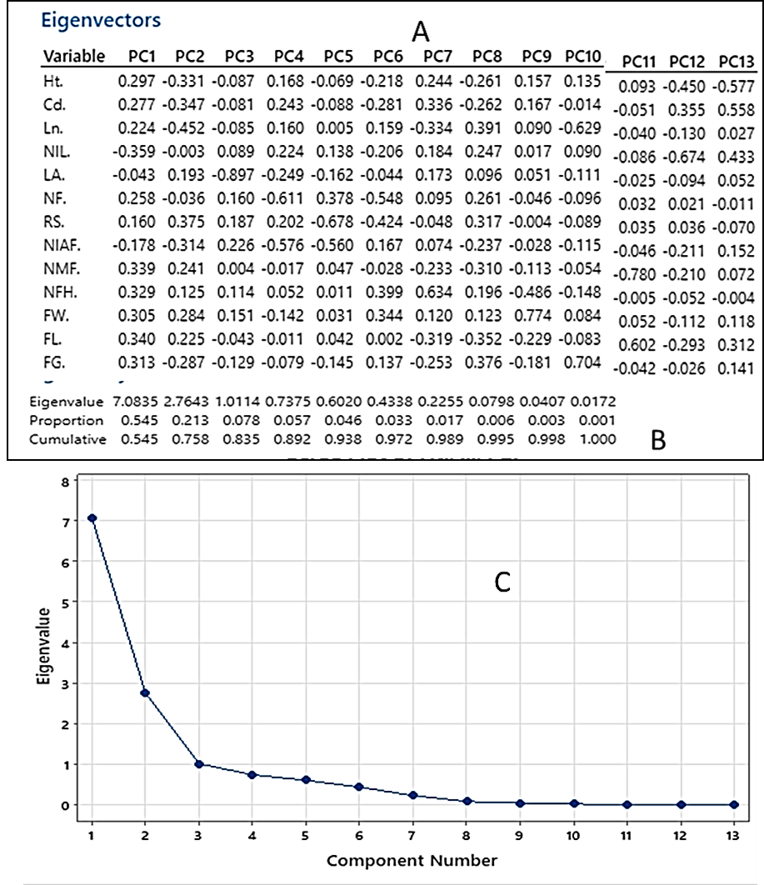

Figure 3. Principal component analysis of Cucumis sativum L. growth and yield optimised using fertilizer and biofungicide integration
Eigenvalues (A), proportions (B), and Scree plot (C) for PCA analysis of cucumber growth parameters.

Discussion

The significant findings highlight the synergistic impact of poultry manure and fungicide application on cucumber growth and yield. Increased poultry manure levels (particularly 10 t/ha) consistently correlated with superior vegetative growth (vine length/plant height, leaf number, collar diameter) and fruit yield, confirming its role in enhancing nutrient availability (Ehiokhileni & Remison, 2009; Brar et al., 2015; Agbede et al., 2025). This improved nutrient uptake likely fuelled enhanced cell multiplication, amino acid synthesis, and energy production, leading to increased photosynthetic activity. The substantial yield increase (199.8 t/ha) compared to the control (0.6 t/ha) underscores the potential for significant economic gains from optimized poultry manure application (Brar et al., 2015). The observed increase in fruit length in manure-treated plots further supports the positive impact on fruit morphology and market quality (Jamir et al., 2022). The improved soil aeration and moisture retention associated with higher manure levels likely promoted root growth, leading to enhanced nutrient and water uptake, contributing to the observed increases in biomass and dry weight (Khan et al., 2017; Brar et al., 2015).

Accelerated seed germination in plants treated with 10t/ha + 75ml of fungicide as compared to control might be due to higher manure levels and this supports previous findings on organic amendments improving seed germination (Ali, 2005). This accelerated germination may be attributed to the early release of essential nutrients (N, P, K) from the decomposed manure, stimulating metabolic activity (Tswanya & Olaniyi, 2016; Khan et al., 2017; Brar et al., 2015). In contrast, the nutrient-deficient control soils exhibited slower germination due to reduced microbial activity and moisture retention in the soil (Ngonkeu et al., 2019; Ngosong et al., 2022).

The study also demonstrates the superior efficacy of organic fungicides over synthetic counterparts in disease suppression. Disease incidence decreased significantly from 74.8% (control plots) to 8.34% (T10), corroborating the antimicrobial properties of Zingiber officinale and Senna alata extracts (Gurjar et al., 2012; Pathak et al., 2017). The organic fungicides likely disrupted fungal cell integrity, thereby preventing pathogen proliferation (Pathak et al., 2017). Their eco-friendly nature, coupled with reduced resistance development and environmental impact, position them as a more sustainable alternative for cucumber disease management (Fonmboh et al, 2020). This aspect of the research fills a critical knowledge gap by providing empirical evidence for integrating organic fungicides into effective crop protection strategies.
Profitability in cucumber production was strongly influenced by input intensity and post-harvest efficiency. High-input treatments yielded superior returns, consistent with findings by Egbe et al. (2023), who emphasized the economic gains of strategic intensification in horticulture. However, marketable yield was constrained by post-harvest losses—estimated at 30%—due to spoilage, mechanical damage, and inadequate storage, echoing FAO’s 2023 global assessments (Food and Agriculture Organization of the United Nations, 2023). The variation in benefit-cost ratios highlights that yield alone is insufficient; economic viability depends on both production and recovery. While T10 achieved the highest return, mid-range treatments also performed well, suggesting scalable pathways for smallholders. Conversely, the control treatment negative margin underscores the risks of underinvestment. Strengthening post-harvest systems remains essential for unlocking full value in fresh produce chains.

This study bridges a gap in existing research by demonstrating the synergistic effects of poultry manure and fungicide application on cucumber yield, unlike previous studies that focused on isolated effects (Fonmboh et al., 2020). By integrating these two approaches, it provides a novel, sustainable, and cost-effective framework for enhancing cucumber production and disease management in Cameroon. Given the global demand for eco-friendly and high-yield agricultural practices, these findings have significant implications for sustainable horticulture and environmentally responsible disease management.

Conclusion

This research provides compelling evidence for a synergistic approach to cucumber cultivation, integrating poultry manure and organic fungicides. The findings demonstrate significant improvements in yield and disease suppression, offering a sustainable and cost-effective alternative to synthetic pesticides. This study contributes significantly to agronomic knowledge, providing a practical framework for sustainable vegetable production in resource-constrained environments. Further research should focus on long-term soil health impacts and the scalability of this integrated approach in diverse agricultural settings in Cameroon. This study recommends that in similar agro-ecological zones farmers can apply 10 t/ha poultry manure with 5 L organic fungicide per hectare to enhance cucumber yield and economic returns sustainably.
Conflict of interest: There is no conflict of interest among the authors.

Disclaimer (Artificial intelligence)
Author(s) hereby declare that NO generative AI technologies such as Large Language Models (ChatGPT, COPILOT, etc.) and text-to-image generators have been used during the writing or editing of this manuscript.
References
- Agbede, T. M. (2025). Poultry manure improves soil properties and grain mineral composition, maize productivity and economic profitability. Scientific Reports, 15(1), 1–12. https://doi.org/10.1038/s41598-025-00394-8
- Ali, G. A (2005). Uses of manure and fertilizer as soil management Technique for sustainable crop production,” Paper presented at workshop organized by Taraba State Local Government Service Commission on 8 and 9
- Bray, R. H., & Kurtz, L. T. (1945). Determination of total, organic, and available forms of phosphorus in soils. Soil Science, 59(1), 39–45.
- Bremner, J. M., & Mulvaney, C. S. (1982). Nitrogen—Total. In A. L. Page, R. H. Miller, & D. R. Keeney (Eds.), Methods of soil analysis: Part 2. Chemical and microbiological properties. American Society of Agronomy & Soil Science Society of America. (2nd ed., pp. 595–624).
- Varela, C., Melim, C., Neves, B. G., Sharifi-Rad, J., Calina, D., Mamurova, A., & Cabral, C. (2022). Cucurbitacins as potential anticancer agents: new insights on molecular mechanisms. Journal of translational medicine, 20(1), 630.
- Chiejina, N. V. & Onaebi, C. N. (2013). In vitro fungicidal activity of two plant extracts against five phytopathogenic fungi of cucumber (Cucumis sativus L.) Fruit. International Journal of Applied and Natural Sciences vol. 2, issue 3: 61-68
- Dhall, R. K., Kaur, H., Manchanda, P., & Sharma, E. (2024). Recent advances in genetics and molecular breeding of parthenocarpic cucumber (Cucumis sativus L.) under protected conditions. Euphytica, 220(7), 1–16. https://doi.org/10.1007/s10681-024-03366-7
- Egbe, A. E., Solange, M., Soupi, N., Nkede, F., & Ndogho, A. P. (2023). Growth , yield and yield characteristics of three pepper cultivars to fertilizers application in the Mount Cameroon Region. Journal of Agricultural Chemistry and Environment, 12, 188–205.
- Ehiokhilen, K. E. & Remison, S. U. (2010). The effects of synthetic fertilizer on the yield of two varieties of cucumber (Cucumis sativus L.). Report and Opinion 1(5):74-80
- Eifediyi, E. K. & Remison, S. U. (2010). Growth and yield of cucumber (Cucumis sativus L.) as influenced by farm yard manure and synthetic fertilizer. Journal of Plant Breeding and Crop Science. 2(7): 216-220.
- Fonmboh, D. J., Abah, E. R., Fokunang, T. E., Herve, B., Teke, G. N., Rose, N. M., Borgia, N. N., Fokunang, L. B., Andrew, B. N., Kaba, N., Bathelemy, N., & Ntungwen, F. C. (2020). An overview of methods of extraction, isolation and characterization of natural medicinal plant products in improved traditional medicine research. Asian Journal of Research in Medical and Pharmaceutical Sciences, 9 (2)(November), 31–57. https://doi.org/10.9734/ajrimps/2020/v9i230152
- Food and Agriculture Organization of the United Nations. (2023). FAOSTAT statistical database. Retrieved from https://www.fao.org/faostat/en/#home
- Grumet, R., Lin, Y.-C., Rett-Cadman, S., & Malik, A. (2022). Morphological and Genetic Diversity of Cucumber (Cucumis sativus L.) Fruit Development. Plants, 12(1), 23. https://doi.org/10.3390/plants12010023
- Gurjar, M. S., Ali, S., Akhtar, M., & Singh, K. S. (2012). Efficacy of plant extr acts in plant disease management. Agricultural Sciences, 03(03), 425–433. https://doi.org/10.4236/as.2012.33050
- Jamir, S. Y., E. Topno, S., & Bahadur, V. (2022). Effect of Organic and Inorganic Fertilizers on Growth, Yield & Quality of Cucumber (Cucumis sativus L.) under Protected Cultivation. International Journal of Plant & Soil Science, October, 723–728. https://doi.org/10.9734/ijpss/2022/v34i2131324
- Khan, M., Ullah, F., & Khan, M. N. (2017). Effects of poultry manure levels on growth and yield of effects of poultry manure levels on growth and yield of cucumber cultivars. Sci.Int.(Lahore), 29(6),1381(June 2022).
- Kozik, E. U., & Paris, H. S. (2016). Proceedings of Cucurbitaceae 2016. In XI Eucarpia Meeting on Cucurbit Genetics & Breeding.
- Brar, B. S., Singh, J., Singh, G., & Kaur, G. (2015). Effects of long term application of inorganic and organic fertilizers on soil organic carbon and physical properties in maize–wheat rotation. Agronomy, 5(2), 220-238.
- McLean, E. O. (1982). Soil pH and lime requirement. In A. L. Page, R. H. Miller, & D. R. Keeney (Eds.), Methods of soil analysis: Part 2. Chemical and microbiological properties. American Society of Agronomy & Soil Science Society of America.(2nd ed., pp. 199–224).
- Mfombep, P. M., Fonge, B. A., Atembe-afac, A., & Tabot, P. T. (2016). Soil Type and Amendment Influence Growth and Yield of Tomatoes Lycopersicon esculentum L. in the Humid Mt Cameroon Region. International Journal of Current Research in Biosciences and Plant Biology, 3(8), 58–64. https://doi. org/10.20546/ijcrbp.2016.308.009.
- Nelson, D. W., & Sommers, L. E. (1982). Total carbon, organic carbon, and organic matter. In A. L. Page, R. H. Miller, & D. R. Keeney (Eds.), Methods of soil analysis: Part 2. Chemical and microbiological properties (2nd ed., pp. 539–579).
- Ngosong, C., Bongkisheri, V., Tanyi, C. B., Nanganoa, L. T., & Tening, A. S. (2019). Optimizing nitrogen fertilization regimes for sustainable maize (Zea mays L.) production on the volcanic soils of Buea Cameroon. Advances in Agriculture, 2019. https://doi.org/10.1155/2019/4681825
- Nweke, I.A., Orji E.C. & Ijearu, S.I. (2013). The effect of Staking and Plant Spacing on the growth and yield of Cucumber (Cucumis Sativus L.) Journal of Environmental Science, Toxicology and Food Technology (3) 4:26-31
- Omokhua, G. E. & Kalagbor, S. (2015). Effects of Five Plant Extracts on Damping off Disease Control of Causuarina Equisetifolia L. in the Nursery. Nature and Science 13 (3):63-67
- Pathak, R., Shrestha, A., Lamichhane, J., Gauchan, D., & Gauchan, D. P. (2017). PGPR in biocontrol: mechanisms and roles in disease suppression. International Journal of Agronomy and Agricultural Research, 11(1), 69–80. http://www.innspub.net
- Ravula, A. R., Teegala, S. B., Kalakotla, S., Pasangulapati, J. P., Perumal, V., & Boyina, H. K. (2021). Fisetin, potential flavonoid with multifarious targets for treating neurological disorders: An updated review. European journal of pharmacology, 910, 174492. https://doi.org/10.1016/j.ejphar.2021.174492
- Rhoades, J. D. (1982). Cation exchange capacity. In A. L. Page, R. H. Miller, & D. R. Keeney (Eds.), Methods of soil analysis: Part 2. Chemical and microbiological properties (2nd ed., pp. 149–157). American Society of Agronomy & Soil Science Society of America. Pages 1- 353
- Sharma, S. (2023). Cultivating Sustainable Solutions: Integrated Pest Management (Ipm) for Safer and Greener Agronomy. Corporate Sustainable Management Journal, 1(2), 103–108. https://doi.org/10.26480/csmj.02.2023.103.108
- Thomas, G. W. (1982). Exchangeable cations. In A. L. Page, R. H. Miller, & D. R. Keeney (Eds.), Methods of soil analysis: Part 2. Chemical and microbiological properties (2nd ed., pp. 159–165). American Society of Agronomy & Soil Science Society of America.
- Tswanya, M. N., & Olaniyi. (2016). Effects of pinching time on growth and fruit yield of three tomato varieties (Lycopersicon lycopersicum Mill) in the southern guinea savanna zone of Nigeria. Journal of Agricultural Science and Food Technology, 2(9), 30–40. www.iprjb.org

