GENETIC DIVERSITY OF TROPICAL MAIZE (Zea mays L.) INBRED LINES USING PHENOTYPIC CLUSTERING

ABSTACT
Genetic diversity in maize is a valuable natural resource and plays a key role in hybrid breeding programs. The present study was conducted to assess the magnitude of genetic diversity among 107 tropical maize (Zea mays L.) inbred lines using phenotypic traits. Significant variability was observed for all the 11 traits. Days to 50% tasseling (DFT), days to 50% silking (DFS), plant height (PH), ear height (EH), cob length (CL), cob girth (CG), kernel rows per cob (KRPC), kernel per row (KPR), shelling percent (SP), seed weight (SW) and grain yield (GY). High heritability and genetic advance were observed for the traits Viz., DFT, DFS, CL, CG and KRPC, indicating their suitability for effective selection. In contrast, traits like GY, SP, and SW showed low heritability, suggesting stronger environmental influence and the need to exploit heterosis for yield improvement. Cluster analysis of inbred lines grouped them into seven distinct clusters, with considerable inter-cluster distances, particularly between Cluster II and V. Principal component analysis (PCA) revealed that the first five PCA components explained over 80% of the total variation. Potential genetically diverse genotypes Viz., CIMMYT-19, BHG-19, UASBM-69 and AHG-76-1 were identified by the PCA biplot as promising sources for hybridization. Overall, the results showed the importance of flowering and cob-related traits for selection and demonstrate the combined utility of cluster analysis and PCA in identifying diverse parental lines, thereby providing a strong foundation for hybrid development and genetic improvement of maize.
Keywords – CIMMYT, Dendrogram, Genetic diversity, Inbred lines, Principal component analysis, Polymorphism information content
Introduction
Maize (Zea mays L.), widely referred to as the “Queen of Cereals,” is one of the most important food, feed and industrial crops worldwide. It ranks third among cereals after wheat and rice in terms of production and global consumption. Originating from Mexico, maize has spread across continents due to its exceptional adaptability to a broad range of environmental conditions, thriving from sea level up to altitudes of 3000 meters and under annual rainfall ranging from 250 mm to over 5000 mm (Shaw,1988; Dowswell et al.,1996). Its genetic plasticity, high productivity and multipurpose utilization make it a strategic crop for ensuring global food and nutritional security.
In hybrid maize breeding, the foundation of any successful program lies in the development and selection of genetically distinct inbred lines. It has been well established that hybrids produced from crosses between genetically distant inbreds express higher levels of heterosis and yield stability than those derived from closely related parents (Vasal et al., 1998). Therefore, understanding the extent of genetic diversity among inbred lines is crucial for identifying suitable parents that maximize heterotic potential. The selection of genetically diverse parents can be achieved by quantifying hereditary differences using biometrical and multivariate statistical methods (Saxena et al.,1998; Mian et al.,1989). Studies on genetic diversity among elite inbred lines not only assist in identifying potential heterotic groups but also facilitate the efficient utilization of germplasm resources in breeding programs (Hallauer et al.,1988; Ahloowalia et al.,1963; Xia et al.,2005).
Among the various tools used to measure genetic divergence, cluster analysis and principal component analysis (PCA) are widely recognized as effective approaches. Cluster analysis helps in classifying genotypes into different groups based on their similarity or dissimilarity, allowing breeders to identify genetically distant lines that could serve as promising parents for hybrid development (Rincon et al.,1996). PCA, on the other hand, reduces complex phenotypic data into a few principal components that explain the maximum variability among genotypes, thereby simplifying the interpretation of genetic relationships (Brown-Guedira, 2000). These multivariate techniques are particularly valuable for evaluating the diversity of maize germplasm using morphological and agronomic traits, especially when molecular characterization is not feasible
The present study was undertaken to evaluate the magnitude of genetic diversity among recently developed tropical maize inbred lines using phenotypic clustering. The study aims to identify genetically diverse and agronomically superior inbred lines that can be effectively utilized in heterotic grouping and hybrid development programs suited to tropical environments.
Materials and Methods
The experiment was conducted during Rabi 2024-25 at agriculture college farm, Bheemarayanagudi with 107 tropical maize inbred lines derived from different maize populations. The experimental plot is located in the Northeastern Dry Zone (Zone 2) of Karnataka, at 16°44'01'' N latitude, 76°47'57'' E longitude and an altitude of 468 meters above MSL (mean sea level). The soil at the experimental plot was fertile, well-drained and exhibited uniform topography, ensuring minimal environmental variation
The inbred lines were laid out in an augmented block design consisting of four blocks and five checks to accommodate the large number of genotypes. Each line was sown in two-row plots of 4.0m length with spacing of 60 cm × 20 cm between rows and plants, respectively. All recommended agronomic and crop management practices were followed uniformly throughout the growing season to ensure uniform crop growth and reliable data collection.
Observations were taken on five plants which are randomly selected from each row for a set of morphological and yield-related traits. The traits evaluated were Days to 50% tasseling (DFT), days to 50% silking (DFS), plant height (PH), ear height (EH), cob length (CL), cob girth (CG), kernel rows per cob (KRPC), kernel per row (KPR), shelling percent (SP), seed weight (SW) and grain yield (GY).

The mean data for all traits were subjected to statistical analysis to assess genetic variability and diversity among the inbred lines. Analysis of variance (ANOVA) was performed as per the method described by Panse and Sukhatme (1978) in R software. Principal Component Analysis (PCA) was carried out using the GRAPES platform i.e. General R-based Analysis Platform for Experimental Statistics (Husson et al., 2020). Cluster analysis was performed based on Euclidean distance using Ward’s minimum variance method (Ward, 1963) to classify the inbred lines into genetically similar groups. The K-means clustering algorithm was further employed to refine group formation and validate the results obtained from hierarchical clustering. All statistical computations were performed using the R software, version 4.5.1 (2025).

Results and Discussion
Variability
The ANOVA(analysis of variance) showed highly significant differences among the 107 tropical maize inbred lines for all traits studied, confirming the presence of high level of genetic variability and wide scope for selection (Table 1; Fig. 1 & 2). The magnitude of genotypic and phenotypic coefficients of variation (GCV and PCV), heritability and genetic advance as a percentage of mean (GAM) provided valuable information on the inheritance pattern of the traits.
Days to 50% tasseling and silking exhibited low GCV and PCV but high heritability (>77%), suggesting the predominance of additive gene action and effectiveness of selection for these traits. Cob length, cob girth and number of kernel rows per cob showed moderate variability with heritability above 37% and moderate GAM (11–15%), indicating a balanced influence of genetic and environmental factors.
Plant height and ear height showed low heritability (14–32%) and GAM, reflecting greater environmental influence and limited genetic control. Similar observations were made by Satyanarayana et al. (2020) and Lata et al. (2021) for flowering and cob traits.
Grain yield exhibited medium level GCV (6.24%) but high PCV (24.22%) with low heritability (6.63%) and GAM (3.31%), suggesting strong environmental dependence and non-additive genetic effects. Shelling percentage and hundred-grain weight also showed low heritability, indicating limited selection response. Overall, flowering and cob traits emerged as more reliable for selection, while yield-related traits require multi-environment testing or heterosis exploitation for improvement (Bello et al., 2012; Antony et al., 2024).
Table 1: Mean and Genetic variability parameters for phenotypic traits
Trait | Grand Mean | Range |  | GCV (%) | PCV (%) | Heritability | GAM
Trait | Grand Mean | Min | Max
DFT | 68.18 | 60.55 | 78.55 | 4.76 | 5.42 | 77.19 | 8.63
DFS | 71.50 | 61.80 | 81.00 | 4.54 | 5.12 | 78.49 | 8.29
PH | 136.74 | 88.37 | 179.54 | 5.15 | 13.74 | 14.07 | 3.99
EH | 67.52 | 39.05 | 90.65 | 9.21 | 16.2 | 32.3 | 10.79
CL | 11.67 | 6.98 | 22.55 | 12.64 | 18.47 | 37.24 | 14.38
CG | 11.80 | 5.58 | 16.81 | 8.92 | 14.6 | 37.32 | 11.24
KRPC | 11.63 | 5.07 | 17.09 | 11.26 | 17.5 | 41.54 | 14.64
KPR | 13.02 | 6.20 | 22.41 | 12.49 | 26.08 | 22.97 | 9.07
SP | 77.10 | 61.16 | 89.21 | 4.47 | 7.42 | 36.22 | 5.55
SW | 27.89 | 24.05 | 30.65 | 4.28 | 7.53 | 32.2 | 4.84
GY | 39.23 | 16.44 | 65.35 | 6.24 | 24.22 | 6.63 | 3.31
DFT- Days to 50% tasseling, DFS- Days to 50% silking, PH-plant height, EH-ear height
CL-cob length, CG-cob girth, KRPC- kernel rows per cob, KPR-kernals per row,
SP-shelling percent, SW- seed weight, GY-grain yield

Fig 1: Genetic and Phenotypic Coefficient of Variability for morphological traits in tropical maize inbred lines

Fig 2: Heritability and Genetic Advance percentage of means for morphological traits in tropical maize inbred lines
Hierarchical Clustering of tropical maize inbred lines
Hierarchical and K-means clustering techniques based on Euclidean distance Ward’s D² method grouped the 107 tropical maize accessions into seven different clusters (Table 5; Fig. 6), reflecting substantial genetic divergence among the lines. Cluster I was the largest, consisting of 28 genotypes, followed by Clusters IV and V with 21 genotypes each. Cluster III comprised 13 genotypes, Cluster VI had 11 and Cluster VII included 8, while Cluster II was the smallest with only 5 genotypes. The presence of diverse genotypes in different groups confirms wide genetic variability within the population. Interestingly, genotypes originating from various sources were distributed across clusters, indicating that phenotypic differences, rather than geographical origin, predominantly contributed to the observed divergence. Similar findings were reported by Rafique et al. (2019), Rathod et al. (2021) and Khan et al. (2022), who found that maize inbred clustering was mainly driven by phenotypic performance rather than geographical background.
The inter and intra-cluster distance analysis (Table 2) showed high level of genetic diversity among clusters. Cluster IV recorded the lowest intra-cluster distance (2.99), suggesting high genetic similarity among its members, whereas Cluster II exhibited the highest (4.92), indicating greater genetic variability within that group. Inter-cluster distances were consistently larger than intra-cluster distances, confirming effective grouping of genetically distinct lines. The maximum inter cluster distance was observed between Cluster II and Cluster V (5.01), followed by Cluster II and Cluster III (4.27). Crosses involving genotypes from these distant clusters are expected to produce hybrids with greater heterosis due to their diverse genetic backgrounds. Similar findings on heterotic potential based on cluster distance were reported by Farzana Jabeen et al. (2007), Nehvi et al. (2008), Patel et al. (2009), Pradhan et al. (2009) and Alam and Alam (2009).
Cluster mean performance (Table 3) revealed distinct trait variations among clusters. Cluster V recorded the tallest plants (161.23 cm) and highest ear placement (78.95 cm), suggesting its potential use in developing high-biomass genotypes. Flowering time varied slightly among groups, with Cluster IV being earliest (66.43 days) and Cluster VII latest (69.75 days), indicating diversity in phenological adaptation. Cluster I showed superiority for cob traits, with the longest cobs (11.77 cm), highest cob girth (12.21 cm) and maximum kernel rows per cob (12.47), highlighting its yield potential. Clusters II and V recorded the highest number of kernels per row (14.58 and 14.11, respectively), signifying strong contributions to grain yield. Despite these differences, average grain yield across clusters was similar (36.29 g), reflecting uniform field conditions.
The percentage contribution of traits (Table 4) showed that flowering attributes like days to silking (12.99%) and tasseling (12.56%) contributed most to total variability, followed by cob girth (11.80%), cob length (11.56%) and shelling percentage (11.26%), similar findings were also reported by Prakash et al. (2019) and Kumar et al. (2014). Traits such as seed weight (10.33%) and kernels per row (9.57%) contributed moderately, while plant height (2.94%) and ear height (3.32%) contributed least. Grain yield contributed only 4.68% to total divergence, emphasizing its polygenic nature and strong environmental influence. High heritability estimates that flowering and ear traits suggest additive gene action, making these traits reliable selection criteria for yield improvement (Reddy & Jabeen, 2016).
Overall, the clustering results demonstrate broad phenotypic diversity among tropical maize inbreds, with several promising lines identified for use as parents in heterotic hybrid development programs.
Table 2: Inter and Intra-cluster distance of morphological traits
Cluster id’s | i | ii | iii | iv | v | vi | vii
i | 3.38 | 2.92 | 2.15 | 1.62 | 2.42 | 2.55 | 1.94
ii |  | 4.92 | 4.27 | 3.88 | 5.01 | 2.77 | 3.59
iii |  |  | 3.28 | 2.35 | 2.23 | 2.45 | 2.22
iv |  |  |  | 2.99 | 1.86 | 3.17 | 2.40
v |  |  |  |  | 3.61 | 3.99 | 2.77
vi |  |  |  |  |  | 3.73 | 2.53
vii |  |  |  |  |  |  | 3.68

Table-3: cluster mean performance of maize inbred lines for phenotypic traits
Cluster  ID | DFT | DFS | PH | EH | CL | CG | KPRC | KPR | SP | SW | GY
i | 67.92 | 71.35 | 129.60 | 63.52 | 11.77 | 12.20 | 12.47 | 13.23 | 79.06 | 27.71 | 36.29
ii | 67.8 | 70.8 | 95.57 | 41.24 | 10.84 | 11 | 11.52 | 14.58 | 78.10 | 27.71 | 36.29
iii | 67.92 | 71.53 | 143.13 | 71.94 | 10.85 | 11.97 | 11.88 | 11.56 | 75.31 | 27.71 | 36.29
iv | 66.42 | 69.85 | 146.87 | 68.59 | 11.54 | 11.47 | 11.26 | 12.18 | 76.3 | 27.71 | 36.29
v | 69.47 | 72.66 | 161.23 | 78.94 | 11.54 | 11.88 | 11.42 | 14.11 | 75.53 | 27.79 | 36.29
vi | 66.63 | 69.72 | 115.65 | 55.77 | 12.21 | 10.97 | 10.41 | 11.81 | 76.3 | 27.71 | 36.29
vii | 69.75 | 72.5 | 115.37 | 74.11 | 12.06 | 11.73 | 10.48 | 10.80 | 77.14 | 27.71 | 36.29

DFT- Days to 50% tasseling, DFS- Days to 50% silking, PH-plant height, EH-ear height
CL-cob length, CG-cob girth, KRPC- kernel rows per cob, KPR-kernals per row,
SP-shelling percent, SW- seed weight, GY-grain yield

Table 4: Percent contributions of different traits
Traits | % contribution
DFT | 12.56
DFS | 12.99
PH | 2.94
EH | 3.32
CL | 11.55
CG | 11.80
KPRC | 8.96
KPR | 10.33
SP | 11.26
SW | 9.57
GY | 4.68
DFT- Days to 50% tasseling, DFS- Days to 50% silking, PH-plant height, EH-ear height
CL-cob length, CG-cob girth, KRPC- kernel rows per cob, KPR-kernals per row,
SP-shelling percent, SW- seed weight, GY-grain yield

Table 5. Grouping of 107 maize inbred lines into different clusters
Clusters | No of genotypes | genotypes
i | 28 | AHG-17, AHG-18, AHG-32, AHG-70, AHG-82, AHG-95, AHG-108, AHG-111, AHG-119, AHG-120, AHG-110-2, BHG-04, BHG-92-1, CAL-1426, CAL-1721, UASBM-01, UASBM-13, UASBM-17, UASBM-31, CIMMYT-1, CIMMYT-2, CIMMYT-3, PhD-16, CML-451, HTMA-101, AHG-150, UASBM-12, AHG-76-1
ii | 5 | AHG-29, AHG-118, AHG-110-1, BHG-36, BHG-57
iii | 13 | AHG-30, AHG-50, AHG-72, AHG-81, AHG-88, AHG-99, BHG-24, CAL-1713, CATL-152, UASBM-42, CIMMYT-19, CIMMYT-13, BHG-114
iv | 21 | AHG-31, AHG-40, AHG-66, BHG-11, BHG-58, BHG-73, HHG-48, GPM-45, GPM-06, CAL-1729, CATL-286, UASBM-09, UASBM-30, UASBM-40, UASBM-44, CIMMYT-14, CIMMYT-22, CIMMYT-24, CIMMYT-47, CIMMYT-58, CIMMYT-61
v | 21 | AHG-67, AHG-93, AHG-94, AHG-103, AHG-105, AHG-106.AHG-109, BHG-10, BHG-19, BHG-79, BHG-83, HHG-77, CAL-1712, CIMMYT-04, CIMMYT-52, CIMMYT-21, PHD-13, PHD-15, PHD-IHE1960, IM-106711, IM-106712
vi | 11 | AHG-98, AHG-157, BHG-10, BHG-13, BHG-14, CAL-1435, UASBM-25, UASBM-38, IM-116719, DHG-12, GB-58
vii | 8 | BHG-90, CAL-1728, CAL-17129, UASBM-11, UASBM-24, UASBM-43, CIMMYT-6, CIMMYT-11

Principal Component Analysis (PCA)
PCA was done to reduce the dimensionality of multivariate phenotypic data and to identify the yield-related traits contributing most to genetic divergence among 107 tropical maize inbred lines. This technique transforms correlated variables into a smaller set of uncorrelated principal components that retain most of the original information (Abdi and Williams, 2010).
PCA based on nine quantitative traits revealed that the majority of variation among the maize inbreds was explained by the first few principal components (Table 6). The first component (PC1) had the highest eigenvalue (2.703) and accounted for 24.57% of the total variation, followed by PC2 (18.62%) and PC3 (13.95%). Collectively, these three components explained 57.14% of the total variability. Inclusion of PC4 (13.68%) and PC5 (9.71%) increased the cumulative variation to 80.54%, indicating that five components sufficiently captured the diversity among genotypes.
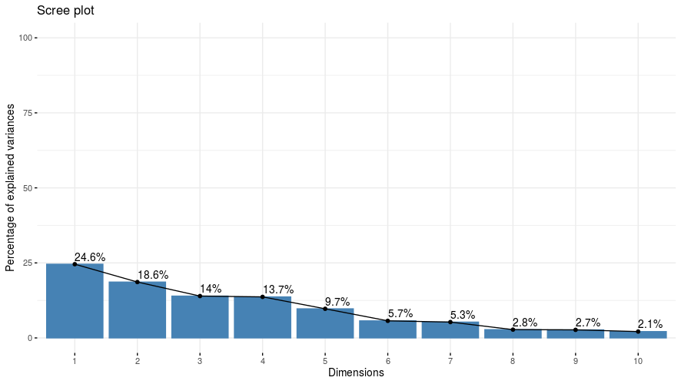
Fig 3: Scree plot representing 10 principal components’ (PCs) against its eigen values
The biplot of PC1 and PC2, which together explained 43.20% of the total variance, revealed clear differentiation among genotypes based on yield-attributing and morphological traits. Traits such as days to 50% tasseling (DFT), days to 50% silking (DFS), number of kernels per cob (KPRC) and cob girth (CG) clustered closely with strong positive associations, suggesting their major contribution to genetic diversity. In contrast, plant height (PH) and ear height (EH) were positioned in a different direction, highlighting their distinct influence on genotype separation.
Overall, PCA indicated that yield-related traits (DFT, DFS, KPRC, CG, SW and GY) and growth-related traits (PH, EH) were key contributors to total genetic divergence. Genotypes such as CIMMYT-19, BHG-19, UASBM-69 and AUG-76-1 were positioned farthest from the origin, identifying them as highly divergent and potentially valuable for hybridization. Conversely, genotypes like CIMMYT-114, CIMMYT-117, CAL-1712 and CML-45 clustered near the center, suggesting limited variability.
These results were also reported by Bhusal et al. (2016), Singh et al. (2020) and Al-Naggar et al. (2020), who also found that the first few components explained a major portion of total variability in maize. Hence, traits with high PCA loadings serve as reliable indicators of diversity and help in the effective selection of parents for heterotic group formation and hybrid breeding programs.
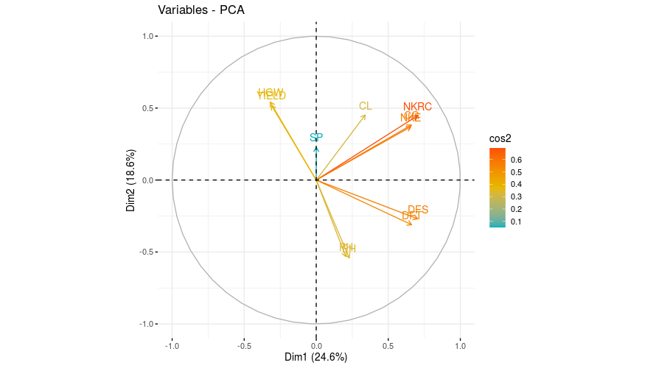

Fig 4: Two dimensional biplot of morphological traits contribution on principal component axes

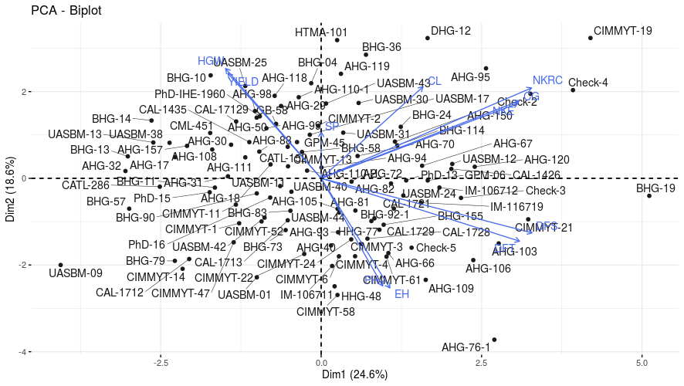

Fig 5: Biplot dispersion graph of maize inbreds
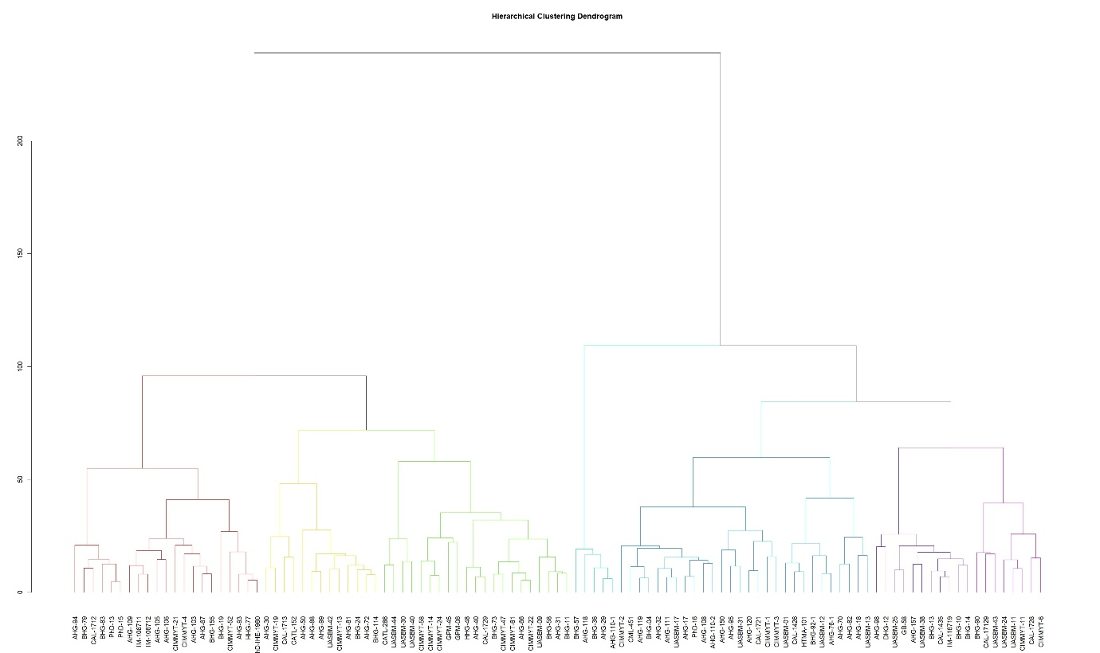
Fig 6: Dendrogram based on Hierarchical Clustering method for 107 tropical maize inbred lines

Conclusion
The present work revealed substantial genetic variability among 107 tropical maize inbred lines based on morphological and yield-related traits, indicating wide scope for selection and genetic improvement. The ANOVA confirmed significant differences for all evaluated traits, signifying a broad genetic base within the studied germplasm. Traits such as days to 50% tasseling and silking exhibited high heritability and moderate genetic advance, suggesting the predominance of additive gene action and their reliability for selection. Conversely, traits like grain yield, shelling percentage and 100-grain weight displayed low heritability, indicating strong environmental influence and the need for multi-location testing or heterosis exploitation to achieve improvement.
Cluster analysis grouped the maize inbred lines into seven different clusters, reflecting wide phenotypic divergence. Genotypes distributed across clusters from diverse origins highlighted that phenotypic variation was independent of geographical background. Crosses between genotypes belonging to genetically distant clusters, particularly between Cluster II and Cluster V are expected to produce high heterotic hybrids due to their substantial genetic divergence.
Principal Component Analysis (PCA) further validated the clustering results and identified key traits such as flowering time, cob girth, kernels per row and cob length, as the major contributors to total variability. Genotypes like CIMMYT-19, BHG-19, UASBM-69 and AUG-76-1 were identified as the most divergent and thus serve as valuable parental sources for future hybrid development.
Overall, the combination of cluster and PCA analyses effectively characterized the genetic diversity of tropical maize inbreds and provided valuable insights for strategic parent selection, heterotic group formation and hybrid breeding in tropical environments.

Disclaimer (Artificial intelligence)
Option 1:
Author(s) hereby declare that NO generative AI technologies such as Large Language Models (ChatGPT, COPILOT, etc.) and text-to-image generators have been used during the writing or editing of this manuscript.
Option 2:
Author(s) hereby declare that generativ AI technologies such as Large Language Models, etc. have been used during the writing or editing of manuscripts. This explanation will include the name, version, model, and source of the generative AI technology and as well as all input prompts provided to the generative AI technology
Details of the AI usage are given below:
1.
2.
3.

References
Abdi, H. and Williams, L.J., 2010. Principal component analysis. WIREs Comp Stats, 2(4), 433-459.
Ahloowalia, B. S. and Dhawan, N. I. 1963. Effect of genetic diversity in combining ability of inbred lines of maize. Indian J. Hum. Genet, 23: 158-162.
Alam, M. S. and Alam, M. F. (2009). Genetic divergence study of maize inbred lines (Zea mays L.). Afr. J. Biotechnol. 5(3): 28-31.
Al-Naggar, A.M.M., Shafik, M.M. and Musa, R.Y.M. 2020. Genetic diversity based on morphological traits of 19 maize genotypes using principal component analysis and GT biplot. Annu. Res. Rev. Biol., 14: 68-85.
Antony, J., Joseph, R., & Thomas, P. (2024). Genetic variability and heritability estimates for yield components in maize. Maydica, 69(1), 1–8.
Bello, O.B., Abdulmaliq, S.Y., Afolabi, M.S. and Ige, S.A., 2010. Correlation and path coefficient analysis of yield and agronomic characters among open pollinated maize varieties and their F1 hybrids in a diallel cross. Afr. J. Biotechnol., 9(18),2633-2639.
Brown‐Guedira, G.L., Thompson, J.A., Nelson, R.L. and Warburton, M.L., 2000. Evaluation of genetic diversity of soybean introductions and North American ancestors using RAPD and SSR markers. Crop Sci, 40(3),815-823.
Dowswell, C.R., Paliwal R.L. and Cantrell R.P. (1996). Maize in the Third World. Boulder: West View Press.
Farzana Jabeen, F.J., Sahib, K.H. and Satyanarayana, E., 2007. Divergence studies in quality protein maize (Zea mays L.) genotypes.
Hallauer, A. R., Russell, W. A. and Lamkey, K. R. 1988. Corn Breeding. In: Corn and Corn Improvement, 3rd edn. Agron Monogr 18, ASA-CSSA-SSSA, Madison, Wisconsin, USA. 469-564.
Hartigan, J.A. and Wong, M.A., 1979. Algorithm AS 136: A k-means clustering algorithm. J. R. Stat. Soc. series c (applied statistics), 28(1), 100-108.
Khan, A., Singh, R., Verma, P. & Ahmed, N., 2022. Morphological trait based clustering and heterotic grouping of maize inbreds. JMRD, 8(2),
Kumar, G.P., Prashanth, Y., Reddy, V.N., Kumar, S.S. and Rao, P.V., 2014. Character Association and Path Coefficient Analysis in Maize (Zea mays L.).
lal, S., Singh, R., & Gupta, P. (2024). Heritability and genetic advance analysis for kernel traits in maize hybrids. Journal of Cereal Research, 16(2), 145–152.
Mian, M. A. K. and Bahl, P. N. 1989. Genetic divergence and hybrid performance in chickpea. Indian J. Hum. Genet, 49: 119-124
Nehvi, F.A., Makhdoomi, M.I., Vaseem Yousuf, V.Y., Bahar, F.A. and Sabeena Naseer, S.N., 2008. Genetic divergence among local maize (Zea mays L.) cultivars of Kashmir Valley.
Patel, J.S., Vaghela, P.K., Patel, D.B., Parmar, D.J. and Macwana, S.S., 2009. Genetic divergence in baby corn (Zea mays L.).
Pradhan, K., Pradhan, B., Sarangi, D.N., Sial, P. and Mishra, T.K., 2009. Genetic divergence in newly developed inbred lines of maize
Prakash, R., Ravikesavan, R., Vinodhana, N.K. and Senthil, A., 2019. Genetic variability, character association and path analysis for yield and yield component traits in maize (Zea mays L.). Electron. J. Plant Breed, 10(2),518-524.
Rafique, M., Malhi, A.R., Altaf, M., Saleem, S. and Khakwani, K., 2018. Cluster analysis and genetic diversity of maize inbred lines. Int J Agric Innov, Res, 6(5),1473-2319.
Rathod, S., Patil, R., Deshmukh, P. & Kulkarni, A., 2021. Genetic diversity and clustering of maize inbred lines using D2 and Ward’s methods. J. Plant Breed. Crop Sci. 13(4)
Reddy, V.R. and Jabeen, F., 2016. Narrow sense heritability, correlation and path analysis in maize (Zea mays L.).
Rincon, F., Johnson, B., Crossa, J. and Taba, S., 1996. Cluster analysis, an approach to sampling variability in maize accessions.
Satyanarayana, E., Reddy, P. S., & Ramesh, S. (2020). Genetic variability and heritability studies for yield and yield component traits in maize, 9(3), 2048–2053.
Saxena, V. K., Mathi, N. S., Singh, N. N. and Vasal, S. K. 1998. Heterosis in maize: Grouping and patterns. Proc. of 7th Asian Regional Maize Workshop. Los Banos, Philippines. February 23 27, 124-133, pp.
Shaw, R.H. (1988). Climatic requirements. In: Sprague, G.F. and Dudley, J.W., eds. Corn and Corn Improvement. Madison, Wisconsin: American Society of Agronomy, 609-638.
Singh, S.B., Kasana, R.K., Kumar, S. and Kumar, R. 2020. Assessing genetic diversity of newly developed winter maize (Zea mays L.) inbred lines. Indian J. Plant Genet. Resour., 33(1): 68–76.
Stansluos, A.A., Ozturk, A., Kodaz, S., Pour, A.H. and Sylvestre, H. 2019. Genetic diversity in sweet corn (Zea mays L. saccharata) cultivars evaluated by agronomic traits. Mysore J. Agric. Sci., 53(1): 1-8.
Vasal, S. K. 1998. Hybrid maize technology: Challenges and expanding possibilities for research in the next century. Proc. of 7 th Asian Regional Maize Workshop. Los Banos, Philippines. February 23-27, 58-62, pp
Ward Jr, J.H., 1963. Hierarchical grouping to optimize an objective function. Journal of the American statistical association, 58(301), pp.236-244.
Xia, X. C., Reif, J. C., Melchinger, A. E., Frisch, M., Hoisington, D. A., Beck, D., Pixley, K. and Warburton, M. L. 2005. Genetic diversity among CIMMYT maize inbred lines investigated with SSR markers. Crop Sci, 45; 2573-2582.
Yuvaraja, A., Rajarajan, K., Ganesan, K., Ravikesavan, R. and Thangahemavathy, A., 2017. Principal Component, Clustering pattern and association analysis of sweet corn (Zea saccharata L.) inbred lines. Forage Res, 43(1), pp.17-21.

